T Level Technical Qualification in Building Services Engineering for Construction (Level 3)

Skills Practice Workbook for Learners

Electrotechnical Engineering
Practical Training

Learner name:.

Centre name:.

Contents
Task 1: Workshop induction: health and safety procedures 5
Task 2: Risk assessment 9
Task 3: Method statement 10
Task 5: Access equipment 13
Task 6: Manual handling 16
Task 7: Safe isolation 19
Task 8: Identification of tools and equipment 21
Task 9: Measuring and cutting 27
Task 10: Identification of cable types, fixings, termination and accessories 28
Task 11: Cable termination 36
Task 12: PVC/SWA cable termination 40
Task 13: Installing lighting circuits – PVC/PVC 44
Task 14: Installing lighting circuits – PVC/PVC 47
Task 15: Installing lighting circuits – FP200 cable 50
Task 16: Installing ring final circuits – PVC/PVC 53
Task 17: Cutting, bending and terminating conduit 56
Task 18: Installing lighting circuits – PVC conduit 60
Task 19: Installing lighting circuits – steel conduit 63
Task 20: Installing ring final circuits – plastic conduit 66
Task 21: Installing ring final circuits – steel conduit 69
Task 23: Steel trunking – Flat 90-degree angle 75
Task 24: Steel tray – tee joint 78
Task 25: Steel tray – Gusset bend 81
Task 26: Steel basket – 90-degree angle 84
Task 27: Steel basket – Tee joint 87
Task 28: PVC/SWA on steel tray – sub-main supply 90
Task 29: Earthing and bonding 94
Task 30: Data cable installation 96
Task 31: Inspection and testing – initial verification 99
Task 33: Composite installation 105
Acknowledgements 114

Task summary and progress tracker

 | Task | Date complete
1 | Workshop health and safety procedures
2 | Risk assessment
3 | Method statement
4 | Personal protective equipment
5 | Access equipment
6 | Manual handling
7 | Safe isolation
8 | Identification of tools and equipment
9 | Measuring and cutting
10 | Cable types, fixings, connectors and accessories
11 | Cable termination
12 | PVC/SWA cable termination
13 | Installing lighting circuits – PVC/PVC – 1-Way
14 | Installing lighting circuits – PVC/PVC – 2-Way
15 | Installing lighting circuits – FP200 – 1-Way
16 | Installing ring final circuits – PVC/PVC
17 | Cutting, bending and terminating conduit
18 | Installing lighting circuits – Plastic conduit
19 | Installing lighting circuits – Steel conduit
20 | Installing ring final circuits – Plastic conduit
21 | Installing ring final circuits – Steel conduit
22 | Steel trunking – Internal 90-degree angle
23 | Steel trunking – Flat 90-degree angle
24 | Steel tray – Tee joint
25 | Steel tray – Gusset bend
26 | Steel basket – 90-degree angle
27 | Steel basket – Tee joint
28 | PVC/SWA on Steel tray – Sub-main supply
29 | Earthing and bonding
30 | Data cable installation
31 | Inspection and testing – Initial verification
32 | Inspection and testing – Fault finding
33 | Composite installation

Task 1: Workshop induction: health and safety procedures
Health and safety are very important in any workshop or workplace. All rules must be followed to ensure everyone's safety.
The primary legislation that covers health and safety in such surroundings is the Health and Safety at Work Act (1974).
To establish a safe working environment, familiarise yourself with the workshop and complete the following tasks:
- Show the position of any emergency stop buttons in the workshop.

- List the types of fire extinguishers and the colour codes that identify them.

- Find where the first aid box is kept and suggest what should be kept in it.

- List the main items of protective clothing you are expected to wear.

- Write out the emergency evacuation procedure for the workshop and where the assembly point is.

- Identify who to immediately inform in the event of an accident.

- Find out where we record any accidents that may occur in the workshop.

- Determine the first action to take if someone receives an electric shock.

- Familiarise yourself with the emergency procedure to summon help in your place of learning.

- Locate these four signs in the workshop and explain their meaning.
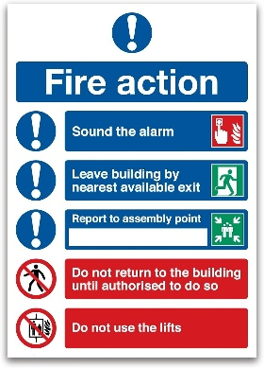
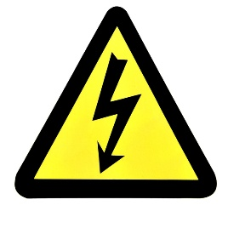
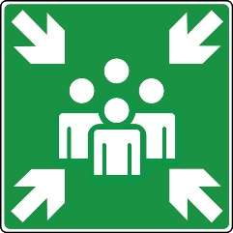


General health and safety rules within an electrical skills workshop.
These are designed to provide a framework, and specific rules should be adapted based on the equipment and activities within your own workshop.
General conduct and awareness
- Follow instructions: Always listen carefully to and follow the instructions given by your instructor or supervisor. If you are unsure about anything, ask for clarification before proceeding.
- Work area tidiness: Always keep your work area clean and tidy. Clear away tools, equipment and materials when you have finished with them. Avoid clutter that could cause trips or falls.
- No running or horseplay: Running, shouting or any form of horseplay is strictly prohibited in the workshop. Maintain a professional and focused attitude.
- Report hazards: Immediately report any unsafe conditions, faulty equipment or accidents – no matter how minor – to your instructor or supervisor.
- No food or drink: Eating and drinking are prohibited in the workshop area to prevent contamination and distractions.
- Appropriate clothing: Wear appropriate clothing for the workshop environment. Avoid loose clothing, jewellery and long hair that could get caught in machinery or become a hazard.
- Personal protective equipment (PPE): Always wear the required personal protective equipment (PPE) for your task. This may include safety glasses, gloves and other protective gear. Ensure PPE fits correctly and is in good condition.
- Tool and equipment checks: Before using any tool or equipment, visually inspect it for damage or defects. Report any issues to your instructor. Do not use faulty equipment.
- Use equipment correctly: Only use tools and equipment for their intended purpose and according to the manufacturer's instructions and any training you have received.
- Isolate before maintenance: Never attempt to adjust, clean or maintain any electrical equipment or circuits without first ensuring that the power supply is completely isolated and locked out/tagged out (if applicable).
- Awareness of others: Be aware of the people around you and their activities. Ensure you do not endanger yourself or others while working.
- Emergency procedures: Know the location of fire extinguishers, first aid kits, emergency exits and the procedures to follow in case of an emergency.
- Waste disposal: Dispose of waste materials in the designated containers, including electrical components and consumables. Follow any specific instructions for the disposal of hazardous waste.
Electrical safety
- Live work restrictions: Do not work on live electrical circuits unless specifically instructed and under strict supervision, with appropriate safety measures in place.
- Safe isolation procedures: Understand and follow the correct procedures for safely isolating electrical circuits before working on them. This includes identifying the correct circuit, switching it off, locking it off (where applicable), and proving it is dead using a suitable voltage tester.
- Use correct tools for electrical work: Always use insulated tools specifically designed for electrical work and rated for the voltage you are working with.
- Damaged cables and plugs: Never use equipment with damaged cables, plugs or connectors. Report any damage immediately.
- Water and electricity: Keep water and other liquids away from electrical equipment and circuits. Never touch electrical equipment with wet hands.
- Testing and measurement: Use appropriate and calibrated test equipment for measuring voltage, current, and resistance. Ensure you understand how to use the test equipment safely and correctly.
Machine and equipment safety
- Machine guards: Never remove or tamper with safety guards on machinery. Ensure they are in place and functioning correctly before operating any equipment.
- Operating procedures: Before using each piece of machinery, familiarise yourself with its safe operating procedures. If you are unsure, ask for instructions.
- Moving parts: Be aware of any moving parts on machinery and keep hands and other body parts clear.
- Emergency stop buttons: Know the location and operation of emergency stop buttons on all machinery you may use.
These rules are intended to promote a safe working environment in the electrical workshop. Remember that safety is everyone's responsibility; following these guidelines can help prevent accidents and injuries.
Always prioritise safety in all your activities.
Learner reflection
Do you feel confident about this topic? | Yes | I would like more guidance

Task 2: Risk assessment
For any employer, risk assessments are required by law; however, if you employ fewer than five people, you don't have to write anything down.
To carry out a risk assessment, you need to consider what might harm people and decide if you are taking reasonable steps to prevent this. For certain risks, such as working with electricity, specific regulations require control measures to be put in place.
Hazard: Anything that may cause harm
Risk: The chance, high or low, that somebody could be harmed
You must complete a risk assessment before attempting the practical tasks in this workbook. Use the general health and safety factors listed in Task 1 to identify what could be hazards in each task, assign each a risk level, and complete an assessment as per the examples below.
To practice, fill in the missing columns in the table below to expand on each given hazard.
L = Low risk M = Medium risk H = High risk
What are the hazards? | Risk |  |  | Possible outcomes | Who is involved | Control methods | Review methods
What are the hazards? | L | M | H
Manual handling |  | M |  | Splinters in hands/fingers, bruised or trapped fingers, wrong lifting technique, back injury, lacerations | Learners | Training and close supervision | Monitor, then reduce supervision as training and experience are gained
Running or horseplay |  |  | H | Injury to oneself or others | Learners | Education and close supervision, small group numbers or more staff | Monitor, then reduce supervision as training and experience are gained
Using stepladders
Waste bins overflowing with cables
Handling a 110v power drill

Learner reflection
Do you feel confident about this topic? | Yes | I would like more guidance

Task 3: Method statement
A method statement, also known as a ‘safe system of work’, is a document that details how to carry out a task safely. It outlines all the hazards involved and includes a step-by-step guide on how to do so. It ensures that the risks and precautions required of all those involved in the task are effectively communicated. Method statements also detail control measures introduced to ensure the safety of anyone affected by the task.

A method statement includes the following information:
Description/overview of works | Link to risk assessment
Location | Control measures
Start and finish time | PPE
Supervisor name and contact details | Emergency actions
Resources required | Welfare and first aid measures

Department/Location:
Description of the task/activity:
Personnel involved: | Name |  | Role/Trade
Key plant and tools:
Other essential equipment:
(platforms/winches/ladders, etc)
Sequence of operations:
(include sketches if required)
Required PPE:
Emergency procedures:

Learner reflection
Do you feel confident about this topic? | Yes | I would like more guidance

Task 4: Personal protective equipment
- Identify the PPE and describe its use.
PPE Item | Name/Use



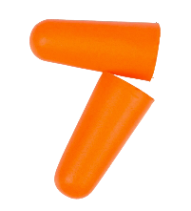
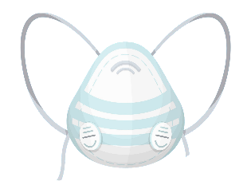
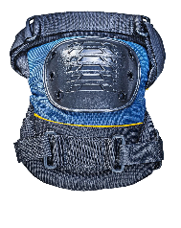




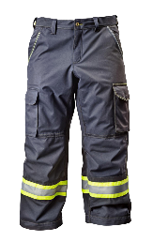
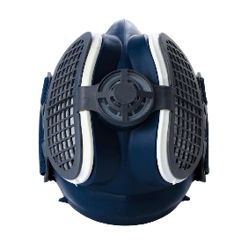

- Why is it important to check that your PPE is in good working order before and after use?

- Who is responsible for maintaining personal protective equipment on a building site?

- Who is responsible for providing PPE in the workplace if it is deemed necessary?

Learner reflection
Do you feel confident about this topic? | Yes | I would like more guidance

Task 5: Access equipment
Safe use of access equipment exercise
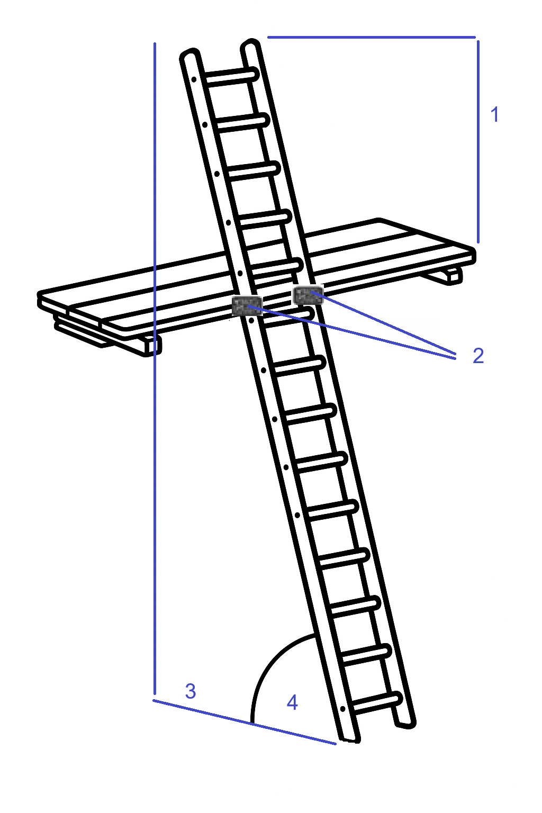

Figure 5.1
- What type of ladder is shown here (Figure 5.1) and what safety checks should be carried out before using this type of ladder?

- Label the diagram (Figure 5.1).

- Identify the two other types of ladders shown below and list any safety checks that must be carried out before their use.
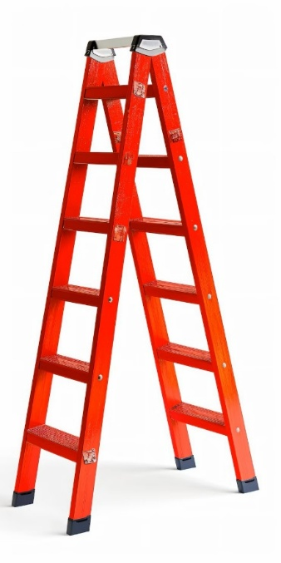
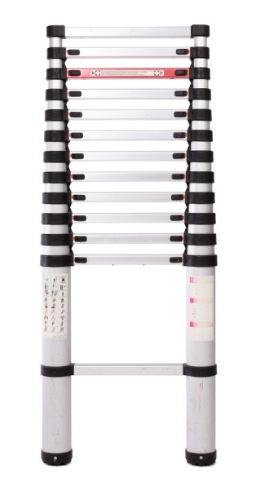

- Safe use of ladders

Expected time | 30 minutes
Safety instructions | - Inspect the ladder thoroughly before use.  - Ensure that the use of the ladder will not endanger you or others.  - Ensure your work area is clear and safe for work to proceed.  - Hard hats and gloves must be worn.  - Your work must conform to the Health and Safety at Work Act requirements.
Task instructions | You must transport an extension ladder for a short distance and erect it in an area designated by the assessor.  - Complete a risk assessment and method statement.  - Put on your PPE.  - When told to do so by your tutor, check the ladder for defects. If any are found, do not use the ladder. Report its condition.  - If there are no defects, transport the ladder to the designated area.  - Safely erect the ladder using the 4:1. (You may ask for assistance from another person, but you must tell them exactly what to do.)  - After ensuring that the ladder will not move, ascend and secure the ladder to the landing stage.  - Descend the ladder.  - Lower the ladder safely.  - Carry the ladder back to the starting point.

 | ASSESSMENT CRITERIA |  | Y | N
1 | Displays warning notices in the appropriate positions
2 | Visually inspects ladder
3 | Lifts and carries ladder correctly
4 | Erects ladder correctly
5 | Slope of ladder correctly set to gradient
6 | Top extends>1.07m above landing (5 rungs)
7 | Safe position of ladder rung adjacent to transom
8 | Secured ladder before ascending
9 | Ascends and descends ladder in a safe manner
10 | Secures top of ladder safely
11 | Lowers ladder correctly
12 | Returns ladder safely to start position.
13 | Work conformed to the requirements of HASWA
 | Total
Feedback from the task:
Learner reflection
Do you feel confident about this topic? | Yes | I would like more guidance

Task 6: Manual handling
Manual handling of materials and equipment exercise

Use the HSE-Manual Handling at Work webpage to answer the following questions.

- The Manual Handling Regulations set out three ways employers must manage the risks from manual handling. What are they?

- List six things that can be done to reduce the risk of injury from manual handling tasks you can't avoid.

- Practical task

To lift an object and carry it for 10 metres and then assist in the lifting and handling of an object between a bench and the floor.
Object 1: 100m roll of 2.5mm² PVC/PVC cable.
Object 2: Conduit bending machine or a similar piece of equipment.
Time | 30 minutes
Safety instructions | - Think before handling/lifting.  - Keep the load close to your waist.  - Adopt a stable position.  - Ensure a good hold on the load.  - Slightly bend your back, hips and knees at the start of the lift.  - Don't flex your back any further while lifting.  - Avoid twisting your back or leaning sideways.  - Keep your head up when handling.  - Move smoothly.  - Don't lift or handle more than you can easily manage.  - Put the load down, then slide it into the desired position.  - You must ensure that all your work conforms to the Health and Safety at Work Act requirements.
Task instructions | - Complete a risk assessment and method statement.  - Put on your PPE.  - Walk from the start position across to object 1, which is laid on the floor.  - Lift object 1 and carry it approximately 5 metres to the workbench or table. Then lower object 1 and rest it on the workbench or table.  - Lift object 1 and return it to the start position on the floor.  - You are to take the lead role and instruct the assistant on the lifting and handling requirements for object 2.  - You and the assistant lift object 2 and carry it approximately 5 metres to the workbench or table.  - Lower object 2 and rest it on the workbench or table.  - You and the assistant lift object 2 and return it to the start position on the floor.

 | ASSESSMENT CRITERIA | Y | N
1 | Takes firm grip with palms and fingers of both hands
2 | Feet positioned correctly for lift
3 | Knees bent correctly for lift
4 | Straight back, chin in
5 | Arms tight to body
6 | Carries object safely to bench
7 | Rests object carefully and safely onto bench
8 | Takes firm grip and lifts correctly
9 | Carries object safely and lowers correctly
10 | Knees bent, back straight
11 | Rests object safely to floor
12 | Gives assistant clear and concise instructions at the start of the task
13 | Knees bent to commence lift
14 | Straight back during lift
15 | Work conformed to the requirements of HASWA
 | Totals
Feedback from this task:

Learner reflection
Do you feel confident about this topic? | Yes | I would like more guidance

Task 7: Safe isolation
Electrical safety exercise

Answer the following questions from the HSE’s Electrical Safety and Electrical Safety First's guide on safe isolation procedures webpages.

- The HSE lists the main hazards of working with electricity. What are they?

- List four types of injuries you could receive from electrical systems.

- Which two statutory documents underpin the Electrical Safety First best practice guide on safe isolation?

- List the PPE and equipment required when carrying out safe isolation of electrical systems.

- List the stages detailing the full safe isolation procedure for a complete single-phase 230 V circuit consumer unit.

- Practical task
To safely isolate a single-phase (230v) consumer unit, use the safe isolation procedure detailed in the Electrical Safety First best practice guide and your notes.
Time | 30 minutes
Safety instructions | - Plan the task.  - Check that all chosen PPE, tools and equipment are serviceable and meet relevant safety standards.  - All work must conform to the Health and Safety at Work Act requirements.
Task instructions | - Complete a risk assessment and method statement.  - Put on your PPE.  - Ensure all required tools and equipment are available and the consumer unit is serviceable and ready for use.  - Select approved voltage indicator and prove on proving unit.  - Switch off OCPDs and Main Switch and remove consumer unit cover.  - Carry out safe isolation procedure on single-phase consumer unit.  - Fit locking device and warning label.  - Carry out work.  - Return all accessories to the pre-task state.  10. Re-energise consumer unit, return all equipment for next student.

 | ASSESSMENT CRITERIA | Y | N
1 | Selected correct PPE, tools and equipment for task
2 | Identified the correct point of isolation
3 | Asked permission to turn off supply to consumer unit
4 | Selected approved voltage indicator and proves on proving unit
5 | Switched off OCPDs and Main Switch and removed consumer unit cover
6 | Carried out 3-point test on consumer unit
7 | Re-proved approved voltage indicator on proving unit
8 | Correctly fitted locking device, label and padlock
9 | Removed and retained key
10 | Completed the task within target time
11 | Refixed all accessory covers and switched on Main Switch and OCPDs
12 | Work conformed to the requirements of HASWA/EAWR
 | Totals
Feedback from this task:

Learner reflection
Do you feel confident about this topic? | Yes | I would like more guidance

Task 8: Identification of tools and equipment
- The following pages contain pictures of tools and equipment commonly used in the electrical installation industry. Give the tool's correct name and use(s) for each picture.

Tip: If you struggle to identify any of them, ask your tutor to show you where they are stored in the workshop.

Tools/Equipment | Name/Use
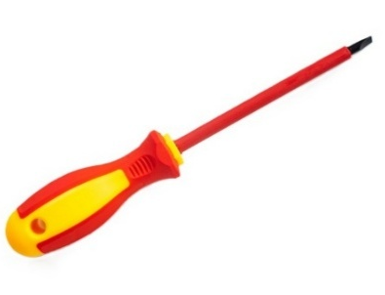
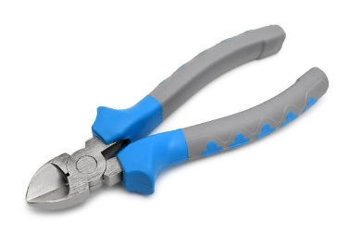

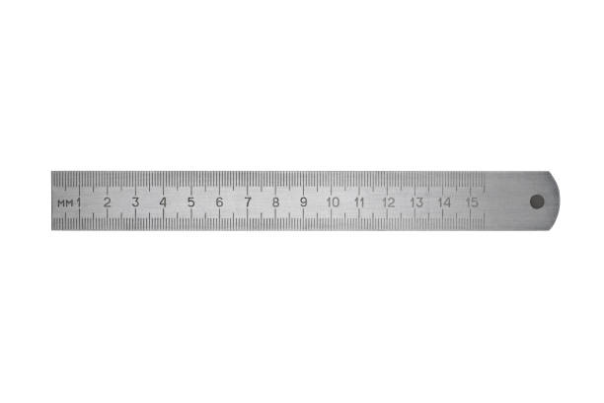

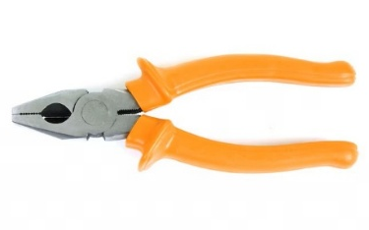
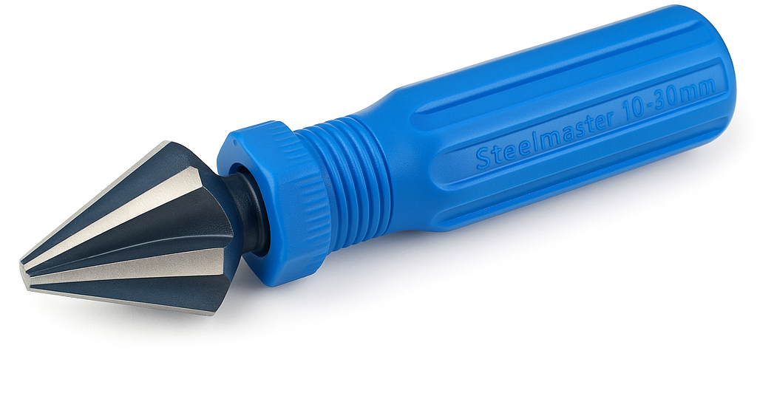

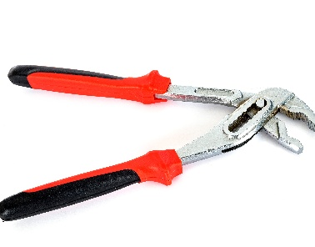

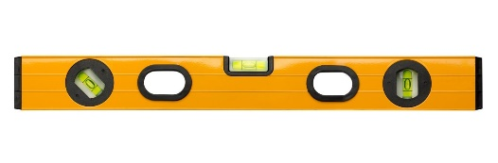
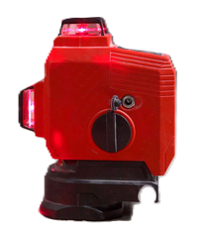

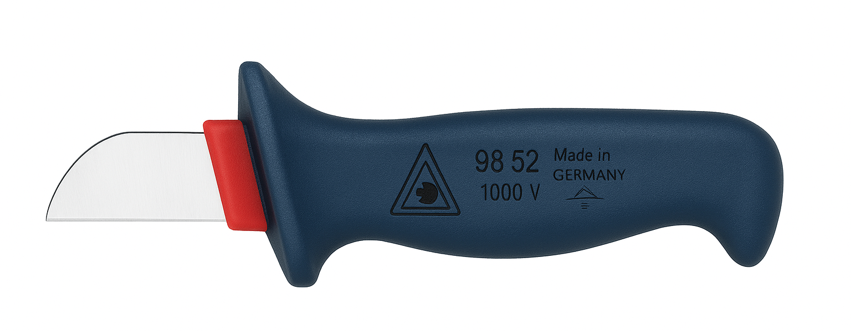


Tools/Equipment | Name/Use
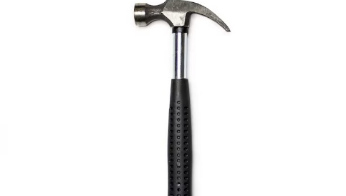
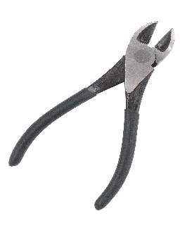

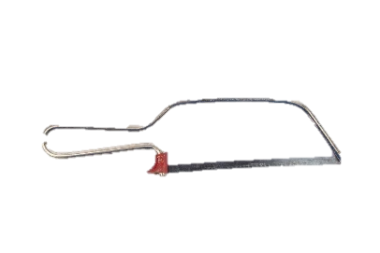



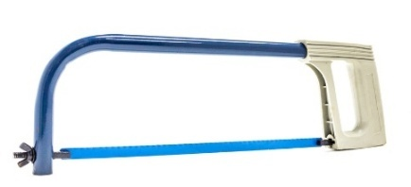



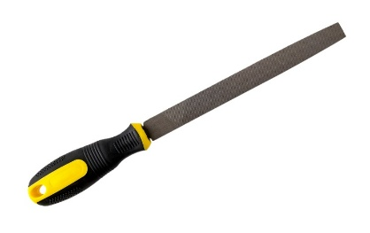
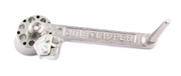

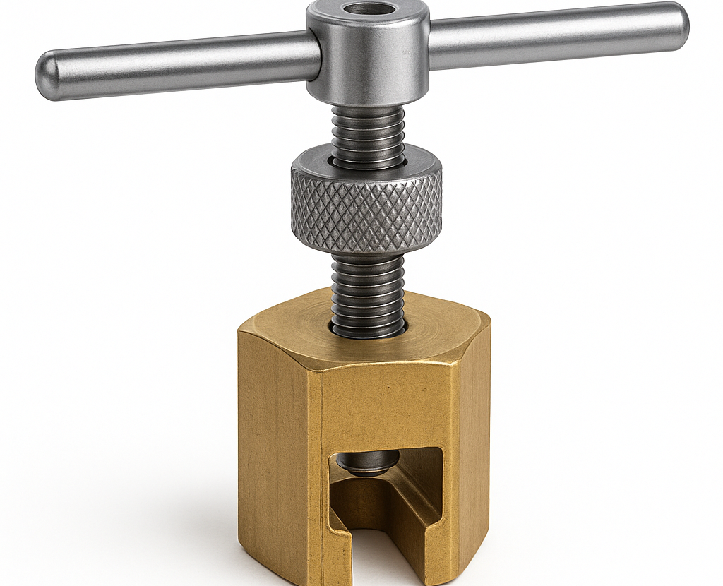
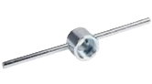

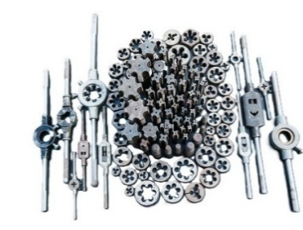



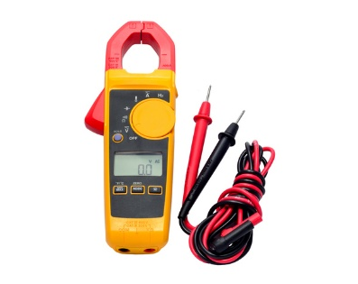
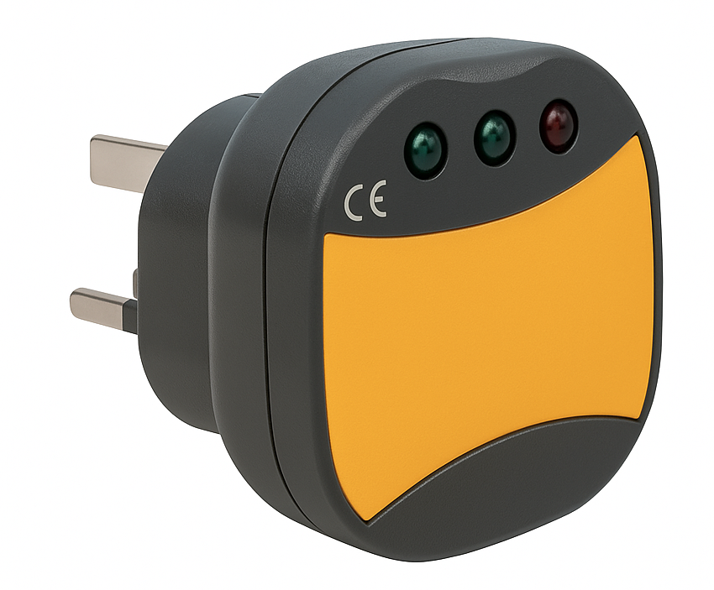
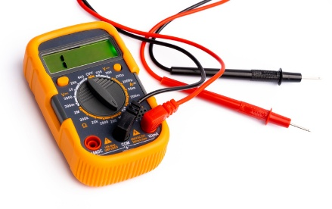

- What procedure would be followed if you were asked to use a tool that was unfamiliar to you?

- Why is it important to check that your tools and equipment are safe and in good working order before and after use?

Learner reflection
Do you feel confident about this topic? | Yes | I would like more guidance

Task 9: Measuring and cutting
To use a tape measure accurately, you must ensure you are reading the correct units. The millimetre is a common unit for precise measurements in electrical installation practical work.
One side of the tape shows metric units. This is the side of the tape to use. You will notice that:
- 1 metre is divided into 100 centimetres.
- 1 centimetre is divided into 10 millimetres.
- 1 metre is divided into 1000 millimetres.
The other side of the tape shows feet and inches. These are imperial units. You will rarely need to use this side of the tape.
Galvanised steel trunking can be ordered in metric or imperial.

Instructions: Select the following sizes of conduit and trunking and cut them into the lengths shown in the table below.
Type | Size | Cut Length | Achieved (Y/N)
Plastic conduit | 20 mm | 100 mm
Plastic conduit | 25 mm | 110 mm
Plastic conduit | 32 mm | 120 mm
Steel conduit | 20 mm | 100 mm
Steel conduit | 32 mm | 110 mm
Plastic trunking | 25 mm x 16 mm | 150 mm
Plastic trunking | 40 mm x 25 mm | 20 cm
Steel trunking | 2” x 2” | 15 cm
Steel trunking | 4” x 4” | 200 mm
Steel tray | 75 mm | 20 cm

Learner reflection
Do you feel confident about this topic? | Yes | I would like more guidance

Task 10: Identification of cable types, fixings, termination and accessories
- Identify the types of cable shown and research where an electrician will likely use it.
Cable | Name/Use
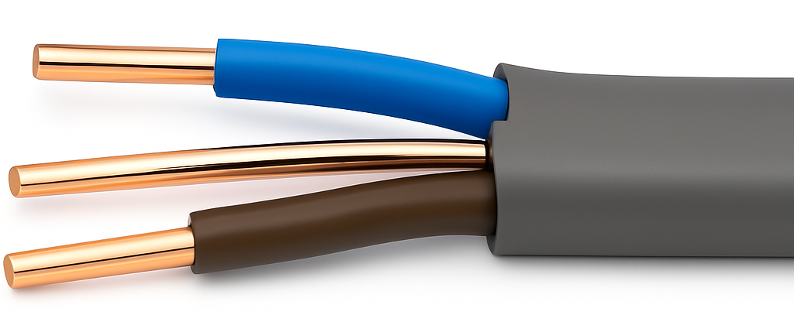
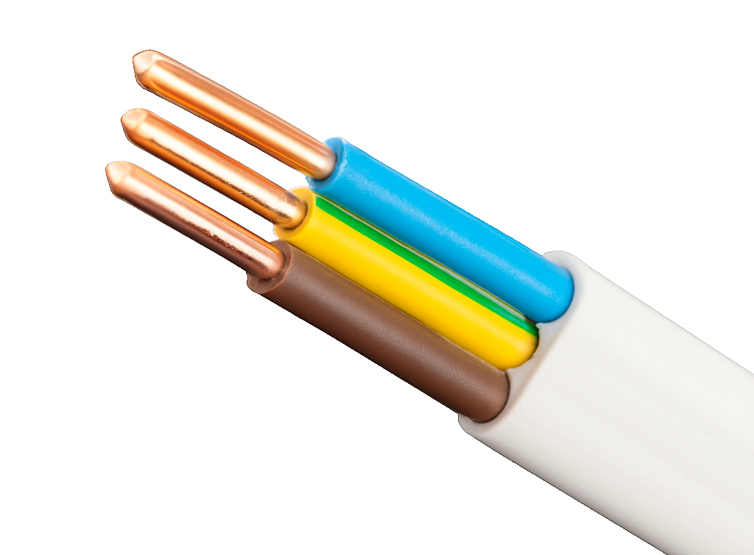
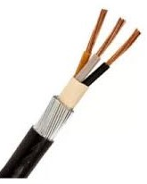
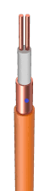
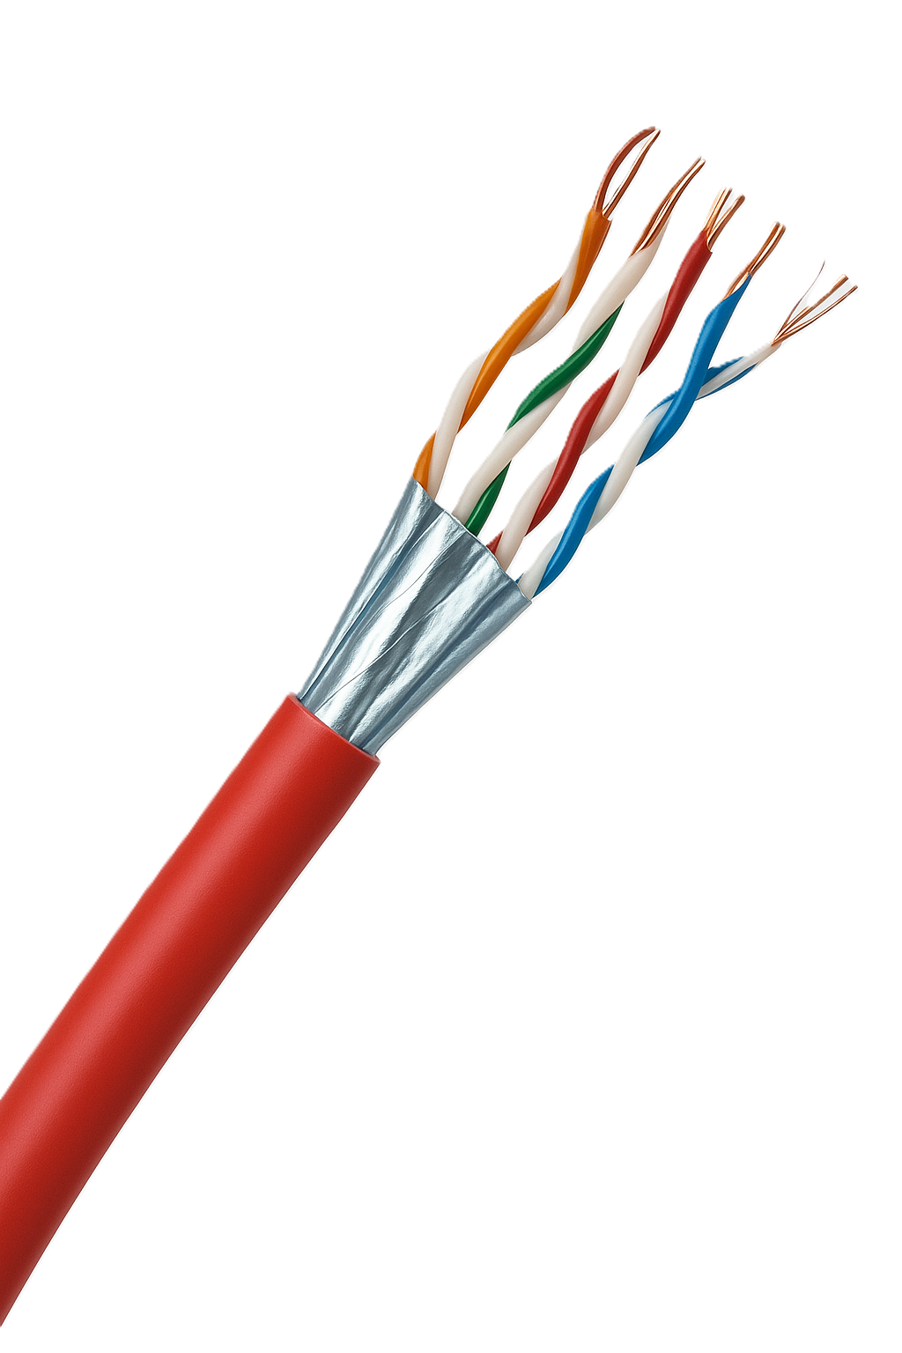
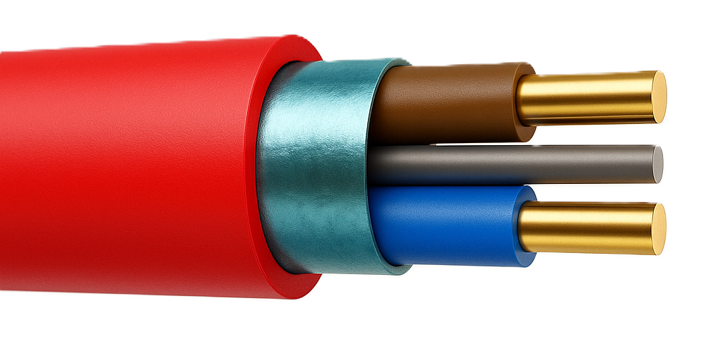
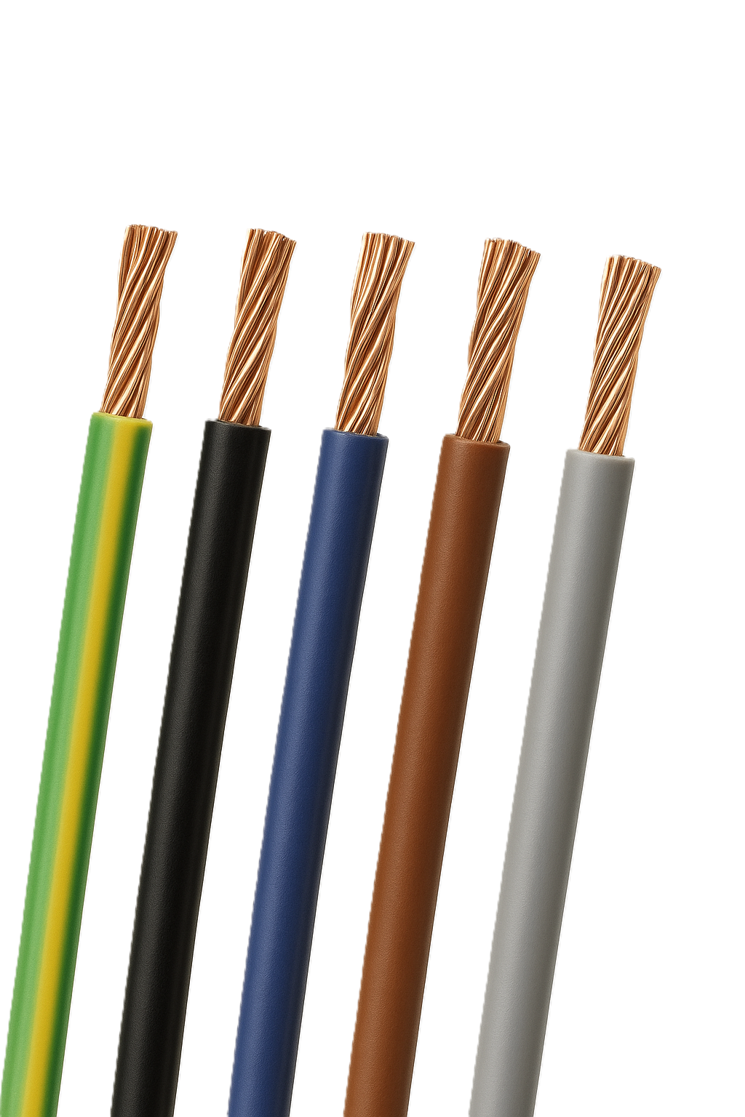
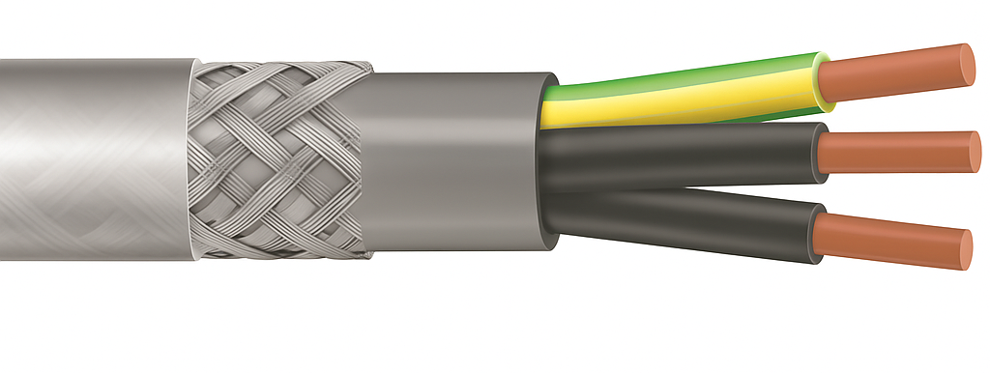

- Identify the cable fixing and describe its use.
Fixing | Name/Use
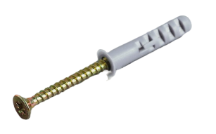
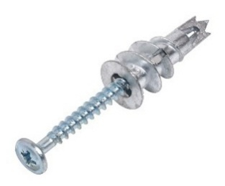
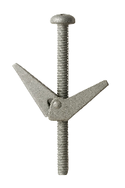
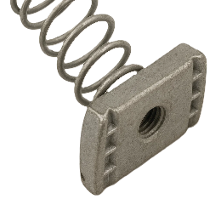
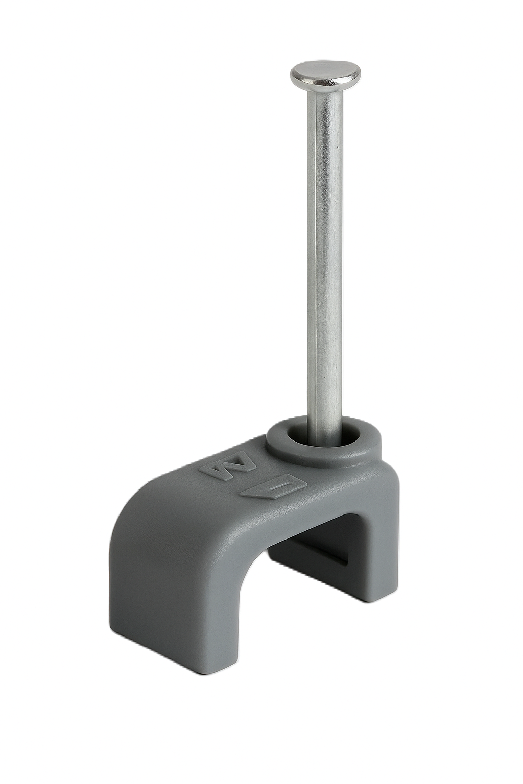

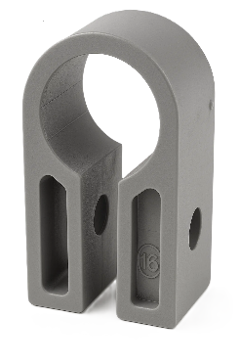
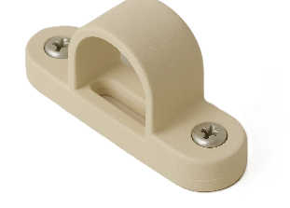
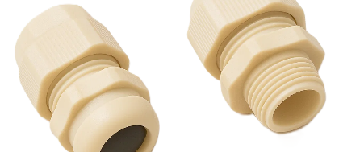
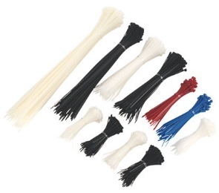

- Identify the electrical termination device and describe its use.
Termination | Name/Use
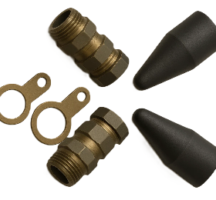
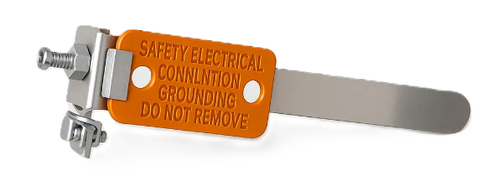
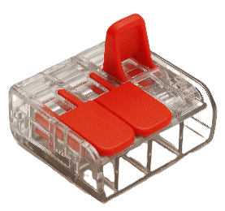
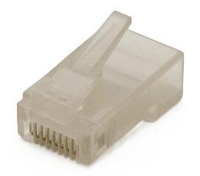
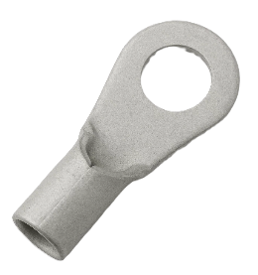
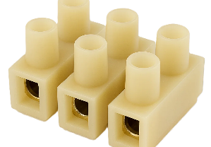

- Identify the electrical accessory and describe its use.
Accessory | Name/Use
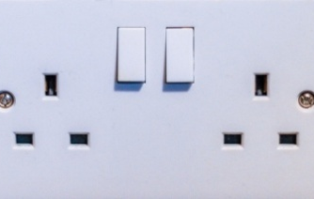
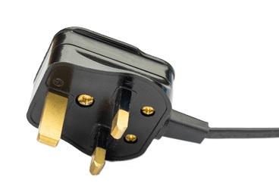
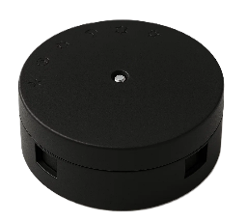



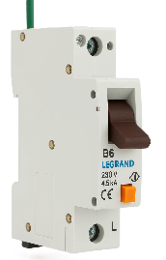
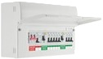
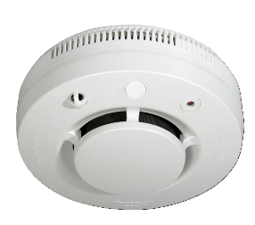
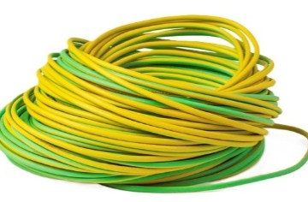
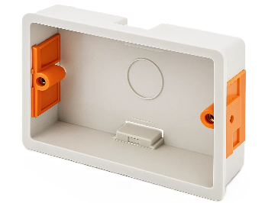

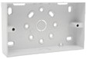
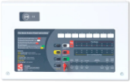
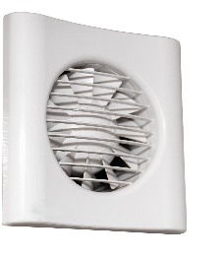

- Identify the wiring accessory and describe its use.
Wiring Accessory | Name/Use
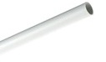
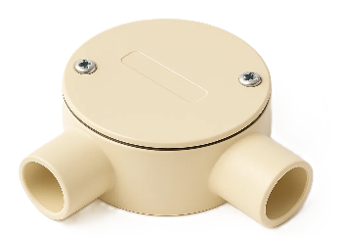
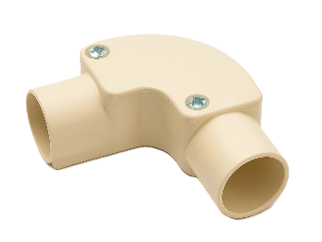
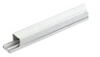
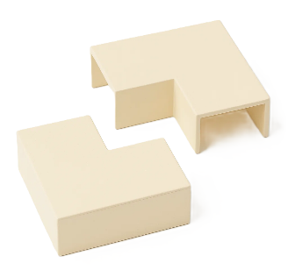
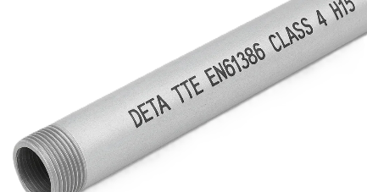
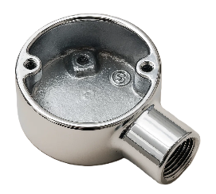
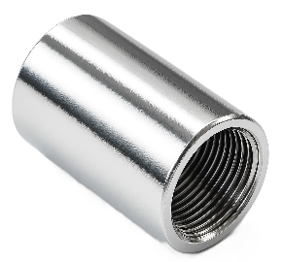
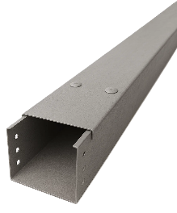

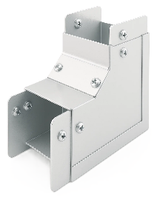
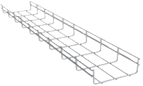

Learner reflection
Do you feel confident about this topic? | Yes | I would like more guidance

Task 11: Cable termination
- Cable stripping exercise
Knowing how to strip cable properly is crucial for making safe and reliable electrical connections, preventing short circuits and fire hazards, and ensuring efficient and effective wiring.
Practical Task
Request the materials listed below and carry out the task following the instructions.
Materials
- 300 mm of 2.5 mm² twin and cpc PVC/PVC insulated and sheathed cable
- 300 mm of 1.5 mm² twin and cpc PVC/PVC insulated and sheathed cable
- 300 mm of 6 mm² single-core, PVC-insulated and sheathed cable
- 200 mm of cpc sleeving.
Time | 60 minutes
Safety instructions | - Ensure your work area is clear and safe for work to proceed.  - It is essential that the CSA of each conductor be maintained throughout its length.  - Where necessary, the conductor ends must be doubled to fill the terminal hole.  - All your work must conform to the Health and Safety at Work Act requirements and Electricity at Work Regulations.
Task instructions | Sheathed cables  - Put on your PPE.  - Obtain the material from the stores.  - Ensure the cable is cut to correct length.  - Remove 100 mm of sheathing from one end of the cable.  - Fit cpc sleeving where applicable.  - Remove sufficient insulation from the end of each cable core to expose the conductor and retain the length of insulation.  - Cut the exposed conductors to the required length.  - Where necessary, bend the end of each exposed conductor over to the required length to double its thickness.  - Check that all the dimensions are correct.  Stranded cable  - Ensure the cable is cut to correct length.  - Remove 30 mm of insulation from one end of the cable to expose the conductors.  - Twist the exposed conductor strands together.  - Check that all dimensions are correct.  - Hand the work to your tutor for marking and assessment.
 | ASSESSMENT CRITERIA | Y | N
1 | Selected correct PPE, tools and equipment for task
2 | Sheath cut back correctly and to correct length
3 | Insulation undamaged and to the correct length
4 | Conductor cores undamaged
5 | Cpc correctly sheathed and to the correct length
6 | Conductor cores bent over where necessary and to the correct length
7 | Overall appearance to a commercially acceptable standard
8 | Completed task within target time
9 | Work conformed to the requirements of HASWA/EAWR
 | Totals
Feedback from the task:

Learner reflection
Do you feel confident about this topic? | Yes | I would like more guidance

Cable termination and connection exercise
Knowing how to properly terminate and connect cables to electrical equipment and accessories is crucial for safe, reliable and efficient electrical systems.
Practical task
To complete this task, you must connect a length of 3-core flex to a 3-pin plug top (Figure 11.1) and 60309 plug (Figure 11.2). You must work safely at all times and leave your work area and tools clean and tidy. You must also complete a tools and equipment and materials checklist (see Annexe A).
Materials
- 300 mm of 1.5 mm² 3-core heat-resistant flex (white)
- 1 x BS 1363 3-pin plug top
- 1 x BS EN 60309 16A plug.


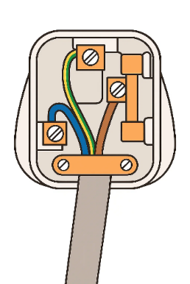
(Figure 11.1) (Figure 11.2)

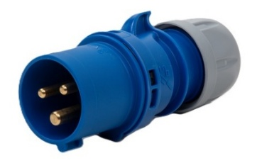

Time | 60 minutes
Safety instructions | - Ensure your work area is clear and safe for work to proceed.  - It is essential that the CSA of each conductor be maintained throughout its length.  - Conductor ends may be doubled to ensure the terminal hole is filled.  - All your work must conform to the Health and Safety at Work Act requirements and Electricity at Work Regulations.
Task instructions | - Wear the correct PPE for the task.  - Complete the material and tool list for the task.  - Select the tools and equipment for the task.  - Select materials to complete the task.  - Connect flex to the BS 1363 plug top.  - Connect the other end of the flex to BS EN 60309 plug.  - Set up and maintain a clean and safe working environment.  - Obtain the material from the stores.  - Hand the work to your tutor for marking and assessment.

 | ASSESSMENT CRITERIA | Y | N
1 | Selected correct PPE, tools and materials for task
2 | Correctly completed tool and material lists
3 | Removed outer layer of cable to expose required length of wires, completed without damage to the insulation of the wires
4 | Removed the insulation to expose the required length of bare wire
5 | Securely fixed the bare wires to the appropriate terminals
6 | Ensured no bare strands of wire are visible
7 | Used the cable grip correctly, and the cable is secure
8 | Replaced the plug cover
9 | Identified and selected tools and equipment required
10 | Completed task within target time
11 | Work conformed to the requirements of HASWA/EAWR
 | Totals
Feedback from the task:

Learner reflection
Do you feel confident about this topic? | Yes | I would like more guidance

Task 12: PVC/SWA cable termination
Steel-wired armoured (SWA) cable stripping exercise
This practical task requires you to demonstrate your proficiency in terminating a PVC/SWA cable according to industry standards and safety regulations. You will be assessed on your adherence to health and safety procedures, the quality and accuracy of your termination, and your ability to manage materials and time effectively.
Practical task
You are to request the materials listed below and carry out the task by following the instructions.
Materials
- 500 mm length of 2.5 mm² stranded SWA black XLPE/PVC
- 1 x BW20 cable gland and shroud
- 1 x metal enclosure (adaptable box 100 mm x 50 mm x 100 mm).
Time | 60 minutes
Safety instructions | - Ensure your work area is clear and safe for work to proceed.  - It is essential that the CSA of each conductor be maintained throughout its length.  - Conductor ends may be doubled to ensure the terminal hole is filled.  - All your work must conform to the Health and Safety at Work Act requirements and Electricity at Work Regulations.
Task instructions | - Put on your PPE.  - Obtain the material from the stores.  - Measure approximately 50–75 mm from the cable end. This will be the length of the outer PVC sheath you need to remove. (Figure 12.1)  - Carefully hold the cable and score the outer PVC sheath around its circumference at your marked point. Don't cut too deeply and damage the steel wire armour underneath. Apply light pressure and rotate the knife around the cable.  - Gently bend the cable at the scored mark. This should cause the sheath to split. Carefully peel back the outer sheath from the cut end. You may need to use your knife to carefully slit the sheath along its length towards the cable end to remove it fully.  - Use a junior hacksaw to carefully cut the steel wire armour at your marked point. Hold the cable firmly and ensure you cut all the armour wires cleanly; do not damage the inner conductors. (Figure 12.2)  - Carefully bend back the cut armour wires and trim them neatly to the length required to fit within the gland's armour clamping section. Ensure there are no sharp protruding ends. (Figure 12.3)  - The shroud should be fitted to the cable at this stage. The upper part or parts of the gland should now be slid over the cable. (Figure 12.4)  - Position the cable up against the gland body, now fitted to the electrical enclosure, and make a mark just above the top of the cone. (Figure 12.5)  - Using a knife, cut completely around the cable's outer sheath at the marked point. Remove the small piece of sheath. (Figure 12.6)  - The armour strands now need to be spread to fit over the cone of the gland: Hold the armour and rotate the cable against the direction of the wind of the armour. It is important to ensure the ends of each armour strand are straight and that none crosses over another. (Figure 12.7)  - Slid down over the cone. Slide the upper part of the gland down the cable and tighten it to grip the armour. If using a CW gland, tighten the uppermost part onto the cable sheath to form a seal. Finally, fit the shroud over the gland. (Figure 12.8)  - In some cases, it is better to strip the inner core before fitting the gland together.  - When passing the cable through the gland body, care must be taken to avoid damaging the insulation of the inner cores on the gland body.  - The cable is now ready for final termination.  - Hand the work to your tutor for marking and assessment.
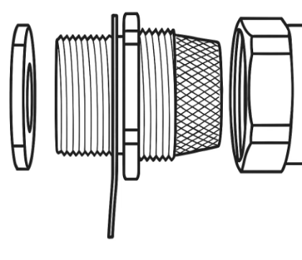

Illustrated stages of SWA cable termination
Figure 12.1  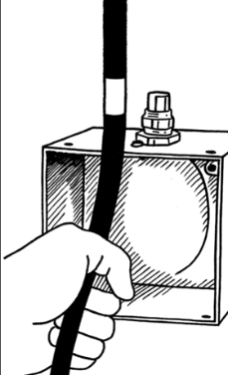 | 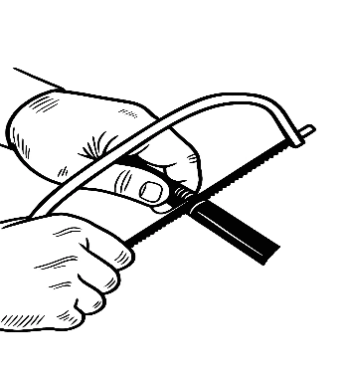  Figure 12.2 | Figure 12.3  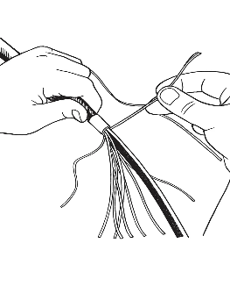
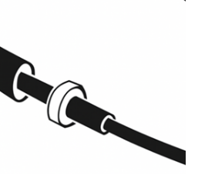  Figure 12.4 | 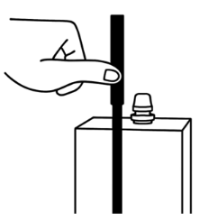  Figure 12.5 | 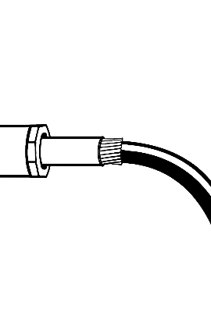  Figure 12.6
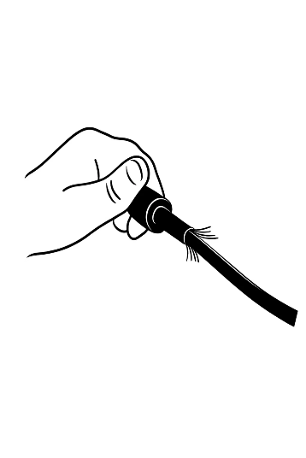  Figure 12.7 | 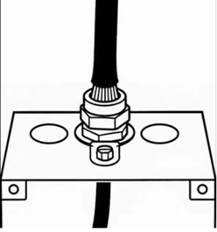  Figure 12.8

 | ASSESSMENT CRITERIA | Y | N
1 | Selected correct PPE, tools and equipment for task
2 | Exposed armouring of appropriate length
3 | Serving sheath removed to appropriate length
4 | Bedding sheath removed to appropriate length
5 | No damage to conductor insulation
6 | Gland correctly assembled
7 | Armouring appropriately held by gland
8 | Shroud fitted properly
9 | Overall appearance to a commercially acceptable standard
10 | Completed task within target time
11 | Work conformed to the requirements of HASWA/EAWR
 | Totals
Feedback from the task:

Learner reflection
Do you feel confident about this topic? | Yes | I would like more guidance

Task 13: Installing lighting circuits – PVC/PVC
1-way light circuit exercise
Practical task
This task involves the installation of a basic lighting circuit controlled by a single switch. You will be working with 1.5 mm² twin and earth cable, which contains a line (brown), neutral (blue), and protective earth (green/yellow) conductor. The cable will be secured directly to the surface using appropriate clips.
You are to request the materials listed below and carry out the task following the instructions. Always work in a safe manner and leave your work area and tools clean and tidy. You must also complete a tools and equipment and a materials checklist (see Annexes).
Materials
- 1 x consumer unit
- 1 x B6A RCBO
- 1 x surface-mounted 1-gang pattress
- 1 x surface-mounted ceiling rose adaptor
- 1 x 1 gang light switch
- 1 x 3 plate pendant lamp with integral back plate
- 2.5m of 1.5 mm² twin and cpc PVC/PVC insulated and sheathed cable
- 300 mm of green/yellow cpc sleeving
- 50 mm of brown sleeving
- clips, screws and connector blocks as required.
Time | 120 minutes
Safety instructions | - Ensure your work area is clear and safe for work to proceed.  - All your work must conform to the Health and Safety at Work Act requirements and Electricity at Work Regulations.  - All practical electrical installation exercises must comply with BS 7671 (IET Wiring Regulations).  - All terminations must be mechanically and electrically sound.
Task instructions | - Wear the correct PPE for the task.  - Complete the material and tool list for the task.  - Prepare work site for installation by ensuring all work areas are free from hazards.  - Measure and mark out positions of materials and cable runs.  - Install cables and accessories and make terminations for the Loop in Method.  - Check that all terminations are tight and secure.  - Hand the work to your tutor for marking and assessment.

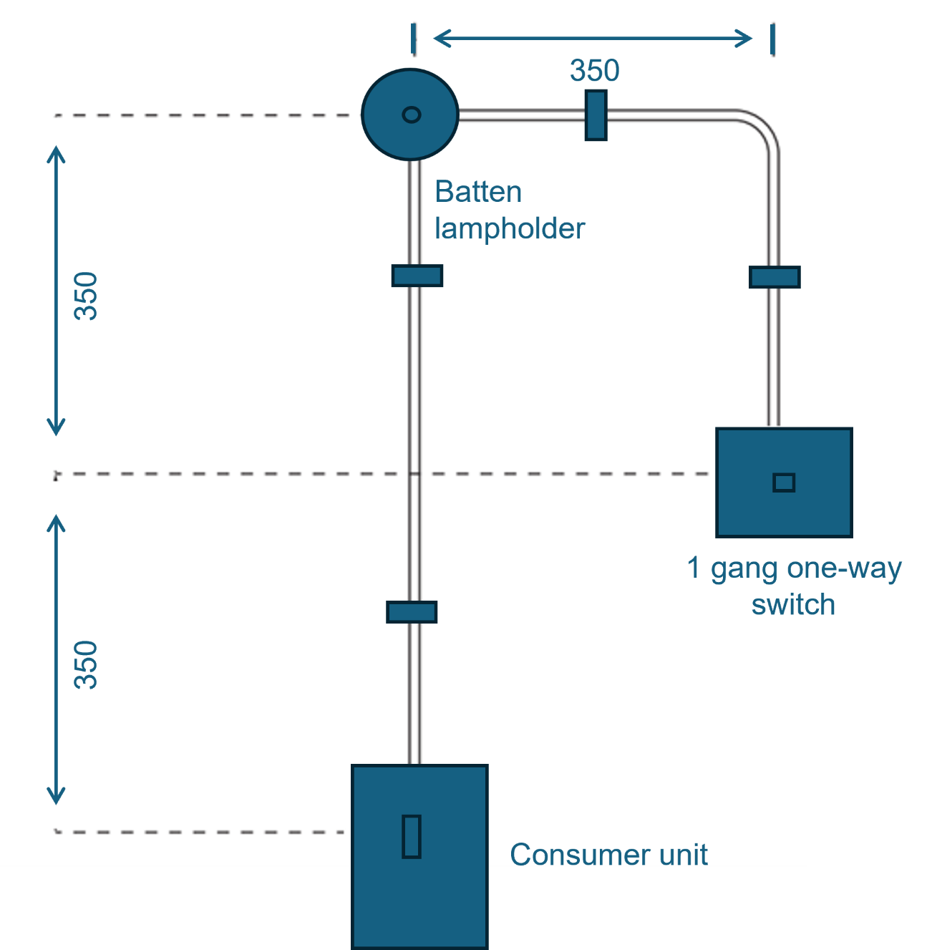

 | ASSESSMENT CRITERIA | Y | N
1 | Selected correct PPE, tools and materials for task
2 | Correctly completed tool and material lists
3 | All accessories assembled correctly and undamaged
4 | PVC cable clipped flat and straight to surface
5 | Clip positions and spacings acceptable
6 | Bends formed to an acceptable standard
7 | Cable sheath taken into accessories
8 | All circuit protective conductors sleeved
9 | Minimum insulation removed and conductors undamaged
10 | Acceptable amount of spare left at all terminations
11 | All conductors secured in all terminations
12 | All conductors identified in switch terminations
13 | Completed task within target time
14 | Work conformed to the requirements of HASWA/EAWR
 | Totals
Feedback from the task:

Learner reflection
Do you feel confident about this topic? | Yes | I would like more guidance

Task 14: Installing lighting circuits – PVC/PVC
2-way light circuit exercise
Practical task
This task involves installing a lighting circuit that can be controlled from two different switch locations. This requires the use of both 1.5 mm² twin and earth cable and 1.5 mm² three-core and earth cable. The three-core and earth cable contains a permanent line (brown), a switched line 1 (black), a switched line 2 (grey), and a protective earth (green/yellow) conductor. Again, the cables will be clipped directly to the surface.
You are to request the materials listed below and carry out the task following the instructions. Always work in a safe manner and leave your work area and tools clean and tidy. You must also complete a tools and equipment and materials checklist (see Annexes).
Materials
- 1 x consumer unit
- 1 x B6A RCBO
- 2 x surface-mounted 1-gang pattress
- 1 x surface-mounted ceiling rose adaptor
- 2 x 1-gang 2-way light switch
- 1 x 3 plate pendant lamp with integral back plate
- 2.5m of 1.5 mm² twin and cpc PVC/PVC insulated and sheathed cable
- 500 mm of 1.5 mm² three-core and cpc PVC/PVC insulated and sheathed cable
- 350 mm green/yellow cpc sleeving
- 50 mm of brown sleeving
- 1x 20 mm compression gland
- clips, screws and connector blocks as required.
Time | 150 minutes
Safety instructions | - Ensure your work area is clear and safe for work to proceed.  - All your work must conform to the Health and Safety at Work Act requirements and Electricity at Work Regulations.  - All practical electrical installation exercises must comply with BS 7671 (IET Wiring Regulations).  - All terminations must be mechanically and electrically sound.
Task instructions | - Wear the correct PPE for the task.  - Complete the material and tool list for the task.  - Prepare work site for installation by ensuring all work areas are free from hazards.  - Measure and mark out positions of materials and cable runs.  - Install cables and accessories and make terminations for the ‘loop in’ method.  - Check that all terminations are tight and secure.  - Hand the work to your tutor for marking and assessment.
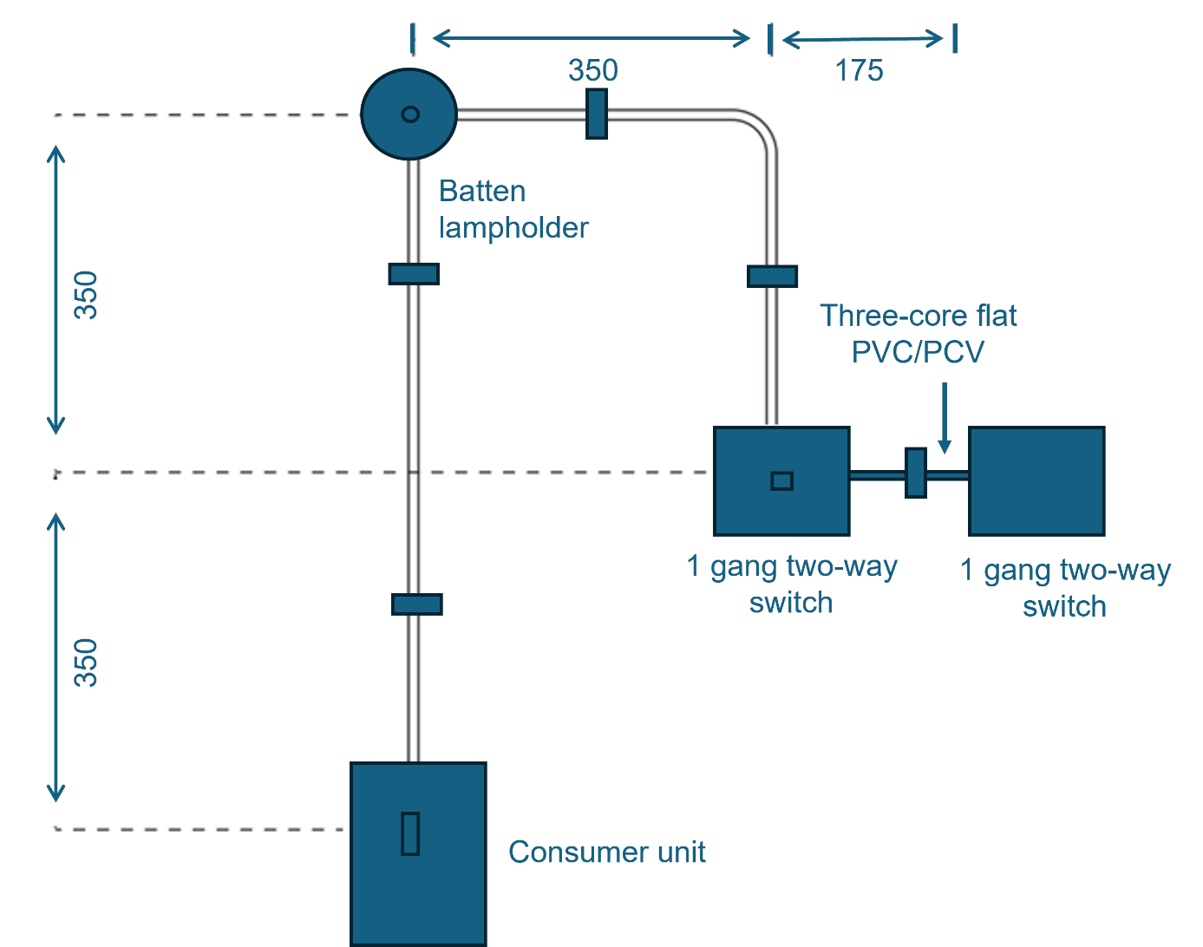

 | ASSESSMENT CRITERIA | Y | N
1 | Selected correct PPE, tools and materials for task
2 | Correctly completed tool and material lists
3 | All accessories assembled correctly and undamaged
4 | PVC cable is clipped flat and straight to surface
5 | Clip positions and spacings acceptable
6 | Bends formed to acceptable standard
7 | Cable sheath taken into accessories
8 | All circuit protective conductors sleeved
9 | Minimum insulation removed and conductors undamaged
10 | Acceptable amount of spare left at all terminations
11 | All conductors secured in all terminations
12 | All conductors identified in switch terminations
13 | Completed task within target time
14 | Work conformed to the requirements of HASWA/EAWR
 | Totals
Feedback from the task:

Learner reflection
Do you feel confident about this topic? | Yes | I would like more guidance

Task 15: Installing lighting circuits – FP200 cable
1-way light circuit exercise
Practical task
This practical task focuses on installing a basic lighting circuit controlled by a single switch, but with the crucial addition of using FP200 twin and earth cable. FP200 cable is a fire-resistant cable, designed to maintain circuit integrity for a specified period during a fire. The cable (containing line brown, neutral-blue and protective earth-green/yellow conductors) will be secured directly to the surface using appropriate fire-rated clips.
You are to request the materials listed below and carry out the task following the instructions. Always work in a safe manner and leave your work area and tools clean and tidy. You must also complete tools and equipment and a materials checklist (see Annexes). Your tutor will give these to you to complete before starting the practical task.
Materials
- 1 x consumer unit
- 1 x B6A RCBO
- 1 x surface mounted 1 gang pattress
- 1 x surface-mounted ceiling rose adaptor
- 1 x 1 gang light switch
- 1 x 3 plate pendant lamp with integral back plate
- 2.5m of 1.5 mm² 2C+E Red FP200 cable
- 300 mm of green/yellow cpc sleeving
- 50 mm of brown sleeving
- 2 x 20 mm compression gland
- clips, screws and connector blocks as required.
Time | 120 minutes
Safety instructions | - Ensure your work area is clear and safe for work to proceed.  - All your work must conform to the Health and Safety at Work Act requirements and Electricity at Work Regulations.  - All practical electrical installation exercises must comply with BS 7671 (IET Wiring Regulations).  - All terminations must be mechanically and electrically sound.
Task instructions | - Wear the correct PPE for the task.  - Complete the material and tool list for the task  - Prepare work site for installation by ensuring all work areas are free from hazards.  - Measure and mark out positions of materials and cable runs  - Install cables and accessories and make terminations for the Loop in Method.  - Check that all terminations are tight and secure.  - Hand the work to your tutor for marking and assessment.

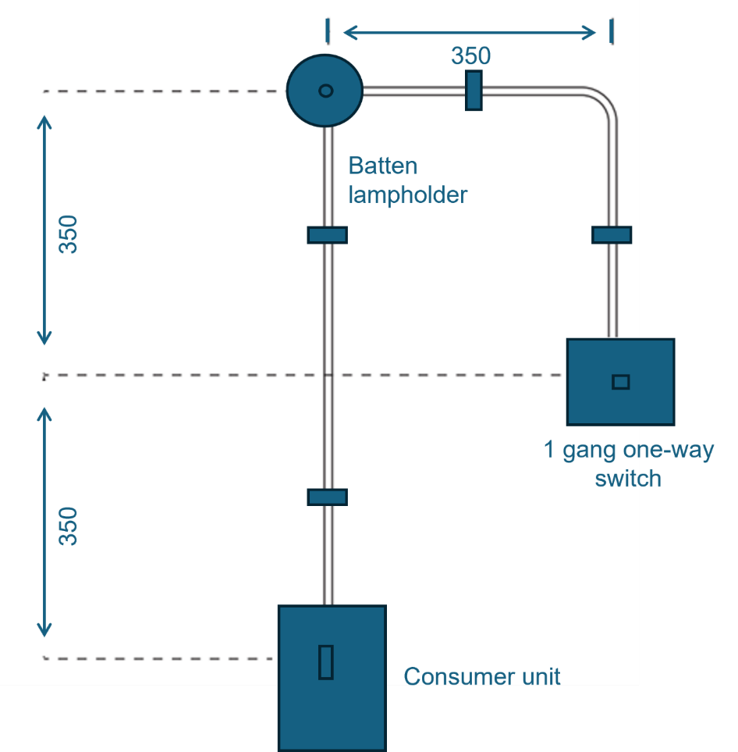

 | ASSESSMENT CRITERIA | Y | N
1 | Selected correct PPE, tools and materials for task
2 | Correctly completed tool and material lists
3 | All accessories assembled correctly and undamaged
4 | PVC cable clipped flat and straight to surface
5 | Clip positions and spacings acceptable
6 | Bends formed to an acceptable standard
7 | Cable sheath taken into accessories
8 | All circuit protective conductors sleeved
9 | Minimum insulation removed and conductors undamaged
10 | Acceptable amount of spare left at all terminations
11 | All conductors secure in all terminations
12 | All conductors identified in switch terminations
13 | Completed task within target time
14 | Work conformed to the requirements of HASWA/EAWR
 | Totals
Feedback from the task:

Learner reflection
Do you feel confident about this topic? | Yes | I would like more guidance

Task 16: Installing ring final circuits – PVC/PVC
Ring final circuit exercise
Practical task
This task involves installing a ring final circuit, commonly used for supplying multiple power outlets. You will be working with 2.5 mm² line twin and earth cable. A key characteristic of a ring final circuit is that the line and neutral conductors form a continuous loop, starting and ending at the same overcurrent protective device in the consumer unit. This task includes the installation of a switched fused spur, which allows for the connection of a specific appliance with its own overload protection.
You are to request the materials listed below and carry out the task following the instructions. You must always work in a safe manner and should leave your work area and tools clean and tidy. You must also complete tools and equipment and a materials checklist (see Annexes).
Materials
- 1 x consumer unit
- 1 x B32A RCBO
- 4 x 13 Amp 2 gang switched socket
- 1 x 13A switched fused connection Unit
- 4 x surface-mounted 2-gang pattress
- 1 x surface-mounted 1-gang pattress
- 5m of 2.5 mm² twin and cpc PVC/PVC insulated and sheathed cable
- 500 mm of green/yellow cpc sleeving
- 6 x 20 mm compression gland
- clips, screws and connector blocks as required.
Time | 120 minutes
Safety instructions | - Ensure your work area is clear and safe for work to proceed.  - All your work must conform to the Health and Safety at Work Act requirements and Electricity at Work Regulations.  - All practical electrical installation exercises must comply with BS 7671 (IET Wiring Regulations).  - All terminations must be mechanically and electrically sound.
Task instructions | - Wear the correct PPE for the task.  - Complete the material and tool list for the task  - Prepare work site for installation by ensuring all work areas are free from hazards.  - Measure and mark out positions of materials and cable runs.  - Install cables and accessories and make terminations at the sockets and spurs tight and secure.  - Hand the work to your tutor for marking and assessment.

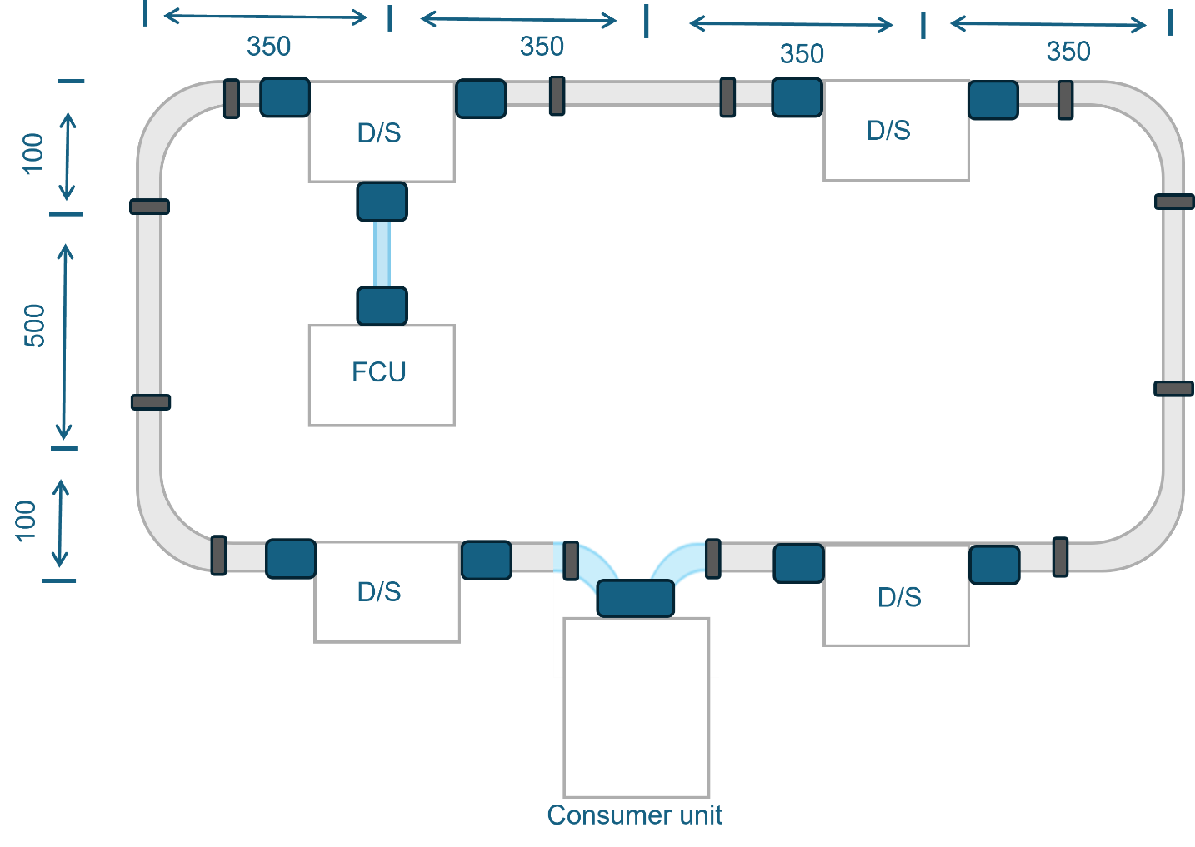

 | ASSESSMENT CRITERIA | Y | N
1 | Selected correct PPE, tools and materials for task
2 | Correctly completed tool and material lists
3 | All accessories assembled correctly and undamaged
4 | PVC cable clipped flat and straight to surface
5 | Clip positions and spacings acceptable
6 | Bends formed to acceptable standard
7 | Cable sheath taken into accessories
8 | All circuit protective conductors sleeved
9 | Minimum insulation removed and conductors undamaged
10 | Acceptable amount of spare left at all terminations
11 | All conductors secured in all terminations
12 | Completed task within target time
13 | Work conformed to the requirements of HASWA/EAWR
 | Totals
Feedback from the task:

Learner reflection
Do you feel confident about this topic? | Yes | I would like more guidance

Task 17: Cutting, bending and terminating conduit
Practical task
This practical task involves developing the fundamental skills required to work with both steel and PVC conduit systems. These systems are essential for providing mechanical protection and routing for electrical cables in various installations. You will learn to accurately cut conduit to length and create two common types of bends (a 90-degree right/left angle and an offset).
You are to request the materials listed below and carry out the task following the instructions. Always work in a safe manner and should leave your work area and tools clean and tidy. You must also complete tools and equipment and a materials checklist (see Annexes).
Materials and Equipment
- 1.2m of 20 mm steel conduit
- 1.2m of 20 mm PVC conduit
- 4 x 20 mm steel conduit saddles
- 4 x 20 mm PVC conduit saddles
- 4 x 20 mm steel conduit couplers
- 4 x 20 mm PVC conduit threaded couplers
- 4 x 20 mm brass male bushes
- 4 x 20 mm PVC male bushes
- 1 x conduit bending machine, 20 mm former and 20 mm stocks and dies
- 1 x 20 mm PVC conduit bending spring
- 1 x conduit deburring tool
- 1 x can of cutting compound.

Time | 3 hours
Safety instructions | - Ensure your work area is clear and safe for work to proceed.  - All your work must conform to the Health and Safety at Work Act requirements and Electricity at Work Regulations.  - All practical electrical installation exercises must comply with BS 7671 (IET Wiring Regulations).  - All terminations must be mechanically and electrically sound.
Task instructions | - Wear the correct PPE for the task.  - Complete the material and tool list for the task.  - Prepare work site for installation by ensuring all work areas are free from hazards.  - Measure and mark out positions of conduit runs.  - Cut steel conduit square (with end square) to given length.  - Produce a right-angled bend using a bending machine.  - Thread conduit.  - Fix conduit using standard 20 mm conduit saddles.  - Terminate to metal boxes using couplers and male bushes.  - Cut steel conduit square (with end square) to given length.  - Produce an offset using a bending machine.  - Thread conduit.  - Fix conduit using standard 20 mm conduit saddles.  - Terminate to metal boxes using couplers and male bushes.  - Cut plastic conduit square to given length.  - Produce a right-angle bend in plastic conduit.  - Fix conduit using standard 20 mm conduit saddles.  - Terminate plastic conduit into accessory boxes.  - Cut plastic conduit square to given length.  - Produce an offset in plastic conduit.  - Fix conduit using standard 20 mm conduit saddles.  - Terminate plastic conduit to accessory boxes.  - Hand the work to your tutor for marking and assessment.

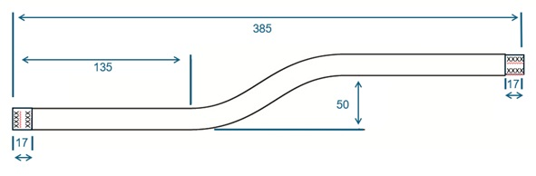
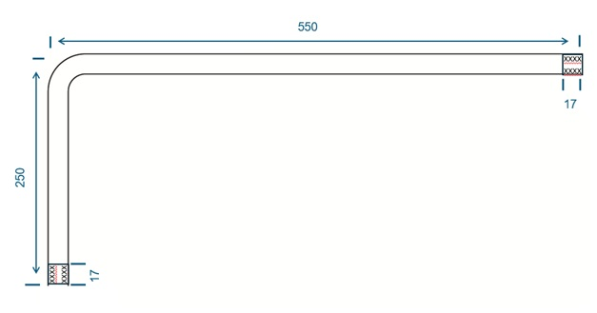

 | ASSESSMENT CRITERIA | Y | N
1 | Selected correct PPE, tools and materials for task
2 | Correctly completed tool and material lists
Steel conduit
3 | Work carried out in a safe manner
4 | Conduit cut to specified length
5 | Conduit finish undamaged
6 | Conduit end cut square
7 | No burrs left in conduit
8 | Conduit end threaded correctly (no threads showing)
9 | Conduit runner threaded with no excess threads
10 | Conduit terminated to adaptable box correctly
11 | Conduit bushes and couplers tight
12 | Offset produced to good commercial standard
Plastic conduit
13 | Work carried out in a safe manner
14 | Conduit cut to specified length
15 | Terminated correctly to boxes
17 | Right-angle bend fabricated correctly
18 | Completed task within target time
19 | Work conformed to the requirements of HASWA/EAWR
 | Totals
Feedback from the task:

Learner reflection
Do you feel confident about this topic? | Yes | I would like more guidance

Task 18: Installing lighting circuits – PVC conduit
Two-way light circuit in PVC conduit exercise
Practical task
This task involves installing a two-way lighting circuit where the line, neutral and switch wires are run as individual 1.5 mm² single-core cables within a 20 mm PVC conduit system. This method provides mechanical protection and a pathway for cables.
You are to request the materials listed below and carry out the task following the instructions. You must always work in a safe manner and should leave your work area and tools clean and tidy. You must also complete tools and equipment and a materials checklist (see Annexes).
Materials
- 1 x consumer unit
- 1 x B6A RCBO
- 2 x 1 gang 2-way light switch
- 1 x 3 plate pendant lamp with integral back plate
- 2 x Surface mounted 1 gang pattress
- 2.5 m of 20 mm PVC conduit
- 1 x 20 mm PVC conduit 90° angle box
- 7 x 20 mm PVC conduit saddles
- 4 x 20 mm PVC conduit threaded couplers
- 4 x 20 mm PVC male bushes
- 1 x 20 mm PVC conduit bending spring
- 2.5 m of 1.5 mm² PVC single brown cable
- 1 m of 1.5 mm² PVC single blue cable
- 2.5 m of 1.5 mm² PVC single yellow/green cable
- screws and connector blocks as required.

Time | 150 minutes
Safety instructions | - Ensure that your work area is clear and safe for work to proceed.  - All your work must conform to the Health and Safety at Work Act requirements and Electricity at Work Regulations.  - All practical electrical installation exercises must comply with BS 7671 (IET Wiring Regulations).  - All terminations must be mechanically and electrically sound.
Task instructions | - Wear the correct PPE for the task.  - Complete the material and tool list for the task.  - Prepare work site for installation by ensuring all work areas are free from hazards.  - Measure and mark out positions of conduct runs and accessories.  - Cut plastic conduit square to given length.  - Produce a right-angle bend in plastic conduit using the bending spring.  - Fix conduit using standard 20 mm conduit saddles.  - Terminate plastic conduit into accessory boxes.  - Install PVC single cables and accessories and make terminations for the Loop in Method.  - Check that all accessories and terminations are tight and secure.  - Hand the work to your tutor for marking and assessment.
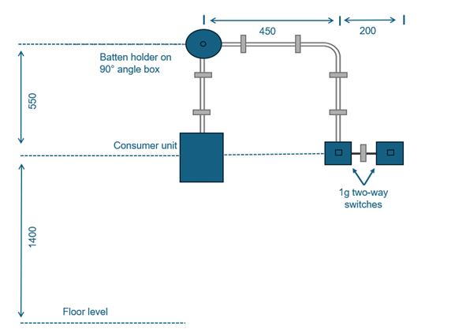

 | ASSESSMENT CRITERIA | Y | N
1 | Selected correct PPE, tools and materials for task
2 | Correctly completed tool and material lists
3 | All accessories assembled correctly and undamaged
4 | Conduit cut to specified length
5 | Right-angle bend fabricated correctly
6 | Terminated correctly to boxes
7 | Saddle positions and spacings acceptable
8 | Minimum insulation removed and conductors undamaged
9 | Acceptable amount of spare left at all terminations
10 | All conductors secure in all terminations
11 | All conductors identified in switch terminations
12 | Completed task within target time
13 | Work conformed to the requirements of HASWA/EAWR
 | Totals
Feedback from the task:

Learner reflection
Do you feel confident about this topic? | Yes | I would like more guidance

Task 19: Installing lighting circuits – steel conduit
Two-way light circuit in steel conduit exercise
Practical task
This task involves installing a two-way lighting circuit in which the line neutral and switch wires are run as individual 1.5 mm² single-core cables within a 20 mm steel conduit system. This method provides greater mechanical protection for cables and can also serve as the circuit protective conductor under certain conditions.
You are to request the materials listed below and carry out the task following the instructions. You must always work in a safe manner and should leave your work area and tools clean and tidy. You must also complete tools and equipment and a materials checklist (see Annexes).
Materials
- 1 x consumer unit
- 1 x B6A RCBO
- 2 x 1 gang 2-way light switch
- 1 x 3 plate pendant lamp with integral back plate
- 2 x surface-mounted 1-gang pattress
- 2.5 m of 20mm steel conduit
- 1 x 20 mm steel conduit right-angle box
- 7 x 20 mm steel conduit saddles
- 4 x 20 mm steel conduit couplers
- 4 x 20 mm brass male bushes
- 1 x conduit bending machine, 20 mm former and 20 mm stocks and dies
- 2.5 m of 1.5 mm² PVC single brown cable
- 1 m of 1.5 mm² PVC single blue cable
- 2.5 m of 1.5 mm² PVC single yellow/green cable
- screws and connector blocks as required.

Time | 3 hours
Safety instructions | - Ensure that your work area is clear and safe for work to proceed.  - All your work must conform to the Health and Safety at Work Act requirements and Electricity at Work Regulations.  - All practical electrical installation exercises must comply with BS 7671 (IET Wiring Regulations).  - All terminations must be mechanically and electrically sound.
Task instructions | - Wear the correct PPE for the task.  - Complete the material and tool list for the task  - Prepare work site for installation by ensuring all work areas are free from hazards.  - Measure and mark out positions of conduct runs and accessories.  - Cut steel conduit square (with end square) to given length.  - Produce a right-angled bend using a bending machine.  - Thread conduit.  - Fix conduit using standard 20 mm conduit saddles.  - Terminate to metal boxes using couplers and male bushes.  - Install PVC single cables and accessories and make terminations for the Loop in Method.  - Check that all accessories and terminations are tight and secure.  - Hand the work to your tutor for marking and assessment.

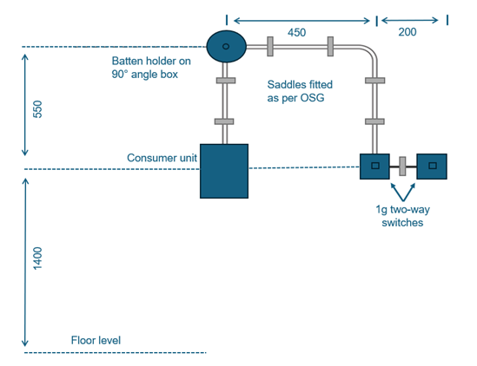

 | ASSESSMENT CRITERIA | Y | N
1 | Selected correct PPE, tools and materials for task
2 | Correctly completed tool and material lists
3 | All accessories assembled correctly and undamaged
4 | Conduit cut to specified length
5 | Right-angle bend fabricated correctly
6 | Terminated correctly to boxes
7 | Saddle positions and spacings acceptable
8 | Minimum insulation removed and conductors undamaged
9 | Acceptable amount of spare left at all terminations
10 | All conductors secured in all terminations
11 | All conductors identified in switch terminations
12 | Completed task within target time
13 | Work conformed to the requirements of HASWA/EAWR
 | Totals
Feedback from the task:

Learner reflection
Do you feel confident about this topic? | Yes | I would like more guidance

Task 20: Installing ring final circuits – plastic conduit
Ring final circuit PVC conduit exercise
Practical task
This task involves installing a four-socket ring final circuit using 2.5 mm² single-core cables run within a 20 mm PVC conduit system.
You are to request the materials listed below and carry out the task following the instructions. You must always work in a safe manner and should leave your work area and tools clean and tidy. You must also complete tools and equipment and a materials checklist (see Annexes).
Materials
- 1 x consumer unit
- 1 x B32A RCBO
- 4 x 13-amp 1-gang switched socket
- 4 x surface-mounted 1-gang pattress
- 5 m of 20 mm PVC conduit
- 11 x 20 mm PVC conduit saddles
- 7 x 20 mm PVC conduit threaded couplers
- 7 x 20 mm PVC male bushes
- 2 x 20 mm PVC conduit through boxes
- 3 x 20 mm PVC conduit tee boxes
- 5 m of 2.5 mm² PVC single brown cable
- 5 m of 2.5 mm² PVC single blue cable
- 5 m of 1.5 mm² PVC single yellow/green cable
- screws and connector blocks as required.
Time | 180 minutes
Safety instructions | - Ensure that your work area is clear and safe for work to proceed.  - All your work must conform to the Health and Safety at Work Act requirements and Electricity at Work Regulations.  - All practical electrical installation exercises must comply with BS 7671 (IET Wiring Regulations).  - All terminations must be mechanically and electrically sound.
Task instructions | - Wear the correct PPE for the task.  - Complete the material and tool list for the task  - Prepare work site for installation by ensuring all work areas are free from hazards.  - Measure and mark out positions of conduct runs and accessories.  - Cut plastic conduit square to given length.  - Fix conduit using standard 20 mm conduit saddles.  - Terminate plastic conduit into accessory boxes.  - Install PVC single cables and accessories.  - Check that all accessories and terminations are tight and secure.  - Hand the work to your tutor for marking and assessment.
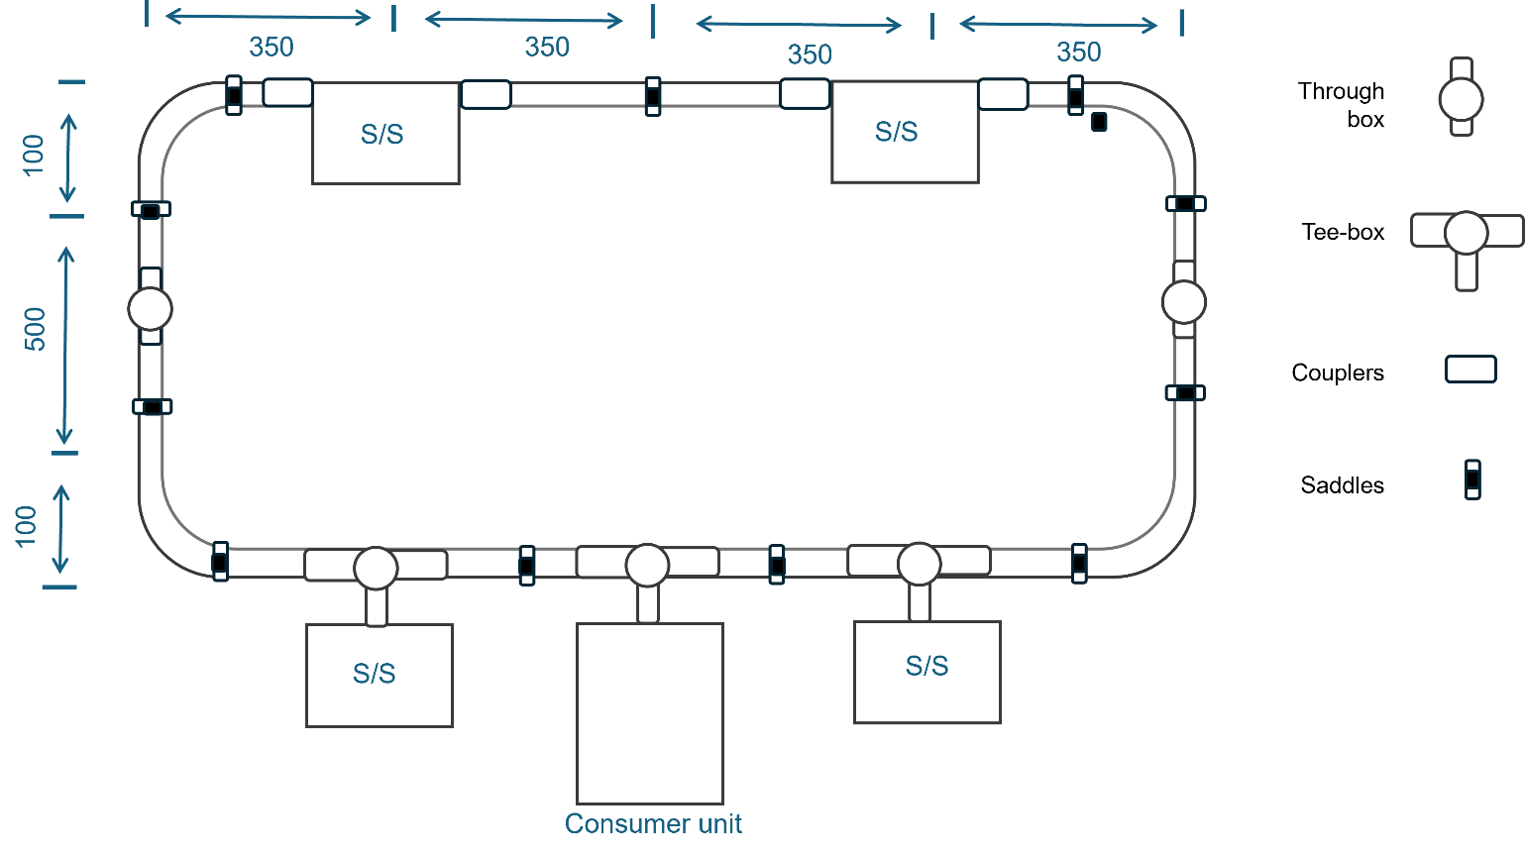

 | ASSESSMENT CRITERIA | Y | N
1 | Selected correct PPE, tools and materials for task
2 | Correctly completed tool and material lists
3 | All accessories assembled correctly and undamaged
4 | Conduit cut to specified length
5 | Terminated correctly to boxes
6 | Saddle positions and spacings acceptable
7 | Minimum insulation removed and conductors undamaged
8 | Acceptable amount of spare left at all terminations
9 | All conductors secured in all terminations
10 | Completed visual polarity check
11 | Completed installation within target time
12 | Work conformed to the requirements of HASWA/EAWR
 | Totals
Feedback from the task:

Learner reflection
Do you feel confident about this topic? | Yes | I would like more guidance

Task 21: Installing ring final circuits – steel conduit
Ring final circuit steel conduit exercise
Practical task
This task involves installing a four-socket ring final circuit using 2.5 mm² single-core cables run within a 20 mm steel conduit system. This method provides greater mechanical protection for cables and can also serve as the circuit protective conductor under certain conditions.
You are to request the materials listed below and carry out the task following the instructions. You must always work in a safe manner and should leave your work area and tools clean and tidy. You must also complete tools and equipment and a materials checklist (see Annexes).
Materials
- 1 x consumer unit
- 1 x B32A RCBO
- 4 x 13-amp 1 gang switched socket
- 4 x surface mounted 1 gang pattress
- 2 m of 20 mm steel conduit
- 11 x 20 mm steel conduit saddles
- 4 x 20 mm steel conduit couplers
- 7 x 20 mm brass male bushes
- 2 x 20 mm PVC conduit through boxes
- 3 x 20 mm PVC conduit tee boxes
- 1 x conduit bending machine and 20 mm stocks and dies
- 5 m of 2.5 mm² PVC single brown cable
- 5 m of 2.5 mm PVC single blue cable
- 5 m of 1.5 mm² PVC single yellow/green cable
- screws and connector blocks as required.

Time | 3 hours
Safety instructions | - Ensure that your work area is clear and safe for work to proceed.  - All your work must conform to the Health and Safety at Work Act requirements and Electricity at Work Regulations.  - All practical electrical installation exercises must comply with BS 7671 (IET Wiring Regulations).  - All terminations must be mechanically and electrically sound.
Task instructions | - Wear the correct PPE for the task.  - Complete the material and tool list for the task.  - Prepare work site for installation by ensuring all work areas are free from hazards.  - Measure and mark out positions of conduct runs and accessories.  - Cut steel conduit square to given length.  - Thread conduit.  - Fix conduit using standard 20 mm conduit saddles.  - Terminate to metal boxes using couplers and male bushes.  - Install PVC single cables and accessories.  - Check that all accessories and terminations are tight and secure.  - Hand the work to your tutor for marking and assessment.

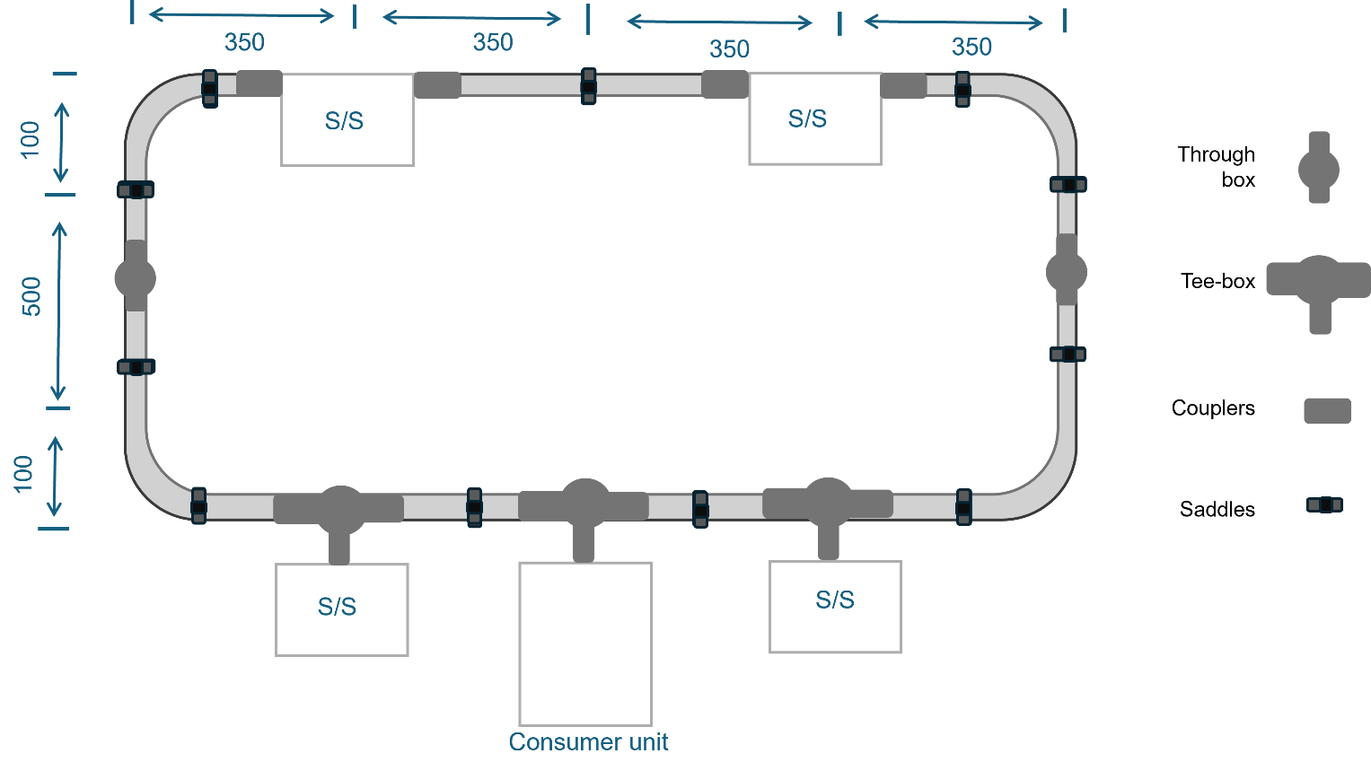

 | ASSESSMENT CRITERIA | Y | N
1 | Selected correct PPE, tools and materials for task
2 | Correctly completed tool and material lists
3 | All accessories assembled correctly and undamaged
4 | Conduit cut to specified length
5 | All conduit ends cut square with no burrs left
6 | Conduit fixed to accessories correctly
7 | Conduit bushes and couplers tight
8 | All accessory boxes fitted squarely and securely
9 | Saddle positions and spacings acceptable
10 | All conductors undamaged
11 | Acceptable amount of spare left at all terminations
12 | All conductors secure in all terminations
13 | Completed visual polarity check
14 | Completed installation within target time
15 | Work conformed to the requirements of HASWA/EAWR
 | Totals
Feedback from the task:

Learner reflection
Do you feel confident about this topic? | Yes | I would like more guidance

Task 22: Steel trunking – internal 90-degree angle
Fabricating internal 90-degree angle
Practical task
This practical fabrication task requires you to demonstrate your ability to accurately measure, cut, notch, and form a precise 90-degree internal bend in a length of 50 mm x 50 mm steel trunking. Steel trunking is a robust and widely used containment system in electrical installations, providing mechanical protection and a defined pathway for cables.
You are to request the materials listed below and carry out the task following the instructions. You must always work in a safe manner and should leave your work area and tools clean and tidy. You must also complete tools and equipment and a materials checklist (see Annexes).
Materials
- 1 x 320 mm of 50x50 steel trunking complete with lid
- 8 x 12 mm M6 roofing nuts and bolts.
Time | 180 minutes
Safety instructions | - Ensure your work area is clear and safe for work to proceed.  - All your work must conform to the Health and Safety at Work Act requirements and Electricity at Work Regulations.  - All practical electrical installation exercises must comply with BS 7671 (IET Wiring Regulations).  - All terminations must be mechanically and electrically sound.
Task instructions | - Wear the correct PPE for the task.  - Complete the material and tool list for the task  - Prepare work site for installation by ensuring all work areas are free from hazards.  - Square off and cut one end of the trunking and remove any burrs.  - From the squared end, measure 200 mm and mark both sides of the trunking.  - Draw a line through these marks at 90° to the trunking edge.  - Cut through the marked lines on the sides only.  - Form the bend as shown in the diagram, ensuring that the edges of the 200m section are inside the bend.  - Ensure that all burrs and sharp edges are removed.  - Fix trunking to form the 90° bend.  - Mark and drill suitable-sized fixing holes on both sides of the trunking.  - Secure both sides of the trunking together in the correct position using the M6 nuts and bolts.  - Mark and drill the other end, fixing holes in both ends to complete the bend.  - Remove any burrs and sharp edges.  - Hand the work to your tutor for marking and assessment.

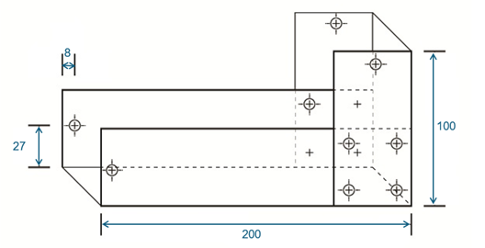
 | ASSESSMENT CRITERIA | Y | N
1 | Selected correct PPE, tools and materials for task
2 | Correctly completed tool and material lists
3 | Trunking square- and burr-free
4 | Bend marked out correctly from squared end
5 | Bend marked out correctly on both sides
6 | Bend securely fixed using M6 nuts and bolts
7 | Overall dimensions correct +/- 5 mm
8 | Completed angle 90°
9 | End fixing holes correct position and size
10 | Lid correctly cut, fits bend correctly, and ends are square
11 | Used only given length of trunking and lid
12 | Completed installation within target time
13 | Work conformed to the requirements of HASWA/EAWR
 | Totals
Feedback from the task:

Learner reflection
Do you feel confident about this topic? | Yes | I would like more guidance

Task 23: Steel trunking – Flat 90-degree angle
Fabricating flat 90-degree angle
Practical task
This practical fabrication task requires you to demonstrate your ability to accurately measure, cut, notch, and form a precise flat 90-degree bend in a length of 50 mm x 50 mm steel trunking.
You are to request the materials listed below and carry out the task following the instructions. You must always work in a safe manner and should leave your work area and tools clean and tidy. You must also complete tools and equipment and a materials checklist (see Annexes).
Materials
- 1 x 300 mm of 50x50 steel trunking complete with lid
- 2 x 12 mm M6 roofing nuts and bolts.
Time | 180 minutes
Safety instructions | - Ensure that your work area is clear and safe for work to proceed.  - All your work must conform to the Health and Safety at Work Act requirements and Electricity at Work Regulations.  - All practical electrical installation exercises must comply with BS 7671 (IET Wiring Regulations).  - All terminations must be mechanically and electrically sound.
Task instructions | - Wear the correct PPE for the task.  - Complete the material and tool list for the task.  - Prepare work site for installation by ensuring all work areas are free from hazards.  - Measure 200 mm to centre and mark a datum line all the way round the trunking.  - Using the set square, draw a line at 45° (B).  - 50 mm either side of the datum, mark two lines on one side only (A).  - Using the set square, from (A) draw two lines on the bottom of the trunking at 45° to converge (C).  - At position (B) top of the trunking cut on the 45° line to (A).  - On the base of the trunking from point (A) to point (C), cut on the 45° line and between (C) to (D).  - Using the wood block inside the trunking, and fold to make 90° bend.  - Drill and fix to complete the construction of flat 90° bend.  - Remove any burrs and sharp edges.  - Hand the work to your tutor for marking and assessment.

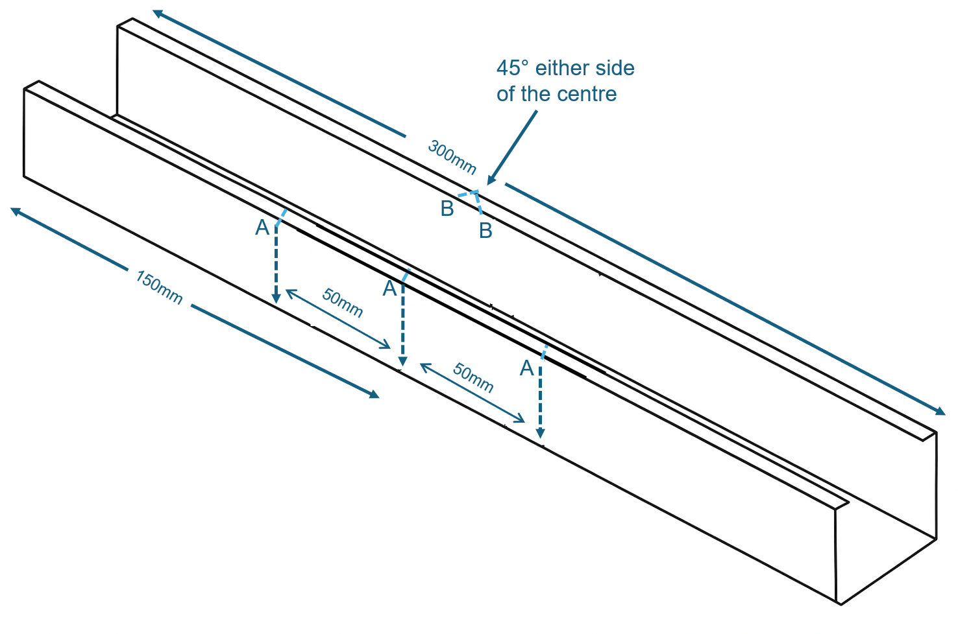
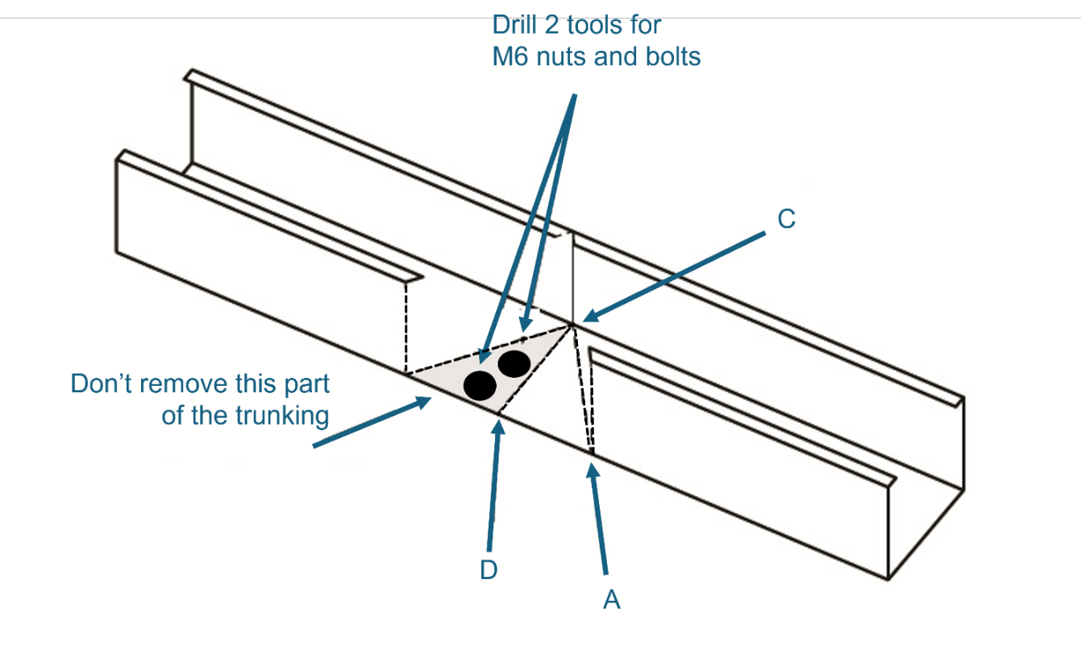

 | ASSESSMENT CRITERIA | Y | N
1 | Selected correct PPE, tools and materials for task
2 | Correctly completed tool and material lists
3 | Trunking square- and burr-free
4 | Bend marked out correctly from squared end
5 | Bend marked out correctly on both sides
6 | Bend securely fixed using M6 nuts and bolts
7 | Overall dimensions correct +/- 5 mm
8 | Completed flat 90° bend
9 | End fixing holes correct position and size
10 | Lid correctly cut, fits bend correctly, and ends are square
11 | Used only the given length of trunking and lid
12 | Completed installation within target time
13 | Work conformed to the requirements of HASWA/EAWR
 | Totals
Feedback from the task:

Learner reflection
Do you feel confident about this topic? | Yes | I would like more guidance

Task 24: Steel tray – tee joint
Fabricating a tee joint
Practical task
This task requires you to demonstrate your ability to accurately prepare and join two sections of 100 mm steel cable tray to form a tee joint. A tee joint is a fundamental connection in cable tray systems, allowing for branching pathways for cable runs. This task will assess your skills in measuring, cutting, deburring and securely fastening cable tray sections to create a structurally sound and electrically continuous joint. You will need to pay close attention to ensuring that fixings are installed in a manner that will not damage any cables subsequently laid within the tray.
You are to request the materials listed below and carry out the task following the instructions. You must always work in a safe manner and should leave your work area and tools clean and tidy. You must also complete tools and equipment and a materials checklist (see Annexes).
Materials
- 2 x 400 mm of 100 mm steel tray (light gauge)
- 3 x 12 m M6 roofing nuts and bolts.
Time | 90 minutes
Safety instructions | - Ensure your work area is clear and safe for work to proceed.  - All your work must conform to the Health and Safety at Work Act requirements and Electricity at Work Regulations.  - All practical electrical installation exercises must comply with BS 7671 (IET Wiring Regulations).  - All terminations must be mechanically and electrically sound.
Task instructions | - Wear the correct PPE for the task.  - Complete the material and tool list for the task  - Prepare work site for installation by ensuring all work areas are free from hazards.  - Mark the position of the tee the centre point of tray 1 (200 mm).  - Measure the width of tray 2 of the tee section accurately.  - Cut the flange on the through section and fold it out.  - Cut away or fold out both flanges on the Tee section of the tray.  - Deburr all cut edges.  - ‘Round off’ all corners.  - Drill holes as required to secure both pieces together.  - Use M6 round head bolts.  - Ensure bolt heads are inside the tray to prevent cable damage.  - Tighten all bolts securely.  - Hand the work to your tutor for marking and assessment.

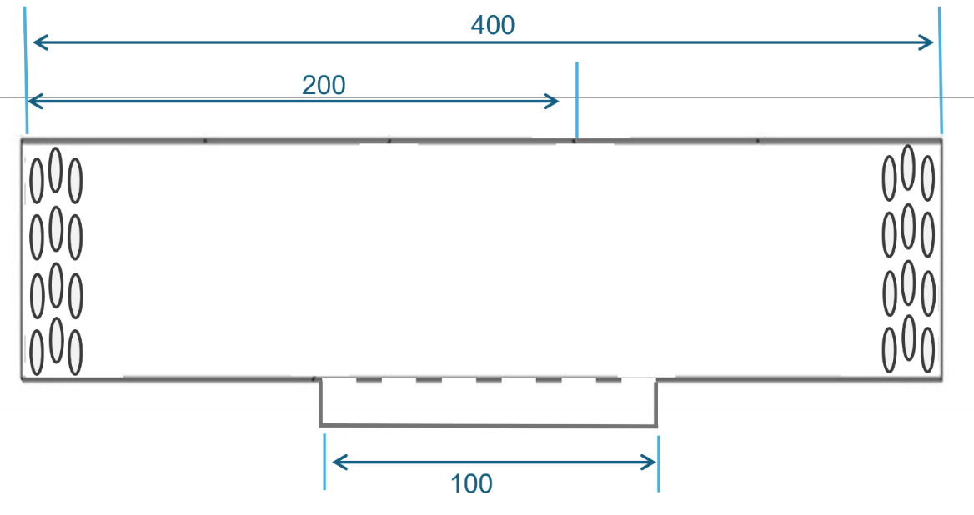
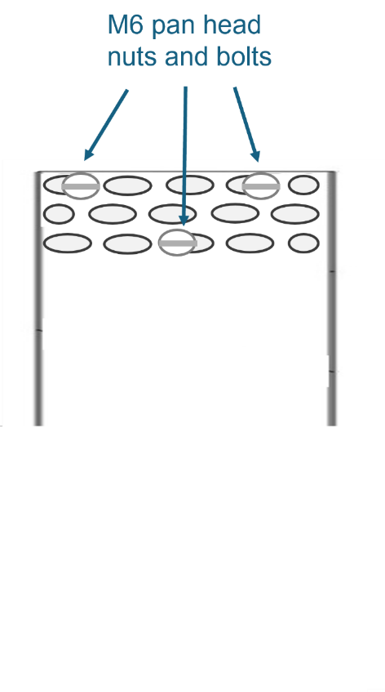
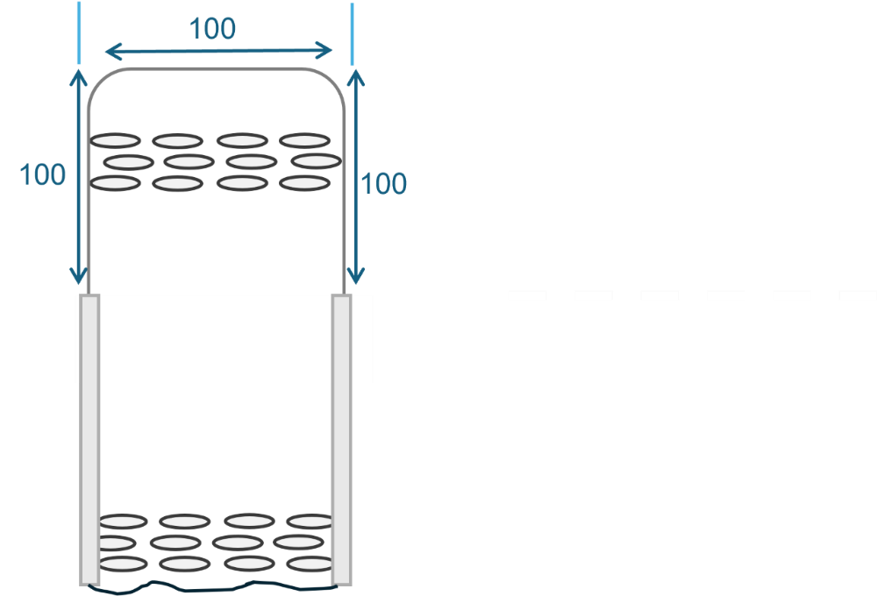

 | ASSESSMENT CRITERIA | Y | N
1 | Selected correct PPE, tools and materials for task
2 | Correctly completed tool and material lists
3 | Cable tray cut to specified dimensions and ends square and smooth
4 | All burrs removed from drilled holes and cut ends
5 | Sets and bends fabricated without gaps
6 | Bolt heads located on the inside of tray on each fabricated section
7 | Nut and bolt fastenings secure
8 | Completed installation within target time
9 | Work conformed to the requirements of HASWA/EAWR
 | Totals
Feedback from the task:

Learner reflection
Do you feel confident about this topic? | Yes | I would like more guidance

Task 25: Steel tray – Gusset bend
Fabricating a 90-degree gusset bend
Practical task
This practical task requires you to demonstrate your ability to accurately measure, mark, cut and form a robust flat 90-degree bend in a steel cable tray, incorporating a gusset for increased structural support. A flat 90-degree bend allows for a change in direction of the cable tray run on the same horizontal plane, and the addition of a gusset reinforces the bend, providing extra strength and rigidity.
You are to request the materials listed below and carry out the task following the instructions. You must always work in a safe manner and should leave your work area and tools clean and tidy. You must also complete tools and equipment and a materials checklist (see Annexes).
Materials
- 550 mm of 150 mm steel tray (light gauge)
- 8 x 12m M6 roofing nuts and bolts.
Time | 90 minutes
Safety instructions | - Ensure your work area is clear and safe for work to proceed.  - All your work must conform to the Health and Safety at Work Act requirements and Electricity at Work Regulations.  - All practical electrical installation exercises must comply with BS 7671 (IET Wiring Regulations).  - All terminations must be mechanically and electrically sound.
Task instructions | - Wear the correct PPE for the task.  - Complete the material and tool list for the task  - Prepare work site for installation by ensuring all work areas are free from hazards.  - Mark the square and cut one end of the cable tray.  - From the squared end, mark lines at 200, 300 and 500 mm.  - Mark two angled lines at the 200 mm and 300 mm marks so that the completed angle will be 90°.  - Cut and square the tray at the 500 mm mark.  - Cut along these two angled lines and mark the three pieces ‘A’, B’ and ‘C’, as shown in the diagram.  - Make two fillets for joining the cable tray out of tray off-cuts.  - Turn section ‘C’ round and rejoin to sections ‘A’ and ‘B’ to form a 90° bend using fillets and M6 pins and nuts.  - Remove burrs and sharp edges and recheck angle and dimensions.  - Ensure bolt heads are inside the tray to prevent cable damage.  - Tighten all bolts securely.  - Hand the work to your tutor for marking and assessment.

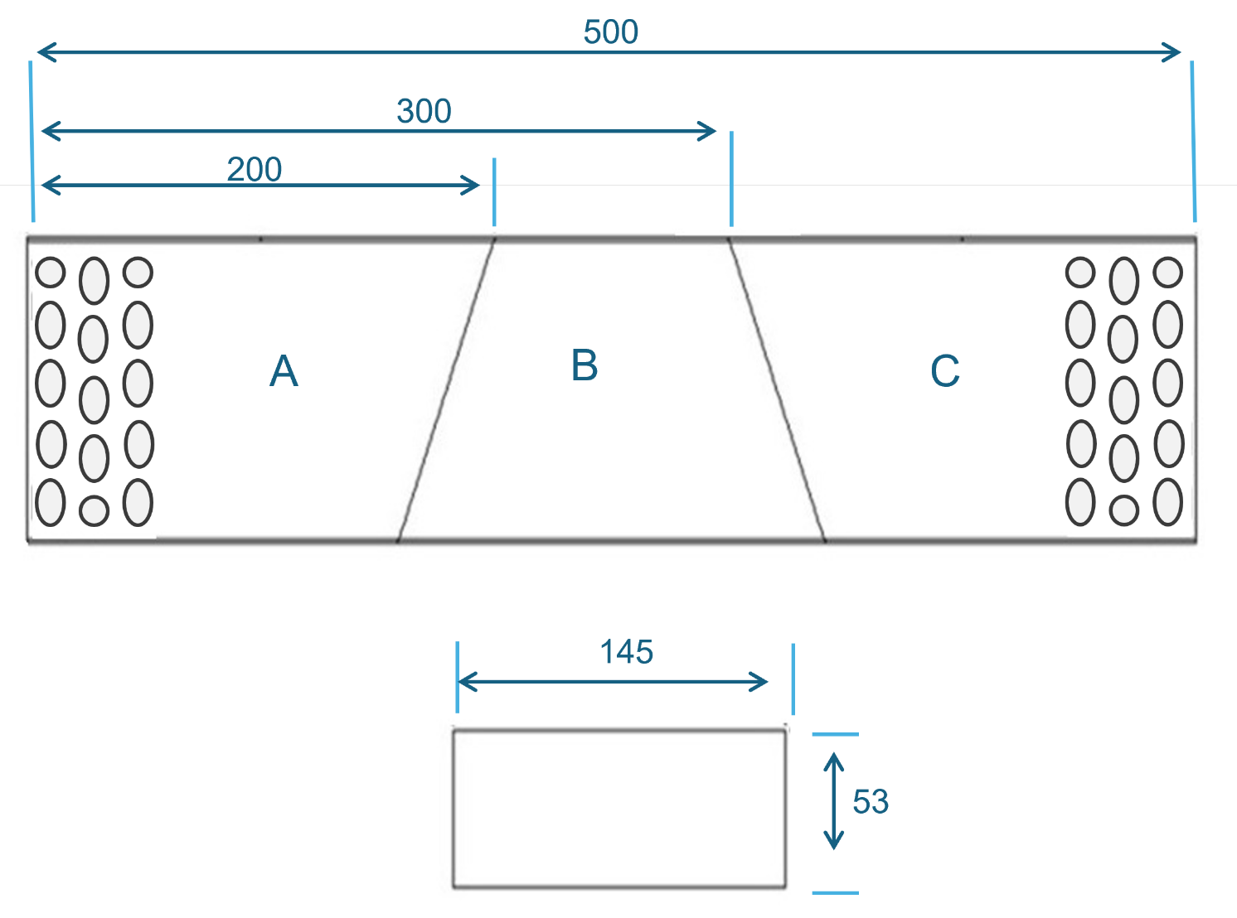

 | ASSESSMENT CRITERIA | Y | N
1 | Selected correct PPE, tools and materials for task
2 | Correctly completed tool and material lists
3 | Cable tray cut to specified dimensions and ends square and smooth
4 | All burrs removed from drilled holes and cut ends
5 | Sets and bends fabricated without gaps
6 | Bolt heads located on the inside of tray on each fabricated section
7 | Nut and bolt fastenings secure
8 | Completed installation within target time
9 | Work conformed to the requirements of HASWA/EAWR
 | Totals
Feedback from the task:

Learner reflection
Do you feel confident about this topic? | Yes | I would like more guidance

Task 26: Steel basket – 90-degree angle
Fabricating a 90-degree angle
Practical task
This practical fabrication task requires you to demonstrate your ability to accurately prepare and form a 90-degree short radius bend in a 150 mm wide steel cable basket. Unlike solid steel cable trays, working with steel cable baskets involves carefully cutting specific wires and manipulating the basket structure to create the desired bend.
You are to request the materials listed below and carry out the task following the instructions. You must always work in a safe manner and should leave your work area and tools clean and tidy. You must also complete tools and equipment and a materials checklist. (see Annexes).
Materials
- 500 mm of 150 mm steel basket (light gauge)
- 1 x M6 x 20 mm nut and bolt and small clamp plate.
Time | 60 minutes
Safety instructions | - Ensure your work area is clear and safe for work to proceed.  - All your work must conform to the Health and Safety at Work Act requirements and Electricity at Work Regulations.  - All practical electrical installation exercises must comply with BS 7671 (IET Wiring Regulations).  - All terminations must be mechanically and electrically sound.
Task instructions | - Wear the correct PPE for the task.  - Complete the material and tool list for the task.  - Prepare work site for installation by ensuring all work areas are free from hazards.  - Identify and mark the wires on the bottom and edges of the basket that need to be cut.  - Using the wire cutters, carefully cut the marked wires on the bottom and edges of the steel cable basket. Ensure clean cuts without leaving sharp protrusions that could damage cables.  - Carefully turn the cable basket 90° horizontally at the prepared section. Manipulate the remaining wires to create a smooth and consistent bend with a short radius.  - Position the medium connecting strip (L=550 mm) to span across the joint created by the 90° bend, ensuring it overlaps both sections of the basket.  - Use the joint clamp to attach the connecting strip securely to both sides of the bend.  - Use the joint clamp to further secure the connection at the bend itself, as per the accessory standards for a 150 mm wide basket.  - Firmly tighten all the screw joints to create a mechanically strong and stable 90° bend.  - Ensure that the nuts are installed on the outside of the tray, so they do not damage any cables laid inside.  - Inspect to ensure a smooth 90-degree turn with no sharp edges or loose wires that could pose a hazard to cables.  - Hand the work to your tutor for marking and assessment.
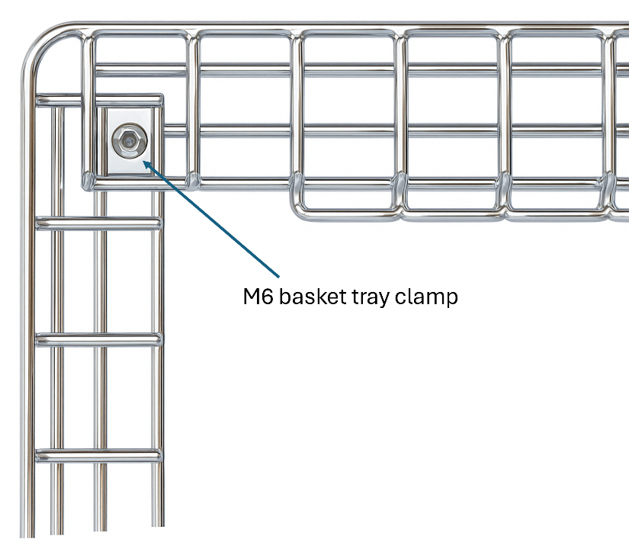
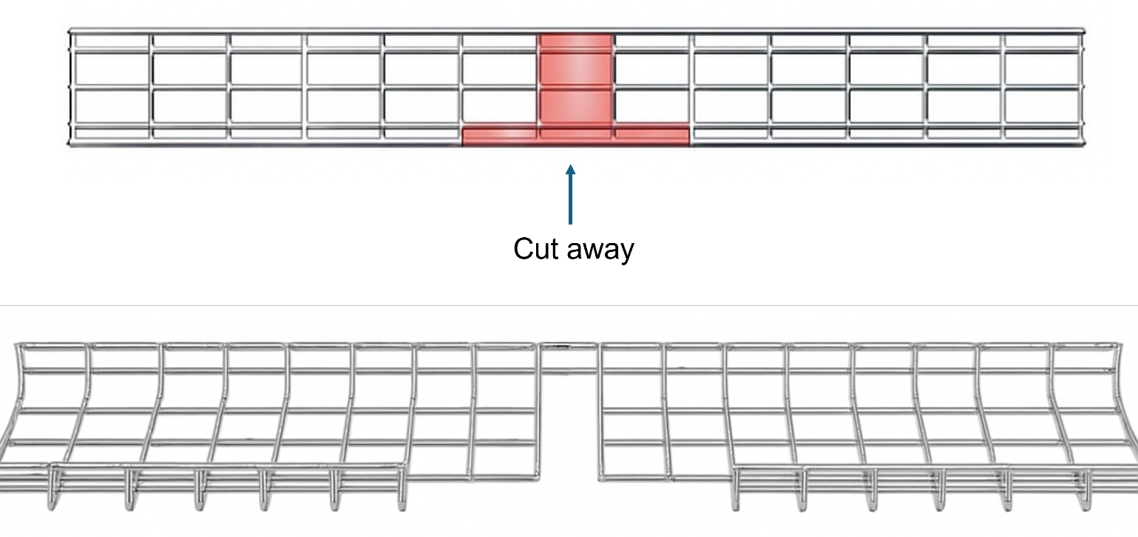

 | ASSESSMENT CRITERIA | Y | N
1 | Selected correct PPE, tools and materials for task
2 | Correctly completed tool and material lists
3 | Cable basket cut to specified dimensions and ends square and smooth
4 | All burrs removed from drilled holes and cut ends
5 | Sets and bends fabricated without gaps
6 | Bolt heads located on the outside of basket
7 | Nut and bolt fastenings secure
8 | Completed installation within target time
9 | Work conformed to the requirements of HASWA/EAWR
 | Totals
Feedback from the task:

Learner reflection
Do you feel confident about this topic? | Yes | I would like more guidance

Task 27: Steel basket – Tee joint
Fabricating a flat tee joint
Practical task
This practical fabrication task requires you to demonstrate your ability to accurately prepare and form a flat tee joint in a 150 mm wide steel cable basket.
You are to request the materials listed below and carry out the task following the instructions. You must always work in a safe manner and should leave your work area and tools clean and tidy. You must also complete tools and equipment and a materials checklist. (see Annexes).
Materials
- 500 mm of 150 mm steel basket (light gauge)
- 3 x M6 x 20 mm nut and bolt and clamp plate.
Time | 60 minutes
Safety instructions | - Ensure that your work area is clear and safe for work to proceed.  - All your work must conform to the Health and Safety at Work Act requirements and Electricity at Work Regulations.  - All practical electrical installation exercises must comply with BS 7671 (IET Wiring Regulations).  - All terminations must be mechanically and electrically sound.
Task instructions | - Wear the correct PPE for the task.  - Complete the material and tool list for the task  - Prepare work site for installation by ensuring all work areas are free from hazards.  - Identify on basket (piece 1) where the T-joint will be formed. This is where piece 2 will connect.  - Piece 1: Measure the width of the 150 mm cable basket and mark out a section on the side of the main basket that is slightly wider than 150 mm and extends from the top edge down.  - Ensure your marks align with the existing mesh grid, cut along the marked lines on the main basket, and remove a section of the side wires and potentially some top and bottom wires.  - Debur to smooth down any sharp edges or burrs.  - Piece 2: Position it where it will connect to piece 1 and trim some of the longitudinal wires on the connecting end.  - Ensure the two pieces are aligned correctly, forming a neat 'T' shape. The top edges should ideally be level, and the sides should be as flush as possible.  - Place couplers across the joint on both sides and tighten, ensuring all are firm to prevent movement.  - Check for any remaining sharp edges or burrs and deburr them thoroughly.  - Ensure the joint is rigid and stable, with no excessive movement.  - Hand the work to your tutor for marking and assessment.
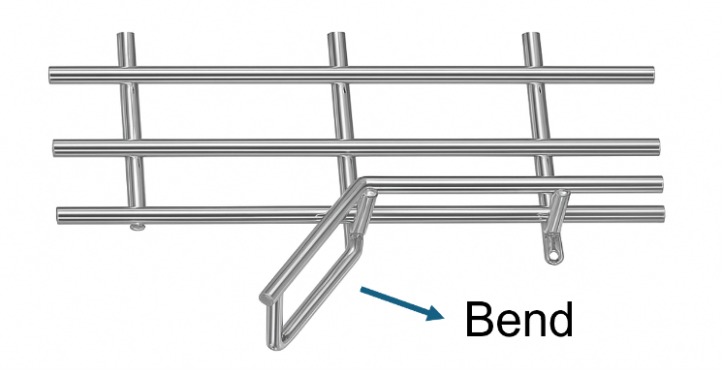
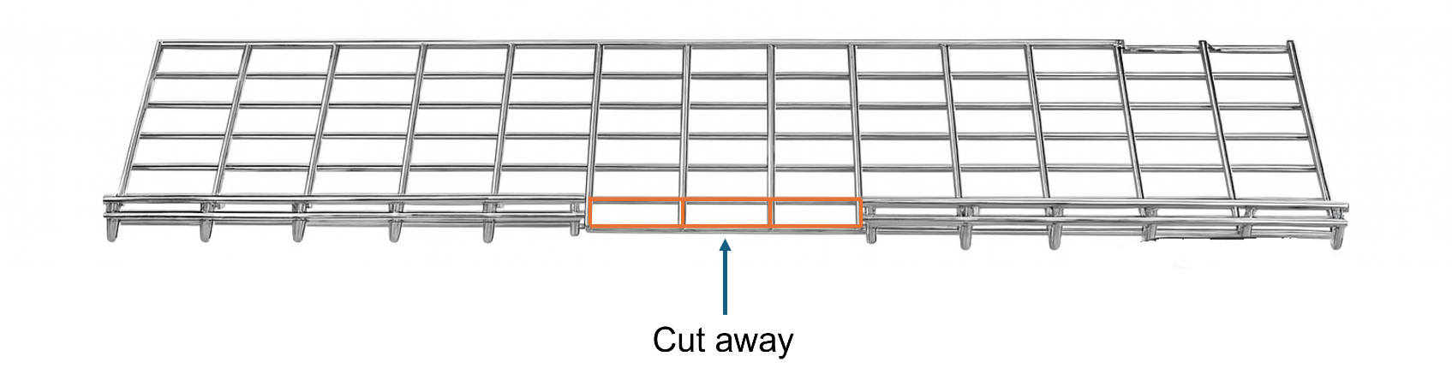

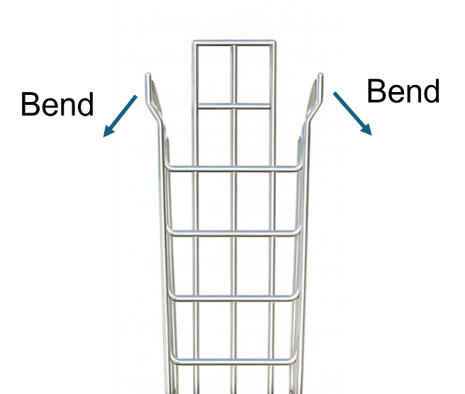
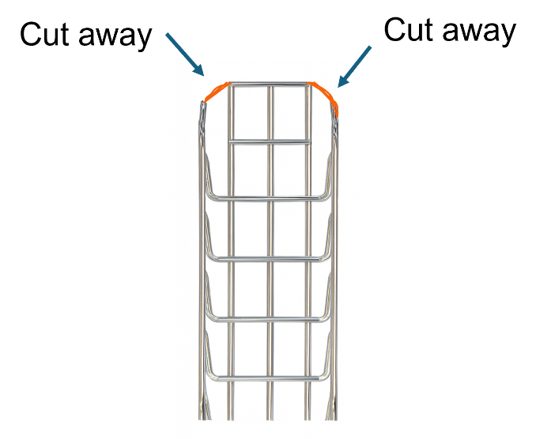

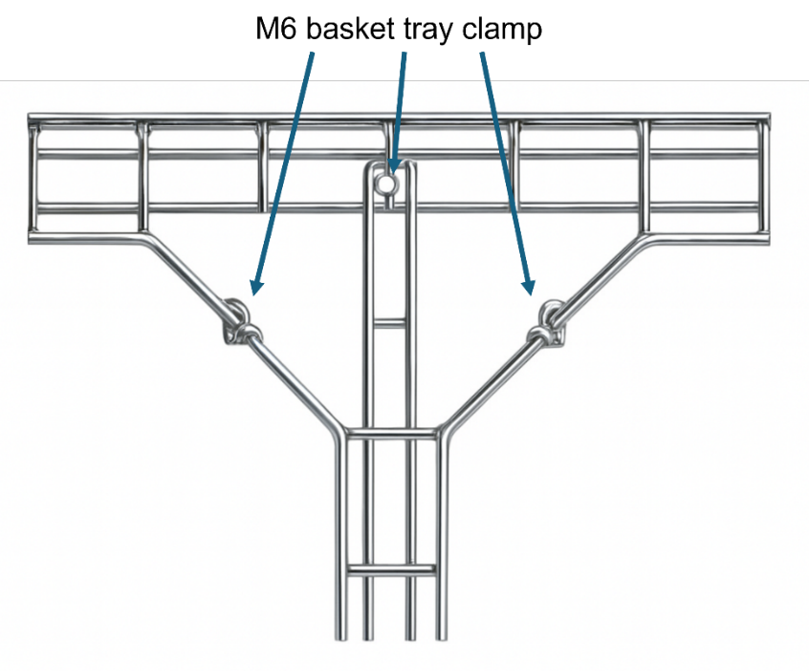

 | ASSESSMENT CRITERIA | Y | N
1 | Selected correct PPE, tools and materials for task
2 | Correctly completed tool and material lists
3 | Cable basket cut to specified dimensions, ends square and smooth
4 | All burrs removed from drilled holes and cut ends
5 | Sets and bends fabricated without gaps
6 | Bolt heads located on the outside of basket
7 | Nut and bolt fastenings secure
8 | Completed installation within target time
9 | Work conformed to the requirements of HASWA/EAWR
 | Totals
Feedback from the task:

Learner reflection
Do you feel confident about this topic? | Yes | I would like more guidance

Additional underpinning knowledge tasks as required

Task 28: PVC/SWA on steel tray – sub-main supply
Fabricating a cable tray and SWA wiring system
Practical task
This practical task requires you to install a simulated 10 mm² PVC/SWA, three-core submain cable, supported by a 150 mm cable tray system incorporating two 90-degree gusset bends and raised on slotted uni-strut, running between two consumer units. You must work safely, assemble the tray system, correctly install and support the cable, and terminate the cable with glands at both ends.
You are to request the materials listed below and carry out the task following the instructions. You must always work in a safe manner and should leave your work area and tools clean and tidy. You must also complete tools and equipment and a materials checklist. (see Annexes).
Materials
- 2 x consumer unit
- 1 x B40A MCB
- 3m of 10 mm² three-core PVC/SWA cable
- 2 x 20 mm BW brass SWA gland
- 2.5 m of 150 mm cable tray
- 450 mm of slotted uni-strut
- 6 x M6 roofing nuts and bolts
- 6 x ng hardware for uni-strut and cable tray (e.g., bolts, nuts, washers)
- 300 mm green/yellow cpc sleeving
- 50 mm blue sleeving
- cable ties for fixing SWA cable to tray
- screws and connector blocks as required.
Time | 2 hours
Safety instructions | - Ensure your work area is clear and safe for work to proceed.  - All your work must conform to the Health and Safety at Work Act requirements and Electricity at Work Regulations.  - All practical electrical installation exercises must comply with BS 7671 (IET Wiring Regulations).  - All terminations must be mechanically and electrically sound.
Task instructions | - Wear the correct PPE for the task.  - Complete the material and tool list for the task  - Prepare work site for installation by ensuring all work areas are free from hazards.  - Fabricate tray using the skills previously learnt.  - Measure and mark the locations for the uni-strut supports.  - Measure and cut uni-strut to the required size and deburr any sharp edges.  - Secure the uni-strut lengths to wall using appropriate fixings, ensure they are level and provide adequate support for the cable tray.  - Ensure all connections are tight and the tray system is mechanically sound and follows the intended route.  - Measure cable length of the 10 mm² SWA cable to run the entire route along the installed cable tray, including some slack at each end for termination.  - Lay cable along the cable tray system, avoiding sharp kinks or excessive strain on the cable.  - Fix the SWA cable to the cable tray using appropriate cable clips at regular intervals.  - Terminate one end with a 20 mm gland into the 40A MCB.  - Terminate the other end into the mains switch of the 2nd consumer unit.  - Verify both glands are secure and tight.  - Check for any damage to the cable or tray system during installation.  - Ensure your work area is clean and tidy.  - Hand the work to your tutor for marking and assessment.

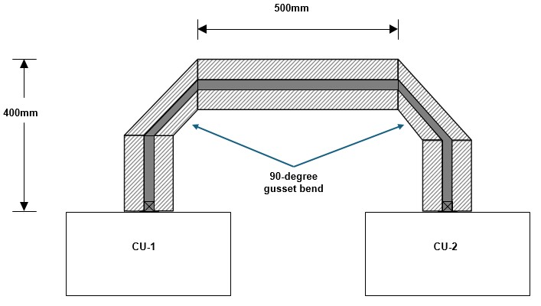

 | ASSESSMENT CRITERIA | Y | N
1 | Selected correct PPE, tools and materials for task
2 | Correctly completed tool and material lists
3 | Cable tray cut to specified dimensions, ends square and smooth
4 | All burrs removed from drilled holes and cut ends
5 | Sets and bends fabricated without gaps
6 | Bolt heads located on the inside of tray on each fabricated section
7 | Cable cut to specified length and cable sheath undamaged
8 | Glands assembled correctly and fitted securely
9 | Shroud fitted over gland with no steel armour steel exposed
10 | Cable inner sheath stripped correctly
11 | Conductor insulation undamaged
12 | Cable clipped to cable tray correctly
13 | Cable cut to specified length with cable end cut square
14 | Cable is straight, horizontal and vertical as required
15 | Sufficient spare left on all terminations
16 | All conductors secure in all terminations
17 | All conductors installed neatly at both consumer units
18 | Correct terminations used, and all circuit wiring correct
19 | Completed installation within target time
20 | Work conformed to the requirements of HASWA/EAWR
 | Totals
Feedback from this task:

Learner reflection
Do you feel confident about this topic? | Yes | I would like more guidance

Task 29: Earthing and bonding
Connection of extraneous metalwork to main earthing terminal
Practical task
This practical task requires you to install a simulated 10 mm² PVC/SWA, three-core distribution cable, supported by a 150 mm cable tray system incorporating two 90-degree gusset bends and raised on slotted uni-strut, running between two consumer units. You must work safely, assemble the tray system, correctly install and support the cable, and terminate the cable with glands at both ends.
You are to request the materials listed below and carry out the task following the instructions. You must always work in a safe manner and should leave your work area and tools clean and tidy. You must also complete tools and equipment and a materials checklist. (see Annexes).
Materials
- 1 x consumer unit
- 1 m of 16 mm² green/yellow single core PVC cable
- 2 m of 10 mm² green/yellow single core PVC cable
- 2 x BS 951 earth/bonding clamp
- clips as required.
Time | 2 hours
Safety instructions | - You are to make sure that your work area is clear and safe for work to proceed.  - All your work must conform to the Health and Safety at Work Act requirements and Electricity at Work Regulations.  - All practical electrical installation exercises must comply with BS 7671 (IET Wiring Regulations).  - All terminations must be mechanically and electrically sound.
Task instructions | - Wear the correct PPE for the task.  - Complete the material and tool list for the task.  - Prepare work site for installation by ensuring all work areas are free from hazards.  - Measure cable lengths, avoiding sharp kinks or excessive strain at terminations.  - Fix cables using appropriate cable clips at regular intervals.  - Terminate ends at bonding clamps and consumer unit.  - Terminate three ends at MET.  - Verify both clamps are secure and tight.  - Check for any damage to the cable or accessories during installation.  - Ensure your work area is clean and tidy.  - Hand the work to your tutor for marking and assessment.
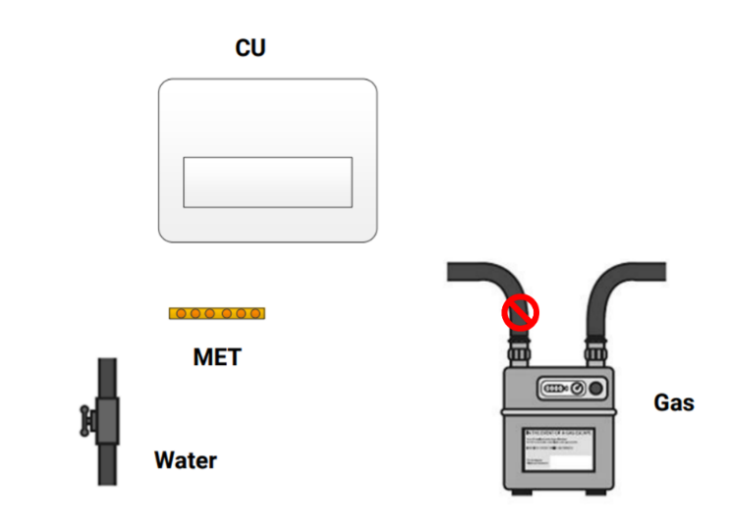

 | ASSESSMENT CRITERIA |  | Y | N
1 | Selected correct PPE, tools and materials for task
2 | Correctly completed tool and material lists
3 | Selects the correct position for bonding of gas service
4 | Selects the correct position for bonding of water service
5 | Services bonded and unbroken
6 | Services cleaned at bonding positions
7 | Bonding clamps fitted correctly and securely
8 | Cable connections to bonding clamps secure
9 | Cable connections to MET secure
10 | Cables clipped correctly
11 | Labels fitted securely
12 | Completed installation within target time
13 | Work conformed to the requirements of HASWA/EAWR
 |  | Totals
Feedback from this task:

Learner reflection
Do you feel confident about this topic? | Yes | I would like more guidance

Task 30: Data cable installation
Connection of data cable installed in PVC trunking
Practical task
This practical task requires you to install a data cable inside PVC mini- and three-compartment trunking. The mini trunking will incorporate two 90-degree bends, one of which will have two 45-degree mitred ends. The data cable will be terminated at both ends into RJ45 ethernet sockets.
You are to request the materials listed below and carry out the task following the instructions. You must always work in a safe manner and should leave your work area and tools clean and tidy. You must also complete tools and equipment and a materials checklist. (see Annexes).
Materials
- 1m of MT mini-trunking
- 1m of 3-compartment data trunking and end caps
- 2 x 1-gang RJ45 ethernet socket
- 1 x 1 gang socket pattress
- 1 x 50 mm 1 gang trunking accessory box
- 1m of Cat6 data cable
- screws as required.
Time | 120 minutes
Safety instructions | - Ensure that your work area is clear and safe for work to proceed.  - All your work must conform to the Health and Safety at Work Act requirements and Electricity at Work Regulations.  - All practical electrical installation exercises must comply with BS 7671 (IET Wiring Regulations).  - All terminations must be mechanically and electrically sound.
Task instructions | - Wear the correct PPE for the task.  - Complete the material and tool list for the task.  - Prepare work site by ensuring all work areas are free from hazards.  - Measure and mark trunking runs on wall.  - Install 3C trunking, fix securely and fit end cap.  - Fix accessory box into 3-compartment trunking (where mini-trunking will connect).  - Measure, cut two 45° mitres, and join to form 90° bend.  - Form another 90° bend with straight ends to pattress.  - Fix mini-trunking from 3C trunking to pattress.  - Run CAT6 data cable inside trunking from accessory box to pattress.  - Fit trunking lid and 90° cover.  - Terminate data cable to RJ45 outlets and secure.  - Check for any damage to the cable or accessories during installation.  - Ensure your work area is clean and tidy.  - Hand the work to your tutor for marking and assessment.
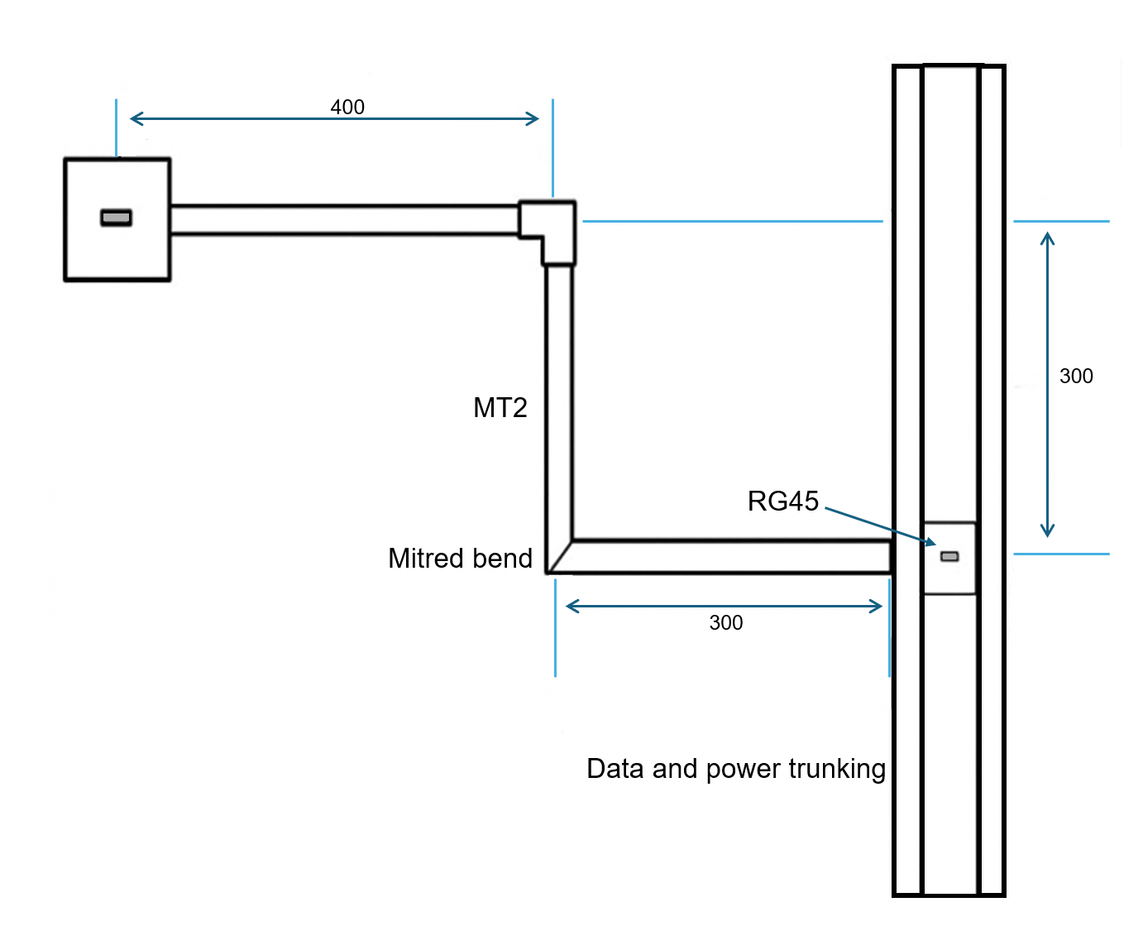

 | ASSESSMENT CRITERIA | Y | N
1 | Selected correct PPE, tools and materials for task
2 | Correctly completed tool and material lists
3 | 3C trunking correctly installed and securely fixed
4 | End caps correctly fitted to 3-compartment trunking
5 | Trunking accessory box securely fixed to 3C trunking
6 | Mini-trunking correctly installed and securely fixed
7 | Standard 90-degree bend correctly formed and secured
8 | 90-degree bend with 45-degree mitred ends correctly formed and secured
9 | 1-gang socket pattress(s) securely mounted onto wall and trunking
10 | Data cable neatly routed within both trunking systems
11 | Data cable free from kinks or excessive strain
12 | Completed installation within target time
13 | Work conformed to the requirements of HASWA/EAWR
 | Totals
Feedback from this task:

Learner reflection
Do you feel confident about this topic? | Yes | I would like more guidance

Task 31: Inspection and testing – initial verification
Practical task
This practical task requires you to carry out pre-commissioning electrical tests on an electrical installation in accordance with the current edition of BS 7671 wiring regulations. You are to follow the procedure for inspection and testing laid out in the IET On-Site guide and Guidance Note 3 and carry out safe isolation procedures in accordance with recognised guidelines.
You must always work in a safe manner and should leave your work area and tools clean and tidy.
Materials and equipment
- a current edition of On-Site Guide/Guidance Note 3
- all appropriate test instruments and leads for the assessment
- any relevant information required to correctly conduct the initial verification of the rig
- an Electrical Installation Certificate, with related schedules.

Time | 4 hours
Safety instructions | - Ensure that your work area is clear and safe for work to proceed.  - All your work must conform to the Health and Safety at Work Act requirements and Electricity at Work Regulations.  - All practical electrical installation exercises must comply with BS 7671 (IET Wiring Regulations).
Task instructions | - Wear the correct PPE for the task.  - Complete the tool list for the task.  - Prepare work site by ensuring all work areas are free from hazards.  - Carry out inspection and testing in accordance with the procedures laid out in BS 7671 and associated guides.  - Verify results comply with BS 7671 and record on the appropriate documentation.  - Check for any damage to the cable or accessories during installation.  - Ensure your work area is clean and tidy.  - Hand the work to your tutor for marking and assessment.

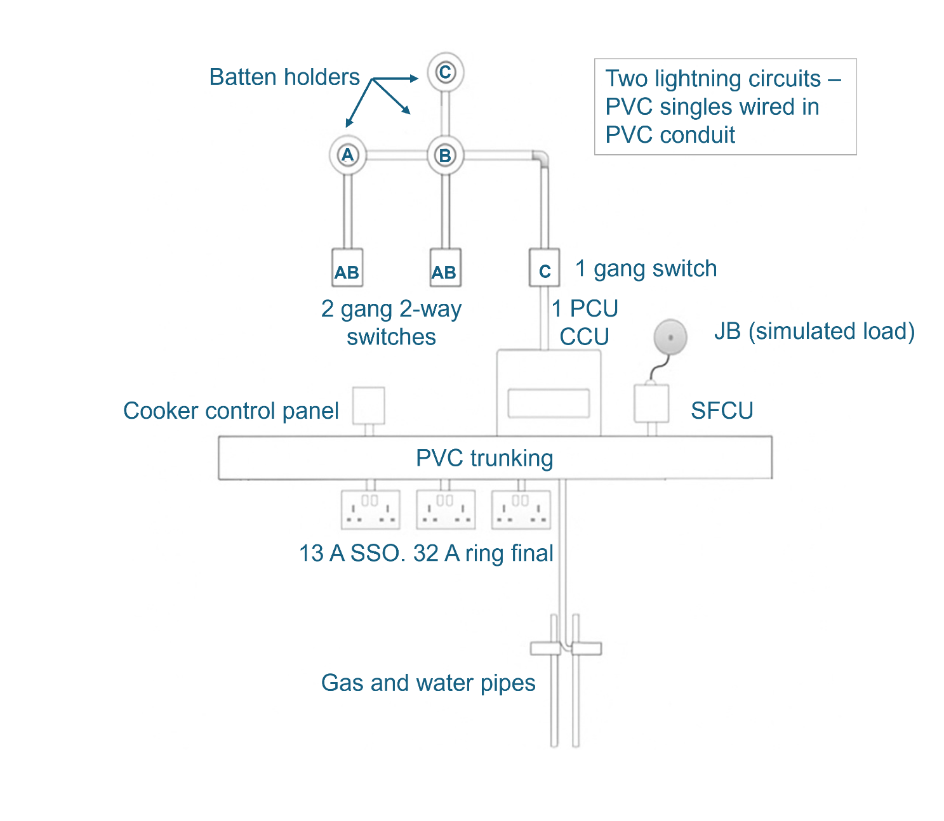

 | ASSESSMENT CRITERIA | Y | N
1 | Selected correct PPE, tools and materials for task
2 | Correctly completed tool list
3 | Identified correct point of isolation
4 | Asked permission to turn off supply to consumer unit
5 | Selected approved voltage indicator and proves on proving unit
6 | Carried out 3-point test on consumer unit
7 | Re-proved approved voltage indicator on proving unit
8 | Correctly fitted locking device, label and padlock
9 | Removed and retained key
10 | Correctly carried out an initial inspection in accordance with the requirements of BS 7671
11 | Correctly selected the test instruments and their accessories for the tests
12 | Correctly carried out the range of tests in accordance with BS 7671 and Guidance Note 3
13 | Confirmed compliance of the rig by verifying test results
14 | Accurately completed appropriate documentation in accordance with BS 7671 and IET Guidance Note 3
15 | Completed installation within target time
16 | Work conformed to the requirements of HASWA/EAWR
 | Totals
Feedback from this task:

Learner reflection
Do you feel confident about this topic? | Yes | I would like more guidance

Task 32: Inspection and testing – fault finding
Practical task
This practical task requires you to carry out inspection and testing to find various pre-wired faults on an electrical installation in accordance with the current edition of BS 7671 wiring regulations. You are to follow the procedure for inspection and testing laid out in the IET On-Site guide and Guidance Note 3 and carry out safe isolation procedures in accordance with recognised guidelines.
You must always work in a safe manner and should leave your work area and tools clean and tidy.
Materials and equipment
- a current edition of On-Site Guide/Guidance Note 3
- all appropriate test instruments and leads for the assessment
- relevant information required to test fault rig
- an Electrical Installation Condition Report with related schedules.

Time | 4 hours
Safety instructions | - Ensure that your work area is clear and safe for work to proceed.  - All your work must conform to the Health and Safety at Work Act requirements and Electricity at Work Regulations.  - All practical electrical installation exercises must comply with BS 7671 (IET Wiring Regulations).
Task instructions | - Wear the correct PPE for the task.  - Complete the tool list for the task.  - Prepare work site by ensuring all work areas are free from hazards.  - Carry out inspection and testing in accordance with the procedures laid out in BS 7671 and associated guides.  - Record any faults you find on the appropriate documentation.  - Check for any damage to the cable or accessories during installation.  - Ensure your work area is clean and tidy.  - Hand the work to your tutor for marking and assessment.

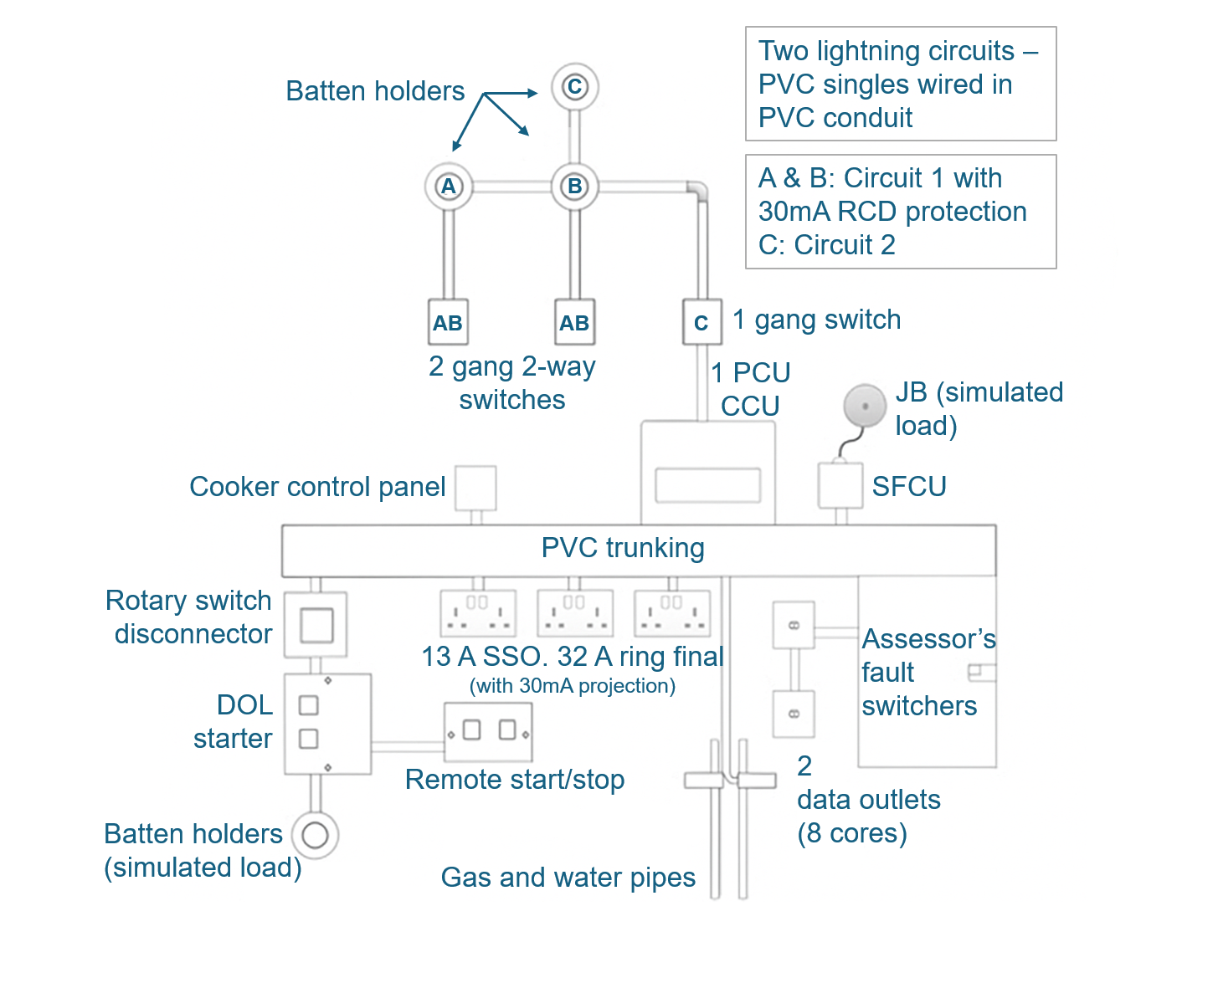

 | ASSESSMENT CRITERIA | Y | N
1 | Selected correct PPE, tools and materials for task
2 | Correctly completed tool list
3 | Identified correct point of isolation
4 | Asked permission to turn off supply to consumer unit
5 | Selected approved voltage indicator and proves on proving unit
6 | Carried out 3-point test on consumer unit
7 | Re-proved approved voltage indicator on proving unit
8 | Correctly fitted locking device, label and padlock
9 | Removed and retained key
10 | Correctly carried out an inspection and testing in accordance with the requirements of BS 7671
11 | Correctly selected test instruments and their accessories for the tests
12 | Correctly carried out the range of tests in accordance with BS 7671 and Guidance Note 3
13 | Knew the difference between a good and bad test result and recorded in appropriate documentation
14 | Accurately completed appropriate documentation in accordance with BS 7671 and IET Guidance Note 3
15 | Completed installation within target time
16 | Work conformed to the requirements of HASWA/EAWR
 | Totals
Feedback from this task:

Learner reflection
Do you feel confident about this topic? | Yes | I would like more guidance

Task 33: Composite installation
Practical task
This practical task requires you to use all the skills you have learnt. You must create your own material and tool lists and submit them to your tutor before beginning the task.
Time | 9 hours
Safety instructions | - Ensure that your work area is clear and safe for work to proceed.  - All your work must conform to the Health and Safety at Work Act requirements.  - All practical electrical installation exercises must comply with BS 7671 (IET Wiring Regulations).  - All terminations must be mechanically and electrically sound.
Task  instructions | - Wear the correct PPE for the task.  - Complete material and tool lists for the task.  - Prepare work site by ensuring all work areas are free from hazards.  - Carry out installation, inspection and testing in accordance with the procedures laid out in BS 7671 and associated guides.  - Install circuits in the sequence listed below.  - Check for any damage to the cable or accessories during installation.  - Ensure your work area is clean and tidy.  - Hand the work to your tutor for marking and assessment.

Circuit
1 | 6A lighting circuit to a spotlight on surface 1, wired in 1 mm² PVC singles in trunking and conduit. Lamp is controlled by one-way switch.
2 | 20A Radial circuit wired in 2.5/1.5 mm² PVC singles in trunking to a double socket.
3 | 16A Radial circuit to a Fused Connection Unit wired in 2.5/1.5 mm² PVC singles in trunking and conduit.

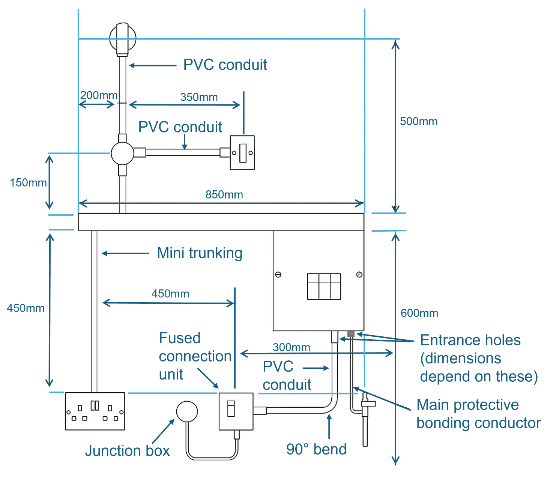

 | ASSESSMENT CRITERIA | Y | N
1 | Selected correct PPE, tools and materials for task
2 | Correctly completed tool and material lists
3 | Produced accurate wiring diagram for the lighting circuit
4 | Correct materials selected and used
5 | Work carried out in a safe manner
6 | All enclosures correctly fabricated and installed
7 | All circuit protective conductors sleeved
8 | Minimum insulation removed and conductors undamaged
9 | Acceptable amount of spare left at terminations
10 | All terminations electrically and mechanically sound
11 | All conductors installed neatly in consumer unit
12 | Correct selection of line, neutral and CPC terminals at the consumer unit
13 | Correctly selected test instruments and their accessories for the tests
14 | Correctly carried out range of tests in accordance with BS 7671 and Guidance Note 3
15 | Knew the difference between a good and bad test result and recorded in appropriate documentation
16 | Accurately completed appropriate documentation in accordance with BS 7671 and IET Guidance Note 3
17 | Completed installation within target time
18 | Work conformed to the requirements of HASWA/EAWR
 | Totals
Feedback from the task:

Learner reflection
Do you feel confident about this topic? | Yes | I would like more guidance

Annex A
Name: | Practical Task No:
Date:

Materials/Tools/ Equipment | Quantity
Annex B


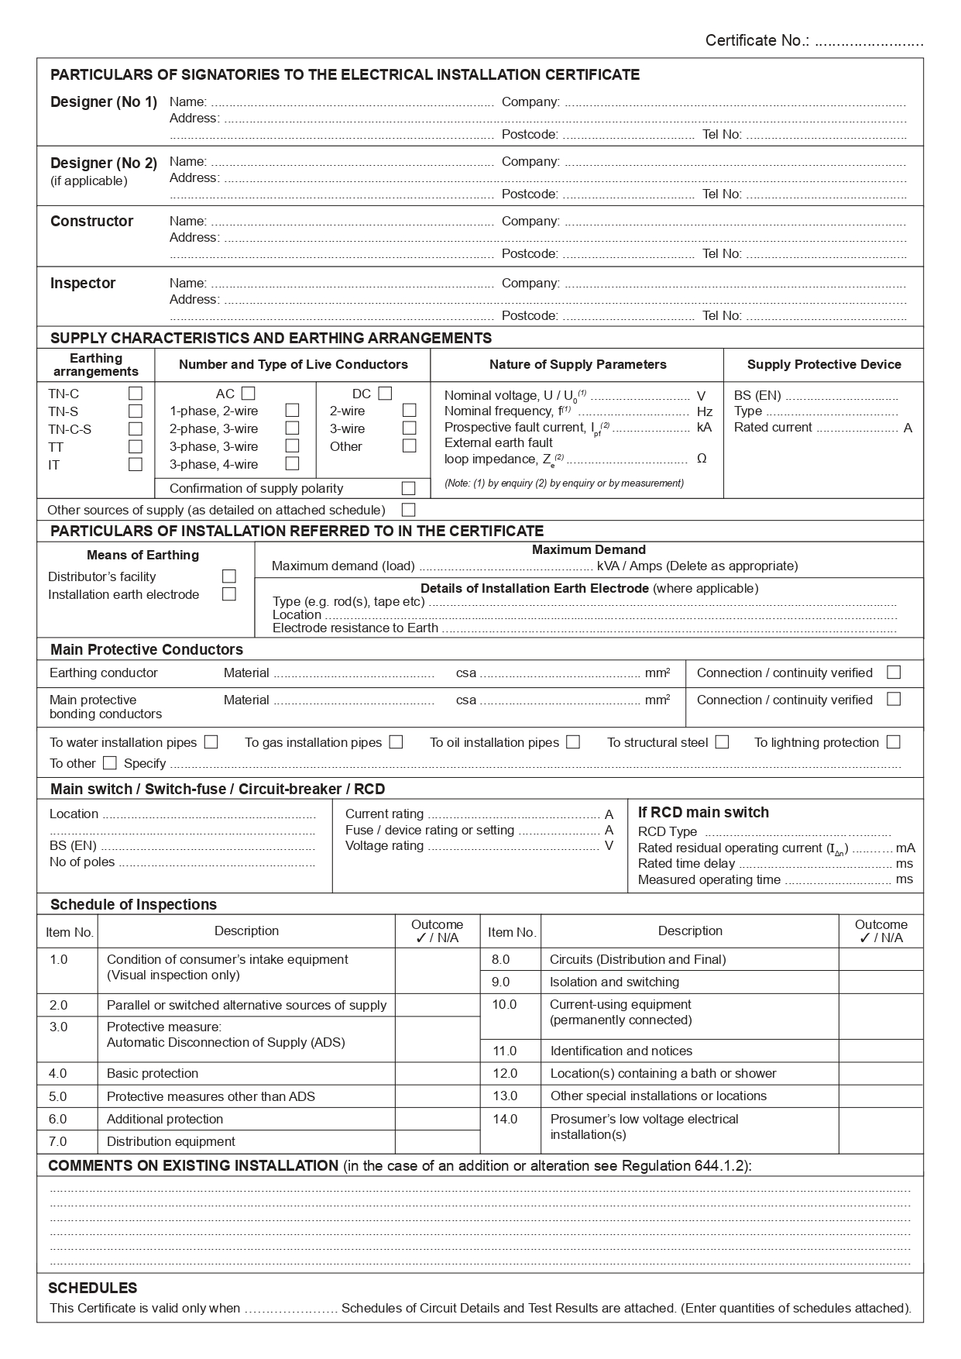
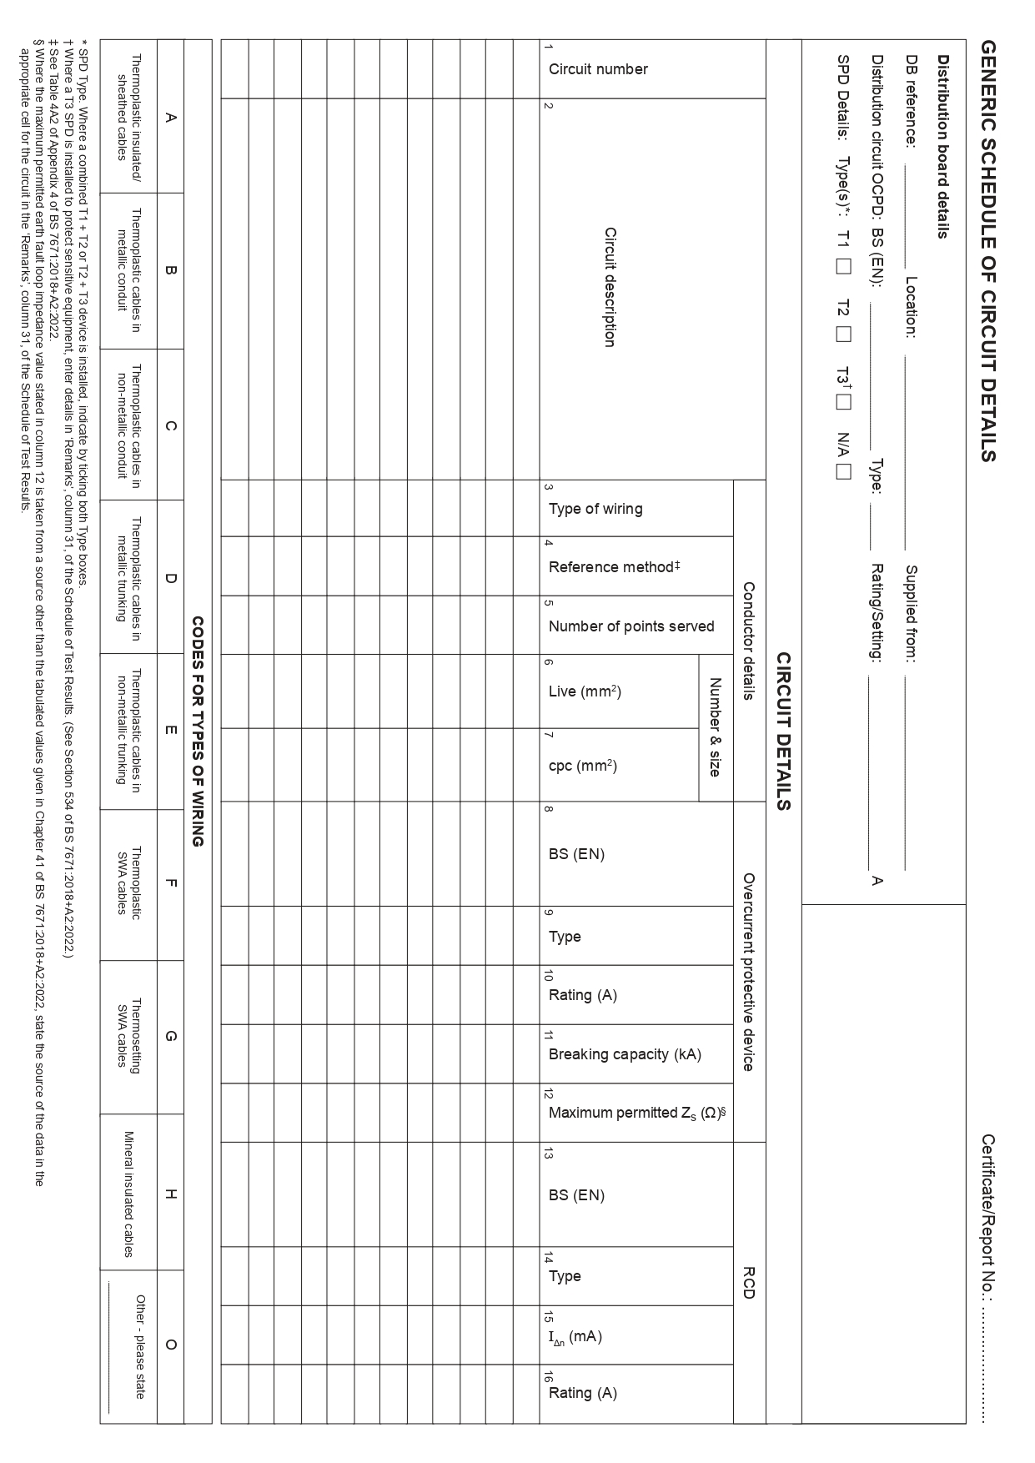
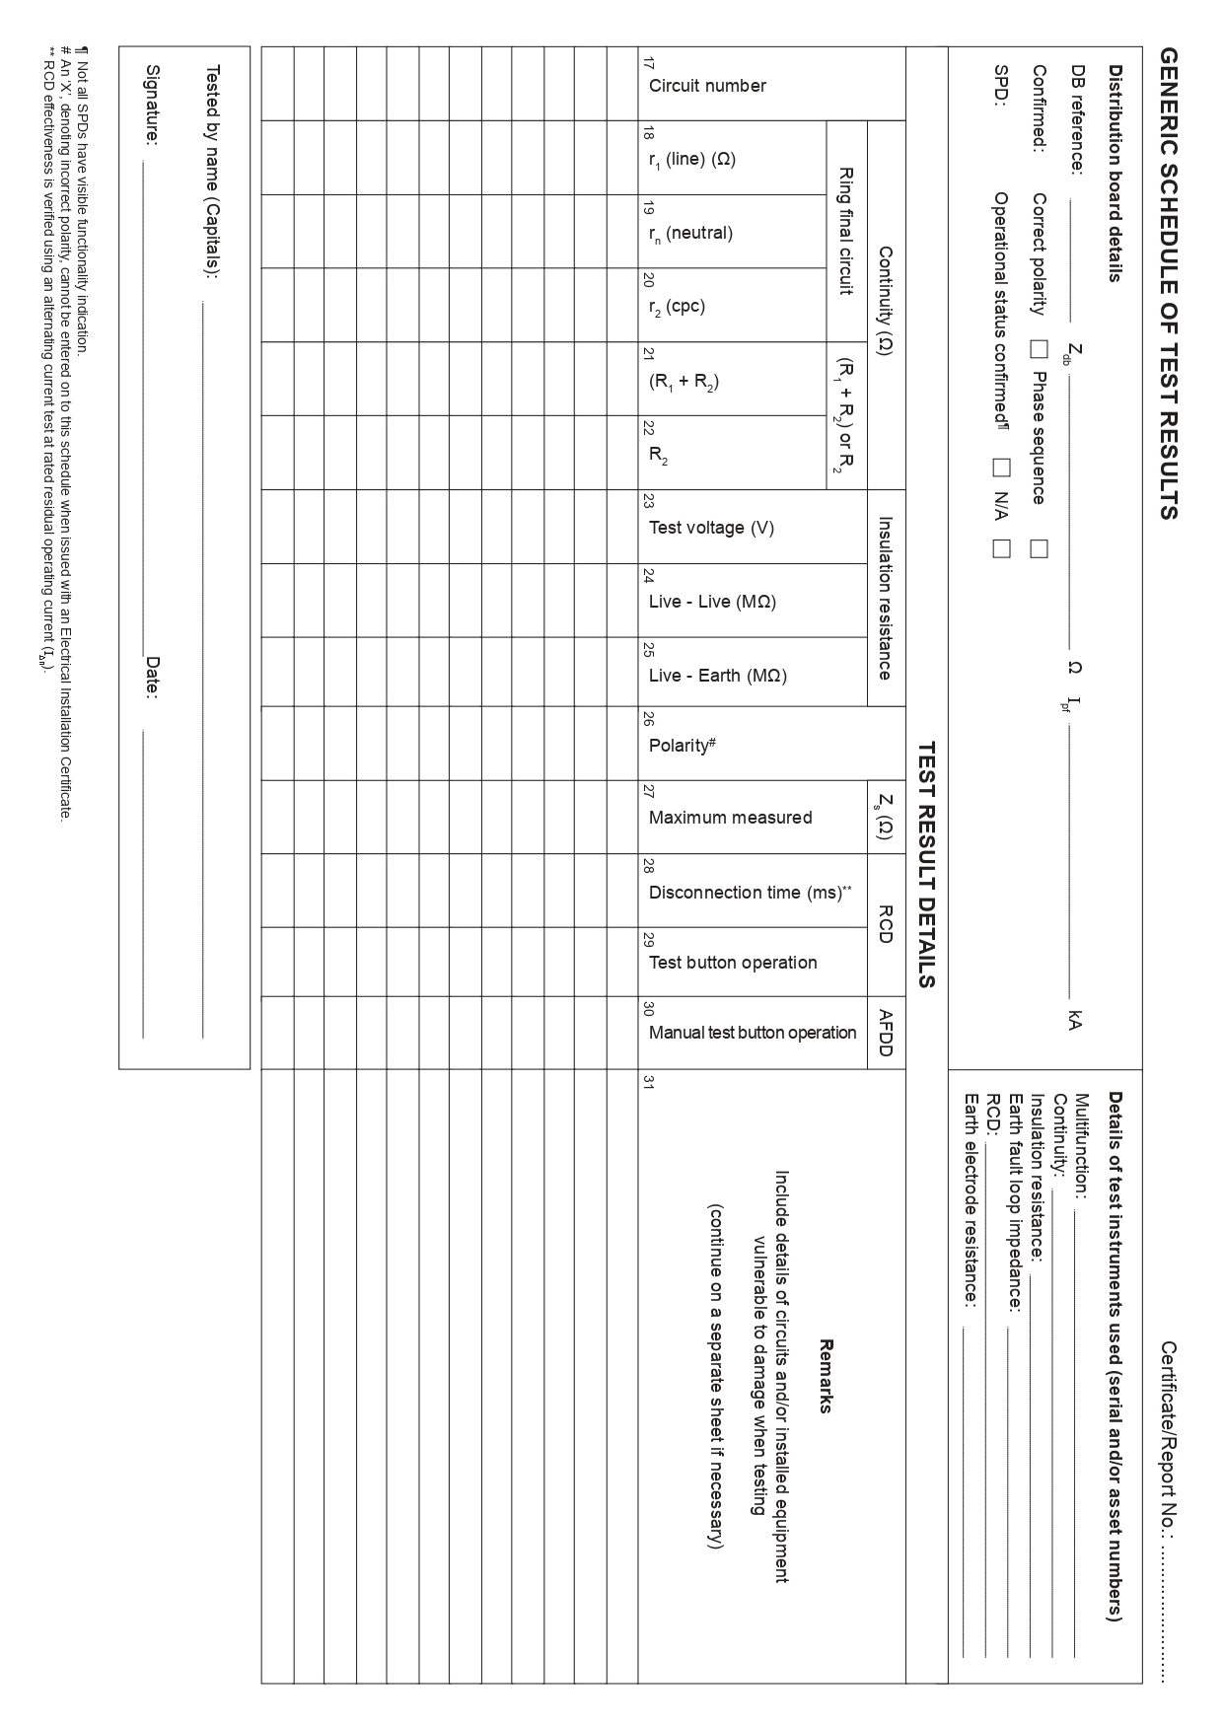
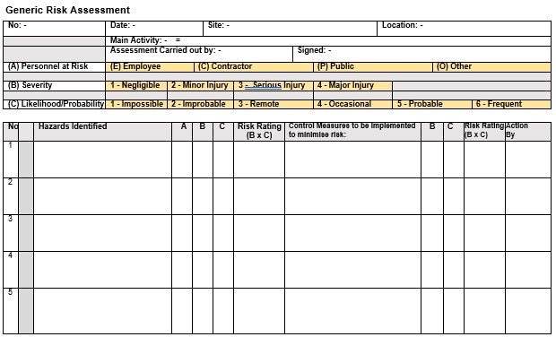
Annex C
Copyright in this document belongs to and is used under licence from the Department for Education, © 2025.
‘T-LEVELS’ and ‘T Level’ are registered trademarks of the Department for Education.
WJEC is authorised by the Department for Education to develop and deliver this T Level Technical Qualification.
WJEC operates in England under the name Eduqas which is a registered trademark of WJEC.

Acknowledgements
Images used within these resources have been created using artificial intelligence (AI) and is intended to provide a visual representation only.
p.5 VladimirSorokin / iStock / Getty Images; p.5 Mohamed Rasik / iStock / Getty Images; p.5 Jorris GUILHOT / iStock / Getty Images; p.5 Paul-Briden / iStock / Getty Images; p11 Image by jannoon028 / Freepik.com; p.11 Image by Macrovector / Freepik.com; p.11 Image by mrsiraphol / Freepik.com; p.11 EyeEm / Freepik.com; p.11 Image by Freepik.com; p.11 Mihalec / Freepik.com; p.12 Sirastock / Freepik.com; p.12 New Africa / Freepik.com; p.12 harsh2030fp / Freepik.com; p.12 abdulrehman4906231 / Freepik.com; p.12 Aprikalims / Freepik.com; p.15 Avinda Gunawardhana / Freepik.com; p.15 Michaklootwijk / iStock / Getty Images; p.22 Unomat / iStock / Getty Images; p.22 popovaphoto / iStock / Getty Images; p.22 A_M_Radul / iStock / Getty Images; p.22 Image by brgfx / Freepik.com; p.23 cynoclub / Freepik.com; p.23 Nomadsoul1 / iStock / Getty Images; p.23 Ruslan Sidorov / iStock / Getty Images; p.24 MAXSHOT / iStock / Getty Images; p.24 Comstock / Stockbyte / Getty Images; p.24 Thien Woei Jiing / iStock / Getty Images; p.24 Nigel Stripe / iStock / Getty Images; p.24 Nonillion / iStock / Getty Images; p.25 Василий Авраменко / iStock / Getty Images; p. Veni vidi...shoot / iStock / Getty Images; p.25 Sergii Zhmurchak / iStock / Getty Images; p.26 Andrei Berezovskii / iStock / Getty Images; p.26 Doomu / iStock / Getty Images; p.26 Nikonlike / iStock / Getty Images; p.27 Zheka-Boss / iStock / Getty Images; p.28 Image by macrovector / Freepik.com; Forms from The IET (2015) BS 7671:2008 + A3:2015 Model Forms [online] London: The Institution of Engineering and Technology.

