T Level Technical Qualification in Building Services Engineering for Construction (Level 3)

Skills Practice Workbook – Tutor Guide

Electrotechnical Engineering
Practical Training

Contents
Introduction 5
Task 1: Workshop induction: Health and safety procedures 6
Task 2: Risk assessment 7
Task 3: Method statement 9
Task 4: Personal protective equipment (PPE) 10
Task 5: Access equipment 13
Task 6: Manual handling 16
Task 7: Safe isolation 19
Task 8: Identification of tools and equipment 22
Task 9: Measuring and cutting 28
Task 10: Identification of cable types, fixings, termination and accessories 30
Task 11: Cable termination 38
Task 12: PVC/SWA cable termination 40
Task 13: Installing lighting circuits – PVC/PVC (1-way) 42
Task 14: Installing lighting circuits – PVC/PVC 44
Task 15: Installing lighting circuits – FP200 cable 46
Task 16: Installing Ring Final Circuits – PVC/PVC 48
Task 17: Cutting, bending and terminating conduit 50
Task 18: Installing lighting circuits – PVC conduit 52
Task 19: Installing lighting circuits – steel conduit 54
Task 20: Installing ring final circuits – plastic conduit 56
Task 21: Installing ring final circuits – steel conduit 58
Task 22: Steel trunking – internal 90-degree angle 60
Task 23: Steel trunking – Flat 90-degree angle 62
Task 24: Steel tray – Tee joint 64
Task 25: Steel tray – Gusset bend 66
Task 26: Steel basket – 90-degree angle 68
Task 27: Steel basket – tee joint 70
Task 28: PVC/SWA on steel tray – Sub-main supply 72
Task 29: Earthing and bonding 74
Task 30: Data cable installation 76
Task 31: Inspection and testing – Initial verification 78
Task 32: Inspection and testing – Fault finding 80
Task 33: Composite installation 82
Annexes guidance for tutors 84
Acknowledgements 85

Task summary and progress tracker
 | Task | Performance criteria reference number(s) | Date  Task Issued
1 | Workshop induction: Health and safety procedures | S21, S31, PO2, PO3, PO4
2 | Risk assessment | S2.1, S3.1, PO2, PO3, PO4
3 | Method statement | S2.2, S4.1, PO2, PO3, PO4
4 | Personal protective equipment (PPE) | S2.1, S3.1, PO2, PO3, PO4
5 | Access equipment | S2.1, S3.1, PO2, PO3, PO4
6 | Manual handling | S2.1, S3.1, PO2, PO3, PO4
7 | Safe isolation | S2.1, S3.1, PO2, PO3, PO4
8 | Identification of tools and equipment | S2.3, S2.2, S3.3, S3.5, PO2, PO3, PO4
9 | Measuring and cutting | MC1, S2.3, MC2, PO2
10 | Cable types, fixings, connectors and accessories | S2.3, PO2
11 | Cable termination | S2.3, PO2
12 | PVC/SWA cable termination | S2.3, PO2
13 | Installing lighting circuits – PVC/PVC – 1 Way | PO2
14 | Installing lighting circuits – PVC/PVC – 2 Way | PO2
15 | Installing lighting circuits – FP200 – 1 Way | PO2
16 | Installing ring final circuits – PVC/PVC | PO2
17 | Cutting, bending and terminating conduit | S2.3, PO2
18 | Installing lighting circuits – Plastic conduit | S2.3, PO2
19 | Installing lighting circuits – Steel conduit | S2.3, PO2
20 | Installing ring final circuits – Plastic conduit | S2.3, PO2
21 | Installing ring final circuits – Steel conduit | S2.3, PO2
22 | Steel trunking – Internal 90-degree angle | S2.3, PO2
23 | Steel trunking – Flat 90-degree angle | S2.3, PO2
24 | Steel tray – Tee joint | S2.3, PO2
25 | Steel tray - Gusset bend | S2.3, PO2
26 | Steel basket – 90-degree angle | S2.3, PO2
27 | Steel basket – Tee joint | S2.3, PO2
28 | PVC/SWA on steel tray – Sub-main supply | S2.3, PO2
29 | Earthing and bonding | S3.3, PO2, PO3
30 | Data cable installation | PO2
31 | Inspection and testing – Initial verification | S3.1, S3.2, S3.3, S3.5, PO3
32 | Inspection and testing – Fault finding | PO3, S4.8, S4.9
33 | Composite installation | PO2, PO3

Introduction
Tutor guide: T-Level Electrotechnical Engineering Skills Practice Workbook for Learners
This guide is designed to support tutors in delivering and assessing practical tasks within the T-Level Electrotechnical Engineering Skills Practice Workbook for Learners. For each task, it outlines expected learner outcomes, potential areas of difficulty, and suggestions for tutor intervention and support.
General guidance for tutors:
- Demonstrate and supervise: Always demonstrate safe practices before learners attempt tasks. Maintain vigilant supervision, especially during tasks involving electrical work, tools and machinery.
- Encourage independent learning: Encourage learners to research and solve problems independently while providing guidance.
- Promote a safety-first culture: Emphasise the importance of health and safety throughout all practical tasks. This is paramount in electrotechnical engineering.
- Facilitate peer learning: Encourage learners to collaborate, discuss, and learn from each other's experiences and approaches.
- Provide timely and constructive feedback: Regular, specific, and actionable feedback will help learners identify areas for improvement and reinforce correct practices.
- Repetition: Allow for repetition of tasks where necessary to build confidence and proficiency.
- Planning: Encourage learners to consistently plan their material and equipment needs for each task, fostering good organisational habits.
- Learner reflection: Encourage learners to complete the ‘Learner reflection’ section after each task to promote self-assessment and identify areas where they require more guidance.
- Documentation: Ensure learners accurately complete all required documentation (e.g., tool/material lists, risk assessments, method statements, certificates) as specified in each task.
- Time management: Guide learners in managing their time effectively to complete tasks within the suggested target times, simulating real-world project constraints.
- Relate to BS 7671 and IET guidance notes: Continuous reference to the Wiring Regulations (BS 7671) and IET On-Site Guide as the authoritative sources for best practice and compliance.
Remember to adapt teaching methods to the individual needs of your learners and always prioritise safety and adherence to industry standards.

Task-specific tutor guidance

Task 1: Workshop induction: Health and safety procedures
Objective: To familiarise learners with the workshop environment, key health and safety legislation, and emergency procedures.
Tutor role:
Conduct a thorough workshop tour. Point out all safety features, signs and equipment. Facilitate discussion around the questions rather than just providing answers.
Key learning points: Health and Safety at Work Act (1974), types of fire extinguishers, first aid box contents, PPE, emergency evacuation, accident reporting, electrical shock procedure, understanding safety signs.
Assessment: Observe learner engagement during the induction and review their written answers for accuracy and completeness.
Expected learner outcomes:
- Identify emergency exits, assembly points and first aid locations.
- List common PPE and their uses.
- Explain basic emergency procedures (fire, electric shock, accident reporting).
- Recognise and interpret common workshop safety signs.
Potential learner struggles:
- Difficulty recalling specific details of legislation or procedures without prompting.
- Misunderstanding the meaning of certain safety signs.
- Reluctance to ask questions if unsure.
Suggestions for improvement:
- Use visual aids (posters, actual equipment) during the induction.
- Incorporate a short quiz or interactive game to test knowledge retention.
- Encourage peer-to-peer explanation of safety concepts.
Suggestions for stretch activity:
- Ask learners to research a specific workplace accident related to poor H&S and present their findings on how it could have been prevented.
- Challenge learners to create a new safety sign for a specific hazard in the workshop.

Task 2: Risk assessment
Objective: To understand the concepts of hazard and risk and apply them to complete a basic risk assessment for electrical tasks.
Tutor role:
Explain the definitions of 'hazard' and 'risk' clearly.
Provide examples relevant to the electrical workshop.
Guide learners through completing the risk assessment table, ensuring they identify plausible outcomes, involved parties, control methods and review methods.
Key learning points: Hazard versus risk, legal requirements for risk assessment, identifying potential harm, implementing control measures.
Assessment: Evaluate the learner's ability to identify relevant hazards and risks, propose appropriate control measures, and complete the table accurately.
Expected learner outcomes:
- Differentiate between a hazard and a risk.
- Identify at least three common electrical hazards in a workshop.
- Propose effective control measures for identified risks.
- Understand the importance of reviewing risk assessments.
Potential learner struggles:
- Confusing hazards with risks.
- Struggling to identify specific, actionable control methods.
- Underestimating the severity or likelihood of certain risks.
Suggestions for improvement:
- Provide a few pre-filled examples in the table to guide learners.
- Facilitate group discussions to brainstorm hazards and controls.
- Use real-life case studies of electrical incidents to highlight the importance of risk assessment.
Suggestions for stretch activity:
- Ask learners to conduct a risk assessment for a different, more complex task within the workshop (e.g., working with a specific machine).
- Challenge them to identify residual risks after control measures are applied.

What are the hazards? | Risk |  |  | Possible outcomes | Who is involved | Control methods | Review methods
What are the hazards? | L | M | H
Manual handling |  | M |  | Splinters in hands/fingers, bruised or trapped fingers, wrong lifting technique, back injury, lacerations | Learners | Training and close supervision | Monitor, then reduce supervision as training and experience are gained
Running or horseplay |  |  | H | Injury to oneself or others | Learners | Education and close supervision, small group numbers or more staff | Monitor, then reduce supervision as training and experience are gained
Using stepladders |  | M |  | Falls from height, bruises, fractures | Learners, instructors | Ensure ladders are stable, provide training on safe use | Regular equipment checks, supervision during use
Waste bins overflowing with cables |  | M |  | Trips, falls, fire hazard | Everyone in the area | Regular waste disposal, cable management | Daily housekeeping checks
Handling a 110v power drill |  |  | H | Electric shock, lacerations, burns | Learners, instructors | PAT testing, PPE, training | Tool inspections, incident reporting

Task 3: Method statement
Objective: To understand the purpose and components of a method statement and to be able to outline a safe system of work.
Tutor role:
Explain the importance of method statements in ensuring safe task execution.
Walk through each section of the method-statement template, providing examples for clarity.
Key learning points: Safe system of work, communication of risks and precautions, linking to risk assessments, essential information for a method statement.
Assessment: Review of the completeness and logical flow of the method statement. Ensure hazards and control measures are appropriately detailed.
Expected learner outcomes:
- Explain the purpose of a method statement.
- List the key sections included in a method statement.
- Outline a step-by-step safe procedure for a given task.
- Demonstrate understanding of how a method statement links to a risk assessment.
Potential learner struggles:
- Difficulty detailing sequential steps clearly.
- Overlooking specific control measures.
- Not adequately linking the method statement to the identified risks.
Suggestions for improvement:
- Provide a partially completed method statement for learners to finish.
- Have learners work in pairs to develop a method statement for a simple task, then peer-review.
- Discuss the legal implications of not having a clear method statement.
Suggestions for stretch activity:
- Instruct learners to include a simple flow chart or diagram within their method statement to illustrate the sequence of operations.
- Ask the learners to consider how a method statement might differ for a complex, multi-person task.

Task 4: Personal protective equipment (PPE)
Objective: To identify common PPE items, understand their use, and recognise the importance of PPE maintenance and provision.
Tutor role:
Provide various examples of PPE.
Discuss the specific uses of each item and the consequences of not wearing appropriate PPE.
Emphasise the shared responsibility for PPE.
Key learning points: Identification and function of various PPE, importance of pre-/post-use checks, employer and employee responsibilities for PPE.
Assessment: Observe learners' ability to correctly identify PPE and articulate their uses and importance.
Expected learner outcomes:
- Correctly name and describe the use of at least five common PPE items.
- Explain why PPE must be checked before and after use.
- Identify who is responsible for providing and maintaining PPE in the workplace.
Potential learner struggles:
- Confusing similar-looking PPE items.
- Not fully understanding why certain PPE is required for specific tasks.
- Forgetting to mention the responsibility of both employer and employee.
Suggestions for improvement:
- Set up a ‘PPE station’ where learners can physically handle and identify items.
- Use scenarios (e.g., ‘What PPE would you need for this task?’) to promote critical thinking.
Suggestions for stretch activity:
- Research and present on specialised PPE used in specific electrical environments (e.g., arc-flash suits).
- Design a simple PPE inspection checklist for a particular item.

- Identify the PPE and describe its use.
PPE Item | Name/Use
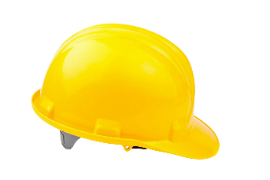 | Hard hat / protect head
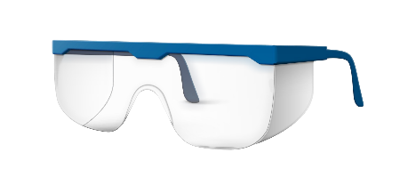 | Safety glasses / protect eyes
 | Safety boots / protect feet
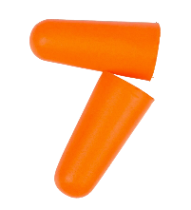 | Earplugs / protect hearing
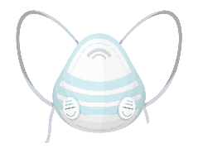 | Dust mask / protect lungs
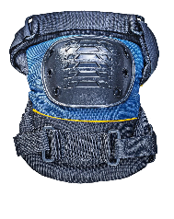 | Knee pads / protect knees
 | Safety gloves / protect hands
 | Hi-Viz vest / visibility for wearer
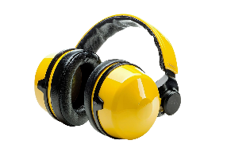 | Ear defenders / protect hearing
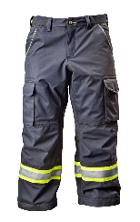 | Work trousers / protect legs
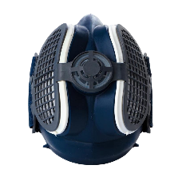 | Respirator / protect lungs

- Why is it important to check that your PPE is in good working order before and after use?
It is important to check that your PPE is in good working order before and after use to ensure it provides the necessary protection. Damaged or faulty PPE may not perform as intended, putting the user at risk of injury. Regular checks help maintain its effectiveness and identify any wear and tear that might compromise safety.
- Who is responsible for maintaining personal protective equipment on a building site?
While the employer is responsible for providing PPE, the employee is also responsible for ensuring it is in good working order before and after use.
- Who is responsible for providing PPE in the workplace if it is deemed necessary?
The employer is responsible for providing PPE in the workplace if it is deemed necessary.

Task 5: Access equipment
Objective: To identify different types of ladders, understand their safe use, and perform pre-use safety checks.
Tutor role:
Demonstrate safe handling, transportation, and erection of ladders (e.g., 4:1 rule).
Explain common hazards associated with working at height. Refer to HSE guidance.
Key learning points: Ladder types (extension, stepladder, multi-purpose), pre-use checks, safe erection (4:1 rule), securing ladders, safe ascent/descent, HASWA compliance.
Assessment: Observe practical application of ladder safety, including visual inspection, correct lifting/carrying, and safe erection/dismantling. Review completed assessment criteria.
Expected learner outcomes:
- Identify and name different types of access equipment, specifically ladders.
- List of essential safety checks to perform before using a ladder.
- Demonstrate the correct 4:1 angle for ladder erection.
- Safely transport, erect, ascend, descend and lower a ladder.
Potential learner struggles:
- Incorrectly setting the ladder angle (4:1 rule).
- Forgetting to secure the ladder before ascending.
- Not conducting a thorough visual inspection for defects.
Suggestions for improvement:
- Use a marked wall to visually demonstrate the 4:1 rule.
- Provide a checklist for ladder inspections that learners must complete.
- Encourage peer observation and feedback during the practical task.
Suggestions for stretch activity:
- Research and present on other types of access equipment (e.g., scaffolding, mobile elevated work platforms – MEWPs) and their safety requirements.
- Ask learners to identify potential hazards when working at height in different environments (e.g., uneven ground, near power lines).

- What type of ladder is shown here (Figure 5.1), and what safety checks should be carried out before using this type of ladder?

Steel scaffold ladder
- Stiles: Check for any signs of twisting, bending, denting or damage. Damaged stiles can cause the ladder to buckle or collapse.
- Feet: Inspect for wear and damage, or if they are missing. Ensure they are in good condition to prevent slipping.
- Rungs: Examine for cracks, bends, wear, looseness or if any are missing. These can affect the stability of the ladder and the user's safety.
- Locking mechanisms: If the ladder has locking bars or other mechanisms, ensure they work correctly, not bent, worn, or damaged.
- Tie rods: Check for missing or damaged tie rods, as they provide stability to the ladder.
- Welded joints: Look for cracks or damage in welded joints, which are crucial for the ladder's structural integrity.
- Stays: Inspect for damage to stays, which help support the ladder's structure.
- Treads: Ensure treads are not slippery or contaminated.

- Label the diagram (Figure 5.1).

- 1 metre or over
- Lashings/clamps
- 4:1
- 75° angle

- Identify the two other types of ladders shown below and list any safety checks that must be carried out before use.

Step ladders
- Overall condition: Inspect stiles (side rails) and rungs/treads for any visible damage, such as bends, cracks, splits, dents, or twists. Ensure they are clean and free from slippery substances.
- Stability and feet: All four feet must be present, securely fitted, undamaged, and have effective anti-slip surfaces. Ensure the ladder is placed on a firm, level, non-slippery surface.
- Secure rungs/treads: Verify all rungs or treads are firmly attached to the stiles, free from damage, and have intact anti-slip surfaces.
- Locking mechanisms (if applicable): Ensure spreaders are fully engaged for stepladders. For extension ladders, confirm all locking clasps/hooks are working correctly and fully engaged.
Telescopic ladders
- Overall condition: Inspect all sections for bends, dents, cracks, twists or other damage. Ensure the ladder is clean and free from oil, grease or other slippery substances.
- Locking mechanisms and buttons: Crucially, check that all rung locking mechanisms (pins, buttons, or clips) are present and fully functional, and that they engage securely when extended. Inspect for damage or wear.
- Feet/end caps: All four feet must be present, securely attached, undamaged, and have effective anti-slip surfaces. Ensure they are placed on a firm, level, non-slippery surface.
- Smooth operation: Extend and retract the ladder (or a section of it) to ensure all sections slide smoothly and that there's no excessive play, sticking or jamming.

- Safe use of ladders exercise
 | ASSESSMENT CRITERIA |  | Y | N
1 | Displays warning notices in the appropriate positions
2 | Visually inspects ladder
3 | Lifts and carries ladder correctly
4 | Erects ladder correctly
5 | Slope of ladder correctly set to gradient
6 | Top extends>1.07m above landing (5 rungs)
7 | Safe position of ladder rung adjacent to transom
8 | Secured ladder before ascending
9 | Ascends and descends ladder in a safe manner
10 | Secures top of ladder safely
11 | Lowers ladder correctly
12 | Returns ladder safely to start position.
13 | Work conformed to the requirements of HASWA
 | Total

Task 6: Manual handling
Objective: To understand manual handling regulations and apply safe lifting and handling techniques.
Point learners to the HSE-Manual Handling webpage.
Tutor role:
Explain the three ways employers manage manual handling risks and the six ways to reduce injury.
Demonstrate correct lifting techniques (e.g., 'think before you lift', 'keep load close', 'stable position').
Supervise closely during practical lifts.
Key learning points: Manual Handling Regulations, risk reduction strategies, correct lifting posture and technique, teamwork in lifting.
Assessment: Observe learners' practical application of safe manual handling techniques for individual and assisted lifts. Review completed assessment criteria.
Expected learner outcomes:
- Explain the principles of safe manual handling.
- Demonstrate correct posture and technique for lifting and carrying objects.
- Understand the importance of teamwork in handling heavy or awkward objects.
- Identify ways to reduce manual handling risks.
Potential learner struggles:
- Forgetting to bend knees or keeping a straight back.
- Attempting to lift objects that are too heavy alone.
- Poor communication when working with a partner.
Suggestions for improvement:
- Use a ‘spotter’ system during practice lifts to provide immediate feedback.
- Show videos demonstrating correct and incorrect lifting techniques.
- Discuss the long-term health implications of poor manual handling.
Suggestions for stretch activity:
- Ask learners to analyse a real-world manual handling task and suggest improvements based on the principles learned.
- Challenge learners to design a simple mechanical aid for a specific manual handling task.

  - The Manual Handling Regulations set out three ways that employers must manage the risks from manual handling. What are they?

The Manual Handling Regulations set out three ways that employers must manage the risks from manual handling:

- Avoid hazardous manual handling operations so far as reasonably practicable.
- Assess any hazardous manual handling operations that cannot be avoided.
- Reduce the risk of injury from hazardous manual handling operations as reasonably practicable.

  - List six things that can be done to reduce the risk of injury from manual handling tasks you can't avoid.

Potential answers.
- Think before handling/lifting.
- Keep the load close to your waist.
- Adopt a stable position.
- Ensure a good hold on the load.
- Slight bending of your back, hips and knees at the start of the lift.
- Don't flex your back any further while lifting.
- Avoid twisting your back or leaning sideways.
- Keep your head up when handling.
- Move smoothly.
- Don't lift or handle more than you can easily manage.
- Put down, then slide load into the desired position.

  - Practical task

 | ASSESSMENT CRITERIA | Y | N
1 | Takes firm grip with palms and fingers of both hands
2 | Feet positioned correctly for lift
3 | Knees bent correctly for lift
4 | Straight back, chin in
5 | Arms tight to body
6 | Carries object safely to bench
7 | Rests object carefully and safely onto bench
8 | Takes firm grip and lifts correctly
9 | Carries object safely and lowers correctly
10 | Knees bent, back straight
11 | Rests object safely to floor
12 | Gives assistant clear and concise instructions at the start of the task
13 | Knees bent to commence lift
14 | Straight back during lift
15 | Work conformed to the requirements of HASWA
 | Totals

Task 7: Safe isolation
Objective: To understand electrical hazards and types of electrical injuries and to correctly perform safe isolation procedures.
Point learners to the following websites: HSE-Electricity Safety and Electrical Safety First's guide on safe isolation procedures.
Tutor role:
Emphasise the critical importance of safe isolation.
Demonstrate each step of the safe isolation procedure meticulously.
Provide hands-on practice with voltage indicators, proving units, and locking devices.
Key learning points: Main electrical hazards (shock, burns, arc flash), types of electrical injuries, statutory documents (EAWR, BS 7671), PPE for electrical work, full safe isolation procedure (identify, switch off, secure, prove dead, re-prove).
Assessment: Observe strict adherence to the safe isolation procedure. Ensure learners can correctly use test equipment and apply locking devices.
Expected learner outcomes:
- Identify the main hazards of working with electricity.
- Describe the four types of electrical injuries.
- List the PPE and equipment required for safe isolation.
- Perform the full safe isolation procedure on a single-phase consumer unit.
Potential learner struggles:
- Forgetting to prove the voltage indicator on a proving unit before and after testing.
- Not correctly identifying the point of isolation.
- Failing to remove and retain the key for the locking device.
Suggestions for improvement:
- Use a dedicated ‘safe isolation rig’ for repeated practice.
- Discuss the legal consequences of failing to isolate safely.
Suggestions for stretch activity:
- Challenge learners to perform the safe isolation procedure for a three-phase system.
- Ask learners to research and explain the concept of ‘lockout/tagout’ (LOTO) procedures in industrial settings.

- The HSE lists the main hazards of working with electricity. What are they?
The main hazards of working with electricity are electric shock, burns and arc flash.
- List four types of injuries you could receive from electrical systems.
- electric shock
- electrical burns
- loss of muscle control
- thermal burns
- fractures
- respiratory tissue damage.

- Which two statutory documents underpin the Electrical Safety First best practice guide on safe isolation?
The two statutory documents that underpin the Electrical Safety First best practice guide on safe isolation are the Health and Safety at Work Act (HASAWA) and Electricity at Work Regulations (EAWR).
- List the PPE and equipment required when carrying out safe isolation of electrical systems.
The PPE and equipment required when carrying out safe isolation of electrical systems include:
- appropriate PPE (e.g., safety glasses, gloves)
- approved voltage indicator
- proving unit
- locking device
- warning label
- padlock.
- List the stages detailing the full safe isolation procedure for a complete single-phase 230 V circuit consumer unit.
- Identify the correct point of isolation.
- Switch off OCPDs (Overcurrent Protective Devices) and Main Switch.
- Remove consumer unit cover.
- Select an approved voltage indicator and check it is serviceable and safe to use.
- Carry out a 3-point test on the consumer unit using an approved voltage indicator.
- Re-prove the approved voltage indicator on the proving unit.
- Correctly fit the locking device, label and padlock.
- Remove and retain the key.

- Practical task
 | ASSESSMENT CRITERIA | Y | N
1 | Selected correct PPE, tools and equipment for task
2 | Identified the correct point of isolation
3 | Asked permission to turn off supply to consumer unit
4 | Selected approved voltage indicator and proves on proving unit
5 | Switched off OCPDs and Main Switch and removed consumer unit cover
6 | Carried out 3-point test on consumer unit
7 | Re-proved approved voltage indicator on proving unit
8 | Correctly fitted locking device, label and padlock
9 | Removed and retained key
10 | Completed the task within target time
11 | Refixed all accessory covers and switched on Main Switch and OCPDs
12 | Work conformed to the requirements of HASWA/EAWR
 | Totals

Task 8: Identification of tools and equipment
Objective: To identify common electrical tools and equipment and understand their correct uses.
Tutor role:
Provide a range of tools and equipment for learners to handle and inspect.
Discuss the specific applications and safety considerations for each tool.
Encourage learners to ask questions if unfamiliar.
Key learning points: Correct naming and function of various hand tools, power tools and test equipment used in electrical installation. Importance of checking tools for safety and good working order.
Assessment: Evaluate the learner's ability to correctly name tools and describe their uses.
Expected learner outcomes:
- Correctly name and identify at least 15 common electrical tools and equipment.
- Describe the primary use(s) of each identified tool.
- Explain the procedure for using an unfamiliar tool.
- Justify the importance of checking tools for safety and good working order.
Potential learner struggles:
- Confusing tools with similar appearances or functions.
- Providing vague descriptions of tool uses.
- Not knowing the correct procedure for an unfamiliar tool.
Suggestions for improvement:
- Create a ‘tool recognition’ station with various tools for learners to interact with.
- Use flashcards or a matching game for tool identification.
- Encourage learners to demonstrate the correct grip and use of a tool.
Suggestions for stretch activity:
- Ask learners to research and present on a specialised electrical tool not covered in the workbook.
- Challenge learners to identify the correct tool for a specific, complex electrical task.

- Identify the tools and equipment and describe their use.
Tools/Equipment | Name/Use
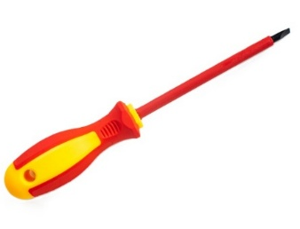 | Insulated screwdrivers / Tighten screws and terminals
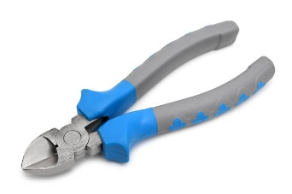 | Insulated cable cutters / Cutting cables
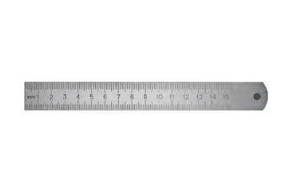 | Metal rule / Measuring and marking
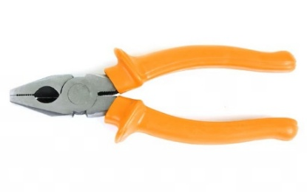 | Insulated pliers /  Used to safely grip and manipulate materials or wires
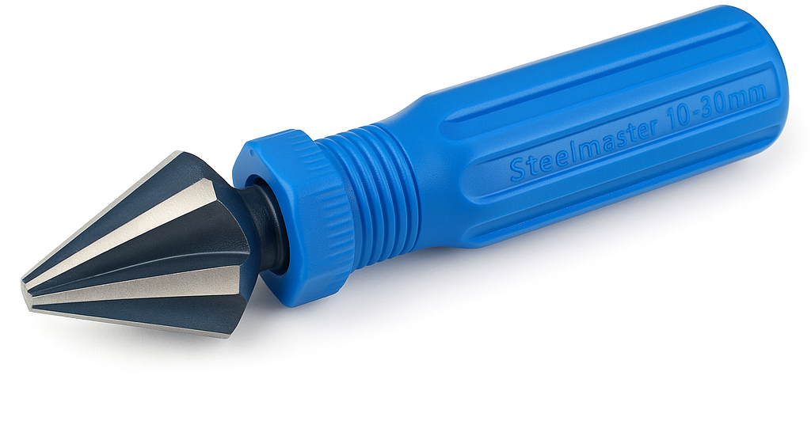 | Tapered reamer deburring tool /  Used to smooth and enlarge the inside diameter of cut conduit, removing burrs and sharp edges
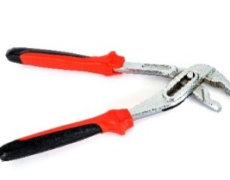 | Water pump pliers /  Used to tighten and hold nuts and bolts, gripping irregularly shaped objects
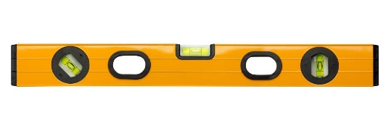 | Level /  Marking horizontal and vertical lines
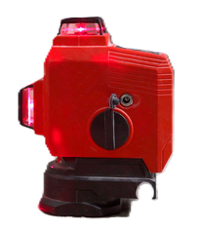 | Laser level /  Marking horizontal and vertical lines from a common datum line
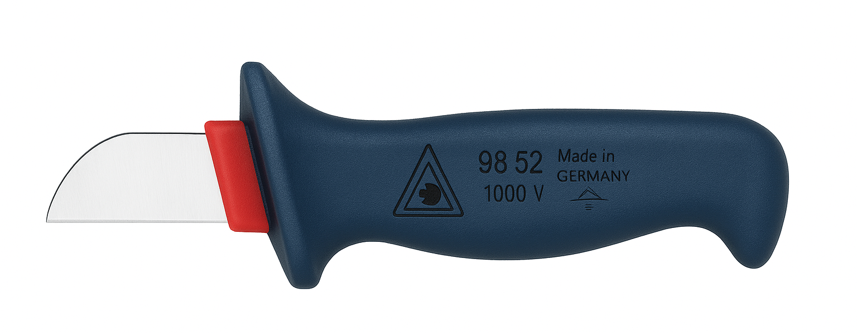 | Electrician's knife / Stripping cable outer sheath
 | Pad saw / cutting plasterboard
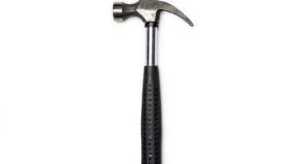 | Claw hammer /  driving or removing nails
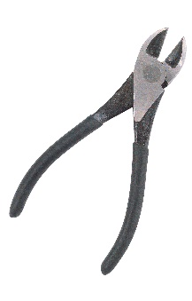 | Single-core cable strippers /  Removal of cable insulation
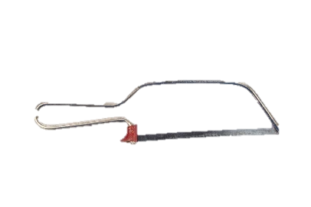 | Junior hacksaw / cutting metal
 | Tape measure /  Measuring and marking
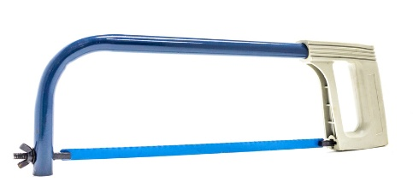 | Hacksaw / cutting metal
 | Cross-cut hand saw / cutting timber
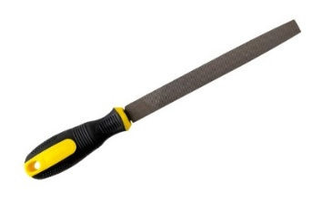 | File /  removal of sharp edges and burrs
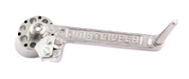 | Joistripper /  Used for stripping MICC cable sheath from 2L1 to 4L1
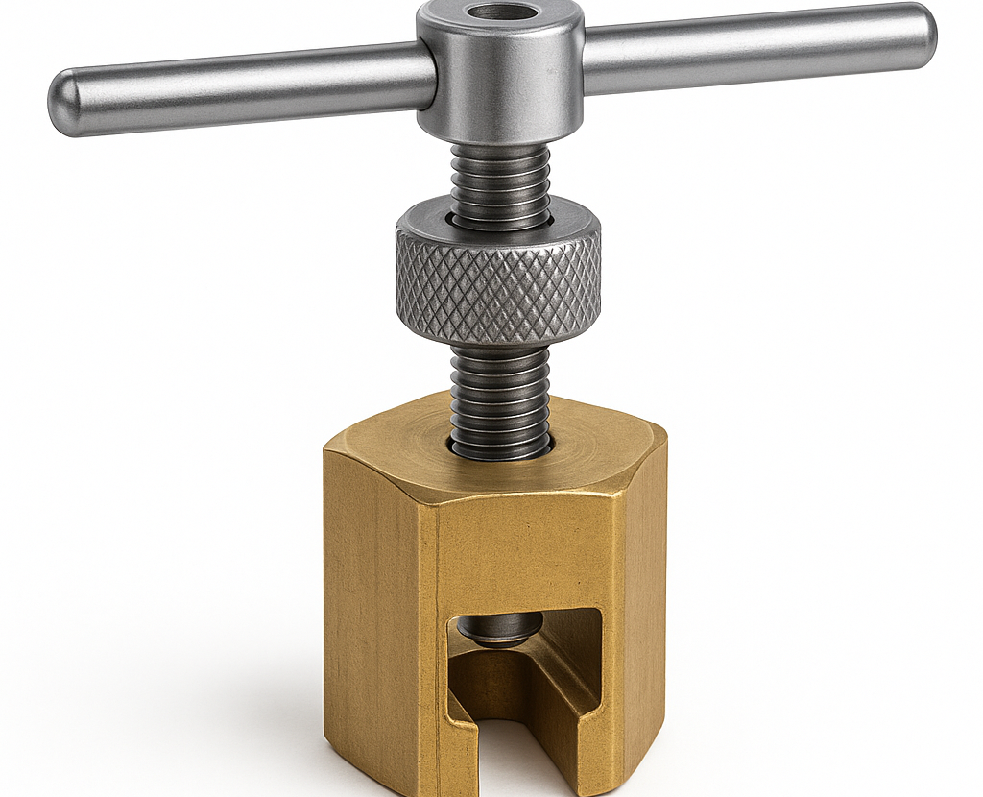 | MICC pot crimper tool /  Used to secure the pot seal on mineral-insulated cable terminations
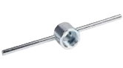 | Pot wrenches /  Used for fixing the pot to MICC cable
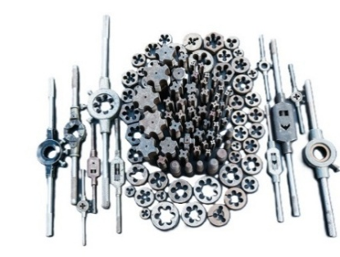 | Stock and die set /  Used to cut a thread onto steel conduit.
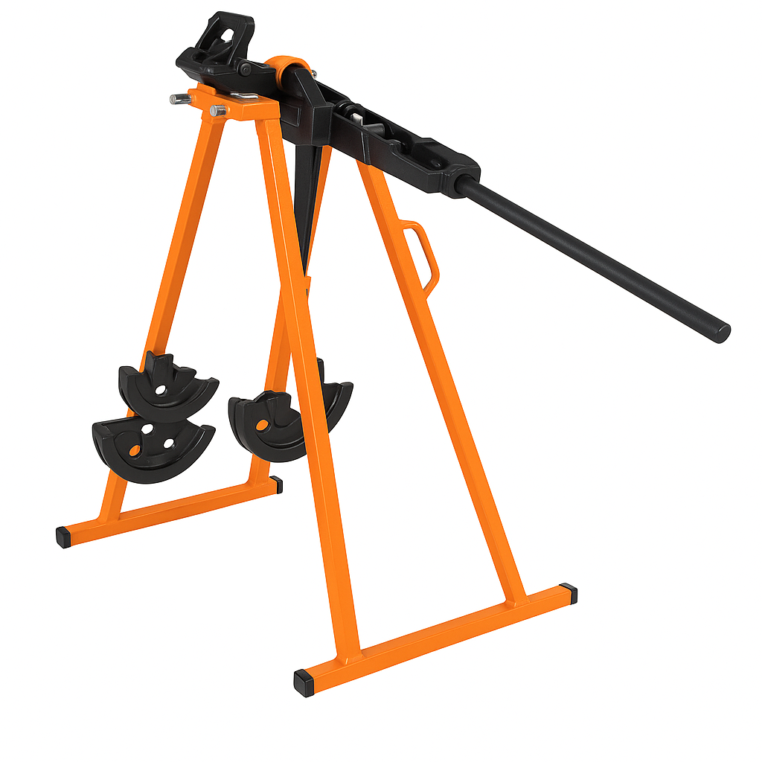 | Conduit bender /  Used to bend and form conduit
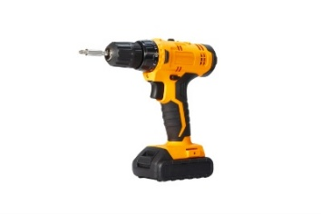 | Battery hand drill /  Portable drilling of materials
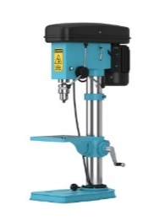 | Pillar drill /  Used for precision drilling
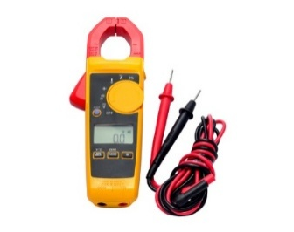 | Approved voltage indicator and proving unit /  Testing for voltage on circuits when carrying out safe isolation
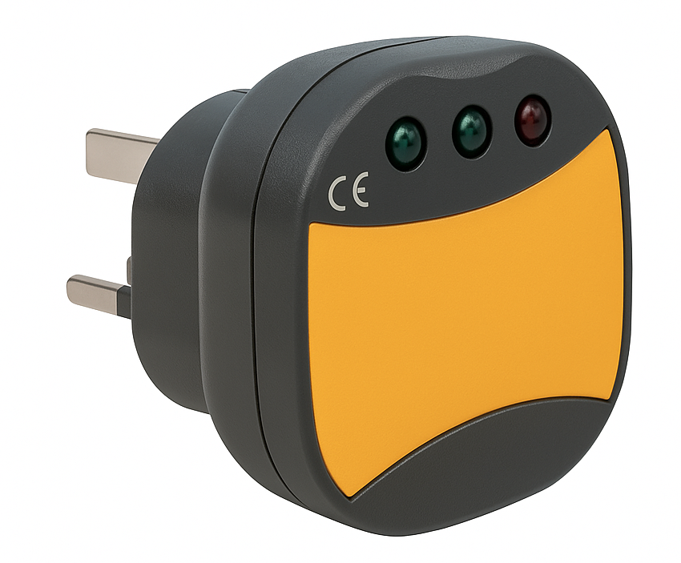 | Socket tester /  Used to check polarity at socket outlets
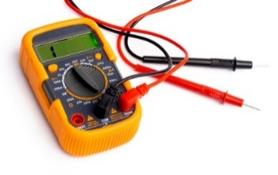 | Multi-function tester /  Used to perform multiple tests on electrical wiring systems

- What procedure would be followed if you were asked to use a tool that was unfamiliar to you?
If you're asked to use an unfamiliar tool:
- Don't use it immediately.
- Inform your supervisor and request training and the manufacturer's manual.
- Understand its purpose, function and safety features.
- Identify potential hazards and ensure you have the correct Personal Protective Equipment (PPE).
- Ask questions until you fully understand safe operation.
- Adhere to all safety procedures.

- Why is it important to check that the tools and equipment you use are safe and in good working order before and after using them?

Checking tools and equipment before and after use is crucial for:
- Safety: Prevents accidents, injuries, and electrical shocks from faulty equipment.
- Functionality: Ensures the tool works correctly, improving work quality and efficiency.
- Maintenance: Identifies issues early, preventing costly repairs and extended downtime.
- Longevity: Proper cleaning, maintenance and storage extend the tool's lifespan.
- Compliance: Meets health and safety regulations.

Task 9: Measuring and cutting
Objective: To accurately measure and cut various types of conduit and trunking to specified lengths.
Tutor role:
Explain metric and imperial units.
Demonstrate precise measuring techniques and safe cutting methods for different materials (plastic conduit, steel conduit, plastic trunking, steel trunking, steel tray).
Emphasise the importance of deburring.
Key learning points: Metric versus Imperial units, accurate measurement, safe cutting techniques for different containment systems, importance of square cuts and deburring.
Assessment: Assess the accuracy of cut lengths and the quality of the cuts (squareness, absence of burrs).
Expected learner outcomes:
- Read and interpret measurements accurately using a tape measure (metric).
- Safely and accurately cut plastic and steel conduit to specified lengths.
- Safely and accurately cut plastic and steel trunking to specified lengths.
- Deburr all cut edges effectively.
Potential learner struggles:
- Inaccurate measurement (e.g., parallax error).
- Uneven or non-square cuts.
- Forgetting or inadequately deburring cut edges, leading to sharp hazards.
Suggestions for improvement:
- Provide clear marking guides or jigs for cutting.
- Emphasise the ‘measure twice, cut once’ principle.
- Have learners peer-assess each other's cuts for accuracy and deburring.
Suggestions for stretch activity:
- Challenge learners to cut and join sections of trunking/conduit to form a perfect right angle or a T-junction without pre-made fittings.
- Introduce cutting of larger diameter conduit or tray.

Instructions: Select the following sizes of conduit and trunking and cut them into the lengths, shown in the table below.
Type | Size | Cut Length | Achieved (Y/N)
Plastic conduit | 20 mm | 100 mm
Plastic conduit | 25 mm | 110 mm
Plastic conduit | 32 mm | 120 mm
Steel conduit | 20 mm | 100 mm
Steel conduit | 32 mm | 110 mm
Plastic trunking | 25 mm x 16 mm | 150 mm
Plastic trunking | 40 mm x 25 mm | 20 cm
Steel trunking | 2” x 2” | 15 cm
Steel trunking | 4” x 4” | 200 mm
Steel tray | 75 mm | 20 cm

Task 10: Identification of cable types, fixings, termination and accessories
Objective: To identify various cable types, fixings, termination devices, and wiring accessories, and understand their applications.
Tutor role:
Provide physical samples of each item.
Discuss their characteristics, typical uses, and relevant standards.
Key learning points: Identification of common cable types (e.g., T&E, SWA, flex), their applications, various cable fixings (clips, glands), termination devices (connectors, terminals), and wiring accessories (sockets, switches).
Assessment: Evaluate the learner's ability to correctly identify and describe the use of each item.
Expected learner outcomes:
- Identify and name at least eight common cable types and their typical uses.
- Identify and name at least five cable fixings and describe their uses.
- Identify and name at least three electrical termination devices and describe their uses.
- Identify and name at least five wiring accessories and describe their uses.
Potential learner struggles:
- Confusing similar cable types or fixings.
- Difficulty articulating the specific application or advantage of certain items.
- Overlooking fewer common accessories.
Suggestions for improvement:
- Create a ‘show and tell’ station with labelled examples of each item.
- Use a quiz format where learners match items to their descriptions.
- Discuss the relevant British Standards for each item.
Suggestions for stretch activity:
- Ask learners to research a specialised cable type (e.g., data, fibre optic, fire alarm) and its installation requirements.
- Challenge learners to design a small electrical circuit and list all the necessary cables, fixings, and accessories.

- Identify the type of cable and describe its use.
Cable | Name/Use
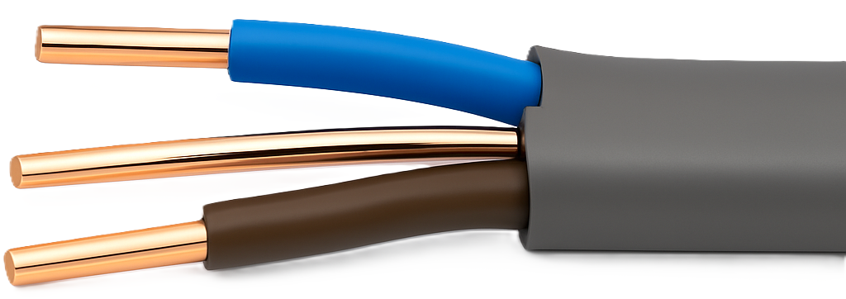 | PVC/PVC-sheathed flat-profile cable with integral CPC /  Domestic lighting and power circuit
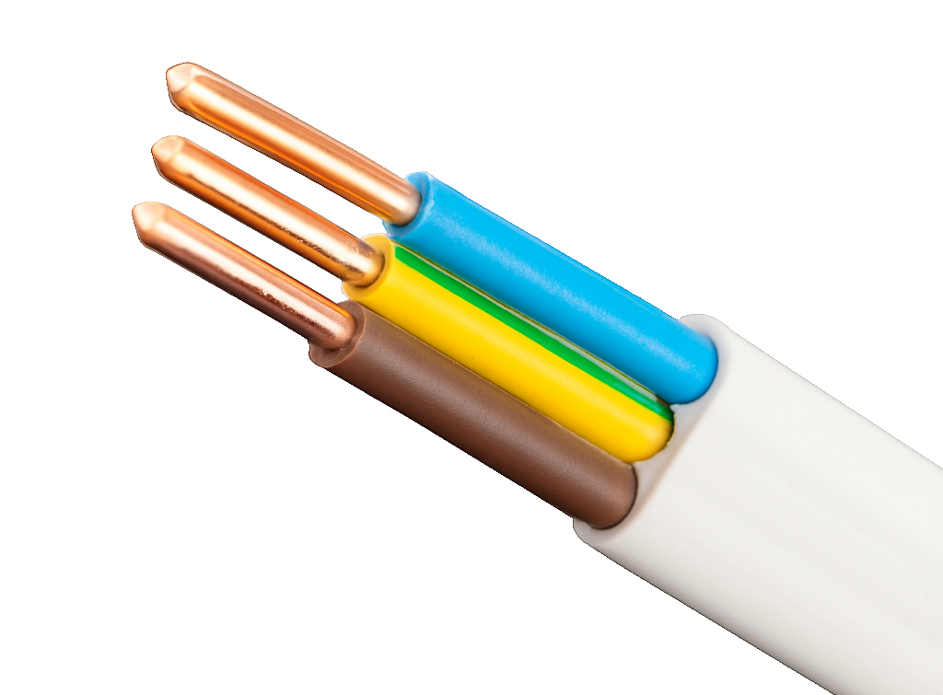 | Circular flexible cords / Portable equipment and heating controls
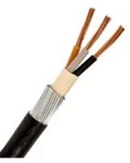 | Steel wire armoured cable / Outside lighting and power
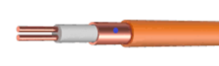 | Mineral-insulated cable / Circuit critical applications such as fire/smoke systems
 | Unshielded twisted pair (UTP cables /  Data transmission
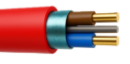 | Fire platinum-resistant cable / Circuit critical applications such as fire and emergency lighting systems
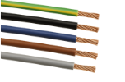 | Single-core insulated cable / Lighting and power circuits
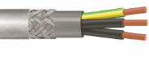 | Steel wire braid PVC cable (SY) / Flexible armoured control cable commonly used in industrial settings for controlling and regulating machinery, particularly in applications with medium to high mechanical stress
- Identify the cable fixing and describe its use.
Fixing | Name/Use
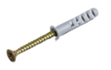 | Plugs and screws /  Used together to securely mount objects to plasterboard, brick or concrete
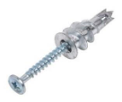 | Plasterboard fixings /  Used to provide a secure and long-lasting fixing to plasterboard or dry-walling
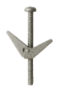 | Spring toggles or toggle bolts / Used to secure items to hollow walls like plasterboard or drywall
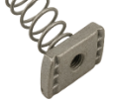 | Spring channel nuts /  Used in strut channel systems
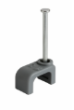 | T&E cable clips /  Used to securely fasten T&E cables to surfaces like walls or wooden joists.
 | P-clips /  Used to secure round cables to flat surfaces
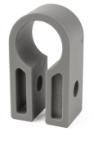 | SWA cable cleat /  Used to securely fix and support SWA cables
 | Plastic conduit saddles /  Provides fixing and support to conduit runs on flat surfaces
 | Plastic compression glands /  Used to secure and seal cables where they enter equipment or enclosures
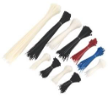 | Plastic zip ties /  Used for bundling and securing cables

- Identify the electrical termination device and describe its use.
Termination | Name/Use
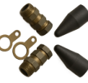 | SWA cable gland /  Used to terminate and seal SWA cables into enclosures
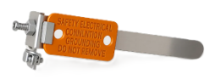 | BS 951 clamp /  Bonding extraneous pipework
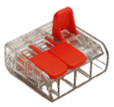 | Non-screw compression connector / Joining cables
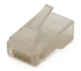 | RJ45 connector /  Standardised connector used for network cabling.
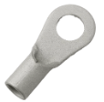 | Uninsulated ring crimp /  To create secure electrical connection to a screw or bolt
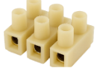 | Terminal connectors /  Used to securely join electrical wires or circuits

- Identify the electrical accessory and describe its use.
Accessory | Name/Use
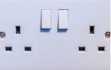 | BS 1363 socket outlets /  Used as a connection point between power circuits and electrical devices
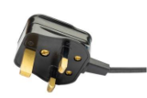 | BS 1363 pin plug /  Used to connect devices to sockets via flexible cable
 | 20A junction box /  An electrical enclosure used to safely house wiring connections to existing circuits
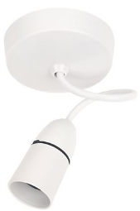 | Pendant ceiling rose /  Used to connect wiring to a ceiling light fixture
 | 1 gang switch /  Used to control lighting
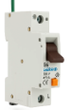 | Residual current circuit breaker with overcurrent protection /  A device that protects electrical circuits from both overcurrent and earth leakage faults.
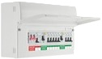 | Consumer unit /  Central control and distribution point for electricity in a building.
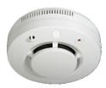 | Optical smoke alarm /  Used to detect smoke and provide an audible alarm.
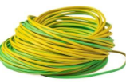 | Earth sleeving /  Used to insulate and identify circuit protective conductors in electrical installations
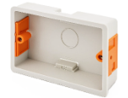 | Fast fix socket box or dry lining box /  Used for mounting sockets and switches in plasterboard or dry-lined walls.
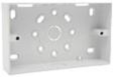 | Surface pattress back box /  Used where installation within the wall is not possible or desired
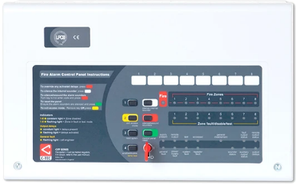 | Fire alarm panel /  The central control unit of a fire alarm system
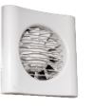 | Extractor or ventilation fan /  A mechanical device that removes air from a room and expels it outside

- Identify the wiring accessories and describe their use.
Wiring Accessory | Name/Use
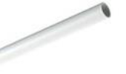 | Plastic conduit /  Used to protect electrical wiring in walls or ceilings.
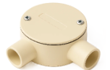 | Plastic conduit right-angle box /  A junction box allowing 90-degree change in direction of the conduit run.
 | Plastic conduit inspection bend / Provides a 90-degree bend in the conduit run while also offering access for inspection and cable installation/maintenance
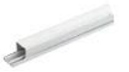 | Plastic trunking /  Used to protect and conceal electrical and data cables
 | Mini trunking right-angle covers / Creates neat and finished corners when installing plastic mini trunking
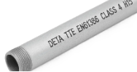 | Steel conduit /  Used to protect electrical wiring, in indoor and outdoor wiring systems
 | Steel conduit stop end box /  Used to protect electrical conductors against mechanical and electrical damage.
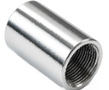 | Steel conduit couplers /  Used to securely join two lengths of steel conduit together
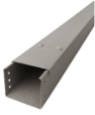 | Steel trunking /  Used for protecting electrical cables in industrial, commercial, and outdoor environments
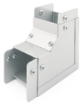 | Steel trunking internal 90-degree bend /  Used to allow steel trunking to make a sharp, 90-degree turn inwards
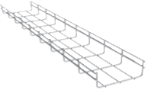 | Steel cable basket /  Used for supporting lightweight cables while allowing air circulation and visibility of the wiring

Task 11: Cable termination
Objective: To safely and correctly strip and terminate various types of cables.
Tutor role:
Demonstrate precise cable-stripping techniques, ensuring no damage to conductors or insulation.
Emphasise proper conductor preparation (e.g., twisting strands, doubling ends). Supervise closely.
Key learning points: Safe cable stripping, maintaining conductor CSA, correct sleeving (cpc), conductor preparation for termination, secure connections.
Assessment: Evaluate the quality of cable stripping, conductor preparation, and the security of terminations.
Expected learner outcomes:
- Safely remove outer sheathing from PVC/PVC cables without damaging insulation.
- Correctly strip insulation from individual conductors to the required length.
- Properly sleeve the CPC (circuit protective conductor) where applicable.
- Prepare stranded conductors (e.g., twisting) for termination.
- Terminate cables securely into plug tops and other accessories.
Potential learner struggles:
- Cutting too deeply and nicking conductor insulation.
- Leaving too much or too little bare conductor exposed.
- Failing to twist stranded conductors tightly when necessary.
- Loose connections at terminals.
Suggestions for Improvement:
- Provide clear visual examples of correctly and incorrectly stripped/terminated cables.
- Peer assessment of completed work.
- Emphasise the mechanical and electrical integrity of terminations.
Suggestions for stretch activity:
- Introduce different types of terminals (e.g., crimp terminals, screwless terminals) and have learners practice.
- Challenge learners to terminate a multi-core flexible cable into a more complex appliance.

 | ASSESSMENT CRITERIA | Y | N
1 | Selected correct PPE, tools and equipment for task
2 | Sheath cut back correctly and to correct length
3 | Insulation undamaged and to the correct length
4 | Conductor cores undamaged
5 | Cpc correctly sheathed and to the correct length
6 | Conductor cores bent over where necessary and to the correct length
7 | Overall appearance to a commercially acceptable standard
8 | Completed task within target time
9 | Work conformed to the requirements of HASWA/EAWR
 | Totals

 | ASSESSMENT CRITERIA | Y | N
1 | Selected correct PPE, tools and materials for task
2 | Correctly completed tool and material lists
3 | Removed outer layer of cable to expose required length of wires, completed without damage to the insulation of the wires
4 | Removed the insulation to expose the required length of bare wire
5 | Securely fixed the bare wires to the appropriate terminals
6 | Ensured no bare strands of wire are visible
7 | Used the cable grip correctly, and the cable is secure
8 | Replaced the plug cover
9 | Identified and selected tools and equipment required
10 | Completed task within target time
11 | Work conformed to the requirements of HASWA/EAWR
 | Totals

Task 12: PVC/SWA cable termination
Objective: To proficiently terminate PVC/SWA cable using appropriate glands.
Tutor role:
Provide a detailed demonstration of SWA cable termination, focusing on scoring the sheath, cutting the armour, preparing the wires, and correctly assembling the gland.
Emphasise safety and neatness.
Key learning points: Step-by-step SWA termination, use of specific tools (hacksaw, knife), correct gland assembly (BW gland), ensuring mechanical and electrical integrity, safety considerations (sharp armour).
Assessment: Assess the quality of the SWA termination, gland assembly, and overall neatness and safety.
Expected learner outcomes:
- Safely and accurately remove the outer PVC sheath and steel wire armour from SWA cable.
- Correctly prepare the armour wires for gland termination.
- Assemble and fit various glands securely to the SWA cable and enclosure.
- Ensure no sharp armour wires are exposed.
Potential learner struggles:
- Cutting too deeply and damaging inner insulation when scoring the outer sheath.
- Leaving sharp or uneven armour wires.
- Incorrect assembly sequence of gland components.
- Not achieving a secure grip on the armour.
Suggestions for improvement:
- Use a cut-away model of an SWA gland to show internal components and their function.
- Provide a step-by-step pictorial guide for SWA termination.
- Emphasise the importance of deburring and smoothing any sharp edges.
Suggestions for stretch activity:
- Introduce different types of SWA glands (e.g., A2, E1W) and their applications.
- Challenge learners to terminate a larger diameter SWA cable.

 | ASSESSMENT CRITERIA | Y | N
1 | Selected correct PPE, tools and materials for task
2 | Correctly completed tool and material lists
3 | Removed outer layer of cable to expose required length of wires, completed without damage to the insulation of the wires
4 | Removed the insulation to expose the required length of bare wire
5 | Securely fixed the bare wires to the appropriate terminals
6 | Ensured no bare strands of wire are visible
7 | Used the cable grip correctly, and the cable is secure
8 | Replaced the plug cover
9 | Identified and selected tools and equipment required
10 | Completed task within target time
11 | Work conformed to the requirements of HASWA/EAWR
 | Totals

Task 13: Installing lighting circuits – PVC/PVC (1-way)
Objective: To install a basic 1-way lighting circuit using PVC/PVC cable.
Tutor role:
Explain the circuit diagram and loop-in method.
Demonstrate correct cable routing, clipping, and accessory termination.
Emphasise neatness, correct polarity, and secure connections.
Key learning points: 1-way lighting circuit principles, loop-in wiring method, cable clipping standards, accessory installation, secure and identified terminations, BS 7671 compliance.
Assessment: Evaluate adherence to wiring regulations, neatness of installation, and security of all terminations.
Expected learner outcomes:
- Correctly interpret a 1-way lighting circuit diagram.
- Install PVC/PVC cable neatly and securely using appropriate clips.
- Terminate cables correctly at the consumer unit, switch, and ceiling rose/lamp holder.
- Ensure all protective conductors are correctly sleeved.
- Achieve mechanically and electrically sound terminations.
Potential learner struggles:
- Incorrect cable routing or clipping spacing.
- Poor termination, leading to loose connections or exposed conductors.
- Forgetting to sleeve the CPC or using the wrong colour.
- Difficulty in understanding the loop-in method.
Suggestions for improvement:
- Provide a clear, large-scale wiring diagram for reference.
- Use a ‘mock-up’ board for initial practice before final installation.
- Emphasise visual inspection of all terminations before power-up.
Suggestions for stretch activity:
- Ask learners to draw a different wiring method for a 1-way circuit (e.g., junction box method) and discuss pros/cons.
- Challenge learners to integrate a dimmer switch into the circuit.

 | ASSESSMENT CRITERIA | Y | N
1 | Selected correct PPE, tools and materials for task
2 | Correctly completed tool and material lists
3 | All accessories assembled correctly and undamaged
4 | PVC cable clipped flat and straight to surface
5 | Clip positions and spacings acceptable
6 | Bends formed to an acceptable standard
7 | Cable sheath taken into accessories
8 | All circuit protective conductors sleeved
9 | Minimum insulation removed and conductors undamaged
10 | Acceptable amount of spare left at all terminations
11 | All conductors secured in all terminations
12 | All conductors identified in switch terminations
13 | Completed task within target time
14 | Work conformed to the requirements of HASWA/EAWR
 | Totals

Task 14: Installing lighting circuits – PVC/PVC
Objective: To install a 2-way lighting circuit using PVC/PVC and 3-core cable.
Tutor role:
Explain the principles of 2-way switching and the role of 3-core cable.
Demonstrate the wiring connections at both switches and the batten holder.
Key learning points: 2-way switching principles, use of 3-core and earth cable, identification of conductors (switched lines), correct termination at 2-way switches.
Assessment: Assess the functional correctness of the 2-way circuit, neatness, and compliance with wiring standards.
Expected learner outcomes:
- Correctly interpret a 2-way lighting circuit diagram.
- Install PVC/PVC and 3-core cable neatly and securely.
- Terminate cables correctly at both 2-way switches and the lamp holder.
- Properly identify, sleeve and connect switched lines (strappers).
Potential learner struggles:
- Confusing the common terminal with switched line terminals.
- Incorrectly identifying the colours for switched lines.
- Poor cable management, especially with the additional conductors.
Suggestions for improvement:
- Use a colour-coded diagram for the 2-way switching.
- Provide a fault-finding scenario if the circuit doesn't work.
- Discuss the different types of 2-way switch arrangements (e.g., intermediate switch).
Suggestions for stretch activity:
- Challenge learners to install a multi-gang switch controlling multiple 1-way and 2-way circuits.
- Ask learners to explain how an intermediate switch works and integrate one into a 3-way switching circuit.

 | ASSESSMENT CRITERIA | Y | N
1 | Selected correct PPE, tools and materials for task
2 | Correctly completed tool and material lists
3 | All accessories assembled correctly and undamaged
4 | PVC cable is clipped flat and straight to surface
5 | Clip positions and spacings acceptable
6 | Bends formed to acceptable standard
7 | Cable sheath taken into accessories
8 | All circuit protective conductors sleeved
9 | Minimum insulation removed and conductors undamaged
10 | Acceptable amount of spare left at all terminations
11 | All conductors secured in all terminations
12 | All conductors identified in switch terminations
13 | Completed task within target time
14 | Work conformed to the requirements of HASWA/EAWR
 | Totals

Task 15: Installing lighting circuits – FP200 cable
Objective: To install a 1-way lighting circuit using fire-resistant FP200 cable.
Tutor role:
Explain the specific properties and applications of FP200 cable.
Demonstrate the correct methods for stripping and terminating FP200, including the use of fire-rated clips and glands.
Key learning points: Properties and applications of FP200 cable, fire-rated fixings, specific termination techniques for FP200, maintaining circuit integrity.
Assessment: Evaluate the correct use of FP200 cable and accessories, ensuring fire integrity is maintained.
Expected learner outcomes:
- Understand the purpose and characteristics of FP200 fire-resistant cable.
- Safely and correctly strip and terminate FP200 cable.
- Use appropriate fire-rated clips and glands for FP200 installation.
- Install a functional 1-way lighting circuit with FP200 cable.
Potential learner struggles:
- Difficulty stripping FP200 due to its construction.
- Not using the correct fire-rated fixings.
- Damaging the cable during installation, compromising fire integrity.
Suggestions for improvement:
- Provide ample practice material for FP200 stripping and termination.
- Emphasise the importance of maintaining fire integrity and discuss relevant building regulations.
- Show examples of correct and incorrect FP200 installations.
Suggestions for stretch activity:
- Research and present on other types of fire-resistant cables and their applications (e.g., MICC).
- Challenge learners to identify scenarios where FP200 cable is legally required.

 | ASSESSMENT CRITERIA | Y | N
1 | Selected correct PPE, tools and materials for task
2 | Correctly completed tool and material lists
3 | All accessories assembled correctly and undamaged
4 | PVC cable clipped flat and straight to surface
5 | Clip positions and spacings acceptable
6 | Bends formed to an acceptable standard
7 | Cable sheath taken into accessories
8 | All circuit protective conductors sleeved
9 | Minimum insulation removed and conductors undamaged
10 | Acceptable amount of spare left at all terminations
11 | All conductors secure in all terminations
12 | All conductors identified in switch terminations
13 | Completed task within target time
14 | Work conformed to the requirements of HASWA/EAWR
 | Totals

Task 16: Installing Ring Final Circuits – PVC/PVC
Objective: To install a ring final circuit with multiple sockets and a switched fused spur using PVC/PVC cable.
Tutor role:
Explain the concept of a ring final circuit and its advantages.
Demonstrate the continuous loop wiring and the connection of the fused spur.
Key learning points: Ring final circuit principles, wiring multiple sockets, installation of a switched fused connection unit, correct termination at consumer unit and accessories.
Assessment: Assess the functional correctness of the ring circuit, neatness, and compliance with BS 7671.
Expected learner outcomes:
- Correctly interpret a ring final circuit diagram.
- Install PVC/PVC cable to form a continuous ring.
- Wire multiple 13A switched sockets correctly within the ring.
- Install and terminate a 13A switched fused connection unit (SFCU) correctly.
- Ensure all terminations are secure and correctly identified.
Potential learner struggles:
- Breaking the continuity of the ring.
- Incorrectly wiring the SFCU (e.g., incorrect connection to the ring).
- Poor cable management around multiple socket outlets.
Suggestions for improvement:
- Use a large-scale diagram to illustrate the ring circuit concept.
- Produce a written functional test procedure for the ring circuit (e.g., continuity tests).
- Discuss common faults in ring circuits and how to diagnose them.
Suggestions for stretch activity:
- Challenge learners to install a spur from the ring circuit to a fixed appliance.
- Ask learners to study On-Site Guide Appendix H or BS 7671 Appendix and comment on the different requirements for spurred socket outlets and cable CSAs.
- Ask learners to produce a written guide on the test procedure for the ring circuit (e.g., 3-step tests).

 | ASSESSMENT CRITERIA | Y | N
1 | Selected correct PPE, tools and materials for task
2 | Correctly completed tool and material lists
3 | All accessories assembled correctly and undamaged
4 | PVC cable clipped flat and straight to surface
5 | Clip positions and spacings acceptable
6 | Bends formed to acceptable standard
7 | Cable sheath taken into accessories
8 | All circuit protective conductors sleeved
9 | Minimum insulation removed and conductors undamaged
10 | Acceptable amount of spare left at all terminations
11 | All conductors secured in all terminations
12 | Completed task within target time
13 | Work conformed to the requirements of HASWA/EAWR
 | Totals

Task 17: Cutting, bending and terminating conduit
Objective: To develop skills in cutting, bending (90-degree and offset), and terminating both steel and PVC conduit.
Tutor role: Demonstrate the use of conduit bending machines (steel) and bending springs (PVC).
Emphasise accurate marking, precise cuts, and deburring. Show correct threading for steel conduit and termination to boxes.
Key learning points: Conduit cutting techniques (square cuts, deburring), types of bends (90°, offset), use of bending tools, threading steel conduit, correct termination with couplers and bushes.
Assessment: Evaluate the accuracy of bends, quality of cuts, and secure termination of conduit systems.
Expected learner outcomes:
- Safely and accurately cut steel and PVC conduit to specified lengths.
- Produce accurate 90-degree and offset bends in both steel and PVC conduit.
- Correctly thread steel conduit ends.
- Securely terminate conduit to metal and accessory boxes using appropriate fittings.
- Deburr all cut and threaded edges.
Potential learner struggles:
- Inaccurate measurements leading to incorrect bend positions.
- Damaging the conduit during bending. (e.g., kinking or flattening)
- Poorly cut threads on steel conduit.
- Leaving burrs inside conduit, which could damage cables.
Suggestions for improvement:
- Provide dedicated practice pieces for each type of bend.
- Use visual aids showing correct bend measurements and marking.
- Emphasise the importance of a smooth internal finish to prevent cable damage.
Suggestions for stretch activity:
- Challenge learners to create a more complex conduit run involving multiple bends and offsets.
- Ask learners to research and demonstrate the use of a different conduit bending tool (e.g., hydraulic bender).
 | ASSESSMENT CRITERIA | Y | N
1 | Selected correct PPE, tools and materials for task
2 | Correctly completed tool and material lists
Steel conduit
3 | Work carried out in a safe manner
4 | Conduit cut to specified length
5 | Conduit finish undamaged
6 | Conduit end cut square
7 | No burrs left in conduit
8 | Conduit end threaded correctly (no threads showing)
9 | Conduit runner threaded with no excess threads
10 | Conduit terminated to adaptable box correctly
11 | Conduit bushes and couplers tight
12 | Offset produced to good commercial standard
Plastic conduit
13 | Work carried out in a safe manner
14 | Conduit cut to specified length
15 | Terminated correctly to boxes
17 | Right-angle bend fabricated correctly
18 | Completed task within target time
19 | Work conformed to the requirements of HASWA/EAWR
 | Totals

Task 18: Installing lighting circuits – PVC conduit
Objective: To install a 2-way lighting circuit using individual single-core cables within a PVC conduit system.
Tutor role:
Guide learners through running individual conductors within conduit.
Emphasise correct cable pulling techniques and ensure no damage to insulation.
Key learning points: Installation of single-core cables in PVC conduit, conduit routing, termination within accessory boxes, identification of conductors.
Assessment: Assess the neatness of conduit installation, correct cable routing, and secure terminations.
Expected learner outcomes:
- Correctly interpret a 2-way lighting circuit diagram for conduit installation.
- Installing PVC conduit runs neatly and securely, including bends and accessory boxes.
- Pull individual single-core cables through the conduit system without damage.
- Terminate single-core cables correctly at switches and lamp holders, ensuring proper identification.
Potential learner struggles:
- Difficulty pulling cables through conduit, especially with multiple bends.
- Damaging cable insulation during pulling.
- Incorrect identification or termination of single-core conductors.
- Poor alignment of conduit runs.
Suggestions for improvement:
- Demonstrate proper cable lubricant use and pulling techniques.
- Emphasise labelling conductors at each end before pulling.
- Provide a clear diagram showing the conduit layout and cable runs.
Suggestions for stretch activity:
- Challenge learners to install a circuit with a greater number of bends or longer conduit runs.
- Ask learners to consider the maximum number of cables allowed in each conduit size. Then check against the guidance given in the On-Site Guide.

 | ASSESSMENT CRITERIA | Y | N
1 | Selected correct PPE, tools and materials for task
2 | Correctly completed tool and material lists
3 | All accessories assembled correctly and undamaged
4 | Conduit cut to specified length
5 | Right-angle bend fabricated correctly
6 | Terminated correctly to boxes
7 | Saddle positions and spacings acceptable
8 | Minimum insulation removed and conductors undamaged
9 | Acceptable amount of spare left at all terminations
10 | All conductors secure in all terminations
11 | All conductors identified in switch terminations
12 | Completed task within target time
13 | Work conformed to the requirements of HASWA/EAWR
 | Totals

Task 19: Installing lighting circuits – steel conduit
Objective: To install a 2-way lighting circuit using individual single-core cables within a steel conduit system.
Tutor role:
Highlight the mechanical protection and earthing potential of steel conduit.
Demonstrate techniques for pulling cables through steel conduit and ensuring continuity of the protective conductor if conduit is used for earthing.
Key learning points: Installation of single-core cables in steel conduit, steel conduit as CPC (where applicable), robust termination, mechanical protection.
Assessment: Assess the quality of steel conduit installation, including threading, secure fixing, and correct cable installation.
Expected learner outcomes:
- Correctly interpret a 2-way lighting circuit diagram for steel conduit installation.
- Install steel conduit runs neatly and securely, including bends, threading, and accessory boxes.
- Pull individual single-core cables through the steel conduit system without damage.
- Terminate single-core cables correctly at switches and lamp holders, ensuring proper identification.
- Ensure earth continuity of the steel conduit system if used as a CPC.
Potential learner struggles:
- Difficulty with steel conduit bending and threading.
- Ensuring good earth continuity at all steel conduit joints.
- Damaging cable insulation during pulling through steel conduit.
Suggestions for improvement:
- Provide specific guidance on ensuring good electrical continuity at threaded joints.
- Emphasise the use of appropriate pulling-in compounds for steel conduit.
- Discuss the inspection and testing required for steel conduit as a CPC.
Suggestions for stretch activity:
- Challenge learners to install a steel conduit system in a more challenging environment (e.g., around obstacles).
- Ask learners to calculate the resistance of a steel conduit earth path.
 | ASSESSMENT CRITERIA | Y | N
1 | Selected correct PPE, tools and materials for task
2 | Correctly completed tool and material lists
3 | All accessories assembled correctly and undamaged
4 | Conduit cut to specified length
5 | Right-angle bend fabricated correctly
6 | Terminated correctly to boxes
7 | Saddle positions and spacings acceptable
8 | Minimum insulation removed and conductors undamaged
9 | Acceptable amount of spare left at all terminations
10 | All conductors secured in all terminations
11 | All conductors identified in switch terminations
12 | Completed task within target time
13 | Work conformed to the requirements of HASWA/EAWR
 | Totals

Task 20: Installing ring final circuits – plastic conduit
Objective: To install a four-socket ring final circuit using single-core cables within a PVC conduit system.
Tutor role:
Guide learners in planning the conduit runs for a ring circuit.
Emphasise cable capacity within conduit and neat routing.
Key learning points: Ring final circuit in PVC conduit, cable management within conduit, termination at sockets and consumer unit.
Assessment: Evaluate the functional correctness, neatness, and compliance of the PVC conduit ring circuit.
Expected learner outcomes:
- Correctly interpret a ring final circuit diagram for PVC conduit installation.
- Install PVC conduit runs accurately to accommodate a four-socket ring circuit.
- Pull and route multiple single-core cables (line, neutral, CPC) within the conduit system.
- Terminate cables correctly at all socket outlets and the consumer unit.
- Complete a visual polarity check.
Potential learner struggles:
- Managing the volume of cables within the conduit.
- Ensuring correct polarity at all socket outlets.
- Maintaining neatness and correct saddle spacing for the conduit.
Suggestions for improvement:
- Provide visual examples of correctly filled conduit and accessory boxes.
- Emphasise the importance of clear labelling for conductors within the conduit.
- Discuss the implications of exceeding conduit fill ratios.
Suggestions for stretch activity:
- Challenge learners to install an additional spur from the ring circuit within the conduit.
- Ask learners to consider how a radial circuit would differ in terms of conduit fill.

 | ASSESSMENT CRITERIA | Y | N
1 | Selected correct PPE, tools and materials for task
2 | Correctly completed tool and material lists
3 | All accessories assembled correctly and undamaged
4 | Conduit cut to specified length
5 | Terminated correctly to boxes
6 | Saddle positions and spacings acceptable
7 | Minimum insulation removed and conductors undamaged
8 | Acceptable amount of spare left at all terminations
9 | All conductors secured in all terminations
10 | Completed visual polarity check
11 | Completed installation within target time
12 | Work conformed to the requirements of HASWA/EAWR
 | Totals

Task 21: Installing ring final circuits – steel conduit
Objective: To install a four-socket ring final circuit using single-core cables within a steel conduit system.
Tutor role:
Emphasise the importance of good continuity for steel conduit used as a protective conductor.
Demonstrate secure connections at all joints and accessories.
Key learning points: Ring final circuit in steel conduit, ensuring earth continuity through conduit, robust and secure terminations.
Assessment: Assess the functional correctness, neatness, and compliance of the steel conduit ring circuit, paying close attention to earth continuity.
Expected learner outcomes:
- Correctly interpret a ring final circuit diagram for steel conduit installation.
- Install steel conduit runs accurately to accommodate a four-socket ring circuit, including threading and bends.
- Pull and route multiple single-core cables within the steel conduit system.
- Terminate cables correctly at all socket outlets and the consumer unit.
- Ensure robust earth continuity throughout the steel conduit system.
Potential learner struggles:
- Achieving good earth continuity at all threaded joints and accessory connections.
- Difficulty pulling multiple cables through steel conduit.
- Maintaining neatness and correct saddle spacing for the steel conduit.
Suggestions for improvement:
- Provide clear instructions on using earth continuity conductors or bonding straps across joints if needed.
- Emphasise the importance of good workmanship for both mechanical and electrical integrity.
- Discuss the testing procedures for earth continuity on steel conduit systems.
Suggestions for stretch activity:
- Challenge learners to incorporate a different type of steel containment (e.g., trunking) into the ring final circuit.
- Ask learners to research the advantages and disadvantages of steel versus PVC conduits in different environments.
 | ASSESSMENT CRITERIA | Y | N
1 | Selected correct PPE, tools and materials for task
2 | Correctly completed tool and material lists
3 | All accessories assembled correctly and undamaged
4 | Conduit cut to specified length
5 | All conduit ends cut square with no burrs left
6 | Conduit fixed to accessories correctly
7 | Conduit bushes and couplers tight
8 | All accessory boxes fitted squarely and securely
9 | Saddle positions and spacings acceptable
10 | All conductors undamaged
11 | Acceptable amount of spare left at all terminations
12 | All conductors secure in all terminations
13 | Completed visual polarity check
14 | Completed installation within target time
15 | Work conformed to the requirements of HASWA/EAWR
 | Totals

Task 22: Steel trunking – internal 90-degree angle
Objective: To fabricate a precise 90-degree internal bend in steel trunking.
Tutor role:
Demonstrate accurate marking, cutting (notching), and forming techniques for steel trunking.
Emphasise removing burrs and securing the bend with nuts and bolts.
Key learning points: Steel trunking fabrication, internal bend formation, accurate measurement and marking, deburring, secure fastening.
Assessment: Evaluate the accuracy of the bend, quality of cuts, and security of the fabricated joint.
Expected learner outcomes:
- Accurately measure and mark steel trunking for an internal 90-degree bend.
- Safely and correctly cut and notch steel trunking to form the bend.
- Fabricate a neat and precise internal 90-degree bend.
- Securely fasten the fabricated bend using nuts and bolts.
- Ensure all cut edges are deburred and safe.
Potential learner struggles:
- Inaccurate marking, leading to an incorrect angle or gaps.
- Cutting too deeply or unevenly.
- Difficulty in forming the bend neatly without distortion.
- Leaving sharp edges or burrs.
Suggestions for improvement:
- Provide a template or detailed drawing with dimensions for marking.
- Emphasise the importance of light, multiple cuts rather than one deep cut.
- Demonstrate the use of appropriate tools for deburring.
Suggestions for stretch activity:
- Challenge learners to fabricate an internal bend of a different angle (e.g., 45 degrees).
- Ask learners to consider how to create a smooth internal surface for cable protection.

 | ASSESSMENT CRITERIA | Y | N
1 | Selected correct PPE, tools and materials for task
2 | Correctly completed tool and material lists
3 | Trunking square- and burr-free
4 | Bend marked out correctly from squared end
5 | Bend marked out correctly on both sides
6 | Bend securely fixed using M6 nuts and bolts
7 | Overall dimensions correct +/- 5 mm
8 | Completed angle 90°
9 | End fixing holes correct position and size
10 | Lid correctly cut, fits bend correctly, and ends are square
11 | Used only given length of trunking and lid
12 | Completed installation within target time
13 | Work conformed to the requirements of HASWA/EAWR
 | Totals

Task 23: Steel trunking – Flat 90-degree angle
Objective: To fabricate a precise flat 90-degree bend in steel trunking.
Tutor role:
Demonstrate the specific marking and cutting required for a flat bend, including the 45-degree cuts.
Show how to fold and secure the trunking to form the bend.
Key learning points: Steel trunking fabrication, flat bend formation, precise angled cuts, folding techniques, secure fastening.
Assessment: Evaluate the accuracy of the bend, quality of cuts, and security of the fabricated joint.
Expected learner outcomes:
- Accurately measure and mark steel trunking for a flat 90-degree bend, including 45-degree cuts.
- Safely and correctly cut and notch steel trunking to form the bend.
- Fabricate a neat and precise flat 90-degree bend.
- Securely fasten the fabricated bend using nuts and bolts.
- Ensure all cut edges are deburred and safe.
Potential learner struggles:
- Incorrect angle of cuts (not 45 degrees).
- Difficulty in folding the trunking neatly to form the bend.
- Gaps or misalignment at the joint.
Suggestions for improvement:
- Produce a clear diagram illustrating the marking and cutting lines.
- Emphasise the use of a set square for accurate angles.
- Demonstrate techniques for achieving a clean fold without distorting the trunking.
Suggestions for stretch activity:
- Challenge learners to fabricate a flat T-junction in steel trunking.
- Ask learners to consider how different trunking sizes might affect the fabrication process.

 | ASSESSMENT CRITERIA | Y | N
1 | Selected correct PPE, tools and materials for task
2 | Correctly completed tool and material lists
3 | Trunking square- and burr-free
4 | Bend marked out correctly from squared end
5 | Bend marked out correctly on both sides
6 | Bend securely fixed using M6 nuts and bolts
7 | Overall dimensions correct +/- 5 mm
8 | Completed flat 90° bend
9 | End fixing holes correct position and size
10 | Lid correctly cut, fits bend correctly, and ends are square
11 | Used only the given length of trunking and lid
12 | Completed installation within target time
13 | Work conformed to the requirements of HASWA/EAWR
 | Totals

Task 24: Steel tray – Tee joint
Objective: To fabricate a tee joint in steel cable tray.
Tutor role:
Demonstrate how to accurately mark and cut the flanges of the tray to form the Tee.
Emphasise deburring and ensuring bolt heads are on the inside of the tray to prevent cable damage.
Key learning points: Steel cable tray fabrication, tee joint formation, cutting flanges, deburring, secure fastening with internal bolt heads.
Assessment: Evaluate the accuracy of the joint, quality of cuts, and security of the fastenings.
Expected learner outcomes:
- Accurately mark the position for the tee joint on the main tray section.
- Safely and correctly cut and fold/remove flanges on both sections of the tray.
- Fabricate a neat and structurally sound tee joint.
- Securely fasten the joint using M6 bolts, ensuring bolt heads are inside the tray.
- Deburr all cut edges to prevent cable damage.
Potential learner struggles:
- Inaccurate cutting of flanges.
- Difficulty in aligning the two tray sections for a neat joint.
- Forgetting to place bolt heads on the inside of the tray.
- Leaving sharp edges after cutting.
Suggestions for improvement:
- Provide a template or clear diagram for marking the cuts.
- Emphasise the purpose of internal bolt heads for cable protection.
- Discuss the importance of a strong mechanical joint for cable support.
Suggestions for stretch activity:
- Challenge learners to fabricate a cross-over joint in steel cable tray.
- Ask learners to consider how different cable tray widths might affect the joint fabrication.

 | ASSESSMENT CRITERIA | Y | N
1 | Selected correct PPE, tools and materials for task
2 | Correctly completed tool and material lists
3 | Cable tray cut to specified dimensions and ends square and smooth
4 | All burrs removed from drilled holes and cut ends
5 | Sets and bends fabricated without gaps
6 | Bolt heads located on the inside of tray on each fabricated section
7 | Nut and bolt fastenings secure
8 | Completed installation within target time
9 | Work conformed to the requirements of HASWA/EAWR
 | Totals

Task 25: Steel tray – Gusset bend
Objective: To fabricate a 90-degree gusset bend in steel cable tray for increased structural support.
Tutor role:
Explain the purpose of the gusset.
Demonstrate the marking, cutting and rejoining of tray sections to form the gusset bend, including the creation of fillets.
Key learning points: Steel cable tray fabrication, gusset bend formation, creating fillets, accurate marking and cutting, secure fastening.
Assessment: Evaluate the accuracy and structural integrity of the gusset bend.
Expected learner outcomes:
- Accurately mark and cut steel cable tray to form a 90-degree gusset bend.
- Create and integrate fillets for structural support.
- Fabricate a neat and structurally sound gusset bend.
- Securely fasten the bend using M6 bolts, ensuring bolt heads are inside the tray.
- Deburr all cut edges.
Potential learner struggles:
- Inaccurate marking for the angled cuts.
- Difficulty in forming the gusset and rejoining sections neatly.
- Creating fillets that don't fit correctly.
Suggestions for improvement:
- Provide a detailed step-by-step pictorial guide for gusset bend fabrication.
- Emphasise the importance of precise cutting for a strong joint.
- Discuss the load-bearing capabilities of different types of bends.
Suggestions for stretch activity:
- Challenge learners to fabricate a gusset bend for a different angle (e.g., 45 degrees).
- Ask learners to research the use of pre-fabricated gusset bends versus on-site fabrication.

 | ASSESSMENT CRITERIA | Y | N
1 | Selected correct PPE, tools and materials for task
2 | Correctly completed tool and material lists
3 | Cable tray cut to specified dimensions and ends square and smooth
4 | All burrs removed from drilled holes and cut ends
5 | Sets and bends fabricated without gaps
6 | Bolt heads located on the inside of tray on each fabricated section
7 | Nut and bolt fastenings secure
8 | Completed installation within target time
9 | Work conformed to the requirements of HASWA/EAWR
 | Totals

Task 26: Steel basket – 90-degree angle
Objective: To fabricate a 90-degree short radius bend in steel cable basket.
Tutor role:
Demonstrate the specific wire cutting and manipulation techniques for cable basket.
Show how to use connecting strips and clamps to secure the bend.
Emphasise smooth bends and no sharp edges.
Key learning points: Steel cable basket fabrication, wire cutting for bends, manipulating basket structure, use of connecting strips and clamps, ensuring no sharp edges.
Assessment: Evaluate the neatness and security of the basket bend, ensuring no potential cable damage points.
Expected learner outcomes:
- Accurately identify and cut wires on steel cable basket to form a 90-degree bend.
- Manipulate the basket to create a smooth and consistent bend.
- Securely join the bend using connecting strips and joint clamps.
- Ensure all cut wire ends are deburred and do not pose a hazard to cables.
Potential learner struggles:
- Cutting too many or too few wires.
- Creating an uneven or distorted bend.
- Not securing the joint clamps tightly enough.
- Leaving sharp wire ends.
Suggestions for improvement:
- Provide clear diagrams showing which wires to cut for specific bends.
- Demonstrate techniques for bending the basket smoothly.
- Emphasise the importance of a smooth internal surface for cable protection.
Suggestions for stretch activity:
- Challenge learners to fabricate a different type of bend (e.g., a vertical bend) in cable basket.
- Ask learners to research the different types of connectors and accessories available for cable basket.

 | ASSESSMENT CRITERIA | Y | N
1 | Selected correct PPE, tools and materials for task
2 | Correctly completed tool and material lists
3 | Cable basket cut to specified dimensions and ends square and smooth
4 | All burrs removed from drilled holes and cut ends
5 | Sets and bends fabricated without gaps
6 | Bolt heads located on the outside of basket
7 | Nut and bolt fastenings secure
8 | Completed installation within target time
9 | Work conformed to the requirements of HASWA/EAWR
 | Totals

Task 27: Steel basket – tee joint
Objective: To fabricate a flat tee joint in steel cable basket.
Tutor role:
Demonstrate how to cut and trim the wires of the basket to form the tee connection.
Show how to align and secure the two pieces using couplers/clamps.
Key learning points: Steel cable basket fabrication, tee joint formation, precise wire cutting, alignment of sections, secure fastening.
Assessment: Evaluate the neatness and security of the basket tee joint.
Expected learner outcomes:
- Accurately identify and cut wires on steel cable basket to form a flat tee joint.
- Align and connect two sections of cable basket to form a neat 'T' shape.
- Securely fasten the joint using couplers/clamp plates.
- Ensure all cut wire ends are deburred and do not pose a hazard to cables.
Potential learner struggles:
- Inaccurate cutting of wires leading to gaps or misalignment.
- Difficulty in achieving a flush and level joint.
- Not securing the joint components tightly.
Suggestions for improvement:
- Provide detailed diagrams for cutting and assembly.
- Emphasise the importance of a strong, stable joint for supporting cables.
- Discuss the different methods of joining cable basket.
Suggestions for stretch activity:
- Challenge learners to fabricate a cross-over joint in cable basket.
- Ask learners to consider the advantages of cable basket over cable tray for certain installations.

 | ASSESSMENT CRITERIA | Y | N
1 | Selected correct PPE, tools and materials for task
2 | Correctly completed tool and material lists
3 | Cable basket cut to specified dimensions and ends square and smooth
4 | All burrs removed from drilled holes and cut ends
5 | Sets and bends fabricated without gaps
6 | Bolt heads located on the outside of basket
7 | Nut and bolt fastenings secure
8 | Completed installation within target time
9 | Work conformed to the requirements of HASWA/EAWR
 | Totals

Additional underpinning knowledge tasks as required

Task 28: PVC/SWA on steel tray – Sub-main supply
Objective: To install a simulated sub-main cable (PVC/SWA) on a steel cable tray system with Uni-strut supports.
Tutor role:
Guide learners through the entire process, from fabricating the tray system to installing and terminating the SWA cable.
Emphasise correct cable support, glanding, and neatness at consumer units.
Key learning points: Integrated containment system installation (tray, Uni-strut), SWA cable installation and support, correct SWA glanding, termination at consumer unit, overall system integrity.
Assessment: Comprehensive assessment of the entire installation, including fabrication quality, cable management, and secure terminations.
Expected learner outcomes:
- Fabricate and install a steel cable tray system with Uni-strut supports, including gusset bends.
- Safely install a 10 mm² PVC/SWA three-core submain cable on the tray.
- Correctly secure the SWA cable to the tray using appropriate clips/ties.
- Terminate the SWA cable at both consumer units using 20 mm glands.
- Ensure all terminations are neat, secure and correctly identified.
Potential learner struggles:
- Difficulty in coordinating the fabrication of the tray with the cable installation.
- Incorrectly supporting the cable on the tray.
- Difficulty with SWA glanding or termination at the consumer unit.
- Maintaining overall neatness and compliance.
Suggestions for improvement:
- Break down the task into smaller, manageable sub-tasks.
- Provide clear diagrams of the complete installation.
- Emphasise the importance of correct cable bending radii.
Suggestions for stretch activity:
- Challenge learners to install a larger sub-main cable or a three-phase sub-main.
- Ask learners to consider the implications of different cable routes (e.g., through walls, underground).
 | ASSESSMENT CRITERIA | Y | N
1 | Selected correct PPE, tools and materials for task
2 | Correctly completed tool and material lists
3 | Cable tray cut to specified dimensions, ends square and smooth
4 | All burrs removed from drilled holes and cut ends
5 | Sets and bends fabricated without gaps
6 | Bolt heads located on the inside of tray on each fabricated section
7 | Cable cut to specified length and cable sheath undamaged
8 | Glands assembled correctly and fitted securely
9 | Shroud fitted over gland with no steel armour steel exposed
10 | Cable inner sheath stripped correctly
11 | Conductor insulation undamaged
12 | Cable clipped to cable tray correctly
13 | Cable cut to specified length with cable end cut square
14 | Cable is straight, horizontal and vertical as required
15 | Sufficient spare left on all terminations
16 | All conductors secure in all terminations
17 | All conductors installed neatly at both consumer units
18 | Correct terminations used, and all circuit wiring correct
19 | Completed installation within target time
20 | Work conformed to the requirements of HASWA/EAWR
 | Totals

Task 29: Earthing and bonding
Objective: To correctly connect extraneous metalwork to the main earthing terminal (MET).
Tutor role:
Explain the importance of earthing and bonding for safety.
Demonstrate the correct selection of cable size, cleaning of bonding positions, and secure fitting of bonding clamps.
Key learning points: Principles of earthing and bonding, identification of extraneous metalwork, correct cable sizing (10 mm², 16 mm²), cleaning contact points, secure clamp fitting, termination at MET.
Assessment: Evaluate the correct selection of cable and clamps, secure and clean connections, and overall compliance with bonding requirements.
Expected learner outcomes:
- Understand the fundamental principles of earthing and bonding.
- Select the correct size of green/yellow single-core PVC cable for main protective bonding.
- Correctly identify and prepare extraneous metalwork for bonding connections.
- Securely fit BS 951 earth/bonding clamps.
- Terminate bonding conductors neatly and securely at the clamps and the MET.
Potential learner struggles:
- Incorrectly sizing the bonding conductor.
- Failing to adequately clean the bonding connection points.
- Not fitting bonding clamps securely.
- Confusing earthing with bonding.
Suggestions for improvement:
- Use visual aids to demonstrate correct bonding points on gas/water services.
- Emphasise the importance of low resistance connections for effective bonding.
- Discuss the relevant sections of BS 7671 and On-Site Guide related to earthing and bonding.
Suggestions for stretch activity:
- Challenge learners to identify and discuss supplementary bonding requirements in specific locations (e.g., bathrooms).
- Ask learners to research the different types of earthing systems (e.g., TN-S, TN-C-S, TT).

 | ASSESSMENT CRITERIA |  | Y | N
1 | Selected correct PPE, tools and materials for task
2 | Correctly completed tool and material lists
3 | Selects the correct position for bonding of gas service
4 | Selects the correct position for bonding of water service
5 | Services bonded and unbroken
6 | Services cleaned at bonding positions
7 | Bonding clamps fitted correctly and securely
8 | Cable connections to bonding clamps secure
9 | Cable connections to MET secure
10 | Cables clipped correctly
11 | Labels fitted securely
12 | Completed installation within target time
13 | Work conformed to the requirements of HASWA/EAWR
 | Totals

Task 30: Data cable installation
Objective: To install data cable within PVC mini and three-compartment trunking, terminating into RJ45 sockets.
Tutor role:
Demonstrate the specific techniques for working with data trunking (mini and 3-compartment).
Show how to form mitred bends and terminate RJ45 sockets.
Emphasise maintaining cable integrity (avoiding kinks).
Key learning points: Data cable installation, PVC trunking systems (mini, 3-compartment), forming mitred bends, RJ45 termination, cable routing to avoid damage.
Assessment: Evaluate the neatness of trunking installation, correct data cable routing, and functional termination of RJ45 sockets.
Expected learner outcomes:
- Install PVC mini and three-compartment trunking neatly and securely.
- Fabricate mitred 90-degree bends in mini-trunking.
- Route Cat6 data cable within the trunking systems, avoiding kinks or excessive strain.
- Correctly terminate Cat6 data cable into RJ45 ethernet sockets.
- Ensure functional data connectivity (if testing equipment is available).
Potential learner struggles:
- Inaccurate mitre cuts for trunking bends.
- Damaging data cable during pulling or termination (e.g., untwisting pairs too much).
- Incorrect wiring sequence for RJ45 termination.
Suggestions for improvement:
- Provide a clear diagram for RJ45 wiring standards.
- Emphasise the sensitivity of data cables to bending and crushing.
- Use a LAN Tester to verify correct termination.
Suggestions for stretch activity:
- Challenge learners to install and terminate satellite TV cable (if equipment is available).
- Ask learners to research different categories of data cable (e.g., Cat5e, Cat7) and their applications.

 | ASSESSMENT CRITERIA | Y | N
1 | Selected correct PPE, tools and materials for task
2 | Correctly completed tool and material lists
3 | 3C trunking correctly installed and securely fixed
4 | End caps correctly fitted to 3-compartment trunking
5 | Trunking accessory box securely fixed to 3C trunking
6 | Mini-trunking correctly installed and securely fixed
7 | Standard 90-degree bend correctly formed and secured
8 | 90-degree bend with 45-degree mitred ends correctly formed and secured
9 | 1-gang socket pattress(s) securely mounted onto wall and trunking
10 | Data cable neatly routed within both trunking systems
11 | Data cable free from kinks or excessive strain
12 | Completed installation within target time
13 | Work conformed to the requirements of HASWA/EAWR
 | Totals

Task 31: Inspection and testing – Initial verification
Objective: To carry out pre-commissioning electrical tests and initial inspection in accordance with BS 7671 and IET On-Site or Guidance Note 3.
Tutor role:
Provide a clear overview of initial verification procedures.
Demonstrate the use of all required test instruments and how to interpret results. Emphasise safe isolation before testing.
Key learning points: Initial inspection procedures (visual checks), range of electrical tests (continuity, insulation resistance, earth fault loop impedance, RCD testing), use of test instruments, recording results on EIC.
Assessment: Observe the learner's ability to follow inspection and testing procedures, correctly use instruments, interpret results, and accurately complete documentation.
Expected learner outcomes:
- Safely isolate an electrical installation prior to testing.
- Conduct a comprehensive visual inspection of the installation.
- Select and use appropriate test instruments for initial verification tests.
- Perform continuity of protective conductors, ring final circuit continuity, insulation resistance, polarity, earth fault loop impedance, and RCD tests.
- Interpret test results against BS 7671 requirements.
- Accurately complete an Electrical Installation Certificate (EIC).
Potential learner struggles:
- Incorrectly connecting test instruments.
- Misinterpreting test results (e.g., acceptable versus unacceptable values).
- Failing to follow the correct sequence of tests.
- Errors in completing the EIC.
Suggestions for improvement:
- Provide a checklist for the visual inspection.
- Use simulation software or a virtual reality environment for practising tests.
- Review completed EICs in detail, highlighting common errors.
Suggestions for stretch activity:
- Challenge learners to perform initial verification on a more complex installation (e.g., three-phase).
- Ask learners to research the legal responsibilities associated with signing an EIC.
 | ASSESSMENT CRITERIA |  | Y | N
1 | Selected correct PPE, tools and materials for task
2 | Correctly completed tool list
3 | Identified correct point of isolation
4 | Asked permission to turn off supply to consumer unit
5 | Selected approved voltage indicator and proves on proving unit
6 | Carried out 3-point test on consumer unit
7 | Re-proved approved voltage indicator on proving unit
8 | Correctly fitted locking device, label and padlock
9 | Removed and retained key
10 | Correctly carried out an initial inspection in accordance with the requirements of BS 7671
11 | Correctly selected the test instruments and their accessories for the tests
12 | Correctly carried out the range of tests in accordance with BS 7671 and Guidance Note 3
13 | Confirmed compliance of the rig by verifying test results
14 | Accurately completed appropriate documentation in accordance with BS 7671 and IET Guidance Note 3
15 | Completed installation within target time
16 | Work conformed to the requirements of HASWA/EAWR
 | Totals

Task 32: Inspection and testing – Fault finding
Objective: To carry out inspection and testing to identify pre-wired faults on an electrical installation.
Tutor role:
Provide a rig with common pre-wired faults.
Guide learners through systematic fault-finding procedures using test instruments. Encourage logical deduction and safe practices.
Key learning points: Systematic fault-finding techniques, using test instruments to diagnose faults, identifying good versus bad test results, recording faults on EICR.
Assessment: Evaluate the learner's ability to safely and accurately identify pre-wired faults using testing procedures.
Expected learner outcomes:
- Safely isolate an electrical installation for fault finding.
- Apply systematic fault-finding techniques to diagnose common electrical faults.
- Correctly use test instruments to identify specific types of faults (e.g., open circuit, short circuit, earth fault, high resistance).
- Differentiate between good and bad test results.
- Accurately record identified faults on an Electrical Installation Condition Report (EICR).
Potential learner struggles:
- Lack of a systematic approach, leading to random testing.
- Difficulty in interpreting abnormal test results to pinpoint the fault.
- Overlooking subtle visual clues.
Suggestions for improvement:
- Provide a structured fault-finding flowchart.
- Introduce a variety of common faults for practice.
- Encourage learners to explain their diagnostic process with their peers.
Suggestions for stretch activity:
- Challenge learners to identify multiple faults within a single installation.
- Ask learners to propose a repair strategy for each identified fault.

 | ASSESSMENT CRITERIA | Y | N
1 | Selected correct PPE, tools and materials for task
2 | Correctly completed tool list
3 | Identified correct point of isolation
4 | Asked permission to turn off supply to consumer unit
5 | Selected approved voltage indicator and proves on proving unit
6 | Carried out 3-point test on consumer unit
7 | Re-proved approved voltage indicator on proving unit
8 | Correctly fitted locking device, label and padlock
9 | Removed and retained key
10 | Correctly carried out an inspection and testing in accordance with the requirements of BS 7671
11 | Correctly selected test instruments and their accessories for the tests
12 | Correctly carried out the range of tests in accordance with BS 7671 and Guidance Note 3
13 | Knew the difference between a good and bad test result and recorded in appropriate documentation
14 | Accurately completed appropriate documentation in accordance with BS 7671 and IET Guidance Note 3
15 | Completed installation within target time
16 | Work conformed to the requirements of HASWA/EAWR
 | Totals

Task 33: Composite installation
Objective: To integrate all previously learned skills into a comprehensive electrical installation project.
Tutor role:
Act as a project manager, providing minimal direct instruction but guiding learners in planning, material selection, sequencing, and problem-solving.
Encourage independence.
Key learning points: Project planning, material and tool selection, sequential installation, integration of various wiring systems (trunking, conduit), comprehensive inspection and testing.
Assessment: Holistic assessment of all practical skills, adherence to regulations, safety, neatness, and ability to complete a complex installation within time.
Expected learner outcomes:
- Plan and execute a multi-circuit electrical installation project independently.
- Accurately produce wiring diagrams for complex circuits.
- Select and use appropriate materials, tools and equipment for the entire installation.
- Fabricate and install various containment systems (trunking, conduit) as required.
- Install and terminate multiple circuits (lighting, radial) to industry standards.
- Perform comprehensive initial verification on the completed installation.
- Accurately complete all relevant documentation (EIC).
- Work safely and efficiently to complete the installation within target time.
Potential learner struggles:
- Overwhelmed with the complexity of integrating multiple skills.
- Poor planning, leading to inefficiencies or errors.
- Difficulty in diagnosing faults in a larger, integrated system.
- Time management issues.
Suggestions for improvement:
- Encourage detailed pre-planning, including drawing full wiring diagrams and material lists.
- Provide opportunities for peer review at different stages of the installation.
Suggestions for stretch activity:
- Challenge learners to design a more complex composite installation with additional circuits or features.
- Ask learners to present their completed project, explaining their design choices and problem-solving approaches.
 | ASSESSMENT CRITERIA | Y | N
1 | Selected correct PPE, tools and materials for task
2 | Correctly completed tool and material lists
3 | Produced accurate wiring diagram for the lighting circuit
4 | Correct materials selected and used
5 | Work carried out in a safe manner
6 | All enclosures correctly fabricated and installed
7 | All circuit protective conductors sleeved
8 | Minimum insulation removed and conductors undamaged
9 | Acceptable amount of spare left at terminations
10 | All terminations electrically and mechanically sound
11 | All conductors installed neatly in consumer unit
12 | Correct selection of line, neutral and CPC terminals at the consumer unit
13 | Correctly selected test instruments and their accessories for the tests
14 | Correctly carried out range of tests in accordance with BS 7671 and Guidance Note 3
15 | Knew the difference between a good and bad test result and recorded in appropriate documentation
16 | Accurately completed appropriate documentation in accordance with BS 7671 and IET Guidance Note 3
17 | Completed installation within target time
18 | Work conformed to the requirements of HASWA/EAWR
 | Totals

Annexes guidance for tutors
Annexe A:
Materials/Tools/Equipment List
Purpose: To ensure learners plan and gather all necessary resources before starting a task.
Tutor role:
Review and approve learner-completed lists before practical work begins.
Use this as an opportunity to discuss tool selection and material quantities.
Annexe B:
Electrical Installation Certificate and Schedule of circuit details and test results.
Purpose: To familiarise learners with industry-standard documentation for electrical installations.
Tutor role:
Provide blank copies and guide learners in accurately completing these forms based on their practical work and test results.
Emphasise the legal importance of these documents.
Annexe C:
Generic Risk Assessment
Purpose: To provide a template for learners to complete specific risk assessments for tasks.
Tutor role:
Ensure learners understand how to adapt this generic template to specific practical scenarios, identifying unique hazards and controls.

This guidance document should serve as a valuable resource for tutors in delivering high-quality and effective practical training for the T Level Electrotechnical Engineering qualification. Regular review and adaptation based on learner progress and industry updates are encouraged.

Copyright in this document belongs to and is used under licence from the Department for Education, © 2025.
‘T-LEVELS’ and ‘T Level’ are registered trademarks of the Department for Education.
WJEC is authorised by the Department for Education to develop and deliver this T Level Technical Qualification.
WJEC operates in England under the name Eduqas which is a registered trademark of WJEC.

Acknowledgements
Images used within these resources have been created using artificial intelligence (AI) and is intended to provide a visual representation only.
p10 Image by jannoon028 / Freepik.com; p.10 Image by Macrovector / Freepik.com; p.10 Image by mrsiraphol / Freepik.com; p.10 EyeEm / Freepik.com; p.10 Image by Freepik.com; p.11 Mihalec / Freepik.com; p.10 Sirastock / Freepik.com; p.11 New Africa / Freepik.com; p.11 harsh2030fp / Freepik.com; p.11 abdulrehman4906231 / Freepik.com; p.11 Fabrikasimf / Freepik.com; p.22 Unomat / iStock / Getty Images; p.22 popovaphoto / iStock / Getty Images; p.22 A_M_Radul / iStock / Getty Images; p.22 Image by brgfx / Freepik.com; p.22 cynoclub / Freepik.com; p.22 Nomadsoul1 / iStock / Getty Images; p.23 Ruslan Sidorov / iStock / Getty Images; p.23 MAXSHOT / iStock / Getty Images; p.23 Comstock / Stockbyte / Getty Images; p. 23 Thien Woei Jiing / iStock / Getty Images; p.23 Nigel Stripe / iStock / Getty Images; p. 24 Nonillion / iStock / Getty Images; p.24 Василий Авраменко / iStock / Getty Images; p.24 Veni vidi...shoot / iStock / Getty Images; p.24 Sergii Zhmurchak / iStock / Getty Images; p.25 Andrei Berezovskii / iStock / Getty Images; p.25 Doomu / iStock / Getty Images; p.25 Nikonlike / iStock / Getty Images; p.25 Zheka-Boss / iStock / Getty Images;

