T Level Technical Qualification in Building Services Engineering for Construction (Level 3)

Plumbing and Heating Engineering

Skills Practice Workbook – Tutor Guide

Contents
Task summary 3
Introduction 6
Task 1: Health and safety 7
Task 2: Risk assessments 8
Task 3: Personal Protective Equipment (PPE) 9
Task 4: Safe isolation procedure 10
Task 5: Fire fighting 12
Task 6: Gas heating equipment 13
Task 7: Access Equipment 14
Task 8: Hand Tools 16
Task 9: Power tools 19
Task 10: Materials 21
Task 11: Measuring and cutting 25
Task 12: Bending techniques - copper 28
Task 13: Bending techniques - Low Carbon Steel (LCS) 30
Task 14: Connection techniques - copper (soldered) 31
Task 15: Connection techniques - copper (compression) 35
Task 16: Connection techniques - Low Carbon Steel (LCS) 37
Task 17: Connection techniques - plastic pressure pipe (push-fit) 39
Task 18: Connection techniques - plastic waste pipe (push-fit) 41
Task 19: Connection techniques - combined 43
Task 20: Decommissioning 45
Task 21: Install clips/brackets 47
Task 22: Plastic pipe installation 49
Task 23: Joist notching 51
Task 24: Rainwater system components 53
Task 25: Rainwater installation 55
Task 26: Soil stack components 58
Task 27: Soil stack installation 60
Task 28: Air testing 63
Task 29: Installing radiators 67
Task 30: Central heating installation 68
Task 31: Cloakroom Installation 70
Task 32: Unvented cylinder installation 73
Task 33: Termination of BS1363 plug top 76
Task 34: WC macerator installation 77
Task 35: Y Plan central heating wiring 80
Task 36: S Plan central heating wiring 81
Task 37: WC installation 82
Task 38: Central heating installation 90
Task 39: Cloakroom installation 98
Task 40: S Plan central heating installation 106
Task 41: Bathroom installation 114
Task 42: Maintenance - sanitation systems 122
Task 43: Maintenance - cold water systems 124
Task 44: Maintenance - hot water systems 126
Task 45: Maintenance - central heating systems 129
Acknowledgements 131

Task summary
 | Task | Performance criteria | Date complete
1 | Health and Safety | K1.2
2 | Risk assessments | K1.2
3 | Personal Protective Equipment | K1.2
4 | Safe isolation procedure | K1.2
5 | Fire fighting | K1.2
6 | Gas heating equipment | K1.2
7 | Access equipment | K1.2
8 | Hand tools | K1.4, K1.5
9 | Power tools | K1.5
10 | Materials | K1.4, K1.26, K1.27, K1.28
11 | Measuring and cutting | S2.7
12 | Bending techniques- copper | K1.32, S2.6
13 | Bending techniques- Low Carbon Steel (LCS) | K1.32, S2.6
14 | Connection techniques- Copper (soldered) | K1.33, S2.8
15 | Connection techniques- Copper (compression) | K1.33, S2.8
16 | Connection techniques- Low Carbon steel (LCS) | K1.33, S2.8
17 | Connection techniques- Plastic Pressure (push-fit) | K1.33, S2.8
18 | Connection techniques- Plastic Waste (push-fit) | K1.33, S2.8
19 | Connection techniques- combined | K1.33, S2.8
20 | Decommissioning | K1.44, K1.47
21 | Install clips/brackets | K1.29, S2.9
22 | Plastic pipe installation | K1.26, K1.27, S2.2, S2.7, S2.9, S2.10
23 | Joist notching | S2.10
24 | Rainwater system components | K1.7, S2.19
25 | Rainwater installation | K1.7, K1.8, S2.1, S2.2, S2.3, S2.4, S2.5, S2.6, S2.7, S2.8, S2.9, S2.10, S2.19
26 | Soil stack components | K1.7, K1.29
27 | Soil stack installation | K1.7, K1.8, S2.1, S2.2, S2.3, S2.4, S2.5, S2.6, S2.7, S2.8, S2.9, S2.10, S2.19
28 | Air testing | K1.37
29 | Installing radiators | S2.11, S2.12
30 | Central heating installation | K1.7, K1.8, K1.11, S2.1, S2.2, S2.3, S2.4, S2.5, S2.6, S2.7, S2.8, S2.9, S2.10, S2.11, S2.12, S2.14, S2.18
31 | Cloakroom installation | K1.7, K1.8, K1.11, S2.1, S2.2, S2.3, S2.4, S2.5, S2.6, S2.7, S2.8, S2.9, S2.10, S2.19
32 | Unvented cylinder installation | K1.7, K1.8, K1.11, S2.1, S2.2, S2.3, S2.4, S2.5, S2.6, S2.7, S2.8, S2.9, S2.10, S2.19
33 | Termination of BS1363 plug top | K1.1, K1.2
34 | WC macerator installation | K1.11, S2.1, S2.2, S2.3, S2.4, S2.5, S2.6, S2.7, S2.8, S2.9, S2.10, S2.19
35 | Y Plan central heating wiring | K1.10, K1.11, S2.14, S2.18
36 | S Plan central heating wiring | K1.10, K1.11, S2.14, S2.18
37 | WC installation | K1.11, K1.35, K1.36, K1.37, K1.38, K1.44, S2.1, S2.2, S2.3, S2.4, S2.5, S2.6, S2.7, S2.8, S2.9, S2.10, S2.20, S3.6, S3.7, S3.9, S3.10, S3.11, S3.12, S5.1, S5.3, S5.4, S5.6, S5.7, S5.8, S5.9, S5.10
38 | Central heating installation | K1.7, K1.8, K1.1, K1.35, K1.36, K1.37, K1.38, K1.44, S2.1, S2.2, S2.3, S2.4, S2.5, S2.6, S2.7, S2.8, S2.9, S2.10, S2.11, S2.12, S2.14, S2.18, S2.20, S3.4, S3.6, S3.7, S3.8, S3.9, S3.10, S3.11, S3.12, S5.1, S5.3, S5.4, S5.6, S5.7, S5.8, S5.9, S5.10
39 | Cloakroom installation | K1.7, K1.8, K1.11, K1.35, K1.36, K1.37, K1.38, K1.44, S2.1, S2.2, S2.3, S2.4, S2.5, S2.6, S2.7, S2.8, S2.9, S2.10, S2.11, S2.19, S2.20, S3.6, S3.7, S3.9, S3.10, S3.11, S3.12, S5.1, S5.3, S5.4, S5.6, S5.7, S5.8, S5.9, S5.10
40 | S Plan central heating installation | K1.7, K1.8, K1.11, K1.35, K1.36, K1.37, K1.38, K1.44, S2.1, S2.2, S2.3, S2.4, S2.5, S2.6, S2.7, S2.8, S2.9, S2.10, S2.11, S2.12, S2.14, S2.18, S2.20, S3.4, S3.6, S3.7, S3.8, S3.9, S3.10, S3.11, S3.12, S5.1, S5.3, S5.4, S5.6, S5.7, S5.8, S5.9, S5.10
41 | Bathroom installation | K1.7, K1.8, K1.11, K1.35, K1.36, K1.37, K1.38, K1.44, S2.1, S2.2, S2.3, S2.4, S2.5, S2.6, S2.7, S2.8, S2.9, S2.10, S2.19, S2.20, S3.6, S3.7, S3.9, S3.10, S3.11, S3.12, S5.1, S5.3, S5.4, S5.6, S5.7, S5.8, S5.9, S5.10
42 | Maintenance: sanitation systems | K1.40, K1.41, K1.42, S4.1, S4.2, S4.4, S4.6, S4.7, S4.8, S4.9, S4.10
43 | Maintenance: cold water wystems | K1.40, K1.41, K1.42, S4.1, S4.2, S4.4, S4.6, S4.7, S4.8, S4.9, S4.10
44 | Maintenance: hot hater systems | K1.40, K1.41, K1.42, S4.1, S4.2, S4.4, S4.6, S4.7, S4.8, S4.9, S4.10
45 | Maintenance: central heating systems | K1.40, K1.41, K1.42, S4.1, S4.2, S4.4, S4.6, S4.7, S4.8, S4.9, S4.10

Introduction
Tutor guide: T Level BSE Plumbing and Heating OS Skills Practice Workbook for Students.
This guide is designed to support tutors in delivering and assessing practical tasks within the T Level BSE Plumbing and Heating OS Skills Practice Workbook for Students. For each task, it outlines expected student outcomes and suggestions for tutor intervention and support.
General guidance for tutors:
- Demonstrate and supervise: Always demonstrate safe practices before students attempt tasks. Maintain vigilant supervision, especially during tasks involving electrical work, tools and machinery.
- Encourage independent learning: Encourage students to research and problem-solve independently while providing guidance.
- Promote a safety-first culture: Emphasise the importance of health and safety throughout all practical tasks. This is paramount in electrotechnical engineering.
- Facilitate peer learning: Encourage students to collaborate, discuss, and learn from each other's experiences and approaches.
- Provide timely and constructive feedback: Regular, specific, and actionable feedback will help students identify areas for improvement and reinforce correct practices.
- Repetition: Allow for repetition of tasks where necessary to build confidence and proficiency.
- Planning: Encourage students to consistently plan their material and equipment needs for each task, fostering good organisational habits.
- Student reflection: Encourage students to complete the ‘Student reflection’ section after each task to promote self-assessment and identify areas where they require more guidance.
- Documentation: Ensure students accurately complete all required documentation (e.g., tool/material lists, risk assessments, method statements, certificates) as specified in each task.
- Time management: Guide students in managing their time effectively to complete tasks within the suggested target times, simulating real-world project constraints.
Remember to adapt teaching methods to the individual needs of your students and always prioritise safety and adherence to industry standards.

1.0 Health and Safety
In any workplace, the health and safety of the company’s employees and visitors is very important. Many rules must be followed to ensure their safety.
There are many regulations dealing with health and safety, but the main document to refer to is the Health and Safety at Work Act (1974). The rules within it are law, which means you can be prosecuted by the Health and Safety Executive (HSE) if you break them.

Task 1: Health and safety
As an employee (learner) you have legal duties too. They include:

■ Taking reasonable care for your own health and safety and that of others who may be affected by what you do or do not do;

■ Co-operating with your employer on health and safety;

■ Correctly using work items provided by your employer, including personal protective equipment, in accordance with training or instructions; and

■ Not interfering with or misusing anything provided for your health, safety or welfare.

Who is responsible for providing personal protective equipment (PPE) in your workplace? Employer
Which types of accident need to be recorded and where do we record the information? All accidents should be recorded in the accident book
Who is responsible for health and safety on site? Everyone

Task 2: Risk assessments
Objective: To familiarise students with the workshop environment, key health and safety legislation, and emergency procedures.
Tutor Role: Conduct a thorough workshop tour. Point out all safety features, signs, and equipment. Facilitate discussion around the questions rather than just providing answers.
Key Learning Points: Health and Safety at Work Act (1974), types of fire extinguishers, First Aid box contents, PPE, emergency evacuation, accident reporting, electrical shock procedure, and understanding safety signs.
Assessment: Observe student engagement during the induction and review their written answers for accuracy and completeness.

Risk assessments are something you are required to carry out by law; however, if you employ fewer than five people, you don't have to write anything down. To carry out a risk assessment, you need to think about the things that might cause harm to people and decide if you are taking reasonable steps to prevent the harm. For certain risks, specific regulations require particular control measures to be put in place, for example, working in a confined space.
Hazard: Anything that may cause harm.
Risk: The chance, high or low, that somebody could be harmed.
Complete the following risk assessment template for the workshop you are working in.
This risk assessment should be completed by the candidate identifying all hazards.
What are the hazards? | Risk |  |  | Possible outcomes | Who is involved | Control methods | Review methods
What are the hazards? | L | M | H
Slips and trips |  | M |  | Staff and visitors may be injured if they trip over objects or slip on spillages. | All staff, including managers or supervisors. | Arrange for loose carpet tile on the second floor to be repaired/replaced.  General good housekeeping is carried out.  All areas well lit  No trailing leads or cables.  Staff keep work areas clear, e.g. no boxes left in walkways  Deliveries are stored immediately.  Safety signs are displayed throughout. | Monitor the environment for any further potential hazards and risks.

Task 3: Personal Protective Equipment (PPE)
Objective: To familiarise students with the types of PPE in construction.
Tutor Role: Provide examples of PPE.
Key Learning Points: Health and Safety at Work Act (1974), types of PPE, emergency evacuation, accident reporting, electrical shock procedure, and understanding safety signs.
Assessment: Review students' written answers for accuracy and completeness.

Identify the PPE and describe its use.

 Task 4: Safe isolation procedure
Overalls: Used to protect your body.
Safety glasses: Used to protect your eyes. Use when operating power drills etc
Gloves: Used to protect your hands. There are several of them available for different tasks
Boots: Used to protect your feet, you should always wear these
High visibility vest: Used to make you visible on a construction site
Hardhat: Used to protect you head
Objective: To familiarise students with the safe isolation of electrical appliances.
Tutor Role: Provide the tools and equipment required to carry out safe isolation.
Key Learning Points: Health and Safety at Work Act (1974), safe isolation of systems.
Assessment: Observe student engagement during the task and review their written answers for accuracy and completeness.

Identify the steps and equipment used for the correct safe isolation of electrical appliances and circuits.
Carry out the safe isolation of plumbing and heating components.

Step | Description
1 | Obtain the required permission to work on the installation and identify the source(s) of supply.
2 | Isolate the supply, disconnecting the system from the mains.
3 | Lock out all isolation points.  Tagging.
4 | Test your voltage detector or test lamp to make sure that it is working properly.
5 | Check the equipment is not live.
6 | Test your voltage detector or test lamp to make sure that it is working properly.
7 | Begin work.

Task 5: Fire fighting
Objective: To familiarise students with firefighting equipment.
Tutor Role: Provide a range of extinguishers and demonstrate the correct operation, discussing what to do in the event of a fire.
Key Learning Points: the Health and Safety at Work Act (1974), firefighting, and what to do in the event of a fire.
Assessment: Observe student engagement during the task and review their written answers for accuracy and completeness.

Identify the types of firefighting equipment.
Identify the following information
Class Of fire | Source Of fuel | Colour of fire extinguisher necessary | Contents of fire extinguisher
Class A | Fires involving combustible materials such as paper, wood, and textiles. | Red | Water
Class B | Fires involving flammable liquids like petrol, oils, and paints. | Cream | Foam
Class C | Fires involving flammable gases such as propane and butane. | Blue | Power
Class D | Fires involving combustible metals like magnesium and sodium. | Blue | Power
Class E | Electrical fires | Black | CO2
Class F | Fires involving cooking oils and fats, typically found in kitchens. | Green | Wet chemical

Explain the correct procedure for using a fire extinguisher to tackle a small solid fuel fire:
With the water extinguisher on the ground a safe distance from the fire, remove the safety pin and break the tamper seal. Aim the hose at the base of the fire with one hand. Don’t aim for the flames, but instead for the base moving the jet across the area of fire.

Task 6: Gas heating equipment
Objective: To familiarise students with the safe assembly of gas heating equipment.
Tutor Role: Provide the tools and equipment required to carry out the task.
Key Learning Points: Health and Safety at Work Act (1974), use of gas heating equipment.
Assessment: Observe student engagement during the task and review their written answers for accuracy and completeness.

Inspect and assemble gas heating equipment and complete the table below.
Identify whether the following situation is safe or unsafe
Situation | Safe or Unsafe?
Full and empty gas cylinders are stored in an outside cage with a roof that is locked and far away from combustible materials overnight. | Safe
Cylinders are being transported around a building site on three-wheeled trolleys. | Safe
A lot of oxygen cylinders are stored in a basement with one small door and no windows. The gas bottles are fully strapped up horizontally and cannot roll. | Unsafe
A gas cylinder is often subjected to shocks and falls on site. | Unsafe
A tradesman is carrying an oxyacetylene bottle by its control valve. | Unsafe
Cylinders are stored in a cage on a building site. A strong wall shields the cylinders from direct sunlight. | Safe
Gas cylinders are stored close to a welding area that is used regularly. | Unsafe
Oxygen, acetylene & LPG cylinders are all stored together in a well-ventilated area. | Safe
Gas cylinders are stored outside in a cage. The cage is designed so that the gas bottles are stacked horizontally four cylinders high. They are secured to prevent falling onto the soft ground below. | Safe

2.0 Tools, equipment and materials

Task 7: Access Equipment
Objective: To familiarise students with the use of access equipment.
Tutor Role: Provide the equipment required to work at height, and provide training on the safe use of access equipment.
Key Learning Points: Health and Safety at Work Act (1974), working at height regulations, safe use of access equipment.
Assessment: Observe student engagement during the task and review their written answers for accuracy and completeness.

Identify the access equipment and list safety checks.

Name: Extension ladder | Name: Step ladder
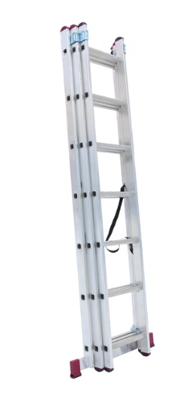 | 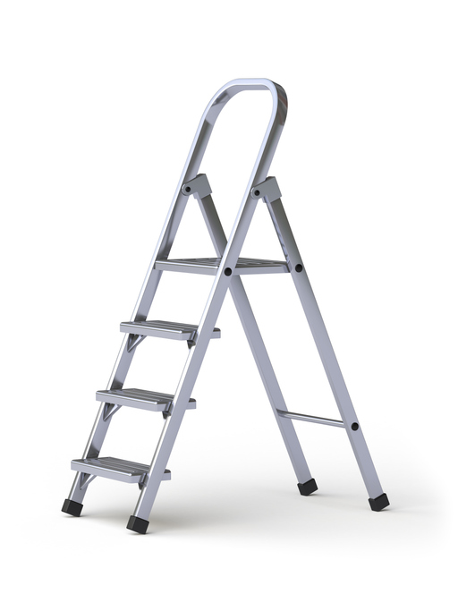
Safety checks:  - Stiles: Make sure they are not bent or damaged, as the ladder could buckle or collapse.  - Feet: If they are missing, worn or damaged, the ladder could slip.  - Rungs: If they are bent, worn, missing or loose, the ladder could fail.  - Any locking mechanism: Does the mechanism work properly? Are components or fixings bent, worn or damaged? If so, the ladder could collapse. Ensure any locking bars are fully engaged. | Safety checks:  - Stepladder platform: If it is split or buckled, the ladder could become unstable or collapse.  - Steps or treads on stepladders: If they are contaminated, they could be slippery; if the fixings are loose on the steps, they could collapse.  - Feet: If they are missing, worn or damaged, the ladder could slip.

Task 8: Hand Tools
Objective: To familiarise students with the tools required for plumbing and heating work.
Tutor Role: Provide examples of tools, explain their use and discuss any safety checks.
Key Learning Points: Types of tools used when working on plumbing and heating systems. How to store tools and equipment appropriately.
Assessment: Review students' written answers for accuracy and completeness.

Identify the tools and describe their use.
Tools/Equipment | Name/Use
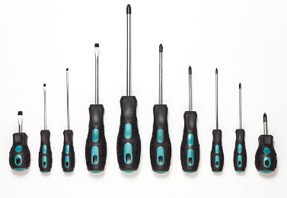 | Screwdrivers for use with screws
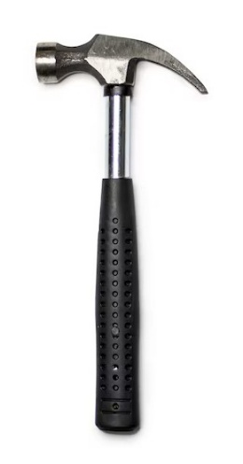 | Hammer for use with nails
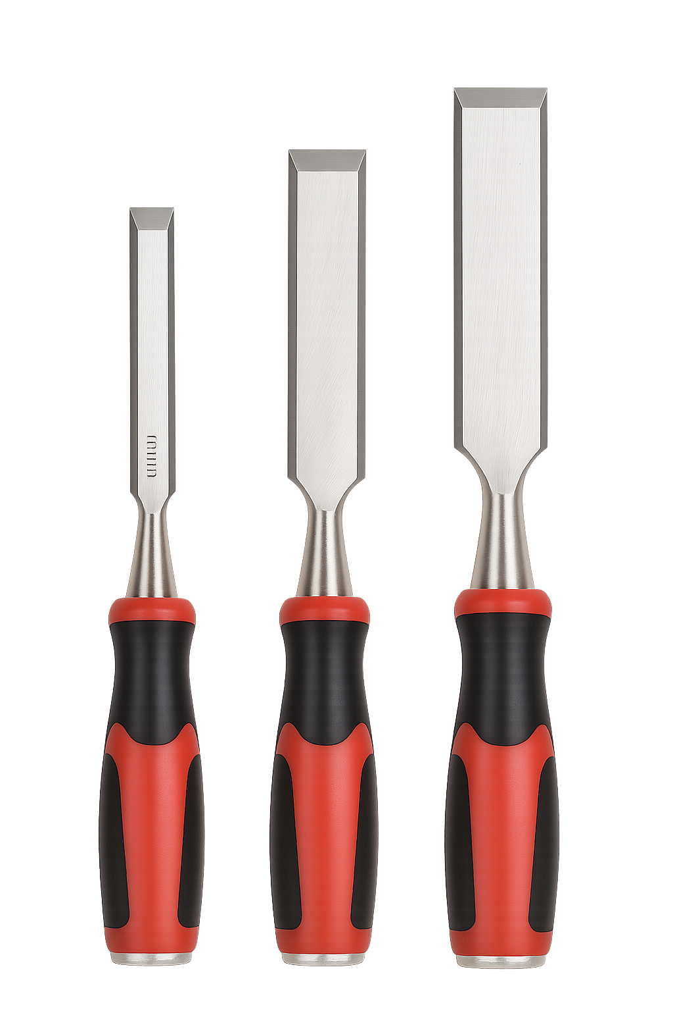 | Wood chisels for notching wood
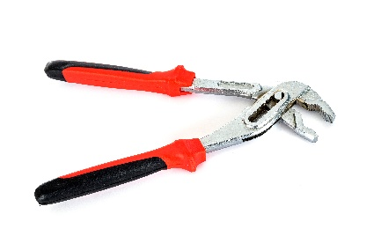 | Water pump pliers for use with fittings and valves
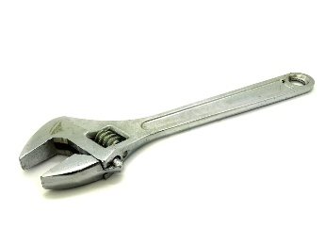 | Adjustable spanners for tightening nuts
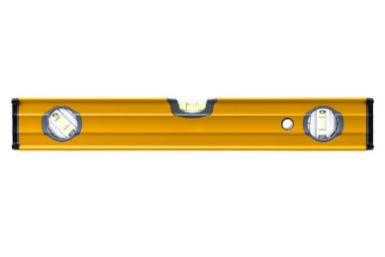 | Spirit level used to ensure things are installed level
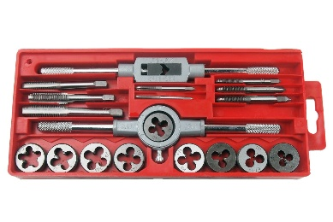 | Threading kit- used to put a thread onto steel pipe
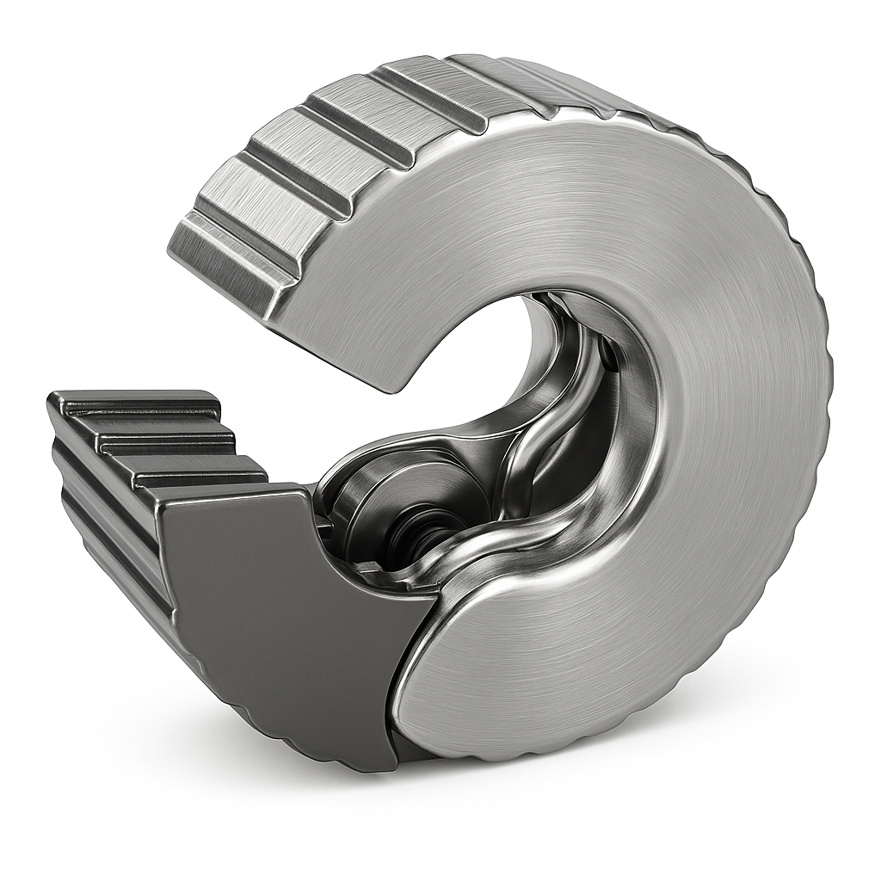 | Pipe slice- for cutting copper pipework
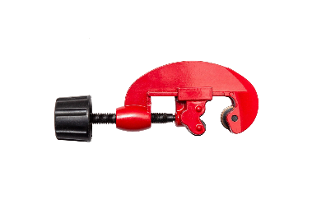 | Adjustable Pipe cutter- for cutting copper pipework
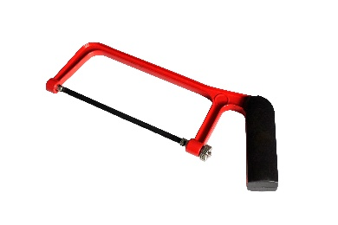 | Junior hacksaw - for cutting materials such as copper
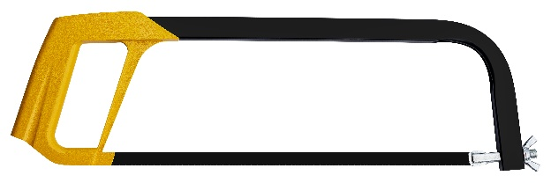 | Large hacksaw - for cutting materials such as LCS
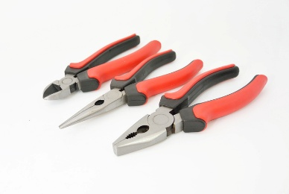 | Electrical side cutters  Pliers  Long nose pliers
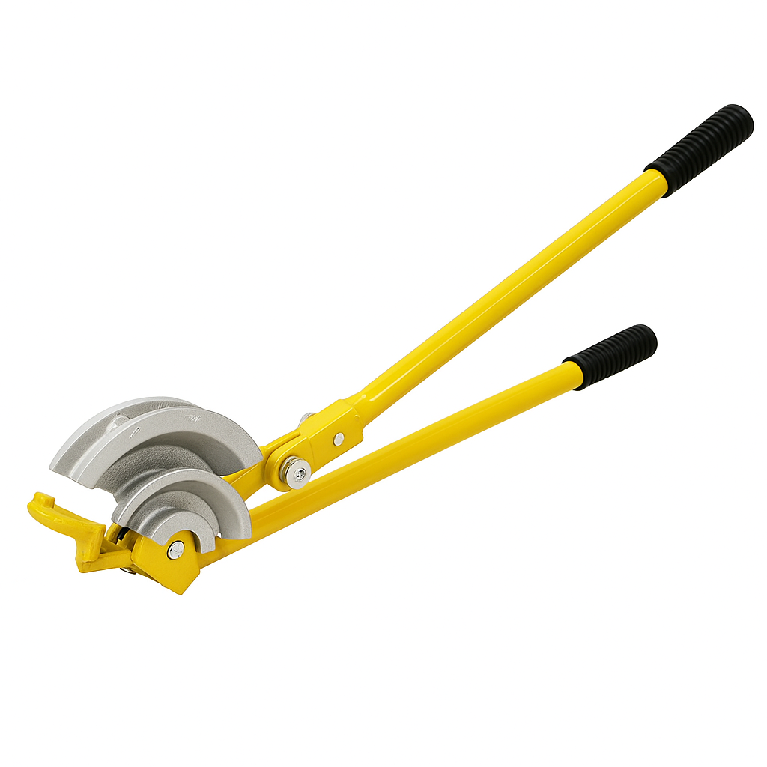 | Scissor bending machine for bending copper pipe
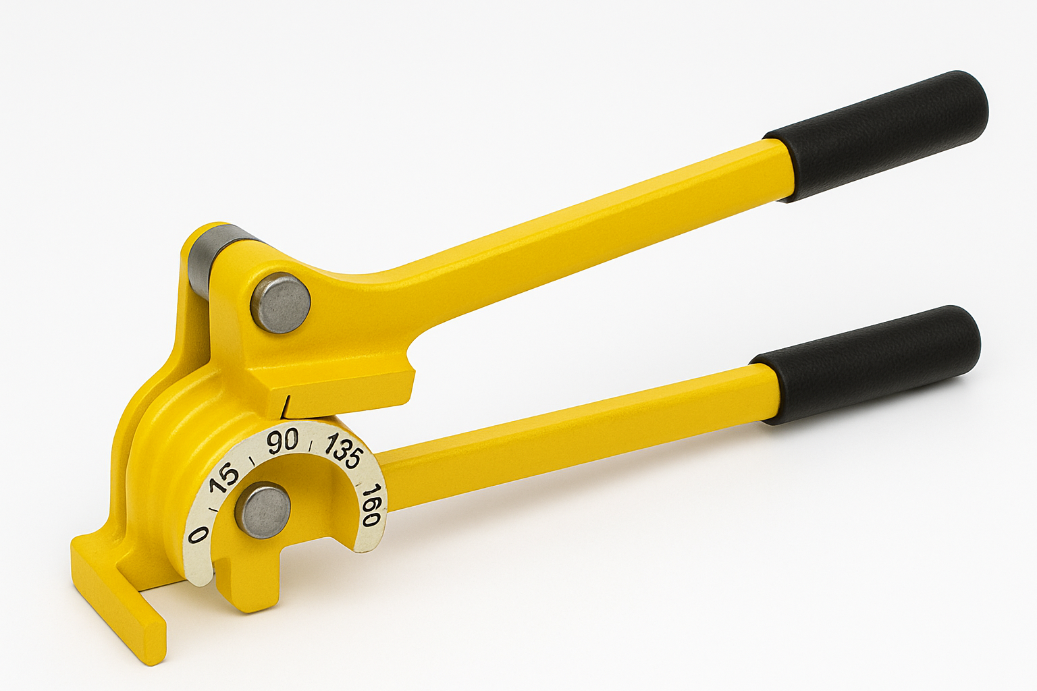 | Micro bender for bending 8mm and 10mm
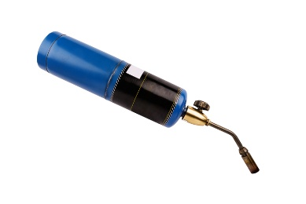 | Blow torch for soldering fittings

Task 9: Power tools
Objective: To familiarise students with the tools required for plumbing and heating work.
Tutor Role: Provide examples of power tools, explain their use and discuss any safety checks.
Key Learning Points: Types of power tools used when working on plumbing and heating systems. How to store power tools and equipment appropriately.
Assessment: Review students' written answers for accuracy and completeness.

Identify the tools and describe their use.
Tools/Equipment | Name/Use
 | Cordless drill  Used for light applications such as screwing into timber
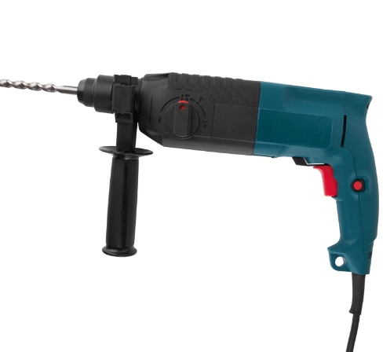 | Corded drill  Used for drilling into masonry
 | Circular saw  Used for cutting timber, for example, floorboards
 | Jigsaw  Used for cutting holes in worktops and timber sheet materials
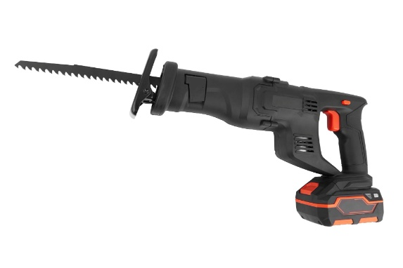 | Reciprocating saw  Used for cutting holes in plasterboard and timber
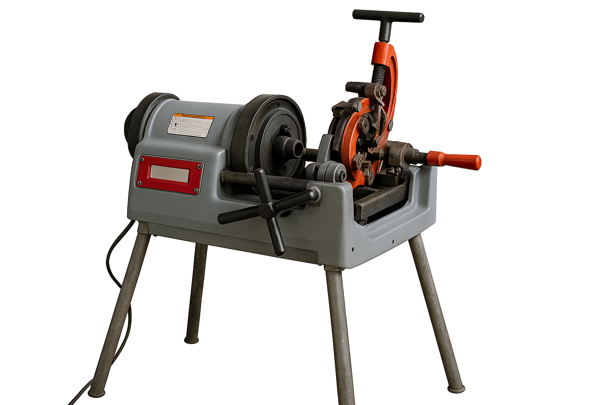 | Threading machine  Used for putting threads onto LCS pipework
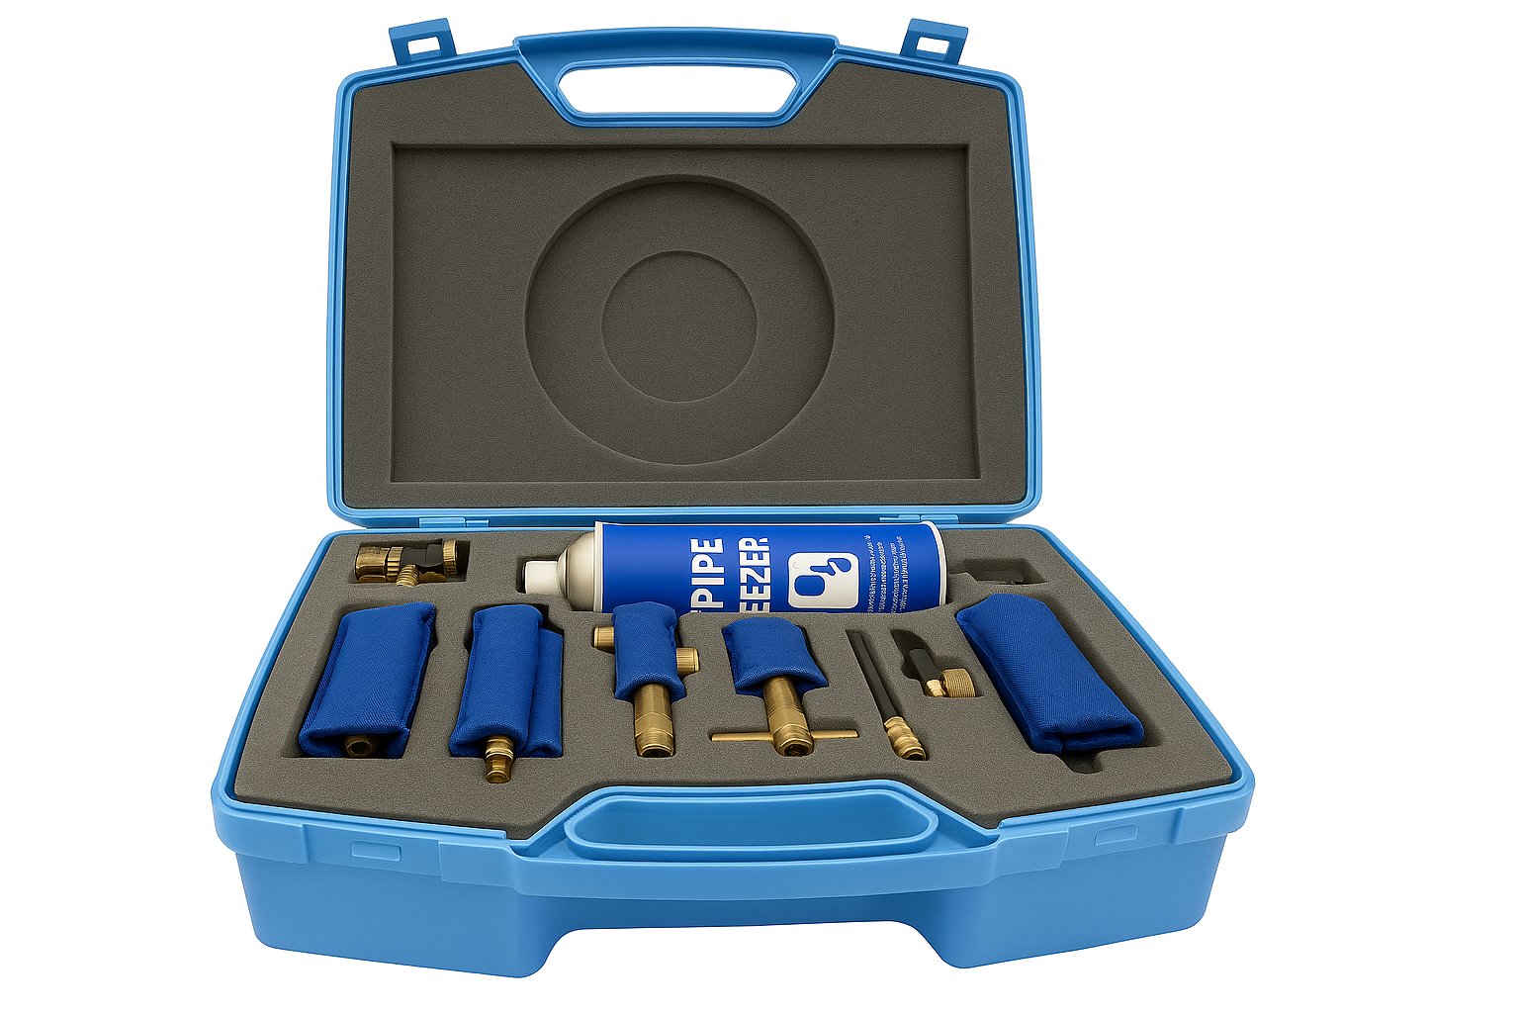 | Pipe freezing kit  Used for freezing pipework
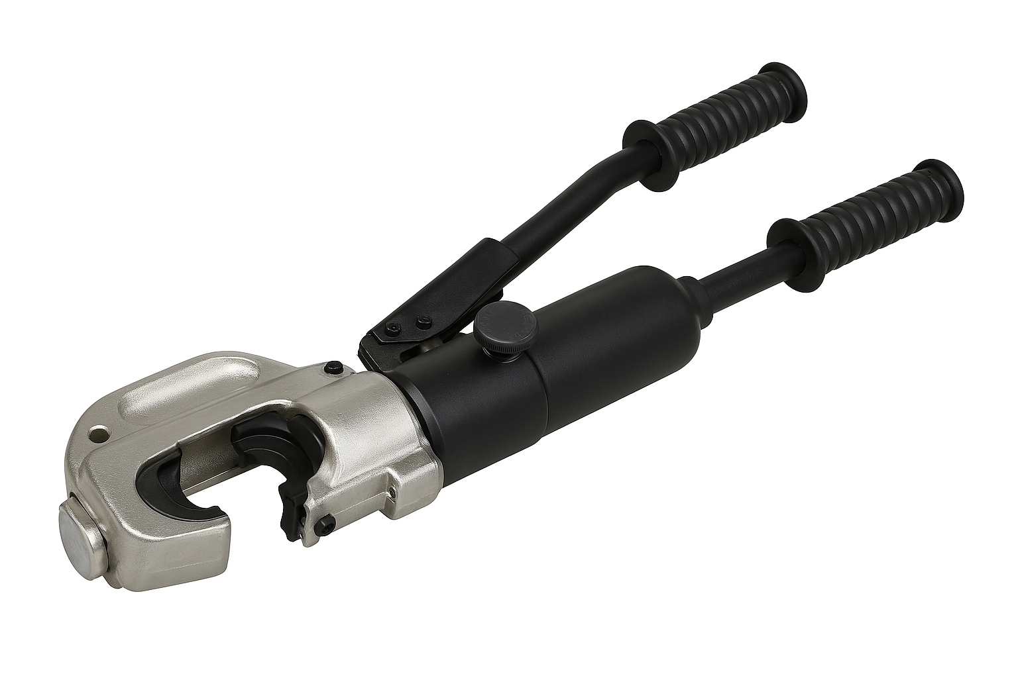 | Pipe crimping tool  Used for press fit fittings

Task 10: Materials
Objective: To familiarise students with the types of pipework and types of fittings
Tutor Role: Provide examples of pipework, fittings and how to correctly join them, discussing the positioning and fixing of pipework within the building fabric
Key Learning Points: Types of pipework and pipework materials and sizes used in buildings. The different types and use of fitting and their suitability for different applications/material types.
Assessment: Review students' written answers for accuracy and completeness.

Identify the copper fittings and their purpose.
List the sizes of copper pipe
15mm
22mm
28mm
Fitting | Description | Purpose
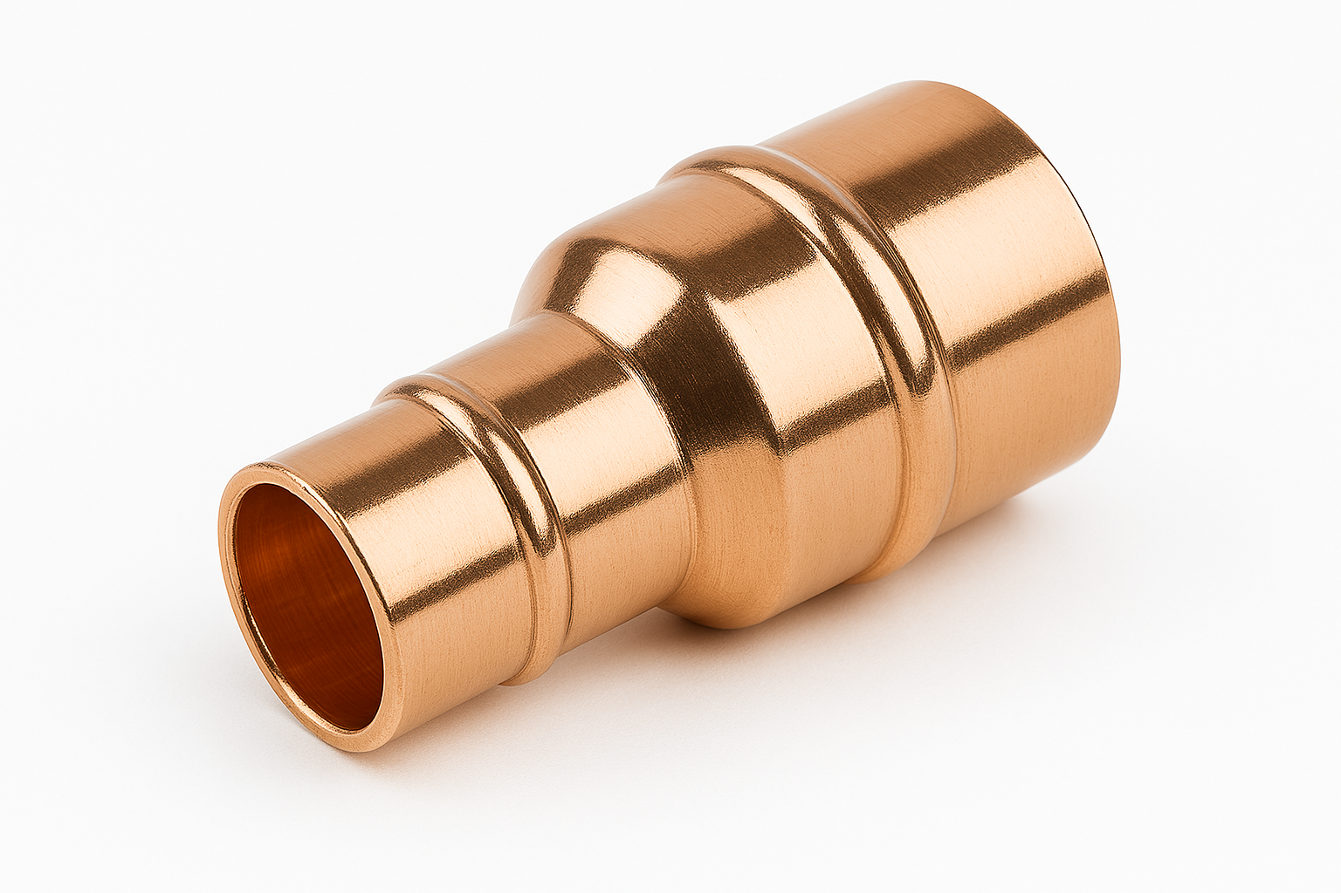 | Integral solder ring reducer | Reducing pipe size
 | End feed stop end | Capping off pipework
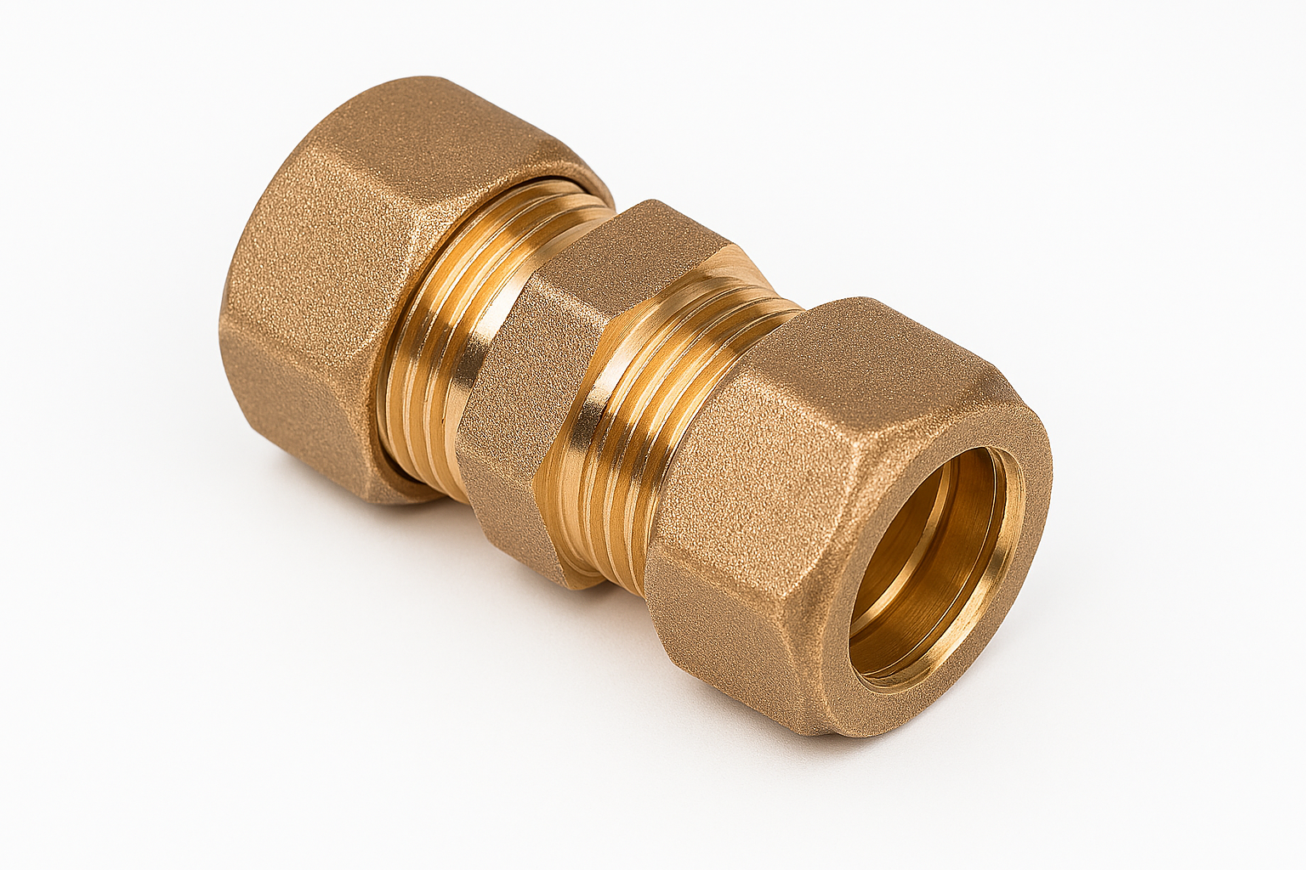 | Compression socket | Joining two pipes together
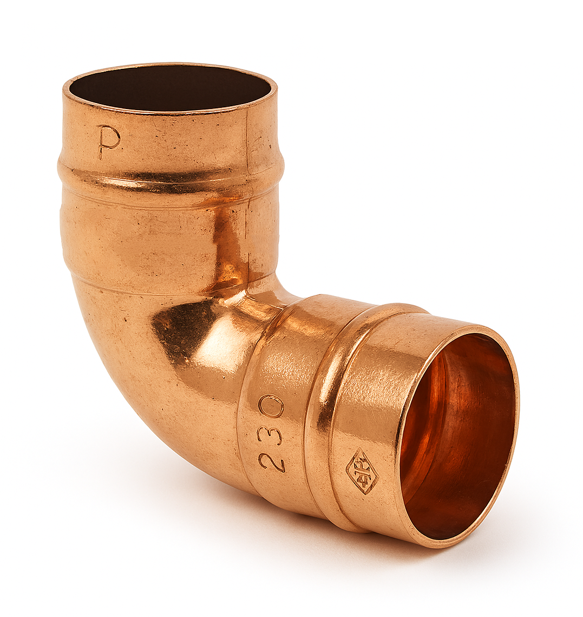 | Integral solder ring elbow | Changing direction
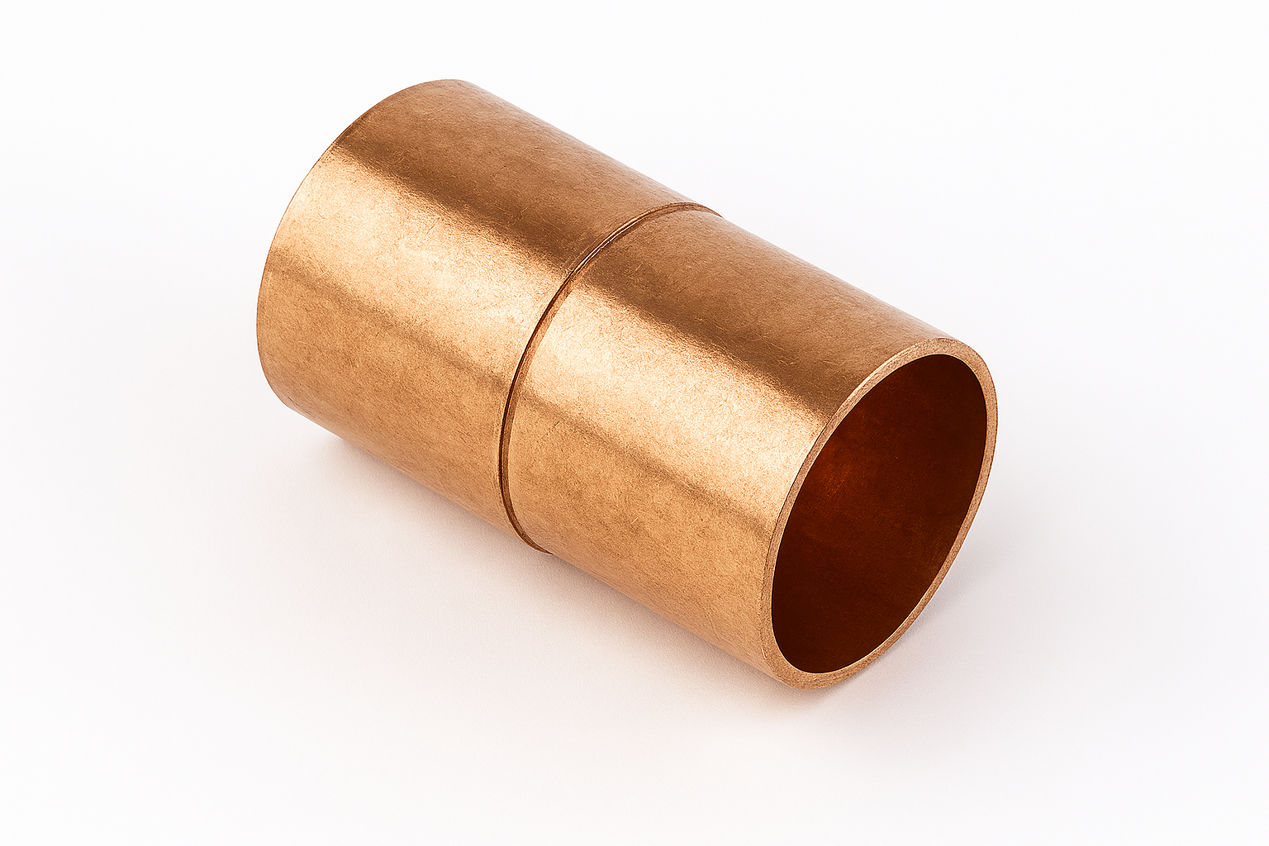 | End feed equal coupler | Joining two pipes together
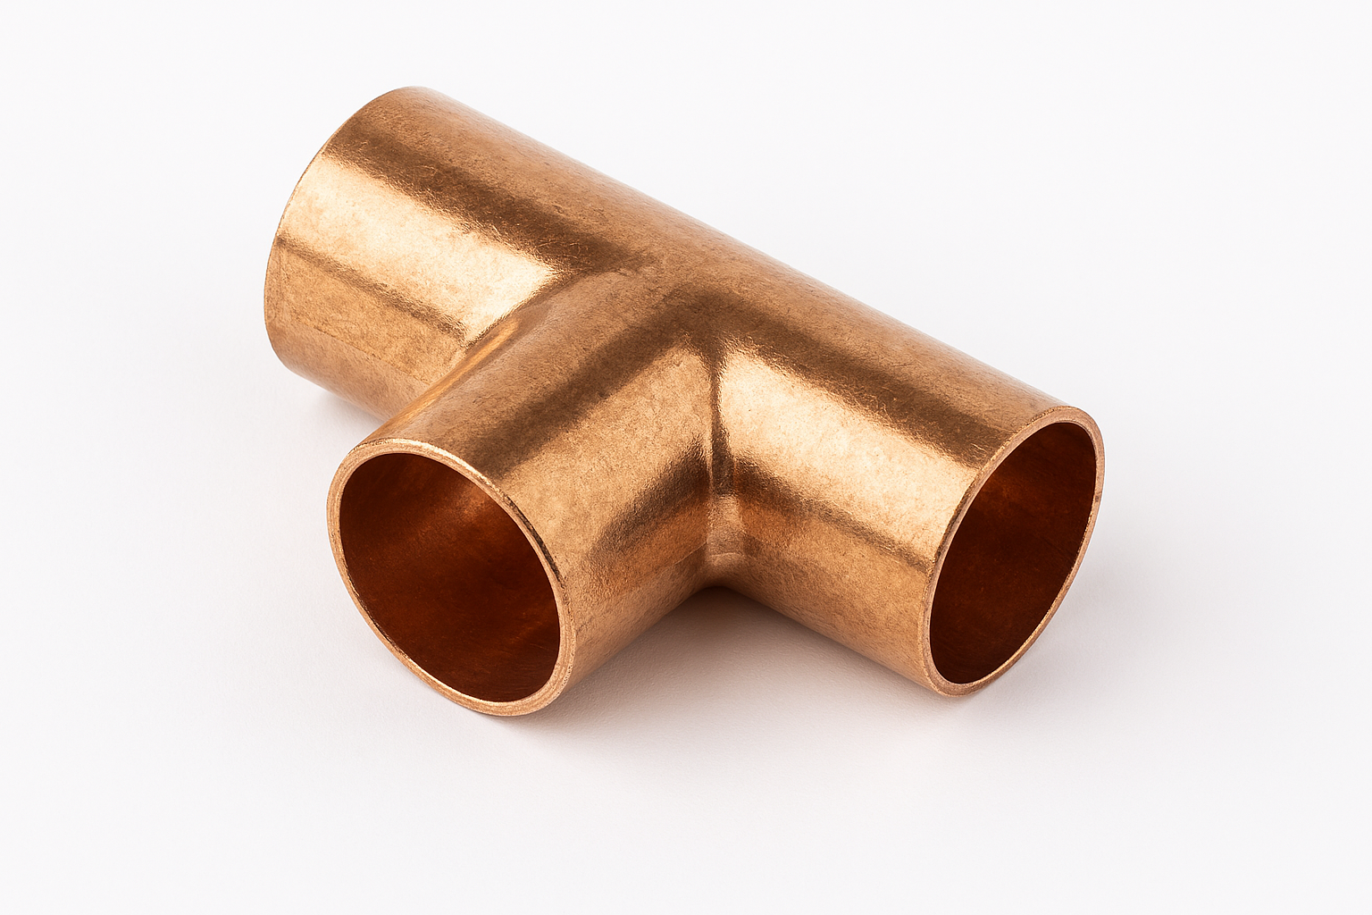 | End feed tee | Installing a branch

Identify the plastic pipe fittings and their purpose.
Fitting | Description | Purpose
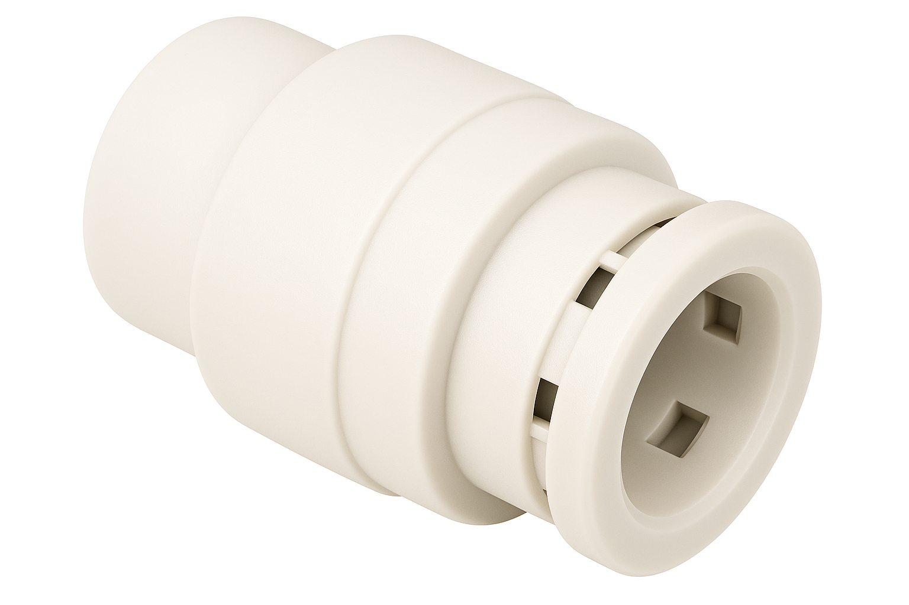 | Push-fit Stop end | Capping off pipework
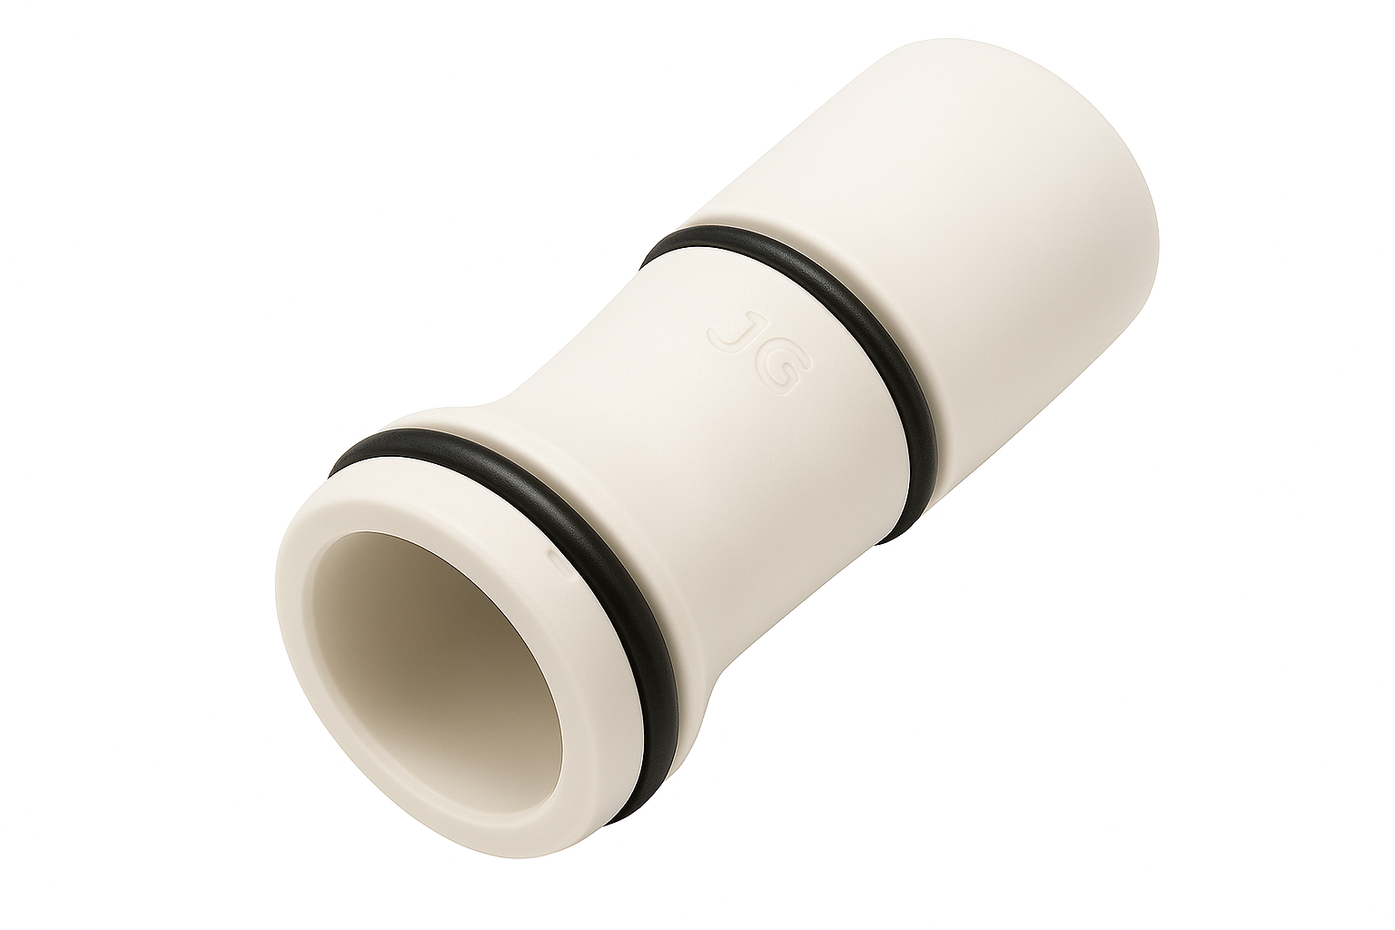 | Liner | To support plastic pipe
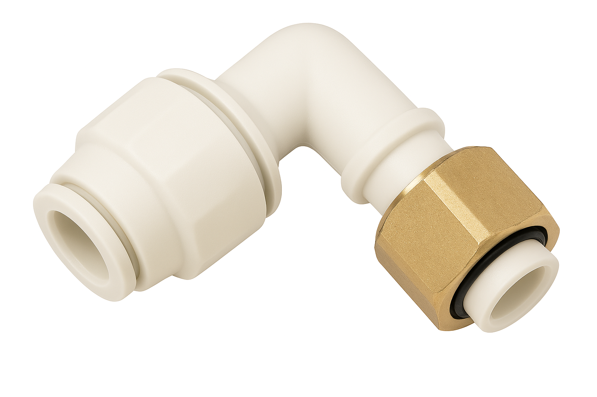 | Push-fit bent tap connector | Used to connect to a terminal fitting
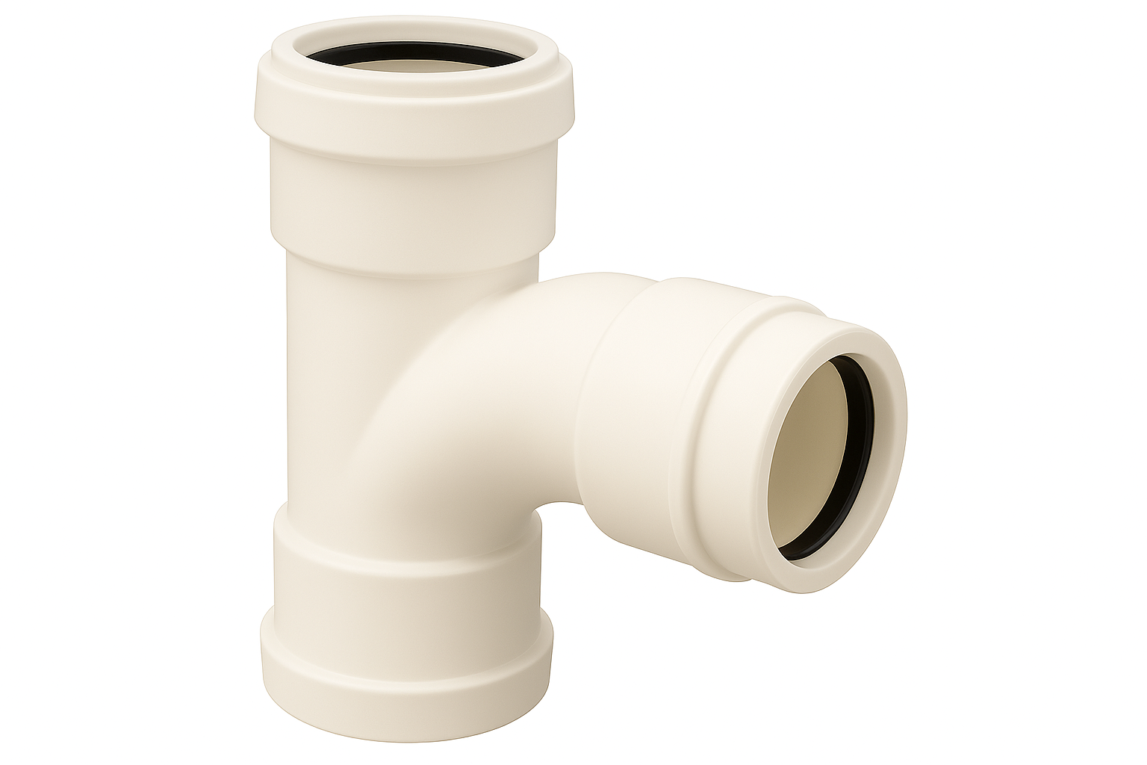 | Waste tee | Adding a branch
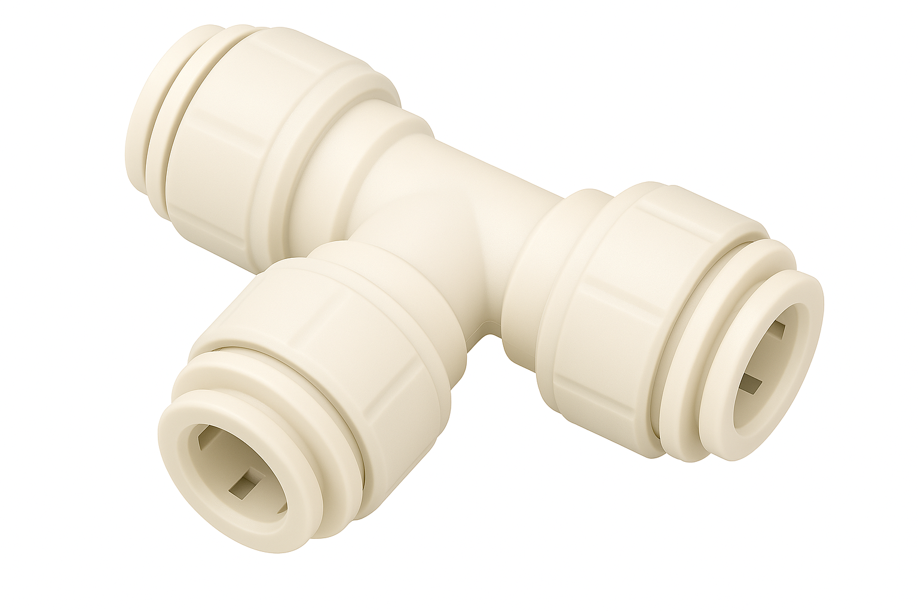 | Push-fit tee | Adding a branch
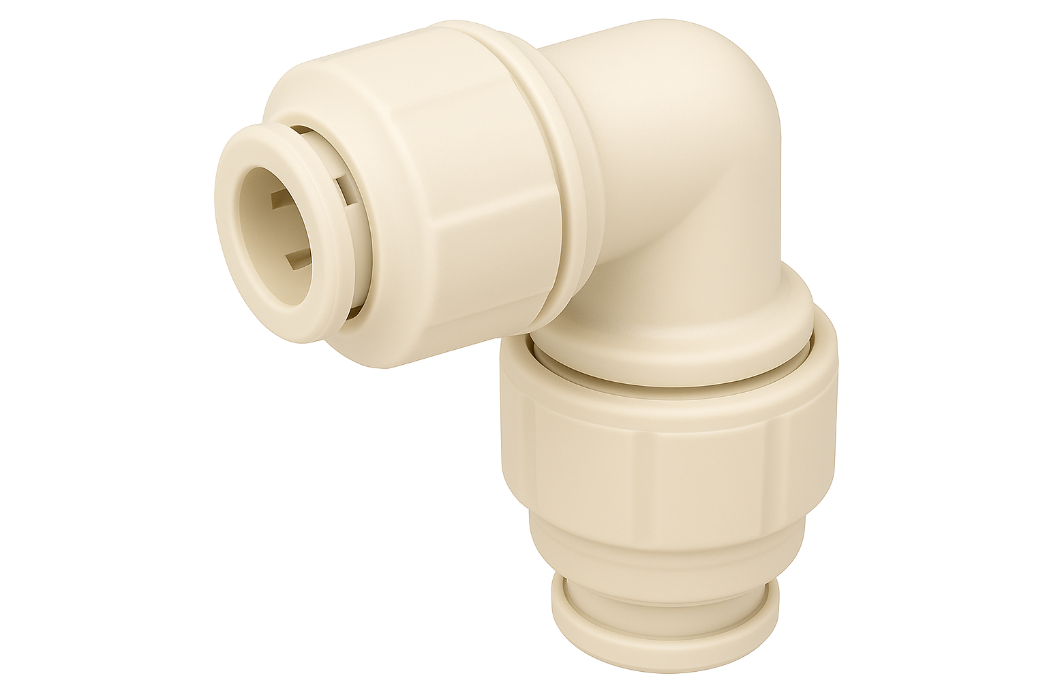 | Push-fit elbow | Changing direction

Identify the steel fittings and their purpose.
List the sizes of Steel Pipe
½”
¾”
1”
Fitting | Description | Purpose
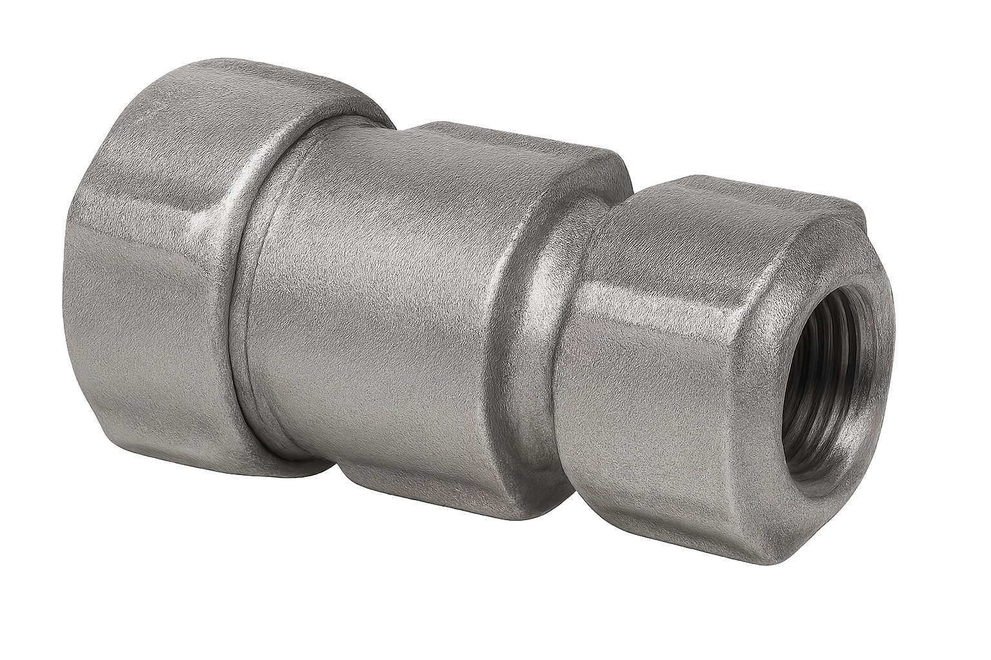 | LCS Compression reducer | Reducing pipe size
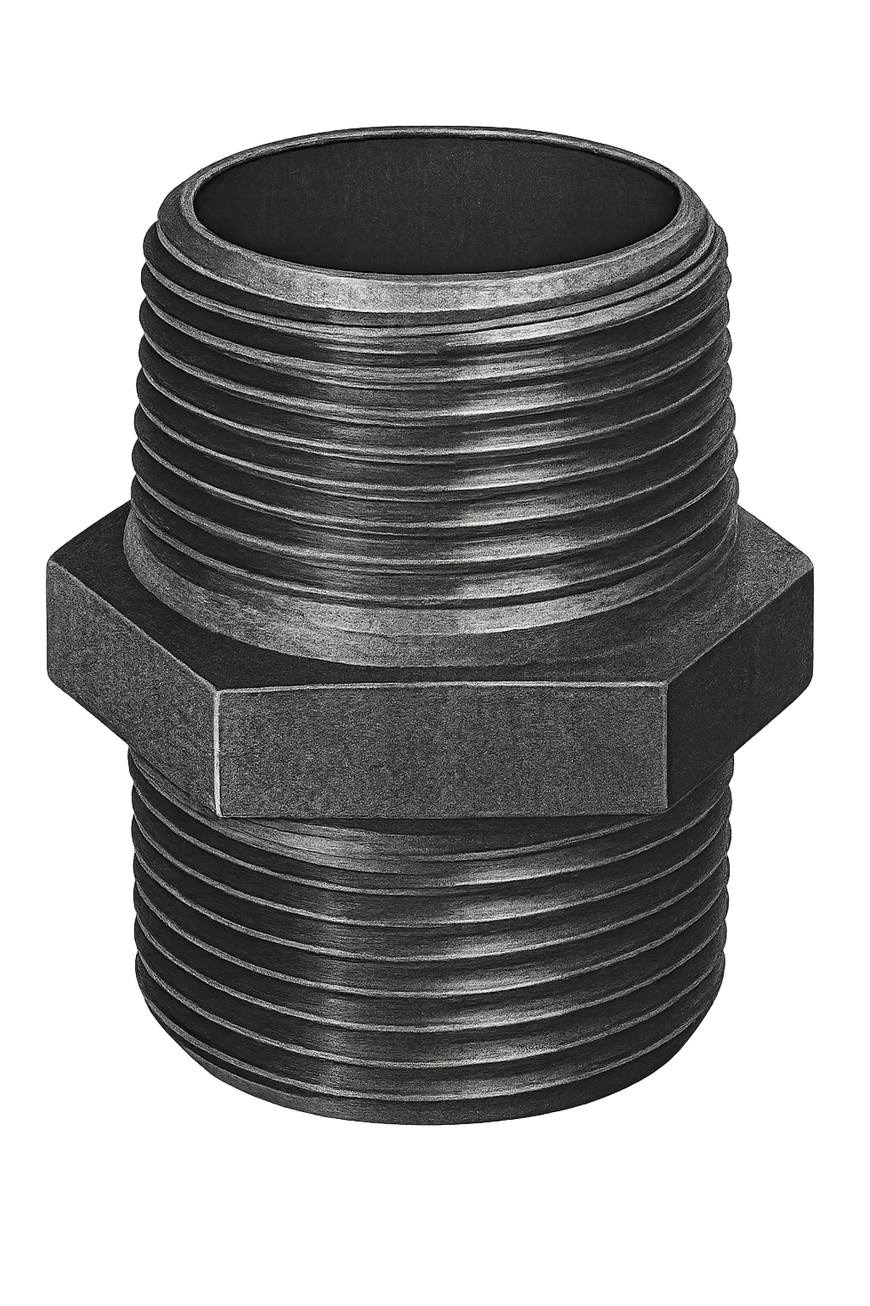 | LCS Nipple | Joining fittings
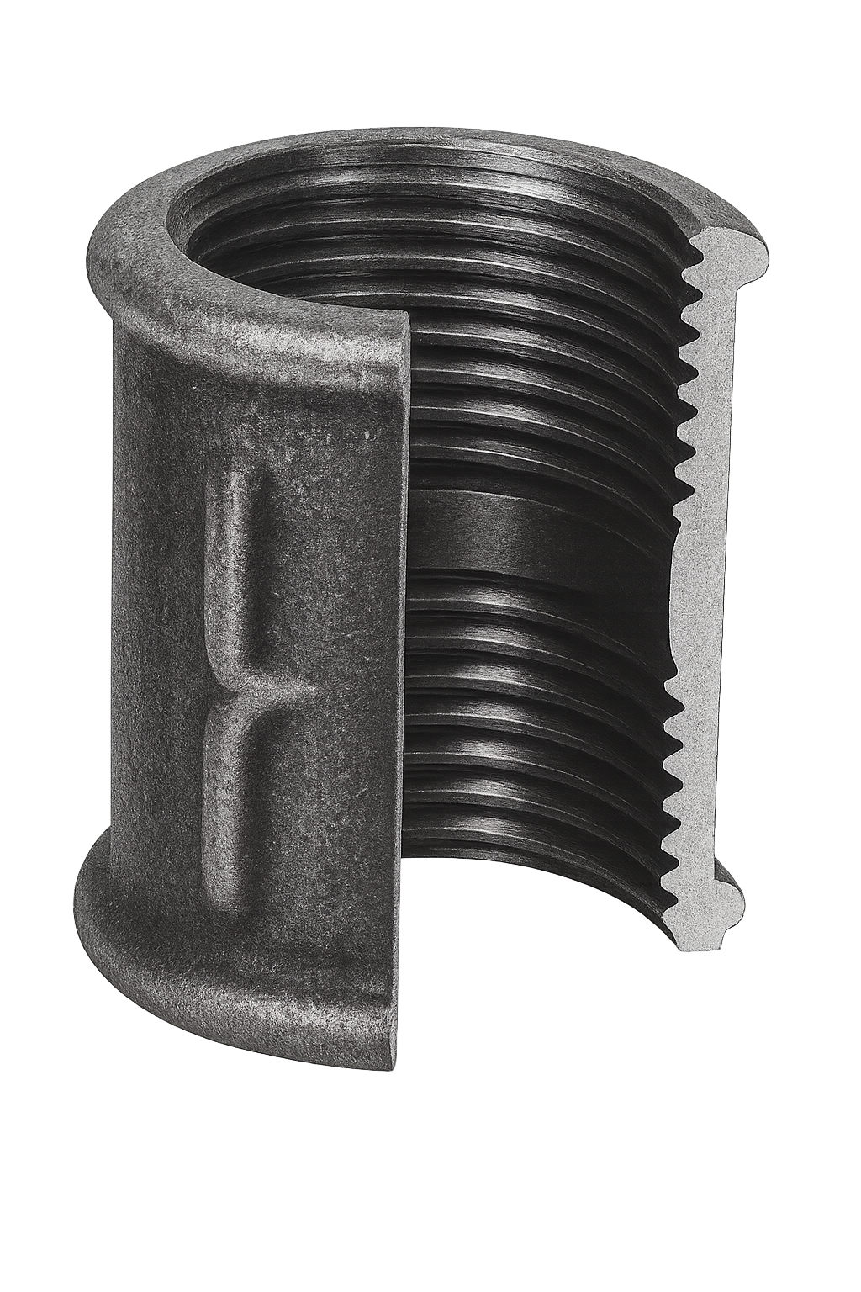 | LCS Socket | Joining two pipes together
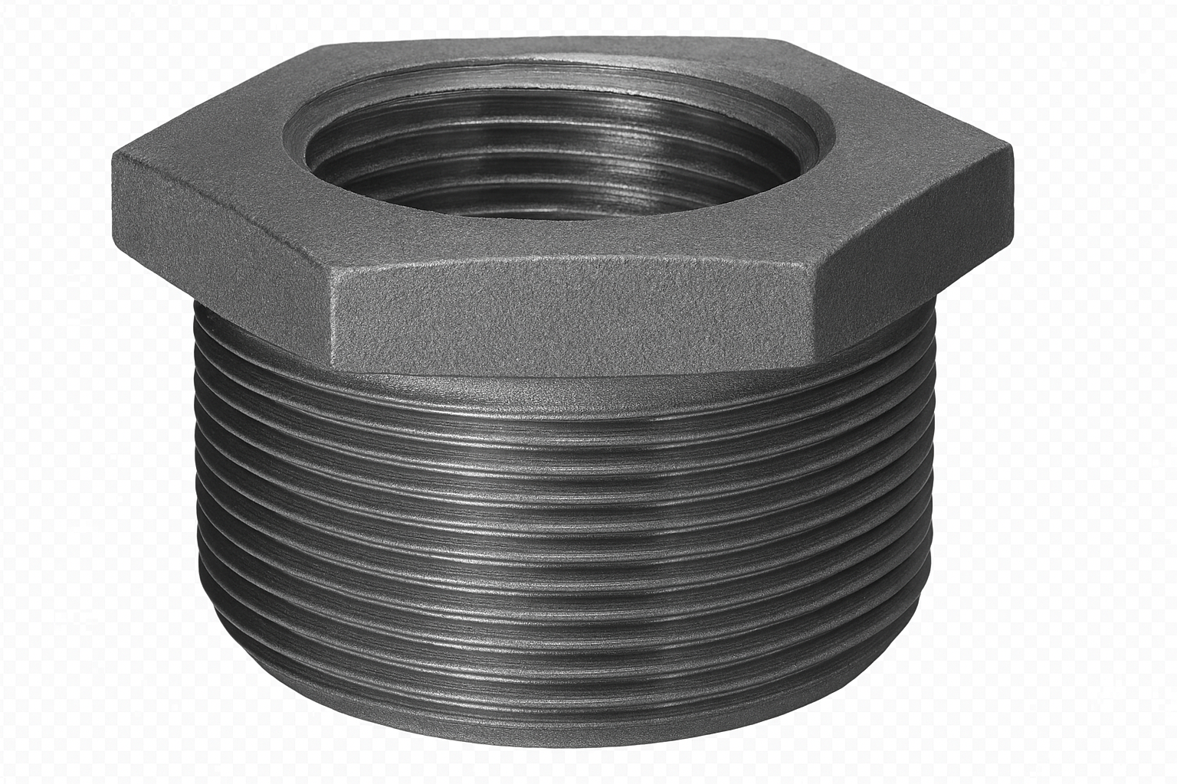 | LCS Bush | Reducing pipe size
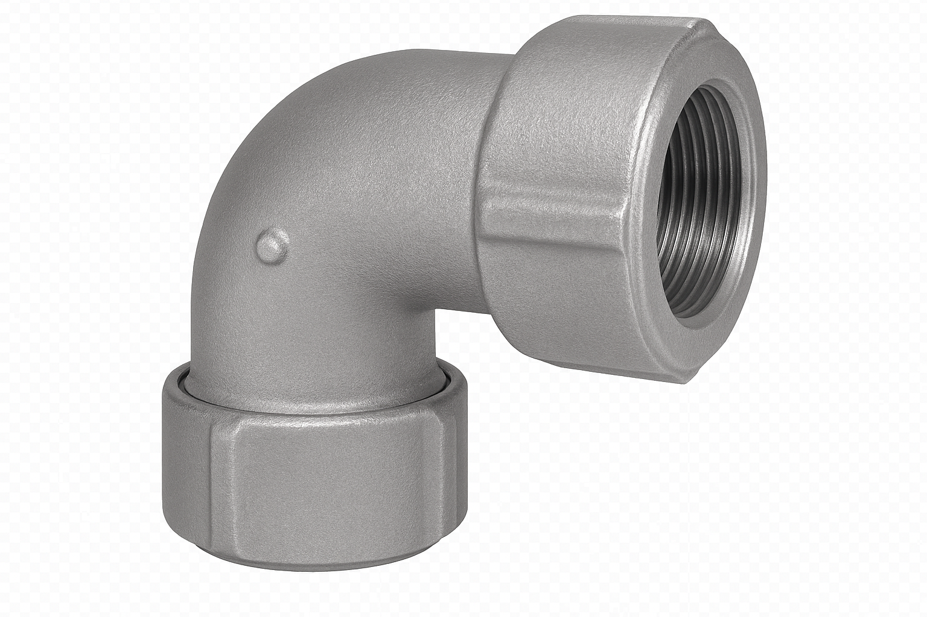 | LCS Compression elbow | Changing direction
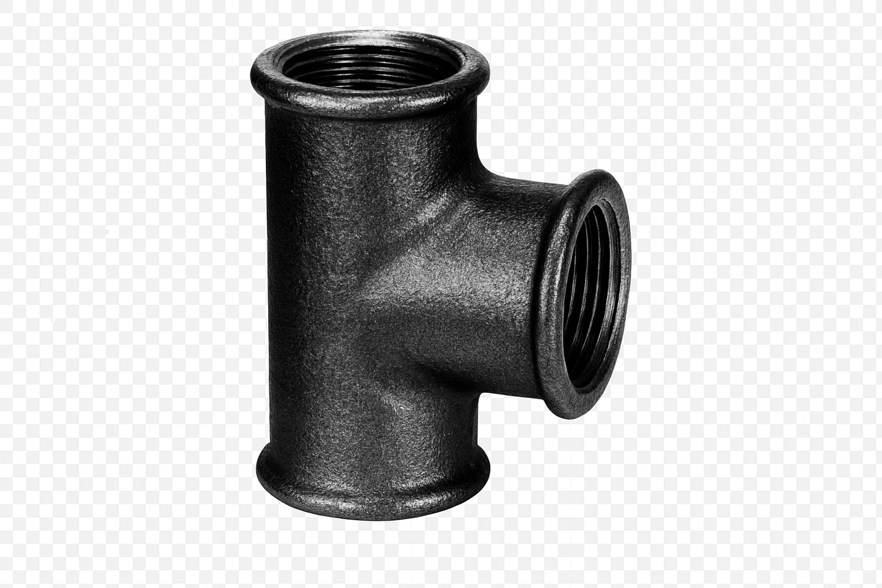 | LCS Tee | Adding a branch
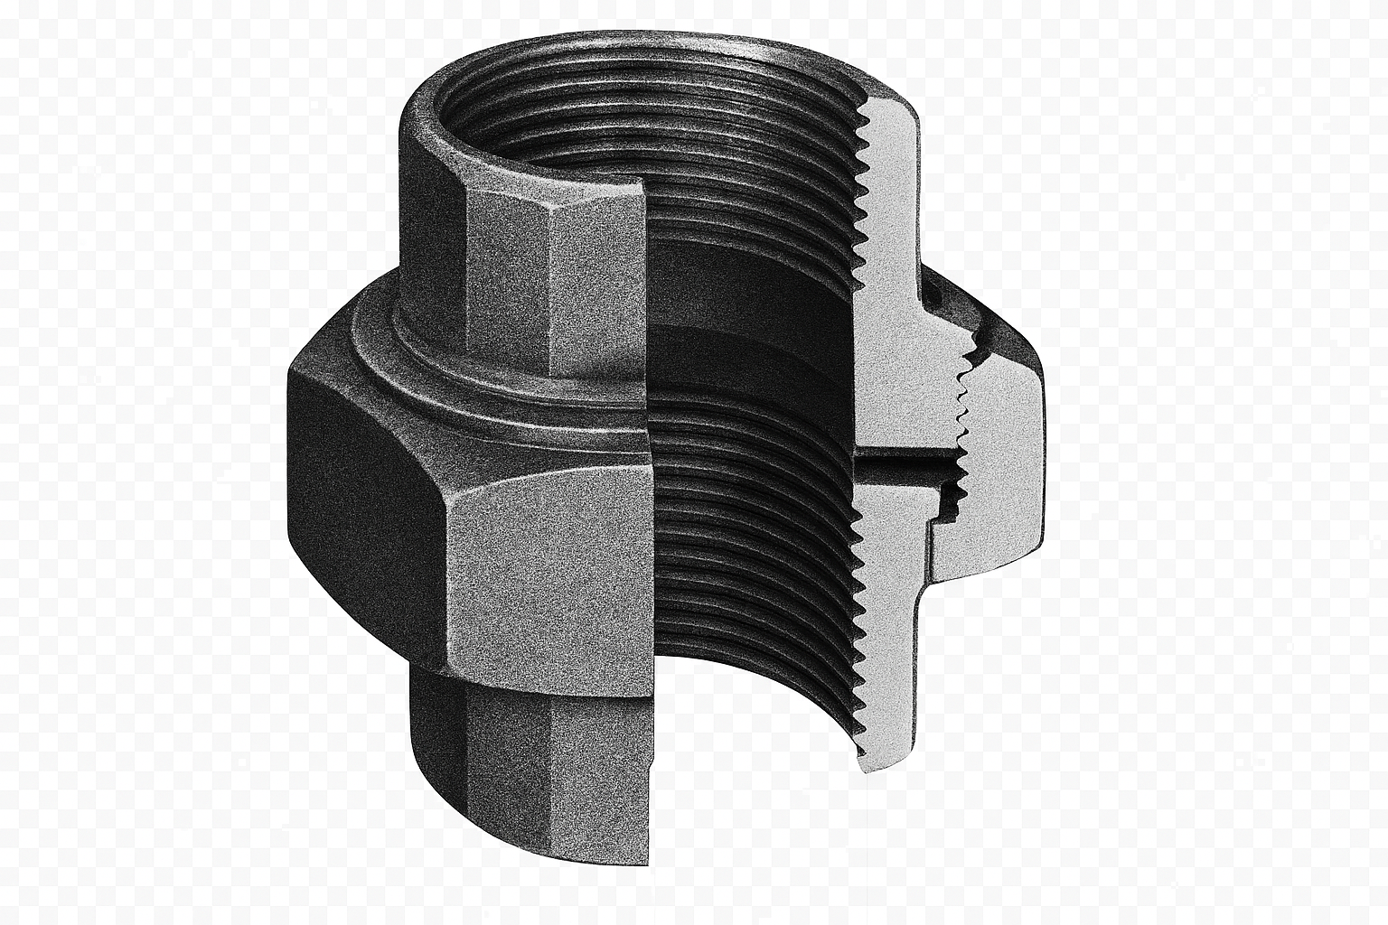 | LCS Union | Joining two pipes together

3.0 System installation

Task 11: Measuring and cutting
Objective: To familiarise students with how to accurately measure pipework materials
Tutor Role: Provide examples of pipework and measuring equipment and demonstrate how to measure and cut materials.
Key Learning Points: Types of pipework and pipework materials and sizes used in buildings. Accurate measurement of materials.
Assessment: Review students' practical work and written answers for accuracy and completeness.

To use a tape measure accurately, you must ensure you are reading the correct units. In plumbing, we use metric units, most commonly the millimetre.
One side of the tape shows metric units. This is the side of the tape to use. You will notice that:
- 1 metre is divided into 100 centimetres
- 1 centimetre is divided into 10 millimetres
- 1 metre is divided into 1000 millimetres

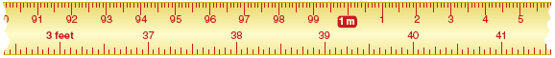

The other side of the tape shows feet and inches. These are imperial units. You will need to use this side of the tape.

You are required to select the following diameters of pipe and cut the lengths in the table below. The diameter is the measurement from one side to the other across the centre.

Type | Diameter | Length to cut | Achieved (Y/N)
Copper | 15mm | 100mm
Copper | 22mm | 150mm
Plastic | 32mm | 120mm
Plastic | 40mm | 170mm
Plastic | 15mm | 130mm
Plastic | 22mm | 180mm
Steel | 20mm | 195mm

Task 12: Bending techniques - copper
Objective: To familiarise students with the methods of bending pipework
Tutor Role: Provide a demonstration of how to accurately bend pipework
Key Learning Points: Methods of bending pipework and how to bend pipework
Assessment: Review students' written answers for accuracy and completeness.

Form the bends pictured below in 15mm copper tube. Remember to allow for pipe gain.
- How much tube is required to form this bend? At least 400mm.
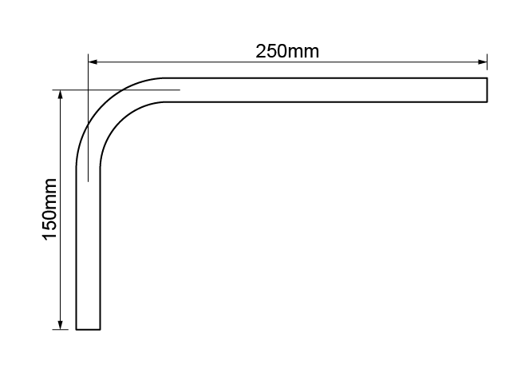

- What angle did you use to form the offset? Angle should be 45 degrees.
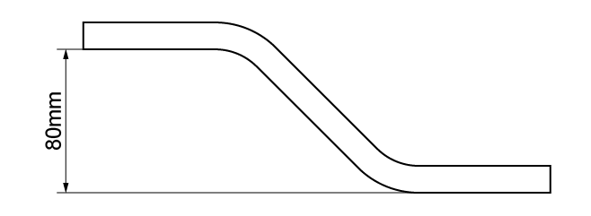

- Recreate this bend.
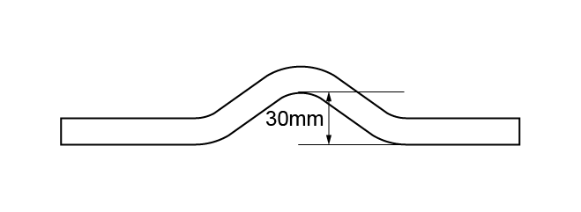

- Recreate this bend.
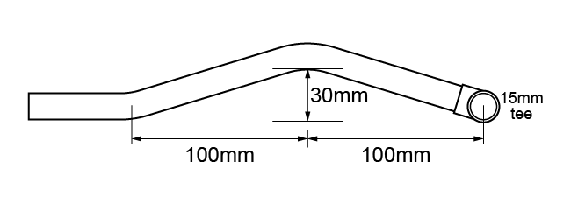

Task 13: Bending techniques - Low Carbon Steel (LCS)
Objective: To familiarise students with the methods of bending pipework.
Tutor Role: Provide a demonstration of how to accurately bend pipework.
Key Learning Points: Methods of bending pipework and how to bend pipework.
Assessment: Review students' written answers for accuracy and completeness.

- Form the 90° bend pictured below in 15mm low carbon steel (LCS) pipe. How much pipe is required to form this bend? Also show how much the pipe gains when it is bent to 90°. 400mm required. Students to measure gain after bending pipe.
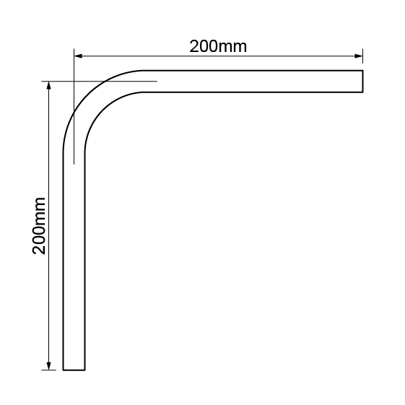

- Form the 45º bend pictured below in 20mm LCS pipe. How much pipe is required to form this bend? 375mm
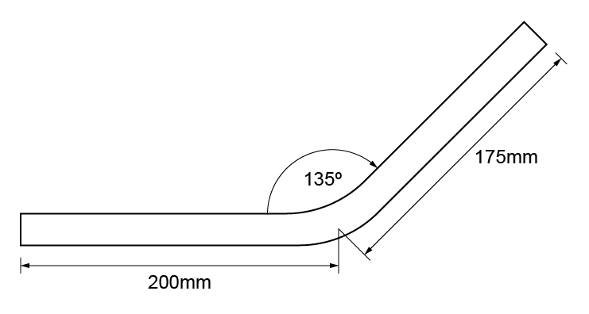

Task 14: Connection techniques - copper (soldered)
Objective: To familiarise students with how to accurately measure pipework materials and how to correctly join them.
Tutor Role: Provide guidance during the task.
Key Learning Points: Types of pipework and pipework materials. Accurate measurement of materials. Types of fittings and jointing methods.
Assessment: Review students’ practical work and written answers for accuracy and completeness.

- You are required to fabricate the frame shown below, using 15mm copper pipe. Use end feed fittings.
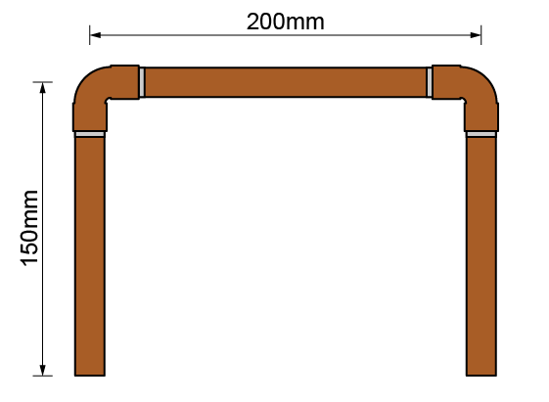

Material type (description) | Quantity
Candidate to list the materials required to complete the task

Tool list – list the tools required to complete the work task
Candidate to list the tools required to complete the task

Stretch and Challenge: When students finish the task early, the tutor provides the task with new measurements.

- You are required to fabricate the frame shown below, using 15mm copper pipe. Use end feed fittings, except for the integral solder ring elbow.
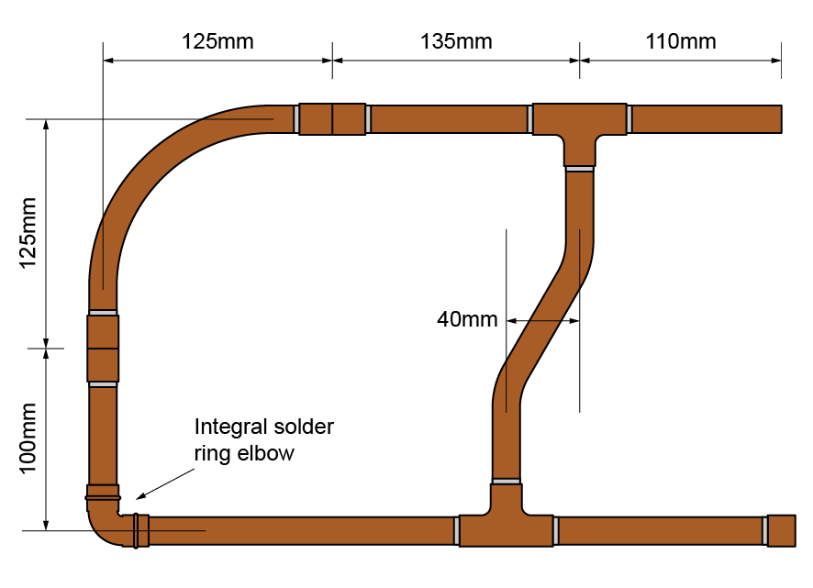

Material type (description) | Quantity
Candidate to list the materials required to complete the task

Tool list – list the tools required to complete the work task
Candidate to list the tools required to complete the task

Feedback - Assessor to tick
Please develop and work on the following elements: |  | Criteria
Measurement |  | - +/- 2mm of the dimensions on the drawing
Marking out |  | - +/- 2mm of the dimensions on the drawing  - Marked out in pencil  - Spirit level used
Clipping |  | - Select appropriate pipework clips for use and space them correctly
Pipe jointing |  | - Soldered joints must be free from excessive solder and residual flux  - Pipe and fittings are free from tool and vice marks
Pipe bending |  | - Pipe bends must be free from ripples, throating or excessive distortion
Presentation of work
Ensuring work meets industry requirements |  | - Completed pipework must be leak free
Health and safety |  | - Health and safety requirements must be observed at all times

Stretch and Challenge: When students finish the task early, the tutor provides the task with new measurements.

Task 15: Connection techniques - copper (compression)
Objective: To familiarise students with how to accurately measure pipework materials, methods of bending pipework and how to correctly join them.
Tutor Role: Provide guidance during the task.
Key Learning Points: Types of pipework and pipework materials. Accurate measurement of materials. Types of fittings and jointing methods. Methods of bending pipework.
Assessment: Review students’ practical work and written answers for accuracy and completeness.

You are required to fabricate the frame shown below, using 15mm copper pipe. Use compression fittings.
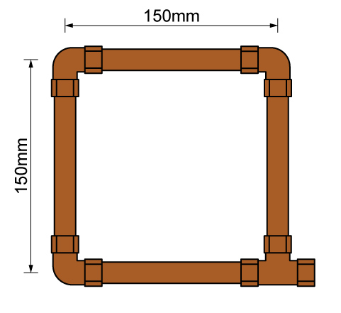

Material type (description) | Quantity
Candidate to list the materials required to complete the task

Tool list – list the tools required to complete the work task
Candidate to list the tools required to complete the task

Feedback - Assessor to tick
Please develop and work on the following elements: |  | Criteria
Measurement |  | - +/- 2mm of the dimensions on the drawing
Marking out |  | - +/- 2mm of the dimensions on the drawing  - Marked out in pencil  - Spirit level used
Clipping |  | - Select appropriate pipework clips for use and space them correctly
Pipe jointing |  | - Pipe and fittings are free from tool and vice marks
Pipe bending
Presentation of work
Ensuring work meets industry requirements |  | - Completed pipework must be leak free
Health and safety |  | - Health and safety requirements must be observed at all times

Stretch and Challenge: Where students finish the task early, tutor to provide the task with new measurements.

Task 16: Connection techniques - Low Carbon Steel (LCS)
Objective: To familiarise students with how to accurately measure pipework materials. Methods of bending pipework and how to correctly join them.
Tutor Role: Provide guidance during the task.
Key Learning Points: Types of pipework and pipework materials. Accurate measurement of materials. Types of fittings and jointing methods. Methods of bending pipework.
Assessment: Review students’ practical work and written answers for accuracy and completeness.

You are required to fabricate the frame shown below using ½ inch LCS pipe and threaded fittings.
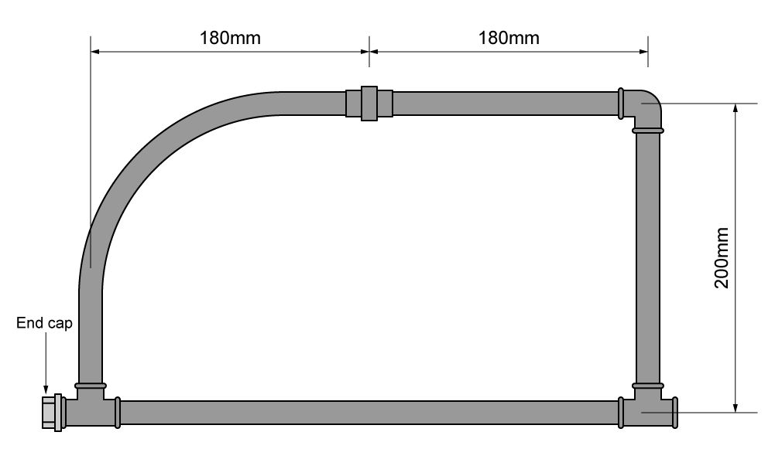

Material type (description) | Quantity
Candidate to list the materials required to complete the task

Tool list – list the tools required to complete the work task
Candidate to list the tools required to complete the task

Feedback - Assessor to tick
Please develop and work on the following elements: |  | Criteria
Measurement |  | - +/- 2mm of the dimensions on the drawing
Marking out |  | - +/- 2mm of the dimensions on the drawing  - Marked out in pencil  - Spirit level used
Clipping |  | - Select appropriate pipework clips for use and space them correctly
Pipe jointing |  | - Soldered joints must be free from excessive solder and residual flux  - Pipe and fittings are free from tool and vice marks  - Malleable iron fittings show no more than 1 ½ threads
Pipe bending |  | - Pipe bends must be free from ripples, throating or excessive distortion
Presentation of work
Ensuring work meets industry requirements |  | - Completed pipework must be leak free
Health and safety |  | - Health and safety requirements must be observed at all times

Stretch and Challenge: Where students finish the task early, tutor to provide the task with new measurements

Task 17: Connection techniques - plastic pressure pipe (push-fit)
Objective: To familiarise students with how to accurately measure pipework materials and how to correctly join them.
Tutor Role: Provide guidance during the task
Key Learning Points: Types of pipework and pipework materials. Accurate measurement of materials. Types of fittings and jointing methods.
Assessment: Review students’ practical work and written answers for accuracy and completeness.

You are required to fabricate the frame shown below using plastic pressure pipe and push-fit fittings.
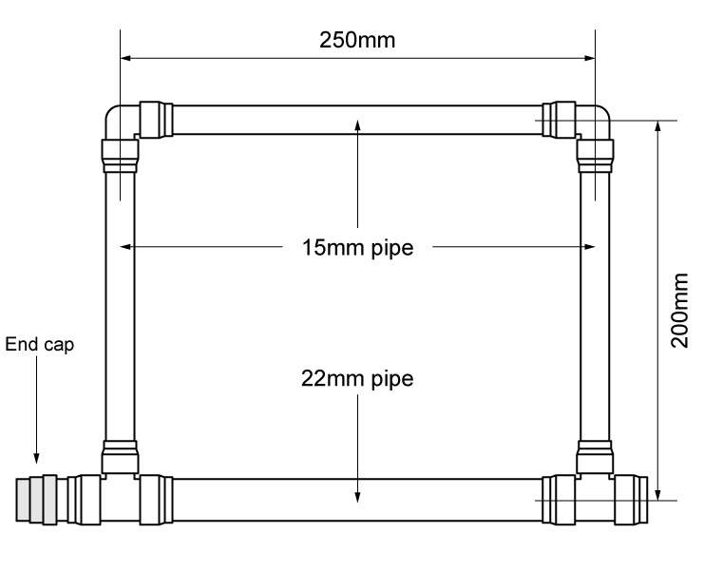

Material type (description) | Quantity
Candidate to list the materials required to complete the task

Tool list – list the tools required to complete the work task
Candidate to list the tools required to complete the task

Feedback - Assessor to tick
Please develop and work on the following elements: |  | Criteria
Measurement |  | - +/- 2mm of the dimensions on the drawing.
Marking out |  | - +/- 2mm of the dimensions on the drawing.  - Marked out in pencil.  - Spirit level used where necessary.
Clipping |  | - Select appropriate pipework clips for use and space them correctly.
Pipe jointing |  | - Pipe and fittings are free from tool and vice marks.
Pipe bending
Presentation of work
Ensuring work meets industry requirements |  | - Completed pipework must be leak free
Health and safety |  | - Health and safety requirements must be observed at all times

Stretch and Challenge: Where students finish the task early, tutor to provide the task with new measurements.

Task 18: Connection techniques - plastic waste pipe (push-fit)
Objective: To familiarise students with how to accurately measure pipework materials and how to correctly join them.
Tutor Role: Provide guidance during the task
Key Learning Points: Types of pipework and pipework materials. Accurate measurement of materials. Types of fittings and jointing methods.
Assessment: Review students’ practical work and written answers for accuracy and completeness.

You are required to fabricate the frame shown below using plastic waste pipe and push-fit fittings.
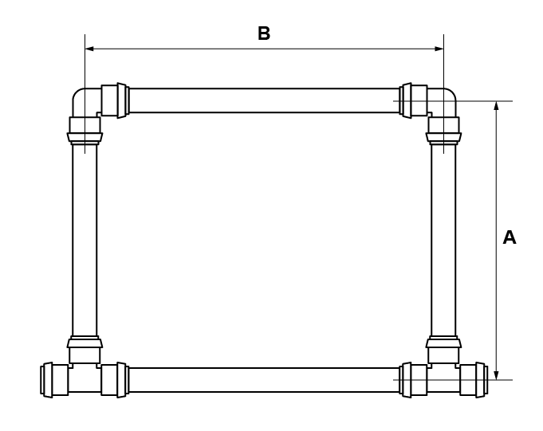
32mm pipe | 40mm pipe
A = 150mm | A = 175mm
B = 200mm | B = 225mm

Material type (description) | Quantity
Candidate to list the materials required to complete the task

Tool list – list the tools required to complete the work task
Candidate to list the tools required to complete the task

Feedback - Assessor to tick
Please develop and work on the following elements: |  | Criteria
Measurement |  | - +/- 2mm of the dimensions on the drawing.
Marking out |  | - +/- 2mm of the dimensions on the drawing.  - Marked out in pencil.  - Spirit level used where necessary.
Clipping |  | - Select appropriate pipework clips for use and space them correctly.
Pipe jointing |  | - Pipe and fittings are free from tool and vice marks.
Pipe bending
Presentation of work
Ensuring work meets industry requirements |  | - Completed pipework must be leak free
Health and safety |  | - Health and safety requirements must be observed at all times

Stretch and Challenge: Where students finish the task early, tutor to provide the task with new measurements.

Task 19: Connection techniques - combined
Objective: To familiarise students with how to accurately measure pipework materials. Methods of bending pipework and how to correctly join them.
Tutor Role: Provide guidance during the task
Key Learning Points: Types of pipework and pipework materials. Accurate measurement of materials. Types of fittings and jointing methods. Methods of bending pipework
Assessment: Review students’ practical work and written answers for accuracy and completeness.

You are required to fabricate the combined frame shown below using 15mm copper, plastic and LCS.
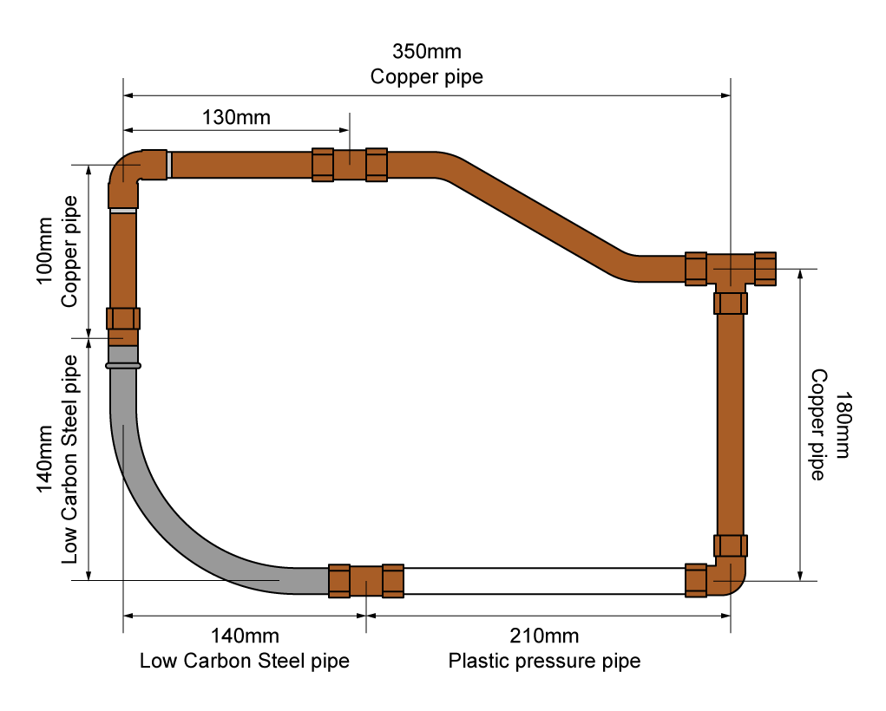

Material type (description) | Quantity
Candidate to list the materials required to complete the task

Tool list – list the tools required to complete the work task
Candidate to list the tools required to complete the task

Feedback - Assessor to tick
Please develop and work on the following elements: |  | Criteria
Measurement |  | - +/- 2mm of the dimensions on the drawing
Marking out |  | - +/- 2mm of the dimensions on the drawing  - Marked out in pencil  - Spirit level used
Clipping |  | - Select appropriate pipework clips for use and space them correctly
Pipe jointing |  | - Soldered joints must be free from excessive solder and residual flux  - Pipe and fittings are free from tool and vice marks  - Malleable iron fittings show no more than 1 ½ threads
Pipe bending |  | - Pipe bends must be free from ripples, throating or excessive distortion
Presentation of work
Ensuring work meets industry requirements |  | - Completed pipework must be leak free
Health and safety |  | - Health and safety requirements must be observed at all times
Stretch and Challenge: Where students finish the task early, tutor to provide the task with new measurements.

Task 20: Decommissioning
Objective: To familiarise students with the procedures involved in decommissioning
Tutor Role: Provide guidance and explain the procedures involved in decommissioning
Key Learning Points: procedures involved in decommissioning
Assessment: Review students’ written answers for accuracy and completeness.

Decommissioning is the process of taking the system safely ‘out of action’, which may be either temporarily or permanently.
Temporary decommission: The process of temporarily taking a system ‘out of action’ to carry out additional work to the system, to undertake maintenance or as a result of the system not being used.
Permanently decommission: The process of permanently taking a system ‘out of action’ and removing the installation
Procedure for decommissioning systems
- Notify the relevant person.
- Isolate fuel/electricity supply to the system as appropriate.
- Isolate the water supply.
- Apply warning notices and signs.
- Drain system to a suitable location.
- Appropriately dispose of contents and any additives.
- Continuity bonding as required.
- Temporary capping of pipework sections as required.
- Notify building users.
10. Alternative source of heat or supplies as required.
Whilst working through this training manual, once the installations have been completed, checked, and verified by the customer (assessor)
You must:
- Decommission in a safe manner, ensuring safe isolation.
- Ensure the workspace is made good, including filling, sanding and painting any holes or damage to the building fabric.

Following dismantling, consideration must be given to sustainability and recycling

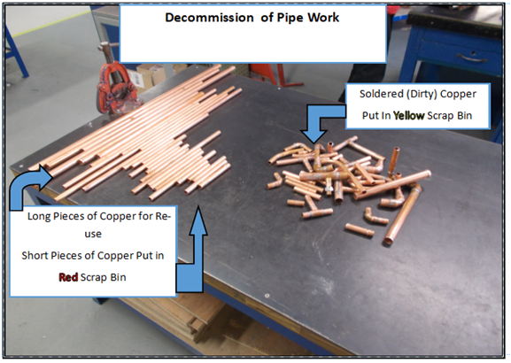

Notes for decommissioning:
Candidate to make notes in relation to decommissioning

Task 21: Install clips/brackets
Objective: To familiarise students with how to install clips/brackets to different types of building fabric.
Tutor Role: Provide guidance during the task.
Key Learning Points: Install clips/brackets to different types of building fabric.
Assessment: Review students’ practical work and written answers for accuracy and completeness.

You are required to install and fix pipework clips and brackets at recommended spacing intervals to meet specification requirements and in accordance with current industry standards.
Mark a horizontal level and fix the clips as shown below into a timber surface:
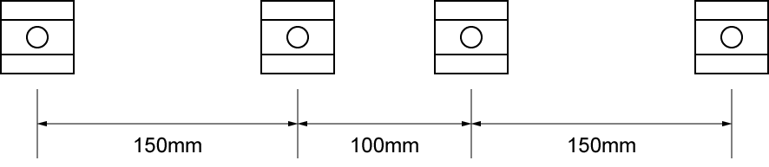

Mark a horizontal level and fix the clips as shown below into a brick or block surface:
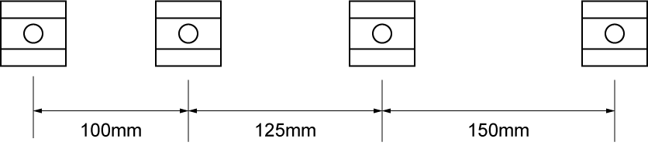

Attach the two pictured back plate elbows to a brick or block surface:
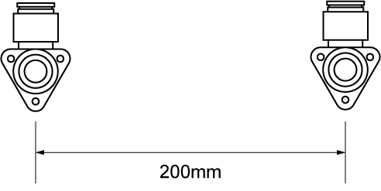
Tool list – list the tools required to complete the work task
Candidate to list the tools required to complete the task

Task 22: Plastic pipe installation
Objective: To familiarise students with how to install pipework relevant to the type of system.
Tutor Role: Provide guidance on the installation of pipework.
Key Learning Points: Install pipework relevant to the type of system.
Assessment: Review students’ practical work and written answers for accuracy and completeness.

You are required to fabricate the installation shown below using 32mm plastic waste pipe.
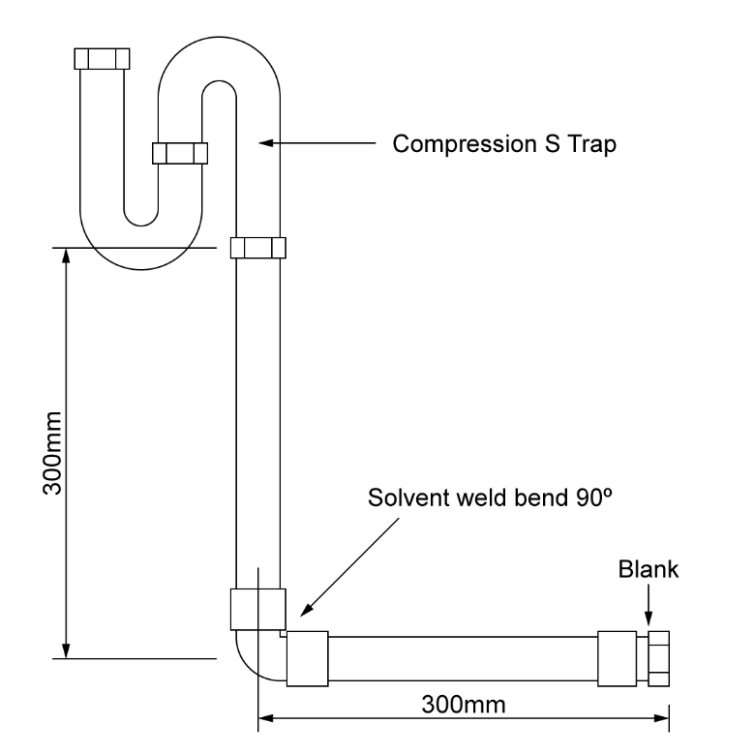

Material type (description) | Quantity
Candidate to list the materials required to complete the task

Tool list – list the tools required to complete the work task
Candidate to list the tools required to complete the task

Feedback - Assessor to tick
Please develop and work on the following elements: |  | Criteria
Measurement |  | - +/- 2mm of the dimensions on the drawing.
Marking out |  | - +/- 2mm of the dimensions on the drawing.  - Marked out in pencil.  - Spirit level used where necessary.
Clipping |  | - Select appropriate pipework clips for use and space them correctly.
Pipe jointing |  | - Pipe and fittings are free from tool and vice marks
Pipe bending
Presentation of work
Ensuring work meets industry requirements |  | - Completed pipework must be leak free.
Health and safety |  | - Health and safety requirements must be observed at all times

Task 23: Joist notching
Objective: To familiarise students with how to prepare the building fabric.
Tutor Role: Provide guidance on how to prepare the building fabric.
Key Learning Points: Preparation techniques to prepare the building fabric. Assessment: Review students’ practical work and written answers for accuracy and completeness.

Many installations require the notching and drilling of timber joists to accommodate pipes and fittings under the floor.
Notches must be made as shown in the diagram below:
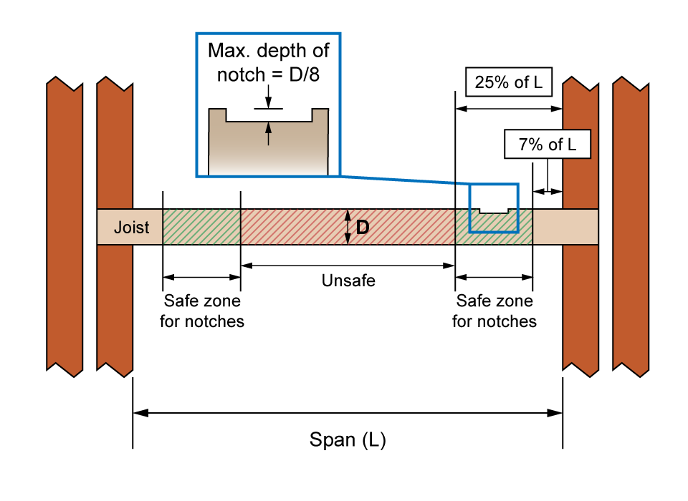
- If a joist had a depth of 150mm, the maximum depth of notch would be?
18.75mm

- If a joist had a depth of 250mm, the maximum depth of notch would be?
31.25mm

- Complete all calculations for a joist with a span of 3000mm and a depth of 200mm
Notch= 25mm
0.07x3000mm= 210mm
0.25x3000mm= 750mm

Holes drilled or cut into joists follow a similar procedure. A hole must not begin within 25 per cent of the span, measured from the end of the joist and must stop at a point equal to 40 per cent of the span, again measured from the end. The size of the hole must not exceed a measurement equal to 25 per cent of the depth of the joist.
Holes must be made as shown in the diagram below:
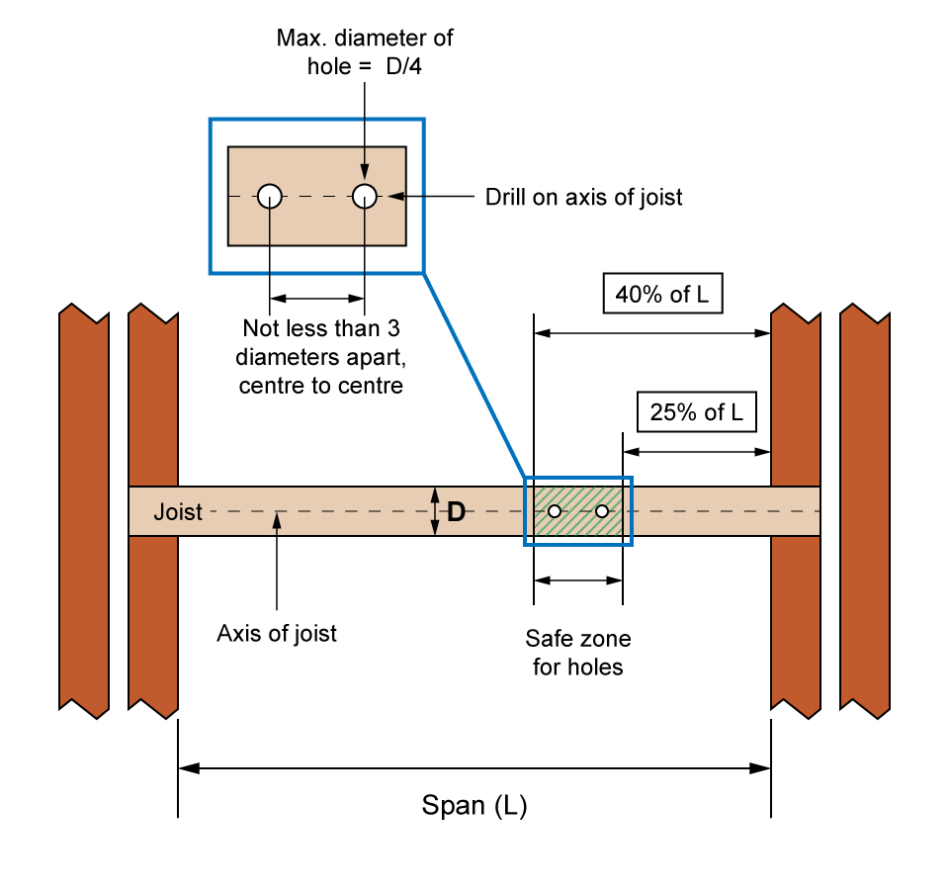
- If a joist had a depth of 200mm, the maximum diameter of hole would be?
50mm
- If a joist had a depth of 250mm, the maximum diameter of hole would be?
62.5mm

- Complete all calculations for a joist with a span of 3000mm and a depth of 200mm
Hole= 50mm
0.4x3000mm= 1200mm
0.25x3000mm= 750mm

Task 24: Rainwater system components
Objective: To familiarise students with the types of pipework and types of fittings.
Tutor Role: Provide examples of pipework, fittings and how to correctly join them, discussing the positioning and fixing of pipework within the building fabric.
Key Learning Points: Types of pipework and pipework materials and sizes used in buildings. The different types and use of fitting and their suitability for different applications/material types.
Assessment: Review students' written answers for accuracy and completeness.

Identify the rainwater system components
Fitting | Description | Purpose
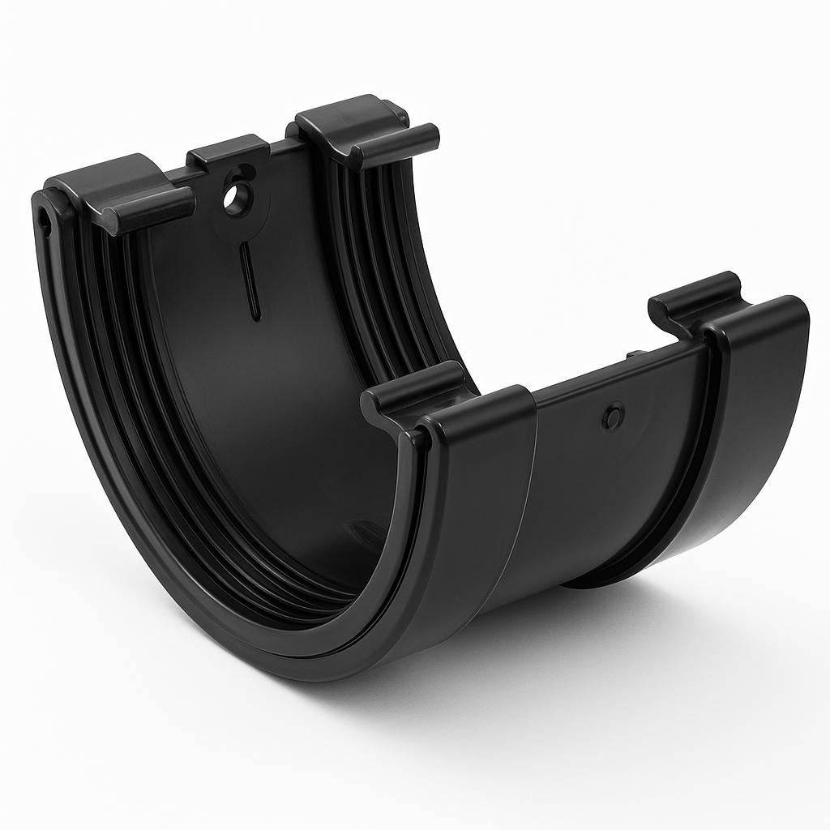 | Union | Joining two pieces of gutter together
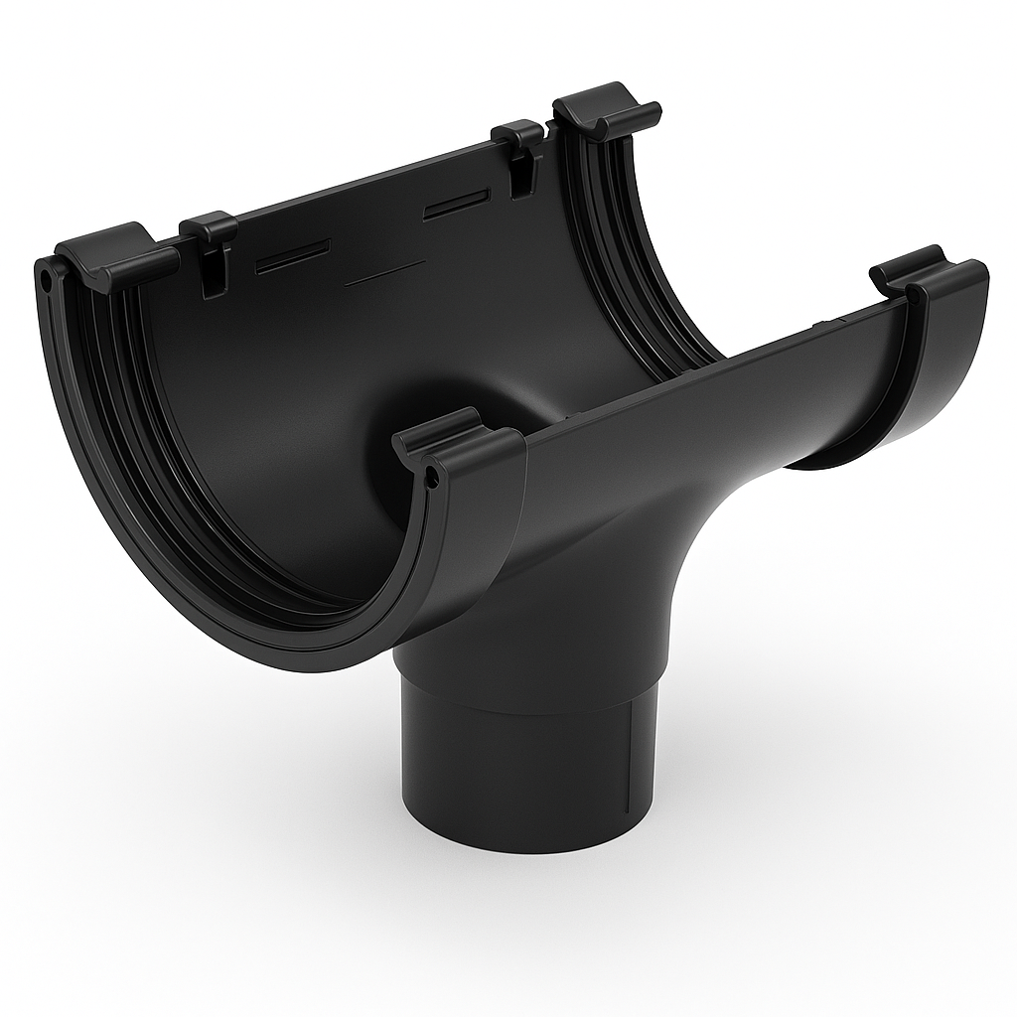 | Running outlet | Connecting a gutter to rainwater pipe
 | 90 gutter angle | Changing directing
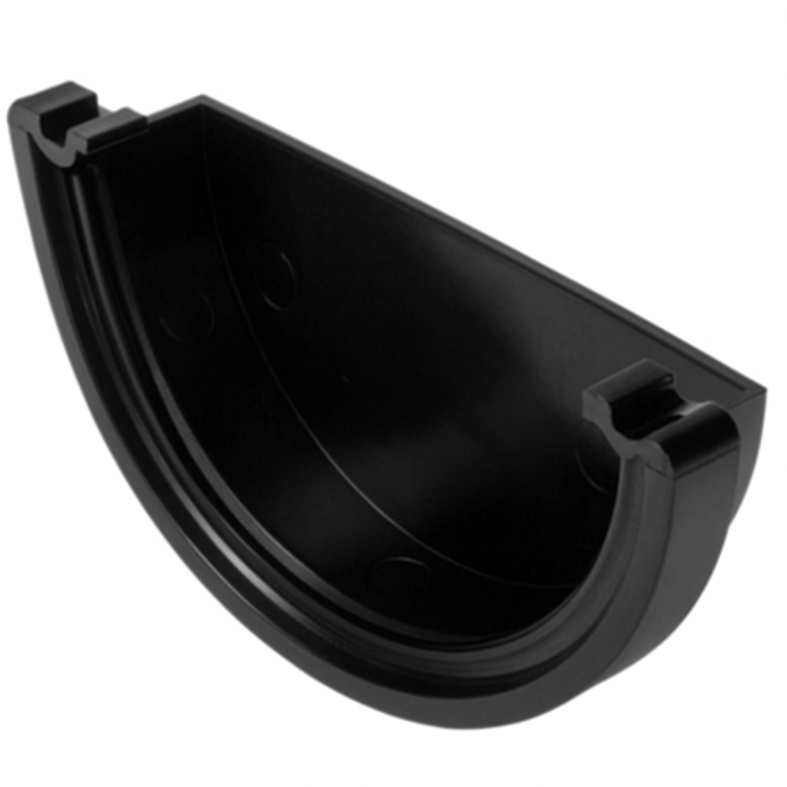 | Stop end | At the end of a run
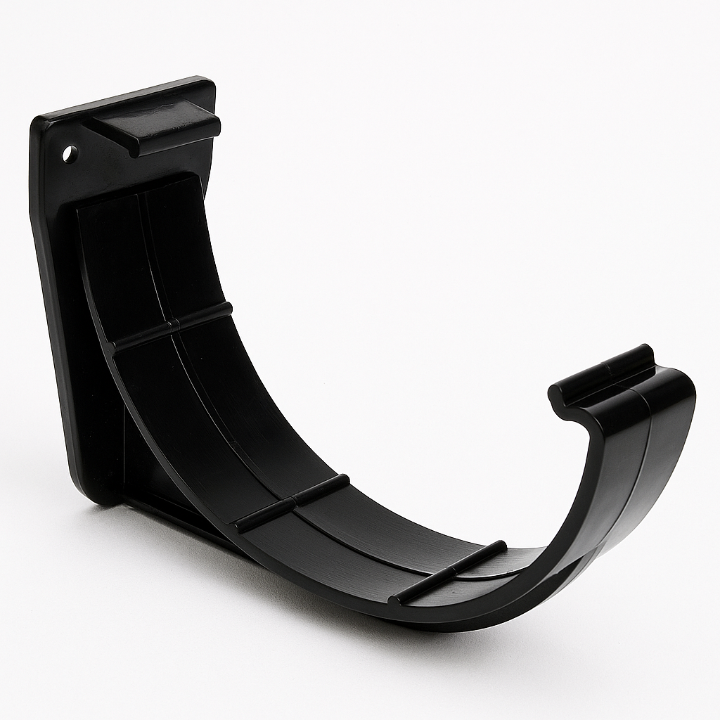 | Fascia bracket | To secure the gutter to the building
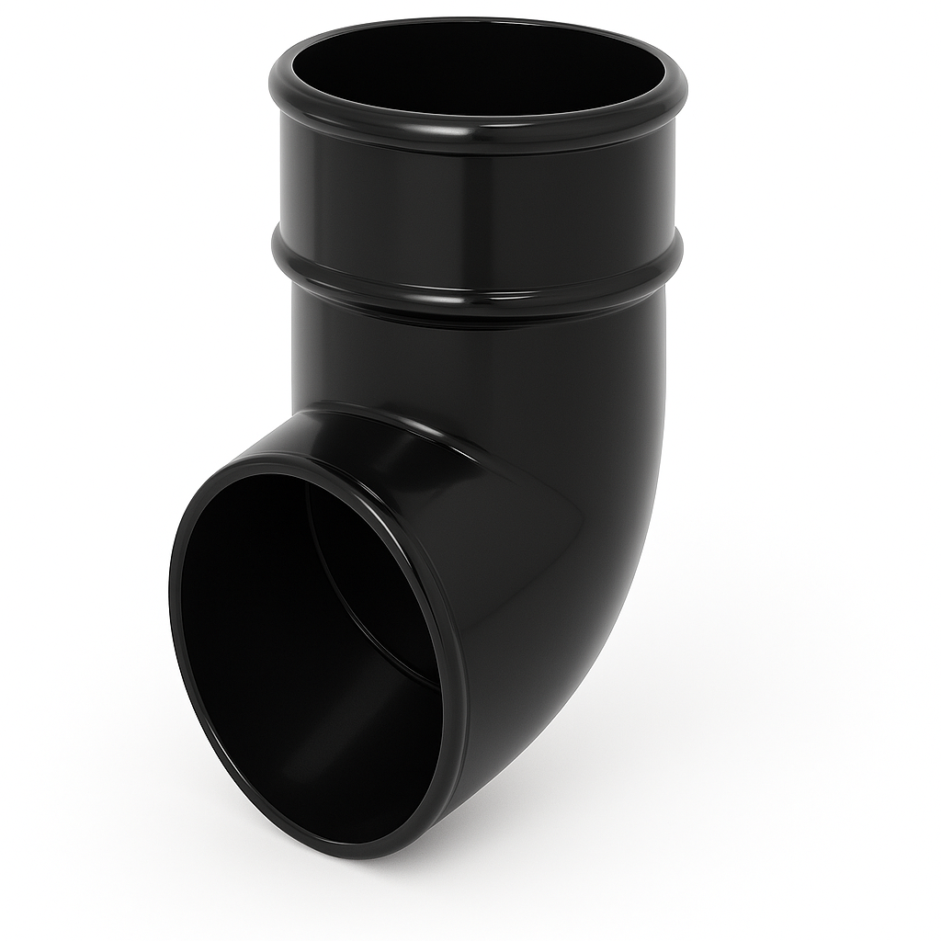 | Shoe | At the bottom of a rainwater pipe
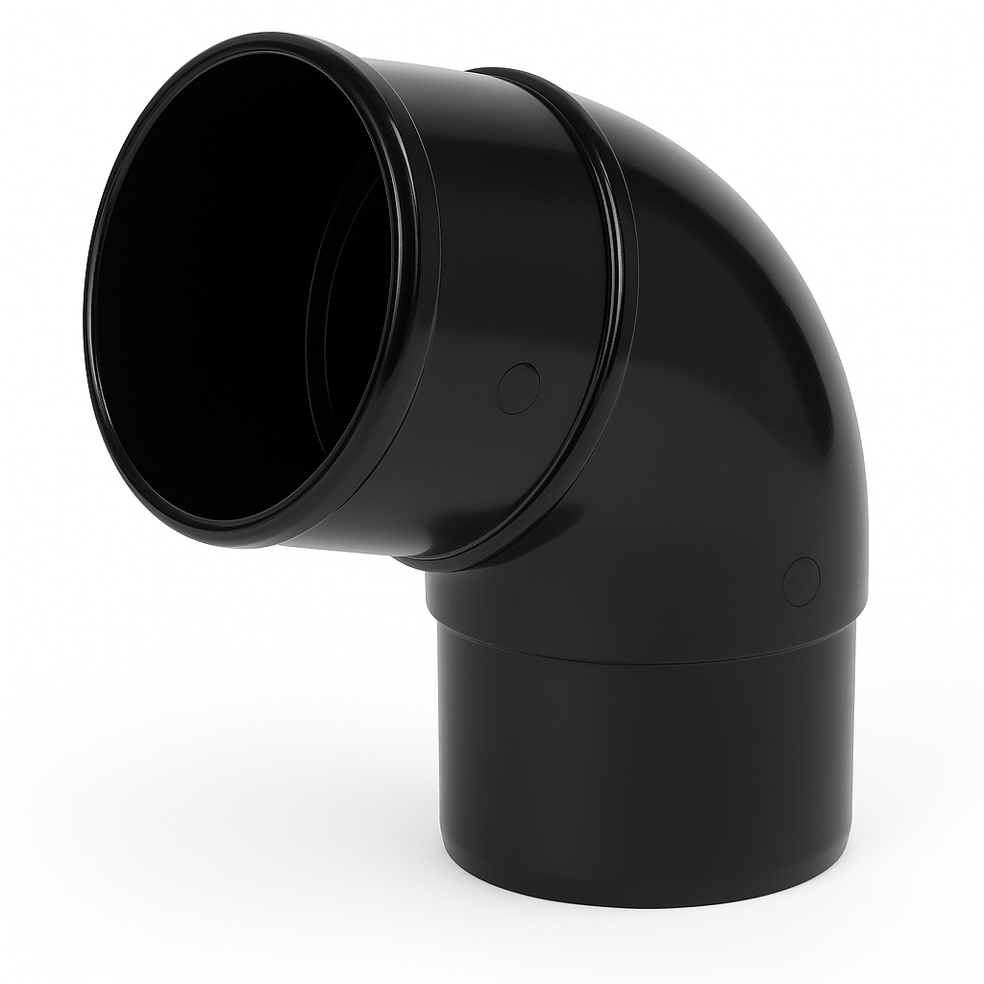 | 45 bend | To offset a rainwater pipe

Task 25: Rainwater installation
Objective: To familiarise students with how to install pipework relevant to the type of system.
Tutor Role: Provide guidance on the installation of pipework
Key Learning Points: Install pipework relevant to the type of system.
Assessment: Review students’ practical work and written answers for accuracy and completeness.

You are required to fabricate the rainwater system shown below.
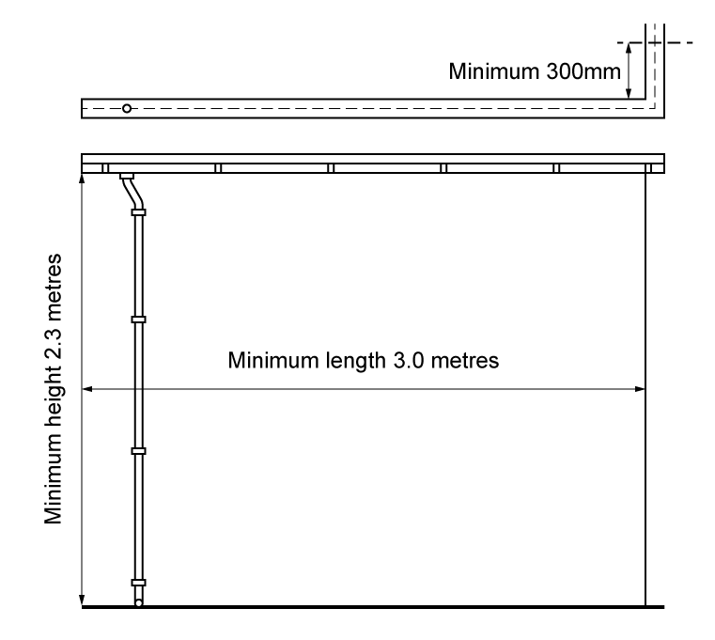

Material type (description) | Quantity
Candidate to list the materials required to complete the task

Tool list – list the tools required to complete the work task
Candidate to list the tools required to complete the task

Feedback - Assessor to tick
Please develop and work on the following elements: |  | Criteria
Measurement |  | - Student installs guttering brackets at the correct gradient and at correct spacing intervals (+/- 2mm)
Marking out |  | - Marked out in pencil  - Spirit level used
Clipping |  | - Select appropriate pipework clips for use and space them correctly
Presentation of work
Ensuring work meets industry requirements |  | - Completed pipework must be leak free
Health and safety |  | - Health and safety requirements must be observed at all times

Task 26: Soil stack components
Objective: To familiarise students with the types of pipework and types of fittings
Tutor Role: Provide examples of pipework, fittings and how to correctly join them, discussing the positioning and fixing of pipework within the building fabric.
Key Learning Points: Types of pipework and pipework materials and sizes used in buildings. The different types and use of fitting and their suitability for different applications/material types.
Assessment: Review students' written answers for accuracy and completeness.

Identify the soil stack components.
Fitting | Description | Purpose
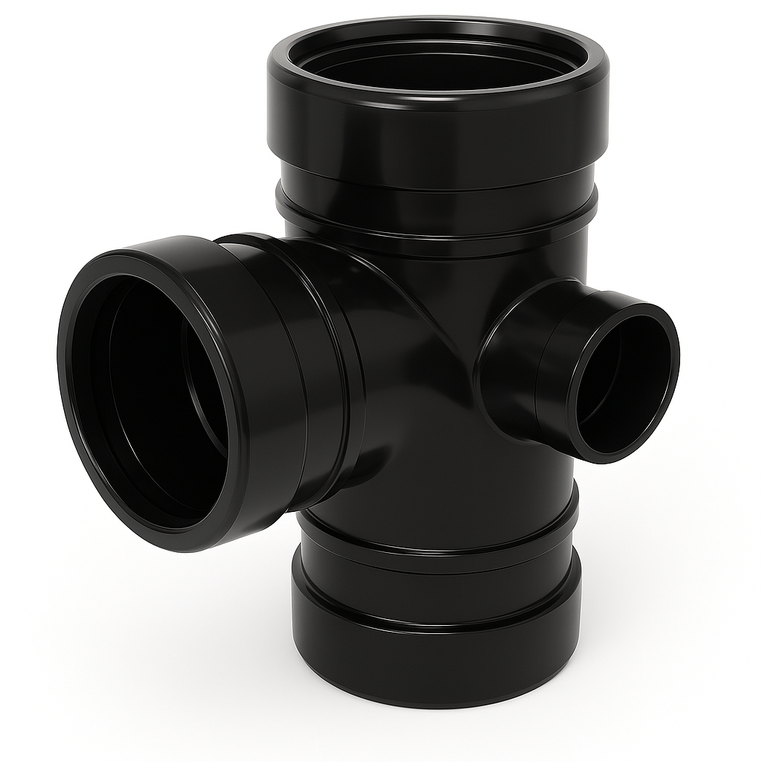 | Soil branch | To install a branch
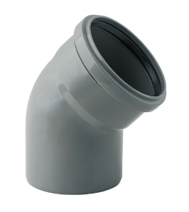 | 45 soil bend | Change of direction
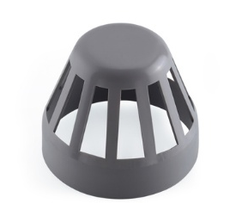 | Vent guard | At the top of a soil stack
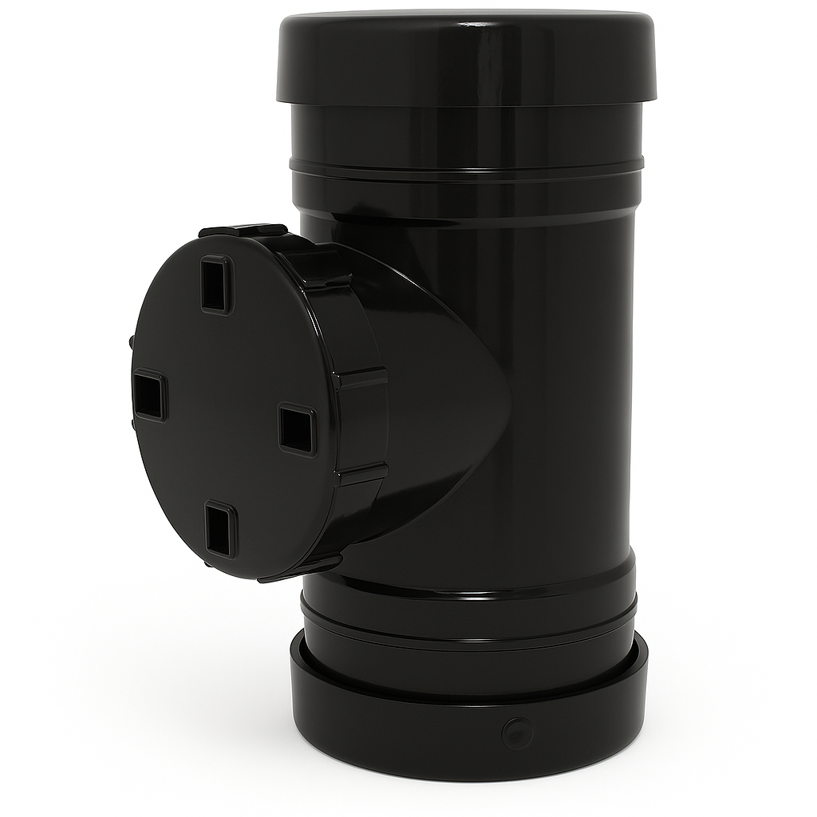 | Access pipe | At the base of the bottom stack to allow access for cleaning
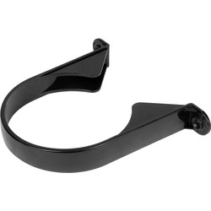 | Soil clip | To secure soil pipe to the building
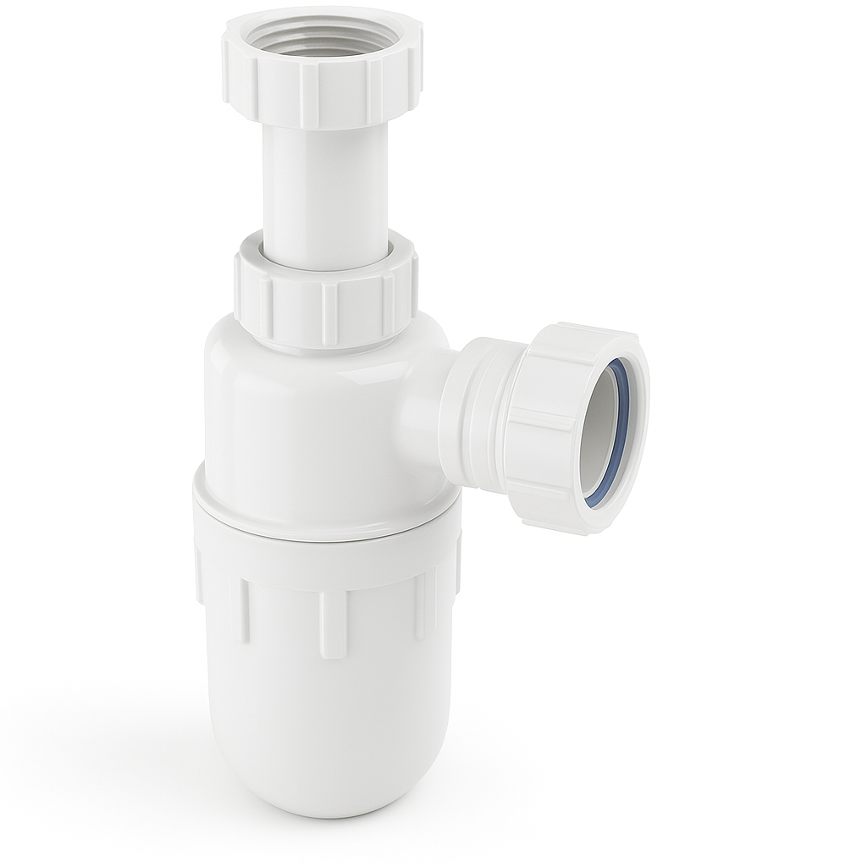 | Trap | To prevent bad smells entering the building
 | Strap on boss | To connect a waste pipe to a soil pipe
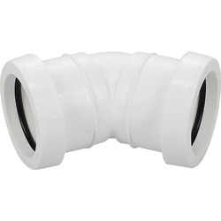 | 45 waste bend | To change direction
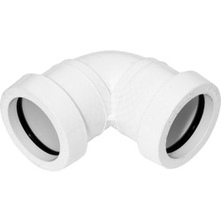 | 90 waste bend | To change direction
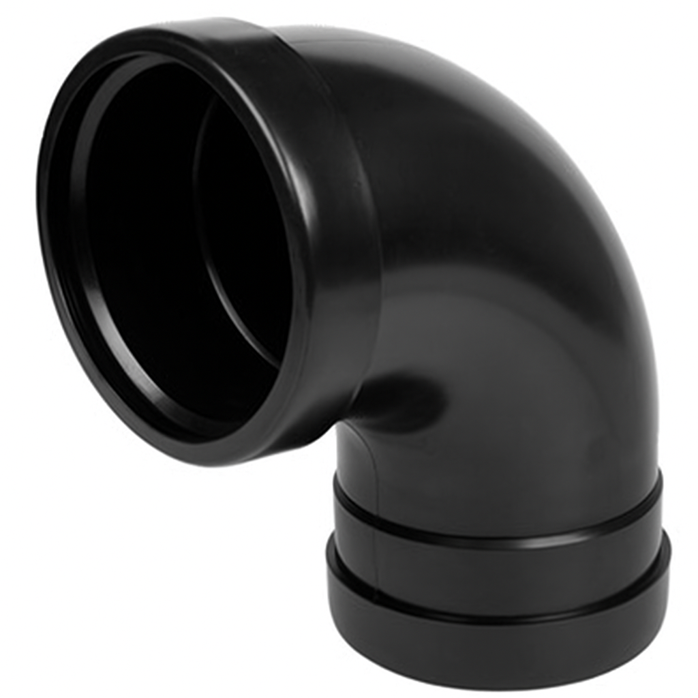 | 90 soil bend | To change direction

Task 27: Soil stack installation
Objective: To familiarise students with how to install pipework relevant to the type of system.
Tutor Role: Provide guidance on the installation of pipework
Key Learning Points: Install pipework relevant to the type of system.
Assessment: Review students’ practical work and written answers for accuracy and completeness.

You are required to install the soil stack.

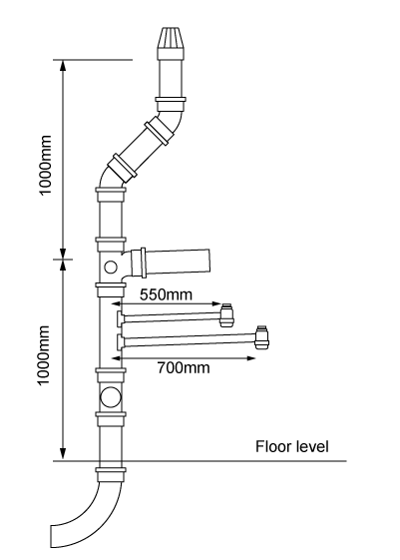
Material type (description) | Quantity
Candidate to list the materials required to complete the task

Tool list – list the tools required to complete the work task
Candidate to list the tools required to complete the task

Feedback - Assessor to tick
Please develop and work on the following elements: |  | Criteria
Measurement |  | - Student installs brackets at the correct gradient and at correct spacing intervals (+/- 2mm)
Marking out |  | - Marked out in pencil  - Spirit level used
Clipping |  | - Select appropriate pipework clips for use and space them correctly
Presentation of work
Ensuring work meets industry requirements |  | - Completed pipework must be leak free
Health and safety |  | - Health and safety requirements must be observed at all times

Task 28: Air testing
Objective: To familiarise students on Inspection techniques, Factors to inspect during pre-commissioning, Testing techniques and their application
Tutor Role: Provide guidance on system commissioning
Key Learning Points: Inspection techniques, Factors to inspect during pre-commissioning, Testing techniques and their application
Assessment: Review students’ practical work and written answers for accuracy and completeness.

Soundness testing should be carried out in accordance with BS EN 12056.
Test specification:
38mm water gauge pressure for a period of 3 minutes with no pressure loss.
Procedure:
- Seal the system using drain plugs or air bags
- Fill traps with water.
- Connect water gauge.
- Using hand bellows apply test pressure and carry out test using leak detector spray to locate leaks.
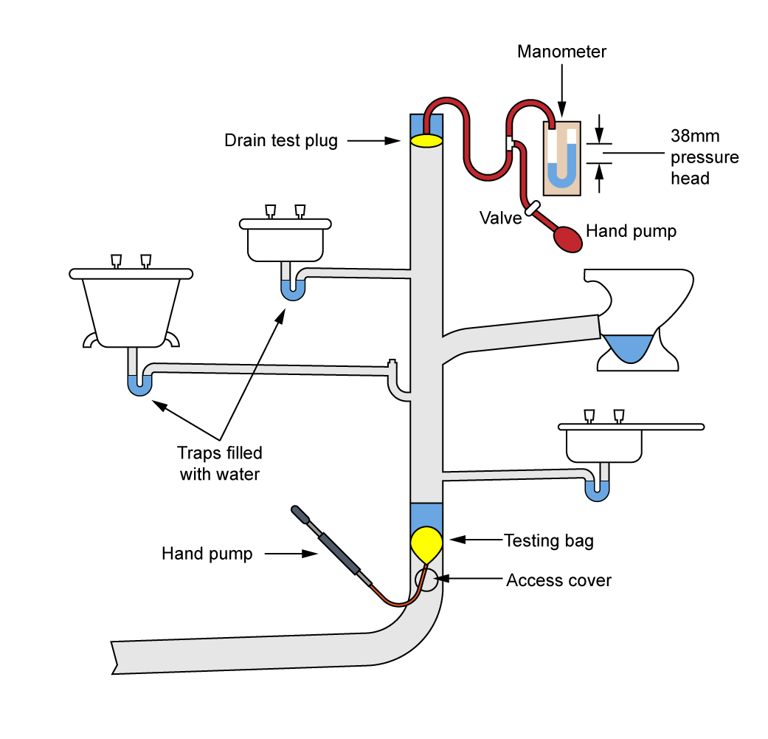

Write a brief description on how to carry out a soundness test
Seal the System
  - Insert test bungs at all open ends of the soil stack, including branch connections and appliance outlets.
  - Ensure the stack is isolated from the rest of the drainage system.
Attach the Air Testing Gauge
  - Connect the gauge to a suitable point on the stack, typically via a tee fitting.
  - Ensure the gauge is calibrated and zeroed before use.

Pressurise the System
  - Use a hand pump or compressor to introduce air into the system.
  - Raise the pressure to 38mm water gauge (WG) for above-ground pipework (or 100mm WG for below-ground systems).
Monitor the Pressure
  - Maintain the pressure for at least 3 minutes.
  - Observe the gauge for any drop in pressure, which would indicate a leak.
Check for Leaks
  - Apply soapy water to joints and fittings to visually detect escaping air bubbles.
  - If pressure drops or bubbles appear, locate and rectify the leak before retesting.
Record the Results
Document the test pressure, duration, and outcome.

Sanitation Commissioning Sheet
Address | To be completed by the candidate during commissioning
Engineer’s Name
Date
Soundness Test Record pressure and duration
Air Test: AGDS
Record pressure and duration
Check appliances for self-siphonage Y/N
Check appliances for induced siphonage Y/N
Performance test
Satisfactory Y/N

Task 29: Installing radiators
Objective: To familiarise students on the installation of appliances and components.
Tutor Role: Provide guidance on the installation of appliances and components.
Key Learning Points: Install heat-emitting devices.
Assessment: Review students’ practical work and written answers for accuracy and completeness.

You are required to hang and pipe up a panel radiator. Name the objects below and describe the procedure for hanging the radiator.
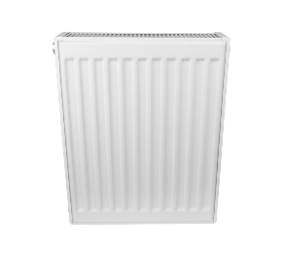 | 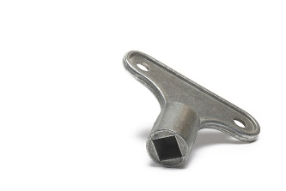
A) Radiator | B) Bleed key
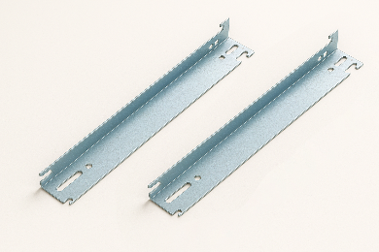 | 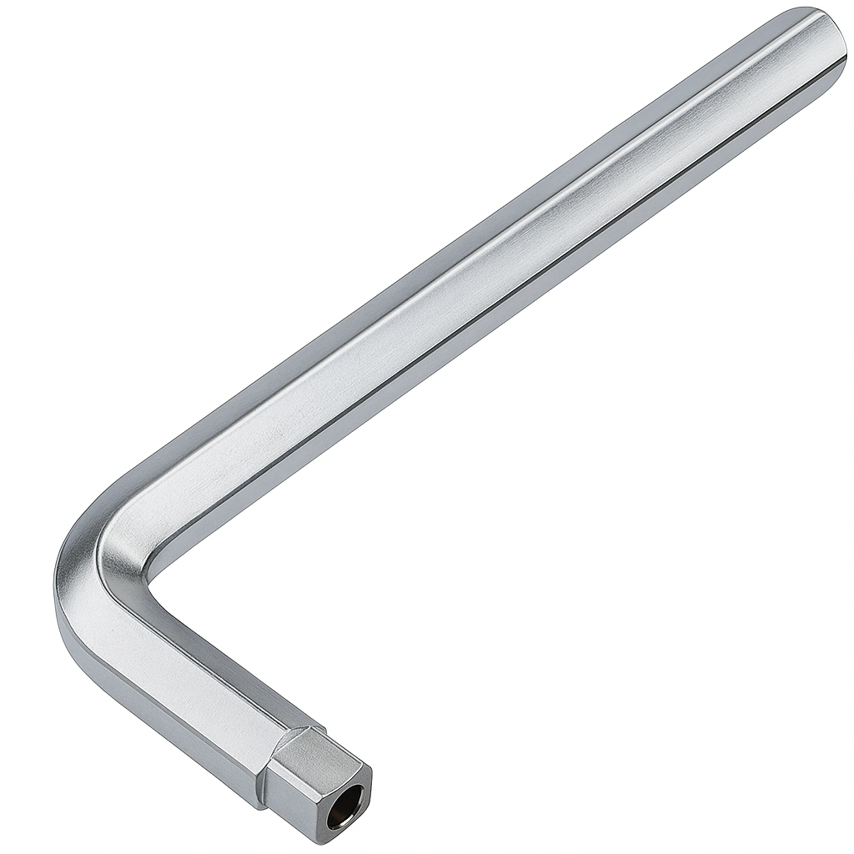
C) Brackets | D) Radiator key
Procedure:

Mark the centre line between the radiator pipes on the wall.
Determine the bottom line where the radiator should hang, based on valve height.
Measure bracket positions on the radiator and transfer those to the wall using a spirit level.
Drill pilot holes and insert wall plugs.
Screw in the brackets, ensuring they’re level and secure.
Wrap PTFE tape around valve threads.
Fit the TRV and lockshield valves to the radiator.
Mount the radiator onto the wall brackets.
Connect the valves to the pipework and tighten compression nuts.

Task 30: Central heating installation
Objective: To familiarise students on the installation of pipework, appliances and components
Tutor Role: Provide guidance on the installation of appliances and components
Key Learning Points: Install heat-emitting devices, Install clips/brackets to different types of building fabric, Install pipework relevant to the type of system
Assessment: Review students’ practical work and written answers for accuracy and completeness
You are required to install the central heating system using copper pipework and end feed fittings. Once completed the installation must be pressure tested.
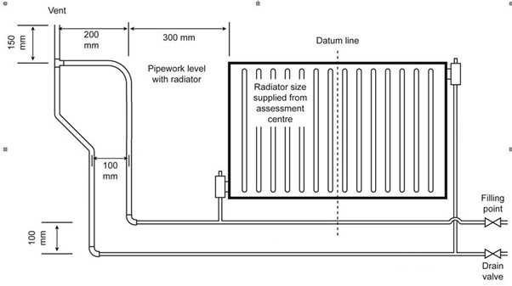
Material type (description) | Quantity
Candidate to list the materials required to complete the task

Tool list – list the tools required to complete the work task
Candidate to list the tools required to complete the task

Feedback - Assessor to tick
Please develop and work on the following elements: |  | Criteria
Measurement |  | - +/- 2mm of the dimensions on the drawing
Marking out |  | - +/- 2mm of the dimensions on the drawing  - Marked out in pencil  - Spirit level used
Clipping |  | - Select appropriate pipework clips for use and space them correctly
Pipe jointing |  | - Soldered joints must be free from excessive solder and residual flux  - Pipe and fittings are free from tool and vice marks  - Malleable iron fittings show no more than 1 ½ threads
Pipe bending |  | - Pipe bends must be free from ripples, throating or excessive distortion
Presentation of work
Ensuring work meets industry requirements |  | - Completed pipework must be leak free
Health and safety |  | - Health and safety requirements must be observed at all times

Task 31: Cloakroom Installation
Objective: To familiarise students on the installation of pipework, appliances and components
Tutor Role: Provide guidance on the installation of appliances and components
Key Learning Points: Install appliances, install components, Install clips/brackets to different types of building fabric, Install pipework relevant to the type of system
Assessment: Review students’ practical work and written answers for accuracy and completeness
You are required to install the cloakroom fittings using copper pipework and end feed fittings. Once completed the installation must be pressure tested.
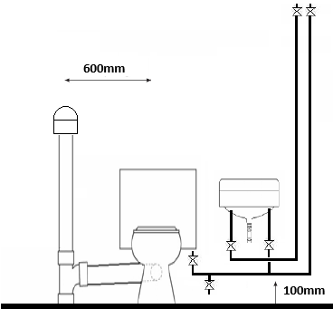
Material type (description) | Quantity
Candidate to list the materials required to complete the task

Tool list – list the tools required to complete the work task
Candidate to list the tools required to complete the task

Feedback - Assessor to tick
Please develop and work on the following elements: |  | Criteria
Measurement |  | - +/- 2mm of the dimensions on the drawing
Marking out |  | - +/- 2mm of the dimensions on the drawing  - Marked out in pencil  - Spirit level used
Clipping |  | - Select appropriate pipework clips for use and space them correctly
Pipe jointing |  | - Soldered joints must be free from excessive solder and residual flux  - Pipe and fittings are free from tool and vice marks  - Malleable iron fittings show no more than 1 ½ threads
Pipe bending |  | - Pipe bends must be free from ripples, throating or excessive distortion
Presentation of work
Ensuring work meets industry requirements |  | - Completed pipework must be leak free
Health and safety |  | - Health and safety requirements must be observed at all times

Task 32: Unvented cylinder installation
Objective: To familiarise students on the installation of pipework, appliances and components including commissioning and decommissioning.
Tutor Role: Provide guidance on the installation of appliances and components.
Key Learning Points: Install appliances, install components, Install clips/brackets to different types of building fabric, Install pipework relevant to the type of system, Commission systems, decommission systems.
Assessment: Review students’ practical work and written answers for accuracy and completeness.
You are required to install the central heating system using copper pipework and end feed fittings. Once completed the installation must be commissioned.
Key components
- Unvented cylinder: The main vessel where water is stored and heated.
- Cold Water inlet group: Includes a pressure-reducing valve, check valve, and strainer to regulate and clean incoming water.
- Expansion vessel Accommodates water expansion as it heats.
- Tundish: A visible air gap that shows if water is discharging from safety valves.
- Discharge pipework: Safely channels hot water from safety valves to a termination point.
- Temperature and pressure relief valve – Releases water if temperature exceeds ~90°C or pressure becomes excessive.
- Pressure reducing valve – Keeps incoming mains pressure at a safe level (typically around 3 bar).
- Check valve – Stops backflow of water, protecting mains supply from contamination.
Label the system components
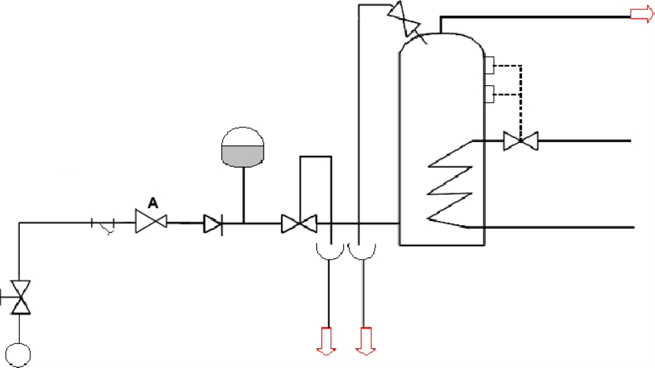
Material type (description) | Quantity
Candidate to list the materials required to complete the task

Tool list – list the tools required to complete the work task
Candidate to list the tools required to complete the task

Feedback - Assessor to tick
Please develop and work on the following elements: |  | Criteria
Measurement |  | - +/- 2mm of the dimensions on the drawing
Marking out |  | - +/- 2mm of the dimensions on the drawing  - Marked out in pencil  - Spirit level used
Clipping |  | - Select appropriate pipework clips for use and space them correctly
Pipe jointing |  | - Soldered joints must be free from excessive solder and residual flux  - Pipe and fittings are free from tool and vice marks  - Malleable iron fittings show no more than 1 ½ threads
Pipe bending |  | - Pipe bends must be free from ripples, throating or excessive distortion
Presentation of work
Ensuring work meets industry requirements |  | - Completed pipework must be leak free
Health and safety |  | - Health and safety requirements must be observed at all times

Task 33: Termination of BS1363 plug top
Objective: To familiarise students on how to carryout electrical tasks
Tutor Role: Provide guidance on basic electrical tasks
Key Learning Points: how to prepare and terminate electrical cables
Assessment: Review students’ practical work and written answers for accuracy and completeness

You are required to terminate BS1363 plug top using 1.5mm2 3 core flexible cable.
Identify the parts of the plug

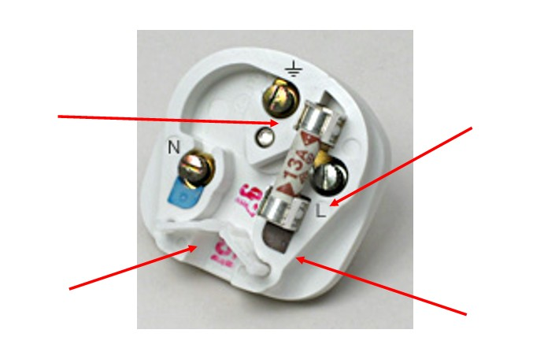
Plug top
Connection information
Cable Grip
Fuse

Task 34: WC macerator installation
Objective: To familiarise students on the installation of pipework, appliances and components including commissioning and decommissioning.
Tutor Role: Provide guidance on the installation of appliances and components.
Key Learning Points: Install appliances, install components, Install clips/brackets to different types of building fabric, Install pipework relevant to the type of system, Commission systems, decommission systems.
Assessment: Review students’ practical work and written answers for accuracy and completeness.

You are required to install the WC macerator.
A WC macerator is a compact waste disposal unit that allows toilets to be installed in areas without access to standard gravity drainage, like basements or loft spaces. It works by grinding solid waste into a slurry using internal blades, then pumping it through narrow pipework (typically 22–32mm in diameter) to the main soil stack. For installation, the macerator should be positioned directly behind or near the toilet, with access to a fused spur power supply and a suitable discharge route. Plumbing must follow specific guidelines, including a minimum vertical lift, a gradual gradient for horizontal runs, and avoidance of sharp bends to prevent clogs. Additionally, a check valve and air vent should be installed to manage backflow and ventilation.

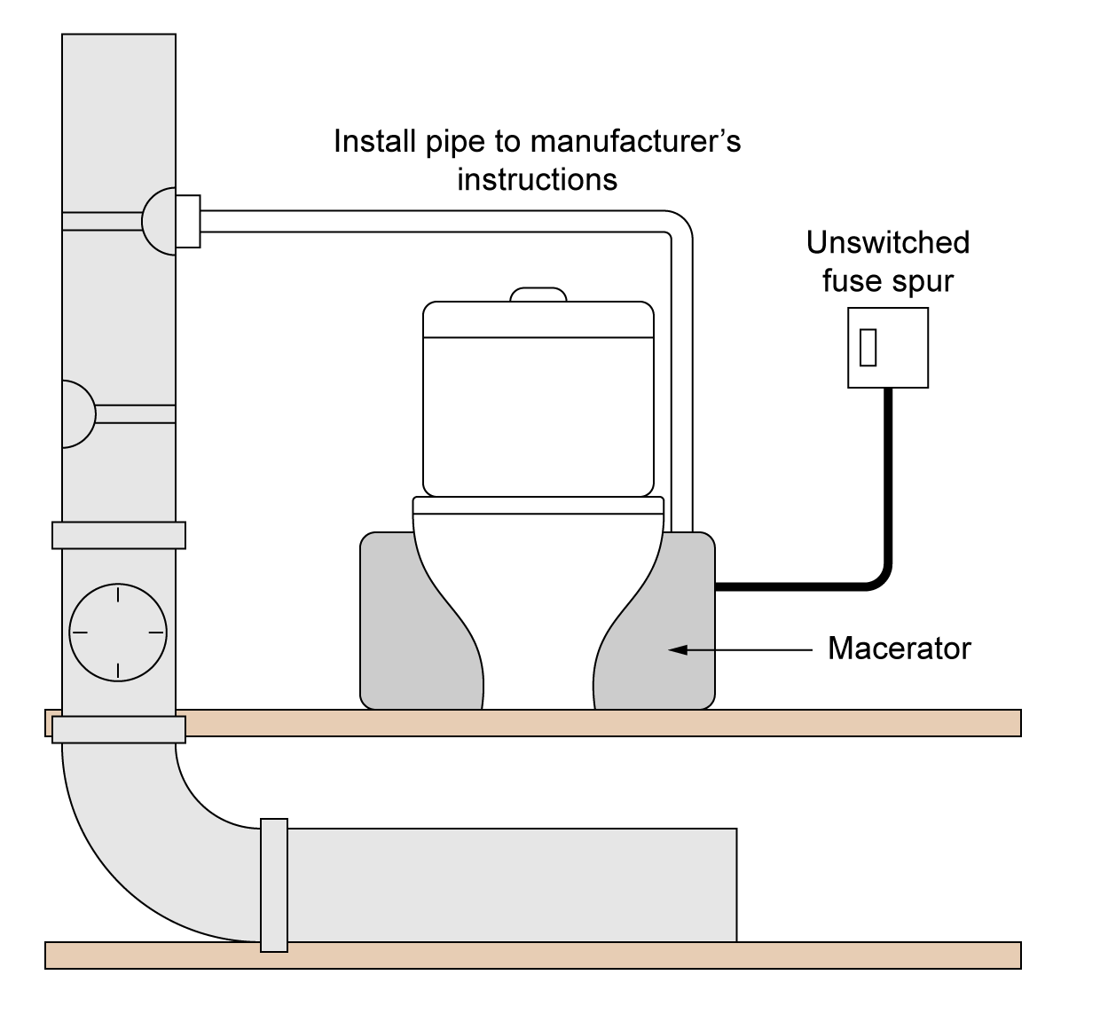

Material type (description) | Quantity
Candidate to list the materials required to complete the task

Tool list – list the tools required to complete the work task
Candidate to list the tools required to complete the task

Feedback - Assessor to tick
Please develop and work on the following elements: |  | Criteria
Measurement |  | - +/- 2mm of the dimensions on the drawing
Marking out |  | - +/- 2mm of the dimensions on the drawing  - Marked out in pencil  - Spirit level used
Clipping |  | - Select appropriate pipework clips for use and space them correctly
Pipe jointing |  | - Soldered joints must be free from excessive solder and residual flux  - Pipe and fittings are free from tool and vice marks  - Malleable iron fittings show no more than 1 ½ threads
Pipe bending |  | - Pipe bends must be free from ripples, throating or excessive distortion
Presentation of work
Ensuring work meets industry requirements |  | - Completed pipework must be leak free
Health and safety |  | - Health and safety requirements must be observed at all times

Task 35: Y Plan central heating wiring
Objective: To familiarise students on how to install electrical controls.
Tutor Role: Provide guidance on how to install electrical controls.
Key Learning Points: how to prepare and terminate electrical cables and how to install electrical controls.
Assessment: Review students’ practical work and written answers for accuracy and completeness.
You are required to complete the wiring for a Y Plan central heating system.
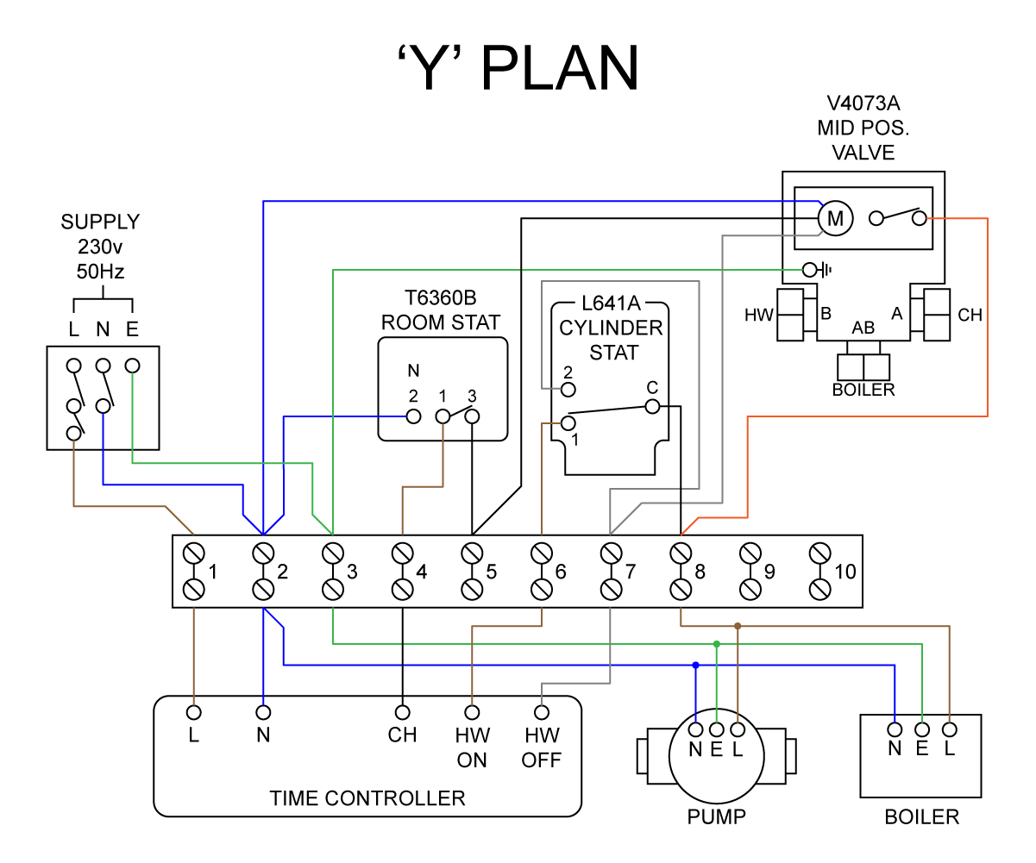
Notes.
Candidate to make notes on wiring

Task 36: S Plan central heating wiring
Objective: To familiarise students on how to install electrical controls.
Tutor Role: Provide guidance on how to install electrical controls.
Key Learning Points: how to prepare and terminate electrical cables and how to install electrical controls.
Assessment: Review students’ practical work and written answers for accuracy and completeness.
You are required to complete the wiring for a S Plan central heating system.
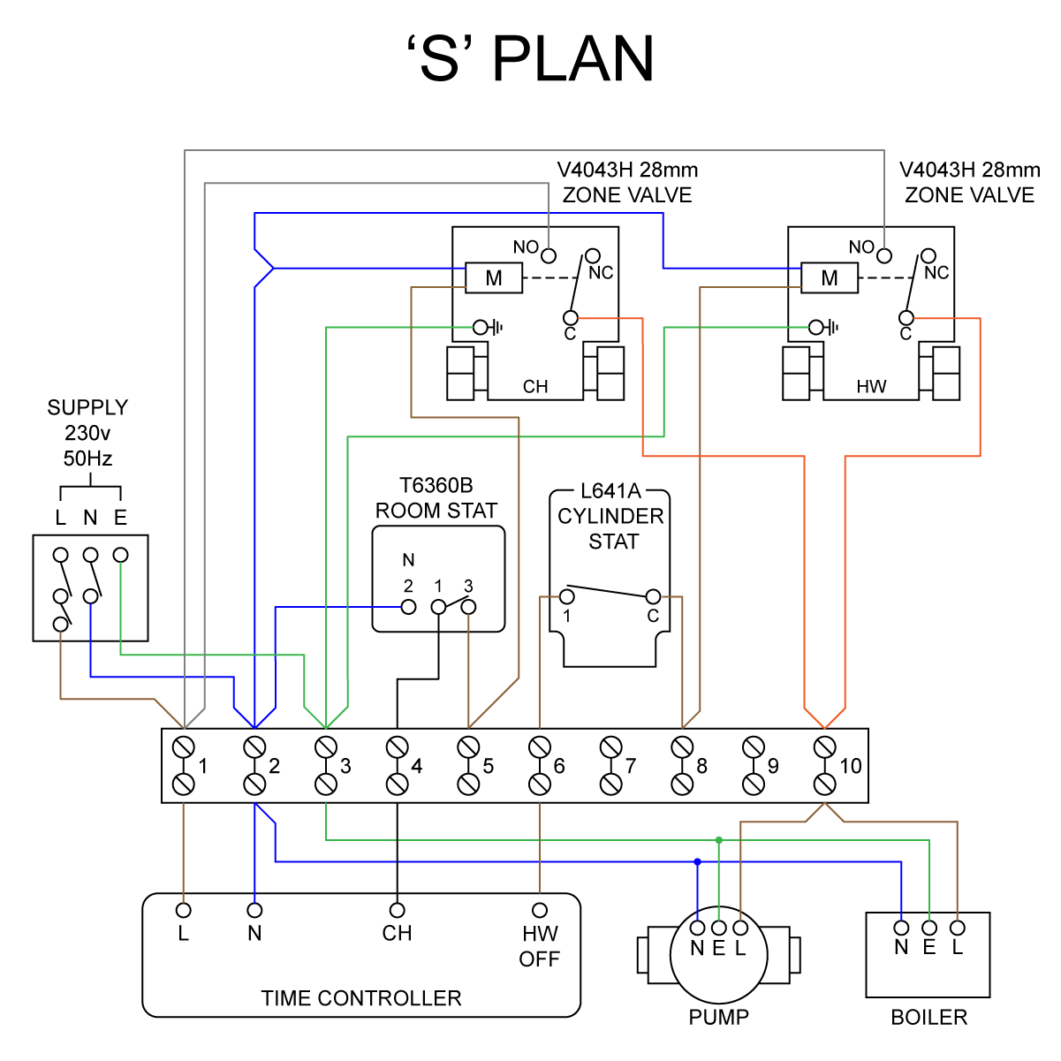
Notes.
Candidate to make notes on wiring

Task 37: WC installation
Objective: To familiarise students on the installation of pipework, appliances and components including commissioning and decommissioning
Tutor Role: Provide guidance on the installation of appliances and components
Key Learning Points: Install appliances, install components, Install clips/brackets to different types of building fabric, Install pipework relevant to the type of system, Commission systems, decommission systems.
Assessment: Review students’ practical work and written answers for accuracy and completeness
You are working as a plumbing engineer and have been called to a domestic property to undertake the planning and installation of an additional WC.
As part of this work you will be required to carry out a full survey of the proposed installation, including planning activities, measurements and calculations.
The customer has identified a ground floor space that they want to convert into a cloakroom and has requested the installation of:
- A new Water Closet (WC)
- A new soil stack
The existing cold supplies are available from an installation that is already in place.
Your supervisor will notify you of the requirements of the installation and a plan of the proposed space and location of existing services where you will carry out the installation.
The installation must include:
- cold-water supply to any suitable WHB
- all pipework is to be surface mounted and installed to a commercially acceptable standard.
Once your installation has been completed, commissioned and checked to the customer’s satisfaction, you are required to decommission the installation.

Part 1: Produce the following documents
- Installation diagram
- Risk Assessment
- Material list
- Method statement
Part 2: Installation, Commissioning and Decommissioning.

Installation diagram
Candidate to produce a drawing. This should meet the following criteria: Installation drawing is complete and accurate, and the position of components is correct with consideration of aesthetics or performance. The diagram includes all key measurements, uses industry recognised symbols and includes a key.

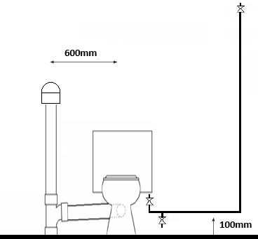

Risk Assessment
What are the hazards? | Risk |  |  | Possible outcomes | Who is involved | Control methods | Review methods
What are the hazards? | L | M | H

Material type (description) | Quantity
Candidate to list the materials required to complete the task
All materials, quantities and PPE required to meet the brief have been identified with excellent consideration given to the aesthetics of the finished installation.

Tool list – list the tools required to complete the work task
Candidate to list the tools required to complete the task

Method statement of the installation

Instructions: Provide a detailed account of the installation
It must include sequencing of activities with justification of each part of the task e.g. marked my work area out with a pencil, tape measure and ruler to ensure all measurements are correct and lines are level and plumb.

Method Statement of the Installation
Candidate to produce a method statement. This should meet the following criteria:
Documents are thorough and demonstrate comprehensive technical knowledge, and the process is set out in a logical order. There is detail in how to perform tasks with clear reasoning that links to the assignment brief and tasks to justify choices made.

Commissioning record
Sanitation Commissioning Sheet

Address
Engineer’s Name
Date
Soundness Test Record pressure and duration
Air Test: AGDS
Record pressure and duration
Appliance 1: | Flow Rate: | Outlet Temperature:
Appliance 2: | Flow Rate: | Outlet Temperature:
Appliance 3: | Flow Rate: | Outlet Temperature:
Appliance 4: | Flow Rate: | Outlet Temperature:
Appliance 5: | Flow Rate: | Outlet Temperature:
Check appliances for self-siphonage Y/N
Check appliances for induced siphonage Y/N
Performance test
Satisfactory Y/N
Notes:

Feedback - Assessor to tick
Please develop and work on the following elements: |  | Criteria
Measurement |  | - +/- 2mm of the dimensions on the drawing
Marking out |  | - +/- 2mm of the dimensions on the drawing  - Marked out in pencil  - Spirit level used
Clipping |  | - Select appropriate pipework clips for use and space them correctly
Pipe jointing |  | - Soldered joints must be free from excessive solder and residual flux  - Pipe and fittings are free from tool and vice marks  - Malleable iron fittings show no more than 1 ½ threads
Pipe bending |  | - Pipe bends must be free from ripples, throating or excessive distortion
Presentation of work
Ensuring work meets industry requirements |  | - Completed pipework must be leak free
Health and safety |  | - Health and safety requirements must be observed at all times

Task 38: Central heating installation
Objective: To familiarise students on the installation of pipework, appliances and components including commissioning and decommissioning.
Tutor Role: Provide guidance on the installation of appliances and components.
Key Learning Points: Install appliances, install components, Install clips/brackets to different types of building fabric, Install pipework relevant to the type of system, Commission systems, decommission systems.
Assessment: Review students’ practical work and written answers for accuracy and completeness.

You are working as a heating engineer and have been called to a domestic property to undertake the planning and installation of a new central heating system.
As part of this work, you will be required to carry out a full survey of the proposed installation, including planning activities, measurements and calculations.
The customer has requested the installation of:
- A panel radiator
- A towel radiator
The combination boiler has been pre-installed.
Your supervisor will notify you of the requirements of the installation and a plan of the proposed space and location of existing services where you will carry out the installation.
The installation must include:
- A panel radiator and associated valves
- A towel radiator and associated valves
- Hot and cold pipework to an existing appliance
- All pipework is to be surface mounted and installed to a commercially acceptable standard.
Once your installation has been completed, commissioned and checked to the customer’s satisfaction, you are required to decommission the installation.

Part 1: Produce the following documents
- Installation diagram
- Risk Assessment
- Material list
- Method statement
Part 2: Installation, Commissioning and Decommissioning.

Installation diagram
Candidate to produce a drawing. This should meet the following criteria: Installation drawing is complete and accurate, and the position of components is correct with consideration of aesthetics or performance. The diagram includes all key measurements, uses industry recognised symbols and includes a key.

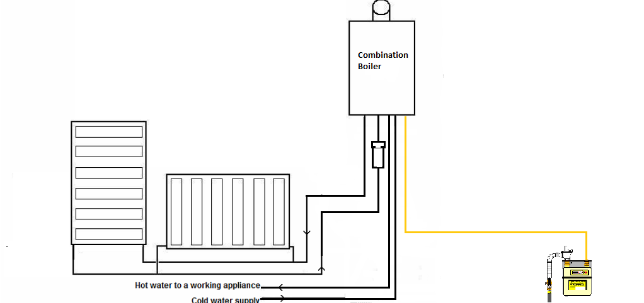

Risk Assessment
What are the hazards? | Risk |  |  | Possible outcomes | Who is involved | Control methods | Review methods
What are the hazards? | L | M | H

Material type (description) | Quantity
Candidate to list the materials required to complete the task
All materials, quantities and PPE required to meet the brief have been identified with excellent consideration given to the aesthetics of the finished installation.

Tool list – list the tools required to complete the work task
Candidate to list the tools required to complete the task

Method statement of the installation

Instructions: Provide a detailed account of the installation
It must include sequencing of activities with justification of each part of the task e.g. marked my work area out with a pencil, tape measure and ruler to ensure all measurements are correct and lines are level and plumb.

Method Statement of the Installation
Candidate to produce a method statement. This should meet the following criteria:
Documents are thorough and demonstrate comprehensive technical knowledge, and the process is set out in a logical order. There is detail in how to perform tasks with clear reasoning that links to the assignment brief and tasks to justify choices made.

Commissioning record
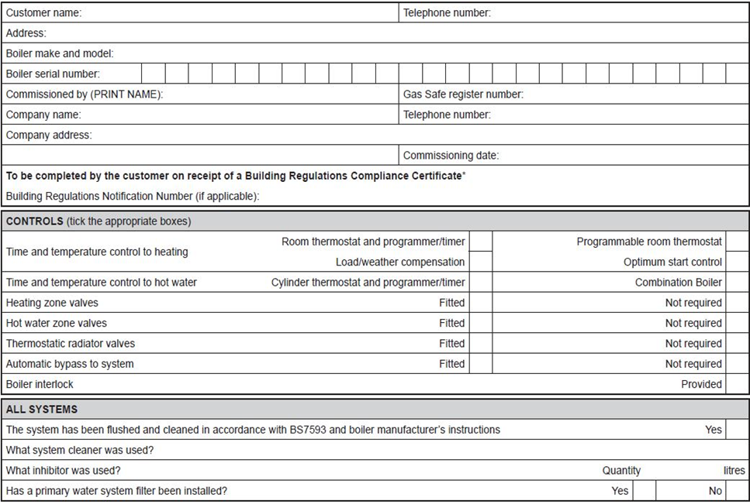

Feedback - Assessor to tick
Please develop and work on the following elements: |  | Criteria
Measurement |  | - +/- 2mm of the dimensions on the drawing
Marking out |  | - +/- 2mm of the dimensions on the drawing  - Marked out in pencil  - Spirit level used
Clipping |  | - Select appropriate pipework clips for use and space them correctly
Pipe jointing |  | - Soldered joints must be free from excessive solder and residual flux  - Pipe and fittings are free from tool and vice marks  - Malleable iron fittings show no more than 1 ½ threads
Pipe bending |  | - Pipe bends must be free from ripples, throating or excessive distortion
Presentation of work
Ensuring work meets industry requirements |  | - Completed pipework must be leak free
Health and safety |  | - Health and safety requirements must be observed at all times

Task 39: Cloakroom installation
Objective: To familiarise students on the installation of pipework, appliances and components including commissioning and decommissioning
Tutor Role: Provide guidance on the installation of appliances and components
Key Learning Points: Install appliances, install components, Install clips/brackets to different types of building fabric, Install pipework relevant to the type of system, Commission systems, decommission systems.
Assessment: Review students’ practical work and written answers for accuracy and completeness
You are working as a plumbing engineer and have been called to a domestic property to undertake the planning and installation of a new cloakroom.
As part of this work, you will be required to carry out a full survey of the proposed installation, including planning activities, measurements and calculations.
The customer has identified a ground floor space that they want to convert into a cloakroom and has requested the installation of:
- A new Water Closet (WC)
- A new wash hand basin (WHB)
- A new soil stack
The existing hot and cold supplies are available from an installation that is already in place.
Your supervisor will notify you of the requirements of the installation and a plan of the proposed space and location of existing services where you will carry out the installation.
The installation must include:
- Hot and cold-water supply to any suitable WHB
- Cold water supply to any suitable WC
- Installation of waste/soil pipe connections
- All pipework is to be surface mounted and installed to a commercially acceptable standard.
Once your installation has been completed, commissioned and checked to the customer’s satisfaction, you are required to decommission the installation.

Part 1: Produce the following documents
- Installation diagram
- Risk Assessment
- Material list
- Method statement
Part 2: Installation, Commissioning and Decommissioning.

Installation diagram
Candidate to produce a drawing. This should meet the following criteria: Installation drawing is complete and accurate, and the position of components is correct with consideration of aesthetics or performance. The diagram includes all key measurements, uses industry recognised symbols and includes a key.

Risk Assessment
What are the hazards? | Risk |  |  | Possible outcomes | Who is involved | Control methods | Review methods
What are the hazards? | L | M | H

Material type (description) | Quantity
Candidate to list the materials required to complete the task
All materials, quantities and PPE required to meet the brief have been identified with excellent consideration given to the aesthetics of the finished installation.

Tool list – list the tools required to complete the work task
Candidate to list the tools required to complete the task

Method statement of the installation

Instructions: Provide a detailed account of the installation
It must include sequencing of activities with justification of each part of the task e.g. marked my work area out with a pencil, tape measure and ruler to ensure all measurements are correct and lines are level and plumb.

Method Statement of the Installation
Candidate to produce a method statement. This should meet the following criteria:
Documents are thorough and demonstrate comprehensive technical knowledge, and the process is set out in a logical order. There is detail in how to perform tasks with clear reasoning that links to the assignment brief and tasks to justify choices made.

Commissioning record
Sanitation Commissioning Sheet

Address
Engineer’s Name
Date
Soundness Test Record pressure and duration
Air Test: AGDS
Record pressure and duration
Appliance 1: | Flow Rate: | Outlet Temperature:
Appliance 2: | Flow Rate: | Outlet Temperature:
Appliance 3: | Flow Rate: | Outlet Temperature:
Appliance 4: | Flow Rate: | Outlet Temperature:
Appliance 5: | Flow Rate: | Outlet Temperature:
Check appliances for self-siphonage Y/N
Check appliances for induced siphonage Y/N
Performance test
Satisfactory Y/N
Notes:

Feedback - Assessor to tick
Please develop and work on the following elements: |  | Criteria
Measurement |  | - +/- 2mm of the dimensions on the drawing
Marking out |  | - +/- 2mm of the dimensions on the drawing  - Marked out in pencil  - Spirit level used
Clipping |  | - Select appropriate pipework clips for use and space them correctly
Pipe jointing |  | - Soldered joints must be free from excessive solder and residual flux  - Pipe and fittings are free from tool and vice marks  - Malleable iron fittings show no more than 1 ½ threads
Pipe bending |  | - Pipe bends must be free from ripples, throating or excessive distortion
Presentation of work
Ensuring work meets industry requirements |  | - Completed pipework must be leak free
Health and safety |  | - Health and safety requirements must be observed at all times

Task 40: S Plan central heating installation
Objective: To familiarise students on the installation of pipework, appliances and components including commissioning and decommissioning
Tutor Role: Provide guidance on the installation of appliances and components
Key Learning Points: Install appliances, install components, Install clips/brackets to different types of building fabric, Install pipework relevant to the type of system, Commission systems, decommission systems.
Assessment: Review students’ practical work and written answers for accuracy and completeness
You are working as a heating engineer and have been called to a domestic property to undertake the planning and installation of a new S plan + central heating system.
As part of this work, you will be required to carry out a full survey of the proposed installation, including planning activities, measurements and calculations.
The customer has requested the installation of:
- An underfloor heating circuit
- A towel radiator
The system boiler and unvented hot water cylinder has been pre-installed.
Your supervisor will notify you of the requirements of the installation and a plan of the proposed space and location of existing services where you will carry out the installation.
The installation must include:
- Underfloor heating circuit and controls
- A towel radiator and associated valves
- Hot and cold pipework to an existing appliance
- S plan + heating controls
- All pipework is to be surface mounted and installed to a commercially acceptable standard.
Once your installation has been completed, commissioned and checked to the customer’s satisfaction, you are required to decommission the installation.
Part 1: Produce the following documents
- Installation diagram
- Risk Assessment
- Material list
- Method statement
Part 2: Installation, Commissioning and Decommissioning.

Installation diagram
Candidate to produce a drawing this should meet the following criteria: Installation drawing is complete and accurate, and the position of components is correct with consideration of aesthetics or performance. The diagram includes all key measurements, uses industry recognised symbols and includes a key.

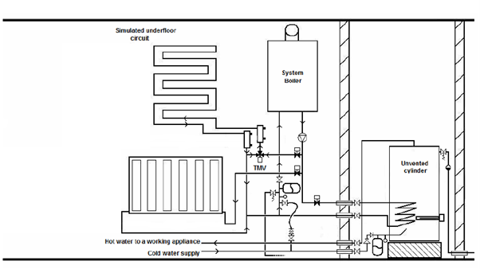

Risk Assessment
What are the hazards? | Risk |  |  | Possible outcomes | Who is involved | Control methods | Review methods
What are the hazards? | L | M | H

Material type (description) | Quantity
Candidate to list the materials required to complete the task
All materials, quantities and PPE required to meet the brief have been identified with excellent consideration given to the aesthetics of the finished installation.

Tool list – list the tools required to complete the work task
Candidate to list the tools required to complete the task

Method statement of the installation

Instructions: Provide a detailed account of the installation
It must include sequencing of activities with justification of each part of the task e.g. marked my work area out with a pencil, tape measure and ruler to ensure all measurements are correct and lines are level and plumb.

Method Statement of the Installation
Candidate to produce a method statement. This should meet the following criteria:
Documents are thorough and demonstrate comprehensive technical knowledge, and the process is set out in a logical order. There is detail in how to perform tasks with clear reasoning that links to the assignment brief and tasks to justify choices made.

Commissioning record
Feedback - Assessor to tick
Please develop and work on the following elements: |  | Criteria
Measurement |  | - +/- 2mm of the dimensions on the drawing
Marking out |  | - +/- 2mm of the dimensions on the drawing  - Marked out in pencil  - Spirit level used
Clipping |  | - Select appropriate pipework clips for use and space them correctly
Pipe jointing |  | - Soldered joints must be free from excessive solder and residual flux  - Pipe and fittings are free from tool and vice marks  - Malleable iron fittings show no more than 1 ½ threads
Pipe bending |  | - Pipe bends must be free from ripples, throating or excessive distortion
Presentation of work
Ensuring work meets industry requirements |  | - Completed pipework must be leak free
Health and safety |  | - Health and safety requirements must be observed at all times

Task 41: Bathroom installation
Objective: To familiarise students on the installation of pipework, appliances and components including commissioning and decommissioning.
Tutor Role: Provide guidance on the installation of appliances and components.
Key Learning Points: Install appliances, install components, Install clips/brackets to different types of building fabric, Install pipework relevant to the type of system, Commission systems, decommission systems.
Assessment: Review students’ practical work and written answers for accuracy and completeness.
You are working as a plumbing engineer and have been called to a domestic property to undertake the planning and installation of a new bathroom.
As part of this work, you will be required to carry out a full survey of the proposed installation, including planning activities, measurements and calculations.
The customer has identified a ground floor space that they want to convert into a cloakroom and has requested the installation of:
- A new Water Closet (WC)
- A new wash hand basin (WHB)
- A new bath
- A radiator
- Connections to a combination boiler
Your supervisor will notify you of the requirements of the installation and a plan of the proposed space and location of existing services where you will carry out the installation.
The installation must include:
- Hot and cold-water supply to any suitable WHB and bath
- Cold water supply to any suitable WC
- Installation of waste/soil pipe connections
- The installation of a new radiator
- All pipework is to be surface mounted and installed to a commercially acceptable standard.
Once your installation has been completed, commissioned and checked to the customer’s satisfaction, you are required to decommission the installation.

Part 1: Produce the following documents
- Installation diagram
- Risk Assessment
- Material list
- Method statement
Part 2: Installation, Commissioning and Decommissioning.

Installation diagram
Candidate to produce a drawing and should meet the following criteria: Installation drawing is complete and accurate, and the position of components is correct with consideration of aesthetics or performance. The diagram includes all key measurements, uses industry recognised symbols and includes a key.

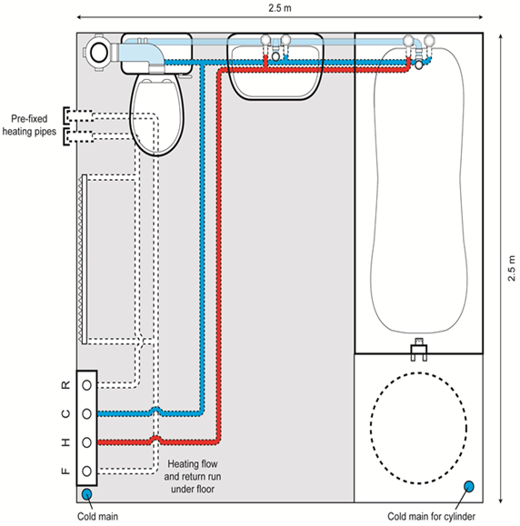

Risk Assessment
What are the hazards? | Risk |  |  | Possible outcomes | Who is involved | Control methods | Review methods
What are the hazards? | L | M | H

Material type (description) | Quantity
Candidate to list the materials required to complete the task
All materials, quantities and PPE required to meet the brief have been identified with excellent consideration given to the aesthetics of the finished installation.

Tool list – list the tools required to complete the work task
Candidate to list the tools required to complete the task

Method statement of the installation

Instructions: Provide a detailed account of the installation
It must include sequencing of activities with justification of each part of the task e.g. marked my work area out with a pencil, tape measure and ruler to ensure all measurements are correct and lines are level and plumb.

Method Statement of the Installation
Candidate to produce a method statement. This should meet the following criteria:
The documents are thorough and demonstrate comprehensive technical knowledge, and the process is set out in a logical order. There is detail in how to perform tasks with clear reasoning that links to the assignment brief and tasks to justify choices made.

Commissioning record
Sanitation Commissioning Sheet

Address
Engineer’s Name
Date
Soundness Test Record pressure and duration
Air Test: AGDS
Record pressure and duration
Appliance 1: | Flow Rate: | Outlet Temperature:
Appliance 2: | Flow Rate: | Outlet Temperature:
Appliance 3: | Flow Rate: | Outlet Temperature:
Appliance 4: | Flow Rate: | Outlet Temperature:
Appliance 5: | Flow Rate: | Outlet Temperature:
Check appliances for self-siphonage Y/N
Check appliances for induced siphonage Y/N
Performance test
Satisfactory Y/N
Notes:

Feedback - Assessor to tick
Please develop and work on the following elements: |  | Criteria
Measurement |  | - +/- 2mm of the dimensions on the drawing
Marking out |  | - +/- 2mm of the dimensions on the drawing  - Marked out in pencil  - Spirit level used
Clipping |  | - Select appropriate pipework clips for use and space them correctly
Pipe jointing |  | - Soldered joints must be free from excessive solder and residual flux  - Pipe and fittings are free from tool and vice marks  - Malleable iron fittings show no more than 1 ½ threads
Pipe bending |  | - Pipe bends must be free from ripples, throating or excessive distortion
Presentation of work
Ensuring work meets industry requirements |  | - Completed pipework must be leak free
Health and safety |  | - Health and safety requirements must be observed at all times

Task 42: Maintenance - sanitation systems
Objective: To familiarise students on how to maintain systems and conduct fault finding and rectification.
Tutor Role: Provide guidance on how to maintain systems and conduct fault finding and rectification.
Key Learning Points: Identify any end user concerns around system operation, Conduct fault finding, Repair faulty system components as identified
Assessment: Review students’ practical work and written answers for accuracy and completeness
You will inspect a pre-installed operational system, functioning with electrical components and controls which has several pre- set faults. You will discuss the fault with your assessor to determine the cause of the fault and suggest appropriate methods for repair. You will be assessed on your ability to ask relevant questions to determine faults and to select a suitable solution.
Part 1: Discuss faults with the customer, investigate and diagnose fault.
Part 2: Produce a written report of the maintenance activity
Part 3: Repair and rectify fault.

Checks required:
- Visual inspection of pipework for leakage and adequate support.
- Operation of flushing cisterns/mechanisms/terminal fittings/float operated valve.
- Fitting effective waste outlet plugs.
- Effective operation of appliance traps/ self-sealing valves.

Complete the table detailing faults identified.
Checks | Fault Identified
Leakage from plastic soil and waste pipework. | Candidates to record what faults have been identified
Improper support to plastic pipework systems.

Loss of trap seal at sanitary appliances.

Blockage in above ground soil and waste pipework.

Blockage in below ground drainage systems.

Written report of maintenance activity
Instructions: Provide a detailed account of the fault diagnosis procedure, possible solutions and how you are going to rectify the problem.

Your report MUST be clear and detailed.

You MUST provide reasoning to support the methods selected to rectify the fault.
Reference MUST be made to informing the customer, safe isolation, equipment and materials required and to the use of manufacturer instructions during fault diagnosis.

Fault Report
Details of the fault:

Description of fault diagnosis:

Actions taken to rectify the fault:

Task 43: Maintenance - cold water systems
Objective: To familiarise students on how to maintain systems and conduct fault finding and rectification.
Tutor Role: Provide guidance on how to maintain systems and conduct fault finding and rectification.
Key Learning Points: Identify any end user concerns around system operation, Conduct fault finding, Repair faulty system components as identified.
Assessment: Review students’ practical work and written answers for accuracy and completeness.
You will inspect a pre-installed operational system, functioning with electrical components and controls which has several pre- set faults. You will discuss the fault with your assessor to determine the cause of the fault and suggest appropriate methods for repair. You will be assessed on your ability to ask relevant questions to determine faults and to select a suitable solution.
Part 1: Discuss faults with the customer, investigate and diagnose fault.
Part 2: Produce a written report of the maintenance activity
Part 3: Repair and rectify fault.

Checks required:
- Visual inspection of pipework for leakage and adequate support.
- Operation of cisterns/mechanisms/terminal fittings/float-operated valve.
- Condition of cold-water storage cistern.
- Float and pressure switch operation

Complete the table detailing faults identified.
Checks | Fault Identified
Leakage from pipework. | Candidates to record what faults have been identified
Improper support to pipework systems.

leakage or ineffective operation of
o terminal fittings
o float-operated valves
o stop and service valves
Excessive noise in pipework systems
Accumulator expansion vessel failure
Pump failure

Written report of maintenance activity
Instructions: Provide a detailed account of the fault diagnosis procedure, possible solutions and how you are going to rectify the problem.

Your report MUST be clear and detailed.

You MUST provide reasoning to support the methods selected to rectify the fault.
Reference MUST be made to informing the customer, safe isolation, equipment and materials required and to the use of manufacturer instructions during fault diagnosis.

Fault Report
Details of the fault:

Description of fault diagnosis:

Actions taken to rectify the fault:

Task 44: Maintenance - hot water systems
Objective: To familiarise students on how to maintain systems and conduct fault finding and rectification.
Tutor Role: Provide guidance on how to maintain systems and conduct fault finding and rectification.
Key Learning Points: Identify any end user concerns around system operation, Conduct fault finding, Repair faulty system components as identified
Assessment: Review students’ practical work and written answers for accuracy and completeness
You will inspect a pre-installed operational system, functioning with electrical components and controls which has several pre- set faults. You will discuss the fault with your assessor to determine the cause of the fault and suggest appropriate methods for repair. You will be assessed on your ability to ask relevant questions to determine faults and to select a suitable solution.
Part 1: Discuss faults with the customer, investigate and diagnose fault.
Part 2: Produce a written report of the maintenance activity
Part 3: Repair and rectify fault.

Checks required:
- Visual inspection of pipework for leakage and adequate support.
- Operation of cisterns/mechanisms/terminal fittings/float operated valve.
- Condition of cold-water storage cisterns and cylinders.
- Pump operation

Complete the table detailing faults identified.
Checks | Fault Identified
Leakage from pipework. | Candidates to record what faults have been identified
Improper support to pipework systems.

leakage or ineffective operation of  o terminal fittings  o float operated valves  o stop and service valves  o mixer showers  o thermostatic mixing valves | Blocked strainer
Excessive noise in pipework systems
Expansion vessel failure
Pump failure
Hot water storage cylinder/ heater failure
Thermostats
Motorised valves

Written report of maintenance activity
Instructions: Provide a detailed account of the fault diagnosis procedure, possible solutions and how you are going to rectify the problem.

Your report MUST be clear and detailed.

You MUST provide reasoning to support the methods selected to rectify the fault.
Reference MUST be made to informing the customer, safe isolation, equipment and materials required and to the use of manufacturer instructions during fault diagnosis.

Fault Report
Details of the fault: Blocked strainer
Description of fault diagnosis:
Example answer: I liaised with the customer asking suitable questions to check if the hot water was working at any other outlets as this would confirm that either the problem was at the point of use tap or an issue on the installation pipework and components. After discussion with my assessor and initial investigations with reference to manufacturer instructions I was able to confirm that there was a fault on the installation and traced this to a blocked line strainer. This would need to be cleared of the blockage.
Actions taken to rectify the fault:

I decided the best solution to this problem was to isolate the water supply, drain some of the water from the cylinder drain off and clear the blocked line strainer once I was confident the water is out of the system, as I am confident in draining system installations and know the risk of water damage to the customer property has been reduced.
To repair the fault I carried out the following sequence:
• Inform customer I was about to drain the system and chose a suitable route to drain
the water via a hose from the drain off point at the bottom of the cylinder.
• Isolate the cold feed supply to the hot water cylinder.
• Open all hot water outlets and drain water from system to the suitable safe location.
• Remove line strainer and cleared the blockage.
• Ensure the valve compression connections are tight
• Close all outlets
• Refill system.
• Inform customer of completed repair

Task 45: Maintenance - central heating systems
Objective: To familiarise students on how to maintain systems and conduct fault finding and rectification.
Tutor Role: Provide guidance on how to maintain systems and conduct fault finding and rectification.
Key Learning Points: Identify any end user concerns around system operation, conduct fault finding, repair faulty system components as identified.
Assessment: Review students’ practical work and written answers for accuracy and completeness.
You will inspect a pre-installed operational system, functioning with electrical components and controls which has several pre- set faults. You will discuss the fault with your assessor to determine the cause of the fault and suggest appropriate methods for repair. You will be assessed on your ability to ask relevant questions to determine faults and to select a suitable solution.
Part 1: Discuss faults with the customer, investigate and diagnose fault.
Part 2: Produce a written report of the maintenance activity
Part 3: Repair and rectify fault.
Checks required:
- Visual inspection of pipework for leakage and adequate support.
- Operation of cisterns/mechanisms/pumps/controls.
- Expansion vessel condition/operation.
- Heat emitter operation
Complete the table detailing faults identified.
Checks | Fault Identified
Leakage from pipework. | Candidates to record what faults have been identified
Improper support to pipework systems.

leakage or ineffective operation of
o radiator valves
o service valves
o pipework
Excessive noise in pipework systems
Expansion vessel failure
Pump failure
Emitter cold spots
Thermostats
Motorised valves
System controls - Programmer, timers

Written report of maintenance activity
Instructions: Provide a detailed account of the fault diagnosis procedure, possible solutions and how you are going to rectify the problem.

Your report MUST be clear and detailed.

You MUST provide reasoning to support the methods selected to rectify the fault.
Reference MUST be made to informing the customer, safe isolation, equipment and materials required and to the use of manufacturer instructions during fault diagnosis.

Fault Report
Details of the fault:

Description of fault diagnosis:

Actions taken to rectify the fault:

Copyright in this document belongs to and is used under licence from the Department for Education, © 2025.

‘T-LEVELS’ and ‘T Level’ are registered trademarks of the Department for Education.

WJEC is authorised by the Department for Education to develop and deliver this T Level Technical Qualification.

WJEC operates in England under the name Eduqas which is a registered trademark of WJEC.

Acknowledgements
Some images used within these resources have been created using artificial intelligence (AI) and is intended to provide a visual representation only.
p.13 Apriori1 / iStock / Getty Images; p.13 PashaIgnatov / iStock / Getty Images; p.15 Arthito / iStock / Getty Images; p.15 KamiPhotos / iStock / Getty Images; p.15 Cynoclub / Freepik.com; p.15 EyeEm / Freepik.com; p.16 sergeyskleznev / iStock / Getty Images; p.16 wildlifeworld / Freepik.com; p.16 vitaliiborkovskyi / Freepik.com; p.16 photour.1904 / Freepik.com; p.16 Deksaplan / Freepik.com; p.16 Antonzm / iStock / Getty Images; p.17 MikeyGen73 / iStock / Getty Images; p.18 Andrei Berezovskii / iStock / Getty Images; p.18 pioneer111-1 / Freepik.com; p. 18 EyeEm / Freepik.com; p.19 pioneer111-1 / Freepik.com; p.19 pioneer111-1 / Freepik.com; p. 55 vav63 / iStock / Getty Images; p.55 Ronak Joshi / iStock / Getty Images; p. 62 pioneer111-1 / Freepik.com; p. 62 PictureSyndicate / iStock / Getty Images;

