T Level Technical Qualification in Building Services Engineering for Construction (Level 3)

Plumbing and Heating Engineering

Skills Practice Workbook for Learners

Student Name: .

Centre Name: .
Contents
Task summary and progress tracker 3
Introduction 5
Task 1: Health and safety 6
Task 2: Risk assessments 7
Task 3: Personal Protective Equipment (PPE) 8
Task 4: Safe isolation procedure 9
Task 5: Fire fighting 10
Task 6: Gas heating equipment 11
Task 7: Access Equipment 12
Task 8: Hand Tools 13
Task 9: Power tools 16
Task 10: Materials 18
Task 11: Measuring and cutting 22
Task 12: Bending techniques - copper 23
Task 13: Bending techniques - Low Carbon Steel (LCS) 25
Task 14: Connection techniques - copper (soldered) 27
Task 15: Connection techniques - copper (compression) 30
Task 16: Connection techniques - Low Carbon Steel (LCS) 32
Task 17: Connection techniques - plastic pressure pipe (push-fit) 34
Task 18: Connection techniques - plastic waste pipe (push-fit) 36
Task 19: Connection techniques - combined 38
Task 20: Decommissioning 41
Task 21: Install clips/brackets 44
Task 22: Plastic pipe installation 46
Task 23: Joist notching 48
Task 24: Rainwater system components 51
Task 25: Rainwater installation 52
Task 26: Soil stack components 54
Task 27: Soil stack installation 56
Task 28: Air testing 58
Task 29: Installing radiators 61
Task 30: Central heating installation 62
Task 31: Cloakroom installation 65
Task 32: Unvented cylinder installation 67
Task 33: Termination of BS1363 plug top 70
Task 34: WC macerator installation 71
Task 35: Y Plan central heating wiring 74
Task 36: S Plan central heating wiring 75
Task 37: WC installation 76
Task 38: Central heating installation 82
Task 39: Cloakroom installation 88
Task 40: S Plan central heating installation 95
Task 41: Bathroom installation 101
Task 42: Maintenance - sanitation systems 107
Task 43: Maintenance - cold water systems 109
Task 44: Maintenance - hot water systems 111
Task 45: Maintenance - central heating systems 113
Acknowledgements 115

Task summary and progress tracker
 | Task | Date complete
1 | Health and safety
2 | Risk assessments
3 | Personal Protective Equipment (PPE)
4 | Safe isolation procedure
5 | Fire fighting
6 | Gas heating equipment
7 | Access equipment
8 | Hand Tools
9 | Power tools
10 | Materials
11 | Measuring and cutting
12 | Bending techniques - copper
13 | Bending techniques - Low Carbon Steel (LCS)
14 | Connection techniques - copper (soldered)
15 | Connection techniques - copper (compression)
16 | Connection techniques - Low Carbon Steel (LCS)
17 | Connection techniques - plastic pressure pipe (push-fit)
18 | Connection techniques - plastic waste pipe (push-fit)
19 | Connection techniques - combined
20 | Decommissioning
21 | Install clips/brackets
22 | Plastic pipe installation
23 | Joist notching
24 | Rainwater system components
25 | Rainwater installation
26 | Soil stack components
27 | Soil stack installation
28 | Air testing
29 | Installing radiators
30 | Central heating installation
31 | Cloakroom installation
32 | Unvented cylinder installation
33 | Termination of BS1363 plug top
34 | WC macerator installation
35 | Y Plan central heating wiring
36 | S Plan central heating wiring
37 | WC installation
38 | Central heating installation
39 | Cloakroom installation
40 | S Plan central heating installation
41 | Bathroom installation
42 | Maintenance - sanitation systems
43 | Maintenance - cold water systems
44 | Maintenance - hot water systems
45 | Maintenance - central heating systems

Introduction
This workbook contains a range of activities which enable you to apply the knowledge you gain and use your practical skills at the same time.
The activities vary in length and difficulty, but each one is based on what you have learnt and gives you a chance to practice a wide variety of practical skills, so you are familiar with what is required by the final assessments.
Your tutor will provide support for these activities, explaining what to do, what you should learn and suggestions about how to solve any problems.
At the end of each activity, there is a check box for you to complete. This helps you and your tutor identify whether you are confident about that particular topic or would like more support with it.
1.0 Health and Safety
In any workplace, the health and safety of the company’s employees and visitors is very important. Many rules must be followed to ensure their safety.
There are many regulations dealing with health and safety, but the main document to refer to is the Health and Safety at Work Act (1974). The rules within it are law, which means you can be prosecuted by the Health and Safety Executive (HSE) if you break them.

Task 1: Health and safety
As an employee (learner) you have legal duties too. They include:

■ Taking reasonable care for your own health and safety and that of others who may be affected by what you do or do not do;

■ Co-operating with your employer on health and safety;

■ Correctly using work items provided by your employer, including personal protective equipment, in accordance with training or instructions; and

■ Not interfering with or misusing anything provided for your health, safety or welfare.

Who is responsible for providing personal protective equipment (PPE) in your workplace?
Which types of accident need to be recorded and where do we record the information?
Who is responsible for health and safety on site?

Student reflection
Do you feel confident about this topic? | Yes | I would like more guidance

Task 2: Risk assessments
Risk assessments are something you are required to carry out by law; however, if you employ fewer than five people, you don't have to write anything down. To carry out a risk assessment, you need to think about the things that might cause harm to people and decide if you are taking reasonable steps to prevent the harm. For certain risks, for example, working in a confined space, specific regulations require particular control measures to be put in place.
Hazard: Anything that may cause harm.
Risk: The chance, high or low, that somebody could be harmed.
Complete the following risk assessment template for the workshop you are working in.

What are the hazards? | Risk |  |  | Possible outcomes | Who is involved | Control methods | Review methods
What are the hazards? | L | M | H

Student reflection
Do you feel confident about this topic? | Yes | I would like more guidance

Task 3: Personal Protective Equipment (PPE)
Identify the PPE and describe its use.


Student reflection
Do you feel confident about this topic? | Yes | I would like more guidance

Task 4: Safe isolation procedure
Identify the steps and equipment used for the correct safe isolation of electrical appliances and circuits.
Carry out the safe isolation of plumbing and heating components.

Step | Description
1
2
3
4
5
6
7

Student reflection
Do you feel confident about this topic? | Yes | I would like more guidance

Task 5: Fire fighting
Identify the types of firefighting equipment.
Identify the following information
Class of fire | Source of fuel | Colour of fire extinguisher necessary | Contents of fire extinguisher
Class A
Class B
Class C
Class D
Class E
Class F

Explain the correct procedure for using a fire extinguisher to tackle a small solid fuel fire:

Student reflection
Do you feel confident about this topic? | Yes | I would like more guidance

Task 6: Gas heating equipment
Inspect and assemble gas heating equipment and complete the table below.
Identify whether the following situation is safe or unsafe:
Situation | Safe or Unsafe?
Full and empty gas cylinders are stored in an outside cage with a roof that is locked and far away from combustible materials overnight.
Cylinders are being transported around a building site on three-wheeled trolleys.
A lot of oxygen cylinders are stored in a basement with one small door and no windows. The gas bottles are fully strapped up horizontally and cannot roll.
A gas cylinder is often subjected to shocks and falls on site.
A tradesman is carrying an oxyacetylene bottle by its control valve.
Cylinders are stored in a cage on a building site. A strong wall shields the cylinders from direct sunlight.
Gas cylinders are stored close to a welding area that is used regularly.
Oxygen, acetylene & LPG cylinders are all stored together in a well-ventilated area.
Gas cylinders are stored outside in a cage. The cage is designed so that the gas bottles are stacked horizontally four cylinders high. They are secured to prevent falling onto the soft ground below.

Student reflection
Do you feel confident about this topic? | Yes | I would like more guidance

2.0 Tools, equipment and materials

Task 7: Access Equipment
Identify the access equipment and list safety checks.

Name: | Name:
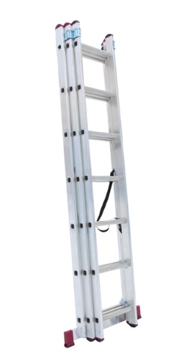 | 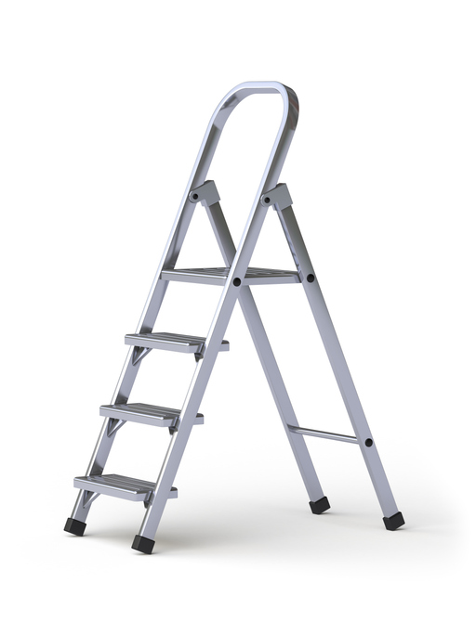
Safety checks: | Safety checks:

Student reflection
Do you feel confident about this topic? | Yes | I would like more guidance

Task 8: Hand Tools
Identify the tools and describe their use.
Tools/Equipment | Name/Use
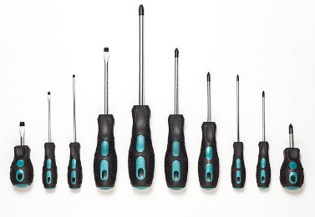
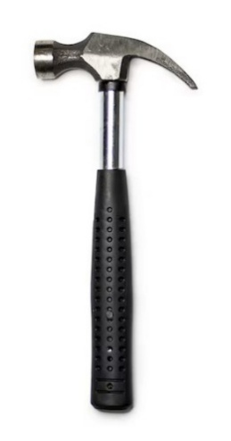
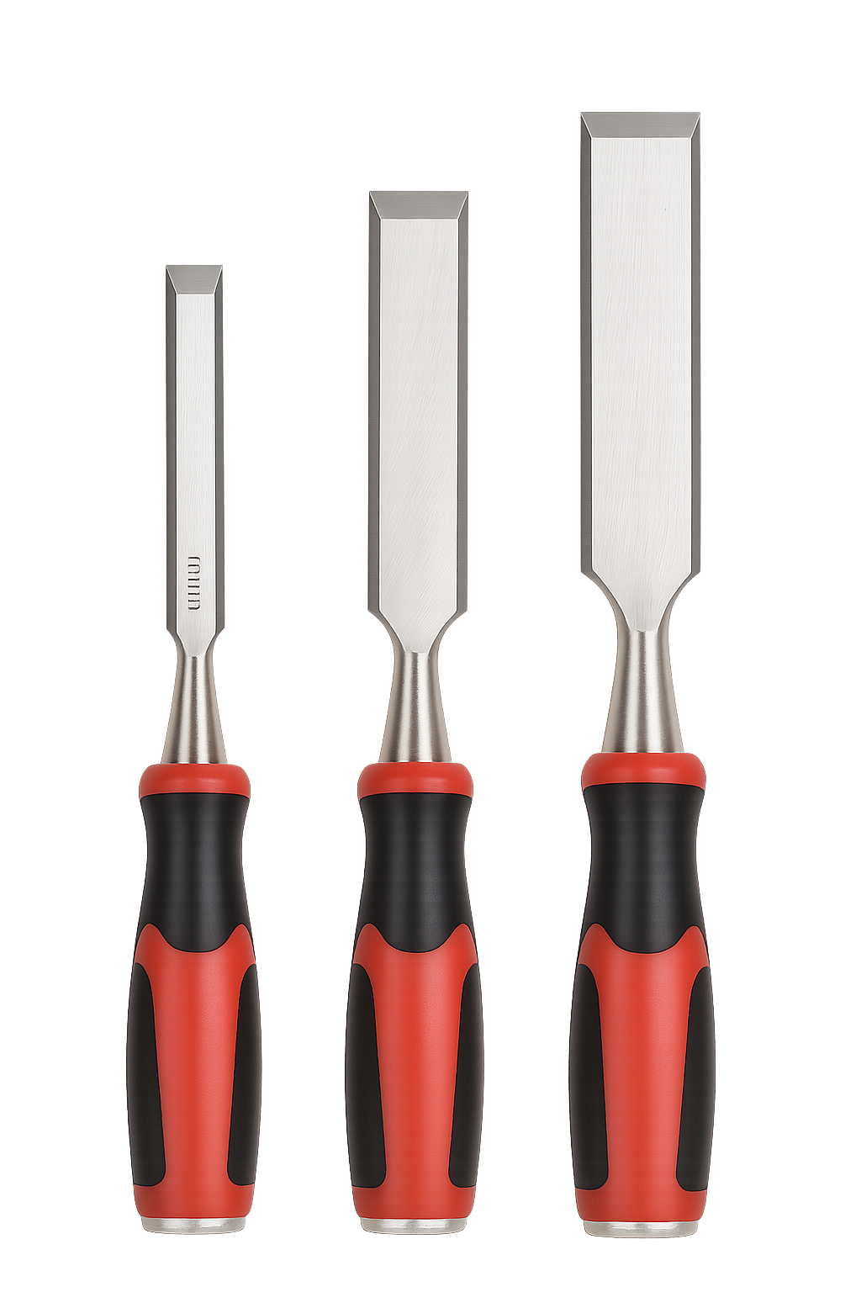
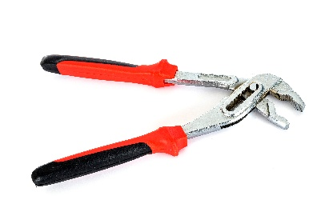
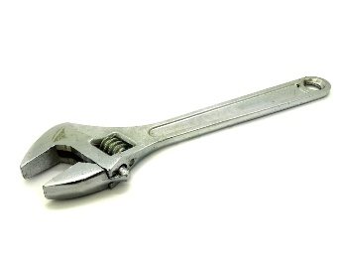
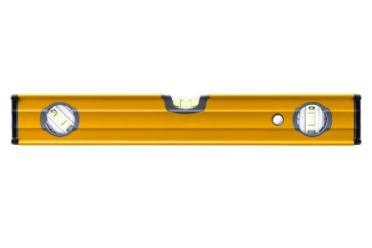
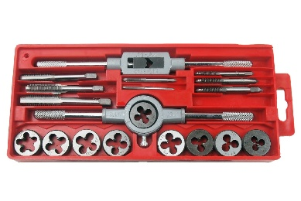
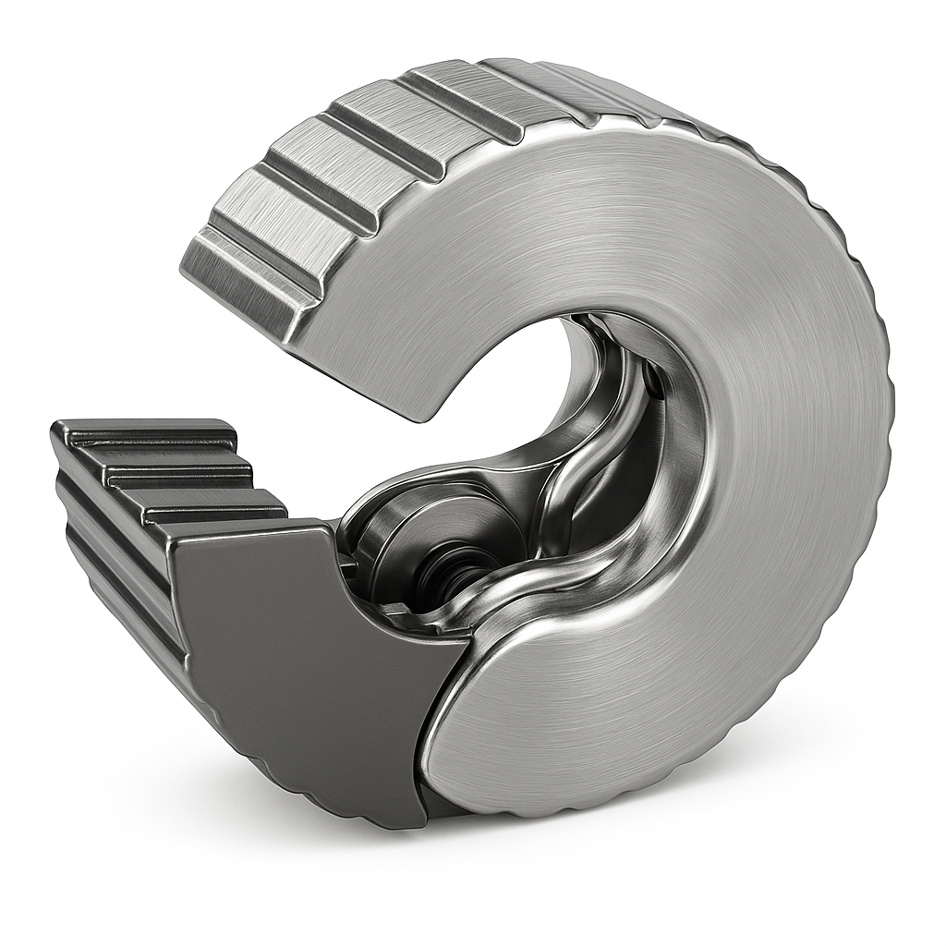
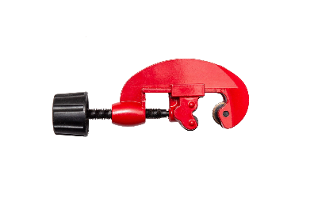
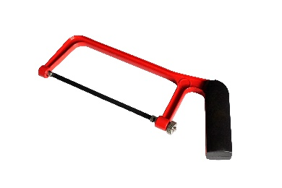
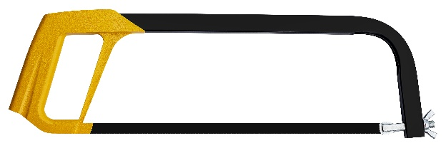
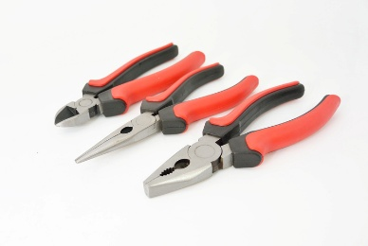
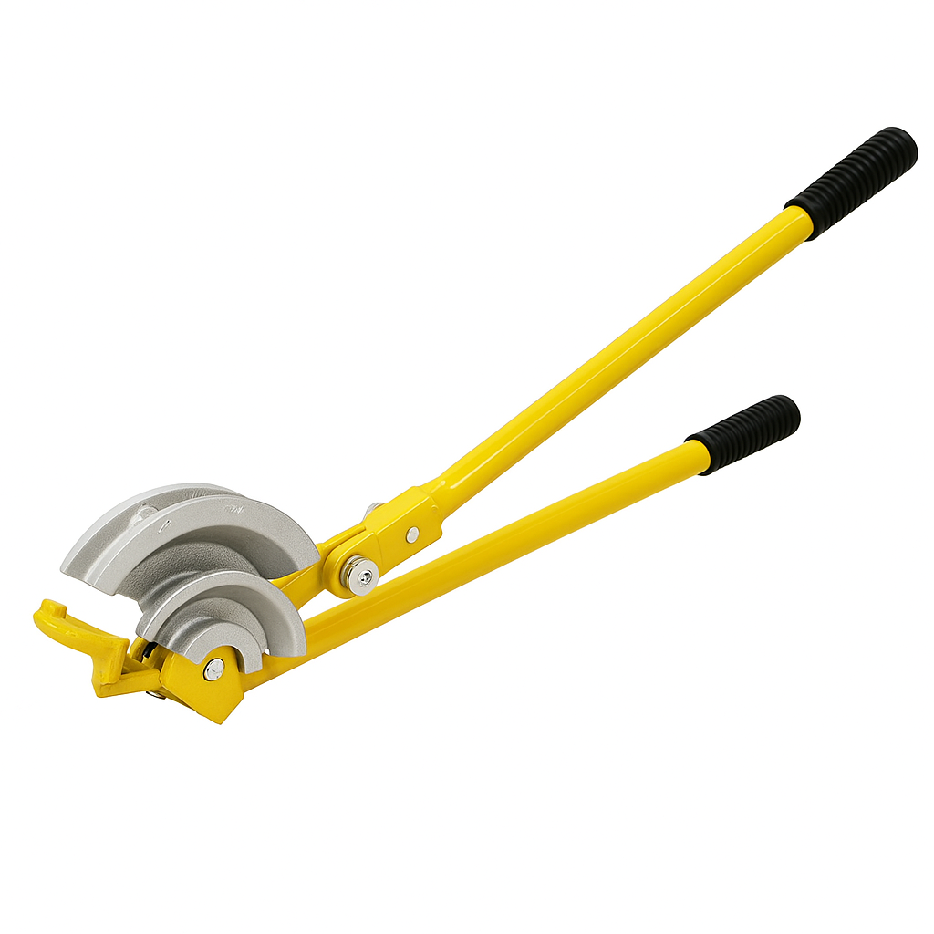
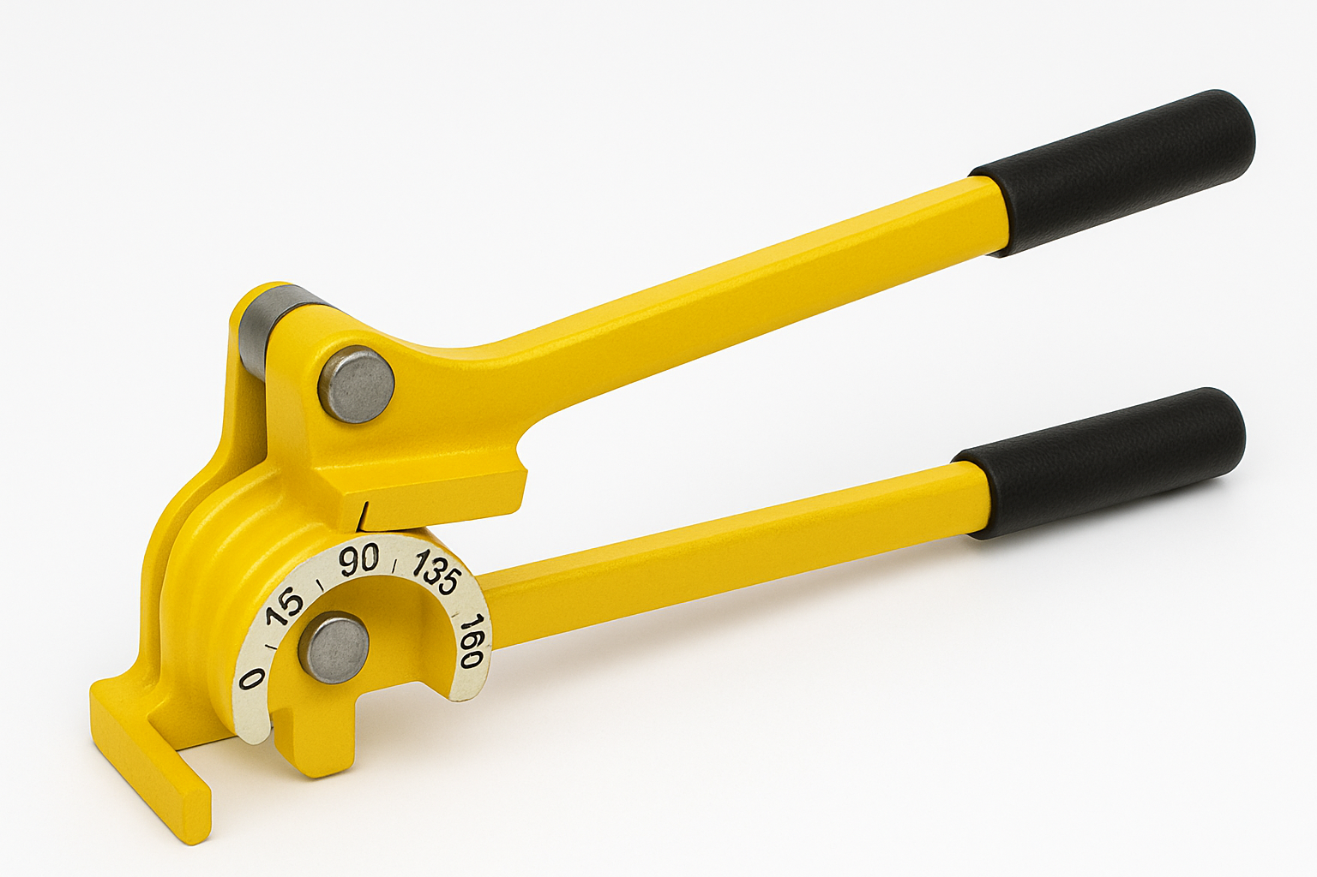
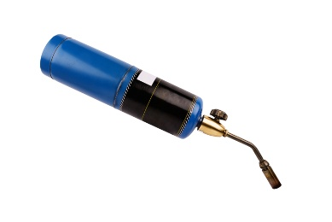

Student reflection
Do you feel confident about this topic? | Yes | I would like more guidance

Task 9: Power tools
Identify the tools and describe their use.
Tools/Equipment | Name/Use

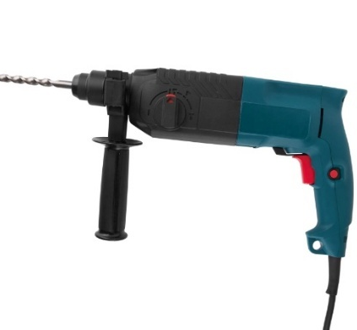
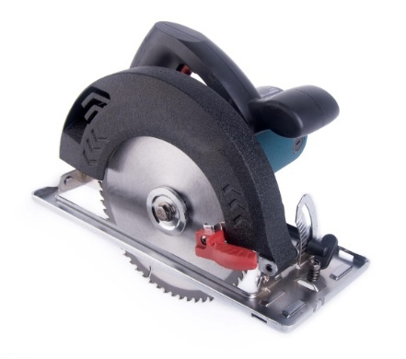

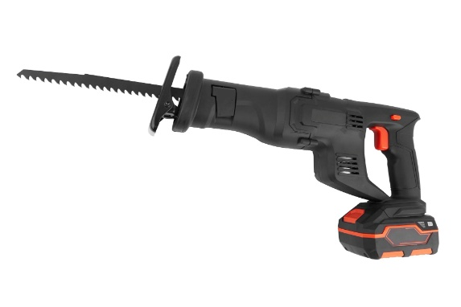
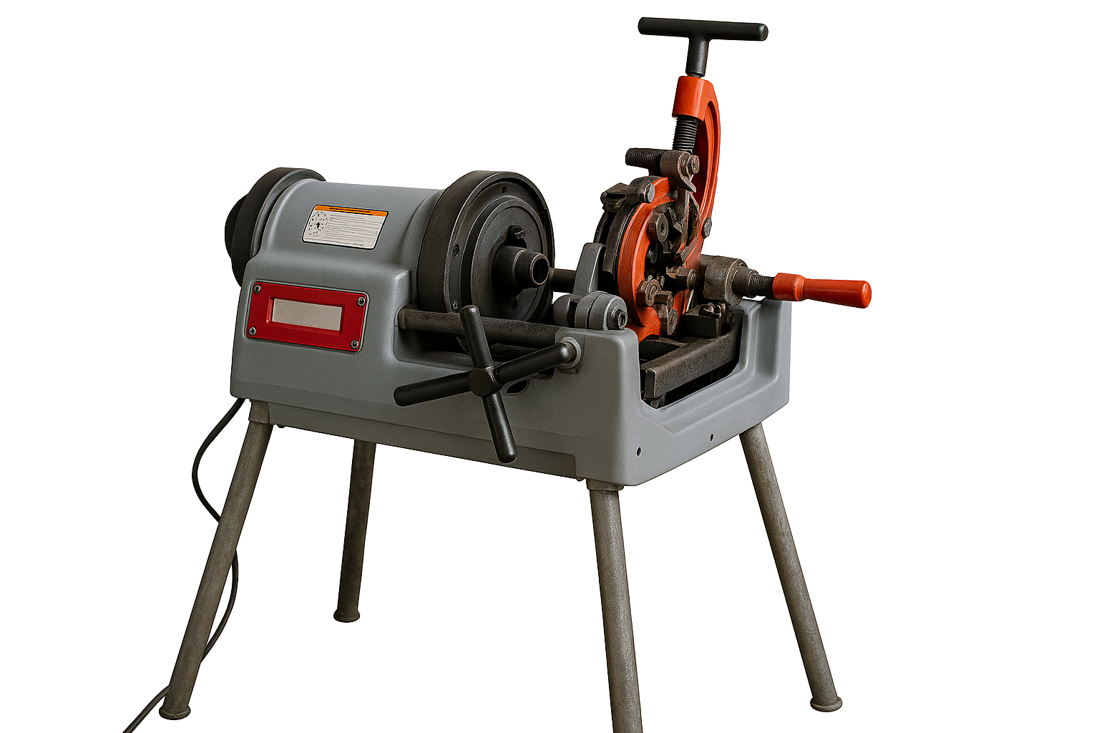
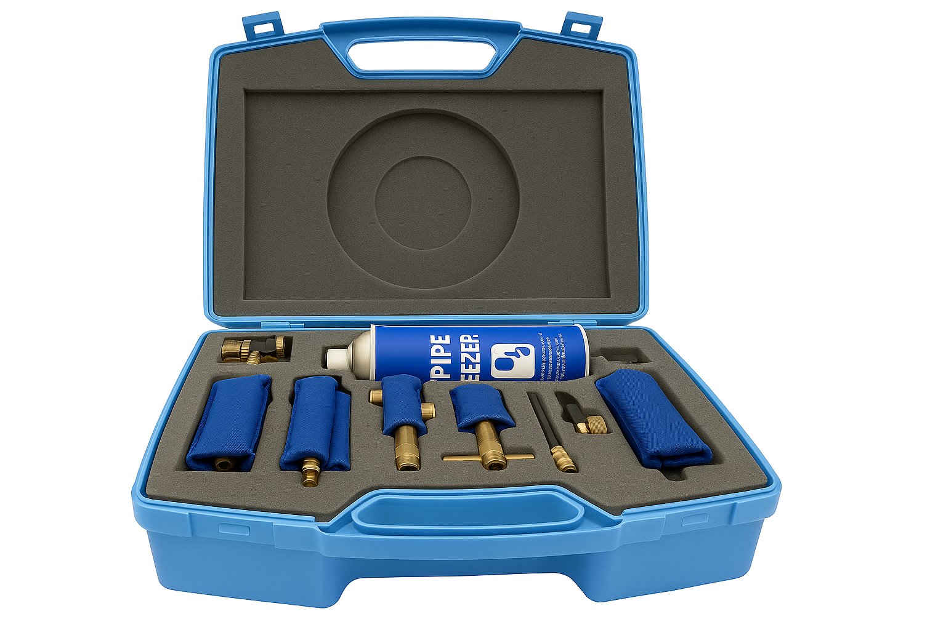
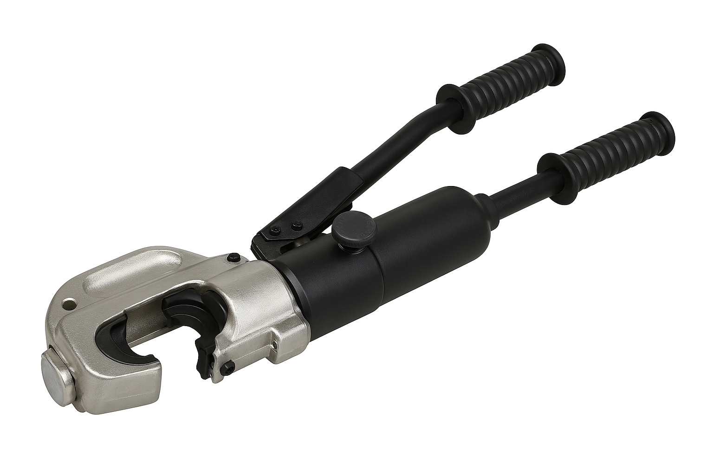

Student reflection
Do you feel confident about this topic? | Yes | I would like more guidance

Task 10: Materials
Identify the copper fittings and their purpose.
List the sizes of copper pipe:

Fitting | Description | Purpose
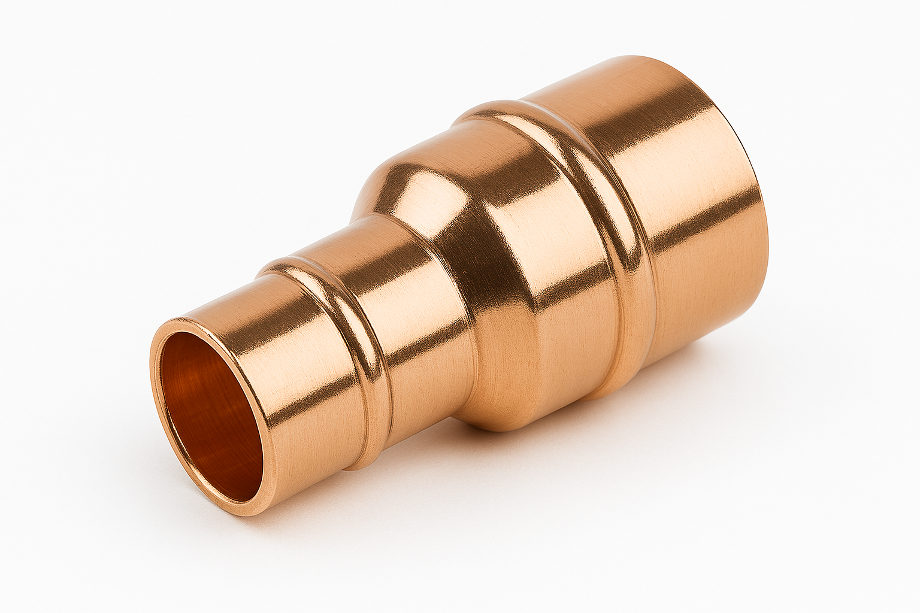

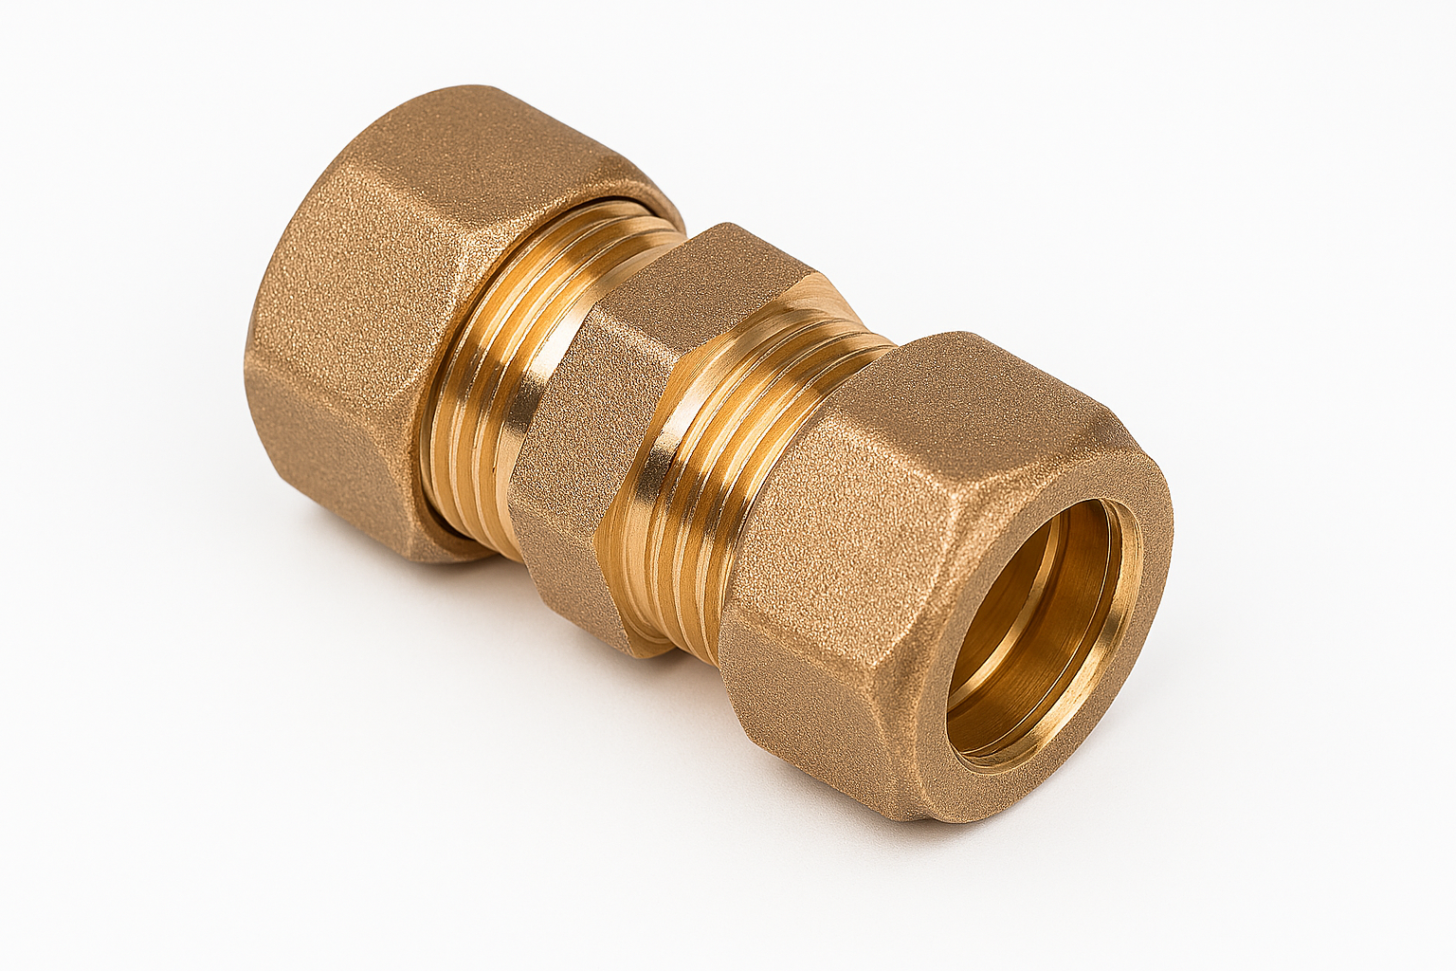
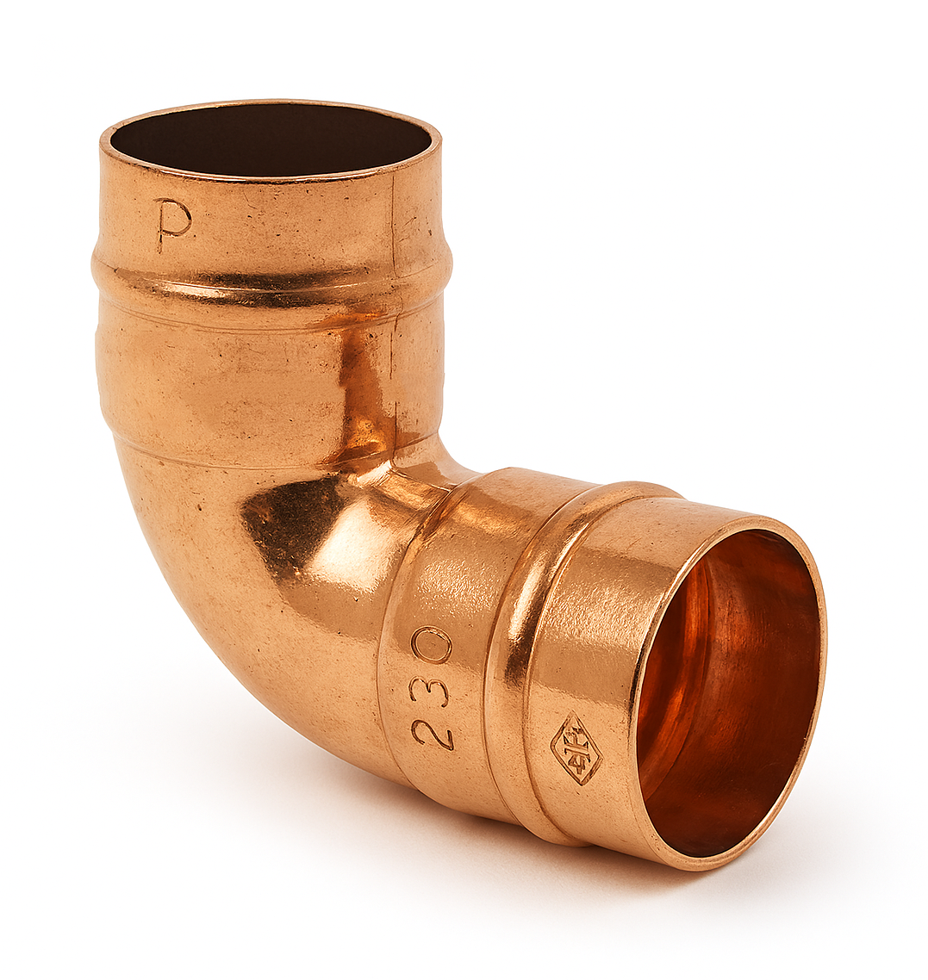
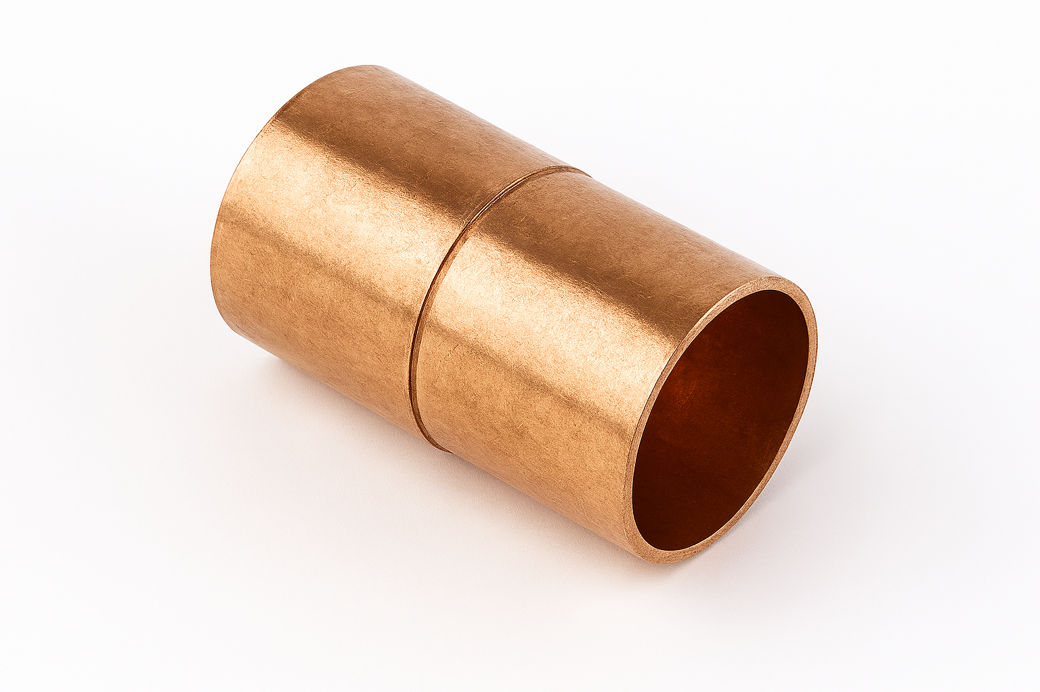
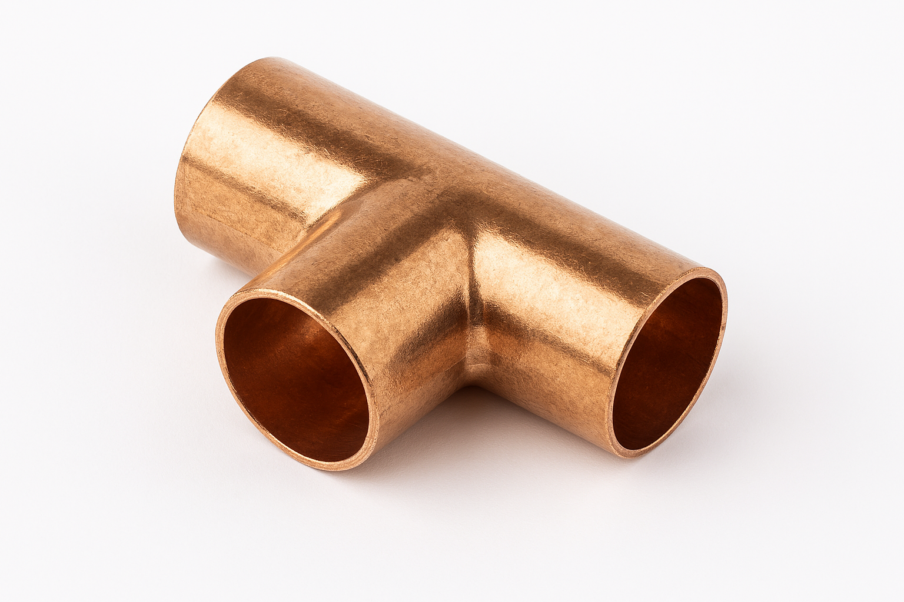

Identify the plastic pipe fittings and their purpose.
Fitting | Description | Purpose
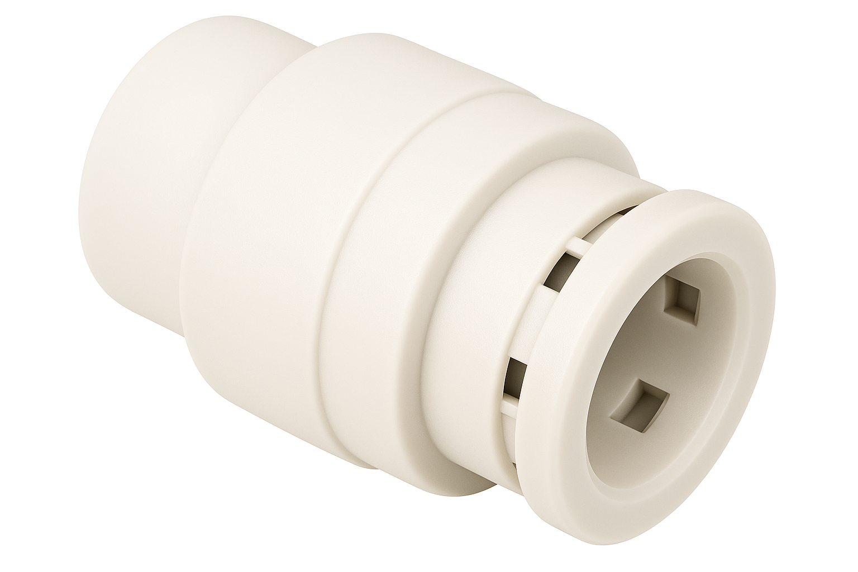
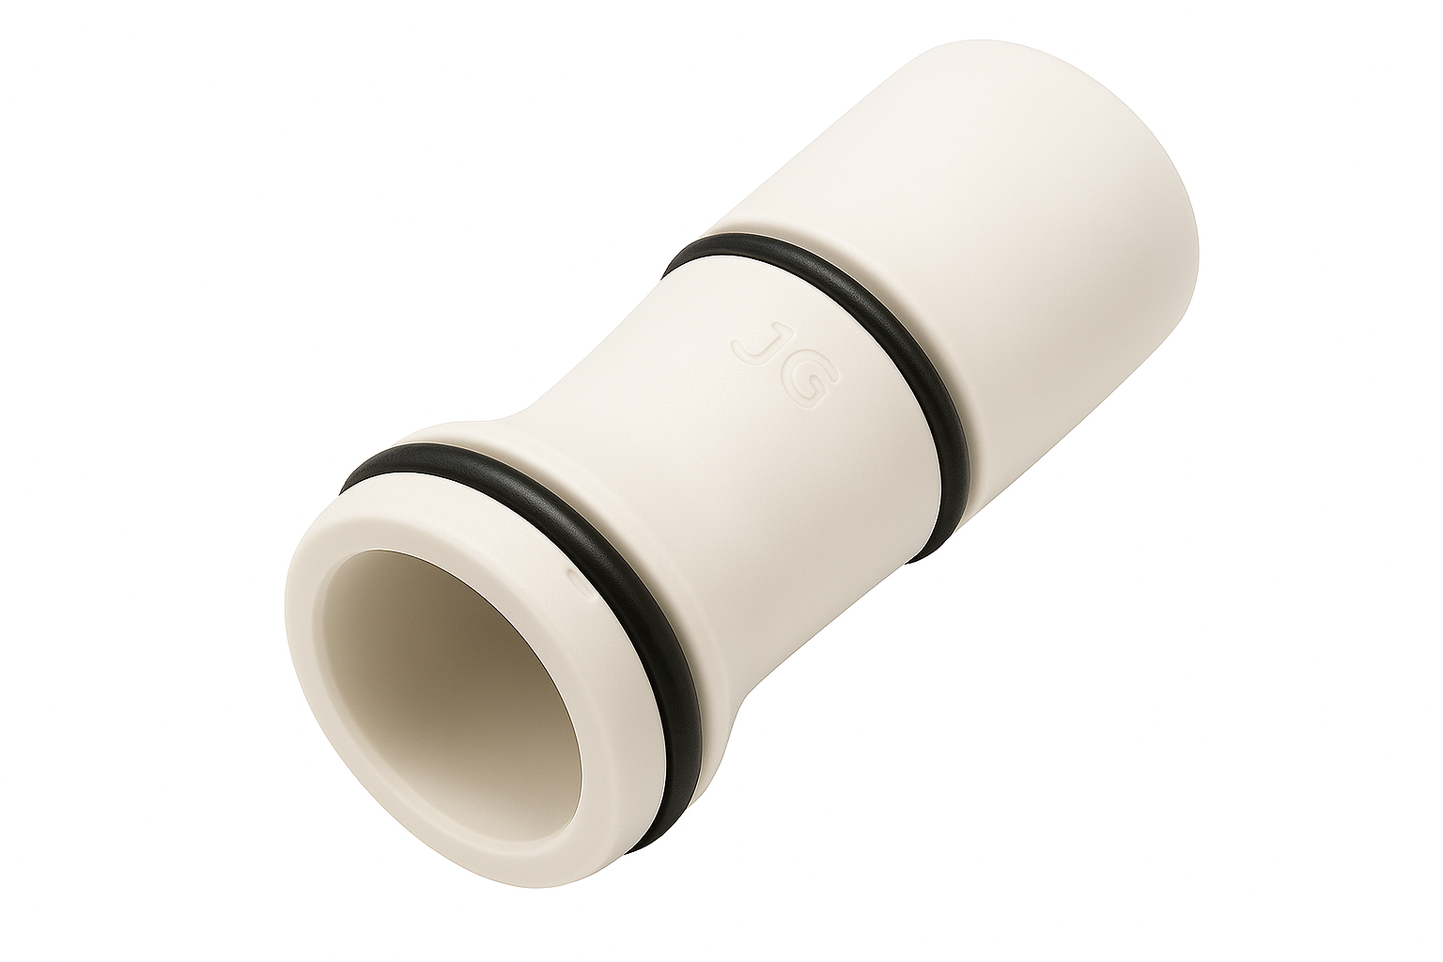
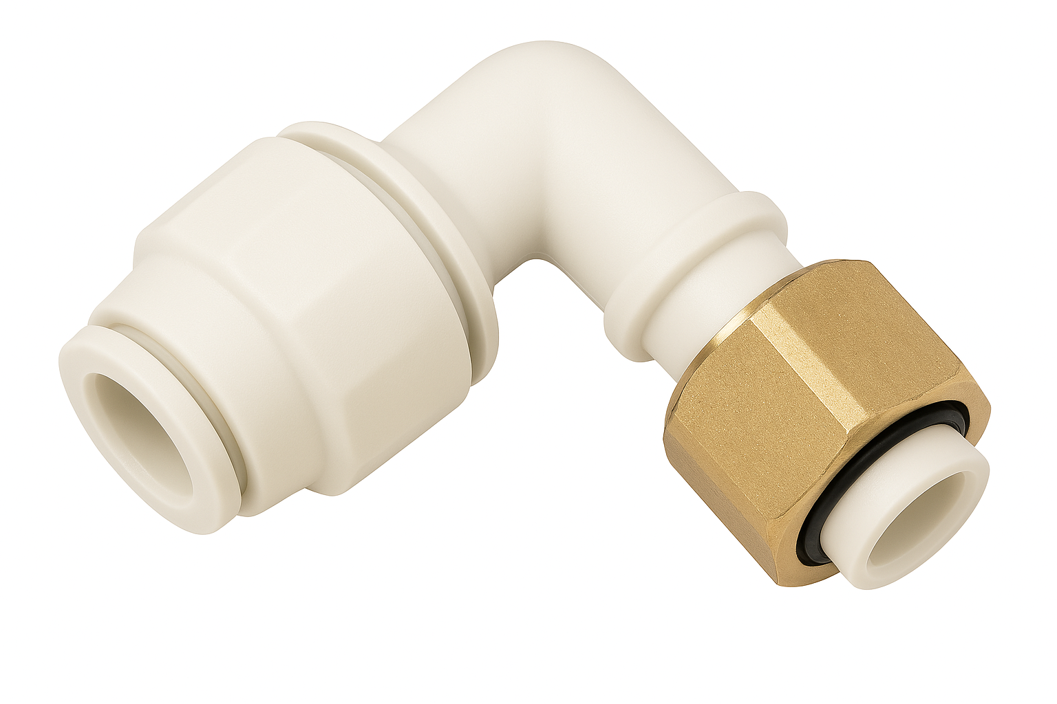
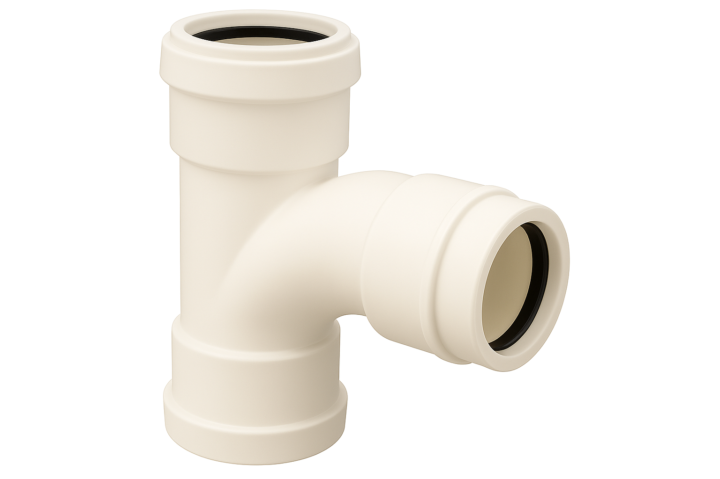
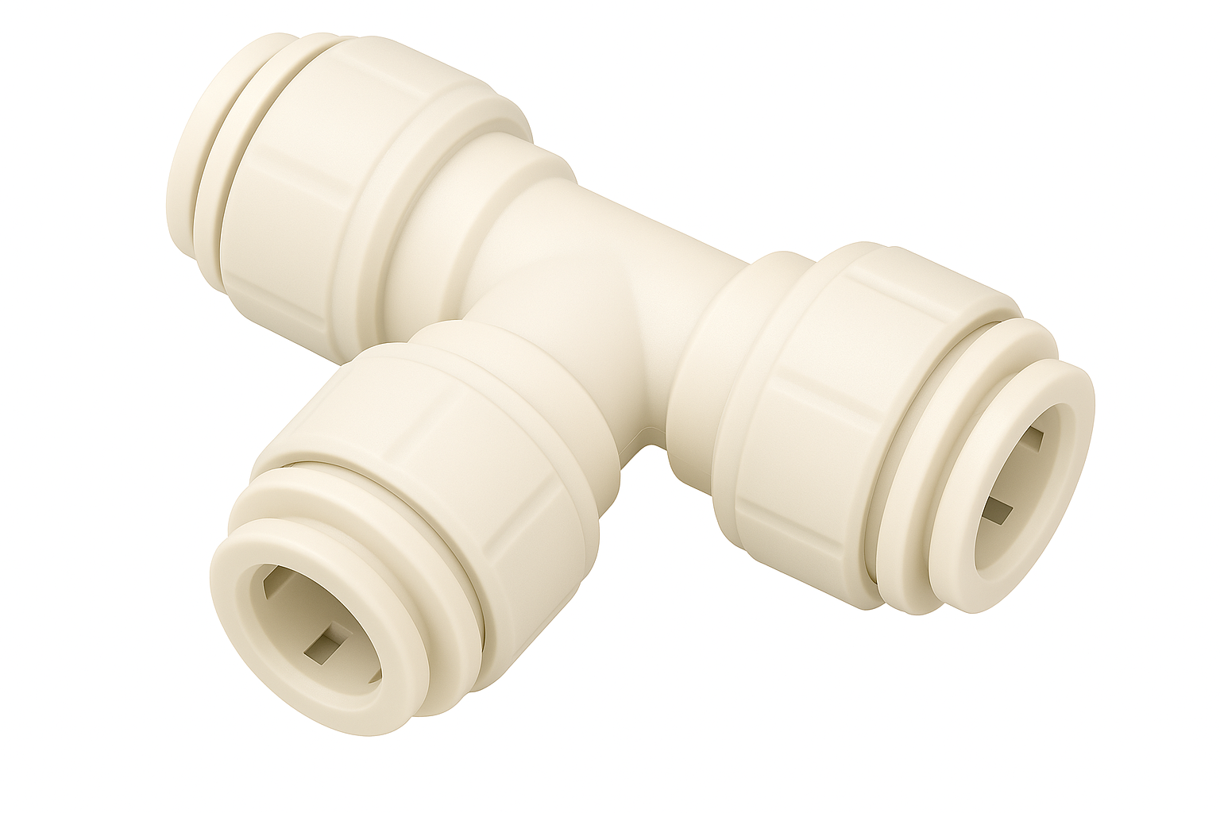
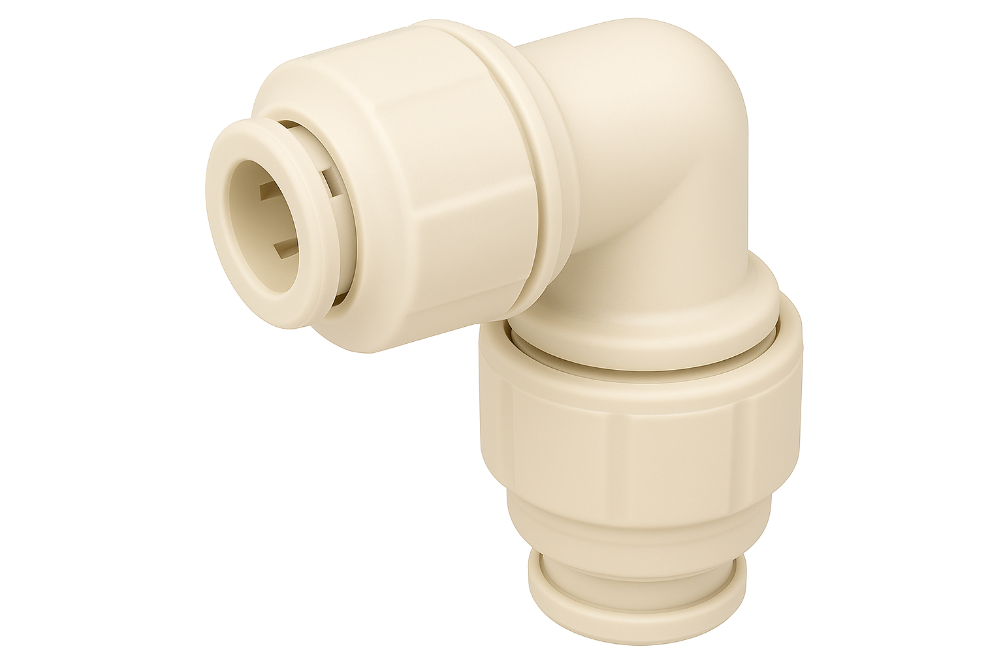

Identify the steel fittings and their purpose.
List the sizes of steel pipe:

Fitting | Description | Purpose
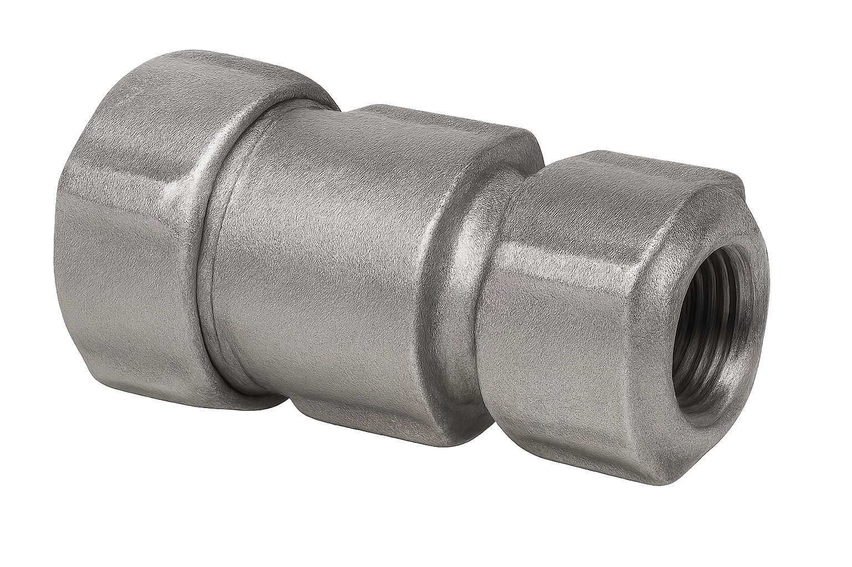
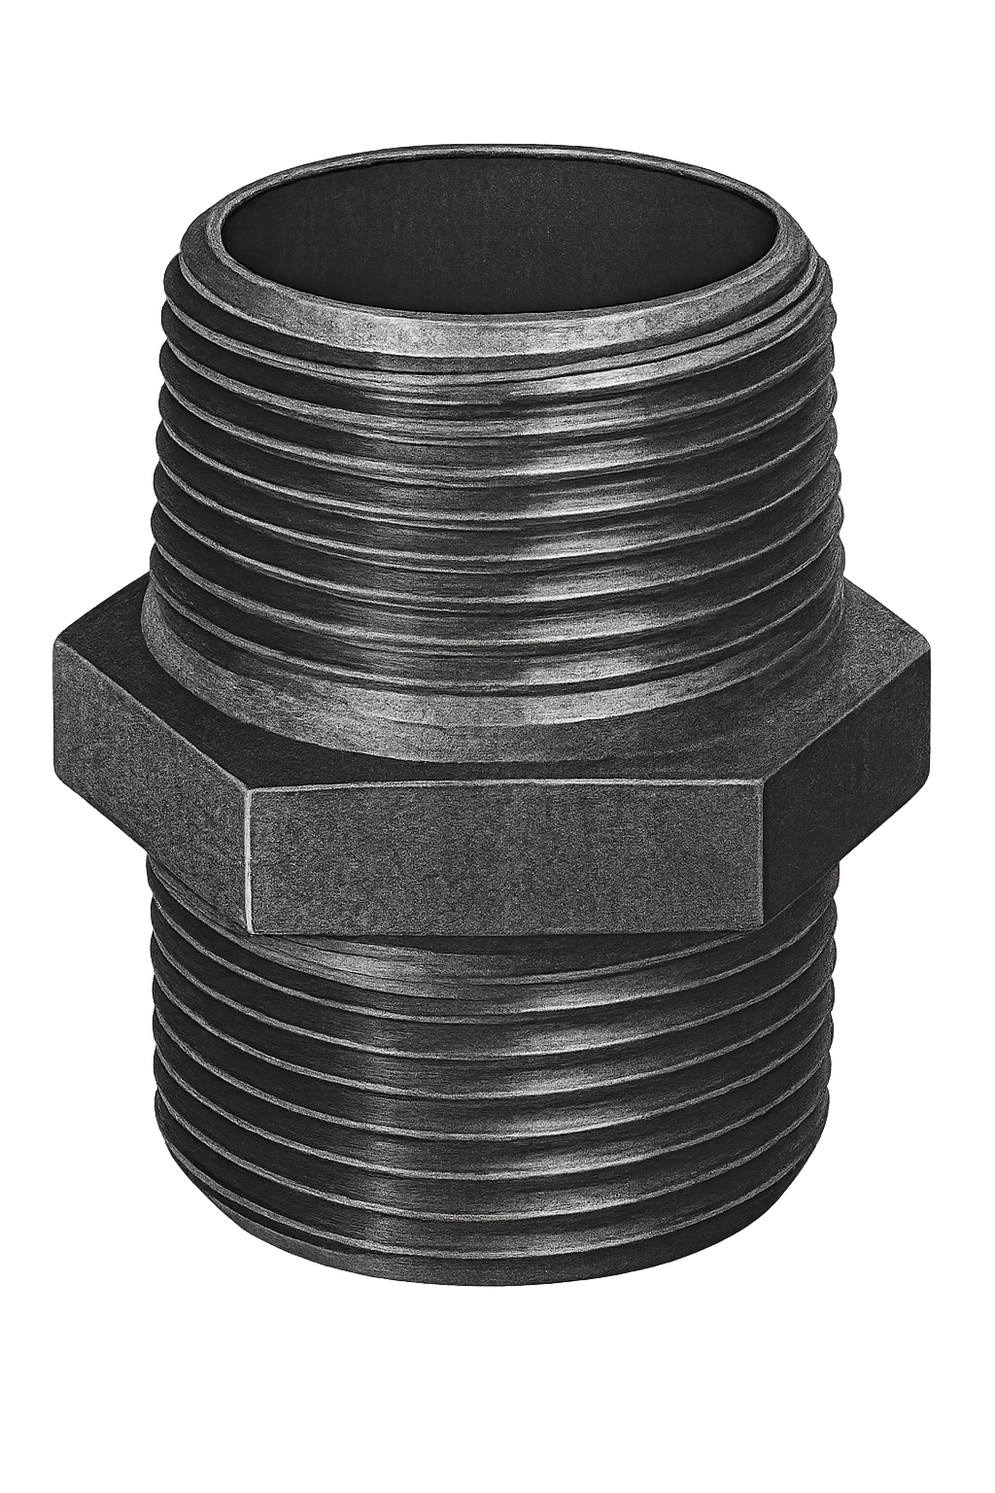
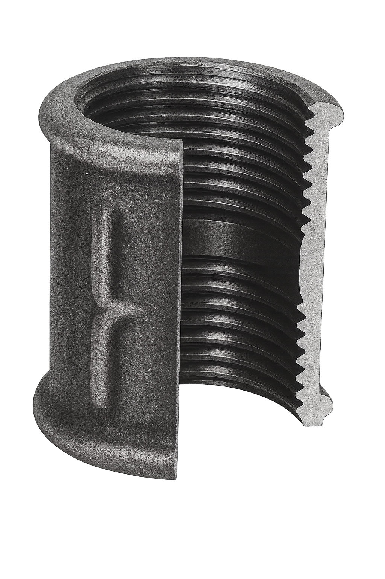
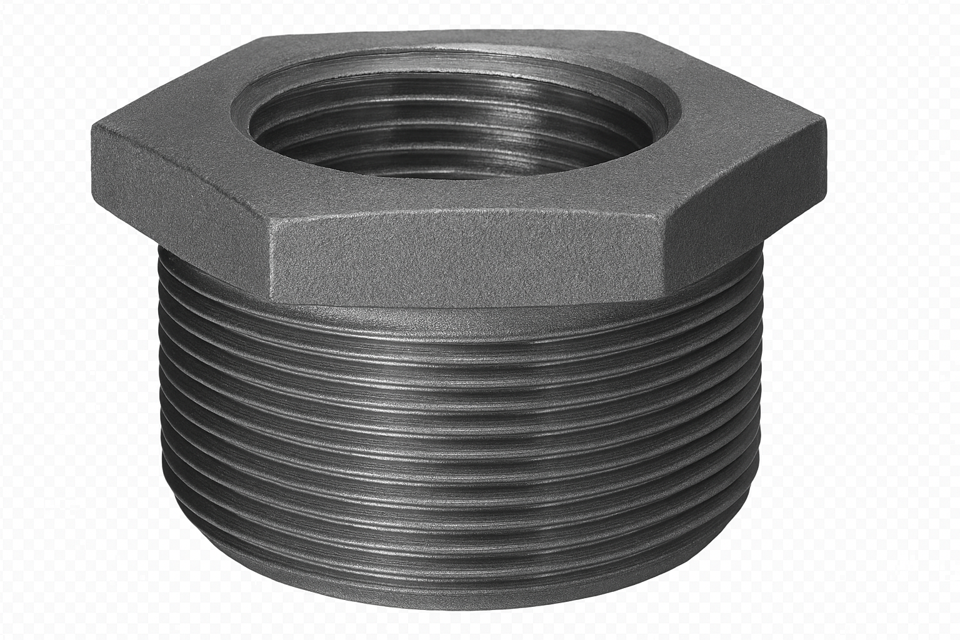
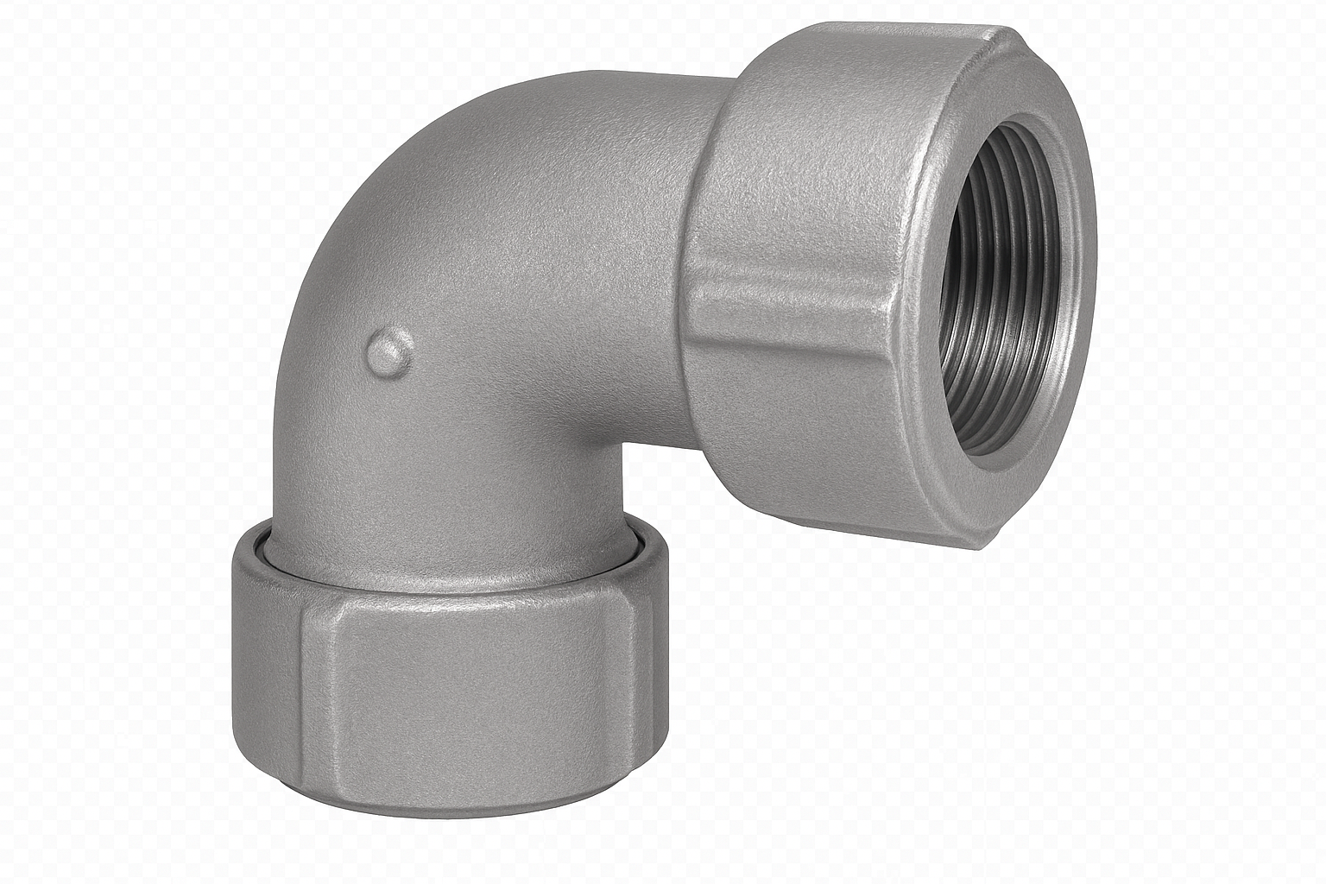
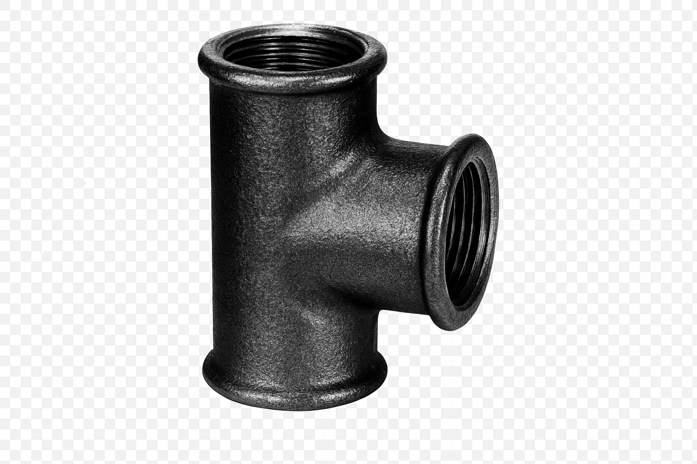
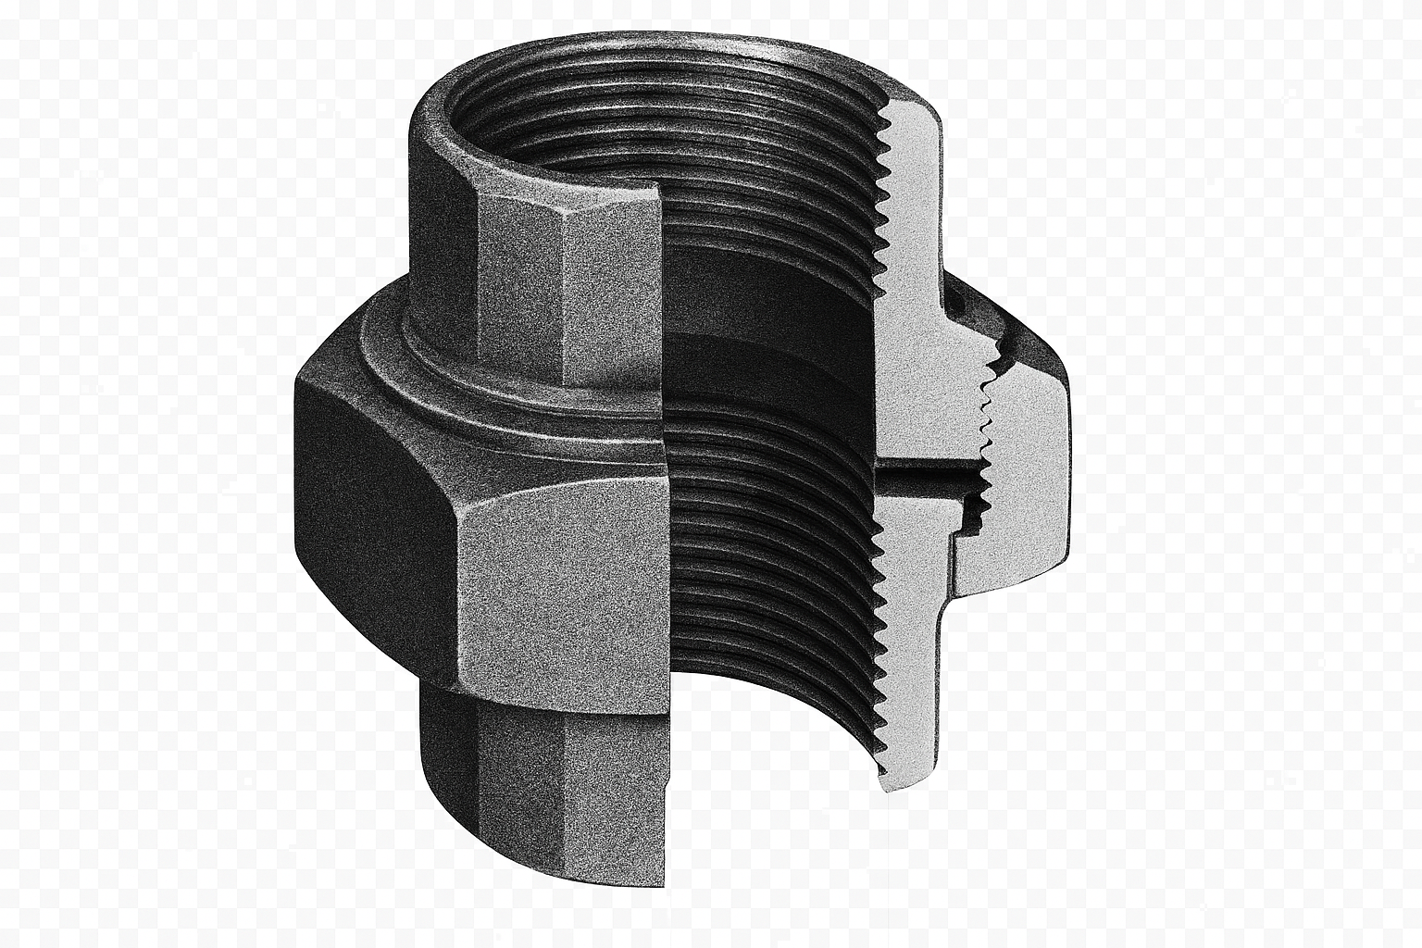

Student reflection
Do you feel confident about this topic? | Yes | I would like more guidance

3.0 System installation

Task 11: Measuring and cutting
To use a tape measure accurately, you must ensure you are reading the correct units. In plumbing, we use metric units, most commonly the millimetre.
One side of the tape shows metric units. This is the side of the tape to use. You will notice that:
- 1 metre is divided into 100 centimetres
- 1 centimetre is divided into 10 millimetres
- 1 metre is divided into 1000 millimetres

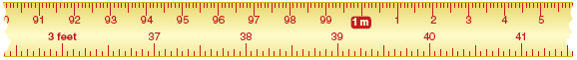
The other side of the tape shows feet and inches. These are imperial units. You will need to use this side of the tape.

Select the following diameters of pipe and cut the lengths in the table below. The diameter is the measurement from one side to the other across the centre.
Type | Diameter | Length to cut | Achieved (Y/N)
Copper | 15mm | 100mm
Copper | 22mm | 150mm
Plastic | 32mm | 120mm
Plastic | 40mm | 170mm
Plastic | 15mm | 130mm
Plastic | 22mm | 180mm
Steel | 20mm | 195mm

Student reflection
Do you feel confident about this topic? | Yes | I would like more guidance

Task 12: Bending techniques - copper
Form the bends pictured below in 15mm copper tube. Remember to allow for pipe gain.
- How much tube is required to form this bend?
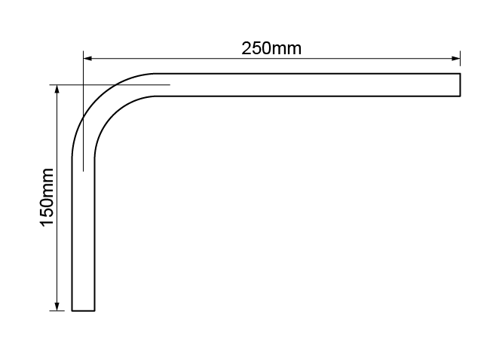

- What angle did you use to form the offset?
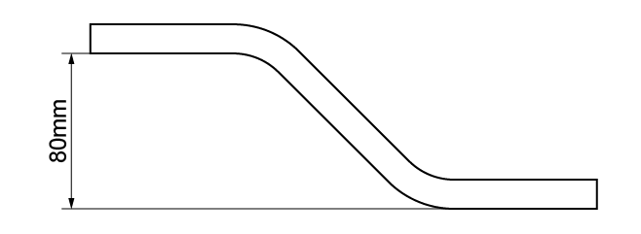

- Recreate this bend.
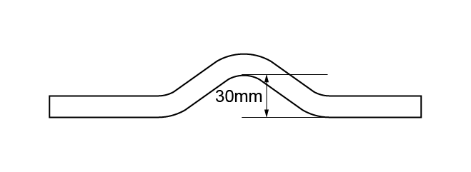

- Recreate this bend.
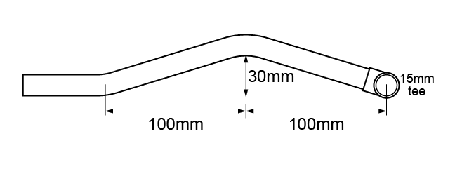

Student reflection
Do you feel confident about this topic? | Yes | I would like more guidance

Task 13: Bending techniques - Low Carbon Steel (LCS)
- Form the 90º bend pictured below in 15mm low carbon steel (LCS) pipe. How much pipe is required to form this bend? Also show how much the pipe gains when it is bent to 90°.
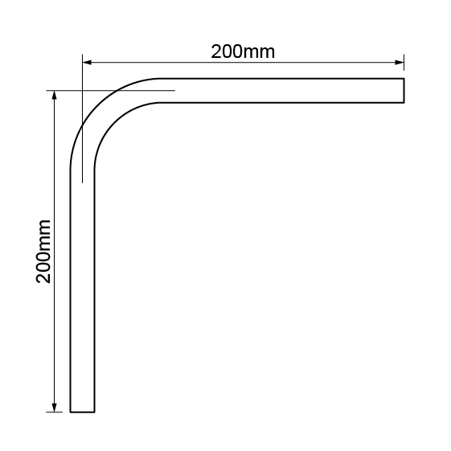

- Form the 45º bend pictured below in 20mm LCS pipe. How much pipe is required to form this bend?
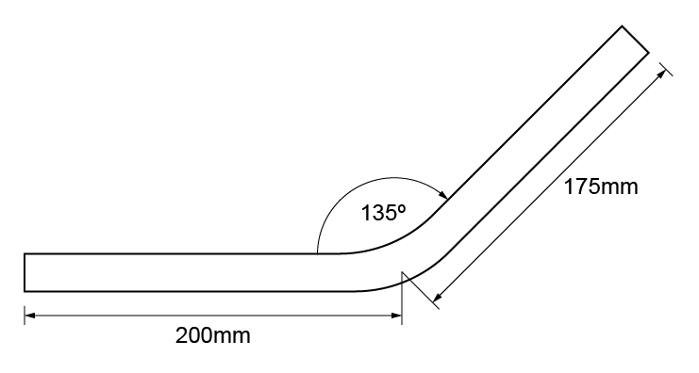

Student reflection
Do you feel confident about this topic? | Yes | I would like more guidance

Task 14: Connection techniques - copper (soldered)
- You are required to fabricate the frame shown below, using 15mm copper pipe. Use end feed fittings.
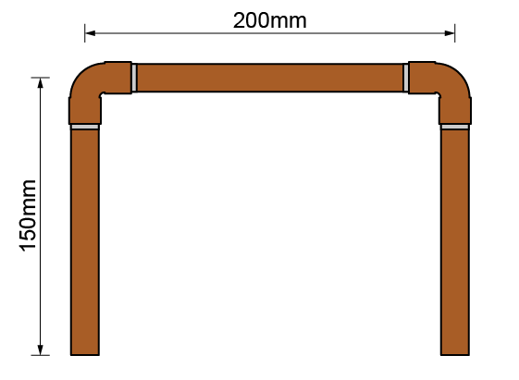

Material type (description) | Quantity

Tool list – list the tools required to complete the work task

Student reflection
Do you feel confident about this topic? | Yes | I would like more guidance

- You are required to fabricate the frame shown below, using 15mm copper pipe. Use end feed fittings, except for the integral solder ring elbow.
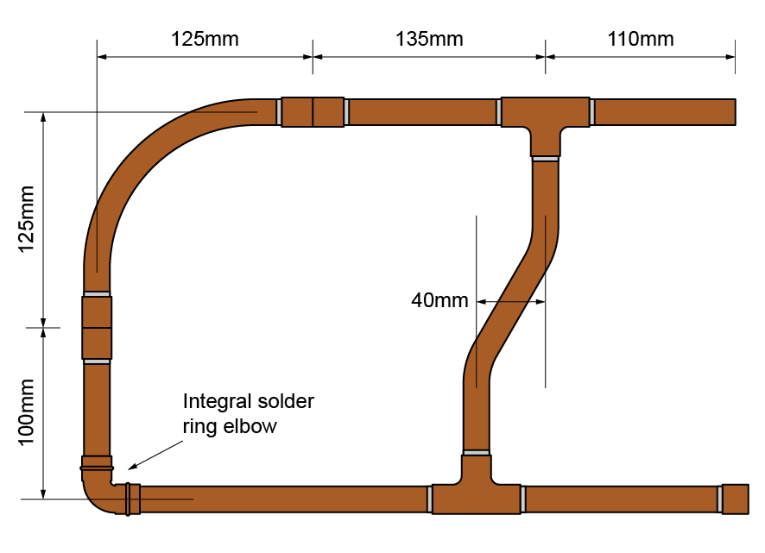

Material type (description) | Quantity

Tool list – list the tools required to complete the work task

Feedback - Assessor to tick
Please develop and work on the following elements: |  | Criteria
Measurement |  | +/- 2mm of the dimensions on the drawing.
Marking out |  | +/- 2mm of the dimensions on the drawing.  Marked out in pencil.
Clipping |  | Select appropriate pipework clips for use and space them correctly.
Pipe jointing |  | Soldered joints must be free from excessive solder and residual flux.  Pipe and fittings are free from tool and vice marks.
Pipe bending |  | Pipe bends must be free from ripples, throating or excessive distortion.
Presentation of work |  | Work presented to a high standard
Ensuring work meets industry requirements |  | Completed pipework must be leak free.
Health and safety |  | Health and safety requirements must be observed at all times

Student reflection
Do you feel confident about this topic? | Yes | I would like more guidance

Task 15: Connection techniques - copper (compression)
You are required to fabricate the frame shown below, using 15mm copper pipe. Use compression fittings.
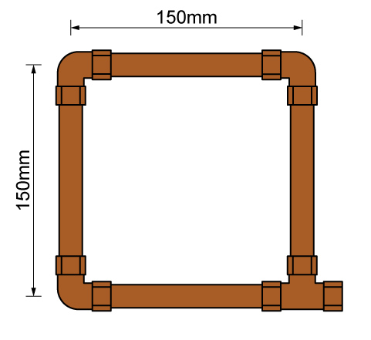

Material type (description) | Quantity

Tool list – list the tools required to complete the work task

Feedback - Assessor to tick
Please develop and work on the following elements: |  | Criteria
Measurement |  | - +/- 2mm of the dimensions on the drawing.
Marking out |  | - +/- 2mm of the dimensions on the drawing.  - Marked out in pencil.
Clipping |  | - Select appropriate pipework clips for use and space them correctly.
Pipe jointing |  | - Pipe and fittings are free from tool and vice marks.
Pipe bending
Presentation of work
Ensuring work meets industry requirements |  | - Completed pipework must be leak free.
Health and safety |  | - Health and safety requirements must be observed at all times

Student reflection
Do you feel confident about this topic? | Yes | I would like more guidance

Task 16: Connection techniques - Low Carbon Steel (LCS)
You are required to fabricate the frame shown below using ½ inch LCS pipe and threaded fittings.
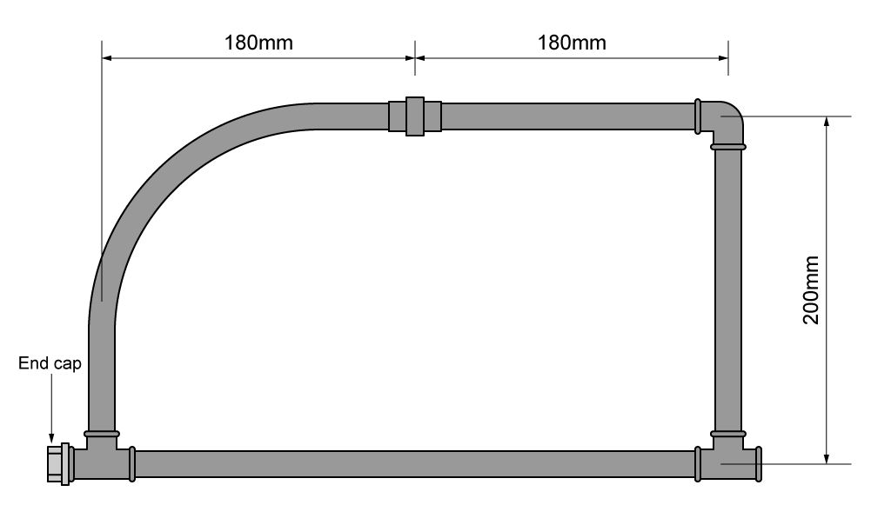

Material type (description) | Quantity

Tool list – list the tools required to complete the work task

Feedback - Assessor to tick
Please develop and work on the following elements: |  | Criteria
Measurement |  | - +/- 2mm of the dimensions on the drawing.
Marking out |  | - +/- 2mm of the dimensions on the drawing.  - Marked out in pencil.
Clipping |  | - Select appropriate pipework clips for use and space them correctly.
Pipe jointing |  | - Pipe and fittings are free from tool and vice marks.  - Malleable iron fittings show no more than 1 ½ threads.
Pipe bending |  | - Pipe bends must be free from ripples, throating or excessive distortion.
Presentation of work
Ensuring work meets industry requirements |  | - Completed pipework must be leak free.
Health and safety |  | - Health and safety requirements must be observed at all times.

Student reflection
Do you feel confident about this topic? | Yes | I would like more guidance

Task 17: Connection techniques - plastic pressure pipe (push-fit)
You are required to fabricate the frame shown below using plastic pressure pipe and push-fit fittings.
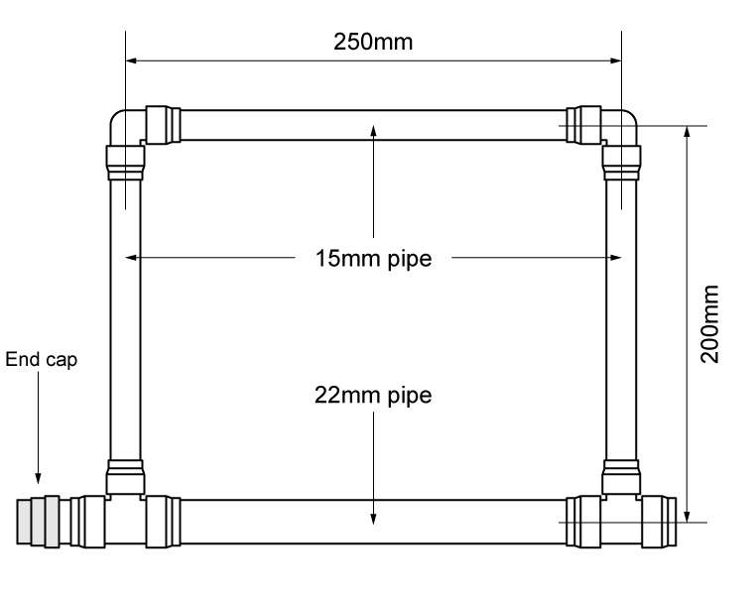

Material type (description) | Quantity

Tool list – list the tools required to complete the work task

Feedback - Assessor to tick
Please develop and work on the following elements: |  | Criteria
Measurement |  | - +/- 2mm of the dimensions on the drawing.
Marking out |  | - +/- 2mm of the dimensions on the drawing.  - Marked out in pencil.  - Spirit level used where necessary.
Clipping |  | - Select appropriate pipework clips for use and space them correctly.
Pipe jointing |  | - Pipe and fittings are free from tool and vice marks.
Pipe bending
Presentation of work
Ensuring work meets industry requirements |  | - Completed pipework must be leak free
Health and safety |  | - Health and safety requirements must be observed at all times

Student reflection
Do you feel confident about this topic? | Yes | I would like more guidance

Task 18: Connection techniques - plastic waste pipe (push-fit)
You are required to fabricate the frame shown below using plastic waste pipe and push-fit fittings.
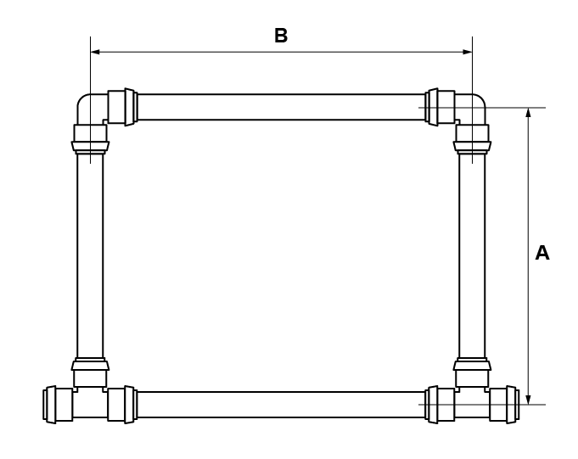
32mm pipe | 40mm pipe
A = 150mm | A = 175mm
B = 200mm | B = 225mm

Material type (description) | Quantity

Tool list – list the tools required to complete the work task
Feedback - Assessor to tick
Please develop and work on the following elements: |  | Criteria
Measurement |  | - +/- 2mm of the dimensions on the drawing.
Marking out |  | - +/- 2mm of the dimensions on the drawing.  - Marked out in pencil.  - Spirit level used where necessary.
Clipping |  | - Select appropriate pipework clips for use and space them correctly.
Pipe jointing |  | - Pipe and fittings are free from tool and vice marks.
Pipe bending
Presentation of work
Ensuring work meets industry requirements |  | - Completed pipework must be leak free
Health and safety |  | - Health and safety requirements must be observed at all times

Student reflection
Do you feel confident about this topic? | Yes | I would like more guidance

Task 19: Connection techniques - combined
You are required to fabricate the combined frame shown below using 15mm copper, plastic and LCS.
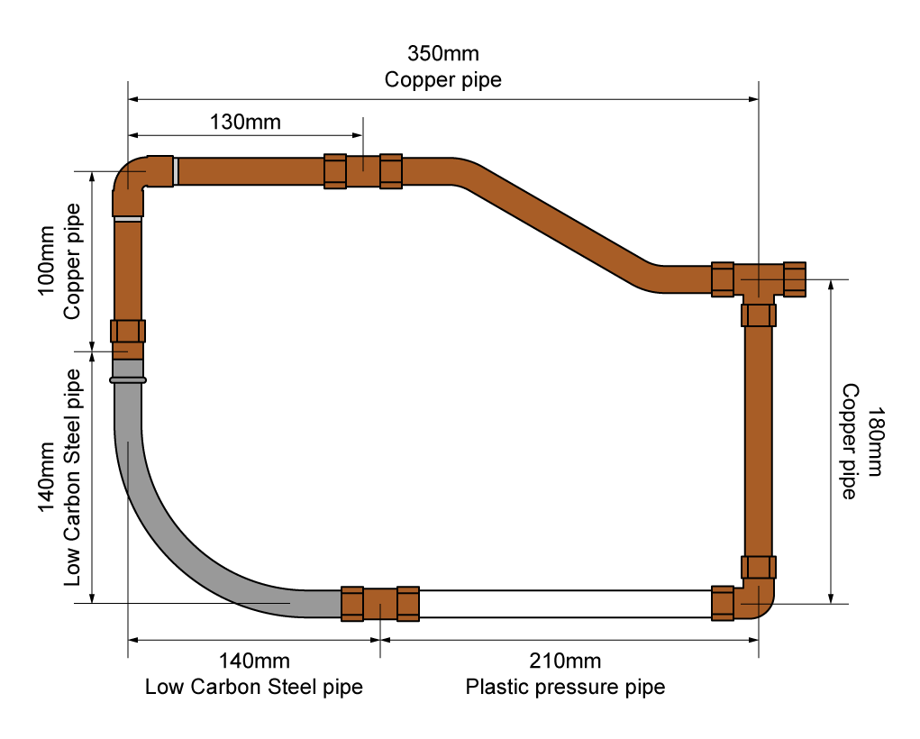

Material type (description) | Quantity

Tool list – list the tools required to complete the work task

Feedback - Assessor to tick
Please develop and work on the following elements: |  | Criteria
Measurement |  | - +/- 2mm of the dimensions on the drawing
Marking out |  | - +/- 2mm of the dimensions on the drawing  - Marked out in pencil.  - Spirit level used where necessary.
Clipping |  | - Select appropriate pipework clips for use and space them correctly.
Pipe jointing |  | - Soldered joints must be free from excessive solder and residual flux.  - Pipe and fittings are free from tool and vice marks.  - Malleable iron fittings show no more than 1 ½ threads.
Pipe bending |  | - Pipe bends must be free from ripples, throating or excessive distortion.
Presentation of work
Ensuring work meets industry requirements |  | - Completed pipework must be leak free.
Health and safety |  | - Health and safety requirements must be observed at all times.

Student reflection
Do you feel confident about this topic? | Yes | I would like more guidance

Task 20: Decommissioning
Decommissioning is the process of taking the system safely ‘out of action’, which may be either temporarily or permanently.
Temporary decommission: The process of temporarily taking a system ‘out of action’ to carry out additional work to the system, to undertake maintenance or as a result of the system not being used.
Permanently decommission: The process of permanently taking a system ‘out of action’ and removing the installation.
Procedure for decommissioning systems:
- notify the relevant person
- isolate fuel/electricity supply to the system as appropriate
- isolate water supply
- apply warning notices and signs
- drain system to a suitable location
- appropriately dispose of contents and any additives
- continuity bonding as required
- temporary capping of pipework sections as required
- notify building users
- alternative source of heat or supplies as required.
Whilst working through this training manual, once the installations have been completed, checked, and verified by the customer (assessor).
You must:
- decommission in a safe manner, ensuring safe isolation
- ensure the workspace is made good, including filling, sanding and painting any holes or damage to the building fabric.

Following dismantling, consideration must be given to sustainability and recycling.

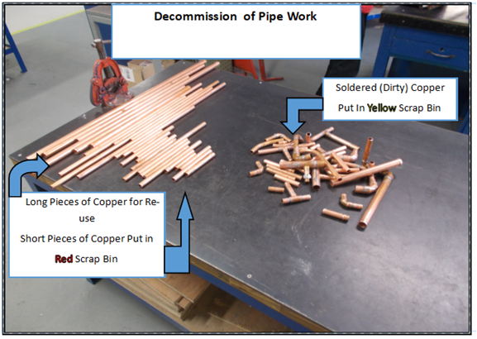

Notes for decommissioning:

Task 21: Install clips/brackets
You are required to install and fix pipework clips and brackets at recommended spacing intervals to meet specification requirements and in accordance with current industry standards.
Mark a horizontal level and fix the clips as shown below into a timber surface:
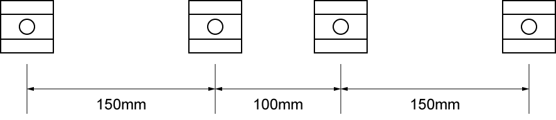

Mark a horizontal level and fix the clips as shown below into a brick or block surface:
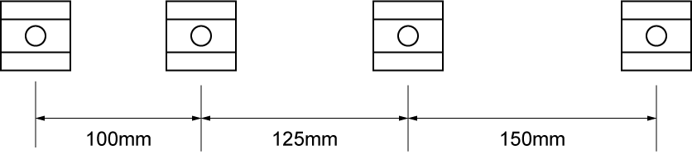

Attach the two back plate elbows to a brick or block surface:
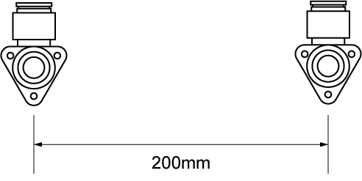

Tool list – list the tools required to complete the work task

Student reflection
Do you feel confident about this topic? | Yes | I would like more guidance

Task 22: Plastic pipe installation
You are required to fabricate the installation shown below using 32mm plastic waste pipe.
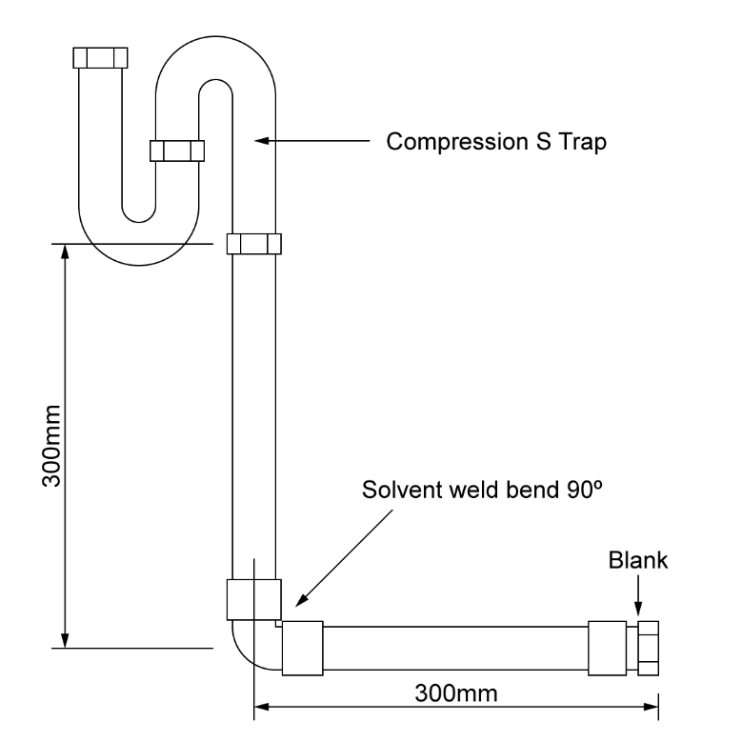

Material type (description) | Quantity

Tool list – list the tools required to complete the work task

Feedback - Assessor to tick
Please develop and work on the following elements: |  | Criteria
Measurement |  | - +/- 2mm of the dimensions on the drawing.
Marking out |  | - +/- 2mm of the dimensions on the drawing.  - Marked out in pencil.  - Spirit level used where necessary.
Clipping |  | - Select appropriate pipework clips for use and space them correctly.
Pipe jointing |  | - Pipe and fittings are free from tool and vice marks
Pipe bending
Presentation of work
Ensuring work meets industry requirements |  | - Completed pipework must be leak free.
Health and safety |  | - Health and safety requirements must be observed at all times

Student reflection
Do you feel confident about this topic? | Yes | I would like more guidance

Task 23: Joist notching
Many installations require the notching and drilling of timber joists to accommodate pipes and fittings under the floor.
Notches must be made as shown in the diagram below:
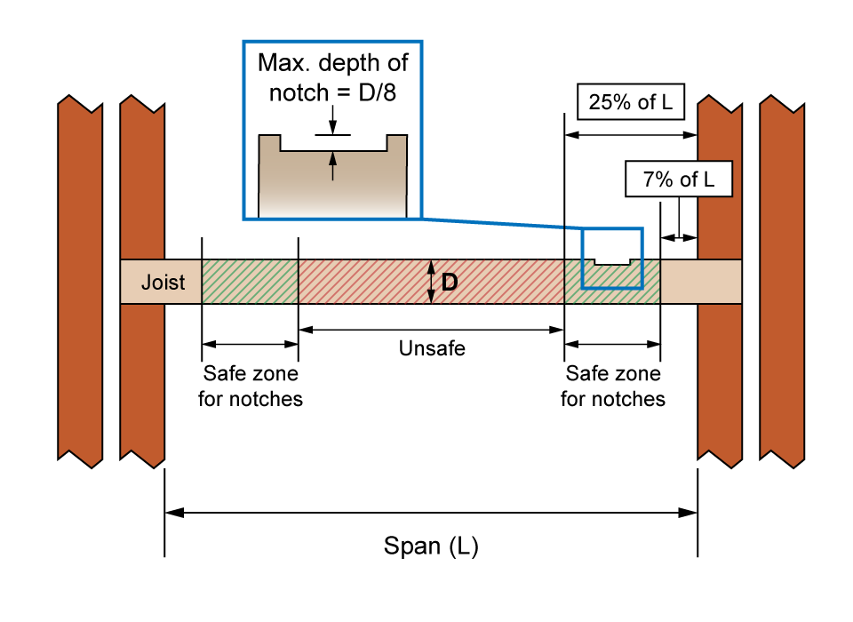
- If a joist had a depth of 150mm, the maximum depth of notch would be?

- If a joist had a depth of 250mm, the maximum depth of notch would be?

- Complete all calculations for a joist with a span of 3000mm and a depth of 200mm

Holes drilled or cut into joists follow a similar procedure. A hole must not begin within 25 per cent of the span, measured from the end of the joist and must stop at a point equal to 40 per cent of the span, again measured from the end. The size of the hole must not exceed a measurement equal to 25 per cent of the depth of the joist.
Holes must be made as shown in the diagram below:
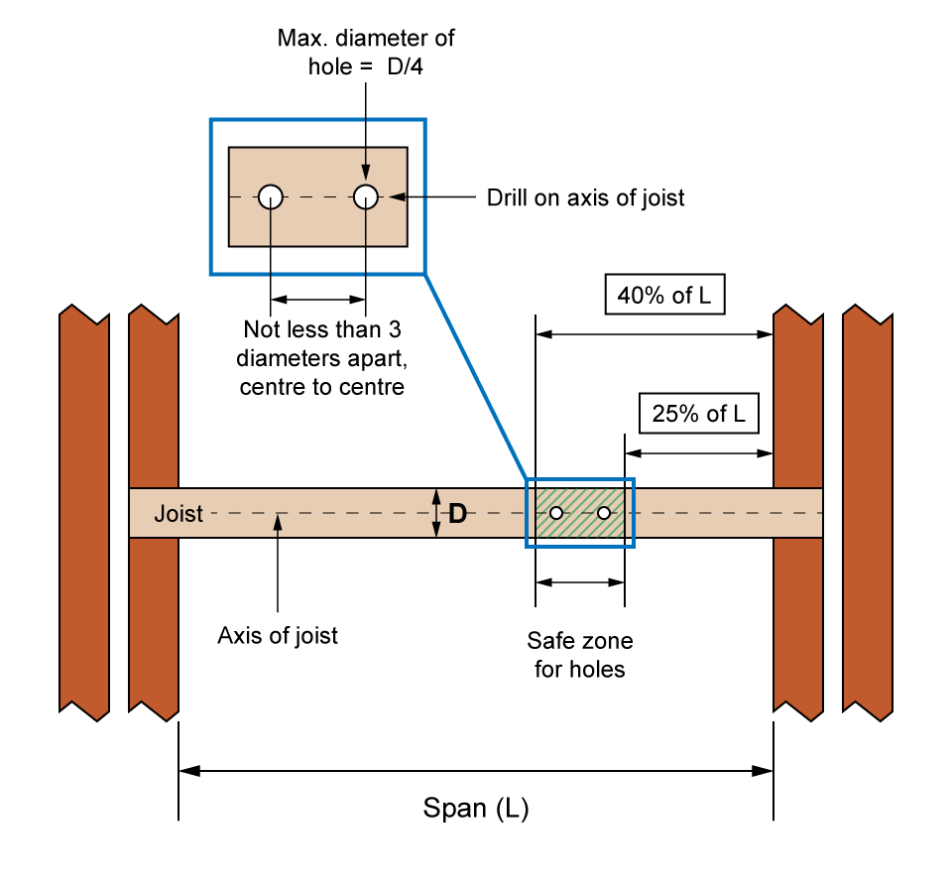
- If a joist had a depth of 200mm, the maximum diameter of the hole would be?

- If a joist had a depth of 250mm, the maximum diameter of the hole would be?

- Complete all calculations for a joist with a span of 3000mm and a depth of 200mm

Student reflection
Do you feel confident about this topic? | Yes | I would like more guidance

Task 24: Rainwater system components
Identify the rainwater system components
Fitting | Description | Purpose
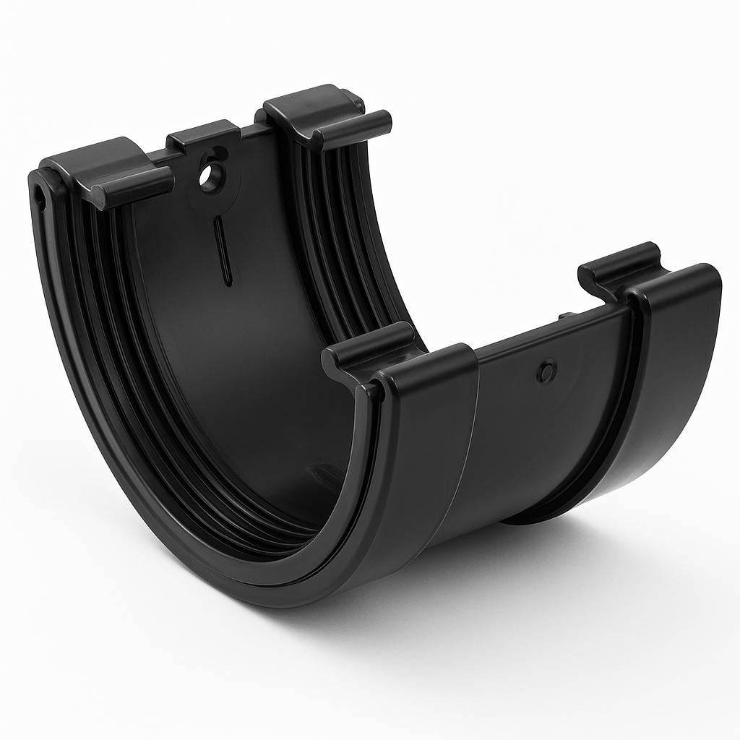
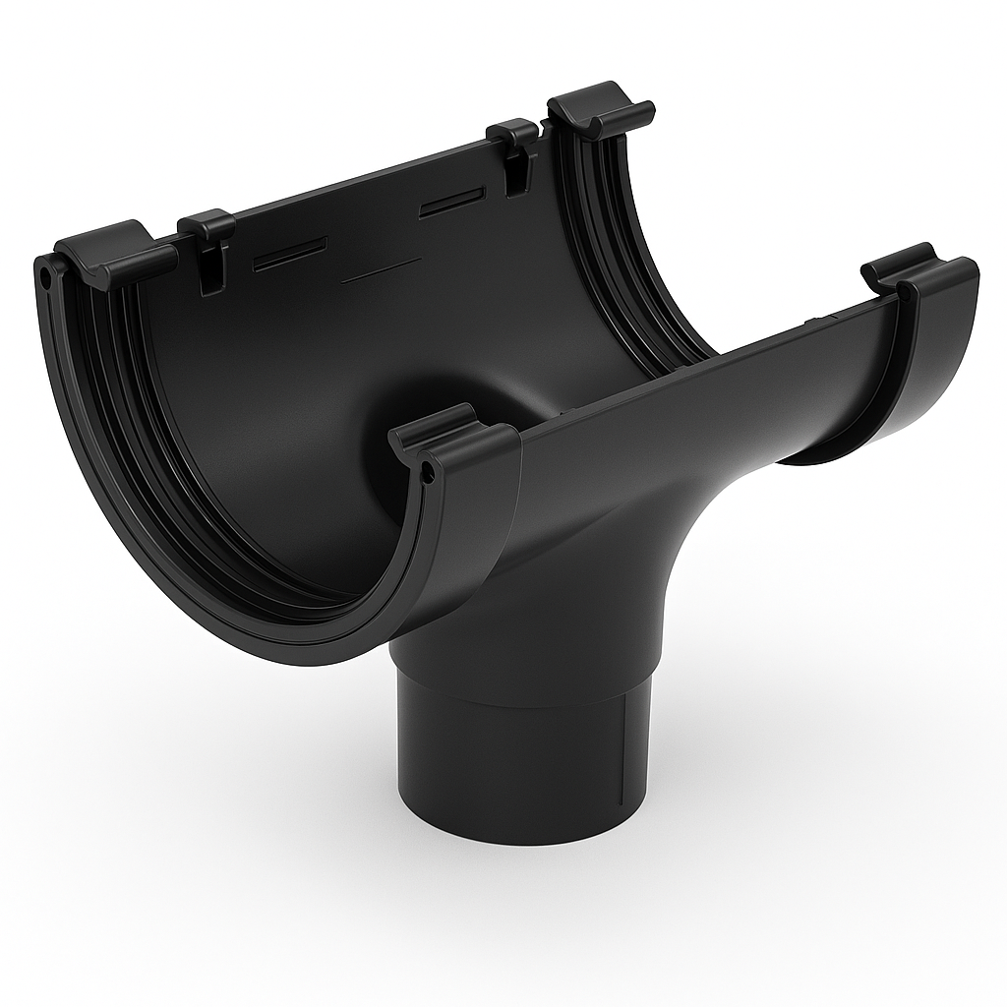
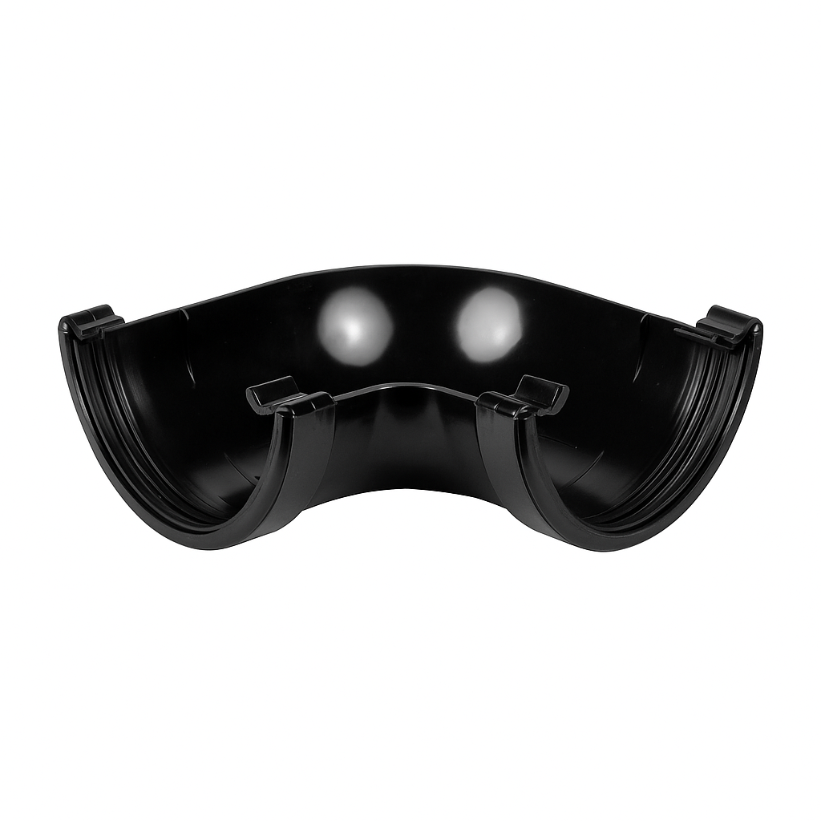
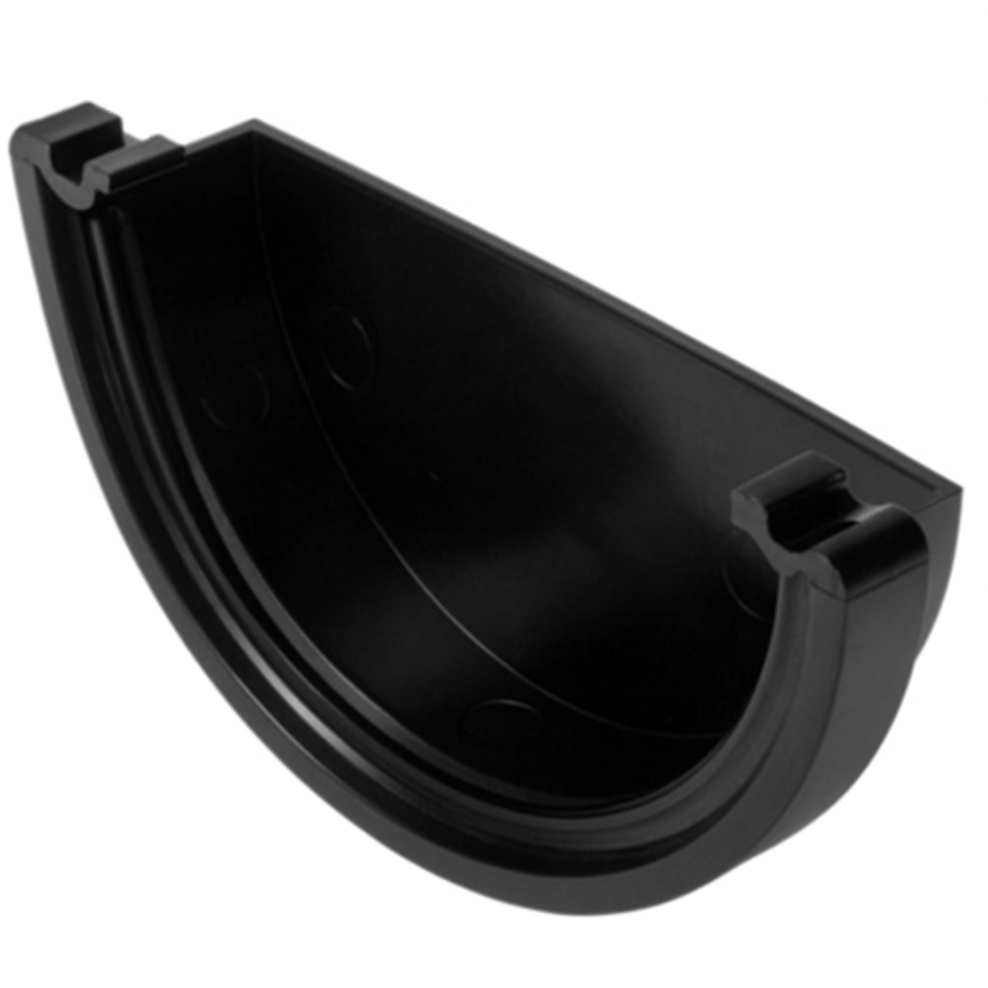
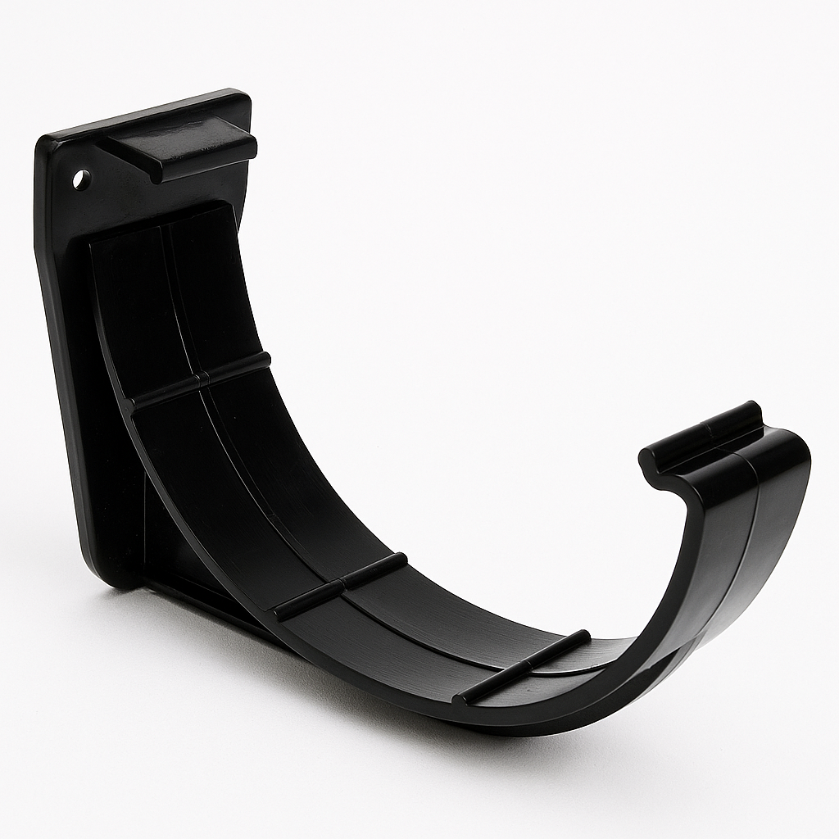
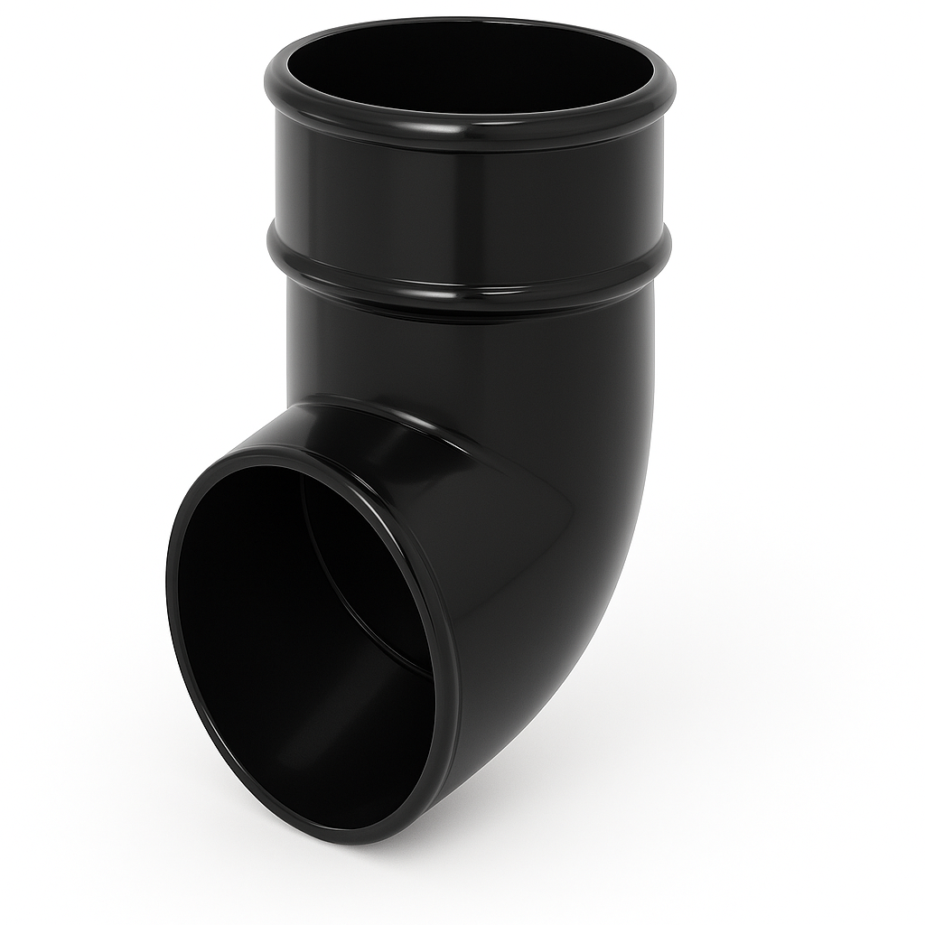
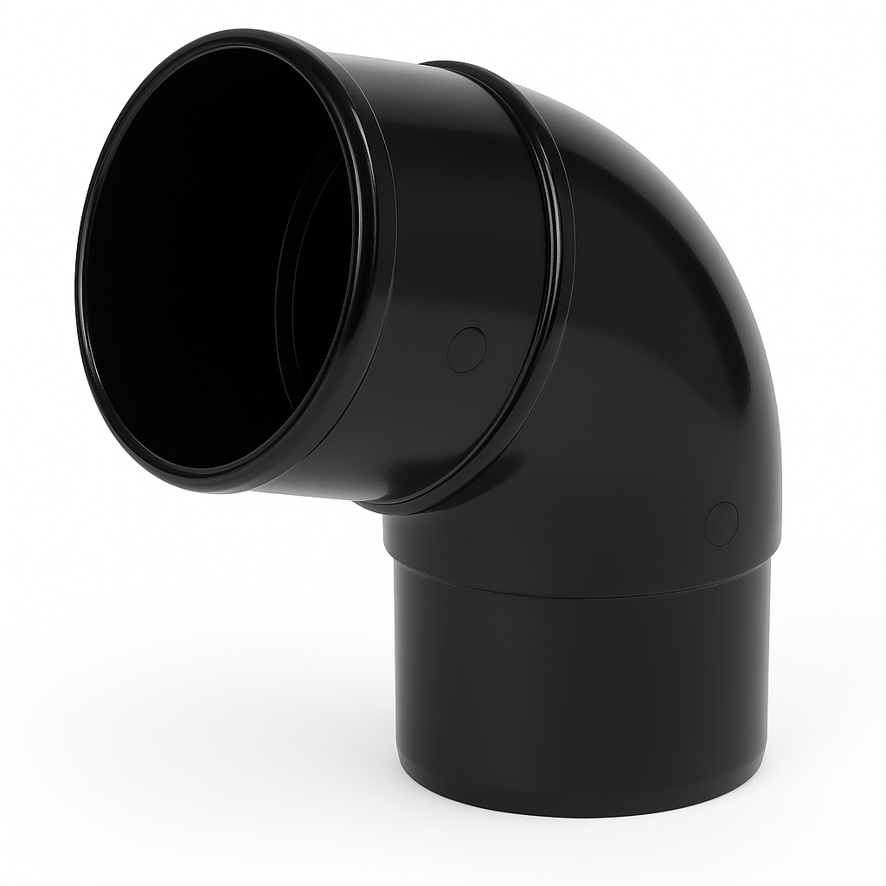

Task 25: Rainwater installation
You are required to fabricate the rainwater system shown below.
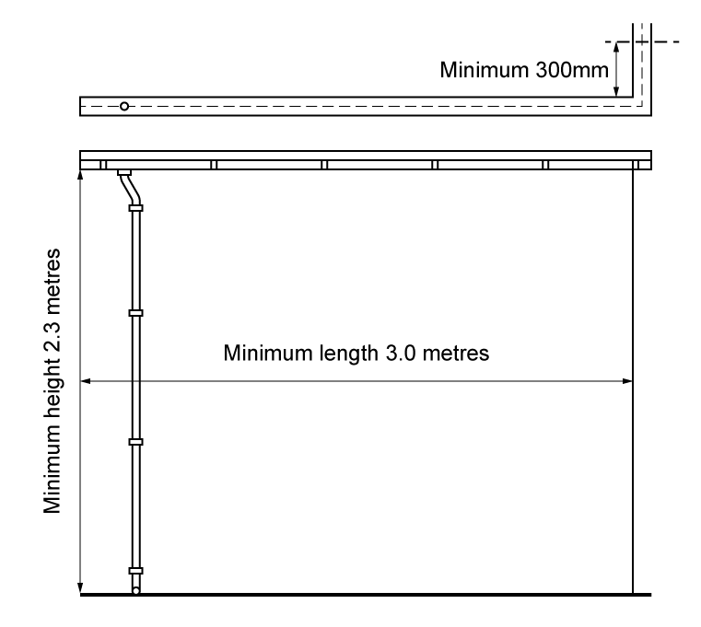

Material type (description) | Quantity

Tool list – list the tools required to complete the work task

Feedback - Assessor to tick
Please develop and work on the following elements: |  | Criteria
Measurement |  | - Student installs guttering brackets at the correct gradient and at correct spacing intervals (+/- 2mm).
Marking out |  | - Marked out in pencil.  - Spirit level used where necessary.
Clipping |  | - Select appropriate pipework clips for use and space them correctly.
Presentation of work
Ensuring work meets industry requirements |  | - Completed pipework must be leak free.
Health and safety |  | - Health and safety requirements must be observed at all times.

Student reflection
Do you feel confident about this topic? | Yes | I would like more guidance

Task 26: Soil stack components
Identify the soil stack components.
Fitting | Description | Purpose
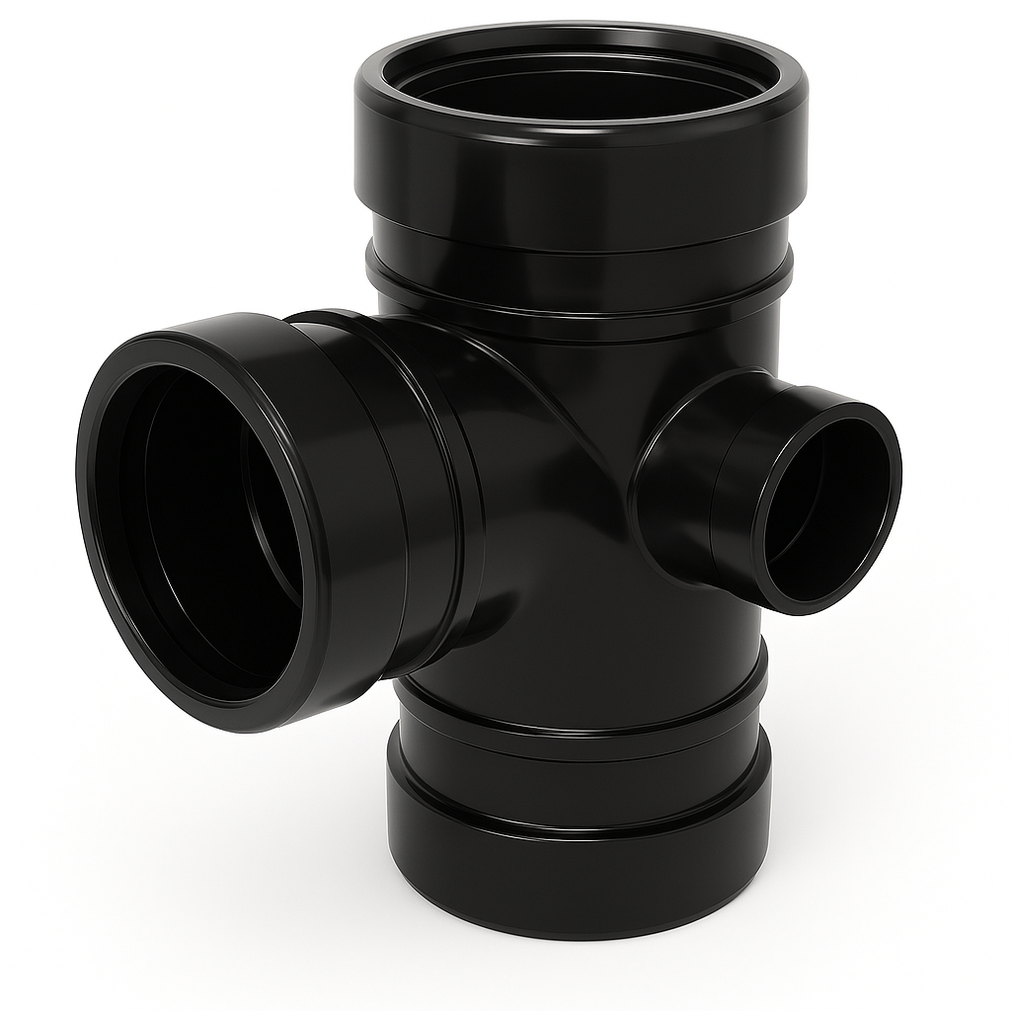
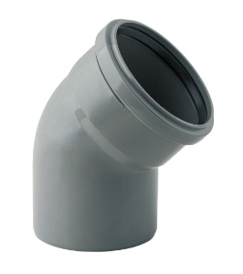
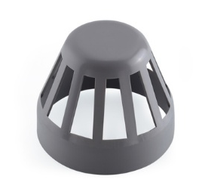
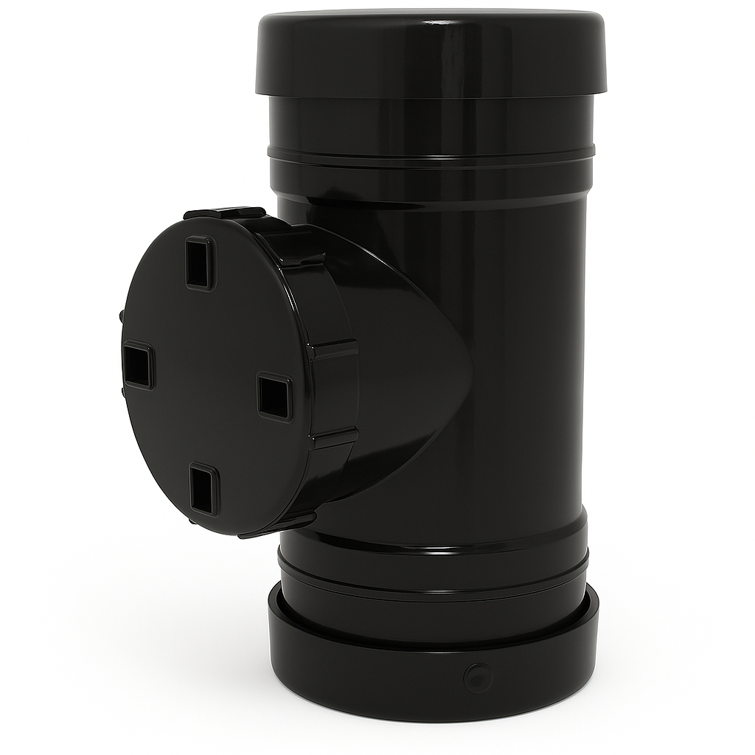
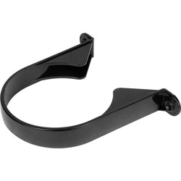
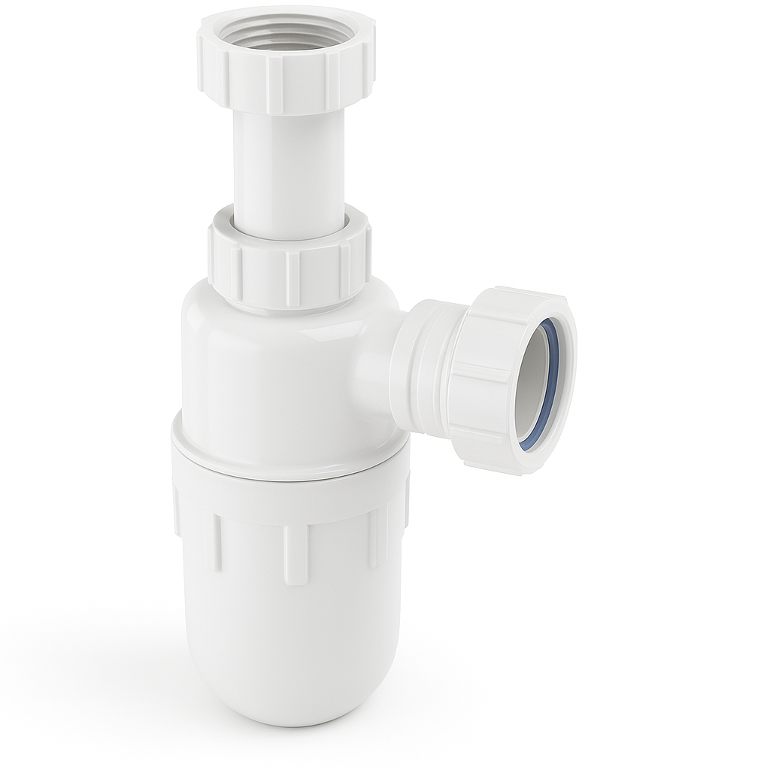

Fitting | Description | Purpose
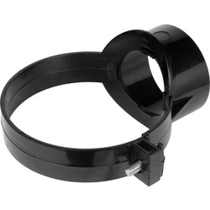
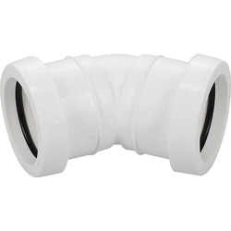
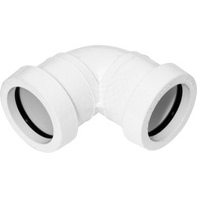
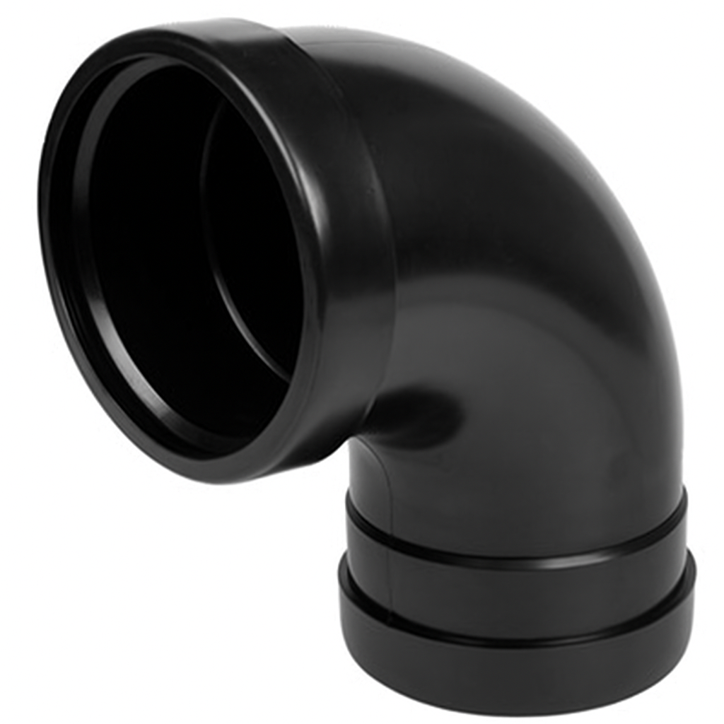

Task 27: Soil stack installation
You are required to install the soil stack shown below.

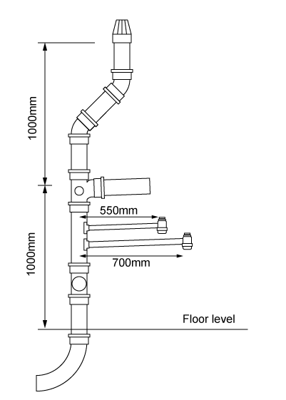
Material type (description) | Quantity

Tool list – list the tools required to complete the work task

Feedback - Assessor to tick
Please develop and work on the following elements: |  | Criteria
Measurement |  | - Student installs brackets at the correct gradient and at correct spacing intervals (+/- 2mm).
Marking out |  | - Marked out in pencil  - Spirit level used where necessary.
Clipping |  | - Select appropriate pipework clips for use and space them correctly.
Presentation of work
Ensuring work meets industry requirements |  | - Completed pipework must be leak free.
Health and safety |  | - Health and safety requirements must be observed at all times.

Student reflection
Do you feel confident about this topic? | Yes | I would like more guidance

Task 28: Air testing
Soundness testing should be carried out in accordance with BS EN 12056.
Test specification:
38mm water gauge pressure for a period of 3 minutes with no pressure loss.
Procedure:
- Seal the system using drain plugs or air bags.
- Fill traps with water.
- Connect water gauge.
- Using hand bellows apply test pressure and carry out test using leak detector spray to locate leaks.
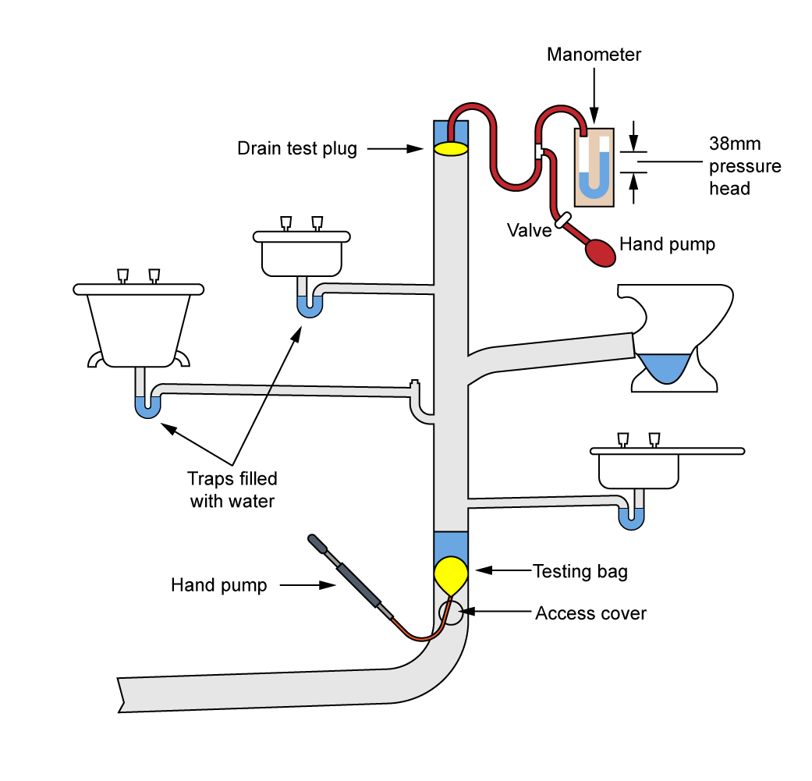

Write a brief description on how to carry out a soundness test

Sanitation Commissioning Sheet
Address
Engineer’s Name
Date
Soundness Test Record pressure and duration
Air Test: AGDS
Record pressure and duration
Check appliances for self-siphonage Y/N
Check appliances for induced siphonage Y/N
Performance test
Satisfactory Y/N

Student reflection
Do you feel confident about this topic? | Yes | I would like more guidance

Task 29: Installing radiators
You are required to hang and pipe up a panel radiator. Name the objects below and describe the procedure for hanging the radiator.
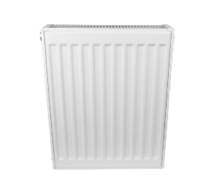 | 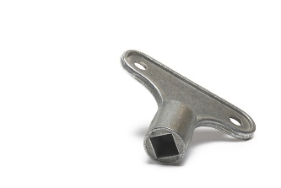
A) | B)
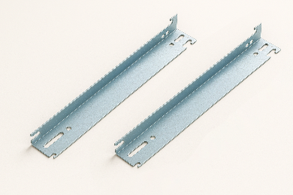 | 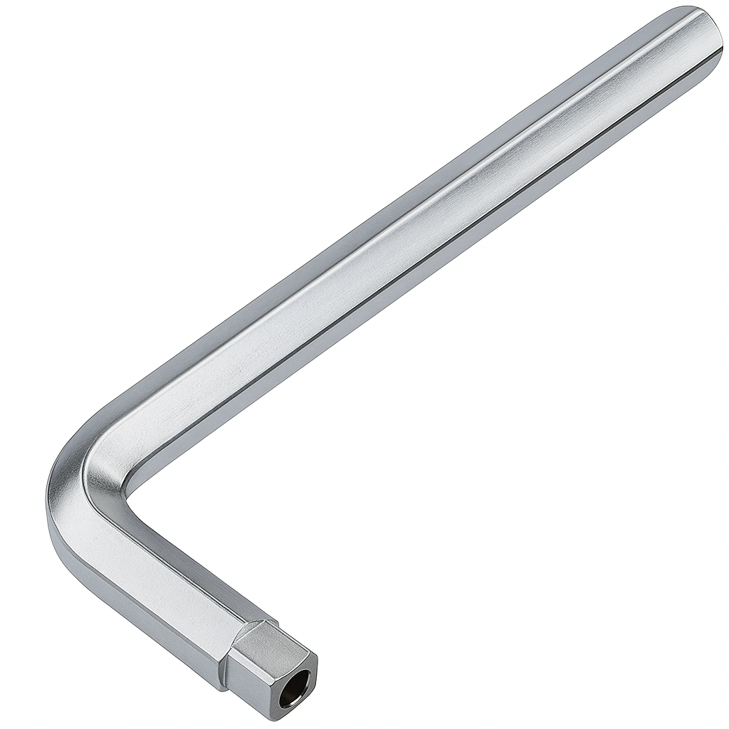
C) | D)
Procedure:

Student reflection
Do you feel confident about this topic? | Yes | I would like more guidance

Task 30: Central heating installation
You are required to install the central heating system using copper pipework and end feed fittings. Once completed the installation must be pressure tested.
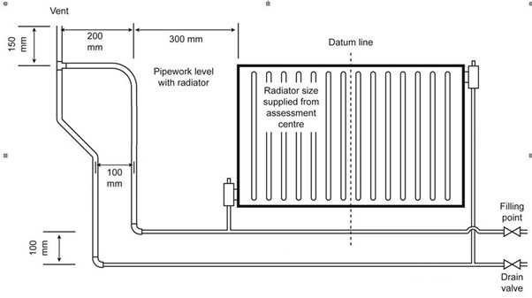
Material type (description) | Quantity

Tool list – list the tools required to complete the work task

Feedback - Assessor to tick
Please develop and work on the following elements: |  | Criteria
Measurement |  | - +/- 2mm of the dimensions on the drawing.
Marking out |  | - +/- 2mm of the dimensions on the drawing.  - Marked out in pencil.  - Spirit level used where necessary.
Clipping |  | - Select appropriate pipework clips for use and space them correctly.
Pipe jointing |  | - Soldered joints must be free from excessive solder and residual flux.  - Pipe and fittings are free from tool and vice marks.  - Malleable iron fittings show no more than 1 ½ threads.
Pipe bending |  | - Pipe bends must be free from ripples, throating or excessive distortion.
Presentation of work
Ensuring work meets industry requirements |  | - Completed pipework must be leak free.
Health and safety |  | - Health and safety requirements must be observed at all times.

Student reflection
Do you feel confident about this topic? | Yes | I would like more guidance

Task 31: Cloakroom installation
You are required to install the cloakroom fittings using copper pipework and end feed fittings. Once completed the installation must be pressure tested.
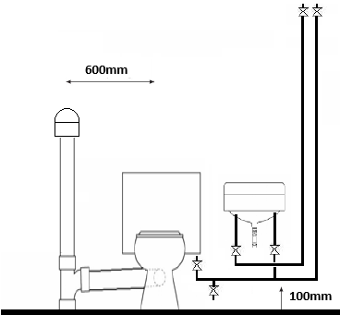
Material type (description) | Quantity

Tool list – list the tools required to complete the work task

Feedback - Assessor to tick
Please develop and work on the following elements: |  | Criteria
Measurement |  | - +/- 2mm of the dimensions on the drawing.
Marking out |  | - +/- 2mm of the dimensions on the drawing.  - Marked out in pencil.  - Spirit level used where necessary.
Clipping |  | - Select appropriate pipework clips for use and space them correctly.
Pipe jointing |  | - Soldered joints must be free from excessive solder and residual flux.  - Pipe and fittings are free from tool and vice marks.  - Malleable iron fittings show no more than 1 ½ threads.
Pipe bending |  | - Pipe bends must be free from ripples, throating or excessive distortion.
Presentation of work
Ensuring work meets industry requirements |  | - Completed pipework must be leak free.
Health and safety |  | - Health and safety requirements must be observed at all times.

Student reflection
Do you feel confident about this topic? | Yes | I would like more guidance

Task 32: Unvented cylinder installation
You are required to install the central heating system using copper pipework and end feed fittings. Once completed, the installation must be commissioned.
Key components:
- Unvented cylinder: The main vessel where water is stored and heated.
- Cold water inlet group: Includes a pressure-reducing valve, check valve, and strainer to regulate and clean incoming water.
- Expansion vessel Accommodates water expansion as it heats.
- Tundish: A visible air gap that shows if water is discharging from safety valves.
- Discharge pipework: Safely channels hot water from safety valves to a termination point.
- Temperature and pressure relief valve: Releases water if temperature exceeds ~90°C or pressure becomes excessive.
- Pressure reducing valve: Keeps incoming mains pressure at a safe level (typically around 3 bar).
- Check valve – Stops backflow of water, protecting mains supply from contamination.
Label the system components:

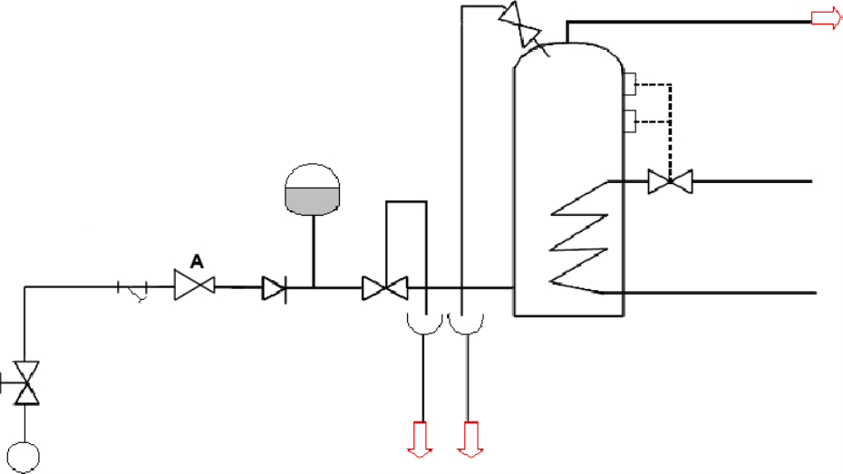

Material type (description) | Quantity

Tool list – list the tools required to complete the work task

Feedback - Assessor to tick
Please develop and work on the following elements: |  | Criteria
Measurement |  | - +/- 2mm of the dimensions on the drawing.
Marking out |  | - +/- 2mm of the dimensions on the drawing.  - Marked out in pencil.  - Spirit level used where necessary.
Clipping |  | - Select appropriate pipework clips for use and space them correctly.
Pipe jointing |  | - Soldered joints must be free from excessive solder and residual flux.  - Pipe and fittings are free from tool and vice marks.  - Malleable iron fittings show no more than 1½ threads.
Pipe bending |  | - Pipe bends must be free from ripples, throating or excessive distortion.
Presentation of work
Ensuring work meets industry requirements |  | - Completed pipework must be leak free.
Health and safety |  | - Health and safety requirements must be observed at all times.

Student reflection
Do you feel confident about this topic? | Yes | I would like more guidance

Task 33: Termination of BS1363 plug top
You are required to terminate BS1363 plug top using 1.5mm2 3 core flexible cable.
Identify the parts of the plug:
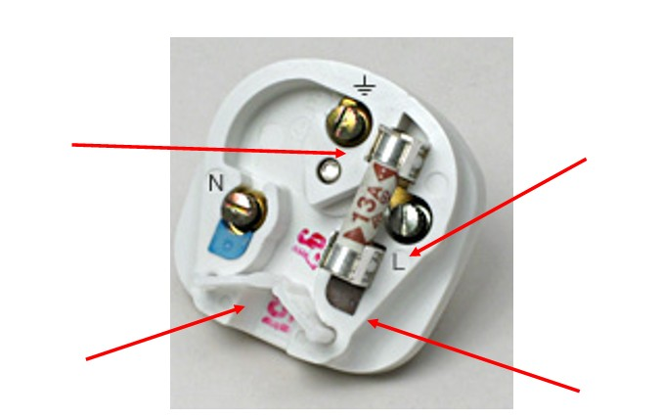

Student reflection
Do you feel confident about this topic? | Yes | I would like more guidance

Task 34: WC macerator installation
You are required to install the WC macerator.
A WC macerator is a compact waste disposal unit that allows toilets to be installed in areas without access to standard gravity drainage, like basements or loft spaces. It works by grinding solid waste into a slurry using internal blades, then pumping it through narrow pipework (typically 22–32mm in diameter) to the main soil stack. For installation, the macerator should be positioned directly behind or near the toilet, with access to a fused spur power supply and a suitable discharge route. Plumbing must follow specific guidelines, including a minimum vertical lift, a gradual gradient for horizontal runs, and avoidance of sharp bends to prevent clogs. Additionally, a check valve and air vent should be installed to manage backflow and ventilation.

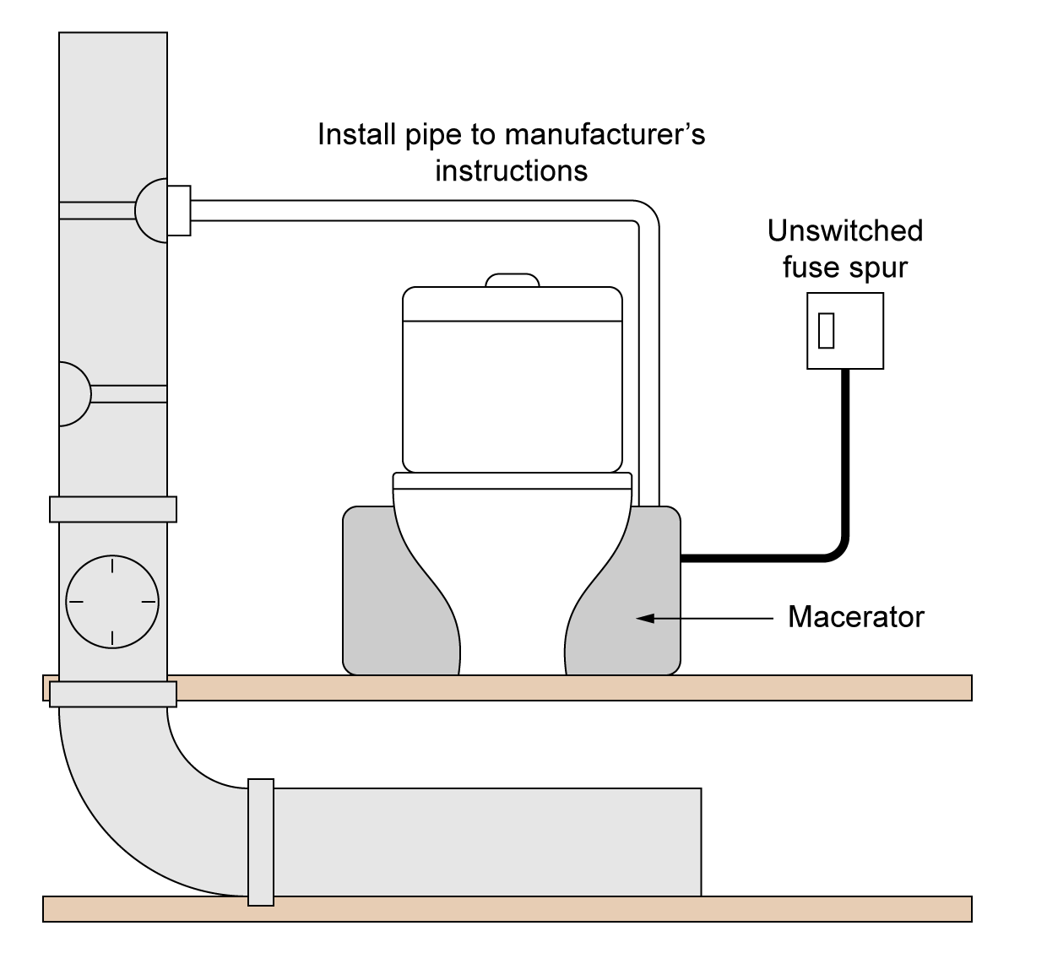

Material type (description) | Quantity

Tool list – list the tools required to complete the work task

Feedback - Assessor to tick
Please develop and work on the following elements: |  | Criteria
Measurement |  | - +/- 2mm of the dimensions on the drawing
Marking out |  | - +/- 2mm of the dimensions on the drawing.  - Marked out in pencil.  - Spirit level used where necessary.
Clipping |  | - Select appropriate pipework clips for use and space them correctly.
Pipe jointing |  | - Soldered joints must be free from excessive solder and residual flux.  - Pipe and fittings are free from tool and vice marks.  - Malleable iron fittings show no more than 1 ½ threads.
Pipe bending |  | - Pipe bends must be free from ripples, throating or excessive distortion.
Presentation of work
Ensuring work meets industry requirements |  | - Completed pipework must be leak free.
Health and safety |  | - Health and safety requirements must be observed at all times.

Student reflection
Do you feel confident about this topic? | Yes | I would like more guidance

Task 35: Y Plan central heating wiring
You are required to complete the wiring for a Y Plan central heating system.
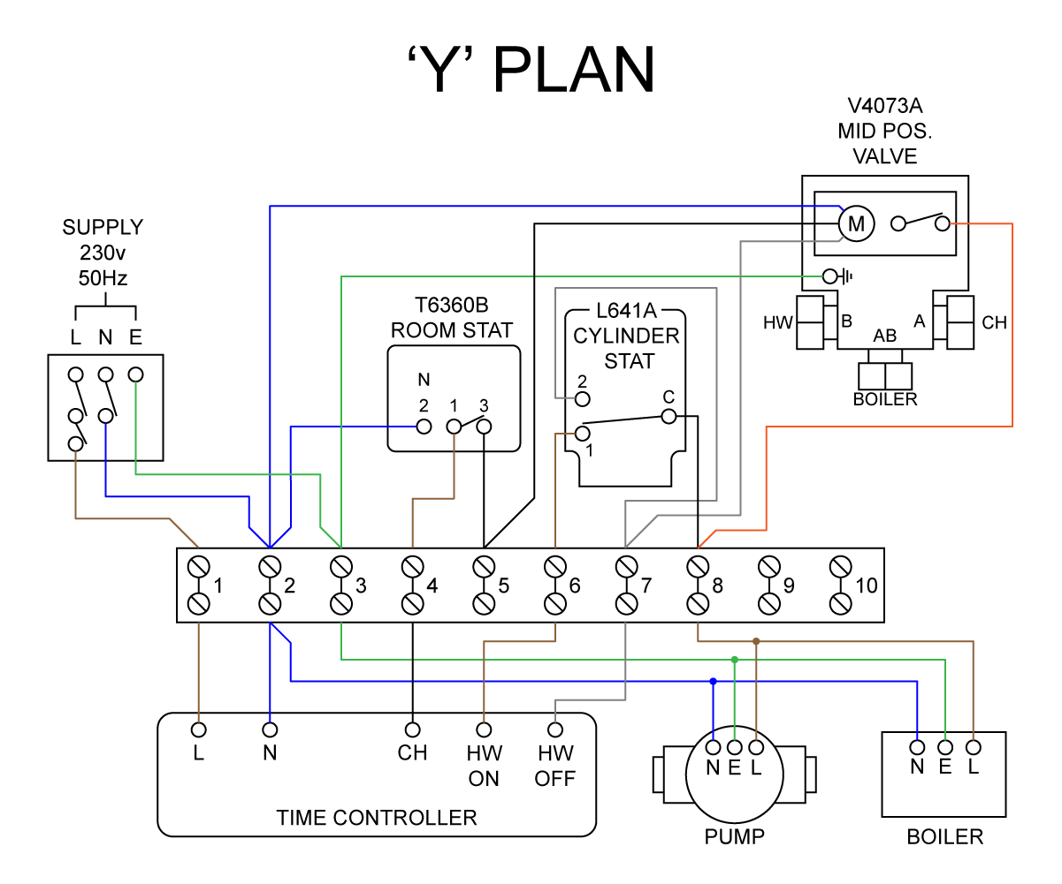
Notes

Student reflection
Do you feel confident about this topic? | Yes | I would like more guidance

Task 36: S Plan central heating wiring
You are required to complete the wiring for a S Plan central heating system.
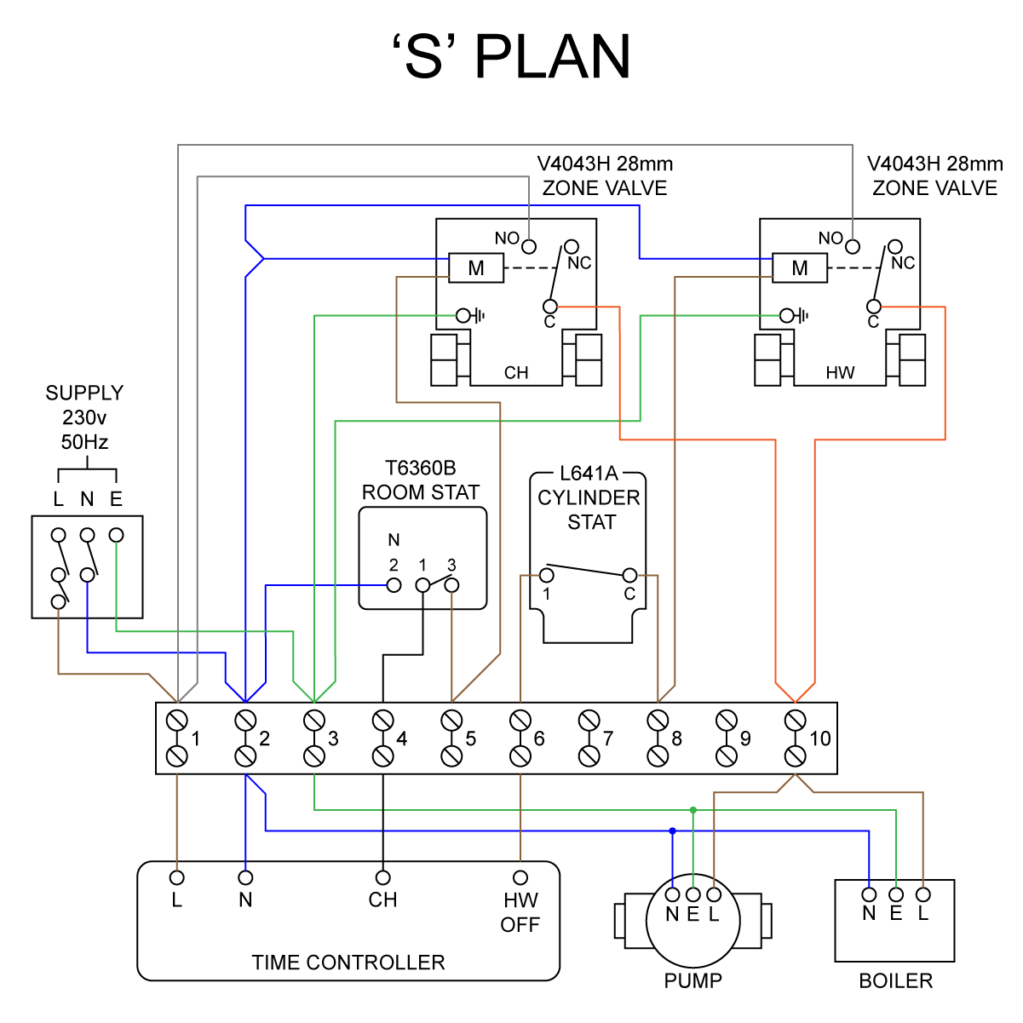
Notes.

Student reflection
Do you feel confident about this topic? | Yes | I would like more guidance

Task 37: WC installation
You are working as a plumbing engineer and have been called to a domestic property to undertake the planning and installation of an additional WC.
As part of this work, you will be required to carry out a full survey of the proposed installation, including planning activities, measurements and calculations.
The customer has identified a ground floor space that they want to convert into a cloakroom and has requested the installation of:
- a new Water Closet (WC)
- a new soil stack.
The existing cold supplies are available from an installation that is already in place.
Your supervisor will notify you of the requirements of the installation and a plan of the proposed space and location of existing services where you will carry out the installation.
The installation must include:
- cold-water supply to any suitable WHB
- all pipework is to be surface mounted and installed to a commercially acceptable standard.
Once your installation has been completed, commissioned and checked to the customer’s satisfaction, you are required to decommission the installation.

Part 1: Produce the following documents
- Installation diagram
- Risk Assessment
- Material list
- Method statement

Part 2: Installation, Commissioning and Decommissioning.

Installation diagram

Risk Assessment
What are the hazards? | Risk |  |  | Possible outcomes | Who is involved | Control methods | Review methods
What are the hazards? | L | M | H

Material type (description) | Quantity

Tool list – list the tools required to complete the work task

Method statement of the installation

Instructions: Provide a detailed account of the installation
It must include sequencing of activities with justification of each part of the task e.g. marked my work area out with a pencil, tape measure and ruler to ensure all measurements are correct and lines are level and plumb.

Method Statement of the Installation
Commissioning record
Sanitation Commissioning Sheet

Address
Engineer’s Name
Date
Soundness Test Record pressure and duration
Air Test: AGDS
Record pressure and duration
Appliance 1: | Flow Rate: | Outlet Temperature:
Appliance 2: | Flow Rate: | Outlet Temperature:
Appliance 3: | Flow Rate: | Outlet Temperature:
Appliance 4: | Flow Rate: | Outlet Temperature:
Appliance 5: | Flow Rate: | Outlet Temperature:
Check appliances for self-siphonage Y/N
Check appliances for induced siphonage Y/N
Performance test
Satisfactory Y/N
Notes:

Feedback - Assessor to tick
Please develop and work on the following elements: |  | Criteria
Measurement |  | - +/- 2mm of the dimensions on the drawing.
Marking out |  | - +/- 2mm of the dimensions on the drawing.  - Marked out in pencil.  - Spirit level used where necessary.
Clipping |  | - Select appropriate pipework clips for use and space them correctly.
Pipe jointing |  | - Soldered joints must be free from excessive solder and residual flux.  - Pipe and fittings are free from tool and vice marks.  - Malleable iron fittings show no more than 1 ½ threads.
Pipe bending |  | - Pipe bends must be free from ripples, throating or excessive distortion.
Presentation of work
Ensuring work meets industry requirements |  | - Completed pipework must be leak free.
Health and safety |  | - Health and safety requirements must be observed at all times.

Student reflection
Do you feel confident about this topic? | Yes | I would like more guidance

Task 38: Central heating installation
You are working as a heating engineer and have been called to a domestic property to undertake the planning and installation of a new central heating system.
As part of this work, you will be required to carry out a full survey of the proposed installation, including planning activities, measurements and calculations.
The customer has requested the installation of:
- a panel radiator
- a towel radiator.
The combination boiler has been pre-installed.
Your supervisor will notify you of the requirements of the installation and a plan of the proposed space and location of existing services where you will carry out the installation.
The installation must include:
- a panel radiator and associated valves
- a towel radiator and associated valves
- hot and cold pipework to an existing appliance
- all pipework is to be surface mounted and installed to a commercially acceptable standard.
Once your installation has been completed, commissioned and checked to the customer’s satisfaction, you are required to decommission the installation.

Part 1: Produce the following documents
- Installation diagram
- Risk Assessment
- Material list
- Method statement
Part 2: Installation, Commissioning and Decommissioning.

Installation diagram

Risk Assessment
What are the hazards? | Risk |  |  | Possible outcomes | Who is involved | Control methods | Review methods
What are the hazards? | L | M | H

Material type (description) | Quantity

Tool list – list the tools required to complete the work task

Method statement of the installation

Instructions: Provide a detailed account of the installation
It must include sequencing of activities with justification of each part of the task e.g. marked my work area out with a pencil, tape measure and ruler to ensure all measurements are correct and lines are level and plumb.

Method Statement of the Installation

Commissioning record
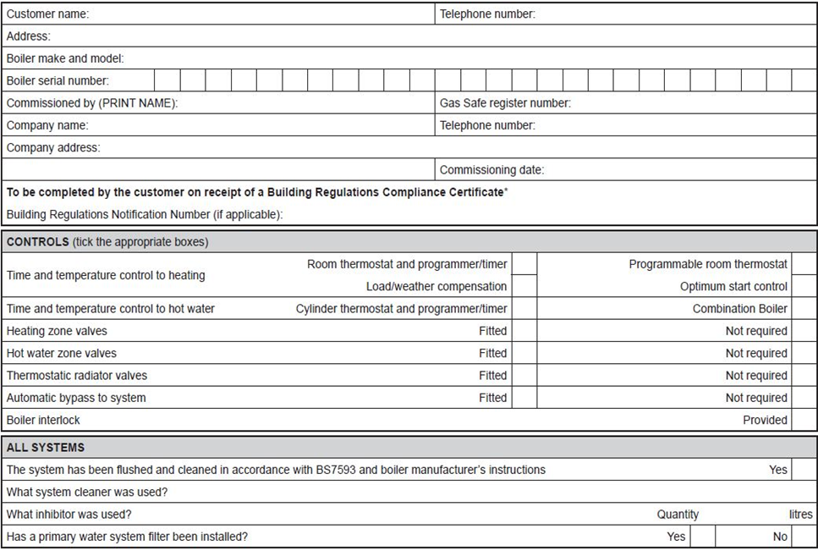

Feedback - Assessor to tick
Please develop and work on the following elements: |  | Criteria
Measurement |  | - +/- 2mm of the dimensions on the drawing.
Marking out |  | - +/- 2mm of the dimensions on the drawing.  - Marked out in pencil.  - Spirit level used where necessary.
Clipping |  | - Select appropriate pipework clips for use and space them correctly.
Pipe jointing |  | - Soldered joints must be free from excessive solder and residual flux.  - Pipe and fittings are free from tool and vice marks.  - Malleable iron fittings show no more than 1 ½ threads.
Pipe bending |  | - Pipe bends must be free from ripples, throating or excessive distortion.
Presentation of work
Ensuring work meets industry requirements |  | - Completed pipework must be leak free.
Health and safety |  | - Health and safety requirements must be observed at all times.

Student reflection
Do you feel confident about this topic? | Yes | I would like more guidance

Task 39: Cloakroom installation
You are working as a plumbing engineer and have been called to a domestic property to undertake the planning and installation of a new cloakroom.
As part of this work, you will be required to carry out a full survey of the proposed installation, including planning activities, measurements and calculations.
The customer has identified a ground floor space that they want to convert into a cloakroom and has requested the installation of:
- A new Water Closet (WC)
- A new wash hand basin (WHB)
- A new soil stack
The existing hot and cold supplies are available from an installation that is already in place.
Your supervisor will notify you of the requirements of the installation and a plan of the proposed space and location of existing services where you will carry out the installation.
The installation must include:
- Hot and cold-water supply to any suitable WHB
- Cold water supply to any suitable WC
- Installation of waste/soil pipe connections
- All pipework is to be surface mounted and installed to a commercially acceptable standard.
Once your installation has been completed, commissioned and checked to the customer’s satisfaction, you are required to decommission the installation.

Part 1: Produce the following documents
- Installation diagram
- Risk Assessment
- Material list
- Method statement
Part 2: Installation, Commissioning and Decommissioning.

Installation diagram

Risk Assessment
What are the hazards? | Risk |  |  | Possible outcomes | Who is involved | Control methods | Review methods
What are the hazards? | L | M | H

Material type (description) | Quantity

Tool list – list the tools required to complete the work task

Method statement of the installation

Instructions: Provide a detailed account of the installation
It must include sequencing of activities with justification of each part of the task e.g. marked my work area out with a pencil, tape measure and ruler to ensure all measurements are correct and lines are level and plumb.

Method Statement of the Installation

Commissioning record
Sanitation Commissioning Sheet

Address
Engineer’s Name
Date
Soundness Test Record pressure and duration
Air Test: AGDS
Record pressure and duration
Appliance 1: | Flow Rate: | Outlet Temperature:
Appliance 2: | Flow Rate: | Outlet Temperature:
Appliance 3: | Flow Rate: | Outlet Temperature:
Appliance 4: | Flow Rate: | Outlet Temperature:
Appliance 5: | Flow Rate: | Outlet Temperature:
Check appliances for self-siphonage Y/N
Check appliances for induced siphonage Y/N
Performance test
Satisfactory Y/N
Notes:

Feedback – Assessor to tick
Please develop and work on the following elements: |  | Criteria
Measurement |  | - +/- 2mm of the dimensions on the drawing.
Marking out |  | - +/- 2mm of the dimensions on the drawing.  - Marked out in pencil.  - Spirit level used where necessary.
Clipping |  | - Select appropriate pipework clips for use and space them correctly.
Pipe jointing |  | - Soldered joints must be free from excessive solder and residual flux.  - Pipe and fittings are free from tool and vice marks.  - Malleable iron fittings show no more than 1½ threads.
Pipe bending |  | - Pipe bends must be free from ripples, throating or excessive distortion.
Presentation of work
Ensuring work meets industry requirements |  | - Completed pipework must be leak free.
Health and safety |  | - Health and safety requirements must be observed at all times.

Student reflection
Do you feel confident about this topic? | Yes | I would like more guidance

Task 40: S Plan central heating installation
You are working as a heating engineer and have been called to a domestic property to undertake the planning and installation of a new S plan + central heating system.
As part of this work, you will be required to carry out a full survey of the proposed installation, including planning activities, measurements and calculations.
The customer has requested the installation of:
- an underfloor heating circuit
- a towel radiator.
The system boiler and unvented hot water cylinder has been pre-installed.
Your supervisor will notify you of the requirements of the installation and a plan of the proposed space and location of existing services where you will carry out the installation.
The installation must include:
- underfloor heating circuit and controls
- a towel radiator and associated valves
- hot and cold pipework to an existing appliance
- S plan + heating controls
- all pipework is to be surface mounted and installed to a commercially acceptable standard.
Once your installation has been completed, commissioned and checked to the customer’s satisfaction, you are required to decommission the installation.
Part 1: Produce the following documents
- Installation diagram
- Risk Assessment
- Material list
- Method statement
Part 2: Installation, Commissioning and Decommissioning.

Installation diagram

Risk Assessment
What are the hazards? | Risk |  |  | Possible outcomes | Who is involved | Control methods | Review methods
What are the hazards? | L | M | H

Material type (description) | Quantity

Tool list – list the tools required to complete the work task

Method statement of the installation

Instructions: Provide a detailed account of the installation
It must include sequencing of activities with justification of each part of the task e.g. marking my work area out with a pencil, tape measure and ruler to ensure all measurements are correct and lines are level and plumb.

Method Statement of the Installation

Commissioning record

Feedback - Assessor to tick
Please develop and work on the following elements: |  | Criteria
Measurement |  | - +/- 2mm of the dimensions on the drawing.
Marking out |  | - +/- 2mm of the dimensions on the drawing.  - Marked out in pencil.  - Spirit level used where necessary.
Clipping |  | - Select appropriate pipework clips for use. and space them correctly.
Pipe jointing |  | - Soldered joints must be free from excessive solder and residual flux.  - Pipe and fittings are free from tool and vice marks.  - Malleable iron fittings show no more than 1½ threads.
Pipe bending |  | - Pipe bends must be free from ripples, throating or excessive distortion.
Presentation of work
Ensuring work meets industry requirements |  | - Completed pipework must be leak free.
Health and safety |  | - Health and safety requirements must be observed at all times.

Student reflection
Do you feel confident about this topic? | Yes | I would like more guidance

Task 41: Bathroom installation
You are working as a plumbing engineer and have been called to a domestic property to undertake the planning and installation of a new bathroom.
As part of this work, you will be required to carry out a full survey of the proposed installation, including planning activities, measurements and calculations.
The customer has identified a ground floor space that they want to convert into a cloakroom and has requested the installation of:
- a new Water Closet (WC)
- a new wash hand basin (WHB)
- a new bath
- a radiator
- connections to a combination boiler.
Your supervisor will notify you of the requirements of the installation and a plan of the proposed space and location of existing services where you will carry out the installation.
The installation must include:
- hot and cold-water supply to any suitable WHB and bath
- cold water supply to any suitable WC
- installation of waste/soil pipe connections
- the installation of a new radiator
- all pipework is to be surface mounted and installed to a commercially acceptable standard.
Once your installation has been completed, commissioned and checked to the customer’s satisfaction, you are required to decommission the installation.

Part 1: Produce the following documents
- Installation diagram
- Risk Assessment
- Material list
- Method statement
Part 2: Installation, Commissioning and Decommissioning.

Installation diagram

Risk Assessment
What are the hazards? | Risk |  |  | Possible outcomes | Who is involved | Control methods | Review methods
What are the hazards? | L | M | H

Material type (description) | Quantity

Tool list – list the tools required to complete the work task

Method statement of the installation

Instructions: Provide a detailed account of the installation.
It must include sequencing of activities with justification of each part of the task e.g. marking my work area out with a pencil, tape measure and ruler to ensure all measurements are correct and lines are level and plumb.

Method Statement of the Installation

Commissioning record
Sanitation Commissioning Sheet

Address
Engineer’s Name
Date
Soundness Test Record pressure and duration
Air Test: AGDS
Record pressure and duration
Appliance 1: | Flow Rate: | Outlet Temperature:
Appliance 2: | Flow Rate: | Outlet Temperature:
Appliance 3: | Flow Rate: | Outlet Temperature:
Appliance 4: | Flow Rate: | Outlet Temperature:
Appliance 5: | Flow Rate: | Outlet Temperature:
Check appliances for self-siphonage Y/N
Check appliances for induced siphonage Y/N
Performance test
Satisfactory Y/N
Notes:

Feedback - Assessor to tick
Please develop and work on the following elements: |  | Criteria
Measurement |  | - +/- 2mm of the dimensions on the drawing.
Marking out |  | - +/- 2mm of the dimensions on the drawing.  - Marked out in pencil.  - Spirit level used where necessary.
Clipping |  | - Select appropriate pipework clips for use and space them correctly.
Pipe jointing |  | - Soldered joints must be free from excessive solder and residual flux.  - Pipe and fittings are free from tool and vice marks.  - Malleable iron fittings show no more than 1 ½ threads.
Pipe bending |  | - Pipe bends must be free from ripples, throating or excessive distortion.
Presentation of work
Ensuring work meets industry requirements |  | - Completed pipework must be leak free.
Health and safety |  | - Health and safety requirements must be observed at all times.

Student reflection
Do you feel confident about this topic? | Yes | I would like more guidance

Task 42: Maintenance - sanitation systems
You will inspect a pre-installed operational system, functioning with electrical components and controls which has several pre- set faults. You will discuss the fault with your assessor to determine the cause of the fault and suggest appropriate methods for repair. You will be assessed on your ability to ask relevant questions to determine faults and to select a suitable solution.
Part 1: Discuss faults with the customer, investigate and diagnose faults.
Part 2: Produce a written report of the maintenance activity.
Part 3: Repair and rectify faults.
Checks required:
- Visual inspection of pipework for leakage and adequate support.
- Operation of flushing cisterns/mechanisms/terminal fittings/float-operated valve.
- Fitting effective waste outlet plugs.
- Effective operation of appliance traps/ self-sealing valves.
Complete the table detailing faults identified.
Checks | Fault Identified
Leakage from plastic soil and waste pipework.

Improper support to plastic pipework systems.

Loss of trap seal at sanitary appliances.

Blockage in above ground soil and waste pipework.

Blockage in below ground drainage systems.

Written report of maintenance activity
Instructions: Provide a detailed account of the fault diagnosis procedure, possible solutions and how you are going to rectify the problem.

Your report MUST be clear and detailed.

You MUST provide reasoning to support the methods selected to rectify the fault.
Reference MUST be made to informing the customer, safe isolation, equipment and materials required and to the use of manufacturer instructions during fault diagnosis.

Fault Report
Details of the fault:

Description of fault diagnosis:

Actions taken to rectify the fault:

Student reflection
Do you feel confident about this topic? | Yes | I would like more guidance

Task 43: Maintenance - cold water systems
You will inspect a pre-installed operational system, functioning with electrical components and controls which has several pre-set faults. You will discuss the fault with your assessor to determine the cause of the fault and suggest appropriate methods for repair. You will be assessed on your ability to ask relevant questions to determine faults and to select a suitable solution.
Part 1: Discuss faults with the customer, investigate and diagnose fault.
Part 2: Produce a written report of the maintenance activity
Part 3: Repair and rectify fault.

Checks required:
- Visual inspection of pipework for leakage and adequate support.
- Operation of cisterns/mechanisms/terminal fittings/float-operated valve.
- Condition of cold-water storage cistern.
- Float and pressure switch operation

Complete the table detailing faults identified.
Checks | Fault Identified
Leakage from pipework

Improper support to pipework systems

leakage or ineffective operation of
o terminal fittings
o float-operated valves
o stop and service valves
Excessive noise in pipework systems
Accumulator expansion vessel failure
Pump failure

Written report of maintenance activity
Instructions: Provide a detailed account of the fault diagnosis procedure, possible solutions and how you are going to rectify the problem.

Your report MUST be clear and detailed.

You MUST provide reasoning to support the methods selected to rectify the fault.
Reference MUST be made to informing the customer, safe isolation, equipment and materials required and to the use of manufacturer instructions during fault diagnosis.

Fault Report
Details of the fault:

Description of fault diagnosis:

Actions taken to rectify the fault:

Student reflection
Do you feel confident about this topic? | Yes | I would like more guidance

Task 44: Maintenance - hot water systems
You will inspect a pre-installed operational system, functioning with electrical components and controls, which has several pre-set faults. You will discuss the fault with your assessor to determine the cause of the fault and suggest appropriate methods for repair. You will be assessed on your ability to ask relevant questions to determine faults and to select a suitable solution.
Part 1: Discuss faults with the customer, investigate and diagnose fault.
Part 2: Produce a written report of the maintenance activity
Part 3: Repair and rectify fault.

Checks required:
- Visual inspection of pipework for leakage and adequate support.
- Operation of cisterns/mechanisms/terminal fittings/float-operated valve.
- Condition of cold-water storage cisterns and cylinders.
- Pump operation

Complete the table detailing faults identified.
Checks | Fault Identified
Leakage from pipework.

Improper support to pipework systems.

leakage or ineffective operation of
o terminal fittings
o float operated valves
o stop and service valves
o mixer showers
o thermostatic mixing valves
Excessive noise in pipework systems
Expansion vessel failure
Pump failure
Hot water storage cylinder/ heater failure
Thermostats
Motorised valves

Written report of maintenance activity
Instructions: Provide a detailed account of the fault diagnosis procedure, possible solutions and how you are going to rectify the problem.

Your report MUST be clear and detailed.

You MUST provide reasoning to support the methods selected to rectify the fault.
Reference MUST be made to informing the customer, safe isolation, equipment and materials required and to the use of manufacturer instructions during fault diagnosis.

Fault Report
Details of the fault:
Description of fault diagnosis:

Actions taken to rectify the fault:

Student reflection
Do you feel confident about this topic? | Yes | I would like more guidance

Task 45: Maintenance - central heating systems
You will inspect a pre-installed operational system, functioning with electrical components and controls which has several pre-set faults. You will discuss the fault with your assessor to determine the cause of the fault and suggest appropriate methods for repair. You will be assessed on your ability to ask relevant questions to determine faults and to select a suitable solution.
Part 1: Discuss faults with the customer, investigate and diagnose faults.
Part 2: Produce a written report of the maintenance activity
Part 3: Repair and rectify faults.

Checks required:
- Visual inspection of pipework for leakage and adequate su-=pport.
- Operation of cisterns/mechanisms/pumps/controls.
- Expansion vessel condition/operation.
- Heat emitter operation.

Complete the table detailing faults identified.
Checks | Fault Identified
Leakage from pipework.

Improper support to pipework systems.

leakage or ineffective operation of
o radiator valves
o service valves
o pipework
Excessive noise in pipework systems
Expansion vessel failure
Pump failure
Emitter cold spots
Thermostats
Motorised valves
System controls- Programmer, timers

Written report of maintenance activity
Instructions: Provide a detailed account of the fault diagnosis procedure, possible solutions and how you are going to rectify the problem.

Your report MUST be clear and detailed.

You MUST provide reasoning to support the methods selected to rectify the fault.
Reference MUST be made to informing the customer, safe isolation, equipment and materials required and to the use of manufacturer instructions during fault diagnosis.

Fault Report
Details of the fault:

Description of fault diagnosis:

Actions taken to rectify the fault:

Student reflection
Do you feel confident about this topic? | Yes | I would like more guidance

Copyright in this document belongs to and is used under licence from the Department for Education, © 2025.
‘T-LEVELS’ and ‘T Level’ are registered trademarks of the Department for Education.
WJEC is authorised by the Department for Education to develop and deliver this T Level Technical Qualification.
WJEC operates in England under the name Eduqas which is a registered trademark of WJEC.

Acknowledgements
Some images used within these resources have been created using artificial intelligence (AI) and is intended to provide a visual representation only.
p.12 Apriori1 / iStock / Getty Images; p.12 PashaIgnatov / iStock / Getty Images; p.13 Arthito / iStock / Getty Images; p.13 KamiPhotos / iStock / Getty Images; p.13 Cynoclub / Freepik.com; p.13 EyeEm / Freepik.com; p.13 sergeyskleznev / iStock / Getty Images; p.14 wildlifeworld / Freepik.com; p.14 vitaliiborkovskyi / Freepik.com; p.14 photour.1904 / Freepik.com; p.14 Deksaplan / Freepik.com; p.14 Antonzm / iStock / Getty Images; p.15 MikeyGen73 / iStock / Getty Images; p.16 Andrei Berezovskii / iStock / Getty Images; p.16 pioneer111-1 / Freepik.com; p. 16 EyeEm / Freepik.com; p.16 pioneer111-1 / Freepik.com; p.17 pioneer111-1 / Freepik.com; p. 51 vav63 / iStock / Getty Images; p.51 Ronak Joshi / iStock / Getty Images; p. 57 pioneer111-1 / Freepik.com; p. 57 PictureSyndicate / iStock / Getty Images;

