T Level Technical Qualification in Building Services Engineering for Construction
(Level 3)

Skills Practice Workbook for Learners

Protection Systems Engineering
Practical Training

Learner name:.

Centre name:.

Contents
Task summary and progress tracker 4
Task 1: Workshop induction: health and safety procedures 5
Task 2: Risk assessment 8
Task 3: Method statement 10
Task 4: Personal protective equipment (PPE) 11
Task 5: Access equipment 13
Task 6: Manual handling 20
Task 7: Safe isolation 23
Task 8: Identification of tools and equipment 26
Task 9: Measuring and cutting 31
Task 10: Identification of cable types, fixings, termination and accessories 32
Task 11: Cable termination 39
Task 12: Electrical instruments for measurement 43
Task 13: Sources of technical and functional information 48
Task 14: Installing emergency lighting circuits 50
Task 15: Maintaining emergency lighting systems 56
Task 16: Non-maintained emergency lighting systems 59
Task 17: Installing and maintaining CCTV systems 64
Task 18: Installing a conventional intruder alarm system 70
Task 19: Installing a conventional fire alarm system 81
Task 20: Plan an addressable fire alarm system 90
Task 21: Installation of a door entry system 96
Task 22: Cutting, bending and terminating conduit 108
Task 23: Steel trunking – internal 90-degree angle 113
Task 24: Steel trunking – Flat 90-degree angle 116
Task 25: Steel tray – Tee joint 119
Task 26: Steel tray – Gusset bend 123
Task 27: Steel basket – 90-degree angle 126
Task 28: Steel basket – Tee joint 129
Task 29: Function and application of electronic components in security and emergency systems 133

Task 30: Installation and commissioning of emergency lights, CCTV, intruder alarms, fire alarms, and door entry systems 136
Task 31: Electronic protection systems 138
Task 32: Fixing devices 142
Task 33: Trunking 145
Task 34: Storage and transportation requirements 146
Task 35: Organising and overseeing work programmes 147

Task summary and progress tracker
 | Task | Page number | Date complete
1 | Workshop health and safety procedures | 5
2 | Risk assessment | 8
3 | Method statement | 10
4 | Personal protective equipment (PPE) | 12
5 | Access equipment | 14
6 | Manual handling | 21
7 | Safe isolation | 24
8 | Identification of tools and equipment | 27
9 | Measuring and cutting | 32
10 | Cable types, fixings, connectors and accessories | 33
11 | Cable termination | 40
12 | Electrical instruments for measurement | 44
13 | Sources of technical and functional information | 49
14 | Installing emergency lighting circuits | 51
15 | Maintaining emergency lighting systems | 57
16 | Non-maintained emergency lighting systems | 60
17 | Installing and maintaining CCTV systems | 65
18 | Installing a conventional intruder alarm system | 71
19 | Installing a conventional fire alarm system | 82
20 | Plan an addressable fire alarm system | 90
21 | Installation of a door entry system | 95
22 | Cutting, bending and terminating conduit | 106
23 | Steel trunking – Internal 90-degree angle | 111
24 | Steel trunking – Flat 90-degree angle | 114
25 | Steel tray – Tee joint | 117
26 | Steel tray – Gusset bend | 120
27 | Steel basket – 90-degree angle | 123
28 | Steel basket – Tee joint | 126
Additional underpinning knowledge tasks as required
29 | Function and application of electronic components in security and emergency systems | 130
30 | Installation and commissioning of emergency lights, CCTV, intruder alarms, fire alarms, and door entry systems | 133
31 | Electronic protection systems | 135
32 | Fixing devices | 139
33 | Trunking | 142
34 | Storage and transportation requirements | 143
35 | Organising and overseeing work programmes | 144

Task 1: Workshop induction: health and safety procedures
Health and safety are very important in any workshop or workplace. All rules must be followed to ensure everyone's safety.
The primary legislation that covers health and safety in such surroundings is the Health and Safety at Work etc. Act (1974).
To establish a safe working environment, familiarise yourself with the workshop and complete the following tasks:
- Show the position of any emergency stop buttons in the workshop.

- List the types of fire extinguishers and the colour codes that identify them.

- Find where the first aid box is kept and suggest what should be kept in it.

- List the main items of protective clothing you are expected to wear.

- Write out the emergency evacuation procedure for the workshop and where the assembly point is.

- Identify who to immediately inform in the event of an accident.

- Find out where we record any accidents that may occur in the workshop.

- Determine the first action to take if someone receives an electric shock.

- Familiarise yourself with the emergency procedure to summon help in your place of learning.

- Locate these four signs in the workshop and explain their meaning.

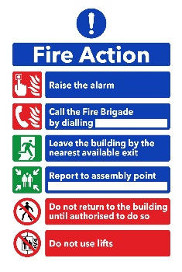
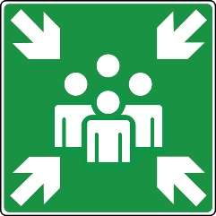
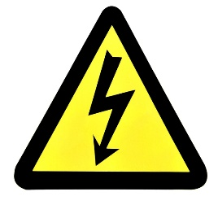


General health and safety rules within an electrical skills workshop
These are designed to provide a framework, and specific rules should be adapted based on the equipment and activities within your own workshop.
General conduct and awareness
- Follow instructions: Always listen carefully to and follow the instructions given by your instructor or supervisor. If you are unsure about anything, ask for clarification before proceeding.
- Work area tidiness: Always keep your work area clean and tidy. Clear away tools, equipment and materials when you have finished with them. Avoid clutter that could cause trips or falls.
- No running or horseplay: Running, shouting or any form of horseplay is strictly prohibited in the workshop. Maintain a professional and focused attitude.
- Report hazards: Immediately report any unsafe conditions, faulty equipment or accidents – no matter how minor – to your instructor or supervisor.
- No food or drink: Eating and drinking are prohibited in the workshop area to prevent contamination and distractions.
- Appropriate clothing: Wear appropriate clothing for the workshop environment. Avoid loose clothing, jewellery and long hair that could get caught in machinery or become a hazard.
- Personal protective equipment (PPE): Always wear the required personal protective equipment (PPE) for your task. This may include safety glasses, gloves and other protective gear. Ensure PPE fits correctly and is in good condition.
- Tool and equipment checks: Before using any tool or equipment, visually inspect it for damage or defects. Report any issues to your instructor. Do not use faulty equipment.
- Use equipment correctly: Only use tools and equipment for their intended purpose and according to the manufacturer's instructions and any training you have received.
- Isolate before maintenance: Never attempt to adjust, clean or maintain any electrical equipment or circuits without first ensuring that the power supply is completely isolated and locked out/tagged out (if applicable).
- Awareness of others: Be aware of the people around you and their activities. Ensure you do not endanger yourself or others while working.
- Emergency procedures: Know the location of fire extinguishers, first aid kits, emergency exits and the procedures to follow in case of an emergency.
- Waste disposal: Dispose of waste materials in the designated containers, including electrical components and consumables. Follow any specific instructions for the disposal of hazardous waste.

Electrical safety
- Live work restrictions: Do not work on live electrical circuits unless specifically instructed and under strict supervision, with appropriate safety measures in place.
- Safe isolation procedures: Understand and follow the correct procedures for safely isolating electrical circuits before working on them. This includes identifying the correct circuit, switching it off, locking it off (where applicable), and proving it is dead using a suitable voltage tester.
- Use correct tools for electrical work: Always use insulated tools specifically designed for electrical work and rated for the voltage you are working with.
- Damaged cables and plugs: Never use equipment with damaged cables, plugs or connectors. Report any damage immediately.
- Water and electricity: Keep water and other liquids away from electrical equipment and circuits. Never touch electrical equipment with wet hands.
- Testing and measurement: Use appropriate and calibrated test equipment for measuring voltage, current, and resistance. Ensure you understand how to use the test equipment safely and correctly.
Machine and equipment safety
- Machine guards: Never remove or tamper with safety guards on machinery. Ensure they are in place and functioning correctly before operating any equipment.
- Operating procedures: Before using each piece of machinery, familiarise yourself with its safe operating procedures. If you are unsure, ask for instructions.
- Moving parts: Be aware of any moving parts on machinery and keep hands and other body parts clear.
- Emergency stop buttons: Know the location and operation of emergency stop buttons on all machinery you may use.
These rules are intended to promote a safe working environment in the electrical workshop. Remember that safety is everyone's responsibility; following these guidelines can help prevent accidents and injuries.

Always prioritise safety in all your activities.
Learner reflection
Do you feel confident about this topic? | Yes | I would like more guidance

Task 2: Risk assessment
For any employer, risk assessments are required by law; however, if you employ fewer than five people, you don't have to write anything down.
To carry out a risk assessment, you need to consider what might harm people and decide if you are taking reasonable steps to prevent this. For certain risks, such as working with electricity, specific regulations require particular control measures to be put in place.
Hazard: Anything that may cause harm.
Risk: The chance, high or low, that somebody could be harmed.

Research activity – find out and list the 5 Steps to Risk Assessment.
Step | Title | What does it mean?
1

2

3

4

5

You must complete a risk assessment before attempting the practical tasks in this workbook. Use the general health and safety factors listed in Task 1 to identify what could be hazards in each task, assign each a risk level, and complete an assessment as per the examples below.
To practice, fill in the missing columns in the table below to expand on each given hazard.
L = Low risk M = Medium risk H = High risk
What are the hazards? | Risk |  |  | Possible outcomes | Who could be harmed | Control methods | Review methods
What are the hazards? | L | M | H
Manual handling |  | M |  | Splinters in hands/fingers, bruised or trapped fingers, wrong lifting technique, back injury, lacerations | Learners | Training and close supervision | Monitor, then reduce supervision as training and experience are gained
Running or horseplay |  |  | H | Injury to oneself or others | Learners | Education and close supervision, small group numbers or more staff | Monitor, then reduce supervision as training and experience are gained
Using stepladders
Waste bins overflowing with cables
Handling a 110v power drill

Learner reflection
Do you feel confident about this topic? | Yes | I would like more guidance

Task 3: Method statement
A method statement, also known as a ‘safe system of work’, is a document that details how to carry out a task safely. It outlines all the hazards involved and includes a step-by-step guide on how to do so. It ensures that the risks and precautions required of all those involved in the task are effectively communicated. Method statements also detail control measures introduced to ensure the safety of anyone affected by the task.
Your tutor will suggest a suitable task relevant to your workplace to complete the following method statement.

A method statement includes the following information:
- Description/overview of works | - Link to risk assessment
- Location | - Control measures
- Start and finish time | - PPE
- Supervisor name and contact details | - Emergency actions
- Resources required | - Welfare and first aid measures

Department/Location:
Description of the task/activity:
Personnel involved: | Name |  | Role/Trade
Key plant and tools:
Other essential equipment:
(platforms/winches/ladders, etc)
Sequence of operations:
(include sketches if required)
Required PPE:
Emergency procedures:
Learner reflection
Do you feel confident about this topic? | Yes | I would like more guidance

Task 4: Personal protective equipment (PPE)
- Identify the PPE and describe its correct use and maintenance.
PPE Item | Name/Use

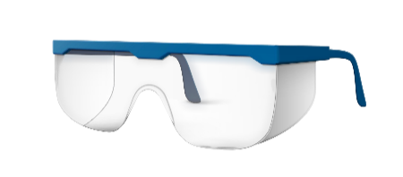




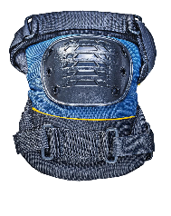


PPE Item | Name/Use


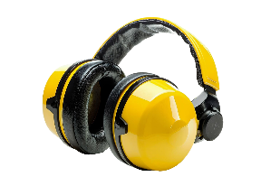
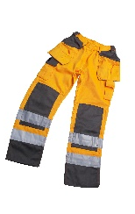
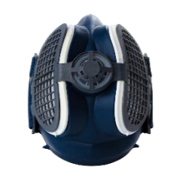

- Why is it important to check that your PPE is in good working order before and after use?

- Who is responsible for maintaining personal protective equipment on a building site or when retrofitting into an existing building?

- Who is responsible for providing PPE in the workplace if it is deemed necessary?
Learner reflection
Do you feel confident about this topic? | Yes | I would like more guidance

Task 5: Access equipment
Safe use of access equipment exercise

- What type of ladder is shown below (Figure 5.1) and what safety checks should be carried out before using this type of ladder?

- Label the diagram (Figure 5.1).

Figure 5.1
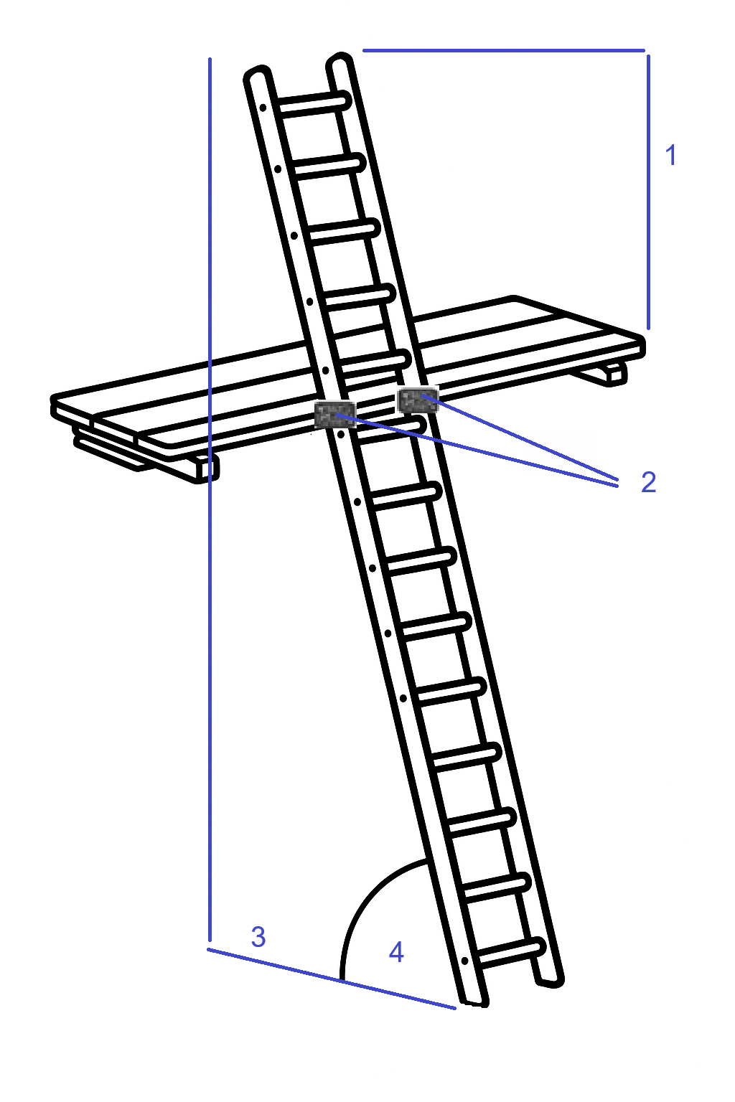

- Identify the two other types of ladders shown below and list any safety checks that must be carried out before their use.

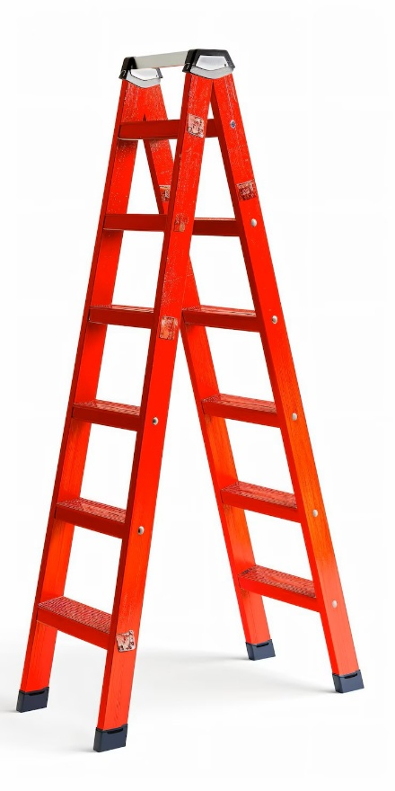
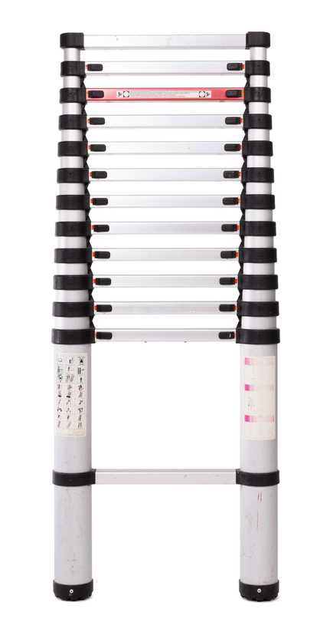

Figure 5.3
Figure 5.2

- Safe use of ladders

Expected time | 30 minutes
Safety instructions | - Inspect the ladder thoroughly before use.  - Ensure that the use of the ladder will not endanger you or others.  - Ensure your work area is clear and safe for work to proceed.  - Hard hats and gloves must be worn.  - Your work must conform to the Health and Safety at Work Act requirements.
Task instructions | You must transport an extension ladder for a short distance and erect it in an area designated by the assessor.  - Complete a risk assessment and method statement.  - Put on your PPE.  - When told to do so by your tutor, check the ladder for defects. If any are found, do not use the ladder. Report its condition.  - If there are no defects, transport the ladder to the designated area.  - Safely erect the ladder using the 4:1. (You may ask for assistance from another person but you must tell them exactly what to do.)  - After ensuring that the ladder will not move, ascend and secure the ladder to the landing stage.  - Descend the ladder.  - Lower the ladder safely.  - Carry the ladder back to the starting point.

 | ASSESSMENT CRITERIA |  | Y | N
1 | Displays warning notices in the appropriate positions
2 | Visually inspects ladder
3 | Lifts and carries ladder correctly
4 | Erects ladder correctly
5 | Slope of ladder correctly set to gradient
6 | Top extends>1.07m above landing (5 rungs)
7 | Safe position of ladder rung adjacent to transom
8 | Secured ladder before ascending
9 | Ascends and descends ladder in a safe manner
10 | Secures top of ladder safely
11 | Lowers ladder correctly
12 | Returns ladder safely to start position.
13 | Work conformed to the requirements of HASWA
 | Total
Feedback from the task:

Learner reflection
Do you feel confident about this topic? | Yes | I would like more guidance

Steps for erecting and checking a mobile scaffold
Step 1: Inspect all components
Examine every part for damage and confirm they meet safety standards.

Step 2: Assemble the base frame
Connect the base frame sections and ensure the castor wheels are properly locked.

Step 3: Attach diagonal and horizontal braces
Secure diagonal and horizontal braces to strengthen and stabilize the scaffold base.

Step 4: Install the platform
Position the platform firmly on the scaffold at the required working height.

Step 5: Fit guardrails
Add guardrails at the top to provide fall protection.

Step 6: Check overall stability
Verify that the scaffold is steady and all components are correctly secured.

Step 7: Perform a safety check
Confirm that castor wheels are locked and guardrails are in place before use.

Step 8: Tag the scaffold
Attach a visible inspection tag to indicate the scaffold has passed safety checks.

 | ASSESSMENT CRITERIA |  | Y | N
1 | Displays warning notices in the appropriate positions
2 | Visually inspects scaffold parts
3 | Erects scaffold correctly
4 | Correct use of struts
5 | Secured scaffold before ascending
6 | Ascends and descends scaffold in a safe manner
7 | Work conformed to the requirements of HASWA
 | Total
Feedback from the task:

Learner reflection
Do you feel confident about this topic? | Yes | I would like more guidance

Steps for checking a mobile scissor lift

Step 1: Inspect the scissor lift
Examine the lift for any visible damage or wear and confirm it is in good working condition.

Step 2: Test the safety controls
Check all operational and emergency controls to ensure they function correctly.

Step 2: Inspect the tyres
Look over the tyres for proper inflation, wear, or damage that could affect stability.

Step 3: Check the structure
Review the entire frame and platform for cracks, bends, or loose components.

 | ASSESSMENT CRITERIA |  | Y | N
1 | Displays warning notices in the appropriate positions
2 | Visually inspects scaffold parts
3 | Erects the scaffold correctly
4 | Correct use of struts
5 | Secured the scaffold before ascending
6 | Ascends and descends the scaffold in a safe manner
7 | Work conformed to the requirements of HASWA
 | Total
Feedback from the task:

Learner reflection
Do you feel confident about this topic? | Yes | I would like more guidance

Task 6: Manual handling
Manual handling of materials and equipment exercise

Use the HSE-Manual Handling at Work webpage to answer the following questions.

- The Manual Handling Regulations set out three ways employers must manage the risks from manual handling. What are they?

- List six things that can be done to reduce the risk of injury from manual handling tasks you can't avoid.

- Practical task

To lift an object and carry it for a distance of 10 metres and then assist in the lifting and handling of an object between a bench and the floor.
Object 1: 100m roll of 2.5mm² PVC/PVC cable.
Object 2: Conduit bending machine or a similar piece of equipment.
Time | 30 minutes
Safety instructions | - Think before handling/lifting.  - Keep the load close to your waist.  - Adopt a stable position.  - Ensure a good hold on the load.  - Slightly bend your back, hips and knees at the start of the lift.  - Don't flex your back any further while lifting.  - Avoid twisting your back or leaning sideways.  - Keep your head up when handling.  - Move smoothly.  - Don't lift or handle more than you can easily manage.  - Put the load down, then slide it into the desired position.  - You must ensure that all your work conforms to the Health and Safety at Work Act requirements.
Task instructions | - Complete a risk assessment and method statement.  - Put on your PPE.  - Walk from the start position across to object 1, which is laid on the floor.  - Lift object 1 and carry it approximately 5 metres to the workbench or table. Then lower object 1 and rest it on the workbench or table.  - Lift object 1 and return it to the start position on the floor.  - You are to take the lead role and instruct the assistant on the lifting and handling requirements for object 2.  - You and the assistant lift object 2 and carry it approximately 5 metres to the workbench or table.  - Lower object 2 and rest it on the workbench or table.  - You and the assistant lift object 2 and return it to the start position on the floor.

 | ASSESSMENT CRITERIA | Y | N
1 | Takes firm grip with palms and fingers of both hands
2 | Feet positioned correctly for lift
3 | Knees bent correctly for lift
4 | Straight back, chin in
5 | Arms tight to body
6 | Carries object safely to bench
7 | Rests the object carefully and safely onto the bench
8 | Takes a firm grip and lifts correctly
9 | Carries object safely and lowers correctly
10 | Knees bent, back straight
11 | Rests the object safely on the floor
12 | Gives assistant clear and concise instructions at the start of the task
13 | Knees bent to commence lift
14 | Straight back during lift
15 | Work conformed to the requirements of HASWA
 | Totals
Feedback from this task:

Learner reflection
Do you feel confident about this topic? | Yes | I would like more guidance

Task 7: Safe isolation
Electrical safety exercise

Answer the following questions from the HSE’s Electrical Safety and Electrical Safety First's guide on safe isolation procedures webpages.
- The HSE lists the main hazards of working with electricity. What are they?

- List four types of injuries you could receive from electrical systems.
1.
2.
3.
4.
- Which two statutory documents underpin the Electrical Safety First best practice guide on safe isolation?

- List the PPE and equipment required when carrying out safe isolation of electrical systems.

- List the stages detailing the full safe isolation procedure for a complete single-phase 230v circuit consumer unit.
- Practical task
Fit a fuse lock
Time | 30 minutes
Safety instructions | - Plan the task.  - Check that all chosen PPE, tools and equipment are serviceable and meet relevant safety standards.  - All work must conform to the Health and Safety at Work Act requirements.
Task instructions | - Complete a risk assessment and method statement.  - Put on your PPE.  - Ensure all required tools and equipment are available and the cable containment installation unit and cables are serviceable and ready for use.  - Select the approved voltage indicator and prove on the proving unit.  - Switch off OCPDs and undo the switched fused connection unit.  - Fit fuse lock.  - Carry out a safe isolation procedure on the single-phase SFCU.  - Carry out work.  - Return all accessories to the pre-task state.  10. Re-energise the consumer unit and SFCU, return all equipment for the next student.

 | ASSESSMENT CRITERIA | Y | N
1 | Selected the correct PPE, tools and equipment for the task
2 | Identified the correct point of isolation
3 | Asked permission to turn off the supply to the consumer unit
4 | Selected approved voltage indicator and proves on the proving unit
5 | Switched off OCPDs and Main Switch and removed the consumer unit cover
6 | Carried out a 3-point test on the consumer unit
7 | Re-proved the approved voltage indicator on the proving unit
8 | Correctly fitted locking device, label and padlock
9 | Removed and retained key
10 | Completed the task within the target time
11 | Refixed all accessory covers and switched on Main Switch and OCPDs
12 | Work conformed to the requirements of HASWA/EAWR
 | Totals
Feedback from this task:

Learner reflection
Do you feel confident about this topic? | Yes | I would like more guidance

Task 8: Identification of tools and equipment
- The following pages contain pictures of tools and equipment commonly used in the electrical installation industry. Give the tool's correct name and use(s) for each picture, and how they should be correctly maintained.

Tip: If you struggle to identify any of them, ask your tutor to show you where they are stored in the workshop.

Tools/Equipment | Name/Use

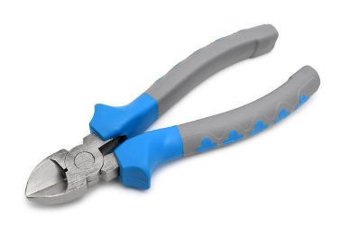

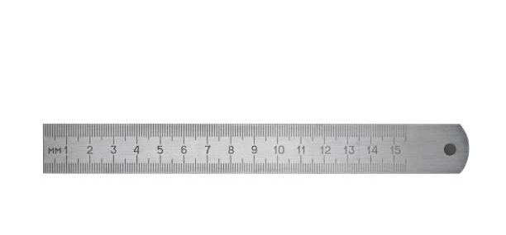

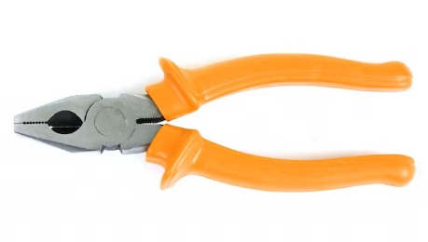


Tools/Equipment | Name/Use
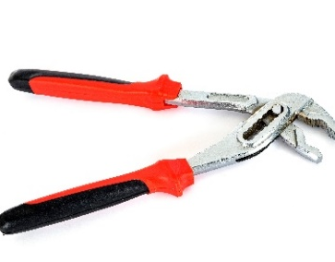

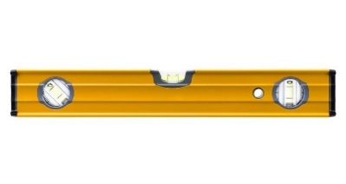
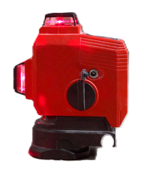

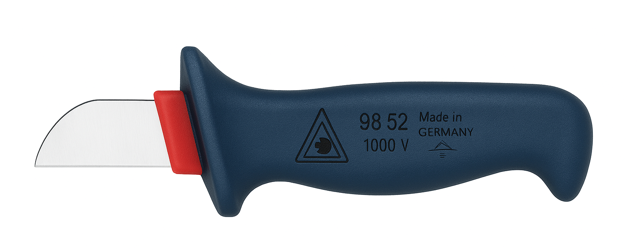



Tools/Equipment | Name/Use
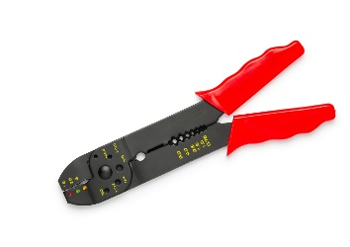
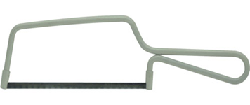

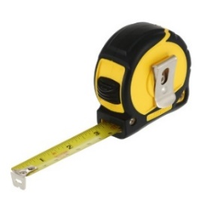

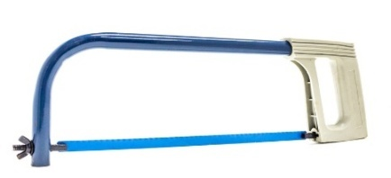





Tools/Equipment | Name/Use

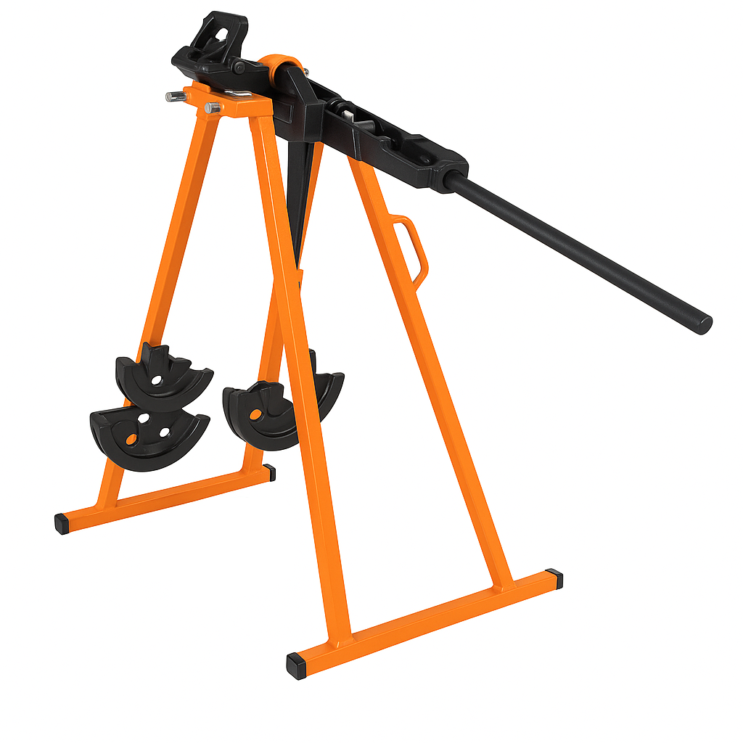


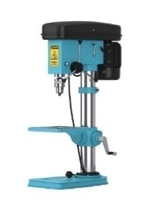
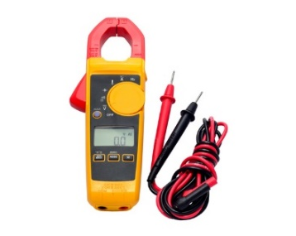
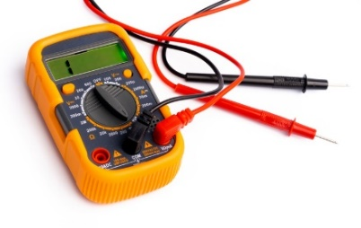

- What procedure would be followed if you were asked to use a tool that was unfamiliar to you?

- Why is it important to check that your tools and equipment are safe and in good working order before and after use?

Learner reflection
Do you feel confident about this topic? | Yes | I would like more guidance

Task 9: Measuring and cutting
To use a tape measure accurately, you must ensure you are reading the correct units. The millimetre is a common unit for precise measurements in electrical installation practical work.
One side of the tape shows metric units. This is the side of the tape to use. You will notice that:
- 1 metre is divided into 100 centimetres.
- 1 centimetre is divided into 10 millimetres.
- 1 metre is divided into 1000 millimetres.

The other side of the tape shows feet and inches. These are imperial units. You will rarely need to use this side of the tape.
Galvanised steel trunking can be ordered in metric or imperial.

Instructions: Select the following sizes of conduit and trunking and cut them into the lengths shown in the table below.
Make sure you cut the items safely – make square cuts, deburring, measure twice.

Type | Size | Cut Length | Achieved (Y/N)
Plastic conduit | 20mm | 100mm
Plastic conduit | 25mm | 110mm
Plastic conduit | 32mm | 120mm
Steel conduit | 20mm | 100mm
Steel conduit | 25mm | 110mm
Plastic trunking | 25mm x 16mm | 150mm
Plastic trunking | 40mm x 25mm | 20cm
Steel trunking | 50mm x 50mm | 15cm
Steel trunking | 100mm x 100mm | 200mm
Steel tray | 75mm | 20cm

Learner reflection
Do you feel confident about this topic? | Yes | I would like more guidance

Task 10: Identification of cable types, fixings, termination and accessories
- Identify the types of cable shown and their applications

Cable | Name/Use
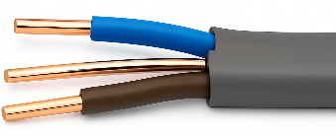
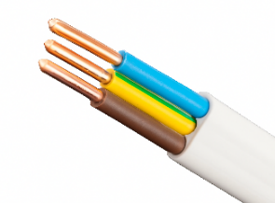
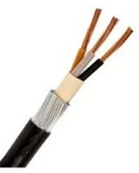
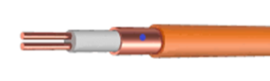
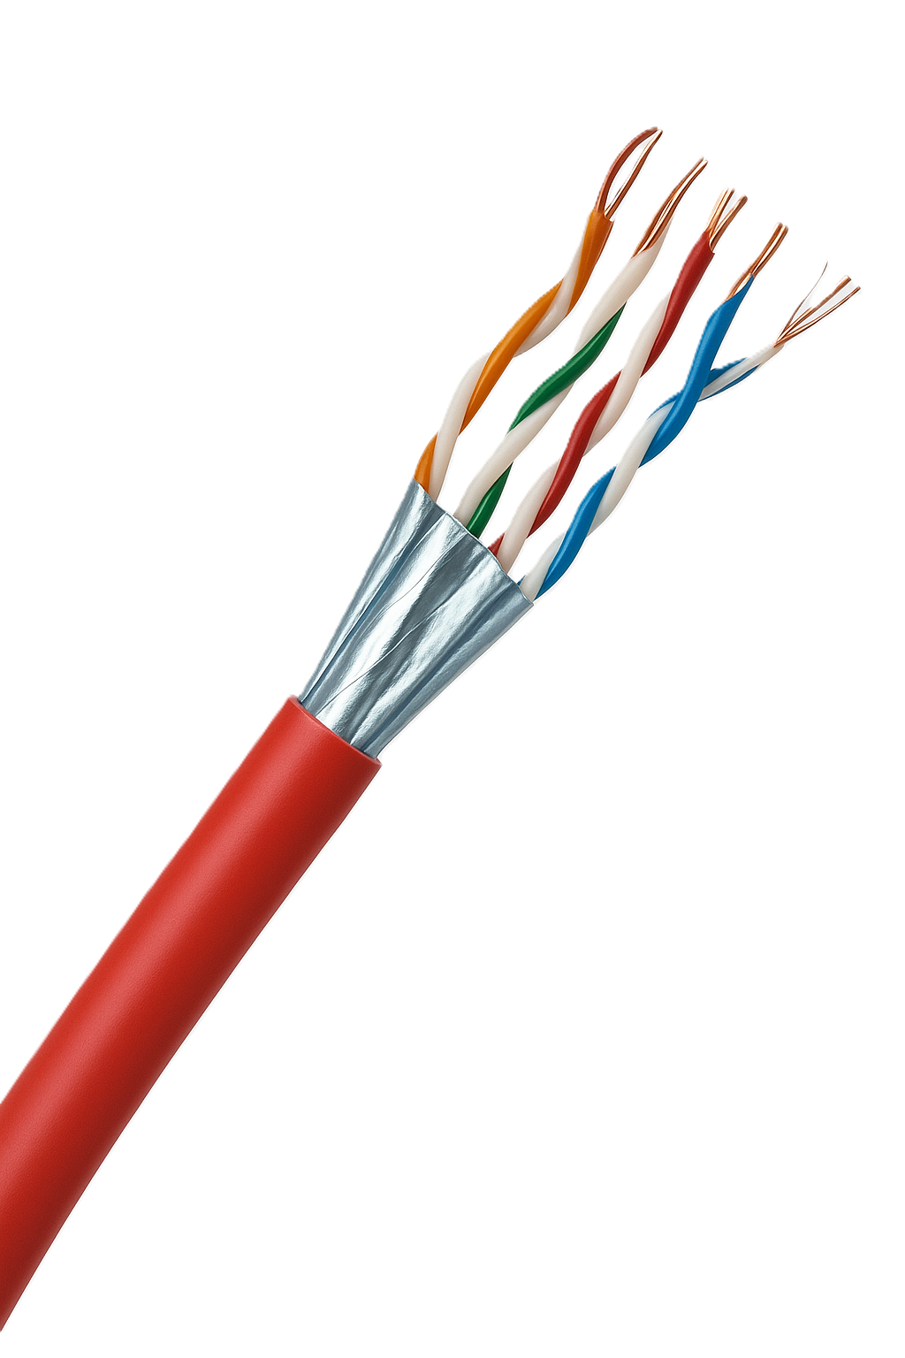

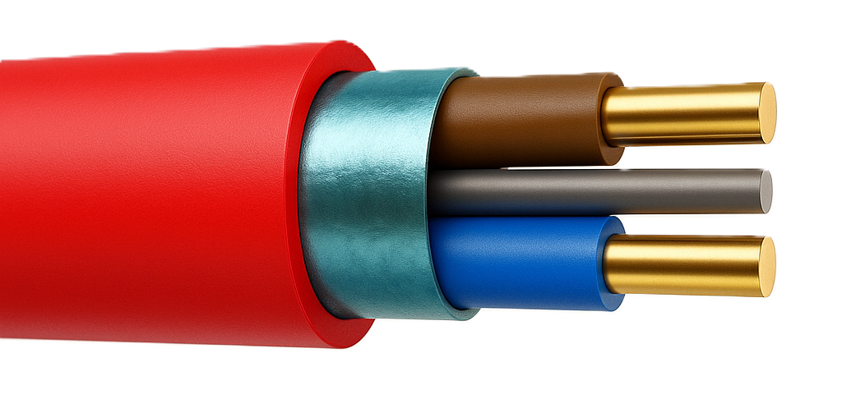
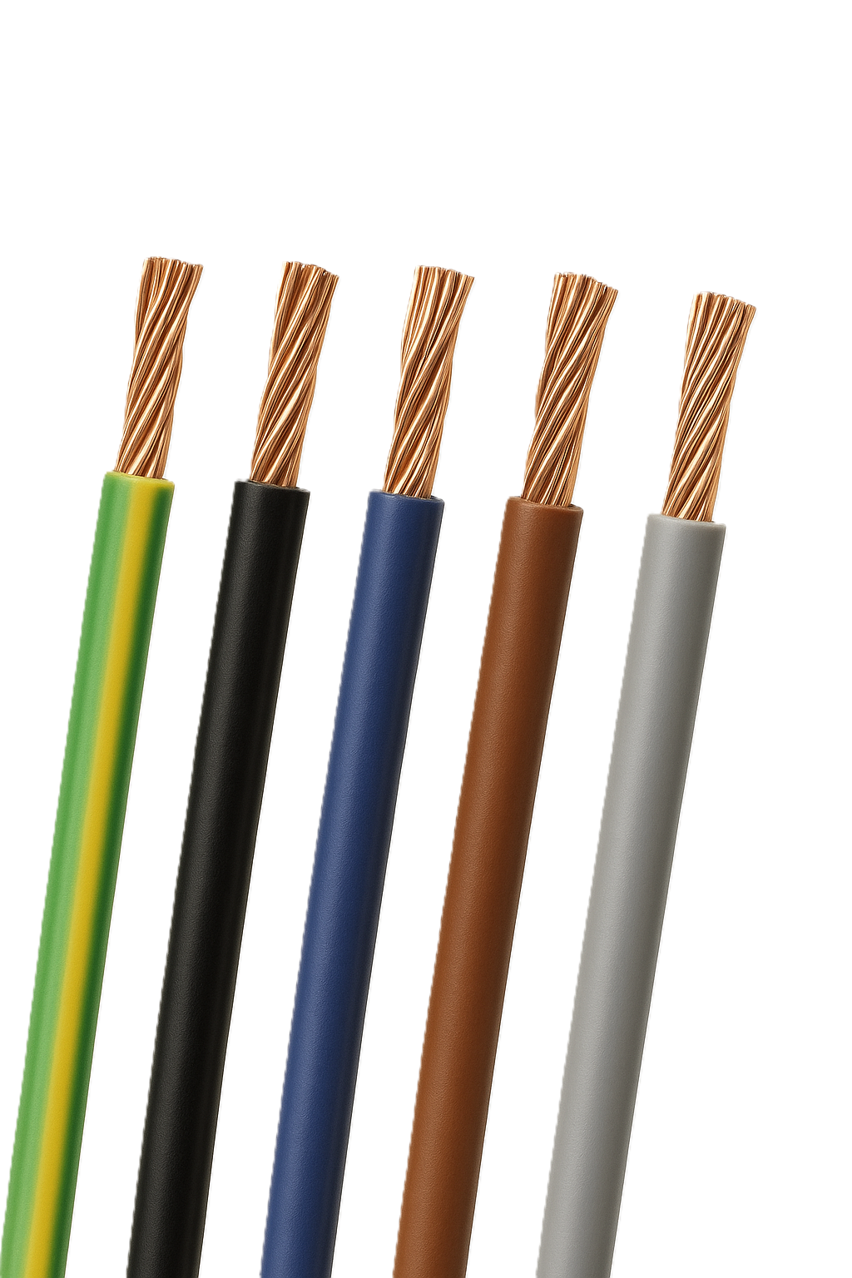

- Identify the cable fixing and describe its use.
Fixing | Name/Use
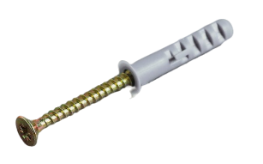
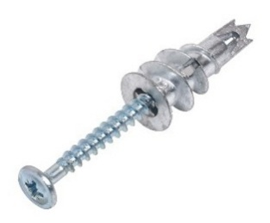
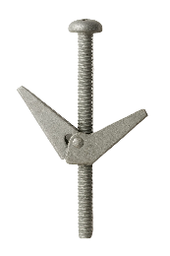

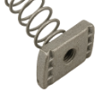
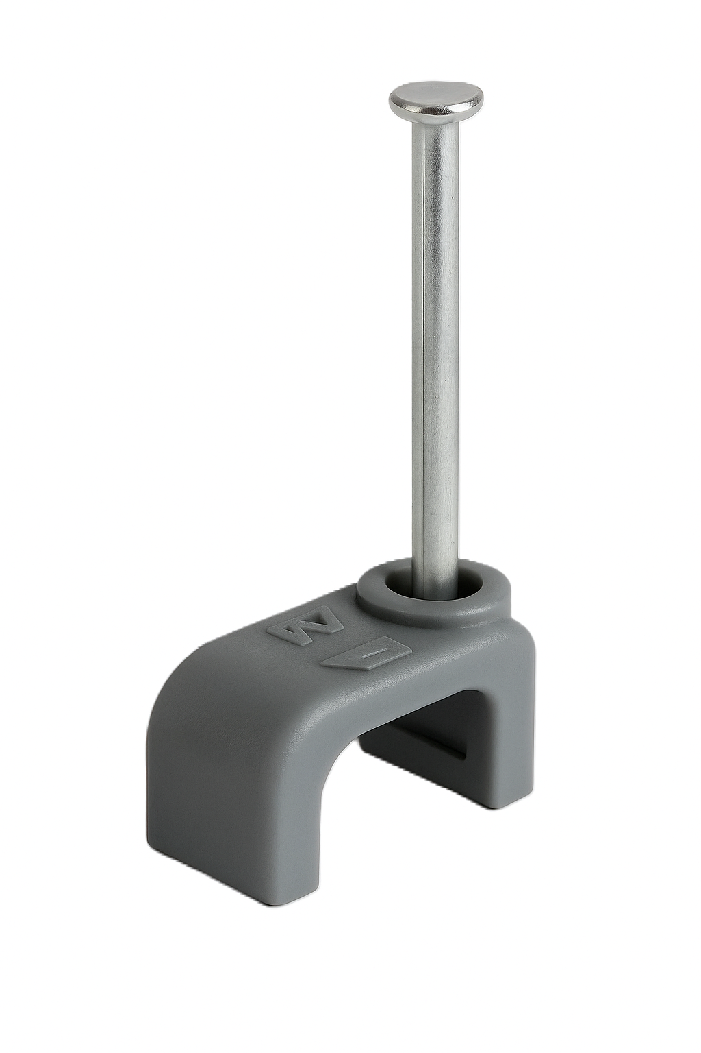

Fixing | Name/Use

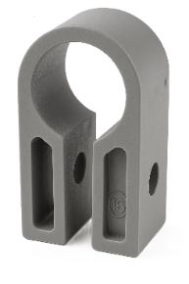

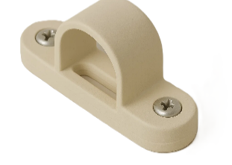
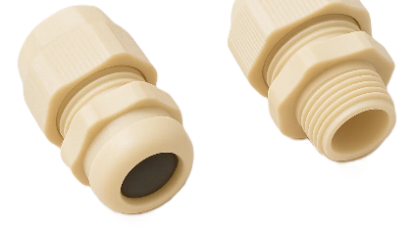


- Identify the electrical termination device and describe its use.
Termination | Name/Use
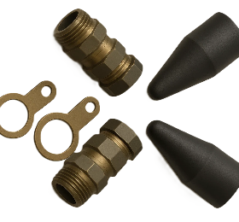
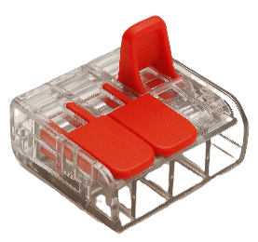
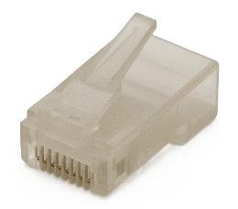

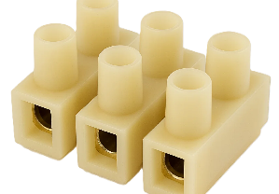

- Identify the protection system accessory and describe its use.
Accessory | Name/Use
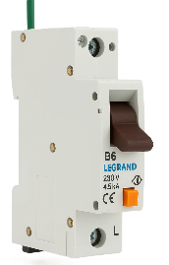
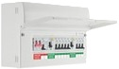
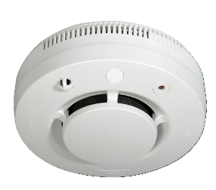

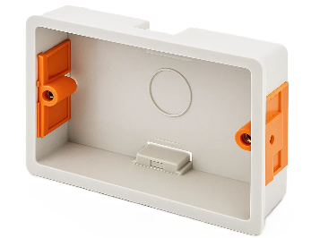

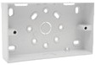
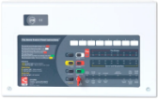

- Identify the wiring accessory and describe its use.
Wiring Accessory | Name/Use
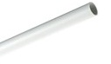
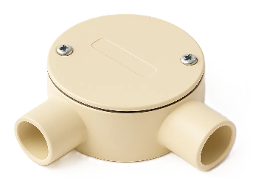
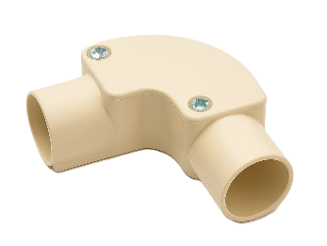
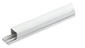

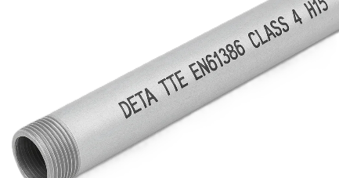

Wiring Accessory | Name/Use
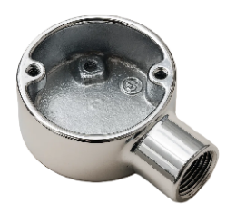

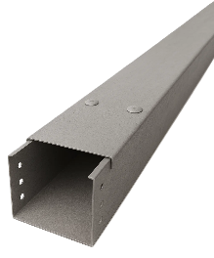

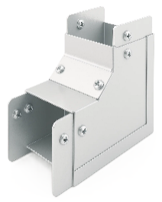
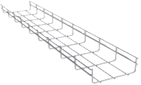
Learner reflection
Do you feel confident about this topic? | Yes | I would like more guidance

Task 11: Cable termination
- Cable stripping exercise
Knowing how to strip cable properly is crucial for making safe and reliable electrical connections, preventing short circuits and fire hazards, and ensuring efficient and effective wiring.
Practical Task
Request the materials listed below and carry out the task following the instructions.
Materials
- 300mm of 1.5mm² 2 core and cpc FP200 insulated and sheathed cable
- 300mm of 1.5mm² twin and cpc PVC/PVC insulated and sheathed cable
- 300mm of 6 core security cable
- 200mm of cpc sleeving.
Time | 60 minutes
Safety instructions | - Ensure your work area is clear and safe for work to proceed.  - It is essential that the CSA of each conductor be maintained throughout its length.  - Where necessary, the conductor ends must be doubled to fill the terminal hole.  - All your work must conform to the Health and Safety at Work Act requirements and Electricity at Work Regulations.
Task instructions | Sheathed cables  - Put on your PPE.  - Obtain the material from the stores.  - Ensure the cable is cut to correct length.  - Remove 100mm of sheathing from one end of the cable.  - Fit cpc sleeving where applicable.  - Remove sufficient insulation from the end of each cable core to expose the conductor and retain the length of insulation.  - Cut the exposed conductors to the required length.  - Where necessary, bend the end of each exposed conductor over to the required length to double its thickness.  - Check that all the dimensions are correct.  Stranded cable  - Ensure the cable is cut to correct length.  - Remove 30mm of insulation from one end of the cable to expose the conductors.  - Twist the exposed conductor strands together.  - Check that all dimensions are correct.  - Hand the work to your tutor for marking and assessment.

 | ASSESSMENT CRITERIA | Y | N
1 | Selected correct PPE, tools and equipment for task
2 | Sheath cut back correctly and to correct length
3 | Insulation undamaged and to the correct length
4 | Conductor cores undamaged
5 | Cpc correctly sheathed and to the correct length
6 | Conductor cores bent over where necessary and to the correct length
7 | Overall appearance to a commercially acceptable standard
8 | Completed task within target time
9 | Work conformed to the requirements of HASWA/EAWR
 | Totals
Feedback from the task:

Learner reflection
Do you feel confident about this topic? | Yes | I would like more guidance

- Cable termination and connection exercise
Knowing how to properly terminate and connect cables to electrical equipment and accessories is crucial for safe, reliable and efficient electrical systems.
Practical task
To complete this task, you must connect a length of 3-core flex to a 3-pin plug top (Figure 11.1) and 60309 plug (Figure 11.2). You must work safely at all times and leave your work area and tools clean and tidy. You must also complete a tools and equipment and materials checklist (see Annexe A).
Materials
- 300mm of 1.5mm² 3-core heat-resistant flex (white)
- 1 x BS 1363 3-pin plug top
- 1 x BS EN 60309 16A plug.


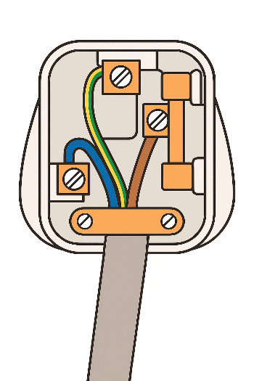
(Figure 11.1) (Figure 11.2)D

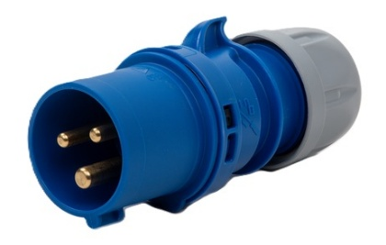

Time | 60 minutes
Safety instructions | - Ensure your work area is clear and safe for work to proceed.  - It is essential that the CSA of each conductor be maintained throughout its length.  - Conductor ends may be doubled to ensure the terminal hole is filled.  - All your work must conform to the Health and Safety at Work Act requirements and Electricity at Work Regulations.
Task instructions | - Wear the correct PPE for the task.  - Complete the material and tool list for the task.  - Select the tools and equipment for the task.  - Select materials to complete the task.  - Connect flex to the BS 1363 plug top.  - Connect the other end of the flex to BS EN 60309 plug.  - Set up and maintain a clean and safe working environment.  - Obtain the material from the stores.  - Hand the work to your tutor for marking and assessment.

 | ASSESSMENT CRITERIA | Y | N
1 | Selected correct PPE, tools and materials for task
2 | Correctly completed tool and material lists
3 | Removed outer layer of cable to expose required length of wires, completed without damage to the insulation of the wires
4 | Removed the insulation to expose the required length of bare wire
5 | Securely fixed the bare wires to the appropriate terminals
6 | Ensured no bare strands of wire are visible
7 | Used the cable grip correctly, and the cable is secure
8 | Replaced the plug cover
9 | Identified and selected tools and equipment required
10 | Completed task within target time
11 | Work conformed to the requirements of HASWA/EAWR
 | Totals
Feedback from the task:

Learner reflection
Do you feel confident about this topic? | Yes | I would like more guidance

Task 12: Electrical instruments for measurement
a. Fill in the blanks

Fill in the blanks with the correct terms.

- A _________ is used to measure the electrical potential difference between two points in a circuit.
- The unit of resistance is the ____.
- An ammeter is always connected in _________ with the circuit.
- A _________ is a device used to measure the power in an electrical circuit.
- The function of a _______ is to measure the frequency of an alternating current signal.

b. Multiple choice questions
Choose the correct answer for each question.
- Which of the following instruments is used to measure the current in a circuit?
A. Voltmeter
B. Ammeter
C. Ohmmeter
D. Wattmeter
- What is the main unit of electrical power?
A. Joule
B. Watt
C. Ampere
D. Volt
- A multimeter can measure which of the following quantities?
A. Voltage only
B. Current and resistance only
C. Voltage, current, and resistance
D. Power
- Which instrument is used for testing the continuity of a circuit?
A. Oscilloscope
B. Megger
C. Multimeter
D. Frequency counter

c. Matching activity
Match the instrument in Column A with its function in Column B.
Column A (Instrument) | Column B (Function)
1. Voltmeter | a. Measures electrical resistance
2. Ammeter | b. Measures electrical power
3. Ohmmeter | c. Measures electrical potential difference
4. Wattmeter | d. Measures electrical current

d. True or False
State whether the following statements are true or false.
- An oscilloscope is used to measure current directly. True/False
- A multimeter can only measure one electrical quantity at a time. True/False
- A galvanometer is a device used to detect small electric currents. True/False
- The unit of measurement for capacitance is the ohm. True/False

e. Labelling diagram
Label the following diagram of a multimeter with the correct parts.

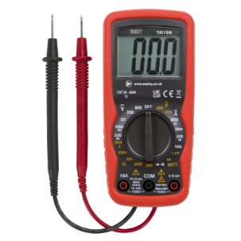
- Display screen
- Dial
- Probes
- Input ports

Learner reflection
Do you feel confident about this topic? | Yes | I would like more guidance
- Practical activity
Use 2x 10W power resistors to simulate the sounders and create a circuit using a 12V supply and multimeters to measure circuits as below.
Step 1 - Calculate what the current should be.

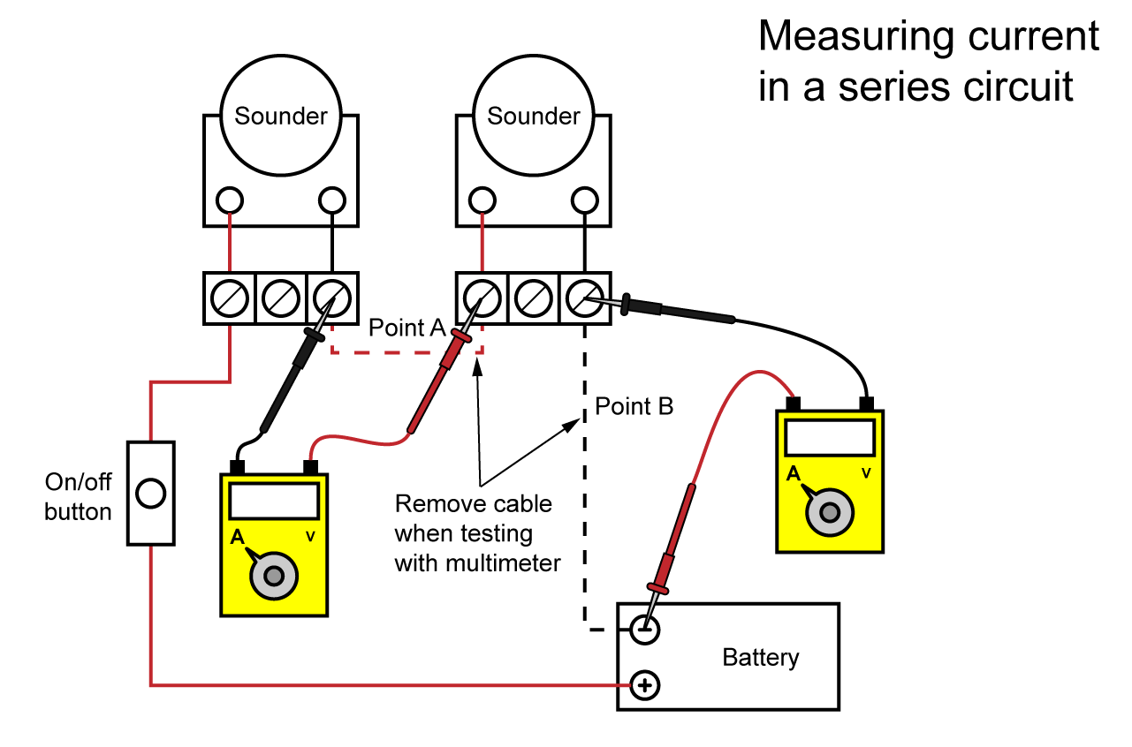

Step 2 - Calculate the voltage drop across each sounder.

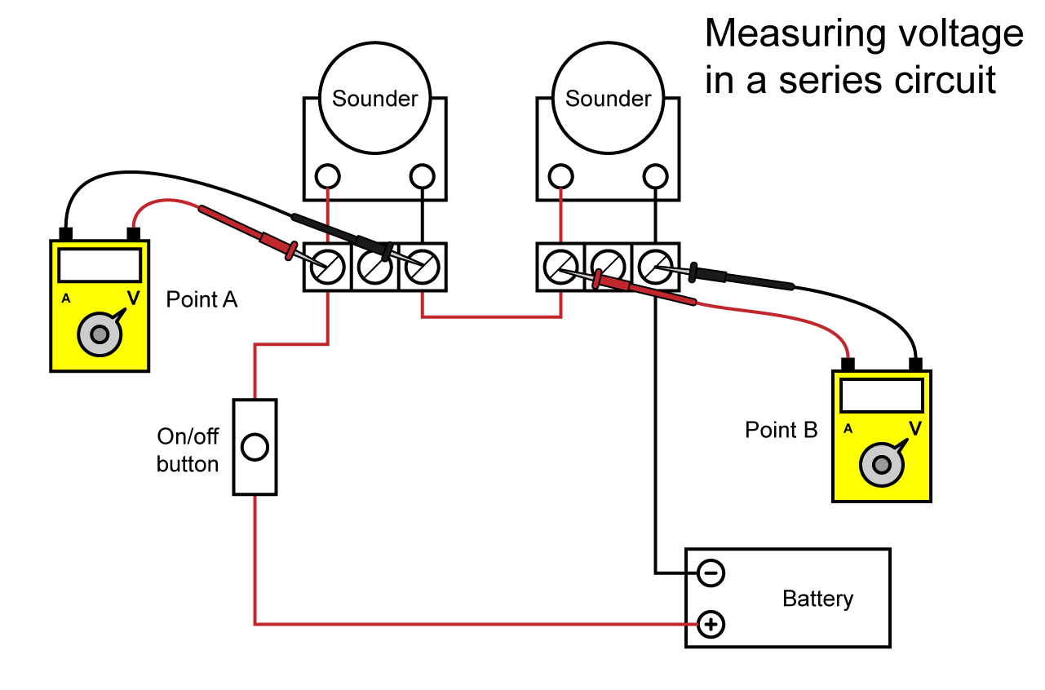

Step 3 - Now, with the power off. measure across sounders/resistors and make a note.
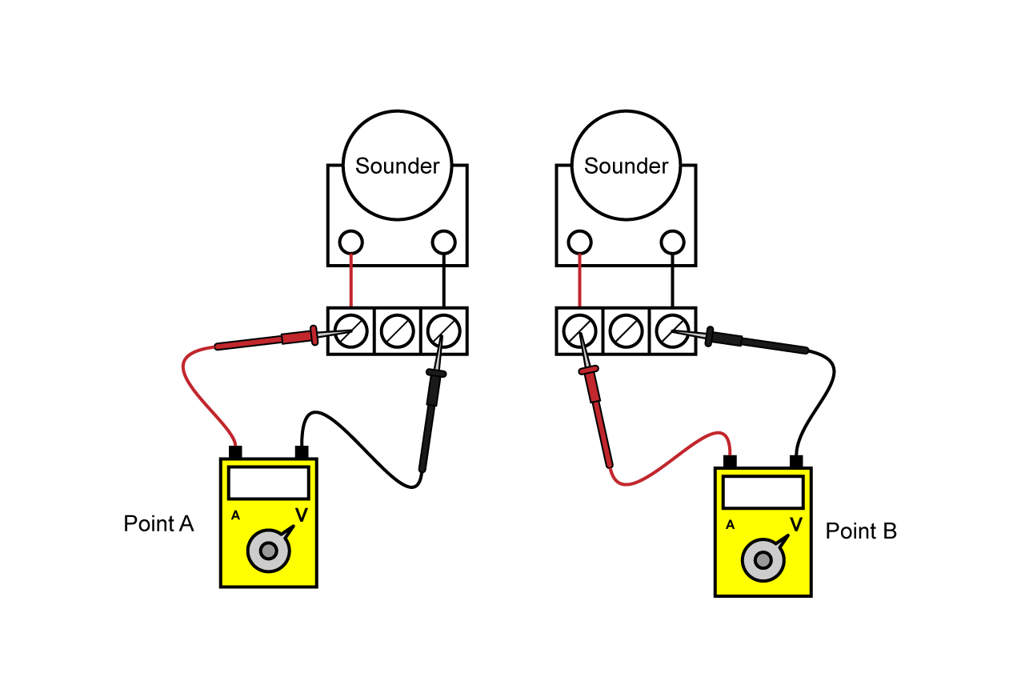
Extension task - Use other various resistors and measure them in series and parallel.
Resistors | Total calculated | Total measured
10kΩ and 120Ω in series

10kΩ and 120Ω in parallel

1.1kΩ and 240Ω in series

1.1kΩ and 240Ω in parallel

220Ω and 270Ω in parallel

Learner reflection
Do you feel confident about this topic? | Yes | I would like more guidance

Task 13: Sources of technical and functional information
  - What type of information is the following an example of, and where could it be found?
Control panel
£120 (inc VAT)
Product code: Y747A652
Manufacturer: Door Entry Are Us
Surface mounting thermostat, range -5 to +40 deg C

b. ‘A set of documents, plans or diagrams which sets out requirements for materials, components and services.’ What is this sentence describing?

c. ‘The system is to consist of FP200 cables installed in a basket run at a height of 2.3m above FFL.’
The above statement could form part of what type of document?

d. The following information is being sent to you as part of a policy of continuous professional development (CPD):

First Aid Training will be made available at the head office for all those who wish to take part.
Please contact Mr G Nash for further details.

Staff wishing to update to the 18th Wiring Regulations, please contact Ms Stefano. The next course will take place at the head office in the training room.

What is the likely source of the information shown above?

- For the four contacts in the table below, identify the technical information that may need to be supplied to them and the method of supplying the information. Put this information into the table.

 | Client and Customer | Major and sub-contractors | Site Managers | Other Services
Technical information that could be provided
Method of providing information
Functional information
Method of providing information

Learner reflection
Do you feel confident about this topic? | Yes | I would like more guidance

Task 14: Installing emergency lighting circuits
a: Multiple choice questions
1. Why is it important to isolate the power before working on an emergency lighting system?
A. To save electricity
B. To prevent electrical shock or injury
C. To reset the battery
D. To avoid triggering alarms
2. What PPE is most appropriate when drilling ceilings for emergency lighting fixtures?
A. Hard hat, safety glasses, dust mask, and gloves
B. Apron and oven mitts
C. Flip-flops and sunglasses
D. Welding helmet and safety boots
3. What is one of the major hazards during emergency lighting installation in ceiling spaces?
A. Static electricity
B. Exposure to UV light
C. Falling from height or through ceiling tiles
D. Loud noise
4. Which of the following is a safe method for testing emergency lighting after installation?
A. Turn off the power without warning occupants
B. Use the system’s built-in test button and inform building users in advance
C. Remove all batteries and check with a multimeter
D. Activate the fire alarm at the same time
5. Why is proper cable management critical in emergency lighting installations?
A. It improves the building's aesthetics
B. It prevents overheating
C. It ensures safety and reduces tripping/fire risks
D. It reduces costs

b: True or False
1. Emergency lighting systems are only tested during fire drills. True/False
2. PPE must be worn to reduce risk which can’t be controlled by other means. True/False
3. Battery backup units can be dangerous if mishandled. True/False
4. All emergency lighting installations must comply with relevant regulations. True/False
5. It is safe to install emergency lights in wet areas without waterproof protection. True/False
c: Short answer questions
1. List three common hazards associated with emergency lighting installation or maintenance.

2. Describe two safe practices when working in ceiling voids or high areas.

3. Why is it important to label and document all emergency lighting test results?

d: Scenario-based task
Scenario:
You are tasked with replacing the emergency lights in a hospital corridor. The work involves using ladders, disconnecting power, and installing battery-powered fixtures during operational hours.
- Identify three safety concerns in this scenario.
- Suggest a control measure for each.

Safety Concern
- ________________________________________________________________________________________
- ________________________________________________________________________________________
- ________________________________________________________________________________________
Control Measure
- ________________________________________________________________________________________
- ________________________________________________________________________________________
- ________________________________________________________________________________________

Practical task

You are to plan the installation of an emergency lighting system. Use appropriate FP200 cable sizes.

You need to produce the following information:
- Risk assessment
- Method statement with justifications
- Installation diagram with cable layout and equipment positions and associated controls
- Materials and tool list

Risk Assessment
Activity:  Location: |  |  |  | Date:  Position:
SEVERITY (S): Degree of harm which may be caused (including numbers affected)  1 Minor Injury 2 Major Injury 3 Fatality  LIKELIHOOD (L): Probability that event will occur  1 Remote 2 Possible 3 Likely |  |  |  |  | RISK RATING (RR): Severity x Likelihood  1-2 Low  3-5 Medium  6-9 High
Item No: | Activity: | Hazard | Persons at Risk | Existing Controls (Mitigation) | S  1-3 | L  1-3 | RR | Are the Risks Controlled?

Method statement
Complete a write-up detailing the installation task
__________________________________________________________________________________________________________________________________________________________________________________________________________________________________________________________________________________________________________________________________________________________________________________________________________________________________________________________________________________________________________________________________________________________________________________________

Installation circuit diagram

Material type (description) | Quantity

Tool list – list the tools required to complete the work task

Tutor Feedback:
What went well?
Even better if:

Learner reflection
Do you feel confident about this topic? | Yes | I would like more guidance

Task 15: Maintaining emergency lighting systems
a: Multiple choice questions
1. Which of the following is a key feature of maintained emergency lighting?
A It only operates during power cuts
B It remains on at all times
C It relies solely on natural light
D It functions only when manually activated
2. What type of lamp is commonly used in new emergency lighting systems?
A Incandescent lamps
B Halogen lamps
C LED lamps
D Fluorescent lamps
3. What is the minimum illumination level required for emergency escape routes under BS 5266-1?
A 0.5 lux
B 1 lux
C 5 lux
D 10 lux
4. Which of these is NOT a component of a maintained emergency lighting system?
A Battery
B Control gear
C Light fitting
D Water pump

b: True or False
State whether the following statements are true or false:
- Maintained emergency lighting is only activated during a power failure. True/False
- Emergency lighting is crucial in ensuring compliance with fire safety regulations. True/False
- LED lamps are more energy-efficient than incandescent lamps in emergency systems. True/False
- A central battery system is commonly used for large buildings. True/False

c: Labelling diagram
Look at the diagram of an emergency lighting system provided by your instructor. Label the components, including the battery, control unit, and light fitting.

d: Matching terms
Match the terms in Column A with their definitions in Column B:
Column A | Column B
Maintained lighting | a) Operates only during a power failure
Non-maintained lighting | b) A unit of illumination
BS 5266 | c) Illuminates at all times
Lux | d) British Standard for emergency lighting

e: Calculation
A building has an emergency lighting system with a 3-hour battery backup and the system uses 6 light fittings, each rated at 5 watts. Calculate the total energy required in watt-hours (Wh).

Learner reflection
Do you feel confident about this topic? | Yes | I would like more guidance

Task 16: Non-maintained emergency lighting systems
a: Fill in the blanks
Fill in the blanks with the correct terms:
- Non-maintained emergency lighting is designed to operate only when the __________ power supply fails.
- Emergency lighting systems are crucial for ensuring the safety of building __________ during emergencies.
- The duration for which a non-maintained emergency light must operate is typically __________ hours, as per regulations.
- The emergency lighting units must be regularly __________ to ensure they are functioning correctly.

b: Multiple choice questions
1. What is a non-maintained emergency luminaire?
A. A light that is always on and switches off when the mains fails
B. A light that only comes on when the mains supply fails
C. A light that stays on at a dimmed level during normal operation
D. A light that operates only during scheduled tests
2. Which standard typically governs the installation of emergency lighting in the UK?
A. BS 5266
B. BS 7671
C. ISO 9001
D. BS 5839

3. What is the purpose of a functional test?
A. To check the battery capacity over its full rated duration
B. To ensure the system switches on and illuminates under mains failure
C. To measure the lux level of escape routes
D. To verify correct fuse ratings in the circuit
4. During a duration test, the emergency luminaire must:
A. Stay on for its rated 1 or 3 hours
B. Switch off immediately when mains fails
C. Flash intermittently
D. Only run until the battery is half empty

5. A common sign of battery failure in a non-maintained unit is:
A. Excessively bright illumination
B. Flickering or short emergency operation
C. Permanent full brightness during normal operation
D. Audible alarm sounding continuously
6. When performing a functional test using a test key, the key:
A. Disconnects all circuits from the distribution board
B. Simulates a mains failure to trigger emergency mode
C. Recharges the battery more quickly
D. Adjusts the brightness of the lamp
7. What must be updated after every emergency lighting test?
A. Cable lengths
B. Building wiring diagrams
C. Emergency lighting logbook
D. Component warranty card
8. If a luminaire illuminates during test but only lasts 10 minutes in duration test, the most likely fault is:
A. Incorrect fuse
B. Weak/degraded battery
C. Faulty test switch
D. Over-voltage on the supply
9. When inspecting an emergency lighting battery, which of the following is a hazard indicator?
A. Clear electrolyte
B. Cool and clean terminals
C. Swelling, leakage, or corrosion
D. Original manufacturer label intact
10. A non-maintained emergency light will operate under which condition?
A. When the room is dark
B. When the mains supply fails
C. When the PIR sensor activates
D. Only when the battery is removed

c: Matching
Match the terms with their descriptions:
Term | Description
A. Lumen | 1. System used to classify the degree of protection against environmental factors.
B. Photometric Data | 2. A unit of measurement for luminous flux.
C. Ingress Protection (IP) Rating | 3. A unit of measurement for luminous flux.
B. Lux | 4. Information about the light output and distribution of a luminaire.

d: True or False
Determine whether the following statements are true or false:
- Emergency lighting is only required in commercial buildings. True/False
- Non-maintained emergency lighting operates continuously. True/False
- Emergency lighting must be installed in accordance with BS 5266. True/False
- Emergency lighting systems should be tested monthly. True/False

e: Calculation
An emergency lighting system is rated to operate for 3 hours, and its power consumption is 1228 watts. Calculate the total energy consumed in kilowatt-hours (kWh).

f: Scenario-based question
Scenario: You are tasked with designing a non-maintained emergency lighting system for a small office. Explain the key factors you would consider when selecting the type of emergency light fittings and their placement.

Practical tasks – non-maintained emergency lighting systems
Task 1 – Visual inspection
Objective: Identify defects and confirm system readiness before testing.
Instructions:
- Inspect the luminaire casing for damage, discoloration, or loose fittings.
- Check labels: model, rating, test date, and installation date.
- Verify wiring is secure and free of heat damage.
- Inspect battery compartment for swelling, leakage, or corrosion.
- Record findings in the inspection sheet.

Task 2 – Perform a functional test
Objective: Confirm automatic operation during mains failure.
Instructions:
- Isolate the local circuit or use the emergency lighting test key.
- Observe the luminaire switching into emergency mode.
- Check brightness output and stability.
- Restore mains supply and ensure system recharges correctly.
- Record results in the logbook.

Task 3 – Duration test (Full discharge test)
Objective: Confirm that the system provides rated emergency illumination time (usually 1 or 3 hours).
Instructions:
- Disable mains supply and start the timer.
- Observe light output at intervals (every 10–15 minutes).
- At the end of test duration, note whether illumination meets minimum levels.
- Restore mains and verify charging indicators.
- Complete duration test documentation.

Task 4 – Battery condition assessment
Objective: Inspect and evaluate the emergency battery pack.
Instructions:
- Access the battery compartment safely.
- Identify battery type and rated capacity.
- Check terminals, wiring, and charger unit condition.
- Compare observed performance with manufacturer data.
- Decide if the battery requires replacement.

Task 5 – Fault diagnosis scenario
Objective: Identify and resolve system faults using logical troubleshooting steps.
Scenario examples:
• The emergency light does not come on during mains failure.
• The unit illuminates but only for 10 minutes.
• The charger indicator is off or flashing.
• The lamp flickers in emergency mode.
Instructions:
- Use a multimeter and test key where appropriate.
- Check supply, lamp, battery, charger and internal connections.
- Identify root cause of the fault.
- Propose and justify corrective actions.
Task 6 – Documentation and Compliance
Objective: Practice recording maintenance information to regulatory standards.
Instructions:
- Complete an emergency lighting logbook based on today’s tests.
- Create a mock compliance report summarising system condition.
- Include recommendations for replacement, repair, or future inspection.

Task 17: Installing and maintaining CCTV systems
a: Multiple choice questions
1. What is the first step before starting a CCTV installation?
A. Drill into the wall
B. Read the equipment manual
C. Power up the DVR
D. Test the camera’s zoom
2. Why is a risk assessment important before CCTV installation?
A. It speeds up the installation
B. It guarantees image quality
C. It identifies potential hazards
D. It makes the client happy
3. Which of the following PPE is most likely required during installation?
A. Lab coat
B. Welding mask
C. Safety goggles and hard hat
D. Apron and gloves
4. Which hazard is associated with ladder use during CCTV installation?
A. Electric shock
B. Falls from height
C. Burn injuries
D. Exposure to UV light
5. Before working on an electrical component, you should:
A. Touch the wires to check if they’re live
B. Use an approved voltage indicator to test voltage
C. Wear sandals
D. Work quickly without turning off power
b: Short answer questions
1. List three potential hazards when installing or maintaining CCTV systems.

2. Describe two safe practices when working with electrical components in CCTV systems.

3. Why is it important to secure cables during and after installation?

c: Scenario-based question
You’re installing a CCTV camera on the exterior wall of a commercial building using a ladder. It's a windy day and the work requires drilling near a power line.
- List three safety concerns in this situation.
- Suggest one control measure for each concern.

Safety Concern
- ____________________________________________________________________________________________
- ____________________________________________________________________________________________
- ____________________________________________________________________________________________
Control Measure
- ____________________________________________________________________________________________
- ____________________________________________________________________________________________
- ____________________________________________________________________________________________

Practical task
You are to plan the installation of a CCTV system. Use appropriate Cat5e, coaxial cables.

You need to produce the following information:
- Risk assessment
- Method statement with justifications
- Installation diagram with cable layout and equipment positions and associated controls
- Materials and tool list

Risk Assessment
Activity:  Location: |  |  |  | Date:  Position:
SEVERITY (S): Degree of harm which may be caused (including numbers affected)  1 Minor Injury 2 Major Injury 3 Fatality  LIKELIHOOD (L): Probability that event will occur  1 Remote 2 Possible 3 Likely |  |  |  |  | RISK RATING (RR): Severity x Likelihood  1-2 Low  3-5 Medium  6-9 High
Item No: | Activity: | Hazard | Persons at Risk | Existing Controls (Mitigation) | S  1-3 | L  1-3 | RR | Are the Risks Controlled?

Method statement
Complete a write-up detailing the installation task.
________________________________________________________________________________________________________________________________________________________________________________________________________________________________________________________________________________________________________________________________________________________________________________________________________________________________________________________________________________________________________________________________________________________________________________________________________________

Installation circuit diagram

Material type (description) | Quantity

Tool list – list the tools required to complete the work task

Tutor Feedback:
What went well?
Even better if:

Learner reflection
Do you feel confident about this topic? | Yes | I would like more guidance

Task 18: Installing a conventional intruder alarm system
a: Multiple choice questions
1. What is the most important reason to perform a site survey before starting intruder alarm installation?
A. To impress the client
B. To assess layout aesthetics
C. To identify hazards and plan safe work procedures
D. To estimate installation time
2. When working in ceiling spaces or confined areas, what risk is most likely?
A. Noise exposure
B. Falling objects
C. Restricted movement and poor ventilation
D. Slippery surfaces
3. Which piece of PPE is essential when drilling or chasing walls for alarm wiring?
A. Gloves only
B. Dust mask, safety goggles, and gloves
C. Lab coat and rubber boots
D. Welding helmet
4. Which of the following is a safe practice when using power tools during installation?
A. Wear earphones to reduce noise
B. Work quickly to finish early
C. Inspect tools and use according to the manufacturer's instructions
D. Ignore minor sparks
5. When maintaining an intruder alarm system, you should always:
A. Skip power isolation if you’re quick
B. Ignore false alarm logs
C. Isolate power supply and follow lockout/tagout procedures
D. Work alone for efficiency

b: True or False
1. Cabling should be routed through areas with low foot traffic to prevent trip hazards. True/False
2. It’s acceptable to place tools or parts on top of ladders while working. True/False
3. Warning signage should be displayed during maintenance activities. True/False
4. Only licensed electricians can touch alarm wiring. True/False
5. Working at height requires risk assessment and fall prevention measures. True/False

c: Short answer questions
1. List three hazards commonly encountered during intruder alarm installation.

2. Give two safety precautions when working in roof voids or attic spaces.

3. Why is regular maintenance of alarm systems critical from a safety standpoint?

d: Scenario-based activity
You are installing an intruder alarm system at a retail store that remains open during the day. You need to access ceiling panels, drill holes, and run cables through areas with customer traffic.
- Identify three safety risks involved.
- Provide a control measure for each.

Safety Risk
- ____________________________________________________________________________________________
- ____________________________________________________________________________________________
- ____________________________________________________________________________________________
Control Measure
- ____________________________________________________________________________________________
- ____________________________________________________________________________________________
- ____________________________________________________________________________________________

Practical task
You are to plan the installation of a conventional intruder alarm system.

Use this diagram to show the position of each control equipment item in the Key list. Use appropriate Cat5e, 4 pair 0.22mm² cables.

You need to produce the following information:
- Risk assessment
- Method statement with justifications
- Installation diagram with equipment positions and associated controls
- Materials and tool list
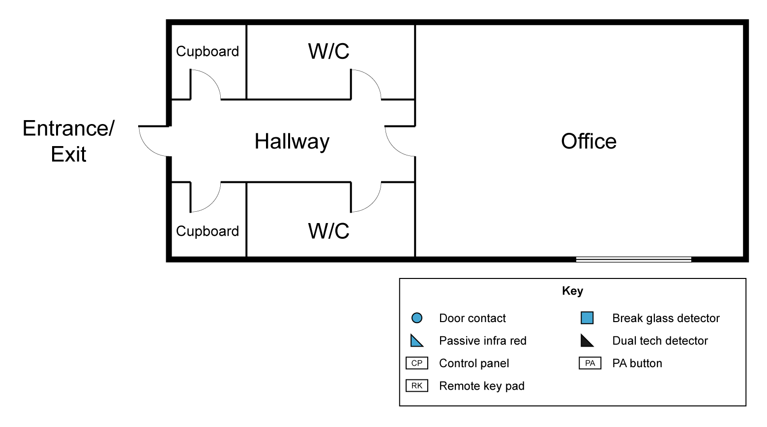

Typical components that make up an intruder alarm system include:
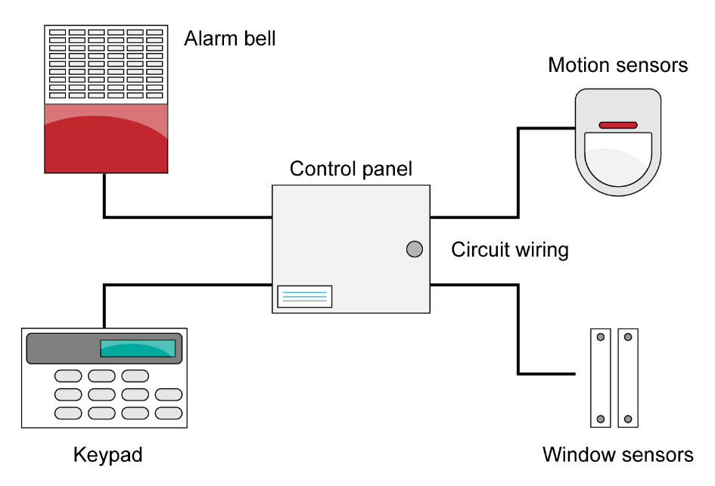
When installing cables some good practices are:​
- Try to use the shortest route
- Complete the full test of the circuits and note readings (this helps with maintenance)​
- Label cables clearly on the panel.

Testing procedure below
Quick reference — tools & parts
- Digital multi-meter (DMM) with continuity & DC voltage.
- Insulation resistance tester / multifunction meter capable of 250 V and 500 V DC output (use vendor guidance for low-voltage alarm wiring).
- Battery tester / load tester (or a fixed load resistor sized for a controlled discharge) or electronic load.
- Clip leads, crocodile clips, test probes.
- Small screwdriver set, insulated tools.
- Known value resistors (e.g., 1 kΩ, 4.7 kΩ — common EOLR values) and a bench power supply (optional).
- Lock off kit and safety PPE (gloves, eye protection).
- Paper / mobile device to record results (or use the test log below).

1. Continuity / wiring checks (loop integrity)
Purpose: Verify each zone circuit is continuous, connectors not open, and EOL resistor present.
Precautions: Power down the alarm panel and remove/disconnect the battery before resistance/continuity testing.
Steps
- Turn the power OFF at the panel, remove the battery.
- Identify zone wiring and EOL resistor value (if known). If unknown, note what’s fitted.
- Set DMM to resistance (Ω) or continuity mode.
- Measure end-to-end across the zone conductors (panel zone + to zone − or panel zone terminal to return).
  - If EOLR is fitted at the sensor end, you’ll measure the EOLR value (e.g. ~4.7 kΩ).
  - If you’re measuring the wiring only (EOLR removed), expect a low resistance (a few ohms up to a few tens of ohms depending on cable length).
- Probe every connection/junction (junction boxes, terminal blocks). Look for sudden jumps in resistance (bad crimp, corrosion).
- If continuity fails (open circuit), trace the cable: disconnect at intermediate points to localise the open.
Pass/Fail guidance
- If an EOLR is expected, measured resistance ≈ EOLR ± 5–10%.
- If no EOLR, wiring resistance should be near 0 Ω for short runs; for long runs a few ohms is acceptable. Anything > 50–100 Ω suggests a fault or very long/undersized wire — investigate.
- Intermittent continuity (fluctuating) = fail (loose/oxidised contact)

2. Insulation Resistance (IR) testing
Purpose: Make sure wiring insulation is intact — there is high resistance between conductors and to earth. Finds shorts, moisture ingress and damaged cable.
Precautions
- Disconnect all electronics and remove batteries. Disconnect sensors, tamper switches and any other devices from the circuit under test. A megger’s DC test voltage can damage sensitive electronics.
- Use a suitable test voltage. Common practice for low-voltage wiring: 250 V DC or 500 V DC on the megger, depending on cable rating and installer guidance. (Check cable and equipment manuals - using an unnecessarily high test voltage may stress old insulation)
- Wear PPE, follow manufacturer instructions.

Steps
- Isolate the zone wiring from the control panel and any connected devices.
- Select megger test voltage (commonly 250 V DC for 12 V alarm wiring; use 500 V only if specified as safe).
- Connect megger positive to the live conductor(s) (or zone +) and megger negative to the negative conductor (or to earth, depending on which measurement you want). For conductor-to-earth tests, connect one lead to conductor and the other to earth/ground.
- Apply test voltage and read meg-ohms (MΩ). Hold for ~1 minute to observe stability.
- Record the IR value.
Typical expectations (general guidance)
- Conductor-to-conductor (zone + to zone −): expect >> 1 MΩ (commonly many 10s to 100s of MΩ in dry, healthy wiring).
- Conductor-to-earth: also >> 1 MΩ.
- As a practical threshold, many techs take 1 MΩ as a minimum pass for low-voltage signalling; better systems aim for >10 MΩ. If moisture or contaminated cable is suspected, values under 1 MΩ are a fail and require repair/replacement and re-testing.
If you see low IR readings (<1 MΩ)
- Inspect for water ingress, cable damage, crushed cable, rodent damage or incorrectly connected earthing.
- Replace or re-terminate faulty cable runs. After repair, retest to confirm.
Document: test voltage, measured MΩ, duration, and which conductors tested.

3. Battery testing (12 V sealed lead-acid typical)
Purpose: Verify standby battery condition and ability to handle alarm loads.
Battery safety: Batteries can supply high currents. Shorting battery terminals is dangerous. Disconnect charging supply before connecting a heavy load if required by your test method (but be mindful that alarm chargers are designed to be connected during tests; follow panel manual).
Tests
A. Visual & terminal check
- Check for corrosion, swollen case, leakage, and loose terminals. Replace if physical damage.
- Clean terminals and tighten to spec.

B. Open-circuit voltage (no load)
- With battery connected or after disconnecting and waiting a few minutes, measure DC voltage across battery terminals with DMM.
- Guideline values (12 V nominal):
  - 12.6 V — fully charged (good)
  - 12.3–12.6 V — moderately charged (ok/marginal)
  - 12.0–12.3 V — weak (consider replacement soon)
  - < 12.0 V — poor / likely failing (replace)
- If panel charger is connected, measure panel charging voltage too — a healthy 12 V SLA float voltage typically ~13.4–13.8 V (manufacturer dependent).
C. Load test (recommended)
- The best check is a controlled load test: apply a known load and measure voltage under load.
- Typical approach: apply a load equal to 0.1C (10% of battery Ah rating) for a short interval OR use the alarm’s normal load (simulate bell or trigger). Example: a 12 Ah battery → 1.2 A load for test.
- If you don’t know Ah, many installers use a 1–2 A load for 12 V alarm batteries.

Procedure:
  - With battery charged, connect the load (electronic load or power resistor sized for the intended current).
  - Measure voltage immediately after applying load and after 10–30 seconds.
  - A good battery should not collapse below ~11.8–12.0 V under a normal test load. If it falls below ~11.5 V quickly, the battery is suspect.
- For a more accurate capacity check, perform a full discharge at 0.1C and time how long until 10.5 V; compare to rated Ah (this is destructive / long - not usually done onsite).
D. Internal resistance / battery analyser
- Many battery testers estimate internal resistance; higher internal resistance indicates age/failure.
- Compare to manufacturer specs or to a similar new battery if possible.
Pass/Fail summary for a typical 12 V SLA
- Open circuit >12.6 V, holds >12.0 V under expected alarm load → PASS.
- Open circuit 12.0–12.6 V or voltage droops under load but recovers → MARGINAL (monitor / consider replacement).
- Open circuit <12.0 V or large voltage collapse under load → FAIL (replace).

Practical test sequence for one zone & battery (recommended order)
- Put the panel in service/test mode (so alarms won’t trigger the monitoring centre). Follow the panel manual.
- Record system baseline: model, battery age, EOLR value, last test date.
- Power down main supply to panel and remove batteries (for continuity & IR).
- Continuity checks on each zone (measure resistance; confirm EOLR).
- Insulation resistance tests on each zone (megger). Record voltage used and MΩ readings.
- Reconnect wiring to panel.
- Reinstall battery and power up the system. Check panel battery charging voltage.
- Battery open-circuit voltage and loaded voltage test.
- Check alarm operation (walk test sensors) and restore panel to normal operation.
- Document results and any remedial actions.

Example test log (quick template)
Site: __________________ Date: ___/___/____ Tech: ________

Panel model: _________________ Battery: 12 V __ Ah (age ____ months)

Zone EOLR expected Continuity (Ω) IR test (250 V) MΩ Pass/Fail Notes
1 4.7 kΩ 4.68 kΩ 120 MΩ PASS OK
2 4.7 kΩ Open (∞) n/a FAIL Open at junction box

Battery test:
- Open circuit voltage: 12.62 V (PASS)
- Charger float voltage at panel: 13.6 V
- Load test 1.2 A for 30 s -> voltage under load: 12.1 V (PASS)
Recommendations: Replace zone 2 cable; retest IR after repair.

Useful tips and manufacturer notes
- Many conventional alarm systems use end-of-line resistors (e.g., 1 kΩ, 2.2 kΩ, 4.7 kΩ) for loop supervision — don’t remove or replace them unless you know the expected value for that panel. If you change resistors, update the panel’s zone programming.
- Always disconnect devices (sirens, strobes, external modules) before IR testing to avoid damaging electronics.

- Keep test voltages and procedures in the panel and battery manuals — manufacturer limits trump general guidance.
- For critical installations (CCTV, monitored commercial systems), keep a dated test record and carry out periodic re-tests (commonly every 6–12 months depending on local codes and contract).

Risk Assessment
Activity:  Location: |  |  |  | Date:  Position:
SEVERITY (S): Degree of harm which may be caused (including numbers affected)  1 Minor Injury 2 Major Injury 3 Fatality  LIKELIHOOD (L): Probability that event will occur  1 Remote 2 Possible 3 Likely |  |  |  |  | RISK RATING (RR): Severity x Likelihood  1-2 Low  3-5 Medium  6-9 High
Item No: | Activity: | Hazard | Persons at Risk | Existing Controls (Mitigation) | S  1-3 | L  1-3 | RR | Are the Risks Controlled?

Method statement
Complete a write-up detailing the installation task
_________________________________________________________________________________________________________________________________________________________________________________________________________________________________________________________________________________________________________________________________________________________________________________________________________________________________________________________________________________________________________________________________________________________________________________________________________________________________________________________________________________________

Installation circuit diagram

Material type (description) |  | Quantity
Tool list – list the tools required to complete the work task

Tutor Feedback:
What went well?
Even better if:
Learner reflection
Do you feel confident about this topic? | Yes | I would like more guidance

Task 19: Installing a conventional fire alarm system
a: Multiple choice questions
1. What is the primary reason for conducting a risk assessment before beginning fire alarm installation?
A. To test all the alarms
B. To identify hazards and minimise risks
C. To meet customer preferences
D. To reduce costs
2. Which of the following is considered appropriate PPE for fire alarm installation?
A. Flip-flops and safety glasses
B. Helmet and fireproof gloves
C. Safety goggles, gloves, and appropriate footwear
D. Welding helmet and lab coat
3. When working at height to install alarm systems, which equipment should be used?
A. Wooden ladder only
B. Step stool
C. Properly secured ladder or scaffold with fall protection
D. Any available chair
4. What should you do before drilling into a wall to mount fire alarm components?
A. Drill immediately
B. Ask the client where to drill
C. Check for electrical cables and pipes
D. Knock on the wall to listen
5. During maintenance, what is a safe practice for testing sounders and alarms?
A. Disconnect power entirely
B. Warn building occupants and use protective ear equipment
C. Leave all alarms active without informing anyone
D. Trigger alarms silently to avoid disturbance

b: True or False
1. It is safe to perform installation work near live wires. True/False
2. Fire alarm systems must be isolated before electrical work begins. True/False
3. Regular tool inspections are unnecessary for fire alarm technicians. True/False
4. Working in ceiling voids may involve additional risks such as dust or asbestos. True/False
5. Fire alarms should be tested after installation or maintenance. True/False

c: Short answer questions
1. List three hazards associated with fire alarm installation or maintenance.

2. Describe two safety measures to follow when working on ladders.

3. Why is communication with building occupants important during alarm maintenance?

d: Scenario-Based Question
You are assigned to install a fire alarm control panel in a school. The work is scheduled during class hours. You must use power tools and climb a ladder near a fire exit.
- Identify three safety concerns in this scenario.
- Suggest a control measure for each.

Safety Concern
- ____________________________________________________________________________________________
- ____________________________________________________________________________________________
- ____________________________________________________________________________________________
Control Measure
- ____________________________________________________________________________________________
- ____________________________________________________________________________________________
- ____________________________________________________________________________________________

Practical task
You are to plan the installation of a conventional fire alarm system. Use appropriate FP220 cables.

You need to produce the following information:
- Risk assessment
- Method statement with justifications
- Installation diagram with cable layout and equipment positions and associated controls
- Materials and tool list
- Complete a full test of the system
Risk Assessment
Activity:  Location: |  |  |  | Date:  Position:
SEVERITY (S): Degree of harm which may be caused (including numbers affected)  1 Minor Injury 2 Major Injury 3 Fatality  LIKELIHOOD (L): Probability that event will occur  1 Remote 2 Possible 3 Likely |  |  |  |  | RISK RATING (RR): Severity x Likelihood  1-2 Low  3-5 Medium  6-9 High
Item No: | Activity: | Hazard | Persons at Risk | Existing Controls (Mitigation) | S  1-3 | L  1-3 | RR | Are the Risks Controlled?

Method statement
Complete a write-up detailing the installation task
__________________________________________________________________________________________________________________________________________________________________________________________________________________________________________________________________________________________________________________________________________________________________________________________________________________________________________________________________________________________________________________________________________________________________________________________

Installation circuit diagram

Material type (description) | Quantity

Tool list – list the tools required to complete the work task

Test procedure
Conventional fire alarm system - circuit testing
Circuits to test:
- Detection zones (smoke/heat detectors & manual call points)
- Sounder circuits
- Auxiliary/trigger outputs
- Panel supply & battery charger
Before testing:
- Isolate mains supply
- Disconnect panel batteries for continuity/IR testing
- Remove electronic devices (detectors, sounders) during insulation resistance testing
- Follow BS 5839 / NFPA 72 (or your local code)

A. Continuity testing (Fire alarm)
Purpose: Verify zone and sounder wiring is unbroken and correctly terminated.
Steps:
- Power OFF panel and remove standby batteries.
- Disconnect zone wires or sounder circuit wires from panel terminals.
- At the far end of each circuit, link the outgoing and return conductors together.
- At the control panel, measure resistance using a multimeter (Ω scale).
Expected results:
- Zone circuits (Class B / Radial): typically < 10–20 Ω depending on cable length.
- Sounder circuits: usually slightly lower (thicker cable).
- A stable, low resistance = PASS.
- High, fluctuating, or infinite resistance = FAIL (open or poor connection).

B. Insulation resistance testing (Fire alarm)
Purpose: Check for shorts, moisture ingress and cable breakdown.
⚠ Critical safety
- Remove detectors, call points, sounders, and all electronic equipment OR isolate device bases.
- Never megger the panel or connected devices.
Steps:
- Disconnect the zone/sounder cables at the panel.
- Separate conductors:
  - Zone +
  - Zone –
  - Earth/shield
- Using a 500 V DC insulation tester (sometimes 250 V for sensitive cable):
  - Test + to –
  - Test + to Earth
  - Test – to Earth
- Hold each reading for ~1 minute.
Expected results (Typical)
- > 1 MΩ minimum required (BS 5839).
- Healthy wiring is often > 20–200 MΩ.
Low IR = moisture, cable damage, or poor terminations.

C. Battery tests (Fire panel)
Most panels use 12 V SLA batteries (two in series for 24 V platforms).

Steps:
1. Visual & physical check
- No swelling, leaks, corrosion.
- Terminals tight and clean.
2. Open-Circuit Voltage (after resting)
- 12.6–13.0 V (good)
- 12.3–12.6 V (acceptable)
- <12.3 V (weak) — consider replacement
- <12.0 V (fail)
3. Load test
Perform a short load test (0.1C guideline).
Example: 7 Ah battery → approx. 0.7 A load.
- Voltage under load should stay > 11.8–12.0 V.
- Rapid collapse below 11.5 V = failing.
4. Charger voltage test (with mains supply ON)
- Typical float voltage per battery: 13.4–13.8 V (manufacturer-dependent).

Tutor Feedback:
What went well?
Even better if:

Learner reflection
Do you feel confident about this topic? | Yes | I would like more guidance

Task 20: Plan an addressable fire alarm system
a: Fill in the blanks

1. An addressable fire alarm system divides a building into multiple ________, which are used to identify the general location of a fire.
2. Addressable systems use individual ________ to provide specific information about each connected device.
3. The main control panel in a fire alarm system is responsible for monitoring and ________ the system's components.
4. The primary purpose of a fire alarm system is to _______ occupants of a potential fire.
5. In an addressable system, each device has a unique _______ for identification.

b: Multiple choice questions
1. What is the main advantage of an addressable fire alarm system compared to a conventional one?
A. Lower cost
B. Precise identification of the alarm's location
C. Simpler installation process
D. Requires no maintenance
2. Which component is typically included in both conventional and addressable fire alarm systems?
A. Smoke detectors
B. Sprinklers
C. Fire extinguishers
D. Emergency lighting
3. In an addressable system, what happens when a detector is activated?
A. The system identifies the specific device
B. The entire zone goes into alarm
C. The system automatically suppresses the fire
D. Nothing happens
4. Which type of cable is commonly used in fire alarm installations?
A. Category 5 (Cat5) cable
B. Fiber optic cable
C. Fire-rated cable
D. Coaxial cable
5. What does BS 5839 apply to in the United Kingdom?
A. Installation of emergency lighting
B. Design and installation of fire alarm systems
C. Maintenance of fire extinguishers
D. Evacuation procedures

c: Short answer questions
1. Explain the difference between a heat detector and a smoke detector and provide an example of where each might be used.

2. Describe the purpose of a fire alarm repeater panel and where it might be installed in a building.

3. What is the role of a sounder in a fire alarm system? Why is it important?

4. Identify two advantages of using an addressable fire alarm system in a large building.

Practical task
You are to plan the installation of an addressable fire alarm system. Use appropriate FP220 cables.

You need to produce the following information:
- Risk assessment
- Method statement including programming with justifications
- Installation diagram with cable layout and equipment positions and associated controls
- Materials and tool list

Risk Assessment
Activity:  Location: |  |  |  | Date:  Position:
SEVERITY (S): Degree of harm which may be caused (including numbers affected)  1 Minor Injury 2 Major Injury 3 Fatality  LIKELIHOOD (L): Probability that event will occur  1 Remote 2 Possible 3 Likely |  |  |  |  | RISK RATING (RR): Severity x Likelihood  1-2 Low  3-5 Medium  6-9 High
Item No: | Activity: | Hazard | Persons at Risk | Existing Controls (Mitigation) | S  1-3 | L  1-3 | RR | Are the Risks Controlled?

Method statement
Complete a write-up detailing the installation task
__________________________________________________________________________________________________________________________________________________________________________________________________________________________________________________________________________________________________________________________________________________________________________________________________________________________________________________________________________________________________________________________________________________________________________________________

Installation circuit diagram
Draw the alarm circuit system in the diagram below:
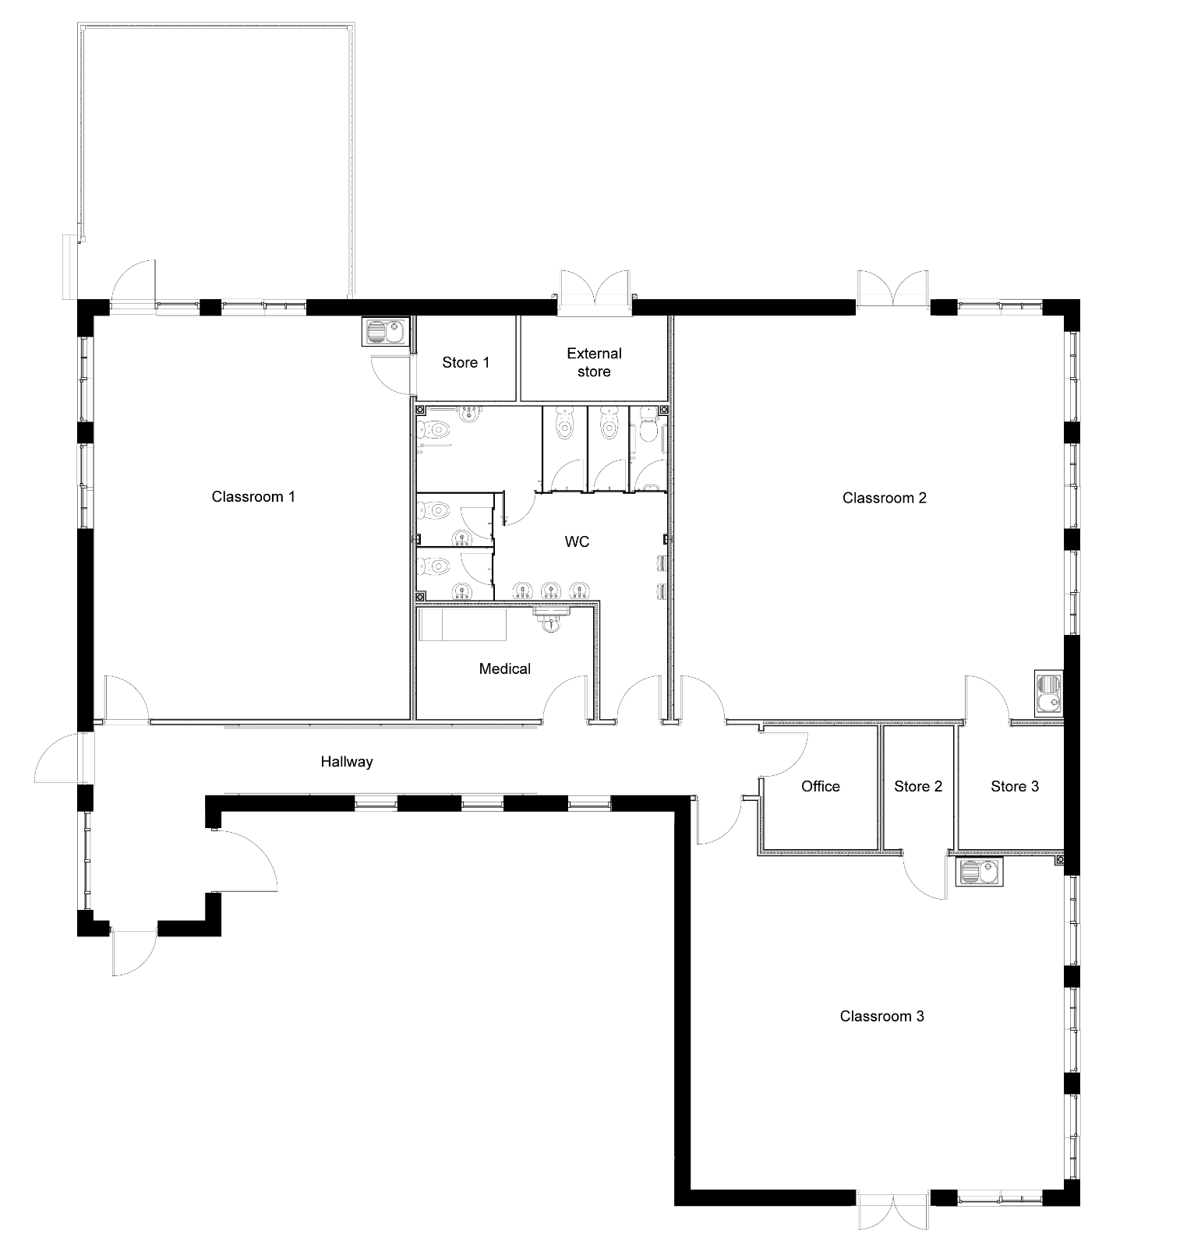

Material type (description) | Quantity

Tool list – list the tools required to complete the work task

Tutor Feedback:
What went well?
Even better if:
Learner reflection
Do you feel confident about this topic? | Yes | I would like more guidance

Task 21: Installation of a door entry system
a: Multiple choice questions
- Why is it important to carry out a risk assessment before starting door entry system installation?
A. To speed up the installation
B. To identify hazards and prepare controls
C. To please the client
D. To decide the colour of the system
- Which of the following PPE should be worn when drilling walls for mounting door entry units?
A. Safety goggles, gloves, and dust mask
B. Flip-flops and sunglasses
C. Lab coat and helmet
D. Welding gloves and apron
- When working near electrical wiring during installation, what should you do?
A. Work without isolating power if in a hurry
B. Always isolate electrical power before starting
C. Touch wires to check if live
D. Wear sandals for comfort
- What is a safe practice when using ladders to install overhead door entry components?
A. Use any ladder without inspection
B. Ensure ladder is stable and use fall protection if needed
C. Carry tools in your hands while climbing
D. Stand on the top rung
- Why is cable management important in door entry system installation?
A. It improves aesthetics only
B. It prevents tripping hazards and damage to cables
C. It makes cables harder to access
D. It increases installation time

b: True or False
  - Door entry system power should always be isolated before maintenance. True/False
  - It’s safe to leave cables hanging loose during installation. True/False
  - Warning signs should be used when working in public areas. True/False
4. Tools should be regularly inspected and maintained. True/False
5. Working in wet conditions is acceptable if the system is low voltage. True/False

c: Short answer questions
- List three common hazards when installing or maintaining door entry systems.

- Describe two safe practices when handling electrical components.

- Why is communication with building occupants important during maintenance?

d: Scenario-based question
You are installing a door entry system in a school during working hours. The installation requires drilling near a busy entrance and running cables through ceiling spaces.
- Identify three safety concerns.
- Suggest a control measure for each.

Safety Concern
- ____________________________________________________________________________________________
- ____________________________________________________________________________________________
- ____________________________________________________________________________________________
Control Measure
- ____________________________________________________________________________________________
- ____________________________________________________________________________________________
- ____________________________________________________________________________________________

Practical task
You are to plan the installation of a door entry system, using the building plan below.
Use appropriate Coaxial, Cat 5e and 4-pair 0.22mm² cables.

You need to produce the following information:
- Risk assessment
- Method statement with justifications
- Installation diagram with cable layout and equipment positions and associated controls
- Materials and tool list
- Complete the testing procedure

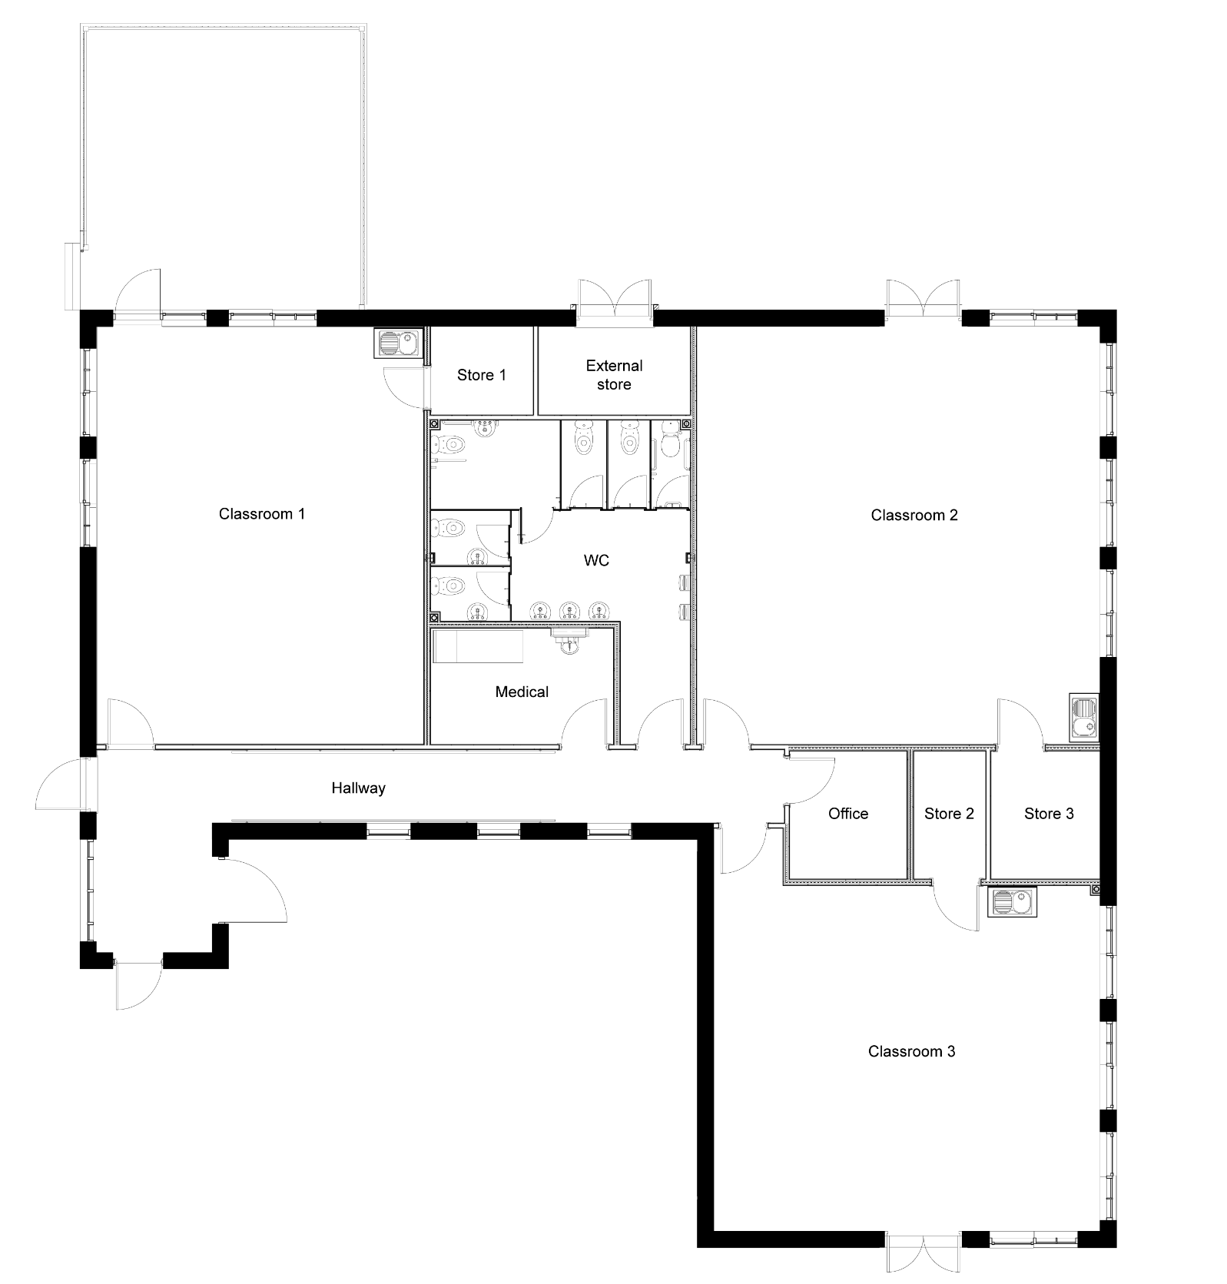

Risk Assessment
Activity:  Location: |  |  |  | Date:  Position:
SEVERITY (S): Degree of harm which may be caused (including numbers affected)  1 Minor Injury 2 Major Injury 3 Fatality  LIKELIHOOD (L): Probability that event will occur  1 Remote 2 Possible 3 Likely |  |  |  |  | RISK RATING (RR): Severity x Likelihood  1-2 Low  3-5 Medium  6-9 High
Item No: | Activity: | Hazard | Persons at Risk | Existing Controls (Mitigation) | S  1-3 | L  1-3 | RR | Are the Risks Controlled?

Method statement
Complete a write-up detailing the installation task.
__________________________________________________________________________________________________________________________________________________________________________________________________________________________________________________________________________________________________________________________________________________________________________________________________________________________________________________________________________________________________________________________________________________________________________________________

Installation circuit diagram

Material type (description) | Quantity

Tool list – list the tools required to complete the work task

Testing procedure for door entry system
Applies to:
- Audio entry systems
- Video entry systems (CCTV door stations)
- Multi-station intercoms
- Access-controlled entry (with electric strike or maglock)
- Analogue, digital, or IP-based systems

1. Pre-inspection checks
1.1 Visual inspection
- Check all station units (door panel, monitors, handsets) for damage or looseness.
- Inspect cabling for:
  - correct terminations
  - no exposed copper
  - no water ingress at external stations
- Confirm cable type used matches manufacturer recommendations (e.g., CAT5e for IP, twisted pair for analogue).
- Verify PSU/enclosure is secure and properly ventilated.

1.2 Safety and preparation
- Ensure the door can be manually opened (fire safety).
- Place the system in maintenance mode if applicable.
- Confirm you have test access to:
  - door entry panel
  - internal receivers
  - lock hardware (electric strike/maglock)
  - network switches (IP systems)
2. Power supply tests
2.1 PSU output voltage
- Measure the power supply output using a multimeter.
- Compare to manufacturer spec (e.g., 12 V DC, 24 V DC, PoE 48 V).
Acceptable ranges:
- 12 V DC system: 12.0–13.8 V
- 24 V DC system: 24–27.5 V
- PoE: 44–57 V depending on PoE class
2.2 Load check
- While pressing the call button OR activating the lock, measure voltage drop at:
  - PSU output
  - lock terminals
  - door station
  - internal handset
Voltage should not sag >10% under load.

3. Cabling and continuity tests
3.1 Continuity
- System must be powered OFF.
- Test pairs for continuity using the multimeter (Ω range).
- Long cable runs may show slight resistance (1–20 Ω depending on length).
- Confirm no open circuits.
3.2 Polarity check (analogue systems)
- Ensure speech lines and lock feed are correctly polarised.
3.3 Network cabling (IP systems)
- Use a network cable tester for:
  - wiremap
  - crossed pairs
  - shorts
  - split pairs
- Check link status at switches (10/100/1000 Mbps as required).
4. Insulation resistance testing
(For analogue systems only; NOT used on IP or PoE)
⚠ Disconnect all electronic devices before IR testing
Steps:
- Disconnect cabling at panels.
- Test using 250 V DC (recommended) between:
  - speech pair
  - call wire
  - lock wires
  - earth/shield
- Acceptable results:
  - > 1 MΩ minimum
  - ideally > 10–50 MΩ

5. Door panel functional testing
5.1 Call button test
- Press the call button → handset/monitor should ring immediately.
- Confirm the correct apartment receives the call (multi-tenant systems).
5.2 Audio test
- Listen for audio quality both ways:
  - echo
  - distortion
  - low volume
  - background hum (indicates earthing/noise issues)
5.3 Video test (video units)
- Confirm:
  - camera image clarity
  - night-vision/IR operation
  - correct angle and focus
  - no condensation inside the camera window
6. Internal station testing (handset/monitor)
6.1 Answer function
- Accept the call → audio/video should activate correctly.
6.2 Button function
- Test door-release button.
- Test any additional buttons (light, concierge, secondary door).
6.3 Screen and settings (video)
- Check brightness, contrast, colour, volume controls.

7. Lock and access control tests
7.1 Electric strike / maglock activation
- Operate door release from:
  - internal handset
  - door panel (if admin features allow)
- Door should release consistently.

7.2 Lock voltage output
- Measure lock voltage when energised:
  - should match lock spec (e.g., 12 V or 24 V).
- Check current draw does not exceed PSU rating.
7.3 Fail-safe / fail-secure check
- Confirm behaviour during power interruption matches specification:
  - fail-safe → unlocks
  - fail-secure → stays locked
7.4 Manual override / keys
- Test mechanical key override.

8. Intercom functionality (system-wide)
8.1 Multi-call operation
- Call several rooms to verify addressing.
8.2 Group calling (if present)
- Concierge/system office should receive correct call routing.
8.3 Door status monitoring
- Test door-open reed switch (if fitted).
- Confirm panel indicates door state.
9. Network testing (IP systems only)
Steps:
- Check devices are reachable (ping test).
- Confirm correct IP addressing/subnetting.
- Verify PoE delivery.
- Check packet loss, jitter (video systems).
- Confirm door station streams correctly to all monitors.

10. Backup battery testing (If system includes standby supply)
10.1 Visual inspection
- No swelling, leaks or corrosion.
10.2 Voltage check
- Measure open-circuit voltage:
  - 12.6–13.0 V (good)
  - 12.3–12.6 V (borderline)
  - <12.3 V (weak)
10.3 Load test
- Apply system load and verify battery holds > 12 V.

11. Final system test
11.1 Full operational simulation
- From outside:
  - press call → receive → speak → release → door opens
- From inside:
  - door release button works
  - video pops up (video systems)
11.2 Power failure test
- Remove mains; system must operate on battery (if fitted).
11.3 Handover verification
- Confirm user settings.
- Label devices and circuits.
- Verify documentation matches installed system.

Tutor Feedback:
What went well?
Even better if:

Learner reflection
Do you feel confident about this topic? | Yes | I would like more guidance

Task 22: Cutting, bending and terminating conduit
Practical task
This practical task involves developing the fundamental skills required to work with both steel and PVC conduit systems. These systems are essential for providing mechanical protection and routing for electrical cables in various installations. You will learn to accurately cut conduit to length and create two common types of bends (a 90-degree right/left angle and an offset).
You are to request the materials listed below and carry out the task following the instructions. Always work in a safe manner and leave your work area and tools clean and tidy. You must also complete the tools, equipment and materials checklist (see Annexes).
Materials and Equipment
- 1.2m of 20mm steel conduit
- 1.2m of 20mm PVC conduit
- 4 x 20mm steel conduit saddles
- 4 x 20mm PVC conduit saddles
- 4 x 20mm steel conduit couplers
- 4 x 20mm PVC conduit adapters
- 4 x 20mm brass male bushes
- 4 x 20mm PVC male bushes
- 1 x conduit bending machine, 20mm former and 20mm stocks and dies
- 1 x 20mm PVC conduit bending spring
- 1 x conduit deburring tool
- 1 x can of cutting compound.

Time | 3 hours
Safety instructions | - Ensure your work area is clear and safe for work to proceed.  - All your work must conform to the Health and Safety at Work Act requirements and Electricity at Work Regulations.  - All practical electrical installation exercises must comply with BS 7671 (IET Wiring Regulations).  - All terminations must be mechanically and electrically sound.
Task instructions | - Wear the correct PPE for the task.  - Complete the material and tool list for the task.  - Prepare work site for installation by ensuring all work areas are free from hazards.  - Measure and mark out positions of conduit runs.  - Cut steel conduit square (with end square) to given length.  - Produce a right-angled bend using a bending machine.  - Thread conduit.  - Fix conduit using standard 20mm conduit saddles.  - Terminate to metal boxes using couplers and male bushes.  - Cut steel conduit square (with end square) to given length.  - Produce an offset using a bending machine.  - Thread conduit.  - Fix conduit using standard 20mm conduit saddles.  - Terminate to metal boxes using couplers and male bushes.  - Cut plastic conduit square to given length.  - Produce a right-angle bend in plastic conduit.  - Fix conduit using standard 20mm conduit saddles.  - Terminate plastic conduit into accessory boxes.  - Cut plastic conduit square to given length.  - Produce an offset in plastic conduit.  - Fix conduit using standard 20mm conduit saddles.  - Terminate plastic conduit to accessory boxes.  - Hand the work to your tutor for marking and assessment.

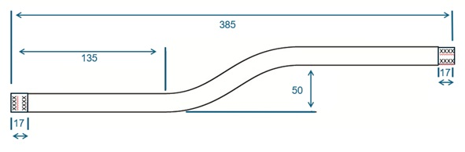

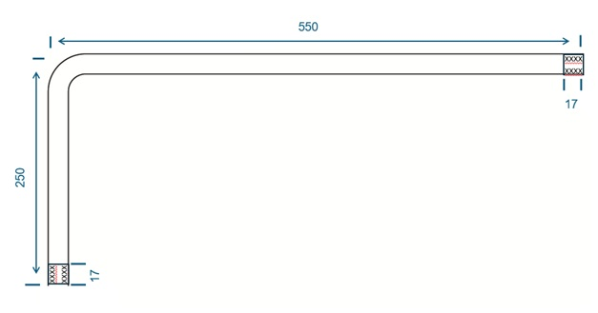

 | ASSESSMENT CRITERIA | Y | N
1 | Selected correct PPE, tools and materials for task
2 | Correctly completed tool and material lists
Steel conduit
3 | Work carried out in a safe manner
4 | Conduit cut to specified length
5 | Conduit finish undamaged
6 | Conduit end cut square
7 | No burrs left in conduit
8 | Conduit end threaded correctly (no threads showing)
9 | Conduit runner threaded with no excess threads
10 | Conduit terminated to adaptable box correctly
11 | Conduit bushes and couplers tight
12 | Offset produced to good commercial standard
Plastic conduit
13 | Work carried out in a safe manner
14 | Conduit cut to specified length
15 | Terminated correctly to boxes
17 | Right-angle bend fabricated correctly
18 | Completed task within target time
19 | Work conformed to the requirements of HASWA/EAWR
 | Totals
Feedback from the task:

Learner reflection
Do you feel confident about this topic? | Yes | I would like more guidance

Task 23: Steel trunking – internal 90-degree angle
Fabricating an internal 90-degree angle
Practical task
This practical fabrication task requires you to demonstrate your ability to accurately measure, cut, notch, and form a precise 90-degree internal bend in a length of 50mm x 50mm steel trunking. Steel trunking is a robust and widely used containment system in electrical installations, providing mechanical protection and a defined pathway for cables.
You are to request the materials listed below and carry out the task following the instructions. You must always work in a safe manner and should leave your work area and tools clean and tidy. You must also complete the tools, equipment, and materials checklist (see Annexes).
Materials
- 1 x 320mm of 50x50 steel trunking complete with lid
- 8 x 12mm M6 roofing nuts and bolts.
Time | 180 minutes
Safety instructions | - Ensure your work area is clear and safe for work to proceed.  - All your work must conform to the Health and Safety at Work Act requirements and Electricity at Work Regulations.  - All practical electrical installation exercises must comply with BS 7671 (IET Wiring Regulations).  - All terminations must be mechanically and electrically sound.
Task instructions | - Wear the correct PPE for the task.  - Complete the material and tool list for the task.  - Prepare work site for installation by ensuring all work areas are free from hazards.  - Square off and cut one end of the trunking and remove any burrs.  - From the squared end, measure 200mm and mark both sides of the trunking.  - Draw a line through these marks at 90° to the trunking edge.  - Cut through the marked lines on the sides only.  - Form the bend as shown in the diagram, ensuring that the edges of the 200m section are inside the bend.  - Ensure that all burrs and sharp edges are removed.  - Fix trunking to form the 90° bend.  - Mark and drill suitable-sized fixing holes on both sides of the trunking.  - Secure both sides of the trunking together in the correct position using the M6 nuts and bolts.  - Mark and drill the other end, fixing holes in both ends to complete the bend.  - Remove any burrs and sharp edges.  - Hand the work to your tutor for marking and assessment.

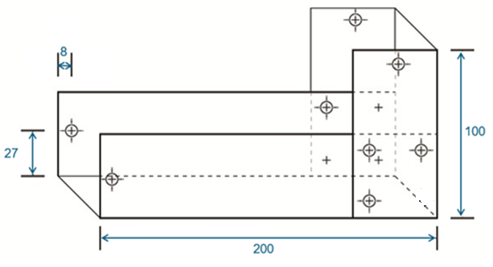
2 fixings of the joint on either side

 | ASSESSMENT CRITERIA | Y | N
1 | Selected correct PPE, tools and materials for task
2 | Correctly completed tool and material lists
3 | Trunking square- and burr-free
4 | Bend marked out correctly from squared end
5 | Bend marked out correctly on both sides
6 | Bend securely fixed using M6 nuts and bolts
7 | Overall dimensions correct +/- 5mm
8 | Completed angle 90°
9 | End fixing holes correct position and size
10 | Lid correctly cut, fits bend correctly, and ends are square
11 | Used only given length of trunking and lid
12 | Completed installation within target time
13 | Work conformed to the requirements of HASWA/EAWR
 | Totals
Feedback from the task:

Learner reflection
Do you feel confident about this topic? | Yes | I would like more guidance

Task 24: Steel trunking – Flat 90-degree angle
Fabricating a flat 90-degree angle
Practical task
This practical fabrication task requires you to demonstrate your ability to accurately measure, cut, notch, and form a precise flat 90-degree bend in a length of 50mm x 50mm steel trunking.
You are to request the materials listed below and carry out the task following the instructions. You must always work in a safe manner and should leave your work area and tools clean and tidy. You must also complete the tools, equipment, and materials checklist (see Annexes).
Materials
- 1 x 300mm of 50x50 steel trunking complete with lid.
- 2 x 12mm M6 roofing nuts and bolts.
Time | 180 minutes
Safety instructions | - Ensure that your work area is clear and safe for work to proceed.  - All your work must conform to the Health and Safety at Work Act requirements and Electricity at Work Regulations.  - All practical electrical installation exercises must comply with BS 7671 (IET Wiring Regulations).  - All terminations must be mechanically and electrically sound.
Task instructions | - Wear the correct PPE for the task.  - Complete the material and tool list for the task.  - Prepare work site for installation by ensuring all work areas are free from hazards.  - Measure 200mm to the centre and mark a datum line all the way round the trunking.  - Using the set square, draw a line at 45° (B).  - 50mm either side of the datum, mark two lines on one side only (A).  - Using the set square, from (A) draw two lines on the bottom of the trunking at 45° to converge (C).  - At position (B) top of the trunking cut on the 45° line to (A).  - On the base of the trunking from point (A) to point (C), cut on the 45° line and between (C) to (D).  - Using the wood block inside the trunking and fold to make a 90° bend.  - Drill and fix to complete the construction of a flat 90° bend.  - Remove any burrs and sharp edges.  - Hand the work to your tutor for marking and assessment.

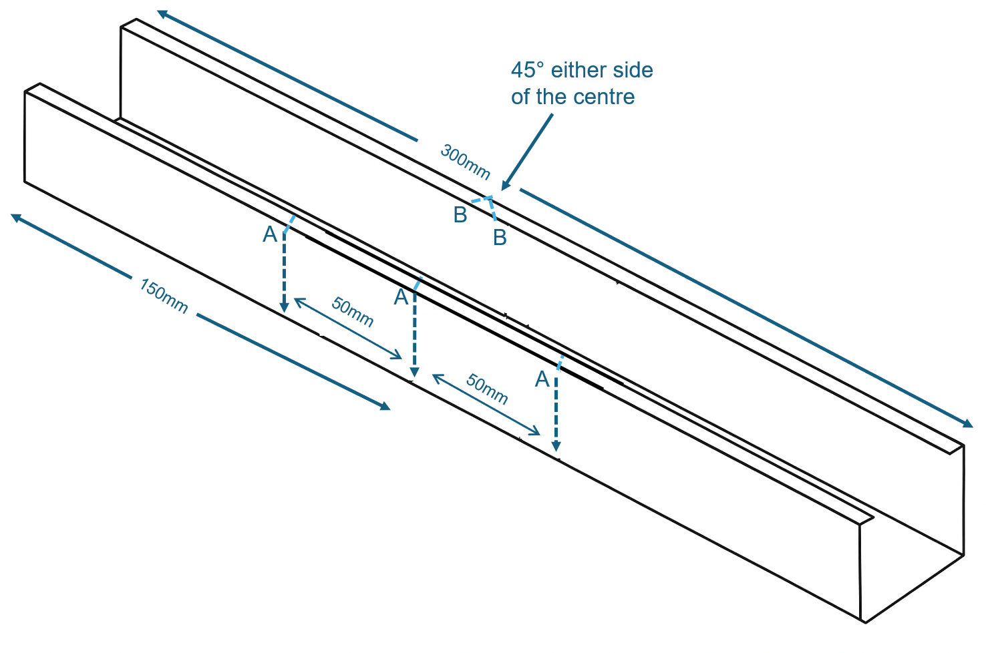
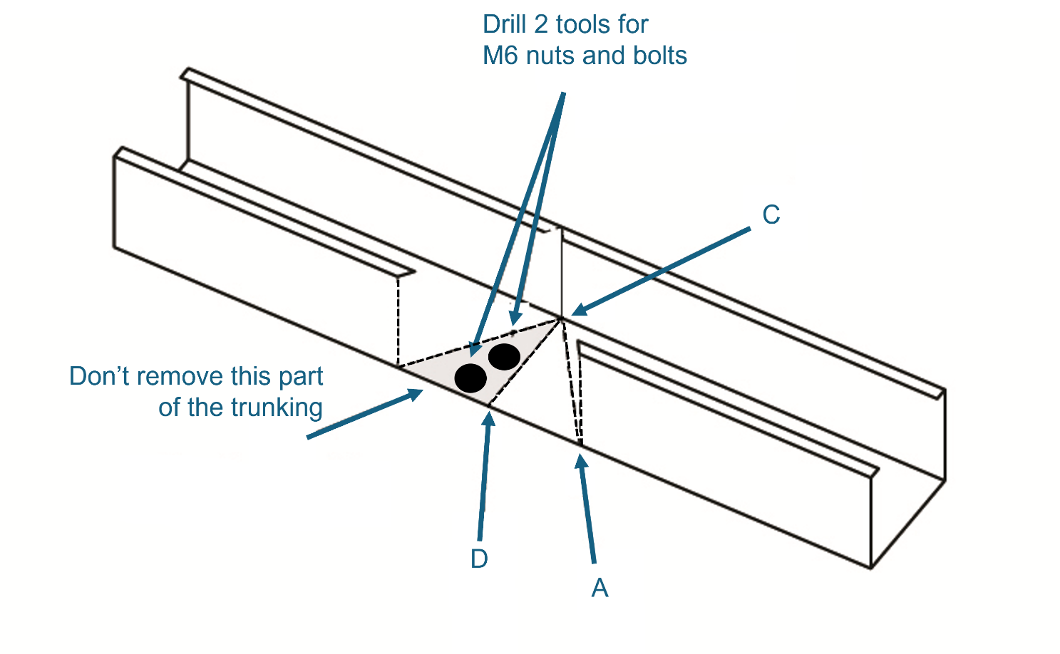

 | ASSESSMENT CRITERIA | Y | N
1 | Selected correct PPE, tools and materials for the task
2 | Correctly completed tool and material lists
3 | Trunking square- and burr-free
4 | Bend marked out correctly from the squared end
5 | Bend marked out correctly on both sides
6 | Bend securely fixed using M6 nuts and bolts
7 | Overall dimensions correct +/- 5mm
8 | Completed a flat 90° bend
9 | End fixing holes correct position and size
10 | Lid is correctly cut, fits bend correctly, and ends are square
11 | Used only the given length of trunking and lid
12 | Completed installation within the target time
13 | Work conformed to the requirements of HASWA/EAWR
 | Totals
Feedback from the task:

Learner reflection
Do you feel confident about this topic? | Yes | I would like more guidance

Task 25: Steel tray – Tee joint
Fabricating a tee joint
Practical task
This task requires you to demonstrate your ability to accurately prepare and join two sections of 100mm steel cable tray to form a tee joint. A tee joint is a fundamental connection in cable tray systems, allowing for branching pathways for cable runs. This task will assess your skills in measuring, cutting, deburring and securely fastening cable tray sections to create a structurally sound and electrically continuous joint. You will need to pay close attention to ensuring that fixings are installed in a manner that will not damage any cables subsequently laid within the tray.
You are to request the materials listed below and carry out the task following the instructions. You must always work in a safe manner and should leave your work area and tools clean and tidy. You must also complete the tools, equipment, and materials checklist (see Annexes).
Materials
- 2 x 400mm of 100mm steel tray (light gauge)
- 3 x 12m M6 roofing nuts and bolts.
Time | 90 minutes
Safety instructions | - Ensure your work area is clear and safe for work to proceed.  - All your work must conform to the Health and Safety at Work Act requirements and Electricity at Work Regulations.  - All practical electrical installation exercises must comply with BS 7671 (IET Wiring Regulations).  - All terminations must be mechanically and electrically sound.
Task instructions | - Wear the correct PPE for the task.  - Complete the material and tool list for the task.  - Prepare work site for installation by ensuring all work areas are free from hazards.  - Mark the position of the tee at the centre point of tray 1 (200mm).  - Measure the width of tray 2 of the tee section accurately.  - Cut the flange on the through section and fold it out.  - Cut away or fold out both flanges on the Tee section of the tray.  - Deburr all cut edges.  - ‘Round off’ all corners.  - Drill holes as required to secure both pieces together.  - Use M6 round head bolts.  - Ensure bolt heads are inside the tray to prevent cable damage.  - Tighten all bolts securely.  - Hand the work to your tutor for marking and assessment.

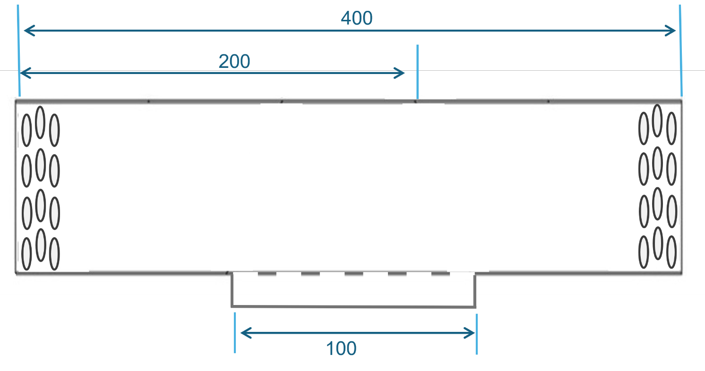
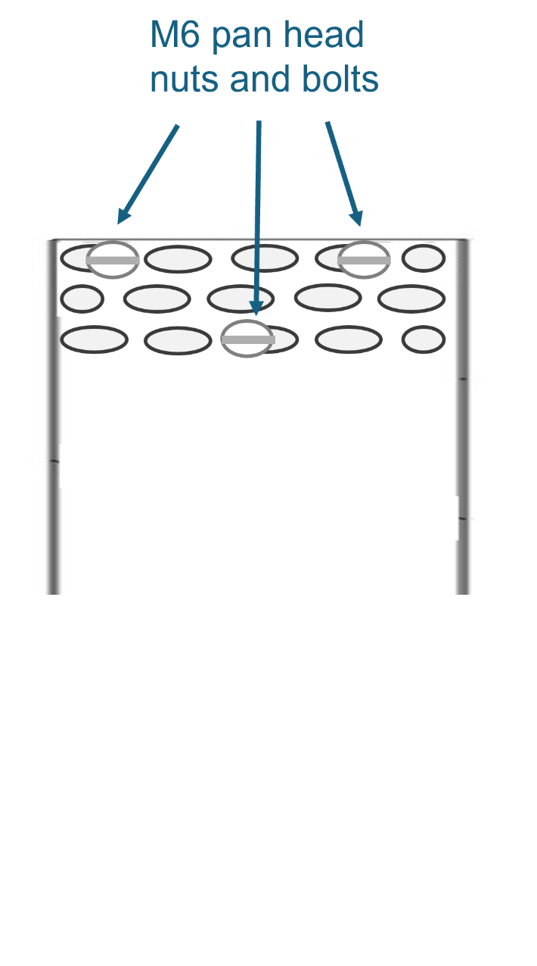
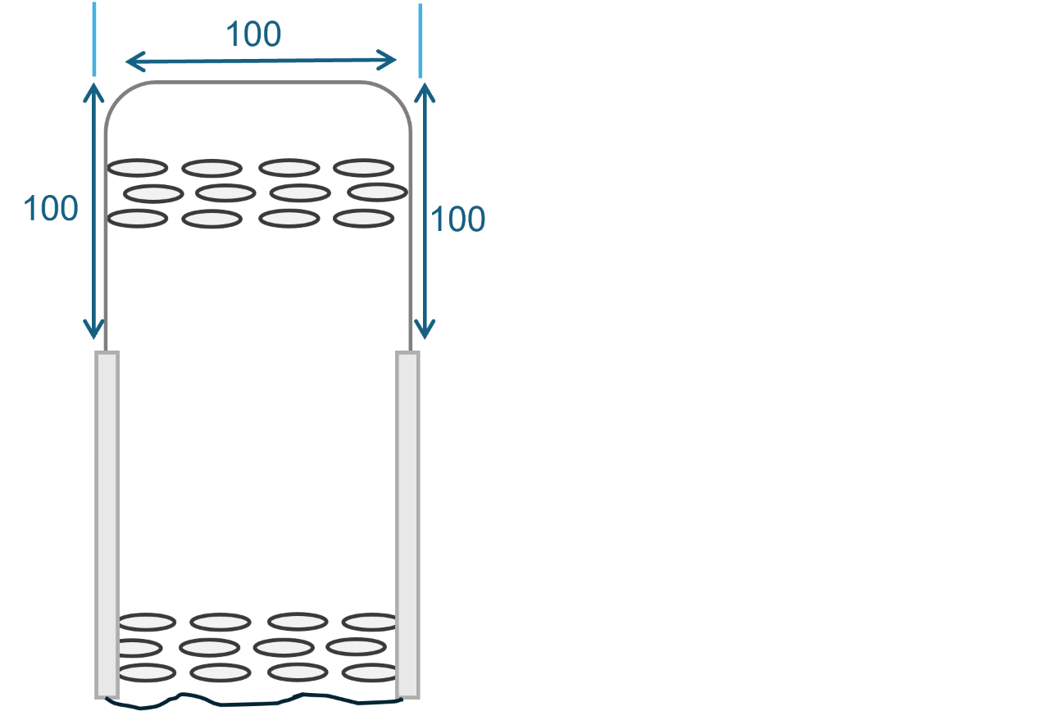

 | ASSESSMENT CRITERIA | Y | N
1 | Selected correct PPE, tools and materials for task
2 | Correctly completed tool and material lists
3 | Cable tray cut to specified dimensions and ends square and smooth
4 | All burrs removed from drilled holes and cut ends
5 | Sets and bends fabricated without gaps
6 | Bolt heads located on the inside of tray on each fabricated section
7 | Nut and bolt fastenings secure
8 | Completed installation within target time
9 | Work conformed to the requirements of HASWA/EAWR
 | Totals
Feedback from the task:

Learner reflection
Do you feel confident about this topic? | Yes | I would like more guidance

Task 26: Steel tray – Gusset bend
Fabricating a 90-degree gusset bend
Practical task
This practical task requires you to demonstrate your ability to accurately measure, mark, cut and form a robust flat 90-degree bend in a steel cable tray, incorporating a gusset for increased structural support. A flat 90-degree bend allows for a change in direction of the cable tray run on the same horizontal plane, and the addition of a gusset reinforces the bend, providing extra strength and rigidity. You are to request the materials listed below and carry out the task following the instructions. You must always work in a safe manner and should leave your work area and tools clean and tidy. You must also complete a tools and equipment and a materials checklist (see Annexes).
Materials
- 550mm of 50mm steel tray (light gauge)
- 8 x 12m M6 roofing nuts and bolts.
Time | 90 minutes
Safety instructions | - Ensure your work area is clear and safe for work to proceed.  - All your work must conform to the Health and Safety at Work Act requirements and Electricity at Work Regulations.  - All practical electrical installation exercises must comply with BS 7671 (IET Wiring Regulations).  - All terminations must be mechanically and electrically sound.
Task instructions | - Wear the correct PPE for the task.  - Complete the material and tool list for the task.  - Prepare work site for installation by ensuring all work areas are free from hazards.  - Mark the square and cut one end of the cable tray.  - From the squared end, mark lines at 200, 300 and 500mm.  - Mark two angled lines at the 200mm and 300mm marks so that the completed angle will be 90°.  - Cut and square the tray at the 500mm mark.  - Cut along these two angled lines and mark the three pieces ‘A’, B’ and ‘C’, as shown in the diagram.  - Make two fillets for joining the cable tray out of tray off cuts.  - Turn section ‘C’ round and rejoin to sections ‘A’ and ‘B’ to form a 90° bend using fillets and M6 pins and nuts.  - Remove burrs and sharp edges and recheck angle and dimensions.  - Ensure bolt heads are inside the tray to prevent cable damage.  - Tighten all bolts securely.  - Hand the work to your tutor for marking and assessment.

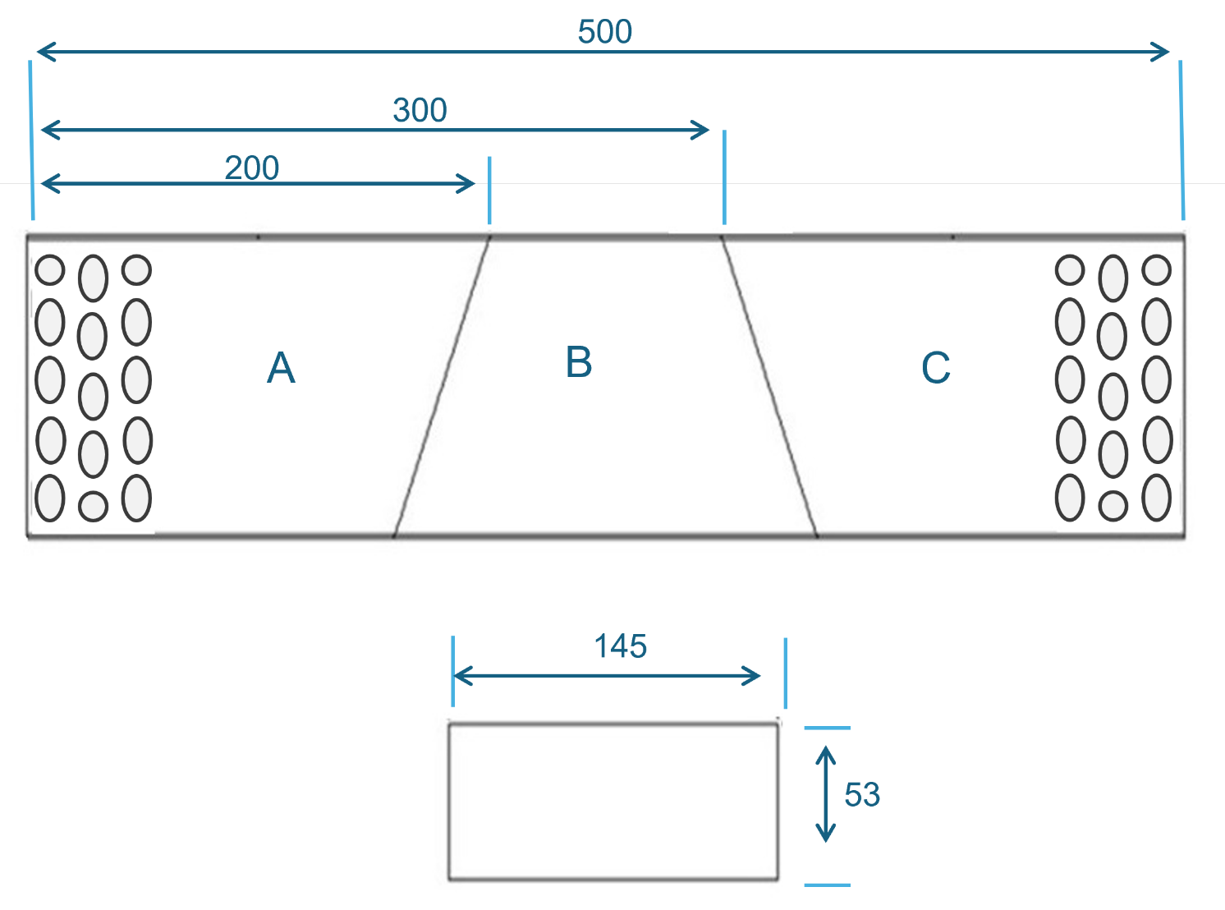

 | ASSESSMENT CRITERIA | Y | N
1 | Selected correct PPE, tools and materials for the task
2 | Correctly completed tool and material lists
3 | Cable tray cut to specified dimensions and ends square and smooth
4 | All burrs removed from drilled holes and cut ends
5 | Sets and bends fabricated without gaps
6 | Bolt heads are located on the inside of the tray on each fabricated section
7 | Nut and bolt fastenings secure
8 | Completed installation within the target time
9 | Work conformed to the requirements of HASWA/EAWR
 | Totals
Feedback from the task:

Learner reflection
Do you feel confident about this topic? | Yes | I would like more guidance

Task 27: Steel basket – 90-degree angle
Fabricating a 90-degree angle
Practical task
This practical fabrication task requires you to demonstrate your ability to accurately prepare and form a 90-degree short radius bend in a 150mm wide steel cable basket. Unlike solid steel cable trays, working with steel cable baskets involves carefully cutting specific wires and manipulating the basket structure to create the desired bend. You are to request the materials listed below and carry out the task following the instructions. You must always work in a safe manner and should leave your work area and tools clean and tidy. You must also complete the tools, equipment, and materials checklist. (see Annexes).
Materials
- 100mm of 150mm steel basket (light gauge)
- 1 x M6 x 20mm nut and bolt and a small clamp plate.
Time | 60 minutes
Safety instructions | - Ensure your work area is clear and safe for work to proceed.  - All your work must conform to the Health and Safety at Work Act requirements and Electricity at Work Regulations.  - All practical electrical installation exercises must comply with BS 7671 (IET Wiring Regulations).  - All terminations must be mechanically and electrically sound.
Task instructions | - Wear the correct PPE for the task.  - Complete the material and tool list for the task.  - Prepare work site for installation by ensuring all work areas are free from hazards.  - Identify and mark the wires on the bottom and edges of the basket that need to be cut.  - Using the wire cutters, carefully cut the marked wires on the bottom and edges of the steel cable basket. Ensure clean cuts without leaving sharp protrusions that could damage cables.  - Carefully turn the cable basket 90° horizontally at the prepared section. Manipulate the remaining wires to create a smooth and consistent bend with a short radius.  - Position the medium connecting strip (L=550mm) to span across the joint created by the 90° bend, ensuring it overlaps both sections of the basket.  - Use the joint clamp to attach the connecting strip securely to both sides of the bend.  - Use the joint clamp to further secure the connection at the bend itself, as per the accessory standards for a 150mm wide basket.  - Firmly tighten all the screw joints to create a mechanically strong and stable 90° bend.  - Ensure that the nuts are installed on the outside of the tray, so they do not damage any cables laid inside.  - Inspect to ensure a smooth 90-degree turn with no sharp edges or loose wires that could pose a hazard to cables.  - Hand the work to your tutor for marking and assessment.
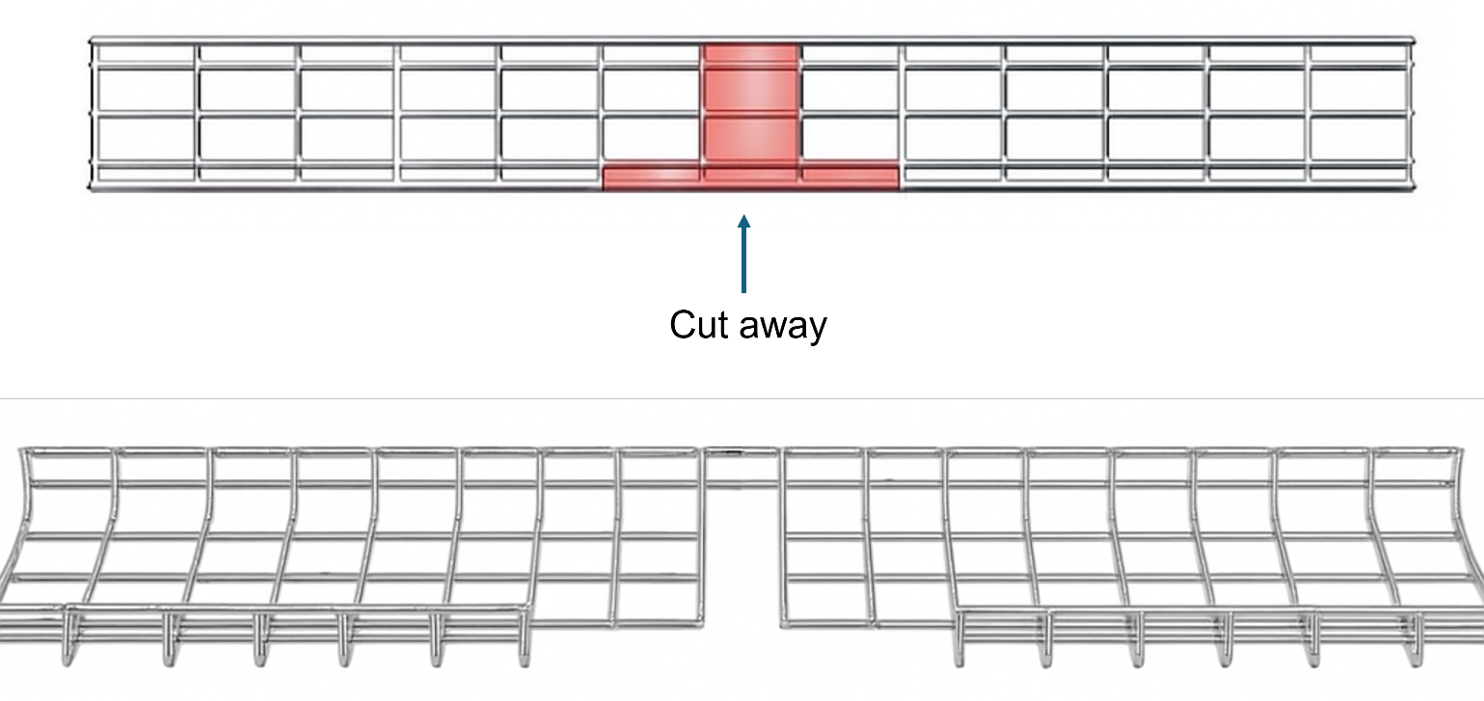

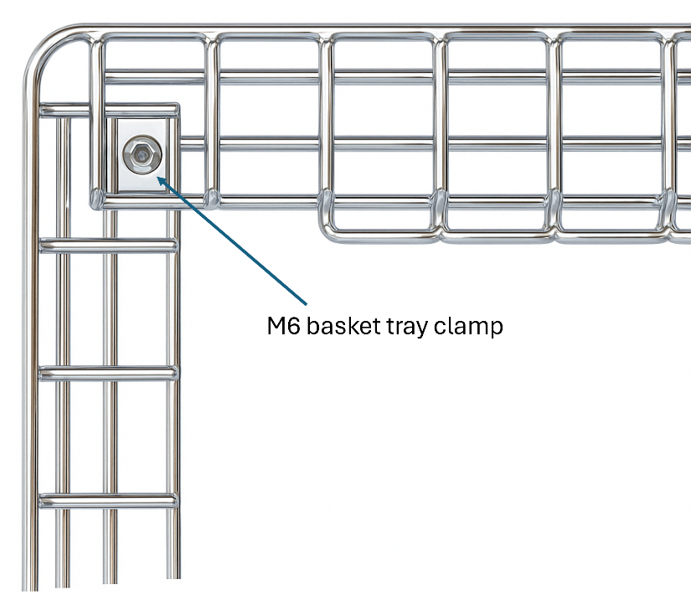

 | ASSESSMENT CRITERIA | Y | N
1 | Selected correct PPE, tools and materials for the task
2 | Correctly completed tool and material lists
3 | Cable basket cut to specified dimensions and ends square and smooth
4 | All burrs removed from drilled holes and cut ends
5 | Sets and bends fabricated without gaps
6 | Bolt heads located on the outside of the basket
7 | Nut and bolt fastenings secure
8 | Completed installation within the target time
9 | Work conformed to the requirements of HASWA/EAWR
 | Totals
Feedback from the task:

Learner reflection
Do you feel confident about this topic? | Yes | I would like more guidance

Task 28: Steel basket – Tee joint
Fabricating a flat tee joint
Practical task
This practical fabrication task requires you to demonstrate your ability to accurately prepare and form a flat tee joint in a 150mm wide steel cable basket.
You are to request the materials listed below and carry out the task following the instructions. You must always work in a safe manner and should leave your work area and tools clean and tidy. You must also complete tools and equipment and a materials checklist. (see Annexes).
Materials
- 1000mm of 150mm steel basket (light gauge).
- 3 x M6 x 20mm nut and bolt and clamp plate.
Time | 60 minutes
Safety instructions | - Ensure that your work area is clear and safe for work to proceed.  - All your work must conform to the Health and Safety at Work Act requirements and Electricity at Work Regulations.  - All practical electrical installation exercises must comply with BS 7671 (IET Wiring Regulations).  - All terminations must be mechanically and electrically sound.
Task instructions | - Wear the correct PPE for the task.  - Complete the material and tool list for the task.  - Prepare work site for installation by ensuring all work areas are free from hazards.  - Identify on basket (piece 1) where the T-joint will be formed. This is where piece 2 will connect.  - Piece 1: Measure the width of the 150mm cable basket and mark out a section on the side of the main basket that is slightly wider than 150mm and extends from the top edge down.  - Ensure your marks align with the existing mesh grid, cut along the marked lines on the main basket, and remove a section of the side wires and potentially some top and bottom wires.  - Debur to smooth down any sharp edges or burrs.  - Piece 2: Position it where it will connect to piece 1 and trim some of the longitudinal wires on the connecting end.  - Ensure the two pieces are aligned correctly, forming a neat 'T' shape. The top edges should ideally be level, and the sides should be as flush as possible.  - Place couplers across the joint on both sides and tighten, ensuring all are firm to prevent movement.  - Check for any remaining sharp edges or burrs and deburr them thoroughly.  - Ensure the joint is rigid and stable, with no excessive movement.  - Hand the work to your tutor for marking and assessment.
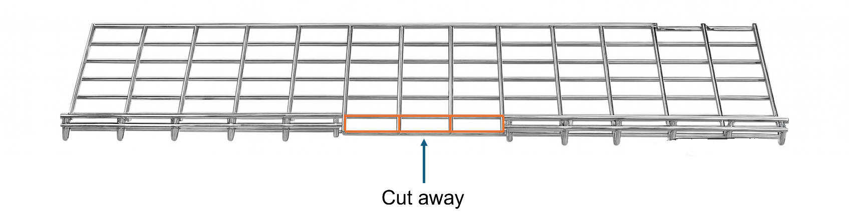
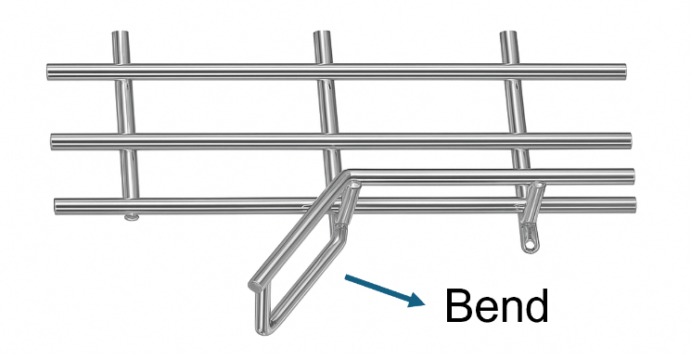

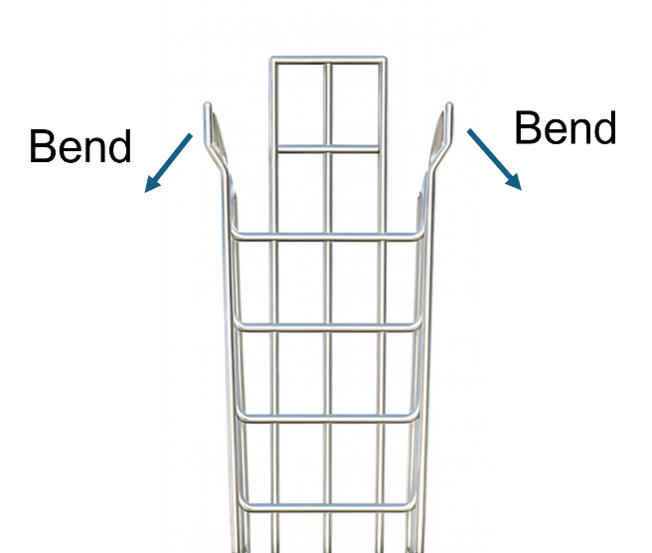
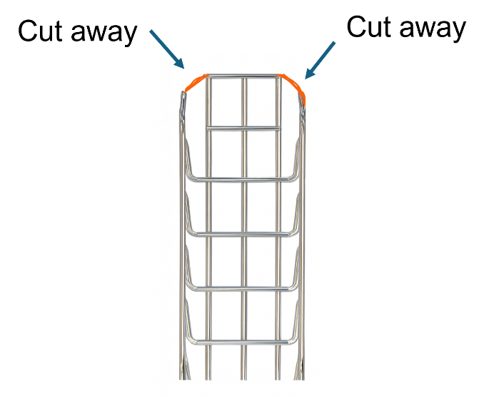

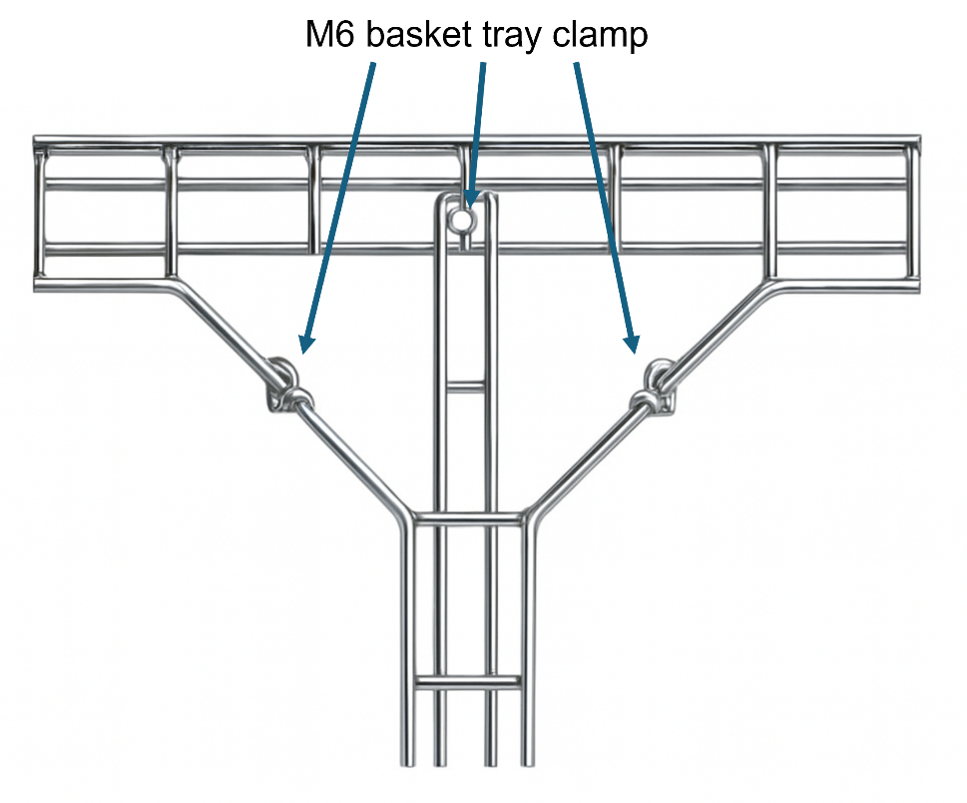

 | ASSESSMENT CRITERIA | Y | N
1 | Selected correct PPE, tools and materials for task
2 | Correctly completed tool and material lists
3 | Cable basket cut to specified dimensions, ends square and smooth
4 | All burrs removed from drilled holes and cut ends
5 | Sets and bends fabricated without gaps
6 | Bolt heads located on the outside of basket
7 | Nut and bolt fastenings secure
8 | Completed installation within target time
9 | Work conformed to the requirements of HASWA/EAWR
 | Totals
Feedback from the task:

Learner reflection
Do you feel confident about this topic? | Yes | I would like more guidance

Task 29: Function and application of electronic components in security and emergency systems
Complete the following activities to demonstrate your understanding of electronic components used in CCTV, intruder alarm, fire alarm, door entry, and emergency light systems. Write your answers clearly in the space provided.
a: Fill in the blanks
1. The primary function of a __________ in a CCTV system is to convert light into electrical signals for video recording.
2. A __________ is used in fire alarm systems to detect changes in temperature.
3. __________ lights are designed to provide illumination during a power failure.
4. A __________ is an electronic component that allows current to flow in only one direction.
5. In a door entry system, a __________ is used to unlock the door electronically when access is granted.
Word bank: diode, camera sensor, solenoid, emergency, heat sensor

b: Multiple choice questions
1. What type of sensor is most commonly used in intruder alarm systems to detect motion?
A. Infrared Sensor
B. Smoke Detector
C. Pressure Sensor
D. Temperature Sensor
2. Which component in a CCTV system stores recorded footage?
A. Lens
B. DVR/NVR
C. Microphone
D. LED
3. What is the role of a relay in an emergency lighting system?
A. To convert DC power to AC power
B. To switch circuits when a fault is detected
C. To store electrical energy
D. To step down high voltage to a usable level

4. Which of the following is an example of an output device in an intruder alarm system?
A. PIR Sensor
B. Siren
C. Control Panel
D. Transformer
5. What is the purpose of a capacitor in an emergency lighting system?
A. To reduce voltage fluctuations
B. To increase current flow
C. To amplify signals
D. To act as a backup power source

c: Short essay questions
1. Explain how a smoke detector works and describe its importance in a fire alarm system. (50-100 words)
2. Discuss the role of a control panel in an intruder alarm system and why it is critical to system functionality. (50-100 words)

- Describe how emergency lighting systems contribute to safety in public buildings during a power failure. (50-100 words)

d: Matching

Match the component to its function:
A PIR sensor __________
B Buzzer __________
C Relay __________
D Battery backup __________
E) Camera lens __________

Options:
1. Provides optical zoom for better focus
2. Provides power during a mains failure
3. Detects motion in a specified area
4. Produces audible alerts
5. Switches circuits based on input signals

e. Labelling circuit components

Below is a diagram of a basic sounder. Label the components in it:

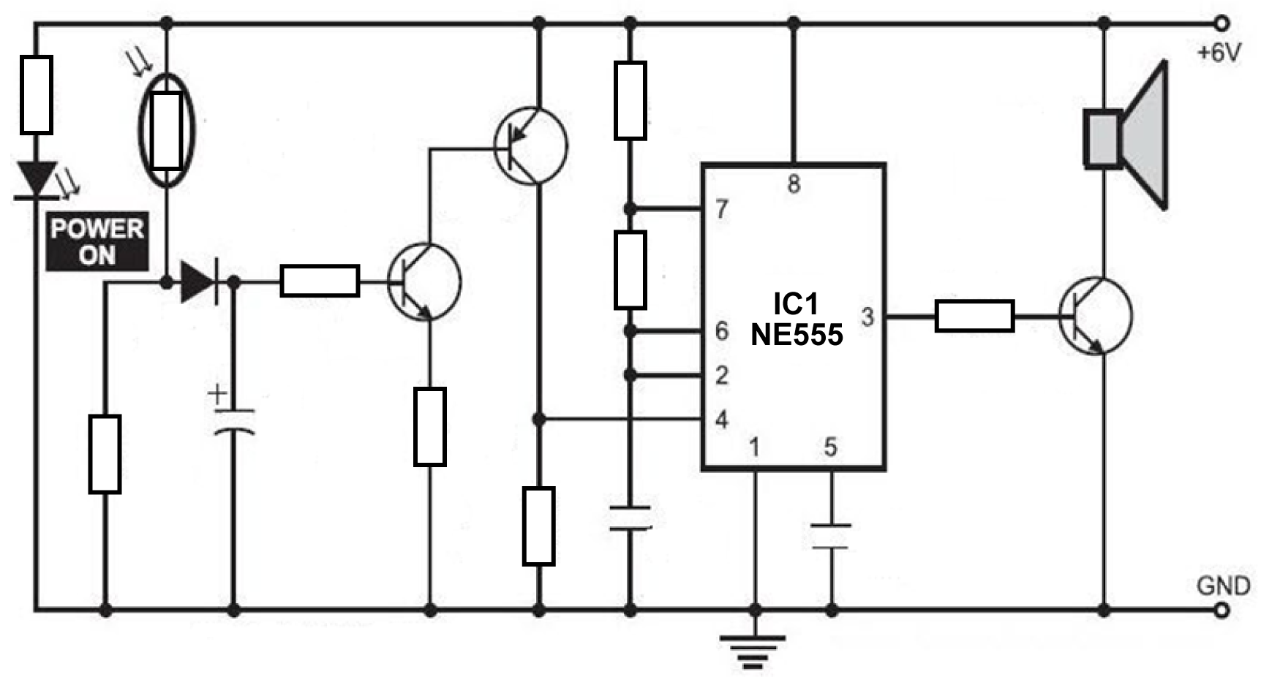
18
17
11
14
13
12
15
16
1
2
5
4
3
6
7
10
9
8
Identify each component
1 |  | 10
2 |  | 11
3 |  | 12
4 |  | 13
5 |  | 14
6 |  | 15
7 |  | 16
8 |  | 17
9 |  | 18

Learner reflection
Do you feel confident about this topic? | Yes | I would like more guidance

Task 30: Installation and commissioning of emergency lights, CCTV, intruder alarms, fire alarms, and door entry systems
  - Fill in the blanks
Fill in the blanks with the appropriate words from the list provided below.
- The primary purpose of ___________ lighting is to provide illumination during power outages.
- A ___________ system is used to monitor activities within a designated area using cameras.
- An ___________ alarm is activated to alert individuals about unauthorised access or breaches.
- Before commissioning any system, it is essential to ___________ all components to ensure they are functioning correctly.
- A ___________ system enables authorised personnel to control access to a building or property.

Word bank: CCTV, intruder, test, emergency, door entry

  - Multiple choice questions
Choose the correct answer for each question by circling the letter corresponding to the best option.
- Which type of emergency lighting is specifically designed for evacuation routes?
A. Standby lighting
B. Escape route lighting
C. Open area lighting
D. Decorative lighting

- Which of the following is a key feature of a CCTV system?
A. Automatic fire suppression
B. Video recording and playback
C. Audible siren
D. Smoke detection

- What is the primary purpose of commissioning a fire alarm system?
A. To design a suitable layout
B. To ensure the system is installed according to the manufacturer's specifications
C. To test the response time of emergency services
D. To verify the system is operational and compliant

  - Short essay questions
Answer the following questions in 2–3 sentences each.
- Explain why regular maintenance is crucial for the proper functioning of emergency lighting systems.

- Describe how a door entry system contributes to building security and give an example of its application.

- Discuss the importance of testing an intruder alarm system after installation.

Learner reflection
Do you feel confident about this topic? | Yes | I would like more guidance

Task 31: Electronic protection systems
These activities explore the key principles applicable to electronic protection systems, such as fire alarms, CCTV, intruder alarms, door entry systems, and emergency lighting.

a: Fill in the blanks
Complete the following sentences with the correct terms:
- The primary purpose of a _________ is to monitor and capture video footage for surveillance purposes.
- An ________ system is designed to detect unauthorised access or entry into a building or area.
- Emergency lighting must activate automatically in the event of a _________ failure to ensure safe evacuation.
- Fire alarm systems often include ________ detectors and manual call points.
- In a door entry system, the _________ unit is used to communicate with visitors and grant or deny access.

b: Multiple choice questions
Select the correct answer for each question:
- Which type of sensor is commonly used in motion detection for intruder alarms?
A. Heat sensor
B. Passive Infrared (PIR) sensor
C. Smoke sensor
D. Ultrasonic sensor
- What is the standard voltage supply for most emergency lighting systems in the UK?
A. 110V
B. 230V
C. 12V
D. 400V
- Which type of fire detection system uses a network of sensors to pinpoint the exact location of a fire?
A. Conventional system
B. Addressable system
C. Wireless system
D. Analogue system

- What does CCTV stand for?
A. Central Control Television
B. Closed Circuit Television
C. Controlled Camera Television
D. Continuous Camera Television
- What governs emergency lighting requirements in the UK?
A. The Electricity at Work Regulations 1989
B. The Fire Safety Order 2005
C. BS 5839
D. BS 5266
c: Short answer question
Explain the importance of regular maintenance and testing of fire alarm systems and describe the potential consequences of neglecting this responsibility.

d: Labelling diagram
Below is a diagram of a basic fire alarm system. Label the following components on the diagram:
- Control panel
- Smoke detector
- Heat sensor
- Manual call point
- Alarm sounder
- Power supply
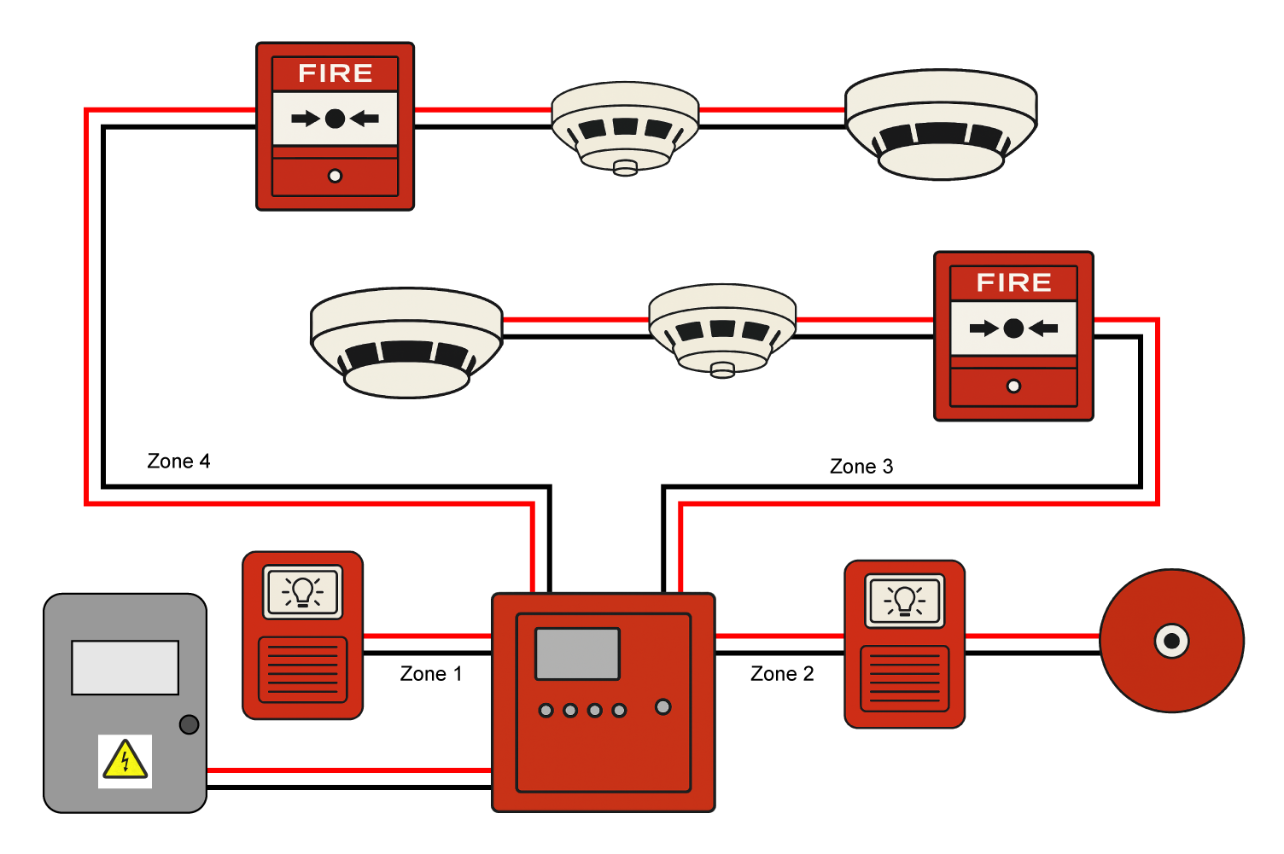

e: True or False
- Emergency lighting is only required in commercial buildings. True/False
- PIR sensors detect changes in heat patterns. True/False
- Addressable fire alarm systems are more suitable for large buildings. True/False
- CCTV systems only work during daylight hours. True/False
- Door entry systems can integrate with intruder alarms. True/False

f: Matching
Match the components with their functions:
Component | Function
Smoke detector | a) Provides visual surveillance
Control panel | b) Activates during a power outage
CCTV camera | c) Detects smoke particles in the air
Emergency lighting | d) Alerts occupants to evacuate
Alarm sounder | e) Monitors and controls the system

Learner reflection
Do you feel confident about this topic? | Yes | I would like more guidance

Task 32: Fixing devices
For each of the following examples, list the suitable fixing devices you would use:

1. Metal-clad socket outlet to plastered brick wall

2. Ceiling rose to plasterboard ceiling

3. Distribution panel to a concrete floor

4. Storage heater to plastered block wall

5. Metal back box to thermalite block

6. Mini trunking to plastered block wall

7. Consumer unit to plasterboard wall

9. SWA cable to RSJ beam

Practical task
You must attach a fire alarm panel from the stores to a plasterboard wall.

Insert equipment required
Insert equipment required | Amount

Complete method statement below
________________________________________________________________________________________________________________________________________________________________________________________________________________________________________________________________________________________________________________________________________________________________________________________________________________________________________________________________________________________________________________________________________________________________________________________________________________________________________________________________________________________________________________________________________________________________________________________

 | ASSESSMENT CRITERIA |  | Y | N
1 | Selected correct PPE, tools and materials for the task
2 | Correctly completed tool list
3 | Other?
 |  | Totals

Learner reflection
Do you feel confident about this topic? | Yes | I would like more guidance

Task 33: Trunking
Answer the following questions:
1. What 2 main materials is trunking made from?

2. What regulation covers the fire barriers within a trunking?

3. What type of screws should be used to fix trunking to a wall?

4. Why should cable supports be used in trunking on vertical runs?

5. Why is it not advisable to fit trunking with the lid on the bottom?

6. What are the requirements that allow cables of voltage bands I and II to be contained within the same wiring system?

Learner reflection
Do you feel confident about this topic? | Yes | I would like more guidance

Task 34: Storage and transportation requirements
For each of the following materials or plant, state the transportation and storage needs.
An example has been completed for you.
Material/Plant |  | Transportation | Storage
1 | Small cables normally  delivered on small reels | Wholesaler small van | Site office or compound
2 | 150mm x 150mm galvanised trunking
3 | Large cables supplied on drums of diameter 2m
4 | Aluminium towers to be erected on site
5 | Temporary supply cables (110V) for lighting and power
6 | 230/110V 2 kVA transformers
7 | Large switchgear panels measuring 2m high, 2m deep and 1m deep
8 | Diesel fuel reserves for mobile standby generator
9 | Mobile hoists
10 | Small components and accessories

Learner reflection
Do you feel confident about this topic? | Yes | I would like more guidance

Task 35: Organising and overseeing work programmes
Fill in the gaps in the table below. An example has been completed to help you.
 | Situation | Action to be taken | Need to be aware of
1 | An installation which requires specialist skills or knowledge | Make sure that you plan to have sufficient electricians on site with the necessary skills for the job at hand. Check CVs of staff if not personally known to you. | Staff who are pushed onto you, or recommended to you by others, staff who claim to have the skills and knowledge but then fail to do the work properly, putting the job behind schedule
2 | Specification variations
3 | Work by other services including other trades and public services.
4 | Material delivery
5 | Expected adverse weather conditions
6 | Tools and plant storage

Learner reflection
Do you feel confident about this topic? | Yes | I would like more guidance
Annex A
Name: | Practical Task No:
Date:

Materials/Tools/ Equipment | Quantity


Annex B



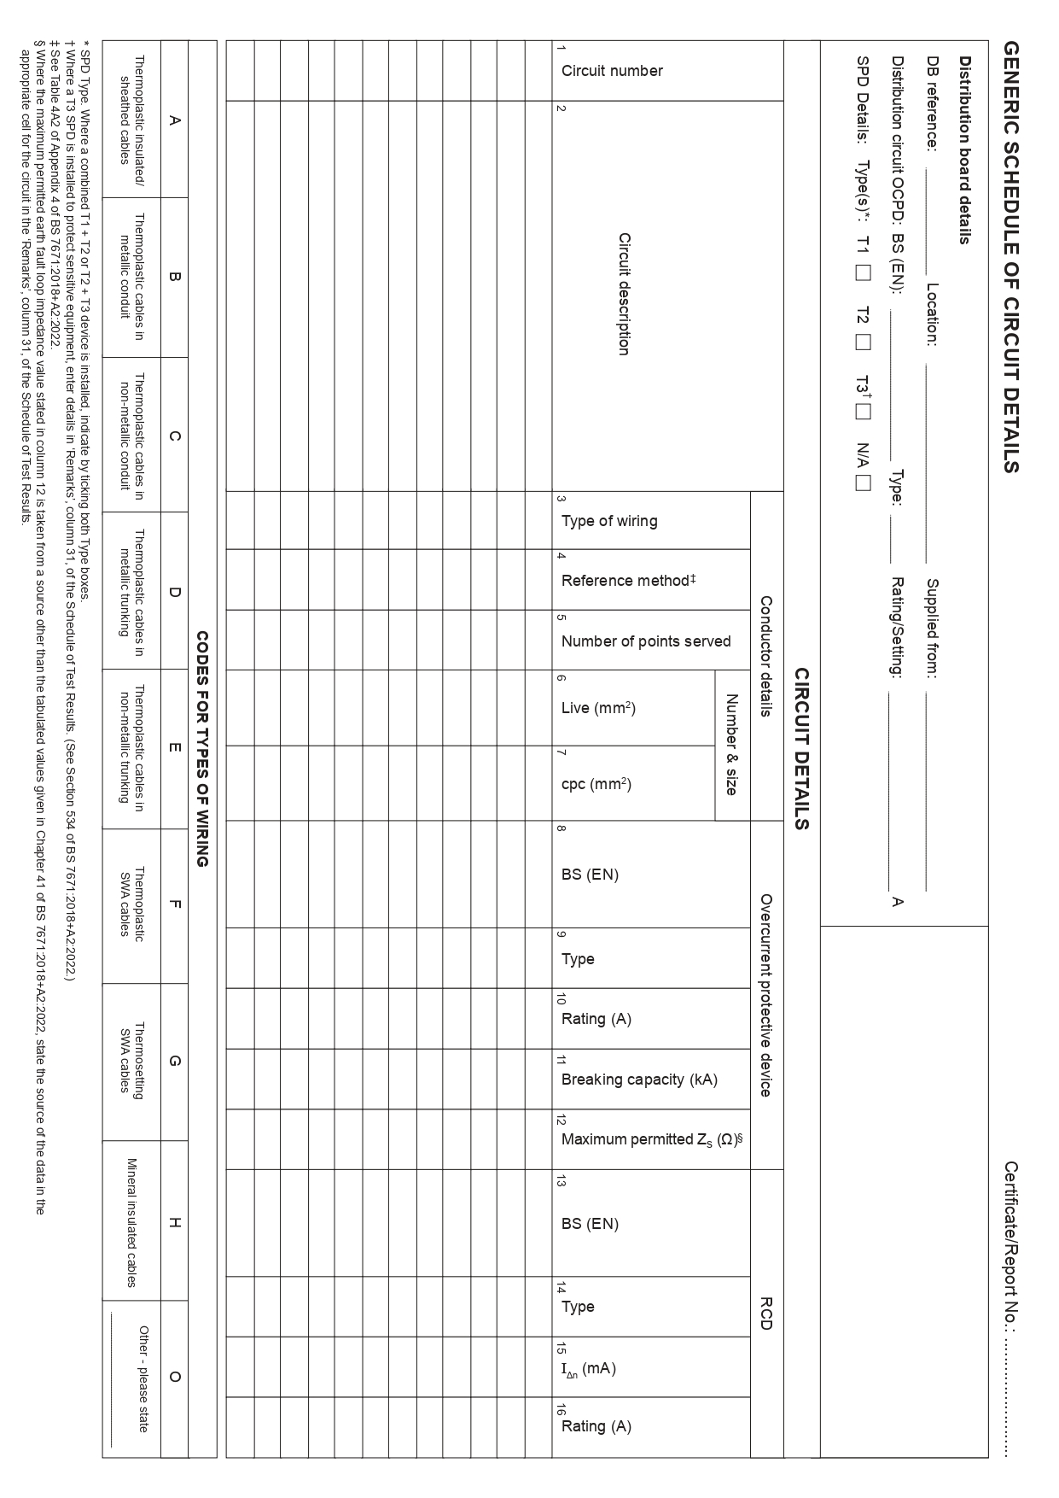

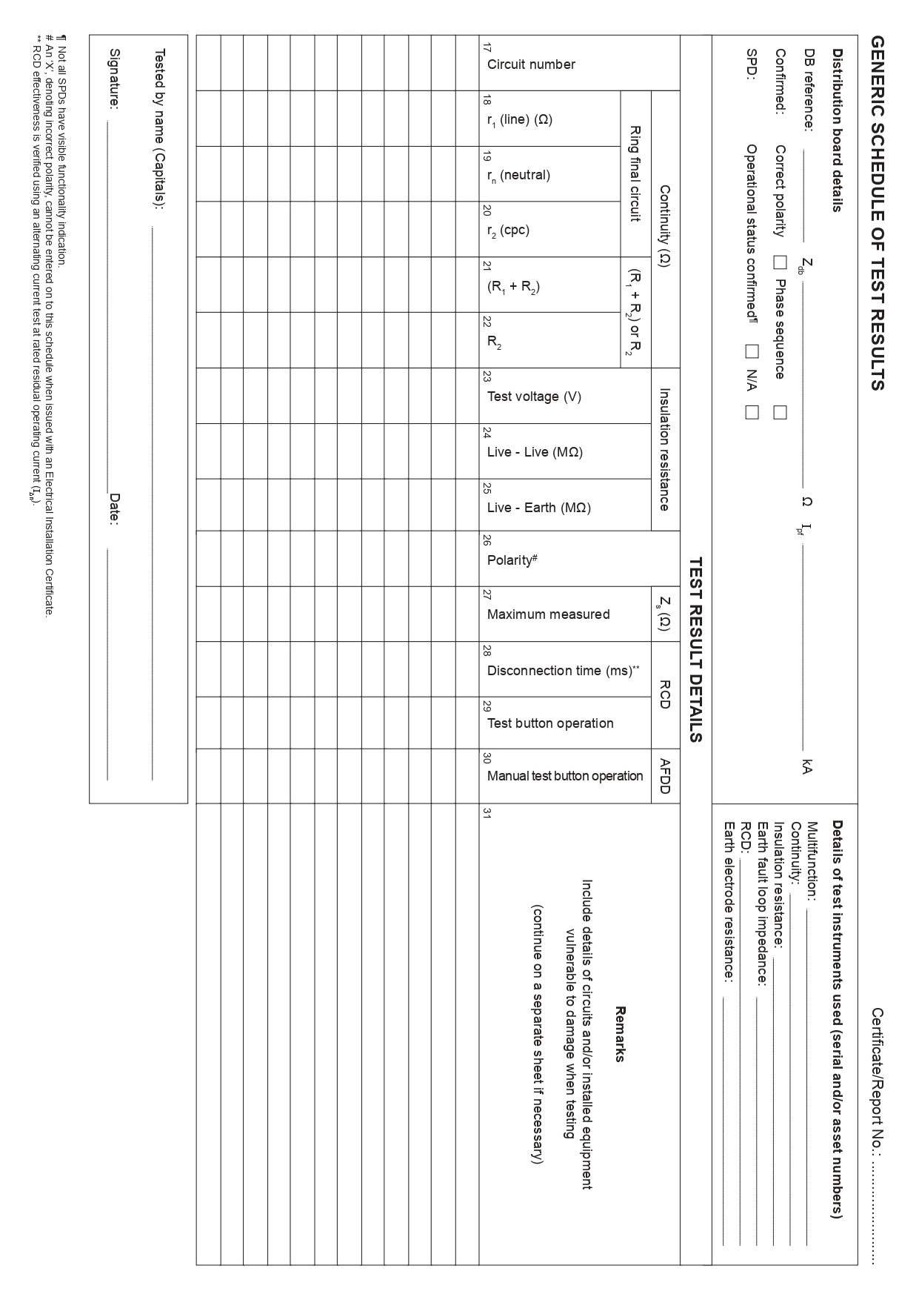
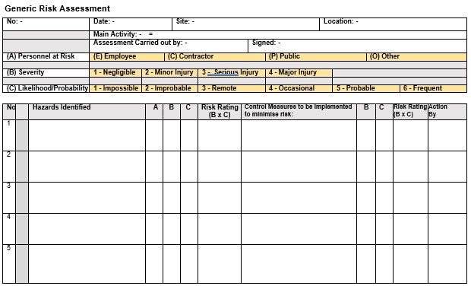
Annex C

Emergency lighting logbook
Date | Location | Pass/Fail | Reason for fail | Action required | Action completed by | Date completed

Fire Alarm logbook
Date | Fire alarm system |  | Automatic door release Yes/No | Remedial action needed | Date complete | Engineers signature
Date | Location/ID number | Satisfactory  Yes/No

Copyright in this document belongs to and is used under licence from the Department for Education, © 2025.

‘T-LEVELS’ and ‘T Level’ are registered trademarks of the Department for Education.

WJEC is authorised by the Department for Education to develop and deliver this T Level Technical Qualification.

WJEC operates in England under the name Eduqas which is a registered trademark of WJEC.

Acknowledgements
p.5 VladimirSorokin / iStock / Getty Images; p.5 ratmaner / iStock / Getty Images; p.5 mertkantekin / iStock / Getty Images; p.5 Mustafa Ovec / iStock / Getty Images; p.11 Wavebrak Media / Freepik.com; p.11 Macrovector / Freepik.com; p.11 mrsiraphol / Freepik.com; p. 11 EyeEm / Freepik.com; p.11 Image by Freepik.com; p.11 Mihalec / Freepik.com; p.12 nipastock / iStock / Getty Images; p.12 indigolotos / iStock / Getty Images; p.12 harsh2030fp / Freepik.com; p.12 shutswis / iStock / Getty Images; p.12 FabrikaCr / iStock / Getty Images; p.14 Thanhtungdo / Freepik.com; p.14 Michaklootwijk / iStock / Getty Images; p.26 unomat / iStock / Getty Images; p.26 popovaphoto / iStock / Getty Images; p.26 A_M_Radul / iStock / Getty Images; p.26 brgfx / Freepik.com; p.27 cynoclub / Freepik.com; p.27 sergeyskleznev / iStock / Getty Images; p.27 Ruslan Sidorov / iStock / Getty Images; p.28 Kamiphoto / Freepik.com; p.28 karayuschij / iStock / Getty Images; p.28 Nigel Stripe / iStock / Getty Images; p.28 nonillion / iStock / Getty Images; p.29 Василий Авраменко / iStock / Getty Images; p.29 Veni vidi...shoot / iStock / Getty Images; p.29 Sergii Zhmurchak / iStock / Getty Images; p.29 Andrei Berezovskii / iStock / Getty Images; p.29 doomu / iStock / Getty Images; p.30 Nikonlike / iStock / Getty Images; p.30 Zheka-Boss / iStock / Getty Images; p.31 macrovector / Freepik.com; p.41 Peter Togel / iStock / Getty Images; Annex Forms from The IET (2015) BS 7671:2008 + A3:2015 Model Forms [online] London: The Institution of Engineering and Technology.

