T Level Technical Qualification in Building Services Engineering for Construction
(Level 3)

Skills Practice Workbook for Learners

Low Carbon Engineering
Practical Training

Learner name:.

Centre name:.

Contents
Task summary and progress tracker 3
Task 1: Heating design 1 – Heat loss 4
Task 2: Heating design 2 – Heat loss 7
Task 3: Heating design 1 – Radiator sizing 10
Task 4: Heating design 2 – Radiator sizing 11
Task 5: Heating design 1 – Pipe sizing 12
Task 6: Heating design 2 – Pipe sizing 13
Task 7: Heating design 1 – Pressure loss 14
Task 8: Heating design 2 – Pressure loss 15
Task 9: Heating design 1 – Air source heat pump sizing 16
Task 10: Heating design 2 – Air source heat pump sizing 18
Task 11: Heating design 1 – Heat pump selection 20
Task 12: Heating design 2 – Heat pump selection 22
Task 13: Hot Water Requirements 1 24
Task 14: Hot Water Requirements 2 26
Task 15: Identification of key components in an air source heat pump installation 28
Task 16: Heat pump siting 36
Task 17: Anti-vibration mounts and level 39
Task 18:Pipe up 41
Task 19: Schematics 43
Task 20: Glycol levels 45
Task 21: Setting the flow rate 47
Task 22: Weather compensation curve 49
Task 23: Setting the controls 56
Task 24: Flow fault alarm 58
Task 25: Refrigerant low pressure fault alarm 62
Task 26: Lukewarm heating and incorrect hot water operation 65
Task 27: Legionella fault alarm 68
Task 28: Incorrect system performance, energy consumption and occupant comfort 70
Task 29: Planned annual service on an air source heat pump system 75

Task summary and progress tracker
 | Task | Page number | Date complete
 | Outcome 2: Design low carbon heating and hot water systems
1 | Heating design 1 – Heat loss
7 | Heating design 2 – Heat loss
2 | Heating design 1 – Radiator sizing
8 | Heating design 2 – Radiator sizing
3 | Heating design 1 – Pipe sizing
9 | Heating design 2 – Pipe sizing
4 | Heating design 1 – Pressure loss
10 | Heating design 2 – Pressure loss
5 | Heating design 1 – Air source heat pump sizing
11 | Heating design 2 – Air source heat pump sizing
6 | Heating design 1 – Heat pump selection
12 | Heating design 2 – Heat pump selection
13 | Hot Water Requirements 1
14 | Hot Water Requirements 2
15 | Identification of key components in an air source heat pump installation
 | Outcome 3: Install low carbon heating and hot water systems
16 | Heat pump siting
17 | Anti-vibration mounts and level
18 | Pipe up
19 | Schematics
 | Outcome 4: Commission low carbon heating and hot water systems
20 | Glycol levels
21 | Setting the flow rate
22 | Weather compensation curve
23 | Setting the controls
 | Outcome 5: Maintain low carbon heating and hot water systems
24 | Flow fault alarm
25 | Refrigerant low pressure fault alarm
26 | Lukewarm heating and incorrect hot water operation
27 | Legionella fault alarm
28 | Incorrect system performance, energy consumption and occupant comfort
29 | Planned annual service on an air source heat pump system

Heating design tasks:
These training tasks help Low Carbon T Level learners develop core heating design skills. They focus on heat loss, system sizing, and low-carbon technologies through practical, real-world scenarios.

Task 1: Heating design 1 – Heat loss
Use the drawings and information in the tables below and complete the radiator and pipework sizing requirements.
The property is in Yorkshire and has a design outdoor temperature of –3℃ and a thermal comfort temperature of 21℃.
The room has 2 external walls (numbered 1 and 2). The ceiling height is 2.4m and the walls are made of solid stone, unplastered with a U Value of 1.7wm2/k
The window in wall 1 has a U value of 2.6wm2/k and is 1m x 2.1m
An air permeability test has been completed, and the room has an air change rate of 0.5ACH
The property currently has an air source heat pump installed to provide thermal comfort, with a flow temperature of 45℃ and a return temperature of 40℃, with the system filled with water.
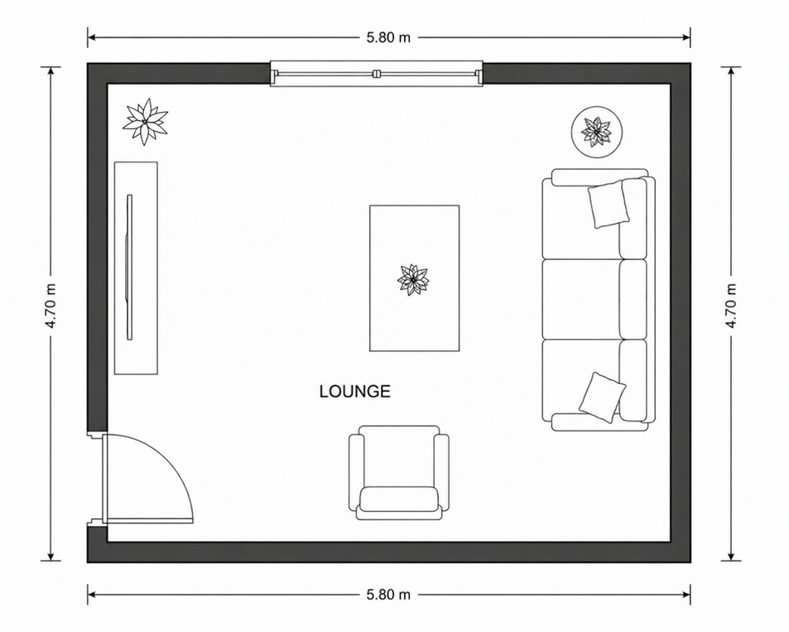
1

1

2
2

Fabric heat loss
Wall | Height (m) | Length (m) | U value | Delta T | Heat loss Kilowatts (KW)
1
2
Window

Calculation


Ventilation heat loss
Room | Height (m) | Length (m) | Width (m) | Air change per hour (ACH) | Delta T | Heat loss Kilowatts (KW)
Lounge

Calculation

Total room heat loss
Fabric heat loss | Ventilation heat loss | Total room heat loss  (Kilowatts)

Learner reflection
Do you feel confident about this topic? | Yes | I would like more guidance

Task 2: Heating design 2 – Heat loss
Use the drawings and information in the tables below and complete the radiator and pipework sizing requirements.
The property is in Scotland and has a design outdoor temperature of –5℃ and a thermal comfort temperature of 21℃.
The room has 2 external walls (numbered 1 and 2). The ceiling height is 2.4m and the walls are made of 200mm breeze with no cavity and a U Value of 1.9 wm2/k
The window is 1.3m x 2.4m and has a U value of 3.1wm2/kAn air permeability test has been completed, and the room has an air change rate of 0.5ACH
The property currently has an air source heat pump installed to provide thermal comfort with a flow temperature of 50℃ and a return temperature of 45℃ with the system filled with water.
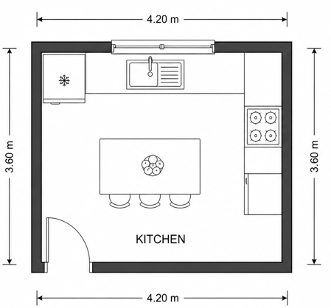
1

2

Fabric heat loss
Wall | Height (m) | Length (m) | U value | Delta T | Heat loss Kilowatts (KW)
1

2

Window

Calculation

Ventilation heat loss
Room | Height (m) | Length (m) | Width (m) | Air change per hour (ACH) | Delta T | Heat loss Kilowatts (KW)
Lounge

Calculation

Total room heat loss
Fabric heat loss | Ventilation heat loss  Kilowatts (kW) | Total room heat loss  Kilowatts (KW)

Learner reflection
Do you feel confident about this topic? | Yes | I would like more guidance

Task 3: Heating design 1 – Radiator sizing
Flow temperature ℃ | Return temperature ℃ | Mean water temperature ℃

Calculation

Mean water temperature ℃ | Room design temperature ℃ | Mean water – Air temperature (MWT-AT)

Using the correction factor table below, use your calculated MWT-AT to size the required output of the lounge radiator (to the nearest whole number away from 50).
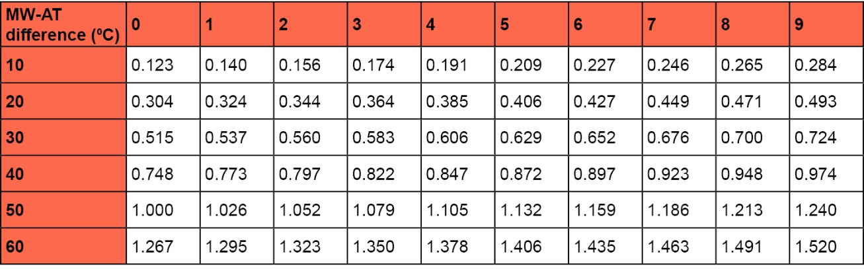
MWT-A | Correction factor | Calculation | Radiator output required Kilowatts (KW)

Learner reflection
Do you feel confident about this topic? | Yes | I would like more guidance

Task 4: Heating design 2 – Radiator sizing
Flow temperature | Return temperature ℃ | Mean water temperature ℃

Calculation

Mean water temperature ℃ | Room design temperature ℃ | Mean water – Air temperature (MWT-AT)

Using the correction factor table below, use your calculated MWT-AT to size the required output of the lounge radiator (to the nearest whole number away from 50).

MWT-AT | Correction factor | Calculation | Radiator output required Kilowatts (KW)

Learner reflection
Do you feel confident about this topic? | Yes | I would like more guidance

Task 5: Heating design 1 – Pipe sizing
Room heat loss  Kilowatts (KW) | Delta T x specific heat capacity of water | Mass flow rate (KG/s)

Calculation

Using CIBSE heating design guide 20/21 pages 5–28/5–29.
Pipe size choice between the recommended 0.5–1.5M/S
Pipe diameter (mm)

Learner reflection
Do you feel confident about this topic? | Yes | I would like more guidance

Task 6: Heating design 2 – Pipe sizing
Room heat loss  Kilowatts (KW) | Delta T x specific heat capacity of water | Mass flow rate (KG/s)

Calculation

Using the CIBSE heating design guide 20/21 pages 5–28/5–29.
Pipe size choice between the recommended 0.5–1.5M/S
Pipe diameter (mm)

Learner reflection
Do you feel confident about this topic? | Yes | I would like more guidance

Task 7: Heating design 1 – Pressure loss
Use CIBSE Heating Design Guide 20/21 pages 5–28/5–29
You have been contracted to install a 15 kW air source heat pump at a domestic property. The system design includes primary flow and return pipework with longer-than-average pipe runs, incorporating multiple bends, fittings, and isolation/control valves.
Your task is to carry out a full assessment of the primary circuit to ensure correct operation and efficiency of the system.
Complete the tables below.
Kw | Mass flow rate (Kg/s) | Pipe size (mm) | Flow rate required (L/m) | Pressure loss m(h)/m | Effective pipework length (including fittings /valves) | Total Pressure loss (M)
15 | 0.714 | 35mm |  | 0.024 | 62 metres

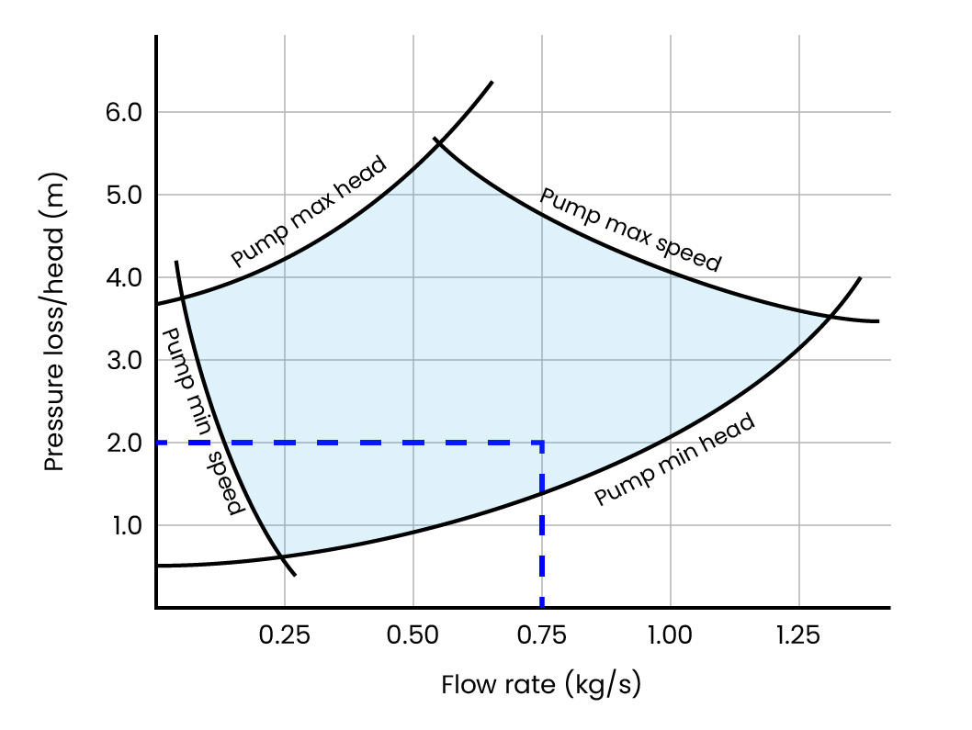
Use the pump graph below to identify if the total pressure loss can be achieved by the circulating pump. Tick the relevant box.

Pump suitable | Pump unsuitable

Learner reflection
Do you feel confident about this topic? | Yes | I would like more guidance

Task 8: Heating design 2 – Pressure loss
Use the CIBSE heating design guide 20/21, pages 5–28/5–29

You have been contracted to install an 11 kW air source heat pump at a domestic property. The system design includes primary flow and return pipework with longer-than-average pipe runs, incorporating multiple bends, fittings, and isolation/control valves.

Your task is to carry out a full assessment of the primary circuit to ensure correct operation and efficiency of the system.

Complete the tables below.

Kw | Mass flow rate (kg/s) | Pipe size (mm) | Flow rate required (L/m) | Pressure loss m(h)/m | Effective pipework length (including fittings /valves) | Total Pressure loss (M)
11 | 0.530 | 28 mm |  | 0.040 | 75 metres

Use the pump graph below to identify if the total pressure loss can be achieved by the circulating pump. Tick the relevant box.

Pump suitable | Pump unsuitable

Learner reflection
Do you feel confident about this topic? | Yes | I would like more guidance

Task 9: Heating design 1 – Air source heat pump sizing
A property has been assessed and calculated to have a heat loss of 8 kW. The heating system has been designed to operate with a flow temperature of 55°C.

You are provided with the manufacturer’s performance data (power output chart) for an 8 kW air source heat pump.

Using the manufacturer’s data, determine whether the selected heat pump can deliver the required 8 kW heat output at an external temperature of –5°C.

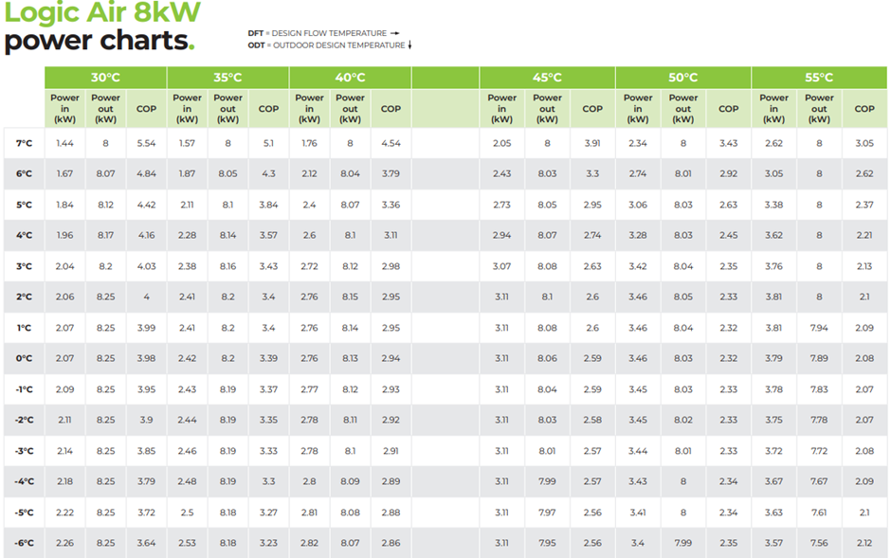

What is the maximum output of the heat pump at the design temperatures stated above?

If you were to install this 8KW heat pump, what maximum flow temperature could you use to fulfil the required maximum output and what would be the impact on pipework and radiator sizing?

Learner reflection
Do you feel confident about this topic? | Yes | I would like more guidance

Task 10: Heating design 2 – Air source heat pump sizing
A property has been assessed and calculated to have a heat loss of 8 kW. The heating system has been designed to operate with a flow temperature of 45°C.

You are provided with the manufacturer’s performance data (power output chart) for an 8 kW air source heat pump.

Using the manufacturer’s data, determine whether the selected heat pump can deliver the required 8 kW heat output at an external temperature of –4°C.

What is the maximum output of the heat pump at the design temperatures stated above?

If you were to install this 8KW heat pump, what maximum flow temperature could you use to fulfil the required maximum output and what would be the impact on pipework and radiator sizing?

Learner reflection
Do you feel confident about this topic? | Yes | I would like more guidance

Task 11: Heating design 1 – Heat pump selection
A domestic property has been surveyed and has a calculated heat loss of 6 kW at a design outdoor temperature of –5°C. The heating system is designed to operate at a flow temperature of 50°C.
You are provided with a manufacturer’s data table showing the performance of three air source heat pumps under different operating conditions. Identify the correct heat pump to use.
Heat Pump Output | 5 kW | 6 kW | 7 kW
ERP Rating | A**** | A**** | A****
Sound Power level (db.) | 53 | 55 | 55
Weight (kg) | 86 | 87 | 90
Max Output at 0℃ | 5.0 kW | 6.0 kW | 7.0 kW
Max Output at –3℃ | 5.0 kW | 6.0 kW | 6.75 kW
Max Output at –5℃ | 4.3 kW | 5.5 kW | 6.1 kW
Refrigerant charge (Kg) | 0.7 | 1.0 | 1.2
Heat pump selected (Tick size required)

Tutor feedback

Learner reflection
Do you feel confident about this topic? | Yes | I would like more guidance

Task 12: Heating design 2 – Heat pump selection
A domestic property has been surveyed and has a calculated heat loss of 6 kW at a design outdoor temperature of –5°C. The heating system is designed to operate at a flow temperature of 50°C.
You are provided with a manufacturer’s data table showing the performance of three air source heat pumps under different operating conditions. Identify the correct heat pump to use.
Heat Pump Output | 5 kW | 6 kW | 7 kW
ERP Rating | A**** | A**** | A****
Sound Power level (db.) | 53 | 55 | 55
Weight (Kg) | 86 | 87 | 90
Max Output at 0℃ | 3.5 kW | 6.0 kW | 7.0 kW
Max Output at –3℃ | 3.3 kW | 5.0 kW | 6.0 kW
Max Output at –5℃ | 3.0 kW | 4.0 kW | 5.0 kW
Refrigerant | R290 | R290 | R290
Refrigerant charge (Kg) | 0.75 | 1.1 | 1.3
Heat pump selected (Tick size required)

Tutor feedback

Learner reflection
Do you feel confident about this topic? | Yes | I would like more guidance

Task 13: Hot Water Requirements 1
The domestic hot water calculations in this task are separate from the previous heat loss and space heating design calculations. Learners should treat the hot water design requirements as an independent exercise, using the information provided to determine cylinder sizing, hot water demand, recovery times, and related calculations.
Using the CIBSE heating design guide 20/21, complete the following calculations for hot water cylinder requirements and reheat times in domestic dwellings (use Table 4.1 for minimum cylinder sizing).
A customer has asked you for information regarding the hot water requirement at one of their properties.
The house has 3 bedrooms, 1 bathroom and a WC downstairs.
The cold mains enter the property at 10℃ and requires the hot water to be heated to 60℃ by an indirect cylinder.

1. What is the minimum size indirect cylinder required for this property?

2. What would the indirect coil rating be if the customer requires the cylinder reheat time to be 40 minutes?

3. How long would it take to reheat the same cylinder if the coil rating was 20 kW at 60℃?

Tutor feedback

Learner reflection
Do you feel confident about this topic? | Yes | I would like more guidance

Task 14: Hot Water Requirements 2
The domestic hot water calculations in this task are separate from the previous heat loss and space heating design calculations. Learners should treat the hot water design requirements as an independent exercise, using the information provided to determine cylinder sizing, hot water demand, recovery times, and related calculations.
Using the CIBSE heating design guide 20/21, complete the following calculations for hot water cylinder requirements and reheat times in domestic dwellings (use Table 4.1 for minimum cylinder sizing).
A customer has asked you for information regarding the hot water requirement at one of their properties.
The house has 4 bedrooms and 2 bathrooms.
The cold mains the property at 9℃ and requires the hot water to be heated to 55℃ with an indirect cylinder heated by an air source heat pump.

1. What is the minimum size indirect cylinder required for this property?

2. What would the indirect coil rating be if the customer requires the cylinder reheat time to be 30 minutes?

3. How long would it take to reheat the same cylinder if the coil rating was 8 kW at 60℃?

Tutor feedback

Learner reflection
Do you feel confident about this topic? | Yes | I would like more guidance

Task 15: Identification of key components in an air source heat pump installation
Identify the key components installed in a domestic air-source heat pump system and demonstrate an understanding of their purpose, operation, and sizing in accordance with MCS principles and industry good practice.
Scenario
A complete air-source heat pump installation has been assembled in the workshop.
All major system components have been labelled with identification tags.
You are required to inspect the installation and complete the component identification task sheet.
For each tagged component:
1. Identify the component name
2. Describe the purpose/function of the component
3. State the component size, rating or specification
4. Explain why the component is required within the system

Section 1 – Outdoor unit components
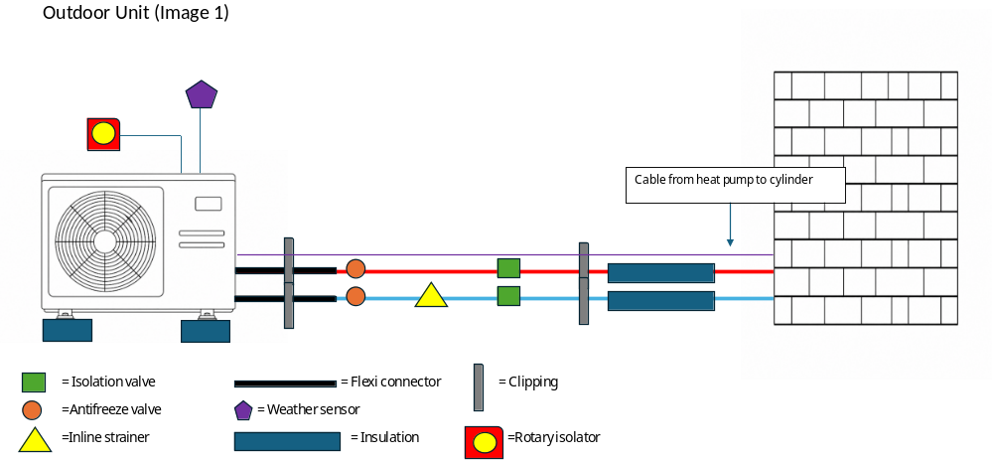

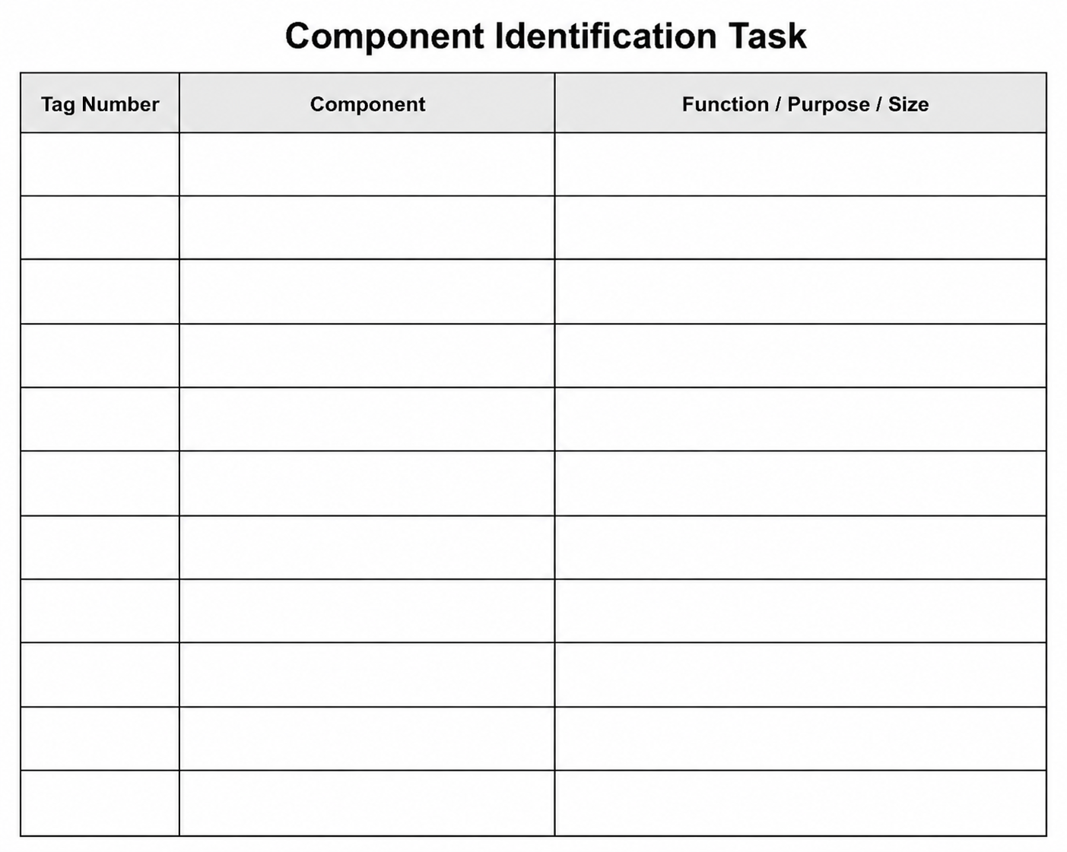
Section 1: Outdoor unit components
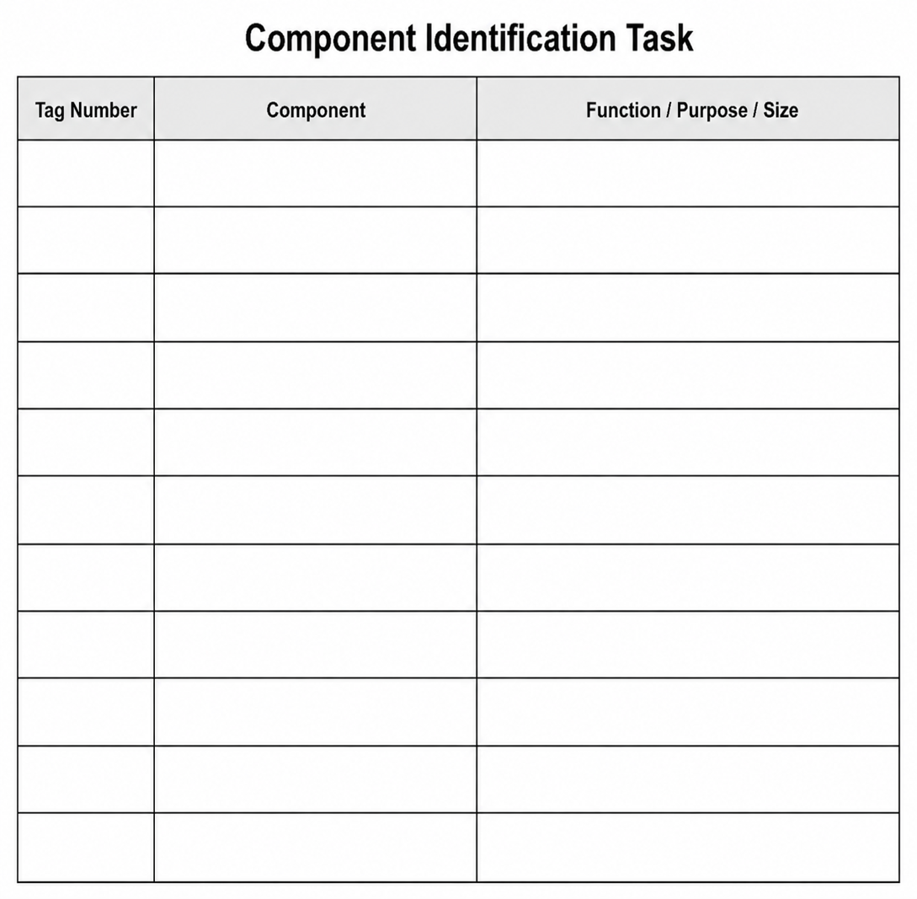

Section 2: Indoor cylinder components
Indoor Unit (Image 2)

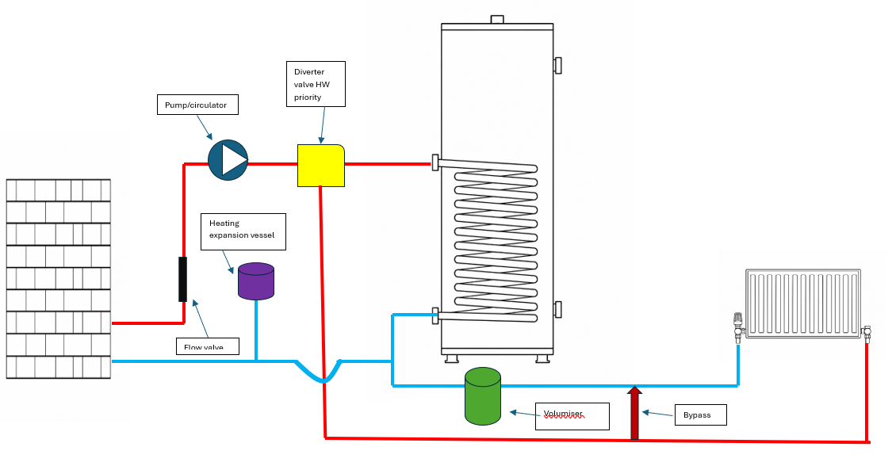

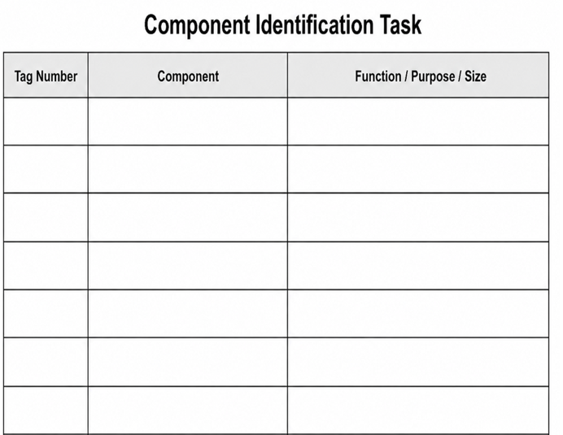
Tutor feedback

Learner reflection
Do you feel confident about this topic? | Yes | I would like more guidance

Extension task
Design a domestic heat pump system
Draw a clear, neat and professional installer-style schematic drawing of a low temperature heating system in line with industry good practice and manufacturer guidance.
It must:
- correctly identify the position of all the required components
- demonstrate understanding of flow and return pipework arrangements
- show correct placement of valves, controls and safety devices
- apply good installation practice and a logical system layout

The completed drawing should demonstrate:
- understanding of a domestic heat pump system operation
- correct integration of heating and domestic hot water components
- awareness of servicing, maintenance and commissioning considerations
- appropriate use of insulation, clipping and external protection components

Include the following domestic hot water pipework and components:
- Combination valve
- HW expansion vessel
- Tundish
- D1 and D2 pipework
- HW outlet
- Pressure relief valve
- Temperature/Pressure relief valve

The drawing does not need to be to scale but should be technically accurate, easy to follow and suitable for installation planning purposes.

Schematic drawing

Learner reflection
Do you feel confident about this topic? | Yes | I would like more guidance

Task 16: Heat pump siting
You are required to identify a safe location for an ideal HP290 (R290 refrigerant) heat pump to be sited before installation, following the guidance below, which is taken from the Ideal HP290 Manufacturer’s Instructions, page 29.

You must:
- identify the installation scenario
- identify and avoid risks within the exclusion zone

Your tutor will tell you if the heat pump is to be installed in:
- a corner
- against a wall or
- an open space

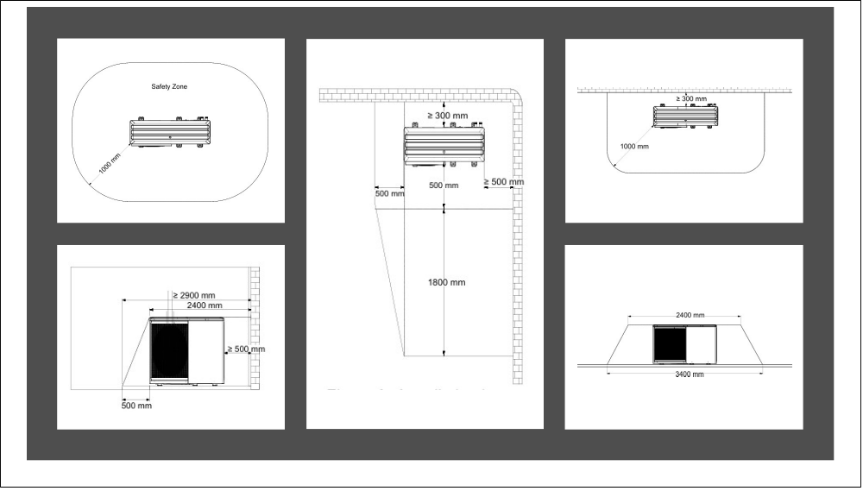

Tool list – list the tools required to complete the work task

PPE – what PPE is required to carry out the task safely?

Key task elements | Criteria | Trainer to tick
Measurement | - Accurate to the dimensions on the drawing | ☐
Marking out | - +/- 2mm of the dimensions on the drawing  - Marked out in pencil  - Spirit level used | ☐

Behaviours demonstrated during this task | Trainer to tick
Dependable and responsible | ☐
Enthusiasm and positive attitude | ☐
Quality focus | ☐
Willingness to learn | ☐
Work with others | ☐
Sustainable working | ☐

Learner reflection
Do you feel confident about this topic? | Yes | I would like more guidance

Task 17: Fit anti-vibration feet and level a heat pump
You are required to select suitable anti-vibration feet and attach them to the heat pump.
Make sure the air source heat pump (ASHP) is level front to back and level left to right, and the minimum ground clearance is achieved.
Reference the Ideal Logic Air Manufacturer’s Instructions.


Tool list – list the tools required to complete the work task

PPE – what PPE is required to carry out the task safely?

Key task elements | Criteria | Trainer to tick
Measurement | - Level front to back  - Level left to right  - Achieve minimum height from to ASHP to the ground  (Manufacturer minimum ground clearance requirement as specified in the Ideal Logic Air Installation and Servicing Guide) | ☐
Marking out | - Mark out mounting points  - Spirit level used | ☐

Behaviours demonstrated during this task | Trainer to tick
Dependable and responsible | ☐
Enthusiasm and positive attitude | ☐
Quality focus | ☐
Willingness to learn | ☐
Work with others | ☐
Sustainable working | ☐

Learner reflection
Do you feel confident about this topic? | Yes | I would like more guidance

Task 18: Pipe up to an air-source heat pump (ASHP)
From the list given to you by your tutor, identify the accessories required to attach to the ASHP and decide on the most sensible order to fit them before lagging and clipping the pipework correctly.
- Ensure the flow and return pipes are correct
- Mark up clip locations for the lagged pipework before installing components
- Identify and confirm flow and return connections on both the heat pump and the pipework or manifold before connecting any components
- Add the correct size lagging before using the correct supports to hold the lagged pipework
- Pay attention to the accessory instructions to ensure they are installed correctly. The system has been designed to have water only in the system
Note: This is a task-specific design decision rather than standard practice. Water-only systems are not normal practice, as MCS 020 requirements state that glycol protection is required in frost-risk locations.
Tool list – list the tools required to complete the work task

PPE – what PPE is required to carry out the task safely?

Key task elements | Criteria | Trainer to tick
Measurement | - Measure and mark out clip locations  - Measure and cut pipework between accessories  - Ensure clearances maintained for antifreeze valves | ☐
Marking out | - Marked out in pencil/marker  - Spirit level used | ☐
Clipping | - Select appropriate pipework clips for use and space them correctly | ☐

Behaviours demonstrated during this task | Trainer to tick
Dependable and responsible | ☐
Enthusiasm and positive attitude | ☐
Quality focus | ☐
Willingness to learn | ☐
Work with others | ☐
Sustainable working | ☐

Learner reflection
Do you feel confident about this topic? | Yes | I would like more guidance

Task 19: Schematics
Identify the components on the schematic provided, and number them on the schematic.
Your tutor will provide you with two schematics:
- one with a bypass and volumizer
- one with a buffer and single zone.

List the components below
Buffer | 1
Secondary circulator | 2
Volumiser | 3
Auto bypass valve | 4

Key task elements | Criteria | Trainer to tick
Identify | - Buffer  - Secondary circulator  - Volumiser  - By-pass | ☐
Stretch activity identify | - Single zone  - Multi zone with buffer  - Underfloor symbol | ☐

Behaviours demonstrated during this task | Trainer to tick
Dependable and responsible | ☐
Enthusiasm and positive attitude | ☐
Quality focus | ☐
Willingness to learn | ☐
Work with others | ☐
Sustainable working | ☐

Learner reflection
Do you feel confident about this topic? | Yes | I would like more guidance

Task 20: Glycol level
Work out the volume of glycol required to protect this ASHP installation to the recommended level published by MCS.
Scenario
This 10-radiator system has a heat pump containing 5 litres of water, with 6 radiators containing 1.5 L of water each, and 4 radiators containing 2.1 L of water each.
There is 20M of 28mm pipe, 40M of 22mm pipe, and 12M of 15mm pipe.
Work out the system volume then calculate the volume of glycol required.
28mm Pipe: 1M hold 0.54 litres of water
22mm Pipe: 1M holds 0.32 litres of water
15mm Pipe: 1M holds 0.15 litres of water
After calculating, add your results in the box below, highlighting the correct sample that meets the MCS requirements without exceeding them.
Calculations:

Glycol sample Result (Temp in degrees ℃)
Water
Sample 1
Sample 2
Circle the correct reading

What tools are required to complete the task?

What PPE is required to carry out the task safely?

Key task elements | Criteria | Trainer to tick
Measurement | - Measure the cold mains to identify zero protection  - Test Samples 1 and 2, recording the temperature at which it protects down to | ☐
Identify | - Correctly identify the sample protecting down to –10 (MCS) | ☐

Behaviours demonstrated during this task | Trainer to tick
Dependable and responsible | ☐
Enthusiasm and positive attitude | ☐
Quality focus | ☐
Willingness to learn | ☐
Work with others | ☐
Sustainable working | ☐
Learner reflection
Do you feel confident about this topic? | Yes | I would like more guidance

Task 21: Setting the flow rate
It is important to ensure the correct flow rate is set on the air-source heat pump (ASHP). This will ensure the system DT is maintained and operates efficiently.
Use the mass flow rate calculation to work out the required flow rate for the system, which has an 8KW ASHP accurately sized to satisfy the property heat loss. The ASHP is running at a 5-degree DT and the system is filled with water only.
Work out the flow rate and convert it to litres per minute, before setting the flow rate either electronically on the unit or by means of adjusting the flow meter valve.

Calculations
SHC of water
System DT
Kw of the unit/heat loss
Mass flow rate (L/Min)

Flow rate (l/sec) = KW
(SHC X DT)
Calculations:

Convert to l/min by multiplying your answer by 60.

What tools are required to complete the task?

What PPE is required to carry out the task safely?

Key task elements | Criteria | Trainer to tick
Measurement | - Work out the design flow rate for the 8KW unit | ☐
Adjustment | - Set the flow rate to the calculated value. | ☐
Record | - Record your results on the commissioning/design sheet. | ☐

Behaviours demonstrated during this task | Trainer to tick
Dependable and responsible | ☐
Enthusiasm and positive attitude | ☐
Quality focus | ☐
Willingness to learn | ☐
Work with others | ☐
Sustainable working | ☐

Learner reflection
Do you feel confident about this topic? | Yes | I would like more guidance

Task 22: Weather compensation curve
Using the commissioning sheet provided in Appendix 1, fill in the missing information and add the glycol results from Task 1 (20) before identifying the system design flow temperature and the design outdoor temperature.
With the information, plot the lines on the weather compensation graph (Appendix 2) to determine which heat curve to select. The design indoor temperature is 21 degrees.

Result
Design flow temperature
Design indoor temperature
Design outdoor temperature
Heat curve

What tools are required to complete the task?

What PPE is required to carry out the task safely?

Key task elements | Criteria | Trainer to tick
Curve selection | - Correctly select heat curve | ☐
Identify | - The effect of flow temperatures on efficiency | ☐

Behaviours demonstrated during this task | Trainer to tick
Dependable and responsible | ☐
Enthusiasm and positive attitude | ☐
Quality focus | ☐
Willingness to learn | ☐
Work with others | ☐
Sustainable working | ☐

Learner reflection
Do you feel confident about this topic? | Yes | I would like more guidance

Task 22 – Appendix 1
Weather compensation commissioning sheet
Heat Pump Commissioning Sheet
Customer and Installation Details
Customer name
Installation address
Postcode
Heat pump make and model
Heat pump serial number
Commissioned by
Company name
Commissioning date

Design Information
Design item | Recorded value
Heat loss | 8KW
Design indoor temperature | 21°C
Design outside temperature | –3°C
System design flow temperature | 45°C
Design return temperature | 40°C
Design temperature difference (DT) | 5°C
Design flow rate
Heat emitter type | Low-temperature radiators
Weather compensation enabled | Yes
Heat curve selected
Outdoor sensor fitted | Yes
Domestic hot water target temperature | 49°C
Legionella protection configured | Yes, via timed temperature control

System and Controls Checklist
Check | Status | Notes
Heating system filled and pressure tested | Complete | No visible leaks identified at time of commissioning
System flushed and cleaned in accordance with BS 7593 guidance and manufacturer instructions | Complete | Cleaner and inhibitor details to be recorded by installer if required
Expansion vessel sized, fitted and charged | Complete | Set in accordance with manufacturer requirements
System filter fitted and clean | Complete | Filter checked during commissioning
Automatic bypass fitted or confirmed not required | Complete | As per system design
Heating zone valves operational | Complete | All zones tested
Hot water zone valve operational | Complete | Confirmed during hot water demand
Room thermostat / programmer operational | Complete | Time and temperature controls verified
Heat pump safety interlock operational | Complete | Confirmed during control test
Outdoor unit secure, level and clear of airflow obstructions | Complete | Clearances checked
External pipework insulated and frost protected | Complete | Insulation visually checked

Water Treatment and Frost Protection
Item | Recorded value
System cleaner used
Heating system inhibitor used
Antifreeze / inhibitor used
Glycol level calculated
In Litres and percentage
Frost protection setting | Enabled
System pressure cold | 1.5 bar
System pressure hot | 2.0 bar

Commissioning Test Results
Test | Recorded value | Result
Heating flow temperature achieved | 45°C | Pass
Heating return temperature recorded | 40°C | Pass
Flow and return temperature difference | 5°C | Pass
Domestic hot water operation | Confirmed | Pass
Circulation pump operation | Confirmed | Pass
Air removed from system | Confirmed | Pass
System filters checked | Clean at commissioning | Pass
Weather compensation curve checked | Set for 45°C design flow at –3°C outside temperature | Pass
Defrost operation checked where conditions allow | Confirmed / not observed during commissioning | Acceptable
Controls handover completed | Customer to be advised on operation | Complete

Commissioning Declaration
The heat pump system has been commissioned using the design outside temperature of –3°C and the system design flow temperature of 45°C. The system checks and test results recorded above should be verified against the manufacturer’s instructions, site conditions and measured commissioning readings before handover.
Engineer signature
Customer signature
Date

Task 22 – Appendix 2
Weather compensation graph

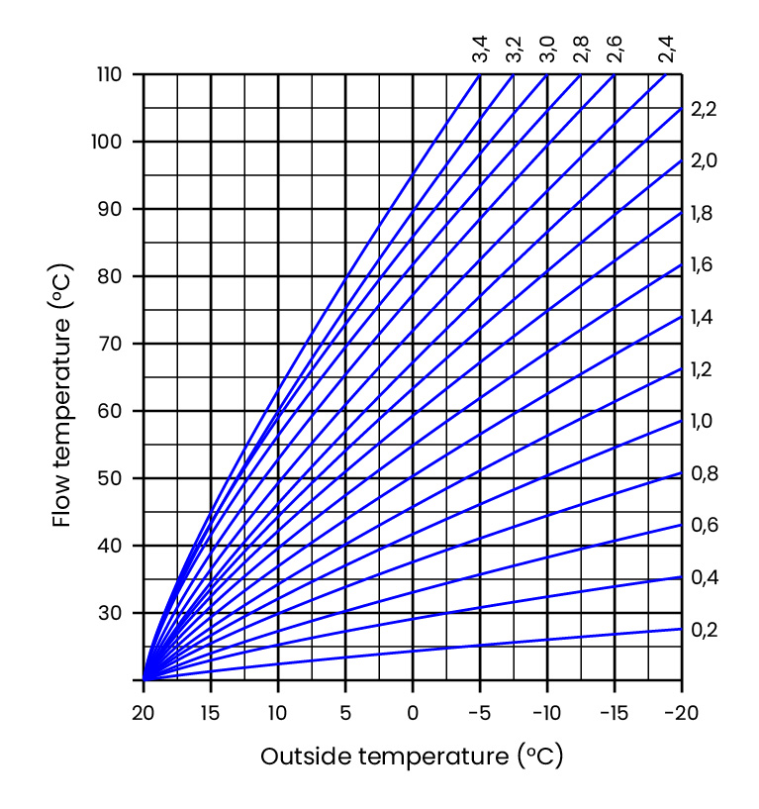

Note: Select the weather compensation curve by finding the system design flow temperature and the design outdoor temperature. Then simply plot a line on both axes, and where they meet, follow the curve you hit to find out the numerical value. This is your heat curve value.
The numbers denote the curve selected but also hold more information. For every 1-degree deviation in outside temperature, the curve number represents the effect on the flow temperature. For example, on a 1.6 curve, if the outdoor temperature dropped by 1 degree, the flow temperature would increase by 1.6 degrees to compensate for the deviation.

Task 23: Setting the controls
Using the manufacturer's instructions, set the customer controls to deliver the following:
- Comfort temperature of 21 degrees
- Setback temperature of 18 degrees
- Hot water setpoint at 49 degrees
Set the Legionella function to run a disinfection cycle every Sunday at midnight.
Once set, hand over the controls to the customer, describing what has been set and the most efficient way to operate the low-temperature system.

What tools are required to complete the task?

What PPE is required to carry out the task safely?

Key task elements | Criteria | Trainer to tick
Configure controller | - Set the comfort temperature  - Set the setback temperature  - Set hot water set point  - Configure Legionella function | ☐
Handover | - Handover to the customer | ☐
Verbally | - Explain controls and settings | ☐

Behaviours demonstrated during this task | Trainer to tick
Dependable and responsible | ☐
Enthusiasm and positive attitude | ☐
Quality focus | ☐
Willingness to learn | ☐
Work with others | ☐
Sustainable working | ☐

Learner reflection
Do you feel confident about this topic? | Yes | I would like more guidance

Fault-finding tasks:
These tasks involve visually inspecting an air source heat pump installation and identifying faults intentionally introduced into the system.
Under the observation of your Tutor/Trainer, you must:
- Carry out a safe and systematic visual inspection of the installation
- Identify faults and non-compliances within the system
- Explain the effect each fault may have on system performance, efficiency, reliability, and safety
- Recommend and implement appropriate corrective actions
- Rectify the faults and confirm the system is operating correctly
- Demonstrate an understanding of industry good practice and manufacturer installation requirements
You must complete a fault-finding record for each task, as well as a tool list and any health and safety procedures required.
On completion of the task, you should be able to demonstrate competence in fault identification, fault rectification, and restoring the air source heat pump system to its correct operational condition.

Task 24: Flow fault alarm
Scenario
You are a Heat Pump Service Engineer attending a customer's property following reports that some radiators are not heating correctly and the controller is displaying a Flow Fault alarm.
Under the observation of your Tutor/Trainer, carry out a safe inspection of the system, identify the cause of the faults, explain their effect on system operation, and rectify the issues to restore normal heating performance.

Air Source Heat Pump Fault Finding Record
Learner Name: ________________________ Date: _____________
Components / Controls inspected

Fault(s) identified

Fault(s) identified – Effect on system operation

Corrective action taken

Final system verification
☐ Flow fault cleared
☐ Heat pump operating correctly
☐ System circulating correctly
☐ All radiators heating correctly
☐ No leaks present
☐ System returned to normal operation

Learner Summary

Learner Signature: ___________________
Tutor Signature: ___________________

Behaviours demonstrated during this task | Trainer to tick
Dependable and responsible | ☐
Enthusiasm and positive attitude | ☐
Quality focus | ☐
Willingness to learn | ☐
Work with others | ☐
Sustainable working | ☐

Learner reflection
Do you feel confident about this topic? | Yes | I would like more guidance

Task 25: Refrigerant low pressure fault alarm
Scenario

You are a Heat Pump Service Engineer attending a customer's property following reports that there is no heating or hot water available. The customer has also advised that the heat pump is displaying a Low-Pressure Fault alarm.

Under the observation of your Tutor/Trainer, carry out a safe and systematic inspection of the system, identify the cause of the fault, explain the effect it is having on the operation of the heat pump, and rectify the issue to restore normal heating and hot water service.

Air Source Heat Pump Fault Finding Record
Learner Name: ________________________ Date: _____________
Components / Controls inspected

Fault(s) identified

Fault(s) identified – Effect on system operation

Corrective action taken

Final system verification
☐ Low Pressure fault cleared
☐ Heat pump operating correctly
☐ System circulating correctly
☐ All radiators heating correctly
☐ Hot water supplied correctly
☐ System returned to normal operation

Learner Summary

Learner Signature: ___________________
Tutor Signature: ___________________

Behaviours demonstrated during this task | Trainer to tick
Dependable and responsible | ☐
Enthusiasm and positive attitude | ☐
Quality focus | ☐
Willingness to learn | ☐
Work with others | ☐
Sustainable working | ☐

Learner reflection
Do you feel confident about this topic? | Yes | I would like more guidance

Task 26: Lukewarm heating and incorrect hot water operation
Scenario
You are a Heat Pump Service Engineer attending a customer's property following reports that the radiators are only getting lukewarm and the domestic hot water is not reaching the required temperature. The customer has also noticed that the heat pump appears to be switching on and off frequently and entering the defrost cycle more often than expected.

Under the observation of your Tutor/Trainer, carry out a safe and systematic inspection of the system, identify the cause of the fault(s), explain the effect they are having on system performance and efficiency, and rectify the issues to restore normal heating and hot water operation.

Air Source Heat Pump Fault Finding Record
Learner Name: ________________________ Date: _____________
Customer Complaint: Some radiators are not heating correctly, and the controller is displaying a Flow Fault alarm.
Components / Controls inspected

Fault(s) identified

Fault(s) identified – Effect on system operation

Corrective action taken
Final system verification
☐ Fault alarm cleared
☐ Heat pump operating correctly
☐ System circulating correctly
☐ All radiators heating correctly
☐ Hot water supplied correctly
☐ System returned to normal operation

Learner Summary

Learner Signature: ___________________
Tutor Signature: ___________________

Behaviours demonstrated during this task | Trainer to tick
Dependable and responsible | ☐
Enthusiasm and positive attitude | ☐
Quality focus | ☐
Willingness to learn | ☐
Work with others | ☐
Sustainable working | ☐

Learner reflection
Do you feel confident about this topic? | Yes | I would like more guidance

Task 27: Legionella fault alarm
Scenario
You are a Heat Pump Service Engineer attending a customer's property following reports that the domestic hot water is not reaching the required temperature. The customer has advised that space heating is operating normally; however, the heat pump controller is displaying a Legionella Fault alarm.

Legionella cycle requires:
- ≥60°C hot water storage for 1 hour once per week
- ≥50°C at distribution outlets within 1 minute.

Under the observation of your Tutor/Trainer, carry out a safe and systematic inspection of the system, identify the cause of the fault, explain the effect it is having on hot water production and legionella protection, and rectify the issue to restore normal operation.

Once the fault has been rectified, confirm that the domestic hot water system can achieve the required legionella cycle temperature and that the fault has been cleared.

Air Source Heat Pump Fault Finding Record
Learner Name: ________________________ Date: _____________
Components / Controls inspected

Fault(s) identified

Fault(s) identified – Effect on system operation

Corrective action taken
Final system verification
☐ Legionella Fault alarm cleared
☐ Heat pump controller operating correctly
☐ System circulating correctly
☐ Legionella cycle temperature reached correctly
☐ Hot water supplied correctly
☐ System returned to normal operation

Learner Summary

Learner Signature: ___________________
Tutor Signature: ___________________

Behaviours demonstrated during this task | Trainer to tick
Dependable and responsible | ☐
Enthusiasm and positive attitude | ☐
Quality focus | ☐
Willingness to learn | ☐
Work with others | ☐
Sustainable working | ☐

Learner reflection
Do you feel confident about this topic? | Yes | I would like more guidance

Task 28: Incorrect system performance, energy consumption and occupant comfort
Scenario

You are a Heat Pump Service Engineer attending a customer's property following reports of unusually high electricity bills. The customer has also noticed that the radiators feel hotter than normal and that the property is frequently exceeding the temperature set on the room thermostat, making some rooms uncomfortably warm.

Under the observation of your Tutor/Trainer, carry out a safe and systematic inspection of the system, identify the cause of the fault, explain the effect it is having on system performance, energy consumption and occupant comfort, and rectify the issue to restore normal operation.

Once the fault has been rectified, confirm that the heating controls are operating correctly, the property maintains the required comfort temperature, and the system is running efficiently.

Air Source Heat Pump Fault Finding Record
Learner Name: ________________________ Date: _____________
Components / Controls inspected

Fault(s) identified

Fault(s) identified – Effect on system operation

Corrective action taken
Customer report
Fault identified
Action taken

System condition

Maintenance recommendations

Final system verification
☐ Fault cleared
☐ Heating controls operating correctly
☐ System circulating correctly
☐ Radiator temperature reached correctly
☐ System returned to normal operation

Behaviours demonstrated during this task | Trainer to tick
Dependable and responsible | ☐
Enthusiasm and positive attitude | ☐
Quality focus | ☐
Willingness to learn | ☐
Work with others | ☐
Sustainable working | ☐

Learner reflection
Do you feel confident about this topic? | Yes | I would like more guidance

Air Source Heat Pump Fault-Finding Tasks

Tools and Health and Safety Record Sheet
Learner Name: ________________________ Date: ______________
Task Reference: _______________________________________________

Tools and equipment used
List all tools and equipment used during the task:

Health and safety considerations
List the health and safety considerations identified before and during the task:

PPE used

Risk control measures implemented

Learner summary
Briefly describe how health and safety requirements were met whilst carrying out the task:

Learner Signature: ___________________
Tutor Signature: ___________________

Task 29: Planned annual service on an air source heat pump system
Scenario

You have been asked to carry out a planned annual service on an air source heat pump system installed at a domestic property. The homeowner has reported that the system is operating but would like reassurance that it is working efficiently ahead of the heating season.

As the service engineer, you are required to inspect the installation, carry out all relevant safety and performance checks, assess the condition of system components, verify operating pressures, temperatures and flow rates, check controls and settings, identify any faults or maintenance requirements, and provide recommendations to improve system performance and efficiency.

Record all findings on the service documentation and explain any actions required to the customer.

Complete the service record sheet in Appendix 1.

Learner Summary

Learner Signature: ___________________
Tutor Signature: ___________________

Behaviours demonstrated during this task | Trainer to tick
Dependable and responsible | ☐
Enthusiasm and positive attitude | ☐
Quality focus | ☐
Willingness to learn | ☐
Work with others | ☐
Sustainable working | ☐

Learner reflection
Do you feel confident about this topic? | Yes | I would like more guidance
Task 29 – Appendix 1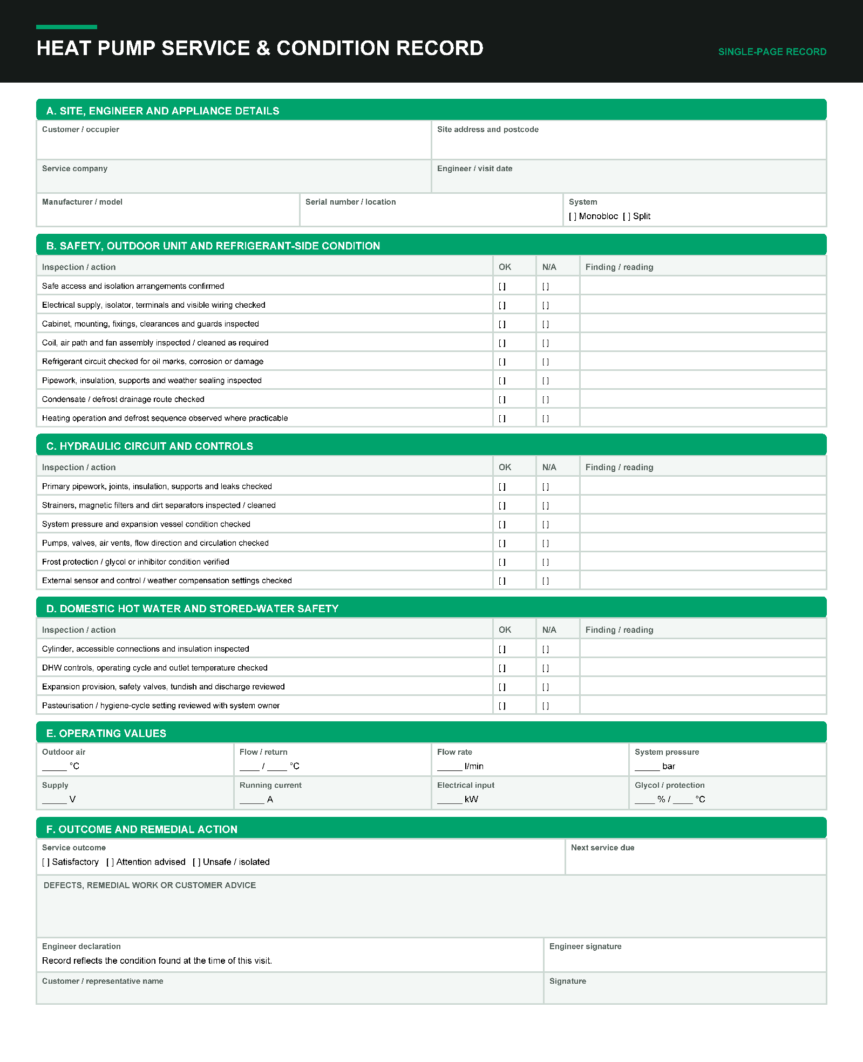

Copyright in this document belongs to and is used under licence from the Department for Education, © 2025.

‘T-LEVELS’ and ‘T Level’ are registered trademarks of the Department for Education.

WJEC is authorised by the Department for Education to develop and deliver this T Level Technical Qualification.

WJEC operates in England under the name Eduqas which is a registered trademark of WJEC.

Acknowledgements
p.14 table from Ideal Heating / idealheating.com; p.18 table from Ideal Heating / idealheating.com; p.36 images from Ideal Heating - Manufacturers Instructions / idealheating.com; p.39 QuirkCraft Studio / Shutterstock.com;

