T Level Technical Qualification in Building Services Engineering for Construction
(Level 3)

Skills Practice Workbook – Tutor Guide

Low Carbon Engineering
Practical Training

Contents
Task summary and progress tracker 3
Introduction 5
General guidance for tutors 5
Task 1: Heating design 1 – Heat loss 6
Task 2: Heating design 2 – Heat loss 9
Task 3: Heating design 1 – Radiator sizing 12
Task 4: Heating design 2 – Radiator sizing 14
Task 5: Heating design 1 – Pipe sizing 16
Task 6: Heating design 2 – Pipe sizing 18
Task 7: Heating design 1 – Pressure loss 20
Task 8: Heating design 2 – Pressure loss 22
Task 9: Heating design 1 – Air source heat pump sizing 24
Task 10: Heating design 2 – Air source heat pump sizing 27
Task 11: Heating design 1 – Heat pump selection 30
Task 12: Heating design 2 – Heat pump selection 32
Task 13: Hot Water Requirements 1 34
Task 14: Hot Water Requirements 2 37
Task 15: Identification of key components in an air source heat pump installation 40
Task 16: Heat pump siting 46
Task 17: Anti-vibration mounts and level 50
Task 18: Pipe up 53
Task 19: Schematics 57
Task 20: Glycol levels 60
Task 21: Setting the flow rate 64
Task 22: Weather compensation curve 67
Task 23: Setting the controls 74
Task 24: Flow fault alarm 77
Task 25: Refrigerant low pressure fault alarm 80
Task 26: Lukewarm heating and incorrect hot water operation 83
Task 27: Legionella fault alarm 86
Task 28: Incorrect system performance, energy consumption and occupant comfort 89
Task 29: Planned annual service on an air source heat pump system 92

Task summary and progress tracker
 | Task | Performance criteria reference number(s) | Task Page number | Date  Task Issued
 | Outcome 2: Design low carbon heating and hot water systems
1 | Heating design 1 – Heat loss | S2.1, S2.3
7 | Heating design 2 – Heat loss | S2.1, S2.3
2 | Heating design 1 – Radiator sizing | S2.1, S2.3, 2.4
8 | Heating design 2 – Radiator sizing | S2.1, S2.3, 2.4
3 | Heating design 1 – Pipe sizing | S2.1, S2.3, 2.4
9 | Heating design 2 – Pipe sizing | S2.1, S2.3, 2.4
4 | Heating design 1 – Pressure loss | S2.1, S2.3, 2.4
10 | Heating design 2 – Pressure loss | S2.1, S2.3, 2.4
5 | Heating design 1 – Air source heat pump sizing | S2.1, S2.3, 2.4
11 | Heating design 2 – Air source heat pump sizing | S2.1, S2.3, 2.4
6 | Heating design 1 – Heat pump selection | S2.1, S2.3, 2.4
12 | Heating design 2 – Heat pump selection | S2.1, S2.3, 2.4
13 | Hot Water Requirements 1 | S2.1, S2.3, 2.4, 2.5
14 | Hot Water Requirements 2 | S2.1, S2.3, 2.4, 2.5
15 | Identification of key components in an air source heat pump installation | S2.1, S2.2
 | Outcome 3: Install low carbon heating and hot water systems
16 | Heat pump siting | S3.1, S3.2, S3.5, S3.6, S3.11
17 | Anti-vibration mounts and level | S3.1, S3.2, S3.3, S3.4, S3.5, S3.6, S3.9
18 | Pipe up to an air-source heat pump (ASHP) | S3.1, S3.2, S3.3, S3.4, S3.5, S3.6, S3.7,S3.8, S3.9, 3.11
19 | Schematics | S3.2
 | Outcome 4: Commission low carbon heating and hot water systems
20 | Glycol level | S4.1, S4.2, S4.3, S4.4, S4.5, S4.6, S4.7, S4.8, S4.9, S4.10
21 | Setting the flow rate | S4.1, S4.2, S4.3, S4.4, S4.5, S4.6, S4.7, S4.8, S4.9, S4.10
22 | Weather compensation curve | S4.1, S4.2, S4.6, S4.7, S4.8, S4.9, S4.10
23 | Setting the controls | S4.1, S4.2, S4.7, S4.9, S4.10
 | Outcome 5: Maintain low carbon heating and hot water systems
24 | Flow fault alarm | S5.1, S5.2, S5.3, S5.5, S5.6. S5.7, S5.8, S5.10
25 | Refrigerant low pressure fault alarm | S5.1, S5.3, S5.4, S5.5, S5.10
26 | Lukewarm heating and incorrect hot water operation | S5.1, S5.3, S5.5, S5.6, S5.7, S5.8, S5.10
27 | Legionella fault alarm | S5.1, S5.3, S5.4, S5.5, S5.6. S5.7, S5.8, S5.10
28 | Incorrect system performance, energy consumption and occupant comfort | S5.1, S5.2, S5.3, S5.4, S5.5, S5.6. S5.7, S5.8, S5.10
29 | Planned annual service on an air source heat pump system | S5.9

Introduction
Tutor guide: T-Level Low Carbon Skills Practice Workbook for Learners
This guide is designed to support tutors in delivering and assessing practical tasks within the T-Level Low Carbon Skills Practice Workbook for Learners. For each task, it outlines expected learner outcomes, potential areas of difficulty, and suggestions for tutor intervention and support.

General guidance for tutors
- Demonstrate and supervise: Always demonstrate safe practices before learners attempt tasks. Maintain vigilant supervision, especially during tasks involving electrical work, tools and machinery.
- Encourage independent learning: Encourage learners to research and problem-solve independently while providing guidance.
- Promote a safety-first culture: Emphasise the importance of health and safety throughout all practical tasks. This is paramount in Low Carbon engineering.
- Facilitate peer learning: Encourage learners to collaborate, discuss, and learn from each other's experiences and approaches.
- Provide timely and constructive feedback: Regular, specific, and actionable feedback will help learners identify areas for improvement and reinforce correct practices.
- Repetition: Allow for repetition of tasks where necessary to build confidence and proficiency.
- Planning: Encourage learners to consistently plan their material and equipment needs for each task, fostering good organisational habits.
- Learner reflection: Encourage learners to complete the ‘Learner reflection’ section after each task to promote self-assessment and identify areas where they require more guidance.
- Documentation: Ensure learners accurately complete all required documentation (e.g. tool/material lists, risk assessments, method statements, certificates) as specified in each task.
- Time management: Guide learners in managing their time effectively to complete tasks within the suggested target times, simulating real-world project constraints.

Remember to adapt teaching methods to the individual needs of your learners and always prioritise safety and adherence to industry standards.

Heating design tasks:
These training tasks help Low Carbon T Level learners develop core heating design skills. They focus on heat loss, system sizing, and low-carbon technologies through practical, real-world scenarios.

Task 1: Heating design 1 – Heat loss
Objective: To calculate the heating requirement of a room and determine suitable radiator and pipework sizes using the supplied property information, design conditions, and heat pump operating temperatures.
Tutor role:
- Guide learners through the process of calculating room heat loss using the provided building data.
- Support learners in selecting appropriate radiator outputs and pipework sizes based on the calculated heat demand and system temperatures.
- Check that learners use the correct formulas, units, and design temperatures.
- Reinforce the relationship between heat loss calculations and system design.
Key learning points:
- Heat loss is influenced by U-values, surface areas, temperature difference, and ventilation losses.
- Design outdoor temperature and indoor comfort temperature are used to establish the temperature difference (ΔT).
- Air change rate contributes to ventilation heat loss and must be included in calculations.
- Radiator sizing must be suitable for the heat pump flow and return temperatures (45°C/40°C).
- Pipework sizing must match the required heat output and system operating conditions.

Assessment: Extract relevant data from the task description and drawings and make relevant calculations.
Expected learner outcomes:
- Accurately calculate the room heat loss using the supplied building and environmental data.
- Correctly select a radiator and associated pipework that meets the heating demand of the room.
- Demonstrate understanding of how heat pump operating temperatures affect emitter sizing.

Potential learner struggles:
- Identifying which dimensions and U-values should be used in each heat loss calculation.
- Calculating ventilation losses correctly using the air change rate.
- Applying the correct temperature difference (21°C to –3°C).
- Selecting radiator outputs at low-temperature heat pump operating conditions rather than traditional boiler temperatures.
Suggestions for improvement:
- Provide a worked example showing one complete room heat loss calculation before learners attempt the task independently.
- Include a radiator manufacturer selection table so learners can compare calculated demand with actual radiator outputs at 45°C/40°C temperatures.

Suggestions for stretch activity:
- Ask learners to compare the radiator size required for a heat pump system (45°C/40°C) versus a traditional boiler system (70°C/50°C) and explain the difference.
- Require learners to calculate the impact on heat loss if the window were upgraded to a lower U-value or if insulation were added to the walls.

Task answers
Use the drawings and information in the tables below and complete the radiator and pipework sizing requirements.
The property is in Yorkshire and has a design outdoor temperature of –3℃ and a thermal comfort temperature of 21℃.
The room has 2 external walls (numbered 1 and 2). The ceiling height is 2.4m and the walls are made of solid stone, unplastered with a U Value of 1.7wm2/k
The window in wall 1 has a U value of 2.6wm2/k and is 1m x 2.1m
An air permeability test has been completed, and the room has an air change rate of 0.5ACH
The property currently has an air source heat pump installed to provide thermal comfort, with a flow temperature of 45℃ and a return temperature of 40℃, with the system filled with water.
1
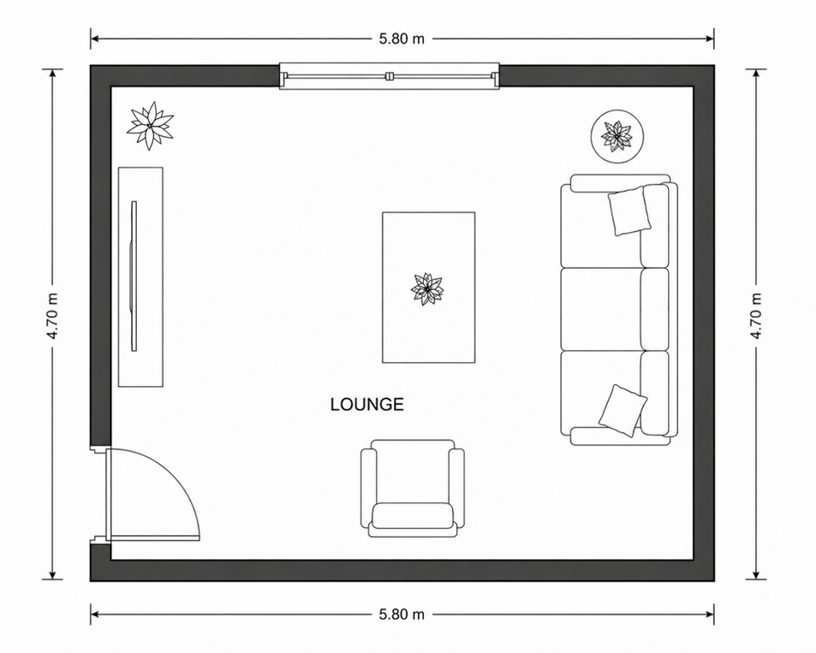

2

Fabric heat loss
Wall | Height (m) | Length (m) | U value | Delta T | Heat loss Kilowatts (kW)
1 | 2.4m | 5.8m | 1.7 | 24 | 0.482
2 | 2.4m | 4.7m | 1.7 | 24 | 0.460
Window | 1.0m | 2.1m | 2.6 | 24 | 0.131

Calculation
Wall 1: 2.4 x 5.8 = 13.92m² – 2.1m2 = 11.82m² x 1.7 x 24 = 0.482 kW
Wall 2: 2.4 x 4.7 = 11.28m² x 1.7 x 24 = 0.460 kW
Window: 1 x 2.1 = 2.1m² x 2.6 x 24 = 0.131 kW

Ventilation heat loss
Room | Height (m) | Length (m) | Width (m) | Air change per hour (ACH) | Delta T | Heat loss Kilowatts (kW)
Lounge | 2.4 | 5.8 | 4.7 | 0.5 | 24 | 0.259

Calculation
2.4 x 5.8 x 4.7 = 65.4m³
0.33 x 65.4m³ x 0.5 x 24 = 0.259 kW

Total room heat loss
Fabric heat loss  (Kilowatts) | Ventilation heat loss | Total room heat loss  (Kilowatts)
1.073 | 0.259 | 1.332

Task 2: Heating design 2 – Heat loss
Objective: To calculate the heating requirement of a room and determine suitable radiator and pipework sizes using the supplied property information, design conditions, and heat pump operating temperatures.
Tutor role:
- Guide learners through the process of calculating room heat loss using the provided building data.
- Support learners in selecting appropriate radiator outputs and pipework sizes based on the calculated heat demand and system temperatures.
- Check that learners use the correct formulas, units, and design temperatures.
- Reinforce the relationship between heat loss calculations and system design.
Key learning points:
- Heat loss is influenced by U-values, surface areas, temperature difference, and ventilation losses.
- Design outdoor temperature and indoor comfort temperature are used to establish the temperature difference (ΔT).
- Air change rate contributes to ventilation heat loss and must be included in calculations.
- Radiator sizing must be suitable for the heat pump flow and return temperatures (50°C/45°C).
- Pipework sizing must match the required heat output and system operating conditions.

Assessment: Extract relevant data from the task description and drawings and make relevant calculations.
Expected learner outcomes:
- Accurately calculate the room heat loss using the supplied building and environmental data.
- Correctly select a radiator and associated pipework that meets the heating demand of the room.
- Demonstrate understanding of how heat pump operating temperatures affect emitter sizing.

Potential learner struggles:
- Identifying which dimensions and U-values should be used in each heat loss calculation.
- Calculating ventilation losses correctly using the air change rate.
- Applying the correct temperature difference (21°C to v –3°C).
- Selecting radiator outputs at low-temperature heat pump operating conditions rather than traditional boiler temperatures.
Suggestions for improvement:
- Provide a worked example showing one complete room heat loss calculation before learners attempt the task independently.
- Include a radiator manufacturer selection table so learners can compare calculated demand with actual radiator outputs at 50°C/45°C temperatures.

Suggestions for stretch activity:
- Ask learners to compare the radiator size required for a heat pump system (50°C/45°C) versus a traditional boiler system (70°C/50°C) and explain the difference.
- Require learners to calculate the impact on heat loss if the window were upgraded to a lower U-value or if insulation were added to the walls.

Task answers
Using the drawings and information in the tables below and complete the radiator and pipework sizing requirements
The property is in Scotland and has a design outdoor temperature of –5℃ and a thermal comfort temperature of 21℃.
The room has 2 external walls (numbered 1 and 2). The ceiling height is 2.4m and the walls are made of 200mm breeze with no cavity and a U Value of 1.9 wm2/k
The window is 1.3m x 2.4m and has a U value of 3.1wm2/kAn air permeability test has been completed, and the room has an air change rate of 0.5ACH
The property currently has an air source heat pump installed to provide thermal comfort with a flow temperature of 50℃ and a return temperature of 45℃ with the system filled with water.
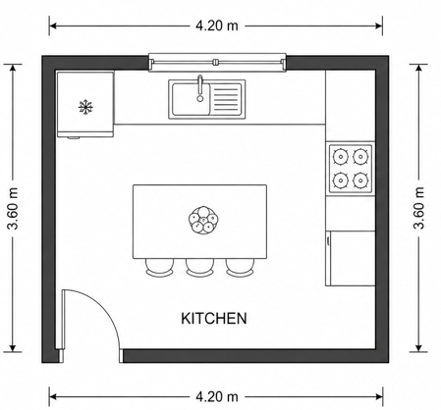
1

2

Fabric heat loss
Wall | Height (m) | Length (m) | U value | Delta T | Heat loss Kilowatts (kW)
1 | 2.4 | 4.2 | 1.9 | 26 | 0.498
2 | 2.4 | 3.6 | 1.9 | 26 | 0.427
Window | 1.3 | 2.4 | 3.1 | 26 | 0.251

Calculation
Wall 1: 2.4 x 4.2 =10.08m² – 3.12m2 = 6.96m2 x 1.9 x 26 = 0.498kW
Wall 2: 2.4 x 3.6 =8.64m² x 1.9 x 26 = 0.427kW
Window: 1.3 x 2.4 = 3.12m² x 3.1 x 26 = 0.251kW

Ventilation heat loss
Room | Height (m) | Length (m) | Width (m) | Air change per hour (ACH) | Delta T | Heat loss Kilowatts (kW)
Lounge | 2.4 | 3.6 | 4.2 | 0.5 | 26 | 0.155

Calculation
2.4 x 3.6 x 4.2 = 36.2m³
0.33 x 36.2m³ x 0.5 x 26 = 0.155kW

Total room heat loss
Fabric heat loss  Kilowatts (kW) | Ventilation heat loss  Kilowatts (kW) | Total room heat loss  Kilowatts (kW)
1.176 | 0.155 | 1.331

Task 3: Heating design 1 – Radiator sizing
Objective: To determine the required radiator output for a room by applying mean water temperature (MWT), room design temperature, and radiator correction factors for a low-temperature heat pump system.
Tutor role:
- Explain how flow temperature, return temperature, and room temperature influence radiator sizing.
- Guide learners through the MWT and MWT-AT calculations.
- Support learners in using correction factor tables correctly.
- Check learners' calculations and understanding of low-temperature heating system design.

Key learning points:
- Mean Water Temperature (MWT) is derived from the flow and return temperatures.
- The temperature difference between the mean water temperature and room design temperature (MWT-AT) affects radiator performance.
- Correction factors must be applied when selecting radiators for low-temperature heat pump systems.
- Radiator outputs at standard test conditions cannot be used directly for heat pump applications.
- Accurate calculations ensure radiators are correctly sized to meet room heat loss requirements.

Assessment: Calculate the mean water temperature from the flow and return temperatures. Select or specify a radiator with an appropriate output of approximately 4.1 kW.
Expected learner outcomes:
- Correctly calculate the MWT, MWT-AT value, and required correction factor.
- Determine the required radiator output for the room based on the calculated heat loss and heat pump operating temperatures.

Potential learner struggles:
- Confusing flow temperature, return temperature, and mean water temperature.
- Selecting the wrong correction factor from the table.
- Using the correction factor incorrectly within the calculation.
- Understanding why larger radiators are required when operating at lower heat pump.

Suggestions for improvement:
- Include a worked example showing each calculation stage from MWT through to final radiator selection.
- Provide a radiator manufacturer's output table so learners can match the calculated 4.1 kW requirement to an actual radiator model.

Suggestions for stretch activity:
- Ask learners to recalculate the radiator output requirement for alternative flow and return temperatures (e.g. 50°C/45°C or 35°C/30°C) and compare the results.
- Require learners to select a suitable radiator from a manufacturer's catalogue and justify their choice based on size, output, and heat pump operating temperatures.

Task answers
Flow temperature ℃ | Return temperature ℃ | Mean water temperature ℃
45 | 40 | 42.5

Calculation
45 + 40 = 85 ÷ 2 = 42.5 round down to 42

Mean water temperature ℃ | Room design temperature ℃ | Mean water- Air temperature (MWT-AT)
42 | 21 | 21

Using the correction factor table below, use your calculated MWT-AT to size the required output of the lounge radiator (to the nearest whole number away from 50).
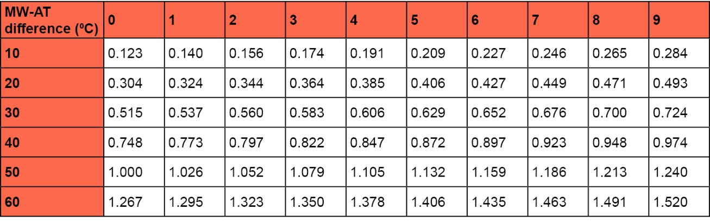
MWT-A | Correction factor | Calculation | Radiator output required  Kilowatts (kW)
21 | 0.324 | 1332 ÷ 0.324 | 4.1

Task 4: Heating design 2 – Radiator sizing
Objective: To determine the required radiator output for a room by applying mean water temperature (MWT), room design temperature, and radiator correction factors for a low-temperature heat pump system.
Tutor role:
- Explain how flow temperature, return temperature, and room temperature influence radiator sizing.
- Guide learners through the MWT and MWT-AT calculations.
- Support learners in using correction factor tables correctly.
- Check learners' calculations and understanding of low-temperature heating system design.

Key learning points:
- Mean Water Temperature (MWT) is derived from the flow and return temperatures.
- The temperature difference between the mean water temperature and room design temperature (MWT-AT) affects radiator performance.
- Correction factors must be applied when selecting radiators for low-temperature heat pump systems.
- Radiator outputs at standard test conditions cannot be used directly for heat pump applications.
- Accurate calculations ensure radiators are correctly sized to meet room heat loss requirements.

Assessment: Calculate the mean water temperature from the flow and return temperatures. Select or specify a radiator with an appropriate output of approximately 3.12 kW.
Expected learner outcomes:
- Correctly calculate the MWT, MWT-AT value, and required correction factor.
- Determine the required radiator output for the room based on the calculated heat loss and heat pump operating temperatures.

Potential learner struggles:
- Confusing flow temperature, return temperature, and mean water temperature.
- Selecting the wrong correction factor from the table.
- Using the correction factor incorrectly within the calculation.
- Understanding why larger radiators are required when operating at lower heat pump.

Suggestions for improvement:
- Include a worked example showing each calculation stage from MWT through to final radiator selection.
- Provide a radiator manufacturer's output table so learners can match the calculated 3.12 kW requirement to an actual radiator model.

Suggestions for stretch activity:
- Ask learners to recalculate the radiator output requirement for alternative flow and return temperatures (e.g. 50°C/45°C or 35°C/30°C) and compare the results.
- Require learners to select a suitable radiator from a manufacturer's catalogue and justify their choice based on size, output, and heat pump operating temperatures.

Task answers
Flow temperature ℃ | Return temperature ℃ | Mean water temperature ℃
50 | 45 | 47.5

Calculation
50 + 45 = 95 ÷ 2 = 47.5

Mean water temperature ℃ | Room design temperature ℃ | Mean water – Air temperature (MWT-AT)
47.5 | 21 | 26 (rounded down away from 50)

Using the correction factor table below, use your calculated MWT-AT to size the required output of the lounge radiator (to the nearest whole number away from 50).

MWT-AT | Correction factor | Calculation | Radiator output required Kilowatts (kW)
26 | 0.427 | 1.331 ÷ 0.427 =3.84 | 3.12

Task 5: Heating design 1 – Pipe sizing
Objective: To calculate the mass flow rate required for a heating circuit and select an appropriate pipe size using CIBSE heating design guidance and system operating conditions.
Tutor role:
- Explain the relationship between room heat loss, mass flow rate, water temperature difference (ΔT), and pipe sizing.
- Guide learners through the mass flow rate calculation.
- Support learners in using the CIBSE Heating Design Guide to select an appropriate pipe size.
- Verify that learners understand the importance of maintaining recommended water velocities within pipework.

Key learning points:
- Pipe sizing is based on the heat output required and the system temperature difference.
- Mass flow rate can be calculated from room heat loss and the specific heat capacity of water.
- Pipe velocities should fall within the recommended range of 0.5–1.5 m/s.
- CIBSE design tables are used to determine suitable pipe diameters.
- Correct pipe sizing helps ensure efficient system performance and reduces noise and excessive pressure losses.

Assessment: Use the data correctly to select a pipe size that operates within the recommended velocity range.
Expected learner outcomes:
- Correctly calculate the mass flow rate as approximately 0.063 kg/s.
- Select an appropriate 15 mm pipe diameter using the CIBSE design guidance.
- Explain the relationship between heat demand, flow rate, and pipe size.

Potential learner struggles:
- Understanding the purpose of the mass flow rate calculation and how it relates to pipe sizing.
- Interpreting the CIBSE pipe sizing tables correctly.
- Confusing pipe diameter selection with radiator sizing calculations.

Suggestions for improvement:
- Provide a worked example showing how the calculated flow rate is matched to the CIBSE pipe sizing chart.
- Include a simplified pipe sizing worksheet that guides learners through each stage of the process.

Suggestions for stretch activity:
- Ask learners to investigate how changing the system ΔT would affect the required mass flow rate and pipe size.
- Have learners compare the suitability of 15 mm, 22 mm, and 28 mm pipework for the same heat load and explain the advantages and disadvantages of each option.

Task answers

Room heat loss  Kilowatts (kW) | Delta T x specific heat capacity of water | Mass flow rate (kg/s)
1.332 | 20.92 | 0.063

Calculation
5 x 4.183 = 20.92
5 is the delta t (difference in temperature between flow and return, which on a Heat pump is 5℃)
4.183 is the specific heat capacity of water (how many joules to raise 1 litre by 1℃). This is given in the equation in CIBSE, and the learners will be familiar with this value.
Therefore, the mass flow rate is 1.332 ÷ 20.92 = 0.063kg/s

Using the CIBSE heating design guide 20/21 on pages 5–28/5–29.
Pipe size choice between the recommended 0.5 g–1.5M/S

Pipe diameter (mm)
15mm

Task 6: Heating design 2 – Pipe sizing
Objective: To calculate the mass flow rate required for a heating circuit and select an appropriate pipe size using CIBSE heating design guidance and system operating conditions.
Tutor role:
- Explain the relationship between room heat loss, mass flow rate, water temperature difference (ΔT), and pipe sizing.
- Guide learners through the mass flow rate calculation.
- Support learners in using the CIBSE Heating Design Guide to select an appropriate pipe size.
- Verify that learners understand the importance of maintaining recommended water velocities within pipework.

Key learning points:
- Pipe sizing is based on the heat output required and the system temperature difference.
- Mass flow rate can be calculated from room heat loss and the specific heat capacity of water.
- Pipe velocities should fall within the recommended range of 0.5–1.5 m/s.
- CIBSE design tables are used to determine suitable pipe diameters.
- Correct pipe sizing helps ensure efficient system performance and reduces noise and excessive pressure losses.

Assessment: Use the data correctly to select a pipe size that operates within the recommended velocity range.
Expected learner outcomes:
- Correctly calculate the mass flow rate as approximately 0.090 kg/s.
- Select an appropriate 15 mm pipe diameter using the CIBSE design guidance.
- Explain the relationship between heat demand, flow rate, and pipe size.

Potential learner struggles:
- Understanding the purpose of the mass flow rate calculation and how it relates to pipe sizing.
- Interpreting the CIBSE pipe sizing tables correctly.
- Confusing pipe diameter selection with radiator sizing calculations.

Suggestions for improvement:
- Provide a worked example showing how the calculated flow rate is matched to the CIBSE pipe sizing chart.
- Include a simplified pipe sizing worksheet that guides learners through each stage of the process.

Suggestions for stretch activity:
- Ask learners to investigate how changing the system ΔT would affect the required mass flow rate and pipe size.
- Have learners compare the suitability of 15 mm, 22 mm, and 28 mm pipework for the same heat load and explain the advantages and disadvantages of each option.

Task answers
Room heat loss  Kilowatts (KW) | Delta T x specific heat capacity of water | Mass flow rate (kg/s)
1.893 | 20.92 | 0.090

Calculation
5 x 4.183 = 20.92
5 is the delta T (difference in temp between flow and return, which on a Heat pump is 5℃)
4.183 is the specific heat capacity of water (how many joules to raise 1 litre by 1℃). This is given in the equation in CIBSE, and the learners will be familiar with this value.
Therefore, the mass flow rate is 1.893 ÷ 20.92 = 0.090kg/s

Using the CIBSE heating design guide 20/21 on pages 5–28/5–29.
Pipe size choice between the recommended 0.5–1.5M/S
Pipe diameter (mm)
15mm

Task 7: Heating design 1 – Pressure loss
Objective: To assess pressure losses within a heat pump primary circuit, determine whether the selected pipework is suitable, and verify that the circulating pump can overcome the total system resistance.
Tutor role:
- Guide learners through the calculation of flow rate and total pressure loss.
- Explain how pipe size, flow rate, fittings, valves, and pipe length affect system resistance.
- Support learners in using the CIBSE Heating Design Guide to obtain pressure loss values.
- Demonstrate how to interpret a pump performance graph and compare it against calculated system requirements.

Key learning points:
- Pressure loss occurs due to friction within pipes, fittings, bends, and valves.
- Effective pipe length includes both actual pipework and allowances for fittings and valves.
- Flow rate is calculated from the mass flow rate and converted to litres per minute.
- Pipe sizing influences pressure loss and system efficiency.
- Pump performance must be checked against the total calculated pressure loss to ensure adequate circulation.
- CIBSE guidance should be used when selecting pipe sizes and estimating pressure losses.

Assessment: Calculate the required flow rate from the mass flow rate and decide whether the proposed pump can meet the system requirements.
Expected learner outcomes:
- Correctly calculate the flow rate requirement of 42.84 litres per minute and total pressure loss of 1.488 m.
- Select an appropriate 35 mm pipe size and determine whether the circulating pump can achieve the required duty point.
- Demonstrate understanding of how pressure losses affect heat pump system performance.

Potential learner struggles:
- Understanding the difference between pressure loss per metre and total system pressure loss.
- Interpreting CIBSE design charts and pump performance curves correctly.
- Accounting for fittings and valves within the effective pipework length.
- Identifying the correct duty point on the pump graph.

Suggestions for improvement:
- Include a worked example showing how effective pipe length is derived from actual pipework, bends, valves, and fittings.
- Provide a step-by-step guide on reading and interpreting a pump performance graph.
- Include a diagram of the pipework layout to help learners visualise where pressure losses occur.

Suggestions for stretch activity:
- Ask learners to investigate how changing the pipe diameter (e.g. 28 mm, 42 mm) would affect the pressure loss and pump selection.
- Require learners to compare two different circulating pumps and justify which is the most suitable for the calculated system duty point.
- Ask learners to calculate the impact on pressure loss if additional valves or a longer pipe run were added to the system.

Task answers
Use CIBSE Heating Design Guide 20/21 pages 5–28/5–29
You have been contracted to install a 15 kW air source heat pump at a domestic property. The system design includes primary flow and return pipework with longer-than-average pipe runs, incorporating multiple bends, fittings, and isolation/control valves.
Your task is to carry out a full assessment of the primary circuit to ensure correct operation and efficiency of the system.
Complete the tables below.
kW | Mass flow rate (kg/s) | Pipe size (mm) | Flow rate required (L/m) | Pressure loss m(h)/m | Effective pipework length (including fittings /valves) | Total Pressure loss (M)
15 | 0.714 | 35mm | 42.84 | 0.024 | 62 metres | 1.488

Flow rate calc = Mass flow rate in litres per second x 60 (secs in a min) = 42.84 litres per minute
Total pressure loss would be pressure loss 0.040 x effective length 62 = 1.488 metres
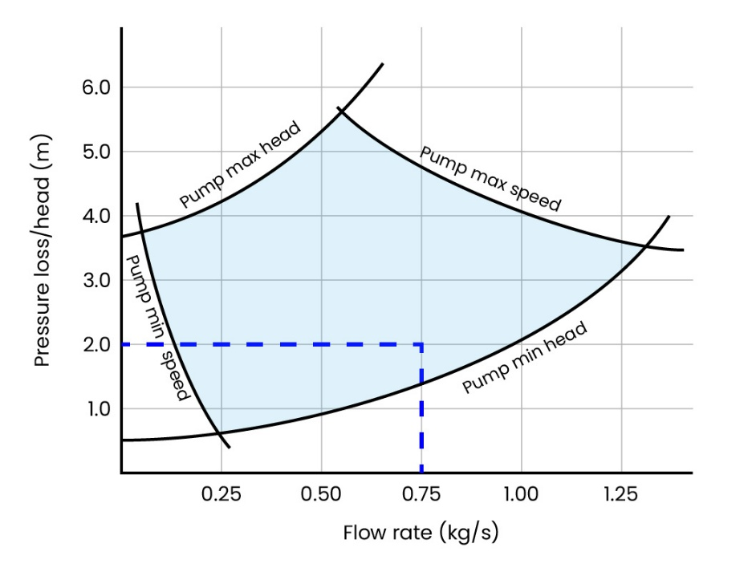
Use the pump graph below to identify if the total pressure loss can be achieved by the circulating pump. Tick the relevant box.

Pump suitable | Pump unsuitable
Yes

Task 8: Heating design 2 – Pressure loss
Objective: To assess pressure losses within a heat pump primary circuit, determine whether the selected pipework is suitable, and verify that the circulating pump can overcome the total system resistance.
Tutor role:
- Guide learners through the calculation of flow rate and total pressure loss.
- Explain how pipe size, flow rate, fittings, valves, and pipe length affect system resistance.
- Support learners in using the CIBSE Heating Design Guide to obtain pressure loss values.
- Demonstrate how to interpret a pump performance graph and compare it against calculated system requirements.

Key learning points:
- Pressure loss occurs due to friction within pipes, fittings, bends, and valves.
- Effective pipe length includes both actual pipework and allowances for fittings and valves.
- Flow rate is calculated from the mass flow rate and converted to litres per minute.
- Pipe sizing influences pressure loss and system efficiency.
- Pump performance must be checked against the total calculated pressure loss to ensure adequate circulation.
- CIBSE guidance should be used when selecting pipe sizes and estimating pressure losses.

Assessment: Calculate the required flow rate from the mass flow rate and decide whether the proposed pump can meet the system requirements.
Expected learner outcomes:
- Correctly calculate the flow rate requirement of 31.8 litres per minute and total pressure loss of 3 m.
- Select an appropriate 35 mm pipe size and determine whether the circulating pump can achieve the required duty point.
- Demonstrate understanding of how pressure losses affect heat pump system performance.

Potential learner struggles:
- Understanding the difference between pressure loss per metre and total system pressure loss.
- Interpreting CIBSE design charts and pump performance curves correctly.
- Accounting for fittings and valves within the effective pipework length.
- Identifying the correct duty point on the pump graph.

Suggestions for improvement:
- Include a worked example showing how effective pipe length is derived from actual pipework, bends, valves, and fittings.
- Provide a step-by-step guide on reading and interpreting a pump performance graph.
- Include a diagram of the pipework layout to help learners visualise where pressure losses occur.

Suggestions for stretch activity:
- Ask learners to investigate how changing the pipe diameter (e.g. 28 mm, 42 mm) would affect the pressure loss and pump selection.
- Require learners to compare two different circulating pumps and justify which is the most suitable for the calculated system duty point.
- Ask learners to calculate the impact on pressure loss if additional valves or a longer pipe run were added to the system.

Task answers
Use the CIBSE heating design guide 20/21, pages 5–28/5–29

You have been contracted to install an 11 kW air source heat pump at a domestic property. The system design includes primary flow and return pipework with longer-than-average pipe runs, incorporating multiple bends, fittings, and isolation/control valves.

Your task is to carry out a full assessment of the primary circuit to ensure correct operation and efficiency of the system.

Complete the tables below.

kW | Mass flow rate (kg/s) | Pipe size (mm) | Flow rate required (L/m_ | Pressure loss m(h)/m | Effective pipework length (including fittings /valves) | Total Pressure loss (M)
11 | 0.530 | 28 mm | 31.8 | 0.040 | 75 metres | 3

Flow rate calc = Mass flow rate in litres per second x 60 (secs in a min) = 31.8litres per minute
Total pressure loss would be pressure loss 0.040 x effective length 75 = 3.0 metres

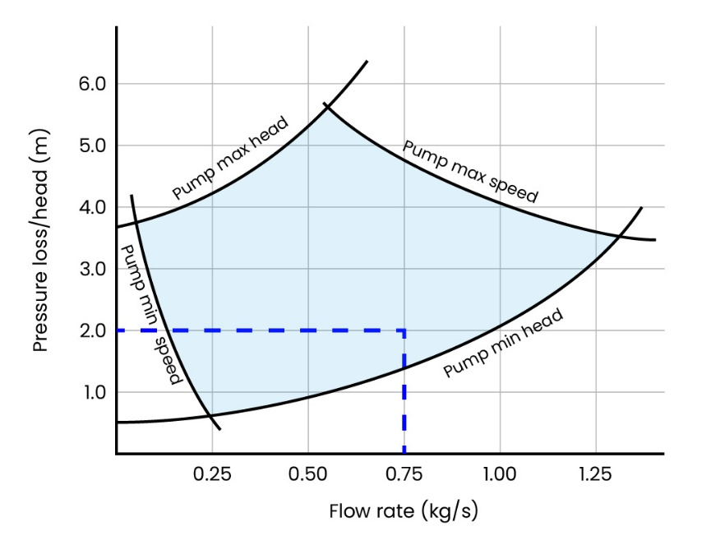
Use the pump graph below to identify if the total pressure loss can be achieved by the circulating pump. Tick the relevant box.

Pump suitable | Pump unsuitable
Yes

Task 9: Heating design 1 – Air source heat pump sizing
Objective: To determine whether an 8 kW air source heat pump can meet a property's heat loss requirement at the specified outdoor and flow temperatures by interpreting manufacturer performance data.
Tutor role:
- Explain how manufacturer performance charts are used to assess heat pump suitability.
- Guide learners in locating and interpreting performance data for different outdoor and flow temperatures.
- Reinforce the relationship between flow temperature, heat pump output, and emitter sizing.
- Support learners in understanding the system design implications of reducing flow temperatures.

Key learning points:
- Heat pump outputs vary according to outdoor temperature and flow temperature.
- Manufacturer performance data must be consulted to verify design performance.
- A heat pump's nominal rating does not guarantee that output under all operating conditions.
- Lower flow temperatures can improve heat pump efficiency but may require larger radiators and pipework.
- Heat pump selection should be checked against property heat loss and design temperatures.

Assessment: Check learners can interpret the manufacturer's power output chart correctly and justify whether the selected heat pump is suitable for the design conditions.
Expected learner outcomes:
- Correctly identify that the maximum flow temperature for achieving 8 kW output at –5°C is 40°C.
- Explain that reducing the flow temperature may require increased radiator outputs and potentially larger pipework.
- Demonstrate the ability to use manufacturer performance data to assess heat pump suitability.

Potential learner struggles:
- Reading the manufacturer performance chart correctly and locating the appropriate design conditions.
- Understanding the relationship between flow temperature, heat pump output, and system sizing requirements.
- Confusing heat pump nominal output with actual output under design conditions.

Suggestions for improvement:
- Provide examples of several heat pump performance charts from different manufacturers so learners can practise interpreting a range of formats.
- Include a short discussion or worksheet explaining why lower flow temperatures often improve heat pump efficiency whilst requiring larger heat emitters.

Suggestions for stretch activity:
- Ask learners to compare the performance of different sized heat pumps (e.g. 8 kW, 10 kW and 12 kW) under the same design conditions and justify the most appropriate selection.
- Require learners to estimate how much radiator capacity would need to increase when reducing the system flow temperature from 55°C to 40°C.
- Ask learners to investigate how a change in outdoor temperature (e.g. from -5°C to 0°C) would affect the heat pump's available output and system design.

Task answers
A property has been assessed and calculated to have a heat loss of 8 kW. The heating system has been designed to operate with a flow temperature of 55°C.

You are provided with the manufacturer’s performance data (power output chart) for an 8 kW air source heat pump.

Using the manufacturer’s data, determine whether the selected heat pump can deliver the required 8 kW heat output at an external temperature of –5°C.

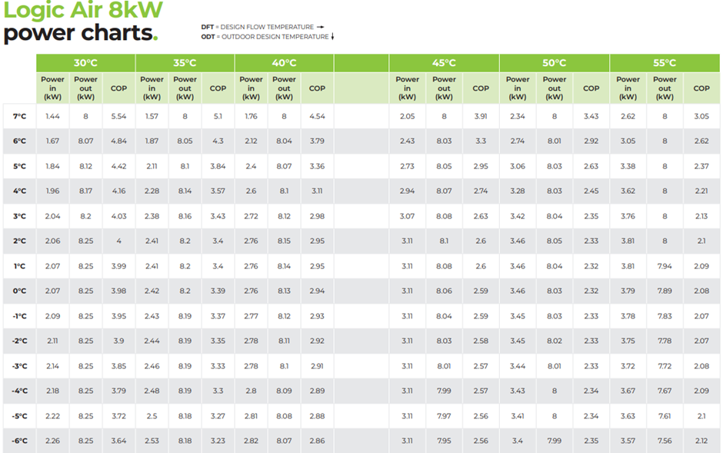
7.61kW
What is the maximum output of the heat pump at the design temperatures stated above?

If you were to install this 8KW heat pump, what maximum flow temperature could you use to fulfil the required maximum output and what would be the impact on pipework and radiator sizing?

Answers:
- 40℃
- Radiators and pipework could need increasing in size /outputs.

Method:
- The power chart is for an 8kw unit.
- On the left is the outside design temp. Find –5℃.
- On the top axis is flow temp. The highest flow temp you can get the 8kW output at –5℃ is 40℃. This means if they were to lower the flow temperature to 40℃ from a higher temperature, they may also have to resize radiators and pipework.
No specific calculation to do, other than using the chart to draw on info, with the possible rad/pipe adjustments being knowledge picked up through training.

Task 10: Heating design 2 – Air source heat pump sizing
Objective: To determine whether an 8 kW air source heat pump can meet a property's heat loss requirement at the specified outdoor and flow temperatures by interpreting manufacturer performance data.
Tutor role:
- Explain how manufacturer performance charts are used to assess heat pump suitability.
- Guide learners in locating and interpreting performance data for different outdoor and flow temperatures.
- Reinforce the relationship between flow temperature, heat pump output, and emitter sizing.
- Support learners in understanding the system design implications of reducing flow temperatures.

Key learning points:
- Heat pump outputs vary according to outdoor temperature and flow temperature.
- Manufacturer performance data must be consulted to verify design performance.
- A heat pump's nominal rating does not guarantee that output under all operating conditions.
- Lower flow temperatures can improve heat pump efficiency but may require larger radiators and pipework.
- Heat pump selection should be checked against property heat loss and design temperatures.

Assessment: Check learners can interpret the manufacturer's power output chart correctly and justify whether the selected heat pump is suitable for the design conditions.
Expected learner outcomes:
- Correctly identify that the maximum flow temperature for achieving 8 kW output at –4°C is 40°C.
- Explain that reducing the flow temperature may require increased radiator outputs and potentially larger pipework.
- Demonstrate the ability to use manufacturer performance data to assess heat pump suitability.

Potential learner struggles:
- Reading the manufacturer performance chart correctly and locating the appropriate design conditions.
- Understanding the relationship between flow temperature, heat pump output, and system sizing requirements.
- Confusing heat pump nominal output with actual output under design conditions.

Suggestions for improvement:
- Provide examples of several heat pump performance charts from different manufacturers so learners can practise interpreting a range of formats.
- Include a short discussion or worksheet explaining why lower flow temperatures often improve heat pump efficiency whilst requiring larger heat emitters.

Suggestions for stretch activity:
- Ask learners to compare the performance of different sized heat pumps (e.g. 8 kW, 10 kW and 12 kW) under the same design conditions and justify the most appropriate selection.
- Require learners to estimate how much radiator capacity would need to increase when reducing the system flow temperature from 55°C to 40°C.
- Ask learners to investigate how a change in outdoor temperature (e.g. from –5°C to 0°C) would affect the heat pump's available output and system design.

Task answers
A property has been assessed and calculated to have a heat loss of 8 kW. The heating system has been designed to operate with a flow temperature of 45°C.

You are provided with the manufacturer’s performance data (power output chart) for an 8 kW air source heat pump.

Using the manufacturer’s data, determine whether the selected heat pump can deliver the required 8 kW heat output at an external temperature of –4°C.

What is the maximum output of the heat pump at the design temperatures stated above?
Answer: 7.99kW

If you were to install this 8KW heat pump, what maximum flow temperature could you use to fulfil the required maximum output, and what would be the impact on pipework and radiator sizing if the flow temperature were altered?
Answers:
- 40℃
- Radiators and pipework could need increasing in size /outputs.

Method:
- The power chart is for an 8kw unit.
- On the left is the outside design temp. Find -4℃
- On the top axis is flow temp. The highest flow temp you can get the 8kw output at –4℃ is 40℃. This means if they were to lower the flow temp to 40℃ from a higher temperature, they may also then have to resize radiators and pipework.
No specific calculation to do, other than using the chart to draw on info with the possible rad/pipe adjustments being knowledge picked up through training.

Task 11: Heating design 1 – Heat pump selection
Objective: To select the most suitable air source heat pump for a domestic property by comparing the property's heat loss requirements against manufacturer performance data at the design operating conditions.
Tutor role:
- Guide learners in interpreting manufacturer performance tables.
- Explain the importance of selecting a heat pump based on output at design conditions rather than nominal rating.
- Support learners in comparing the performance characteristics of different heat pump models.
- Reinforce the relationship between property heat loss, outdoor temperature, and heat pump output.

Key learning points:
- Heat pump selection must be based on the property's design heat loss.
- Manufacturer performance data should be checked at the specified outdoor temperature.
- Nominal heat pump size may differ from actual output at low outdoor temperatures.
- Heat pump performance decreases as external temperatures reduce.
- Other factors such as sound levels, refrigerant charge, weight, and efficiency ratings may influence equipment selection.

Assessment: Check learners can identify the property's design heat loss requirement, select the correct heat pump model based on design conditions and justify the selection.
Expected learner outcomes:
- Correctly identify that the 7 kW heat pump should be selected because it provides 6.1 kW at –5°C.
- Explain why the 5 kW and 6 kW units are unsuitable, as they cannot meet the required 6 kW heat loss at the design temperature.
- Demonstrate confidence in using manufacturer performance data to select heat pumps.

Potential learner struggles:
- Selecting the heat pump based on its nominal size rather than its output at –5°C.
- Misreading the performance table and selecting the 6 kW model because it appears to match the building heat loss.
- Understanding why a larger-rated heat pump may be required to meet the design load.

Suggestions for Improvement:
- Include additional selection scenarios with different heat losses and outdoor temperatures to provide more practice interpreting manufacturer data.
- Add a question requiring learners to justify why the selected heat pump provides appropriate performance margin at design conditions.

Suggestions for stretch activity:
- Ask learners to compare the three heat pumps using factors such as ERP rating, sound power level, refrigerant charge, and weight to determine the most appropriate overall selection.
- Provide a second property with a different heat loss and design temperature and require learners to repeat the selection process.
- Ask learners to investigate the consequences of undersizing or oversizing a heat pump and explain the impact on efficiency, comfort, and running costs.

Task answers
A domestic property has been surveyed and has a calculated heat loss of 6 kW at a design outdoor temperature of –5°C. The heating system is designed to operate at a flow temperature of 50°C.
You are provided with a manufacturer’s data table showing the performance of three air source heat pumps under different operating conditions. Identify the correct heat pump to use.
Heat Pump Output | 5 kW | 6 kW | 7 kW
ERP Rating | A**** | A**** | A****
Sound Power level (db.) | 53 | 55 | 55
Weight (kg) | 86 | 87 | 90
Max Output at 0℃ | 5.0 kW | 6.0 kW | 7.0 kW
Max Output at -3℃ | 5.0 kW | 6.0 kW | 6.75 kW
Max Output at –5℃ | 4.3 kW | 5.5 kW | 6.1 kW
Refrigerant charge (Kg) | 0.7 | 1.0 | 1.2
Heat pump selected (Tick size required) |  |  | X

Tutor feedback
Check the information selected and the calculations used to select the heat pump. Go through each and explain each step if required.

Task 12: Heating design 2 – Heat pump selection
Objective: To select the most suitable air source heat pump for a domestic property by comparing the property's heat loss requirements against manufacturer performance data at the design operating conditions.
Tutor role:
- Guide learners in interpreting manufacturer performance tables.
- Explain the importance of selecting a heat pump based on output at design conditions rather than nominal rating.
- Support learners in comparing the performance characteristics of different heat pump models.
- Reinforce the relationship between property heat loss, outdoor temperature, and heat pump output.

Key learning points:
- Heat pump selection must be based on the property's design heat loss.
- Manufacturer performance data should be checked at the specified outdoor temperature.
- Nominal heat pump size may differ from actual output at low outdoor temperatures.
- Heat pump performance decreases as external temperatures reduce.
- Other factors such as sound levels, refrigerant charge, weight, and efficiency ratings may influence equipment selection.

Assessment: Check learners can identify the property's design heat loss requirement, select the correct heat pump model based on design conditions and justify the selection.
Expected learner outcomes:
- Correctly identify that the 6 kW heat pump should be selected because it provides 4 kW at –5°C.
- Explain why the 5 kW and 7 kW units are unsuitable, as they cannot meet the required 6 kW heat loss at the design temperature.
- Demonstrate confidence in using manufacturer performance data to select heat pumps.

Potential learner struggles:
- Selecting the heat pump based on its nominal size rather than its output at –5°C.
- Misreading the performance table and selecting the 6 kW model because it appears to match the building heat loss.
- Understanding why a larger-rated heat pump may be required to meet the design load.

Suggestions for Improvement:
- Include additional selection scenarios with different heat losses and outdoor temperatures to provide more practice interpreting manufacturer data.
- Add a question requiring learners to justify why the selected heat pump provides appropriate performance margin at design conditions.

Suggestions for stretch activity:
- Ask learners to compare the three heat pumps using factors such as ERP rating, sound power level, refrigerant charge, and weight to determine the most appropriate overall selection.
- Provide a second property with a different heat loss and design temperature and require learners to repeat the selection process.
- Ask learners to investigate the consequences of undersizing or oversizing a heat pump and explain the impact on efficiency, comfort, and running costs.

Task answers
A domestic property has been surveyed and has a calculated heat loss of 6 kW at a design outdoor temperature of –5°C. The heating system is designed to operate at a flow temperature of 50°C.
You are provided with a manufacturer’s data table showing the performance of three air source heat pumps under different operating conditions. Identify the correct heat pump to use.
Heat Pump Output | 5 kW | 6 kW | 7 kW
ERP Rating | A**** | A**** | A****
Sound Power level (db.) | 53 | 55 | 55
Weight (Kg) | 86 | 87 | 90
Max Output at 0℃ | 3.5 kW | 6.0 kW | 7.0 kW
Max Output at –3℃ | 3.3 kW | 5.0 kW | 6.0 kW
Max Output at –5℃ | 3.0 kW | 4.0 kW | 5.0 kW
Refrigerant | R290 | R290 | R290
Refrigerant charge (Kg) | 0.75 | 1.1 | 1.3
Heat pump selected (Tick size required) |  | X

Tutor feedback
Check the information selected and the calculations used to select the heat pump. Go through each and explain each step if required.

Task 13: Hot Water Requirements 1
Objective: To determine domestic hot water requirements by selecting an appropriate hot water cylinder size and calculating cylinder reheat performance using CIBSE Heating Design Guide 20/21.
Tutor role:
- Guide learners in using CIBSE Table 4.1 to determine the minimum cylinder size for the property.
- Explain the factors affecting domestic hot water demand, including property size, occupancy indicators, and temperature rise requirements.
- Support learners in calculating coil ratings and cylinder reheat times.
- Reinforce the distinction between domestic hot water design calculations and space heating calculations.

Key learning points:
- Domestic hot water design should be considered separately from space heating design.
- Minimum cylinder sizing is determined using recognised design guidance such as CIBSE Table 4.1.
- The energy required to heat stored water depends on cylinder volume and temperature rise.
- Coil output ratings influence cylinder recovery (reheat) times.
- Cold water inlet and hot water storage temperatures affect overall hot water demand calculations.

Assessment: Check learners can calculate the reheat time of a cylinder when provided with a known coil output and present calculations accurately.
Expected learner outcomes:
- Correctly identify the minimum indirect cylinder size for a three-bedroom property with one bathroom and a downstairs WC.
- Calculate the required indirect coil rating to achieve a 40-minute reheat time.
- Calculate the reheat time when using a 20 kW indirect coil.
- Demonstrate an understanding of how cylinder size, temperature rise, and coil output influence hot water system performance.

Potential learner struggles:
- Locating and interpreting the correct cylinder sizing information from the CIBSE guide.
- Applying the correct temperature rise when carrying out calculations.
- Understanding the relationship between cylinder volume, coil rating, and reheat time.
- Confusing domestic hot water calculations with space heating design calculations.

Suggestions for improvement:
- Include a worked example demonstrating the complete process from cylinder sizing through to reheat time calculations.
- Provide a summary sheet of the formulas required for hot water energy and reheat calculations.
- Include a cylinder manufacturer's specification sheet so learners can compare theoretical calculations with real product data.

Suggestions for stretch activity:
- Ask learners to compare cylinder sizing requirements for properties with different numbers of bedrooms and bathrooms using CIBSE guidance.
- Require learners to assess the impact of increasing the storage temperature from 60°C to 65°C on energy requirements and reheat times.
- Ask learners to compare the performance of different coil ratings (e.g. 15 kW, 20 kW, 25 kW) and explain how they affect customer hot water availability.

Task answers
The domestic hot water calculations in this task are separate from the previous heat loss and space heating design calculations. Learners should treat the hot water design requirements as an independent exercise, using the information provided to determine cylinder sizing, hot water demand, recovery times, and related calculations.
Using the CIBSE heating design guide 20/21, complete the following calculations for hot water cylinder requirements and reheat times in domestic dwellings (use Table 4.1 for minimum cylinder sizing).
A customer has asked you for information regarding the hot water requirement at one of their properties.
The house has 3 bedrooms, 1 bathroom and a WC downstairs.
The cold mains enter the property at 10℃ and requires the hot water to be heated to 60℃ by an indirect cylinder.

1. What is the minimum size indirect cylinder required for this property?
150 litres

2. What would the indirect coil rating be if the customer requires the cylinder reheat time to be 40 minutes?
60 – 10 = 50
150 x 50 = 7500
14.3 x 40 = 572 = 13.1 kW
7500 ÷ 572 =13.1 Kw

3. How long would it take to reheat the same cylinder if the coil rating was 20 kW at 60℃?
60 – 10 = 50
150 x 50 = 7500
14.3 x 20 =286
7500 ÷ 286 = 26.2 minutes

Tutor feedback
Go through each calculation and explain each step if required.

Task 14: Hot Water Requirements 2
Objective: To determine domestic hot water requirements by selecting an appropriate hot water cylinder size and calculating cylinder reheat performance using CIBSE Heating Design Guide 20/21.
Tutor role:
- Guide learners in using CIBSE Table 4.1 to determine the minimum cylinder size for the property.
- Explain the factors affecting domestic hot water demand, including property size, occupancy indicators, and temperature rise requirements.
- Support learners in calculating coil ratings and cylinder reheat times.
- Reinforce the distinction between domestic hot water design calculations and space heating calculations.

Key learning points:
- Domestic hot water design should be considered separately from space heating design.
- Minimum cylinder sizing is determined using recognised design guidance such as CIBSE Table 4.1.
- The energy required to heat stored water depends on cylinder volume and temperature rise.
- Coil output ratings influence cylinder recovery (reheat) times.
- Cold water inlet and hot water storage temperatures affect overall hot water demand calculations.

Assessment: Check learners can calculate the reheat time of a cylinder when provided with a known coil output and present calculations accurately.
Expected learner outcomes:
- Correctly identify the minimum indirect cylinder size for a three-bedroom property with one bathroom and a downstairs WC.
- Calculate the required indirect coil rating to achieve a 30-minute reheat time.
- Calculate the reheat time when using an 8 kW indirect coil.
- Demonstrate an understanding of how cylinder size, temperature rise, and coil output influence hot water system performance.

Potential learner struggles:
- Locating and interpreting the correct cylinder sizing information from the CIBSE guide.
- Applying the correct temperature rise when carrying out calculations.
- Understanding the relationship between cylinder volume, coil rating, and reheat time.
- Confusing domestic hot water calculations with space heating design calculations.

Suggestions for improvement:
- Include a worked example demonstrating the complete process from cylinder sizing through to reheat time calculations.
- Provide a summary sheet of the formulas required for hot water energy and reheat calculations.
- Include a cylinder manufacturer's specification sheet so learners can compare theoretical calculations with real product data.

Suggestions for stretch activity:
- Ask learners to compare cylinder sizing requirements for properties with different numbers of bedrooms and bathrooms using CIBSE guidance.
- Require learners to assess the impact of increasing the storage temperature from 60°C to 65°C on energy requirements and reheat times.
- Ask learners to compare the performance of different coil ratings (e.g. 15 kW, 20 kW, 25 kW) and explain how they affect customer hot water availability.

Task answers
The domestic hot water calculations in this task are separate from the previous heat loss and space heating design calculations. Learners should treat the hot water design requirements as an independent exercise, using the information provided to determine cylinder sizing, hot water demand, recovery times, and related calculations.
Using the CIBSE heating design guide 20/21, complete the following calculations for hot water cylinder requirements and reheat times in domestic dwellings (use Table 4.1 for minimum cylinder sizing).
A customer has asked you for information regarding the hot water requirement at one of their properties.
The house has 4 bedrooms and 2 bathrooms.
The cold mains enter the property at 9℃ and requires the hot water to be heated to 55℃ with an indirect cylinder heated by an air source heat pump.

1. What is the minimum size indirect cylinder required for this property?

200 litres

2. What would the indirect coil rating be if the customer requires the cylinder reheat time to be 30 minutes?
55 – 9 = 46
200 x 46 = 9200
14.3 x 30 = 429 = 21.4 kW
9200 ÷ 429 = 21.4 kW

3. How long would it take to reheat the same cylinder if the coil rating was 8 kW at 60℃?
55 – 9 = 46
200 x 46 = 9200
14.3 x 8 = 114.4
9200 ÷ 114.4 = 80.4 minutes

Tutor feedback
Go through each calculation and explain each step if required.

Task 15: Identification of key components in an air source heat pump installation
Objective: To identify the key components of a domestic air source heat pump installation and explain their purpose, operation, sizing, and importance within the system in accordance with MCS principles and industry good practice.
Tutor role:
- Set up and supervise the workshop-based inspection activity.
- Guide learners in identifying system components and interpreting component labels.
- Explain the purpose and operation of each component and how it contributes to system performance.
- Reinforce the importance of correct component selection, sizing, and compliance with industry standards.
- Add additional components to the exercise to extend learning where appropriate.

Key learning points:
- Air source heat pump systems consist of multiple components that work together to provide heating and hot water.
- Each component has a specific function and must be correctly sized and specified.
- System efficiency, safety, and reliability depend on appropriate component selection and installation.
- MCS principles and industry good practice should be considered when assessing heat pump installations.
- Understanding component ratings and specifications is essential when designing, installing, and maintaining systems.

Assessment: Check learners can correctly identify each tagged component for function, size, rating and specification.
Expected learner outcomes:
- Correctly identify all major components within a domestic air source heat pump installation.
- Explain the purpose, specification, and system importance of each component.
- Demonstrate an understanding of component selection and sizing principles.

Potential learner struggles:
- Confusing components with similar appearances or functions (e.g. circulation pumps, low loss headers, volumisers, and buffer vessels).
- Understanding how component size or specification affects system performance.
- Interpreting manufacturer labels and technical data correctly.

Suggestions for improvement:
- Include manufacturer datasheets for each component to help learners identify specifications and ratings.
- Provide a system schematic showing how the components are connected and interact with one another.
- Include photographs and symbols commonly used in design drawings to reinforce identification skills.

Suggestions for stretch activity:
- Ask learners to explain the consequences of removing or incorrectly sizing a selected component within the system.
- Require learners to draw and label a simplified heat pump system schematic showing the identified components and flow paths.
- Ask learners to compare components used in different heat pump system configurations (e.g. buffer tank versus volumiser arrangements) and justify their application.

Task answers
Identify the key components installed in a domestic air-source heat pump system and demonstrate an understanding of their purpose, operation, and sizing in accordance with MCS principles and industry good practice.
Scenario
A complete air-source heat pump installation has been assembled in the workshop.
All major system components have been labelled with identification tags.
You are required to inspect the installation and complete the component identification task sheet.
For each tagged component:
1. Identify the component name
2. Describe the purpose/function of the component
3. State the component size, rating or specification
4. Explain why the component is required within the system

The rationale list is not exhaustive. Tutor to add any further components to extend learning.
Component sizes etc are examples.
For each tagged component, learners must:
- Identify the component name
- Describe the purpose/function of the component
- State the component size, rating or specification
- Explain why the component is required

Section 1: Outdoor unit components
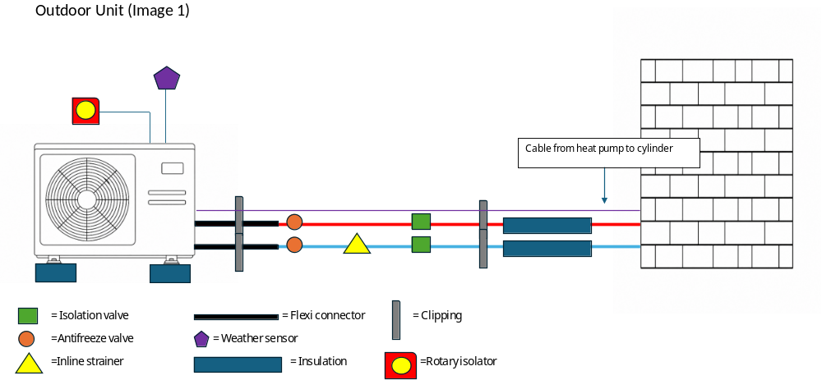

Component Identification Task
Tag Number | Component | Function/Purpose/size
 | Anti vibration feet | Stop vibration and Lift ASHP above weather/snow level
 | Flexible pipework connectors | ¾-22mm to connect ASHP to primary pipework and prevent vibration
 | Antifreeze valves | 22mm to prevent pipework freezing by discharging pressure at extreme low temperatures
 | Inline strainer/Filter | 22mm to prevent condenser blockage and to be serviced annually
 | Insulation | Minimum thickness 19mm to prevent heat loss from external pipework
 | Rotary isolator | 16 amp to isolate ASHP from electrics
 | Weather compensation sensor | Part of the system control strategy for system to know ambient outdoor sensor
 | Condensate/Soakaway | Minimum pipe size 19mm to dispose of water during ASHP defrost cycle
 | Isolation/lever valves | 22mm to isolate ASHP from primary pipework

Section 2: Indoor cylinder components
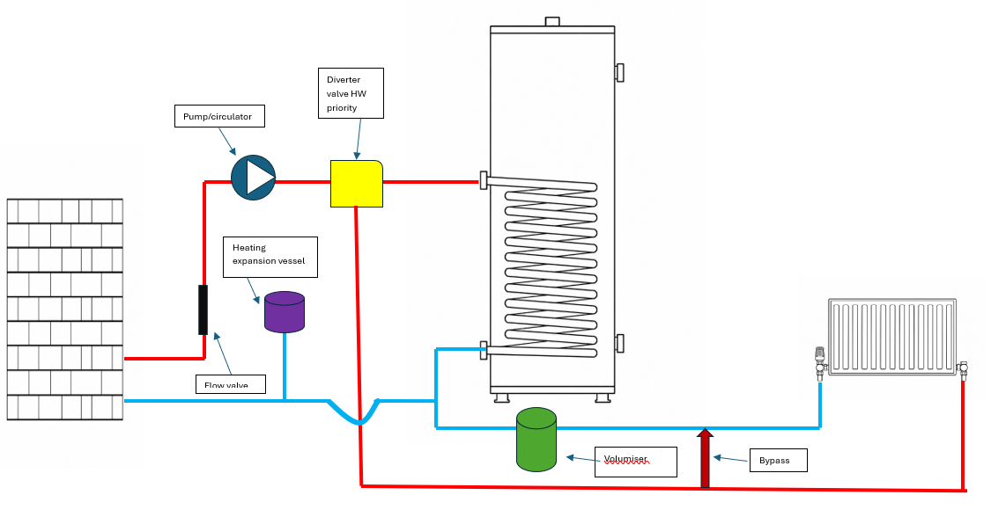
Component Identification Task
Tag Number | Component | Function/Purpose/size
 | Flow valve | 22mm to observe system flow rate
 | Flow sensor | Wired from the control box to primary flow pipework
 | Return sensor | Wired from the control box to primary return pipework
 | Hot water temp sensor | Temperature sensor in dry pocket to confirm temperature of hot water in cylinder
 | Zone valve/s | 22mm Diverter valve /Esbe Valve/2 port valve to switch between heating and Hot water. normally HW priority
 | Expansion vessel/s | 8 litres to allow for heating and domestic HW expansion when heated
 | Filling loop | To pressurise the heating system pipework with
 | Cylinder | 200 litres Hot water storage
 | Buffer vessel/Volumiser | Hydronic separation as multiple zones and controls/adds volume to aid defrost cycle
 | Control Box | Where all sensors and stats wire into and where heat curves and control functions are altered
 | Fuse spur/s | Electrical isolation for controls/immersion heater 3 amp
 | Magnetic filter | System filter to gather any debris in pipework for ease of removing during annual service
 | Room thermostat | Controls indoor room temperature
 | Automatic air vent | Removes air from the system automatically
 | Isolation valves | 22 mm Isolates components from the system  e.g. pump/zone valve
 | Drain off | 15mm allows access to connect a hose pipe to drain the system
 | Bypass | If installed on system/to assist the system flow when radiator Trvs may have shut off reducing system volume
 | Radiators | 600x 600 K1 Convects heat into a room
 | Thermostatic radiator valves/Lock shield valves | Isolate a radiator/shut off or open at set room temperatures
 | Underfloor heating Manifold | Where multiple rooms/circuits underfloor pipework connect to the heating flow and return
 | Circulator/Pump | Circulates water around the system primary /secondary pump

Extension task
 | HW Thermal cut out | Shuts off zone valve/immersion if water temperature gets to high
 | Immersion heater | Backup heater for Hot water or used for Legionella cycle in R32 Heat pump
 | Tundish | 15mmx 22mm visible indicator of pressure/temperature relief activating
 | Combination valve | 22mm mains cold pressure-reducing valve/check valve /balanced cold /expansion/ pressure relief connection for domestic HW
 | Discharge 1 /2 pipework | D1 D2 pressure temperature relief pipework Domestic HW

Tutor feedback
Go through each diagram and explain the function of each component if required.
Check completed drawings demonstrate:
- understanding of a domestic heat pump system operation
- correct integration of heating and domestic hot water components
- awareness of servicing, maintenance and commissioning considerations
- appropriate use of insulation, clipping and external protection components

Task 16: Heat pump siting
Objective: Identify a safe location for the HP290 (R290 refrigerant) heat pump to be sited prior to installation.
Tutor role: Select a scenario for the learner(s), place items within the exclusion zone to be highlighted by the candidate. Remove risks when identified.
Key learning points: Understand R290 is an LPG, therefore siting is key due to the flammable nature of the refrigerant.
Assessment: Completion of assessment for a suitable location.

Expected learner outcomes:
- Identify installation scenario.
- Identify and avoid risks within the exclusion zone.

Potential learner struggles:
- Identifying all the risks.
- Understanding the exclusion zone measurements.

Suggestions for improvement:
- Use visual guides to identify all the risks.
- Examine the different scenarios with the candidate beforehand.

Suggestions for stretch activity:
- Create a template for the clearances.
- Explore using a different refrigerant heat pump, such as R32 unit.

Exclusions from the zone:
- Drains.
- Depression, ditches or troughs in the ground.
- Vent or extractor into/out of the property.
- Opening into the property.
- No source of ignition.
- No hot surfaces above 400°C.
- No electrical switches.
- Boundary lines.

Task answers
You are required to identify a safe location for an ideal HP290 (R290 refrigerant) heat pump to be sited before installation, following the guidance below, which is taken from the Ideal HP290 Manufacturer’s Instructions, page 29.

You must:
- identify the installation scenario
- identify and avoid risks within the exclusion zone

Your tutor will tell you if the heat pump is to be installed in:
- a corner
- against a wall or
- an open space
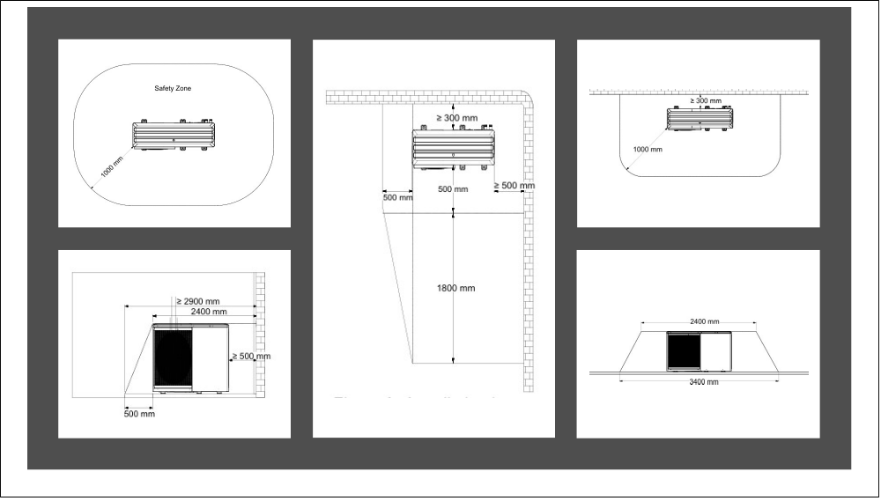

Activity guidance:

- Select either of the scenarios: corner installation, against a wall or in open space.
- Then place laminated sheets with the items that should be outside the exclusion zone within it.
- Also place some outside the zone to check if the candidate has understood the criteria entirely.
- Once the learner has noted the items inside the exclusion zone, remove them and allow them to site the ASHP in the correct location with help from another person to lift.

Always refer to the manufacturer's instructions for clearances, as it states the clearances which are not generic across the range of R290 appliances. The Vaillant Aurotherm Pro allows electric isolators to be mounted alongside the heat pump within the ‘traditional’ clearances.
The HP290 heat pump is selected as an example to try to make the point to learners that Manufacturer’s Instructions MUST be referenced, as there can be details that can be overlooked if assumptions such as ‘it’s the refrigerant that dictates clearances’ are made. Page 29 of the Ideal HP290 M I’s scan QR below installation and maintenance.

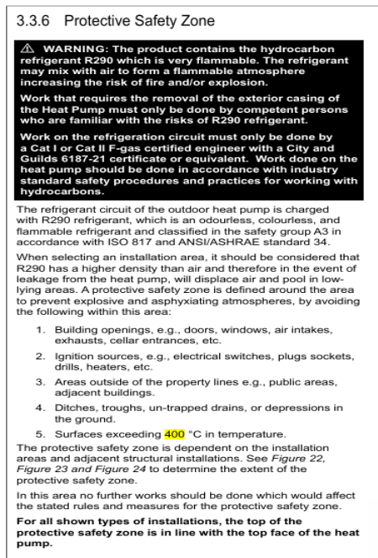
What tools are required to complete the task?
Tape measure

What PPE is required to carry out the task safely?
Boots
Gloves

Check the following task elements are met
Key elements | Criteria
Measurement | - Accurate to the dimensions on the drawing
Marking out | - +/- 2mm of the dimensions on the drawing  - Marked out in pencil  - Spirit level used

Check which of the following behaviours are demonstrated
Behaviours demonstrated during this task
Dependable and responsible
Enthusiasm and positive attitude
Quality focus
Willingness to learn
Work with others
Sustainable working

Task 17: Fit anti-vibration feet and level a heat pump
Objective: To work safely with help when lifting, installing anti-vibration mounts, ensuring to level the unit left to right and front to back.
Tutor role: Allow the candidate to select the feet to use – have 4 individual feet all set to different heights to begin.
Key learning points: how to fit feet and level the heat pump and understand why it is so important to do so.
Assessment: Fit the four individual feet to the unit safely, adjust the feet to level the unit as described.

Expected learner outcomes:
- Learn the minimum height to satisfy MCS standards.
- Understand the importance of using anti-vibration mounts and the reason for levelling so the fan bearings are not damaged and the unit is secure.

Potential learner struggles:
- May struggle to attach the anti-vibration mounts.
- Could be difficult raising the unit to fit the mounts.

Suggestions for improvement:
- Allow the candidates to watch a YouTube video on levelling a heat pump:
Air source heat pumps - Installation using adjustable support feet
- Allow assistance with a second person to help lifting.

Suggestions for stretch activity:
- Research into different methods of levelling heat pumps.
- Research heat pump lifters for safety and ease.

Task answers
You are required to select suitable anti-vibration feet and attach them to the heat pump.
Make sure the air source heat pump (ASHP) is level front to back and level left to right, and the minimum ground clearance is achieved.
Reference the Ideal Logic Air Manufacturer’s Instructions.


What tools are required to complete the task?
Tape measure
Spanners
Spirit level

What PPE is required to carry out the task safely?
Boots
Gloves

Activity guidance
- The learner is to select the feet, and the best method is to level the feet before fitting them to the ASHP.
- Have the position of the mounting points marked out from the Ideal Logic Air Manufacturer’s Instructions.
- Once the feet are level, allow the learner, with help, to lift up the ASHP and locate it.
- Double-check it is level and has 100mm clearance, as per Ideal Logic Air Manufacturer’s Instructions.

Check the following task elements are met
Key task elements | Criteria
Measurement | - Level front to back  - Level left to right  - 100mm minimum height from to ASHP to the ground
Marking out | - Mark out mounting points  - Spirit level used

Check which of the following behaviours are demonstrated
Behaviours demonstrated during this task
Dependable and responsible
Enthusiasm and positive attitude
Quality focus
Willingness to learn
Work with others
Sustainable working

Task 18: Pipe up to an air-source heat pump (ASHP)
Objective: Successfully select all the relevant components to pipe up to an ASHP, mark up clip locations for the lagged pipework before installing components in the best practice order. Complete by adding the correct size lagging before using the correct supports to hold the lagged pipework.
Tutor role: Show the candidate an example of the pipework done and lagged correctly.
Key learning points: The importance of using the correct pipework accessories to ensure warranties are covered by the manufacturer and the customer is satisfied. Plus grasping how vital lagging pipework correctly is when it comes to efficient low-temperature systems.
Assessment: Completion of the pipework in a best practice order before correctly lagging and adequately supporting.

Expected learner outcomes:
- Making pipework configurations.
- Making compression joints.
- Selecting lagging.
- Lagging and supporting pipework correctly.

Potential learner struggles:
- Correctly marking up pipe clip positions.
- Installing the pipework in a ‘best practice manner’.
- Making the joint with mastic.

Suggestions for improvement:
- Use visual aids to determine the correct lagging to use.
- Have an example of the best practice installation.
- Demonstrate pipe lagging jointing method, using the primary pro and mastic (other lagging available).

Suggestions for stretch activity:
- Research making joints and lagging antifreeze valve and isolation valves.
- Use a 90-degree bend and make a joint onto a straight section of pipe lagging.

Task answers
From the list given to you by your tutor, identify the accessories required to attach to the ASHP and decide on the most sensible order to fit them before lagging and clipping the pipework correctly.
- Ensure the flow and return pipes are correct
- Mark up clip locations for the lagged pipework before installing components
- Identify and confirm flow and return connections on both the heat pump and the pipework or manifold before connecting any components
- Add the correct size lagging before using the correct supports to hold the lagged pipework
- Pay attention to the accessory instructions to ensure they are installed correctly. The system has been designed to have water only in the system
Note: This is a task-specific design decision rather than standard practice. Water-only systems are not normal practice, as MCS 020 requirements state that glycol protection is required in frost-risk locations.
Flow pipework – provide for learner to attach to the ASHP
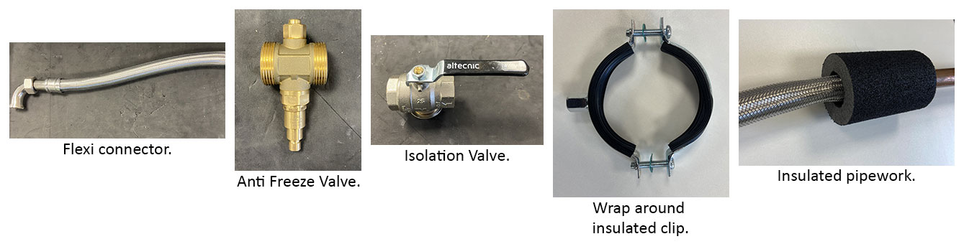

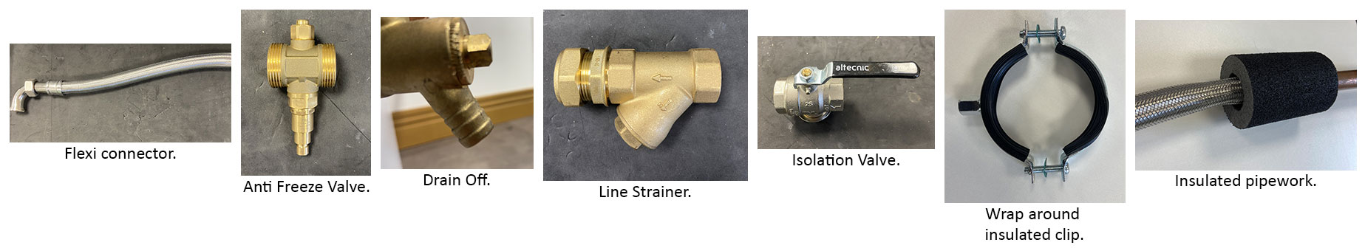
Return pipework

List of accessories/parts to give the learner:
- Compression tee (size depends on pipe size)
- Drain off
- 2 X Antifreeze valves
- Line strainer
- 2 X Flexible connectors
- 2 X Isolation lever valves
- Primary Pro lagging (other equivalent brand lagging is available)
- 4 X Wrap around Unistrut clips
- Copper pipe

What tools are required to complete the task?
Tape measure
Spirit level
Pipe cutter or slice
Screwdriver
Pencil/marker
Adjustable spanner
Junior hacksaw
Mastic (ordered with primary pro)

What PPE is required to carry out the task safely?
Boots
Gloves
Goggles

Activity guidance:
- The learner selects the components and references MI’s to ensure that the accessories are installed correctly.
- One point is that the antifreeze valves will need to be staggered so as not to discharge on top of the lowest valve, plus require 150mm clearance from the ground. Please reference the manufacturer’s instructions of the valves you have (e.g. refer to MCS 020 and the Ideal Logic Air Installation and Servicing Guide).

- The learner needs to consider the lagging when looking to mark up for the clips.
- Once the accessories are selected, the learner has to put them onto the pipework in a best practice method – this is as follows:
- flexis onto the ASHP (bent connectors are best) antifreeze valves
- drain off the y-strainer followed by isolation valves
This is so the strainer stops any debris from getting into the accessories and the entire heating system can be isolated from the ASHP and accessories.
- Make sure the learners identify and confirm flow and return connections on both the heat pump and the pipework or manifold before connecting any components.
- Once it is all put together, allow the learner to use the lagging on a section of pipe before fastening the wrap-around clip over the lagging.

The point of the task is to state water only, so the learner selects the antifreeze valves. This will test the learners – they should have been taught that some form of protection is required from the risk of freezing.
Note: This is a task-specific design decision rather than standard practice. Emphasise that water-only systems are not normal practice, as MCS 020 requirements state that glycol protection is required in frost-risk locations.

Check the following task elements are met
Key task elements | Criteria
Measurement | - Measure and mark out clip locations  - Measure and cut pipework between accessories  - Ensure clearances maintained for antifreeze valves
Marking out | - Marked out in pencil/marker  - Spirit level used
Clipping | - Select appropriate pipework clips for use and space them correctly

Check which of the following behaviours are demonstrated
Behaviours demonstrated during this task
Dependable and responsible
Enthusiasm and positive attitude
Quality focus
Willingness to learn
Work with others
Sustainable working

Task 19: Schematics
Objective: To successfully identify the components on a schematic and be able to recognise the system to be installed.
Tutor role: Provide a schematic with a design for the candidate to identify components.
Key learning points: Becoming familiar with schematics and identifying various components found on an ASHP heating system.
Assessment: Identify an auto bypass valve, a volumiser, a buffer and a secondary circulator.

Expected learner outcomes:
- Understand schematic layouts
- Identify system components
- Identify system type

Potential learner struggles:
- Difficulty understanding what symbol relates to what component

Suggestions for improvement:
- Use the schematic Legend as a reference tool

Suggestions for stretch activity:
- Use more complex setups to identify an underfloor circuit (Figure 10), a single zone (Figure 4) and 3 zones with low loss headers (Figure 10)

Task answers
Identify the components on the schematic provided, and number them on the schematic.
Your tutor will provide you with two schematics:
- one with a bypass and volumizer
- one with a buffer and single zone

Activity guidance
- For this task, hand the learner 2 schematics, one with a bypass and volumizer, and one with a buffer and single zone. Then ask them to identify the components.
- This is important as the vast majority of current installers have never had to interpret schematics and cannot identify system types and therefore miss vital components needed for a heating system to operate efficiently.
- Reference Schematics PDF attached, for the buffer and secondary circulator use:
- Figure 2 (Logic Air with Single Zone Pre-Plumbed Cylinder with Integrated Buffer) on page 5 and
- Figure 5 (Logic Air with Standard Non Pre-Plumbed Heat Pump Cylinder with Buffer — Single Zone) on page 8
- for the volumizer and auto bypass use Figure 4 (Logic Air with Single Zone Pre-Plumbed Cylinder) on page 7.

Make it clear to learners that the bypass valve appears in the specific schematic figures as:


Check the following key task elements are met
Key task elements | Criteria
Identify | - Buffer  - Secondary circulator  - Volumiser  - By-pass
Stretch activity identify | - Single zone  - Multi zone with buffer  - Underfloor symbol

Check which of the following behaviours are demonstrated
Behaviours demonstrated during this task
Dependable and responsible
Enthusiasm and positive attitude
Quality focus
Willingness to learn
Work with others
Sustainable working

Task 20: Glycol level
Objective: To determine the volume of a central heating system, identify the volume of glycol required to meet MCS standards, and identify from 3 samples, the one that satisfies MCS requirements.

Tutor role: Demonstrate safe and accurate methods of testing, advising on MCS requirements.

Key learning points: Understand the percentage of glycol required and the temperature to protect down to.

Assessment: Complete the tasks laid out using the refractometer to identify the correct sample.

Expected learner outcomes:
- Calculate system volume.
- Calculate glycol volume.
- Safely test samples.
- Identify a suitable sample.
- Identify MCS requirements.

Potential learner struggles:
- Difficulties calculating volumes
- Struggle using a refractometer

Suggestions for improvement:
- Use simple volume figures to help with calculations
- Practice sample testing

Suggestions for stretch activity:
- Research antifreeze valves and glycol use
- Discuss the pros and cons of using glycol and antifreeze valves

NOTE. The commissioning/design form is used throughout these 4 tasks.

Task answers
Work out the volume of glycol required to protect this ASHP installation to the recommended level published by MCS.
Scenario
This 10-radiator system has a heat pump containing 5 litres of water, with 6 radiators containing 1.5 L of water each, and 4 radiators containing 2.1 L of water each.
There is 20M of 28mm pipe, 40M of 22mm pipe, and 12M of 15mm pipe.
Work out the system volume then calculate the volume of glycol required.
28mm Pipe: 1M hold 0.54 litres of water
22mm Pipe: 1M holds 0.32 litres of water
15mm Pipe: 1M holds 0.15 litres of water
After calculating, add your results in the box below, highlighting the correct sample that meets the MCS requirements without exceeding them.

Activity description
The learner will have to work out the system volume from knowing the following:
ASHP contains 5 litres of water
There are 20M of 28mm pipe, 40M of 22mm pipe, 12M of 15mm pipe.
10 radiators in all – 6 X 1.5 L water content and 4 X 2.1 L water content.
28mm pipe holds 0.54 L of water per metre
22mm pipe holds 0.32 L of water per metre
15mm pipe holds 0.15 L of water per metre
Therefore, the total is: 20 x 0.54 = 10.8
40 x 0.32 = 12.8
12 x 0.15 = 1.8
6 x 1.5 = 9
4 x 2.1 = 8.4
ASHP = 5

Total: = 47.8 L

The MCS requirement is to protect down to –10 degrees which equates to between 25% and 30% concentration of glycol in water – we will use 25%.
So, take the total volume of 47.8 litres and multiply by 0.25 to give us the glycol level:
47.8 x 0.25 = 11.95 L of glycol.
Flush and fill valve, along with a filling machine, would be required to pump the mixture into the system. Glycol doesn’t mix very well, so it needs pre-mixing before filling. This is for information only, it would not be practical to fill a system. Knowing the process, the standard and the method of filling is adequate.
Once the volumes have been worked out, we can move on to the sample testing. The candidate can now sample the cold supply to get a base reading. Use the pipette to put 4 or 5 droplets onto the lens before covering with the lens cover. Recording the result, the reading will be 0 degrees.
Have Sample 1 that has 50% concentration and Sample 2 with 25% concentration.
Allow the learners to record all results before identifying the correct sample.
Always check the Glycol Manufacturer Data sheet – 25% delivers minimum protection with no margins.
Expected results are as follows: water sample = 0 degrees
25% mix = –10 degrees (the correct sample for MCS standards)
50% = –30 degrees (incorrectly overdosed)
The sample that protects to –10 degrees without exceeding the value is correct.
Overdosing adds expense to the job but also reduces the SHC of the liquid in the system, leading to less efficient systems or oversized pipes to accommodate the loss in SHC of the fluid.

What tools are required to complete the task?
Refractometer kit with pipette
Glycol
Sample tubs with lids

What PPE is required to carry out the task safely?
Boots
Gloves
Goggles

Check the following key task elements are met
Key task elements | Criteria
Measurement | - Measure the cold mains to identify zero protection  - Test sample 1 and 2, recording the temperature it protects down to
Identify | - Correctly identify the sample protecting down to –10 (MCS)

Check which of the following behaviours are demonstrated
Behaviours demonstrated during this task
Dependable and responsible
Enthusiasm and positive attitude
Quality focus
Willingness to learn
Work with others
Sustainable working

Task 21: Setting the flow rate
Objective: Identify the design flow rate and set that on the unit or system.

Tutor role: Demonstrate the different methods of setting flow rates, electronically or manually with a valve.

Key learning points: How to work out design flow rates, how to set flow rates using different methods and understand the importance of setting the flow rate.

Assessment: Correctly identify the design flow rate and set it on the system.

Expected learner outcomes:
- Understand how to work out design flow rate.
- Confidently adjust the unit/valve to achieve flow rate.
- Understand why it is important.

Potential learner struggles:
- Working out the design flow rate.
- Adjusting the unit settings.

Suggestions for improvement:
- Use the mass flow calculation for flow rates.
- Learn conversions to l/min, l/hr and M3/hr from l/sec or kg/sec.

Suggestions for stretch activity:
- Use different SHC of fluids to see the effect on flow rate.
- Research the impact of incorrect flow rates, particularly over pumping.

Task answers
It is important to ensure the correct flow rate is set on the air-source heat pump (ASHP). This will ensure the system DT is maintained and operates efficiently.
Use the mass flow rate calculation to work out the required flow rate for the system, which has an 8KW ASHP accurately sized to satisfy the property heat loss. The ASHP is running at a 5-degree DT and the system is filled with water only.
Work out the flow rate and convert it to litres per minute, before setting the flow rate either electronically on the unit or by means of adjusting the flow meter valve.

Activity description
As different ASHP designs vary, the method of adjusting and setting the flow rates can be very different. In this example, we can utilise either an ASHP with an integral primary pump and means of electronic adjustment, or a flow setting valve which can be manually adjusted to provide the requisite flow rate.
To calculate the design flow rate, simply take the unit size, sized accurately to match the property heat loss, then divide it by the SHC of water (advise the learners that water is used in the system – not a glycol mix), and multiply that by the system DT.
So, for our example:
- SHC water = 4.2 Kj/Kg k (to 1DP)
- System DT = 5 degrees
- ASHP output = 8 KW
Therefore 8 / (4.2 X 5) = 0.381 l/sec or kg/sec.
0.381 X 60 (l/min) = 22.9 l/min 22.9 X 60 (l/hr) = 1374 l/hr
Now, to change that figure to M3/hr you can divide l/hr by 1000, therefore 1374 l/hr = 1.374 M3/hr
Or, if you want to go from l/sec straight to M3/hr simply multiply by 3.6, so 0.381 X 3.6 = 1.372 M3/hr (due to rounding).
For the stretch exercise, change the SHC for a glycol water mix to 3.7 Kj/KG k and let the candidates work out that the flow rate has increased.
SHC of the glycol mix = 3.7 Kj/Kg k
System DT = 5 degrees
ASHP output = 8KW
Therefore 8 / (3.7 X 5) = 0.432 l/sec or kg/sec
0.432 X 60 = 25.9 l/min

So now allow the learners to put the heat pump to work and either manually adjust the flow meter valve or digitally alter using the manufacturer's instructions.
Once complete, fill in the commissioning/design sheet.

What tools are required to complete the task?
Calculator
Pen and paper
Adjustable spanner

What PPE is required to carry out the task safely?
Boots
Gloves

Check the key task elements are met
Key task elements | Criteria
Measurement | - Work out the design flow rate for the 8KW unit
Adjustment | - Set the flow rate to the calculated value.
Record | - Record your results on the commissioning/design sheet.

Check which of the following behaviours are demonstrated
Behaviours demonstrated during this task
Dependable and responsible
Enthusiasm and positive attitude
Quality focus
Willingness to learn
Work with others
Sustainable working

Task 22: Weather compensation curve
Objective: To determine the correct heat curve to select for an installation from the information provided.
Tutor role: Provide the learner with the relevant documentation for them to select a heat curve accurately.
Key learning points: Understand how to identify the correct curve on a graph and understand what the heat curve graph is telling us.
Assessment: Using information provided, determine a heat curve for an ASHP central heating system, understand the heat curve graph.

Expected learner outcomes:
- Understand the relationship between outdoor temperature and flow temperature.
- Understand the impact of higher flow temperatures
- Understand the impacts of low outdoor temperatures.
- Identify heat curves and understand the graph.

Potential learner struggles:
- Understanding how to select the curve to the corresponding number.

Suggestions for improvement:
- Research heat curves and room influence.

Suggestions for stretch activity:
- Use the calculation method to select a heat curve.

Task answers

Using the commissioning sheet provided in Appendix 1, fill in the missing information and add the glycol results from Task 1 (20) before identifying the system design flow temperature and the design outdoor temperature.
With the information, plot the lines on the weather compensation graph (Appendix 2) to determine which heat curve to select. The design indoor temperature is 21 degrees.
Activity description
Provide the learner with a system design/commissioning sheet and weather compensation graph, which will contain the information required to identify a heat curve to select for optimum comfort and efficiency and plot it on the graph.
The learner can fill in the customer details, including the address of the centre you are in.
The figures in the design section of the commissioning sheet are as follows:
- 45-degree flow temp with an outdoor temp of –3.
- The curve to be selected is the nearest to where the lines intersect, which is curve 1 in Appendix 1: Commissioning sheet.
- The design indoor temperature is 21 degrees.
- Appendix 2: Weather compensation graph. This graph is just for this exercise; manufacturers' graphs may differ.
- Through discussion questions, the learner checks their knowledge on the impact of higher flow temperatures on running costs, and the impact on performance caused by lower outdoor temperatures. Lower outdoor temperatures affect performance and output, whilst increased flow temperatures mean higher running costs and lower efficiency.
Stretch activity is a simple calculation:
(Flow temperature – Indoor design temperature) / (Indoor design temperature – Design outdoor temperature).
45 – 21 = 24 21 – (-3) = 24 24/24 = 1 Select curve 1.

What tools are required to complete the task?
Ruler
Pen

What PPE is required to carry out the task safely?
Boots

Check the following key task elements are met

Key task elements | Criteria
Curve selection | - Correctly select heat curve
Identify | - The effect of flow temperatures on efficiency

Check which of the following behaviours are demonstrated
Behaviours demonstrated during this task
Dependable and responsible
Enthusiasm and positive attitude
Quality focus
Willingness to learn
Work with others
Sustainable working

Task 22 – Appendix 1
Weather compensation commissioning sheet
Heat Pump Commissioning Sheet
Customer and Installation Details
Customer name
Installation address
Postcode
Heat pump make and model
Heat pump serial number
Commissioned by
Company name
Commissioning date

Design Information
Design item | Recorded value
Heat loss | 8KW
Design indoor temperature | 21°C
Design outside temperature | –3°C
System design flow temperature | 45°C
Design return temperature | 40°C
Design temperature difference (DT) | 5°C
Design flow rate
Heat emitter type | Low-temperature radiators
Weather compensation enabled | Yes
Heat curve selected
Outdoor sensor fitted | Yes
Domestic hot water target temperature | 49°C
Legionella protection configured | Yes, via timed temperature control

System and Controls Checklist
Check | Status | Notes
Heating system filled and pressure tested | Complete | No visible leaks identified at time of commissioning
System flushed and cleaned in accordance with BS 7593 guidance and manufacturer instructions | Complete | Cleaner and inhibitor details to be recorded by installer if required
Expansion vessel sized, fitted and charged | Complete | Set in accordance with manufacturer requirements
System filter fitted and clean | Complete | Filter checked during commissioning
Automatic bypass fitted or confirmed not required | Complete | As per system design
Heating zone valves operational | Complete | All zones tested
Hot water zone valve operational | Complete | Confirmed during hot water demand
Room thermostat / programmer operational | Complete | Time and temperature controls verified
Heat pump safety interlock operational | Complete | Confirmed during control test
Outdoor unit secure, level and clear of airflow obstructions | Complete | Clearances checked
External pipework insulated and frost protected | Complete | Insulation visually checked

Water Treatment and Frost Protection
Item | Recorded value
System cleaner used
Heating system inhibitor used
Antifreeze / inhibitor used
Glycol level calculated
In Litres and percentage
Frost protection setting | Enabled
System pressure cold | 1.5 bar
System pressure hot | 2.0 bar

Commissioning Test Results
Test | Recorded value | Result
Heating flow temperature achieved | 45°C | Pass
Heating return temperature recorded | 40°C | Pass
Flow and return temperature difference | 5°C | Pass
Domestic hot water operation | Confirmed | Pass
Circulation pump operation | Confirmed | Pass
Air removed from system | Confirmed | Pass
System filters checked | Clean at commissioning | Pass
Weather compensation curve checked | Set for 45°C design flow at –3°C outside temperature | Pass
Defrost operation checked where conditions allow | Confirmed / not observed during commissioning | Acceptable
Controls handover completed | Customer to be advised on operation | Complete

Commissioning Declaration
The heat pump system has been commissioned using the design outside temperature of –3°C and the system design flow temperature of 45°C. The system checks and test results recorded above should be verified against the manufacturer’s instructions, site conditions and measured commissioning readings before handover.
Engineer signature
Customer signature
Date

Task 22 – Appendix 2
Weather compensation graph

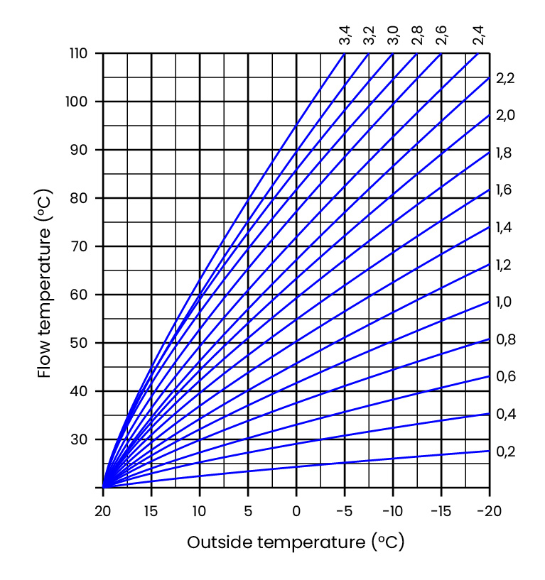

Note: Select the weather compensation curve by finding the system design flow temperature and the design outdoor temperature. Then simply plot a line on both axes, and where they meet, follow the curve you hit to find out the numerical value. This is your heat curve value.
The numbers denote the curve selected but also hold more information. For every 1-degree deviation in outside temperature, the curve number represents the effect on the flow temperature. For example, on a 1.6 curve, if the outdoor temperature dropped by 1 degree, the flow temperature would increase by 1.6 degrees to compensate for the deviation.

Task 23: Setting the controls
Objective: Set the central heating and hot water times with comfort and setback temperatures, and hand over to the customer with an explanation of how to use the system efficiently.
Tutor role: Provide the learner with the desired settings and become the customer to facilitate the handover.
Key learning points: Understand why we use a 3-degree temperature difference between comfort and setback. Understand why an ASHP utilises priority hot water.
Assessment: Correctly set the controls to operate efficiently and hand over the information verbally to the tutor (customer).

Expected learner outcomes:
- Understand comfort and setback temperatures.
- Understand why priority hot water is used with ASHP systems.
- Be confident when speaking to customers during handover.

Potential learner struggles:
- Confidently handing over to the customer.
- Operating some controls differs across manufacturers.

Suggestions for improvement:
- Use online videos.
- Research different control strategies.

Suggestions for stretch activity:
- Explore open-loop systems rather than trv’s and zones, and the benefits.

Task answers
Using the manufacturer's instructions, set the customer controls to deliver the following:
- Comfort temperature of 21 degrees
- Setback temperature of 18 degrees
- Hot water setpoint at 49 degrees
Set the Legionella function to run a disinfection cycle every Sunday at midnight.
Once set, hand over the controls to the customer, describing what has been set and the most efficient way to operate the low-temperature system.
Activity description
Ensure the controls are set correctly, and that the instructions and the understanding the customer gets from the commissioning engineers lead to expectations being set and understood. Without a good handover, customers can expect their heating system to be the same as their old fossil fuel burning high temperature system.
The parameters to be set by the candidate are as follows:
Comfort temperature 21 degrees
Setback temperature 18 degrees
DHW setpoint 49 degrees
Legionella settings Sunday at midnight
The hot water can be set as on constant therefore being a priority system rather than reheating overnight as a strategy. Although in some instances this can be more efficient for a better customer experience set up as above. The ASHP has to run priority water as it would be difficult for an ASHP to adequately heat both heating and hot water simultaneously plus highly inefficient. The setback temperature should be no greater than 3 degrees for optimum use, this is so the heat pump can easily and efficiently heat from the setback to comfort. If we allow the fabric of the building to cool, the reheat times would be excessive and the ASHP would be highly inefficient.
Setting the DHW at 49 degrees helps efficient operation and a weekly disinfection via an immersion heater for example lifts the temperature above 60 degrees to satisfy legionella requirements.

What tools are required to complete the task?
Note pad and pen
Manufacturer’s instructions

What PPE is required to carry out the task safely?
Boots

Check the following key task elements are met
Key task elements | Criteria
Configure controller | - Set the comfort temperature  - Set the setback temperature  - Set hot water set point  - Configure Legionella function
Handover | - Handover to the customer
Verbally | - Explain controls and settings

Check which of the following behaviours are demonstrated
Behaviours demonstrated during this task
Dependable and responsible
Enthusiasm and positive attitude
Quality focus
Willingness to learn
Work with others
Sustainable working

Fault-finding tasks:
These tasks involve visually inspecting an air source heat pump installation and identifying faults intentionally introduced into the system.

Task 24: Flow fault alarm
Objective: To diagnose and rectify a heat pump system displaying a Flow Fault alarm, restoring normal heating performance through safe inspection, fault identification, and corrective actions.

Tutor role:
- Observe learners carrying out the fault-finding activity safely and systematically.
- Ensure learners follow correct health and safety procedures during inspection and rectification.
- Guide learners in identifying system faults, analysing their impact, and selecting appropriate corrective actions.
- Reinforce manufacturer requirements and industry good practice throughout the task.

Key learning points:
- Fault finding should be carried out using a safe and systematic approach.
- Flow faults can affect system performance, efficiency, reliability, and comfort.
- Heat pump faults must be investigated before corrective actions are taken.
- Fault identification should be linked to understanding the effect on system operation.
- Correct rectification procedures and final system verification are essential.
- Manufacturer instructions and industry best practice should be followed when servicing heat pump systems.
- Accurate documentation of faults, tools used, and safety procedures is an important part of maintenance activities.

Assessment: Assess learner competence in fault diagnosis, rectification, and system verification.

Expected learner outcomes:
- Correctly identify the cause of the flow fault and any associated system issues.
- Safely rectify faults and restore the heat pump system to normal operation.
- Demonstrate competence in fault finding, fault rectification, and system verification.

Potential learner struggles:
- Distinguishing between the symptoms of a fault and the root cause of the fault.
- Applying a systematic fault-finding process rather than making assumptions.
- Explaining how identified faults affect system performance and efficiency.
- Completing the final verification checks thoroughly.

Suggestions for improvement:
- Provide a fault-finding flowchart or troubleshooting guide to help learners structure their diagnostic process.
- Introduce a range of common heat pump faults so learners gain experience diagnosing different fault scenarios.
- Include access to manufacturer fault code documentation as part of the exercise.

Suggestions for stretch activity:
- Require learners to identify multiple simultaneous faults and prioritise rectification actions based on safety and system impact.
- Ask learners to produce a detailed service report explaining the fault, diagnosis process, rectification work, and verification results.
- Challenge learners to compare how the same fault might present on different heat pump manufacturers' systems and discuss variations in fault codes and diagnostics.

Task answers
Scenario
You are a Heat Pump Service Engineer attending a customer's property following reports that some radiators are not heating correctly and the controller is displaying a Flow Fault alarm.
Under the observation of your Tutor/Trainer, carry out a safe inspection of the system, identify the cause of the faults, explain their effect on system operation, and rectify the issues to restore normal heating performance.
Tutor guidance
Under the observation of the Tutor/Trainer, the learner must:
- Carry out a safe and systematic visual inspection of the installation.
- Identify faults and non-compliances within the system.
- Explain the effect each fault may have on system performance, efficiency, reliability, and safety.
- Recommend and implement appropriate corrective actions.
- Rectify the faults and confirm the system is operating correctly.
- Demonstrate an understanding of industry good practice and manufacturer installation requirements.
Learners are to complete a fault-finding record for each task, as well as a tool list and any health and safety procedures required.
On completion of the task, the learner should be able to demonstrate competence in fault identification, fault rectification, and restoring the air source heat pump system to its correct operational condition.
Check final system verification
☐ Flow fault cleared
☐ Heat pump operating correctly
☐ System circulating correctly
☐ All radiators heating correctly
☐ No leaks present
☐ System returned to normal operation

Check which of the following behaviours are demonstrated
Behaviours demonstrated during this task
Dependable and responsible
Enthusiasm and positive attitude
Quality focus
Willingness to learn
Work with others
Sustainable working

Task 25: Refrigerant low pressure fault alarm
Objective: To diagnose and rectify a Low-Pressure Fault on an air source heat pump, restoring heating and hot water services through safe inspection, fault identification, and corrective action.
Tutor role:
- Observe learners carrying out the fault-finding activity safely and systematically.
- Ensure learners follow appropriate health and safety procedures throughout the task.
- Guide learners in identifying the fault and understanding its impact on heat pump operation.
- Support learners in selecting and implementing suitable corrective actions.
- Reinforce manufacturer instructions and industry good practice when diagnosing and rectifying faults.

Key learning points:
- Low pressure faults can result in loss of heating and hot water service.
- Fault diagnosis should follow a safe and systematic process.
- Faults and non-compliances can affect system performance, efficiency, reliability, and safety.
- Corrective actions should be identified before any rectification work takes place.
- Final system testing and verification are essential to confirm successful fault resolution.
- Manufacturer requirements and industry best practice should be followed during troubleshooting and repair.
- Accurate fault records and safety documentation form part of professional maintenance activities.

Assessment: Assess learner competence in fault diagnosis, rectification, and final system verification.

Expected learner outcomes:
- Correctly identify the cause of the low-pressure fault and explain its impact on heating and hot water performance.
- Safely rectify the fault and restore the heat pump system to full operational condition.
- Demonstrate competence in fault diagnosis, rectification, and final verification procedures.

Potential learner struggles:
- Identifying the root cause of the low-pressure fault rather than focusing only on the fault alarm.
- Following a structured fault-finding process when multiple symptoms are present.
- Explaining the relationship between the fault and loss of heating and hot water.
- Completing all verification checks after rectification.

Suggestions for improvement:
- Provide learners with manufacturer fault code information and troubleshooting guidance as part of the activity.
- Include a diagnostic flowchart to help learners follow a logical fault-finding sequence.
- Use multiple fault scenarios to allow learners to compare different causes of low-pressure alarms.

Suggestions for stretch activity:
- Introduce additional faults alongside the low-pressure fault and require learners to prioritise their diagnosis and repair activities.
- Ask learners to complete a full-service engineer report detailing symptoms, diagnosis, corrective actions, and verification results.
- Require learners to compare low pressure fault diagnostics and recovery procedures across different heat pump manufacturers and explain any differences.

Task answers
Scenario

You are a Heat Pump Service Engineer attending a customer's property following reports that there is no heating or hot water available. The customer has also advised that the heat pump is displaying a Low-Pressure Fault alarm.

Under the observation of your Tutor/Trainer, carry out a safe and systematic inspection of the system, identify the cause of the fault, explain the effect it is having on the operation of the heat pump, and rectify the issue to restore normal heating and hot water service.

Tutor guidance
Under the observation of the Tutor/Trainer, the learner must:
- Carry out a safe and systematic visual inspection of the installation.
- Identify faults and non-compliances within the system.
- Explain the effect each fault may have on system performance, efficiency, reliability, and safety.
- Recommend and implement appropriate corrective actions.
- Rectify the faults and confirm the system is operating correctly.
- Demonstrate an understanding of industry good practice and manufacturer installation requirements.
Learners are to complete a fault-finding record for each task, as well as a tool list and any health and safety procedures required.
On completion of the task, the learner should be able to demonstrate competence in fault identification, fault rectification, and restoring the air source heat pump system to its correct operational condition.
Check final system verification
☐ Low Pressure fault cleared
☐ Heat pump operating correctly
☐ System circulating correctly
☐ All radiators heating correctly
☐ Hot water supplied correctly
☐ System returned to normal operation

Check which of the following behaviours are demonstrated
Behaviours demonstrated during this task
Dependable and responsible
Enthusiasm and positive attitude
Quality focus
Willingness to learn
Work with others
Sustainable working

Task 26: Lukewarm heating and incorrect hot water operation
Objective: To diagnose and rectify faults causing lukewarm radiator heating, inadequate domestic hot water temperatures, frequent heat pump cycling, and excessive defrost operation, restoring the system to normal performance and efficiency.
Tutor role:
- Observe learners carrying out a safe and systematic fault-finding process.
- Ensure learners follow appropriate health and safety procedures during inspection and rectification.
- Guide learners in identifying faults and understanding how they affect system operation.
- Support learners in recommending and implementing suitable corrective actions.
- Reinforce manufacturer requirements, industry good practice, and systematic diagnostic techniques.
Key learning points:
- Heat pump faults can affect heating performance, domestic hot water production, efficiency, and reliability.
- Frequent cycling and excessive defrost operation are indicators of potential system faults or incorrect operation.
- Fault finding should follow a structured and logical process.
- The effect of faults on performance, efficiency, safety, and reliability should be understood before rectification.
- Corrective actions should be based on identified causes rather than symptoms.
- Final verification checks are required to confirm successful restoration of the system.
- Accurate documentation forms an important part of servicing and maintenance activities.
Assessment: Assess learner competence in fault diagnosis, rectification, and final system verification.

Expected learner outcomes:
- Correctly identify the causes of lukewarm radiators, inadequate hot water temperatures, frequent cycling, and excessive defrost operation.
- Safely rectify the identified faults and restore normal heating and hot water performance.
- Demonstrate competence in fault diagnosis, rectification, and system verification.

Potential learner struggles:
- Diagnosing multiple symptoms that may be linked to one or more underlying faults.
- Distinguishing between root causes and secondary effects of system faults.
- Understanding how issues affecting flow rates, controls, sensors, or system design can influence cycling and defrost behaviour.
- Following a systematic fault-finding process when several faults may be present simultaneously.

Suggestions for improvement:
- Provide learners with manufacturer fault-finding guides, operating data, and system schematics to support diagnosis.
- Include a troubleshooting flowchart to help learners follow a structured diagnostic sequence.
- Introduce additional fault scenarios to build confidence in identifying faults with similar symptoms.

Suggestions for stretch activity:
- Require learners to prioritise multiple faults according to their impact on safety, efficiency, and customer comfort.
- Ask learners to produce a detailed service engineer report explaining the diagnosis process, rectification work, and final verification results.
- Challenge learners to compare how similar symptoms could be caused by different faults and explain how they would distinguish between them during diagnosis.

Task answers
Scenario
You are a Heat Pump Service Engineer attending a customer's property following reports that the radiators are only getting lukewarm and the domestic hot water is not reaching the required temperature. The customer has also noticed that the heat pump appears to be switching on and off frequently and entering the defrost cycle more often than expected.

Under the observation of your Tutor/Trainer, carry out a safe and systematic inspection of the system, identify the cause of the fault(s), explain the effect they are having on system performance and efficiency, and rectify the issues to restore normal heating and hot water operation.

Tutor guidance
Under the observation of the Tutor/Trainer, the learner must:
- Carry out a safe and systematic visual inspection of the installation.
- Identify faults and non-compliances within the system.
- Explain the effect each fault may have on system performance, efficiency, reliability, and safety.
- Recommend and implement appropriate corrective actions.
- Rectify the faults and confirm the system is operating correctly.
- Demonstrate an understanding of industry good practice and manufacturer installation requirements.
Learners are to complete a fault-finding record for each task, as well as a tool list and any health and safety procedures required.
On completion of the task, the learner should be able to demonstrate competence in fault identification, fault rectification, and restoring the air source heat pump system to its correct operational condition.
Check final system verification
☐ Fault alarm cleared
☐ Heat pump operating correctly
☐ System circulating correctly
☐ All radiators heating correctly
☐ Hot water supplied correctly
☐ System returned to normal operation
Check which of the following behaviours are demonstrated
Behaviours demonstrated during this task
Dependable and responsible
Enthusiasm and positive attitude
Quality focus
Willingness to learn
Work with others
Sustainable working

Task 27: Legionella fault alarm
Objective: To diagnose and rectify a Legionella Fault alarm on an air source heat pump system, ensuring the domestic hot water system can achieve the required Legionella protection temperatures and restore normal operation.
Tutor role:
- Observe learners carrying out a safe and systematic inspection of the installation.
- Ensure learners follow appropriate health and safety procedures throughout the task.
- Guide learners in identifying faults affecting domestic hot water production and legionella protection.
- Support learners in understanding the importance of legionella control measures and required temperatures.
- Reinforce manufacturer requirements and industry good practice.

Key learning points:
- Legionella protection is an essential safety function within domestic hot water systems
- Faults affecting the legionella cycle can compromise hot water hygiene and system safety.
- Fault-finding should be carried out using a safe and systematic process.
- Corrective actions should restore both normal hot water operation and legionella protection.
- Final verification is required to confirm the legionella cycle can be achieved successfully.
- Manufacturer instructions and industry good practice should be followed when diagnosing and rectifying faults.
Assessment: Assess learner competence in fault diagnosis, rectification, and final system verification.

Expected learner outcomes:
- Correctly identify the cause of the Legionella Fault alarm and explain its effect on domestic hot water and Legionella protection.
- Safely rectify the fault and restore normal hot water operation and legionella cycle functionality.
- Demonstrate competence in fault diagnosis, fault rectification, and final verification procedures.

Potential learner struggles:
- Understanding the specific temperature and time requirements of the legionella protection cycle.
- Distinguishing between faults affecting hot water comfort and faults affecting legionella protection.
- Identifying the root cause of the alarm while following a systematic diagnostic process.
- Verifying that the required legionella temperatures have been achieved following rectification.

Suggestions for improvement:
- Provide learners with manufacturer controller manuals and fault code guidance to support diagnosis.
- Include a worksheet explaining legionella risks, control measures, and relevant temperature requirements.
- Provide access to system temperature records or controller history logs to aid fault investigation.

Suggestions for stretch activity:
- Ask learners to explain the health risks associated with ineffective legionella control and how the heat pump system mitigates these risks.
- Require learners to produce a service report documenting the fault, diagnosis process, corrective actions, and final verification results.
- Challenge learners to compare Legionella cycle requirements across different manufacturers' heat pump controls and discuss any operational differences.

Task answers
Scenario
You are a Heat Pump Service Engineer attending a customer's property following reports that the domestic hot water is not reaching the required temperature. The customer has advised that space heating is operating normally; however, the heat pump controller is displaying a Legionella Fault alarm.

Legionella cycle requires:
- ≥60°C hot water storage for 1 hour once per week
- ≥50°C at distribution outlets within 1 minute.

Under the observation of your Tutor/Trainer, carry out a safe and systematic inspection of the system, identify the cause of the fault, explain the effect it is having on hot water production and legionella protection, and rectify the issue to restore normal operation.

Once the fault has been rectified, confirm that the domestic hot water system can achieve the required legionella cycle temperature and that the fault has been cleared.

Tutor guidance
Under the observation of the Tutor/Trainer, the learner must:
- Carry out a safe and systematic visual inspection of the installation.
- Identify faults and non-compliances within the system.
- Explain the effect each fault may have on system performance, efficiency, reliability, and safety.
- Recommend and implement appropriate corrective actions.
- Rectify the faults and confirm the system is operating correctly.
- Demonstrate an understanding of industry good practice and manufacturer installation requirements.
Learners are to complete a fault-finding record for each task, as well as a tool list and any health and safety procedures required.
On completion of the task, the learner should be able to demonstrate competence in fault identification, fault rectification, and restoring the air source heat pump system to its correct operational condition.
Check final system verification
☐ Legionella Fault alarm cleared
☐ Heat pump controller operating correctly
☐ System circulating correctly
☐ Legionella cycle temperature reached correctly
☐ Hot water supplied correctly
☐ System returned to normal operation
Check which of the following behaviours are demonstrated
Behaviours demonstrated during this task
Dependable and responsible
Enthusiasm and positive attitude
Quality focus
Willingness to learn
Work with others
Sustainable working

Task 28: Incorrect system performance, energy consumption and occupant comfort
Objective: To diagnose and rectify faults causing poor system performance, excessive energy consumption, overheating within the property, and incorrect heating control operation, restoring efficient and comfortable system operation.
Tutor role:
- Observe learners carrying out a safe and systematic fault-finding process.
- Ensure learners follow appropriate health and safety procedures throughout the task.
- Guide learners in identifying faults affecting heating controls, system performance, and energy efficiency.
- Support learners in understanding how faults can impact occupant comfort, electricity consumption, and heat pump operation.
- Reinforce manufacturer installation requirements and industry good practice.

Key learning points:
- Incorrect system operation can lead to excessive energy consumption and increased electricity bills.
- Heating controls play a critical role in maintaining occupant comfort and efficient system operation.
- Overheating of rooms can indicate control faults, incorrect settings, or system non-compliances.
- Faults can affect system efficiency, reliability, safety, and customer comfort.
- A safe and systematic diagnostic approach should be used to identify root causes.
- Correct rectification and verification procedures are essential to ensure efficient operation is restored.
- Correct and accurate completion of documentation

Assessment: Assess learner competence in diagnosing faults, implementing corrective actions, and verifying system performance.
Expected learner outcomes:
- Correctly identify the cause of excessive energy consumption, overheating, and poor heating control performance.
- Safely rectify the fault(s) and restore efficient operation and appropriate comfort conditions within the property.
- Demonstrate competence in fault diagnosis, fault rectification, and final system verification.

Potential learner struggles:
- Distinguishing between symptoms (high bills, overheating, hot radiators) and the root cause of the fault.
- Understanding how heating control faults can affect both energy consumption and occupant comfort.
- Diagnosing faults that may not generate a specific alarm code.
- Evaluating system performance after repairs to confirm efficiency has been restored.

Suggestions for improvement:
- Provide learners with system control diagrams and operating schedules to help identify control-related faults.
- Include examples of common heating control faults such as incorrect weather compensation settings, thermostat issues, sensor faults, or control configuration errors.
- Provide access to historical energy consumption and temperature data to support fault diagnosis.

Suggestions for stretch activity:
- Ask learners to compare the system's operating conditions before and after rectification and explain the likely impact on energy consumption and running costs.
- Require learners to produce a detailed service report explaining the diagnosis, corrective actions, and expected improvements in efficiency and occupant comfort.
- Challenge learners to identify alternative control strategies or settings that could improve efficiency while maintaining thermal comfort.

Task answers
Scenario
You are a Heat Pump Service Engineer attending a customer's property following reports of unusually high electricity bills. The customer has also noticed that the radiators feel hotter than normal and that the property is frequently exceeding the temperature set on the room thermostat, making some rooms uncomfortably warm.

Under the observation of your Tutor/Trainer, carry out a safe and systematic inspection of the system, identify the cause of the fault, explain the effect it is having on system performance, energy consumption and occupant comfort, and rectify the issue to restore normal operation.

Once the fault has been rectified, confirm that the heating controls are operating correctly, the property maintains the required comfort temperature, and the system is running efficiently.

Tutor guidance
Under the observation of the Tutor/Trainer, the learner must:
- Carry out a safe and systematic visual inspection of the installation.
- Identify faults and non-compliances within the system.
- Explain the effect each fault may have on system performance, efficiency, reliability, and safety.
- Recommend and implement appropriate corrective actions.
- Rectify the faults and confirm the system is operating correctly.
- Demonstrate an understanding of industry good practice and manufacturer installation requirements.
Learners are to complete a fault-finding record for each task, as well as a tool list and any health and safety procedures required.
On completion of the task, the learner should be able to demonstrate competence in fault identification, fault rectification, and restoring the air source heat pump system to its correct operational condition.
Check final system verification
☐ Fault cleared
☐ Heating controls operating correctly
☐ System circulating correctly
☐ Radiator temperature reached correctly
☐ System returned to normal operation

Check which of the following behaviours are demonstrated
Behaviours demonstrated during this task
Dependable and responsible
Enthusiasm and positive attitude
Quality focus
Willingness to learn
Work with others
Sustainable working

Task 29: Planned annual service on an air source heat pump system
Objective: To carry out a planned annual service on an air source heat pump system, assess its condition and performance, identify any faults or maintenance requirements, and ensure the system is operating safely and efficiently.
Tutor role:
- Observe learners carrying out the service inspection safely and systematically.
- Ensure learners follow appropriate health and safety procedures throughout the service activity.
- Guide learners in assessing system performance, component condition, controls, pressures, temperatures, and flow rates.
- Support learners in identifying faults, maintenance requirements, and opportunities to improve efficiency.
- Reinforce manufacturer servicing requirements and industry good practice.

Key learning points:
- Annual servicing is important for maintaining system efficiency, reliability, and safety.
- A planned service should include visual inspection, operational checks, performance assessment, and condition monitoring.
- Pressures, temperatures, flow rates, controls, and settings must be verified against manufacturer requirements.
- Faults and maintenance issues should be identified before they affect system performance.
- Recommendations for efficiency improvements form an important part of the service process.
- Accurate service documentation and customer communication are essential professional responsibilities.
- Industry good practice and manufacturer instructions must be followed during servicing activities.

Assessment: Assess learner competence in inspection, fault identification, rectification, documentation, and customer communication.
Expected learner outcomes:
- Complete a comprehensive annual service inspection in accordance with industry good practice and manufacturer requirements.
- Correctly identify any faults, maintenance requirements, or efficiency improvements and document findings accurately.
- Demonstrate competence in assessing, maintaining, and verifying the operational condition of an air source heat pump system.

Potential learner struggles:
- Remembering all required service checks and completing them in a logical sequence.
- Interpreting operating data such as pressures, temperatures, and flow rates against expected values.
- Distinguishing between normal wear and conditions requiring maintenance or corrective action.
- Completing service documentation fully and accurately.

Suggestions for improvement:
- Provide learners with a detailed service checklist aligned to manufacturer servicing schedules.
- Include examples of completed service records to demonstrate good documentation practices.
- Provide access to manufacturer manuals and servicing specifications during the activity.

Suggestions for stretch activity:
- Require learners to produce a written efficiency improvement report with recommendations for the homeowner.
- Ask learners to compare annual servicing requirements from two different heat pump manufacturers and identify any differences.
- Challenge learners to analyse operational data trends and identify potential future maintenance issues before they become faults.

Task answers
Scenario

You have been asked to carry out a planned annual service on an air source heat pump system installed at a domestic property. The homeowner has reported that the system is operating but would like reassurance that it is working efficiently ahead of the heating season.

As the service engineer, you are required to inspect the installation, carry out all relevant safety and performance checks, assess the condition of system components, verify operating pressures, temperatures and flow rates, check controls and settings, identify any faults or maintenance requirements, and provide recommendations to improve system performance and efficiency.

Record all findings on the service documentation and explain any actions required to the customer.

Complete the service record sheet in Appendix 1.

Tutor guidance
Under the observation of the Tutor/Trainer, the learner must:
- Carry out a safe and systematic visual inspection of the installation.
- Identify faults and non-compliances within the system.
- Explain the effect each fault may have on system performance, efficiency, reliability, and safety.
- Recommend and implement appropriate corrective actions.
- Rectify the faults and confirm the system is operating correctly.
- Demonstrate an understanding of industry good practice and manufacturer installation requirements.
Learners are to complete a fault-finding record for each task, as well as a tool list and any health and safety procedures required.
On completion of the task, the learner should be able to demonstrate competence in fault identification, fault rectification, and restoring the air source heat pump system to its correct operational condition.

Check which of the following behaviours are demonstrated
Behaviours demonstrated during this task
Dependable and responsible
Enthusiasm and positive attitude
Quality focus
Willingness to learn
Work with others
Sustainable working

Task 29 – Appendix 1
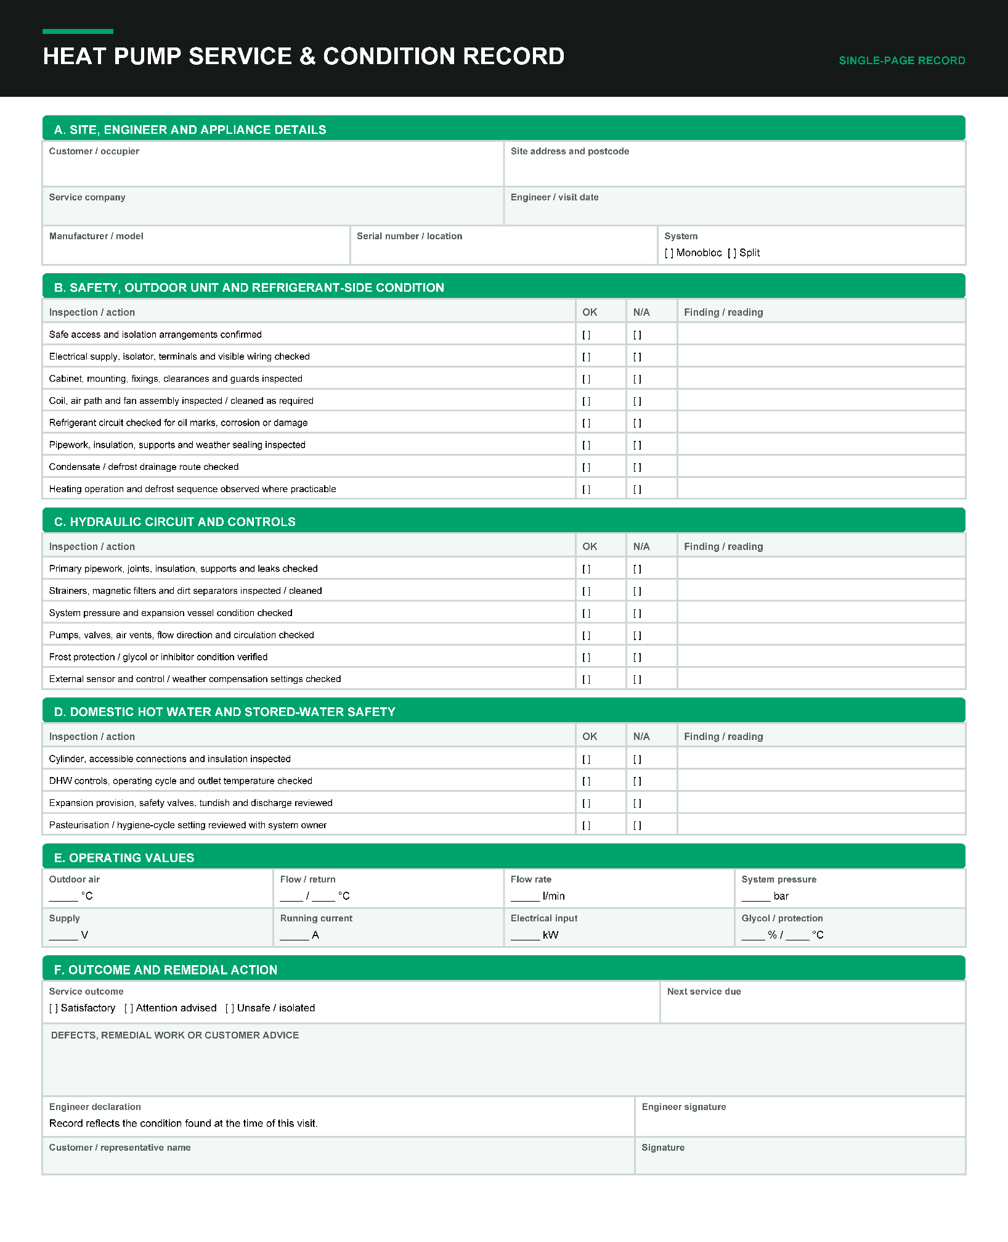

Copyright in this document belongs to and is used under licence from the Department for Education, © 2025.

‘T-LEVELS’ and ‘T Level’ are registered trademarks of the Department for Education.

WJEC is authorised by the Department for Education to develop and deliver this T Level Technical Qualification.

WJEC operates in England under the name Eduqas which is a registered trademark of WJEC.

Acknowledgements
p.25 table from Ideal Heating / idealheating.com; p.28 table from Ideal Heating / idealheating.com; p.47 images from Ideal Heating - Manufacturers Instructions / idealheating.com; p.48 Ideal Heating - Manufacturers Instructions / idealheating.com; p.51 QuirkCraft Studio / Shutterstock.com;

