T Level Technical Qualification in Building Services Engineering for Construction (Level 3)

Skills Practice Workbook – Tutor Guide

Gas Engineering
Practical Training

Contents
Task 1 - Health & Safety 6
Task 2 - Access Equipment 7
Task 3 - Risk Assessment 8
Task 4 - Method Statement 10
Task 5 - Personal Protective Equipment 11
Task 6 - Identification of Tools 13
Task 7 – Access Equipment Ladders 16
Task 8 - Liquified Petroleum Gas (L.P.G.) equipment 17
Task 9 – Fire Extinguishers 21
Task 10 – Mobile scaffold 22
Task 11 - Safe Isolation Procedure 25
Task 12 - Measuring and Cutting 26
Task 13 - Fittings 27
Task 14 - X Dimensions and Z Dimensions 31
Task 15 – Fixings 32
Task 16 - Decommissioning 34
Task 17 - Copper Compression 36
Task 18 - Copper Soldering 38
Task 19 - Copper Bending 40
Task 20 - Copper Frame 42
Task 21 - Plastic Push Fit 44
Task 22 - Steel bending 46
Task 23 - Steel jointing 48
Task 24 – Combined Frame 50
Task 25 - Electrical tools 53
Task 26 - Fittings And Jointing Materials Identification 54
Task 27 - Termination of BS1363 plug top 55
Task 28 - Operating a U gauge and digital manometer 57
Task 29 - Gas meters and enclosures 59
Task 30 - Let-by testing and tightness testing – low pressure 60
Task 31 - Let-by testing and tightness testing – medium pressure 61
Task 32 - Purging 62
Task 33 - The installation pipework 65
Task 34 - Installing a boiler 74
Task 35 - Gas Rating 81
Task 36 - Gas Flow and Pressure Loss 85
Task 37 - Pressure Regulators 87
Task 38 - Servicing a boiler 90
Task 39 - Flues and chimneys 95
Task 40 - Flues and chimneys part 2 96
Task 41 - Ventilation 102
Task 42 - Installing a gas multipoint water heater 105
Task 43 - Servicing a gas multipoint water heater 109
Task 44 - Electrical safe isolation procedure and Electrical Testing 112
Task 45 - Recognition of controls 116
Task 46 - IGEM G/13 Procedures 121
Task 47 - Gas Safety (Installation and Use) Regulations 123
Task 48 - Written report of maintenance activity 129

Task summary and progress tracker
 | Task | Performance criteria reference number(s) | Page number | Date  Task Issued
1 | Workshop health and safety procedures | S21, S31, PO2, PO3, PO4
2 | Access equipment
3 | Risk assessment
4 | Method statement
5 | Personal protective equipment
6 | Identification of Tools
7 | Access equipment ladders
8 | L.P.G equipment
9 | Fire extinguishers
10 | Mobile scaffold
11 | Safe isolation procedure
12 | Measuring and cutting
13 | Fittings
14 | X dimensions & Z dimensions
15 | Fixings
16 | Decommissioning
17 | Copper compression
18 | Copper soldering
19 | Copper bending
20 | Copper frame
21 | Plastic push fit
22 | Steel bending
23 | Steel jointing
24 | Combined frame
25 | Electrical tools
26 | Fitting and Jointing Materials Identification
27 | Termination of Plug Top
28 | Operating a U Gauge and Digital Manometer
29 | Gas meters and enclosures
30 | Let-by testing and tightness testing – low pressure
31 | Let-by testing and tightness testing – medium pressure
32 | Purging
33 | The installation pipework
34 | Installing a boiler
35 | Gas rating
36 | Gas flow and pressure loss
37 | Pressure regulators
38 | Servicing a boiler
39 | Flues and Chimneys Part 1
40 | Flues and Chimneys Part 2
41 | Ventilation
42 | Installing a gas multi point water heater
43 | Servicing a gas multi point water heater
44 | Electrical safe isolation procedure and electrical testing
45 | Recognition of controls
46 | IGEM G/13 procedures
47 | Gas Safety (Installation and Use) Regulations
48 | Written report of maintenance activity

Introduction
Tutor guide: T-Level Electrotechnical Engineering Skills Practice Workbook for Learners
This guide is designed to support tutors in delivering and assessing practical tasks within the T-Level Electrotechnical Engineering Skills Practice Workbook for Learners. For each task, it outlines expected learner outcomes, potential areas of difficulty, and suggestions for tutor intervention and support.

General guidance for tutors:
- Demonstrate and supervise: Always demonstrate safe practices before learners attempt tasks. Maintain vigilant supervision, especially during tasks involving electrical work, tools and machinery.
- Encourage independent learning: Encourage learners to research and problem-solve independently while providing guidance.
- Promote a safety-first culture: Emphasise the importance of health and safety throughout all practical tasks. This is paramount in electrotechnical engineering.
- Facilitate peer learning: Encourage learners to collaborate, discuss, and learn from each other's experiences and approaches.
- Provide timely and constructive feedback: Regular, specific, and actionable feedback will help learners identify areas for improvement and reinforce correct practices.
- Repetition: Allow for repetition of tasks where necessary to build confidence and proficiency.
- Planning: Encourage learners to consistently plan their material and equipment needs for each task, fostering good organisational habits.
- Learner reflection: Encourage learners to complete the ‘Learner reflection’ section after each task to promote self-assessment and identify areas where they require more guidance.
- Documentation: Ensure learners accurately complete all required documentation (e.g., tool/material lists, risk assessments, method statements, certificates) as specified in each task.
- Time management: Guide learners in managing their time effectively to complete tasks within the suggested target times, simulating real-world project constraints.
Remember to adapt teaching methods to the individual needs of your learners and always prioritise safety and adherence to industry standards.

Task 1: Workshop induction, health and safety procedures

Objective: To familiarise learners with the workshop environment, key health and safety legislation, and emergency procedures.
Tutor role: Conduct a thorough workshop tour. Point out all safety features, signs and equipment. Facilitate discussion around the questions rather than just providing answers.
Key learning points: Health and Safety at Work Act (1974), types of fire extinguishers, first aid box contents, PPE, emergency evacuation, accident reporting, electrical shock procedure, understanding safety signs.
Assessment: Observe learner engagement during the induction and review their written answers for accuracy and completeness.

Expected learner outcomes:
- Understand the legal responsibilities under the Health and Safety at Work Act (1974).
- Identify key safety procedures and reporting requirements in a workplace setting.

Potential learner struggles:
- Confusing the difference between regulations and best practices.
- Forgetting to document incidents or near misses appropriately.

Suggestions for improvement:
- Use real-life case studies to illustrate the consequences of poor health and safety practices.
- Encourage learners to role-play reporting an incident to reinforce the process.

Suggestions for stretch activity:
- Research and present a summary of a recent HSE prosecution case.
- Create a poster outlining key responsibilities under the Health and Safety at Work Act.

Most of the following task details don’t need to be included – maybe just the answers (in red) somewhere appropriate.

In any workplace, the health and safety of the company’s employees and visitors is very important. Many rules must be followed to ensure their safety.
There are many regulations dealing with health and safety, but the main document to refer to is the Health and Safety at Work Act (1974). The rules within it are law, which means you can be prosecuted by the Health and Safety Executive (HSE) if you break them.
Who is responsible for providing personal protective equipment (PPE) in your workplace? Employer.
Which types of accident need to be recorded and where do we record the information? All accidents should be recorded in the accident book.
Who is responsible for health and safety on site? Everyone.

As an employee (learner) you have legal duties too. They include:

■ Taking reasonable care for your own health and safety and that of others who may be affected by what you do or do not do.

■ Co-operating with your employer on health and safety.

■ Correctly using work items provided by your employer, including personal protective equipment, in accordance with training or instructions.

■ Not interfering with or misusing anything provided for your health, safety or welfare.

Task 2: Access equipment
Objective: To identify different types of ladders, understand their safe use, and perform pre-use safety checks.
Tutor role: Demonstrate safe handling, transportation, and erection of ladders (e.g., 4:1 rule). Explain common hazards associated with working at height. Refer to HSE guidance.
Key learning points: Ladder types (extension, stepladder, multi-purpose), pre-use checks, safe erection (4:1 rule), securing ladders, safe ascent/descent, HASWA compliance.
Assessment: Observe practical application of ladder safety, including visual inspection, correct lifting/carrying, and safe erection/dismantling. Review completed assessment criteria.

Expected learner outcomes:
- Identify different types of ladders and their appropriate uses.
- Conduct pre-use safety checks on access equipment.

Potential learner struggles:
- Confusing the inspection steps for different ladder types.
- Overlooking minor damage that could compromise safety.

Suggestions for improvement:
- Provide hands-on demonstrations with damaged and undamaged ladders.
- Use visual aids or checklists to reinforce inspection routines.

Suggestions for stretch activity:
- Design a safety checklist poster for ladder inspections.
- Compare and contrast access equipment used in domestic vs. commercial settings.
The task information below could be retained as it includes answers
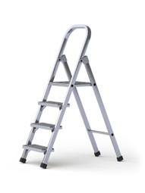
Below are two types of ladders. What are they called, and what checks would you carry out before you use them?
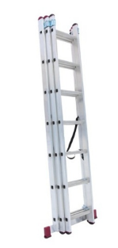
Step Ladder Ladder

1. Check ‘ladder tag’
2. Check stiles
3. Check steps
4. Check feet
5. Check platform
The above can be in any order, for both ladder types.

Task 3: Risk assessment

Objective: To understand the concepts of hazard and risk and apply them to complete a basic risk assessment for electrical tasks.
Tutor role: Explain the definitions of 'hazard' and 'risk' clearly. Provide examples relevant to the electrical workshop. Guide learners through completing the risk assessment table, ensuring they identify plausible outcomes, involved parties, control methods and review methods.
Key learning points: Hazard versus risk, legal requirements for risk assessment, identifying potential harm, implementing control measures.
Assessment: Evaluate the learner's ability to identify relevant hazards and risks, propose appropriate control measures, and complete the table accurately.

Expected learner outcomes:
- Understand the purpose and legal requirement of risk assessments.
- Complete a basic risk assessment template for a workshop environment.

Potential learner struggles:
- Identifying less obvious hazards in familiar environments.
- Writing vague or non-specific control measures.

Suggestions for improvement:
- Conduct a guided walk-through of the workshop to identify real hazards.
- Provide examples of well-written vs. poorly written risk assessments.

Suggestions for stretch activity:
- Create a risk assessment for a non-workshop environment (e.g., a public park or kitchen).
- Research how risk assessments differ in high-risk industries like oil and gas.

Risk assessments are something you are required to carry out by law; however, if you employ fewer than five people, you don't have to write anything down. To carry out a risk assessment you need to think about the things that might cause harm to people and decide if you are taking reasonable steps to prevent the harm. For certain risks, specific regulations require particular control measures to be put in place for example, working in a confined space.
Hazard - anything that may cause harm.
Risk - the chance, high or low, that somebody could be harmed.

Complete the following risk assessment template for the workshop you are working in.
What are the hazards? | Who might be harmed and how? | What are you already doing? | Do you need to do anything else to control this risk? | Action by who? | Action by when? | Done
Slips and trips | Staff and visitors may be injured if they trip over objects or slip on spillages. | General good housekeeping is carried out.  All areas well lit  No trailing leads or cables.  Staff keep work areas clear, e.g. no boxes left in walkways.  Deliveries are stored immediately.  Safety signs displayed throughout. | Arrange for the loose carpet tile on the second floor to be repaired or replaced. | All staff and supervisors are to monitor.  Manager.
Learner must pick a hazard from the workshop | Learner must pick a hazard from the workshop | Learner must pick a hazard from the workshop | Learner must pick a hazard from the workshop | Learner must pick a hazard from the workshop | Learner must pick a hazard from the workshop | Learner must pick a hazard from the workshop

Task 4: Method statement

Objective: To understand the purpose and components of a method statement and to be able to outline a safe system of work.
Tutor role: Explain the importance of method statements in ensuring safe task execution. Walk through each section of the method-statement template, providing examples for clarity.
Key learning points: Safe system of work, communication of risks and precautions, linking to risk assessments, essential information for a method statement.
Assessment: Review the completeness and logical flow of the method statement. Ensure hazards and control measures are appropriately detailed.

Expected learner outcomes:
- Understand the components of a method statement.
- Write a method statement for a workshop task.

Potential learner struggles:
- Forgetting to link the method statement to the risk assessment.
- Omitting emergency procedures.

Suggestions for improvement:
- Use templates to guide structure.
- Review real-world examples from industry.

Suggestions for stretch activity:
- Write a method statement for a complex multi-phase task.
- Compare method statements from different trades.

A method statement, also known as a “safe system of work", is a document that details how to carry out a task safely. It outlines all the hazards involved and includes a step-by-step guide on how to carry out the task safely. The method statement ensures that the risks and precautions required of all those involved in the task are effectively communicated.
Method statements also detail the control measures introduced to ensure the safety of anyone who is affected by the task.
A method statement includes the following information:
- Description/overview of works
- Location
- Start and finish time
- Supervisor name and contact details
- Resources required
- Referenced to the risk assessment conducted for the task
- Control measures
- PPE
- Emergency actions
- Welfare and first aid measures
Task: Use of a power drill:

The learner should produce a method statement for the task above taking place in the workshop. To be reviewed by tutor.

Task 5: Personal Protective Equipment (PPE)

Objective: To identify common PPE items, understand their use, and recognise the importance of PPE maintenance and provision.
Tutor role: Provide various examples of PPE. Discuss the specific uses of each item and the consequences of not wearing appropriate PPE. Emphasise the shared responsibility for PPE.
Key learning points: Identification and function of various PPE, importance of pre-/post-use checks, employer and employee responsibilities for PPE.
Assessment: Observe learners' ability to correctly identify PPE and articulate their uses and importance.

Expected learner outcomes:
- Identify common PPE items and their uses.
- Understand the importance of PPE in hazard prevention.

Potential learner struggles:
- Confusing PPE items with general workwear.
- Not understanding when each item is required.

Suggestions for improvement:
- Use role-play scenarios to match PPE to tasks.
- Provide tactile demonstrations of PPE.

Suggestions for stretch activity:
- Research PPE innovations in hazardous industries.
- Create a PPE guide for a specific job role.

Identify the PPE and describe its use.
PPE Item | Name/Use
 | Helmet – To protect the head from falling objects.
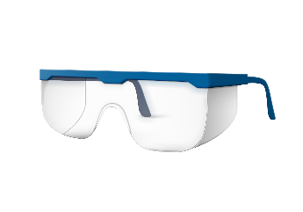 | Goggles – To protect the eyes from debris.
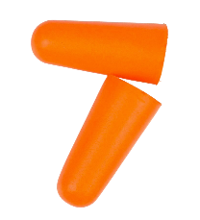 | Ear plugs – Provides basic protection from loud noises.
 | Face mask – Provides basic protection from dust/loose particles.
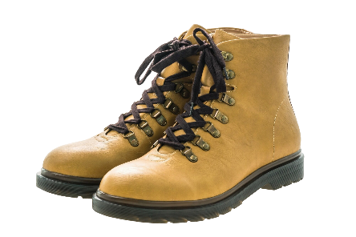 | Steel toecap boots – Protects feet from heavy objects.
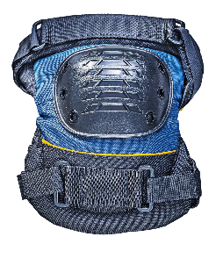 | Knee pads – Protects our knees from long periods of kneeling.
 | Hi-vis jacket – Allows the operative to be seen easily.
 | Gloves – Protects hands from cuts/splinters/abrasions.
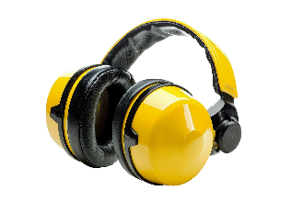 | Ear defenders – Provides a good level of protection from loud noises.
 | Overalls- protects from burns/dirt/grease.
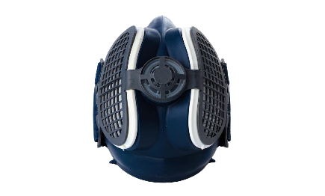 | Respirator – Provides a good level of protection from dust/harmful chemicals etc.

Task 6: Identification of tools

Objective: To identify common electrical tools and equipment and understand their correct uses.
Tutor role: Provide a range of tools and equipment for learners to handle and inspect.
Discuss the specific applications and safety considerations for each tool. Encourage learners to ask questions if unfamiliar.
Key learning points: Correct naming and function of various hand tools, power tools and test equipment used in electrical installation. Importance of checking tools for safety and good working order.
Assessment: Evaluate the learner's ability to correctly name tools and describe their uses.

Expected learner outcomes:
- Identify common tools used in gas engineering.
- Understand the function and safe use of each tool.

Potential learner struggles:
- Confusing similar-looking tools.
- Not knowing how to use unfamiliar tools.

Suggestions for improvement:
- Provide tool handling workshops.
- Use labelled tool boards for practice.

Suggestions for stretch activity:
- Create a tool identification quiz.
- Research specialist tools used in advanced installations.

Identify the tools and describe their use.
Tools/Equipment | Name/Use
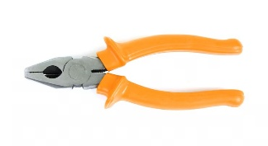 | Pliers – Gripping cable etc.
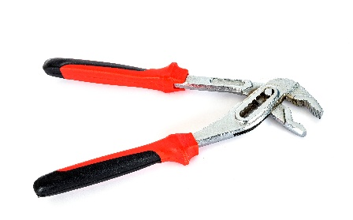 | Water pump pliers – Removing water pumps.
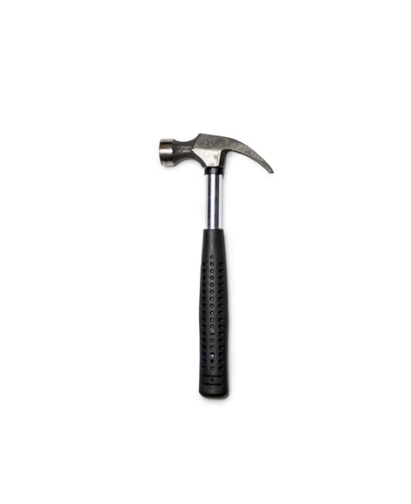 | Hammer – Knocking nails in, removing floorboards etc.
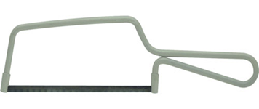 | Junior Hacksaw – for cutting plastic and smaller bore waste pipe.
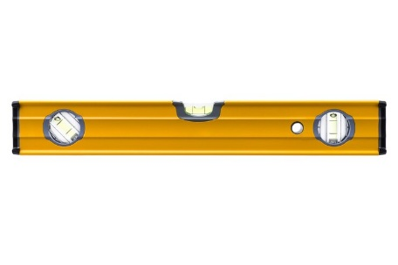 | Spirit level – Levelling different components (Radiators etc.)
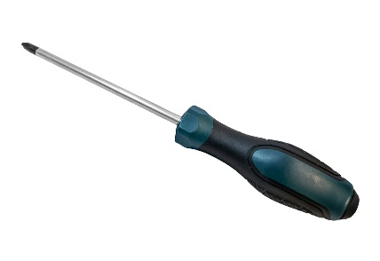 | Pozi-screwdriver - Tightening/loosening pozi screws.
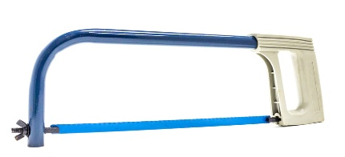 | Senior hacksaw – Used for cutting metal and larger bores of pipe.
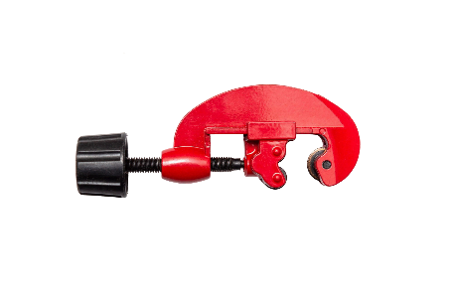 | Adjustable pipe cutter – Cutting pipe 4mm- 35mm.
 | Cable strippers – Stripping cable.
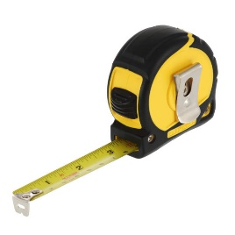 | Tape measure – Measuring different materials/lengths.
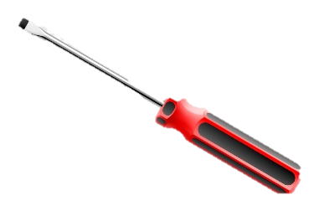 | Flathead screwdriver – Tightening/loosening flathead screws.
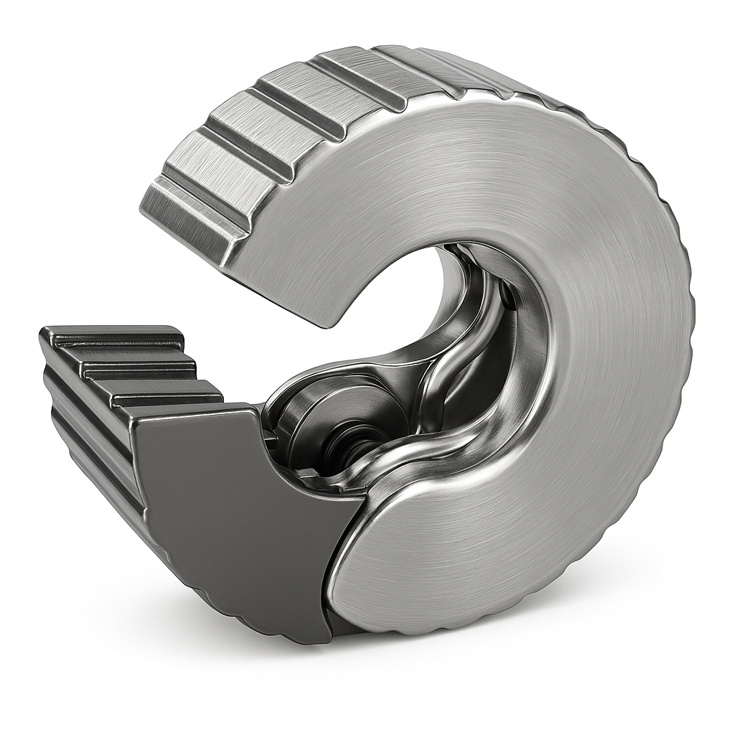 | Pipe slice- For cutting copper pipework
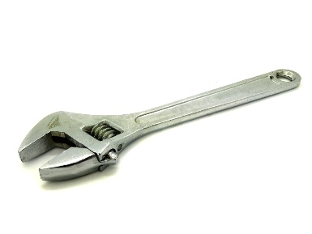 | Water pump pliers – Removing water pumps.
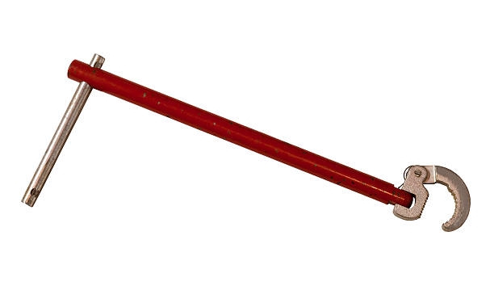 | Basin spanner – Tightening basin taps and their connections.

What would you do if you discovered a tool that you did not know what it is used for or how to use?
Refer to manufacturers instructions.
Why is it important to check tools are safe and in good working order after using them?
To prevent injury/damage.

Task 7: Access equipment ladders

Objective: Understand ladder setup angles and perform safety checks.
Tutor Role: Demonstrate correct ladder positioning and supervise safety checks.
Key Learning Points: Correct ladder angle (1:4 ratio and 75°). Stand step safety checks. Ladder tagging and stability.
Assessment: Labelling ladder setup diagram and listing four safety checks.

Expected learner outcomes:
- Understand ladder safety principles and setup angles.
- Perform safety checks on stand steps.

Potential learner struggles:
- Misinterpreting ladder angle ratios.
- Forgetting key safety checks.

Suggestions for improvement:
- Use physical demonstrations of ladder setup.
- Practice identifying faults on damaged ladders.

Suggestions for stretch activity:
- Design a ladder safety infographic.
- Compare ladder safety standards internationally.

Label numbers 1 to 4 correctly.
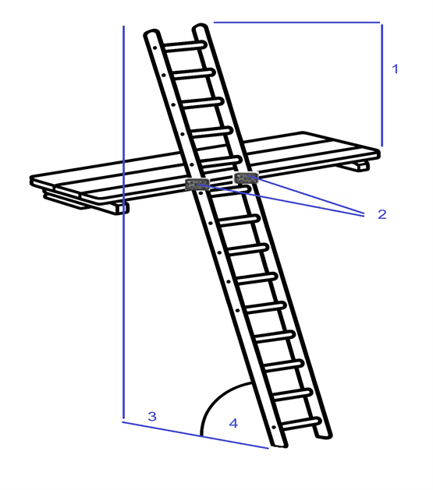
- 4 rungs or 1m above platform.
- Lashings.
- Ratio of 1m out for every 4m’s up.
- 75 °

List four safety checks required prior to using stand steps:
Safety Check
1 | Check feet for damage and non/slip rubber feet.
2 | Check steps for damage/paint.
3 | Check Stiles for damage/paint.
4 | Check ladder tag.

Task 8: Liquified Petroleum Gas (L.P.G) equipment

Objective: Safely commission and decommission LPG equipment.
Tutor Role: Oversee practical demonstrations and reinforce safety protocols.
Key Learning Points: Pre-use checks and leak testing. Commissioning/decommissioning steps. Ventilation and protective measures.
Assessment: Completion of safety checklist and demonstration of commissioning procedure.

Expected learner outcomes:
- Understand safe use and checks for LPG equipment.
- Demonstrate commissioning and decommissioning procedures.

Potential learner struggles:
- Forgetting ventilation requirements.
- Skipping leak checks before use.

Suggestions for improvement:
- Use checklists during practical sessions.
- Simulate commissioning with peer review.

Suggestions for stretch activity:
- Research LPG safety regulations.
- Create a training video on LPG equipment setup.

You will be required to use this equipment when soldering, however there is a safe method of use that you must demonstrate before you will be able to solder.
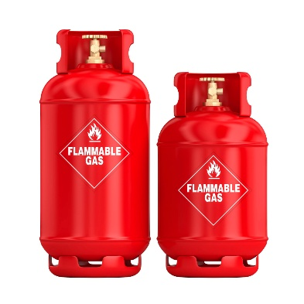
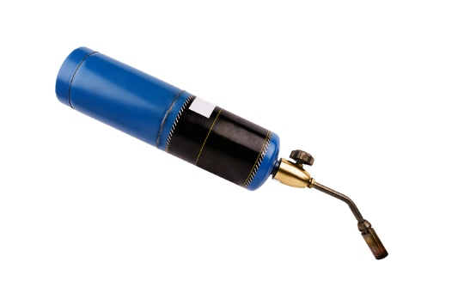

What checks must be made prior to using this equipment?
1. Check regulator, thread and jubilee
2. Ensure correct gas
3. Ensure adequate ventilation
4. Check for leaks prior to using

Describe the commissioning and decommissioning procedures.
Commissioning Decommissioning
1. Correct all equipment is present and correct 1. Switch off
2. Connect equipment as per M.I’s 2.Remove equipment
3. Switch on and test for leaks 3. Ensure LPG not passing
4.Begin work 4. Tidy away equipment

What can be used to protect the fabric of the building?
Dust sheets.
Heat mat.

Gas Cylinder Safety Report
The following information should be provided:
- Assess Situations & Equipment for Safety
Identify whether the following situation is safe or unsafe
Situation | Safe or Unsafe?
Full & empty gas cylinders are stored in an outside cage with a roof that is locked and far away from combustible materials overnight. | Safe
Cylinders are being transported around a building site on three wheeled trolleys. | Safe
A lot of oxygen cylinders are stored in a basement with one small door and no windows. The gas bottles are fully strapped up horizontally and cannot roll. | Unsafe
A gas cylinder is often subjected to shocks and falls on site. | Unsafe
A tradesman is carrying an oxyacetylene bottle by its control valve. | Unsafe
Cylinders are stored in a cage on a building site. A strong wall shields the cylinders from direct sunlight. | Safe
Gas cylinders are stored close to a welding area that is used regularly. | Unsafe
Oxygen, acetylene & LPG cylinders are all stored together in a well-ventilated area. | Unsafe
Gas cylinders are stored outside in a cage. The cage is designed so that the gas bottles are stacked horizontally four cylinders high. They are secured to prevent falling onto the soft ground below. | Unsafe
Trolleys used for transporting cylinders should be manufactured to: | BS2270

Task 9: Fire extinguishers

Objective: Identify fire classes and use appropriate extinguishers correctly.
Tutor Role: Provide hands-on extinguisher training and explain fire classifications.
Key Learning Points: Fire classes A–F and fuel sources. Extinguisher types, colours, and contents. PASS method for extinguisher use.
Assessment: Completion of fire classification table and explanation of extinguisher procedure.

Expected learner outcomes:
- Identify fire classes and appropriate extinguishers.
- Demonstrate correct extinguisher use.

Potential learner struggles:
- Confusing extinguisher types and contents.
- Improper use of extinguishers during practice.

Suggestions for improvement:
- Use colour-coded charts for fire classes.
- Practice extinguisher use with mock fires.

Suggestions for stretch activity:
- Create a fire safety guide for a specific workplace.
- Research historical fire incidents and response methods.

The following information should be provided:
Classification of fires and fire extinguisher procedures
Identify the following information
Class Of Fire | Source Of Fuel | Colour of Fire Extinguisher Necessary | Contents of Fire Extinguisher
Class A | Combustible materials such as wood, paper, textiles, plastics. | Red (with a symbol of a fire triangle). | Water, Foam, or Multi-purpose powder.
Class B | Flammable liquids like petrol, oil, solvents, paints. | Red (with a symbol of a fire triangle and a liquid flame). | Foam, CO₂ (Carbon Dioxide), or Powder
Class C | Gases like propane, butane, methane, and natural gas. | Red (with a symbol of a gas cylinder flame). | CO₂ (Carbon Dioxide), or Dry Powder
Class D | Combustible metals like magnesium, titanium, sodium, and potassium. | Yellow (with a symbol of a metal fire). | Special Dry Powder (metal fire powder)
Class E | Electrical fires (caused by electrical equipment or wiring). | Red (with a symbol of an electrical equipment and a cross). | CO₂ (Carbon Dioxide) or Dry Powder.
Class F | Cooking oils or fats (common in kitchens). | Black (with a symbol of a pan and flame). | Wet Chemical (potassium acetate solution).

Explain the correct procedure for using a fire extinguisher to tackle a small solid fuel fire:
1. Select the correct fire extinguisher
2. (Following the MI’s) Pull the pin
3. Aim at the base of the fire
4. Squeeze the handle
5. Sweep side to side until the flame is extinguished.

Task 10: Mobile scaffold

Objective: Conduct scaffold inspections in line with WAH Regulations.
Tutor Role: Support learners in completing inspection checklists and understanding legal requirements.
Key Learning Points: Inspection timings and legal obligations. Scaffold components and safety features. Use of PASMA tags and checklists.
Assessment: Completion of scaffold inspection form and tutor observation.

Expected learner outcomes:
- Understand inspection requirements under WAH Regulations.
- Complete a scaffold inspection checklist.

Potential learner struggles:
- Forgetting inspection intervals.
- Misidentifying structural faults.

Suggestions for improvement:
- Conduct scaffold inspections in pairs.
- Use scaffold models for practice.

Suggestions for stretch activity:
- Research scaffold failures and prevention strategies.
- Design a scaffold safety poster.

WAH Regulations 12(7) - The learner should complete the sheet below following guidance from their trainer. The trainer should then review.
These regulations require that a Mobile Access Tower be inspected and approved by a competent person and within 24 hours a report thereof be provided to the person on whose behalf the inspection was carried out.
It is also required that a tag system be attached to the tower recording that an inspection has taken place and that there is an inspection checklist in existence.
The timing of inspections
This checklist refers to one off the following timings (please tick as appropriate):
When the tower has been built and taken into us e for the first time | ☐
After any substantial addition, dismantling or other alteration | ☐
After any event likely to have affected it strength or stability | ☐
At regular intervals NOT exceeding 7 days | ☐
Details of the competent person making this inspection
Name |  |  | PASMA No.
Date of inspection |  |  | Time
Person to whom this inspection was carried out
Name |  |  | Organisation
Description of the tower
Double/single width |  | Height |  | Mobile | ☐
 |  |  |  | Static | ☐
Tower Manufacturer |  |  | Type | Aluminium | ☐
Tower Manufacturer |  |  | Type | GRP | ☐
Location of tower at time of inspection

The following items to be checked | Yes | No
- Do you have a copy of the manufacturers instruction manual (MIM) to enable you check the tower? | ☐ | ☐
- Does a risk assessment for the tower exist? | ☐ | ☐
- Check that the environment has no detrimental effect on the safe use of the tower. | ☐ | ☐
- Are the castors or base plates fully in contact with the ground and bearing their share of the weight of the tower and that all 4 brakes are applied? | ☐ | ☐
- Are the adjustable legs only being used to level the tower and not for gaining height? | ☐ | ☐
- Is a tower level in all planes? | ☐ | ☐
- Is the tower built on firm and stable ground? | ☐ | ☐
- Are stabilisers fitted and are they the correct size for the height of the tower? | ☐ | ☐
- Check that the feet are fully in contact with the ground, and wing nuts are tight. | ☐ | ☐
- Check that the foot of the stabilisers are positioned to form a squire. | ☐ | ☐
- Is the bracing pattern used, in accordance with the manufacturer’s instructions? | ☐ | ☐
- Check that all the hooks on the braces are fully engaged. | ☐ | ☐
- Check that all the handrails and mid guardrails are fitted in the correct positions. | ☐ | ☐
- Check that the interlocking devise, locking frames together are engaged. | ☐ | ☐
- Check that all platforms are in the correct position on the tower. | ☐ | ☐
- Check that the trap door opens to the outboard side of the tower. | ☐ | ☐
- Check that, if the tower is single width that all platforms have trap doors. | ☐ | ☐
- If wind locks are fitted to platform, check they are engaged. | ☐ | ☐
- Are toe boards fitted to the working platform, or any platform with gear stowed? | ☐ | ☐
- If the tower has been tied in check that the method is adequate and at the correct intervals in accordance with the MIM. | ☐ | ☐

Signature of inspector
Name in block capitals |  | Date

Task 11: Safe isolation procedure

Objective: Learn the correct steps to safely isolate electrical circuits.
Tutor Role: Demonstrate isolation procedures and supervise voltage testing.
Key Learning Points: Lock-off and tagging procedures. Use of voltage testers and proving units. Importance of re-proving equipment.
Assessment: Practical demonstration of safe isolation and completion of checklist.

Expected learner outcomes:
- Understand steps for safely isolating electrical circuits.
- Use appropriate equipment for voltage testing and lock-off.

Potential learner struggles:
- Skipping re-proving of test equipment.
- Misidentifying circuit components.

Suggestions for improvement:
- Use flowcharts to reinforce procedure.
- Practice isolation on mock circuits.

Suggestions for stretch activity:
- Create a safe isolation checklist.
- Compare isolation procedures across trades.

Identify the steps and equipment used for the correct safe isolation of electrical appliances and circuits.
Step | Description
1 | Identify the circuit to be worked on
2 | Switch off the circuit and inform customer
3 | Prove the voltage testing equipment on a known source
4 | Test the circuit
5 | Reprove the voltage testing equipment
6 | Lock off at fused spur/MCB including placing warning notices
7 | Begin work

Task 12: Measuring and cutting

Objective: Accurately measure and cut materials for installation.
Tutor Role: Provide hands-on guidance and check learner technique.
Key Learning Points: Use of tape measures and cutters. Importance of accuracy and safety. Material handling and preparation.
Assessment: Completion of a measuring and cutting task with tutor review.

Expected learner outcomes:
- Accurately measure and cut pipes to specified lengths.
- Understand metric units used in plumbing.

Potential learner struggles:
- Misreading tape measures.
- Cutting pipes inaccurately.

Suggestions for improvement:
- Practice measuring with peer verification.
- Use cutting jigs for precision.

Suggestions for stretch activity:
- Create a guide to pipe measurement techniques.
- Research tolerance levels in professional plumbing.

To use a tape measure accurately you have to ensure you are reading the correct units. In plumbing we use metric units, most commonly the millimetre.
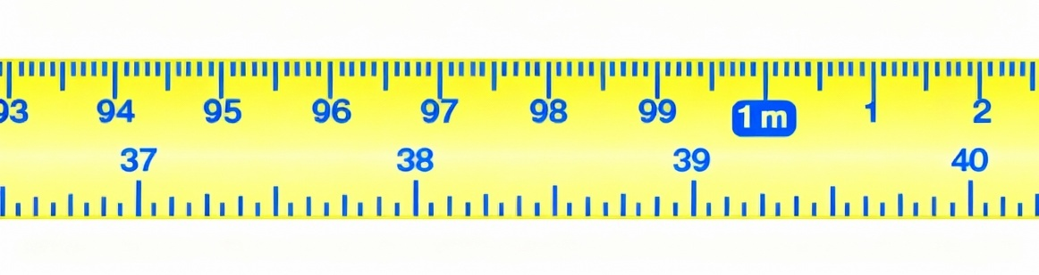
You are required to select the following diameters of pipe and cut the lengths in the table below. The diameter is the measurement from one side to the other across the centre.

Type | Diameter | Length to cut | Achieved (Y/N)
Copper | 15mm | 100mm | Trainers discretion
Copper | 15mm | 125mm | Trainers discretion
Copper | 22mm | 150mm | Trainers discretion
Copper | 22mm | 110mm | Trainers discretion
Plastic | 32mm | 120mm | Trainers discretion
Plastic | 40mm | 170mm | Trainers discretion
Plastic | 15mm | 130mm | Trainers discretion
Plastic | 22mm | 180mm | Trainers discretion
Steel | 15mm | 175mm | Trainers discretion
Steel | 20mm | 195mm | Trainers discretion

Task 13: Fittings

Objective: Identify and install various pipe fittings correctly.
Tutor Role: Explain fitting types and assess installation accuracy.
Key Learning Points: Types of fittings (compression, soldered, push-fit). Correct installation techniques. Leak prevention and testing.
Assessment: Practical fitting task and tutor observation.

Expected learner outcomes:
- Identify pipe fittings and their purposes.
- Understand fitting types for copper, steel, and CSST.

Potential learner struggles:
- Confusing similar fittings.
- Not understanding fitting compatibility.

Suggestions for improvement:
- Use labelled fitting boards.
- Practice assembling mock pipe systems.

Suggestions for stretch activity:
- Create a fitting identification quiz.
- Research fitting standards in different countries.

Identify the fittings and purpose.
List the sizes of Copper Pipe
15mm
22mm
Plus, any of the following:
- 8mm
- 10mm
- 28mm
- 35mm

Fitting | Description | Purpose
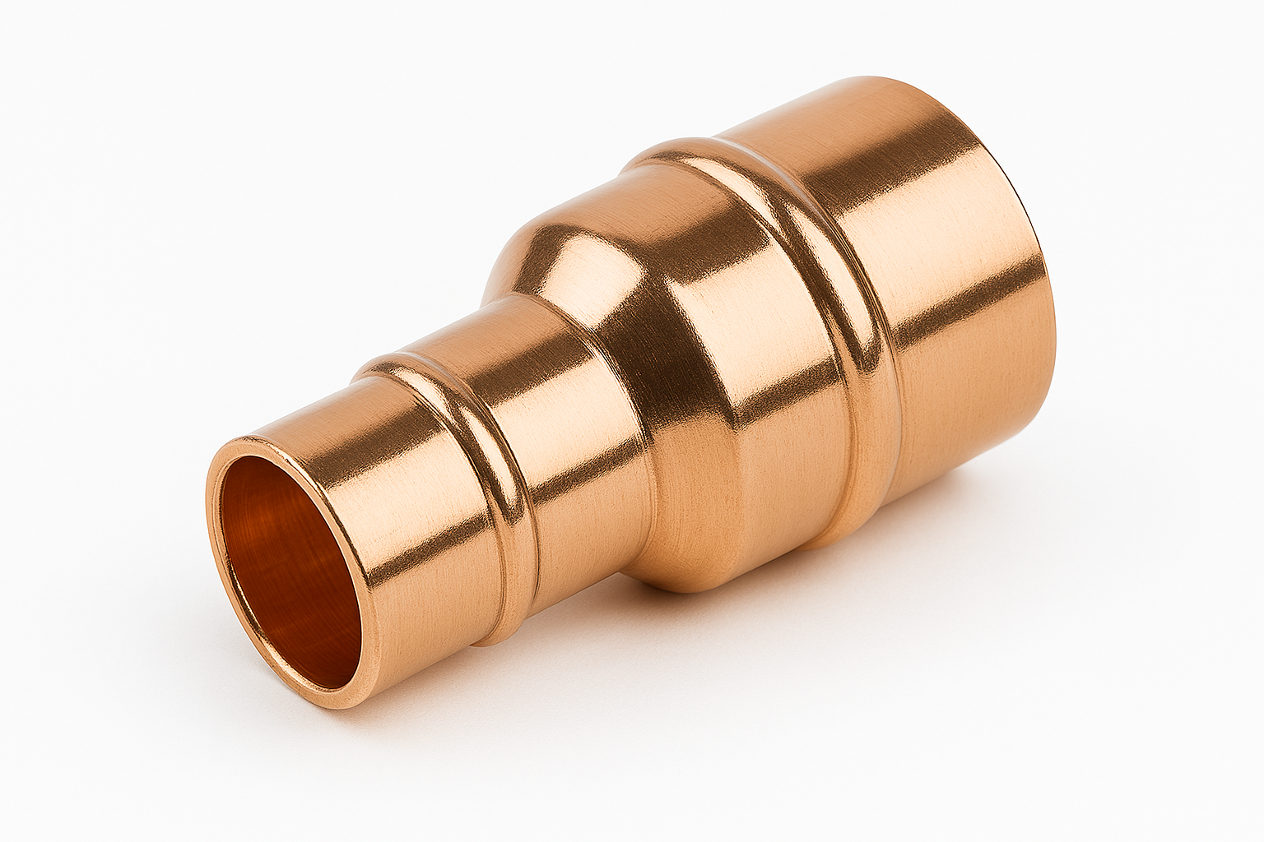 | Endfeed reducer | Connecting 2 pipes of different sizes
 | Endfeed stop end | Blanking off a pipe
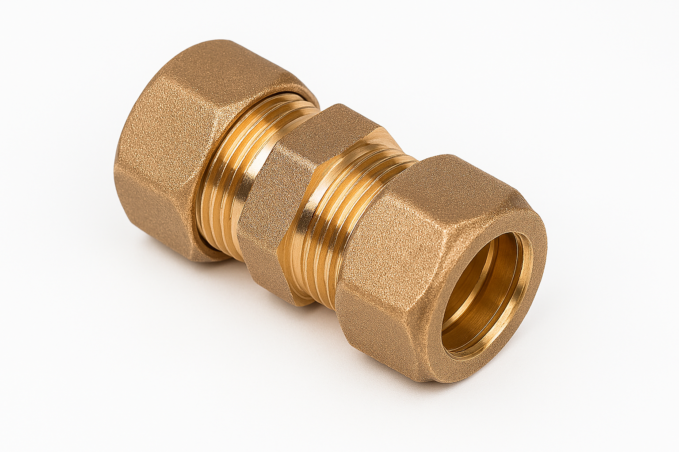 | Compression coupling | Connecting 2 pipes of the same size
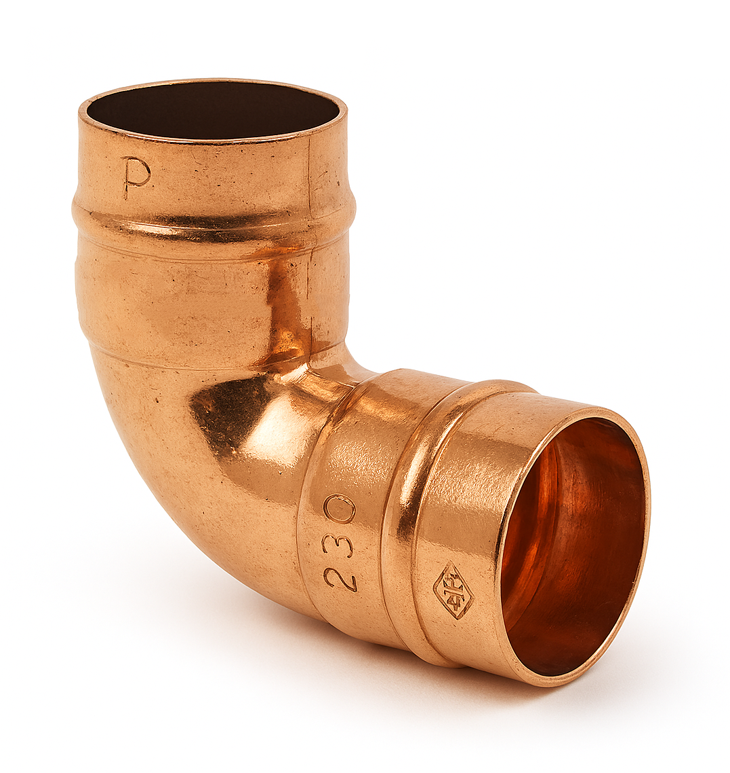 | Endfeed elbow | 90° bend for copper pipe
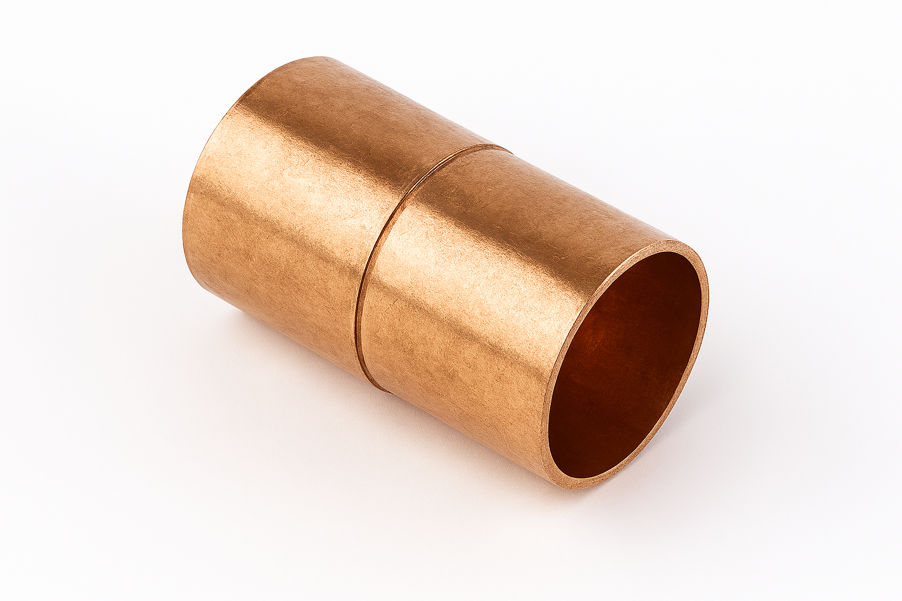 | Endfeed coupling | Connecting 2 pipes of the same size
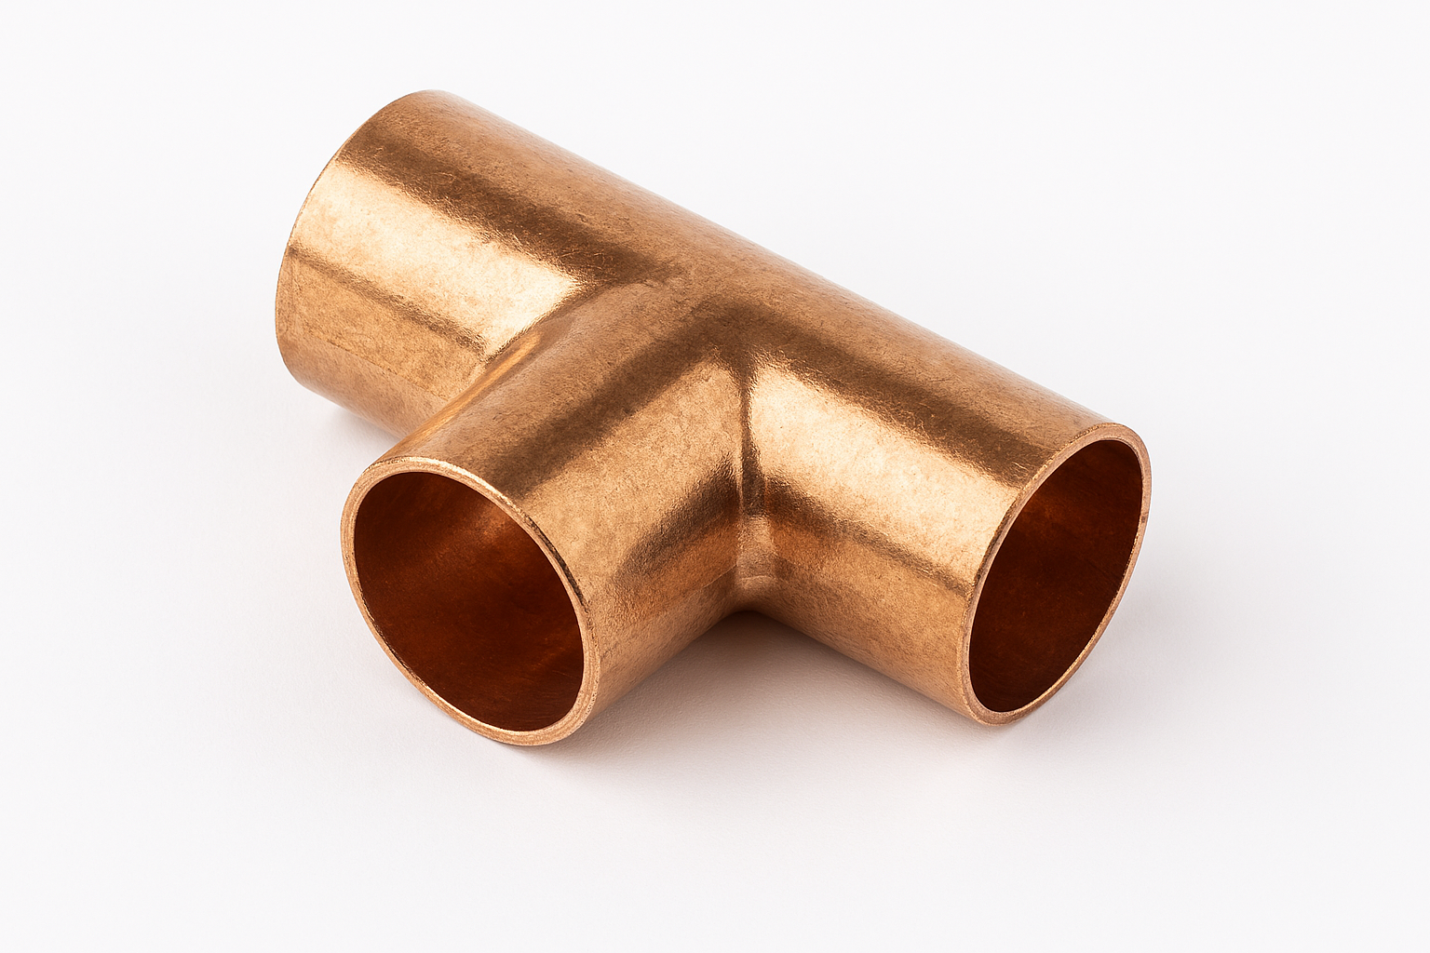 | Endfeed Tee | Connecting 3 pipes of the same size
Identify the fittings and purpose
List the sizes of Steel Pipe
1/2 Inch
¾ Inch
1 Inch
Fitting | Description | Purpose
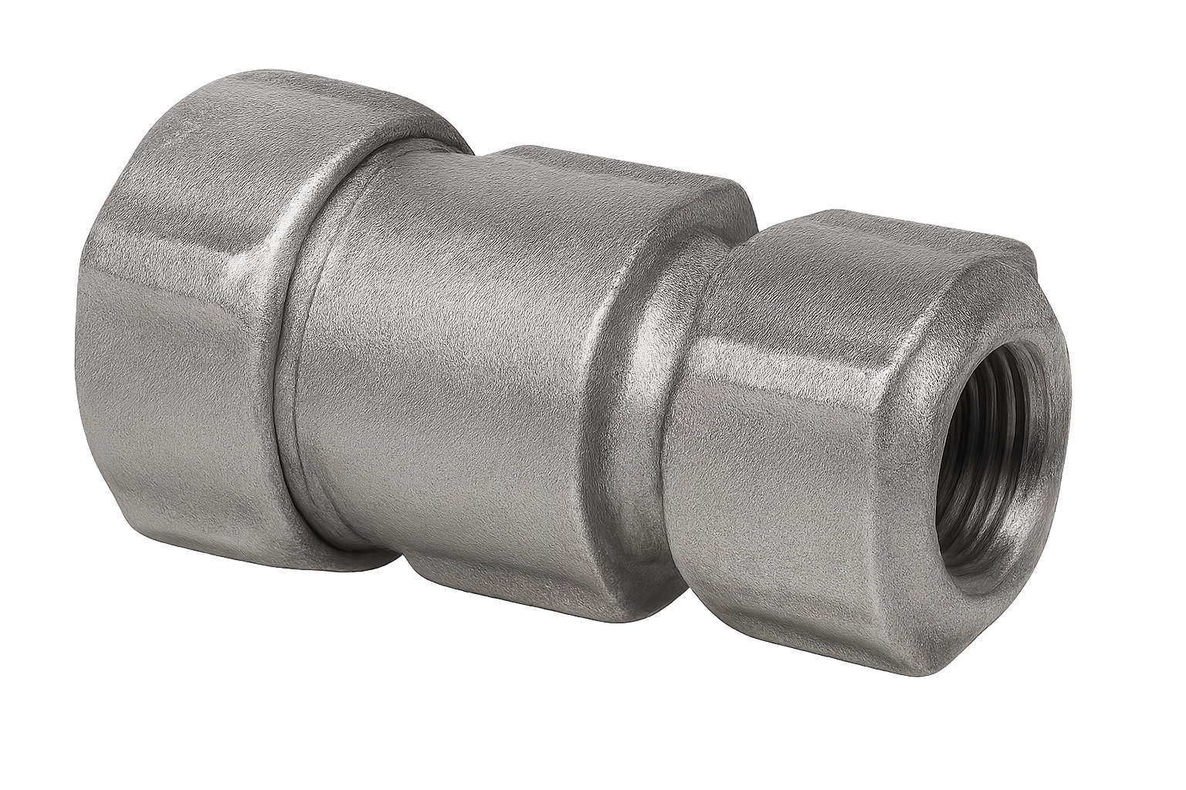 | Compression reducing coupling | Connecting 2 LCS pipes of different diameters
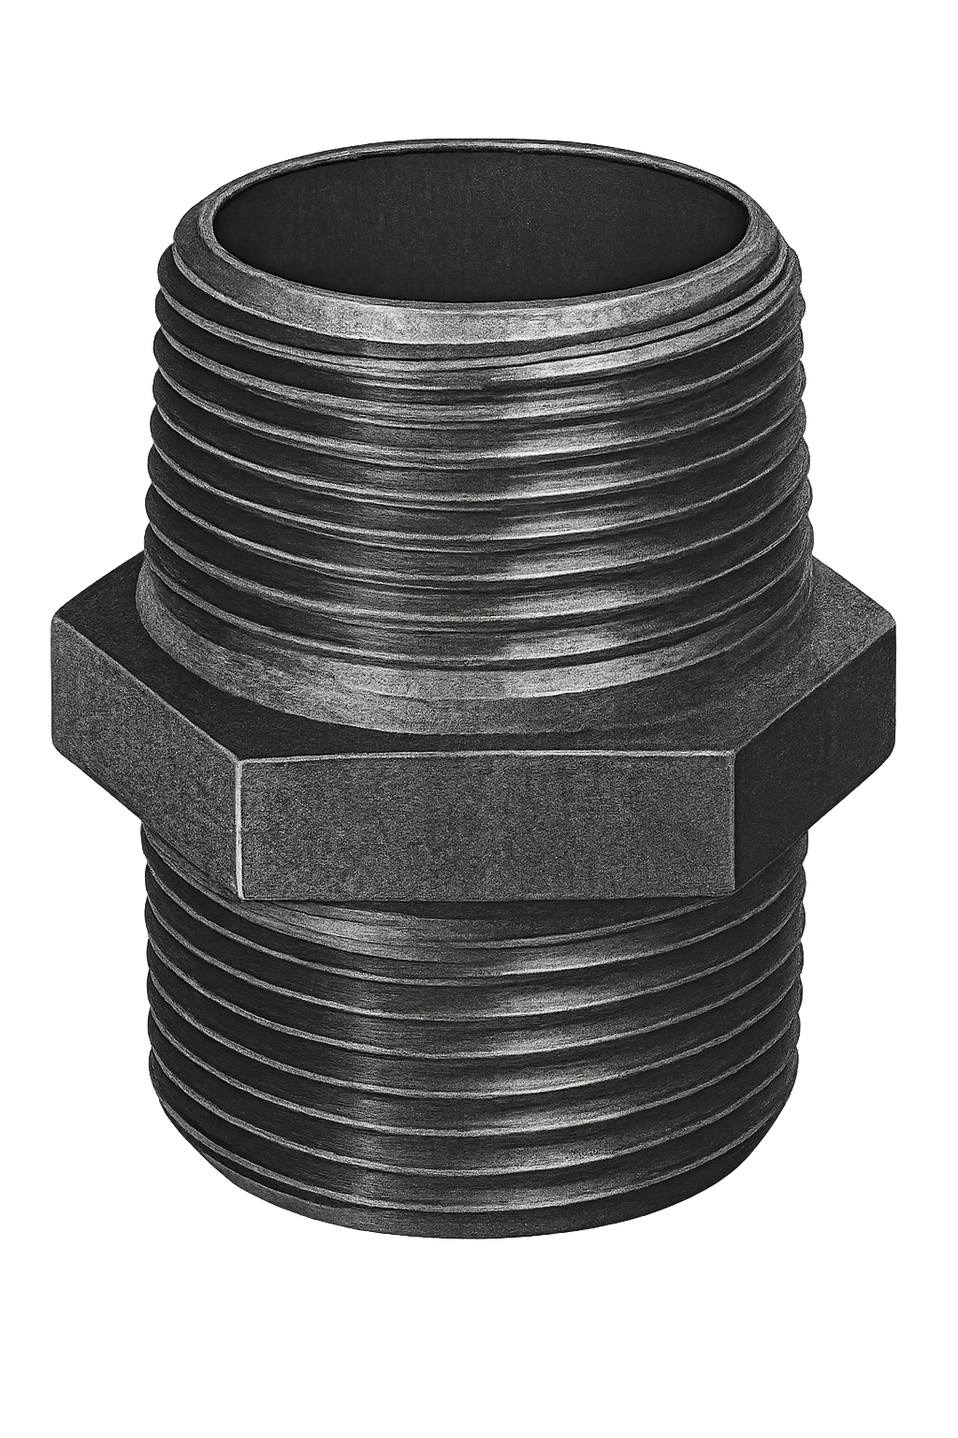 | Barrel | Extension from a fitting to another fitting
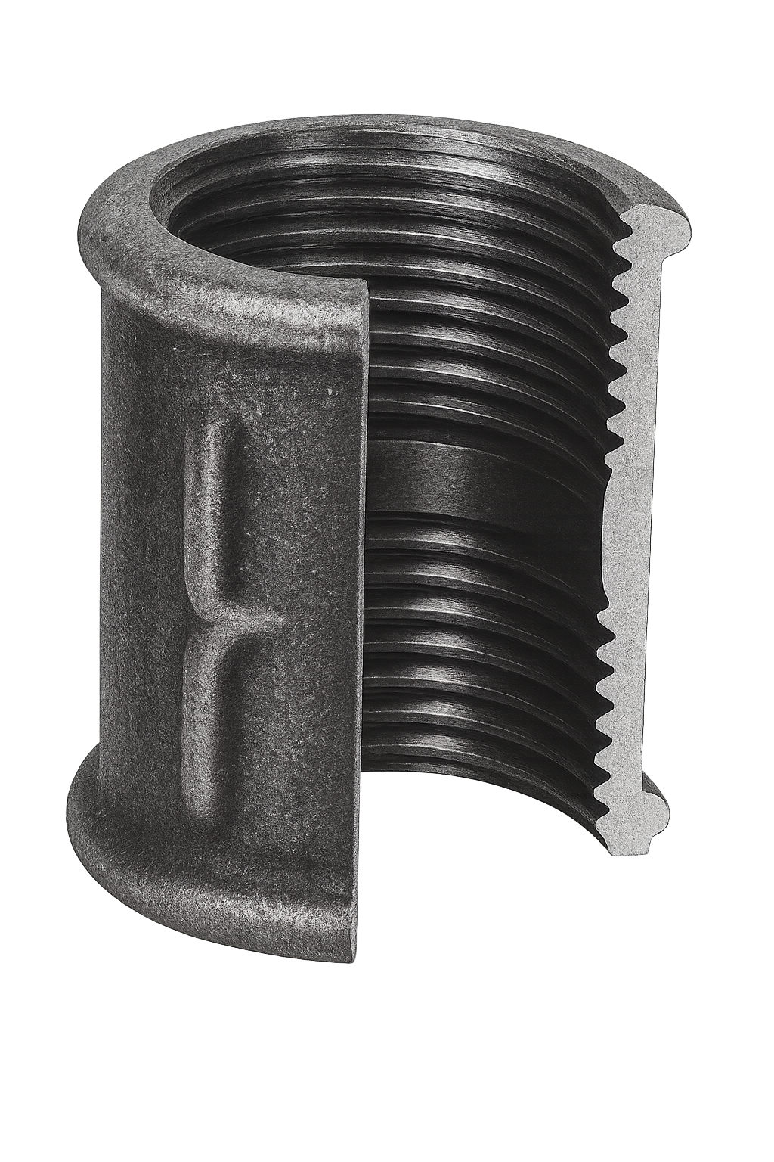 | LCS threaded coupling | Conencting 2 LCS pipes of the same diameter
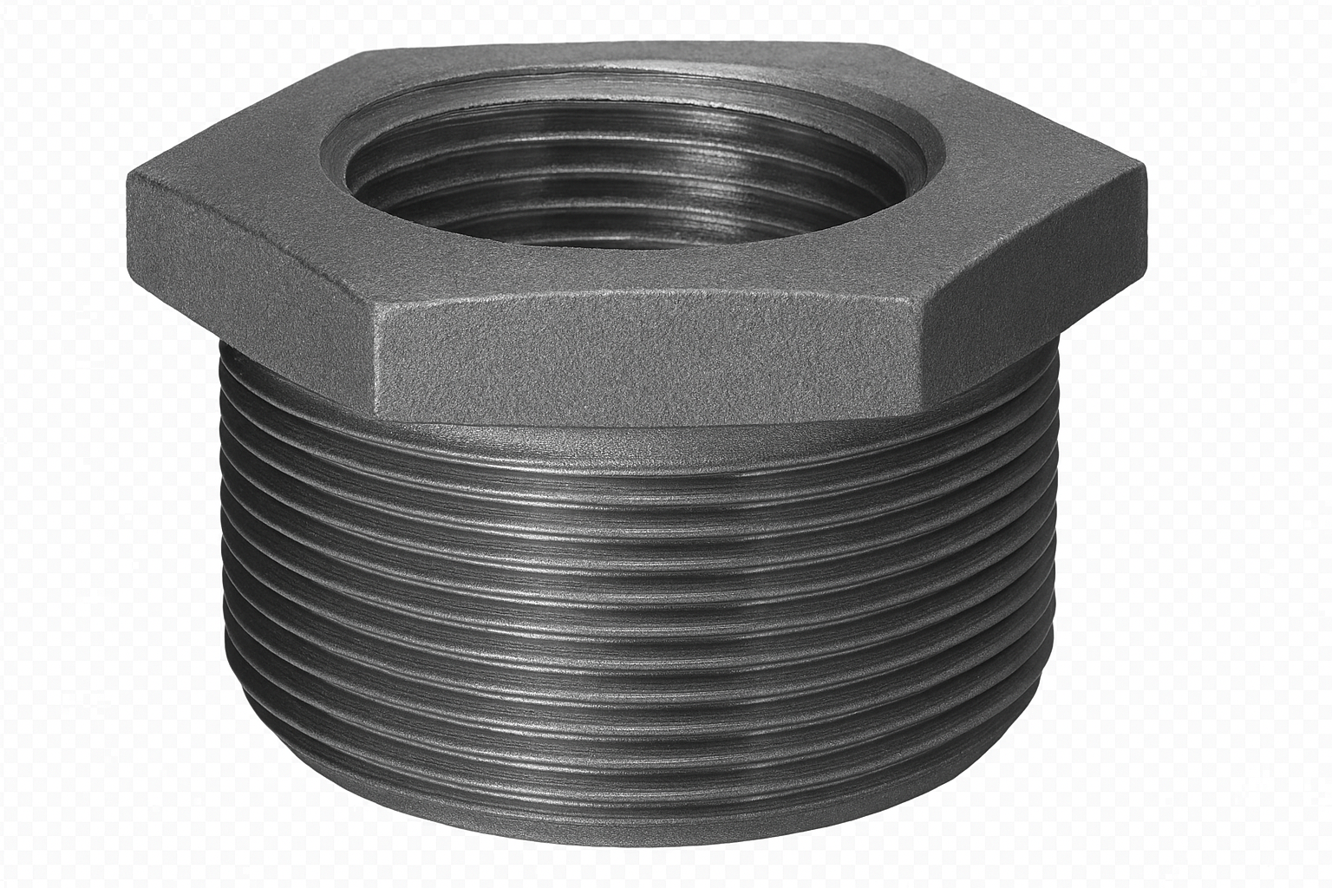 | LCS threaded reducing bush | Reduces pipe size within a fitting
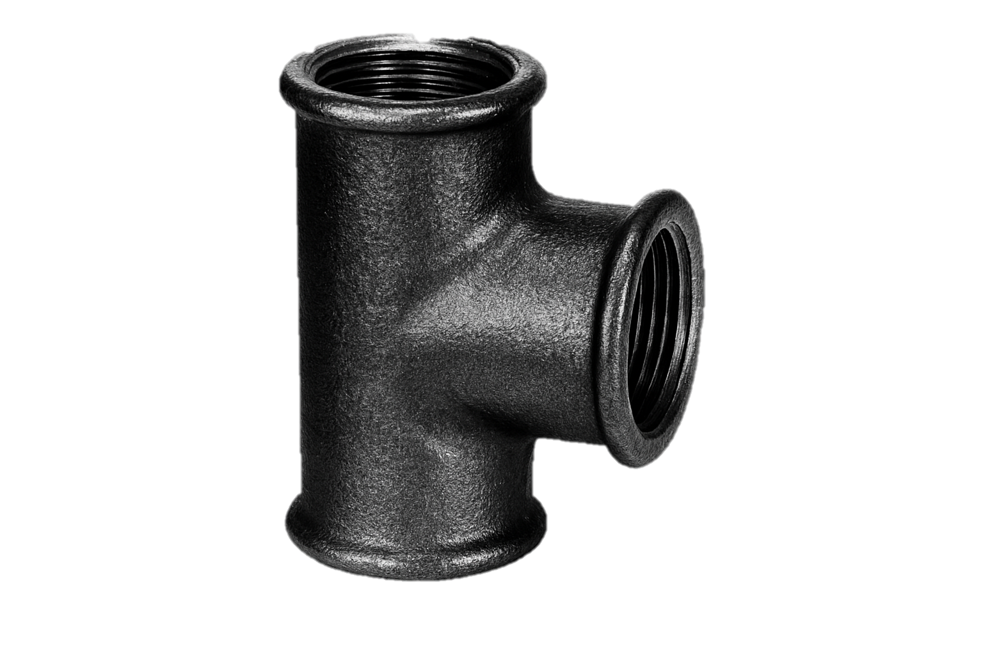 | LCS threaded tee | Connecting 3 LCS pipes of the same diameter
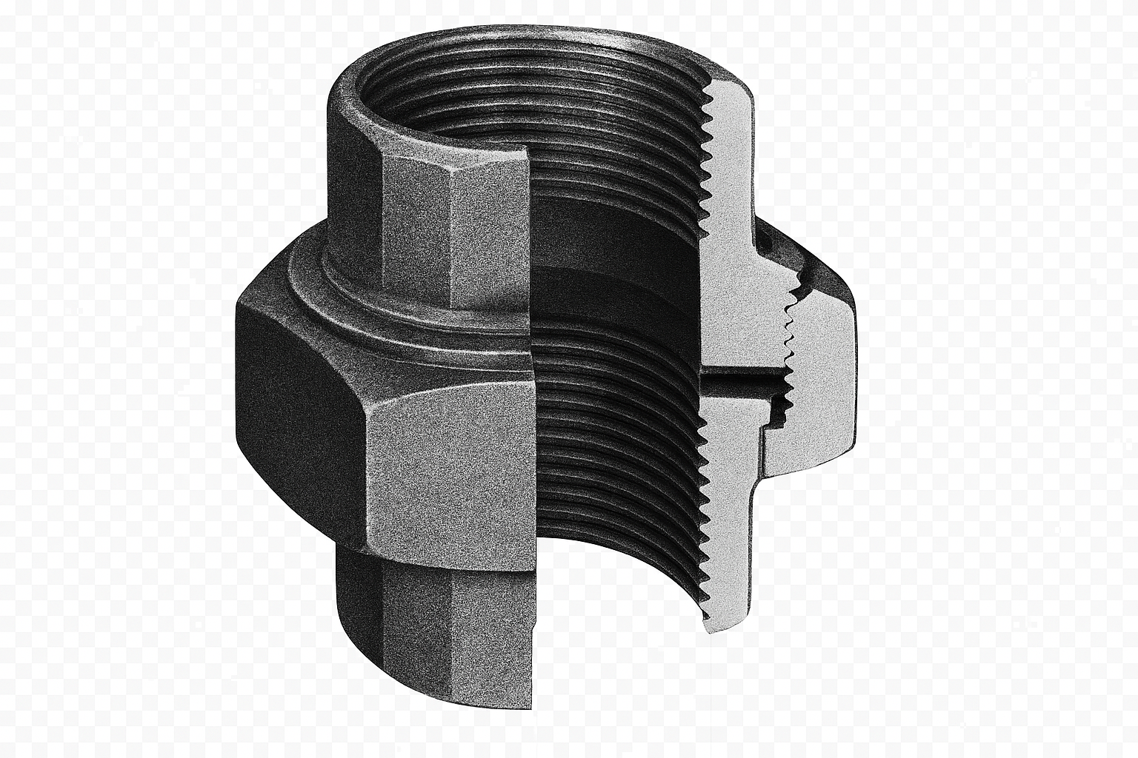 | LCS union | Connects 2 pipe of the same diameter

Task 14: X and Z dimensions

Objective: Understand and apply dimensional measurements in pipework.
Tutor Role: Clarify measurement principles and review learner calculations.
Key Learning Points: Definition and use of X and Z dimensions. Impact on pipe layout and fitting. Measurement accuracy.
Assessment: Completion of dimension calculations and layout task.

Expected learner outcomes:
- Understand X and Z dimensions for pipe fitting.
- Apply dimensions to workshop drawings.

Potential learner struggles:
- Confusing X and Z dimension definitions.
- Miscalculating pipe lengths.

Suggestions for improvement:
- Use diagrams to reinforce concepts.
- Practice dimensioning with sample drawings.

Suggestions for stretch activity:
- Create a dimensioning guide for new learners.
- Compare dimensioning techniques across materials.

Working out the X/Z Dimensions of a fitting will allow you to measure and cut a piece of copper/steel to the correct size when working from a workshop drawing (centre to centre measurements).
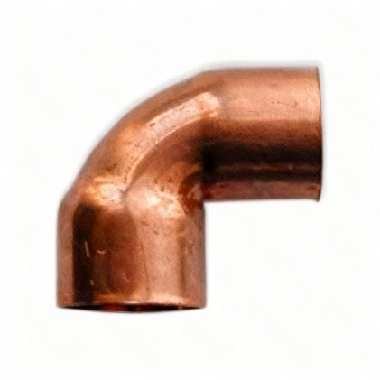
Describe an X dimension- The measurement between the end of the pipe and the centre of the fitting (Drawing are measure from the centre of the fitting). Copper only.
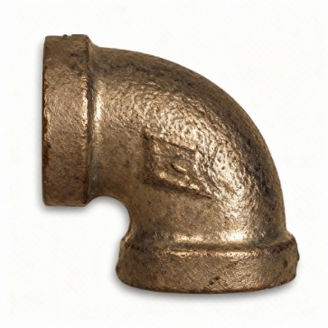
Describe a Z dimension- The measurement between the end of the pipe and the centre of the fitting (Drawing are measure from the centre of the fitting). LCS only.

Task 15: Fixings

Objective: Select and apply appropriate fixings for different surfaces.
Tutor Role: Demonstrate fixing methods and ensure safe application.
Key Learning Points: Types of fixings (wall plugs, brackets, clips). Surface compatibility. Load-bearing considerations.
Assessment: Installation of fixings in a workshop setting.

Expected learner outcomes:
- Mark horizontal levels and fix clips accurately.
- Understand spacing requirements for pipe fixings.

Potential learner struggles:
- Inconsistent spacing between clips.
- Misalignment of fixings.

Suggestions for improvement:
- Use templates for marking levels.
- Practice fixing on various surfaces.

Suggestions for stretch activity:
- Design a fixing layout for a complex pipe system.
- Research fixing standards in commercial installations.

Mark a horizontal level and fix the clips as shown below into a timber surface:
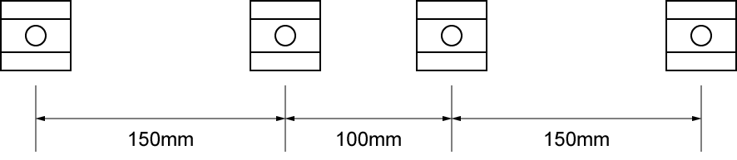

Mark a horizontal level and fix the clips as shown below into a brick or block surface:
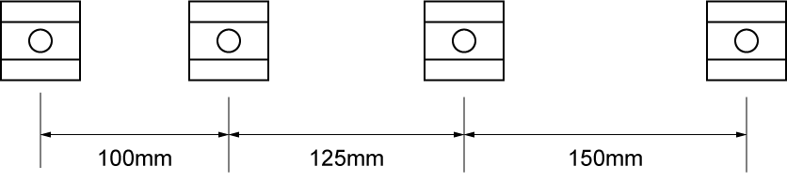
Attach the two back plate elbows to a brick or block surface:
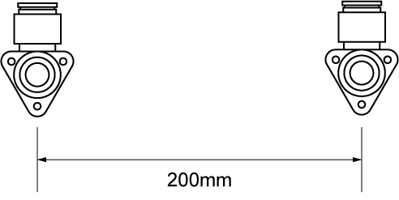

What tools and fixings are required to complete the task?
Pencil, Level. Wall plugs (Depending on wall type), Screwdriver or drill, Tape measure, Screws.
What PPE is required to carry out the task safely?
Boots, Goggles, Gloves, Ear defenders if SDS drill used.

Task 16: Decommissioning

Objective: Safely decommission gas systems and components.
Tutor Role: Supervise decommissioning steps and reinforce safety checks.
Key Learning Points: Isolation and removal procedures. Documentation and safety protocols. Environmental considerations.
Assessment: Completion of a decommissioning task with tutor sign-off.

Expected learner outcomes:
- Understand the safe process for decommissioning gas systems and equipment.
- Identify the steps and tools required for proper shutdown.

Potential learner struggles:
- Forgetting to isolate all relevant systems.
- Skipping documentation of the decommissioning process.

Suggestions for improvement:
- Use flowcharts to visualize the decommissioning sequence.
- Practice decommissioning on mock setups.

Suggestions for stretch activity:
- Create a decommissioning checklist for a multi-appliance system.
- Research environmental considerations during decommissioning.

Decommissioning is the process of taking the system safely ‘out of action’, this may be either temporarily or permanently.
Temporary decommission: The process of temporarily taking a system ‘out of action’ to carry out additional work to the system, to undertake maintenance or as a result of the system not being used.
Permanently decommission: The process of permanently taking a system ‘out of action’ and removing the installation
Procedure for decommissioning systems:
- notify relevant person.
- isolate Gas/electricity supply to the system as appropriate.
- isolate water supply.
- apply warning notices and signs.
- drain system to a suitable location.
- appropriately dispose of contents and any additives.
- continuity bonding as required.
- temporary capping of pipework sections as required.
- notify building users.
- alternative source of heat or supplies as required.
Whilst working through this training manual, once the installations have been completed, checked, and verified by the customer (trainer).
You must:
- Decommission in a safe manner ensuring safe isolation.
- Ensure the workspace is made good, including filling, sanding and painting any holes or damage to the building fabric.
Following dismantling, consideration must be given to sustainability and recycling.
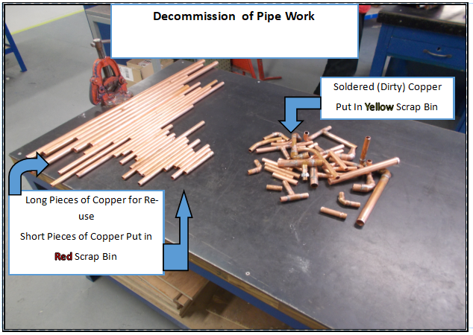
Notes for decommissioning:

Task 17: Copper compression

Objective: Install copper compression fittings correctly.
Tutor Role: Guide learners through fitting assembly and leak testing.
Key Learning Points: Assembly of compression joints. Use of spanners and sealing techniques. Leak detection.
Assessment: Practical installation and pressure test.

Expected learner outcomes:
- Assemble copper compression fittings correctly.
- Understand sealing principles.

Potential learner struggles:
- Over-tightening or under-tightening fittings.
- Using incorrect pipe preparation techniques.

Suggestions for improvement:
- Demonstrate fitting assembly.

Suggestions for stretch activity:
- Compare compression fittings with soldered joints.

You should now complete the frame below using compression fittings. Once complete you should then test to at least 1.5bar for 3 minutes.
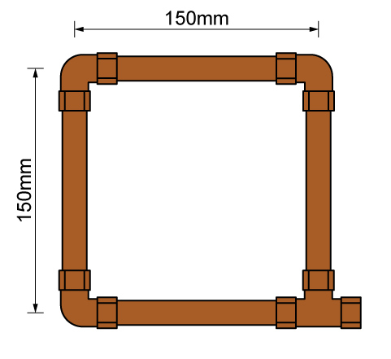
X Dimensions

Elbow 1 | 10mm x 2 = 20mm
Elbow 2 | 10mm x 2 = 20mm
Elbow 3 | 10mm x 2 = 20mm
Elbow 4 | 10mm x 2 = 20mm

Materials list
600mm 15mm Copper
3 x 15mm compression Elbows
1 x 15mm Compression Tee

What tools are required to complete the task?
Pipe cutter or slice
Tape measure
Spanner
Water pump pliers

What PPE is required to carry out the task safely?
Gloves
Boots

Formative Feedback/Development points |  | Trainer to tick
Please develop and work on the following elements: | Criteria
Measurement | - +/- 2mm of the dimensions on the drawing | ☐
Marking out | - +/- 2mm of the dimensions on the drawing  - Marked out in pencil  - Spirit level used | ☐
Clipping | - Select appropriate pipework clips for use and space them correctly | ☐
Pipe jointing | - Pipe and fittings are free from tool and vice marks  - Malleable iron fittings show no more than 1 ½ threads | ☐
Ensuring work meets industry requirements | - Completed pipework must be leak free | ☐
Health and safety | - Health and safety requirements must be observed at all times | ☐

Behaviours demonstrated during this task Trainer to tick

Dependable and responsible | ☐
Enthusiasm and positive attitude | ☐
Quality focus | ☐
Willingness to learn | ☐
Work with others | ☐
Sustainable working | ☐

Task 18: Copper soldering

Objective: Perform safe and effective copper pipe soldering.
Tutor Role: Demonstrate soldering techniques and monitor safety compliance.
Key Learning Points: Use of flux and heat application. Joint preparation and cleaning. Safety with LPG equipment.
Assessment: Completion of soldered joints and visual inspection.

Expected learner outcomes:
- Perform safe and effective copper soldering.
- Understand heat application and flux usage.

Potential learner struggles:
- Applying too much or too little solder.
- Overheating joints and damaging pipework.

Suggestions for improvement:
- Use visual guides for solder flow.
- Practice on scrap copper before assessed tasks.

Suggestions for stretch activity:
- Create a troubleshooting guide for poor solder joints.
- Research alternative joining methods for copper.

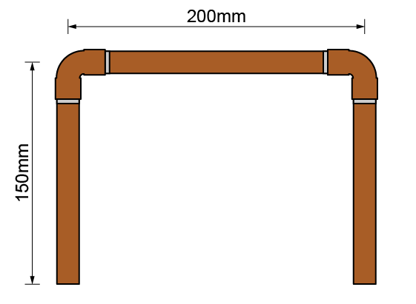

X dimensions
Fitting 1 | 2 x 15mm = 30mm
Fitting 2 | 2 x 15mm = 30mm

What tools are required to complete the task?
Tape Measure
Blowlamp
Pipe cutter or slice

What PPE is required to carry out the task safely?
Boots
Gloves
Goggles

Please develop and work on the following elements: | Criteria | Trainer to tick
Measurement | - +/- 2mm of the dimensions on the drawing | ☐
Marking out | - +/- 2mm of the dimensions on the drawing  - Marked out in pencil  - Spirit level used | ☐
Clipping | - Select appropriate pipework clips for use and space them correctly | ☐

Behaviours demonstrated during this task | Trainer to tick
Dependable and responsible | ☐
Enthusiasm and positive attitude | ☐
Quality focus | ☐
Willingness to learn | ☐
Work with others | ☐
Sustainable working | ☐

Task 19: Copper bending

Objective: Bend copper pipework to specification without damage.
Tutor Role: Teach bending methods and inspect learner outcomes.
Key Learning Points: Use of bending springs and machines. Avoiding kinks and flattening. Measurement and angle control.
Assessment: Production of bent pipework to specified dimensions.

Expected learner outcomes:
- Bend copper pipe accurately using appropriate tools.
- Understand bend radius and pipe integrity.

Potential learner struggles:
- Kinking the pipe during bending.
- Misjudging bend angles.

Suggestions for improvement:
- Use bending templates and guides.
- Practice with different pipe diameters.

Suggestions for stretch activity:
- Design a complex pipe layout requiring multiple bends.
- Compare manual (Spring) vs. machine bending techniques.

Form the bends pictured below in 15mm copper tube. Remember to allow for pipe gain.
How much tube is required to form this bend? 400mm
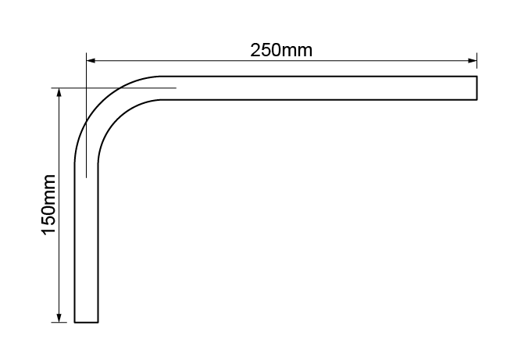

What angle did you use to form the offset? 45 degrees
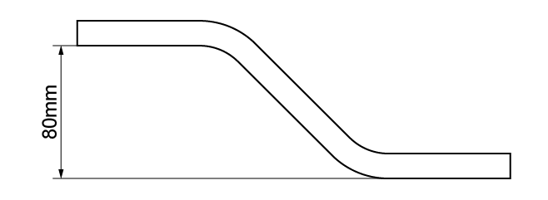
Recreate this bend.
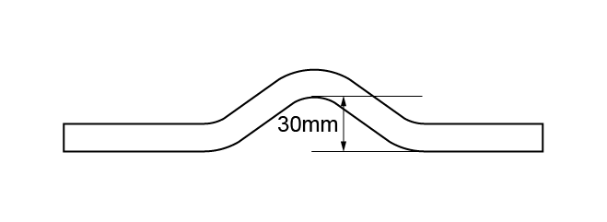
Recreate this bend.
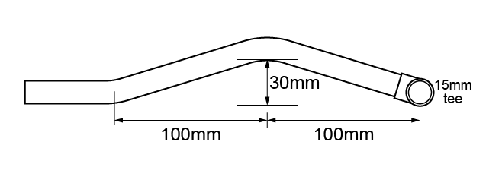
Please develop and work on the following elements: | Criteria | Trainer to tick
Measurement | - +/- 2mm of the dimensions on the drawing | ☐
Marking out | - +/- 2mm of the dimensions on the drawing  - Marked out in pencil  - Spirit level used | ☐
Pipe jointing | - Pipe and fittings are free from tool and vice marks | ☐
Pipe bending | - Pipe bends must be free from ripples, throating or excessive distortion | ☐
Presentation of work | - The task is completed according to the brief, with all components correctly oriented | ☐
Health & safety | - Health and safety requirements must be observed at all times | ☐

Behaviours demonstrated during this task | Trainer to tick
Dependable and responsible | ☐
Enthusiasm and positive attitude | ☐
Quality focus | ☐
Willingness to learn | ☐
Work with others | ☐
Sustainable working | ☐

Task 20: Copper frame

Objective: Construct a copper frame using appropriate joints and techniques.
Tutor Role: Support learners in layout planning and frame assembly.
Key Learning Points: Combining soldered and compression joints. Structural layout and support. Accuracy and neatness.
Assessment: Completion of copper frame project with tutor evaluation.

Expected learner outcomes:
- Construct a stable copper frame using correct fittings.
- Apply measurement and alignment techniques.

Potential learner struggles:
- Misaligning joints and fittings.
- Inaccurate measurements leading to poor fit.

Suggestions for improvement:
- Use clips during assembly.
- Encourage peer review of frame layout.

Suggestions for stretch activity:
- Build a frame with integrated valves or outlets.

You should now complete the frame below using compression fittings. Once complete, you should then test to at least 1.5bar for 3 minutes.
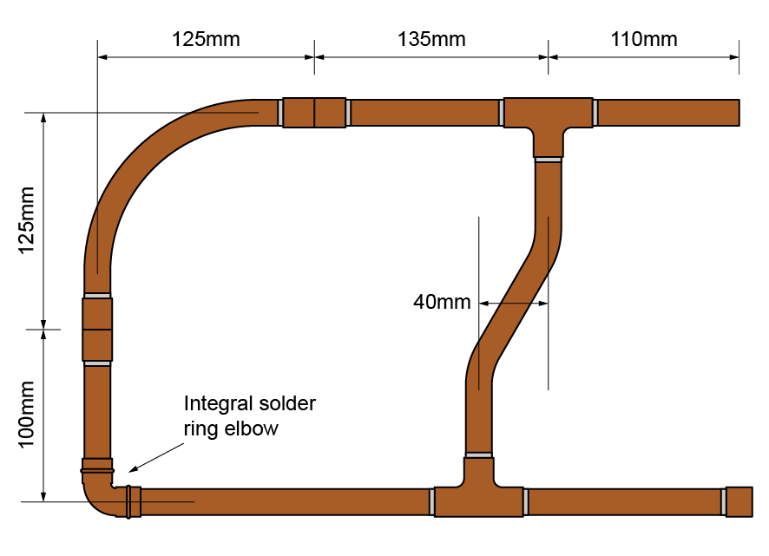
Material type (description) | Quantity
15mm End feed coupling | 2
15mm End feed tee | 2
15mm End feed elbow | 1
15mm Copper | 1000mm

Tool list – list the tools required to complete the work task
Pipe cutter or slice
Blow lamp
Tape measure
Pen or Pencil

Please develop and work on the following elements: | Criteria | Trainer to tick
Measurement | - +/- 2mm of the dimensions on the drawing | ☐
Marking out | - +/- 2mm of the dimensions on the drawing  - Marked out in pencil  - Spirit level used | ☐
Clipping | - Select appropriate pipework clips for use and space them correctly | ☐
Pipe jointing | - Soldered joints must be free from excessive solder and residual flux  - Pipe and fittings are free from tool and vice marks | ☐
Pipe bending | - Pipe bends must be free from ripples, throating or excessive distortion | ☐
Presentation of work | - The task is completed according to the brief, with all components correctly oriented | ☐
Ensuring work meets industry requirements | - Completed pipework must be leak free | ☐
Health & safety | - Health and safety requirements must be observed at all times | ☐

Behaviours demonstrated during this task | Trainer to tick
Dependable and responsible | ☐
Enthusiasm and positive attitude | ☐
Quality focus | ☐
Willingness to learn | ☐
Work with others | ☐
Sustainable working | ☐

Task 21: Plastic push-fit

Objective: Install plastic push-fit pipework systems correctly.
Tutor Role: Demonstrate fitting techniques and supervise learner practice.
Key Learning Points: Push-fit fitting principles and compatibility. Importance of clean cuts and secure connections. Leak prevention and testing.
Assessment: Completion of a push-fit installation task with leak check.

Expected learner outcomes:
- Assemble plastic push-fit joints correctly.
- Understand sealing mechanisms and compatibility.

Potential learner struggles:
- Failing to insert pipe fully into fittings.
- Using incompatible pipe types.

Suggestions for improvement:
- Demonstrate correct insertion depth.
- Provide compatibility charts for fittings.

Suggestions for stretch activity:
- Design a water distribution system for your own house using push-fit.

List the fittings required to form the frame pictured below using push-fit pressure plastic pipework and note the X- dimensions then pressure test to 1.5 bar for 3 minutes.
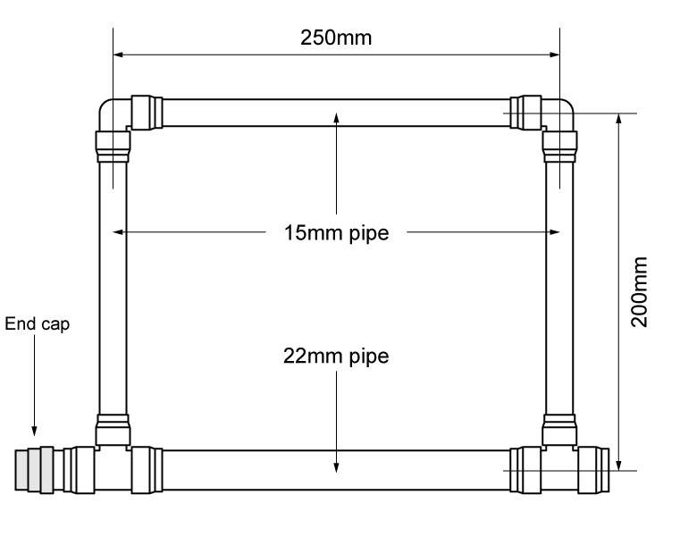
Assemble the frame on the diagram below.

Fitting Type | Quantity | X- Dimensions
15mm push fit elbow | 2 | Dependent on manufacturer of elbow
22mm reducing push fit elbow | 1 | Dependent on manufacturer of elbow
22/15/22mm reducing tee | 1 | Dependent on manufacturer of elbow

What tools are required to complete the task?
Tape measure
Deburrer
Plastic pipe cutter or slice

What PPE is required to carry out the task safely?
Boots
Gloves

Please develop and work on the following elements: | Criteria | Trainer to tick
Measurement | - +/- 2mm of the dimensions on the drawing | ☐
Marking out | - +/- 2mm of the dimensions on the drawing  - Marked out in pencil  - Spirit level used | ☐
Clipping | - Select appropriate pipework clips for use and space them correctly
Pipe jointing | - Pipe and fittings are free from tool and vice marks | ☐
Presentation of work | - The task is completed according to the brief, with all components correctly oriented. | ☐
Ensuring work meets industry requirements | - Completed pipework must be leak free | ☐
Health & safety | - Health and safety requirements must be observed at all times | ☐

Task 22: Steel bending

Objective: Bend steel pipework safely and accurately.
Tutor Role: Demonstrate bending tools and supervise learner practice.
Key Learning Points: Use of bending equipment and techniques. Avoiding deformation and maintaining structural integrity. Safety considerations during bending.
Assessment: Production of a bent steel pipe to specification.

Expected learner outcomes:
- Bend steel pipe safely and accurately.
- Understand material limitations and tool use.

Potential learner struggles:
- Applying uneven force during bending.
- Misjudging bend angles due to pipe rigidity.

Suggestions for improvement:
- Use mechanical benders for consistency.

Suggestions for stretch activity:
- Create a guide comparing steel and copper bending.

Form the 90º bend pictured below in 15mm low carbon steel (LCS) pipe. How much pipe is required to form this bend? Also, show how much the pipe gains when it is bent to 90°. 400mm. ;earrners to measure gain after bending pipe.
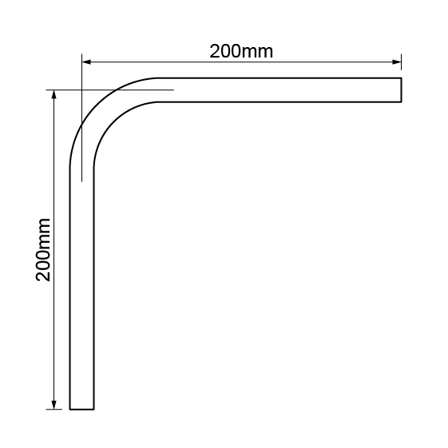
Form the 45º bend pictured below in 20mm LCS pipe. How much pipe is required to form this bend? 375mm
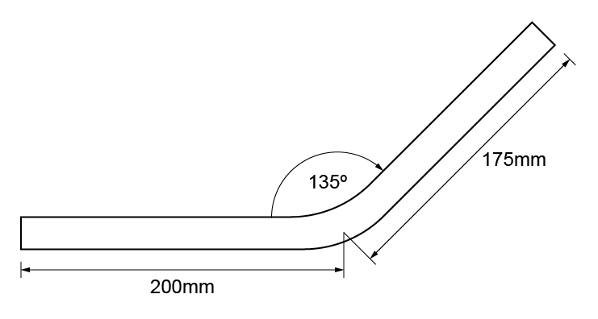
List the tools and P.P.E. that you used to complete this task.
Tape Measure, Hydraulic Steel Bender, Boots, Gloves.

Please develop and work on the following elements: | Criteria | Trainer to tick
Measurement | - +/- 2mm of the dimensions on the drawing | ☐
Marking out | - +/- 2mm of the dimensions on the drawing  - Marked out in pencil  - Spirit level used | ☐
Pipe bending | - Pipe bends must be free from ripples, throating or excessive distortion | ☐
Presentation of work | - The task is completed according to the brief, with all components correctly oriented. | ☐
Health & safety | - Health and safety requirements must be observed at all times | ☐

Task 23: Steel jointing

Objective: Join steel pipework using appropriate methods.
Tutor Role: Provide jointing demonstrations and assess learner technique.
Key Learning Points: Types of steel joints and their applications. Use of sealants and torque settings. Testing for joint integrity.
Assessment: Completion of a steel jointing task with tutor review.

Expected learner outcomes:
- Assemble steel joints using threaded and compression fittings.
- Understand sealing techniques and joint integrity.

Potential learner struggles:
- Cross-threading fittings.
- Using incorrect sealing compounds.

Suggestions for improvement:
- Practice threading with visual inspection.
- Provide samples of good vs. poor joints.

Suggestions for stretch activity:
- Research jointing standards in industrial piping.
- Build a frame with mixed joint types.

Using the 90º bend you formed in the previous task, measure the Z-dimensions of the fittings, calculate the pipe lengths required and make the frame pictured below:
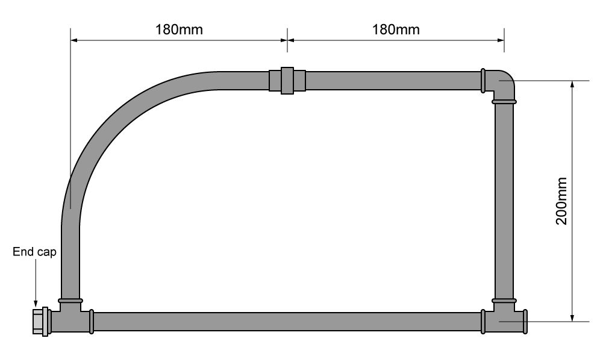

Fitting Name | Z – Dimension 1 | Z – Dimension 2
LCS Union | Depends on manufacturer | Depends on manufacturer
LCS Elbow | Depends on manufacturer | Depends on manufacturer
LCS Tee | Depends on manufacturer | Depends on manufacturer

List the tools and P.P.E. that you used to complete this task.
Tape Measure
Hacksaw/Steel pipe cutter
Stock and dye
Boots
Gloves
Goggles
Which techniques did you use to make this frame?
LCS bending
LCS jointing

Please develop and work on the following elements: | Criteria | Trainer to tick
Measurement | - +/- 2mm of the dimensions on the drawing | ☐
Marking out | - +/- 2mm of the dimensions on the drawing  - Marked out in pencil  - Spirit level used | ☐
Clipping | - Select appropriate pipework clips for use and space them correctly | ☐
Pipe jointing | - Soldered joints must be free from excessive solder and residual flux  - Pipe and fittings are free from tool and vice marks  - Malleable iron fittings show no more than 1 ½ threads | ☐
Pipe bending | - Pipe bends must be free from ripples, throating or excessive distortion | ☐
Presentation of work | - The task is completed according to the brief, with all components correctly oriented. | ☐
Ensuring work meets industry requirements | - Completed pipework must be leak free | ☐
Health & safety | - Health and safety requirements must be observed at all times | ☐

Task 24: Combined frame

Objective: Build a frame using mixed materials and jointing methods.
Tutor Role: Oversee material selection and structural assembly.
Key Learning Points: Integration of copper, plastic, and steel components.
Joint compatibility and layout planning. Structural stability and neatness.
Assessment: Completion of a combined frame project.

Expected learner outcomes:
- Construct a frame using multiple pipe materials.
- Apply joining techniques across copper, steel, and plastic.

Potential learner struggles:
- Misaligning different material joints.
- Forgetting material-specific preparation steps.

Suggestions for improvement:
- Use colour-coded plans for material types.
- Practice transitions between materials.

Suggestions for stretch activity:
- Design a multi-material frame.
- Research compatibility issues in mixed systems.
You are required to fabricate the combined frame and then test it to 1.5 bar for 3 minutes.
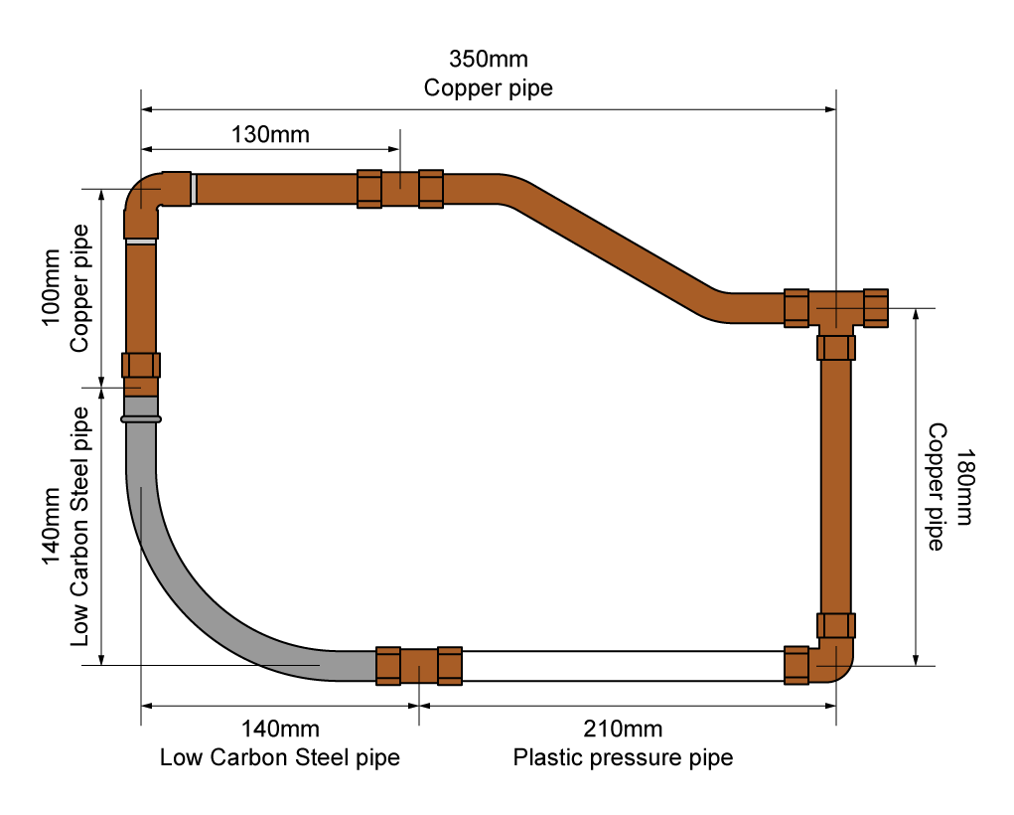
Material type (description) | Quantity
15mm Endfeed coupling | 1
22/22/15mm Endfeed Tee | 1
15mm CSST elbow to copper compression | 1
15mm CSST coupling to male iron with ½ inch steel coupling | 1
15mm Half inch steel coupling to 15mm copper compression | 1
15mm Endfeed elbow | 1

Tool list – list the tools required to complete the work task
Tape measure
Copper pipe cutter or slice
Plastic pipe cutter or slice
Spanners
Water pump pliers
Stock and dye
Hacksaw or LCS pipe slice
Blowlamp

Please develop and work on the following elements: | Criteria | Trainer to tick
Measurement | - +/- 2mm of the dimensions on the drawing | ☐
Marking out | - +/- 2mm of the dimensions on the drawing  - Marked out in pencil  - Spirit level used | ☐
Clipping | - Select appropriate pipework clips for use and space them correctly | ☐
Pipe jointing | - Soldered joints must be free from excessive solder and residual flux  - Pipe and fittings are free from tool and vice marks  - Malleable iron fittings show no more than 1 ½ threads | ☐
Pipe bending | - Pipe bends must be free from ripples, throating or excessive distortion | ☐
Presentation of work | - The task is completed according to the brief, with all components correctly oriented | ☐
Ensuring work meets industry requirements | - Completed pipework must be leak free | ☐
Health & safety | - Health and safety requirements must be observed at all times | ☐

Behaviours demonstrated during this task | Trainer to tick
Dependable and responsible | ☐
Enthusiasm and positive attitude | ☐
Quality focus | ☐
Willingness to learn | ☐
Work with others | ☐
Sustainable working | ☐

Task 25: Electrical tools

Objective: Identify and use electrical tools safely.
Tutor Role: Introduce tool functions and supervise practical use.
Key Learning Points:
Common electrical tools and their uses.
Safe handling and maintenance.
Tool selection for specific tasks.
Assessment: Completion of tool identification table and practical demonstration.
Expected Learner Outcomes:
- Identify and use electrical tools safely.
- Understand tool-specific applications in gas engineering.
Potential Learner Struggles:
- Confusing similar tools (e.g., pliers vs. strippers).
- Using tools incorrectly due to lack of familiarity.
Suggestions for Improvement:
- Provide tool demonstrations with hands-on practice.
- Use labelled toolkits for reference.
Suggestions for Stretch Activity:
- Create a tool identification game.
- Research innovations in electrical tool design.

Identify the tool and its use:
Tools/Equipment | Name/Use
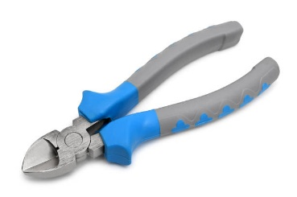 | Side cutters – cutting cable
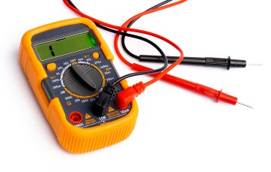 | Multi-meter – testing different types of energy in a range of electrical systems
 | Terminal screwdriver – Tightening/loosening screws

What is the safety feature of electrical tools?
They are insulated to provide protection from electrocution

Task 26: Fittings and jointing materials identification

- Objective: Recognize fittings and jointing materials used in gas systems.
- Tutor Role: Present samples and quiz learners on identification.
- Key Learning Points:
Types of fittings and jointing compounds.
Material compatibility and application.
Safety and regulatory standards.
- Assessment: Completion of identification activity and verbal Q&A.
Expected Learner Outcomes:
- Identify various fittings and jointing materials.
- Understand their applications and limitations.
Potential Learner Struggles:
- Misidentifying fittings due to similar appearance.
- Forgetting material compatibility.
Suggestions for Improvement:
- Use tactile learning with real samples.
- Provide comparison charts.
Suggestions for Stretch Activity:
- Create a fitting identification guide.
- Research jointing standards across regions.
The Trainer should select a mixture of 12 of the following and give to learners to identify and state if it is appropriate for gas. (Include a minimum of 1 cooker hose and 1 jointing material)
- Press fit – provide gas- appropriate and non-gas approved fittings
- Push fit – assortment include a cap (not appropriate)
- Soldered fittings
- Compression fittings – include fittings like tap connectors that are not appropriate
- Threaded and compression fittings for Steel, CSSP etc.
- Cooker flexes – Nat gas, LPG and Multi occupancy dwellings
- Provide joint materials for the above including correct and incorrect materials i.e. PTFE for water and gas

 | Identification of fitting | Appropriate for gas?
1.
2.
3.
4.
5.
6.
7.
8.
9.
10.
11.
12.

Task 27: Termination of BS1363 plug top

Objective: Safely terminate and wire a BS1363 plug top.
Tutor Role: Demonstrate wiring steps and check for compliance.
Key Learning Points:
Wiring colour codes and terminal identification.
Use of cable strippers and screwdrivers.
Safety checks and fuse selection.
Assessment: Completion of plug termination task with tutor inspection.

Expected Learner Outcomes:
- Terminate a plug top safely and correctly.
- Understand wiring colour codes and fuse selection.
Potential Learner Struggles:
- Incorrect wire placement.
- Forgetting to check fuse rating.
Suggestions for Improvement:
- Use plug top models for practice.
- Provide wiring diagrams.
Suggestions for Stretch Activity:
- Create a guide for plug top safety checks.
- Compare UK plug standards with other countries.

Aim:
To terminate BS1363 plug top using 1.5mm² 3 core flexible cable.
Objective:
Label the plug top using coloured pencils.

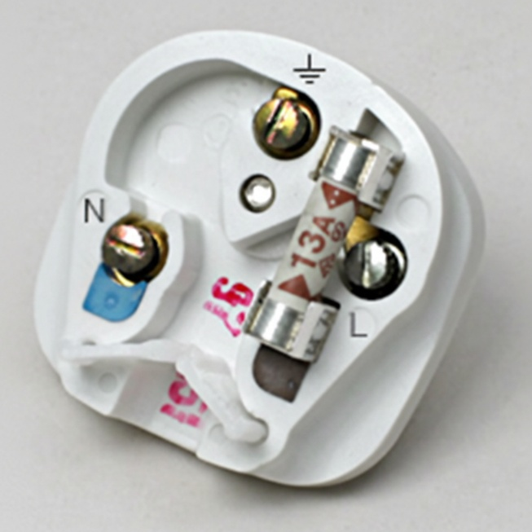
Fuse
Earth Terminal

Neutral Terminal
Live Terminal

- Obtain materials and tools
- Terminate 1.5mm² 3 core flexible cable into plug top
- Secure cover and inform trainer of completed task
- Clean & Tidy work area

Marking scheme
1 | Correct polarity of plug top
2 | Termination secure
3 | Cord grip secure
4 | Front cover secure
Trainer feedback

Is the installation complete to a satisfactory industrial standard

Task 28: Operating a U gauge and digital manometer

Objective: Use pressure testing equipment to assess gas systems.
Tutor Role: Guide learners through setup and interpretation of readings.
Key Learning Points:
Function and calibration of U gauge and manometer.
Reading and recording pressure values.
Identifying faults through pressure testing.
Assessment: Demonstration of pressure testing and result interpretation
Expected Learner Outcomes:
- Use pressure testing equipment accurately.
- Understand readings and calibration.
Potential Learner Struggles:
- Misreading U gauge or digital displays.
- Forgetting to zero the gauge.
Suggestions for Improvement:
- Practice with both analogue and digital tools.
- Use simulated faults for troubleshooting.
Suggestions for Stretch Activity:
- Compare pressure testing tools across applications.
- Design a pressure test procedure for a gas system.

Your trainer will provide you with an empty U gauge and digital manometer together with a section of pipework and appropriate hand air pump required to perform this task. Complete all tasks below:

Item | Task | Check
1 | Identify and correctly fill/ calibrate U gauge
2 | Select appropriate tools for the task and inspect for safety
3 | Check hoses for leaks
4 | Connect hose to test point
5 | Charge U gauge to 10mbar and 20mbar accurately
6 | Remove U gauge and check for leaks
7 | Select and calibrate digital manometer
8 | Check hoses for leaks
9 | Connect hose to test point
10 | Charge digital manometer to 10mbar and 20mbar accurately
11 | Remove manometer and check test point for leaks
12 | Complete task in a safe working area

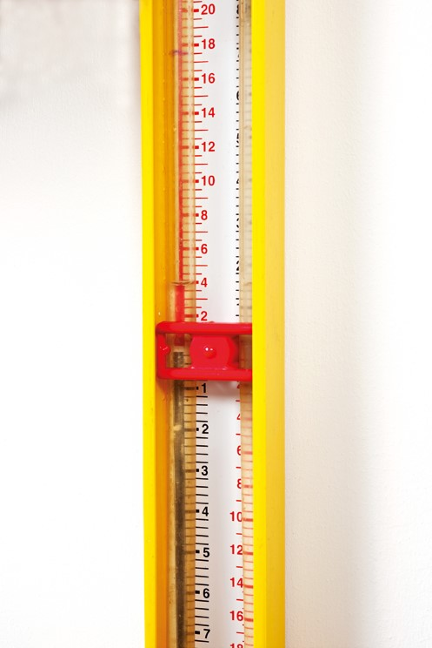
Identify how many mbar is displayed below:

4Mbar

Task 29: Gas meters and enclosures

Objective: Identify and install gas meters and enclosures.
Tutor Role: Explain meter types and supervise installation.
Key Learning Points:
Types of gas meters and their applications.
Enclosure standards and positioning.
Safety and accessibility requirements.
Assessment: Completion of meter installation task with tutor review
Expected Learner Outcomes:
- Identify types of gas meters and their enclosures.
- Understand installation and safety requirements.
Potential Learner Struggles:
- Confusing meter types.
- Overlooking ventilation needs.
Suggestions for Improvement:
- Use labelled meter displays.
- Practice enclosure fitting.
Suggestions for Stretch Activity:
- Research smart meter technology.
- Design a meter installation plan for a new build.
The trainer will now give the learner 6 different types of Gas metre for them to identify below.
Using the examples given to you by your tutor identify the following 6 types of Gas meter? You should also state whether they are imperial or metric.
1.
2.
3.
4.
5.
6.

Task 30: Let-by testing and tightness testing – low pressure

Objective: Conduct let-by and tightness tests on low-pressure systems.
Tutor Role: Demonstrate testing procedures and validate results.
Key Learning Points:
Purpose and sequence of let-by and tightness tests.
Use of test equipment and recording results.
Identifying leaks and corrective actions.
Assessment: Completion of low-pressure test with documented results.

Expected Learner Outcomes:
- Perform let-by and tightness tests on low-pressure systems.
- Understand test procedures and pass/fail criteria.
Potential Learner Struggles:
- Misinterpreting test results.
- Skipping leak detection steps.
Suggestions for Improvement:
- Use step-by-step guides.
- Practice with mock leaks.
Suggestions for Stretch Activity:
- Create a troubleshooting guide for failed tests.
- Compare low vs. medium pressure testing protocols.

You will be allocated a training bay by your trainer. The task is as follows:
Carry out a let-by and tightness test. What are the results of this test?
Bay number |  | Meter type
Installation
How many appliances are fitted? |  |  |  |  |  | Appliance types (if applicable)
Let-by test
Let-by pressure |  |  | mbar |  |  |  |  | Duration (minutes)
Is the ECV letting by? |  |  | If yes, record actions taken:
Yes | No
Tightness test
Stabilisation period pressure |  |  |  | mbar |  |  | Duration (minutes
Tightness test pressure |  |  |  | mbar |  |  | Duration (minutes)
Explain why we test at this pressure:

Maximum permissible drop |  |  |  |  | mbar |  | Is the installation gas tight?  If no, state why and the actions required |  |  |  | Yes | No
What is the operating pressure in your bay? |  | What is the correct operating pressure of the meter regulator? |  |  |  |  | Actions required:
mbar |  | mbar

Learner signature: | Trainer signature: | Date:

Task 31: Let-by testing and tightness testing – medium pressure
Objective: Perform medium-pressure gas system tests safely and accurately.
Tutor Role: Demonstrate procedures and supervise learner execution.
Key Learning Points:
Differences between low and medium pressure testing.
Use of correct equipment and test durations.
Recording and interpreting results.
Assessment: Completion of medium-pressure test with documented outcomes.
Expected Learner Outcomes:
- Conduct let-by and tightness tests on medium-pressure gas systems.
- Understand the differences between low and medium pressure procedures.
Potential Learner Struggles:
- Misapplying low-pressure procedures to medium-pressure systems.
- Inaccurate interpretation of test results.
Suggestions for Improvement:
- Use side-by-side comparisons of low vs. medium pressure tests.
- Practice with calibrated equipment and mock faults.
Suggestions for Stretch Activity:
- Create a troubleshooting guide for medium-pressure systems.
- Research industry standards for medium-pressure testing.
Centre Discretion for this task. Minimum of 2 x appliances.
Task description: You will be allocated a training bay by your trainer. The task is as follows:
Carry out a let by and tightness test. What are the results of this test?
Bay number |  | Meter type

Installation
How many appliances are fitted? |  |  |  |  |  | Appliance types (if applicable)
Let-by test
Let-by pressure |  |  | mbar |  |  |  |  | Duration (minutes)
Is the ECV letting by? |  |  | If yes, record actions taken:
Yes | No
Tightness test
Stabilisation period pressure |  |  |  | mbar |  |  | Duration (minutes)
Tightness test pressure |  |  |  | mbar |  |  | Duration (minutes)
Explain why we test at this pressure:

Maximum permissible drop |  |  |  |  | mbar |  | Is the installation gas tight?  If no, state why and the actions required |  |  |  | Yes | No
What is the operating pressure in your bay? |  | What is the correct operating pressure of the meter regulator? |  |  |  |  | Actions required:
mbar |  | mbar

Learner signature: | Trainer signature: | Date:

Task 32: Purging

Objective: Safely purge gas systems before and after work.
Tutor Role: Explain purging principles and supervise execution.
Key Learning Points:
Importance of purging for safety and compliance.
Methods for purging air and gas.
Ventilation and monitoring requirements.
Assessment: Demonstration of purging procedure and completion of checklist.

Expected Learner Outcomes:
- Understand purging procedures for gas systems.
- Identify when and how to safely purge air or gas.
Potential Learner Struggles:
- Confusing purging with tightness testing.
- Forgetting to monitor gas concentrations.
Suggestions for Improvement:
- Use gas detection tools during practice.
- Simulate purging in different system types.
Suggestions for Stretch Activity:
- Research purging procedures for large-scale installations.
- Create a purging checklist for domestic and commercial systems.
Centre Discretion for this task. Minimum of 2 x appliances.
You will be allocated a training bay by your trainer. The task is as follows:

Carry out the purging process.

Bay number |  | Meter type

Installation
How many appliances are fitted? |  |  |  | Appliance types (if applicable)
Volumes
Meter volume (IV_{m}) |  |  |  |  |  |  |  |  | IV_{m} | = | m³
Pipework volume (IV_{p}) |  |  |  |  | m of 35mm copper |  |  |  | x 0.00084 | = | m³
 |  |  |  |  | m of 28mm copper |  |  |  | x 0.00054 | = | m³
 |  |  |  |  | m of 22mm copper |  |  |  | x 0.00032 | = | m³
 |  |  |  |  | m of 15mm copper |  |  |  | x 0.00014 | = | m³
 |  |  |  |  |  |  |  |  | IV_{p} | = | m³
Fittings volume (IV_{f}) = IV_{p} x 0.1 |  |  |  |  |  |  |  |  | IV_{f} | = | m³
Total volume (IV_{t})
IV_{m} + IV_{p} + IV_{f} = IV_{t} |  | + |  |  |  | + |  |  | IV_{t} | = | m³
Purge volume (P_{V})
IV_{t} x 1.5 = P_{V} |  |  |  |  |  |  |  |  | P_{V} | = | m³

Purge volume for the system | m³
Purge method to be used

Answer the following questions:
Give a brief description of the gas network from the beach to the building:
- Offshore production
- Subsea pipelines
- Onshore processing
- Transmission pipelines
- Local distribution network
- Buildings gas supply
- End use

What are the operating pressure ranges of the following:
- Low pressure - Up to 75 Mbar
- Medium pressure - 75Mbar to 2Bar
- Intermediate pressure - 2Bar to 7Bar
- High pressure - 7Bar plus
Describe the different types of gases used to supply gas appliances in domestic dwellings:
Natural gas – Methane
Propane – LPG
Butane - LPG
What are the requirements when issuing testing and purging certificates?
Compliance with standards
Qualified and registered with competent persons scheme (Gas safe)
Leak free
Commissioned as per M.I’s
What is the correct action to take when a non-commissioned appliance is identified?
Notify the customer, inspect the appliance and commission if possible. Issue the correct documentation.
If unable to commission safely cap off pipework so it cannot be switched on. Place a warning notice and notify customer.
What is the correct action to take if pipework and appliances are not commissioned when the gas supply to the property is re-established?
Commission if possible. If not cap the gas metre to prevent an unsafe situation in the future.
State the purge volume for an installation containing a U6 meter, 3m of 28mm pipe and 5m of 22mm pipe.
U6 = 0.008m3 - IVM
28mm = 0.00054 x 3 = 0.00162
22mm = 0.00032 x 5 = 0.0016
0.00162 + 0.0016 = 0.00322 IVP
0.00322 x 0.1 = 0.000322 IVF
0.008 IVM + 0.00322 IVP + 0.000322 IVF = 0.011542 IVT
0.011542 IVT x 1.5 = 0.017313 PV

Task 33: The installation pipework
Objective: Install gas pipework to specification and standards.
Tutor Role: Review layout plans and inspect installation quality.
Key Learning Points: Pipe sizing, routing, and support. Compliance with regulations and manufacturer instructions.
Leak testing and documentation.
Assessment: Completion of pipework installation and tutor inspection.

The trainer will dedicate the learner a bay with pipework including a minimum of 3 faults. This should include all materials of pipe.
You will be allocated a training bay by your trainer. The tasks are as follows:
Visually inspect the installation pipework and record any faults.
Is the ECV installed correctly? |  |  | Yes |  |  | No
If no, state why not:
Is the installation pipework installed correctly? |  |  | Yes |  |  | No
If no, state why not:
Record and describe briefly one (1) AR/ID situation which may exist with the installation. Identify which notice and labels should be used and detail the correct procedure to be followed to make the installation safe.

Extend the installation pipework to an appliance in the bay allocated to suit a new position as indicated by your trainer. Your installation may include copper pipe, low carbon steel tube and/or Corrugated Stainless Steel Tube (CSST).
Record findings before pipework alteration
Let-by test
Let-by pressure. |  | mbar |  |  | Duration (minutes)
Is the ECV letting by? |  | If yes, record actions you would take:
Yes | No
Tightness test
Stabilisation period pressure |  |  | mbar | Duration (minutes)
Tightness test pressure |  |  | mbar | Duration (minutes)
Explain why we test at this pressure:

Maximum permissible drop |  | mbar |  | Is the installation gas tight?  If no, state why and the actions required |  |  | YES | NO
What is the operating pressure in your bay? |  | What is the correct operating pressure of the system? |  | Actions required:
mbar |  | mbar

Photographs
Installation BEFORE alteration | Installation AFTER alteration

Give a brief description of the work completed including the type and size of pipework and fittings used.

Record findings after pipework alteration
Let-by test
Let-by pressure. |  |  | mbar |  |  | Duration (minutes)
Is the ECV letting by? |  |  | If yes, record actions you would take:
Yes |  | No
Tightness test
Stabilisation period pressure |  |  |  | mbar | Duration (minutes)
Tightness test pressure |  |  |  | mbar | Duration (minutes)
Maximum permissible drop |  |  | mbar |  | Is the installation gas tight?  If no, state why and the actions required |  | Yes | No
 | Actions required:

Check the standing pressure and the operating pressure at the meter.
From the relevant pressure test point, record the following
Standing pressure: |  | mbar
Operating pressure at the meter: |  | mbar
Operating pressure at the appliance: |  | mbar
What is the maximum permissible pressure drop between the meter and the appliance? |  | mbar

Answer the following questions:
For the purposes of these questions, the Gas Safety (Installation and Use) Regulations will be abbreviated to ‘GSIUR’.

Produce a plan of the installation you have just altered showing the positioning and protection of pipework and fixing methods.

British Standard BS6891:2019 specifies the design, materials and methods of installing gas pipework, but what is the maximum size and pressure it refers to? 35mm, 2 Bar
Describe how to take measurements and record details for fabrication of pipework off-site.
- Conduct a site survey to confirm routing and connection points.
- Take accurate measurements using reliable tools (tape, laser, etc.).
- Measure centre-to-centre distances between fittings.
- Record pipe sizes, lengths, and diameters.
- Identify and record changes in direction, bends, and offsets.
- List all fittings and valves (type, size, and position).
- Produce a dimensioned drawing or sketch (plan).
- Assign reference numbers or labels to each section.
- Note flow direction and orientation for assembly.
- Specify pipe material and diameter to meet BS 6891.
- Include tolerances to allow for site adjustments.
- Check all measurements against the actual site before fabrication.
- Keep records signed, dated, and filed for traceability.
- Ensure compliance with Gas Safety (Installation and Use) Regulations and BPEC/IGEM guidance

Using the method specified in the nominated textbooks, calculate the pipe sizes for the following installation.

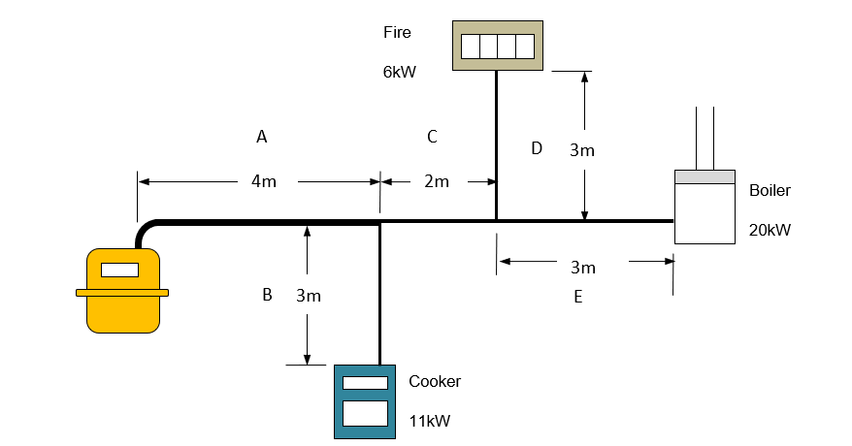

1 | 2 | 3 | 4 | 5 | 6 | 7 | 8 | 9 | 10
Pipe section | Gross heat input | Gas flow rate  (kW x 0.09) | Actual pipe length | Allowance for fittings |  | Equivalent length  (4+6) | Pipe dia.  (chart) | pressure loss per m (mbar) | Pressure loss
 |  |  |  | No. and type in section | Length
Pipe section | Kw gross | M³/h | m | No. and type in section | m | m | mm | mbar | mbar
A  B  C  D  E | 37KW  11KW  26KW  6KW  20KW | 3.3  0.99  2.34  0.54  1.8 | 4  3  2  3  3 | 1 X tee  0  1 x tee  0  0 | 1.80  0  1.80  0  0 | 5.80  3  3.80  3  3 | 22mm  12mm  22mm  12mm  15mm | 0.0998  0.2444  0.1253  0.1514  0.1839 | 0.57884  0.7332  0.47614  0.4542  0.5517

Name four types of materials for gas pipework installations.
1. Copper
2. CSST
3. LCS
4. PE

Explain how the above pipe materials can be bent.
Scissor bender
Is flexible, hand bent
Hydraulic bender
Is flexible, hand bent

‘Tracpipe’ corrugated stainless steel tubing conforms to the BS7838 bend test. What does the bend test stipulate?
The tubing can withstand repeated bending without damage, cracking, or leakage.
What precautions must be exercised when making new connections on existing gas installations?
The fitting is accessible and appropriate for conveying Gas
Explain how to set gas meter regulators.
Ensure system is gas-tight (tightness test complete).
Confirm correct gas type (natural gas or LPG).
Identify the correct outlet pressure (e.g. 21 mbar for NG)
Setting the regulator:
Connect a manometer to the meter outlet test point.
Turn on gas and establish working (flowing) conditions.
Remove the regulator’s adjustment cap.
Adjust screw slowly:
Clockwise = increase pressure
Anticlockwise = decrease pressure
Set pressure to the correct value (e.g. 21 mbar).
Allow reading to stabilise and check it stays steady.
Replace and seal the adjustment cap.
Check pressure under both flow and no-flow conditions.
Confirm appliance burner pressures are correct.
Record inlet and outlet pressures on the commissioning or test sheet.
What is the requirement where a pipe passes through a solid wall?
Sleeved and sealed.
Explain how to confirm that the gas supply and earthing system are adequate for the installation of the new gas system and components or, for extending the system or adding components to system.
Gas Supply Checks
Identify meter type and pressure rating.
Measure inlet and outlet pressure with a manometer (NG ~21 mbar).
Confirm pipe size is adequate for the installation or additional appliances.
Inspect pipework condition (no corrosion, damage, or leaks). Conduct tightness test on existing pipework if extending the system.
Verify pressure drop will remain within acceptable limits (<1 mbar).
Earthing and Bonding Checks
Check for main equipotential bonding to metallic gas pipework.
Ensure bonding conductor is correct size (≥10 mm² copper) and securely connected.
Ensure bonding is within 600 mm of the meter outlet.
Inspect condition of bonding cable (intact, not corroded or loose).
Record any missing or inadequate bonding and arrange rectification by a qualified electrician.

Which type of pipework can be used within a protected structure but not used within a protected shaft?
CSST is flexible and can be routed through ceilings, walls, or protected areas where access is restricted.
CSST is not permitted in protected shafts.
Where should the main equipotential bonding be connected to the installation pipework?
First 600mm of pipework from the metre or before the first Tee.
According to GSIUR Regulation 18, main equipotential bonding is most commonly required on which two types of installations?
Metallic Gas pipe installations
LPG installations
When should a temporary continuity bond be used?
When removing or cutting into a section of metallic pipework.
True or false? Temporary continuity bonds can be left permanently in place.
False

Task 34: Installing a boiler
Objective: Fit and connect a boiler system safely.
Tutor Role: Guide learners through installation steps and safety checks.
Key Learning Points: Boiler positioning and flue requirements. Electrical and gas connections. Commissioning and handover procedures.
Assessment: Completion of boiler installation task with tutor review.
Expected Learner Outcomes:
- Install a boiler safely and in compliance with regulations.
- Connect pipework, flue, and electrical components correctly.
Potential Learner Struggles:
- Overlooking ventilation or flue requirements.
- Misconnecting electrical terminals.
Suggestions for Improvement:
- Use manufacturer manuals during installation.
- Practice with boiler mock-ups.
Suggestions for Stretch Activity:
- Research boiler types and installation differences.
- Create a step-by-step installation guide.
This task is at centre discretion
You will be allocated a training bay by your trainer. The task is as follows:
Bay number |  | Meter type

Complete the installation a central heating boiler in a position as indicated by your trainer. Commission the appliance in accordance with the manufacturer’s instructions leaving the appliance in full working order.
Complete the following commissioning checklist
Boiler make |  |  |  | Model number/name
Appliance classification: Type A – flueless / Type B – Open flue / Type C – Room sealed
Natural draught |  |  |  |  | Fanned draught
Appliance location satisfactory? |  |  |  |  |  |  |  |  |  |  |  | Yes |  |  | No
Ventilation provision satisfactory? |  |  |  |  |  |  |  | N/A |  |  |  | Yes |  |  | No
Flue/chimney visual check satisfactory? |  |  |  |  |  |  |  |  |  |  |  | Yes |  |  | No
Flue flow test satisfactory? |  |  |  |  |  |  | N/A |  |  |  |  | Yes |  |  | No
Gas rate: |  |  |  |  |  |  |  |  |  |  |  | m³/h
Gas rate satisfactory? |  |  |  |  |  |  |  |  |  |  |  | Yes |  |  | No
Heat input |  |  |  |  |  |  |  |  |  |  |  | kW
Heat input satisfactory? |  |  |  |  |  |  |  |  |  |  |  | Yes |  |  | No
Burner pressure |  |  |  |  |  |  |  |  |  |  |  | mbar
Burner pressure satisfactory? |  |  |  |  |  |  |  | N/A |  |  |  | Yes |  |  | No
Flame picture satisfactory? |  |  |  |  |  |  |  |  |  |  |  | Yes |  |  | No
Flue integrity readings (as required)
CO₂ |  |  | O₂ |  |  | CO |  |  |  |  | CO/CO₂
N/A |  |  | % |  |  | ppm |  |  |  |  | N/A
Combustion performance readings (as required)
CO₂ |  | O₂ |  |  | CO |  |  |  |  | CO/CO₂
INITIAL % |  | INITIAL % |  |  | INITIAL ppm |  |  |  |  | INITIAL
FINAL % |  | FINAL % |  |  | FINAL ppm |  |  |  |  | FINAL
Ignition system operating? |  |  |  |  |  |  |  |  |  |  |  | Yes |  |  | No
Flame failure device/flame rectification operating? |  |  |  |  |  |  |  |  |  |  |  | Yes |  |  | No
Thermostats operating? |  |  |  |  |  |  |  |  |  |  |  | Yes |  |  | No
Spillage test satisfactory? (if applicable) |  |  |  |  |  |  |  |  |  |  |  | Yes |  |  | No
Finished installation gas tight? |  |  |  |  |  |  |  |  |  |  |  | Yes |  |  | No
Record any observations/faults/detail of any adjustments:

Answer the following questions:
For the purposes of these questions, the Gas Safety (Installation and Use) Regulations will be abbreviated to ‘GSIUR’.
What information does the appliance data plate contain?
Manufacturer and model
Gas type
Input rating
Output rating
Required gas pressure
Electrical info
Approval/certification
What is the purpose of gas water heating and central heating appliances in dwellings?
To provide thermal comfort.
To provide a reliable controllable supply of hot water.
State the typical flue gas temperature ranges of a condensing boiler.
40°C – 70°C
State the minimum gradient and direction of a condensing boiler flue.
Fall of 3°–5° down (away from boiler)
Which pipe materials are recommended for condensate removal?
PVC (Polyvinyl Chloride)
PP (Polypropylene)
Copper (sometimes used if compatible with the condensate)
ABS

State the minimum gradient of a condensate pipe.
1:60. 10mm for every 600mm

List suitable discharge points for the condensate pipework.
Into a trap of a sink, washbasin, or gully (internal plumbing).
Into an external drain or soakaway.
Into an approved external hopper or drain fitting

What are the methods of determining and/or setting gas appliance operating pressures?
Use a calibrated pressure gauge or manometer:
- Connect to the test point on the appliance or meter.
- Ensure the appliance is running at full load.
- Measure the outlet working pressure/
- Compare with manufacturer’s data:
- Check the appliance’s data plate or manual for correct operating pressure.
- Adjust the appliance regulator (if fitted):
- Some appliances have adjustable regulators to fine-tune pressure.
- Check inlet pressure

Explain the working principles of central heating appliances.
Combustion: Gas is burned in a sealed chamber to produce heat.
Heat exchanger: Transfers heat from combustion gases to water.
Circulation: Heated water is pumped through radiators or underfloor pipes.
Return flow: Cooled water returns to the boiler to be reheated.
Flue system: Expels combustion gases safely outside.
Modern systems often use condensing boilers, which recover additional heat from exhaust gases for improved efficiency
Explain how central heating controls operate heating systems.
Room thermostat: Monitors ambient temperature and signals boiler to turn on/off.
Programmer/timer: Sets heating schedules (e.g., morning/evening).
Thermostatic radiator valves (TRVs): Regulate heat output per room.
Cylinder thermostat (for hot water): Controls water heating in storage cylinders.
Smart controls: Allow remote access and adaptive learning for energy efficiency.

Explain how to determine the gas rates at appliances
Metric meter method:
  - Record meter reading over 2 minutes.
  - Convert volume (m³) to energy using:
$$\text{Gas rate (kW)}=\frac{\text{Volume}×1.02264×\text{Calorific Value}}{\text{Time (seconds)}}$$
Imperial meter method:
  - Time for one revolution of the dial (usually 0.01 ft³).
  - Use conversion factors to calculate gas rate.
Always ensure appliance is running at full load during test.
What is the procedure when an incorrect pressure reading is noted on a gas system?
If pressure is outside acceptable range:
- Stop work immediately.
- Check for leaks or blockages in pipework.
- Verify regulator and meter function.
- Repeat test to confirm reading.
- If still incorrect:
- Report to Gas Emergency Service (e.g., Cadent or National Grid).
- Do not commission the appliance until resolved.
- Label and isolate affected appliance if necessary.
This ensures safety and compliance with IGEM/G/13 and GSIUR standards

Task 35: Gas rating
Objective: Calculate gas appliance consumption rates.
Tutor Role: Teach calculation methods and verify learner accuracy.
Key Learning Points:
Gas rating formulas and units.
Use of meter readings and timing.
Recording and interpreting results.
Assessment: Completion of gas rating calculation with correct values.

Expected Learner Outcomes:
- Calculate gas rating for appliances.
- Understand the importance of accurate readings.
Potential Learner Struggles:
- Misreading meter dials or digital displays.
- Incorrect formula application.
Suggestions for Improvement:
- Use worked examples and calculators.
- Practice with different appliance types.
Suggestions for Stretch Activity:
- Compare gas rating methods for domestic vs. commercial appliances.
- Create a gas rating calculator tool.

We Gas rate to confirm that an appliance is operating correctly and in accordance with Manufacturer’s Instructions.
How is the Gas Rate measured on an Imperial meter?
We need to measure the quantity of gas flowing into the appliance.

An Imperial Meter (U6)
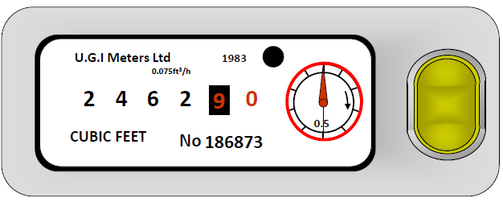
We are interested in the meter test dial only.
One full revolution = 1ft³ of gas has flowed
3600 = Seconds in an hour
1040 = calorific value in btu per cubic foot (ft³)
3412 = You use this number to divide btu/hr in kW

The formula =
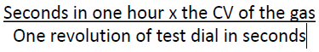
This will give you your answer in BTU’s/hour – you should now convert it to KW’s by dividing it by 3412.

A Metric Meter (E6)
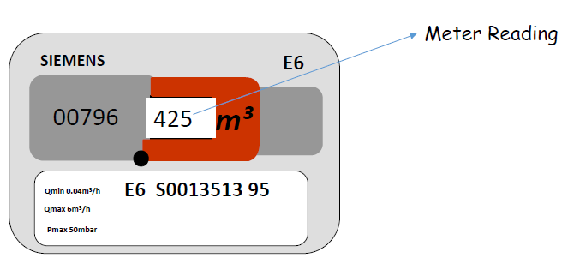

- Write meter reading down before time test.
- Take note of meter reading after time test.
- Record the amount of time test has taken minimum 2 minutes till full revolution of last digit.

3600 = Seconds in an hour
10.76 = energy in a cubic meter of gas m³

The formula =

Your tutor will now set you up on at least one of each of the following appliances and you are required to complete a gas rate and record it for each appliance also stating whether the result is satisfactory using the Manufacturer’s Instructions and the data plate.
Appliance (Including make & model) | Gas Rate | Satisfactory?
Boiler | Centre’s discretion | Centre’s discretion
Fire | Centre’s discretion | Centre’s discretion
Boiler | Centre’s discretion | Centre’s discretion
Water Heater | Centre’s discretion | Centre’s discretion

You should now use calculate the Gas rate for 2 appliances fitted with smart meters, record this and state whether they are satisfactory or not.
Appliance (Including make & model) | Gas Rate | Satisfactory?
Centre’s discretion | Centre’s discretion | Centre’s discretion
Centre’s discretion | Centre’s discretion | Centre’s discretion

Answer the following questions:
What is the purpose of gas rating?
Gas rating is used to verify that a gas appliance is consuming the correct amount of gas as specified by the manufacture.
What are the dangers of an appliance burning too much gas?
Oversized flames, leading to overheating.
Carbon monoxide production, which is toxic and undetectable without sensors.
Damage to components due to excessive heat.
Increased energy bills and reduced appliance lifespan

A metric meter measures what volume?
Cubic meters (m³)
An Imperial meter measures what volume?
Cubic feet (ft³)
A gas boiler uses 0.049 m³ in 120 seconds what is the gross kW rating?
15.82Kw
A gas boiler uses 0.079 m³ in 120 seconds what is its net kW rating?
28Kw
A boiler is gas rated on an imperial meter one revolution takes 66 seconds what is the gross kW rating?
16.6Kw
A boiler is gas rated on an imperial meter one revolution takes 29 seconds what is the net kW rating?
37.8Kw

Task 36: Gas flow and pressure loss
Objective: Measure and interpret gas flow and pressure loss.
Tutor Role: Demonstrate testing techniques and explain results.
Key Learning Points: Causes of pressure loss in systems. Use of manometers and flow meters.
Impact on appliance performance.
Assessment: Completion of pressure loss test and analysis.
Expected Learner Outcomes:
- Understand factors affecting gas flow and pressure loss.
- Calculate pressure drop across pipework.
Potential Learner Struggles:
- Forgetting to account for pipe length and fittings.
- Misinterpreting flow charts.
Suggestions for Improvement:
- Use visual aids and flow diagrams.
- Practice calculations with real scenarios.
Suggestions for Stretch Activity:
- Design a pipe system minimising pressure loss.
You are required to set up a Metered Installation with a long pipe run with a minimum of 3 connected burners and test points at various points (Including prior to the burners).

Following the steps below, you should relate back to the appliance Manufacturer Instructions to see if they are acceptable.

Procedure:
- Set Up the Installation
  - Assemble a metered installation with a pipe run supplying at least 3 gas appliances
- Initial Checks
  - Perform a tightness test to confirm there are no leaks.
  - Confirm all burners are leak free
- Set Regulator Pressure to 21 mbar
  - Adjust the meter regulator to 21 mbar using the screwdriver and U-tube gauge.
  - Test each burner individually and all burners together.
  - Record the burner pressures at each test point.

 | Appliance Type, Make and Model | Burner pressure
Appliance 1 | Centre’s discretion | Centre’s discretion
Appliance 2 | Centre’s discretion | Centre’s discretion
Appliance 3 | Centre’s discretion | Centre’s discretion
All Appliances |  | Centre’s discretion

- Reset Regulator Pressure to 16 mbar
  - Adjust the meter regulator to 16 mbar.
  - Repeat the same sequence of pressure tests:
    - Each burner individually.
    - Both burners operating together.
  - Record all readings.
 | Appliance Type, Make and Model | Burner pressure
Appliance 1 | Centre’s discretion | Centre’s discretion
Appliance 2 | Centre’s discretion | Centre’s discretion
Appliance 3 | Centre’s discretion | Centre’s discretion
All Appliances |  | Centre’s discretion

- Reset Regulator Pressure to 12 mbar
  - Adjust the regulator to 12 mbar.
  - Repeat the pressure tests as above.
  - Record final readings at all test points.

 | Appliance Type, Make and Model | Burner pressure
Appliance 1 | Centre’s discretion | Centre’s discretion
Appliance 2 | Centre’s discretion | Centre’s discretion
Appliance 3 | Centre’s discretion | Centre’s discretion
All Appliances | Centre’s discretion | Centre’s discretion

- Shut Down and Record Results
  - Safely turn off all gas supply and burners.
  - Record all data in the test sheet.
  - Return the system to 21 mbar when complete.

Task 37: Pressure regulators

Objective: Understand and install pressure regulators.
Tutor Role: Present regulator types and supervise installation.
Key Learning Points: Function and types of regulators. Installation procedures and settings.
Safety and compliance checks.
Assessment: Installation of a pressure regulator and tutor verification.
Expected Learner Outcomes:
- Identify and install pressure regulators.
- Understand regulator function and adjustment.
Potential Learner Struggles:
- Confusing regulator types.
- Incorrect pressure settings.
Suggestions for Improvement:
- Use labelled regulator samples.
- Practice adjustments with supervision.
Suggestions for Stretch Activity:
- Compare regulator designs across industries.
- Create a guide to regulator troubleshooting.

Your trainer will now give you the following type of regulators:

- Constant Pressure
- Simple Pressure
- Zero Pressure

Part 1 – Identification and Examination

- Examine each regulator (constant pressure, simple, and zero pressure) and record the following details for each one. Once complete you should discuss the intended application.
  - Connection size and thread type
  - Inlet and outlet pressure range
  - Direction of flow
  - Breather hole position
  - Impulse port position (if applicable)
  - Lock-up pressure specification (from manufacturer data)
 | Constant | Simple | Zero
Connection size and thread type | Centre’s discretion | Centre’s discretion | Centre’s discretion
Inlet and outlet pressure range | Centre’s discretion | Centre’s discretion | Centre’s discretion
Direction of flow | Centre’s discretion | Centre’s discretion | Centre’s discretion
Breather hole position | Centre’s discretion | Centre’s discretion | Centre’s discretion
Impulse port position (if applicable) | Centre’s discretion | Centre’s discretion | Centre’s discretion
Lock-up pressure specification (from manufacturer data) | Centre’s discretion | Centre’s discretion | Centre’s discretion

Part 2 – Setting Up Regulators
- Install each regulator in turn onto a training meter setup or appliance in accordance with industry best practices and manufacturer instructions.
- Carry out a tightness test before supplying gas.
- Adjust each regulator to the required outlet pressure using a manometer.
- Record:
  - Inlet pressure
  - Outlet pressure
  - Lock-up pressure
  - Pressure stability under flow conditions
- Check for any gas escape around joints and the breather hole.

Part 3 – Fault Simulation and Analysis
- The trainer will introduce one or more faults into the system:
  - Blocked or sealed breather hole
  - Incorrect spring tension
  - Restricted or damaged diaphragm
  - Low inlet pressure (meter supply issue)
  - Misconnected impulse line
- Identify the fault through observation, testing, and reasoning.
- Record:
  - Observed appliance performance (e.g., flame instability, failure to light, yellow tipping, etc.)
  - Measured pressure values at various test points
  - Diagnosis of the fault cause and corrective action required.

- Restore the system to correct operation after approval from the trainer.

Part 4 – Discussion and Evaluation

- Explain to your trainer how incorrect regulator performance can:
  - Affect appliance combustion quality
  - Lead to low-pressure faults or unsafe operation
  - Impact meter performance and overall system balance
- Discuss the importance of lock-up testing and how this ensures regulator safety.
- Compare the operating characteristics of constant pressure, simple, and zero pressure regulators.

Task 38: Servicing a boiler

Objective: Carry out boiler servicing procedures.
Tutor Role: Demonstrate service steps and assess learner performance.
Key Learning Points: Cleaning, inspection, and testing components. Identifying faults and wear. Recording service details.
Assessment: Completion of boiler service task and checklist.

Expected Learner Outcomes:
- Perform routine boiler servicing.
- Identify faults and maintenance needs.
Potential Learner Struggles:
- Missing hidden faults during inspection.
- Forgetting to record service details.
Suggestions for Improvement:
- Use service checklists and logs.
- Practice fault finding with simulated issues.
Suggestions for Stretch Activity:
- Research common boiler faults and fixes.

You will be allocated a training bay by your trainer. The task is as follows:
Service the central heating boiler in accordance with the manufacturer’s instructions leaving the appliance in full working order.
This task will vary dependent on manufacturer of appliances. Centre discretion to be used.
Bay number |  | Meter type

Complete the following servicing checklist
Boiler make |  |  |  |  |  | Model number/name
Appliance classification: Type A – flueless / Type B – Open flue / Type C – Room sealed
Natural draught |  |  |  |  | Fanned draught
Appliance location satisfactory? |  |  |  |  |  |  |  |  |  | Yes |  |  |  |  | No
Ventilation provision satisfactory? |  |  |  |  |  |  |  |  |  | Yes |  |  |  |  | No
What is the visual condition of the appliance? (tick as appropriate)
Excellent |  |  | Good |  | Satisfactory |  |  |  |  |  | Poor
Record any observations/faults (i.e. casing condition, fixings, case seal etc.):

Flue/chimney visual check satisfactory? |  |  |  |  |  |  |  |  |  | Yes |  |  |  |  |  | No
Record any observations/faults:

Servicing procedure
Burner removed and cleaned? |  | Yes |  | No |  | Pilot assembly removed and inspected/cleaned? |  |  |  |  |  |  |  | Yes |  |  |  | No
Burner injector inspected and cleaned? |  | Yes |  | No |  | Flame rectification and spark electrodes in good condition? |  |  |  |  |  |  |  | Yes |  |  |  | No
Heat exchanger cleaned? |  | Yes |  | No |  | Combustion chamber free of debris? |  |  |  |  |  |  |  | Yes |  |  |  | No
Flue ways Inspected and cleaned? |  | Yes |  | No |  | Fan assembly removed and cleaned? (if applicable) |  |  |  |  |  |  |  | Yes |  |  |  | No
Has the condensate trap and pipework been inspected, checked and cleaned? |  | Yes |  | No |  | N/A
Post servicing tests and procedures
Flue flow test satisfactory? |  |  |  |  |  |  |  |  |  | N/A |  |  |  | Yes |  |  |  |  | No
Burner pressure: |  |  |  |  |  |  |  |  |  |  |  |  |  | mbar
Gas rate: |  |  |  |  |  |  |  |  |  |  |  |  |  | M³/h
Heat input: |  |  |  |  |  |  |  |  |  |  |  |  |  | kW
Pressure/heat input/gas rate satisfactory: |  |  |  |  |  |  |  |  |  |  |  |  |  | Yes |  |  | No
Flame picture satisfactory? |  |  |  |  |  |  |  |  |  |  |  |  |  | Yes |  |  | No
Combustion performance readings (as required)
CO₂ | O₂ |  |  |  |  | CO |  |  |  |  |  |  | CO/CO₂
INITIAL % | INITIAL % |  |  |  |  | INITIAL ppm |  |  |  |  |  |  | INITIAL
FINAL % | FINAL % |  |  |  |  | FINAL ppm |  |  |  |  |  |  | FINAL
Ignition system operating? |  |  |  |  |  |  |  |  |  |  |  |  |  | Yes |  |  | No
Flame failure device/flame rectification operating? |  |  |  |  |  |  |  |  |  |  |  |  |  | Yes |  |  | No
Thermostats operating? |  |  |  |  |  |  |  |  |  |  |  |  |  | Yes |  |  | No
Spillage test satisfactory? (if applicable) |  |  |  |  |  |  |  |  |  |  |  |  |  | Yes |  |  | No
Finished installation gas tight? |  |  |  |  |  |  |  |  |  |  |  |  |  | Yes |  |  | No
Record any observations/faults, including details of any rectification work carried out:

Heating system
What type of system is fitted? |  |  |  | Sealed |  |  |  |  |  |  | Vented
Filling loop removed? (for Water Regulations compliance) |  |  |  |  |  |  |  |  |  |  |  |  |  | Yes |  |  | No
System pressure or water level in the F & E cistern checked? |  |  |  |  |  |  |  |  |  |  |  |  |  | Yes |  |  | No
External controls checked for safe operation? |  |  |  |  |  |  |  |  |  |  |  |  |  | Yes |  |  | No
Appliance safe to use? |  |  |  |  |  |  |  |  |  |  |  |  |  | Yes |  |  | No

This task will vary dependent on manufacturer of appliances/burners. Centre discretion to be used.
Your trainer will provide various types of gas burners (e.g., simplex, duplex, etc.) installed on a simple pipework rig. (Ensuring test points are available prior to the burner).
Instructions:
The learner should examine each burner and answer the following questions:
- What is the name of the manufacturer and the type of burner?
- What is the injector size (indicated by letter or number) and type (single or multi-hole)?
- What is the aeration size? Is it fixed or adjustable, and how is it adjusted?
- Is the burner simplex or duplex?
- How is flame retention achieved on this burner?
- How are the burner ports arranged? (Provide sketches or diagrams to illustrate the arrangement).

Practical Exercise:
Where possible, the learner should:
- Light the burners.
- Adjust the gas and/or air supply.
- Observe and analyse the varying flame pictures.

Appliance Analysis:
- Move on to appliances and determine the burner and injector specifications, then answer the following questions:

- What is the make and model of the appliance?
- What is the burner type and injector size/type?

Identifying Combustion Faults:
- The learner should inspect the burners and identify any faults based on the flame appearance.

Flame Temperature Analysis:
- Using a Bunsen burner, instruct the learner to measure the flame temperatures at different air port settings (fully open, mid-position, and fully closed). The following temperature readings should be recorded:
a.
b.
c.
d.

- The learner should complete a chart documenting the temperature variations at each air port setting.

Task 39: Flues and chimneys

Objective: Identify flue types and installation requirements.
Tutor Role: Explain flue principles and inspect learner understanding.
Key Learning Points: Types of flues and chimneys. Positioning and termination rules. Safety and ventilation considerations.
Assessment: Identification of flue components and installation plan.
Expected Learner Outcomes:
- Understand flue and chimney requirements.
- Identify safe installation practices.
Potential Learner Struggles:
- Misjudging flue termination points.
- Overlooking clearance requirements.
Suggestions for Improvement:
- Use diagrams and manufacturer guidance.
- Practice flue installation on mock walls.
Suggestions for Stretch Activity:
- Compare flue systems for different boiler types.
- Design a compliant flue layout.

This paperwork is to be completed in full as the task progresses. Incomplete paperwork will result in you being asked to start again from the beginning of the task. If you are in any doubt, ask your trainer.
You will be allocated a training bay by your trainer. The task is as follows:
Visually inspect and test a flue for flue flow and spillage.
This task will vary dependent on manufacturer of appliances. Centre discretion to be used.
Bay number |  | Meter type

Boiler manufacturer |  |  |  |  |  | Model number
Heat input |  |  | kW |  |  | Heat output |  |  | kW
Flue type | Open flue |  |  | Room sealed |  | Flue draught | Natural |  |  | Fanned
Case pressure |  | Positive |  |  | Negative |  |  | Atmospheric
Visual chimney inspection
Type of flue/chimney
Visual Inspection of the chimney/flue |  |  |  |  |  | Pass |  |  | Fail
Visual inspection of the appliance |  |  |  |  |  | Case seal integrity
Pass |  |  |  | Fail |  | Pass |  |  |  | Fail
If any of these tests are unsatisfactory, please indicate the reasons in the space below
Flue flow and spillage tests
Type of flue/chimney
Flue flow test |  |  |  |  |  | Spillage test
Pass |  |  |  | Fail |  | Pass |  |  |  | Fail
If either of these tests are unsatisfactory, please indicate the reasons in the space below

Task 40: Flues and chimneys part 2

Objective: Assess flue performance and compliance.
Tutor Role: Guide learners through inspection and fault identification.
Key Learning Points: Testing for spillage and blockage. Visual inspection techniques. Compliance with building regulations.
Assessment: Completion of flue inspection and fault report.
Expected Learner Outcomes:
- Inspect and maintain flue and chimney systems.
- Identify signs of blockage or deterioration.
Potential Learner Struggles:
- Missing internal faults.
- Misidentifying condensation issues.
Suggestions for Improvement:
- Use inspection cameras and smoke tests.
- Practice maintenance routines.
Suggestions for Stretch Activity:
- Research flue maintenance schedules.
- Create a flue inspection checklist.
The trainer should set up the 4 flues below all with at least 1 fault on each.
You will be allocated a training bay by your trainer. The task is as follows:
Inspect the following open flues and detail any installation faults found.
Flue types
Twin wall chimney | Brick built chimney
Precast flue system | Cement based flue

Answer the following questions:
For the purposes of these questions, the Gas Safety (Installation and Use) Regulations will be abbreviated to ‘GSIUR’.
1. | Give a brief description of carbon monoxide:
Carbon monoxide is a colourless, odourless, and tasteless gas that is produced by the incomplete combustion of carbon-containing fuels. It can be emitted from sources such as gas appliances, vehicles, and fireplaces. CO is highly toxic as it binds with haemoglobin in the blood, preventing oxygen from being carried to the body’s tissues, which can lead to poisoning and even death.
2. | Give one method of testing the reliability of carbon monoxide detectors:
Perform a functional self-test using the devices self-test button.
3. | State the British Standard for carbon monoxide detectors:
BS EN 50291-1:2018.
4. | On the room drawing below, indicate the correct position for the correct installation of carbon monoxide detectors.
The alarm should be placed at head height, 1-3 meters from any fuel-burning appliance and 300mm from walls, on a wall or ceiling at a circulation point.
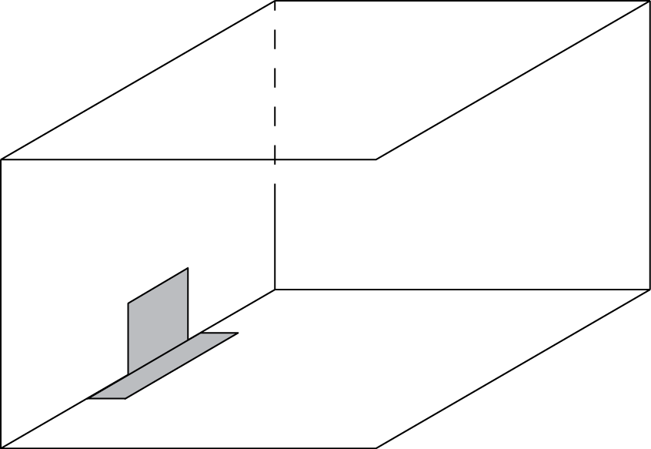

5. | State five positions in a dwelling where carbon monoxide detectors should not be installed:
 | 1. Near windows or doors
 | 2. In areas of high humidity (bathrooms)
 | 3. In or near kitchens
 | 4. In areas of poor ventilation
 | 5. Close to sources of heat

6. | The British Standard gives guidance and advice about the positioning of carbon monoxide detectors. It states that if detectors cannot be fitted in every room, then priority should be given to which types of rooms?
Rooms containing fuel-burning appliances (e.g. gas boilers, fireplaces, wood stoves, or gas heaters)
Bedrooms – where people sleep and may not be aware of CO presence
Rooms where people spend the most time

7. | List the factors that can affect flue performance:
Flue height
Flue size/diameter
Blockages or obstructions
Wind and weather conditions
Temperature differences (inside vs. outside)
Number of bends in the flue
Air supply/ventilation
Flue insulation
Flue termination position
Pressure inside the building

8. | What are the requirements for the provision of hearths used with gas appliances?
Made of non-combustible material (e.g. stone, glass, tile)
At least 12mm thick (if appliance base stays below 100°C)
Extends 150mm at each side of the appliance
Projects 300mm in front of the appliance
Raised 50mm above floor level or clearly marked
No combustible materials underneath
Always follow the manufacturer’s instructions
Required unless the appliance is approved for use without a hearth

9. | What does Regulation 27 of the GSIUR state that a flue must be?
Properly constructed and so maintained as to safely convey the products of combustion to the outside atmosphere.

10. | What are the layout features and uses of the following chimneys/flues?
 | Brick/masonry chimneys:
Layout Features:
- Made from bricks or blocks with a central flue liner (sometimes clay or concrete).
- Typically, large and heavy, built as part of the building structure.
- Can have multiple flues in one chimney stack for different appliances.
Uses:
- Common in older buildings for solid fuel appliances (wood, coal).
- Also used for fireplaces and some gas appliances.
- Suitable for venting smoke and combustion gases where a permanent structure is desired.

Pre-cast concrete flue blocks:
Layout Features:
- Modular, factory-made concrete blocks with built-in flue liners (clay or concrete).
- Easier and faster to install than brickwork.
- Can be assembled on-site like building blocks.
Uses:
- Often used in new build or replacement chimneys.
- Suitable for solid fuel and gas appliances.
- Provide good thermal mass and durability

Flexible metal flue liners:
Layout Features:
- Made of stainless steel or aluminium, flexible to bend around bends or curves.
- Installed inside existing chimneys to line the flue.
- Lightweight and corrosion resistant.
Uses:
- Retrofitting old chimneys to improve safety and performance.
- Suitable for gas, oil, or solid fuel appliances.
- Ideal where rigid liners are difficult to install.

Twin wall insulated flue pipes:
Layout Features:
- Two concentric metal pipes with insulation between them.
- Outer pipe keeps surface temperature low and prevents heat loss.
- Rigid sections joined together with special seals.
Uses:
- Used mainly for high-temperature appliances like gas boilers and wood burners.
- Suitable for both internal and external installations.
- Provides safe and efficient flue for appliances needing high-temperature exhaust systems.
11. | Name the parts of an open flue:
Primary Flue
Secondary Flue
Draught Diverter
Terminal

12. | Describe why condensation can occur in an open flue:
Cooler Chimney: When hot gases meet a cold chimney, water in the gases turns into liquid.
Moist Air: If the air has a lot of moisture, it increases condensation.
Poor Combustion: Incomplete burning of fuel creates extra moisture in the gases.
Cool Air: If the air used for burning is too cool, it can cause condensation inside the flue.

Task 41: Ventilation

Objective: Understand ventilation requirements for gas appliances and enclosed spaces.
Tutor Role: Teach calculation methods and supervise learner assessments.
Key Learning Points:
Types of ventilation (natural, mechanical).
Airflow requirements for combustion and safety.
Regulatory standards for appliance installation.
Assessment: Completion of ventilation calculation and tutor-reviewed scenario analysis.
Expected Learner Outcomes:
- Understand ventilation requirements for gas appliances.
- Calculate minimum ventilation needs.
Potential Learner Struggles:
- Forgetting to consider appliance type.
- Miscalculating air flow rates.
Suggestions for Improvement:
- Use ventilation calculators and charts.
- Practice with different room scenarios.
Suggestions for Stretch Activity:
- Research ventilation failures and consequences.

(Your trainer will give you a choice of different vents)
Study the picture below then, using the ventilation formula provided by your trainer and the domestic gas manual, calculate the ventilation requirement for each appliance (as if it was a single appliance in that room) and record your answers. You will then be asked to choose an appropriate vent. When that task is completed, you will then calculate the vent requirements for the room with all appliances installed (multi appliance ventilation) and again choose the appropriate vent.
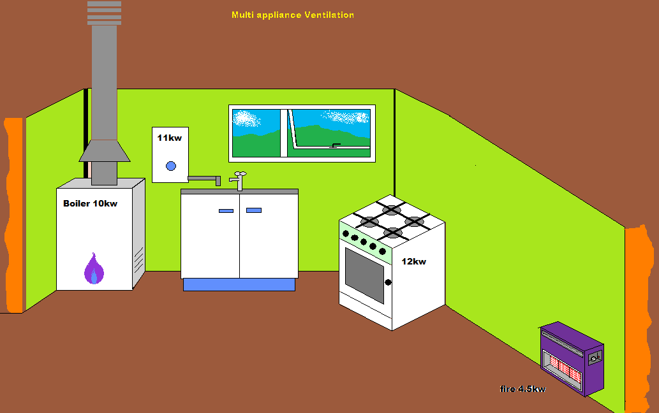
Room measurements width 2m, length 2m, height 2m

Ventilation questions
1. What are the ventilation requirements if only the (Open flued) boiler above is installed in the room?
10kw – 7 (Adventitious air) = 3KW x 5cm = 15cm2

2.What are the ventilation requirements if only the water heater is installed in the room?
11kw – 7 (adventitious air) = 4kw x 5cm =20cm2

3.What type of vent would you install?
Permanent fixed vent
Air brick or sleeve vent with fixed grilles dependent on wall type.

4. What are the ventilation requirements if only the cooker is installed in the room?
12kw – 7 (adventitious air) = 5kw x 5cm = 20cm2

5. What are the ventilation requirements if only the fire is installed in the room?
No purpose installed ventilation required as adventitious air will suffice
6. The ventilation requirements for this room containing all appliances would be…?
10 + 11 + 12 + 4.5 = 33kw – 7 (Adventitious air) = 26kw x 5cm = 130 cm2
(All appliances)

7. An air vent fitted in an internal room shall be fitted no higher than? Why is this?
450 mm (millimetres) from the floor level
To provide combustion air effectively
To help maintain flue draught

Compartment Ventilation
What you need to do
Study the picture below, then using resources from previous pages answer the following questions.

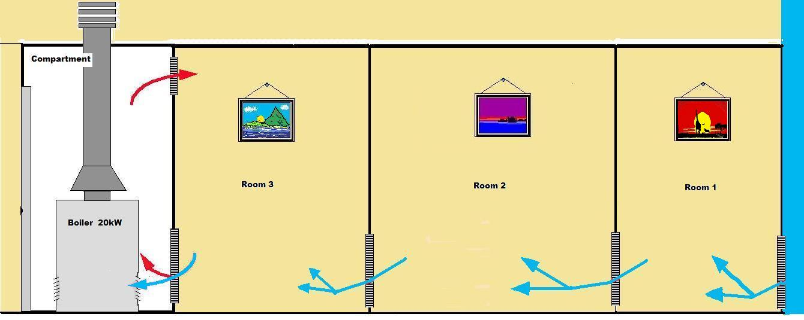

Calculate the vent requirements for the situation above.
1. What are the vent requirements for Room 1?
200cm2
2. What are the vent requirements for Room 2?
400cm2
3. What are the vent requirements for Room 3?
400cm2
4. What are the vent requirements for the compartment vent at high level?
200cm2
5. What are the vent requirements for the compartment vent at low level?
400cm2
6. Consider a room built as a single room that contain two DFE fires each with a heat input of 7.5kW, what would be the ventilation requirements for this room?
DFE fires require permanent ventilation if the input exceeds 7kW.
Total input: 7.5 kW × 2 = 15 kW
Ventilation requirement:
  - 100 cm² per appliance over 7kW
  - So: 100 cm² × 2 = 200 cm²
This must be a permanent air vent to outside air, not via another room.

7. If the fires in the room were then exchanged for two ILFE fires with a heat input of 7.5kW each, what would now be the vent requirements for this room?
ILFE fires require permanent ventilation if the input exceeds 7kW.
Total input: 7.5 kW × 2 = 15 kW
Ventilation requirement:
  - 100 cm² per appliance over 7kW
  - So: 100 cm² × 2 = 200 cm²
This must be a permanent air vent to outside air, not via another room.

Task 42: Installing a gas multipoint water heater
Objective: Fit and connect a multipoint water heater safely.
Tutor Role: Supervise installation and ensure compliance with safety standards.
Key Learning Points: Positioning and flue requirements. Water and gas connections. Commissioning procedures.
Assessment: Completion of installation task and tutor inspection.

This task is at centre’s discretion due to manufacturer of appliance.

You will be allocated a training bay by your trainer. The task is as follows:

Bay number |  | Meter type

Complete the installation an instantaneous multipoint water heater in a position as indicated by your trainer. Commission the appliance in accordance with the manufacturer’s instructions leaving the appliance in full working order.
Complete the following commissioning checklist
Water heater make |  |  | Model number/name
Appliance classification: Type A – flueless / Type B – Open flue / Type C – Room sealed
Natural draught |  |  |  | Fanned draught
Appliance location satisfactory? |  |  |  |  |  |  |  | Yes |  |  | No
Ventilation provision satisfactory? |  |  |  |  |  |  |  | Yes |  |  | No
Flue/chimney visual check satisfactory? |  |  |  |  |  |  |  | Yes |  |  | No
Flue flow test satisfactory? |  |  |  |  | N/A |  |  | Yes |  |  | No
Heat input: |  |  |  |  |  |  |  | kW
Gas rate: |  |  |  |  |  |  |  | m³/h
Burner pressure: |  |  |  |  |  |  |  | mbar
Pressure/heat input/gas rate satisfactory? |  |  |  |  |  |  |  | Yes |  |  | No
Flame picture satisfactory? |  |  |  |  |  |  |  | Yes |  |  | No
Combustion performance readings (as required)
CO₂ |  | O₂ |  | CO |  |  | CO/CO₂
INITIAL % |  | INITIAL % |  | INITIAL ppm |  |  | INITIAL
FINAL % |  | FINAL % |  | FINAL ppm |  |  | FINAL
Ignition system operating? |  |  |  |  |  |  |  | Yes |  |  | No
Flame failure device/flame rectification operating? |  |  |  |  |  |  |  | Yes |  |  | No
Thermostats operating? |  |  |  |  |  |  |  | Yes |  |  | No
Spillage test satisfactory? (if applicable) |  |  |  |  |  |  |  | Yes |  |  | No
Finished installation gas tight? |  |  |  |  |  |  |  | Yes |  |  | No
Hot water flow rate: | Litres/minute
Hot water temperature: | ^{O}C
Hot water and flow rate in accordance with manufacturer’s instructions? |  | Yes |  | No
Appliance safe to use? |  | Yes |  | No
Answer the following questions:
For the purposes of these questions, the Gas Safety (Installation and Use) Regulations will be abbreviated to ‘GSIUR’.
1. | Produce a diagram showing how the following appliances work, you should also give a written response in the space below your diagram:
Gas fired water heater |  | Combi Boiler
Trainer’s discretion providing all main principles are covered by learner in diagram and written response below. |  | Trainer’s discretion providing all main principles are covered by learner in diagram and written response below.
Trainer’s discretion providing all main principles are covered by learner in diagram above and written response. |  | Trainer’s discretion providing all main principles are covered by learner in diagram above and written response.

2. | Identify the working principles of water heating appliances:
Heating Water:
The appliance heats water by burning gas or using electricity.
Heat Exchanger:
Water passes through a heat exchanger to warm it up.
On-Demand Heating:
Heaters only turn on and heat water when you open a tap or programme it to if available.
Temperature Control:
A thermostat keeps the water at the desired temperature.
Safe Exhaust (Gas Heaters):
Excess heat sent outside through a flue.
Safety Features:
The appliance has safety parts to stop it if it gets too hot or the flame goes out.
Storage or Instant Heating:
Some heaters store hot water in a tank.
Others heat water instantly as you use it.

Task 43: Servicing a gas multipoint water heater

Objective: Perform servicing tasks on a multipoint water heater.
Tutor Role: Demonstrate service procedures and check learner technique.
Key Learning Points: Cleaning and inspection of components. Identifying faults and wear. Recording service details.
Assessment: Completion of service task and documentation.
Expected Learner Outcomes:
- Perform servicing tasks on multipoint water heaters.
- Identify common faults and maintenance needs.
Potential Learner Struggles:
- Overlooking internal component wear.
- Forgetting to test water flow and temperature.
Suggestions for Improvement:
- Use service logs and checklists.
- Practice fault diagnosis.
Suggestions for Stretch Activity:
- Research heater servicing intervals.
- Create a troubleshooting guide.
This task is at centre’s discretion due to manufacturer of appliance.
You will be allocated a training bay by your trainer. The task is as follows:
Bay number |  | Meter type

Service a gas multipoint water heater
Complete the following servicing checklist
Water heater make: |  |  |  | Model number/name:
Appliance classification: Type A – flueless / Type B – Open flue / Type C – Room sealed
Natural draught |  |  |  | Fanned draught
Appliance location satisfactory? |  |  |  |  | Yes |  |  | No
Ventilation provision satisfactory? |  |  |  |  | Yes |  |  | No
What is the visual condition of the appliance? (tick as appropriate)
Excellent |  | Good |  | Satisfactory |  |  |  | Poor
Record any observations/faults (I.e. casing condition, fixings, case seal etc.):

Flue/chimney visual check satisfactory? |  |  |  |  | Yes |  |  | No
Record any observations/faults:

Servicing procedure (tick as required):
Check the piezo unit, flame safety device and thermocouple, clean or replace if necessary. |  | Completed | N/A |  | Check the pilot injector and clean or replace if necessary. |  |  |  | Completed |  |  |  |  | N/A
Remove and clean the burner  assembly. |  | Completed | N/A |  | Clean the lint filter. |  |  |  | Completed |  |  |  |  | N/A
Check for water soundness. Replace ‘O’ rings, sealing washers and gaskets where required. |  | Completed | N/A |  | Remove the water governor assembly complete with push rod. Replace the seals if necessary |  |  |  | Completed |  |  |  |  | N/A
Record any observations/faults:

Post servicing tests and procedures:
Flue flow test satisfactory? |  |  |  |  |  |  |  | Yes |  |  |  | No
Heat input: |  |  |  |  |  |  |  | kW
Gas rate: |  |  |  |  |  |  |  | m³/h
Burner pressure: |  |  |  |  |  |  |  | mbar
Pressure/heat input/gas rate satisfactory: |  |  |  |  |  |  |  | Yes |  |  |  | No
Flame picture satisfactory? |  |  |  |  |  |  |  | Yes |  |  |  | No
Combustion performance readings (as required)
CO₂ | O₂ |  |  | CO |  |  |  | CO/CO₂
INITIAL % | INITIAL % |  |  | INITIAL ppm |  |  |  | INITIAL
FINAL % | FINAL % |  |  | FINAL ppm |  |  |  | FINAL
Ignition system operating? |  |  |  |  |  |  |  | Yes |  |  |  | No
Flame failure device/flame rectification operating? |  |  |  |  |  |  |  | Yes |  |  |  | No
High limit thermostat/energy cut-out operating? |  |  |  |  |  | N/A |  | Yes |  |  |  | No
Spillage test satisfactory? (if applicable) |  |  |  |  |  |  |  | Yes |  |  |  | No
Finished installation gas tight? |  |  |  |  |  |  |  | Yes |  |  |  | No
Record any observations/faults, including any rectification work carried out:

Hot water flow rate: |  |  |  |  |  |  |  | Litres/minute
Hot water temperature: |  |  |  |  |  |  |  | ^{O}C
Hot water and flow rate in accordance with manufacturer’s instructions? |  |  |  |  |  |  |  | Yes |  |  |  |  | No
Appliance safe to use? |  |  |  |  |  |  |  | Yes |  |  |  |  | No

Task 44: Electrical safe isolation procedure and electrical testing

Objective: Safely isolate and test electrical circuits.
Tutor Role: Provide equipment and supervise testing steps.
Key Learning Points: Lock-off procedures and tagging. Use of test meters and proving units. Re-proving and verification.
Assessment: Demonstration of isolation and testing procedure.
Expected Learner Outcomes:
- Safely isolate electrical circuits.
- Perform basic electrical tests.
Potential Learner Struggles:
- Skipping re-proving of test equipment.
- Misidentifying circuit components.
Suggestions for Improvement:
- Use flowcharts and test kits.
- Practice isolation on mock circuits.
Suggestions for Stretch Activity:
- Compare isolation procedures across trades.
- Create an electrical safety guide.
This task is at centre’s discretion due to manufacturer of appliance etc.

You will be allocated a training bay by your trainer. The task is as follows:

Demonstrate understanding of the electrical safe isolation procedure.
Bay number |  |  | Appliances fitted
Boiler type (if fitted) |  |  | Appliances fitted
Heat input |  | kW | Heat output |  |  | kW
Fuse rating |  | Amp | Switched fuse spur fitted |  | Yes |  | No
1 | Obtained permission to carry out the work? |  |  |  | Yes |  | No
2 | Identified the correct circuit for isolation? |  |  |  | Yes |  | No
3 | Selected a suitable testing device? |  |  |  | Yes |  | No
4 | Proved that the testing device is working correctly on a known proving unit? |  |  |  | Yes |  | No
5 | Isolated the supply to be tested? |  |  |  | Yes |  | No
6 | Secured the means of isolation using a suitable device or padlock? |  |  |  | Yes |  | No
7 | Confirmed that the circuit is dead by testing between line (live) and earth, line and neutral and earth and neutral at the point of work? |  |  |  | Yes |  | No
8 | Re-proved the test instrument is working correctly on a known voltage or proving unit? |  |  |  | Yes |  | No
9 | Applied a warning label to the isolation point and inform responsible person? |  |  |  | Yes |  | No

Part 1: Preliminary Electrical Safety Checks
Before carrying out any fault-finding or repair work, you must complete a series of safety tests to confirm that the appliance is safe to work on.
Safety Requirements:
- Always isolate the appliance before testing.
- Confirm isolation using approved safe isolation procedures.
- Wear appropriate PPE.
- Never carry out live testing in this exercise.
- Report any defects or hazards to your tutor immediately.

Task 1 – Earth Continuity Check
Procedure:
- Isolate the appliance (remove the plug from the socket outlet).
- Set your multimeter to the Ohms (Ω) ×1 scale.
- Test between any appliance earth point and the earth pin of the plug.
- Record the resistance reading.

Resistance reading =
Is this correct, if not what could be the issue?
The trainer should demonstrate to learners how to find the resistance in the MI’s. If incorrect the trainer should demonstrate next steps as per MI’s.

Task 2 – Short Circuit Check
Procedure:
- Keep the appliance isolated.
- Ensure all switches are ON and thermostats are calling for heat.
- Set your meter to Ohms (Ω) ×1 scale.
- Test between L (live) and N (neutral) at the appliance terminal block.
- Record the meter reading.

Task 3 – Resistance to Earth Check
Procedure:
Keep the appliance isolated.
Set all switches ON and thermostats calling for heat.
Set the meter to Ohms (Ω) ×100 scale.
Test between L (live) and E (earth) at the appliance terminal block.
Record the reading.

Reading =
TUTOR DEMONSTRATION ONLY

Task 4 – Mains Voltage and Polarity Check (Tutor Demonstration Only)

Verify correct voltage and polarity before operation.

Procedure:
- This test must only be demonstrated by the tutor using live test procedures.
- Observe correct use of a voltage indicator or multimeter.
- Note safe testing practices and correct polarity results.

Note: These tests must always be completed in order and repeated after any electrical connections are disturbed or replaced.
Part 2: Practical Testing on Components
Set-Up: You will be provided with a range of electrical components (both operational and faulty).
Task:
Carry out the relevant tests from Part 1 on each component.
Record all readings and identify whether each component is safe or defective.
No live testing is to be performed – all components must be isolated and dead.

Part 3: Fault-Finding on a Working Appliance/System
Set-Up: Faults will be introduced into a working appliance or system.
Task:
Perform the required safety checks from Part 1.
Use the test methods to diagnose and locate the fault.
Repair or report the fault as appropriate.
Re-test after repair to confirm safe operation.

Part 4: Temporary Continuity Bonds Exercise
Learning Objective: To safely install temporary continuity bonds and confirm electrical continuity during pipework modifications.
Set-Up:
You will be given a pipework exercise linked to a previous plumbing activity.
The task involves cutting into an existing gas supply and fitting a tee and a short pipe section.

Task:
Fit temporary continuity bonds across the section to be cut.
Verify the effectiveness of the continuity bonds using a multimeter.
Remove the meter and carefully cut the pipe.
Install the tee and new pipework section.
Recommission the gas system following all safety procedures.

Task 45: Recognition of controls
Objective: Identify and understand appliance control systems.
Tutor Role: Present control types and quiz learners on functions.
Key Learning Points: Types of controls (thermostats, timers, valves). Function and operation of each control. Safety and user interface considerations.
Assessment: Completion of control identification activity.

Expected Learner Outcomes:
- Identify appliance controls and their functions.
- Understand user interface layouts.
Potential Learner Struggles:
- Confusing similar control symbols.
- Misinterpreting control settings.
Suggestions for Improvement:
- Use labelled control panels.
- Practice with different appliance types.
Suggestions for Stretch Activity:
- Create a control identification quiz.
- Research smart control systems.

The trainer should give the learner 10 gas controls from varying appliances.
Your trainer will show you a selection of ten gas controls, you should name them and describe how they work:
Control 1 |  |  |  | Control 2
Control 3 |  |  |  | Control 4
Control 5 |  |  |  | Control 6
Control 7 |  |  |  | Control 8
Control 9 |  |  |  | Control 10

Answer the following questions
On what appliance would control 1 be found?
Centre’s discretion.
Which two metals are bonded to form a bi-metallic strip?
Steel and copper.
Name the component activated by control 3.
Centre’s discretion.
Describe the use of control 4
Centre’s discretion.
Identify the functions of a multifunctional control:
Controls gas flow and ignition to the burner.
Monitors flame presence and shut off gas if the flame fails (safety shut off).
Regulates temperature by adjusting gas flow according to demand.
Ensures correct gas pressure for efficient and safe operation.
Provides a safety lockout in case of faults.

What is the correct name for a thermocouple?
Thermoelectric couple

Your trainer will now show you a controls rig. Identify the following controls from the rig allocated indicated by your trainer.
Rig number
Centres discretion for this task.

Control 1
Description of operation:

Control 2
Description of operation:

Control 3
Description of operation:

Control 4
Description of operation:

Control 5
Description of operation:

Control 6
Description of operation:

Control 7
Description of operation:

Control 8
Description of operation:

Answer the following questions:
For the purposes of these questions, the Gas Safety (Installation and Use) Regulations will be abbreviated to ‘GSIUR’.

What is the purpose of a pressure regulator?
To control and maintain a constant gas pressure to the appliance, even if the supply pressure changes. This ensures the appliance works safely and efficiently

List the different types of pressure regulator.
Constant Pressure Regulator
Compensated Constant Pressure Regulator
Non-Compensated (Simple) Pressure Regulator
Back-Pressure Regulator
Pilot Operated Pressure Regulator

Briefly describe the operation of a compensated constant pressure regulator.
A compensated constant pressure regulator automatically adjusts to changes in both gas supply pressure and flow demand to keep the output pressure steady.

Task 46: IGEM G/13 Procedures
Objective: Learn procedures outlined in IGEM G/13 guidance.
Tutor Role: Explain documentation and support learner interpretation.
Key Learning Points:
Scope and purpose of IGEM G/13.
Procedures for unsafe situations.
Reporting and documentation standards.
Assessment: Completion of written summary or scenario-based application.
Expected Learner Outcomes:
- Understand IGEM G/13 procedures for gas installations.
- Apply procedures to practical scenarios.
Potential Learner Struggles:
- Misinterpreting procedural steps.
- Forgetting documentation requirements.
Suggestions for Improvement:
- Use annotated procedure guides.
- Practice applying procedures to mock installations.
Suggestions for Stretch Activity:
- Research updates to IGEM standards.
- Create a summary guide for G/13.

This task is centre’s discretion due to manufacturer of appliances.
You will now learn how to correctly carry out the process for IGEM/G/13 with different combinations of appliances. Your trainer will have set up a minimum of 5 situations where there are faults. You shou follow the correct IGEM G/13 procedures. You can refer to IGEM G/13 whilst carrying out this task.
Using the installation given to you by your trainer you should follow the steps below to check all appliances and pipework.
- Preparation and Safety
  - Review the current edition of IGEM/G/13.
  - Ensure your test area is safe, and equipment is operational.
  - Check tools and instruments are calibrated and in good condition.
- Appliance Assessment
  - Examine the range of appliances given to you by your trainer (e.g. boiler, cooker, and fire).
  - Check installation, operation, and ventilation.
  - Take necessary measurements such as burner pressure, gas rate, and flue performance.
  - Identify any non-compliances or unsafe conditions in the table on the bottom of the page/next page:
- Classify Each Situation
  - Using the IGEM/G/13 flowchart, determine the correct classification for each fault or unsafe condition:
    - Immediately Dangerous (ID)
    - At Risk (AR)
    - Safe
- Follow Correct Reporting and Handover Process
  - Demonstrate how to fill in the warning notices and documentation accurately.
  - Explain to the “customer” (role-play) what the issue is and what actions must be taken.
  - Ensure the system is left in a safe condition before finishing.

 | Appliance name/Location | Safe/A.R/I.D | Fault and Corrective measure
Fault 1 | The centre should aim for at least 2 x I.D faults and 2 x A.R faults.
Fault 2 | The centre should aim for at least 2 x I.D faults and 2 x A.R faults.
Fault 3 | The centre should aim for at least 2 x I.D faults and 2 x A.R faults.
Fault 4 | The centre should aim for at least 2 x I.D faults and 2 x A.R faults.
Fault 5 | The centre should aim for at least 2 x I.D faults and 2 x A.R faults.

Task 47: Gas safety (installation and use) regulations

Objective: Understand legal requirements for gas safety.
Tutor Role: Review regulations and discuss real-world applications.
Key Learning Points: Key sections of the regulations. Responsibilities of installers and users. Enforcement and penalties.
Assessment: Completion of regulation review and Q&A session.
Expected Learner Outcomes:
- Understand legal requirements under Gas Safety Regulations.
- Apply regulations to installation and servicing tasks.
Potential Learner Struggles:
- Confusing regulation clauses.
- Overlooking record-keeping duties.
Suggestions for Improvement:
- Use simplified regulation summaries.
- Practice applying regulations to case studies.
Suggestions for Stretch Activity:
- Create a compliance checklist.
You may use a textbook for the following questions.
According to the Regulations, what is an ‘appropriate fitting’?
An appropriate fitting is a fitting that is suitable and approved for use.
Which type of valve cannot be regarded as an emergency control?
A plug valve or quarter-turn valve (unless specifically designed) cannot be regarded as an emergency control valve because they are not always easy to operate quickly in an emergency.
What is meant by the term ‘gas’?
A substance which is or (If it were in a gaseous state) would be gas within the meaning of the gas act 1986(2) except it does not include gas consisting wholly of hydrogen when used in non-domestic premises.
OR
In GSIUR, ‘gas’ means any flammable hydrocarbon gas or mixture of hydrocarbon gases supplied for use as fuel.
Describe installation pipework as referred to in the GSIUR.
Installation pipework means all gas pipes downstream of the meter or regulator, including any pipework, fittings, and associated equipment within the premises supplying gas to appliances.
What type of premises are covered by the GSIUR?
The GSIUR covers all premises where gas is supplied and used, including domestic, commercial, and industrial properties.
According to Regulation 3, what is the duty of the employer in respect of gas installations?
The employer must ensure that gas work is carried out only by competent persons and in accordance with gas safety regulations.

The guidance on Regulation 3 states that competence depends on which two aspects?
Adequate knowledge and training
Relevant practical experience

Regulation 5(2) (GSIUR) makes reference to two materials that are not suitable for gas fittings. What are they?
Asbestos
Lead

According to Regulation 6(7), what cannot be fitted in a cellar or basement?
A gas appliance which is not of the room-sealed type.

To which Regulation does the following statement relate:
‘A person who allows gas to flow into any premises for the first time should ensure an appropriately sited emergency control is in place.’
Emergency Control Valve Regulation

Quote the appropriate Regulation to be observed when installing temporary continuity bonding before undertaking gas installation work on existing installations.
Regulation 18(2)

With regard to emergency notices, who has the responsibility for ensuring that an appropriate emergency notice is in place at the meter?
Gas transporter or supplier

Where is main equipotential bonding required?
At point of entry of gas pipework into a building.

With respect to Regulation 19, what does ‘the appropriate standard’ describe?
British standards in relevant to gas or gas appliances.

According to the guidance given with Regulation 22, what should be completed before pipework or joints on a gas installation are painted?
All necessary soundness testing and purging must be carried out and confirmed as satisfactory.

Regulation 26 requires that used gas appliances be inspected before being installed. Why is this necessary?
Is safe to use
Complies with current standards
Has no damage, wear, or missing components This protects against installing unsafe or outdated equipment.

If an appliance cannot be commissioned immediately after being installed and connected to the gas supply, what action must an installer take?
The appliance must not be left connected to the gas supply.
The gas supply must be disconnected and sealed with an appropriate fitting.

Where an installer performs work on an appliance, what should immediately thereafter be examined?
The appliance and any associated flue must be examined, this ensures safe operation, proper combustion, and no risk of carbon monoxide escape.

Complete the following Regulation:
‘No person shall install a gas appliance except in such a manner that it is readily accessible for........’
“inspection, servicing and maintenance”.

Which type of appliance can be installed in a bathroom or shower room?
Only room sealed appliances.

Under Regulation 36, give at least one definition of a ‘relevant gas fitting’:
Any gas appliance or associated flue installed in premises rented by a landlord to a tenant.

According to the Regulations, copy of any relevant record must be given to a tenant by the landlord within what time frame?
28 days.

What is the primary duty on a gas supplier in the event of an emergency?
Respond promptly to any reported gas emergency
Take necessary action to make the situation safe

Where can the name and means of contacting the gas supplier in an emergency be found?
On the emergency notice on the Gas meter.

Which government body may issue exemptions to liability under the GSIUR?
HSE – Health and Safety Executive

GIUSP Scenarios
You will now be given 10 scenarios, it is up to you to identify the fault, state whether it is Safe, A.R or I.D. You then need to find and record which regulation this contravenes.
  - You arrive at a semi-detached property to carry out a landlord gas safety check. As you walk around the exterior, you notice the boiler flue terminal is positioned directly beneath an openable bedroom window, less than 300mm away. The flue gases could easily re-enter the property if the window is open.

  - You’re inspecting a combi boiler located in a hallway cupboard. Upon opening the door, you find the space crammed with coats, cardboard boxes, and cleaning products. The boiler’s ventilation grille is completely blocked.

  - You enter a lounge to inspect a decorative open-flame gas fire. Above the fire, you notice black staining on the wall and a faint smell of combustion products. You perform a flue flow and spillage test, which fails.

  - You’re inspecting a kitchen in a rented flat. The freestanding gas cooker is installed correctly in terms of pipework and ventilation, but when you gently pull the oven door, the appliance tips forward. You check behind and confirm there’s no stability bracket or chain fitted.

  - You’re called to inspect a property where the gas meter is located in a hallway cupboard. Upon opening it, you find the cupboard is sealed with no ventilation grilles. You test for gas and find no immediate leak.

  - You arrive at a property where the tenant reports a smell of gas in the kitchen. You attempt to access the Emergency Control Valve (ECV), but it’s boxed in behind a fixed kitchen unit with no access panel.

  - You’re inspecting a newly installed gas fire in a living room. The homeowner says it was fitted two weeks ago but no one tested it. You find no commissioning paperwork, no flue flow test results, and no tightness test record.

  - You’re inspecting a property where the homeowner has run copper pipework from the kitchen to an outdoor BBQ area. The pipework is clipped loosely, has no sleeve where it passes through the wall, and terminates with a (Water) service valve.

  - You’re inspecting a newly renovated kitchen with a modern gas hob. The room has no openable windows and no mechanical ventilation. You ask about the installation and find no record of ventilation assessment.

  - You arrive at a rental property to carry out a landlord gas safety check. The tenant mentions the gas fire has never been serviced since they moved in five years ago. You inspect the appliance and find dust buildup, poor flame picture, and signs of wear.

 | GIUSP Classification | Regulation Contravened
1. | At Risk (AR) – Flue gases may re-enter the property | Regulation 27 – Flue safety
2. | At Risk (AR) – Inadequate ventilation affects combustion | Regulation 27 – Air supply
3. | Immediately Dangerous (ID) – CO risk from combustion spillage | Regulation 26(1) – Unsafe appliance
4. | At Risk (AR) – Risk of tipping and injury | Regulation 26(9) – Unsafe installation
5. | At Risk (AR) – Potential gas accumulation | Regulation 14 – Meter location
6. | Immediately Dangerous (ID) – Emergency isolation not possible | Regulation 9(1) – Inaccessible ECV
7. | At Risk (AR) – Appliance may operate unsafely without checks | Regulation 26(9) – Appliance not verified as safe
8. | At Risk (AR) or ID – Depends on installation condition | Regulation 3(1) – Competency breach
9. | At Risk (AR) – Poor ventilation may lead to incomplete combustion | Regulation 27 – Air supply
10. | At Risk (AR) – Risk of deterioration and unsafe operation | Regulation 36(2) – No annual check

Task 48: Written report of maintenance activity

Objective: Document a maintenance activity in a formal report.
Tutor Role: Provide report templates and feedback on clarity and detail.
Key Learning Points: Structure and content of maintenance reports. Importance of accurate record-keeping.
Use of technical language and formatting.
Assessment: Submission of a written maintenance report for tutor evaluation.
Expected Learner Outcomes:
- Write a clear and accurate maintenance report.
- Include relevant technical and safety details.
Potential Learner Struggles:
- Omitting key information.
- Using unclear or informal language.
Suggestions for Improvement:
- Use report templates and examples.
- Practice peer review of reports.
Suggestions for Stretch Activity:
- Create a report for a complex multi-appliance service.
- Research best practices in technical reporting.
The Centre will give a learner 3 gas faults on one or more appliances. The learner should write a maintenance report on each one. Trainer to mark and give feedback.

Your trainer will give you three gas faults on one or more appliances you must provide a detailed account of the fault diagnosis procedure, possible solutions and how you are going to rectify the problem.

Your report MUST be clear and detailed.

You MUST provide reasoning to support the methods selected to rectify the fault.

Reference MUST be made to informing the customer, safe isolation, equipment and materials required and to the use of manufacturer instructions during fault diagnosis.

Fault Report 1
Details of the fault:

Description of fault diagnosis:

Actions taken to rectify the fault:

Fault Report 2
Details of the fault:

Description of fault diagnosis:

Actions taken to rectify the fault:

Fault Report 3
Details of the fault:

Description of fault diagnosis:

Actions taken to rectify the fault:

General Notes:

Copyright in this document belongs to and is used under licence from the Department for Education, © 2025.

‘T-LEVELS’ and ‘T Level’ are registered trademarks of the Department for Education.

WJEC is authorised by the Department for Education to develop and deliver this T Level Technical Qualification.

WJEC operates in England under the name Eduqas which is a registered trademark of WJEC.

Acknowledgements
Images used within these resources have been created using artificial intelligence (AI) and is intended to provide a visual representation only.
p.8 PashaIgnatov / iStock / Getty Images; p.8 Apriori1 / iStock / Getty Images; p.14 Wavebrak Media / Freepik.com; p.14 Image by Macrovector / Freepik.com; p.14 EyeEm / Freepik.com; p.14 Image by Freepik.com; p.14 Image by mrsiraphol / Freepik.com; p.14 Mihalec / Freepik.com; p.15 indigolotos / iStock / Getty Images; p.15 nipastock / iStock / Getty Images; p.15 harsh2030fp / Freepik.com; p. 15 Mido.PXl / Freepik.com; p.15 FabrikaCr / iStock / Getty Images; p.16 image by brgfx / Freepik.com; p.16 cynoclub / Freepik.com; p.17 Kamiphoto / Freepik.com; p.17 Pineapple_Studio / Freepik.com; p.17 Francesco Marzovillo / iStock / Getty Images; p. 17 nonillion / iStock / Getty Images; p.17 vitaliiborkovskyi / Freepik.com; p.17 karayuschij / iStock / Getty Images; p.18 Nigel Stripe / iStock / Getty Images; p.18 kharlamov543211 / Freepik.com; p.18 LaymanZoom / iStock / Getty Images; p.18 rookman / iStock / Getty Images; p.21 MikeyGen73 / iStock / Getty Images; p.21 EyeEm / Freepik.com; p.62 popovaphoto / iStock / Getty Images; p.62 user16172657 / Freepik.com; p.63 user15327819 / Freepik.com;

