Section 3: Focus on HARMONY and TONALITY
Across the four areas of study, these are the ‘must-know’ musical terms for HARMONY and TONALITY:

HARMONY | TONALITY
Primary chords
Secondary chords
Inversion
Diatonic
Tonic
Subdominant
Dominant | Major
Dominant 7th | Minor
Perfect cadence | Modal
Imperfect cadence | Modulation to the dominant
Plagal cadence | Modulation to the relative major
Interrupted cadence | Modulation to the relative minor
Chord progression | Pentatonic
Chord sequence
Harmonic rhythm
Drone
Pedal
Dissonance
Power chords

Area of Study 1: Musical Forms and Devices

- This is a short minuet by the composer J.S.Bach. https://www.youtube.com/watch?v=W6tEHI8XV4w

Listen to the extract carefully to answer the following questions on harmony and tonality. An outline score is included below.

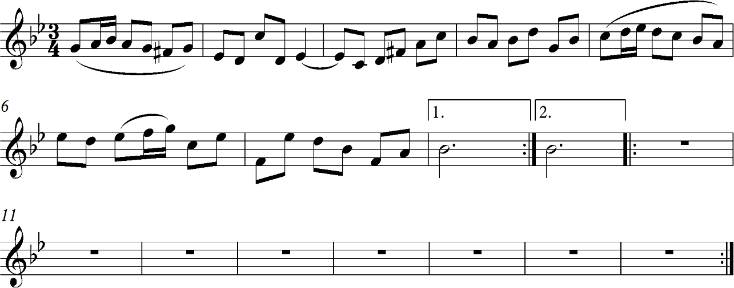

I.

  - Underline the overall tonality of the music. [1]

Major Minor Pentatonic

  - Give the full name of the key of the extract (e.g. D major). [1]

- Underline which chord you think is used in the first bar of the piece. [1]

Tonic chord Subdominant chord Dominant chord

III.

  - Underline the key to which the music modulates in bar 8. [1]

Relative major key Relative minor key

  - Name the key to which the music modulates in bar 8. [1]

- Underline the cadence heard at the very end of the piece. [1] Perfect cadence Imperfect cadence Plagal cadence
- Tick (✔) which musical term best describes the type of harmony overall in this extract. [1]

Type of harmony | Tick
Dissonant
Drone
Diatonic

  - Underline the word below which best describes the type of harmony in bars 9-16
(i.e. the 2nd part of the extract). [1]

Dissonant Chromatic Power chords

  - Give a reason for your answer. [1]

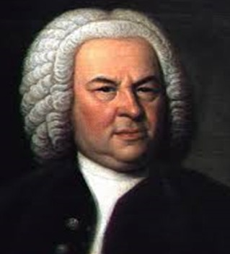
J.S.Bach (1685-1750) was a composer from the Baroque era (approx. 1600 -1750). Other composers of the time were Handel, Vivaldi and Rameau. This was an important era for establishing the major-minor key system upon which harmony was based for the next two centuries. Several new forms and designs became commonly used, including opera, oratorio, the fugue, the suite, the Baroque-sonata and the concerto.
Discuss in class:
- The texture of the given extract
- Any interesting features of the melody (i.e. the phrasing)
- The tempo
- The structure – this piece has two repeated sections. What is this overall from known as, and what are the main features?

- The following extract is the opening of an instrumental piece composed by J.N. Hummel. https://www.youtube.com/watch?v=v6yZkSnZ4lY [from start to 0’53’’]

Look at the score and read the question carefully before the first playing of the extract.

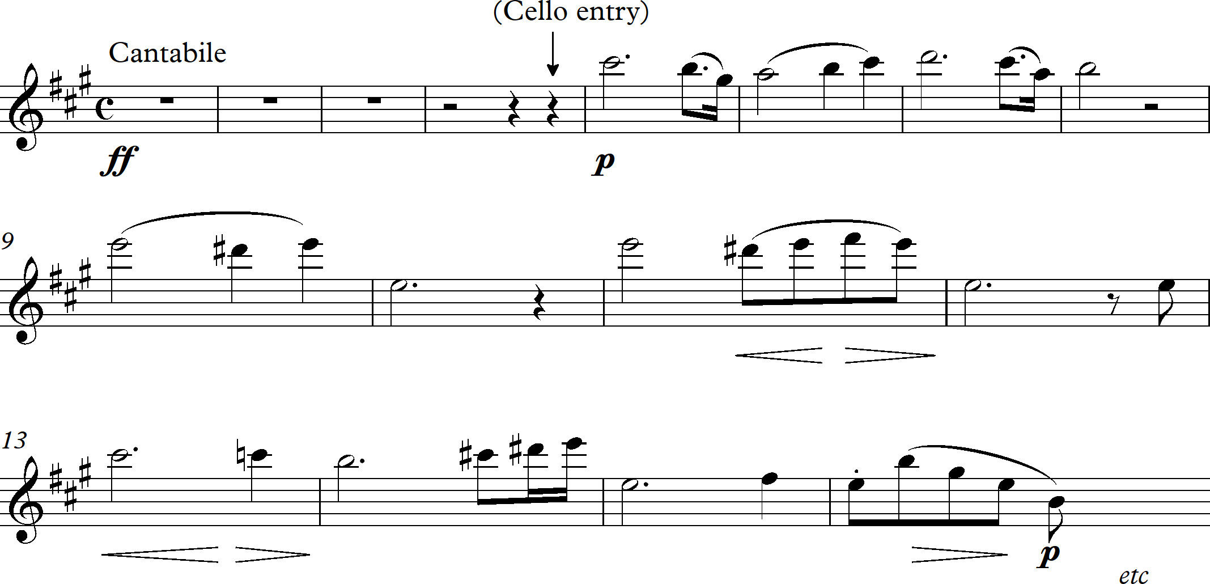

- State the key of the music. [1]

- Underline the correct description of the first note used in bar 1. [1]

Tonic Supertonic Subdominant Dominant

  - Name the chord heard on the first beat of bar 4. [1]

  - Identify the type of chord heard on the first beat of bar 11. State whether you think it is a major
chord or a minor chord. [1]

- In the table below, tick the word which correctly describes the type of harmony in this piece. [1]

Type of harmony | Tick
Power chords
Drone
Diatonic harmony
Dissonant harmony

- There is a change of key at the end of the extract (bars 14 – 16).

  - Tick (✔) the sentences below which best describe this brief change of key.

Sentences | Tick
This change of key is to a relative major key.
This change of key to a relative minor key.
This change of key is to the submediant key.
This change of key is to the dominant key.

  - What is the process of changing key known as?

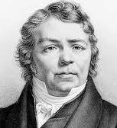
J.N. Hummel was an Austrian composer and pianist. Like Mozart, he was a child prodigy but was less famous than other Classical composers of his time.
More tasks:
- How does the composer add interest through the element of rhythm in this extract?
- What ornaments are used in this piece to decorate the melody?
- How many instruments perform in this piece?
- How would you describe the melodic movement in bar 16 in the treble part?
- How does the composer add interest through the element of texture in this extract?
- Complete the missing notes of the melody in bars 5 – 7. (The rhythm is given for you.)

Area of Study 2: Music for Ensemble

1. Listen to the following extract from the musical ‘Grease’. https://www.youtube.com/watch?v=A_J2bcNx3Gw [from start to 1’04’’]

The words and the structure of the extract are as follows:
- Summer lovin’ had me a blast
- Summer lovin’ happened so fast
- I met a girl crazy for me
- Met a boy cute as can be
- Summer days driftin’ away
- To ah, oh, those summer nights

- Uh well-a well-a well-a huh!

- Tell me more, tell me more
- Did you get very far?
- Tell me more, tell me more
- Like does he have a car?
- Uh-huh uh-huh uh-huh uh-huh

- She swam by me, she got a cramp
- He ran by me, got my suit damp
- I saved her life, she nearly drowned
- He showed off, splashing around
- Summer sun, something’s begun
- But ah, oh, those summer nights

- Uh well-a well-a well-a huh!

  - Underline the tonality of the extract. [1]

Major Minor Pentatonic

  - Underline one word which describes the harmony in the extract. [1] Dissonant Chromatic Perfect Diatonic
  - Underline the chord which is heard on the word ‘more’ – 3rd word in line 8 and line 10
(written in bold above). [1]

Tonic Supertonic Mediant Subdominant

    - State the harmonic device heard in line 4. [1]

    - Identify the line in which the same harmonic device is heard later in the extract. [1]

  - Underline the cadence heard at the end of line 18. [1] Perfect Plagal Interrupted Imperfect

Additional tasks.
- Suggest a tempo marking.
- State the time signature.
- Name the device given to a repeated pattern in this type of music.
- What is the style of this type / genre of music?

2. Musical Theatre
This musical extract is a number called ‘Castle on a Cloud’ from the musical Les Miserables by Schönberg. https://www.youtube.com/watch?v=XMxyy4fdJoU [from start to 0’32’’]

Answer the following questions on harmony and tonality while listening carefully to the audio extract. Here are the words sung in this extract.
- There is a castle on a cloud,
- I like to go there in my sleep.
- Aren’t any floors for me to sweep,
- Not in my castle on a cloud.

  - Tick (✔) the statement about the harmony that you believe to be true. [1]

Statement | Tick
The harmony used in this extract can be described as diatonic.
The harmony used in this extract can be described dissonant.
The harmony used in this extract can be described as dominant.

  - The opening two bars in the introduction are based on the same chord progression – three different
chords in each bar to the following rhythm:

Tick (✔) the harmonic pattern which you believe to be the correct pattern from the 3 options given below. [1]

Harmonic pattern |  |  | Tick
G | F | Em
Am | F | E
Am | Fm | Am

  - Underline whether you believe the last chord of the introduction is a major chord or
a minor chord. [1]

Major chord Minor chord

  - The home key of this piece is A minor. [2]
Write out the letter names of the following chords in this key (e.g. the letter names of the tonic chord in A minor are A C E).

    - The letter names of the subdominant chord in A minor are:

    - The letter names of the dominant chord in A minor are:

  - At the end of line 2, there is a change of key. [3]

    - Give the correct technical name for the process of ‘changing key’.

    - State whether the music changes to the relative major key or to the relative minor key.

    - Name the cadence heard at the end of line 2.

  - Underline the cadence heard at the end of line 3. [1] Perfect cadence Imperfect cadence Plagal cadence Interrupted cadence

- Describe the composer’s use of rhythm in this extract.
- Decide whether the dynamic at the start is ff, mf, f, mp, p or pp.
- Which of these terms best describes the tempo of the music? Tick (✔) your answer.
- Name the type of voice singing in this piece.
- Underline the word which best describes this type of piece. Quartet Trio Duet Solo
- Listen to the full extract. Tick (✔) which structure, in your opinion, is the correct structure of the music.

Largo | Lento | Allegro | Vivace

A B A B | A B C A | A B B A | A A B A

Area of Study 3: Film Music

- This is a musical extract from the film Top Gun. https://www.youtube.com/watch?v=F4M6haOFtcE [from start to 1’10’’]

Listen to the musical extract. Now answer the following questions on harmony and tonality. The extract may
be considered in two sections: a four-bar introduction, then the first verse of the theme song.
Here is the plan and the lyrics of verse 1:

INTRODUCTION – 4 bars (in 4/4 time)

VERSE 1
Watching ev’ry motion in my foolish lover’s game On this endless ocean, fin’lly lovers know no shame, Turning and returning to some secret place inside
Watching in slow motion, as you turn around and say Take my breath away
Take my breath away

  - Tick (✔) the term which best describes the tonality and type of harmony in this musical extract. [2]

Tonality | Tick | Type of harmony | Tick
Major |  | Dissonant
Minor |  | Diatonic
Modal |  | Disjunct

  - Tick (✔) one of the following statements which you believe to be true. [2]

Statement | Tick
The chord changes one every beat
The chord changes on every 2 beats
The chord changes on every 3 beats
The chord changes on every 4 beats

  - Except for the end of line 2, the same cadence is heard at the end of the introduction and every line.

    - Underline the type of cadence you believe this to be. [1]

Perfect cadence Imperfect cadence Plagal cadence Interrupted cadence

    - Name the chord heard at the end of the Introduction and every line except line 2
(e.g. tonic chord). [1]

    - Write the roman numeral which indicates this chord in music (e.g. chord IV). [1]

  - Identify the chord at the start of line 3 as being Major or Minor. Underline your answer below. [1] Major Minor

- What is the best way to describe the texture of this musical extract?
- State the type of voice singing.
- Are the musical phrases balanced or uneven?
- Suggest a tempo marking and a dynamic marking for this section of music.
- Discuss the instrumentation and accompaniment style in the extract.
- Listen to the entire track and discuss the structure of the full song.

- You will hear the opening of famous film theme known as Baby Elephant Walk. https://www.youtube.com/watch?v=b1z4JfxFb6c [from start to 0’39’’]

For clarity, the extract is heard in 3 sections, described below:

Pre-Introduction: solo line ⇨ Introduction: 6 bar instrumental ⇨ Main theme

Look at the score of the main theme and read the question carefully before the first playing of the extract.

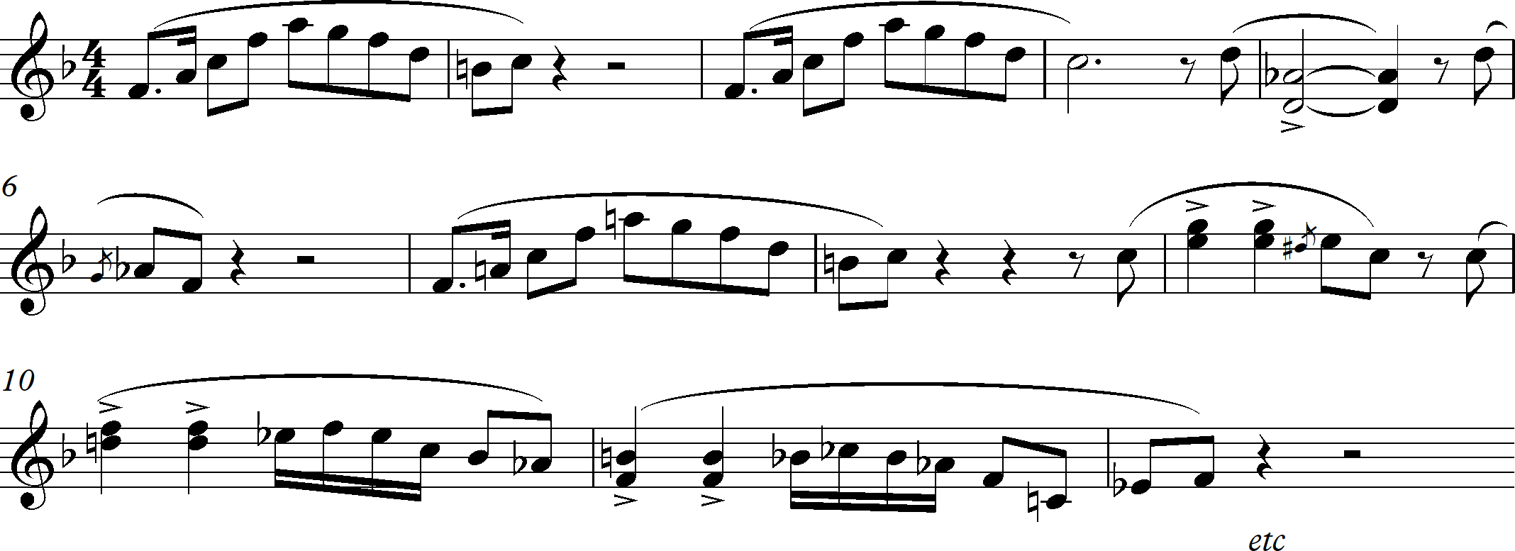

I.

- State the overall tonality of this musical extract. [1]

- Name the key of the extract (e.g. D minor). [1]

- Underline the scale on which the musical content has been based. [1] Minor scale Pentatonic scale Blues scale
- Name the chord heard being played throughout the first 4 bars of the main theme
(e.g. chord vi, submediant chord). [2]

- Identify the chord heard in bar 5 of the main theme. [1]

- Tick two statements about the harmony in this extract which you believe to be true. [2]

Statement | Tick
The chords used in this extract are all secondary chords
The chords used in this extract are all primary chords.
The chords used in this extract are all dissonant chords.
The chords used in this extract are all root position chords.
The chords used in this extract are all first inversion chords.
The chords used in this extract are all second inversion chords.

Extension task 1: the longer answer question.
This film is an American adventure comedy film. Listen to more of the track and discuss in groups how the
composer achieves the mood of comedy in this famous theme – make notes during your discussion!
Now write up your observations as a ‘longer-answer’ response. This is an individual task.
You must explain your observations by considering the use of the musical elements in the music (i.e. the melody, rhythm, harmony, texture, instrumentation, tempo, dynamics, and style).

Extension task 2:
LISTEN to (not watch!) the opening of the theme music from the following films: https://www.youtube.com/watch?v=QH3RhbVP7cA from a film called ‘Cape Fear’ https://www.youtube.com/watch?v=Bt5rCgHN1Gc from a film called ‘Halloween’ https://www.youtube.com/watch?v=meU2gAU7Xss from a film called ‘The Thing’
Discuss how the composer uses harmony and tonality in this extract to achieve the required outcome.
Now write up your observations as a ‘longer-answer’ response. This is an individual task.
After focussing on the use of harmony, you may also want to consider the use of the other musical elements in the music (i.e. the melody, rhythm, texture, instrumentation, tempo, dynamics, and style).

Area of study 4: Popular Music

1. Listen to the opening of ‘Eleanor Rigby’ as performed by the Beatles. https://www.youtube.com/watch?v=6gluNoLVKiQ [from start to 0’45’’]

The extract consists of three sections – the introduction, the first verse and the chorus. Look at the outline of
the score below as you answer the questions.

INTRODUCTION:
- Ah, look at all the lonely people
- Ah, look at all the lonely people

VERSE:
- Eleanor Rigby
- Picks up the rice in the church where a wedding has been
- Lives in a dream
- Waits at the window
- Wearing the face that she keeps in a jar by the door
- Who is it for?

CHORUS:
- All the lonely people
- Where do they all come from?
- All the lonely people
- Where do they all belong?

Now answer the following questions on harmony and tonality.
  - Two chords are used in this extract. They are both heard in line 1, and line 2 is a repeat.
Tick (✔) the two statements below that you believe to be true. [2]

Statement | Tick
The opening chord in the introduction is a minor chord.
The opening chord in the introduction is a power chord.
The opening chord in the introduction is a major chord.
The 2nd chord (on the word ‘people’) is a minor chord.
The 2nd chord (on the word ‘people’) is a power chord.
The 2nd chord (on the word ‘people’) is a major chord.

  - State the tonality of the verse and the chorus. [1]

  - Underline the term which you feel best describes the overall harmony in this extract. [1] Dissonant Imperfect Diatonic
  - Underline the term which describes the chord at the end of line 12 (end of the chorus). [1] Tonic Supertonic Subdominant Dominant
  - Tick two harmonic features you believe to be present in this musical extract. [2]

Harmonic feature | Tick
Root position chords
Perfect cadences
Arpeggio type chords
Modulation
Modal influences

- Suggest a suitable tempo marking.
- Name the instruments used in the accompaniment.
- Note the phrase lengths – tap them out. Are they regular, or irregular?

2. Listen to the opening of a song by Adele called ‘Someone Like You’. https://www.youtube.com/watch?v=hLQl3WQQoQ0 [from start to 0’55’’]

Here are the lyrics for the extract, which includes the introduction and verse 1:
- I heard that you’re settled down
- That you found a girl and you’re married now.
- I heard that your dreams came true,
- Guess she gave you things I didn’t give to you.
- Old friend, why are you so shy?
- Ain’t like you to hold back and hide from the light.

Now answer the following questions on harmony and tonality.

  - Complete the following sentences with the correct musical answer. [2]

    - The type of harmony in this extract is:

    - The tonality of the music is:

  - State how many different chords are heard in the introduction. [1]

  - The chords are repeated throughout this musical extract. Underline the term which correctly describes the pattern of chords. [1]
Power chords Thematic chords Chord progression

  - Tick (✔) the statements below you believe to be correct. [1]

Statement | Tick
All of the chords in the extract are major chords.
All of the chords in the extract are minor chords.
The chords in the extract are a mix of major and minor chords.
Some of the chords are dissonant chords.

  - One of the chords in this extract is labelled as C#m/G#. Explain what this means. [2]

  - This music is in the key of A major.

    - Underline which chord you believe is the correct chord heard at the end of line 6. [1]

A major C#m/G D major

    - Underline which of the technical chord names is the correct name for the last chord in line 6.
[1]

Tonic chord Subdominant chord Submediant chord

- Explain how the chords are played in the accompaniment.
- How many chords are used in each bar?
- Name the instrument playing the accompaniment in this opening of the song.

Further questions
What is the dynamic marking at the start of the song? What is the time signature?
Can you suggest a suitable tempo marking?
What is the musical device heard in lines 1 and 2?

