Using Office Forms to identify revision hotspots
for classes studying WJEC A level R.S.

Contents

1. An introduction to Office Forms Page 2
a. How Office Forms might help you with revision
planning Page 2
b. Getting a Microsoft account if you don’t have one Page 2

c. How to download the WJEC A level R.S.
Office Forms that you need Pages 3-4

2. a. Sharing the Forms with your students Page 5-6
b. How long will it take my students to complete a Form Page 6
c. How can I adapt an Office Form for test revision on
a single Theme? Pages 7-9

3. a. Identifying AO1 and AO2 revision hot spots for whole
classes per subtopic within a Unit Page 10
b. Identifying AO1 and AO2 revision hot spots for
individuals per subtopic within a Unit Page 11

1. What are Office Forms?
Microsoft Office Forms allow you to create surveys, quizzes, and polls. This function is included with Office 365 work and school accounts. You may well already have a work or school Microsoft account you can use.

a. What will the WJEC A level RS Office Forms help me to do?

- Identify AO1 and AO2 revision hotspots for individuals per subtopic within a Unit
- Identify AO1 and AO2 revision hotspots for classes per subtopic within a Unit

b. What if I don’t already have a Microsoft account?
It is highly likely that If work in an educational environment that you do already have Office 365 work or school account, if not you will need to ask your I.T. Department to create you an Office 365 work or school account for you.

c. Once you have created your account click on one of the links
below to download the Office Form you require:

Unit 3a Christianity
Unit 3b Islam
Unit 3c Judaism
Unit 3d Buddhism
Unit 3e Hinduism
Unit 3f Sikhism
Unit 4 Religion and Ethics
Unit 5 Philosophy of Religion
Unit 6 Textual Studies (New Testament)

You will see a screen like this one:
Click here to save the template to your Microsoft account.

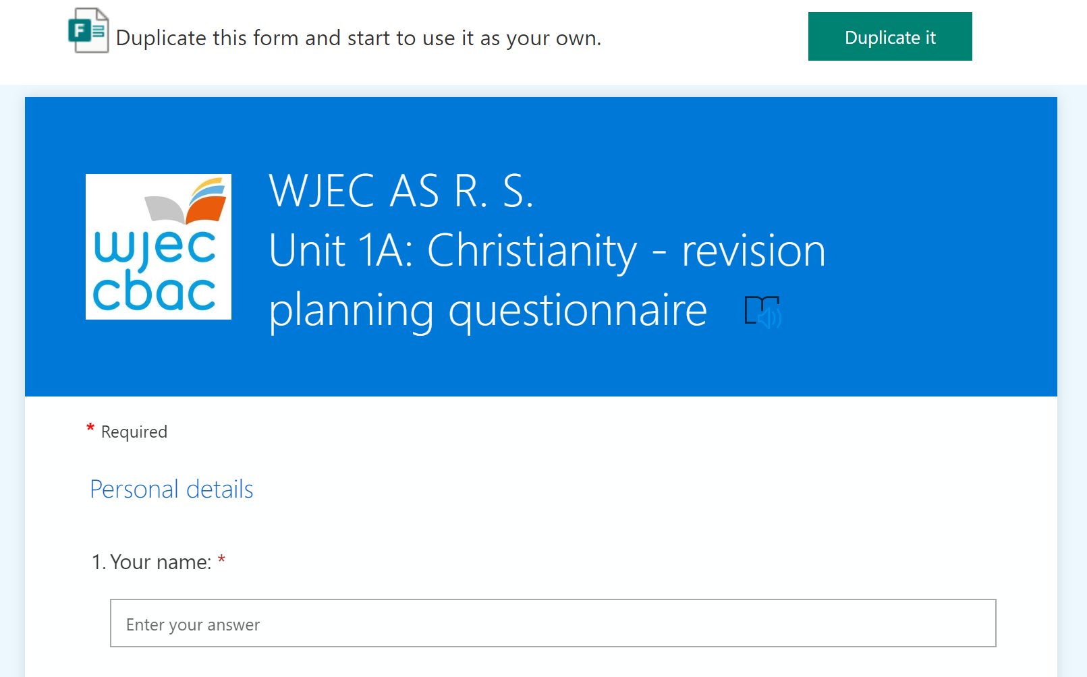

If you are not logged into your Microsoft Account, then you will see a screen like this one after you have clicked on “Duplicate it”:
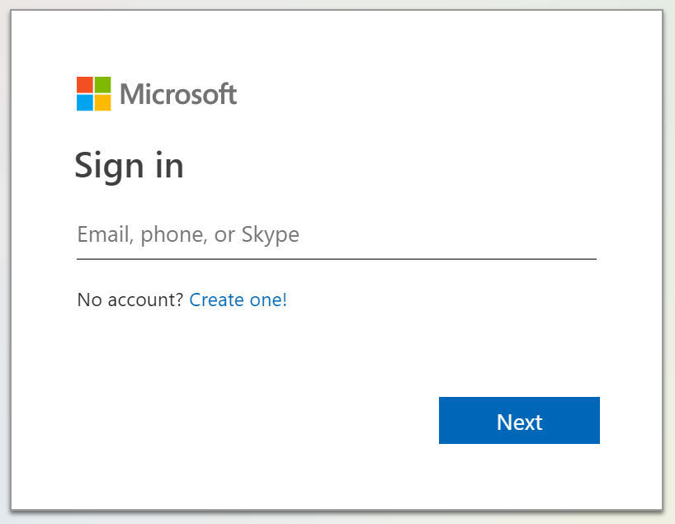
Enter your Microsoft account username (usually an email address) here

then click on Next

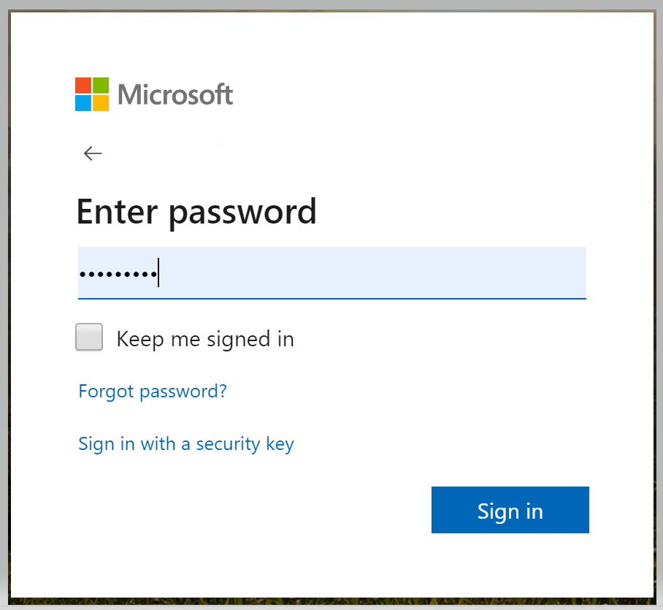
Enter your Microsoft account password here

Then click on Sign in.
This will save the Form to your Office Form account and you always find it by logging in at:
https://forms.office.com/

2. Sharing your Form with your students

a. How can my students complete the Office Forms
questionnaires that I have saved in my account?

Open the form you wish to send them

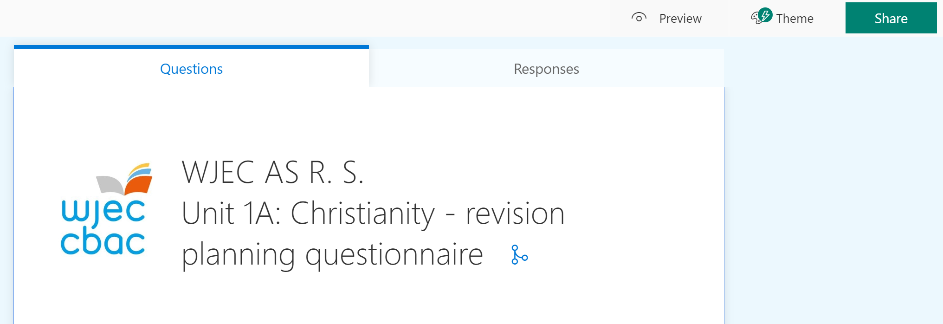
Click on the “Share” tab

If you want to copy the link to the questionnaire so that it can be copied and posted on Twitter, Facebook, etc., then click on copy
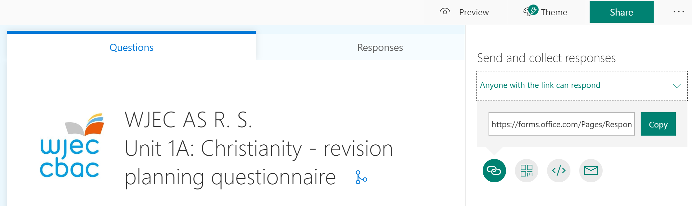

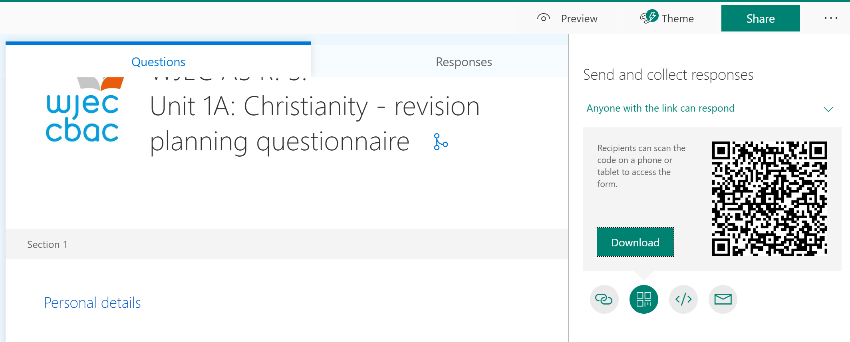
If you want to download a QR Code so you can paste it into a display posters to put in your room or to post it on Twitter, Facebook, etc., then click here.

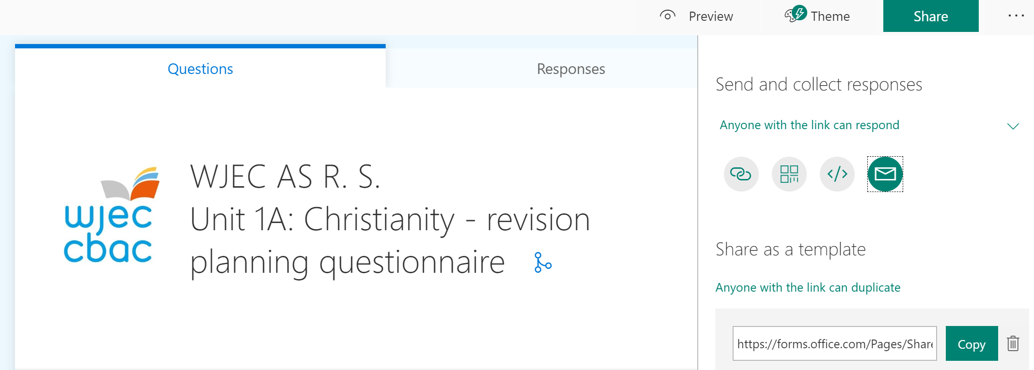
If you want to email the link to your students then click on this symbol.

2.b. How long does it take for my students to complete each
Office Form?

- About 5 mins per Theme
- About 20mins for a Component.

2.c. How can I duplicate one of my Unit Office forms so that I can create another Form covering just one Theme to plan revision for an end of Theme test?

Duplicate your form for the entire Component.

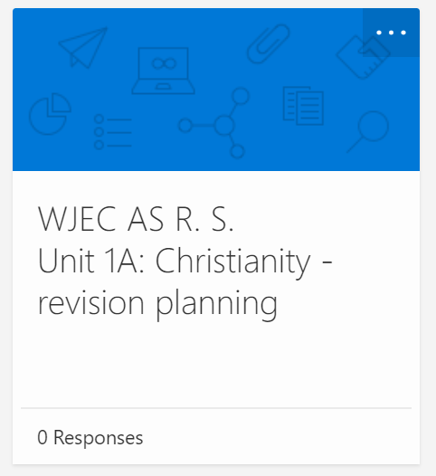
Click on the “…” on the top right of the form you wish to duplicate.
The tile will then change to look like this:

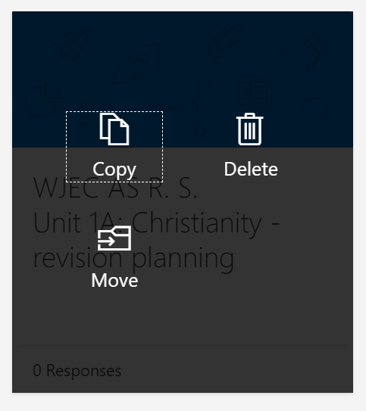
Click on Copy

Once you have your new copy – open the duplicate file by double clicking on it.

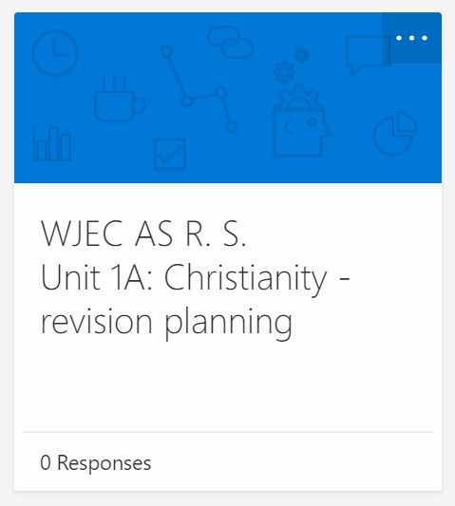

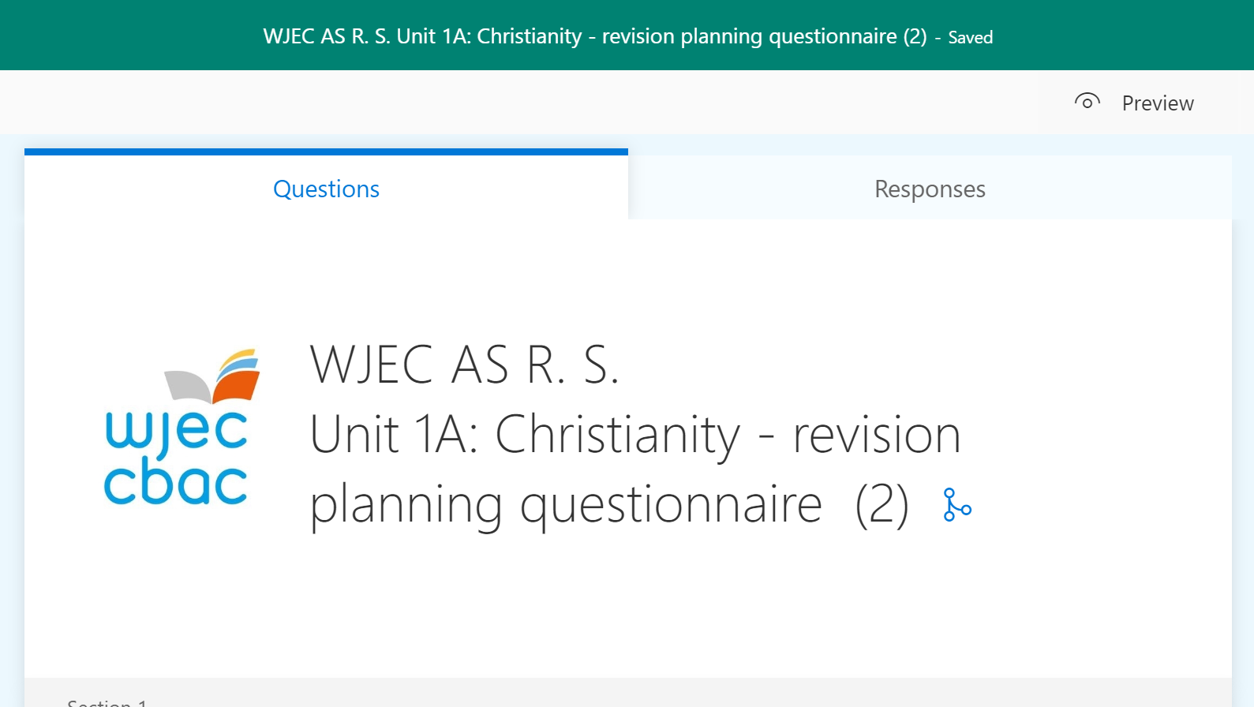
Click on title to rename the file

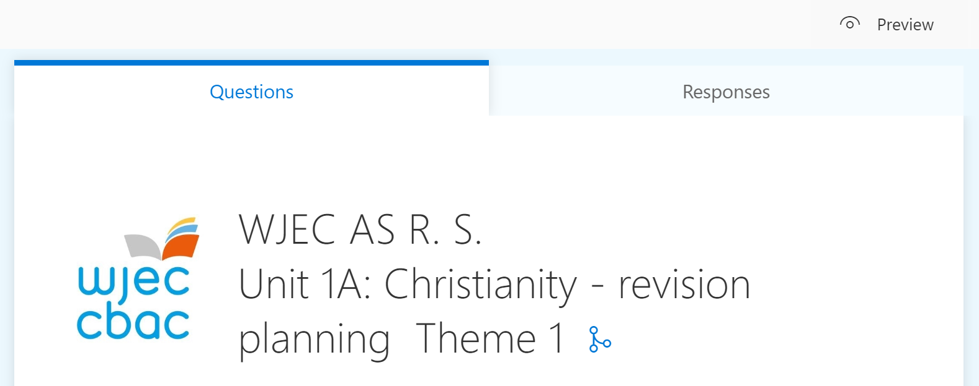

How to delete the sections that you no longer require from the form:

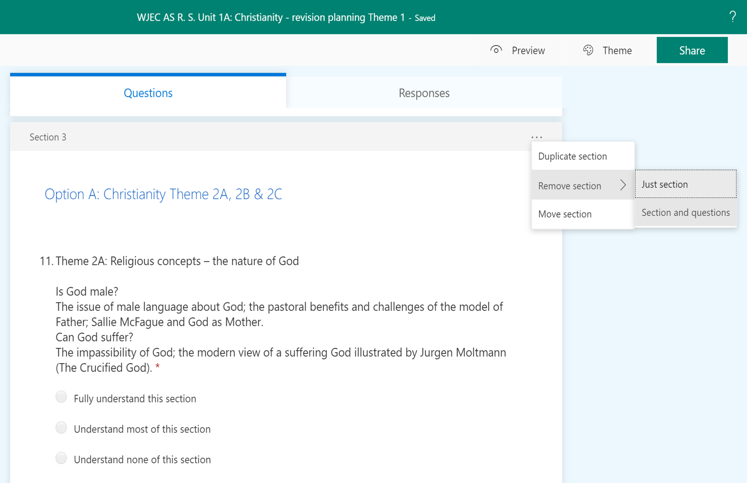
Then click on “Remove section”
Finally, click on “Section and questions”
Click on the top right of the section “…”

3.a. Identifying AO1 and AO2 revision hot spots for whole
classes per subtopic within a Unit:

Open the Office Form you have responses for:

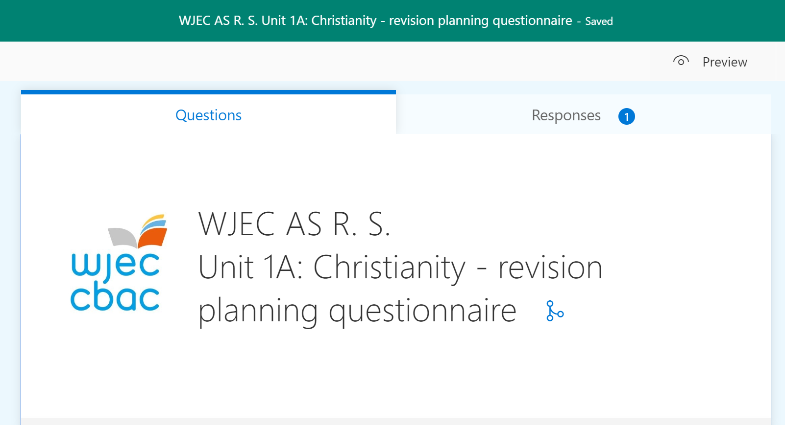
Then click on
“Responses”
You will then be presented with a screen giving you a summary of all the responses for you class so far by subtheme using a combination of textual information and graphs.

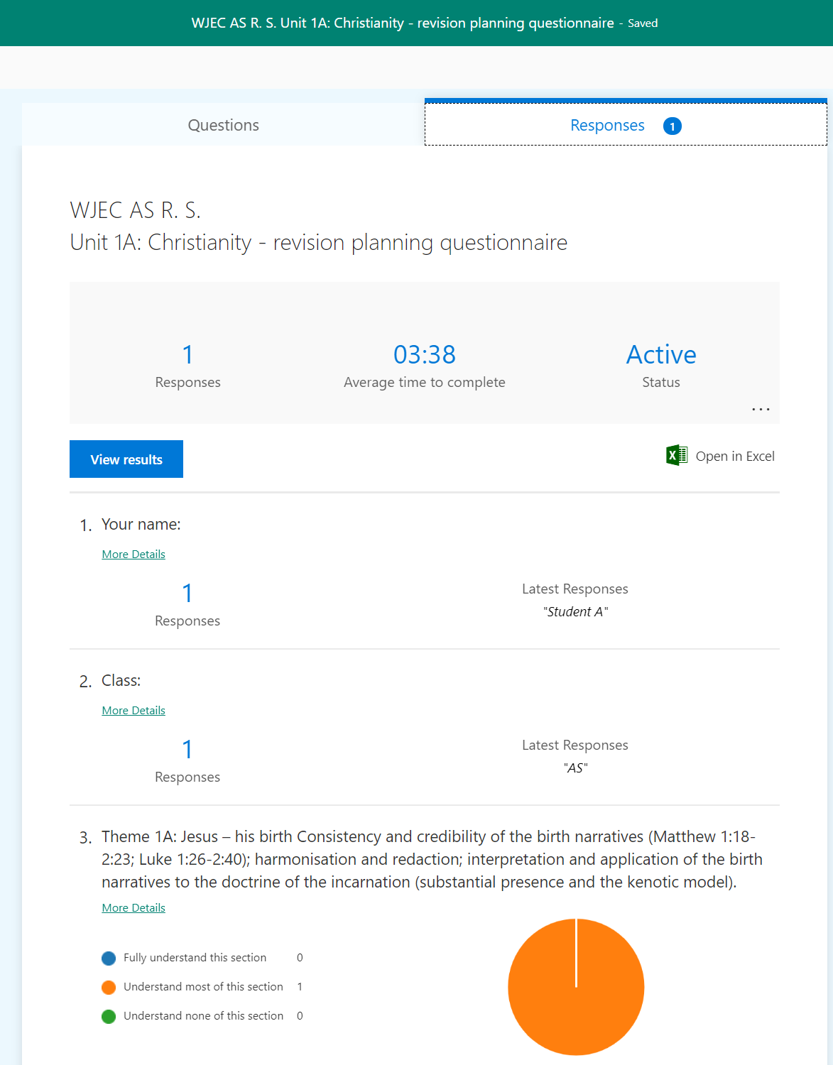
If you prefer, you can download the information into an Excel spreadsheet by clicking here.
3.b. Identifying AO1 and AO2 revision hotspots for individuals per subtopic within a Unit
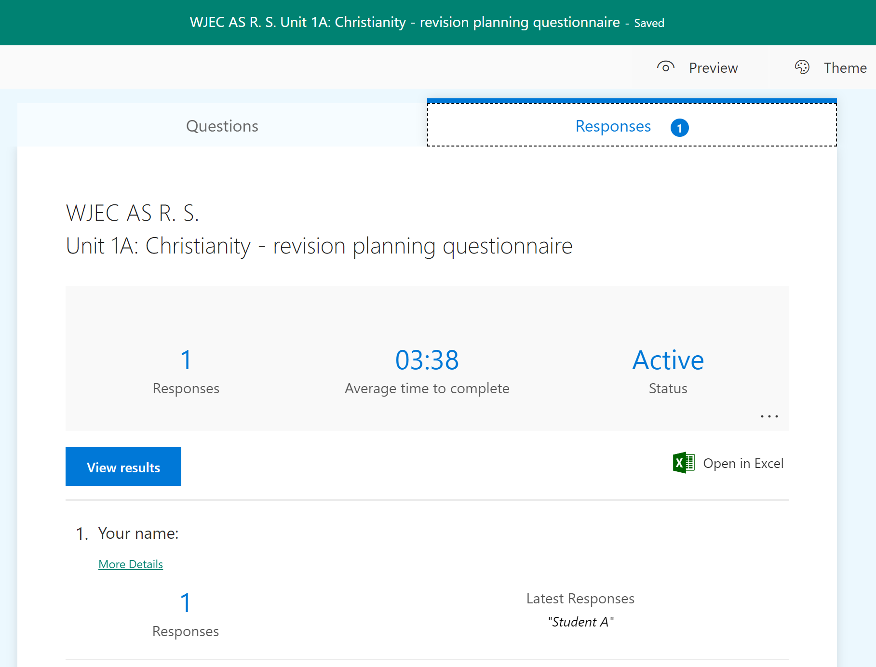
You can display individual student’s responses by clicking on “view results”

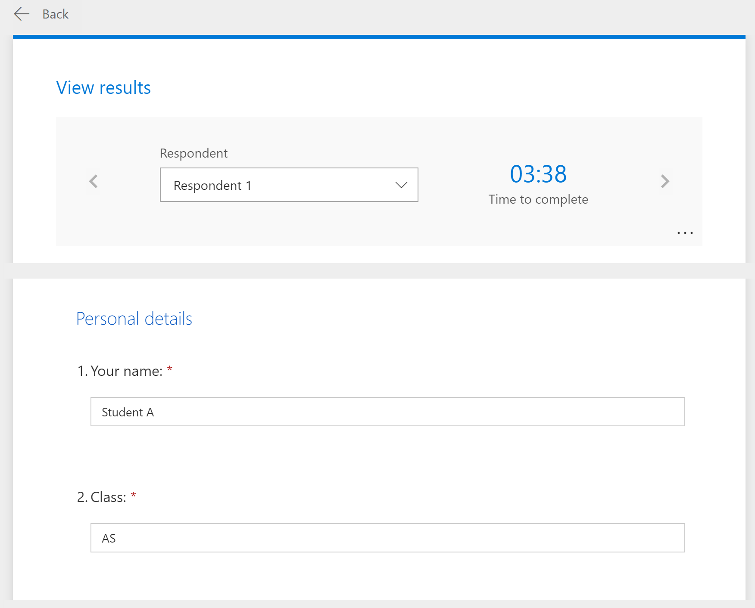
You can also navigate between different student responses by clicking on the navigation arrows provided.

