This interview explores the theorist’s own ideas. The views expressed are the theorist’s own and do not represent Eduqas.
1. Focus on print news: What issues does Sonia Livingstone highlight regarding the way the print news
industry is currently regulated?
Hint questions
•
•
What issues did the Leveson inquiry deal with?
What problems does the current system of press regulation create according to Sonia Livingstone?
http://chilp.it/c2b9102

2. Focus on print news: What factors, according to Sonia Livingstone, are
driving a light-touch regulation of print news in the UK?
Hint questions
•
Do regulatory bodies take a citizen or consumer based approach to print
news regulation?
http://chilp.it/015357d
- How has the content of print news been affected by a globalised media ownership pattern?

- Focus on print news: Look carefully at the front page of The Daily Mail below, published on 14 December 2017. The front page splash refers to eleven Conservative MPS who voted against the government on an amendment to the EU Withdrawal Bill. This amendment was passed, ensuring that MPs would have a chance to vote on the final Brexit deal.
What arguments might be presented to suggest that an effective press regulator should have taken action when this edition was published? What arguments might be presented to support the publication of the Mail’s front cover in this particular instance?
Hint: think about Livingstone and Lunt’s idea that media products serve citizens and consumers

Arguments that might question The Daily Mail’s decision to publish
Answers could refer to:
- The idea that the article is designed as consumer based entertainment
- Sensationalist content
- Reportage that demonstrates political bias
- Inflammatory language
- Recontextualised imagery

Arguments that would support publication
Answers could refer to:
- The idea that the article serves a citizen based audience and informs its readership about political events
- The idea that the article holds democratically elected representatives to account
- The idea that the article engages readers with a potentially valid political viewpoint

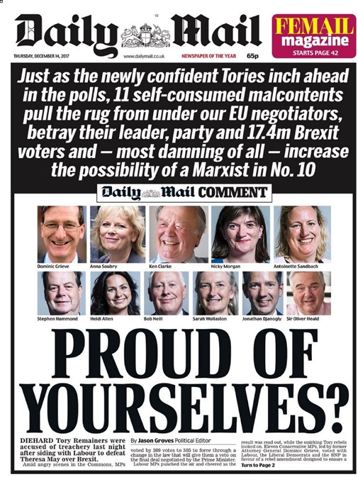
Extension task: Can you apply the ideas of Livingstone and Lunt to the editions of The Times and The Daily Mirror that you have studied?

- Focus on video games: What issues does Sonia Livingstone highlight as important in terms of video game regulation in the UK? The regulation of video games is complex. In the UK, the BBFC classifies some content (mainly linear content such as features and trailers). Since 2012 The Video Standards Council has administered the PEGI ratings system in the UK,

http://chilp.it/cf2d4bb

which classifies video game content using similar categories to the BBFC (such as discrimination and
violence). Assassin’s Creed III Liberation was rated as being suitable for people over the age of 18.
Hint question
- Is video games legislation effective? Why not?

- Focus on video games: Watch the attached trailer for Assassin’s Creed III: Liberation and consider why it might be problematic for a young audience to consume this game.
Trailer link: https://www.youtube.com/watch?v=q5RxYUw4DFY

Possible answer might include:
- The game contains scenes of graphic violence
- The game depicts violence against defenseless victims
- Depictions of violence are realistic
- The game’s central character is depicted in scenes of peril
- Scenes might produce imitable behavior
- Immersive gameplay might magnify the effects described above

