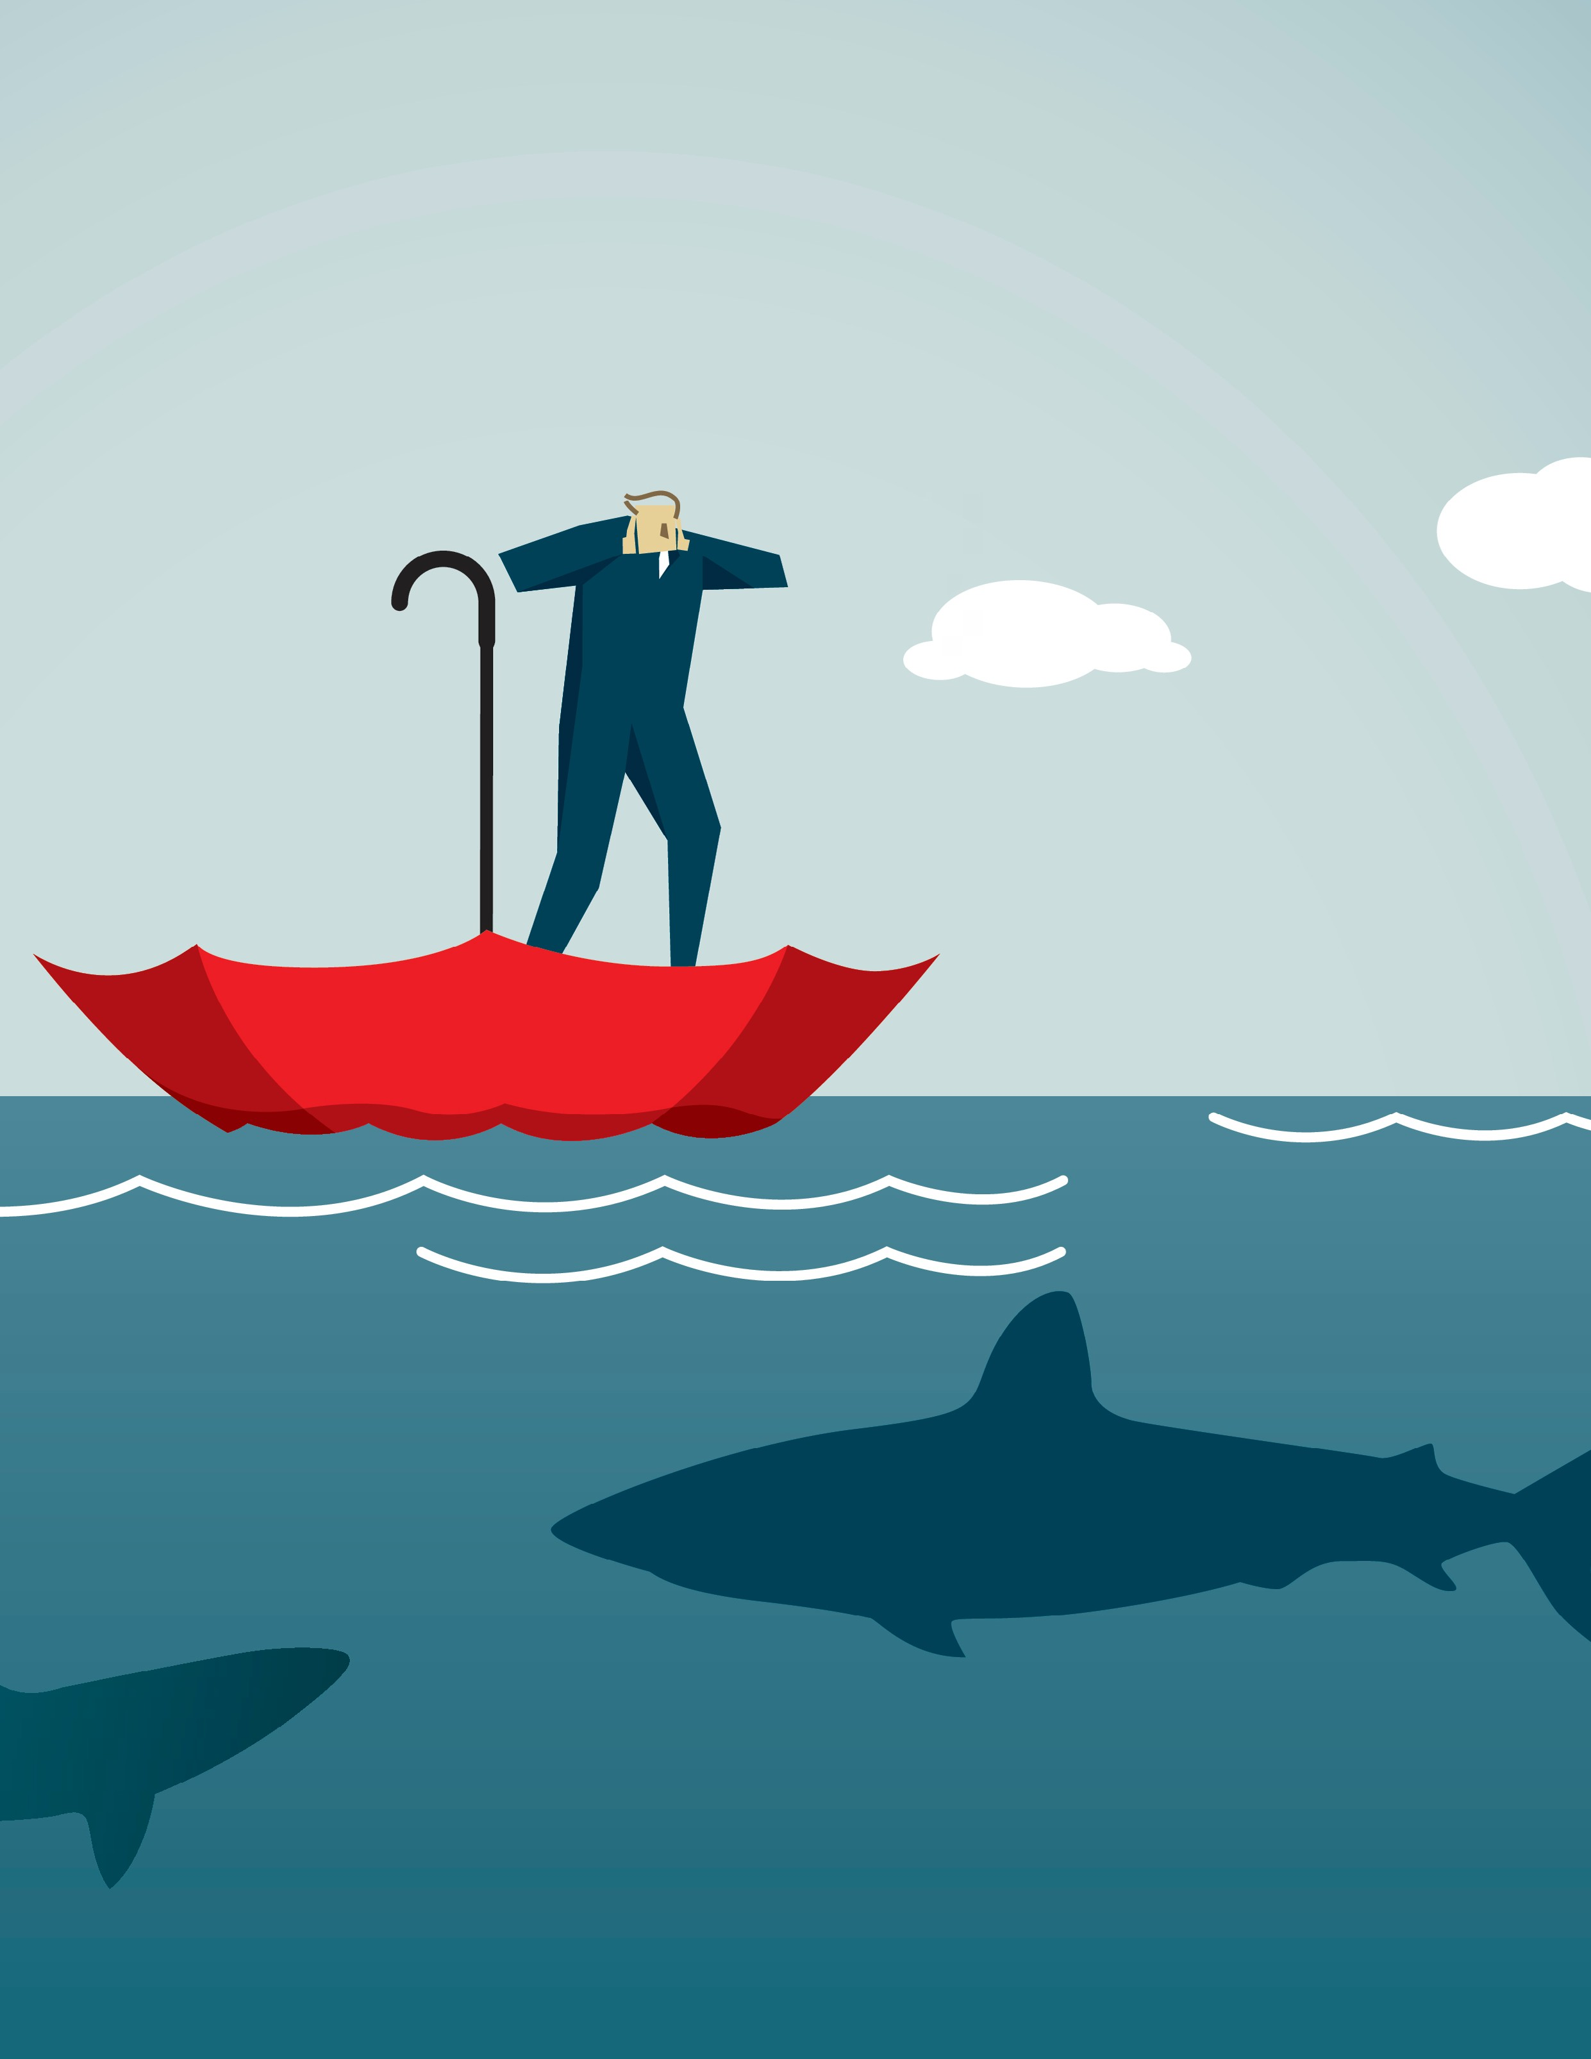

GCSE Business 2

Influences on Business

Index

Technological influences on business activity – 1 Ethical influence on business activity - 17 Environmental influence on business activity - 24 Economic influence on business activity - 30 Legal influence on business activity - 44
The impact of globalisation on businesses - 65 The European Union - 78

Influences on business
Businesses do not operate in isolation; in Section 1 of these resources we have already seen how the business environment is dynamic and competitive. In addition there are other external factors that will impact on business activity.

Some external factors may have a positive impact on the business, while the effects of others may be negative.

A business will never be able to control these factors, but it is important that they take them into account in their planning and business strategy. These factors include:
- Technological
- Ethical
- Environmental
- Economic
- Legal
- Globalisation

Technological influence on business activity

Technology is used exclusively by businesses. No matter what the business activity, some form of technology will be used. This can include communicating with customers using smart phones, using EPOS (electronic point of sale) in retailing or using robotics in manufacturing.

In the last 20 years the pace and advancement of technology has been countless and the increasing levels of automation (making a machine work without any input from a human) and use of information and communications technology (ICT) has had a major impact on all organisations and how they operate.

Many businesses have grasped these new technologies to the maximum extent, whilst others have not been so enthusiastic. Over the last decade, a greater understanding by business owners and managers of the potential impact of robotics and automation, plus the ability
to communicate cheaply to any part of the world, means that all businesses in competitive markets must now accept that these new technologies will have to become an integral part of their operations if they are to stay competitive.

Use of computer packages in the workplace

A range of computer packages are available to businesses to allow them to carry out a range of tasks. The introduction of these packages can improve the efficiency of the business, reduce long term costs and improve the quality of the work undertaken.
Computer packages include:

- Word processing – used to create documents that can be stored and edited. A range
of documents are needed in a business, for internal and external use, and the use of word processing software has greatly improved the quality of presentation in these documents. Templates can be kept for frequently used documents and old
documents can be saved and then edited to create updated versions.

- Databases – used to store information. Businesses need to store a vast amount of information and before the introduction of electronic databases, this information was often stored on paper and information could easily be lost or take a long time to find. Databases have search facilities that allow users to find the information they need quickly and accurately. A business may use databases to store information on stock, customers, suppliers, employees, component parts, etc. The use of mail-merge allows databases to be linked with word processed documents to allow standard letters to be sent to hundreds or thousands of customers with a few simple clicks of the mouse.

- Spreadsheets – used to keep accounting (financial) records and to carry out calculations. The amount of quantitative data used in business activity is vast, this data has to be recorded and used to produce financial and stock records for the business.
A spreadsheet presents data in a constructive format that allows easy interpretation of the data. In addition spreadsheets use of formulas allows for the efficient calculation of data. This data can also be presented in graphs and charts. Spreadsheets are used to produce cash-flow forecasts and income statements and the use of formulas allows for modelling (what happens when a value is changed to predict future events). In addition to standard spreadsheets, there are various accountancy software packages available to businesses to produce the financial records they need.

- Video conferencing – used to connect people at different geographical locations. The connection is a live, visual and audio connection to allow for meetings to be held between locations anywhere in the world. Video conferencing can be used to hold meetings for employees located in different areas, or for communicating with customers. It can save time (no need to travel for a face to face meeting) and costs
(travelling expenses). It is more effective than a telephone call as participants can see each other and group discussion is possible. Video conferencing requires computers, webcam, microphone, speakers, internet and video conferencing software.

- Presentational software – used to create presentations. The software allows the user to create professional and multimedia (text, pictures, video and sound) presentations, often through a series of slides. These can be used to present new products to customers or internal presentations between different workers in a business (for example, a marketing manager presenting to the sales staff the details of a new advertising or promotional campaign). In the age of the internet (presentations are often

uploaded to websites), the use of presentational software is limitless and is an effective tool in giving information to potential customers and other stakeholders connected to a business.
- Computer graphic packages – used to create graphical documents such as adverts, promotional material, logos and artwork. When marketing the business, or products and services of the business, computer graphic packages allow a business to create its own high quality material used to attract customers to the business. These can range from small businesses creating leaflets or business cards (desktop publishing software), to large businesses creating a suite of material that could include brochures, catalogues and magazines.

- Website design – used to create and maintain websites. The importance of the internet in the current business environment is crucial. Whatever their size, most businesses today have some form of platform on the internet, ranging from a simple website
for information to a fully interactive website allowing for e-commerce and instant interaction with online support personnel. There are now many software packages available to buy that help build a website, in addition many large businesses will have a whole dedicated website team of employees to build, improve and maintain its website.

Use a range of computer software to complete the following tasks:
- Produce a leaflet to promote a new business idea.
- Create a short presentation to pitch your idea at prospective investors in your business.

- Use the data below and formulas in a spreadsheet to calculate the following sales revenue data:
January February March April May June
£1 000
£1 500
£1 750
£2 200
£2 500
£2 500
Total sales revenue for the 6 months.
Add a column to create new sales revenue figures for each month with a 10% increase. Add a column to calculate the profit per month if costs total 60% of sales revenue.
Create new 6 month totals for the additional columns.

The ever increasing rate of progress in computer technology will result in even more software becoming available for business use. More advanced stock control software is already in
use and new packages to monitor staff performance are being used by some businesses. Computer technology has an important and growing role to play. The areas below have experienced rapid growth in recent years:

- Internet marketing – internet sales are increasing year on year. Many businesses now use the internet to market their products instead of more traditional advertising media.
- Web-based customer relationships – some businesses have entirely web-based customer relationships, for instance many people now bank online.

- Electronic point of sale systems (EPOS) – this has moved on from just reading bar codes at checkouts. Systems now use EPOS to control its stock, automatic ordering from suppliers, determine promotions, selling space and staff requirements. Manufacturers can use EPOS systems to reduce stockholding to ensure that suppliers only send materials when they are required.
- Sourcing materials for businesses – when a business orders stock or materials from another business. For many businesses this can be done entirely through the internet through the use of business portals resulting in lower costs and good relationships between the businesses.
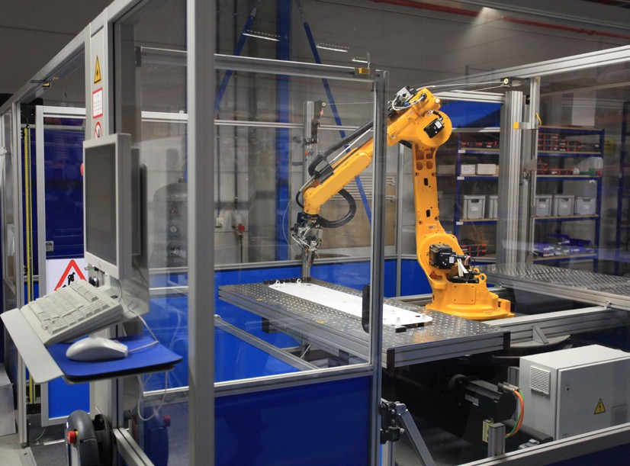
- Explain how the use of computer technology can impact on business activity.
- Describe how supermarkets use computer technology.

- Carry out research to find out what software is available for a small business who wish to buy:
- An accountancy computer package
- Presentational software
- Web design software
How much do these packages cost?

Discuss whether you think it is worth spending the money on these packages.

Automation

Automation involves the use of robots to carry out repetitive tasks in the manufacturing industry, however, in recent years automation has spread to other industries and now there is widespread automation throughout the business supply chain. For example, in agriculture, product quality checking is carried out by machines that take digital photos of vegetables, clean, sort and finally package and label the vegetables to match customer needs.

The main business function where automation has had an enormous impact is in the manufacturing/production of goods. The car industry invests heavily in automation and robotics, and very few cars are built today that have not been produced by an automated process.
Automation is likely to be seen more and more in the following areas:

- Retailers – for retailers automation has become one of the key issues in business efficiency. Whether it is automated ordering or the more visible self-checkouts.

  - Banks – bank clerks are disappearing to be replaced by machines. The bank staff that are visible are often there to help customers use the automated systems and to sell new products.
  - Warehousing – staff functions are being replaced by robots that can do more and more tasks. Robots are not yet capable of removing all goods from shelves, but can transport and pack goods.

- Online services – whole systems will be automated; mathematical analysis will determine which products are marketed, where they will be placed and what prices are charged.
- Utilities (gas and electricity) – smart meters will replace the need for a manual meter reading; switching to the cheapest provider may become automatic.

- Delivery of products – businesses are looking onto the use of drones to deliver items ordered online.
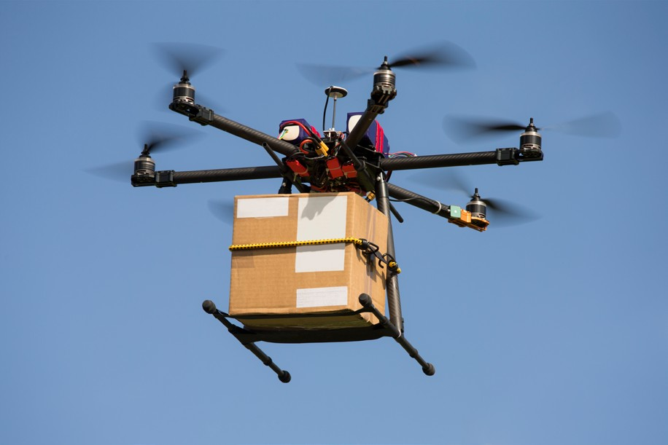
Read the following article and answer the questions that follow:

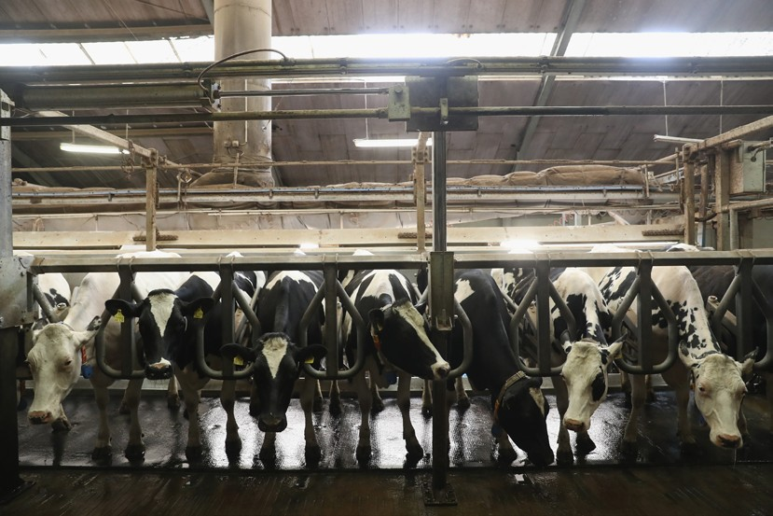How automation could benefit agriculture
Intelligent automation now means that a dairy herd can be fed, cared for and milked by just one or two people.

Robert Veitch has a dairy farm near Glasgow that uses one of the most advanced robotic milking systems in the world. It is a £1.8 million facility where 10 machines take care of 250 cattle. The cows are kept inside a shed that has a high roof and is open to the outdoors at the sides, allowing in daylight and fresh air.

Rather than shovels and tractors being used, an automated claw drops in to a heap of feed, runs along a track and deposits it in to the receptacle of a feeding robot. This large wheeled cylindrical machine moves off by itself and trundles around the shed depositing the feed

in long rows. The cows eat when they want and the machine even helps them to eat it by pushing it under their noses, so there is little waste.
There is no set milking time. When the cows want to be milked, they queue up outside the milking parlour. One by one they push through a gate. They step on a metal plate and
this activates the most intelligent machine of all. Twenty years of research has gone in to a robotic arm that learns about each and every cow.
As well as guiding cups on to her teats and milking her, it maps her by laser and updates the intricate data picture that it already has. It knows her weight, temperature and how much milk she has produced. But also how much she has eaten and even how much she has moved around.

The dairy uses Wi-Fi controlled robots in their plant, working alongside people. But the cows aren't out in the fields eating grass; they are kept in the shed. This is intensive farming with one objective - to produce as much milk as possible.
Mr Veitch says it works. He believes that the cows are kept so comfortable that, "They wouldn't want to go out even on a good day." He says that yields have risen as a result: "Cows respond to comfort. It has gone from 28 litres to 36 litres average a day, without a significant increase in feed cost."

It's the freedom to be able to be milked when they like – they can be milked three, four times a day. A calf would normally suckle its mother many times in a day, so this is actually more natural than a twice a day milking system."
There is even a robot the size of a large dog that trundles around between the hooves cleaning up the mess. All this saves six or seven hours of labour costs per day. But these jobs used to be done by humans. What is the impact? Dr Paul Brassley studies the history of technical change in agriculture. He says that in sixty years the number of people in total working on farms has just about halved.

"The really big change has been in the number of full-time workers: from 700 000 in 1951 to around 63 000 in 2013. This is about a tenth of what it was.
According to Mr Veitch: "It has allowed my family to run the herd without having to milk twice a day. It is a lot more flexible. It allows us to focus on the management of the herd, as opposed to focusing on the milking of the herd."

Many farmers and policy makers now take the view that intelligent machines are more precise, efficient, and ultimately cheaper than humans: that they are the only way to help feed a growing population.
Adapted source: http://www.bbc.co.uk/news/science-environment-34271384

- Summarise how automation is used by Robert Veitch and his business.
- What are the advantages to Robert Veitch and his stakeholders of using automation?
- What are the negative impacts of using automation in dairy farming?

Computer-aided design (CAD)

Computer-aided design is a process whereby designs are displayed digitally, often in 3D, and can be viewed from all angles. CAD allows the design team to edit and test their design on the computer with minimal cost and correct any problems before they arise in the production process. Modifications or changes can be easily made, without having to go back to the 'drawing board'. CAD also allows
an infinite variation on design themes, allowing all possibilities to be tested. CAD can also be used to estimate production costs for the final product.

This system has reduced lead-in time on products – that is the length of time between the initial design concept and actual production. The shorter the lead-in time, the more competitive the business remains.

Once the designer is fully satisfied with the design they have produced, the plans can be fed into a computer for the product to be manufactured.

Computer-aided manufacture (CAM)

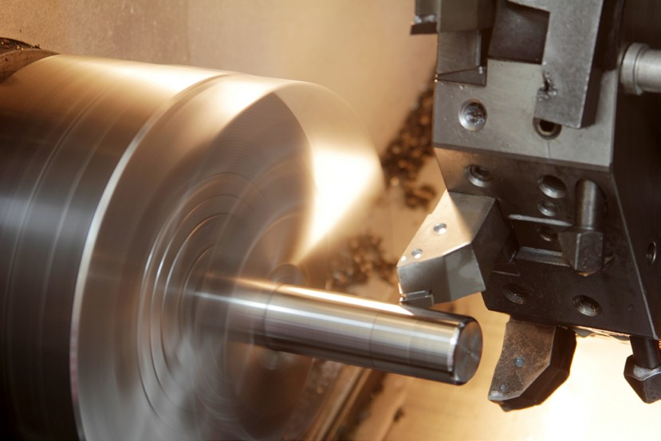
Computer-aided manufacture is a process whereby designs are input into a computer system and the computer then controls the production of
the item through automation and robotics. The use of CAM in production is widespread and is used
in a number of ways, but mainly in the control of machinery – for example robotic welders in vehicle production. These machines always produce welds of the same quality, day in day out.
The use of CAM can aid in flexibility of production. For example, reprogramming is quite simple;
but retraining a welder may be a great deal
more complex and costly. CAM can also cut costs in even small businesses. Tailors and dressmakers use CAM machines to cut material in the most economical way, ensuring that waste is minimised.
CAM equipment can be expensive and in the past is was mainly used by large scale businesses, however, in recent years the cost of this machinery has reduced and more and more small and medium scale businesses are now using CAM in the production of its products. However, it can also be expensive to maintain, replacement parts are not cheap!
One other drawback is that technology does break down from time to time and this can stop the whole production process, which can lead to missing deadlines with customers.
The advantages of using CAM compared to manual machines include:
  - Production is completed quicker
  - Greater accuracy
  - Greater consistency of finished product
  - Greater quality of product
  - Greater efficiency as machines don’t need breaks
  - Human error is minimised. 7

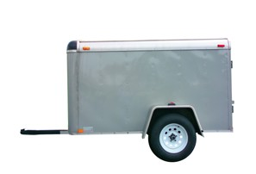
- Explain what is meant by automation. Give examples to illustrate your answer.
- What is the difference between CAD and CAM?

- Oliver Kendall Ltd aims to produce high quality trailers using a computer-aided manufacturing (CAM) system. Outline one advantage and one disadvantage for Oliver Kendall Ltd of using a computer-aided manufacturing (CAM) system.

- Explain how automation and the use of CAD and CAM have benefited consumers.

commerce and m-commerce
The development and widespread use of the internet over the last twenty years has had a huge impact on how a business sells its products and services.
Online shopping, which is also referred to as e-commerce and e-tailing, is a form of electronic commerce which allows consumers to directly buy goods or services from a seller over the internet. The internet has changed buying habits and e-commerce is now a very important part of the retail industry, and is continuing to grow. More recently there has been an increase in sales from wireless hand held devices; this is referred to as m-commerce.

E-commerce M-commerce
Online retailing allows customers to buy products without visiting a physical store. The constant development of new technology will result in the continuing development of new forms of online retailing.
Examples of online retailing include:
  - A retailer's own website
  - A third party market place, such as Amazon, eBay, Etsy, etc.
  - Social media, such as Facebook, Twitter and Pinterest.

The internet, and the use of search engines, has made accessing customers a great deal easier than in the past. All a business needs to sell its products is a decent website, some form of payment processing and ‘shop’ software. All of this can be created for less than £500. In fact, there are 1000s of entrepreneurs running their businesses through auction sites such as eBay, with hardly any fixed costs at all. All of these businesses mean extra competition for existing traditional businesses – as well as lowering prices for customers.

A comparison of prices has become a great deal easier for customers. Using the web, individuals can carry out their own research or use comparison sites, such as Money Supermarket, to find the best deal across a huge range of products. This access to pricing information has had an impact on prices charged by businesses. It has been argued by economists that the increase in internet shopping has had a direct impact on lowering inflation rates.
M-commerce is the buying and selling of goods and services through wireless handheld devices such as mobile phones and tablets. This means ‘having your retail outlet in your consumer's pocket’. Through mobile technology, it is now possible to reach customers 24 hours a day. M-commerce does not just mean buying: it is about providing customers with product information and promotions. Consumers use m-commerce to compare prices online, take photos for future reference and research their potential purchases online.

'Clicks and bricks' is a marketing term which means that businesses need to have a web presence (clicks), plus a physical presence on the high street or in shopping centres (bricks).
Examples of businesses using this to distribute their products include PC World, Argos and Tesco. Each of these businesses have been very successful in using a web presence to increase sales and customer loyalty.
Read the following article then answer the questions that follow:

Almost 6 000 online shops hit by hackers

Almost 6 000 web-sites are unknowingly harbouring malicious code that is stealing the credit card details of customers, suggests research. The code has been injected into the sites by cyber thieves, said Dutch developer Willem De Groot.
Mr De Groot said the attacks exploited known vulnerabilities in several different widely used web retailing programs. Mr De Groot is co-founder and head of security at Dutch ecommerce site byte.nl

Having won access, the attackers injected a short chunk of code that copied credit card and other payment information. Stolen data was being sold on dark web markets at a rate of about $30 (£25) per card, he said. His research found nine separate types of skimming code on sites, suggesting many different crime groups were involved.
Mr De Groot said he had been investigating skimming since his own card details were stolen. Victims included carmakers, fashion firms, government sites and museums.

The code used to steal data steadily became more sophisticated and now makes efforts to hide itself and tackle more types of payment systems.
"New cases could be stopped right away if store owners would upgrade their software regularly," wrote Mr De Groot. "But this is costly and most merchants don't bother." Mr De Groot said some stores had taken action to flush out the skimming code and patch their stores after he published a list of compromised sites.

"I would recommend consumers to only enter their payment details on sites of known payment providers such as PayPal," he told the BBC. "They have hundreds of people working on security, the average store probably has none."
Adapted source: http://www.bbc.co.uk/news/technology-37643754

- What dangers are associated with online shopping?
- How can online retailers reduce the risk of skimming codes?

In an era of rapid change and increasingly advanced technology, it is certain that online shopping will continue to evolve. Who can guess how we will be shopping in 5 or 10 years’ time.
Businesses will have to keep up with the technological changes or face being left behind. Competitors will look to utilise new technology to gain sales and consumers will always demand new and improved experiences when spending their money. It is likely that
  - ommerce will continue to grow and the challenge to online retailers and smart phone manufacturers is to improve the online experience through more compatible software, multiple screens, easier checking out procedures and improved security procedures.

One other possible change in future years is the growth of the personalisation of the online shopping experience. With increased amount of data that is available online and the growth of social media it could be possible for the consumer to have more control of the buying of products online. Another area of growth is social shopping where consumers interact with each other on social platforms, retailers can join this conversation and offer products that match the profile of the engaged consumers.
- Online selling has increased the potential size of a business' market. Explain this statement.
- Explain the impact of increased online shopping on traditional high street shops.

Digital media
The advancement in digital media has been one reason for the rapid growth of online shopping and social media websites. Digital media includes a wide range of computer software including imagery, videos, audio, webpages, games and e-books that can be communicated via the internet and computer networks.

The development of digital media has impacted on traditional media such as print and analogue media, for example the sales of newspapers and music through CDs, have declined as a result of consumers purchasing these digitally.
Digital media is used by a wide range of businesses of all sizes and digital methods of communication and marketing are faster and more versatile than traditional methods.

Digital marketing is used on websites, blogs, internet banner adverts, online videos and email and mobile marketing. Digital marketing costs less than traditional offline marketing methods. An email or social media campaign, for example, can communicate a marketing message to consumers for much cheaper than a TV ad or print campaign and yet reach a wider audience. It can be used by businesses of all sizes and allows smaller scale businesses to compete with larger multinational companies.

Social media

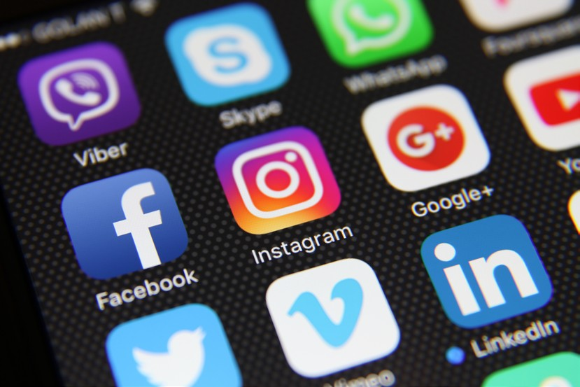
Social media has drastically changed in the way in which a business can communicate with its
customers. These interactive platforms are used by over 2 billion people in the world; most internet users use a social media website on a regular basis. The most popular of these social websites have become a huge source of information for businesses and a new platform to target consumers.

The article below outlines the main benefits on how social media can benefit businesses.

Gain valuable customer insights

Social media generates a huge amount of data about your customers in real time. Every day there are over 500 million Tweets, 4.5 billion Likes on Facebook, and 95 million photos and videos uploaded to Instagram. Behind these staggering numbers is a wealth of information about your customers – who they are, what they like, and how they feel about your brand.
Through daily active engagement and social listening, you can gather relevant customer data and use that information to make smarter business decisions. With Hootsuite Insights, for example, you can gather information across all your social networks in real time – allowing you to gauge customer sentiment, find the conversations happening around your brand, and run real-time reports.

Increase brand awareness and loyalty

When you have a presence on social media, you make it easier for your customers to find and connect with you. And by connecting with your customers on social media, you’re more likely to increase customer retention and brand loyalty. A study by The Social Habit shows that 53 percent of Americans who follow brands on social media are more loyal to those brands.

Run targeted ads with real-time results

Social media advertisements are an inexpensive way to promote your business and distribute content. They also offer powerful targeting options so that you can reach the right audience. For example, if you run an ad campaign on LinkedIn, you can segment by things like location, company, job title, gender, and age the list goes on. If you’re running a Facebook advertisement, you can target based on location, demographics, interests, behaviours, and connections. You can track and measure the performance of your social media advertisements in real time.

Generate higher converting leads

Social media increases sales and customer retention through regular interaction and timely customer service. In the 2015 Sales Best Practices Study from research institute MHI Global, world-class companies rated social media as the most effective way to identify key decision makers and new business opportunities. In the State of Social Selling in 2015, nearly 75 percent of companies that engaged in selling on social media reported an increase in sales in 12 months.
11

Provide rich customer experiences

Even if you aren’t on social media, most of your customers expect you to be. Over 67 percent of consumers now go to social media for customer service. They expect fast response times and 24/7 support – and companies that deliver win. A study by Aberdeen Group shows that companies engaging in social media customer service see much bigger annual financial gains.

Increase website traffic and search ranking

One of the biggest benefits of social media for business is using it to increase your website traffic. Not only do social media help you direct people to your website, but the more social media shares you receive, the higher your search ranking will be. For example, if every person who follows Hootsuite on Twitter retweets this post, it’s more likely to rank higher in Google’s search engine results page for variations of “social media for business.”

Find out what your competitors are doing
With social media monitoring you can gain key information about your competitors. This kind of intel will allow you to make strategic business decisions to stay ahead of them. For example, you can create search streams in Hootsuite to monitor industry keywords and mentions of your competitors’ names and products. Based on your search results, you can improve your business to offer product enhancements, service, or content that they may be missing.

Share content faster and easier
In the past, marketers faced the challenge of ensuring their content reached customers in the shortest possible time. With the help of social media, specifically when it comes to sharing content about your business, all you need to do is share it on your brand’s social network accounts.

Geotarget content

Geo-targeting is an effective way to send your message out to a specific audience based on their location. Social networks like Facebook and Twitter have tools that allow you to
communicate the right kind of content to your audience. For example, in Hootsuite you can target Twitter messages to followers in specific countries, or send messages from Facebook and LinkedIn company pages to specific groups based on geographical and demographic parameters. You can also use Hootsuite geotargeting to find conversations relevant to your brand.

Build relationships

Social media isn’t about blasting your company’s sales pitch on social, it’s a two-way channel where you have the opportunity to enrich relationships with your customers. For example, social media allows tourism brands to create dialogue with travellers, therefore creating relationships with customers before, during, and after they have booked a trip with the company. This kind of social media dialogue between brands and customers is something traditional advertising cannot achieve.
Source: https://blog.hootsuite.com/social-media-for-business/

Having the right social media presence is very important for businesses. A recent survey carried out in the UK reported that nearly 80% of consumers would buy more often in the future because of a brand's presence on social media. Many businesses, small and large, will carry out social media campaigns as part of their marketing process:

    - 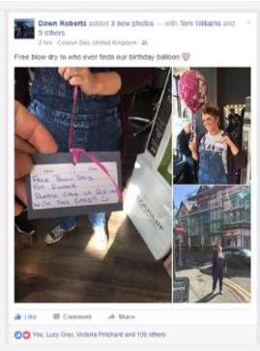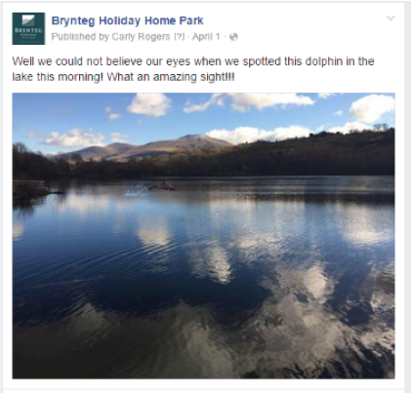April Fools Prank - WilliCreative For Brynteg
A little photoshop editing and we were able to play a fun April Fools prank on our client Brynteg Holiday Park's audience. The post reached over 7,000 people organically.

    - Free Blow Dry

Colwyn Bay based hairdressers Phase 3 ran a brilliant birthday campaign to celebrate their 4th year in business by offering a free blow dry to anyone who found their birthday balloon.

Source: http://www.networkshe.co.uk/11-examples-brilliant-social-media-campaigns- worked/

A quick look on most websites will show what social media platforms businesses are using to help them communicate with their customers:
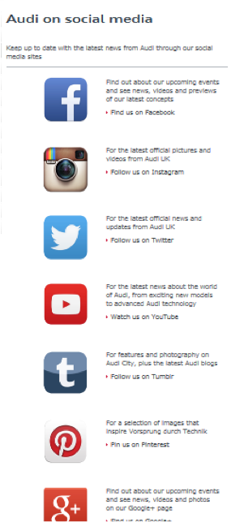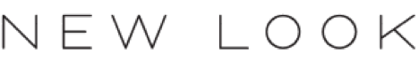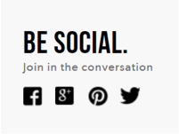

Negative impacts of new technology

Although technology brings many advantages to businesses and its stakeholders it also has various disadvantages, these include:

      - Cost – rapid developments in technology mean that businesses are constantly trying to adopt the latest technology, in order to gain an advantage over their competitors.
Introducing new technology is not cheap and small businesses may not be able to afford the purchase of the equipment or services to maintain its operation. This could result
in business closure if larger businesses are able to use technology and increase their dominance in the market.

      - Increased dependence on technology – this can lead to problems when the technology breaks down as the business will not be able to conduct its activities and could lead to loss of sales and dissatisfied customers.

      - Loss of jobs – technology will replace some jobs; the manufacturing industry now employs fewer workers as many tasks are completed by robots. The banking industry has also made workers redundant as services are now being carried out by automated machines and online banking services. However, the growing demand for computers, software and hardware, has created additional employment opportunities.

      - Closure of high street shops – the increasing popularity of online shopping has resulted in more goods being bought online and less goods being bought in stores. The reduced costs for the retailer to sell online results in many high street stores closing and some traditional shops closing all together.

      - Security breaches – paying for goods and services online does increase the risk of online fraud and, many people who have experienced this don’t even know that money has been taken from their account. As e-commerce requires details to be held online there is also the risk of identity theft.

Will a robot take your job?
Log onto to http://www.bbc.co.uk/news/technology-34066941
Type in different jobs to see the likelihood that it could be automated in the next 20 years.

However it could be argued that the biggest winners from the new technology introduced by businesses are consumers who benefit in a number of ways:
- The internet provides easy price comparison and much more information through review sites
- More choice
- Lower prices
- Improved quality
- Convenience through home shopping and pre-arranged delivery times.

Ruby and Frank have always wanted to start their own business. They have decided to set up their business, called Retro, on the outskirts of Chester. Their shop will meet the increased demand for goods fashionable between 1950 and 1980. Some of the goods will be from the actual time and others will be reproductions.
Ruby and Frank appreciate the importance of technology to their business.

- Suggest and explain ways in which they can use technology in the operation of their business.
- Advise Ruby and Frank on the disadvantages of using new technology in their business.

- Explain how selling products through the internet will reduce costs for businesses.
- Why do businesses use social media as a marketing tool?

- Only large scale businesses have benefited from the use of digital and social media. Do you agree with this statement?

Ethical influence on business activity
Ethics is about what is right and what is wrong.
Anita Roddick founder of The Body Shop “Being good is good business”
In business, ethics are the moral values that direct business behaviour. An ethical business is one that considers the needs of all stakeholders when making business decisions. An ethical business, when setting objectives, takes into consideration its social responsibilities. Ethical businesses consider the moral rights and wrongs of any decisions that are made.
Acting ethically involves being:
  - Honest
  - Trustworthy
  - Fair
  - Caring
  - Respectful
  - Lawful
  - Accountable
Explain what the ethical traits above mean in the content of operating a business. The first one has been done for you:

Honest – when you act honestly people will trust you, making honest decisions will result in support from employees and customers who appreciate your honesty. Don’t deceive others by telling lies or misrepresenting the truth. If a mistake has happened, such as the wrong product being delivered to a customer, don’t try to blame someone else, be honest and apologise for the error – it is likely that this will be appreciated by the customer who is then more likely to trust you and become a loyal customer.

Acting ethically is regarded as good business practice in the modern business environment.
Businesses today have a much wider set of social responsibilities than in the past and ethical awareness has influenced businesses in many ways, for example, some businesses only seek to purchase products from Fairtrade producers in order to ensure suppliers receive
a fair price for their goods. Other businesses have sought to raise wages to improve living standards for their workers in poorer countries.

Examples of ethical issues include:
- Should we use suppliers who don’t pay a living wage?
- Do we ensure all our marketing material is accurate and truthful?
- Do we sell products that were tested on animals?
- Should we reduce the price on harmful products, such as beer and cider, to gain higher sales?
- Do we support our workers when they require time off work when experiencing personal or family difficulties?
- Do we dispose of waste materials in the best way to reduce environmental impact?
Ethical considerations include:

Employees
Businesses should treat employees as their most valuable asset. This means taking care of their health and safety and conditions of work and also paying a living wage. Their ethical responsibilities should not stop with their own employees. Those working for suppliers are equally as important. It cannot be regarded as ethical if a business claims to pay its own employees a living wage if workers further down the supply chain, in perhaps a less developed country, earn the equivalent of 40p an hour.

Suppliers

Suppliers should also be treated fairly, this means sticking to agreed contracts, and not forcing renegotiation upon suppliers. It means paying on time and not putting pressure upon suppliers’ cash flow. Fair trade claims should be backed by positive action, for example, it is not fair trade to charge a customer an extra 30p for fair trade chocolate or tea or coffee and then pass on only a fraction of the 30p price increase to the supplier.

Customers

Customers want a quality product or service at a fair price. Businesses which act unethically fail to fulfil this moral commitment to customers. For example, the PPI scandal was a double failure on the part of many of the major banks in the UK. Not only was the insurance cover provided through PPI often irrelevant to customer needs, it was massively overpriced.

Another ethical issue is how to conduct marketing activities in an ethical way, for example, using false claims in marketing products, such as exaggerating the benefits of using a certain product to improve health or looks. When advertising, a business should take care not to offend consumers through using violence, sex or bad language or creating adverts that may upset certain customer groups.

Animal welfare

Animal welfare is a major issue for those retailers with claims to be ethical. Grocers look down the supply chain to ensure the welfare of animals, and can focus their marketing on how well supplying farmers treat their livestock. The demand for ‘free range’ products is a good example of how retailers have responded to their customers’ concerns.

Clothing retailers too have responded to animal rights issues in relation to the raw materials they use. PETA (People for Ethical Treatment of Animals) has ensured that the argument
has progressed well beyond fur skin coats, covering treatment of other animals used in the

clothing supply chain.

Fairtrade
This is a movement that supports the fair treatment of farmers in getting a fair price for their
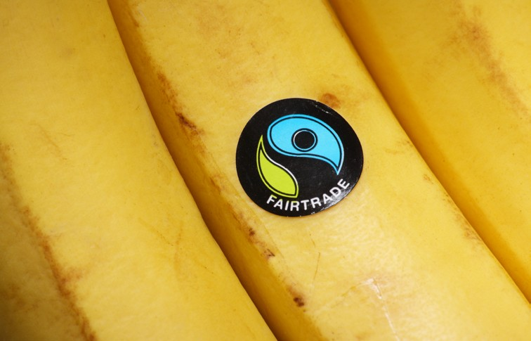
products. Farmers who engage in fair trade also aim to pay their workers a fair price, and engage in environmentally- friendly practices. Fairtrade aims to improve living standards for poor farmers in developing countries.
Fairtrade offers consumers a direct way to reduce poverty through their everyday shopping. When a product carries the Fairtrade mark it means the producers and traders have met Fairtrade Standards. Fairtrade products are becoming more widespread and include tea, coffee, sugar, chocolate and cotton.
Visit the Fairtrade foundation website http://www.fairtrade.org.uk/en/what-is-fairtrade Select one of the headings below and produce a poster that highlights the main points:
- What Fairtrade does
- Where Fairtrade works
- What is the Fairtrade Foundation
- The impact of Fairtrade.

Social responsibility
Businesses have a responsibility that goes beyond making profits for their shareholders. Businesses need to monitor and take responsibility for the impact they have on both social welfare and the environment. Many businesses have a corporate social responsibility (CSR) policy that sets down its ethical principles. When looking at their social responsibility they may ask questions such as:
- How well do we ensure human rights?
- Do we use suppliers who use child labour?
- Do we discriminate when recruiting?
- Do we pay the correct level of remuneration for the job?
- How many women do we have in senior positions?
- Do we support any charities in the locality of our factories?
- Have we broken any laws?
- Do we compete fairly?
- Do we comply with all health and safety legislation?
- Is our advertising truthful?
- Have we caused any pollution?

Businesses are being forced to take action to accept social responsibilities through increased legislation. For example, we now have the minimum wage, four weeks paid annual holiday, requirements for dealing with suppliers and green taxes.

However, ethics and social responsibilities are ignored by some businesses where the profit motive has remained the major concern. This is to be expected; after all the priority of
all businesses has traditionally been the satisfaction of the owners’ needs – which means

increasing profits.

Many businesses will only focus on ethical issues after their profits are assured. For many limited companies, performance pressures mean that the short term profits are the priority. These pressures mean that ethics have to be ignored.

Small to medium-sized businesses may well not have the time or resources to focus on drawing up an ethical policy. However, many new enterprises are using an ethical stance as a USP and thriving as a result. Consumers and society are far more aware of ethical issues, and those businesses which ignore this growing trend run the risk of losing out to their competitors.

To be truly ethical and accept social responsibilities to the full, businesses must face many difficulties. However, although ethical actions cost money, which may mean smaller profits in the short-term, the hope for the ethical business must be that profits will grow in the long-term.

Ethics and profitability
Acting ethically can have a negative impact upon profitability:

- Costs are likely to rise. For example, paying a ‘living wage’, as opposed to complying with the minimum wage legislation, will increase labour costs. Building improved canteen facilities or providing sports facilities for employees would prove to be very costly.
- Revenues are likely to fall. For example, a toy retailer that refuses to target children with blanket advertising prior to Christmas will no doubt lose sales to their competitors. A construction company that declines to offer a bribe to a Third World government official when tendering for a contract may well not be considered for that project.
However, acting ethically can also improve profitability:

- Some customers are attracted to those businesses that adopt an ethical approach. Businesses who act in an ethical way will be viewed in a better light by consumers, which in turn may result in consumer loyalty. The business may see its sales increase, or may be able to charge a higher price for its products, as a result of its ethical credentials.
- Restaurants and coffee shops that source their ingredients from ethical suppliers appeal to a growing number of customers. Using ‘ethics’ at the heart of their marketing
campaigns can boost sales in certain instances. The growth of the Fairtrade movement is evidence of such a trend.
- Acting ethically can improve public relations (PR) and have a positive impact on the image that a business portrays. No business wants to have its name splashed all over the newspapers for mistreating its employees or using low quality ingredients that may be harmful to consumers. Checking supply chains carefully is not only ethical, but can also prevent significant loss of revenue and reputation.
- Employees who work for an ethical business are likely to have the same ethical beliefs and proud that they work for such a business. This is likely to increase their motivation to work hard and remain loyal to the business.

The Virgin Group was set up by Sir Richard Branson in 1970 and he is a major shareholder in all the companies. The Virgin Group is generally regarded as a business with strong ethical policies meaning that it treats its stakeholders such as suppliers, workers and customers with honesty and fairness.
Evaluate whether or not it is good for the business to have such ethical policies.

Read the following article and answer the questions that follow:

Can companies make us better citizens?
If you want to know what coffee and elections have in common, ask Starbucks.

In May, the US giant ran a campaign in the Philippines called "care to vote", which rewarded customers with a free drink if they turned out to vote in the country's general election.
Having visited a polling station, all customers had to do was show an ink-stained voting finger to a barista in order to get their complimentary coffee or other beverage.
"Our intent was simple," says Keith Cole, head of marketing for Starbucks Philippines.

"By helping to increase voter participation we believe more people will have an opportunity to make their votes count."
From campaigning on voting rights, to sustainability, healthy eating, and gender equality, businesses are increasingly speaking out about societal issues, in the hope of influencing - and improving – our behaviour.
The aim, they say, is to use their power and influence for good, and not just for profit.

The idea that brands might encourage us to be better citizens is not new. UK chocolate manufacturer Cadbury and US carmaker Ford invested heavily in the towns where their employees lived in the 19th and 20th Centuries, and in return expected workers to uphold certain values – both in and outside work.

But today such efforts tend to be more consumer-facing, the aim being to promote social good while encouraging brand loyalty.

Take the Dove Campaign for Real Beauty, which has been calling for a wider definition of female beauty since 2004. Run by Anglo-Dutch consumer goods giant Unilever, the owner of toiletries brand Dove, it aims to celebrate women of all shapes and sizes.

Unilever says the scheme has "pioneered the use of attainable images of beauty" in advertising, using women "with real curves".
At the same time, Unilever saw annual sales of Dove products reportedly increase from
$2.5bn (£1.9bn) to $4bn in 2014.

Responsible drinking

Another example is Dutch brewer Heineken, which has promoted moderate drinking in its advertising since 2011.

Heineken PR manager Milly Hutchinson says that the firm believes it has "a role to play in society", and the "perfect platform to spread the message of moderate consumption".
However, she adds that the firm is also reflecting a "discernible shift in consumer behaviour", as its own research shows that a majority of young adults now limit the amount of alcohol they drink.

A Heineken survey published in January found that 75% of drinkers aged between 21 and 35 limited the amount of alcohol they drank on the majority of their nights out. The study was conducted across five countries – the US, the UK, the Netherlands, Mexico and Brazil.
Charlotte West, from UK charity Business in the Community – which encourages businesses to make a positive difference to society or their local community – says it is true that a growing number of firms are making their campaigning voices heard.

She says that the trend has been partly driven by the rise of social media, which has empowered consumers to hold brands to account in an unprecedented way. And so firms are having to respond.
"More and more, customers want businesses to stand for social impact, and in our changing world they have to play a bigger role in solving societal problems," she adds.

However, Laura Spence, professor of business ethics at Royal Holloway, University of London, cautions that "there is bound to be some enlightened self-interest in these campaigns".
She adds: "Companies can see that being associated with a certain practice reflects well on them, and might bring in additional customers.
"But they can risk seeming preachy too, which doesn't always play well."

Vicki Loomes, an analyst at consultancy Trendwatching, says: "If companies are going to campaign on an issue, it needs to be something they are invested in long-term and aligned with what they do."

She adds: "It cannot be a three-month marketing campaign, talking about something like immigration, simply because it is the most newsworthy topic going around."

Ms West of Business in the Community agrees. "People can see through rubbish, so it has to
be authentic and honest and relevant to your brand."

Clearly companies must strike a delicate balance when weighing in on social issues, but it seems that we would rather they tried than did nothing at all.
"Businesses have realised they can't just grow and take away from people," says Ms West.
"They have to grow while giving back, which I think is a really responsible capitalist approach."
Adapted source: http://www.bbc.co.uk/news/business-37057981

- What ethical issues are the businesses in the article concerned with?
- Explain why the businesses are acting ethically.
- Do you agree that these businesses should act in this way?

Environmental influence on business activity
The production, distribution and selling of goods and services has negative effects on the natural environment. These environmental costs include:

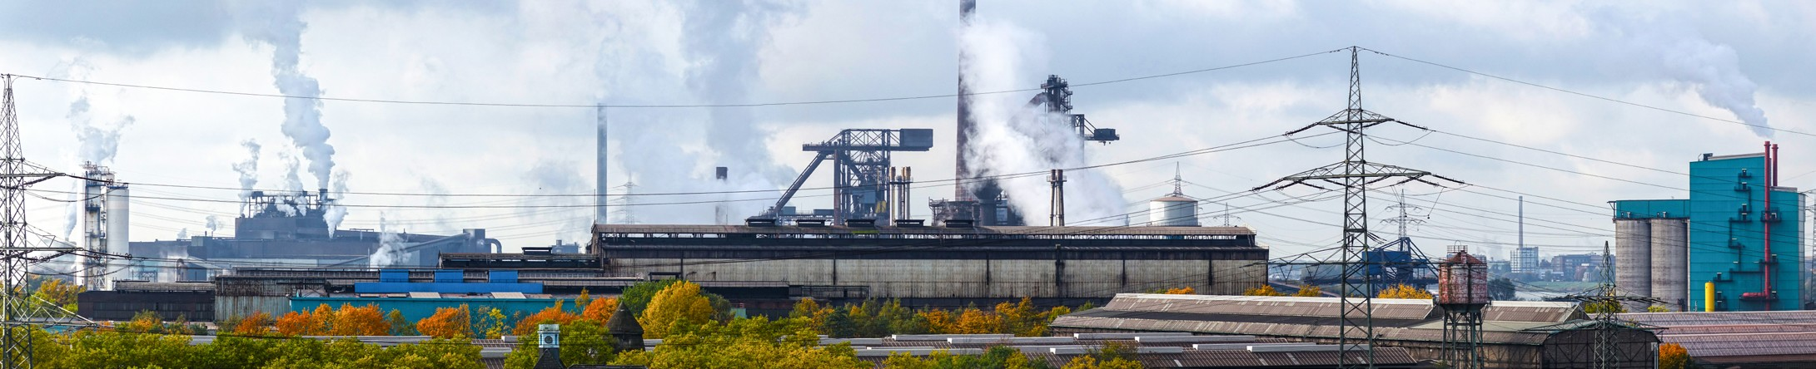

  - Noise pollution
  - Air pollution
  - Water pollution
  - Light pollution
  - Litter
  - Congestion
  - Waste
  - Climate change

  - Use of finite resources – the natural resources available to us are limited, we only have them available to us on our planet and once these have run out it will not be possible to create more.
Human beings are never satisfied with what we have – as soon as we have a new pair of shoes we think about the next pair we are going to purchase. Our wants are described as being unlimited; we constantly demand new clothes, high-tech cars, the latest gadgets etc. We consume more and more products while being unconcerned by the environmental impact of our lifestyle.
Protecting the environment is now a mainstream business issue. In the past businesses ignored their impact on the environment. The awareness of climate change has risen rapidly and is a major concern, however, this is only one of many environmental issues of which businesses have to consider. Other issues include water and noise pollution, congestion, destruction of the environment and waste disposal.
The negative environmental impact of business activity used to be largely ignored by nearly all stakeholders. Today things are very different. The government and pressure groups (whether local or global) have a strong influence on business activity and, to some extent, they are able to limit the environmental impact of business activity. As well as these external influences, many businesses now undertake the control of their environmental impact

without the need for external pressure. Some produce and publish their own environmental audits, which measure their impact on the environment and set out plans for improvement.
Consider the negative impact the following businesses can have on the environment:
- Travel company
- Supermarket
- Manufacturer of electrical household goods
- Fast food take away restaurant.
Businesses are under increasing pressure from consumers and governments to act in a responsible manner and to ensure that our environment and resources are available for future generations to enjoy. This is often referred to as sustainability.

A business that aims to be sustainable will attempt to minimise its overall impact on the environment.
There are many ways that businesses can act in a sustainable manner:
- Reduce the amount of packaging on products
- Increase recyclability of packaging and the introduction of biodegradable packaging
- Promote recycling schemes
- Encourage the re-use of carrier bags
- Introduce energy saving schemes
- Use alternative sources of energy
- Use more energy-efficient equipment
- Reduce water consumption
- Reduce their carbon footprint
- Encourage smarter use of transport
- Eliminate unnecessary business activities
- Switch to more sustainable suppliers.

Complete the table below by giving examples of how businesses can act in a sustainable manner, the first one has been done for you.
Sustainable action | Examples
Reduce the amount of packaging on products | Chocolate manufacturers have reduced the packaging on many of their products including Easter eggs. It is possible to get refill packs for products such as coffee and  washing powder which reduces the amount of  resources needed to produce the packaging.
Increase recyclability of packaging and the introduction of biodegradable packaging
Promote recycling schemes
Encourage the re-use of carrier bags
Introduce energy saving schemes
Use alternative sources of energy
Use more energy-efficient equipment
Reduce water consumption
Reduce their carbon footprint
Encourage smarter use of transport
Eliminate unnecessary business activities
Switch to more sustainable suppliers

Many businesses have improved the sourcing of local produce and often promote local and regional produce. This money is then put back into the local economy, enhances the viability of other local businesses and reduces emissions (carbon footprint) and congestion that result from the long-distance transportation of goods.

Waste is also a major issue for businesses. Waste impacts on many different areas of the environment, from the excessive use of materials and resources (e.g. unnecessary
packaging), the production of pollutants as a by-product of the manufacture of goods and the safe disposal of waste generated. Pressure on landfill sites is at an all-time high and the identification of suitable alternative means of disposal presents some difficult problems for businesses. Businesses are increasingly recognising opportunities to reuse and recycle. This can even help to reduce costs and even improve profitability.

Select one large business with a website. Search for information about its environmental policy and sustainable actions and summarise these in a one page information sheet.

Read both the articles below to see how business activity impacts on the environment and how they can respond.

Network Rail and GWR warned over depot noise and air pollution
Noise and air pollution from a new rail depot in Reading could prompt legal action, it has been warned. Reading Borough Council said it had written to Network Rail and Great Western Railway (GWR) demanding action following complaints from residents.
People in Cardiff Road had complained of trains parked in sidings with engines idling. GWR has previously said the introduction of electric trains in 2019 will reduce the problem.
An online petition set up by residents living close to the GWR depot complained about "low- frequency noise" from trains idling in the early hours of the morning.
Deputy council leader Tony Page said the responses form the companies had so far been "inadequate”. “The council is fully supportive of the huge benefits the realignment of rail lines in and around Reading has brought.
"By the same token, the concerns local residents have [about] noise and air pollution are very real and the council is lobbied on these issues regularly.
"We hope that escalating local concerns to senior management will prove more effective." Earlier this year, GWR said the noise was within safe levels and it had changed the way it operated trains on the sidings.
Jonathan Dart, chairman of the Bell Tower Community Association, said he warmly welcomed the council's announcement to "put an end to the nuisance being caused to the residents of Cardiff Road".
However, he criticised the time it took the authority to investigate the issue.
"It took nine months and a press campaign for the council to release an officer's report stating that being in part of Cardiff Road at 03:29 was akin to being backstage at the Reading Festival," he said.
Source: http://www.bbc.co.uk/news/uk-england-berkshire-36745839

Google data centres to be 100% renewable-powered by 2017

Google has confirmed it will hit its target of offsetting 100% of the energy used at its data centres and offices against power from renewable sources. The firm first made the commitment in 2015 to go 100% renewable by 2017.

In a blog, the company said it was now the largest corporate buyer of renewable energy in the world. Fossil fuels are still used by Google, but now it buys enough electricity from renewable sources to offset energy use at the data centres and offices.

Its 13 data centres alone consumed around 5.7 terawatt-hours (TWh) of electricity a year. "Over the last six years, the cost of wind and solar came down 60% and 80% respectively, proving that renewables are increasingly becoming the lowest cost option," said Urs Holzle, senior vice president for technical infrastructure.

He added: "Since the wind doesn't blow 24 hours a day, we'll also broaden our purchases to a variety of energy sources that can enable renewable power, every hour of every day."
The move by Google has been welcomed by Friends of the Earth (FoE).

"Google has come up with the right answer: investing in renewable power is good for business and good for the planet," said FoE energy campaigner Alasdair Cameron.

He added that he believed companies, cities and even entire countries will switch to 100% renewable sources of energy.

In 2010, Germany's environment agency noted that the country could be 100% powered by renewable energy sources by 2050, for example.

Mr Cameron is also calling on the UK government to follow in the footsteps of Google and to continue to invest in renewable energy sources.
Adapted source: http://www.bbc.co.uk/news/technology-38227491

Implementing environmentally friendly policies can bring a number of advantages:
- Reduced business costs
- Avoiding legal penalties

- Improved business and brand reputation – environmental friendliness can be a highly effective marketing tool

- Recruitment and motivation of employees who commit themselves to ethical company objectives
- Greater customer loyalty from growing number of ethical consumers
- Reduced wastage.

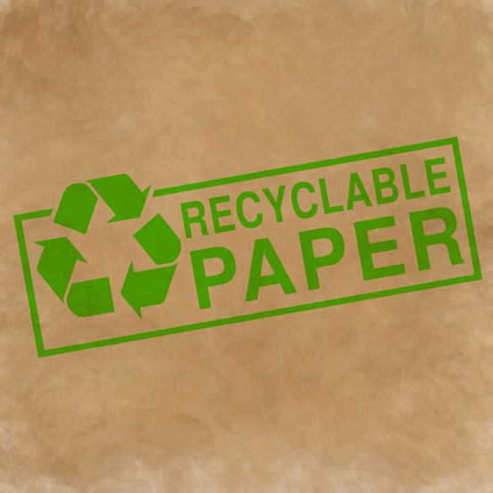
The majority of consumers care about the environment. Sales in Fairtrade coffee, tea, chocolate, etc. are increasing and adverts showing how
businesses recycle and replenish are common, such as toilet paper businesses replanting trees.

Supermarkets also offer recycling of waste products to customers, such as battery bins, and loyalty points for reusing carrier bags. Some businesses work with environmental groups, and actively try to educate consumers on the need to look after the environment.
However, for many businesses, the introduction of
environmentally friendly policies can result in higher costs to the business as they change equipment, seek new suppliers or implement new processes. In turn, these higher costs can result in increased prices for their customers who may then decide to go elsewhere.

- Suggest two ways in which a clothes manufacturer could improve its eco-friendly policies.

- Some very large supermarkets use a variety of methods in an attempt to pay as low a price as possible to the many small businesses which sell them food products. Although this practice may be legal, it is considered by some to be unethical.
Explain why the methods used by some supermarkets might be considered to be unethical.

- Burger Plus has received bad publicity about its environmental standards. Litter is a major problem outside many of its fast food takeaway restaurants.

Suggest and explain two actions the business can take to improve its environmental and ethical reputation.

Greggs plc has adopted a number of environmental and ethical policies. These include donating unsold food to charities for low income families, selling fair trade products, reducing packaging for products, cutting food waste and reducing the amount of energy used in production.

Discuss the advantages and disadvantages to businesses, such as Greggs plc, of adopting environmental and ethical policies.

Economic influence on business activity
Business activity can be hugely affected by the state of the economy. That state of the economy will affect how much consumers spend on goods and services. Consumer incomes will rise and fall depending on a number of economic factors. When consumer incomes increase the demand for goods and services will also increase. When incomes fall the demand for the product will decrease.
So the more a person earns the more they will spend. Businesses are concerned about disposable income which is the amount of money that households have available for spending and saving after income taxes and other mandatory costs have been deducted. For example:
A family have a household income of £120 000. The family have to pay an income tax rate of 40%.
This household's disposable income would then be £72 000 (£120 000 - £48 000).

Disposable income is what businesses hope consumers will spend on their products and services. If wages and salaries rise faster than a rise in prices, then disposable income will increase and this leads to a higher level of spending.
Consider what impact the following situations will have on businesses:
- A general increase in disposable incomes of all consumers
- An increase in disposable incomes of low income families
- A decrease in disposable incomes of households earning above the national average
- A decrease in disposable incomes of retired people.
There are a number of factors that will influence the level of consumer income, these include:
  - Tax rates
  - Unemployment
  - Interest rates
  - Inflation.

Taxation
Tax is paid by individuals and businesses to the Government. The revenue raised through tax is then spent by the Government on providing public services such as the National Health Service, education, housing, defence etc.
The payment of tax is compulsory and the amount paid is calculated by a percentage of earnings.
There are several different types of tax payable in the UK; however, you only need to know about the following types:
  - Income Tax
  - National Insurance
  - Value added tax (VAT)
  - Corporation tax
  - Business rates.

Taxes can be broadly split into two types. Direct taxation (taxation on income) and indirect taxation (taxation on spending). Income tax, National Insurance and Corporation Tax are examples of direct taxation. VAT and Business Rates are examples of indirect taxation.
Direct taxes have to be paid by the individual direct to the government – they cannot avoid paying this tax by passing it on to someone else. There is direct link to the amount a person earns and how much tax they pay. Direct taxes are progressive (the more you earn the more you pay).

Indirect tax is a tax on expenditure and not on income. The good or service bought is taxed so regardless of how much a person earns they will all pay the same rate of tax on the good or service. Businesses that have to pay indirect taxes often pass this cost onto consumers by increasing their prices. Indirect taxes are called regressive as they are not based on the ability to pay.

Income tax
Income Tax is a tax on a person’s income, this form of tax is a statutory (this must be paid) deduction from an employee’s wages. Each person has an income tax personal allowance, and income up to this amount in each tax year is free of tax (it was £11 000 in 2016/17).
People earning different amounts of income will pay a different amount of income tax, the more a person earns a higher percentage of their income is paid in income tax. Currently there are 3 different bands of tax that show how much tax has to be paid (for 2016/17):

Tax rate | Income | Percentage of tax to be paid
Personal allowance | Up to £11 000 | 0%
Basic | £11 001 - £43 000 | 20%
Higher | £43 001 - £150 000 | 40%
Additional | Over £150 000 | 45%
If an individual earned £30 000 then they would pay the following income tax to the Government:
£0 - £11 000 =0
£11 0001 to £ 30 000 = 20%

So £18 999 is taxable at 20% = £3 799.80 is the amount of tax to be paid. This person will therefore have an income after income tax of £26 200.20
Identify the correct rate of tax and calculate the amount paid and the income after tax for the following people:
- Harry Smith is a manager of a large computer retailer, he earns £ 36 000 per annum
- Julie Vaughn is a senior manager working for the NHS, she earns £120 000 per annum
- Dale Phillips works as trainee plumber and earns £14 000 per annum
- Hannah Ainsley works part-time in a local restaurant and earns £10 000 per annum

National insurance

Individuals have to pay National Insurance contributions in order to pay for state benefits including the state pension.
National Insurance is now used to pay for:
- The NHS
- Unemployment benefit
- Sickness and disability allowances
- The state pension

An individual will have to pay National Insurance if they are 16 or over, an employee earning above £155 a week or self-employed and making a profit of £5 965 or more a year. If a person does not make any National Insurance contributions (for example they are unemployed) then they may not receive benefits, or the full rates of benefits, such as the state pension.
An individual is given a National Insurance number which is used to identify the amount paid in National Insurance contributions. The amount paid is directly linked to the amount earned
- though it has a much more complicated rate and band structure than Income tax.
In addition to individuals paying National Insurance, employers also have to make contributions for the people they employ; this is based on a percentage of the employees' earnings.
Both income tax and National Insurance are paid to the government through the pay as you earn (PAYE) system, which is directly taken out of the pay an individual earns. The amount paid is noted on pay slips.

Value added tax (VAT)

VAT is a tax on the purchase of goods and services. VAT is charged on most goods and services that consumers purchase (such as trainers and cinema tickets) and on goods and services that businesses purchase (such as accounting services and printer ink). The standard rate of VAT increased to 20% on 4 January 2011 (from 17.5%).

VAT rates for goods and services
Standard rate | 20% | Most goods and services
Reduced rate | 5% | Some goods and services, e.g. children’s car seats and home energy
Zero rate | 0% | Zero-rated goods and services, e.g. most food, postage stamps and children’s clothes
Food and drink for human consumption is usually zero-rated but some items are standard- rated, including alcoholic drinks, confectionery, crisps and savoury snacks, hot food, sports drinks, hot takeaways, ice cream, soft drinks and mineral water.
Physical education and sports activities, betting and bingo, lottery tickets, admission charges to museums, art exhibitions, zoos and performances, charitable fundraising events, care
or medical treatment provided by a qualifying institution like a hospital, hospice or nursing home, education, vocational training and other connected services provided by an eligible body like a school, college or university are all exempt or have a zero rate of VAT.

- What affect will a raise in VAT have on consumers?
- VAT is an example of an in direct tax, what does this mean?
- Why are some goods and services exempt or have a lower rate of VAT?

Corporation tax
Unlimited businesses, such as sole traders and partnerships, and limited companies are taxed differently:

  - A limited company is taxed as a separate legal entity from its owners and directors, whereas sole traders and partners and their business are taxed as one single entity. Limited companies are subject to Corporation Tax on their annual profits.
  - All sole traders and partners are taxed via a self-assessment system each year, and pay Income Tax and National Insurance Contributions on their business profits after deductions for expenses.
The Corporation Tax rate for company’s profits is currently 20%.

For limited companies of any size, Corporation Tax is charged at 20%. For a sole trader or partnership, profits are taxed at 40% on taxable income in excess of £32,001 and 45% over
£150,000 (rates accurate for 2016/17).
Using the figures above explain the advantages of operating as a limited company and not as a sole trader or partnership.
Corporation Tax is a tax on company profits, it is paid before shareholders are paid their dividend. It is sometimes called Corporate Tax or Business Tax and is another example of a direct tax. The tax is calculated from the net profits earned by a company.

Taxable profits include the money a business makes from trading, any investments they have and selling any assets for a profit.

If a UK based company sells abroad then it has to pay Corporation Tax on all its profits from the UK and abroad. If a company isn’t based in the UK but has an office or branch in the UK, it only pays Corporation Tax on profits from its UK activities.
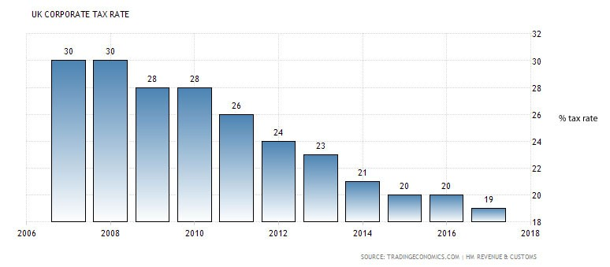

34

- Describe what has happened to the Corporation Tax rates over the last 10 years.
- Why would governments want to reduce the rate of Corporation Tax?

There have been some recent high profile cases of large businesses and tax avoidance:

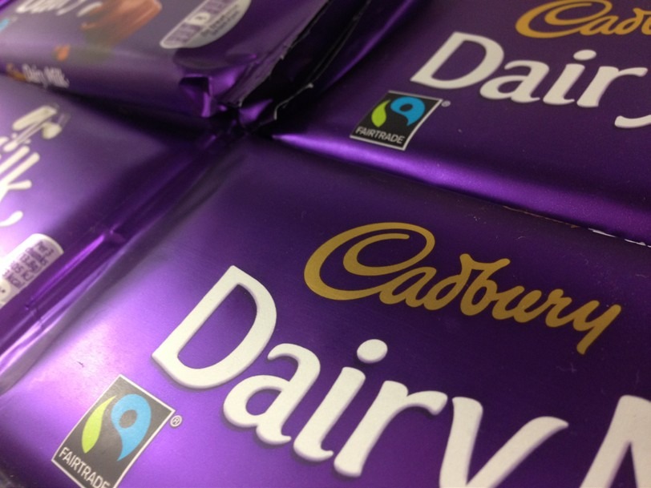Anger over Cadbury Corporation Tax avoidance

The union representing workers at Cadbury's chocolate factory has reacted with anger to news its parent company has not paid UK Corporation Tax. The Sunday Times reported Mondelez International "lawfully avoided tens of millions of pounds" of tax since its takeover of Cadbury five years ago. In 2014 it made a profit of £149m.
Unite Trade union regional officer Joe Clarke said: "Nifty footwork by clever accountants meant that
the Treasury was denied millions of pounds in corporation tax that could have been spent on the NHS and other much-needed public services.
"While the exchequer is denied its due from Mondelez, shareholders are feasting on dividend payments of £1.3bn."

In response to criticism over its tax activities, Mondelez International said: "We comply with UK tax law and, as with all global businesses, pay tax based on the laws of the country we operate in.
"We have invested over £200m into the future of our UK business over the past five years and we contribute £1.06bn to the UK economy."

Labour's Margaret Hodge, who chairs the Commons all-party group on responsible tax, told the Sunday Times the Quakers who founded Cadbury in Birmingham in 1824 would be "turning in their graves".
She said: "Cadbury has a proud history of investing in its communities. Yet this American company is avoiding taxes while using our workforce and infrastructure. It is selfish in the extreme and shows contempt for the people who buy their goods."
Adapted source: http://www.bbc.co.uk/news/uk-england-birmingham-35027160

Starbucks pays £8m in tax as profits surge

Starbucks UK has paid more than £8m in tax in the past 12 months on the back of record profits.
Pre-tax profits jumped to £34.2m in the year to 27 September, compared with less than
£2m the previous year.
Sales grew by 3.8% after the company invested heavily in turning the business around.

The UK arm of the world's biggest coffee chain said in 2012 it would pay significantly more in tax after a public outcry at how little it paid.
Prior to 2012, the company paid just £8.6m in Corporation Tax in its 14 years of trading in the UK, despite sales worth billions of pounds. In 2011, for example, the company recorded sales of almost £400m.
How things have changed. Starbucks will pay as much tax this year as it did in its first 15 years of operation in the UK, where it started trading in 1998. For many years it paid no Corporation Tax at all, bringing a welter of criticism. Starbucks' tax controversy lost customers, and in the highly competitive coffee market that was unsustainable.
Adapted source: http://www.bbc.co.uk/news/business-35102462

Business rates

Business Rates are a tax paid by businesses which is based on the property where the business takes place. They are charged on most non-domestic properties, such as:
  - Shops
  - Offices
  - Pubs
  - Warehouses
  - Factories
  - Holiday rental homes or guest houses
  - Using a building or part of a building for non-domestic purposes (running a business from home).
Business Rates are paid to local councils or authorities and based on the rateable value of the property. In 2016 business rates raised over £27 billion for councils in the UK. Business Rates are an example of indirect tax.

Effects of changes in tax
The Government can change its policy on taxation each year, it can raise taxes to increase the amount of money it receives (to spend on the NHS, schools etc.), or it can decide to reduce taxes to encourage more spending in the economy.

Increasing or decreasing taxes will influence the level of consumer spending and will have an impact on the majority of businesses.
For example, if the government choose to lower the level of Income Tax this will stimulate consumer demand as consumers’ disposable income will rise. On the other hand, a rise in VAT will have the opposite effect and reduce demand for goods and services as they become more expensive.

Businesses will try to pass increases in tax onto their customers if they can, but this will depend upon the degree of competition they face in the marketplace.
Increased rates of Corporation Tax or Business Rates will increase the costs of businesses. National Insurance (paid by employer and employee) is sometimes described as a tax on jobs,

as increases in this tax increase the costs of employing workers.
- The Government increases VAT from 20% to 25%. The cost of the following products before adding VAT is:

T shirt £7.50 Laptop £400 Car £15 000
Calculate the cost to the consumer at 20% VAT and at 25%, assuming the business passes on the total VAT tax to the consumer.
- The Government increases the personal allowance on Income tax from £11 000 to £12
000. How will this impact on consumers’ disposable income?

- The local council decides to increase business rates. How will this affect businesses? How might they respond?
- Corporation Tax is reduced to 15%. How will this affect the various stakeholders of a business?
- Complete the table below by summarising the likely outcome:

Tax | Action | Likely Outcome
Income tax | Reduced
Income tax | Increased
VAT | Reduced
VAT | Increased
Corporation Tax | Reduced
Corporation Tax | Increased

Unemployment

People are unemployed when they don’t have a job. People are looking for work but for some reason they are unable to get a job. The unemployment rate for a county is the amount of people who are unable to find a job. When the economy is doing well unemployment tends to be low, but in times of recession or when the economy is not doing so well, unemployment tends to rise.

The unemployment rate is calculated as a percentage by dividing the number of unemployed individuals by all individuals currently in the labour force.

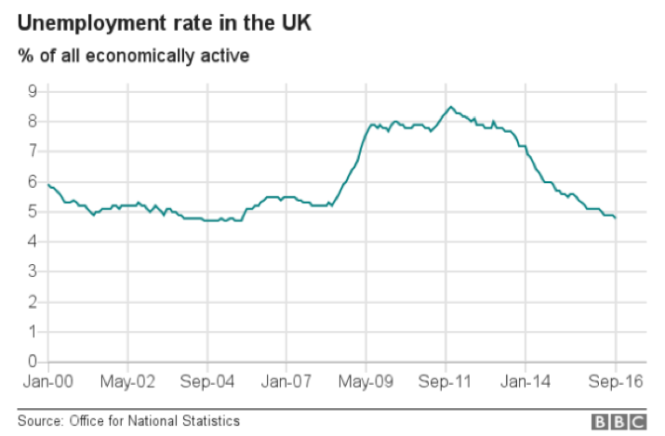
Read the following information and answer the questions that follow:

UK unemployment falls to 11-year low
November 2016

UK unemployment fell by 37 000 to 1.6 million in the three months to September, hitting an 11-year low.

The jobless rate fell to 4.8% in the same period, while the number of people in work went up by 49 000, said the Office for National Statistics (ONS).

The Bank of England has forecast that unemployment is set to rise amid uncertainty over Brexit. However, the ONS said the latest figures brought the unemployment rate to its lowest level since the three months to September 2005.

The total number of people in jobs remained at a record high of 31.8 million, the figures showed.

ONS statistician David Freeman said: "Unemployment is at its lowest for more than 10 years and the employment rate remains at a record high. Nonetheless, there are signs that the labour market might be cooling, with employment growth slowing."

Analysts also noted that the pace of jobs growth was slowing and attributed this to the effects of the UK's vote to leave the EU.

Recruitment fears

"The Leave vote is starting to sap the jobs recovery of its previous strength," said Ruth Gregory, UK economist at Capital Economics.
"Employment growth slowed sharply - with the 49 000 rise in the three months to September down from August's 106 000 and well below the forecast of 91,000."

The British Chambers of Commerce said Brexit was "dampening firms' recruitment intentions" and that this would put "increased pressure on UK employment levels".
The BCC called on Chancellor Philip Hammond to include measures in his Autumn Statement next week that would "support firms looking to recruit and invest in their

workforce, including measures to boost investment and lower upfront business costs".
Source adapted: http://www.bbc.co.uk/news/business-37997713

The number of self-employed people increased by 213 000 to 4.79 million - 15.1% of all people in work.
- With reference to the graph on unemployment, describe the trend over the last 16 years.
- What do you think “Employment growth slowed sharply” means?
- How can the government help businesses to recruit more workers?

The major impact of unemployment is the reduction in demand for goods and services. The economic crisis of 2008 saw the unemployment figure reach 3 million and this had a very significant impact on the sales and orders of UK businesses. Many businesses looked for just survival as their major objective as consumer demand dropped so significantly. This fall in demand then resulted in a further fall in output and then further redundancies for some workers as they were not needed.
Unemployment causes problems for consumers, businesses and the government:
Consumers – reduction in income if they become unemployed, resulting in a fall in living standards, the stress of finding a new job if businesses are not recruiting and the social and emotional effects of being unemployed.

Businesses – the fall in consumer incomes results in a fall in demand for their goods and services, financial problems if they are a small business or a business with no or little savings/ retained profit.
Government – a fall in revenue from Income Tax, VAT and Corporation Tax and an increase in welfare payments (less income and more outgoings).

Employment levels and economic activity

Employment levels tend to rise and fall as the economy grows and declines; this has both benefits and drawbacks for business:

Economic growth
  - Consumer demand for goods and services is high.
  - Businesses need employees in order to meet consumer demand.
  - Most people who want a job are already employed.
  - In order to attract new employees businesses have to offer higher wages.
  - Businesses will find it increasingly difficult to recruit someone with the right skills and qualities for the job.

Recession/slump

  - Consumer demand for goods and services is low, as people have less disposable income to spend.
  - A large number of people are unemployed and looking for work.

  - If businesses decide to take on new workers, they will be able to choose from a wide pool of applicants.
  - Wages will remain low as long as unemployment remains high.

Interest rates

The interest rate is the price of borrowing or saving money from a bank, building society or other lender. Products such as overdrafts, credit cards, loans or mortgages will cost the
borrower money in the form of an interest rate. The interest rate is how the lender will make money on the transaction.

For example, Paula Kelly borrows £10 000 from a bank to pay for a new car, she has agreed with the bank to pay this back over 5 years with an interest rate of 9.9%.
Her monthly repayments are £209.91 for 60 months (5 years). The total amount repayable is
£12 594.46 so the cost of the loan to her is £2 594.46.

The interest rate charged by the bank of 9.9%, if she shopped round she could have got a better interest rate with another bank, for example a different lender had an interest rate of 7.5%. If she had the loan with this bank she would have had to pay back £199.21 per month over the five years resulting in a total amount repayable £11 952.73 and total cost of credit of
£1 952.73 (saving her £641.73).

The example above shows how higher interest rates increase the cost of borrowing for a consumer. The opposite is true for consumers who are saving money in saving accounts – they want a high interest rate as this will give them a higher return on their savings.
Credit cards tend to have higher levels of interest charged, as do payday lenders. Mortgages (a long term loan usually taken out to buy property and secured against the property) tend to have the lowest rates of interest as they are taken out over a long time and are less risky as if a borrower fails to make the monthly payments the lender can get the money back by repossessing the property.
- Use a loan calculator from a lenders website to see how the amount of money borrowed, the length of the loan and the interest charged will affect the cost of the loan.
A possible website to use is http://www.moneysupermarket.com/loans/calculator

- Carry out a survey of the interest rates charged by the main banks in the UK on what they charge for loans and mortgages, and the rate they pay on savings.

Interest rates in the UK are based on the Base Rate of Interest which is set by the Bank of England. The period 2009-2016 has seen the Base Rate of Interest at a historically low level of 0.5%. In September 2016, the Base Rate reached a record low of 0.25%. The impact of such

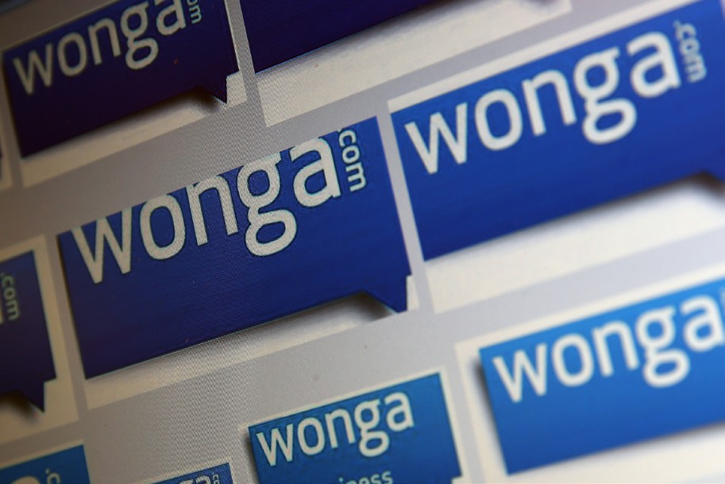
low interest rates on consumers and businesses has been generally beneficial. However, the very high rates of interest in the 1980s – when they reached a peak of 15% – were very damaging to many businesses.
Read the following information and answer the questions that follow:

Payday lender Wonga saw losses double in 2015
The UK's biggest payday lender – Wonga – saw its losses double last year as tougher regulation in the industry continued to bite. The short-term lender saw pre-tax losses grow from £38.1m in 2014 to £80.2m last year.

It has overhauled the way it assesses applications for credit, and extended the repayment term for some loans. However, it suggested 2016 would be a "turning point" in its financial performance.
The company, along with other payday lenders, faces tougher rules from the regulator, the Financial Conduct Authority (FCA), which has ruled that customers must go through stricter affordability checks. The regulator's main weapon
is a cap on the cost of payday loans of 0.8% of the amount borrowed per day, which came into force in January 2015.
Once Wonga stopped selling high cost payday loans to people who could not afford them, its original market was always going to shrink.

Add in the lower returns after the price cap, the hit from compensation bills, plus the cost of complying with strict new regulation and you can see how profits disappeared as well.
Now the short-term lender has gone slightly less short term. It is selling three-month loans with more flexible repayment rules. It believes there is still a market for its products among young borrowers on around £18 000 a year who do not have credit cards.

In a way, it is remarkable that Wonga has survived after the mauling it received. It has even persisted with the tainted Wonga brand. But it still faces a long haul: more losses this year, more backing needed to support the new-style loans, and more work to convince the public that it has cleaned up its act.
After a period of rapid growth, Wonga and much of the payday loan industry were criticised by debt charities and MPs for lending to people who could not afford to repay these loans.

Many companies received fines from the regulator, including Wonga which had to apologise and compensate customers for the use of letters from fake legal firms, as well as write off millions of pounds worth of unsuitable loans.
In mid-2013, the Archbishop of Canterbury, Justin Welby, said he wanted to "compete Wonga out of existence", through credit unions.

For its part, Wonga said it had now overhauled the way it operated "ensuring all lending is responsible and affordable". Last year, it aimed to change its reputation and steer clear of the young and vulnerable with TV adverts that swapped its controversial puppets for "hard-

working dinner ladies and mums".
Source: http://www.bbc.co.uk/news/business-36201486
- What is a payday lender?
- How do payday lenders differ from high street banks?
- Why do some people criticise payday lenders?
- Find out:
» The role of the Financial Conduct Authority (FCA)
» What is meant by credit unions

The effects on businesses of changing interest rates
If interest rates increase, the cost of borrowing increases which will limit demand in the economy. If interest rates fall, the cost of borrowing falls, so demand will increase. Businesses are not generally impacted by small changes in interest rates – say an increase from 0.5%
to 0.75%. However, if there is an increasing trend over time, the cumulative impact can be significant.

When interest rates rise, consumer demand falls. This is because people spend more on paying off mortgages and credit cards, so less money is left over for spending on other goods and services. In addition, higher interest rates discourage borrowing and encourage saving.
Those businesses that target people’s surplus income are likely to lose out the most. Higher interest rates mean consumers cut back on luxuries like weekends away and restaurant meals; instead they might switch to day trips and having pizzas delivered. People are also less likely to borrow as the cost has increased; this will affect demand for products like cars, caravans and home extensions.

Higher interest rates mean that businesses borrow less for investment – firstly because higher interest rates mean that demand for their products is likely to fall, and also because the cost of investment has increased. Those businesses producing items such as machinery and new buildings find their sales decrease. Increased interest rates also push up the cost of existing borrowing, so increasing costs to businesses. These increasing costs can reduce profitability and reduce the competitiveness of businesses.
With falling interest rates, the reverse effect is often seen, with people spending less on paying mortgages and credit cards, so there is more money left over for consumption. Borrowing by households’ increases, businesses are more likely to invest and also business costs are likely to have fallen – all leading to increased demand in the economy.

Increasing interest rates
  - People spend more on paying mortgages, so less money left over for spending on other goods and services
  - People are less likely to borrow as the cost of loans has increased, so less spending
  - Businesses borrow less for investment – too costly.

Decreasing interest rates
  - People spend less on paying mortgages, so more money left over for spending

  - People are more likely to borrow as the cost of loans has fallen, so there is more spending
  - Businesses borrow more for investment – greater chance of success.

Inflation
Inflation is the rate at which the general level of prices is rising.
The government measures inflation through the use of regular pricing of a ‘basket of goods’. This basket of goods is meant to reflect the spending habits of the average person within the UK economy and includes over 600 goods and services. So the basket contains such things as petrol, cars, travel, holidays, consumer electrics, food, medicines, housing, and even lottery tickets and online dating.
By judging and measuring the difference in the cost of purchasing this basket of goods on a monthly basis we are able to obtain an inflation figure. It is worth noting that there is more than one measure of inflation used in the UK. The target rate of inflation is known as The Consumer Price Index (CPI).
Inflation is usually shown as a percentage, for example 2%. If inflation is currently 2% it means that prices are 2% higher than they were this time last year - a basket of goods bought last year for £100 would today cost £102 even though the goods bought are identical.
The UK is currently in an extended low inflationary period and relatively low levels of inflation have been with us for the last 18 years, with CPI inflation varying between 0% and 5%. This low level of inflation contrasts with inflation peaking at 27% in 1977 and an average rate inflation of around 10% during the 1980s.

What does inflation mean for businesses?
Businesses need to purchase a variety of materials, as well as energy, water and premises, in order to run their business. If the inflation rate is above 0%, it means that costs are rising.
For example, a clothes manufacturer will have to pay more for the cotton it uses and the energy it needs to power the sewing machines. A pay increase for company employees may also be required.
If costs are rising, most businesses would want to increase their prices, so they can maintain a certain level of profit. Under normal circumstances, if a business raised their prices then consumers would simply shop elsewhere. However, inflation affects all businesses and so they are all raising their prices – consumers do not have the option of shopping for cheaper goods elsewhere.

Inflation causes uncertainty and as a result businesses will often postpone new investments in machinery or employing more workers. This can cause the business in the longer turn become less efficient. In addition businesses will face demands from workers for higher wages as they need more money to pay for the rising costs of goods and services.
Consumers, business and governments do not want inflation to increase too much; the

government has a target of 2%, at this rate inflation will not have a negative impact on the economy.
- Businesses are affected by factors over which they have no control. Explain how each of the following might affect businesses in the U.K.
- An increase in interest rates
- A decrease in unemployment
- A new tax introduced on reducing pollution by businesses
- A sharp increase in inflation
- An increase in consumer disposable income
- What is the difference between direct and indirect taxes?

- Great Gates and Co Ltd has a factory in South Wales. In this factory they produce wrought iron fences and gates. Some are made for supply to garden centres and do-it- yourself (DIY) shops.
Problems in the UK economy have meant that sales have fallen.
The Government can give help and support to businesses when there are problems in the economy.
Below are two government policies. Suggest and explain one effect each might have on Great Gates’ business.
» A cut in the rate of Income Tax paid by Great Gates’s customers.
» A cut in the rate of interest paid on Great Gates’s overdraft.

Legal influence on business activity
A business has to operate within the laws of the country it operates in. There are a number of different laws that affect the way businesses can operate. These laws are designed to protect individuals, customers, employees and the environment from the potential negative acts of business.
Business legislation covers a wide range of business activity such as company law, employment and anti-discrimination law, consumer protection, competition policy, health and safety legislation, data protection, intellectual property and minimum wage legislation.
However, only three types of legislation listed above need to be covered for GCSE Business:
- Employment law
- Consumer law
- Intellectual property

Employment law

There are a number of different types of legislation that regulate the relationship between employers and employees:
  - Health and safety legislation

Under the Health and Safety at Work legislation, employers have a duty to take all reasonable care to ensure the wellbeing and safety of their employees. Employers have a legal responsibility to ensure that working environments are safe and that employees are able to understand and are trained to deal with the risks involved in their jobs. Employees also have responsibilities, such as taking reasonable care and ensuring that they abide by health and safety rules – e.g. wearing hard hats on building sites. Businesses are also responsible for ensuring the health and safety of their customers.
Carry out some research to find out the meanings of the following health and safety terms:
- Risk assessment
- COSHH
- Health and safety policy
- Slips and trips
- Personal protective equipment (PPE)
- Manual handling

- Health and safety signs have to be displayed by businesses in certain environments and situations. Find out the purpose of the following workplace health and safety signs:

- Have a look around your school and make a note of the health and safety signs.

- 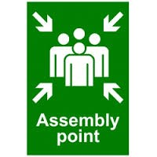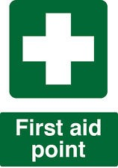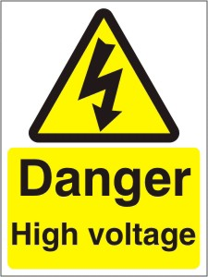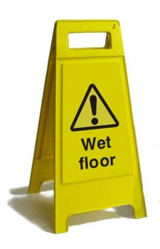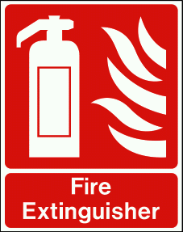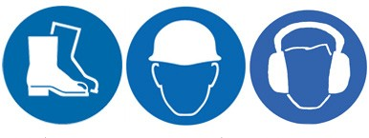Employment rights

This is the key legislation concerned with establishing workers’ rights in regard to their terms and conditions of employment. Employees have to be provided with a written statement
of employment within two months of starting employment. Employees are also protected against unfair dismissal.

European legislation also helps protect workers, such as a legal limit on the hours in a working week (maximum of 48 hours), and paid maternity and paternity leave. It is also illegal to discriminate on the grounds of sex, race, age or disability. This legislation may change following the UK’s decision to withdraw from the EU.

It used to be the normal situation for men and women doing identical jobs or jobs of similar value to have very different pay. Since the mid-1970s this has been illegal. Anti-discrimination laws protect workers from being treated differently because of their race, colour or culture and employers with workforces of over 20 must make efforts to ensure that workplaces, where possible, are suitable for disabled employees.

The retirement age of 65 was abolished in 2011: retirement age is now when the employee chooses to take retirement. An employer can only retire a worker in particular circumstances,
  - not being physically able to complete the tasks involved in the job.

The Equality Act 2010 legally protects people from discrimination in the workplace and in wider society. It is against the law to discriminate against anyone because of:
    - age
    - being or becoming a transsexual person
    - being married or in a civil partnership
    - being pregnant or having a child
    - disability
    - race including colour, nationality, ethnicity or national origin
    - religion, belief or lack of religion/belief
    - sex
    - sexual orientation
These are known as ‘protected characteristics’. Any of the following is regarded as discrimination:
Direct discrimination – treating someone with a protected characteristic less favourably than others;

Indirect discrimination – putting rules or arrangements in place that apply to everyone, but that put someone with a protected characteristic at an unfair disadvantage;
Harassment – unwanted behaviour linked to a protected characteristic that violates someone’s dignity or creates an offensive environment for them;

Victimisation – treating someone unfairly because they have complained about discrimination or harassment.
The law protects workers against discrimination at work in the following situations:
    - dismissal
    - employment terms and conditions
    - pay and benefits
    - promotion and transfer opportunities
    - training
    - recruitment
    - redundancy.

- What is meant by ‘discrimination in the workplace’?
- Explain what is meant by ‘equal pay’.
- What are the ‘protected characteristics’?
- Explain the difference between direct and indirect discrimination?

An employment contract establishes the rights, responsibilities and duties of an employer and an employee.
An employer must give employees a written statement of employment if their employment contract lasts at least a month or more. This isn’t an employment contract but will include the main conditions of employment. The employer must provide the written statement within 2 months of the start of employment. A written statement is the minimum requirement by law, many businesses will give a contact of employment which will include more details that allows an employer to specify an employee's duties and responsibilities – so an employee knows exactly what is expected of them. Every job will have a specific contract of employment, but most will include at least the following information:
    - the business’ name
    - the employee’s name, job title or a description of work and start date
    - how much and how often an employee will get paid
    - hours of work (and if employees will have to work Sundays, nights or overtime)
    - holiday entitlement (and if that includes public holidays)
    - where an employee will be working and whether they might have to relocate
    - assessment of work
    - information on pensions
    - sick pay and redundancy pay
    - the notice period to be given by either the employer or the employee to end the contract.
An employer can only terminate an employee's job lawfully if the employer follows a fair procedure, acts reasonably and has a fair reason, in other words, employees are protected from unfair dismissal. Employees are protected if their employment contract is terminated and their employer did not have fair reason to do so. It also includes situations when the employer did have fair reason but handled the dismissal using the wrong procedure.
Unfair dismissal can happen in the following situations when an employee:
    - asked for flexible working
    - refused to give up your working time rights – e.g. to take rest breaks
    - resigned and gave the correct notice period
    - joined a trade union
    - needed time off for jury service
    - applied for maternity, paternity and adoption leave
    - exposed wrongdoing in the workplace (whistleblowing)
    - were forced to retire (known as ‘compulsory retirement’).

Employees are entitled to take their case to the Employment Tribunal who will decide if the employer was unfair. If the tribunal decides that the employer was unfair they can enforce the employer to reinstate the employee, offer an alternative job and can also order the employer to pay compensation.
- What is an employment contract?
- What information is included in an employment contract?
- Why is an employment contract important for an employer and an employee?

    - The National Minimum Wage and The National Living Wage

The National Minimum Wage is the minimum wage per hour a worker is entitled to in the United Kingdom. When first introduced in April 1999, the National Minimum Wage intended to boost the pay of very low-paid workers. The legal minimum wage is reviewed every year by the Low Pay Commission and has gone up each year since 1999. Businesses have to comply with the new rates or face prosecution.

The National Living Wage is a compulsory minimum wage payable to workers in the United Kingdom aged over 25 which came into effect on 1 April 2016. In April 2017 it will go up to
£7.50.

Minimum Wage Rates (and National Living Wage for 2016 and 2017) from 1 April 2017

Year | 25 and over | 21 to 24 | 18 to 20 | Under 18 | Apprentice
2017 | £7.50 | £7.05 | £5.60 | £4.05 | £3.50
2016 | £7.20 | £6.95 | £5.55 | £4.00 | £3.40
2015 | £6.70 | £6.70 | £5.30 | £3.87 | £3.30
2014 | £6.50 | £6.50 | £5.13 | £3.79 | £2.73
2013 | £6.31 | £6.31 | £5.03 | £3.72 | £2.68
2012 | £6.19 | £6.19 | £4.98 | £3.68 | £2.65
2011 | £6.08 | £6.08 | £4.98 | £3.68 | £2.60
2010 | £5.93 | £5.93 | £4.92 | £3.64 | £2.50
- Use the information in the table above to create a line chart for each category of the National Minimum Wage rates between 2010 and 2017. Use a different colour for each line.
- Comment on what has happened to National Minimum Wage rates over the time period.

- Calculate the percentage increase in the change of the rate for 25 and over for each year. Comment on this change.
The workers who have benefited the most from the introduction of the National Minimum Wage have been younger workers in low-paid industries – these include care services, office services and areas such as cleaning, catering and fast food. For the lowest paid, the National Minimum Wage has allowed a move away from poverty and removed some aspects of the poverty trap.

However, most employees have not been affected by the introduction of the National Minimum Wage. Only around 7–8% of the workforce were in occupations that paid below the National Minimum wage, so the mass of employees were not directly affected by its introduction.

Effects of the national minimum wage on employers

    - It is argued that the National Minimum Wage has made the UK much less attractive to foreign companies who will look to invest in other countries with lower wage levels. Also some businesses in the UK have moved production and investment to low labour-cost countries in the east of Europe and Asia.

    - Small businesses have been most affected, especially those that are labour intensive, with an increase in their costs.

    - Overall wage costs could have increased because of the pressure to keep existing wage differentials in place – as the wage of the lowest paid workers increases, so must the wages of those on the next level up and so on.
Read the following article and answer the questions that follow:

Hundreds of companies failing to pay minimum wage

The government has named 360 businesses which have failed to pay either the National Minimum Wage (NMW) or the National Living Wage (NLW).

Among them are well-known names like Debenhams, Subway, Lloyds Pharmacy and St Mirren Football Club.
More than 15 500 workers had to be paid back nearly one million pounds.

But that may represent just the tip of the iceberg: The Office for National Statistics has calculated that 362 000 jobs did not pay the NMW in April 2016.
The biggest offenders were employers in hairdressing, hospitality and retail.
One worker at a dental practice in London's Harley Street was refunded nearly £12 000.
The fashion store Debenhams had to re-pay £134 000 to more than 11 000 staff – more than half of its shop workers – after an accounting error left each of them around £11 short in wages.
The company was fined £63 000.
A spokesperson said, "As a responsible employer Debenhams is committed to the National Minimum Wage, and as soon as the error was identified by a routine HMRC audit last year, we reimbursed all those affected."
Excuses used by businesses for not paying the full basic wage included using tips to top up their pay, making reductions to pay for a Christmas party, or making staff pay for their own uniforms.
For the first time the list includes firms which failed to pay the National Living Wage, which was introduced on 1 April 2016 for workers over the age of 25.
The current rate is £7.20 an hour. Those under 25 receive the NMW, currently £6.95 for 21 to 24 year-olds, and £5.55 for 18 to 20 year-olds.
In total the 360 businesses that broke the law were fined £800 000.

However the TUC (Trade Union Congress) said that was not a big enough deterrent. It called for higher fines, and more prosecutions.
"This should be a wake-up call for employers who value their reputation. If you cheat your staff out of the minimum wage you will be named and shamed," said the TUC's general secretary, Frances O'Grady.

"But we also need to see prosecutions and higher fines for the most serious offenders, especially those who deliberately flout the law."
The ONS has said that 1.3% of employees are not being paid the minimum, amounting to 178 000 full-time workers, and 184 000 part-time workers.

But the TUC believes that even that number is an under-estimate, as it does not take into account those working in internships, or those who may be wrongly classified as self- employed.
Source: http://www.bbc.co.uk/news/business-38979368
- What are the consequences for businesses that do not pay the National Minimum and Living Wage?
- Why has the Government named these businesses?

Consumer law
Many businesses are managed in an ethical fashion and focus on providing excellent quality goods and services to meet customer expectations. However, this is not always the case and the desire by some businesses to maximise profit will result in them using dubious tactics in order to increase sales and revenue.
Poor quality goods, substandard services, misleading information and pressurised selling tactics are among the practices that the UK government seeks to discourage.
In order to control the way in which businesses conduct themselves and offer protection to consumers, the government has passed a number of laws and set up various organisations. As a result of this legislation, manufacturers and retailers have to take a great deal of care about information presented on their packaging or within advertisements and any other form of promotional material.
These laws and organisations are together known as ‘consumer protection’. These laws are often updated and changed due to the dynamic nature of the business environment, some of the current main pieces of legislation are outlined below:
The Consumer Rights Act 2015 is the major piece of law covering the purchase of goods, services and digital content. Every time a consumer buys a product or a service, they make a ‘contract’ with the retailer. The Consumer Rights Act regulates this contract (agreement). It states that all goods must be of satisfactory quality, fit for the purpose for which they were bought and must correspond with any description given. For example, if you buy a
car it must be capable of reliably transporting its passengers or if you buy a pair of wellington boots they should be waterproof. If a consumer buys a product that isn’t satisfactory or doesn’t match the description etc., they are entitled to return the goods to the retailer

and ask for a refund. If the retailer refuses to reimburse the consumer, the consumer can then take court action, i.e. sue the retailer in court and ask for compensation or repair/ replacement of the product.
The Consumer Rights Act 2015 also states that services must be carried out for a reasonable price (unless agreed beforehand), within a reasonable time, and with reasonable care and skill. For example, if you visit a hair salon to colour your hair, the hairdresser would not be providing a service with reasonable care and skill if they coloured your hair the wrong colour.

The Consumer Protection from Unfair Trading Regulations 2008 makes it a criminal offence for businesses to engage in unfair business practices. This means that businesses can be prosecuted and fined for engaging in these practices, such as making untrue statements about a product or service, using aggressive sales techniques such as harassment or misleading consumers about the price of a product or service. For example, if a car dealer tells you that a vehicle has 50 000 miles on the clock but knows the true figure to be 70 000, they are omitting a key fact which would affect your decision to purchase the car.
Manufacturers and retailers have to take a great deal of care about information presented on the packaging of their goods, or within advertisements and any other form of promotional material.

The Consumer Credit Acts 1974 and 2006 and the Consumer Credit Regulations 2010 control the way that businesses lending money operate. These laws require the creditor (lender) to give certain key information to the debtor (borrower) before the contract is made including the interest rate, how much the repayments will be and the cancellation rights
of the debtor. Credit companies have to publish a figure known as the Annual Percentage Rate (APR). This percentage not only reflects the rate of interest charged but also how it is calculated and added and any arrangement fees. The APR enables consumers to compare credit deals. The laws also give the debtor a ‘cooling off period’ after signing a credit contract during which they can change their mind (in many cases this is 14 days). All organisations involved in credit must obtain a licence from the appropriate government authority – it is a criminal offence to operate without one.

The Consumer Contracts (Information, Cancellation and Additional Charges) Regulations 2013 help to protect consumers who buy over the phone or online. These are distance sales, which mean that there was no face to face contact at the time of purchase. If businesses break these regulations then the consumer is not bound by the purchase contract. These regulations provide the consumer with a cancellation period of 14 days: the
‘cooling off’ period during which consumers are entitled to change their minds and cancel the contract and receive a full refund, regardless of whether the product is defective.

These regulations also apply to goods or services purchased at your home, or ‘off-premises’. For example, if a sales person visits you at your home and you agree to buy a new mobile phone, you have the right to change your mind and cancel the agreement, within 14 days.
Also consumers are not bound by charges they have not expressly agreed to – such as hidden delivery or card payment costs.

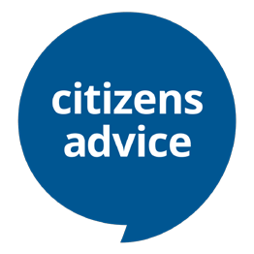
Consumers can get help from Citizens Advice who provide free, independent, confidential and impartial advice to everyone on their rights and responsibilities.

Visit https://www.citizensadvice.org.uk/about-us/how-we-provide-advice/advice/ to find out what services they offer consumers.

Ombudsman services are available for various industries and offer complaints procedures for dissatisfied customers. Ombudsman services are set up by the government and are free for consumers to use. Examples of ombudsman services include the Health Service
Ombudsman, the Legal Services Ombudsman and the Energy Ombudsman. Consumers can usually complain to the relevant ombudsman once they have tried to resolve any dispute with the relevant business and also followed up any other complaints procedures. The ombudsman services are the last port of call before full legal action in court is taken. When consumers take a complaint to an ombudsman, the ombudsman will look at all written information provided by the consumer and the business and make a decision accordingly.
The decision is final and can only be overturned by a court.

The following procedure for consumer complaints is suggested by Ofgem (the industry regulator for Gas and Electricity Markets) when making a complaint about a bill or services from the supplier:

Source: https://www.ofgem.gov.uk/consumers/business-gas-and-electricity-guide/complain- about-your-gas-or-electricity-bill-or-supplier
To complain about your gas or electricity bill or supplier: First Steps
You should contact the energy company directly. The phone number and website will be on your energy bill.
Talk to them
Explain to the energy company what the problem is and what you want them to do about it.
Support
The Citizens Advice consumer service can help you through the process if you can’t find the energy company’s details or need support. They will give you information and advice, and lend you their expertise if you need it.
Taking it further
Ombudsman Services Energy can investigate if: the complaint hasn’t been resolved to your satisfaction after 8 weeks; or the energy company deadlocks the complaint (they say they can do no more to resolve it) before eight weeks are up.
All gas and electricity companies are required through strict complaints handling standards to deal proactively with complaints from consumers. They all have complaints procedures detailing how they do this.
The energy company should respond and try to resolve your complaint. You then need to decide whether you think their response is reasonable and will solve the problem you have. If it doesn’t, tell them.
If the complaint is not resolved to your satisfaction and either eight weeks have passed since the complaint was made or it reaches a point of deadlock (where the energy company says it can do no more to resolve the complaint, whichever is sooner), you can ask Ombudsman Services: Energy to investigate. The energy company should write to you at
52

eight weeks or deadlock to tell you how to do this.

Ombudsman Services: Energy (OS:E) is the free independent scheme set up to investigate complaints from consumers that the energy company cannot resolve (after eight weeks or deadlock). OS:E can require the company to correct the problem, apologise, explain what happened, and make a financial award. Its decisions are binding on the energy company but not the consumer.

All local authorities have a Trading Standards department. The department is responsible for checking that local businesses are complying with the various trading laws e.g. Consumer Protection from Unfair Trading Regulations 2008. Trading Standards officers visit businesses and carry out spot checks. They investigate whether goods are correctly described, priced clearly and sold in the correct quantities. (For example, if a restaurant has ‘locally sourced Welsh beef’ on their menu, the officers will establish whether this is a true statement). They will also ensure that no counterfeit goods are being sold. Trading Standards officers can prosecute businesses if necessary and this process can result in fines and, in extreme cases, imprisonment.

The Competition and Markets Authority (CMA) was set up by the government in 2014 and replaced the former Office of Fair Trading and Competition Commission. Its mission statement is ‘to make markets work well for consumers’.
The CMA carries out investigations into various markets such as the groceries market and the energy market. The purpose of these investigations is to ensure that the businesses operating in these markets are not engaging in any ‘anticompetitive business practices’ that restrict competition within the market. The CMA investigates markets and can make businesses change their business practice if they uncover anticompetitive activities.

The CMA also investigates proposed mergers if the merger would result in a company with such a large market share that it may restrict competition. They also control the power of big business. If businesses in a monopoly or near monopoly (where one business is very powerful in a market and has a market share of 25% or more) are able to hold a dominant market position, then they are likely to have control over price or the amount produced
within the market. The Government will therefore put in place laws and regulators to limit the potential abuse of market power and thereby protect consumers.

One role of the CMA is to examine situations where companies act together, forming an illegal cartel to limit the competition within an industry.

Advertising and the law
All marketing and advertising in the UK must be:
    - an accurate description of the product or service
    - legal
    - decent
    - truthful
    - honest
    - socially responsible (not encouraging illegal, unsafe or anti-social behaviour).

A business must describe its product or service accurately. A business can’t mislead consumers by, for example:

    - including false or deceptive messages
    - leaving out important information.

Advertising codes of practice that describe how businesses should advertise are enforced by the Advertising Standards Authority (ASA). Anyone who thinks advertising rules have been broken can complain to the ASA within 3 months of the advert appearing. If an advert breaks the rules, it may be withdrawn. If the product doesn’t match the description or the advert breaks the law, a business could be prosecuted.

Read the following article and answer the questions that follow:

Moneysupermarket and Paddy Power lead advert complaints
Moneysupermarket's twerking businessman in high heels and Paddy Power's cat-kicking blind footballers were some of the most-complained-about ads of 2016.
Moneysupermarket's dancing bodyguard Gary, twerking businessman Dave and dancing builder Colin were all in the top 10, the advertising watchdog said. The Paddy Power advert was first shown in 2010 but still drew 450 complaints.
The Advertising Standards Authority (ASA) said none on the list "crossed the line" from bad taste to offence.
Three Moneysupermarket price comparison website adverts attracted 2,491 complaints between them. Some viewers found the bodyguard's dance moves "distasteful", and the ads with the businessman and the builder as homophobic.
Top 10 number of complaints
- MoneySuperMarket.com (dancing bodyguard) 1 063
- MoneySuperMarket.com (gang dance-off) 898
- Match.com (kissing women) 896
- MoneySuperMarket.com (solo dance-off) 530
- Paddy Power (blind football) 450
- Smart Energy GB (Gaz and Leccy) 253
- Paddy Power (Scotland fans) 220
- Home Office (domestic violence) 216
- Gourmet Burger Kitchen (vegetarianism) 195
- Mars/Maltesers (disability) 151
Source: Advertising Standards Authority

An advert for dating website Match.com showing a woman removing her female partner's top and kissing her received 896 complaints.
It was seen as sexually explicit and inappropriately scheduled.
The Paddy Power advert featured men playing blind football and inadvertently kicking a cat due to the sound of a bell round its neck.
The ASA had already ruled the majority of viewers would see the advert as humorous and not humiliating or undermining to blind people, and so did not investigate it again.
The bookmaker's advert about Scottish football fans not minding not qualifying for Euro 2016, because they could bet on England to lose, was complained about for being racist and anti-English.
Also in the top 10 were Smart Energy's Gaz and Leccy cartoon characters, the Home Office's Disrespect Nobody domestic violence campaign, Maltesers featuring a woman in a wheelchair and Gourmet Burger Kitchen's references to giving up vegetarianism.
The complaint about the Home Office's ad was that it implied only men were responsible for domestic abuse and it could discourage male victims from coming forward.
ASA chief executive Guy Parker said: "The ads that attract the highest number of complaints are often not the ones that need banning.
"Our action leads to thousands of ads being amended or withdrawn each year, mostly for being misleading, but there wasn't one misleading ad in the top 10.
"In the list there are a number of ads, which while advertising their product or service, have also sought to present a positive statement about diversity but were in fact seen by some as doing the opposite.
"In all those cases, we thought people generally would see the ads in a positive light and that the boundary between bad taste and serious or widespread offence had been navigated well enough, often through using sensible scheduling restrictions."
Source: http://www.bbc.co.uk/news/uk-38672439
- Why were complaints made against the adverts listed in the article?
- Why did the ASA not ban these adverts?

No Man's Sky investigated over 'misleading' adverts

Video game No Man's Sky is being investigated by the UK's Advertising Standards Authority after complaints from gamers.
They say that promotional material does not reflect the finished product.
Some of it dates as far back as 2014, but is still being used to promote the game.

The complaints are specifically about the game's Steam page, where players can download the game for their PC.

"We are investigating whether the content of the Steam store page (comprising trailers, screenshots and written statements) includes claims that specific features will be included in the No Man's Sky game that were not present in the final release," an ASA spokesman tells Newsbeat.

The original gameplay trailer shows a planet teeming with creatures interacting with each other. Players say that the finished product just isn't like that.
Complainants believe it is misleading," the ASA spokesman says. The ASA will publish their findings "in due course".
Players have complained about the lack of space combat, structures and buildings, flowing water, animal behaviour and issues piloting spacecraft in the game, all of which can be seen in the 2014 trailer.

Adapted source: http://www.bbc.co.uk/newsbeat/article/37506501/no-mans-sky- investigated-over-misleading-adverts
- What is meant by consumer protection?
- Summarise the main areas where consumers may need protection from businesses.

- Produce a leaflet aimed at giving advice to consumers of their rights. You should include in your leaflet reference to:
- Satisfactory quality
- Fit for the purpose
- Accurate description
- Cooling off period’
- Citizens advice
- Ombudsman services
- Misleading advertising.

Intellectual property

Intellectual property refers to creative work such as inventions, literary and artistic works and designs, symbols, names and images used in business.

Intellectual property is protected in law by copyright, patents and trademarks, which allows the creator to earn recognition or financial benefit from what they have invented or created.

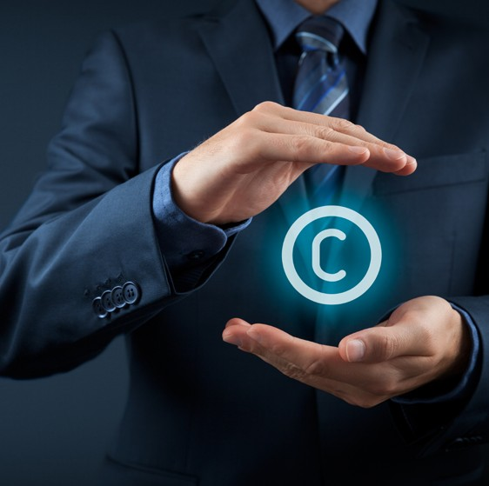
Copyright laws protect people who have created original pieces of work, and give them rights to control how their work is used by others.
Examples of such work include:
- Music (including lyrics and the music itself)
- Written word (including books, poems and plays)
- Artistic works (such as sculptures, drawings, paintings and photographs)
- Films, videos and broadcasts
- Software and games.

As soon as something has been created and put to paper it can be protected by copyright, this means that the law prevents:
  - Unauthorised copying of the work
  - The resale, redistribution or rental of a piece of work
  - Unauthorised performance or display of the work.
The growth of digital media in recent years has resulted in many cases of copyright infringement (the use of works protected by copyright law without permission) in films, music, social networking and online gaming. Piracy (the unauthorised copying, distribution and selling of works in copyright) costs the movie, music and software industry billions of pounds every year.
Madonna wins Vogue copyright case

Madonna's Vogue did not break copyright law, even though it contained a snippet of another artist's song, a US court has ruled.

The case revolved around a horn "hit", which was allegedly lifted from the Salsoul Orchestra track Love Break.

But the US Court of Appeals said the sample lasted less than a second, and would not have been recognisable to the general public. "Without careful attention, the horn hits are easy to miss," it said.

Producer Shep Pettibone worked on both Vogue and Love Break. The one-note horn sequence in contention lasted just 0.23 seconds, the court heard.
Adapted source: http://www.bbc.co.uk/news/entertainment-arts-36442456

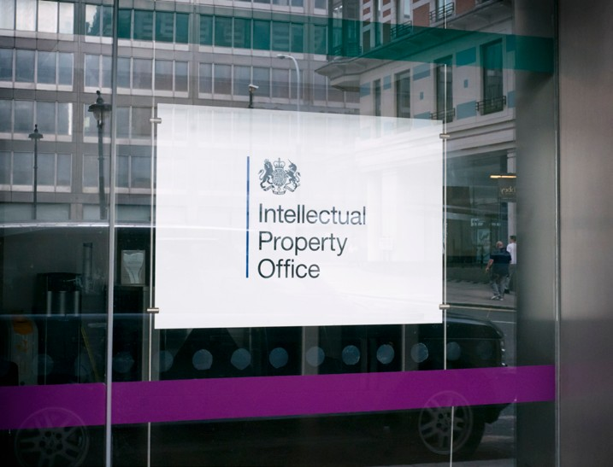
Other individuals or businesses can use the work if they agree a fee with the originator. Copyright protection automatically starts as soon as a work is created. Once the copyright has expired, anyone can use or copy the work.

The length of copyright depends on the type of work:

Type of work | How long copyright usually lasts
Written, dramatic, musical and artistic work | 70 years after the author’s death
Sound and music recording | 70 years from when it’s first published
Films | 70 years after the death of the director, screenplay author and composer
Broadcasts | 50 years from when it’s first broadcast
Layout of published editions of written, dramatic or musical works | 25 years from when it’s first published

A patent is a right granted to the owner of an invention that prevents others from making, using, importing or selling the invention without their permission. A patentable invention can include a new product, a new process or a technical improvement on how certain objects work. To get a patent the invention must have a new and original design.
In the UK a patent is generally given for 20 years, which means that any other business who wants to manufacture the patented product or use a patented process will have to pay the inventor to do so. It is the responsibility of the inventor to apply for a patent, the inventor has to disclose the technical information about the invention to the public. The patent owner can give permission to, or license, other businesses to use the invention.
The owner may also sell the right to the invention to someone else, who will then become the new owner of the patent. Once a patent expires, the protection ends, and an invention enters the public domain, which means that anyone can use the invention without infringing the patent.

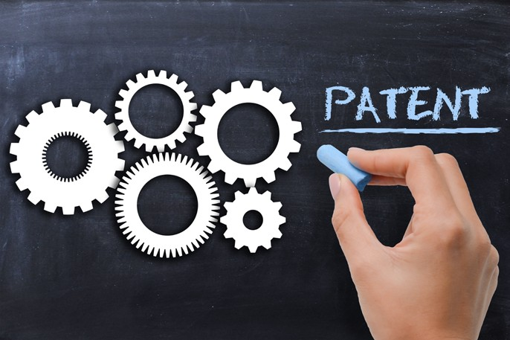

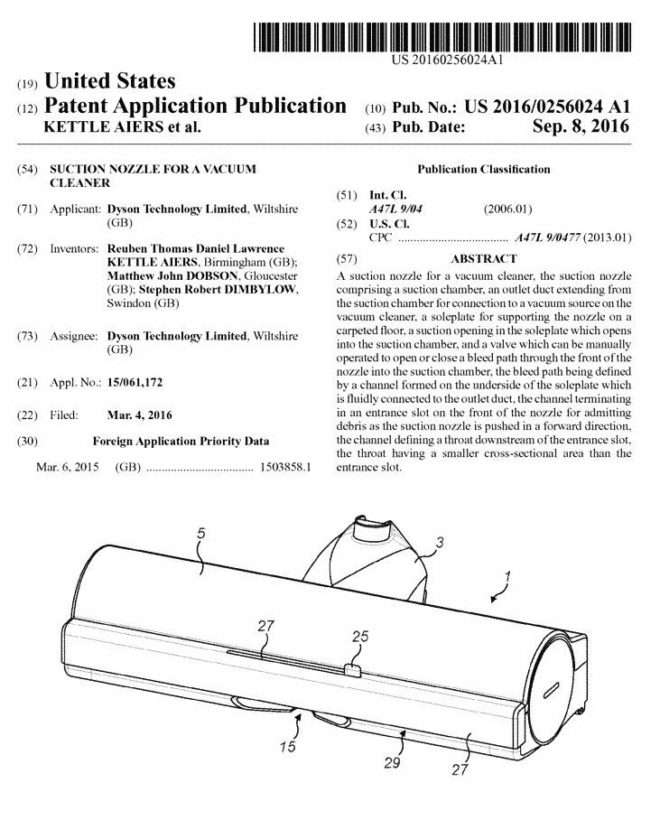Dyson is a business famous for new inventions, ranging from vacuum cleaners, hairdryers, hand dryers, fans and heaters. Many of the products manufactured by Dyson contain
new inventions and in order to protect these from other businesses they have applied for thousands of patents. One product alone could have hundreds of patents on all the different parts needed to manufacture the product.

The images below show part of the patent application in the US for a suction nozzle for a vacuum cleaner:

Source: http://www.freshpatents.com/-dt20160908ptan20160256024.php

- Why is it important that Dyson protects its new inventions from other businesses?
- Why have Dyson been allowed to patent this suction nozzle?

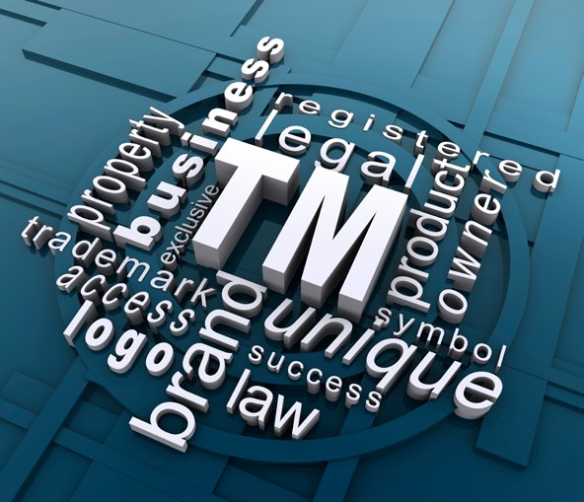
A trademark is a distinctive design, graphic, logo, symbol, figure, letter words or phrase that uniquely identifies a business and/or its goods or services. The trademark gives its owner the legal rights to prevent the trademark's unauthorised use.
A trademark must be distinctive and registered with the appropriate authority to obtain legal ownership and protection rights. Trademark rights are protected worldwide by international intellectual property laws.

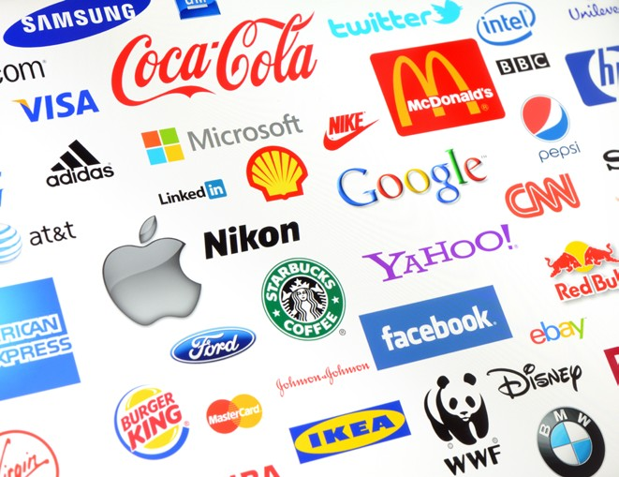
In a competitive environment the use of trademarks is important to protect brands and to make clear to consumers the identification of a product or service from a specific business.
A trademark can be a logo, like the ones shown above a slogan, or simply the name of a product. Some
brands, like Xerox, Kleenex, Tippex and Pritt are so prominent that they have almost replaced the original
word in everyday language.

Trademarks can be bought and sold. Nike purchased the instantly recognizable Swoosh logo for only $35.
Trademarks can also be licensed to other businesses for a period of time or under certain conditions, which can result in crossover brands. Lego has licensed many famous brands like Star Wars and DC Comics to produce Lego versions of popular products.
Two symbols associated with trademarks are:
  - the trademark symbol ™
  - the registered trademark symbol ®
The symbol is usually displayed after the trademark in superscript text.
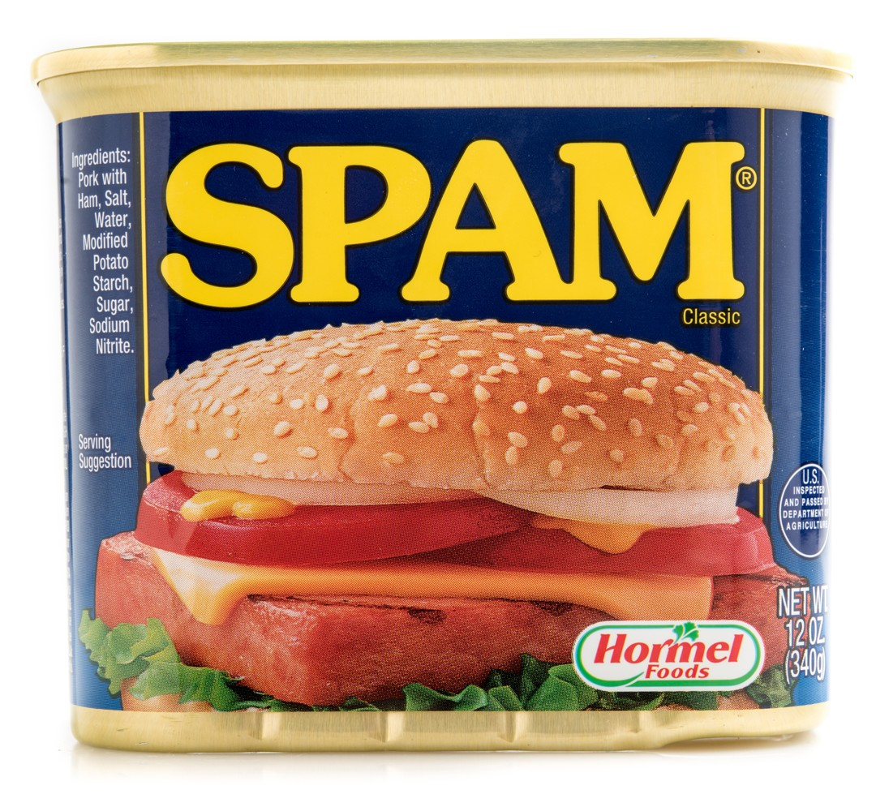
No other business is allowed to sell a similar pork product and call it SPAM or use font and colour similar to the identity created for SPAM.

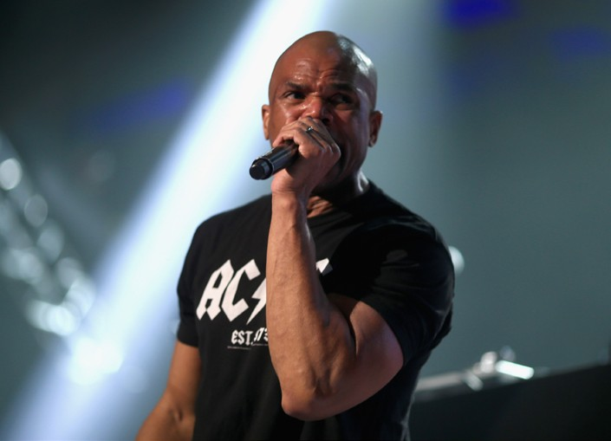Read the following article and answer the questions that follow:

Run-DMC in $50m trademark battle

A member of pioneering rap group Run-DMC has filed a $50m (£40.7m) lawsuit accusing retailers of unlawfully using the group's name on items of clothing.
Darryl "DMC" McDaniels said that products sold by Amazon, Walmart and other stores violated federal trademark and New York competition laws.

McDaniels, who owns a firm named Run-DMC Brand, made the allegations in a complaint filed in the US District Court in Manhattan.
The products include T-shirts and hats.
Run-DMC were one of the biggest rap acts of the 1980s, with global chart hits including Walk This Way and It's Tricky.
Their distinctive logo has become a fashionable motif on T-shirts, often worn by people who are not necessarily fans of the group's music.
McDaniels said the brand was "extremely valuable" and had been legitimately licensed to various manufacturers including sportswear firm Adidas, itself the subject of one of Run- DMC's most successful songs.
Amazon and Walmart have yet to comment on the lawsuit.
McDaniels founded the group in 1981 in the New York borough of Queens with fellow rapper Joseph "Run" Simmons, who is now an ordained Pentecostal minister known as Reverend Run.
Source: http://www.bbc.co.uk/news/business-38466261
- How have the retailers broken trademark laws?
- Why would retailers wish to use the DMC brand on their products?
- Explain what is meant by “the brand was extremely valuable".

Iceland Foods hits back at Icelandic government over trademark

The supermarket Iceland claims that the Icelandic government is "not willing to hold any serious discussion" to reach agreement in a trademark dispute.

The country has launched legal action against the chain, claiming it prevents the nation's firms from describing their products as Icelandic.
Iceland Foods owns the European trademark for using the name Iceland.

The company sent a delegation to the capital Reykjavik on Friday but no agreement was reached. "[The talks] got nowhere because it rapidly became clear that the Icelandic authorities have no interest in reaching a compromise," said founder and chief executive Malcolm Walker. "We have no real idea why this has suddenly become such a major problem for Iceland (the country).
"Iceland Foods had Icelandic majority shareholders and Icelandic representatives on its board for seven years to 2012. At no point in all those years did any representative of Iceland (the country) raise the slightest concern about our company's branding," he said.

On Friday, Iceland's foreign ministry said the company refused to relinquish exclusive control of the word Iceland and that it would therefore pursue legal action to invalidate the company's trademark.
"The registration of a country name that enjoys highly positive national branding to a private company defies logic and is untenable," the ministry said.

But the company, which employs 23 000 people, said it had only ever tried to prevent other food and retail companies using the name Iceland, when it could lead to confusion over the brand.
It acknowledged that it had blocked an attempt to register "Inspired by Iceland", but it had not known it came from the Icelandic government.

Had the supermarket known, it would have been "very happy to have a conversation with them to explore ways in which their desire to promote Icelandic products could co-exist with our established rights as owners of the Iceland brand," the statement said.
Iceland Foods added that it still hoped an amicable arrangement could be reached.
The store was set up in Shropshire in 1970 and the name was suggested by Mr Walker's wife, Rhianydd.
Source: http://www.bbc.co.uk/business-38201571

The impact of legislation on business activity

The main impact of legislation on businesses is the cost and time it takes to make sure that they comply to all legal requirements. There are many laws and regulations that have to be followed by businesses to make sure they act legally:

  - Health and safety laws require the employer to provide a safe working environment, provide adequate premises, equipment and training to protect workers – this will cost money.

  - The human resource function of the business must make sure that all recruitment, employment and redundancy follow the strict guidelines - this will take time and expertise in the business.
  - The Minimum Wage can increase the wage bill.

  - Consumer law covers a wide range of business activity and businesses have to be vigilant to make sure they meet all the strict guidelines in advertising and selling their products and services – failure to do so could harm their reputation and result in substantial fines.
  - Protecting new inventions and ideas can be time consuming to make sure all the legal protection is in place to make sure competitors can't copy original ideas. However, the laws do protect innovative and creative businesses from other businesses copying their inventions.

  - Increased costs of complying with the many laws may affect profits and in some cases, these laws are seen to put an unnecessary burden on new and small businesses and could even cause some businesses to close down or restrict their growth. Many large businesses will have large legal departments and human resource departments to make sure all the laws and regulations are observed. This is even more complicated for multinational businesses that have to follow the individual laws in each country they operate in.
  - Businesses may have to increase prices in order to pay for the increased costs of implementing legislation – this could lose them customers.

  - Maintaining quality products and making sure all products are produced to a certain standard will require businesses to use suitable production processes and quality control procedures - any products produced to a sub-standard level of quality should be thrown away.
  - Businesses have no choice but to comply with these laws as failure to do so is unethical and could lead to fines, imposed restrictions and in some cases imprisonment.

Consumers benefit from the legislation by making sure that businesses are honest and fair in their activities and they purchase quality products that are fit for purpose. Consumers also have a variety of ways in which they can report a business for non-compliance of legal requirements and obtain refunds or in some cases compensation.
Workers benefit in many ways with increased protection from unfair dismissal, discrimination and working in safe conditions, for a minimum wage.

- Why is there a need for legislation in business?

- Produce a PowerPoint presentation for a new retail business that is starting in your area. Advise the owner of the main employment and consumer legal constraints and responsibilities.
- Holdings Ltd manufacture and sell prams and cots through their website. The directors are aware that they will be regulated by laws which will affect the operation of their business. Suggest and explain one legal responsibility Holdings Ltd have to their customers and one legal responsibility they have to their employees.
- Some people think that there is too much regulation for businesses. Do you agree with this?

The impact of globalisation on businesses

International trade
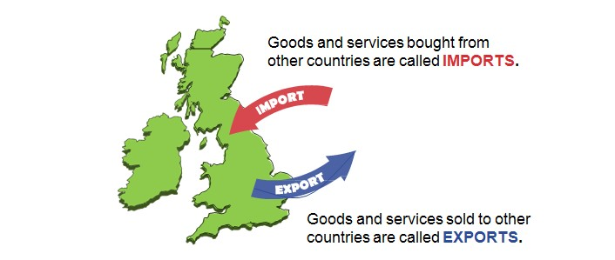
International trade consists of buying and selling of exports and imports between countries.

International trade takes place because:

    - We cannot produce some goods ourselves as we do not have the necessary raw materials in this country

    - Other countries can produce some goods and services more efficiently and cheaper than we can
    - International trade allows consumers a much wider choice in the products they buy

    - The use of the internet and e-commerce means that businesses of all sizes and scale can trade internationally.

- Suggest an example of a product that we cannot produce ourselves.

- Suggest an example of a product or service that other countries can produce/provide more efficiently and cheaper than businesses in the UK.

International trade is important in the UK as many businesses export their products to consumers and businesses in other countries and many consumers and businesses in the UK buy products from other countries.

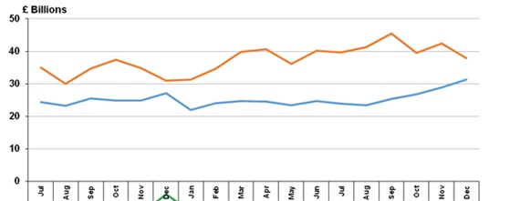The graph below shows the imports and exports for the UK in December 2016:

Billions

Total imports

Total exports

Jul Aug Sep Oct Nov Dec Jan Feb Mar Apr May Jun Jul Aug Sep Oct Nov Dec

Source: HM Revenue & Customs Overseas Trade Statistics Note: 2016 data is provisional

In December 2016 the value of exports increased to £31.4 billion, while imports decreased to £37.9 billion, compared with last month. Consequently the UK is a net importer this month, with imports exceeding exports by £6.6 billion.
- Between July 2015 and December 2016 describe what the lines show.
- What is meant by “a net importer”?

In 2016 the value of UK imports from other countries was £582.3 billion and the value of exports was £542.9 billion.

The list below shows the UKs top trading partners in terms of export sales in 2016 (in American dollars):
  - United States: $60.4 billion (14.8% of total UK exports)
  - Germany: $43.6 billion (10.7%)
  - France: $25.9 billion (6.3%)
  - Netherlands: $25.6 billion (6.3%)
  - Ireland: $22.9 billion (5.6%)
  - Switzerland: $18.9 billion (4.6%)
  - China: $18 billion (4.4%)
  - Belgium: $15.8 billion (3.9%)
  - Italy: $13.1 billion (3.2%)
  - Spain: $12.7 billion (3.1%)
  - United Arab Emirates: $9 billion (2.2%)
  - Hong Kong: $8.8 billion (2.2%)

54.3% of UK exports are sold to Europe 21.2% of UK exports are sold to Asia
  - % of UK exports are sold to North America 2.8% of UK exports are sold to Africa

Construct a pie chart to show the percentage of exports sold to Europe, Asia, North America and Africa.

When businesses are considering moving into overseas markets, there are number of possible advantages. These include:
    - New potential markets – saturation of home market may have occurred. A business may have the finance to expand, but be unable to do so because of competition, or because of lack of new customers in the domestic existing market. There are obvious opportunities to sell to other countries – the UK has a population of 65 million; Europe has a population of 500 million, US a population of nearly 320 million and China a population of nearly 1.4 billion.
    - Selling to new markets can result in higher sales and profits.

    - Spreading of risks – the UK has experienced a drop in disposable incomes in recent years and this will affect demand in the domestic market. Selling to other countries can help protect businesses from falling sales in the UK.

    - Spreading of technical knowledge – the transfer of technology and other skills between countries can improve the products consumers receive. For example, UK businesses can utilise improved technology in producing cars or computers developed in Japan or the USA to improve products made in the UK.
    - Benefits of economies of scale – producing larger production runs helps to cut costs. Other advantages of international trade to the UK and consumers include:
    - Increases competition, improving quality and reducing prices
    - Trading with other countries increases political stability
    - Encourages innovation
    - May bring employment opportunities.

Problems in dealing with international markets

Successful exporting and trading with overseas countries depends upon an understanding that people all over the world have different needs, priorities, incomes and tastes.
Businesses must acknowledge that most products will have to be adapted in some way to suit local cultures, languages, currencies and buying habits.

Cultural differences can have a significant impact on how goods are sold in different markets. The main problems with international trade include:
- Language barriers – different packaging and advertising maybe needed, this can add to costs and problems when communicating with suppliers or distributors in a country with their own language. The need for translation of instruction books leads to high costs for the producer and misunderstandings by the customer.

- Supply chain issues – when dealing with suppliers and distributors that are hundreds or thousands of miles away, the supply chain gets complicated and can take a long time. Importing or exporting products to a range of other countries will increase costs and

there is a possibility of the supply chain breaking down and raw materials or products being damaged, lost or not getting to the right place at the right time.

- Currency issues – businesses that trade internationally have to deal with exchange rates. Different countries use different currencies and changing currency incurs costs. Changes in the value of currency may also affect how much businesses are paid and how much they pay when trading abroad. Regular changes in exchange rates can lead to great uncertainty.

Exchange rates

Each country has its own currency, for example Japan has the yen, Mexico has the peso, the UK has the pound and the USA has the dollar.
If goods or services are being bought from foreign businesses they will expect to be paid in their own currency, and so we would need to change our British pounds for the currency needed.
Exchange rates are simply the cost of switching from one currency to another.

The price of currencies does not stay the same – every day many different currencies are exchanged and their values can go up or down.

For example, you are going on holiday to the USA and you need to swap your British pounds into US dollars. You go in to the ‘Bureau de Change’ and see they are offering 1.5 dollars to the pound. You have saved £100 for the trip and so the £1: $1.50 exchange rate means that your £100 will buy you $150.

Using our example above, suppose the exchange rate decreases to £1:$1.30. This would mean that our same £100 would now buy us only $130.
Any change in the exchange rate will affect the amount of money we have to spend.
It is not just consumers going on holiday that will need to exchange their money for different currencies. Any UK business trading with a foreign business (and vice versa) will need to use the correct currency.

If the exchange rate of the pound increases then:
Prices of UK exports will increase and the price of UK imports will fall

If the exchange rate of the pound falls then:
Prices of UK exports will fall and the price of UK imports will increase

In other words, if the value of the pound against other currencies rises then the price of products sold by British businesses to other countries will increase. If the value of the pound against other currencies falls then the price of products sold by British businesses to other countries will fall.
- Explain the possible effect of a rise and fall in the value of the pound on the sales of British products in foreign markets.

- Explain what will happen to the price of imported products from other countries into the UK if the value of the pound falls.

- Local taxes and laws – these are different in different countries and British businesses that trade internationally must be aware of the different laws and act accordingly. This can cause problems and add to business costs. Some countries will have taxes that are not present in the UK, or they may have tariffs on imported goods (a tax charged by the government on imported goods), these will have to be paid and again this will add to business costs and will affect the profit gained from selling internationally.

Free trade versus protectionism
Free trade means international trade conducted without the existence of barriers to trade, such as tariffs and quotas.
Protectionism is an economic policy of restraining trade between countries through the imposition of barriers to trade, such as tariffs or quotas.
Tariffs are a tax on imported goods and are sometimes referred to as customs duties. They can be used by a government to raise revenue to finance expenditure. However, most often they are used in a deliberate attempt to restrict imports. By imposing a tax on a good, it is likely that the final price to the consumer will rise. A rise in the price of the good will lead to a fall in demand and the volume of imports will fall. A tariff should therefore help domestic businesses as some consumers will switch consumption from the more expensive imported goods to domestically produced products.
A quota is a physical limit on the quantity of a good imported. This will increase the share of the market available for domestic businesses.
- Different technical specifications for products – for example, in France they use a two pin electrical plug whilst in the UK a three pin plug is used; electrical voltages vary around the world; trying to sell goods with the wrong voltage means that electrical goods might not work; in the UK we drive on the left, while in most of the rest of the world drivers travel on the right. Driving on the opposite side of the road adds to the costs of car manufacturers in Britain and producers abroad wanting to sell to British markets. Laws may also cover packaging, labelling, ingredients and so on.

- Below are some of the reasons why international trade is important to Britain and its businesses. Rank the reasons why international trade is important to businesses in the order 1 to 9, 1 being the most important and 9 the least.
- It provides foreign currency
- It provides a market
- It provides cheap raw materials
- It allows foreigners to holiday in this country
- It provides producer goods to be bought from abroad
- It provides a range of consumer goods
- It allows British people to holiday abroad
- It shows possibilities in technology
- It provides a variety of raw materials and components
- Suggest how British car producers might gain from trading in international markets and outline the problems they might experience.
- Jo Downs Handmade Glass is a small business and sells some of its goods abroad. Should Jo Downs Handmade Glass try to sell more of its goods abroad? Justify your answer.

The table below summarises potential differences between home and overseas markets:

Factors | Home market | Overseas markets
Economic | No currency factors  Secure economic environment | Fluctuations of currency value, affecting pricing and profitability  Costs of currency transactions
Cultural | No language problems Known social structure  Purchasing habits understood | Language barriers, costs of translation Different social structure  Unknown purchasing habits
Technological | Familiar standards | Different standards  Product adaptation required
Legal | Known laws and regulations | Different laws regulation Political influence  High levels of bureaucracy
Demographic | Size and structure of population known | Lack of understanding of population
Marketing and Competition | Distribution channels established  Known brand  Activities of competition understood | Need to establish distribution channels  High spending required to establish brand  Unknown competition  Need to adapt pricing strategies 70

Globalisation

The increased level of international trade across the world has resulted in globalisation. Globalisation is the process of greater interaction and integration of people, businesses, cultures and governments of different countries across the world and allows product markets to operate across the globe. For example, global brands such as Coca-Cola, Starbucks, Ford and Samsung are sold in most countries in the world.

The integration of business throughout the world has grown massively in the last 60 years. This change, which continues to grow, has come about as a result of:
  - Political changes
  - Increase in the volume of international trade
  - The lowering of transportation costs
  - Improved communication systems
  - Increased movement of people across the globe
  - Increased movement of capital (money) across the globe
  - Growth of multinational companies.

Many of the products in your home have been produced to a high quality and relatively low cost as a result of the process of globalisation. International trade has been the engine of globalisation, with world trade in manufactured goods increasing more than 100 times since the 1950s.
Key political changes have enabled the process to gather pace. For example, the ending of the old Soviet Union has seen the restructuring of the European economy with countries such as Latvia, Lithuania and Estonia opening up their economies and trading with the rest of the world. Most significantly, the political changes that began in China following the death of Chairman Mao in the 1970s have resulted in the gradual opening up of the Chinese economy. As Chinese consumers become more affluent, the opportunity to satisfy their desire for products from the rest of the world creates huge opportunities for businesses to target
this market. The growth of the European Union in the last 50 years has also contributed to globalisation.
Over the last 60 years increased trade has been made easier by international agreements to help create free trade by the lowering of tariff (import taxes) and non-tariff barriers on the export of manufactured goods, especially to rich countries.

The growth of trade has also been helped by falling transportation costs. Falling communication costs too have meant that the choice of location of customer service centres has become much more flexible. Since 1970, the cost of satellite use (for phone calls, TV and data transmission, etc.) has fallen by 98%. Since 1990, sea freight (shipping goods from one country to another) is down by 50%, and air transport is down by 75%. These figures help explain how flowers grown in Kenya can be sold in garages in the UK, why call centres are often based in India and how Chinese manufacturers can send goods 10 000 miles by sea to USA, UK and European markets, yet still be the lowest cost producer.
The movement of people across the world has also contributed towards great globalisation. Workers from less developed countries with lower living standards move to countries with higher wage rates and standards of living in order to improve their own living standards.
These higher income countries have, until recently, been keen to accept migrants from other countries as it provides a constant supply of workers and helps keep wage rates from rising in their own country. Recent developments, such as the Brexit vote in the UK and the election

of Donald Trump as President of the US, have started to question the free flow of people around the world.
If you own an iPhone, then the software is created in California, the screen produced in Taiwan, the chip designed in Britain, the case in Korea and it is all put together in China. The product is then shipped using a European airline to the British market, all insured through Lloyds of London. The call centre to deal with any problems you may have is based in India - that is globalisation.

The impact of globalisation on UK businesses
Globalisation does present a range of opportunities for UK businesses; however, there are also some threats.
Opportunities include:
  - They can reduce their costs and increase profits by producing in low-cost countries.

  - They have a greater spread of risk. The impact of the decline in one market can be lessened by continued trade in other markets.
  - Massive economies of scale occur. Selling to a number of countries and growing the business (which would not have been possible if they operated in domestic
markets only) increases the scale of production; average costs fall, making them more competitive.
  - New markets bring new sales opportunities. By selling in new markets sales can increase quickly. This has been especially important when the home market is saturated.

  - Opportunities of partnerships with overseas businesses. For example, within the airline industry, British Airways (BA) has relationships with American, Australian and Far Eastern airlines. This improves the service that they are able to offer to customers.
  - The opportunities available for employees of developing countries are now far greater. Skilled and educated workers can now compete in a global marketplace for high-paying positions.
Threats include:

  - Increased competition from overseas businesses. For example the growth of McDonalds and Starbucks in the UK has resulted in smaller UK-based fast food businesses and coffee shops being forced out of business. Many manufacturing businesses in the UK have closed as they cannot compete with foreign manufacturers.

  - Unskilled workers in richer countries have found their real wages falling or their jobs being taken by migrants who are willing to accept lower wages. Also many UK
businesses have relocated some aspects of their business activity to other countries where wages and other costs are lower, resulting in many UK workers losing their jobs.

  - Global companies become more dominant – this can result in a large multinational business attempting to take over a UK business in order to get a foothold in the UK market. These large companies have so much capital from their profits they can afford

to buy a number of smaller UK businesses. These takeovers may be agreed or may be hostile.
Read the following article then answer the question that follows:

NI pharmaceutical firm in global expansion move
Northern Ireland pharmaceutical company, Almac, has announced global expansion plans, along with a new £5m HQ in Craigavon, County Armagh.

It is creating 300 jobs at its existing US operation in Pennsylvania in a £20m investment. Almac has been operating in the US for 20 years.
The move will see the company employing 5 000 people worldwide by next year - about 60% of them in Northern Ireland.

As well as updating its HQ facilities, Almac is investing a further £2m in a business it acquired last year in the Republic of Ireland, the Arran Chemical Company.
Alan Armstrong, chief executive of Almac, said: "We are looking forward to an exciting future.

"Due to significant industry demand for our services it is essential we build capacity and increase headcount to ensure we continue to compete at a global level."
The business started 40 years ago and is one of Northern Ireland's most successful companies.
Source: http://www.bbc.co.uk/news/uk-northern-ireland-33664692 Explain the benefits and threats to Almac of competing globally.

Multinationals
Multinationals are businesses that have their headquarters in one country but operate in many countries, this means that they may have offices and factories around the world.

Many businesses will buy and sell goods around the world but this does not make them multinationals, they are just trading in other countries.
The growth of globalisation has resulted in a significant increase in the number of multinational companies.

Successful British multinationals include BP, HSBC, Tesco, and Vodafone. There is a large number of foreign-owned multinationals manufacturing in the UK, including Toyota, Ford, LG, Sony and Panasonic. Many more are operating in finance and retailing. Multinationals have, in many ways, started to dominate the global economy. Many of the biggest have a level
of turnover larger than the GDP (a countries wealth) of some medium sized countries. This means that they have a huge amount of power and influence.

Global branding is an important part of the success of multinationals. A global brand is a brand that is recognised throughout the world.

The top ten of the most valuable global brands in 2016:
  - Apple
  - Google
  - Coca-Cola
  - Microsoft
  - Toyota
  - IBM
  - Samsung
  - Amazon
  - Mercedes-Benz
  - GE
Make a list of 10 products you own or buy, this can include, mobile devices, clothes, food, drink, etc.

Identify who made the product and whether they are a UK business or a multinational company from another country. Total up how many are made by multinationals and share your results with the rest of the class.

Get the total for your class and calculate the percentage of goods bought by your class that are bought from a multinational company.

Global brands are desirable in different countries as the brand will have a good reputation and will wish to be purchased by millions of people. As the multinational will produce the product in huge quantities they will benefit from economies of scale and are able to reduce costs, and gain huge profits. According to Coca-Cola, they sell more than 1.9 billion servings of their drinks in more than 200 countries each day. How much revenue and profit will this create each day?
Multinationals operate in a world market and can overcome some of the disadvantages of businesses that just trade abroad. Advantages for multinationals may include:
  - Multinationals are well-known around the world, attracting consumers to their products.
  - It is easier to compete in foreign markets as multinationals are in effect local businesses being managed by local people.
  - Multinationals can take advantage of economies of scale, due to their size.

  - Multinationals may benefit from lower production costs. For example, labour costs may be lower in foreign countries than in the UK. For this reason many UK multinational companies have moved production abroad.

  - To take advantage of exchange rate movements. Setting up as a multinational means that there are few concerns caused by changes in the value of money if the business is selling locally or buying materials locally.
  - Taxes on businesses may be lower in other countries.

  - Grants may be available in other countries to encourage multinationals to set up, this means that capital costs may be lower. Governments are keen to give grants to

multinationals if they create jobs in the country.

  - Multinationals can overcome trade restrictions (tariffs) that limit imports, as they already produce in the particular country. Many American and Asian companies have located factories within the European Union to avoid paying tariffs.

  - Transport costs may be reduced as goods and materials do not have to be moved as far. For example, Coca Cola sends the syrup used to make their drinks to factories around the world, where water and gas are added locally to produce the final product.
Multinationals bring positive impacts to the country where they locate, for example:

  - They provide employment and create better living standards – multinationals can employ thousands of local people.
  - Investment leads to infrastructure development – new transport links, communication systems and housing can result when multinationals open large factories.

  - Pay taxes to the government – tax on profits made in the country where the multinationals operate will benefit government revenue.
  - Introduce new technology and working methods – the technology these large businesses bring to the country can be used to increase efficiency in other businesses.

  - Increased customer choice – consumers have a wider range of products and services, try to imagine the high street without the multinational retailers, there would be much less choice.
  - Increased growth in the UK economy – the creation of new jobs and increased spending in the local economy will benefit the country. Many local businesses may experience an increase in business from supplying multinationals in their locality.
However, multinationals also have negative impacts, these include:

  - Multinational companies can severely impact local industries because they increase competition in the economy. They can cause both small and large British businesses to go out of business, leading to increased unemployment.

  - Many of the jobs they create are low paid and involve automated processes that de-skill jobs. Many multinationals also use different employment procedures that include zero contract hours, so many workers are treated unfairly.

  - Multinationals have been accused of destroying local culture. Having recognisable 'superbrands' will inevitably lead to a loss of localised products and a shift in habits.

  - They may have negative environmental impacts, such as pollution, noise, congestion and destruction of the environment.

  - Profits do not stay in the UK. Multinationals tend to send the money earned back to their home country (of course UK multinationals located abroad also do this).

  - Multinationals may move their operations to another country if there is a better location for them, this can result in short term jobs and no long-term job security for workers

and large factories and plants becoming derelict.

The worst effects of multinationals, such as destruction of the environment, and very low levels of pay for workers, are often seen in developing countries. Some jobs can be low- skilled and low-paid. Multinationals are accused of creating ‘screwdriver economies’, when goods are just put together in a low-cost environment. The real value-added tasks are then done elsewhere. These impacts are likely to continue until consumers in the developed world refuse to purchase goods produced in unacceptable conditions.

From the UK’s point of view, it needs investment from multinationals to help drive growth and create jobs. In fact, the UK has received more investment from multinationals over the last 30 years than Germany, France and Italy combined, thus creating thousands of jobs and reinvigorating domestic supply chains. Whether such investment will continue, following the UK’s decision to leave the EU, remains to be seen.
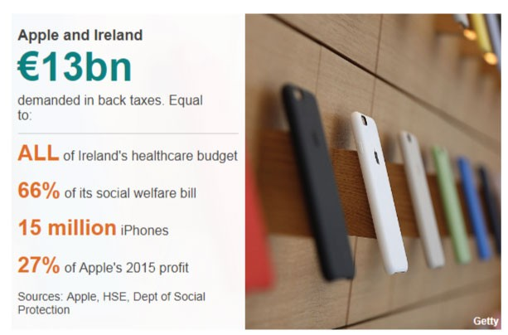Read the following article then answer the questions that follow:

Apple tax ruling 'a serious blow' to Irish investment

The European Commission has ruled that Ireland should recover up to €13bn (£11bn) from Apple in back taxes, after a three-year investigation concluded that the US company's Irish tax.

The European Commission said Ireland had enabled Apple to pay substantially less than other businesses, in effect paying a corporate tax rate of no more than 1%.

Ireland and Apple both said they disagreed with the record penalty and would appeal against it. Apple said the decision would be harmful for jobs.

"The European Commission has launched an effort to rewrite Apple's history in Europe, ignore Ireland's tax laws and upend the international tax system in the process," the company said.

"The Commission's case is not about how much Apple pays in taxes, it's about which government collects the money.
It will have a profound and harmful effect on investment and job creation in Europe.
Apple follows the law and pays all of the taxes we owe wherever we operate. We will appeal and we are confident the decision will be overturned."
This is damaging to Ireland as it hits Ireland’s international reputation and it could make it less attractive as a destination for foreign direct investment (FDI) from multinational companies.

Tax has been a key part of Ireland's success in attracting investment, particularly from US technology firms. The 12.5% corporation tax rate is among the lowest in the developed

world.
However, the record tax bill should not be a problem for Apple, which made a net profit of
$53bn in the 2015 financial year.

Apple is not the only company that has been targeted for securing favourable tax deals in the European Union. Last year, the commission told the Netherlands to recover as much as €30m (£25.6m) from Starbucks, while Luxembourg was ordered to claw back a similar amount from Fiat.

Adapted source: http://www.bbc.co.uk/news/uk-northern-ireland-37219372 and http:// www.bbc.co.uk/news/business-37226101
- What is meant by corporate tax?
- Why does the corporate tax rate of 12.5% appeal to multinationals?
- Why would the Irish Government not like this decision by the European Commission?
- What is meant by foreign direct investment (FDI)?

- Why would this tax ruling have “a profound and harmful effect on investment and job creation in Europe”?

Associated British Foods is a British business operating in 50 countries. It owns many global brands including Twinings, Ovaltine, Ryvita and Jordans.
- What is the name given to a business which operates in many countries?

- Suggest and explain two benefits which Associated British Foods might gain from operating in so many countries.
- Outline one disadvantage Associated British Foods may experience from operating in so many countries.
Below are a jumble of advantages and disadvantages of foreign businesses setting up in the UK. Sort the list into advantages or disadvantages of multinationals locating in the UK.

- Local businesses gain from the increased income of workers and increased spending by foreign businesses.
- Taxpayers’ money used to attract businesses.
- New production techniques / skills introduced e.g. Just in Time.
- Opportunities to learn and develop skills.
- More jobs available in area.
- Higher paid / skilled jobs go to workers from the business’ own country to begin with.
- Factories which are easy to set up may be just as easy to close down when the foreign business sees advantages in other countries or products.
- Opportunities for greater incomes for workers with extra skills and/or promotion.

The European Union
The European Union (EU) is a political and economic grouping that currently has 28 member countries. These countries have given up part of their sovereignty in exchange for political, business, economic and monetary membership of the world’s largest free trade area. It operates as an internal (or single) market which allows free movement of goods, capital, services and people between member states.
The EU (through the Commission, Parliament and Council of Ministers) sets many laws and regulations that control large parts of business activity, economic policies and trade throughout the European Union.
The single market of the European Union, which came into existence on 1 January 1993, aims to make the whole of Europe the 'home market' of all businesses operating within the European Union. EU members gain open access to an export market of over 500 million people comprising 28 countries. Any European country can apply to join the EU.
Businesses operating and competing in the single market are able to trade freely with all other countries within the single market and also, because of increased competition, increased economies of scale and improved access to resources, be able to increase efficiency and compete globally.
The EU countries are:

Austria, Belgium, Bulgaria, Croatia, Republic of Cyprus, Czech Republic, Denmark, Estonia, Finland, France, Germany, Greece, Hungary, Ireland, Italy, Latvia, Lithuania, Luxembourg, Malta, Netherlands, Poland, Portugal, Romania, Slovakia, Slovenia, Spain, Sweden and the UK.

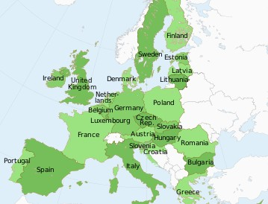

Source:http://www.schengenvisainfo.com/eu-countries/
In 2016 the UK decided to leave the EU and this is expected to take place by 2020.

The European Union is a common market or single market, this means that:
  - There are no customs duties to be paid when goods move from one member to another.
  - There are no border posts, so goods pass easily between member countries.
  - There is easy movement of people (workers) from one European country to another.
  - Investments also move easily across European borders.

Main features of the single market

  - No barriers to trade between member states, this means there are no quotas (limits on number, value or quantities) on imports and exports
  - No tariffs (taxes on imports and exports) on goods and services traded within the single market

  - Free transfer of resources from one country to another, these resources include capital and labour
  - Consistent standards from one country to another (a good, service or professional qualification that is valid for sale or for use in one member state, is free to be sold or used in all member states)
  - Common external tariff on imports into the EU from countries not in the EU.

The advantages of the single market for businesses

  - Increased levels of demand results from access to a larger marketplace as it is easier to export to the other countries in the EU
  - Lower costs through increased economies of scale as larger markets results in larger scale production, lowering average costs of output
  - Lower costs in sourcing raw materials and supplies from EU countries

  - Freeing of capital markets as businesses will be able to access the best finance and capital-raising deals throughout Europe

  - Greater employer access to labour markets – workers from all member states are potential employees

  - Growing wealth in poorer parts of the single market could drive future demand for products.

The advantages of the single market for consumers and workers

  - Increased wealth as trade and competition increases. This results in lower prices and more job opportunities as employment anywhere in Europe is available to anyone living in one of the 28 member states.
  - Increased consumer choice as there is access to all manufacturers and service providers
79

in the EU; why not take out a mortgage or loan with a German bank if the interest rates offered are lower than UK banks?
It is argued that the UK has been one of the greatest beneficiaries of the European single market. Many Asian and American companies that have established production facilities in the UK have done so to gain free access to the rest of the EU.

However, there have been differing impacts in differing sectors of the economy. One great UK success within the single market has been in finance, with London currently the leading financial centre of Europe, producing net exports of £70 billion a year. When the UK leaves the EU, it is uncertain if London will still be the main financial centre in Europe.
Agriculture has been one of the industries that have been impacted the most by the EU and the single market. Large subsidies for certain crops have helped UK farmers.

The Open Skies Policy of the EU deregulated the airline industry allowing entry and expansion of low-cost airlines like Ryanair and easyJet. These, and many other similar airlines, have boomed, allowing low cost travel for all, as well as creating thousands of new jobs.
UK exports to the EU have increased, both in proportion and in total, since the single market was established and many of our largest businesses have benefited from significant economies of scale.

However, there are problems. Smaller UK businesses have lost out to European competitors who can compete in the UK. The relatively new members of the single market, with their lower costs for business, have resulted in manufacturing jobs moving to Eastern Europe.
Many workers from other, less-rich countries have moved to the UK looking for jobs, which creates a higher level of competition for jobs and lowers wage rates as the supply of workers increase. This issue was a major argument in the referendum vote in 2016.

The EU has imposed many regulations on UK businesses, including employment law and consumer law. It is argued that these laws have resulted in increased costs for businesses making them less competitive and having to act within laws that were created by politicians from other countries.
When the UK leaves the EU, many larger UK businesses that currently benefit from membership may struggle to obtain the same market access, sales and profit. The domestic market will fall from a population of 500 million to 65 million; businesses may have to pay tariffs with European countries, which would increase the price of their products in these markets.
Farmers of all types receive subsidies from the EU. When the UK leaves the EU, will the UK Government continue to support farmers in the same way?
Also there is a potential impact on labour supply. Will leaving the EU mean that tens of thousands of European workers employed in hospitality, healthcare, agriculture etc will have to leave the UK? If this were to happen, wage costs would most probably rise in these industries, though it may result in more jobs for UK workers.
Opinions and judgements on the consequences of leaving the EU are conflicting. Until the UK actually leaves the EU, and possibly for a few more years, the actual impact to UK businesses will not be known. The information below summarises the main arguments for remaining in and leaving the EU:

The debate
Arguments for and against Brexit, according to the main campaigns:

Leaving will return control over areas like employment law and health and safety, measures that a recent Business for Britain poll
found businesses favoured.

82

1. Explain what is meant by each of the terms below:
- International trade
- Globalisation
- Multinationals
- The European Union
- Single market

2. Complete the 3 tables below (the rows for each stakeholder will need to be enlarged to write your answers):
Stakeholders | Advantages of international trade | Disadvantages of international trade
Businesses
Consumers
Workers
Government
Stakeholders | Advantages of multinationals | Disadvantages of multinationals
Businesses
Consumers
Workers
Government
Stakeholders | Advantages of being a member of the EU | Disadvantages of being a member of the EU
Businesses
Consumers
Workers
Government
3. Do you think that consumers in the UK have benefited from globalisation? Justify your answer.

Acknowledgements

Document cover; erhui1979 / gettyimages
Meeting with technology; courtneyk / getty images Industrial robotic in a factory; iv-serg / getty images Drone; Oktay Ortakcioglu / getty images
Cows in stalls during milking; Sean Gallup / getty images CAD; LuckyBusiness / getty images
CAM; SafakOguz / getty images Trailer; diane39 / getty images
e-commerce; Pinkypills / getty images m-commerce; Daviles / getty images Social media icons; alexsl / getty images
April Fools Prank, Brynteg Holiday Park; Network She http://bit.ly/2rPnzOi
April Fools Prank, Free Blow Dry; Network She http://bit.ly/2rPnzOi

Audi Social Media; These are used for critical analysis under the fair dealings policy New Look Social Media; This material is used for critical analysis under the fair dealings policy
Odeon Social Media; This material is used for critical analysis under the fair dealings policy
Import / Export; Unable to trace copyright, please contact us if you are the copyright holder
Import / Export graph; Uk Trade info http://bit.ly/1OVoCTJ
Superdry Social Media; These are used for critical analysis under the fair dealings policy Anita Roddick; Chris Jackson / getty images
Fairtrade; Thinglass / getty images Factory; JanWilemKunnen / getty images
Recyclable paper; ricochet64 / getty images
UK Corporate tax rate graph; Trading Economics http://bit.ly/2rnBZZg

Cadbury Dairy Milk chocolate; flickr Creative Commons http://bit.ly/2qQZ460 Unemployment rate in the Uk garph; content available under the Open Government Licence v3.0
Wonga; Dan Kitwood / getty images Health and Safety signs; Crown Copyright
Citizens Advice logo; Wikimedia Creative Commons http://bit.ly/2qRCfgH
Complaint procedure; Ofgem http://bit.ly/2rd4auo

Copyright; jirsak / getty images Madonna; Kevin Winter / getty images
Intellectual Property Office; whitemay / getty images Patent; adrian825 / getty images
Patent application; Fresh Patents http://bit.ly/2qzYMyk - Used for critical analysis under the fair dealings policy
Trademark; Warchi / getty images
Various logos; Hocus Focus Studio / getty images SPAM; Juanmonino / getty images
Darryl Mcdaniels; Christopher Polk / getty images
Import / Export; Unable to trace copyright, please contact us if you hold the copyright.
Import / Export graph; Uk Trade info http://bit.ly/1OVoCTJ

iphone covers; Justin Sullivan / getty images European Union; artJazz / getty images
Map of EU Countries; Schengen Visa info http://bit.ly/2rwnbHc
The Debate; Britain Stronger in Europe http://www.strongerin.co.uk/ Used for critical analysis under the fair dealings policy
83

