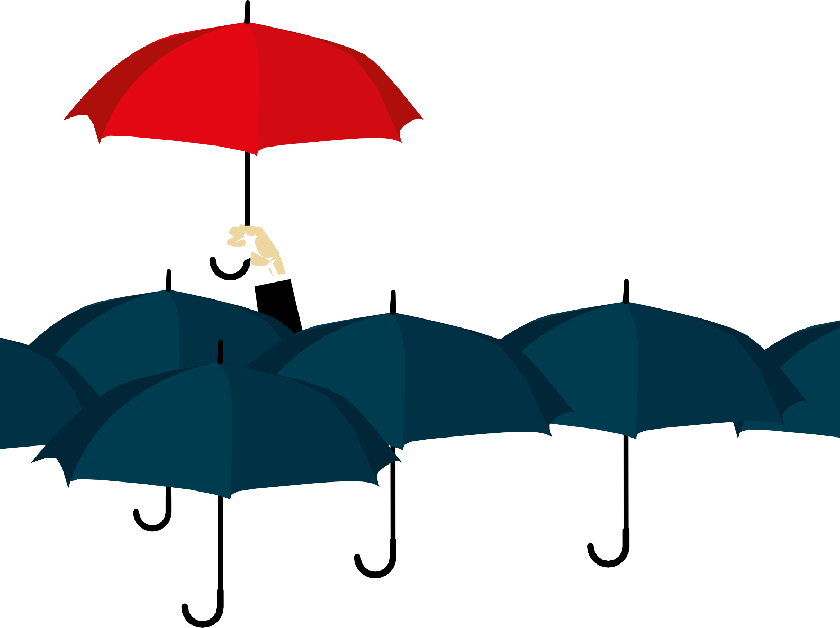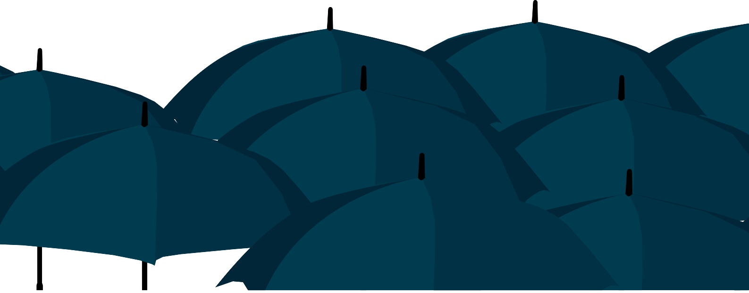

GCSE Business 1

Business Activity

Index

The nature of business activity – 1 Business enterprise – 34
Business ownership – 60 Business growth – 84
Business location and site – 100
Acknowledgements - 113

The nature of business activity

The competitive business environment

Businesses have to compete in a competitive environment. This means that they are not the only business providing a particular good or service (product). Consumers usually have a choice on what they spend their money on, for example if you wanted to buy a new mobile phone you would have a number of different models made by different manufacturers to choose from. Normal consumer behaviour predicts that if the product is identical or very similar you will choose the cheapest.
However, consumers are normally prepared to pay a higher price if they think that the quality of the product is higher, or if the product has a unique selling point (USP) that makes the product stand out from the rest. When choosing your mobile phone, if the price is not a concern then you will consider the functions and features of the phone and also which one will impress your friends!

Products are sold to consumers in markets. In early societies there was only one kind of market where producers and traders would go from town to town to sell their products. Today these physical markets still exist, but there are many other places where consumers can buy their products – market stalls, shops, online, catalogues, etc.

A market is any place that brings buyers and sellers together so that an exchange of goods or services can take place.

The term ‘market’ is also used to categorise different types of products and there is a market for every product or service. For example there is a market for cars, insurance, holidays, take- away food, private health care, Valentine’s Day and so on.
Different markets will have different levels of competitiveness. The more sellers in the market the more competitive it is likely to be. Some markets are dominated by very few and large businesses, so these are considered to have reduced competition.

1. Complete the table below:
Market | Business | Competitors
Cars | 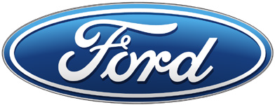
Mobile phones
Banks | 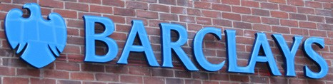
Internet provider | 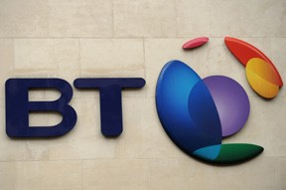
2. Consider the competitiveness in the following markets:
- Cola drinks
- Supermarkets
- Taxis

Successful businesses are the ones that meet the needs of consumers better than their competitors. A business can make its products more appealing by the following factors:
- Cheaper prices
- Better design
- Better quality
- Advertising
- Promotional activities
- Make it available to buy in more places
- Attractive packaging

Having a strong brand identity – making it more recognisable and stand out from the competition.
If a business fails to recognise the competitiveness in the market it competes in it is likely to struggle and gain the sales in order to create enough revenue to be successful. However, if a business is able to successfully compete in the market it is likely to create a good level of revenue and be successful.

Explain what is likely to happen in the following scenarios:

Greg Davies owns a small chain of pizza parlours, his prices are slightly higher than his main competitors, however, he has a unique recipe that has won him awards from the food industry.
Ace Plc manufactures and sells televisions. It is a well-established business that sells its televisions through a well-known high street retailer. They have decided not to create a website and continue to sell through this one retailer.
Prime cinemas are a new business and have opened 20 cinemas around the UK. Its tickets for adults and children are 10% higher than the average market prices.
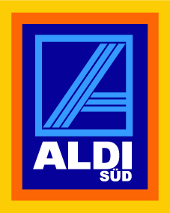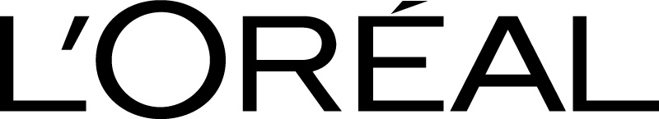
- For each of the products listed below explain why they are successful in their relevant markets:

- What is meant by a competitive market?
- Why is competition in business good for consumers?
- Summarise the factors that helps businesses to remain competitive.

The dynamic business environment

The business world does not stand still, business activity is constantly changing, in other words, it is dynamic. Businesses have to respond to these changes to remain competitive. The business world can change in many different ways; a successful business must recognise these changes and make sure they are not left behind. To remain profitable a business cannot just stand still, what made the business successful yesterday will not automatically make the business successful tomorrow. The rapid growth in selling online via the internet
(e-commerce) and more recently through wireless handheld devices, such as smart phones and tablets, (m-commerce) has drastically changed the way in which businesses can communicate and sell to their customers.

The following products are good examples of how the market they are sold in is constantly changing and how businesses have to adapt their products to remain successful:
- Cars
- Ready meals
- Clothes
- Music playing devices
- Supermarkets

- Choose two of above markets. Use the internet to search for images and make a pictorial diagram of how these products have changed in the last 50 years. Use a timeline and place the images in the correct time.
- It is often said that the pace of change is increasing, does your diagram show this? How?
- For one of your chosen products explain the main reasons why the product has changed.

Consumers needs and wants are not static, their tastes, preferences, attitudes, demands and expectations are constantly changing. In addition, new production techniques, new
technology, new competitors and new markets present businesses with opportunities (as well as threats) to succeed in a competitive environment.

Consider a business environment that did not change; consumers would be content with their products and would not create demand for new products as they would be happy with what they have already got. How would this affect business profitability? There would be no pressure on businesses to improve their products or look at introducing new products or new cheaper ways of producing the products. Technological developments would be much slower, or even not take place. A dynamic environment is needed to improve products and production processes in order to continually satisfy consumers' demand for better products which allows business to seek further ways of making higher levels of profit.

The dynamic business environment should be seen by most businesses as an opportunity and not a threat.
In addition to adapting the actual product, businesses can also respond to change by
adapting the way in which they carry out their business activity, for example;

- Production methods can change
- The use of different materials and suppliers
- Using different promotional activities
- Changing how they distribute their products
- Changing the location of their business
- The way in which they communicate with their customers
- Selling the same products in different markets
- Changing recruitment and employment practices
Change is not always imposed on a business, some businesses create the change themselves.
These businesses are proactive and may spend a great deal of money on research and development in order to bring a brand new product to the market, or drastically change an existing product.
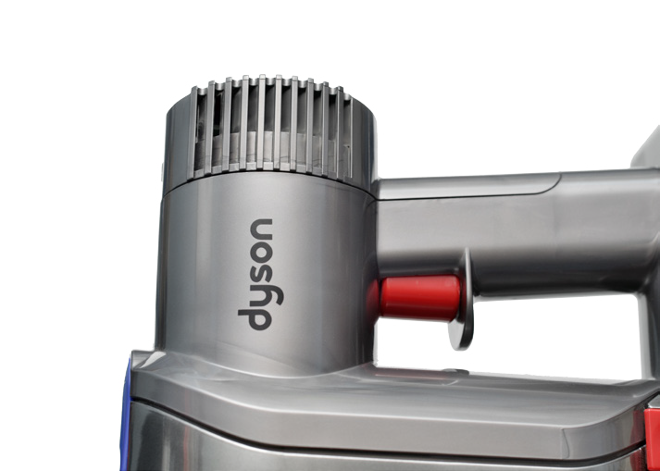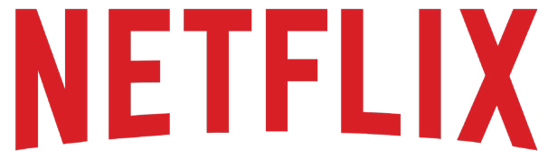
Consider the products and services sold by the following businesses:

- How have they initiated change?
- Why have they been successful?
- What does this mean for their competitors?

The dynamic business environment is affected by changes in:

Economic factors – such as changing levels of consumer income, unemployment, interest rates and the price of important resources such as oil and steel.

Technological factors – such as new inventions, use of robotics, the expansion of information and communications technology and reduced cost of technology.
Society factors – such as demographic, social and cultural changes, new tastes and fashions.

Market factors – such as new competitors, change in strategy of existing competitors and new markets (the global market).

Environmental factors – such as needing to source alternative materials, reducing pollution in the manufacturing of products and using renewable energy.
Political factors – such as new regulation on business activity and change in political policy.
The dynamic environment can lead to uncertainty. It is very difficult to predict what will

happen in the future, especially when the pace of change is so rapid and unpredictable. However, a business must not stand still, if it does it is likely to fail. A business has no control over these factors, it is important that the owners or management of any business are aware of these factors and what affect they may have on their activities. If they do so, they are able to adapt their products and or practices in order to remain competitive.

- What is meant by a dynamic environment?
- How do businesses respond to a changing environment?
- Explain why a dynamic environment is an opportunity?

The identification and response to business opportunities

A business gets started when somebody decides that they can earn a profit by making a particular good or providing a service and selling it to people who are willing to pay for it. We all need to buy goods and services to live so we depend on other people to provide them, we are willing to pay for these if we feel that they are satisfying a need or want.
The desire to make a profit is often the reason why a business person will take a risk investing
money into a business idea.

- What is meant by profit?
- Explain why profit is often the main reason for someone wishing to start their own
business.

A business person is always looking out for chances to provide the goods and services we need and want. A need is something we cannot do without and includes food, water, shelter, clothes and warmth.

Complete the table below. For each need give two examples of businesses that make a
profit from supplying the goods or services:
Food
Water
Clothes
Shelter
Warmth

However, there are some things that we do not really need but which are pleasant to have. No one really needs a mobile phone, it is possible to live without one, but communicating with our friends is much easier if we have one. Most people like to have a TV, car, a summer holiday, make-up, comfortable sofa, etc., you could live without these, but most people want

them. There are plenty more examples of our wants and a business person will provide these
if they think they can make a profit from selling them.

In a dynamic environment, with ever-increasing wants, businesses are always on the lookout for opportunities to make a profit, often a business will attempt to encourage these wants through advertising campaigns and careful pricing strategies to make people want to buy them.
Identifying a new opportunity is not easy, many new businesses will fail with what they thought was a good idea, but was not a commercial success. It is important to carry out thorough research and work out the total costs of starting and running the business.
Watch an episode of ‘Dragons Den’. For one of the pitches:
- Summarise the business idea.
- Make a list of the questions the Dragons asked about the idea.
- For each Dragon that did not invest explain their decision.
- For each Dragon that did invest explain their decision.
- What did you think about the idea?

Important questions that need answering when identifying and responding to a business opportunity include:
- Who are the potential customers?
- What makes my product/service different?
- What will attract customers to my product?
- How will it be made?
- How much will it cost to make it?
- What other costs have to be paid?
- How many will I have to sell to make a profit?
- Where will it be sold?
- How will it be advertised?
- Do I have the experience and skills to make the business a success?

Scale of business activity

Business activity takes place at local, national and global levels. The scale at which a business
operates will affect the way in which it carries out its activities and the profit it makes.

Local scale

A business that operates at a local level is often small, limited in size, the number of people it employs and the revenue it creates. (Revenue is different from profit. Revenue is the number of sales made multiplied by the price charged to customers. Profit is revenue minus the costs.)

A small scale business is often owned and run by the same person and may employ a small number of workers. The business activity is based in a local area focusing on customers who live, or visit, the area.
Characteristics of local and small scale businesses include:

Ownership – small number of owners, usually one person, the ownership structure is simple with clear communication.
Finance - relatively low amounts of money invested in the business (low start-up costs), generates lower amounts of revenue with lower costs than larger businesses. Low levels of money are available for marketing activities, technological improvements and business growth.

Market – a much smaller market than larger businesses, often serving local communities. However, many small businesses sell to customers across the world through the internet. Because of the low quantity they sell and the other characteristics present, these businesses are still considered to be small scale.
Locations – usually focusing on a single area, many are run from home and do not have multiple outlets.
Production – small scale, making small numbers.
Employees – usually very few, owners will often staff the business themselves and may
employ workers at busy times.

Flexible – owners have to be willing to do what it takes to be successful, they will often have to be prepared to change the way they do things in order to react to challenging situations.

Community based – attract loyal customers who see the business as a vital part of the local community.
Technology – the growth of social media and blogs have been utilised by many small
businesses due to its effectiveness and low cost.

Search for examples of how blogs have been used by small local scale businesses to promote their business.

Typical examples of local scale businesses include service or retail outlets such as local newsagents, convenience stores, butchers, florists, garages, pubs, restaurants and fast food outlets, taxis, plumbers, electricians and hairdressers. Small scale manufacturing and
farming also exist as do professional services such as lawyers, accountants, dentists and vets. Internet-related businesses such as web design and computer services and programming can also be small scale.

Local scale businesses vary a great deal in their size; some will be owned and run by one person from home, whilst others may be a small company employing 20 – 40 people from a factory.
From the list in the table below select one business idea you would like to start when you leave school/college. You may need to carry out some research on the ideas to find out what is involved.
When you have selected one consider:
- The start-up costs
- Experience needed
- Level of risk/reward
- Regulation
- Likely success
- Owner satisfaction

Interior decorator | Window cleaning
Personal trainer | Bed and breakfast
Accountant | Christmas tree sales
Website developer | Dog walking
Computer repair | Photographer
Massage therapist | Wedding planner

National scale

A national business will operate all over one country. It may have multiple factories or retail outlets throughout the country and a distribution network to make sure it can distribute its products to where they are being sold. A national business will offer the same products or services, usually at the same prices, to customers all around the country or over a large area of the country.

Compared to a local business, a national business will have more resources to use in carrying out its activities, including greater amounts of capital (money available to invest in the business), more and different types of employees with a wider range of skills.
This extra capital can be spent on more technical and efficient production processes, superior marketing activities, such as national TV adverting campaigns and attractive sales promotions, employing highly skilled workers and efficient support systems such as IT, legal services and transport.

The ownership of national businesses is more complicated than a local business, often having multiple owners and a separate management structure.
The market size of a national business is much greater than a local business so there is a great opportunity to attract a greater number of customers to obtain a high level of sales. The population of the UK is 65 million, for a national business these are all potential customers.
When this total population is divided into cities, towns and districts it is clear to see the
benefits of operating on a national scale.

Cities, towns & districts | Population 2016
London | 7 074 265
Birmingham | 1 020 589
Leeds | 726 939
Glasgow | 616 430
Sheffield | 530 375
Bradford | 483 422
Liverpool | 467 995
Edinburgh | 448 850
Manchester | 430 818
Bristol | 399 633
Kirklees | 388 807
Fife | 349 300
Wirral | 329 179
North Lanarkshire | 325 940
Wakefield | 317 342
Cardiff | 315 040
Dudley | 312 194
Wigan | 309 786
East Riding | 308 689
South Lanarkshire | 307 450
Coventry | 306 503
Belfast | 297 300
Leicester | 294 830
Sunderland | 294 261
Sandwell | 292 196

Doncaster | 291 804
Stockport | 291 080
Sefton | 289 739
Nottingham | 283 969
Newcastle-upon-Tyne | 282 338
Kingston-upon-Hull | 266 775
Bolton | 265 449
Walsall | 262 593
These population figures can be divided further for some small scale businesses that will
only attract customers in the immediate local area.

For example if a house owner in London was looking to employ a plumber to fix a leaking pipe, or a family from Wigan wanted to visit a local restaurant for a meal, they would generally look for a business within a few miles of where they lived. Would a plumber travel across from south London to north London for the job?

It is easy to recognise the businesses that operate at a national level. They are well-known businesses that can be seen as you travel throughout the UK and tend to advertise on national TV, on billboards, in magazines and national newspapers. If suitable, they also tend to have highly developed websites which allow for online purchases with quick delivery times

The table below lists some well-known national businesses in the UK. Use the internet to
find out the information and complete the table
Business | Market(s) | Sales Revenue | Profit | Number of Employees
DFS
National Express
John Lewis
Taylor Wimpey
Direct Line
BT Group

In the UK the grocery market is dominated by four large national businesses, they have the following number of stores throughout the UK.
Supermarket | Number of Stores in the UK
Tesco | 3 500
Sainsbury's | 1 304
Asda | 603
Morrisons | 569

Supermarkets, like most other national retail stores, will have a consistent approach to all its outlets, many will look exactly the same, sell mostly the same products at the same
prices. Buying a packet of crisps or a bottle of tomato sauce will be the same price in Bristol,
Norwich, Manchester or Cardiff, and most likely be positioned in the same aisles next to the same alternative products. This consistent approach helps a national business create a familiarity with all its customers no matter what part of the UK they live.
The rise of the large supermarket chains has resulted in the decline in independent small scale retailers. Over the last 10 years the number of local retailers has fallen by a half, from 35 000 to 18 500.

Global scale
A global business will operate internationally and throughout the world. This includes businesses trading with customers in one or two countries and businesses that trade with many countries across the world. The factors of trading at a global scale include:

- A much bigger market. The UK population is 65 million; the world population is over 7 billion. The population of Europe is over 740 million; the population of the USA is over 320 million. The potential to sell products to more people across the globe is an obvious attraction to businesses who wish to increase their sales.
- Manufacturing or sourcing products from different countries at lower costs. Some
UK businesses may not have the necessary raw materials to produce in the UK or other
countries may be able to produce some goods and services more efficiently than we can.
- Improved communications. The world is now a smaller place, the use of the internet makes it possible to trade efficiently across the globe. Service industries such as insurance services and customer help centres have made use of these developments. Improved transportation systems have also led to cost effective transportation of materials and products across large distances.
- Global brands. These are products and services that are recognised throughout the world. The same products (maybe with some slight changes for different countries) are sold in numerous countries are easily identified by customers. Coca Cola, Apple and Ikea are examples of global brands.
- Complicated ownership and management structure. Many global businesses or brands will be owned by a parent company who in turn will own other businesses. An example is when Facebook (the parent company) bought Instagram (the subsidiary). Facebook has bought other companies (including WhatsApp) and other computer/ technological based businesses.
A small scale business may be an international business; it may carry out its main activity in its country of origin, but may also import materials or products from other countries and export (sell) some of its products to customers in other countries. However, a small scale business will find it difficult to operate in numerous countries. Businesses who operate
in many countries are usually large multinational companies that employ thousands of employees, manufacture and sell a large number of products and create vast amounts of revenue and profit.

Carrying out business activity at a global scale is expensive and complicated, most large global businesses will invest in factories, retail outlets and offices in a number of countries. There are numerous risks involved, however, the potential reward of increasing customer revenue and profit attracts many businesses to try and sell their products and services globally.

Now compare the information you found on these global businesses with the information you found on national scale businesses.
The table below lists some well-known global businesses. Use the internet to find out the
information to complete the table.
Business | Market(s) | Sales Revenue | Profit | Number of employees
Honda
Nike
Google
Kellogg's
Disney
Samsung

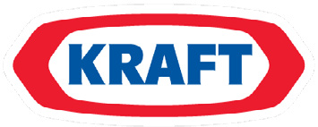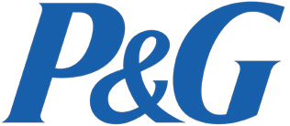
The businesses listed below are all parent companies who own a number of global brands. Select one of these parent companies and find out what brands they own. Produce a poster that can be displayed in your classroom to show the logos of the brands they own.
It is important to remember that all businesses in the same market are in competition. A market will contain businesses that operate at local, national and global scale. When deciding to visit a restaurant a customer can choose from a locally run café, a national restaurant such as Harvester, or a global brand such as Pizza Hut. These businesses have to compete with each other for the same customer. This is the same in many other markets and the customer’s choice may depend on factors such as:
- Price
- Quality of product
- Choice of product
- Advertising and promotional activities
- Quality of the customer service
- Location

Explain how the scale of the business will affect the way in which the business operates.
Complete the table below and summarise the main characteristics of businesses that
operate at the three different scales:
Local | National | Global

The interdependent nature of business activity
A business has a number of different functions, these include:
Purchasing - responsible for buying anything required by the business, for example, the raw
materials for production, finished products to sell or equipment for administration.
Logistics - how the materials and finished products are transported and stored.
Production - responsible for all aspects of producing goods, from the input of raw materials
through to the finished product.

Marketing - responsible for managing all aspects of marketing including the products to sell, advertising, promotion, the prices to charge, where to sell the product and market research. In other words it is concerned about meeting customer needs and wants.
Sales - responsible for finding new customers and looking after existing customers who have
ordered and received goods.

Personnel or Human Resources - responsible for all aspects of the relationship between the business and its workers including, recruitment, training and motivation.
Finance or Accounts - responsible for all money-related aspects of the business, including paying the bills, receiving payments, keeping records and drawing up accounts.
These functions cannot operate in isolation. They have to work together to ensure the success of the business. Decisions and actions in one function will affect the outcomes in another part of the business.
A business needs to coordinate the different functions in order to make sure the whole business is working together to achieve its aims. The business works best when the functions overlap and everybody works together.
- Consider the following business scenario and comment how the actions will require the
different functions of the business to work together:

Dynamite Ltd manufacture and sell a range of domestic lights to a number of retailers. The management would like to invest £1 million in buying new machinery that will increase the number of products they can make and reduce the unit cost of making them. This could result in a reduction of its prices which will lead to an increase in demand from retailers. The business also wants to look for new customers to buy the extra products they can produce. The new machinery will reduce the number of workers needed in the factory and redundancies will take place.
- Explain why the sales team of a large car dealership needs to communicate with the following functions within the business:
- Finance
- Production
- Logistics

Jane Grimes owns and runs a small butchers in a local market. She has been contacted by a local farmer who has offered her a large quantity of meat at very low prices. She would like to accept this extra supply of meat as it could be very profitable for her, but the meat will have to be sold very quickly. What factors does she need to consider before she agrees to buy the meat from the farmer?

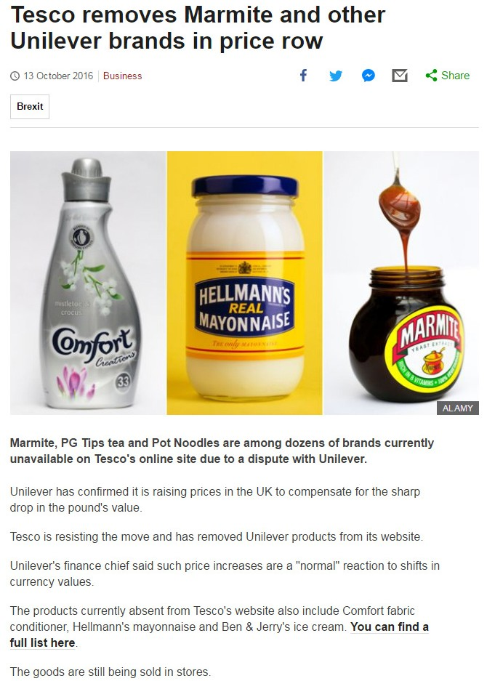The interdependent nature of business also refers to the external cooperation with other businesses. Businesses rely on others for their materials and for the distribution and sale of their products. Supermarkets do not grow or manufacture all the products they sell; they rely on many suppliers for this. Likewise a manufacturer will not sell its products directly
to the consumer, it will sell these to retailers in large quantities who will then sell to the consumer.

Businesses have to create relationships and work together. This cooperation is important to develop trust between businesses.
- Why has the relationship between Tesco and Unilever broken down?
- Why is this situation bad for both businesses?

Source: www.bbc.co.uk/news/business

Use of business data
Studying business requires students to use a large range of business data. Data can be either:

Qualitative - text and words used to describe, analyse and evaluate situations. This data is not in numerical form. This is descriptive information found by experiences or in textbooks or newspapers or reports. The article on the previous page about Marmite is an example of qualitative data.

Quantitative - information about quantities and can be measured and written down with numbers. This includes figures, numbers and calculations shown in text, tables and graphs. The business world is rich with quantitative data.

Qualitative
This resource has examples of news articles from websites and case studies that include a wide range of business terms. It is important that business students understand the technical terms used in the business world.

In your notes create a key terms list as you progress through the course. Add any business terms that you did not understand before your teacher explained it.

Read articles in newspapers and online to improve your understanding of business terminology.

Watch an episode of the Apprentice or Dragons Den and make a note of all the business terms they use that you don’t understand. Find out what these mean.

Quantitative
Quantitative data is used throughout the business world and when studying business, students have to deal with a range of quantitative data. This can include:
  - Market data
  - Market research data
  - Financial data
  - Costs and prices

In addition there are a number of business calculations that have to be carried out; some of these involve formulas that must be learnt. The details and instructions of these calculations will be explained in full in the relevant section of these resources. They will include:
  - Costs
  - Revenue
  - Profit
  - Break-even
  - Average rate of return
  - Profit and loss accounts
  - Cash-flow forecasts

Students should also know how to calculate percentages, percentage changes and averages.
WJEC has produced a separate resource on quantitative skills; this should be used to show
how the various calculations should be carried out.

Quantitative data is often presented in graphs, tables and charts. Examples of graphs used in business are found throughout these resources, they include pie charts, line graphs and bar charts. When reading qualitative data, graphs and charts are often included to show numerical data.

Read articles in newspapers, magazines, company reports and company websites to get familiar with the tables, charts and graphs used to present business information.

Students will be required to interpret (explain what the data means in a business context) numerical data and data in graphs and charts in order to show understanding of business activity and to solve problems and make decisions.
Often case studies and articles will include a mixture of qualitative and quantitative data, students should be able to use both these forms of data in order to answer a question or a set of questions, build an argument and make judgements.

Providing goods and services

Businesses produce goods and provide services.

Goods

Goods are products which can be seen, handled, turned on, lived in, eaten, driven and so on. A good is a physical (tangible) object which can be purchased. There are thousands of different goods that businesses make and sell to customers.
Goods can be divided into two kinds:

Consumer Goods | Producer Goods
- Goods that are used directly by consumers to satisfy their needs and wants.  - The goods are used (consumed) by the consumer.  - These goods are normally bought in shops, online, catalogues etc.  - Examples include cars, chocolate bars and furniture.  - This is sometimes referred to as B2C (business to consumer) | - Goods that are used by businesses to make other goods or help them run their business.  - The goods are used by businesses (producers) to produce consumer goods.  - These goods tend not to be available in shops, but from a specialist supplier.  - Examples include steel, robotics and barley.  - This is sometimes referred to as B2B (business to business)
Consumer and producer goods can themselves be divided into two types:

Durable Goods | Non-durable Goods
- These are goods that tend to have a long life. They will be used until they break or are replaced.  - There is no fixed time on durable goods, but they are expected to last at least 3 years.  - Examples of consumer durable goods include televisions, shoes and kettles.  - Examples of producer durable goods  include car engines, oil tankers and cash registers. | - These are goods which are only used or consumed for a single time or only once.  - They are often used immediately by the user.  - The expected lifespan is three years or less.  - Examples of consumer non-durable goods include milk, vegetables and ice cream.  - Examples of producer non-durable goods include oil, fertilizers and chemicals.
Consumers expect durable goods such as dishwashers, refrigerators and sofas to last for at least several years. In contrast, non-durable goods are consumed in a very short timeframe, ranging from just moments after they have been purchased up to around three years. Food and drink are the fastest-consumed goods. Petrol is another product that is consumed quickly. Some non-durable goods last a bit longer. For some products it is difficult to classify them as durable or non-durable. For example, trends in fashion means that for some people clothes can be considered non-durable goods if they only wear them for one season or if they are children and will grow out of them after 6 months. For others, clothes can be durable if they continue to wear them for over 3 years.

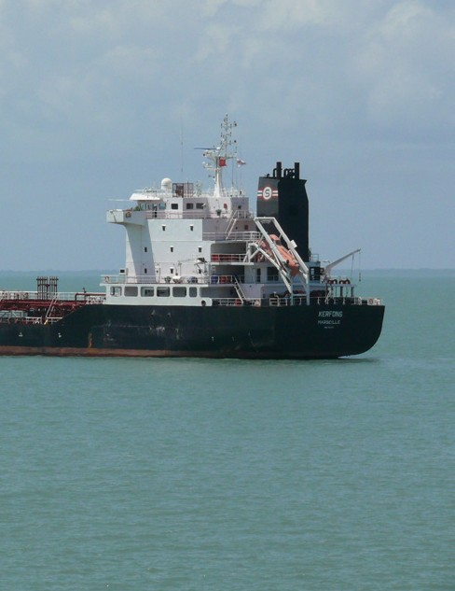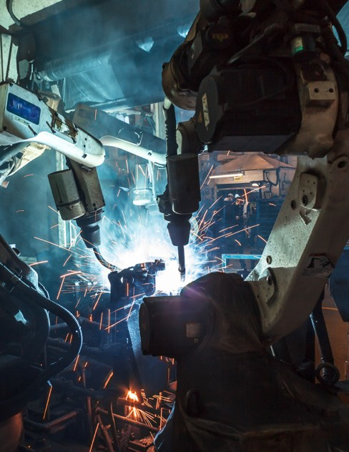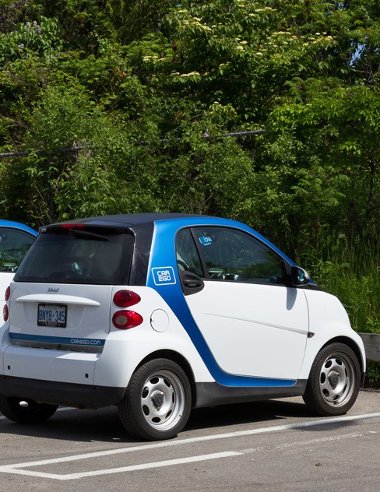
What type of goods are the following?
Oil tanker
consumer durable good
consumer non- durable good
producer durable good
producer non- durable good

Breakfast cereal
consumer durable good
consumer non- durable good
producer durable good
producer non- durable good

Pair of men’s shoes
consumer durable good
consumer non- durable good
producer durable good
producer non- durable good

Loaf of bread
consumer durable good
consumer non- durable good
producer durable good
producer non- durable good

Manufacturing robot
consumer durable good
consumer non- durable good
producer durable good
producer non- durable good

Laptop
consumer durable good
consumer non- durable good
producer durable good
producer non- durable good

Natural rubber
consumer durable good
consumer non- durable good
producer durable good
producer non- durable good

Small urban car
consumer durable good
consumer non- durable good
producer durable good
producer non- durable good

- List 3 non-durable goods a parent would buy for their 1 year old child.
- List 3 durable goods a parent would buy for their 1 year old child.

- List 2 non-durable producer goods needed by a person setting up a new garden maintenance service business.

- List 2 durable producer goods needed by a person setting up a new garden maintenance service business.

Services

Services are activities that other businesses do for you. A service is a non-physical item that can be purchased. Examples of services include retailing, hairdressing, dentists, hotels, pubs, restaurants, computer and IT services, banks, transport and holidays.

Services are sometimes referred to as intangible, which means that you can’t touch or handle them.

The service market employs more people and creates more profit than the goods market in the UK. It is likely that you will work in the service market when you leave school. Many small scale businesses in your local area will provide a service rather than produce goods.
Services can be divided into two kinds:

Personal or Direct Services | Commercial Services
- These are aimed at consumers.  - Consumers use a wide range of personal services on a regular basis.  - Increasingly more consumers are spending a higher percentage of their income on these services. | - These are aimed at businesses.  - Services are used by businesses that do not have the workers or expertise within the business to perform the activity.  - Typical commercial (or B2B) services include accountancy, marketing, market research, call centres and website support.
Some businesses will offer personal services and commercial services, such as banks, hotels
and builders.

What type of services are the following?

Images of services are listed below, identify the service and state whether you think they are personal services or commercial services.
Example | Name of Service | Service Type
 |  | Personal
 |  | Commercial
 |  | Personal
 |  | Commercial
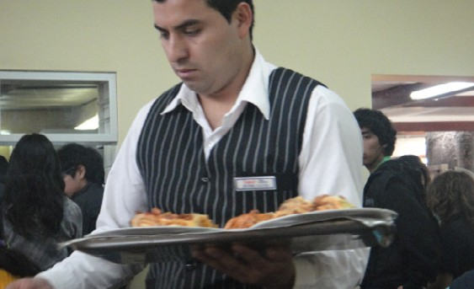 |  | Personal
 |  | Commercial
 |  | Personal
 |  | Commercial

Carry out a search of your local area to find out what services are offered by businesses.
You could use the internet, a telephone directory or personal knowledge to do this.
Categorise the businesses as local, national and global scale businesses.
Business Name | Market (services they offer) | Local, National or Global Scale

Growing importance of the service sector
The service sector dominates the UK economy, contributing around 78% of GDP (This is the value of all the goods and services produced by the UK). This has increased from 46% in 1948.
In 2015 over 80% of all UK workers were in the service industry and around 10% in manufacturing. The financial services industry is very important, and London is the world’s largest financial centre.

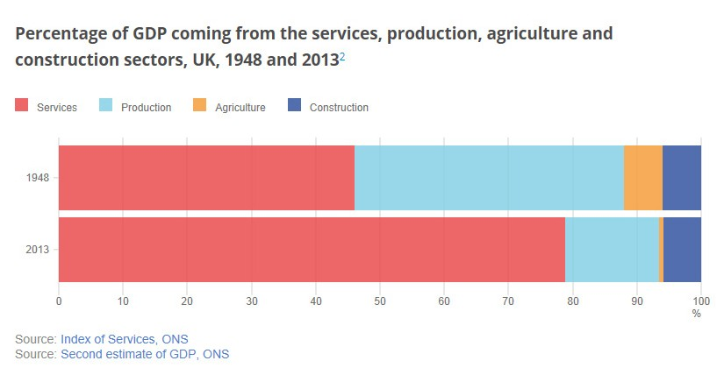
- Using the data in the graph above, describe what has happened to the service sector and production (manufacturing) sector.

- If we are producing fewer goods in the UK but consuming more, where are these goods coming from?
- The agriculture sector is now very small, what does this say about the provision of one of our basic needs?

Private and public sectors

The businesses we have concentrated on so far all want to make a profit and are owned by private individuals. They are in the private sector. Most private sector businesses aim to make a profit.

Some businesses though are not owned by individuals, they are owned by the government or local government and these are in the public sector. The aims of these businesses are different from private sector businesses in that they aim to serve the citizens of the country.

Public Sector | Private Sector
- Includes organisations that are owned by the government.  - They are run for the benefit of everyone.  - They are financed through government income such as income tax, council tax, and value added taxes (VAT).  - Includes services such as military, police, roads, education, health, parks and leisure services. | - Includes all the businesses owned by private individuals.  - They are run for the benefit of the people  who own them.  - Usually want to make as much profit as  they can.  - Includes charities who want to raise money or awareness for a particular cause.
Most goods and services in the UK are produced by the private sector by businesses big and small. Individuals set up the business, people pay for the goods and services, the income is used to produce more and the profits provide a return to the owners or enable the business to expand.
However, because private sector businesses do not provide all our needs or are not always willing to produce at a price the majority of people are able to pay, the public sector provides important goods and services at affordable prices. Also some public sector services are free at the point of use, these include hospitals, schools, the police, waste disposal and street lighting. Some services, such as policing and the military could not be run in the private sector as they have a national role to play and have to serve all the citizens of a country equally.

Below are a number of business organisations. Place them under private or public sector.
You may have to carry out some research to complete the task.
Lloyds Bank | Royal Navy |  | Virgin Leisure clubs
Primary school | WH Smith |  | Thorpe Park
Local library | Ford |  | BT
McDonalds | ITV |  | Hospital
BBC | Metropolitan Police |  | Local leisure centre
Public Sector |  | Private Sector

Use the internet to look at the website of your local council authority. Make a list of all the goods and services they provide.
How are these local services funded?

Public sector goods and services are paid for by taxpayers and by government borrowing. Sometimes the users will also contribute towards the cost. Any money earned goes to the government or local councils to add to their income and to further improve services. Public sector organisations are not generally expected to make a profit.
It is important to note that goods and services do not have to be provided exclusively by either the private or the public sectors. The public sector can overlap with the private sector in producing or providing certain goods and services.
There are many examples of services provided mainly in the public sector which are also provided in the private sector:

Leisure Facilities | There are private leisure gymnasiums and sporting clubs.
Education | There are private schools, some, oddly enough, are called public schools.
Health | People can be treated by private doctors and hospitals.
Transport | The road network is mainly provided by the public sector but toll roads such as the M6 Toll and the Severn Bridge are owned by the private sector.
Social care | There are private nursing homes.
Emergency Services | Factories and airports might have their own fire engines. Private  security businesses exist.

Why would some consumers prefer to pay private sector businesses for goods and services they could get for free from the public sector?

Public sector providers can move from the public sector to the private sector, this is called privatisation. In the UK many businesses that had operated in the public sector were sold and became private sector businesses, these include British Gas, British Telecom, British Airways and most recently Royal Mail. It is also possible to move private sector businesses into the public sector, this is called nationalisation.

Governments sometimes hire private sector businesses to provide goods and services for the private sector, this is called outsourcing.

Resources needed to provide goods and services
In order to carry out business activity a business will need a number of different resources,
these resources include:
  - Raw materials
  - Machinery and equipment
  - Workers
  - Site

Raw materials
These are the materials needed to produce a product. These include natural resources such as crops, iron, wood, rubber etc. They also include manufactured products that are needed to make finished products, such as car engines, bricks, cloth, electronic components and paper. If the businesses are unable to grow, collect or manufacture these resources themselves they will need to pay another business to supply them. Businesses need capital (this is money that is invested in business resources) in order to buy (procure) these resources.

We have already seen that there are many businesses that manufacture producer goods in order to sell to other businesses. Some businesses however carry out the primary stage (where raw materials and natural resources are farmed or extracted from the earth) and secondary stage (where the raw materials and natural resources are turned into parts and components and finished products) and the tertiary stage (where the business will sell the
product to the consumer). If a business is going to carry out all three stages then they tend to be either small scale businesses producing and selling low quantities or large businesses who have the resources to invest in these processes.

The interdependent nature of business is important when procuring raw materials, components and finished products as a business will rely on other businesses to either provide the right supplies in the right quantity at the right time and price, or buy its products in order to sell to the consumer.

For the businesses listed below make a list of the raw materials, components and finished
products they need to carry out their business activity:
- Shoe factory
- House builder
- Car manufacturer
- Mobile phone manufacturer

Machinery and equipment
Businesses will also need machinery and equipment which they need to carry out their business. The machinery and equipment will not be sold to consumers but used in the production or providing a service. Examples include tills in supermarkets, robotics in manufacturing, vans for delivery, computers in the finance office, aeroplanes for travel companies and tractors for farmers.

When purchasing machinery and equipment a business has to be careful to make sure
it spends its money wisely. It is no good buying equipment that is not used effectively or buying equipment that is hardly used. This can be a big expense for a business; in particular, for small scale businesses the capital invested in machinery and equipment should help to make the business profitable. Spending money on ineffective machinery and equipment will waste money and this money could have been used more effectively on other resources or activities.

For the businesses listed below make a list of the machinery and equipment they need to carry out their business activity:
- Shoe factory
- House builder
- Car manufacturer
- Mobile phone manufacturer

Businesses that are focused on offering a service rather than making a product also need machinery and equipment. For the service businesses listed below make a list of the machinery and equipment they need to carry out their business activity:
- Dentist
- Hotel
- Supermarket
- Hairdresser

Workers

Workers (employees) are a very important resource for a business. This is often referred to as human resources or labour.

This includes the physical and mental effort put in by humans to either gather the raw materials, produce the components and finished goods and to sell the goods and services to the consumer.

For many businesses, human resources are the most expensive form of resource as workers will require payment on a regular basis. The more complicated the job the more expensive the payment to workers will be.

For the following businesses identify 2 different types of jobs and comment on how
expensive they will be to employ:
Type of Business | Examples of Employees | Cost to the Business
Fast food restaurant
Solicitors
Audio and vision electrical manufacturer

It is important that businesses employ the people who have the necessary skills, therefore many businesses will take care to employ the right people. Many large scale businesses will have a human resource function (department) that will specialise in recruiting the right people for the right job.
We have seen already the importance of the service sector in the UK and how many jobs are based in this sector. It is important that workers have the right skills to carry out jobs in the service sector.

1. Explain what skills are needed by workers who work in the following service businesses:
- Banks
- Hotels
- Retail

2. It is often reported in the news that there is a skills shortage in the UK, particularly for school leavers and graduates. What does this mean? What does this mean for employers?

Site
A business has to operate from somewhere, for some small businesses this may mean operating from the home or garage, but for most businesses it means they need a place to carry out its activities. This can be a very expensive cost to the business and will often require a large initial payment to purchase the site. The size and nature of the site will depend on the business activity.

Complete the table below by identifying what type of site is needed by the business:
Business | Site
National shoe retailer
Manufacturer of glass bottles
Pig farmer
Plumber

Some businesses will buy the site and some will rent the site. Many small businesses tend to rent as this does not require a large initial investment. However, it will have to pay regular payments to the landlord. Some large businesses also prefer to rent as they don’t want to spend large amounts of money on purchasing land and buildings.
For some businesses that need to be close to customers and have a high level of footfall (the number of customers that pass by the site) the site is a very important feature of the business and care must be taken on what site to buy or rent. For other businesses, such as manufacturers, other features (for example the size and road access) are more important. The location of the site, together with the size and nature of the site will affect how much it will cost.
The money that a business spends on raw materials, machinery and equipment, workers and site will depend on the nature of the goods and services it offers, the scale it operates at and the ambitions of the owner(s). It must be remembered that business activity involves risk and there is no guarantee that it will succeed. Businesses, like individuals, have to be careful what they spend their money on; money spent on resources should be an investment in the future performance of the business.

Business enterprise

Business enterprise is the action taken by individuals to start a business. Enterprise requires initiative from the individual to start the business; however it also carries an element of risk. Initiative is the ability to identify a business opportunity and do something about it. Starting a business is risky, there is no guarantee it will work. Starting a business will involve investing money, as there is no assurance that the business will work it is possible that this money will be lost.
An individual who has this initiative and is willing to take the risk is called an entrepreneur.
The UK has many entrepreneurs, many of these run large organisations, however, the majority of entrepreneurs run small scale businesses and are very important to the UK economy.
Entrepreneurs carry out a number of roles in business activity:
  - Initiative
  - Innovation
  - Identifying opportunities
  - Organising resources

The role of the entrepreneur is crucial to the business world, not only for new business start- ups, but also with existing businesses. The competitive and dynamic nature of the business world means that businesses have to continue to grow and change to make sure they stay successful. Many entrepreneurs are innovative, always looking for new goods and services, new ways of manufacturing or selling their goods and services or new markets to explore.
Many entrepreneurs are also inventors or think of a new service that has not been previously provided.

Entrepreneurs often see opportunities that others miss, they see ways of making a profit by offering existing goods or services to new customers, adapting existing goods and services, or initiating new goods and services. However, all this initiative and innovation is only made into a business idea if the entrepreneur has the ability to organise all the resources required to make the business profitable.

The government is keen to encourage enterprise as increased business start-ups create wealth for the country as well as for the entrepreneur.

In 2015 over 600 000 new business were created, a slight increase from 2014. In the first 6 months of 2016 nearly 350 000 new businesses were created so the enterprise culture in the UK is continuing to grow stronger.

The diagram below shows the number of business start-ups in the UK:
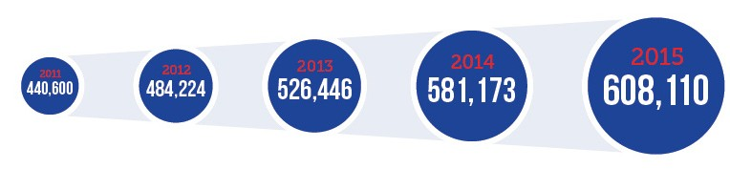
Visit the StartupBritain website at http://startupbritain.org/ to see what help and advice is given to new businesses.

The government has supported enterprise through initiatives such as StartupBritain. The key characteristics of an entrepreneur include:
- Being a risk taker – entrepreneurs risk money and their own time to try and create a business and make a profit. They may remortgage their house or take out other loans or give up well paid jobs to try and make a success out of their business idea.

- Taking initiative – entrepreneurs are often proactive and are willing to change or make important decisions when required.

- Making decisions – when running a business there are many decisions to be made, successful entrepreneurs can make crucial decisions quickly to make sure the business can take advantage of business opportunities.

- Organising the business – an ability to be an effective organiser is crucial when running a business. The entrepreneur may need to carry out a number of different activities, running a business can be a complicated activity and there are only so many hours in the day.

- Being creative and innovative – creativity in business means the ability to come up with innovative concepts and ideas, or developing a better way of doing things. Competing with other businesses often means that a new business has to offer something new or introduce a new product that is not already being provided.

- Hardworking – successful entrepreneurs are generally hard working. This is essential if the business is to be successful, especially in the early days of the business. On average entrepreneurs work for 52 hours per week, compared to 38 hours for an employed person.

- Being determined – this is key to many entrepreneurs. New businesses have low success rates, entrepreneurs have to keep going even if the business is struggling at first. A new business will face difficult challenges and not all ideas initially work, many famous entrepreneurs admit that it took them some time to get the right idea and make a profit.

The people listed below are examples of successful entrepreneurs.
- Julian Dunkerton
- Thea Green
- James Dyson
- Denise Coates
- Deborah Meaden
- Richard Branson
Select one of them and find out:
- How they started their business
- The goods and services they provide
- Their characteristics that helped them become successful
- How much they are now worth
Produce a one-sided fact sheet that summarises your findings.

Your teacher will select the best fact sheet per entrepreneur and create a resource with information on all the entrepreneurs.

Why do people start their own business?
Entrepreneurs have a number of key motives for starting their own business:
- To gain a profit – the motive is financial, this is considered the key motive for many entrepreneurs. The reason entrepreneurs risk losing personal savings or take out a loan is the possibility of making a decent income from their business.
- To use redundancy money – some entrepreneurs are forced into starting their own business as they may have lost their job, or maybe cannot get a job.
However, in addition to this financial motive there are also other non-financial key motives:

- To turn a hobby or pastime they enjoy into a business – creating a business out of something you enjoy gives great satisfaction and can be enjoyable. If this is the key motive then an entrepreneur may decide not to maximise profits but to have an enjoyable experience, just working enough to give them a decent living.

- Control – often people just want to be their own boss, in control of their working life. Working for someone else is not always rewarding and some people get fed up being just another worker in a large organisation. Entrepreneurs are often people who want to lead rather than being told what to do. Running your own business also gives the owner flexibility, setting your own goals and working your own hours.

- To help the community – some entrepreneurs start with a vision to help certain people within society. These are often referred to as social enterprises and promote ethical, environmental and moral business activities. Entrepreneurs who want to help the community will want to make a living out of the business, but the profit is either reinvested to improve the business or used to promote a particular issue.
- Making a difference in the world – some innovate entrepreneurs start as they believe

they can improve the life of others. This is true of people like James Dyson and Bill Gates who both wanted to invent products that would make cleaning homes easier and making computers more affordable and enjoyable.
What are the rewards and risks of business enterprise?

Rewards

The obvious reward for being a successful entrepreneur is financial, if a business is successful then the profit it makes will go to the owner. The more successful the more profit.

For most entrepreneurs this profit is sufficient to give them a good living and thousands of small scale businesses reward their owners with a decent living, the financial rewards maybe similar to a salary they can earn by working for somebody else, but together with other non- financial motives may give them a very nice lifestyle.

For some entrepreneurs the rewards are enormous, these include famous people who are in the news and have businesses who employ thousands of people, creates huge profits and provide well known goods and services.
The table below shows the personal wealth of successful entrepreneurs in the world.

Entrepreneur | Business | Personal Wealth (2016)
Bill Gates | Microsoft | $75 billion
Jeff Bezos | Amazon | $45.2 billion
Mark Zuckerberg | Facebook | $44.6 billion
Larry Page | Google | $35.2 billion
The table below shows the personal wealth of famous entrepreneurs based in the UK.

Entrepreneur | Personal Wealth (2016)
Roman Abramovich | £6.4 billion ($9.21 billion)
James Dyson | £5 billion ($7.2 billion)
Sir Richard Branson | £4.52 billion ($6.51 billion)
Sir Alan Sugar | £1.4 billion ($1.7 billion)
In addition to the financial rewards entrepreneurs also achieve non-financial rewards, these
include:
- Satisfaction of running your own business
- Building something new and building a legacy
- Obtaining good customer feedback

Risks

The main risks in starting a business are financial. Profits are not guaranteed and losses are common for new businesses. Many new businesses don’t manage to last more than a year and close down due to the low levels of revenue they make. Research has shown that 90% of new businesses don’t make it past their second year of trading.

When starting a business an entrepreneur will estimate the sales needed to be profitable, however, often these sales are lower than expected as trying to establish a new business in a competitive market is not easy. Why should people start buying from a new business when they are happy and loyal to an existing business?

In addition, it is difficult to estimate the costs the business will face when they start trading, often these costs can change during the year or unexpected costs can occur. Inexperience may mean that the costs have been incorrectly estimated. Having increased costs will reduce profit and may even result in making a loss. The profit margins for new businesses (the difference between revenue and costs) are usually very low, so having extra costs will result in lowering the profit margin even further.

Unexpected events such as poor weather, a new competitor opening a business close by, theft, a customer complaint shown on social media or ill health of the entrepreneur is also a risk. New businesses may not have the resources, such as a healthy savings account, or an alternative person to run the business to get the business through these difficult times.

Some risks are non-financial, the entrepreneur may not have the full set of skills to run the business effectively and may make mistakes that result in losing customers and revenue. Due to the long hours needed to establish the business and levels of stress involved in making all the decisions, the entrepreneur may become ill or disillusioned with the business, especially if all the hard work is not resulting in a decent profit.
- Explain why new businesses face many risks.
- Do you agree with the following statements? Explain your answers.
- The only rewards for entrepreneurs are financial.
- All entrepreneurs are successful.
- All successful entrepreneurs are millionaires.
- Starting a new business is very challenging.
- I have the characteristics and motives to be a successful entrepreneur.

Case Study: Creative Designs
Carra Robinson had worked for a bank for 6 years since completing her university degree in Graphic Design. Although Carra received a steady wage from her job with the bank she did not feel challenged, and longed to put her expertise in design-work to use.
Carra offered to design a promotional leaflet for a friend’s new business, she produced the leaflet on her home computer and printed 200 copies. Carra’s friend was so impressed with the design and quality of the leaflets that she asked her to produce a business card and newspaper advert to complement the leaflet. This gave Carra the confidence to promote her services
to other small, local businesses and she managed to obtain a number of orders to design and print promotional materials.

More Orders
Cara was soon receiving regular and repeat orders, she completed these in the evening after her days work in the bank. It was difficult holding down a full-time job, looking after her young family and completing the orders, but she enjoyed the creative aspect of the work and wanted to give up her job in the bank to become self-employed.

Carra was nervous about giving up the regular wage from her job at the bank, she realised that starting her own business would be a risky decision as she also needed to invest money into purchasing a better computer, design software and printer to enable her to provide a professional service. Carra saved all the income she made from her design work until eventually she had enough money to upgrade her equipment and software.

Showing Initiative
One day a regular customer of Carra’s complained that the delivery people they were using to distribute the leaflets door-to-door in the local area were not providing a reliable service; a box of Carra’s leaflets had been discovered discarded in an alleyway. Carra realised that there was a gap in the market and decided to provide an optional leaflet distribution service for local businesses, for an additional charge. Carra involved her husband and other family members in the distribution of leaflets, but realised that if her business was to continue to grow she would need to give up her work at the bank.
Carra sent samples of her work, together with a price list, to larger businesses in the area and contacted a local printing shop to negotiate favourable printing costs to further improve the quality of her leaflets and enable her to complete bigger orders.

Big Break
Carra’s big break occurred when a local businessman, who owned several convenience stores, asked her to design a 4 page leaflet not just for the local area, but also for convenience stores in other nearby towns as well – her largest order to date. Carra was nervous about accepting the order but decided to take the risk. The customer was pleased with the work and placed further regular orders.

Success

Carra admits that her workload is far heavier than she expected – she works longer hours than she did at the bank. Carra has also found that running a business has required that she develop new skills not previously required in her job at the bank.

As Carra’s business has grown she has needed to develop people management skills in order to lead her new employees, bookkeeping skills to complete her tax returns correctly and time management skills to ensure her customer orders are managed efficiently.

On the whole, Carra describes running her own business as challenging but rewarding and does not regret her decision to become self-employed.
- Suggest two motives Carra had for starting her own business.
- Why do you think Carra was reluctant to give up her job to start her own business?
- Identify three characteristics Carra needed to be a successful entrepreneur.
- What financial and non-financial rewards has Carra achieved from running her own
business?

Business planning
All businesses need to plan for the future. The activities carried out by a business should be co-ordinated in order for the business to achieve its aims. For new businesses this is essential as there will be so many challenges it will face and the owner(s) will have limited business experience. Planning is also important for established businesses, to make sure they remain successful in a competitive and dynamic business environment.
It is very important that a business has a clear idea of what it is going to do, effective business planning can make the difference between success and failure.
Failing to Plan is Planning to Fail Business planning involves looking at various aspects of the business:
  - What exact goods and services will the business offer?
  - How will these be sourced?
  - What resources are needed (raw materials, machinery and equipment, workers and site)?
  - What start-up capital is needed?
  - Is extra finance needed? Where will this come from?
  - How will the business operate?
  - How will the business attract customers?
  - What does the business want to achieve?
  - What will be the costs and revenues for the business?
  - How will a profit be made?
Why is business planning important?

A business plan will help a business to plan its future activities. Business plans are used by businesses to:
  - secure finance
  - show the future vision of the business
  - prioritise what is needed to be done in the business to make a profit
  - consider opportunities and risks
  - organise business activities in a logical and structured way
  - help the business make decisions
  - map out the actions needed to achieve business success
  - make sure the business has the necessary resources
  - help the owner(s) measure the progress of the business

Business plans are used by new start-up businesses, the plans will differ in size and content, depending on the scale of the business and if extra finance is needed. For example, an entrepreneur who wishes to start a small online website to sell jewellery, who has enough money from their savings to finance the business, may produce a brief business plan that they will just use for their own purpose. The business plan will briefly summarise the key targets and the actions needed to make the business a success. However, if an entrepreneur was starting a business on a larger scale that required finance from an investor then a more detailed plan would need to be written.
A start–up business will often seek finance (investment) from other people (investors), these

may be banks, other entrepreneurs, or business angels (people who invest in a business
in exchange for a share of the ownership, and profit of the business). There are many new businesses that seek this finance from investors; a detailed and accurate business plan is an excellent tool in helping a new business secure finance from investors.
Business planning is an ongoing activity and business plans should be regularly reviewed and updated whenever circumstances change. Business plans should also be used to monitor the business and make sure the business is meeting its targets.
There are no strict rules about what should be included in a business plan, and the content will differ depending on the type of business and the market they will compete in. However, in general plans need to include information on:
- Business description – this should include details about the owners and what the business will sell. It may also include information on the vision of the owners, how much money is needed to start the business, what their goals are and the owner’s background (CV).
- Products and services – what will the business sell? This should include the full range of products and services. Are patents or trademarks needed?
- The market – who are the customers and competitors? This should include information on who are the intended customers for the business (target market), and the strengths and weaknesses of competitors.
- Market research – what research has been carried out to find information about the
market and customers?

- Market strategy – this should be based on the market research. How will the business communicate (advertise) with customers? What advertising media will be used? How will the business distribute its products and services? What prices will be charged?

- Operational strategy – how will the business work on a day to day basis? This should include information on how the product will be produced or sourced. Where will the business be located? What equipment is needed? What suppliers will be needed? When and how will customers pay? Are there any legal requirements? Will the business need transport?
- Human resources – will the business be run by the entrepreneur or will other employees be needed? What skills are needed by employees? How much will it cost to employ other people? What management roles will need to be fillwed as the business grows?
- Financial strategy – this is an essential part of the plan. What funding is needed? What are the costs and likely revenues? A likely sales and costs forecast (cash flow forecast), predicted profit for the first couple of years should be included. What potential risks exist that might affect the financial predictions? What are the potential returns (financial rewards) for an investor?

There are many business plan templates and advice on completing them available on the internet. Sites include:
https://www.gov.uk/write-business-plan
https://www.princes-trust.org.uk/help-for-young-people/tools-resources/business-tools/ business-plans
https://www.startuploans.co.uk/business-plan-template/
http://www.sage.co.uk/business-advice/starting-and-planning/how-to-write-a-business-plan http://www.barclays.co.uk/insight/writing-a-business-plan
- Search these sites and summarise what advice they give to people who want to start-up their own business.
- Download one business plan template. Think of a potential business you would like to start-up and complete the template.
Ali has set up a juice bar in a busy town centre location. Here he uses fresh fruit which is processed to create a healthy drink. Ali competes with a number of other – mainly larger – businesses in the town. He is thinking about expanding his business and realises that he will need to draw up a business plan.
- Why will Ali draw up a business plan if he is going to expand the business?
- What information should Ali include in his business plan?

Business aims and objectives

Aims and objectives are goals that the business will set itself. These are used to measure the success of the business.
Businesses are not the only organisations that have aims and objectives, your school or college, football teams, the police service and government all have aims and objectives.

Individuals also have aims, although these are personal to the individual, the concept is the same as it is for businesses, we all need targets in our life to challenge us and make us put the effort in to achieve those targets.

List three aims you have set yourself this year. These maybe based on your school progress or on other aspects of your life.

Business aims are what the business wants to achieve in the future and they tend to be quite generic and broad. They set out the goals for the business.
Business objectives are more specific and measurable targets the business will set to achieve
its aims.
Business aims can be grouped into the following main categories:
  - Survival
  - Profit maximisation
  - Growth
  - Increase market share
  - Customer satisfaction
  - Ethical and environmental

Survival
Many businesses fail within 2 years of being set up, so for a small business, the initial aim is to survive the difficult time of gaining customers, establishing a good local name and building a reputation. Even for some big businesses survival can become a priority. Many established high street retailers have struggled in recent years. The main aim of these retailers was
to survive in the short term; however retailers such as BHS, JJB Sports and Comet have all
ceased to exist.
To survive a business has at least to break even. This means that it makes neither a profit nor a loss. If a business continually makes a loss it will almost certainly go out of business. During times of economic recession (when sales can be low) larger businesses will have to adjust its aims, they may be able to cope with making a loss for a short while, but eventually they will have to carry out actions to turn this around, this can involve making workers redundant or closing a number of outlets or factories.

Profit maximisation
Most businesses want to do more than just survive; they want to make a profit and lots of it.
They want to make as much as possible.

Maximisation means to make the most of something, to make the most possible profit is to maximise profit. Profit is what remains after all the costs of running the business have been met.

REVENUE COSTS PROFIT
-
=

Money coming into the business
Money going out of the business

Money left over

Josh runs a small computer shop. Last year he spent £20 000 on setting up the business and buying his stock. He spent a further £15 000 on other costs. His revenue totalled £37 000.
Work out his profit.

Profit maximisation is possibly the main aim for most businesses and entrepreneurs. After all, why would you run a business or invest in a business if there is not going to be a worthwhile cash return? Profits can be maximised through increasing revenues and/or reducing costs.

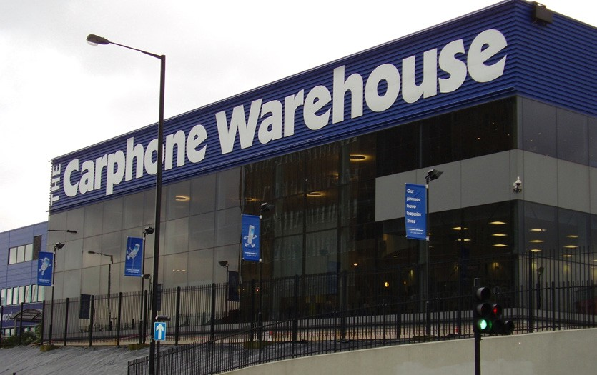Read the information on the businesses below:
Dixons Carphone Profits Jump 19%

Profits at Dixons Carphone have jumped 19% after a rise in sales of phones and
domestic appliances in its home market.
In the six months to 29 October, pre-tax profits climbed to £144m while sales rose 4% to
£4.9bn.
“We have been focusing on reducing our fixed cost base,” said Seb James, group chief
executive.
Dixon Carphone reported growth in all its main divisions, including a 23% jump in sales in
Nordic countries, where it benefited from the weaker pound.

Sales were also positive in its core markets, the UK and Ireland, where it trades under the brands Currys, PC World and Carphone
Warehouse.

That was partly driven by higher sales of mobiles and consumer electronics, as well as a plan to reduce store numbers.

The company aims to close 134 outlets while it rolls out electrical superstores that merge its three main brands.
Source: bbc.co.uk
45

Gatwick Airport Profits Fall Despite
Passenger Increase

Profits at London Gatwick Airport fell by 13% in the first half of the year despite increased passenger numbers.

The West Sussex airport recorded a pre-tax profit of £116m in the six months to 30 September 2016, compared with £134m during the same period last year.
A total of 25 million passengers travelled through
Gatwick in the first half of the year, an increase of 6% but growing operating costs contributed to a fall in profits.
Gatwick chief executive Stewart Wingate said the airport’s growth would slow next year.
He said: “We’re confident that we can continue growing the airport but in the long run we’re still continuing to offer the government the opportunity of expanding Gatwick.”
In October, Gatwick’s bid to build a second runway was rejected by the government in favour of expansion at Heathrow.
Mr Wingate added that the airport was “very happy to compete with Heathrow.”
Gatwick is undergoing a £1.2 billion five-year investment project to expand the departure lounges and shopping facilities in its two terminals, improve its railway station, and provide more parking spaces.

Adapted: bbc.co.uk
- Both businesses aimed at maximising profits. Comment on how well they have
performed.
- Identify the factors that affected the profits for Dixons Carphone and Gatwick Airport.
- Suggest and consider how Gatwick Airport could increase revenue. You need to consider the positive and negative impact of your suggestion.

Growth
A business cannot stand still it needs to change and grow in a dynamic and competitive environment. A business should aim to keep moving forward and not remain static. A business can grow in a number of key ways:
  - Sell more of the same goods and services in the same market
  - Sell more of the same goods and services in different markets
  - Extend its range of goods and services
  - Open new distribution outlets and/or factories
  - Employ more workers
  - Purchase new machinery and equipment
  - Take-over another business either selling the same goods and services or different
goods and services 46

Many businesses will focus on sales growth, which is selling as many of its goods and services as possible. This is linked to increasing market share.

Some businesses will spend large amounts of money to improve its growth. They hope that this will lead to greater profits in the long term. Growth is often based on reinvesting profits, which will reduce short term profits but leading to greater market dominance (a higher market share) in the longer term that can lead to greater profits.

Increase market share

The market share is the proportion of sales made by a business in relation to the whole market. The market share is calculated by the number of customers a business has and is usually given as a percentage. For example, if consumers as a whole buy 200 bars of
chocolate and 50 bars are bought from one business, then that business will have a market share of 25%.

The global market share for smart mobile phone handsets in 2016 (for the 3rd quarter, July, August and September) was:

Business | Market Share
Samsung | 20.0%
Apple | 12.5%
Huawei | 9.3%
OPPO | 7.0%
vivo | 5.8%
Others | 45.4%
Total | 100.0%
Others are made up by many other businesses whose individual market share is smaller than the main 5 businesses. Samsung are the market leaders (the business with the largest share of the market). The figures above are for the global market for smart phones, however, there are also figures for local, regional and national markets. The market share within one region may be different from the global market. For example Apple may have a larger market share within the US, where it is based.
Market share is important as it shows how well the business is doing compared to the competition and it allows the business to measure the success of its activities in the market as a whole. Businesses that have a higher market share are usually more profitable and in a stronger position in the long term. Being the market leader is also beneficial when negotiating with other businesses and improves its status and reputation.
Through increasing brand identity some businesses may concentrate on establishing its brand name through customer loyalty programmes, advertising and new product
development so they become the most recognised business in their market. In the short term this may reduce profit but in the long term it could result in achieving higher sales and profits.
They may even be able to force other competitors out of the market, by using loss making pricing strategies in the short term, that the competitors can’t compete with.

Market share is usually presented graphically in a pie chart. The data on smart phones in the table above can be presented as follows:
Global market share smart phones 2016

Others
Samsung 20%

45% Apple
13%

Huawei

vivo 7%
OPPO 9%
7%

In the UK the chocolate market is dominated by three large businesses. Find out who they are and what their market share is.

Read the information below then answer the questions that follow.

Tinyville is small town with a population of 5 000 people. It has 4 pizza takeaway and delivery businesses. 60% of the population regularly buy pizzas from these 4 businesses. The businesses have the following number of customers:

Supreme Pizza | 1 200
Pizza Delight | 1 000
Gino's Pizza Parlour | 500
Pizza Amalfi | 300
The average price a customer pays for pizzas in Tinyville is £15.
- Calculate the market share for each pizza business.
- Construct a pie chart to show the market share. Clearly label the pie chart.
- Calculate the total revenue for the pizza market in Tinyville.
- Suggest why Pizza Amalfi has just 300 customers.
Google has nearly 90% of the search engine market in the UK. Bing has the second largest,

at 7%.
Explain the benefits to Google of its dominance in this market. (Think where Google gets its
revenue from).

Customer satisfaction

Customer satisfaction measures how goods or services supplied by a business meet or surpass a customer’s expectation. Customer satisfaction is important because it provides business owners with information that they can use to manage and improve their businesses.

Sales made by a business are linked to the levels of customer satisfaction. If a business fails to meet customer satisfaction then it could result in a decrease in sales and profit. Equally, if customer expectations are met and customers are happy with the goods and services they receive then it is likely that sales and profits will increase. In a competitive business
environment it is important that businesses meet customer expectations, otherwise they will take their custom elsewhere.

A business may focus on improving customer satisfaction with the hope that this will lead to improved sales. If a business has experienced problems with satisfying customer expectations in the past, it may well decide to make this a key aim in the future.
Failing to meet the needs of customers is particularly true for small businesses that rely on repeat business and positive word-of-mouth (the passing of information and opinions by oral communication between people who use the business) advertising for its success. This can alienate current customers and stop the business attracting new customers. The reputation of the business will suffer and this could also impact on other businesses who will not want to work with the business and even employees may wish to leave if they are constantly facing angry customers.

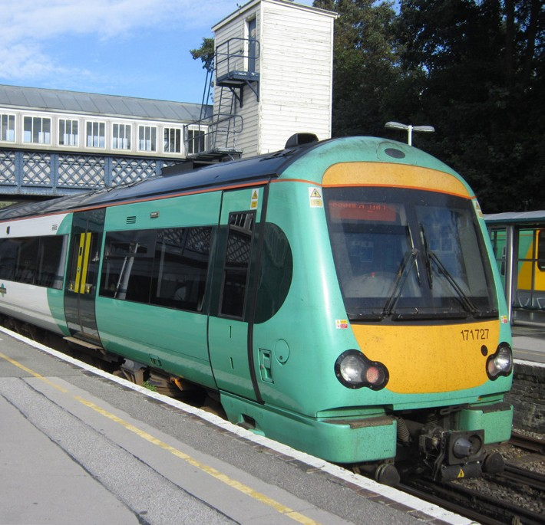Read the information and answer the questions that follow.

Strike-hit Southern rail has ranked lowest in a UK-wide survey of customer satisfaction.

The figures, compiled by consumer organisation Which?, showed nearly half of Southern’s passengers said their last journey was delayed.

The rail operator has seen months of strikes in a long- running dispute with two unions, the RMT and Aslef, over the roles of guards on trains. Parent company Govia Thameslink (GTR) said the firm was “sincerely sorry”.
In the annual survey of all UK train firms, Southern scored
21% and received one star for punctuality, reliability, seat availability, frequency and value for money - 46% of passengers said their most recent journey was delayed.

Researchers surveyed 2,218 commuters and Southern’s results were based on the views of 256 passengers.
Which? Campaigns and Communication Director Vickie Sheriff said “Though Southern have
performed particularly badly this year, the whole sector is continually failing passengers.

“Overcrowding, delays, short trains, carriages in poor condition - many services aren’t providing even the basics. Enough is enough. We need rail services that finally deliver.”
Adapted: www.bbc.co.uk/news/uk-england-38641566
- How have Southern Rail failed to meet customer expectations?
- Explain why focusing on customer satisfaction may improve the business.

Ethical and environmental

Not all businesses will look to maximise profits or aim for growth. Some businesses will have other aims. There are businesses that will try to minimise the impact of their business activities on the environment, consider the needs of society and have aims which are based
on their beliefs. For example, businesses may try to ensure suppliers in developing countries have fair working conditions; ensure employees are earning a fair wage and sourcing raw materials from sustainable sources.

Having ethical and environmental aims may impact on the profit that can be made, however, businesses that focus on ethical and environmental aims are happy to do this as they believe that they have an important role to play and the focus for the business is not profit but society and the environment. Public sector organisations, such as the NHS and schools will aim to provide a service and improve the health and education of the public. Charities are established to promote a specific cause and this will be their main aim.

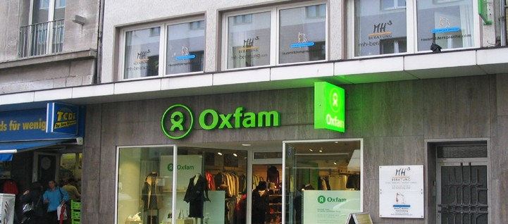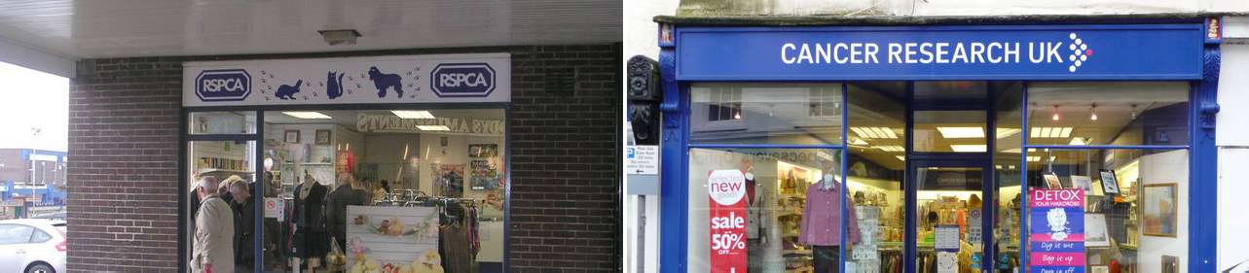
What are the aims of the following organisations?
Oxfam
RSPCA
Cancer Research UK

Examples of private sector businesses that have strong ethical and environmental aims include The Body Shop, Co-op, Google and Microsoft. This aim may come at a cost though in terms of lower profits for the business. However, modern businesses have to be respectful of the wider community and take their social and environmental responsibilities seriously.
Google has the motto: “Don’t be evil.” Through its Google Green Program, it has donated over
$1 billion to renewable energy projects, and has decreased its own footprint by using energy efficient buildings and public transportation. Google employees have access to free health care and treatment from on-site doctors, free legal advice with discounted legal services and a free on-site nursery.
Nearly all large multinational businesses have ethical and environmental aims. These are often in addition to other aims they have.

These are usually shown on their website and used to promote the business. Visit the websites of some well-known multinational businesses and find out what ethical and environmental aims they have.

Although profit maximisation might be the prime aim of most private businesses, it is not the only aim to pursue. Of course, businesses can work to achieve more than one aim at the same time.
Business objectives are the measurable targets set to achieve business aims. Objectives will give the business a clearly defined target. These can then be used to plan activities that can be carried out to meet the objectives and aims of the business. Specific objectives can be
used to measure business progress and also to give clear direction to employees on what the business wants to achieve.

Objectives should be written using the SMART model, in order to make them clearer and more meaningful to understand and achieve:
Specific – objectives should specify what the business wants to achieve. They should be clear so that all stakeholders understand what the objective is.
Measurable – objectives should be measured to make sure the objective has been achieved. This measurement should be numeric.
Agreed – by all those concerned in trying to achieve the objective. The objectives have to be achievable and attainable. There is no point in setting an unrealistic target, this can be demotivating.

Realistic – is the business likely to achieve the objectives with the resources available?
Timed – a timescale needs to be set for achieving the objectives.

SMART objectives are used to provide the clarity, focus and motivation needed by businesses to achieve their goals.
SMART objectives help to focus attention and gain commitment from all levels of employees within a business to agreed performance targets. They will also encourage team work, and they direct resources to where they are needed the most.

SMART objectives also enable feedback and learning within the business, so that management can monitor achievement and make changes where necessary.
Examples of SMART objectives could include:
- Growth objectives: to grow by 15% a year for the next five years by investing an
additional £1m in advertising and opening 10 new stores.
- Market share objectives: to achieve 40% market share from our current level of 35% within 3 years.
- Profitability objectives: to reach a net profit margin of 11% in the next five years.
- Sales objectives: to increase sales by 5% from 2018 - 2019 in at least the following 3 product ranges – menswear, shoes and toiletries.
- Environmental objectives: to reduce the waste from our factories by 10% by 2020.

- Write a SMART objective for yourself. Base the objective on your school performance.
- Write a SMART objective for the following businesses:

  - Jenny Hughes owns a small business selling children’s clothes. She wants to increase the number of customers she has and start selling other goods such as prams, cots and children’s furniture.

  - Diamond Plastics manufacture and sell plastic containers to other businesses that sell packed foodstuffs. They are concerned about the pollution the factory produces and wish to reduce this.

  - The Pines Hotel is owned by Richard Jones, for the last two years the hotel has made a loss. He is determined to turn the business around and make a profit within the next few years.

Business aims and objectives are not static and a business may change these over time. In a dynamic and competitive environment, businesses need to review their aims and objectives. The cause of this change can be internal or external.
Internal change occurs as a business never stands still. What was an important objective last year may no longer be relevant. For example, a new business may have had its prime objective as survival, to break even in the first two years of business. It now may be ready to
start growing and increasing its customer base or market share. Alternatively, a business that was focusing on increasing market share for the last three years may now be in a position to take advantage of having a large base of loyal customers and start focusing on maximising

profits. A multinational business that received bad publicity over the year by paying employees a wage below the national minimum wage, or using a supplier that exploited its workers, may decide to focus on ethical objectives in order to improve its public image.
External change is change that the business has no control over. This could include economic factors such as a reduction or increase in consumer incomes, a rise or decline in unemployment or an increase in tax the business has to pay. Other external factors include a change in consumer tastes and fashions, the introduction of a competing good or service by a competitor, new laws affecting the manufacturing or selling of particular goods or services, introduction of new technology, such as robotics, or a change in demographics (characteristics of the population of the market the business is operating in).

Reviewing and changing aims and objectives will help businesses react to the dynamic nature of business and help it continue to be successful.

- Produce a poster that summarises the key business aims.
- Profit maximisation will always be the most important objective for a business. Evaluate
this statement.

Business stakeholders
Whatever the business, however small or large, it is not just the business owner who is
affected by its activities. Many other people and groups care about what goes on.

Stakeholders are groups that have an interest in the success of a business. They affect and can be affected by business activity. There are many stakeholders in a business and each may have different reasons for being involved.
The main stakeholders in a business are:

Employees Customers

Managers Owners

Shareholders

The government
The business

The local community
Pressure groups

Suppliers and lenders

Stakeholder expectations
Each stakeholder group will be interested in the performance and actions of the organisation
and will have different expectations.

Owners

The owner of a business has contributed their own money to developing the business and will have a great influence on the actions of the business as they are highly involved in decision making. Owners will be concerned with the survival and the financial success of the business.

Shareholders
Some owners are called shareholders as they have invested money into buying a share of the business. Most shareholders are not involved with the running of the business, but will
instead elect directors to control the business on their behalf (more details on shareholders is in the business ownership section).

Managers
A manager is someone who makes decisions about the way in which a business operates. In a small business the manager will be the owner, however as a business gets bigger managers will be employed by the owners to run a section or branch of the business. Managers will want the business to succeed as their future employment will depend on the business surviving. They will be concerned with receiving good pay, job security, good working conditions and job satisfaction.

Employees

Employees are those who are paid to carry out a specific job of work for a business. Most businesses will have employees. Employees tend not to have any influence over the owners and do not make any big decisions that affect the business. Employees will also be concerned about receiving good pay, job security, good working conditions and job satisfaction.

Customers
A business cannot survive without customers as their purchases provide income for
the business. Therefore, customer behaviour will influence how the business operates. Customers will expect good quality products and/or service, a good choice and value for money. If customers are unhappy with the actions of the business they may take their custom elsewhere.

Suppliers and Lenders
Businesses rely on suppliers to provide them with the materials they require to provide their customers with goods and services. Suppliers will want businesses to be successful so that they will continue to receive orders. It is important that a business has a good relationship with its suppliers so that they can rely on them to deliver good quality supplies, on time and at a good price. Lenders will expect the business to repay its debts.

The Government
The government wants businesses to succeed as the better the financial performance of the business, the more taxes it will pay to the government and the more employment opportunities it will offer. The government influences a business in a number of ways.
A government can create laws and regulations that affect the business directly and a government’s general economic policies will also have a considerable effect. For example interest rates and minimum wage levels will influence how a business is run.

The Local Community
Businesses provide employment and facilities for the local community. Sometimes the actions of the business may inconvenience the local community through pollution, traffic congestion or business closure. Large businesses will have a greater impact on the local community than smaller ones.

Pressure Groups
Pressure groups are groups of people who get together to express their objections to a particular government policy, business decision, or the effects of an organisation’s actions. An example of a pressure group would be an environmental organisational established to complain about the high pollution levels caused by industry. Pressure groups can persuade businesses to change their actions.

Complete the table by summarising the interests of the stakeholders on business activity:
Stakeholder | What are the main interests of this stakeholder?  (Why are they interested in the business?)
Owners and Shareholders
Customers
Employees and Managers
Government
Pressure Groups
Local Community

How stakeholders influence business activity and business decisions
Stakeholders will be able to influence the way in which a business operates and the decisions
it makes.

Owners will have a very large influence on business activity. The aims, and possibly objectives, of the business will be formulated by the owners – they will set the overall direction a business wishes to take. The influence of the owners on the business, especially small businesses, is huge. Of all the stakeholders, owners have the greatest say in what
the business does and how it operates. In most cases the owners will decide on all the big decisions in the business and the operational activities, such as what to sell, where to sell it, production decisions, marketing strategies, who to employ (or make redundant) and what happens to the profit.
Managers will also have some influence on businesses as they will make the day to day decisions to meet the aims of the owners. Managers will use the resources under their control to achieve the best outcomes for the business. Managers will be able to make some decisions, such as selecting possible employees, what price discounts to give to certain customers, changing suppliers and where to carry out advertising.

Employees will have little say in the major or important day to day decisions in the business. They will be employed to carry out certain tasks and instructed what to do by the owners and managers. However, employees can also influence businesses by communicating their experiences and opinions to owners and managers. The most likely area of influence for employees will be in operational issues, where they may have some say in the way which certain tasks are carried out. Employees can have a negative influence on a business if

they are unhappy in their work or if they are in dispute with the business and this can lead to industrial action (for example, they could go on strike). If employees are not working
efficiently then this can affect the performance of the business, such as giving poor customer service which could reduce sales and profit.

Even though customers are external to the business, they could be considered the most important stakeholder, as without customers the business will not survive. Happy customers will continue to buy goods and services from the business, however, unhappy customers will not and this can have a huge influence on the sales and profit of the business. The power of the consumer is huge for private sector businesses, ignoring customer views, opinions and complaints will most certainly end in business failure.
Government influence on business can be vast. The government want businesses to do well as this creates employment, increases their revenue through taxes and lowers benefit payments. However, business activity also can increase pollution, traffic congestion and harm the environment. Governments also need to protect consumers against poor quality goods and services. Governments can introduce laws and regulations that can affect the way in which a business can operate. For example, business development can be limited by restricting the building of factories in certain areas and introducing taxes and fines for businesses that are producing high levels of industrial waste. The government can also
set quality standards that require businesses to produce goods and services to a certain standard. These government actions can increase costs for businesses which could result in lower profits.
Local communities can benefit from business activity, mainly through local jobs, increased local wealth, improved facilities and infrastructure. However, there are also negative impacts such as noise and air pollution, environmental damage and loss of space. If an established large business that employs many local people closes or decides to relocate to another area, then the impact on the local community can be disastrous. Local communities can oppose business activity by creating groups to speak out against business activity that harms their local community. These activities could affect the reputation of the business and force them to rethink its plans.

Pressure groups will try to influence the activities of businesses through their organised actions. They will attempt to publicise the negative impacts of business activity in order to rally public opinion against the business and force them into changing their minds. They can also put pressure on governments to try and get them involved in order to stop the business from the proposed action.

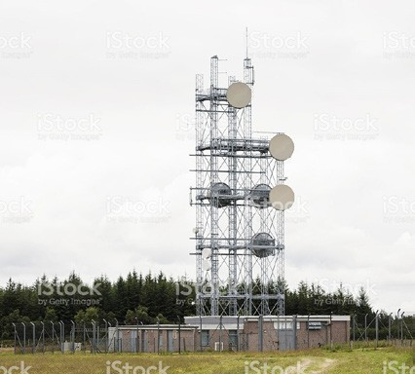
You have just heard that a large mobile phone mast is to be sited in a field close to your
home.

A public meeting is to be held so that all the people involved can have their say. You will be divided into groups to represent different stakeholders to prepare your views on the mast.
Which stakeholders need to be represented? Debate the issue.

The impact of business aims and objectives on stakeholders and how business decisions may
have contradictory effects on stakeholders
The various aims of businesses can impact on stakeholders in different ways.
For example if a business sets its main aim to maximise profits this could include the reduction of costs which could mean redundancies and lower wages for employees. Customers may be charged higher prices and the quality of the product may suffer if cheaper and less quality raw materials are used. Employees may also have to work longer hours if
a business decides to increase production by keeping the factory open through the night. Suppliers may have to wait a longer time for payment which could cause problems for them as they will still have to pay for their costs. This could also affect the local community, if deliveries of raw materials are scheduled for late night then the roads will be busy and there will be increased noise pollution. Governments would be happier if more taxes are paid by the business and they employ more people to produce the extra goods needed so more is paid in income tax to the government and they will pay less in unemployment benefit.
Focusing on growth and increasing market share may affect the profit made by the business. Owners may receive a low return on their investment as the profit made is reinvested into the business in order to help it grow. However, customers may have more goods and services to choose from with extended product ranges and experience an improvement in customer services.

A business that aims to improve its ethical or environmental policies may be good news for society, local communities and low paid workers, but this may come at a cost by changing the goods and services for customers and again affecting the profit made by the owners.
Employees can be affected in many ways by the aims of a business, these impacts can be positive and negative, higher wages, promotion opportunities and developing work skills may all result from a business expanding and using more advanced technology, however, employees may also face job cuts, more unsociable hours of work and less enjoyable jobs all in the name of business progress and expansion.
As the examples above show, these decisions can affect stakeholders in conflicting ways,
what is good for one stakeholder may be bad for another.

Explain the likely impact of the following business aims on stakeholders:

- Jenny Hughes owns a small business selling children’s, clothes. She wants to increase the number of customers she has and wants to start selling other goods such as prams, cots and children’s furniture.
- Diamond Plastics manufacture and sell plastic containers to other businesses that sell packed foodstuffs. They are concerned about the pollution the factory produces and wish to reduce this.
- The Pines Hotel is owned by Richard Jones, for the last two years the hotel has made a loss. He is determined to turn the business around and make a profit within the next few years.

Ragbags Ltd makes and sells children’s clothes in the north of England. The managers want to increase sales in the south, by opening several new stores. But some shareholders are worried that the new investment will affect profitability. Some managers will have to oversee the new stores. They will need to buy much more material to make the clothes.
What affect will the expansion have on the following stakeholders?
- The government
- Shareholders
- Managers
- Customers
- Suppliers
- The local community
- Employees
- Directors and managers will want the business to maximise profit. How will this affect
customers?

- Pressure groups may be concerned with how business activities affect the environment. How will this affect shareholders?
- The local community will be concerned with traffic congestion. How will this affect
managers?
- Explain how the interests of the owners of a business may conflict with the employees.

Business ownership

Businesses in the private sector range from those which are owned and run by one person to multinationals which employ thousands of people in many countries.
They differ in ownership and control and their legal status. Businesses are classified in the following way:

Sole Traders
Partnerships
Private Limited Companies
Public Limited Companies

Unlimited liability business
Limited liability business

Unlimited and limited liability

One of the biggest decisions to make when starting a business is what type of ownership to use. One of the most important considerations is whether to have limited or unlimited
liability. Choosing the appropriate ownership for the business is very important and can save the entrepreneurs’ personal assets from business creditors (people you owe money to).

Unlimited Liability

Sole traders and partnerships do not have a separate legal existence from the business. In the eyes of the law, the business and the owner(s) are the same.
As a result, the owners are personally liable for the business’ debts. If a sole trader or partnership makes a loss and if things go wrong then they are responsible for all the debts.

This is called unlimited liability.The owner(s) have a legal obligation to settle (pay off) all the debts of the business. Worse still—there is no distinction between the assets (money invested in the business, including property, equipment and stock) and debts of the business and the personal assets and debts of the owner. For example, if your business can’t repay its loans or gets sued, the owner is responsible. If the business’ assets aren’t enough to cover the debt or damages then the owner will have to pay the rest of the debts from personal bank accounts, investments, car or even their home.

Limited Liability
Private limited companies and public limited companies are so called as their owners have limited liability, this means that people who invest in the business only risk losing the amount they have invested.

If the company goes out of business, leaving debts, the owners will only lose the money that they have put into the company (the value of their shares/investment). The owners will not be forced to sell their own personal possessions, like a house, to pay the company’s debts.

For example, if an entrepreneur invested £100 000 into a limited liability company and a creditor sues the company to recover money it loaned to the company, the creditor can only get the assets of the company. So, you could lose your £100 000 investment, but you couldn’t lose any of your personal assets. Not good news for the creditor!
Having limited liability is the main advantage of forming a company.

Limited companies have a separate legal identity from their shareholders, this means that the company can buy assets, make contracts and take legal action against other businesses in its own name rather than that of its owners. A limited company can also be sued.

Sole traders

A sole trader is a business that is owned and run by one person. Although a sole trader is owned by only one person, the owner can employ people to work for them.

Sole traders usually finance the business through the owner investing their own savings, money borrowed from friends or family, or a bank loan. There is a lot of financial risk in running a business as a sole trader due to unlimited liability.

The aims and objectives of sole traders will vary according to the type of business, but most sole traders will focus on increasing income and profit to allow the owner to make a living from their investment. Many sole trader businesses will aim to survive in the initial stages of setting up and during difficult economic times.
Many sole traders will operate on a local level; often their main aim is to provide a good
product or service to the local community and provide customer satisfaction.
Running your own business is extremely hard work and the risks are great, but so are the rewards.
- What are the rewards of running your own business?
- What are the risks of running your own business?

Advantages and disadvantages of sole trader ownership Advantages of Setting up as a Sole Trader:
- Decision making is straight-forward, the sole trader being able to make instant decisions without checking with someone else.
- The sole trader is their own boss and does not need to follow the instructions of somebody else.
- A sole trader business is easy to set up because there is no complicated paperwork to complete as thwere may be with other types of business.
- Some sole trader may be able to operate the business to suit their lifestyle with more
flexible working hours.
- Any profit is kept by the sole trader and does not need to be shared.

Disadvantages of Setting up as a Sole Trader:
- It can be difficult to raise the required capital, as only one person is investing in the business. Banks are not keen to lend money to sole traders due to their high rate of failure.
- A lack of the necessary skills and experience required owning a business can increase the risk of failure.
- Fewer ideas are put into the business as there is only one owner. The sole trader doesn’t have an opportunity to share ideas with any business partners, family and friends are often relied upon for advice.
- The owner may need to work long hours as there may be no one to share the workload.
It may be difficult to take time off.
- Unlimited liability is the main disadvantage of this type of business, it can be very risky for the owner - a failing business could cost them their savings and their personal possessions.

There are a range of advantages and disadvantages to sole trader ownership.

Advantages | Disadvantages
Easy to set up | Unlimited liability
Greater owner control | Long working hours
Keep all the profit | Problems in raising capital
Flexibility of working hours | Lack of specialisation
Easy to run | Impact of illness

One very important disadvantage of being a sole trader is unlimited liability. If the sole trader makes a loss and if things go wrong then the sole trader is responsible for all the debts.
Discuss in your class each of the advantages and disadvantages listed below. Show your understanding by explaining each point.
The sole trader has a legal obligation to settle (pay off) all the debts of the business.

For example: Thomas Williams set up as a plumber last year. He bought a van, tools and spent money on producing leaflets to advertise his new venture. He got a loan from the bank for £20 000 to pay for all of this. During the year he has not done very well and he has not been able to pay his monthly repayments to the bank. They have now called in the loan as they think he is going bankrupt. With the interest for the loan he owes £23 500, but has no money himself to pay for this.
Because he is a sole trader he is legally responsible for all the debt so he must pay it all back.
He sells his van and tools and this raises £12 000, so he still owes £11 500. He has to pay for this so he has to sell his own car and the electrical equipment in his house and his wife’s jewellery.
Jayne Davies is a sole trader, she runs an Art Gallery in York. She has invested £50 000 into her business. She has unlimited liability. What does this mean?

Sole Trader: Agree or Disagree?

Tick the relevant boxes to show whether you agree or disagree with the following statements.

Sole traders have limited liability | Agree
 | Disagree
Sole trader businesses are easy to set up | Agree
 | Disagree
Sole traders are required by law to publish their accounts | Agree
 | Disagree
Sole traders are responsible for all business debts incurred | Agree
 | Disagree
Sole traders keep all the profit made by their  business | Agree
 | Disagree
Sole traders often work extremely long hours | Agree
 | Disagree
Sole traders have unlimited liability | Agree
 | Disagree

In recent years people have taken up the hobby of designing and producing their own greetings cards. They buy packs of materials which are used to make birthday and Christmas cards.
Some have developed their hobby into businesses; selling at craft fairs and through the
internet. One such person is Fran Blake who operates her business as a sole trader.
- Outline two benefits Fran gains as a result of operating as a sole trader.
- Explain two disadvantages to Fran of operating as a sole trader.

Partnerships
A partnership is an agreement between two or more people to take joint responsibility for the running of a business, to share the profits and to share the risks. By law a business can have between 2 and 20 partners. Typical partnership businesses include professionals such as solicitors, accountants, doctors and vets.
There is a lot of financial risk in running a business as a partnership due to unlimited liability. The business is not a separate legal entity and the partners are personally liable for the business debts.
A partnership is almost as easy to set up as a sole trader; if no formal agreement is drawn
up everything is split equally between the partners.

A partnership means:
Shared ownership Shared decision making Shared workload Shared profit
Shared liability for debts
It is advisable for partners to draw up a special agreement, called the Deed of Partnership
which will outline the following:
- How profits or losses will be shared amongst the partners.
- How much money each partner invests.
- Voting rights and the number of votes each partner has.
- Arrangements for ending the partnership due to the leaving or death of a partner.
- The details of each partner’s duties and responsibilities – who does what?

It is important to know who you are going into business with. Partners should know each other’s background, their approach to business, and their vision for the partnership.
Some questions to consider before going into a partnership include:
- Only go into business with those you trust
- Discuss potential issues before you start
- Read and understand the Deed of Partnership
The aims and objectives of partnership businesses will vary according to the type of business. However, most partnerships will focus on increasing income and profit to allow the partners to make a living from their investment.
Many partnership businesses will aim to survive in the initial stages of setting up and during
difficult economic times.

Advantages and disadvantages of a partnership Advantages of Partnerships:
- Partnership are cheap and easy to set up.
- There is no complicated paperwork to complete in order to set up the business.
- Extra capital is available, as more than one person is investing into the business.
- The workload is shared between the partners.
- There is less stress for the owners as decisions and workload are shared.
- Each owner will bring their own skills and ideas to the business, meaning
- that more expertise is available within the business. Partner can specialise in particular areas of the business.

Disadvantages of Partnerships:
- Profits must be shared among partners.
- There may be disagreements between partners when making decisions or over workload.
- Partners have to share the control, and work as a team, they will not be their own boss.
- Partners still have unlimited liability.
- If a partner dies or becomes bankrupt, the partnership must come to and end.
There are a range of advantages and disadvantages of partnership ownership.
Discuss in your class each of the advantages and disadvantages listed below. Show your understanding by explaining each point.

Advantages | Disadvantages
Easy to set up | Unlimited liability
Shared responsibility for debt | Disagreements between partners
Shared responsibility for workload | Shared profits
Increased contribution of capital | Workload distribution
Increased expertise and skills | Need for a Deed of Partnership

Rhiannon was told by her business adviser to draw up a Deed of Partnership. She has
typed up the first draft which is shown below.

Deed of Partneship
Between Rhiannon Leigh and Siobhan Evans and
Ricky Rogers
The name of the business will be: Rhiannon Leigh and Partners
The business will: manufacture, market and sell sports clothes made from the fabric designed by Rhiannon Leigh.
Each Partner agrees to provide the sum of: £10 000 to be used to buy an industrial sewing machine, a stock of material and pay the rent on commercial premises.

The duties of the partners will be as follows:
Rhiannon Leigh will design, develop and market the fabric and the clothes made with it Siobhan Evans will organise the workforce, deal with stock and be in charge of production Ricky Rogers will deal with enquiries, orders, accounts, banking and all financial matters. The bank account will be in the name of: Rhiannon Leigh and Partners. The signature of any partner is valid on a cheque.
Voting: Each partner will have equal voting rights.
Wages: Partners will each be entitled to draw wages from the partnership, as decided by a partners meeting
Meetings: The partners will meet formally on the first day of each month or the next
working day if this is a holiday.
Leaving the partnership: Partners agree to clear all outstanding debts and obligations should they decide to leave the partnership.

Signed: Witnessed:

- Why do you think she was advised to draw this up?
- What important factors has she left out?
- What problems do you think the partnership might have if this deed was used?

Which two of the following apply to partnerships? Tick two boxes only
They are owned by shareholders |  | Workload distribution
Increased expertise and skills |  | Need for a Deed of Partnership
Gallops is a business selling horse riding equipment in a small shop in a town. It is owned by Sam Fudge and Mary Matthews.
Suggest and explain two advantages to Sam and Mary of being in a business partnership.
- List 3 advantages of being a sole trader rather than a partnership.
- List 3 advantages of being a partnership rather than a sole trader.
Jed Thomas is a sole trader selling surfing equipment in his shop in Newquay in Cornwall.
- Suggest and explain two advantages of Jed being a sole trader.

Surfing has increased in popularity in the area so Jed wants to take the opportunity to buy the shop next to his. To do this, he needs to borrow money from the bank. Jed’s bank has asked him for a business plan before they will lend him the money.

- Apart from his personal details, telephone number and address, suggest three pieces of information the bank would like to see in Jed’s business plan.

Jed is considering changing the form of ownership of his business from a sole trader to a partnership.
- Discuss the advantages and disadvantages that may result from forming a partnership.

Limited companies
Sole traders and partnerships who wish to expand are often held back by a lack of capital. Another drawback is that they both have unlimited liability, which means that taking risks on new developments, new products or a new premises can result in personal loss and
bankruptcy. A solution to the problem of lack of capital and to the risk that is associated with unlimited liability is to form a limited liability company.
Limited companies are owned by shareholders, these are people who have invested money in order to buy a share of the business. The more shares a shareholder owns, the more control he or she will have within the business.

The words private and public refer to the types of shareholders that own the company. They are called limited companies because they have limited liability. This means that people who invest in the business only risk losing the amount they invested.
Limited liability is important for the owners of companies. If the company goes out of business leaving debts they will only lose the money that they have put into the company (the value of their shares). They will not be forced to sell off their own personal possessions, like a house, to pay off the company’s debts.
Having limited liability is the main advantage of forming a company.

Remember the example of Thomas Williams who wanted to set up as a sole trader. What if we change a few details?

Thomas Williams set up as a plumber last year as a limited company. He bought a van, tools and spent money on producing leaflets to advertise his new venture. He invested £20 000 of his own money to pay for all of this. Over the next two years he has tried to build up his business, unfortunately he has not done very well and by the end of the second year he has had to stop trading, the business owes £33 000.
- If Thomas was a sole trader what would happen to the debts?
- Because he set up as a limited company what happens to the debts?
- How much money will he lose?
Underline the definition which best describes the term limited liability.
- The company is limited to the number of shareholders it has.
- The company must sell its shares on the stock exchange.
- The owners do not have to sell personal possessions if the business fails.

A limited company has separate legal identity in law from its shareholders. So legally a company has the same rights and responsibilities as an individual. A company can buy assets, make contracts, sue other companies and individuals and can be sued itself.

For example:
If you were shopping in a local corner shop that was a sole trader and you fell over some boxes that were left on the floor then you would sue the sole trader personally as he/she is the business (in the eyes of the law they are one person).

However, if you fell over some boxes left in Tesco’s (a limited company) then you will sue the company itself and not any individuals who work for them, the company will have to pay any compensation from its profit.
By law, all limited companies must register with the Registrar Of Companies at Companies House. They must produce a number of legal documents about the business. All limited companies must hold Annual General Meetings (AGMs) and produce an annual report and accounts for shareholders, to keep them informed of the company’s performance.

This separate legal identity is referred to as Incorporation. If a business is incorporated then it means it is a limited company.
Limited companies are owned by shareholders. These are the people who own shares in the company. Shares are the parts into which the value of the business is divided.
If a business is valued at £100 million and there are 200 million shares, how much would each share would be worth?
The more shares that are owned, the more control the shareholders get.

The reason why limited companies are split into private and public is because of the people who are able to buy shares in the business:

A Private limited company can only sell shares privately (hence the name), usually to family and friends. Shares can only be sold if all the shareholders agree.
A Public limited company can sell shares to anyone, they can be bought by any member of the public (the name!). They are sold publicly on the stock exchange.

Private limited companies

Private limited companies (Ltds) are usually small to medium size businesses, although some large businesses are private limited companies. A private limited company is owned by shareholders approved by the other owners, they are sometimes family businesses.
The profits of a private limited company are sometimes paid to the shareholders in the form
of dividends, but are sometimes reinvested back into the business.

The main aims of a private limited company will be to increase income and maximise its profit in order for the shareholders to receive a good return on their investment. Many private limited companies will also aim to achieve growth by expanding their business and opening more outlets, producing a wider range of products or employing more staff. Growth sometimes leads to the business “going public” and becoming a public limited company.

Advantages of private limited companies:
- The owners have limited liability.
- Additional capital can be easily raised by selling more shares.
- The company can keep trading even if a shareholder dies, shareholder’s shares can be transferred to someone else.
- The private limited company has its own legal status, separate from the shareholders, it can sue and be sued. A private limited company can also own property.
- Private limited companies are relatively cheap to set up in comparison with Plcs.
- Private companies cannot be taken over, as shareholders must agree the sale of shares to others.
- Private limited companies are usually run by the major shareholders and so there are few arguments regarding the aims of the business

Disadvantages of private limited companies:
- They are more expensive to set up than sole traders or partnerships.
- The company has to publish its accounts every year. These are available for the general public and competitors to see.
- There is separation of ownership and control, directors are elected to run the business, which means that the owners no longer make all the decisions.
- It may be difficult to raise additional finance as it can be difficult to find suitable new
shareholders, or banks may not be keen on lending money to smaller businesses.

Public limited companies

A public limited company (Plc) is usually a very big business with a large number of employees, this type of business is owned by members of the general public and other businesses who have invested their money into the company by buying shares on the stock exchange. People buy shares in the hope that the business will perform well, leading to an increase in the value of their shares.

As with private limited companies, the profits of this type of business are sometimes paid to the shareholders in the form of dividends and are sometimes reinvested back into the business.

To become a public limited company the business must issue at least £50 000 of shares and the procedure for setting up a public limited company is more complicated than that for a private limited company.
The main aims of a public limited company will be to increase and maximise its profit in order
for the shareholders to receive a good return on their investment.
Many public limited companies will also aim to achieve growth by expanding their business
and opening more outlets, producing a wider range of products or employing more staff.
Many public limited companies will also have ethical and environmental aims.

Use the internet to help answer the following questions:
- What is a share?
- What is the stock market?
- What is the UK’s stock exchange called?
- What is the FTSE?
- What makes share prices go up or down?

The share game
You have £1 000 to invest in public limited companies.
Use the internet or a newspaper to see what shares are available and how much they cost.

Complete the table below by selecting a company or companies to invest in – you will need to calculate the value of the share by the quantity you want to buy. You cannot spend more than £1 000. At the start calculate the value of your shares. Hand this sheet into your teacher.
After at least 4 weeks (make it longer if you can) your teacher will return your sheet and find out the value of the shares and calculate the share value. Then calculate the profit or loss made on each share and add all this up to see the overall profit and loss. The student who has made the biggest profit is the winner.
Company Name | Value of 1 Share at the Start | Quantity Bought | Total Value of Shares at the Start | Value of 1 Share at the End | Total Value of Shares at the End | Profit or  Loss
1
2
3
4
Total

Advantages of public limited companies:
- Similar to private limited companies, Plcs have limited liability, this means that shareholders personal assets are protected and they only risk losing the money they have invested in the business in the form of shares.
- Additional capital can be easily raised by a Plc; more shares can be sold as there is no
upper limit to the number of shareholders. This makes it easier to grow and expand.
- Public limited companies are usually well-known organisations with a good reputation that makes it easier for them to raise finance. Banks are more willing to lend to large, established companies.
- A public limited company can keep trading even if a shareholder dies, shareholder’s shares can be transferred to someone else.
- A public limited company has its own legal status, separate from the shareholders, it can sue and be sued, and it can own property.
- A public limited company can take advantage of its size to benefit from economies of scale (find out about this later).

Disadvantages of public limited companies:
- It is expensive to set up a Plc, at least £50 000 of share capital has to be available and legal paperwork needs to be produced.
- The company has to publish its accounts every year, and these are available for the general public and competitors to see.
- Unwanted takeovers are possible as shares can be bought by anyone; the
- shareholder who owns more than half the shares controls the business.
- There is separation of ownership and control as directors are elected to run the business, this means that the owners no longer make all the decisions

- Describe the main differences between a private limited company and a public limited
company.

- Why might an owner choose to form a private limited company rather than a partnership?
- Tenindi Ltd produces games played on computers. They sell these games on discs. Each disc sells in the shops for £40. As the business has grown, the directors of Tenindi Ltd need to decide whether or not to turn the company into a public limited company. Advise the directors on what they should do. Give reasons for your advice.

Other forms of business ownership

Co-operatives

A co-operative is an organisation that is owned and controlled by a group of people who have an equal say in the running of the business, and receive a share of any profits the business makes. The share they receive is called a dividend.
The owners of a co-operative are known as members, all members invest in and run the business in a democratic way and will have similar needs so they operate the business for their mutual benefit.
Co-operatives are the original people’s business – set up by the people for the people. Co-operatives are run according to a set of values and principles:
- Self-help & self-responsibility
- Democracy
- Equality & fairness
- Social responsibility & solidarity
- Honesty & openness
The key values of all co-operatives are:
- Membership is open and voluntary – anyone can join
- Members are always in control – no matter how many shares a member has, they only get a single vote at society meetings
- Members contribute to capital and decide how to spend it
- They are committed to education and training of their members and employees
- They are committed to promoting the development of communities
- Profits are passed on to the members fairly.
There are a few types of co-operatives, the main ones are:
- Consumer co-operative
- Worker co-operative.

A consumer co-operative is where a group of local consumers get together for mutual benefit. They buy produce together and sell it for a fair price. The co-operative is owned and managed by members, who are also customers.
Consumer co-operatives have 3 main principles:
- Each member has only one vote, regardless of the shares they have.
- Anyone may buy a share and become a member, regardless of race, creed or religion.
- Goods and services are sold at reasonable prices. After business costs have been paid,
the profits are returned to members in the proportion that they have spent.

Example of a consumer co-operative

The Co-operative Group is the one of the largest consumer co-operative organisations in the world. It is owned by its members, comprising of other Co-ops who use the services it
provides and individual members, who shop in our stores. The Co-operative Group operates
across numerous business fields – including retail, travel, funerals, insurance and banking.
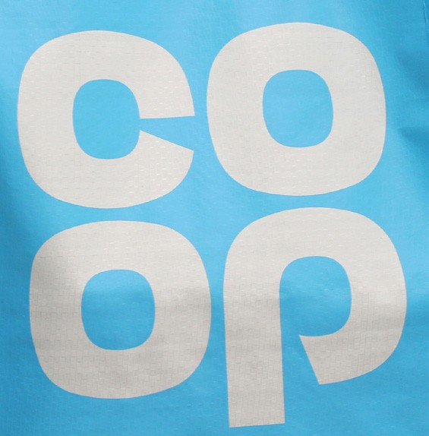The following information is from: https://www.co-operative.coop/about-us/our-co-op

Why we’re Different.
We’re one of the world’s largest consumer co-operatives, owned by millions of members. We’re the UK’s fifth biggest food retailer with more than 2,500 local, convenience and medium-sized stores.
We’re also:
- the UK’s number 1 funeral services provider
- a major general insurer
- a growing legal services business
And, we have a minority shareholding in The Co-operative Bank.

As well as having clear financial and operational objectives and employing nearly 70,000 people, we’re a recognised leader for our social goals and community-led programmes. We exist to meet members’ needs and stand up for the things they believe in.
So, the more successful we are, the more we can give back to you and your local community.
That’s why we’re different.
Visit the co-operative website and answer the following questions:
- Explain, with examples how the group has helped the community in recent years.
- What is responsible retailing? Explain how the Co-op has contributed to this.
- What are the benefits of being a member of the Co-operative Group?
- Would you like to become a member? Explain your answer.

A worker cooperative is a business that is owned and controlled by the whole workforce. People who work within the business are in control rather than outside shareholders and it is the most democratic type of business; everybody plays a part in the decision-making process.

There are around 1 500 worker co-operatives in the UK, most of them are small, with only a dozen or so members. Worker co-operatives may involve workers buying out the business for which they currently work as an employee, or workers may form a cooperative to start their own business with the aim of sharing all risks, profits, decisions etc.
Worker co-operatives give a great deal of job satisfaction because the members are working
for themselves. 76

A disadvantage is that as everybody has a say in the running of the business, it is sometimes
difficult to make key decisions.

Example of a worker co-operative

The following information is from: http://www.suma.coop/about/cooperation/

Co-operation
We don’t really like to blow our own trumpet here at Suma, but we do like to think that being a workers’ co-operative is one of the fundamental keys to our success.

So what’s it all about? Unlike most UK companies, Suma operates a truly democratic system of management that isn’t bound by the conventional notions of hierarchy that often hinder progress and stand in the way of fairness.
While we do use an elected Management Committee to implement decisions and business plans, the decisions themselves are made at regular General Meetings with the consent
of every co-operative member – there’s no chief executive, no managing director and no company chairman.

In practice, this means that our day-to-day work is carried out by self-managing teams of employees who are all paid the same wage, and who all enjoy an equal voice and an equal stake in the success of the business.

Another key feature of our structure and working practice is multi-skilling. At Suma we encourage members to get involved in more than one area of business, so individuals will always perform more than one role within the co-operative. This helps to broaden our skills base and give every member an invaluable insight into the bigger picture. It also helps us
to play to each member’s various different strengths while enabling us to think ‘outside the box’ when it comes to creativity and problem solving. And as for job satisfaction and staff morale – just ask yourself when was the last time you heard someone complain that their job involved too much variety? It is the spice of life, after all.

This all sounds great, but does it work? In a word, yes. Here in the UK we’re often sceptical about workers’ co-operatives, but that’s largely because of our more conventional business culture and the fact that the vast majority of UK companies are purely profit-driven.
Workers’ co-operatives are far more common in many advanced European countries and developing world economies. Of course it’s not all plain sailing, but if you look at Suma’s growth over its 30-year history, we think you’ll agree that we must be doing something right.
- What is meant by a truly democratic system of management?
- Why do you think Suma use an elected Management Committee?
- What are the benefits of working for Suma?

Advantages of co-operatives
• The members feel that they have a real impact in the running of the business.
• Co-operatives often focus less on profit which leads to better customer service and an
emphasis on ethical business practices.
• Profits are distributed fairly among the members.
• Members enjoy working together and get great job satisfaction from working for themselves and their colleagues; they are therefore more likely to be motivated to succeed.
• There is less likelihood of arguments as members share the same aims and objectives.
• Members are more likely to be aware of their responsibilities to the local and larger communities.
• Cooperatives are committed to the training and education of their employees.
• The initial investment required in buying shares and becoming a member is less than other ways of starting a business (sometimes just a pound).

Disadvantages of co-operatives
• Decision making can be difficult and may take a long time as everybody has a say
• in the running of the business.
• All members have an equal right to speak and contribute to the decision-making process
– even if they have little knowledge of the subject being discussed.
• It may be hard for members to make tough decisions that will affect their co-workers,
such as job cuts.
• A cooperative’s focus on fairness and ethical business practice may limit opportunities
for growth and maximising profit.
• Workers in worker co-operatives may find internal promotion or career moves difficult.
• Co-operatives may find it difficult to recruit top quality management, the most able
candidates usually demand a very high salary.

- Co-operative shops are found all over the country.
Who are most likely to be the owners of these shops? Tick one box only.

Taxpayers Customers
The Government

- What is the term for the share of the profits of co-operatives? Tick one box only
Dividend Interest Shareholding

- Co-operatives can never be as successful as a limited company. Do you agree with this statement? Explain your answer.

Charities

Charities are organisations that aim to raise money in order to support a cause, such as cancer research or wiping out poverty in third world countries. Charities will focus on minimising costs and organising fundraising activities to maximise donations.

A charitable organisation is a type of non-profit organisation. Their main income is from donations, though they will also raise money through holding events, providing services and selling products.

Many charities employ paid workers to undertake specialist work, but also rely on volunteers in order to minimise wage costs.

Charities include voluntary organisations that provide a service to society. There are many voluntary organisations in the UK, examples include animal welfare groups, Girl Guides, Scouts and the RNLI. Voluntary organisations do not aim to make a profit, but to cover the costs of running activities. All surplus funds are reinvested into the organisation
Charities will often receive donations from for-profit businesses.
Charities are set up to support a number of different causes, these include:
• the prevention or relief of poverty
• the advancement of human rights, equity and diversity, education, religion, health, community support, arts, heritage and culture, sport participation, animal welfare and environmental issues.

Most Charities that have an income of more than £5 000 must register with the Charity Commission for England and Wales. Charities can receive tax relief and exemptions (they don’t pay a tax on their profits the same way a private business will).
The top ten charities in the UK (ranked by their income) in 2015 was:

1 | Cancer Research UK | £446.5m raised out of a total income of £634.9m
2 | British Heart Foundation | £263.8m raised out of a total income of £288.2m
3 | Macmillan Cancer Support | £214.1m raised out of a total income of £218.4m
4 | Oxfam | £192.8m raised out of a total income of £401.4m
5 | Sightsavers | £184.7m raised out of a total income of £199.7m
6 | RNLI | £170.9m raised out of a total income of £190.1m
7 | British Red Cross | £139.1m raised out of a total income of £261.8m
8 | Salvation Army | £130m raised out of a total income of £196.3m
9 | Save the Children | £125.3m raised out of a total income of £370.3m
10 | NSPCC | £115.3 raised out of a total income of £125.9m

Selection of an appropriate business structure

Owners of a business will have to decide on the most appropriate business structure for the business and may choose to operate as a sole trader, a partnership or a limited company. The most appropriate structure for a business will depend on a number of factors.

The size of a business will have an impact on how the business is run; larger businesses may have different aims and objectives to a small local business.

Some business owners may benefit from working alone as a sole trader, while others would require the support and skills of other owners and investors. Some businesses may require large levels of investment, best achieved by selling shares on the stock exchange as a public limited company. Some businesses do not require large investment and are more suited to being run as small sole trader businesses.

Sole trader businesses tend to be easier to set up, requiring very little paperwork, whereas for a partnership to run smoothly it is recommended that a Deed of Partnership is drawn up to protect the interests of the individual partners.

A sole trader business has unlimited liability which is quite risky for its owner. If the business cannot pay all its debts, then the owner risks losing personal possessions to repay the debt. Therefore, some businesses choose to set up as a limited company in order to receive the protection offered to them by limited liability; it protects the owners from losing any more money than they have invested in the business.

What happens to the profits is important. Sole traders are able to keep all the profit made by their business for themselves, whereas partners will need to share any profits made and public limited companies may need to pay dividends to its shareholders.

The management of a business will differ depending on the business structure. The owners of smaller businesses like sole traders and partnerships tend to adopt a hands-on approach to running a business and are heavily involved in decision-making. Within public limited companies there is a division of ownership and control – shareholders elect directors to run a Plc on their behalf. Shareholders have very little involvement in managing and running the business on a day-to-day basis.

As businesses grow the owners may want to change the type of ownership they have, generally this means:

Sole Trader
⬇
Partnership
⬇
Private Limited Company
⬇
Public Limited Company

Businesses change their type of ownership to gain the advantages of the next level.

However, some businesses stay at one level of ownership due to the disadvantages of the next level.

Comparison of different business structures
Complete the tables below to explain and compare each of the 4 business structures. You will need to expand the rows in order to explain the features of each structure.
Business Structure | Main Advantages | Main Disadvantages
Public Limited Company
Private Limited Company
Partnership
Sole Trader

 | Sole Trader | Partnership | Private limited company | Public limited company
What aims and objectives might this type of business set?
Describe how this type of business is formed.
Explain the ownership of this type of business.
Describe the management and control of this type of business.
Identify the liability of this type of business.
What is the usual size of this type of business?
What are the main sources of finance available to this type of business?
How are profits
distributed?

Hannah and Matthew have decided to start a small business producing and selling wooden picture frames. They wish to sell these in a retail shop and online. They have considered the main types of business ownership but are unsure which would be most appropriate for their business and have asked for your advice.

Write an extended answer (at least 30 lines) to discuss the advantages and disadvantages of each type of ownership and recommend the most appropriate structure for their business.

Business growth

Nearly all businesses started as small businesses - usually as sole traders or partnerships. Think of how each of the following started:
• Marks and Spencer – a market stall in Leeds
• Boots – a chemist shop in Nottingham
• Tesco – a market stall in London
• Virgin – a record shop in London
• Facebook – a social network at Harvard University, USA
• Microsoft – 2 computer “geeks” in the USA

Over time these businesses grew to become the very large-scale businesses that they are today.

They have enormous sales, revenues and profits resulting from enormous capital, marketing budgets and workforces. The business environment is competitive and dynamic, as a result failure to grow could result in business failure as competitors will grow and impact on the business. Standing still in the business world is not a good strategy.

Why businesses grow

To increase profits

Bigger businesses make larger profits. The owners of small businesses want to earn more to improve their own lifestyles. Think of some of the owners of the businesses mentioned above, they are now very rich themselves. Larger businesses will grow to provide better returns on investment for shareholders.

To improve market share

Market share is the proportion of the market that you control. For example, Tesco controls about 28% of the market of goods sold in supermarkets. Sainsbury’s was once the market leader but at one stage the owners and managers of Tesco wanted to grow faster to overtake Sainsbury and take their place as the market leader.This can lead to increased profits.

To reduce competition

As some businesses grow their competitors are unable to keep up, in terms of the goods supplied or the price charged, and so they drop out of the market. Think of how the number of specialist greengrocers and butchers has fallen with the growth of supermarkets. This will lead to increased market dominance for the business that grows, with larger sales and profits.

To secure the market
Strength in the market means that as businesses become bigger they become better known and are more likely to keep their customers. Their reputation is all-important.
To Secure Supplies
Bigger businesses are also likely to have the trust of their suppliers and so they will always

have goods to sell or materials to produce. Large companies can even control the suppliers by determining the prices they pay for goods, owning the sources of materials or by having goods made for them (own brand goods).

To spread risks
Bigger businesses can operate in a number of markets in terms of where they sell or what they produce. A fall in sales in one market can be offset by continued sales in another. This is called diversification. For example, a manufacturer of garden furniture expands into manufacturing bicycles, or a hotel chain buying a chain of clothes shops. This can be a risky method of growth as the business is likely to have limited knowledge of the new market.

To benefit from internal economies of scale
The more a business produces or sells, the less it costs to produce or sell each good. This means that a business has lower unit costs because of its large size. They can buy raw materials cheaply in bulk and also spread the high cost of marketing campaigns and
overheads across larger sales. Reduced unit costs can charge lower prices and/or increase profit margins. For example, a large business can produce a pair of shoes for £18 while it will cost a smaller competitor £30, this will give the larger business a £12 unit cost advantage.

Internal economies of scale

As businesses grow they have higher costs, but these costs can be spread over a large number of goods produced. It is said that the unit cost is lower, this comes about because of economies of scale. As the cost of producing each unit falls as output increases, the average cost of producing the unit falls. For example:
In 2012 a business produced 1 000 bars of soap, the total cost for producing the soap was
£500 so the unit cost for each bar of soap was 50p. The soap was sold to shops for 75p each so the total revenue was £750 giving a profit of £250. The profit margin on each bar of soap was 25p.

By 2016 the business had invested in new equipment and employed more workers. It now produced 10 000 bars of soap with total costs of £3 000 so the unit cost for each bar of soap is now 30p. The soap is still sold to shops for 75p so the total revenue is now £7 500, resulting in a profit of £4 500 and the profit margin on each bar of soap is 45p.
Economies of scale are a major source of competitive advantage for large businesses.
Economies of scale can be defined as:
The reduction in average costs of production that occur as a business increases its scale of production.

There are different types of internal economies of scale that are achieved as a result of increasing internal efficiencies of the business:
• Purchasing
• Marketing
• Technical
• Financial
• Administrative/Managerial.

Purchasing
As businesses grow they can increase the size of orders for raw materials, component parts or stock. This may then result in discounts being given and the cost of each unit purchased will fall. This is also referred to as bulk buying. This is the reason why large supermarkets
or large manufacturers of computers can sell their products much cheaper than smaller businesses. They buy so many products or components from their suppliers, the suppliers need their business so much that they sell these to the supermarkets and computer manufacturers at a much lower price than they sell to other smaller businesses. The supermarkets and computer manufacturers can then sell these to their customers at lower prices so they achieve high sales and market share.

Using an example from when you visit a shop, explain how buying in bulk will increase the total price you pay, but will reduce the unit cost you will pay.

Marketing

As businesses grow each pound they spend on advertising will have greater benefit for the business. A small business with 10 stores will pay the same price for advertising as a large business with 200 stores. The cost of the advertising is spread across the stores, so per store, or per customer the unit cost of reaching these customers through the advertising is much lower for the larger business.

Large businesses also have large marketing budgets and can afford to advertise on the television, to sponsor big events and sports teams. The marketing costs can be spread across all the extra sales made from this marketing. Small businesses cannot afford to do this but they market through leaflets and local media, which cost less but are not seen by so many people, and so the cost per extra customer is higher.

Technical

As a business grows it can afford to buy new machinery and equipment and carry out new ways of production. This can result in increased efficiency, making more products at lower unit costs. Large supermarkets have the latest technology to use for stock control, security systems and checkouts; a smaller business is unable to afford this. In manufacturing, large car producers, such as Toyota and Ford can invest in robotics and computers that design cars, once again resulting in reduced costs and lower prices for customers.

Financial
As a business grows it will have access to a wider range of finance. If a business is looking for extra finance to borrow, larger businesses are more ‘credit worthy’ with banks and other possible investors, often obtaining finance at lower rates of borrowing. Smaller businesses often have to pay high rates of interest as they are considered more risky.

Administrative/managerial
Large businesses can afford to employ specialists such as accountants, marketing, human resources departments, lawyers, production workers and so on. This means high wages and salary costs, but these can be spread over the large number of goods produced so that the cost added for each of these workers is small. This will increase efficiency and reduce the average costs of producing goods. In smaller businesses tasks tend to be carried out by the owners, or services may be bought in at high cost when needed.

Large businesses can also use division of labour. This is when different production processes are divided into separate tasks which will increase efficiency and productivity (the rate of output per worker or machine). This is also known as specialisation. By splitting the tasks or processes, the business is able to produce more output in the same time.

- Summarise the main reasons why businesses grow.
- What is meant by lower unit costs? Give a numerical example.
- Explain how internal economies of scale benefit large businesses.
- Produce a poster to put up in your classroom that outlines the different types of internal
economies of scale.
87

Read the article on Apple and answer the question that follow.

Adapted: https://fayblack.wordpress. com/?s=apple

The types of economies of scale that Apple could face are:

Technical economies of scale: due to the fact that Apple produces so many devices they can maximise the amount of goods produced to maximise their economies of scale and lower average cost per unit.
Apple’s size and the fact that most of
Apple’s products e.g. iPhone, iPad share the same components the company can buy parts such as processing chips and display screens at lower prices due to buying in bulk benefiting from purchasing economies of scale. Any company that wants to make a tablet computer that matches the iPad’s low starting price of $499 would have to endure higher production costs. Due to this Apple has 70% of the tablet computer market.

Furthermore due to the large amount of products being produced by Apple the research and development undertaken by the company is essentially free, another example of technical economies of scale.
Another example of marketing economies of scale that Apple benefits from is the large amount of advertising the company has; also advertising one product essentially advertises all other products produced by Apple meaning that the cost of advertising is much lower than it would be for a smaller business.
Apple can also benefit from financial economies of scale as new competition enters the market Apple can use their economies of scale to lower the prices of their products that competition cannot match.
- Identify the types of internal economies of scale Apple experience.
- Explain how Apple has benefited from internal economies of scale.
- What impact has this had on Apple’s competitors?

Methods of Growth

A business can grow through:
- Internal (organic) growth - the business grows by selling more of its products, hiring
more staff and equipment and increasing advertising, promotion and investment.
- External growth (integration) - the business merges with or takes over another business.
- Franchising - where a business leases its idea to other businesses (franchisees).

Internal (organic growth)
This involves using resources from within the business to expand in steady stages. Organic growth takes place when a business expands its own operations. This can be done by:
- Producing more of its current products in existing markets
- Producing more of its current products in new markets
- Developing new products
- Increasing production capacity (being able to make more products) through investing in new machinery or moving to new location or site
- Increasing the number of customers who buy its products through increased advertising and promotion.

Organic growth can take a long time and requires the owners to reinvest profits into the business, although it can be a relatively inexpensive strategy to use. It is used by businesses of all sizes to expand and the decision to grow this way will depend on the aims and objectives of the business owners.
For many small businesses internal growth is the only option they have to grow.

Shine Ltd is a medium-sized company that manufactures and sells double glazing windows and doors to households. It operates in the north east of England and employs 25 workers in its factory and 8 sales representatives who sell the products. It has built up a good reputation and makes a good profit every year. It now wishes to use its retained profit in order to expand the business, though the owners are not sure how it should expand. With reference to the points below suggest ways it could expand and recommend what it should do. Justify your recommendations.
- Producing more of its current products in existing markets
- Producing more of its current products in new markets
- Developing new products
- Increasing production capacity (being able to make more products) through investing in new machinery or moving to new location or site
- Increasing the number of customers who buy its products through increased advertising and promotion.

External growth

External growth involves a business buying or joining existing businesses, this is also referred to as integration. There are two ways in which this can be achieved:
- Merger
- Takeover (acquisitions).

Merger | Takeover
- Two or more businesses join together to form a new business.  - The businesses tend to be of similar size. | - One business buys another business by acquiring control.  - This can involve the business buying the whole business or buying part of a business.

The advantages of external growth include:
- Faster growth
- Speed of access to new products or markets
- Increase market share and market power
- Economies of scale
- Make use of the strengths of each business
- Invest in fast growing emerging markets.

Mergers and takeovers happen all the time and are used by larger businesses to grow their businesses quickly.

Facebook has acquired many small new businesses in recent years; these include Friendfeed, Onavo, LiveRail and Face.com. They have also acquired Instagram and WhatsApp.
Why do you think Facebook has acquired these particular businesses? Search on the
internet to find out what the acquired businesses do.

However there are some disadvantages of external growth:
- The merger or takeover does not always work - it is difficult to make two different
businesses work as one.
- A takeover can result in creating a bad feeling between the new workforce, some takeovers are hostile (where the business being taken over does not want to be) and the takeover can often result in redundancies.
- The cultures of the two businesses may be very different and it will be very difficult to
agree on the new culture of the business.

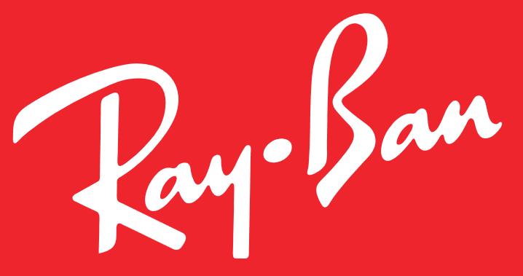Read the article below and answer the questions that follow:
Ray-Ban Maker Luxottica Agrees 46bn Euro Merger with Essilor
Luxottica, the world’s biggest glasses maker, has agreed a huge merger with a rival eyewear business.

The Italian eyewear designer, which owns Ray- Ban and Oakley, is to merge with French lens maker Essilor. Combined, the two businesses will be worth about 46bn euros (£40bn;
$49bn).

Through a series of acquisitions, including of Ray-Ban in 1999 and Oakley in 2007, the business has become the world’s biggest
spectacles maker. It also has licensing agreements to create eyewear for major fashion brands, including Burberry, Dolce & Gabbana and Versace.
The business said in 2014 that it had previously explored a deal with Essilor, the world’s biggest maker of prescription lenses, but that conditions were not right at the time.

“The marriage between two key companies in their sectors will bring great benefits to the market, for employees and mainly for all our consumers,” Leonardo Del Vecchio, Luxottica’s executive chairman said in a statement.
- With reference to the data explain what is meant by a merger.
- How will the two businesses benefit from the merger?
- What effect will the merger have on consumers and competitors?

Carry out research to find a recent merger or takeover that has taken place. Summarise the
main details of the deal.

Different types of external growth (integration)

Horizontal integration

This is when two businesses in the same industry at the same stage of production become one business. In other words they make the same product or provide the same service.
Examples include a car manufacturer takes over another car manufacturer or two hotel chains merge.
Amazon buying LoveFilm, Costa Coffee buying Coffee Nation and Volkswagen buying Porsche
are examples of horizontal integration.

Advantages of horizontal integration include:
- Economies of scale
- Other cost savings – needing fewer workers, managers and premises (this is called rationalisation)
- Increased market share
- The new business will be more competitive in the market and reduce competition
- Buying an already established brand is cheaper than building the brand from the start.

Vertical integration

This is when two businesses in the same industry but at different stages of the supply chain become one business. In other words it is when a business joins with another business that operates at a different stage of production. For example, a shoe manufacturer buys a factory producing the leather or a chain of shoe-selling shops.
There are two types of vertical integration:
- Forward vertical integration is when a business merges or takes over a customer.
For example a manufacturer merges with a retailer or a brewery buying a chain of pubs. This gives the business greater access to customers and gives the business a greater control of the supply chain, reducing costs and improving distribution chains.
- Backward vertical integration is when a business merges or takes over a supplier.
For example a retailer buys a food processing business or a steel producer buying a coal mine. This gives a business greater control of its supplies which can reduce costs and improve the quality and delivery of raw materials and components.

Conglomerate integration

This is when two businesses that are unrelated join together. The businesses operate in different markets and have no connection with each other. This is also known as diversification.
For example a cinema chain buying a clothes retailer or a drinks manufacturer buys an online betting website.
The benefits of diversifying into completely unrelated markets include:

- Spreading business risk, so if the business is experiencing a decline in sales in one market, the business may be less vulnerable as the continued sales in other markets will help the business make a profit.
- It is possible to cross-sell existing products to new customers.

However, conglomerate integration is risky as the business may have no experience of the new market and may make costly mistakes. The business may also put so much time and effort into the new business it may have a negative effect on the original business.

Complete the diagram below with a suitable example

Vertical Integration

Example:
Chain of production

Horizontal Integration

Example:
joins with

joins with

Franchising

Franchising is a popular method of growth for a business. For entrepreneurs who have developed a successful business, franchising is a way to expand their operations.

The owners of the established business (the franchisor) sell the rights to their business logo, name, and model to another business (the franchisee).

The franchisee pays startup fees and regular royalty payments to the franchisor and in return will have the right to use the business name, logos, store design, processes, marketing ideas and products of the business.

The franchisee must agree to run the business according to the franchisor’s guidelines and purchase stock from the franchisor, to ensure the franchisee upholds the franchisor’s standards.
The franchisee will also receive training from the franchisor to help them start the business.

The franchisee is responsible for all debts incurred, and if there are losses then the royalty payments must still be paid and the losses covered by the franchisee.
Franchising can benefit the franchisor, as it provides an opportunity to expand without the
need for extra capital the majority of the costs are covered by the franchisee.
Franchising offers the following benefits to businesses looking to expand:
- Low costs compared to other expansion methods – the franchisees pay most of the costs, including the premises and employee wages. The number of outlets and sales for the business can grow without the need for much capital or needing to request financing from banks or investors.
- Minimises risk. Franchising can generate high financial returns for relatively little risk. A franchisor can earn high royalties from sales from franchisees. These profits can be greater than what could have been earned if the business opened and ran the outlets themselves.
- Motivation of franchisees. Hard working and talented people generally prefer to invest in running a business in return for profits rather than taking a salary as an employee. The more successful the franchisee the more profits they create for the franchisor.
Examples of franchised businesses include some large, well-known names such as Clarks shoes, The Body Shop, McDonald’s and Burger King. There are many smaller, lesser-known franchises as well, including businesses such as cleaning companies, pet care services and car valeting.
There are many examples of successful franchise ventures on the British Franchise Association’s website: www.thebfa.org.uk
Visit the website to see what franchises exist.
It is important to understand that a franchise is a method of expansion, not actually a type of business ownership, since a franchise can be operated and owned as a sole trader, a partnership, or a private limited company.

Franchisees point of view
For many people, the prospect of starting up a business from scratch - finding a market,
developing a product, risking their life savings - is far too daunting.

Businesses which are started often find it difficult to survive, with over half of small businesses failing within the first 2 years of operation, many within the first 6 months.

In contrast, less than 1 in 15 franchise outlets actually cease trading in any one year, with 9 out of 10 being profitable. So operating as a franchisee involves less risk and using a tested and successful name, format and product.

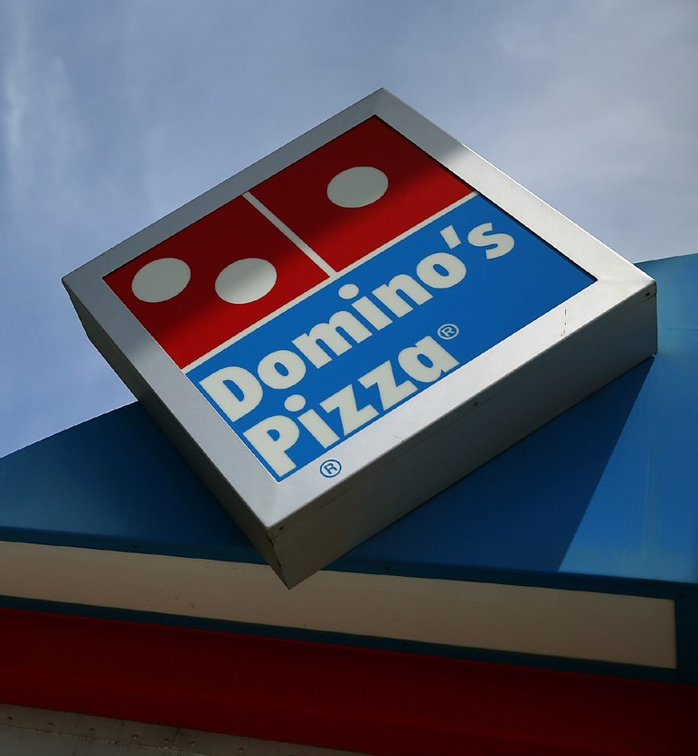Read the following case study and answer the questions that follow.

Name: Antony Tagliamonti Company: Domino’s Pizza Turnover: £2 million Staff: 80
When he was just 20-years-old Antony Tagliamonti had to make the choice between either spending his savings on a Lotus, or opening his first Domino’s Pizza
franchise. Fortunately, he chose the latter and six years on has an income easily great enough to satisfy his love of fast cars.
“I have been at Domino’s since just before my 16th birthday, I was working as a driver to begin with and I got to know a lot of people there.
“I just really liked the company from the start. The whole process, the systems – how they
go from order to delivery.”

Tagliamonti remained in the employ of Domino’s during his teens and into his 20s, also completing A levels and holding down a job in the syndication department of the Times newspaper. He ‘didn’t sleep much’, preferring to work instead – a habit that continues to this day.
All this graft had led to substantial cash savings, the question was, what to spend the money on?
“A friend of mine, who was running the Woodford Green franchise and was having trouble with his business partner, suggested that I take over a part of the business.
“I was saving up for a new car at the time – a Lotus. I love fast cars and I desperately wanted a Lotus Elise. But I just thought: What is more sensible? – A flash car or setting myself up for the future? I decided that it made sense to get into the business that I already knew I loved.
“The store was valued at £165,000. As I was buying half a share it cost me about £82,000
to set up. The first £20,000 was out of my own savings the remainder came through a loan

from the Royal Bank of Scotland.
“I was advised me to do this as the RBS recognise the Domino’s brand, they know how we
operate and I had a business manager appointed to me.”
Tagliamonti’s partner soon sold him the remainder of the franchise. At the age of 20 he was remarkably young for a franchisee. However, he insists that all you really need is the will to succeed; not to mention a love of hard work.
Without any doubt Antony Tagliamonti is a man prepared to put the hours in:
“I was working 60-65 hours each week, sometimes getting up at 7am and not going to bed until 1.30 a.m.

“You have to be responsible and be able to handle the different elements of managing and the demands of the business are high. It is not just a 9-5 you have always got to be on the end of the phone.
“It is hard work but if you do it then you will reap the rewards.”
Tagliamonti can testify to the high level of support that he receives from his franchisor. He was young, had never run a business before and had not been to university, having finished education after his A-levels.
“Domino’s gave me a lot of help and the network between franchisees and head office is brilliant. They are always there at the end of the line with advice when you need them. They don’t just throw you in at the deep end.
“They will help you right across the board from HR to marketing, it is really useful. You know you are selling a tried and tested product and that if you follow the plan then you will succeed.
“I meet up with other franchisees on quite a regular basis and there is a great camaraderie
when we do. It is great to swap ideas and stories and find out how each other is getting on.”

He now runs three franchises employing approximately 80 staff and has sold one franchise that he was running to another franchisee. The money he has made in the last six years means that he has owned many cars, Lotus, Porsche, BMW, to name but a few.
Adapted: startup.co.uk

- Who is the franchisee in the case study?
- Who is the franchisor in the case study?
- What skills and qualities has Antony used to make his business successful?
- What support did Dominoes give Antony?
- What is the benefit to Dominoes of Antony running a successful franchise?
- Explain why Dominoes have chosen to expand through franchising.

How franchising works

The franchisee must agree to run the business in the way required by the franchisor. This means that quality and standards are maintained.

The franchisor relinquishes direct control of the business by permitting individuals to run retail outlets in agreed areas under a franchise contract.

The franchisee buys the right to use the established company’s name, store design, products, processes, logos, display units and promotional methods.
The franchisee will also receive training from the franchisor to help them start the business.

The franchisee is responsible for all the debts and must pay a royalty payment to the franchisor. The royalty payment is calculated on the year’s turnover and the franchisee will keep any further profit. If there are losses then the royalty must still be paid and the losses are covered by the franchisee.
In 2015 the British Franchise Association (BFA) and NatWest Bank carried out research, the results show the importance of franchising to the UK economy:

Franchise industry annual turnover: | £15.1bn
Number of franchisor brands operating in the UK: | 901
Number of franchisee outlets: | 44 200
Number of people employed in franchising: | 621 000
Percentage of profitable franchises: | 97%

This has grown from an industry that 20 years ago had a turnover of just over £5 billion, had 379 different brands and represented 18 300 franchisee outlets. http://www.thebfa.org/about-franchising/franchising-key-facts

- Why do you think franchising is such a popular growth strategy for franchisors?
- Why are so many new entrepreneurs keen to become a franchisee?

There are both benefits and drawbacks to running a business as a franchise for both the
franchisor and the franchisee.

Advantages for the franchisor
- The franchisor can expand quickly without the need for a large amount of capital.
- The franchisor does not lose control of the business.
- The franchisee has invested their own money and so will be motivated to make the business succeed.
- The franchisor receives fees and royalties from the franchisee.
- The franchisor does not have a large workforce to manage.

Disadvantages for the franchisor

- The businesses trade name and reputation can be ruined if franchisees do not maintain standards.
- The initial costs of setting up the franchise system such as training, legal advice,

documentation and marketing can be very expensive.
- On-going costs of national advertising and continual support of franchisees can be expensive.

Advantages for the franchisee
- There is a good chance of success and less risk for the franchisee because of the well- known name, format and product.
- The franchisee benefits from a ready-made reputation because the franchisor controls
the quality of all franchises.
- The franchisor provides sound financial advice and support, so that cash low and
management problems can be avoided.
- The franchisor is responsible for costly activities such as market research and product development.

Disadvantages for the franchisee

- The franchisee will never feel that the business is theirs - for example the business cannot be sold without permission from the franchisor.
- The franchisee cannot make many decisions, all franchises must be run according to the rules of the franchisor.
- The franchise could be withdrawn at any time without any explanation or compensation.
- Fees, royalties and expensive stock make franchising a costly way to run a business.
- Royalties must be paid by the franchisee, even if the business makes a loss.
- If franchises are set up as sole traders or partnerships they still face unlimited liability.

Sunshine International is a franchise company, established in the UK in 2000. The business has over 120 branches throughout England, Scotland, Wales and Northern Ireland, providing a wide range of professional cleaning services for homes and business premises. Since 2005 the business has used franchising to expand its business, this strategy has helped it to grow its business and it is currently advertising for new franchisees on its website.

Julian Smith wants to set up his own business cleaning offices in Birmingham, though he has just read the information on the Sunshine International website and is now considering applying to become a Sunshine International franchisee.

- Discuss the advantages and disadvantages of Julian becoming a Sunshine International franchisee and advise him what to do.

- Discuss the advantages and disadvantages of Sunshine International expanding through franchising.

Why some businesses remain small

Many small businesses either make a decision to stay small scale or are unable to expand. Some business owners decide not to grow as they are content with the profit the business gives them; they don’t want the extra pressure and risk that expansion can bring. The aims of these business owners is to keep the business at the same scale, having similar sales revenue and profit year after year, enough to keep them in the lifestyle they have chosen.

Expanding a business can also lead to a loss of control and direct contact with their customers, for example, opening up a new outlet will require employing a new manager, the owner cannot be in two places at the same time, many small business owners do not want to lose any control of the business as this is something they might enjoy.
Small business owners that wish to expand may face a number of difficulties:

- Expansion is risky. There’s always the chance that any expansion plans can fail and result in losses rather than profit. Owners are then worse off than before the growth of the business.
- Market size limitations. Many small businesses provide a personal service in a local market, the strength of their business is face to face contact they have with local customers. It is difficult to scale up these businesses as the initial reasons for success was the small local market. Also some markets are limited in size, these could include niche markets (a market that has a small number of specialised products with a small number of customers) that do not have the potential for growth.

- Availability of investment. It can be difficult for small businesses to obtain finance to allow them to expand. The profit they make may not be sufficient for organic expansion, the business may be too small to interest investors such as business angels and banks may not want to take the risk of lending money to small businesses. Even when banks are willing to take the risk, the interest rates they charge for the loan may be too high for the business to afford.
- Difficult to compete with larger businesses. By expanding a business will have to seek to attract new customers and build its market share. Competing with larger established businesses, which may have economies of scale, for these customers, will be very difficult.

Business location and site
When businesses are set up it is very important that they are located in a place which is best for them i.e. where they can keep costs at their lowest, take in the most money and therefore make the greatest profit.
Firstly a business needs to consider its geographical location and then the specific site within
the geographical location:

Business location refers to the geographical area of location such as a certain town, city, region or country.
Siting a business is concerned with the more specific factors within a location such as
accessibility, footfall and size.
A business will consider a number of factors when deciding to locate the business.

Business location

For small businesses, the owners will normally locate in the area that they live. However, larger businesses will consider a number of key factors to decide where they locate either their whole business or different factories and outlets of the business.
Every business is different so they will have to consider different factors. A small business may only need to think about a few, whilst other larger businesses may have to consider and balance a complex mixture of location factors.

Monsterworld is a theme park located in a sunny climate on the coast near to a popular seaside town. There are plenty of hotels and other attractions nearby and the transport infrastructure (roads, rail and air links) are very good.

- Give three factors that Monsterworld considered when they located their theme park.

- In your opinion which factor is the most important in making Monsterworld a successful business?
Nia and Hannah want to open a restaurant. They are both married with young children and
live in Cardiff.
Where are they likely to locate their new business?

Location factors
- The market
- Materials and raw materials
- Labour supply
- Cost of land
- Infrastructure
- Government assistance
- Other factors such linkages, historical factors and climate

The market

Being close to the market (the customers) is vital for a number of businesses. A retailer, for example, will sell more products in a busy city than in a rural town or village. There are a number of industries, in addition to retailing where being near to the market is vital.

For example, in personal services, such as hairdressing or the restaurant trade, location is important. Banks, travel agents, opticians and dentists also need convenient locations for their customers.

Which of the following businesses need to be close to their customers?
- Garage
- Manufacturer of tinned foodstuffs
- Supermarket
- Customer support centre
- Bakers of fresh bread and pastries
- Producers of freeze baked products
- Car manufacturer
- Hotel

Some businesses are bulk increasing and these need to be located close to the market. Bulk increasing means that the good being produced is larger or heavier than the materials being used to make it so it is cheaper to locate near customers. Examples of these include businesses making boxes for packing, baking industries and soft drinks manufacturers.
For soft drink manufacturers the main ingredients are water (around 90%), flavour such as lemons for lemonade (5%) and gas (5%). The finished bottles of drink are made in huge
numbers and then distributed to wholesalers and retailers. There will be cheaper transport costs if these bottles are located near to the market with good road links.
In recent years the growth of online shopping (e-commerce) has meant that businesses no longer have to be close to their market.

Home shopping options are many and varied and are changing all the time. The major supermarkets are now online offering home delivery of goods and increasingly the major high street stores are competing for trade online. The Internet lends itself to shops selling goods which are easily transportable, such as DVDs and books.
Most websites are set up to do this work by:
- having an online catalogue which you can browse

- letting you add items to a virtual basket
- sending you to a virtual checkout
- arranging delivery.
Increasingly music, films, games and other digital media are now delivered online in the form
of downloads.

Materials and raw materials

Some businesses need to locate close to where the raw materials, or the components to make their products, are available.

This may be close to the source of the materials, such as mines, quarries, forests, factories etc. or where the business can obtain easy access to materials by being close to ports, major roads and rail links.

In some industries, like the steel industry, costs of transporting raw materials are high. Large quantities of bulky raw materials, such as coal and iron ore are needed to make steel. So steel producers need to be located where the cost of transport of raw materials is lowest.
In the past in the UK, this has meant that steel works have been built next to coal mines and iron mines. However, the UK’s iron ore deposits are now exhausted, so a steel producer today buys from abroad. Its plants are now located on the coast, where the iron ore is delivered in large ships to reduce transport costs.

These businesses operate in bulk reducing industries. This means that the product being produced is lighter, or less bulky, than the raw materials needed to make it. It takes 5 tonnes of materials to produce 1 tonne of steel; Limestone (1/2 tonne) Coal (11/2 tonnes) Iron ore (3 tonnes).
Other businesses which tend to be located close to the source of raw materials include those
dealing with perishable goods, such as fish canning and vegetable freezing.

Today, in the UK, there are fewer heavy bulk reducing industries than there were, when factories were built close to the sources of raw materials. As these resources ran out, factories were relocated close to good transport links. With increased competition from abroad and with the increased costs of production in the UK, many of those factories went into decline.

Some businesses are lucky in that they do not need to locate near their raw materials or their customers. These businesses are called Footloose as they are free to locate anywhere because transport costs are not very important.

A good example of a footloose industry is the electronic components industry. The transport costs of materials to make circuit boards for computers are cheap as is the transport costs of the finished products. For these industries there are other important factors to consider. Land on the edge of cities is often cheaper than in the centre and out of town locations gives easy access to workers.

Footloose industries locate in pleasant environments near good transport routes. An example of a footloose industry would be a hi-tech industry such as computing. Footloose industries have to locate close to research centres like universities. Developments in the hi-tech industry happen so fast that companies need to stay up to date to survive. Footloose industries are usually non-polluting and can locate close to residential areas.

Science Parks are located on the edge of cities in Greenfield locations. Many of the businesses located in science parks are connected with information, high-technology, and electronic industries. Science parks have direct links with universities for research. They have attractive layouts with grassy areas, ornamental gardens, ponds etc. Examples include Cambridge Science Park, Silicon Glen in Scotland and the M4 corridor.

Labour supply
The availability of a workforce with appropriate skills is another important consideration when deciding where to locate.
A business needing a highly skilled workforce needs to be in an area linked to the industry, or one with local training facilities. A business looking for mainly unskilled, cheap labour looks for an area with a high population.
Some industries rely on particular skills and certain areas develop a reputation for specialist skills. A recent example of this has been the growth of hi-tech industries around Cambridge, partly based on the skills and research facilities available at Cambridge University.

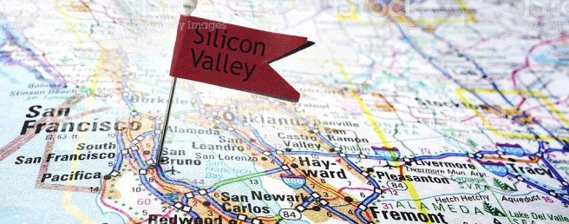
Silicon Valley in California USA, is known as a hub for hi-tech businesses.

Carry out research to produce a fact sheet on which businesses are located there and why they chose to locate there.

Wages tend to be higher in certain parts of the country where the cost of living is high - for example in London and the south east of England. Businesses that want to keep labour costs low will tend to go to areas where wages are generally lower or where there are large numbers of unemployed people willing to take lower paid work rather than live on benefits. This is one reason why a number of call centres have been established in the north east of England. As that area has higher levels of unemployment that the rest of the country.

Many foreign businesses decide to locate in the UK and employ British workers. In areas of high unemployment there is a good supply of workers. Workers in the UK may also have the skills needed.

The cost of employing labour in the UK may also be low compared to other countries. Also, the taxes on employing workers in the UK are low by international standards. For example, in Germany employers have to pay much higher taxes.

However, some businesses may decide to relocate outside the UK as wages for low skilled jobs may be cheaper in less developed countries.

Consideration for labour is only relevant for large businesses or when high skill labour is needed. For small businesses (which represent most of the business activity in the UK) who employ only a few people the availability of labour is not a major concern.

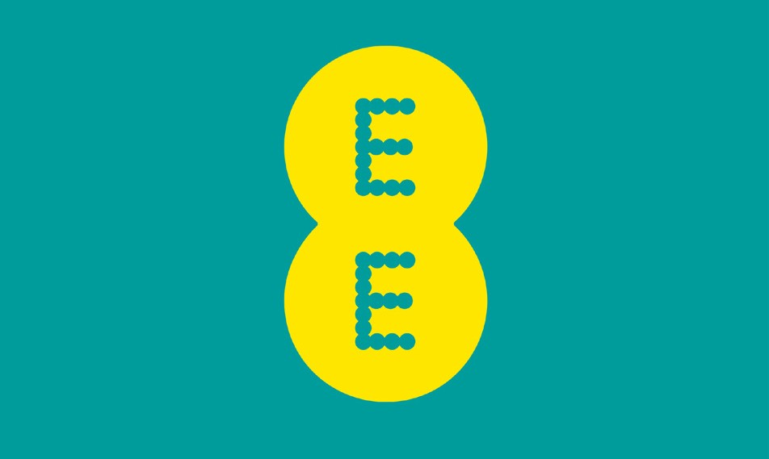EE Creates 260 New Jobs at Darlington and Tyneside Call Centres

Mobile phone company EE is creating 260 new jobs at North Tyneside and Darlington call centres.

The company already employs more than 300 staff at the two customer service centres, which opened in 2013.

Chief executive Marc Allera said the move was part of plans to base all its call centre workers in the UK.
He said: “There’s still more we want to achieve to fully onshore all customer service roles
and provide the best possible experience for our customers.”

The jobs will be shared equally between the two sites at Cobalt Business Park near North Shields and Darlington’s Yarm Road Industrial Estate.
Source: www.bbc.co.uk
- Why has EE decided to base its call centres in the UK?
- Why have they located to North Tyneside and Darlington?

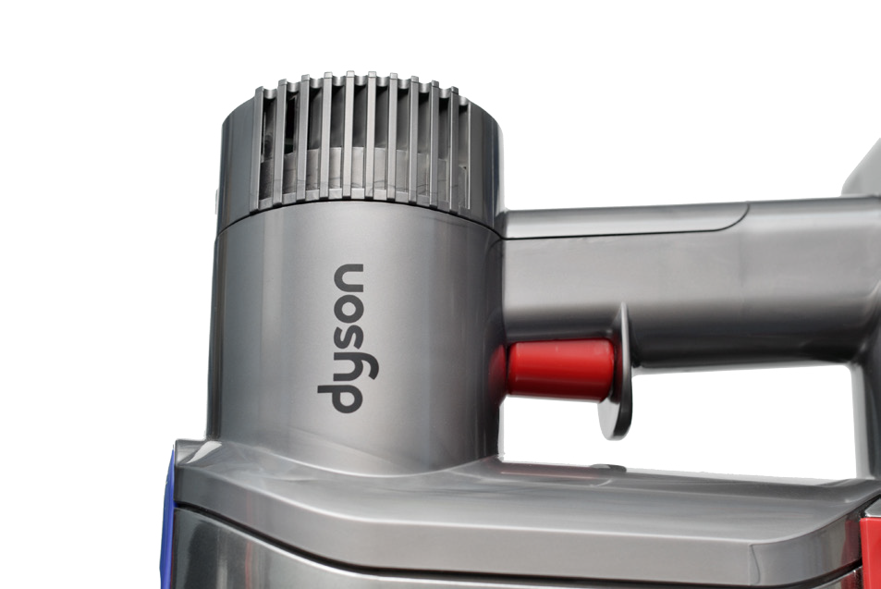The Production of Dyson Products.

When Dyson first started it made its products in the UK. However, in 2002, the business transferred vacuum cleaner production
to Malaysia. Most of the suppliers of its components were located in the Far East. Dyson is a global brand with a high number of customers in New Zealand, Australia and Japan.
In 2003 washing machine production was also
moved to Malaysia. Production costs in Malaysia are 30% lower compared with the UK. The savings made on production allowed for more money to be spent on research and development into improving the product and developing new products.
Dyson has another manufacturing plant in Singapore.
Dyson has received criticism from some people for moving production abroad.
- Explain the reasons why Dyson moved production to Malaysia and Singapore.
- How have consumers benefited from this?

Cost of land
The amount and cost of land will affect the choice of location of the business.

Premises costs tend to be higher in the south east of England than elsewhere. Around the country retail premises will cost more in city centres or major shopping centres. Costs will be lower in outlying shopping areas around a town or city.
The cost of factories or warehouse premises will be affected by how close the premises are to major motorway and rail networks. Business rates for the location are also an important factor.
Rank the following retail locations from the most expensive (1) to the cheapest (6).
- Main road of a small village in the countryside
- Oxford Street, London
- Corner shop in a residential area
- The Bullring, Birmingham
- Out of town retail park 2 miles off the M4
- Industrial park on the outskirts of Manchester
Explain the reasons for your choices.

The UK has become a popular choice for overseas companies wanting to set up in Europe. Manufacturers may locate in GREENFIELD sites. These are specially developed on rural land, and have a good supporting infrastructure. One of the reasons for choosing to locate on a greenfield site is that the cost of the land may be low. Building businesses on greenfield site are generally not liked by environmentalists.
A greenfield site is an area of rural land where businesses have not previously built.
Buying land in a town or city which has already been built on is called a BROWNFIELD site. Brownfields sites include disused or derelict land, these are more available in the North or in the midlands (often where old manufacturing businesses have closed down)

These tend to be more expensive than greenfield sites as the land may need to be cleared. It is also much cheaper to build a factory from scratch than to buy an existing factory and try to convert it.
A very profitable business which reprocesses hazardous chemicals wants to locate in a run-
down industrial area outside a large town.

What arguments for and against the development might be put to a planning meeting at the local council?

When deciding on the location the business should also consider:
- Should it be rented or purchased?
- How long will the site be needed for?
- What is the level of rates payable to the local council?
- Is there room for expansion?
- How much building work is needed?

Infrastructure

All businesses need good sources of energy and water, efficient drainage and waste disposal and good transportation. Generally, in a developed country such as the UK energy, water and waste services are very good and can be supplied to most parts of the country.

Many manufacturing businesses need good transport facilities in order to obtain materials and components and to move the finished goods to the customer. This includes motorways, airports, seaports and rail networks. Being close to airports and seaports is important if the business imports materials and/or exports products.

Good transport facilities are important to retail business for numerous reasons; it is important that goods can be delivered to customers over long distances, and also vital to allow easy access to the store both for customers and employees. This is often an issue in older town centres that were not designed with modern transport needs in mind. The
pedestrianisation of town centres has improved areas for customers, but has made making
deliveries more difficult.

Out of town shopping facilities have been developed close to roads to the benefit of both suppliers and customers with their own transport, or within easy access of public transport. The success of out-of-town shopping centres has been at the expense of town centre traders.

Many businesses have moved away from town centres and cities to less urban locations, near to motorways, to avoid traffic congestion. Major airports have also attracted businesses that have close connections with other countries.

The M4 corridor is the area adjacent to the M4 Motorway. Its eastern end in particular is home to a large number of businesses, particularly in Berkshire, Swindon and the Thames Valley. For this reason this part of the M4 Corridor is sometimes described as the UK ‘s Silicon Valley. Companies which have offices along the M4 include Vodafone, Cisco, Microsoft, Hewlett Packard and MCI.

As with many motorways, companies are attracted to the location because of the ease of travel, this is true of the M4 especially because of the motorway’s proximity to London and Heathrow airport which is also alongside the M4.

Good telecommunications and postal services can also be important, and in the digital age where many businesses communicate via the internet and through handheld devices, internet coverage (Wi-fi) can be essential.

Government assistance

Businesses create jobs and prosperity, therefore attracting business to an area can be very important to a local council or a government.
In the UK businesses may receive help from a local council, the Scottish and Welsh Governments and the UK Government. This was also available from the European Union, however, this will now stop as a result of the UK deciding to leave the EU.

Help may be in the form of grants to businesses that set up in areas of high unemployment or in run down urban areas. Businesses can also receive help through tax breaks or loans with low or no interest to pay.

There is also help available in the form of advice and training for new staff.
Examples of government assistance:

- www.gov.uk/business-finance-support-finder offers finance and support for businesses including grants, finance and loans, business support e.g. mentoring, consultancy and funding for small and medium-sized businesses and start-ups.
- https://businesswales.gov.wales/
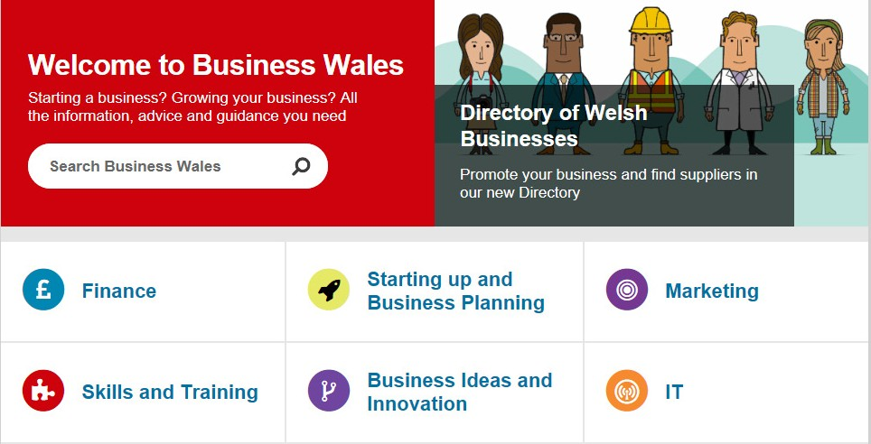

- The Start Up Loans Company was established in 2012. They are a government-backed scheme, supported by the British Business Bank and designed to support businesses who struggle to access other forms of finance.

Other factors

- Linkages - Some businesses depend on others or may need to be in close personal contact with similar types of businesses. This can be seen in the City of London where there is a tremendous concentration of financial businesses close to the Bank of England and the stock exchange.
- Historical Factors - Sometimes the reasons for an industry developing in a particular area in the past have disappeared and yet the industry remains there because it is well established and the costs of moving are high. An example of this is the Cumbria pencil industry, which was originally based on local supplies of graphite, but which now uses synthetic materials.
- Climate - Some businesses can only locate in certain areas. Examples include agriculture
- there are no banana farms in the UK and very few vineyards.

- Near to Competitors - Sometimes being near to your competitors is a good idea as there will be lots of local skilled labour and your customers know where to come. Your suppliers will also want to locate near to you so they can reduce transport costs and delays.
- Personal Reasons - Owners and managers may want somewhere nice to work and live so they might locate their business in an area they like or they have connections to.

For each of the businesses below name 2 location factors that will be the most important.
- Local chip shop
- Pine furniture manufacturer
- Pharmaceutical research and development
- Online goods warehouse
- Nightclub
- Orange farmer
- Solicitors
- Retired couple setting up a tea room
- Bank call centre

For each of the following businesses choose the best location from the information given.
- Granton – is a prosperous city with 300 000 residents. It has a busy city centre with a modern shopping complex. It has good links by road and rail has an international airport nearby. It has a university.
- Beachtown – is a popular holiday destination and situated on the coast. It has a population of 20 000 residents, in the summer this increases to 40 000. It is not close to the main roads but has a train station.
- New Poynton – is a small town that has grown quickly in recent years, it now has 60 000 residents and is very popular with affluent families. It has a small town centre but a few out of town retail parks. It is close to a national park.
- Ferryport – is an old industrial town located near to a large port which services ships exporting and importing products from all around the world. It has many brownfield sites which used to be used by steel manufacturers. The population is 100 000, it has high unemployment. It has excellent road and rail links.
- A multinational steel company to open a new plant employing 3 000 local workers.
- An electronic component engineering company to open a new factory that will manufacture circuit boards to be used in hand held mobile devises.
- A hotel chain to open a large hotel aimed at tourists and business people.
- An insurance firm to open a call centre to deal with customer queries and complaints
from all over the UK.
- A craft shop selling high quality and high end locally produced crafts.

Siting factors
Siting factors need to be considered after a business knows what location they will select. For example a multinational manufacturer has decided to locate along the M4 corridor, it will now look for a specific site, an entrepreneur from Liverpool who wants to open a hairdressers will look for suitable property in the Liverpool area or a large retail chain wishes to open a new store in London, will look at the possible sites in and around London. The following factors will need to be considered.
  - Cost of site
  - Size of site
  - Footfall
  - Accessibility
  - Closeness to competitors
  - Personal reasons

Cost of site
Even within a defined location there will be a range of premises or land available for businesses that will have different costs. For a retailer a store in the city centre will be more expensive than a store in a less busy part of town. Also commercial property prices will differ within an area, with more popular areas having higher prices. Office premises that are on the ground floor will be more expensive than above street level.
The quality of the building or the facilities on offer will also affect the price.
For a new business it is likely that there will be a small budget for siting the business, in this case the business may not be sited in the best area, or the first choice of the entrepreneur, the premises chosen will be one they can afford. Many new businesses do not buy the premises, they rent in order keep their costs low.

Imagine you are a new entrepreneur looking to buy a property for you new business in your local area. Decide on what retail business you wish to start. Using the internet look at estate agents and other sites that are advertising property for sale.
Read the details on the property and make a list of 4 possible properties.
- Is there much difference in price?
- What factors determine the price of the properties you looked at?
- Choose one property and explain the reasons for your choice.

Size of site
The size of the site will affect the cost of the site, with larger properties or pieces of land being
more expensive. It is important that a business selects a site that is not too small and not too big, this will depend on the nature of the business and the possible future plans, such as expansion plans.

In addition to using a premises that is the right size, it must also be suitable to the business, for example a clothes retailer will want a large front window to show the products and someone wanting to open a new café will want a kitchen and toilets for the customers. If these are not present then it will cost money to make the premises suitable.

Footfall
Footfall is the amount of customers that enter the business. Businesses such as retailers, pubs, cafes, restaurants, hairdressers, beauty parlours etc. need a good amount of customers in order to make the business successful. Where a business sites its premises can affect the footfall it gets. Siting in busy high streets, shopping centres and entertainment hubs tend to get a high level of footfall, whereas side streets or suburban areas tend to get much lower levels of footfall.
This is one reason why premises sited in busy areas are more expensive. By having a high level of passing trade a business is more likely to attract new customers and customers making an impulsive purchase.
The footfall a business gets is often measured by businesses to see if the site is the most
effective in attracting customers.

Retailers suffered a steep drop in footfall during the first trading weekend of 2017 as
poor weather and Bank Holiday trading hours drove shoppers online.

New Year’s Eve proved to be the stronger of the two days for retailers. Shopper numbers on high streets fell 2.4% year-on-year, compared with a 5.1% decline on December 31 2015. But New Year’s Day proved to be a washout for retailers, with shopping centres in particular suffering from a slump in shopper traffic.

Footfall at malls across the UK plummeted 49.5% on January 1 compared with the same day last year. It marks a stark contrast to New Year’s Day last year, when footfall at shopping centres jumped 9.8%.
Shopper numbers at retail parks tumbled 19.1%, while high streets proved to be the best-
performing locations on New Year’s Day, despite suffering a 12.7% slip in footfall.

As bricks-and-mortar retailers struggled to attract shoppers, online sales climbed 6.8% during the weekend, with New Year’s Eve registering an 18.2% uplift compared with December 31 2015.

The ease and comfort of online shopping proved too enticing for shoppers keen to snap up further discounts in the sales, rather than bracing the cold outdoors. Shopping centres in particular have a challenge ahead in 2017.

Having experienced a decline in footfall during 2016, these destinations need to up their game in order to provide additional reasons to draw shoppers away from their devices with an offer going beyond retail.
Source: https://www.retail-week.com/analysis/data/retail-footfall-slumps-over-new-years-
weekend/7017229.article

In addition to having good infrastructure specific sites also need good accessibility, in other words, easy to get in and out of. For most businesses accessibility is very important. For retailers the customers must be able to get there by car or public transport, park their car, walk to the store, get into the store or find it if they are new customers. The business will also receive deliveries from suppliers, although this importance will depend on the size and frequency of the products being delivered.
For a business that manufactures products, accessibility is also important as many component parts might be delivered and then distributed to customers. An area to unload and dispatch will be needed, if these are carried out throughout the working day then the access to main roads is essential to get the products in and out on time.

The growth of out of town retail parks have depended on good accessibility with large car parks, that are often free, bus stops nearby and large entrances to allow for many customers to visit the business in peak hours and avoid overcrowding. Also they tend to have excellent delivery facilities well away from the customer areas (not always true with town centre locations).
Closeness to competitors For some businesses it makes sense to be close to competitors as this can increase footfall. A city centre location will inevitably lead to competitors being close to each other, but each
business will be confident that they can compete by having better products, lower prices or more effective promotions. A good example of this is mobile phone shops, many are next door to each other or a close distance away, so when a consumer is looking for a new phone they can visit all at the same time. If one mobile phone shop decided to locate in another area of the town it is highly likely that the consumer will not bother to visit their store as it is too far away and they already have 3 or 4 stores to choose from.

Personal reasons

Many small businesses will choose a site for personal reasons, they may live in the area, have connections to the area or just like the “feel” of the area. Their motivation may be to serve customers that they personally know and enjoy the social side of running the business.

Selecting the most appropriate location and site

Businesses are so varied that it is impossible to give a definitive list of the most important location and site factors for all businesses. The choice of where to locate and site a business will depend on so many different factors; what will be a good location and site for one business will be a poor location and site for another. Even businesses in the same market will have different requirements; a start-up fast food restaurant will have limited funds and may choose premises with cheap rent and low footfall, whereas a large multinational fast food restaurant will be able to choose the site with the highest footfall, which is in the centre of a large city. Some businesses won’t need any footfall at all as their customers are online or on the telephone.

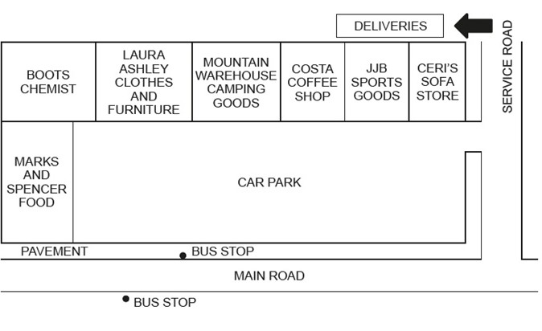
Coed Deri Shopping Centre is on the outskirts of a town. It is situated at the edge of an industrial estate which has offices and workshops. Close by is a leisure centre and within half a mile is a traditional local shopping area.
Below is map of the Coed Deri Shopping Centre.

Ceri’s Sofa Store was recently set up by Ceri Thomas who had been made redundant by a town centre department store.

- Outline two of the benefits Ceri might gain from siting her business in the Coed Deri
Shopping Centre.
- Explain one possible disadvantage Ceri’s Sofa Store may face in this site.
- Suggest and explain an alternative site for Ceri’s business.
Jane Roberts is planning to set up a shoe shop in a small market town. She would like to concentrate on selling more expensive shoes to attract better off customers with high paid jobs.
Jane is considering a number of different sites to set up her shop.

Outline the main factors Jane should take into account when deciding on the best site to locate her business within the town.

Acknowledgements

Document cover (Umbrella); erhui1979 / gettyimages
Ford logo; Wikipedia Creative Commons http://bit.ly/2nEdt5j Samsung logo; Wikimedia Creative Commons http://bit.ly/1VaJ8o5 Barclays logo; Flikr Creative Commons http://bit.ly/2rUmOTM

BT logo; BEN STANSALL / Stringer / gettyimages
L’oreal logo; Wikimedia Creative Commons http://bit.ly/2oXtEe4 Aldi logo; Wikipedia Creative Commons http://bit.ly/2o6r5Ck Apple logo; Wikimedia Creative Commons http://bit.ly/24IUtla Burberry logo; Wikimedia Creative Commons http://bit.ly/2oXL0I0 Dyson; AnthonyRosenberg / gettyimages
Uber logo; Wikimedia Creative Commons http://bit.ly/2osSktJ Netflix logo; Wikimedia Creative Commons http://bit.ly/2mnfjmz Kraft logo; Wikimedia Creative Commons http://bit.ly/2ptqR8F Nestle logo; Wikipedia Creative Commons http://bit.ly/2p7O298 Pepsico logo; Wikipedia Creative Commons http://bit.ly/2osM0lG P&G logo; Wikipedia Creative Commons http://bit.ly/2ptvEqJ Unilever logo; Wikimedia Creative Commons http://bit.ly/2pts7J9 Desk lamp; malerapaso / gettyimages

Comfort; ACORN 1 / Alamy Stock Photo
Hellmann’s Mayonnaise; Cephas Picture Library / Alamy Stock Photo Marmite; Tim Gainey / Alamy Stock Photo
Oil tanker; Wikimedia Creative Commons http://bit.ly/2o5sQz0
Breakfast Cereal; www.pixabay.com
Shoes; www.pixabay.com
Bread; www.pixabay.com

Manufacturing robot; PJ66431470 / gettyimages
Laptop; Ridofranz / gettyimages
Natural rubber; PeskyMonkey / gettyimages Small urban cars; mikeinlondon / gettyimages Hairdresser; www.pixabay.com
Office work; www.pixabay.com
Waiter; Wikimedia Creative Commons http://bit.ly/2oz3eOK Cleaning; flickr Creative Commons http://bit.ly/2oyYEjR Bank worker; www.pixabay.com
Carphone Warehouse; Wikimedia Creative Commons http://bit.ly/2ptjcHN

Airport; ugurhan / gettyimages
Pizza; Denisk999 / gettyimages
Southern Rail; Wikipedia Creative Commons http://bit.ly/2ooN2Oi Oxfam; Wikipedia Creative Commons http://bit.ly/2nEgwKM RSPCA; Wikimedia Creative Commons http://bit.ly/2oXBcO2

Cancer Research Uk; Roger A Smith and licensed for reuse under this Creative Commons Licence http://bit.ly/2oXIdyf
Transmission tower; georgeclerk / gettyimages
Coop logo; Flikr Creative Commons http://bit.ly/2sq4LIQ

Teaching; Klaus Vedfelt / gettyimages
Ray-Ban logo; Wikimedia Creative Commons http://bit.ly/2nK7f3a

Domino’s Pizza; Justin Sullivan / gettyimages Theme park; Andrew Burton / gettyimages Silicon Valley, California; zimmytws / gettyimages
EE logo; Wikipedia Creative Commons http://bit.ly/2ooIWpk

Dyson; Anthony Rosenberg / gettyimages

