Experiment

A psychologist investigated if the reading confidence of primary school children could be
improved if they routinely read to a therapy dog. In September, the psychologist asked two
teachers to rate the reading confidence levels of the 62 children in their classes. The teachers rated the children as having low, medium or high reading confidence. The psychologist used stratified sampling to select 10 children. These children spent 30 minutes per week reading aloud to a therapy dog. At the end of March, the teachers rated the reading confidence of the children. The psychologist then compared their reading confidence ratings to investigate if there had been any change. The raw data recorded by the researcher was as follows:

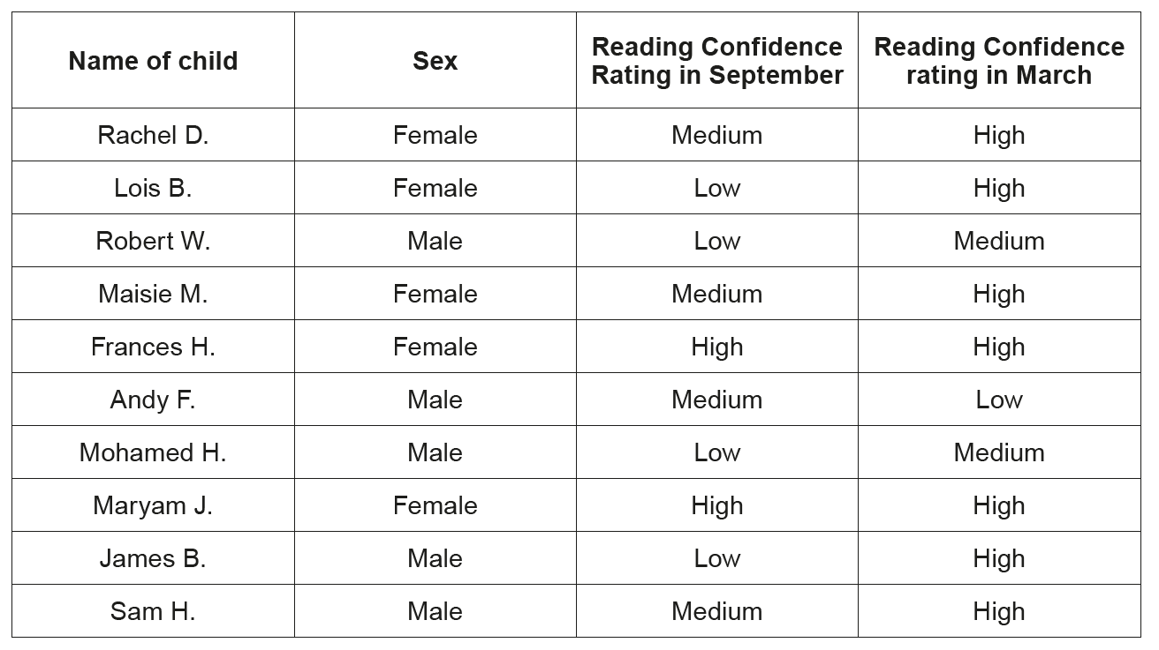
(Eduqas A Level Component 2, May, 2017)

