Experiment
A psychologist conducted an experiment into whether people who are bilingual (fluently speak two languages) have a wider vocabulary than those who are monolingual (fluently speak one language). 60 participants, chosen using snowball sampling, were asked to take a multiple choice on-line vocabulary test.

Average vocabulary scores for each group
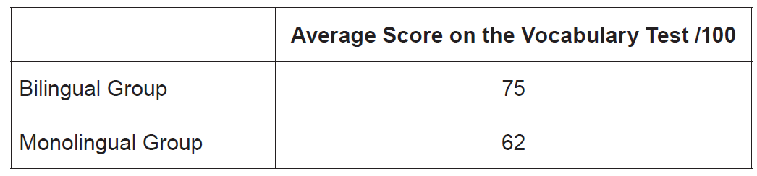

(WJEC Unit 2, June, 2018)

