Experiment

A professor chose to investigate the following hypothesis: ‘There will be a difference in the
attractiveness ratings of men when they wear aftershave and when they don’t wear aftershave’.
The professor conducted his research at a bar. The researcher invited 40 of his female students to attend the event in order to celebrate his 50th birthday. 20 female students were randomly allocated to attend the event at 18:30 and the remaining 20 female students were asked to arrive at 20:00. 25 male students (who were paid by the professor) socialised with the first group of female students, wearing no aftershave. After one hour the first group of female students left. The male students then applied aftershave and socialised with the second group of female students.
As they were leaving, female students were asked to give some feedback using a questionnaire. One of the questions was:

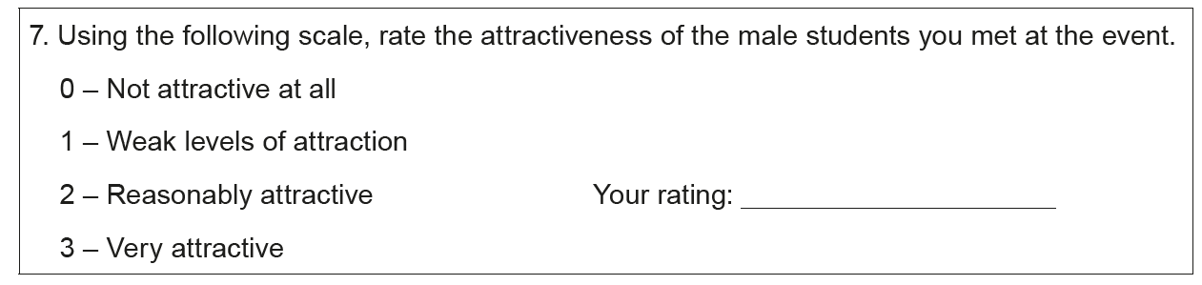

The University professor found that the mean ‘attractiveness’ rating for the male students when they did not wear aftershave was 1.8, whereas the mean ‘attractiveness’ rating for the male students when they wore aftershave was 2.1.

(Eduqas AS Level Component 2, May, 2017)

