Correlation

A psychologist used primary sources to see if longer beards made males more attractive to women. A correlational study was used, where photographs of 10 men with beards were taken and 20 women were asked to rate their attractiveness on a scale of 1-10 (1 = very unattractive, 10 = extremely attractive). The women’s scores of attractiveness were then averaged, using the mean, to create one attractiveness score for each bearded man. The psychologist created the following frequency table to compare beard length to mean attractiveness.

Length of beard compared to level of attractiveness
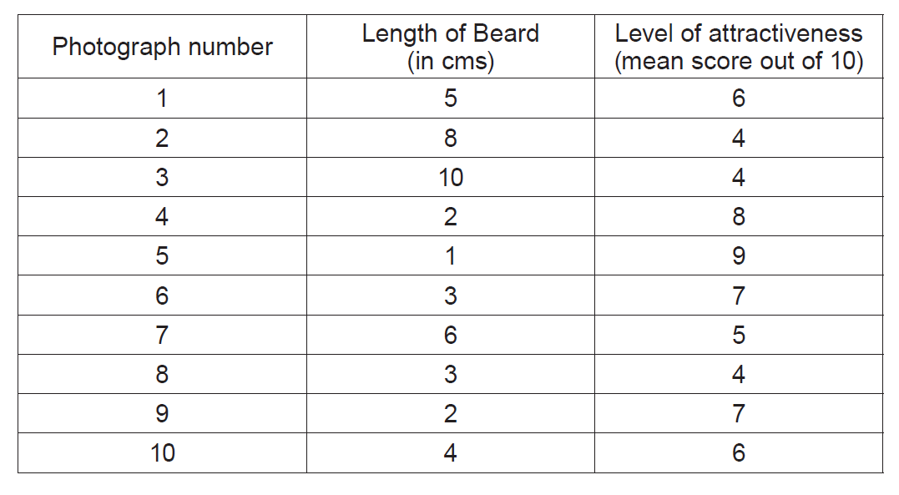

(WJEC Unit 2, June, 2018)

