Self-report

A researcher wanted to investigate if individuals who have a fear of flying (aerophobes) demonstrate lower levels of anxiety if they fly in First Class than if they fly in Economy Class. The researcher asked 12 participants who had just completed a ‘Flying without Fear’ course to take a short flight between London and Manchester in a First Class seat. The same 12 participants were then asked to take the return flight between Manchester and London in an Economy Class seat. After each flight, the participants were asked to self-report their ratings of anxiety, using the following scale: 0 = no anxiety to 10 = highest level of possible anxiety.

Table of anxiety ratings

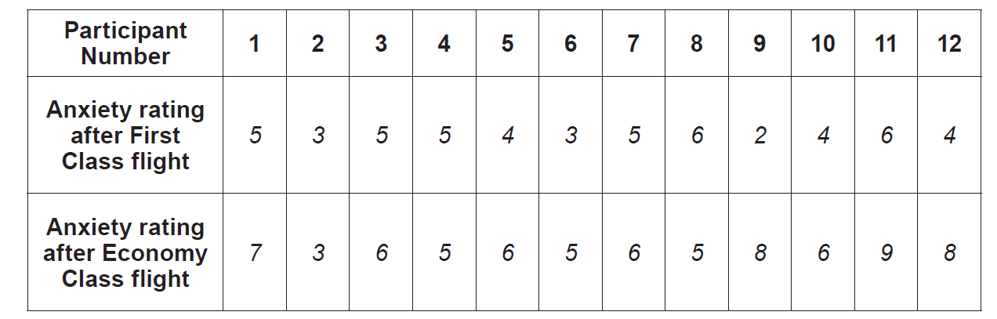

(Eduqas A Level Component 2, June, 2018)

