Observation

A social psychologist wanted to investigate if there was a difference in the disobedience levels of males and females. She conducted her research in the field, in a school canteen. When paying for their food, a member of canteen staff told each student to “clear away your plates and cutlery when you finish eating”. The social psychologist and two teachers from the school sat in the canteen pretending they had just finished their lunch whilst undertaking their observations. They observed 100 students (50 females and 50 males), recording the sex of any children that were being disobedient by not clearing away their plates and cutlery after they had finished.

They displayed their results in the following bar chart:

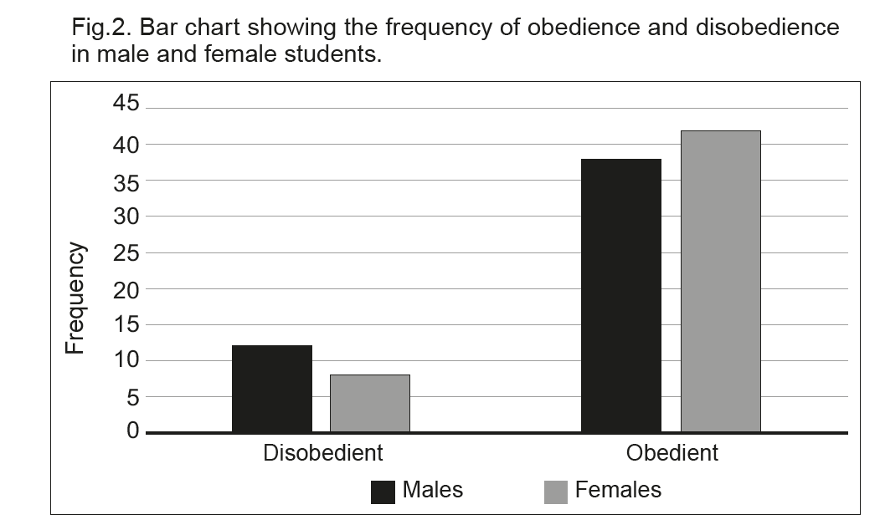

(Eduqas AS Level Component 2, June, 2018)

