Interview

A developmental psychologist was concerned about the amount of time pensioners spent
alone each day. He decided to conduct a semi-structured interview with pensioners who were shopping alone at a local supermarket. One of the questions the developmental psychologist asked each participant was ‘On a scale of 0 (never) to 10 (all the time), rate how lonely you feel’. The results to this question are displayed in the table below:

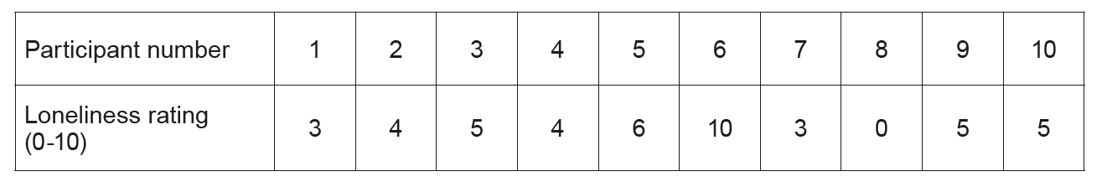

(Eduqas A Level Component 2, May, 2017)

