Experiment

Psychologists have known for a long time that walking has a beneficial impact on our mood.
However, a psychologist wanted to investigate if walking on a treadmill is as beneficial as
walking in a local park. The psychologist advertised in a local coffee shop for volunteers. She then randomly allocated 15 participants to walk on a treadmill and 15 participants to walk in a local park. All participants agreed to take a one-hour walk each day for 5 days. All participants recorded their mood in terms of a happiness percentage following their walk (0% = no happiness to 100% = most happy they have ever been).

Fig.3. Graph representing the daily mean happiness percentages of those
walking on a treadmill and those walking in a local park.

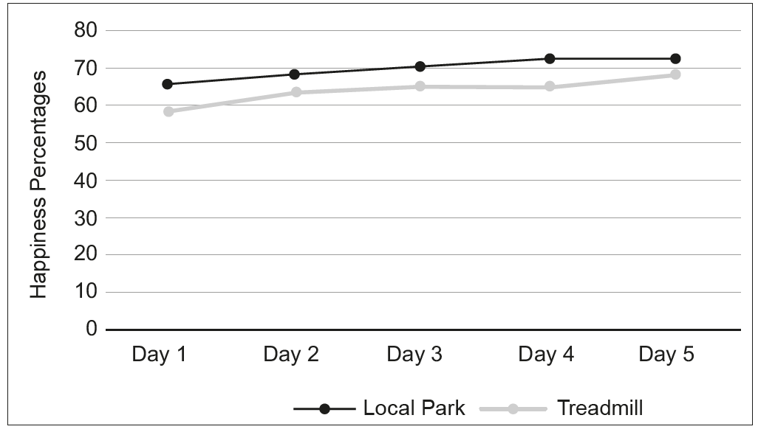

(Eduqas AS Level Component 2, June, 2018)

