Experiment
A group of psychologists were interested in whether females are better at assembling flat-pack furniture than males. The psychologists used systematic sampling to select 10 females and 10 males who were shopping at a local DIY store. The flat-packs were assembled in the participants’ own homes as part of a quasi-experiment.

Results from the above research were placed into a frequency table.

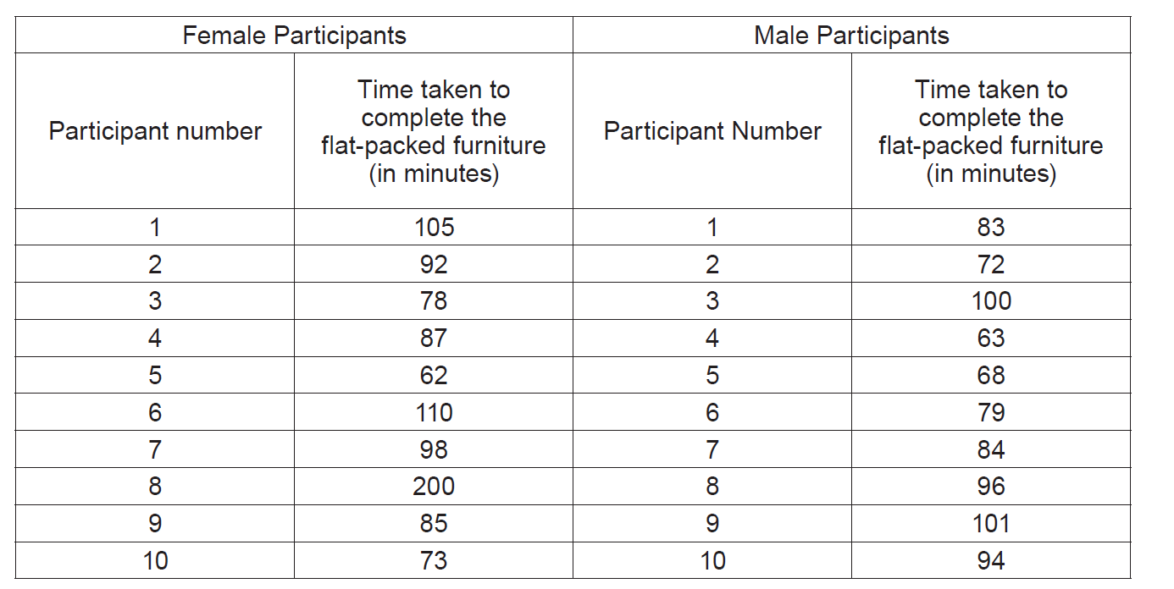

(WJEC Unit 2, May, 2017)

