Correlation

A research psychologist was concerned about the rise of obesity throughout the UK. Using a sample of 2000 people from a typical town the psychologist collected data on the participants’ weight and age. The psychologist collected descriptive data using measures of central tendency. The results are shown in the table below.

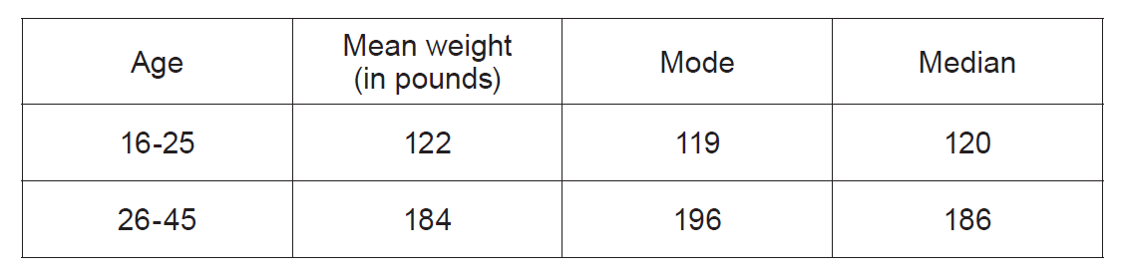

(WJEC Unit 4, June, 2018)

