|  |
| --- |
| EDUQAS |
| AS Level Resources |
| Set Work: Mendelssohn’s ‘Italian’ Symphony |



|  |
| --- |
| *Jan Richards* |

|  |  |
| --- | --- |
| **WCT Set work** | **Mendelssohn: ‘Italian’ Symphony No. 104** |

|  |
| --- |
| Choose a task based on **Movement 1** |

|  |  |
| --- | --- |
| Activity A –  Background information | Activity B –  Structure |
| Activity C –  Tonality | Activity D –  Texture |
| Activity E –  Structure / Themes | Activity F –  Thematic development |
| Activity G –  Harmony | Activity H –  Harmony: Chords |
| Activity I –  Instrumentation |

**Activity A – Background information**

|  |
| --- |
| This symphony is the third of Mendelssohn’s in order of composition, but published as No. IV, opus 90. It was written during the composer’s long journey through Italy, which started in 1831 and finished in 1833. |

Complete the following paragraph by inserting the correct information from the given list.

|  |  |  |  |  |  |  |  |  |  |  |  |  |  |  |  |  |  |  |  |  |  |
| --- | --- | --- | --- | --- | --- | --- | --- | --- | --- | --- | --- | --- | --- | --- | --- | --- | --- | --- | --- | --- | --- |
| |  | | --- | | ***Answers*** | | A minor | | 1834 | | Classical | | Incidental | | Five-part | | Bassoons | | Four | | German | | Trio | | Andante con moto | | Double bass | | Romantic | | Tarantella | | J.S.Bach | | A major | | Hebrides | | Premiere | | Concerto | | Artist | | Romantic |   Mendelssohn (1809-1827) was a prolific and gifted composer of the early  era in music. He had been regarded as a child prodigy (like Mozart) who produced works of mastery at a young age, and he never seemed to outgrow this youthful style. He remained true to the ideals of the era in music, and did not feel the need to revolutionise musical thinking in the same way as some of his contemporaries. He was associated with the revival of public interest in the music of .  The ‘Italian’ Symphony is actually one of his best known works: some other important orchestral pieces were his overture (1830), the violin in E minor, and the music to A Midsummer Night’s Dream .  He began writing the ‘Italian’ Symphony while on tour, and the work was first performed in 1833, with the composer himself conducting the . It was an immediate success and he described the work as “...the jolliest piece I have so far written... and the most mature thing I have ever done”. However, the composition process had not been an easy one and he never actually gave permission for the score to be published during his lifetime, as he continually sought to re-write it. In extensive revisions were made and indeed, he continued making revisions until he died.  Mendelssohn was touring Italy during 1830-1. He began recording his impressions of the trip through his painting (he was also a gifted ) and in his music, the result of which was the ‘Italian’ Symphony. It has been acknowledged that on one level, the Italian symphony is not a reflection of Italian life, but rather more an expression of how Italy made him feel. The symphony has movements: I – Allegro Vivace;  II – ; III – Con moto moderato; IV – Saltarello, Presto. Note that the first movement is in the key of , while the last movement is in the key of  .  Musicologists have offered many interpretations of what each movement was meant to represent. The first movement has been described as a reflection of a lively urban scene in Venice, the second movement as representative of a holy procession witnessed in Rome during Holy Week. The third movement is possibly suggestive of an elegant dance (reminiscent of Mozart) with a that also reminded him of home with the ‘German forest and hunting’. The final movement is the one that first genuinely uses Italian music influences, depicting a rural country scene in Italy as it blends the dance styles of the Italian Saltarello and .  Felix Mendelssohn  The ‘Italian’ Symphony is scored for a full orchestra typical of the time: two each of flutes, oboes, clarinets, , horns, trumpet, timps and the strings. Interestingly, Mendelssohn writes a separate part for the , which means that there is a  string texture. |

**For further consideration:**

♫ Explain the difference between the early 18th century Baroque orchestra and the orchestra used by Mendelssohn in this ‘Italian’ Symphony.

♫ Find out about the following works written by Mendelssohn: the *Scottish* Symphony and the *Reformation* Symphony. Write a paragraph on each, and listen to the works, following the scores if possible. (Scores are available on IMSLP). Working in pairs, note down any features of particular interest.

♫ Mendelssohn once admitted that the *Italian* Symphony had brought him “some of the bitterest moments” that he had ever experienced. Undertake some research to see whether you can find out what he meant by this.

**Activity B – Structure**

|  |
| --- |
| The first movement is in **Sonata Form**.  **Task 1**: Rearrange the section headings in the correct order, then match the sections with the correct bar numbers.  **Task 2**: In pairs, explain to each other the function of each section within the overall form. Some of these sections are main sections, others subsidiary sections.  [Bar numbers correlate to the Eulenberg Audio + Score edition] |

|  |  |
| --- | --- |
| **Section** | **Bar numbers** |
| Development | 1-209 |
| First Subject Section | 286-296 |
| False Reprise | 369-510 |
| Exposition | 66-92 |
| Codetta | 93-187 |
| Coda | 1-66 |
| Recapitulation | 187-209 |
| Second Subject Section | 210-368 |
| Transition Passage | 510-586 |

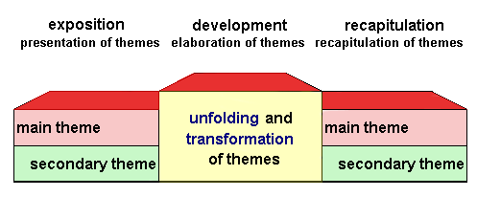

The correct order would be:

|  |  |  |
| --- | --- | --- |
| **Section** | **Bar numbers** | **The function of the Section is...** |
|  |  |  |
|  |  |  |
|  |  |  |
|  |  |  |
|  |  |  |
|  |  |  |
|  |  |  |
|  |  |  |
|  |  |  |

For further consideration:

♫ How does Mendelssohn achieve variety in this movement?

♫ How does the music reflect the ‘Classical’ style?

♫ How important is the material of the First Subject section? How is it used, or treated, throughout the remainder of the movement?

**Activity C – Tonality**

|  |
| --- |
| Complete the following paragraph about the key changes in the first part of this movement by inserting the correct information from the given list. |

This first movement begins in the key of  . The first motif, figure ‘x’ is an important part of the theme, using the  and  notes of the key. This is followed by the remainder of the lively subject, which tonicises the key of  in bar 17, before concluding this first passage in the  of  in bar 23. The Transition section has the function of  from the first subject to that of the second subject . It is a  passage, and includes the tonicisation of  in bar 70, and  in bar 72.

In bar 85, note that there is a in , which is dominant preparation for the next section.

S2a is first heard in , though moves to  by bar 97; however,

S2b starts in bar 110 in the key of . The Exposition ends in the key of

, (as seen in the first time bar codetta section) though the home key of

 is actually reached in bar 209a, ready for the return and the repeat of the Exposition section.

|  |
| --- |
| ***Answers*** |
| tonic |
| D major |
| Changing key |
| E major |
| E major |
| A major |
| A major |
| Home key |
| E major |
| E minor |
| Perfect cadence |
| mediant |
| B minor |
| B major |
| E major |
| Modulatory |
| A major |
| E major |

For further consideration:

♫ Working in pairs, discuss and note all the key changes seen in the **Development** section of this movement.

♫ How do the key changes / modulations relate to the home key? Are there any features of particular interest?

♫ In terms of the overall key structure, what are the main differences between the **Exposition** section and the **Recapitulation** section?

**Activity D – Texture**

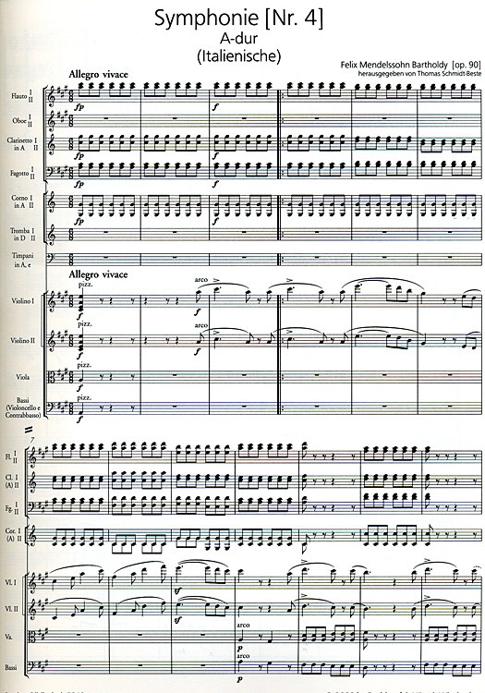

*What does the word* ***texture*** *actually mean?*

|  |
| --- |
| Working in pairs, discuss the meaning of the musical terms listed below. |

Counterpoint

Monophonic

Imitation

Heterophonic

Antiphony

Unison

Homophonic

Fugal

Stretto

|  |
| --- |
| Now, identify and describe the types of texture found in the sections as indicated by the bar numbers below. |

|  |  |
| --- | --- |
| **Bar Numbers** | **Identification / description of the texture** |
| 1-23 |  |
| 66-74 |  |
| 225-237 |  |
| 249-255 |  |
| 265-272 |  |
| 488-508 |  |
| 510-512 |  |

**For further consideration:**

♫ Listen to the first movement from the *Scottish* symphony by Mendelssohn, and note the different types of texture used in the different sections. Refer to the score on IMSLP – you can follow this while you listen.

♫ Write a short essay on Mendelsohn’s use of texture in the first movement of the ‘*Italian’* symphony. Give special attention to the **relationship** between the instruments.

♫ Sometimes, the following terms are used when describing the texture of a section of music. Find out what they mean: **spacing of parts, contrapuntal, countermelody, chordal.**

**Activity E – Structure / Themes**

* A theme is the melodic material upon which part (or all) of a composition is based
* A theme is usually a complete phrase

However, there seem to be ***four*** sections in the first movement of Mendelssohn’s *Italian* Symphony.

Insert the names of these sections, in the order they are heard in the table below. The first letter of each has been given for you.

|  |  |  |  |
| --- | --- | --- | --- |
| **E** | **D** | **R** | **C** |

Within this structure, it is possible to track the main themes as they are presented, developed and then returned. Identify the following melodic ideas and motifs (S1 or S2 etc.), state where they are first introduced (section / bar numbers), and in what keys they are heard.

|  |  |  |  |  |
| --- | --- | --- | --- | --- |
|  | **THEME** | **SECTION** | **BARS** | **KEY** |
|  |  |  |  |  |
|  |  |  |  |  |
|  |  |  |  |  |

**Task:**

Describe the overall structure of the first movement. Comment on features of particular interest, as regards Mendelssohn’s treatment of the sonata-allegro form.

**Activity F – Thematic development**

|  |
| --- |
| Describe the musical features of the first subject, and then discuss and note down how the theme has been treated and developed in subsequent passages as indicated. |

|  |  |
| --- | --- |
| **Musical features of S1:** | **Treatment / development from bar 268 ⮚ 288:** |
| **Musical features of S2:** | **Treatment / development from bar 210 ⮚ 236:** |

**Identify and explain two ways in which contrast has been achieved in the second subject section of the Exposition.**

|  |
| --- |
| **(i)** |
| **(ii)** |

**How does Mendelssohn achieve further variety when S2 appears in the Recapitulation section?**

♫ Explain the devices heard in the following bars:

|  |  |
| --- | --- |
| **Bars** | **Devices** |
| Strings, bars 43-50 |  |
| DB + timps, bars 132-139 |  |
| Violin 2 + viola, bars 159-165 |  |
| Oboe, bars 345-366 |  |

♫ Working in pairs, list the different ways that Mendelssohn develops the thematic material in this movement.

**Activity G – Harmony**

|  |  |  |  |  |  |  |  |  |  |  |  |  |
| --- | --- | --- | --- | --- | --- | --- | --- | --- | --- | --- | --- | --- |
| **What is a cadence?**   1. Consider the following definitions and decide which is the correct one:  * *- the final chord of a piece of music* * *- the opening progression of chords in a phrase* * *- a progression of (at least) two chords that concludes a*   *phrase, or piece of music*   1. There are four main types of cadence. What are they made up of?  |  |  | | --- | --- | | Type of Cadence | ...consisting of: | | 1) |  | | 2) |  | | 3) |  | | 4) |  | |  |  | |

**Task 1** Referring to your score of the first movement of the ‘*Italian*’ Symphony by Mendelssohn, give bar numbers where the following cadences may be located.

|  |  |
| --- | --- |
| **Cadences** | **Bar numbers / location** |
| Perfect cadence in B major |  |
| Perfect cadence in D major |  |
| Perfect cadence in B minor |  |
| Perfect cadence in E major |  |
| Perfect cadence in A major |  |

**Task 2** Identify the **keys**, **chords**, and **cadences** in the following bars:

|  |  |  |  |
| --- | --- | --- | --- |
| **Bars** | **Key** | **Chords** | **Cadence** |
| 22-23 |  |  |  |
| 71-72 |  |  |  |
| 172-173 |  |  |  |
| 235-236 |  |  |  |
| 296-297 |  |  |  |
| 337-339 |  |  |  |

♫ Working in pairs, map out the entire harmonic structure of the Exposition section, and list as many cadences as you can. For further understanding, the process could be repeated with the remainder of the movement.

♫ Write a variety of cadences (for four parts e.g. S.A.T.B.) in the same key as this movement, contrasting both the arrangement and the positioning of the chords.

**Activity H – Harmony: Chords**

|  |
| --- |
| When studying the music of the Western Classical Tradition, you must learn and understand about the different types of chords and the way that they are used in a piece of music. |

**Task 1** Many Western harmonic styles are based on the triads built on each degree of the scale. Using roman numerals, identify the primary triads, the secondary triads, and state their technical name. (The first one has been done for you).

|  |  |  |
| --- | --- | --- |
| **Type of triad** | **Identification**  **of triad (roman numerals)** | **Technical name**  http://www.earmaster.com/images/book/m11643/m11643.id215494.png |
| **PRIMARY TRIADS:** | **I** | **Tonic** |
|  |  |  |
|  |  |
|  |  |
| **SECONDARY TRIADS** |  |  |
|  |  |  |
|  |  |
|  |  |
|  |  |

**Task 2** Complete the following table, identifying the **position** of the chord (**e.g.** 2nd inversion) and giving the accepted figuring (**e.g.** 6/4).

|  |  |  |  |
| --- | --- | --- | --- |
|  | **Position** | **Figuring** |  |
| A chord with the root in the bass is called a ... |  | ( ) | ...chord. |
| A chord with the 3rd in the bass is known as a ... |  | ( ) | ...chord. |
| A chord with the 5th in the bass is called a ... |  | ( ) | ...chord. |
| A chord with the 7th in the bass is called a ... |  | ( ) | ...chord. |

**Task 3** Complete the following sentences by identifying the chords in the first movement of the ‘*Italian*’ symphony.

1. The first chord in bar 16 is ........
2. The last chord in bar 50 is ........
3. The first chord in bar 67 is ........
4. The last chord in bar 84 is ........
5. The first chord in bar 235 is ........
6. The last chord in bar 531 is .........
7. The chord in bar 316 is ........
8. The chord in bar 484 is ........

Using the D major triad as a starting point, follow the instructions to create a different chord each time.

* Add a 4th note to create the dominant 7th of D major.
* Add an accidental to change this to the tonic minor in A minor.
* Add an accidental to create an augmented chord.
* Add a 4th note and an additional accidental to create a diminished chord.
* Take away a note to leave a perfect 5th.
* Rearrange the notes to write a tonic first inversion chord.
* Take away a note to leave a minor 3rd

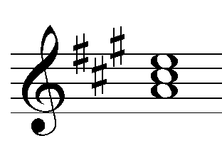

**Activity I – Instrumentation**

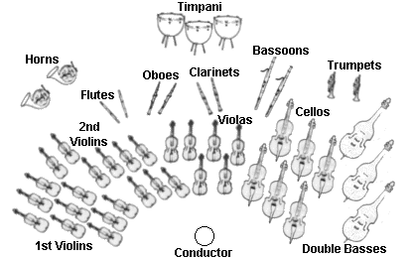

|  |  |
| --- | --- |
| 1 | This is a relatively small Romantic orchestra, using ___________________________ instruments, similar to the orchestra used by __________________. |
| 2 | In this orchestra, the clarinets, horns and trumpets are the ________________ instruments. This means that their music appears to be in a different ______. |
| 3 | Throughout the work, the ______________ are pitched in A. This means that they sound _____________ lower than written on the score. These instruments are a little _____________ than the more common ___________________, but perhaps more suitable for _____________ in the *Italian* Symphony, in the key of A major (minor in IV). |
| 4 | There is one string instrument that regularly uses a different ________ than the rest of the strings. This instrument is the ___________. It uses a ___________ clef, sometimes referred to as a _________________, because the centre point indicates the position of _________________. |
| 5 | It is interesting to note that the horn parts are for different instruments in the work. In movements 1 and 2, there are parts for ____________, but in movements 3 and 4 there are parts for ___________________. |
| 6 | In movement 2, there are no parts for ________________ or __________________. |
| 7 | In movement 1, there are parts included for trumpets in _______. This means that they sound a ________________ than written. In movements 3 and 4, the parts are for trumpets in _______, which means they sound a _________________ higher than written. |
| 8 | The drums used in this symphony are called _____________. At this time, they would have been tuned to the ____________________ and ____________________ notes of the key in which the music was written. In movement 1 and 4, the pitches are tuned to ___________, but in movement 3, they are tuned to ________________. |
| 9 | The largest family of instruments in the orchestra is the ______________ family. This actually consists of two lines for the __________________. The second part is usually lower in __________, and may alternate between playing a __________________ and an __________________________. |
| 10 | The __________________ do not play from the same line as the cellos in this work as Mendelssohn has allocated them their own line. They sound _____________________ than the cellos. |

|  |
| --- |
| ***Answers:*** |
| timpani |
| key |
| B flat clarinets |
| tone higher |
| middle C |
| double basses |
| viola |
| B and E |
| horns in E |
| pairs of woodwind |
| transposing |
| movable C clef |
| melodic line |
| tonic |
| viola |
| clarinets |
| pitch |
| trumpets |
| an octave lower |
| Beethoven |
| D |
| violins |
| major 3rd |
| tuning |
| a minor 3rd |
| timpani |
| clef |
| horns in A |
| larger |
| E |
| dominant |
| A and E |
| string |
| an accompaniment role |

|  |  |  |  |  |
| --- | --- | --- | --- | --- |
| ***ff*** | Cb. | *[Tutti]* | ***fz*** | *Soli.* |
| Cor. | *Pizz.* | Fg. | *[a2]* |  |

In pairs, discuss the meanings of the following symbols and directions as seen on the score:

For further consideration:

♫ Explain the difference between the first subject and the second subject theme, relating you observation to the first movement of the Drum Roll symphony.

.

**The following notes relate to the student worksheets.**

**Activities**

**A**

This first section is designed to provide the students with some basic factual details. They will benefit tremendously from considering the additional tasks as suggested – perhaps working in twos, or groups if preferred. Encouraging them to prepare their research and findings in the form of power point presentations to the rest of class will provide them with additional notes and enhanced contextual knowledge.

[**Note**: In worksheets of this type, students are advised to cross off the words from the given list as they are included in the paragraph].

**B**

It is very important that students realise that they will only understand the structure of the first movement through careful appreciation of the musical material, and how it is organised within sonata form. Constant reference to the score, the bar numbers and continuous identification of significant themes and the way that they are presented, developed and recapped within the set key structure will reinforce their understanding. Discussion about the basic function of each section will also assist in clarifying the outline.

The extension tasks suggested for further consideration provide opportunity for more detailed written responses which demand in-depth understanding of the musical elements, context and language.

**C**

Knowledge of the overall key structure is crucial. This activity is designed to encourage thoughtful understanding of some general aspects of the tonality as regards the Exposition section. A similar approach may be adopted with the remaining sections of the movement. Students must always be encouraged to work closely with the score, locating the keys and any changes for themselves.

**D**

The aim here is to clarify some terminology, and to identify what types of textures are used in the first movement of the ‘Italian’ symphony. The suggested research intended for further consideration will assist in broadening their understanding. Students should also be encouraged to present some of their composing ideas using differing textures.

**E**

This activity confirms the overall structure of movement 1, placing its theme and associated motifs within a recognised structure. Students must grasp the concept of thematic identification and the significance of motifs, repetition and balance.

**F**

Students would be well advised to track the presentation and development of all the initial thematic material throughout the movement, noting similarities, differences and elaboration in the use of the musical elements.

Furthermore, with reference to the developmental devices evident in the movement, it would be good practice to identify as many as possible on their personal score. Clear understanding in this aspect will encourage similar inclusion and detail in their personal compositions.

**G**

The recognition of various cadences (in different keys) is essential to the understanding of the overall structure. Appreciation of the main cadences assists recognition of their inclusion and function. Individual /pair work in mapping out cadential progressions would be beneficial, along with suggested implementation of similar practice in their compositions reflecting the Western Classical Tradition.

**H**

This covers some basic theoretical information about chords. As with cadences, students must be able to recognise and use a variety of chords in different positions, both in written and aural work. This encourages students to ‘spot identify’ chords within the score, and appreciate the make-up of a chord.

**I**

This task offers opportunity to consider some details of the instruments and their particular features in the movement, with some reference to performance signs and symbols. Their knowledge must include details of transposing instruments, different clefs, the limitations of some of the instruments, balance within the score etc.