Chapter 8
Decision-making models

Decisions are made in business organisations all of the time. Some decisions will be straightforward and pose no major issues to decision makers. However, many decisions will not be so clear-cut and the alternatives that exist will result in a business having to decide on which course of action to take. These decisions can have a positive or negative effect on the business.

Decision-making can solve problems for a business. For example, management looking at possible relocation sites to provide increased production capabilities, or the Human Resources team looking at training programmes to improve employee’s skills in order to respond to a drop in quality. Some decisions will be difficult to make and they may have negative outcomes for certain stakeholders of the business, such as redundancy for employees. Whoever is making the decision, it is important that the decision made is based on the common good for the business in order to help achieve its aims and objectives.

All decisions will involve risk, there is no certainty that the decision taken by a business will lead to the best outcome. Many factors, some that the business can control (internal) and some external factors that they have no control over, will affect the success. A business can minimise risk through the use of accurate data and the use of decision-making models.

The types of decisions a business makes include:

Strategic
by senior management

Tactical
by middle management
Operational
by junior management

Strategic decisions are long term and will affect the direction the business takes. These decisions will affect the entire business and will be made by the owners or senior management. Strategic decisions are often complex and may result in major organisational change internal to the business or in the markets, or new markets they operate in. Strategic decisions may also involve a large financial commitment in order to carry out the decision. It may take a few years, and a few million pounds, to see if strategic decisions have had the positive affect anticipated by the business.

Tactical decisions are not as far reaching as strategic decisions – they tend to be medium term. They should aim to implement strategic decisions. Tactical decisions are less complex than strategic decisions and are usually carried out by middle management. Tactical decisions can also be more flexible – if it is failing to meets its objective then it can be changed.

Operational decisions are the day to day decisions made in a business. These are lower level decisions that tend to be short term and have little risk. A business will make hundreds of operational decisions in a typical day by a range of employees, as they do not need the careful thought and planning of strategic and tactical decisions. Many decisions at this level are routine and can be taken fairly quickly.

Scientific and intuitive decision-making

Decision making can be broadly categorised into two different approaches – scientific and intuitive. Scientific decision making involves the use of facts and data in a systematic way in order to arrive at a logical and evidence based decision. The scientific approach will involve a structured approach that will involve:

Clearly identifying the objective/objectives or problem to solve

Collect all relevant information needed to make the decision; this can include primary or secondary data and could take some time to gather

Analyse the information to identify possible ways forward

Make and implement the decision

Monitor and review the decision and change if needed.

The scientific approach is favoured by most businesses making strategic and tactical decisions as it is based on logic and evidence and should reduce the risk of failure. The process includes the consideration of alternative decisions, so all possible courses of action are included and the business will undertake a full analysis before making any decisions.

Intuitive decision-making uses experience and intuition (gut feeling) to make a decision. This has proved successful for many entrepreneurs and managers who use their experiences and emotions to make a decision. There is often no data or systematic approach to back up this decision. Intuitive decisions can be made quickly and are often useful for operational decisions, however at strategic and tactical level there is a large risk on relying on intuitive decision making alone.

Decision making models

Scientific approach to decision making is supported by the use of models, three different types of models used by businesses are:
- Decision trees
- Critical path analysis
- Cost benefit analysis.

Decision trees

Decision trees are a form of diagrammatic analysis used to help businesses with making decisions where there are a number of different options from which to select. Decision trees are particularly useful in situations where chance (or probability) plays an important role in likely outcomes. Decision trees build probability of success and failure into the decision-making process, which helps to provide an effective and clear structure for presenting options through the ‘expected values’, which are the financial returns that can be gained for each option, taking into account both success and failure of each course of action. The different components of a decision tree are outlined below:

Components of a decision tree
 | Square decision nodes
 | Circular chance nodes
 | Lines representing a decision, or probability
£36 000 | Values of outcomes in £
0.3 or 30% | Probability of outcomes in % or decimal point

Drawing a decision tree

A decision tree begins with the decision that a business wants to make, for example, which project out of a choice of three to choose, or whether or not to accept an order from a customer.

The drawing of a decision tree starts with a decisions node (square). Decision nodes represent points where a business has to make a choice between alternatives.

From this decision node we draw out lines towards the right for each possible option or choice, and write the description of that option along the line. At the end of each line, we consider the likely outcome of a decision. If the result of taking that decision is uncertain, we draw a circle – a chance or probability node. Chance nodes represent points at which chance, or probability, plays a dominant role and reflect alternatives over which the business has (effectively) little control. For example, if one of the options a business has is to launch a new product, the possible outcomes of the launch are excellent sales, good sales, and poor sales. The chance or probability node allows us to

represent likelihood of these alternative outcomes. Each probability is based on judgement and research evidence. That is, through gathering of evidence, it may be estimated that the probability of achieving ‘good sales’ is 40% (represented as 0.4). The probabilities from each chance node are added together to total 1 to take into account the full range of possibilities that could occur.

The making of one decision can lead to the need to make another decision (i.e. decision trees can have more than one decision node throughout). For example, the first decision might be to launch a new product. The second decision might be to go for a national or regional launch. For each decision that needs to be made, another square is drawn.

Worked example

A business is choosing whether to invest in updating a product to extend its product life cycle, or whether to let the product go into decline. The information and research that the business has in relation to this decision is in the table below:

 | Future sales Poor | Future sales Good | Future sales Excellent
Invest in product  Cost  £30 000 | Probability of future sales poor  0.2 | Probability of future sales good  0.4 | Probability of future sales excellent  0.4
Projected return | £60 000 | £80 000 | £120 000
Allow decline of product | Probability of future sales poor  0.5 | Probability of future sales good  0.3 | Probability of future sales excellent  0.2
Projected return | £40 000 | £60 000 | £80 000

The decision tree shows the 2 initial choices
Invest in product
£30 000
Allow decline of product

Next, the probabilities of the 3 possible outcomes of the two choices, and the likely return to the business, are written on the decision tree, as below. For example, if the business were to decide to invest in the product, there would be a probability of 0.4 or 40% that this decision would lead to a return of £120 000. Alternatively if the business decided to allow the product to decline, there is probability of 0.5 or 50% that this would lead to a return of
£40 000. The cost of the potential investment on the decision tree (£30 000) is also recorded in the correct place.

Poor 0.2 £60 000
Invest in product
-£30 000
Allow decline of product

Good 0.4 £80 000

Excellent 0.4 £120 000

Poor 0.5 £40 000

Good 0.3 £60 000

Excellent 0.2 £80 000

The next stage is to calculate a value for each option, taking into account the estimated return and the likelihood of that option occurring (written to the far right of the decision tree). For example, for the ‘excellent’ outcome in ‘invest

in product’, 0.4 is multiplied by £120 000 i.e. the probability for each outcome is multiplied by the estimated return. Is this case, the answer is £48 000.

Poor | 0.2 | £60 000
 |  | £12 000
Good | 0.4 | £80 000
 |  | £32 000
Excellent | 0.4 | £120 000
 |  | £48 000

 |  | Poor | 0.5 | £40 000
 | £54 000 |  |  | £20 000
Allow decline of product |  | Good | 0.3 | £60 000
 |  |  |  | £18 000

Excellent 0.2 £80 000
-
Invest in product
£92 000 -£30 000
=£62 000
£92 000
-£30 000
£16 000
This process is continued in the same way for each branch of each chance node. Once all the branches for each outcome have been calculated, they are added up [in the ‘invest in product’ example, this is £92 000 (which is placed by the chance node for this option). This process is repeated for each of the chance nodes.

It is important to remember to deduct the cost of each of the options from the figures calculated (e.g. for invest a product, the cost is £30 000, therefore is deducted from the £92 000 calculated from the returns from each outcome occurring). The final figures for each option are compared, to establish which options should be taken. On purely financial terms, the option with the highest value should be selected. In the example above, this would be to invest in the product (£62 000 compared to £54 000).

Benefits and limitations of decision trees

The benefits of using decision trees are that they:

  - Clearly lay out the problem so that all options can be considered

  - Allow managers to analyse fully the possible consequences and risks of a decision

  - Provide a framework to quantify the values of outcomes and the probabilities of achieving them.

The limitations of decision trees are that they:

  - Use probabilities which only gives an estimate, these may be inaccurate

  - Can oversimplify a decision and focus too much on the financial outcome

  - Don’t include other factors such as manpower considerations, managers’ opinions and marketing issues

  - Can be time consuming to construct and may be interpreted with bias.

Evaluative considerations

The predicted outcomes and estimates need to be based on valid data and research if they are to have any real quantitative value.

As with all decision-making methods, decision tree analysis should be used in conjunction with other types of decision-making, decision trees are just one important part of a business decision-making tool kit.

Qualitative factors will also have an influence on the decision made. In the example above, qualitative factors such as the effects of decisions on stakeholders e.g. workforce, management, suppliers and customers as well as training costs, recruitment, capacity management, marketing impact and so on, all need to be considered before a final decision is made.

Critical path analysis

Critical path analysis (CPA) is a method of planning and controlling large projects and is used to make decisions on the management of resources and time. Businesses carry out many tasks, some small and some large, such as building a bridge, or installing new machinery in a factory. These tasks or activities are inter-related (i.e. one task is dependent upon another previous task being completed). These tasks have to be carried in out in a certain order within a network, using network diagrams and through network analysis, critical path analysis enables a business to plan
the activities involved in completing projects, so that the overall project is completed in the most efficient manner possible.

Critical path analysis is used to allocate resources within a project, judge how long a project should take to complete, and also to recognise those tasks or activities that take place within a project, that are critical to the project being completed on time. A ‘critical task’ or activity is one that must be started and completed on time if the project is to be finished on time.

Constructing CPA diagrams

Nodes indicate the start or finish of tasks or activity. Each node is numbered.

Nodes are divided into 3 sections. In the left hand semicircle, the node number is given. In the top right section, the earliest start time (EST) of the next task or activity is entered; in the bottom right the latest finish time (LFT) for the previous task is entered.

EST
1
LFT

Arrows indicate a task or activity. Above the arrow will be a letter identifying the task, below the arrow, the amount of time taken to complete the task.

A

2

Drawing a critical path diagram

To introduce the basics of drawing a CPA diagram we will use a very simple project that involves just three tasks. The project is brushing your teeth. The tasks involved are putting toothpaste on the brush, wetting the brush and then brushing your teeth. Once we have times for each of these tasks we could present this in a table.

Task | Description | Time Taken
A | Toothpaste on brush | 3 seconds
B | Wet brush | 2 seconds
C | Brush teeth | 30 seconds

From the table we can prepare the CPA diagram.

Below we have laid out the tasks in order, with numbered nodes starting and finishing each task. Tasks that follow on from each other form a path, so ABC form a path, with a total time of 35 seconds.

A
B
C
1
2
3
4
3s
2s
30s

Next we calculate the EST for each activity: The EST for task A is 0 as this is the first task.
The EST for task B is the time taken to put the toothpaste on the brush (task A) – 3 seconds. The EST for task C is the time taken to wet the brush (task B) added to task A – 5 seconds.
As node 4 is the final node then 35 seconds is the time taken to complete the whole process.

A
B
C
0 3 5 35
1 2 3 4
3s
2s
30s

The next step is to enter the LFT at the bottom right segment of the node. This shows the latest time an activity must be completed without causing a delay.

To calculate the LFT we start at the final node. This has already been calculated as it will take 35 seconds. Then working from right to left, each node is calculated by:

LFT for node – the time taken to complete previous task So to calculate the LFT for Node 3 is 35 – 30 = 5
These have been entered to produce the final network diagram for cleaning your teeth:

A
B
C
0 3 5 35
1 2 3 4
0
3s
3
2s
5
30s
35

In the example above, the diagram is a straight line and the EST and LFT are the same as the three tasks are directly reliant on each other to give a simple network. However, many operations for a business can be carried out at the same time and the network will be more complex. The example below shows how to construct a complex network.

By drawing a network diagram, the activities can be sequenced in a way that the project can be completed in the shortest possible time.

Example

A business that manufactures individually built sailing boats has received an order to build a new boat for one of its regular customers. The table below gives the activity, the dependency of preceding activities and the time it will take to complete the activity.

Activity | Preceding activity | Time (days)
A | 2
B | A | 3
C | B | 4
D | A | 4
E | A | 6
F | E | 3
G | C | 5
H | D | 5
I | F | 3
J | I | 4
K | H | 4
L | G | 6
M | J,K,L | 4

To construct the diagram, we start with node 1 (to denote the start of the project), that begins with activity A. At the end of activity A, we can add node 2, which indicates the start of activity B. Activities B, D and E can be carried out together, at the same time, but only after activity A has been completed:

Activity C is carried out after activity B is complete, so C activity will follow node 3. Activity H is carried out after activity D is complete, so activity H will follow node 4. Activity F is carried out after activity E is complete, so F activity will follow node 5.
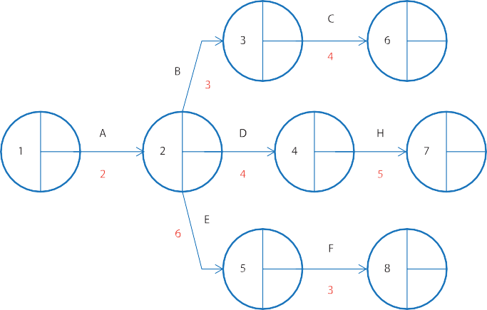
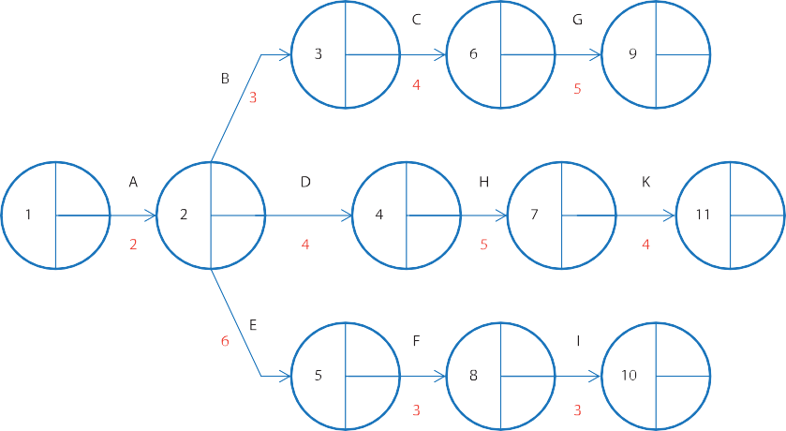Activity G is carried out after activity C is complete, so activity G will follow node 6. Activity I is carried out after activity F is complete, so activity I will follow node 8. Activity K is carried out when activity H is complete, so activity K will follow node 7.

Activity L is carried out when activity G is complete, so activity L will follow node 9. Activity J is carried out when activity I is complete, so activity J will follow node 10.
Activity M is carried out when activities J, K and L are complete, so activity M can only start when all 3 activities are completed and will follow nodes 9, 10 and 11.

Calculate the EST for each activity and enter these into the nodes, starting on the left hand side at node 1. In the top right section we place a zero, as we can start the whole project with nil time so far used (the same for any network diagram i.e. node 1 will always have an EST of zero).

Activity M can only begin when all preceding tasks are complete so:

Activity K is 11 days + 4 days = 15 days Activity J is 14 days + 4 days = 18 days Activity L is 14 days + 6 days = 20 days

The longest time is therefore 20 days so the EST for node 11 is 20 days.

Always select the longest amount of time when selecting the EST

Once all the EST times have been calculated, the next stage is to calculate LFT which tell us the latest an activity can finish without delaying the overall project. To calculate LFTs we start on the far right and count our way back along the network (i.e. start at node 12 and finish at node 1). The figure we start with is the EST in the final node, and
we put this in the bottom right section of the final node (the EST and LST of the final node will always be the same number). We now start to count back. That is, to calculate the LFT of node 11, the duration of activity M is deducted from the LFT of node 12 to give 20 (i.e. 24 – 4 = 20).

This is straight forward for most nodes, however for node 2 there are three paths from nodes 3, 4 and 5:

Node 3 for task B has LFT of 5 days – 3 days = 2 days Node 4 for task D has LFT of 11 days – 4 days = 7 days Node 5 for task E has LFT of 10 days– 6 days = 4 days

The lowest amount of time is selected as the LFT, so for node 2 the LFT is 2 days.

Always select the lowest amount of time when selecting the LFT

The completed CPA diagram is shown below:

When the diagram has been completed it is then possible to identify the critical path. The critical path is marked by those activities that are joined by nodes which have the same figure for EST and LFT in each node.

There is no room for delay on this path. Any delay in finishing an activity, or starting an activity on this critical path will mean that the overall project will be delayed.

The critical path is normally indicated by placing a // on each activity arrow on the critical path.

We can see that activities A, B, C, G, L and M are the critical activities in the building of the sailing boat, any delay in these activities will delay the whole project.

The completed critical path diagram can also be used to calculate the total float time in the project. These are non- critical activities that can be delayed without causing the project to be delayed. The float time can be calculated by:

LFT of activity – duration - EST of activity = total float time

If we apply this to the diagram for building the sailing boat:

Activity | LFT of  activity | Minus  duration | Minus EST of  activity | Total float time
A | 2 | 2 | 0 | 0
B | 5 | 3 | 2 | 0
C | 9 | 4 | 5 | 0
D | 11 | 4 | 2 | 5
E | 10 | 6 | 2 | 2
F | 13 | 3 | 8 | 2
G | 14 | 5 | 9 | 0
H | 16 | 5 | 6 | 5
I | 16 | 3 | 11 | 2
J | 20 | 4 | 14 | 2
K | 20 | 4 | 11 | 4
L | 20 | 6 | 14 | 0
M | 24 | 4 | 20 | 0

Identifying the total float time allows managers to be flexible in carrying other activities. They could switch employees after the activity is complete to other activities or time could be allowed for extra training before the activity is completed. The table also clearly shows the critical path activities, those activities with zero total float time.

Critical path analysis is used by businesses when planning activities and projects, it can help managers make decisions on what resources to allocate to particular activities and help to organise the delivery of supplies. The use of quantitative data in calculating the various aspects of critical path analysis gives evidence to different ways of planning activities. It also allows for flexibility with managers able to reallocate resources if they wish to change or shorten the critical path.

The value of critical path analysis

Advantages of using CPA | Disadvantages of CPA
CPA is an effective management tool for planning and controlling complex projects. Critical activities can be identified. Forces managers to think about the process and supports a systematic approach to planning activities. Problems can be highlighted early so that whole projects are not delayed. | Information can be distorted or poor methods of (over optimistic) estimation of activity times can be used.  Lack of experience of those preparing CPA leads to inaccuracies.
Allows effective management of resources, allocating factors, such as labour, to where they are needed and can be most effective. Supports the transferring of resources for different tasks, if required. | CPA can give the wrong results, or fail to allow for external factors that will influence the total time taken.
Reduces the need for working capital, parts used in the project can be ordered exactly when they are needed. Allows the use of just-in-time production. | Sub-contractors, who may be completing some of the activities on a project, can be outside the control of the project manager.
Improves cash flow – as a result of reduced need for working capital. Also helps with cash flow forecasts. | Supplies may be delayed; they may be of the wrong type or of poor quality.
Can be used to check on efficiency of individual activities and identify if new resources are needed or if employees need training. | Critical path analysis only identifies the critical activities; it does not ensure these are done on time. Close supervision may be needed which may reduce employee morale.
Improves overall management of projects – managers understand what is involved and what needs to be done and when it needs to be done by. | Requires ongoing checking of activities, changes may be required if there is a delay. The construction of critical path analyses can be time consuming.
Can be used to give a business a competitive advantage by being more efficient and supports time-based management. | Critical path analysis does not ensure quality – the focus is on time and meeting deadlines.

Cost benefit analysis

When making a decision most decision models just focus on the internal benefits and costs to a business, and these are often quantified through the potential revenue and cost to a business.

Cost benefit analysis (CBA) is a method for measuring, in financial terms, the costs and benefits of an investment project, but includes a consideration of the external costs and benefits to society as well as the costs and benefits to just the business.

Cost benefit analysis is often used by governments when they are considering a public project, such as the building of a new motorway, rail bridge or hospital. A number of different options can be ranked in order.

When carrying out a cost benefit analysis there are a wide range and variety of costs and benefits to be identified and given a value. These can be divided into two groups:
- Private Costs and Benefits
- Public Costs and Benefits

Private Costs  These are costs that the business making the investment has to accept.  They include training and recruitment costs, purchase of new capital equipment, marketing costs etc. | Private Benefits  These are benefits that the business gains from as a result of making the investment.  These benefits will include things such as increased productivity, increased sales, brand values and increased profits.
Public Costs  These are costs external to the business making the investment.  A building company will have an environmental impact as it builds houses – increased traffic, noise etc.  A farm extracting water from a river to irrigate its crops leaves less water further downstream for fishing.  A new factory may involve the loss of open space, increased traffic congestion and so on. | Public Benefits  These are benefits external to the business that result from making the investment.  An obvious external benefit from a large scale investment would be jobs created by the business.  Other public benefits include further jobs created outside the business as a result of increased business activity and an increase in tax paid by employees to the government.  In areas where unemployment is high, crime and social problems might be reduced.

The calculation for cost benefit analysis is:

Social Benefit (private benefit + public benefits) – Social Cost (private costs + public costs)

The valuation of public costs and benefits

The financial valuation of private costs and benefits may be relatively straight forward. But cost benefit analysis requires a value given to public costs and benefits. These positive and negative externalities of business activity can be difficult to identify and value. For example a business might want to extend its warehouse that will require the demolition of a park used by local residents. The external cost will include the loss of a play area for children and somewhere for local dog owners to safely walk their dogs. The business will have to give a value to these costs. One of the difficulties of cost benefit analysis is giving a monetary value to these intangible issues.

Cost benefit analysis process
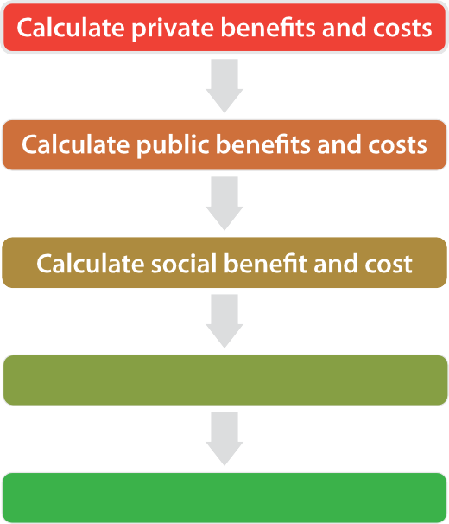
Consider qualitative factors
Decide if the project goes ahead

The value of cost benefit analysis

Advantages

- Takes into account a wide range of benefits and costs
- Impacts on society and the community are included
- Puts a value to external benefits and costs that would normally be ignored by private sector businesses
- Can be used to rank possible major projects in order of public cost.

Disadvantages

- The valuation of intangibles will be difficult – how do you put a value on the effect of pollution or the improve traffic flow of a new road?
- Valuations will often include value judgements – one person’s or manager’s calculation of an intangible benefit is likely to differ from another person’s calculation, who has a different set of views on what is important for a business
- If the social costs and benefits are incorrectly calculated then the wrong choice may be made
- Will all stakeholders be included in the calculation of social costs and benefits?

Information technology and decision-making

Computer technology can be used by businesses to make many day-to-day decisions. Decisions on when to order new stock, how to manage deliveries, or on staffing levels can be calculated and implemented by IT systems.
Information systems can collect inputs from a number of sources, organise the data then distribute the data to make the most efficient decisions. For example IT systems in an ice-cream factory can monitor sales in supermarkets through Electronic Point of Sale (EPOS) systems, take in forecast future sales and weather data, and from this determine levels of production, rota staff shifts and arrange delivery schedules.

Management information systems (MIS) provide managers with information to make tactical and strategic decisions. MIS continuously collects and processes data and makes it available for managers to use in their decision-making.

Smart IT systems look to improve decision-making through the use of internal and external data. Decision-making models such as decision trees and critical path analysis can be carried out by computer models which save time and help accuracy.

Data processing technology helps businesses deal with huge quantities of information in a quick and efficient way and speed up decision-making. Expert systems and artificial intelligence allow computers to imitate human thinking which considers reasoning to give evidence based conclusions.

The internet is almost entirely staffed by computers. Analysis of browsing and purchasing habits is used to determine search results and what is seen on screen. Search for a holiday in Greece, and for the next few weeks your screen will have adverts for Greek holidays cropping up everywhere. Cookies allow retail websites to present choices that are most likely to meet a browsers needs. Data base marketing is based on data-mining, searching through patterns in gathered customer information and using these buying behaviours to create directed advertising – all automatic.

Financial information systems allow the analysis of financial and accounting data. These systems can produce reports on cash flow and income statements and will support the financial management of the business. Features of financial information systems include collecting and storing all payments and receivables, monitoring income and expenditure and balance sheets, keeping all records up to date, highlighting any deviation from budgets and reducing paperwork.

Technology is continuously improving and adapting to aid businesses in decision-making. Although the cost of these systems are an expensive outlay many businesses are prepared to pay the cost in the short term due to the long term benefits of having efficient information and management systems that improves the control and processing of data in order to make effective decisions.

Discussion themes
Explain the three different levels of decision-making.
Give three examples of strategic decisions.
What is the difference between scientific and intuitive decision making?
SA Rogers Ltd. is a manufacturer of confectionery. Its products include boiled sweets and toffees.

Sam Rogers, the managing director, is worried that these products are old-fashioned and wants to make sweets that will appeal to a younger generation. At present he is considering three alternatives: buying a rival confectionery manufacturer, Zingy Sweets Ltd.; refurbishing his existing factory with new machinery in order to make new products; or do nothing.

Sam Rogers asked a management consultant friend to estimate the probability of success of each of these alternatives and their estimated revenue. The results are given in the table below.

Use the information in the table to draw a decision-tree diagram and identify the option which gives him the best return.

Briefly explain two other factors Sam Rogers might need to consider before making his final decision as to the best course of action to take.

Explain the benefits and limitations of using decision trees to make decisions.
 | Cost £(000s) | Probability of success | Estimated Revenue £(000s)
 |  |  | Success | Failure
Buy Zingy Sweets | 480 | 0.6 | 2400 | 400
Refurbish the factory | 360 | 0.7 | 1900 | 600
Do nothing | 0 | 0.9 | 1100 | 900

EasyBeds is a manufacturer of bedroom furniture. Below is a network diagram for the production of one of its wardrobes. Activities A to L need to be carried out in order to build one wardrobe, with the time allocation being given in minutes.

Fill in the earliest start times and latest finishing times on the diagram. Mark the critical path on the diagram.
C 4
9
D
4
J
5
B I
4 2

E
2
A
0
2
20
24
1 2 6
H
15
7
10

3
8

2 5
K
5
G
7
9
L
6

Discuss the usefulness of critical path analysis to a company such as EasyBeds. Explain how a cost benefit analysis can help in decision-making.
5
F
What is meant by social benefit and social cost?
Looking at the article, do you think costs of HS2 outweigh the benefits? Explain your reasoning.
http://www.bbc.co.uk/news/magazine-24159571 Explain how technology can help decision making. Decision Trees:
https://www.mindtools.com/dectree.html Critical Path Analysis: https://www.mindtools.com/critpath.html
Cost Benefit Analysis: https://www.mindtools.com/pages/article/newTED_08.htm

