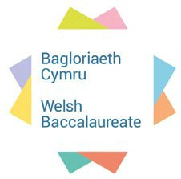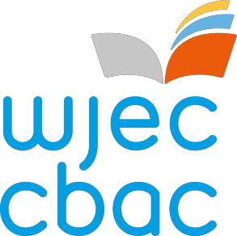

Advanced Skills

Induction Resource



Introduction

Skills Induction preface

The foundation of the Advanced Welsh Baccalaureate is based on the

essentialness of developing the skills of young people in Wales, in order to compete in an international market. Therefore, skills development along

with

knowledge

acquisition is

essential.

The Advanced

Welsh

Baccalaureate must attempt to equip learners with relevant theory in

conjunction with opportunities for experiential learning. It is only with experiential learning that young people will be able to develop their skills through a process of planning, doing and reflecting. It is also vital to ensure that each learner leaves Advanced level education with a minimum competency at level 3 in all 7 skills whilst recognition is given to those who

possess more advanced skills sets.

Skills development pedagogy

Skills development can be broken down into three components1:

1)

2)

3)

Understanding the concept

Understanding the process

Understanding the context. This includes the situation along with the interconnectivity within the context. For example; understanding the audience, the impact of actions on others and the impact of actions

from others

Furthermore, the notion of skills development in general, can be

understood by considering these three components. Each specific skill can then be considered in the same way. The emphasis on skill development is that of Plan, Do, Review and that this process must be repeated. Well- developed skills are a result of practice. These are fundamental tenants to

successful teaching and learning related to skill development.

It is anticipated that this Advanced Skills Induction Resource would be

used in the first half term of learners Advanced Welsh Baccalaureate course and that it could last 30 hours (or more) depending on the

activities selected.

Section 1.4 of the Advanced Welsh Baccalaureate specification details all

of the expected components of each skill. Activities have been produced that focus on one or more of these specific components. Mini challenges have been developed to allow learners to demonstrate a mixture of skills in

one activity.

1 Based on an adaptation from PISA methodology to suit the wider nature of skill development within the

Welsh context

1



Introduction

2

Unit

Activity

Resources

1 – Introduction to Skills

1.1 The Scratch-Card

Activity Plan

PowerPoint

Learner work sheets

PCs with internet

1.2 Newspaper

Reflection

Activity Plan

ICT

Tabloid newspapers and broadsheets Pens/paper

2 - Personal Effectiveness Skills Induction

2.1 Building a personal resource bank

Activity Plan

PowerPoint

Learner information sheets

YouTube

2.2 How I see myself and how others see me

Activity Plan

PowerPoint

Learner work sheets

YouTube Sticky notes Blank cards

2.3 Recognising success and planning for the future

Activity Plan PowerPoint YouTube

'The Great Discovery' Handout

2.4 Working in groups

Activity Plan

PowerPoint

Learner work sheets

Belbin Questionnaire

3 – Literacy Skills

Induction

3.1 Room 101

Activity Plan

PowerPoint

Learner work sheets

3.2 Text types and purpose

Activity Plan

PowerPoint

Learner work sheets

4 – Numeracy Skills

Induction

4.1 Glamping

Activity Plan

Learner work sheets Pens/paper Calculator

If possible flipchart paper or A3 paper attached together

5 - Digital Literacy

Skills Induction

5.1 Group blogging

Activity Plan

Learner information



Introduction

3

sheet

Learner work sheets PC with internet Unrestricted access to blogging sites for example Word Press

5.2 Promotional publications

Activity plan Learner work sheet PC

Access to Padlet

5.3 Silent debate

Activity plan PowerPoint PC

6 - Critical Thinking and Problem Solving Skills Induction

6.1 The Case of Evan

Evans

Activity Plan

PowerPoint

Learner work sheets

7 - Creativity and Innovation Skills Induction

7.1 The 20 shot

Challenge

Activity plan PowerPoint ICT

Mobile device or camera Pens/paper

8 - Planning and Organisation Skills Induction

8.1 Paper chains and plates

Activity Plan

PowerPoint

Learner work sheets SOMA cubes (see activity plan)

9 - Mini Challenge A

9.1 Planning an event /

attraction

Activity Plan

ICT

Digital devices, cameras or recording devices.

10 - Mini Challenge B

10.1 Creating a product

Activity Plan

ICT

Old cassettes

Arts and craft materials

11 - Mini Challenge C

11.1 Wedding planning

Activity Plan

ICT

Arts and craft materials



Introduction

Acknowledgements

With thanks to

resource:

the

following

for their valuable contributions

to

this

Rachel Dodge

Cardiff Metropolitan University

Sharon Giddy

Chepstow Comprehensive School

Dinah Griffiths

University of South Wales

Ruth Jones

St David's College

Tina Parks

Ysgol Eirias

Kate Thomas

Crickhowell High School

Emma Walduck

Ysgol Bryn Elian

Sponsored by Welsh Government

4

12 - Mini Challenge D

12.1 Find the Gap

Activity Plan

PowerPoint

Learner work sheets

SWOT evaluation

13 - Mini Challenge E

13.1 You shall go to the Activity Plan ball PowerPoint

Learner work sheets

ICT

14 - Mini Challenge F

14.1 You're the star

Activity Plan ICT [www.BARB.co.uk](http://www.BARB.co.uk/)



Introduction

understand the

5

Unit 1: Introduction

Activity 1.1: The Scratch-card

Length of Session:

1 hour

Session Objectives:

• To be introduced to the 7 skills of Welsh Baccalaureate

• To plan an itinerary and demonstrate each of the 7 skills

• To begin to appreciate the importance of reflection

Introduction to Session:

This session is intended to be an introductory session that introduces the learners to the 7 skills specifically focuses on in Advance Welsh Baccalaureate.

Resources:

1.1a PowerPoint

PCs with Internet

1.1b Learners worksheets

1.1c Learning Log worksheet

Activity:

1. Work through the PowerPoint slides

2. Use My Learning Log worksheet as an introduction to reflection. This can be used by learners many times through the whole unit of study.

Learning Outcomes:

Engaging in each of the

7 skills

Beginning to

importance of reflection

Plenary:

Learners to reflect on how well they utilised each skills as part of the activity.



Introduction

6

Skills: Literacy Numeracy Digital literacy Problem solving

Personal effectiveness

Creativity and innovation

Planning and organisation



Introduction

Learner

Itinerary

Worksheet

(Activity

1.1b)

7

Time

Activity and details

Costings

7.00am



Activity

1.1c

Date of learning

What most interested me was:

What did I previously think was

true, but now know was

incorrect/wrong?

Am I pleased with the outcome?

My Learning

Log

What was new or

surprising to me?

What 3 main things have I

learnt in this session?

I am still unsure about:

What was I most successful at?

One thing I learned in this

session that I may be able to

What could I do better next time?

8

What least interested me was because:



Introduction

9

Unit 1: Introduction

Activity 1.2: Newspaper reflection

Length of Activity:

1 hour

Session Objectives:

• To enable learners to explore the concept of reflection from different viewpoints.

Introduction to Session:

This activity encourages learners to reflect on the same subject from different viewpoints and introduces exercises for creative writing.

Resources:

ICT

Tabloid newspapers and broadsheets

Pens/paper

Activity:

1. Learners to be given access to a range of newspapers.

The learner should then select a ‘story’ which is reported in both a tabloid and a broadsheet. (Ensure the learners are aware of the difference). E.g. The Mirror and the Times or the Mail and the Guardian.

2. Learners to note and feedback; the similarities and differences in opinions; facts/figures; writing style.

3. Learners should then reflect on their factual or fictional weekend and write an article in the style of a tabloid paper and a broadsheet. Learners can include real or staged photographs.

Ask the learners to split into two teams one to represent the tabloids the other the broadsheets to debate which they believe to be the more factual and representative of society. Is it dependant on the political viewpoint or target market of the different newspapers – who is more influential, the journalist, editor or the readers? What are the ‘writers’ trying to achieve?

Learning Outcomes:

Learners are able to identify writing from different viewpoints and reflect on when different styles of writing are appropriate.

Plenary:

Ask the learners to discuss when different styles of writing are appropriate and for what use/purpose:

Expository Writing, Descriptive Writing, Persuasive Writing, Narrative Writing.



Introduction

10

Skills:

Identify potential solutions or responses and reasons for different views

Critically assess the strength of options and arguments, take into account opposing views or alternative ideas, validity and reliability

Demonstrate imagination and initiative

Reflect on approaches and techniques for critical thinking, decision making and problem solving and own proficiency in them



Personal

Effectiveness

Skills

Induction

11

Unit 2:

Personal Effectiveness

Activity 2.1: Building a personal resource bank

Length of Activity:

1 hour

Activity Objectives:

• For learners to consider their own personality type

• For learners to consider how their personality type affects their learning and future employability skills

• For learners to assess their character strengths

• For learners to consider how much they use their strengths

• For learners to consider how they can use their strengths more

Introduction to Session:

Learners are introduced to the idea of building a personal resource bank.

Resources:

2.1a PowerPoint

2.1b Learner Information (pdf) Sheets

YouTube clip: [https://www.youtube.com/wa tch?v=sZJG3atoc6Q](https://www.youtube.com/watch?v=sZJG3atoc6Q)

Activity:

1. Work through the PowerPoint slides.

2. On slide 7, learners are introduced to the personality test. They are given descriptions of two people and

asked to write down the name of the person they are more like. This will result in four names. They take the first letter of each name which will give them their personality type. They will be provided with a Learner Information Sheet that outlines the strengths of their personality type.

3. Learners can be introduced to the VIA classification of character strengths via the YouTube clip.

4. Learners will be given the test and asked to tick their own strengths. They can then be asked to:

a) Write down what percentage

Learning Outcomes:

Learners will establish their own personality type. This will enable them to discuss whether they find this to be true and how it will help them develop their skills.

Learners to discuss the impact of the video. What has it taught them about using their strengths?

Learners should be asked to reflect on the results of the VIA test. What can they learn to ensure the use their strengths more?



Personal

Effectiveness

Skills

Induction

12

you use your strengths on a daily basis.

b) Write down a time that you used your strengths. What was the result of doing so?

c) Write down 5 things you can do to practice using your strengths on a daily basis.

Plenary:

Learners should reflect on what they have learned in the session. Have they discovered strengths they didn’t know they had? How can they use these strengths in their Level 3 studies?

Skills: Interpersonal skills Resilience Determination Emotional literacy Action planning

**ISTJ**

You are strong and determined. You like to perfect your skills and then use them throughout your life. You can spend a lot of time on your own and be perfectly happy while in your own company.

**Strengths**

•

•

•

You can work quietly and steadily on something until it is finished.

You like using skills you’ve already learned.

You pay attention to details and like to get the job done properly. You can follow plans and decide quickly.

**As a Teenager**

Often more adult than the adults! You value your independence, privacy and personal space. You’re

dependable, loyal and responsible.

**Preferred learning styles**

•

•

•

•

•

You like to work in quiet so that you can concentrate.

You like to work alone.

You like to know the practical benefits before starting. You like a logical order.

You like clear structure.

**Revision Tips**

•

•

Discuss your work with others.

Be open to the ideas of others.

**Job Ideas**

•

•

•

•

•

•

•

•

•

•

•

Accountancy

Insurance

Police

Traffic Warden Prison Officer Trading Standards Inspector Administration

Air-cabin crew

Plumber

Law

13

**INFP**

You can be imaginative, supportive and playful. You can also be quiet and careful, often wondering whether to jump in and trust your instincts or suss out the person or situation first.

**Strengths**

•

•

•

•

You enjoy learning new skills.

You are full of enthusiasm.

You are interested in the thinking behind the idea, particularly how it affects people. You can work on many things at once.

**As a Teenager**

You have strong inner values and beliefs that you like to live by – others may see you as sensitive,

complex and deep.

**Preferred learning style**

•

•

•

•

You like to work in quiet so you can concentrate.

You like to know the theory behind an idea. You like encouragement and praise.

You like variety and choice.

**Revision Tips**

•

•

Make sure you plan your work so there is enough time to get everything finished.

You can take criticism very personally. Remember that some criticism will help you improve your work.

**Job Ideas**

•

•

•

•

•

•

•

•

•

Counselling

Advising Psychology Medical Librarian Journalist Research Archaeology

Creative work

14

**ESFP**

You are very sociable and enjoy socialising and having fun as a way to be close to their loved ones. You can very skilful in sport or leisure activities that interest you.

**Strengths**

•

•

•

•

You are friendly and a good communicator.

You are good at knowing what’s going on. You can join in with people with enthusiasm.

You can be generous and a popular team member.

**As a Teenager**

You are popular and enthusiastic with a zest for life. You dislike routine and conflict – you may try to

please everyone, which is difficult all of the time.

**Preferred Learning Style**

•

•

•

•

You like group activity and discussion.

You like to know the practical benefits before starting. You like encouragement and praise.

You like variety and action.

**Revision Tips**

•

•

Focus on one thing at a time. Complete it before moving on to the next.

Revise in groups as long as you can stick to the work!

**Job Ideas**

•

•

•

•

•

•

•

•

•

•

•

Care work

Counselling Medical Estate agent Journalist Hospitality

Administration

Tourism Armed forces Environmental services Management

15

**ISFJ**

You like the security and safety of your families, being loyal and caring to those around you. You can be strong and determined to protect what you believe in.

**Strengths**

•

•

•

•

You are patient with people and details.

You are good at bringing up relevant facts.

You can be aware of other people’s beliefs, values and strengths.

You are a popular team member but you rarely push your views forward unless asked.

**As a Teenager**

You can be seen as kind and quiet and are popular because you’re sensitive to others’ needs.

You’re realistic, down to earth and respect tradition and authority.

**Preferred Learning Style**

•

•

•

•

You like to work in quiet so that you can concentrate.

You like to work alone.

You like encouragement and praise.

You like structure, procedures and time plans.

**Revision Tips**

•

•

You’re generally good at revising but remember to take breaks.

Check with your tutors that your work plan is ok.

**Job Ideas**

•

•

•

•

•

•

•

•

•

•

•

Business

Administration Public sector Health Sector Libraries

Financial services Fire/ambulance services Hairdressing/beauty Dental

Electrician

Teaching

16

**INTP**

You are intelligent, determined and wise. You are careful and quiet, speaking only when you have something interesting or useful to say. When you speak; it is usually worth listening to. INTPs are quite rare and therefore easy to misunderstand.

**Strengths**

•

•

•

•

You enjoy learning new skills.

You enjoy solving problems using your imagination. You like analysing and putting things in logical order. You can be careful with details.

**As a Teenager**

You’re independent, quiet and a flexible deep thinker.

**Preferred Learning Style**

•

•

•

•

You like to work in quiet so that you can concentrate.

You like to work alone.

You like to know the theory behind an idea.

You like a logical order but appreciate being able to decide on your own way to do things.

**Revision Tips**

•

•

Focus on one thing at a time. Complete it before moving on to the next.

Plan so that you have enough time to finish everything.

**Job Ideas**

•

•

•

•

•

•

•

•

•

•

Computing

Architecture Research Law Engineering Science

Built Environment

Mechanic Inventor Surveying

17

**ENFJ**

You have the qualities of intelligence, warmth, great vision and charisma. You often need to move fast to fit everything in, often enjoying busy and complicated social lives.

**Strength**

•

•

•

•

You are friendly, popular, and a good communicator.

You like variety and action.

You can focus on getting the job done.

You can be imaginative, creative and a problem solver.

**As a Teenager**

You’re popular, cooperative and friendly. People like your enthusiasm, warmth and compassion.

**Preferred Learning Style**

•

•

•

•

You like group activity and discussion.

You like to know the theory behind an idea. You like encouragement and praise.

You like structure, procedures and time plans.

**Revision Tips**

•

•

Focus on the positive and the facts.

Make time for rest and relaxation.

**Job ideas**

•

•

•

•

•

•

•

•

•

•

•

•

•

Journalism

Writer Media Law

PR

Social Sciences Human resources Performing arts Marketing

Public relations Youth work Teacher

Advice worker

18

**ISTP**

You are determined and strong. You can be confident and assertive and enjoy finding out about the world around you.

**Strengths**

•

•

•

•

You can work quietly and steadily on a number of things at once.

You can look at situations and make decisions without getting upset. You can stand up for what they believe in, even if others don’t agree. You can be flexible and try new ways to get things done.

**As a Teenager**

You’re honest and realistic with great common sense and a love for life. If someone doesn’t make

sense, you’ll tell them so. This can sometimes make you seem stubborn and strong-willed.

**Preferred Learning Style**

•

•

•

•

You like to work in quiet so that you can concentrate.

You like to work alone.

You like to know the practical benefits before starting.

You like a logical order, knowing what you’re supposed to do but you like to work out how to do it.

**Revision Tips**

•

•

You like practical hands-on learning.

Try not to leave everything to the last minute.

**Job ideas**

•

•

•

•

•

•

•

•

•

•

•

•

Agriculture

Forestry Environmental Craft Engineering Law

Armed forces Trading standards Photographer Biology

Mechanic

Construction

19

**INTJ**

You are intelligent, determined and wise. You like to think big ideas quietly, while paying attention to the small details to solve problems and develop plans.

**Strengths**

•

•

•

•

You can be careful with facts.

You can work on something for a long time. You are patient with complicated situations. You can be imaginative problem solvers.

**As a Teenager**

At your best, you’re a clever, creative visionary with the determination to achieve your goals, which

means you may be considered aloof, private and argumentative.

**Preferred Learning Style**

•

•

•

•

You like to work in quiet so that you can concentrate.

You like to work alone.

You like to know the theory behind an idea before starting. You like structure, procedures and time plans.

**Revision Tips**

•

Because you’re good at making quick decisions be careful that you don’t miss important

stuff from skipping sections of work.

Take time to undertake research to make sure you have a broad understanding of the whole subject.

•

**Job Ideas**

•

•

•

•

•

•

•

•

•

•

•

•

Computers

Patent work Engineering Science Surveying Market research Business

Law

Mechanic Technical support Politician

Self-employment

20

**ENFP**

You are energetic, creative and busy. You are often thinking of new and clever ways of doing things, preferring variety and action to peace and quiet.

**Strengths**

•

•

•

•

You can get things done at the last minute.

You are full of enthusiasm. You can persuade others.

You can solve problems using imagination and improvisation.

**As a Teenager**

You’re searching for your individual identity. You are drawn to express yourself through drama,

words or art. You don’t like being told what to do – you’d rather work that out for yourself.

**Preferred Learning Style**

•

•

•

•

You like group activity and discussion.

You like to know the theory behind an idea. You like encouragement and praise.

You like variety and choice.

**Revision Tips**

•

•

Try to finish something before moving on to the next topic.

Imagine completing your revision as a happy way to pass time.

**Job Ideas**

•

•

•

•

•

•

•

•

•

•

•

•

•

Journalism

Psychology Marketing Advertising Speech therapy Teacher Performing

Arts

Advice worker

Media

Sports massage Health practitioner Youth worker

21

**ISFP**

You are popular and friendly despite spending a lot of time on your own. You like exploring the outdoors.

**Strengths**

•

•

•

•

You can enjoy what’s going on now.

You can adapt and change your plans.

You can be aware of people’s strengths and beliefs.

You are a popular team member but rarely push your views forward unless asked.

**As a Teenager**

You have an eye for quality and may have collections. You may be very close to your family and can

feel nervous about leaving home. You’re a loyal friend, and good at solving problems.

**Preferred Learning Style**

•

•

•

•

You like to work in quiet so that you can concentrate.

You can work alone.

You like to know the practical benefits before starting. You like encouragement, praise and flexibility.

**Revision Tips**

•

•

Motivate yourself with treats and rewards for finishing revision.

Don’t be afraid to learn new things and ways of doing things.

**Job Ideas**

•

•

•

•

•

•

•

•

•

Hospitality

Care work Agriculture Farming

Art Music Ecology

Working with animals

Environmental work

22

**ESTJ**

You can be strong, taking charge of situations and organising so that things get done. You have a no- nonsense, go for it personality.

**Strengths**

•

•

•

•

You like action.

You can focus on outcomes and results.

You can act and communicate quickly and decisively. You are reliable and realistic.

**As a Teenager**

You’re normally in control and in charge. You work out what needs to be done, how it should be

done, and then do it!

**Preferred Learning Style**

•

•

•

•

You like group activity and discussion.

You like to know the practical benefits before starting. You like logical order.

You like a clear structure.

**Revision Tips**

•

•

Convince yourself of the value of revision and you’ll do it!

Talk to others to get new insight.

**Job Ideas**

•

•

•

•

•

•

•

•

•

•

•

Business management

Engineering Dentistry Systems analyst

Emergency services Marketing Accountancy

Law Plumber Sales person

Self-employment

23

**ESFJ**

You are warm and friendly, loyal, organised and a bit of a chatterbox. You are popular.

**Strengths**

•

•

•

•

You are friendly and a good communicator.

You can be a popular team member.

You can act and communicate quickly and without fuss.

You often know what is going on and join in keeping everyone else involved.

**As a Teenager**

You can be modest about your achievements and be surprised at how well you’re liked by friends.

**Preferred Learning Style**

•

•

•

•

You like group activity and discussion.

You like to know the practical benefits before starting. You like encouragement and praise.

You like a clear structure.

**Revision Tips**

•

•

Try and use and develop your imagination.

Discuss topics with others.

**Job Ideas**

•

•

•

•

•

•

•

•

•

•

•

Health service

Administration Hospitality Tourism Teaching

PR

Marketing Business Studies Retail Hairdressing/beauty

Public services

24

**ENTP**

You can be fast with words and actions, moving quickly from idea to idea and task to task. You like to try out new experiences. When you speak, you may be loud!

**Strengths**

•

•

•

•

You can communicate easily.

You enjoy learning new skills.

You are alert, outspoken and interesting company. You are an imaginative, spontaneous, problem solver.

**As a Teenager**

You’re adventurous, direct and assertive. You tend to ask why.

**Preferred Learning Style**

•

•

•

•

You like group activity and discussion.

You like to know the theory behind an idea. You like logical order.

You like variety and choices.

**Revision Tips**

•

•

Try and understand the subject fully before drawing your conclusions.

Stick to the point, prioritise and don’t jump from idea to idea too quickly.

**Job Ideas**

•

•

•

•

•

•

•

•

•

•

•

•

•

•

IT

PR Management Science Engineering Architect Photographer Law

Performing Arts

Business Politics Philosophy Retail

Self-employment

25

**INFJ**

You are deep, quiet and imaginative, warm and caring. You value your own and other’s uniqueness.

**Strengths**

•

•

•

•

You are interested in the idea behind what you’re doing, especially how it affects people.

You are patient with complicated situations.

You can solve problems using your imagination. You can persuade others.

**As a Teenager**

At your best you can inspire others! You can be a perfectionist and you like to please others.

**Preferred Learning Style**

•

•

•

•

You like to work in quiet so that you can concentrate.

You like to know the theory behind an idea. You like encouragement and praise.

You like structure, procedures and knowing finishing times.

Revision Tips

•

•

Don’t ignore practical details and considerations.

Motivate yourself by imagining the positive benefits all your hard work could bring.

Job Ideas

•

•

•

•

•

•

•

•

•

•

•

Social work

Counselling Psychology Advising Languages Journalism Marketing Life science History Teaching

Receptionist

26

**ESTP**

You are confident and fearless. You prefer action and variety, can be fun to be with, but can react

(usually with a funny comment!) if things get boring.

**Strengths**

•

•

•

•

You’re good at on-the-spot problem solving.

You can act and communicate quickly and decisively.

You can stand up for what you believe in even if others disagree. You can adapt and change plans.

**As a Teenager**

You enjoy freedom and adventure, which can result in clashes with authority.

**Preferred Learning Style**

•

•

•

You like group activity and discussion.

You like to know the practical benefits before starting.

You like to know what to do but not how to do it (you’ll work that out for yourself).

**Revision Tips**

•

•

You can get bored with long explanations and theories.

You’re better working with things that you can take apart or put together.

**Job Ideas**

•

•

•

•

•

•

•

•

•

•

Engineering

Science IT Hospitality

Armed services

Architect Paramedic Builder

Youth worker

Environmental

27

**ENTJ**

You have leadership and strength. You can generate new ideas and new ways to do things. Others are often willing to follow you due to your good ideas and your determination to make them happen.

**Strength**

•

•

•

•

You can enjoy action and variety.

You can be an imaginative, creative problem solver. You can take charge of situations and people easily.

You can provide big ideas for better ways of doing things.

**As a Teenager**

You may be mature and confident, which can be seen by some as big-headed, but it isn’t: it’s being

able to stick up for what you believe in.

**Preferred Learning Style**

•

•

•

You like group activity and discussion.

You like to know the theory behind an idea. You like a clear order and structure.

**Revision Tips**

•

•

You’re usually highly motivated to work on the topics that interest you.

Make sure you’re thorough and get the simple things right.

**Job Ideas**

•

•

•

•

•

•

•

•

•

Catering

Hospitality

Travel

Public sector Retail Manufacturing

Business Management

Politician

Pure Science

28

**The VIA Classification of Character Strengths**

**WISDOM & KNOWLEDGE**

**COURAGE**

**HUMANITY & LOVE**

**JUSTICE**

29

**Signature**

**Strength**

**What it means**

**Tick your strengths**

Citizenship, Loyalty, Teamwork

You’re a great team player, excelling as a member of a group. You are loyal and dedicated to your colleagues, always contributing your share and working hard for the good and success of the group.

Fairness, Equity

You do not allow your own personal feelings to bias your decisions about other people. Instead, you give everyone a fair go and are guided by your larger principles of morality.

Leadership

You’re a good organiser and you’re good at making sure things happen. You ensure work is completed by you and also maintain good relationships among group members.

**Signature**

**Strength**

**What it means**

**Tick your strengths**

Kindness, Generosity

You’re kind and generous to others, and never too busy to do a favour. You gain pleasure and joy from doing good deeds for others. In fact, your actions are

often guided by other people’s best interests. At the core of this particular strength is an acknowledgment of the worth of others.

Loving, Being

Loved

You place a high value on close and intimate relationships with others. More than just loving and caring for others, they feel the same way about you and you allow yourself to be loved.

**Signature**

**Strength**

**What it means**

**Tick your strengths**

Valour, Bravery

You’re prepared to take on challenges and deal with difficult situations even if unpopular or dangerous. You have the courage to overcome fear as well as ability to take a moral stance under stressful circumstances.

Perseverance, Diligence, Industry

You finish what you start. You’re industrious and prepared to take on difficult projects (and you finish them). You do what you say and sometimes you even do more.

Integrity, Honesty

You’re honest, speaking the truth as well as living your life in a genuine and authentic way. You’re down to earth and without pretense.

**Signature**

**Strength**

**What it means**

**Tick your strengths**

Curiosity, Interest in the world

You’re open to new experiences and like to take a flexible approach to most things. You don’t just tolerate ambiguity; you’re intrigued by it. Your curiosity involves a wide-eyed approach to the world and a desire to actively engage in novelty.

Love of Learning

You love learning new things. You love being an expert and/or being in a position where your knowledge is valued by others.

Judgement, Critical Thinking, Open Mindedness

It’s important to you to think things through and to examine issues from all angles. You don’t quickly jump to conclusions but instead, carefully weigh up evidence to make decisions. If the facts suggest you’ve been wrong in the past, you’ll easily change your mind.

Ingenuity, Originality, Practical Intelligence

You excel in finding new and different ways to approach problems and/or to achieve your goals. You rarely settle for simply doing things the conventional way more often looking to find better and more effective approaches.

Social and Emotional Intelligence

You have a good understanding of yourself and of others. You are aware of your own moods and how to manage them. You’re also very good at judging the moods of others and responding appropriately to their needs.

Perspective

This strength is a form of wisdom. Others seek you out to draw on your ability to effectively solve problems and gain perspective. You have a way of looking at the world that makes sense and is helpful to yourself and to others.

**TEMPERANCE**

**TRANSCENDENCE**

*Adapted from the work of Professor Martin Seligman*

**You might also like to visit** [**www.viacharacter.org**](http://www.viacharacter.org/) **for more information about the history**

**and development Character Strengths**

30

**Signature**

**Strength**

**What it means**

**Tick your strengths**

Appreciation of beauty and excellence

You’re one of those people who stops to smell the roses. You appreciate beauty, excellence and skill.

Gratitude

You are highly aware of all the good things that happen to you and you never take them for granted. Further, you take time to express your thanks and you appreciate the goodness in others.

Hope, Optimism

You expect the best for the future and you plan and work to achieve it. Your focus is on the future and on a positive future at that. You know that if you set goals and work hard good things will happen.

Spirituality, Faith, Sense of purpose

You have strong and coherent beliefs about the higher purpose and meaning of the world. You’re also aware of your position in this world and in the larger scheme of things. This awareness shapes your beliefs which shape your daily actions; this is a strong source of comfort to you.

Forgiveness, Mercy

If you’re wronged you can forgive. You allow people a second chance. You’re guided more by mercy than revenge.

Playfulness, Humour

You like to laugh and to make others laugh and smile. You enjoy and are good at play. You easily see the light side of life.

Passion, Enthusiasm

You’re energetic, spirited and passionate. You wake up and look forward to most days. You throw yourself, body and soul, in to all activities you undertake.

**Signature**

**Strength**

**What it means**

**Tick your strengths**

Self-Control

You can easily keep your desires, needs and impulses in check when necessary or appropriate. As well as knowing what’s correct you’re able to put this knowledge in to action.

Discretion, Caution, Prudence

You’re a careful person. You look before you leap. You rarely, if ever, say or do things you later regret. You typically wait until all options have been fully considered before embarking on any course of action. You look ahead and deliberate carefully, making sure long-term success takes precedence over shorter-term goals.

Modesty, Humility

You don’t seek or want the spotlight. You’re happy for your accomplishments to speak for themselves but you don’t ever seek to be the centre of attention. You don’t necessarily see yourself as being special and others often comment on, and respect your modesty.



Personal

Effectiveness

Skills

Induction

31

Unit 2:

Personal Effectiveness

Activity 2.2: How I see myself and how others see me

Length of Activity:

1 hour

Activity Objectives:

• For learners to understand the ABC model of thinking

For learners to understand the difference between irrational and rational thoughts

• For learners to understand ways of improving self-talk

• For learners to reflect on how others view them

• For learners to understand the difference between fixed and growth mind- sets

Introduction to Session:

Students should be introduced to the ABC model of thinking. This model demonstrates how thinking can affect the way that people react to situations.

Resources:

2.2a ABC PowerPoint

2.2b ABC scenario cards

2.2c Learner Work Sheet Envelopes for each learner Sticky notes

Blank cards

YouTube

clip: [https://www.youtube.co m/watch?v=U0lGcESiLWM](https://www.youtube.com/watch?v=U0lGcESiLWM)

Activity:

1. In small groups (4) distribute a Learner Work Sheet to each learner. It is their task to consider how the individuals could behave in a rational and irrational manner by considering each scenario.

2. Working through the PowerPoint, learners will be introduced to unhelpful self-talk and ways to improve their self-talk.

3. Split the class into groups of 4/5.

Ask each learner to write their name on a sticky note and place it on an envelope. Each person in the group

Learning Outcomes:

Learners will see the benefit of reacting in a rational manner.

Learners will reflect on how self-talk can affect them in a negative manner.

This should be an uplifting exercise that reinforces the positive factors that the group see in the individual.

Learners will be able to assess whether they have a fixed or growth mind-set.



Personal

Effectiveness

Skills

Induction

32

needs to write a positive characteristic for each member of the group on a separate card. They then place the characteristic in the appropriate envelope. The sticky notes are then taken off the envelope. The content of the envelopes are displayed and the learners are asked to find the cards written about them. Discuss their reactions to the exercise.

4. Learners are introduced to the concept of mind-sets. The PowerPoint enables them to assess if they have a fixed or a growth mind- set.

Learners will be shown the short You-Tube clip and asked to discuss how this relates to mind-set theory.

Learners will see the benefit of having a growth mind-set.

Plenary:

Learners should reflect about what they have learned about themselves through this lesson. They should try and monitor their negative self-talk and aim towards having a growth mind-set.

Skills:

Resilience Determination Interpersonal Emotional literacy Assertiveness Action planning Relationship management



Personal Effectiveness Skills Induction

Group Work – Scenario One (Activity 2.2c)

You are working with a great group – they are all

your friends. You often meet at the local cafe as it gives a good informal atmosphere and you can

enjoy the work.

It is good because no-one in the

group nags or bosses anyone else around. You have

done some reading around for this project and written a few things down and you hope that it will be useful. You assume everyone else is doing that too; after all, they all turn up and seem engaged.

Assume it is now 2 weeks before your final deadline.

33

Jot down some ideas

How might such a team appear during the project presentation if they don’t change?

What are the dangers for individuals working in a group like this?

Take stock - what does the group need to do NOW?

What would you have learned about group work from such a group?



Personal Effectiveness Skills Induction

Group Work – Scenario Two

You are

all your become what to

working with a group of people – they are

friends.

However, a couple of them have

really bossy and they tell everyone else

do, constantly adjusting and fiddling with

things and even controlling what you are doing.

They have told you to do something you have got no expertise or interest in. There is very little team spirit, and you just seem like a group of individuals having to do this stuff. You never expected these friends of yours to be like this. You’ll be glad when it is all over.

Assume it is now 2 weeks before your deadline.

34

Jot down some ideas

How might such a team appear during the project presentation if they don’t change?

What are the dangers for individuals working in a group like this?

How will you all be feeling right now? Who will do those last minute tasks if you all feel fed up?

Take stock - what does the group need to do NOW?

What would you have learned about group work from such a group?



Personal Effectiveness Skills Induction

Group Work – Scenario Three

You are working with some people you know and some you don’t know. Things are going well; you have even developed ground rules, appointed a group coordinator and have regular meetings. However, as time goes on problems arise as two group members aren’t ‘pulling their weight’ – one

has even stopped coming

produced anything yet. annoyed as they see all

to meetings and hasn’t

The group is getting their hard work being

compromised by those who aren’t contributing

effectively.

2 weeks to go – what would you do from the following?

35

Jot down some ideas

How might such a team appear during the project presentation if they don’t change?

What are the dangers for individuals working in a group like this?

How will you all be feeling right now? Who will do those last minute tasks if you all feel fed up?

Take stock - what does the group need to do NOW?

What would you have learned about group work from such a group?



Personal

Effectiveness

Skills

Induction

36

Unit 2:

Personal Effectiveness

Activity 2.3: Recognising success and planning for the future

Length of Activity:

1 hour

Activity Objectives:

• Learners will reflect on past successes and what skills they used to achieve that success

• Learners will be encouraged to visualise their life in the future and to think about what they would like to achieve

• Learners will undertake a reflective exercise in order to write a mission statement

Introduction to Session:

Last session learners considered how moments of failure helped individuals to keep working towards the future. This session will focus on successful moments and the skills that were utilised to gain that success.

Resources:

2.3a PowerPoint

YouTube

clip [https://www.youtube.com](https://www.youtube.com/watch?v=scr2PrcDxEo)

[/watch?v=scr2PrcDxEo](https://www.youtube.com/watch?v=scr2PrcDxEo)

2.3b ‘The Great Discovery’ handout (pdf) [http://www.seancovey.com/p df/teens/The_Great_Discover y.pdf](http://www.seancovey.com/pdf/teens/The_Great_Discovery.pdf)

Activity:

1. Learners are encouraged to recognise their successes. They are asked to list ten things that they have achieved. For each

achievement they should write down what skills they used to help them become successful. They are then asked to list areas of their life they want to be successful in now. How can they use their past experiences and skills to be successful in the future?

Learning Outcomes: Learners should be able to reflect on the skills they have used in the past to be successful and action plan

how they could use these skills again.

Learners should be able to use this visualisation exercise to help them to aim for a successful; future.



Personal

Effectiveness

Skills

Induction

37

2. Learners should imagine that they are going to a school reunion in ten years’ time. They should imagine that the ten years have gone really well. Learners should write down what has happened to them in that time.

3. Learners should be asked how much they want to be successful. They should then watch the YouTube clip and discuss how it made them feel.

4. Learners should work through ‘The Great Discovery’ handout. This will result in them writing a personal mission statement.

The Clip should encourage discussion around the desire to be successful.

All learners should create a personal mission statement that will help them focus on how they will succeed.

Plenary:

Discuss with the students what they have learned from the session. Which exercise was the most useful in helping them create an action plan for their future?

Skills: Resilience, Determination Interpersonal Emotional literacy Assertiveness



Personal

Effectiveness

Skills

Induction

38

Unit 2: Personal Effectiveness

Activity 2.4: Working in groups

Length of Activity:

1 hour

Activity Objectives:

• To work effectively in a team

Introduction to Session:

The terms ‘groups’ and ‘teams’ are generally used interchangeably. However, there are differences, and a team can be regarded as a group of people who come together for a defined task. It may mean that that they then disband once the task is complete. For the purposes of this session therefore, we see groups as the more generic term and teams as task specific. In order for teams to work well,

they need to understand how people work in groups.

Resources:

2.4a PowerPoint

2.4b Learner Work Sheet

2.4c Belbin Questionnaire

Activity:

1. Divide the class into groups. They will stay in these groups for the lesson. Explain that groups are very often formed just for a particular task and may not have worked together before, so you might feel a little awkward with each other.

Since you will probably be working within a time limit on your WBQ challenges, it is important to understand a little about how groups function in order to be an effective functioning team as soon as

possible. John Adair (1986) developed a classic model of how teams function. In groups learners will be given one of three scenarios and will have questions to answer based on the model.

2. Learners will learn how individuals become a team by working through the PowerPoint. This will lead into a discussion on the importance of

Learning Outcomes:

Learners will be able to discuss how to use the Adair model in group situations.

Learners will be able to develop a list of appropriate ground rules for group work.

In groups learners will discuss which group roles should go to which team member. Learners will establish their ideal team role.

Learners will be able to assess their level of skill when working in a team.



Personal

Effectiveness

Skills

Induction

39

ground rules. As a team develop about 4 or 5 ground rules – some examples are: take responsibility for your own learning, actions and reactions; speak for yourself; be honest and open.

List 3 more that are or would be important to you when working with a group?

3. From the Adair model we can see that a team needs to take care of the task, the group dynamics and its individuals. Since a team is made up of individuals, each with his/ her own characteristics, each person will contribute to the team in different ways and develop different roles within the team. Each learner is to assess what kind of person they are. Looking at the diagram on slide 5,

ask them to rate if each of the descriptions are:1 – very me, 2 – sometimes me, 3 – rarely me

4. Distribute the Learner Work Sheet and in the groups they are in, the learners should look at a list of team roles and establish who would be best in each role.

5. Learners should undertake the Belbin Questionnaire to establish their best team role which is also in their Learner Work Sheet and discuss whether they agree with the result.

6. Finally, learners should also reflect on their developing skills in team work using a scale of 1 – 4 where: 1 = not confident and needs developing and 4 = confident of my ability regarding this skill which is the last part of the Learner Work Sheet.

Plenary:

Learners should reflect on what new skills they have learned from the session and what their roles should be when working in a group.



Personal

Effectiveness

Skills

Induction

40

Skills: Communication Collaboration Participation

Taking responsibility Relationship management Managing conflict



Personal Effectiveness Skills Induction

Team Roles (Activity 2.4b)

Look at the team roles below. From your selection of the kind of person you think you are which role would suit you

1 - ‘ideal role for me’

2 - ‘an OK role for me’

3 - ‘ this is not a role for me’

Coordinator/Leader

Creates common purpose | provides communication and vision | clarifies objectives | makes sure everybody is involved, committed and motivated | coordinates the efforts of the team | ensures that decisions are made and the team makes progress.

You may have preferred the ‘action’ or the

‘people person’ from above. So is this for you? Discuss with other team members how you see your role and their role in the team. Think how an ‘action person’ or ‘people person’ might

develop this role.

How do your perceptions

compare with other team members?

Thinker

Collects and analyses information | listens to what is being said and watches what is going on | is sometimes quiet before contributing ideas | thinks through the problem | sees solutions, anticipates problems.

You will probably have preferred the ‘thinker’

from above. So is this for you?

Discuss with

other team members how you see your role and

their role in the team. Think how an action person or people person might get on with this kind of person – can you see the problems that

might occur for the team?

How do your

perceptions compare with other team members?

41

For me

For team mate

1

For team mate

2

For team mate

3

For me

For team mate

1

For team mate

2

For team mate

3



Personal Effectiveness Skills Induction

Achiever

Wants to succeed and strives for results | wants to progress towards the goal quickly | becomes impatient with delays | challenges assumptions and proposes improvements | has lots of enthusiasm | questions complacency.

You may have preferred the ‘action person’ or

‘thinker’ from above. So is this for you? Discuss with other team members how you see your role and their role in the team. Think how this role might differ with an ‘action person’ or a ‘thinker’

– can you see the problems that might occur? How do your perceptions compare with other team members?

Carer

Is concerned that everybody is fitting in | contributes humour and builds bridges around the team | works to develop a team spirit | is keen to get everyone to agree | watches out for feelings and attitudes | eases tension and fosters a positive spirit.

You may have preferred the ‘’people person’ from

above.

So is this for you? Discuss with other team

members how you see your role and their role in the

team. Think how this role might differ with an ‘action person’ or a ‘thinker’ – can you see the problems that might occur? How do your perceptions compare with other team members?

Doer

Always wants to be active | is prepared to get involved to help others | wants to see progress and adherence to plans | gets bored with too much discussion | hates time wasting | works hard to finish the task.

You may have preferred the ‘’action person’,

‘thinker’ or ‘people person’ from above. So is this

42

For me

For team mate

1

For team mate

2

For team mate

3

For me

For team mate

1

For team mate

2

For team mate

3



Personal Effectiveness Skills Induction

for you? Discuss with other team members how

you see your role and their role in the team. Think how this role might differ with different types of people in this role – can you see the differences that might occur?

Now compare your perceptions and see what the profile is for your group.

Are you able to cover all roles?

Will some of you have to adapt?

43

For me

For team mate

1

For team mate

2

For team mate

3



Personal Effectiveness Skills Induction

Reflect on Your Developing Skills

i

A Quality in Higher Education (QHE) report (1993) reported on a survey

from employers who ranked the qualities sought after in graduates; the top ten being: *effective communication,* team work*, problem solving ability, analytic skills, flexibility and adaptability, self-confidence and management, decision making skills, independent judgement, numeracy, logical*

*argument.* So it is important to reflect on these skills that you are developing throughout your WBQ studies and record how you are developing them.

For now, reflect on the skills you can develop/ are developing by doing

team project work. Tick the skills you are fairly confident you are developing and others that need a little more work.

Use a scale of 1 – 4 where 1 = not confident and needs developing and 4 =

confident of my ability regarding this skill.

44

Level of confidence

1.

I can retain a clear idea of the team’s goal.

2.

I work to keep my activities aligned with the team’s goal.

3.

I know and understand my role within the team and check out any areas of ambiguity that could lead to misunderstandings.

4.

I understand that planning is an essential part of team activity and actively do this.

5.

I can prioritise my tasks and don’t get distracted.

6.

I can communicate with fellow team members honestly.

7.

I can deal with inter-personal issues as they arise in the team.



Personal

Effectiveness

Skills

Induction

For those skills that need developing, consider how you can do this.

45

8.

I understand that conflicts are a normal part of working together and deal with them openly.

9.

I can accept my role in a team – sometimes as leader and sometimes as a group player.

10.

I remain open to ideas during problem solving.

11.

I see mistakes as a learning opportunity and learn from the feedback

I am given.

12.

I respect others in the team and support them.

13.

I deliver what I have agreed to do, on time and to the best of my ability.



Personal Effectiveness Skills Induction

2.4c Belbin Questionnaire

WELSH BACCALAUREATE PERSONAL EFFECTIVENESS

Task 1

Many employers list being a good team player as a key soft skill they look for

in new recruits. They want staff to work together towards achieving corporate or organisational goals. When hiring new staff, they want to find people with a

good attitude and soft skills that reflect the qualities of a good team player.

Complete the following questionnaire (on the next few pages), which was

developed by Dr Meredith Belbin and is used by over 40% of the 100 companies in the UK, the United Nations and thousands of organisations

throughout the world.

How do I work out my profile?

For each of the following sections, share out 10 points among the sentences that

best describe your behaviour. These points may be shared out among lots of statements or you may wish to allocate all 10 points to a statement that you feel really describes your behaviour. Please note that you must allocate 10 points (no more or no less) in each section

Section 1

A)

I like new opportunities to stretch myself …….

B)

I work well with lots of different types of people …….

C)

I have good knowledge about some things and am able to share this with

people …….

D)

When in a group, I can draw quiet people out and help them contribute

to the group …….

E)

I can always be relied on to finish anything I start …….

F)

I can sometimes be outspoken and blunt. Sometimes this is seen as me

being tactless and rude …….

46



Personal Effectiveness Skills Induction

G)

I can usually tell if a plan or idea is good or will work …….

H)

I can think about different options and weigh each up, without being

biased …….

I)

I am really good at coming up with ideas …….

Section 2

A)

I like to be in teams that are organised and structured…….

B)

I like to make sure that when I am in a team everyone has a say about

something …….

C)

I have a tendency to talk a lot in a group…….

D)

I don't appear enthusiastic in a group because I don’t get carried away

with things; I like to think through all decisions that are being made …….

E)

I am sometimes seen as forceful and bossy when I am in a group …….

F)

I find it difficult to lead a group …….

G)

When I am in a team, I sometimes caught up in my own ideas and lose

track of what is happening in the team …….

H)

I am reluctant to contribute in a team, unless I know a lot about what I

am talking about …….

I)

I don't like to give my opinions about something until the end …….

Section 3

A)

B)

I can often influence people without pressurising them …….

I am usually good at spotting careless mistakes and omissions from spoiling the success …….

I like meetings to be productive, and I don’t like meetings that waste time or lose sight about what they are supposed to be doing …….

In a team, I can often come up with an original idea …….

I always try to be professional when I am in a work environment ……. I am good about thinking about new possibilities and ideas …….

People think I have good judgement about things. The decisions I usually make are the right ones …….

I am always the organised one of the group …….

I am prepared to support and back decisions made by others …….

C)

D)

E) F) G)

H)

I)

47



Personal Effectiveness Skills Induction

Section 4

A)

B)

When I am in a group, I have my say if I know what I am talking about …….

I am prepared to disagree and challenge the views of others when I am in a team …….

Even if something isn't a great idea, I may still go along with it …….

If a plan has been put into action, I will make sure that is works and is followed …….

I don't do the obvious thing, I tend to look at other ways to do something first …….

I am a bit of a perfectionist, I like this just right …….

I am good at making contacts with people outside of work an college …….

I can listen to different views, but then make my own mind up as to which is the best decision …….

I like to get to know members of my team well …….

C)

D)

E)

F)

G) H)

I)

Section 5 - I get satisfaction because:

A)

B)

I like to weigh up situations and think about all my options …….

I would like to gain qualifications and training and then actively use these in a job …….

I like to create good working relations with people …….

I can often have a strong influence on decisions as people listen to me

…….

I like meeting new people with new ideas…….

When working in a team, I like the group to agree on priorities and objectives …….

I like to give tasks/activities my full attention ……. I like to use my imagination …….

I like to find a practical solution to a problem …….

C)

D)

E)

F)

G)

H) I)

48



Personal Effectiveness Skills Induction

Section 6 - If I didn't know team members

and our group had to solve a

difficult problem,

A)

I would probably think about my own solution and then try to sell it to

the group …….

I would work with other positive people …….

I would try to divide the task up, by asking what areas each group member could contribute to …….

My natural sense of urgency and not wasting time would make sure we completed the problem…….

I would read up as much as possible on the subject …….

In spite of arguments in the team, I would still press ahead with whatever needed to be done …...

I would take the lead in a group if we weren't making any progress……. I would try to get everyone talking to each other and coming up with

ideas…….

I would keep my cool and still be able to think straight ……. I like to find a practical solution to a problem …….

B)

C)

D)

E)

F)

G)

H)

I)

J)

Section 7

A)

I can show my impatience with people in my group who aren't getting on

with the job …….

People criticize me for being too picky and thinking about things too much ……..

I always try to make sure everything is correct, however this can get on other people’s nerves

I don't really like working in a group, I often think I can get on better by myself …….

I find it difficult to start something, unless I know exactly what is expected of me …….

Sometimes I find it difficult explaining difficult and complex points to others…….

I don't like asking other people to do something, if I can’t do it myself

…….

I don't like to share my personal views in front of difficult or powerful people …….

I tend to show that I am bored unless I am enjoying what I am doing …….

B)

C)

D)

E)

F)

G)

H)

I)

49



Personal Effectiveness Skills Induction

Analysis

Add the points from each section into the table on the next page, then add the points in each row:

______________(State the letters here)

My highest score is for role

My second highest score is for role ___________(State the letters here)

50

Roles

Section 1

Section 2

Section 3

Section 4

Section 5

Section 6

Section 7

TOTAL

CF

E

I

B

F

G

D

C

I

G

A

H

D

I

F

E

ME

H

D

G

C

A

I

B

SP

C

H

E

A

B

E

D

CO

D

B

A

H

F

C

G

TW

B

F

I

I

C

B

H

RI

A

C

F

G

E

H

I

S

F

E

C

B

D

G

A

P

I

G

D

E

H

A

F



Personal Effectiveness Skills Induction

Resource Investigator = RI

You are:

•

Probably the most likeable member of a team

You are positive, relaxed, sociable and enthusiastic

You are best at finding out information, bringing back knowledge, ideas and contacts

You are good under pressure

You are a natural salesperson

•

•

•

However:

•

•

•

•

You can become easily bored and ineffective

You aren't very original

You have short lived enthusiasm so may fail to follow up tasks

You may spend too much time doing things that interest you, but aren't relevant to the group

Team Worker = TW

You are:

•

The most sensitive of the group. You understand others, as well as

knowing about people’s private matters as they tell you

You are likeable, popular and passive/unassertive

You are a good listener and communicator

You promote harmony within the group

You are sympathetic, loyal and uncompetitive

•

•

•

•

However:

•

•

•

You are indecisive and people see you as a bit soft

People may only notice your contribution, once you are not there!

You may spend too much time doing things that interest you, but aren't relevant to the group

Completer—Finisher = CF

You have:

•

•

•

Self-control and strength of character

You always make sure that the team is on task and like schedules

You are conscientious and good at spotting mistakes

However:

•

•

•

You are an anxious person

You get impatient with causal and slaphappy members

You can get bogged down with detail

51



Personal Effectiveness Skills Induction

Coordinator = CO

You are:

•

•

•

•

•

•

You are of average and above average intelligence

You are an extravert—people may say you have charisma You are disciplined and focused on achieving objectives You are a relaxed group member

You tend to trust people and are not a jealous person

You can see strengths and weaknesses in other people and are best at deciding who should do what

You are a good communicator—you don't talk too much or too little

You are a good listener

•

•

However:

•

You can be seen as manipulating people to do what you want them to

do

You can offload your own work on to others

•

Shaper = S

You are:

•

•

Full of nervous energy

Outgoing, emotional, impulsive, impatient, sometimes edgy and easily frustrated

You love a challenge

You often have rows, but they are quickly over and you don't bear grudges

You are most prone paranoia and conspiracy theories

You always try to unite a group

You are self-confident and have great deal of drive. You make things happen

•

•

•

•

•

However:

•

You can be described as arrogant and can steamroll people into making

decisions that they don't really want to make

You can also offend people’s feelings

•

Specialist = SP

You are:

•

•

Intelligent, self -starting and dedicated

You provide knowledge to a group and are motivated and single minded

However:

52



Personal Effectiveness Skills Induction

•

•

You can get caught up in technicalities

You contribute only about the things you know about

Plant = P

You are:

•

•

•

•

•

Original, you always have lots of ideas, suggestions and proposals

You are imaginative and very intelligent

You tend to be more of an introvert but can be quite forceful at times

You can be a trouble shooter and inspire others. You are a vital spark in a team

However:

•

•

•

You can miss out detail and make careless mistakes

You are bad at accepting criticism and can sulk

You can get caught up in your own creativity, forgetting about the objectives of the group

Monitor Evaluator = ME

You are:

•

•

•

•

A serious person and do not get overly enthusiastic about things

You are the person who can stop the group from making mistakes

You are good at constructive criticism.

You skill is dealing with large amounts of information and can take in and interpret complex material

You are objective, solid and dependable

•

However,

•

•

•

You lack warmth, imagination and spontaneity

You can be negative about things

You can lower the team’s morale

Implementer = I

You are:

•

•

Practical and organised

You are good at assessing what is feasible and what can and can’t be achieved

You have strength of character and a disciplined approach

You are sincere, integrity and trust others around you

•

•

However:

•

•

You do not like change of plans

You work methodically so tend to be inflexible and lack creativity

53



Personal Effectiveness Skills Induction

•

You don't like creativity and regard people as being ‘airy fairy’

What is your nickname in the group?

Take you 2 highest scores and see what you nick name is using the table on the next page. Why do you think you have been nick-named this?

54

TEAM-ROLE PAIR

NICKNAME

TEAM-ROLE PAIR

NICKNAME

PL-RI

EXPLORER

CO-TW

COUNSELLOR

PL-CO

NAVIGATOR

CO-CF

EDITOR

PL-SH

MAVERICK

CO-SP

PROJECT LEADER

PL-ME

BRAINS

SH-ME

INQUISITOR

PL-IMP

ARCHITECT

SH-IMP

TASK MASTER

PL-TW

HIDDEN TALLENT

SH-TW

TEAM CAPTAIN

PL-CF

SCULPTOR

SH-CF

PURSUER

PL-SP

PROFESSOR

SH-SP

STEAMROLLER

RI-CO

FACILITATOR

ME-IMP

PLANNER

RI-SH

DYNAMO

ME-TW

TEAM CONSCIENCE

RI-ME

DETECTIVE

ME-CF

CORRECTOR

RI-IMP

SCOUT

ME-SP

CALCULATOR

RI-TW

COMMUNICATOR

IMP-TW

CONFORMER

RI-CF

CONTRACTOR

IMP-CF

DOER

RI-SP

BUTTERFLY COLLECTOR

IMP-SP

MR FIX IT

CO-SH

BOSS

TW-CF

EMPLOYEE OF THE MONTH

CO-ME

JUDGE

TW-SP

TECHNICAL SUPPORT

CO-IMP

ORGANISER

CF-SP

REFINER



Personal

Effectiveness

Skills

Induction

Notes:

55



Literacy

Skills

Induction

skills

56

Unit 3: Literacy

Activity 3.1: Room 101

Length of Activity:

1 hour

Session Objectives:

• To understanding of speaking & listening skills and how to make them effective

• To develop presentation skills

Introduction to Session:

This session is intended to be fun and engaging. Learners need to formulate a speech concerning what they would like to banish to Room 101.

Resources:

3.1a PowerPoint

3.1b Learner Worksheet

Activity:

1. Begin by introducing the PowerPoint (PPT).

This should prompt discussion.

2. Explain ROOM 101 using the YouTube Clip on the PPT, including the presentation of rules - (slide 4)

3. Continue to work through slides and distribute learner worksheet. On slide 8, learners are asked select their items and complete the worksheet.

4. Undertake a discussion including a recap of

Ted talks - (slide 9)

5. In groups of 5 (maximum), learners suggest their items for Room 101 – after all 5 presentations, the audience (of 5) vote for the most convincing argument.

Learning Outcomes:

Engaged in considering successful strategies for discussion

Improved presentation



Literacy

Skills

Induction

57

Plenary:

Learners to discuss why some presentations were more successful than others in convincing an audience why certain items should be banished to Room 101.

Skills:

Individual speaking and listening Group based speaking and listening Persuasion



Literacy Skills Induction

Writing your Speech for Room 101 (Activity 3.1b)

Step 1: Use the grid below to plan your speech by writing bullet point notes about five

items that you would like to banish.

58

My pet hate:

Why I wish to banish it to room 101-aim for 4/5 reasons

Pigeons

➢ There are too many of them

➢ They are really ‘rats’ of the skies-vermin, disease ridden

➢ Their excrement contains acid which rots buildings

➢ The way they flap their wings makes a really creepy noise

➢ Some people have a genuine phobia of them and become like prisoners in their own homes

➢ When I was on the way to an interview once in my best

suit, a pigeon ‘pooed’ on my shoulder which is supposed to be lucky but wasn’t-I didn’t get the job as I was covered in pigeon poo!



Literacy Skills Induction

Step 2: Structuring and writing your speech:

Decide on an order for your items beginning with a really strong idea which will grab the

audience’s attention but also saving another even more gripping idea to create a powerful ending.

Now write your speech- it will need to sound natural, informal and chatty- this is not a formal

task and the purpose is to entertain an audience of your peers who will want to be interested and amused!

Below is an example on how the first two items might be written.

*1.*

*Terrible clothing: There is a lot of terrible clothing out there and I almost don’t know where to*

*start but it is definitely the number one on my list of what should go into Room 101!*

*School uniform: I am putting school uniform in room 101 because I think that it is very*

*uncomfortable and highly unattractive. It may represent the school and show people how well we are educated, but pupils do not wear it properly-they are always just adding bits or not wearing the exact polo shirt or whatever and so it always looks TERRIBLE! So why wear uniform at all if it looks so awful? It’s also a nightmare in the winter-so cold-some classrooms*

*are freezing and these flimsy bits of cotton and bad-quality trouser fabric wouldn’t keep an ant warm! So get rid of school uniform and let’s be confident and happy that we can wear our own*

*clothing. Do these blazers look comfortable? No!*

*Another thing that has to go into Room 101 is Jesus sandals! MEN! DO YOU REALLY THINK*

*THESE ARE FASHIONABLE? These are so disgusting; they don’t catch an eye at all. For starters, men’s toes are horrible, yes HORRIBLE so why show them off in shoes like these? Get rid of them, now! Eww! Cord trousers! I do not find these attractive, they have a horrible feel to them and I’d say they don’t even suit old people. I am literally chucking these in Room 101 NOW.*

*Shocking!*

*2.*

*The next thing has got to be a big one for the worst place in the world and should be banished*

*immediately to the depths of Room 101 - A&E waiting rooms! People who are ‘poorly’ have to wait in a room with a tiny TV that you cannot see or hear anyway for about an hour or longer. There is a mind-numbing repetition of terrible soaps interrupted by even more terrible adverts and no one so much as tells you where you can get a cup of tea! But if you are lucky you might just be seen within SIX hours! In that time you have been surrounded by people with wailing children, bleeding limbs, broken ankles and drunks. And that’s just by 4.30 on a weekday – think what it’s like at 2.00am on a Saturday night! What kind of place is this for sick people? You’d be better off trying to set your own broken arm at home with a teaspoon! NO A&E waiting rooms*

*have got to go!*

Now write your speech for Room 101: Aim to write up all five items and then you can choose

the strongest three or four for the presentation.

Good luck!

59



Literacy

Skills

Induction

purposes

and audience of a text

60

Unit 3: Literacy

Activity 3.2: Text types and purposes

Length of Activity:

1 hour

Session Objectives:

• To identify different text types and purposes

• To adapt text types for different purposes and audiences

Introduction to Session:

This session is intended to introduce learners to different text types and purposes

Resources:

3.2a PowerPoint

Activity:

1. Begin by working through the PowerPoint that shows different and unusual text types (graffiti/signs). Link this to text purposes and understanding of how purpose impacts form, structure and language.

2. On slide 18, identify the purpose of each of the listed text types. There may be more than one for each and the discussion is valid.

3. On slides 19-20 introduce the task. In pairs or small groups, learners should choose a text type and an item and then write the task. They can choose from:

Learning Outcomes:

Understanding of how language, tone and structure adapt for different text

Understanding of the purpose

Estate agent description

Big Brother applicant

Jeremy Kyle show

Newspaper report

Politician

Football commentary

Job application letter

Job description



Literacy

Skills

Induction

61

Plenary:

Reflection: Learners to share the finished written tasks in small groups. Carry out discussion of the importance of adapting language, form and structure to the demands of text purpose.

Skills:

Reading: Identifying writer’s purpose and intentions by its use of vocabulary &

structure

Writing: Select and use appropriate formats, styles and techniques of writing to communicate your purpose and subject matter to your audience



Numeracy

Skills

Induction

62

Unit 4: Numeracy

Activity 4.1 Glamping (luxurious camping)

Length of Activity:

1 hour

(This could be extended)

Activity Objectives:

To enable learners to use numeracy skills to come up with a solution to a problem

Introduction to Session:

Farmer Fred has realised that he is missing out on an opportunity. Having spoken to his friend

whose farm is located on the fringe of the Glastonbury festival, he is missing out on a potential money making opportunity. During the Glastonbury festival, his friend opens up his land for festival goers for glamping. Farmer Fred’s land is next to the Green Man festival which has got him thinking….

Resources:

➢ Paper and pens

➢ Calculators

➢ If possible flip chart paper or A3 paper attached together

➢ 4.1a Learner

Information Sheet

Activity:

1. Learners should be divided into teams and be given the Learner Information Sheet

2. Allow 40 minutes (or more) for learners to respond to the problem

3. Ask learners to regroup into larger groups (6-

8) and each pair to explain their solution to the problem

Extension activity

4. This could be extended by asking learners to write a proposal for Farmer Fred which

advises him what the best strategy in terms of profit generation would be for him

Learning Outcomes:

Learners are successfully apply their numeracy skills to solve a problem

Plenary:

Ask learners to reflect on how confident they felt in responding to the task. What in particular did they find difficult? How could they improve specific numeracy skills?



Numeracy

Skills

Induction

63

Skills:

Numeracy Communication Problem solving



Numeracy Skills Induction

Learner Information Sheet (Activity 4.1a)

Glamping is luxurious camping. This could range from campers being offered larger pitches, pre-erected tents, tepees or even camper vans. Often glamping sites also offer other facilities from bars, showers to areas with hair dryers and mirrors!

Farmer Fred has 3 fields that are located very

festival. Details of each field can be seen below:

close

to

the

Green

Man

Field 1

64

Width:

100 metres

Length: 200 metres



Numeracy

Skills

Induction

Field 2

Field 3

65

Length: 60 metres

Slope: 220 metres

Length: 200 metres

Length: 120 metres

Width:

80 metres

Slope: 120 metres



Numeracy

Skills

Induction

Options:

Capital:

Farmer Fred

has approached his bank manager

who has agreed to offer

him a bank loan of up to £25,000.

Task:

Draw plans for each of Farmer Fred’s fields that will make him the most profit. Calculate the likely profit based on three night’s full occupancy.

Extension task:

Fully cost any additional facilities you would like to offer, including estimated profits. Allow an extra £5000 to fund these facilities.

66

Option

Overall cost

Revenue

Offer large 3 metre x 3 metre pitches

£0

£20 per night

Offer pre-erected tents on 4 metre x 4 metre pitches

£50 per tent

£40 per night

Offer tepees. Each tepee will occupy a 4 metre x 5 metre pitch

£200 per tepee

£250 per night

Offer camper vans. Each camper van will occupy a 5 metre x 5 metre pitch

£700 per camper van

£800 per night



Digital

Literacy

Skills

induction

67

Unit 5:

Digital Literacy

Activity 5.1: Group blogging

Length of Activity:

1 hour

Session Objective:

• To create a group blog using collaborative working to share opinions

Introduction to Session:

Learners will be working on developing the level 3 skills required for digital literacy. The task will involve learners working in small groups (maximum 4 people) and developing the skills to work collaboratively in order to create a basic group/team blog on a topic of their choice. They will then review their own performance in the task at the end of the activity.

Resources:

Access to computers Access to the internet Unrestricted access to

blogging sites for

example: Word Press

5.1a Learner Information

Sheet

5.1b Learner Work Sheet

Activity:

1. At the start of the session, distribute the Learner Work Sheet and ask learners to rate their confidence in using digital literacy skills.

2. Divide learners into groups of 4 and together decide on a topic in order to create a blog. Collaboratively through discussion the group will decide on a team member to lead the blog post.

3. In the groups learners will set up blogging accounts – use the Learner Information Sheet which is a step by step guide for those with no prior knowledge or experience.

4. Learners will be encouraged to be creative in creating a blog post on a topic of choice – every member will contribute to the blog with their own comments.

Learning Outcomes:

Use and create data and information and present it digitally for different audiences

Create a group blog using collaborative working applying digital

techniques

Find, organise, store, manage, share and

protect digital information in a blog



Digital

Literacy

Skills

induction

68

Plenary:

Learners to evaluate their own performance (strengths, weaknesses and suggestions for improvement) and gain feedback from peers in a review.

Ask learners to assess their confidence in the skills after the task to demonstrate the skills learnt and developed.

Skills:

Use social media safely and effectively

Using word press to create a blog

Use digital techniques and methods for a range of activities including:

collaboration, team working, creativity, problem solving and learning

1. Digital Footprint and E-safety

Your digital footprint is everything you do on the internet that is about you. Examples include:

• Facebook, Twitter, WordPress or LinkedIn profiles

• Photographs or videos that you, your friends or family have posted online

• Anything you have written on discussion boards, blogs etc.

A lot of this content that you or others create is often freely available to view by anyone. When new information is posted about ourselves on the internet we increase our digital footprint. Whenever we make references to someone else, we increase theirs.

Information particularly personal is regularly collected by various companies keen to bombard you with emails and communications to advertise and sell their goods or services. This information is normally kept by companies for many years to use at a later date.

The most important part of your digital footprint is that opportunity it gives you with your Career choices and you can use it to your advantage to network and showcase yourself to future employers and educational institutions.

2. Privacy and appropriateness of data

Regular use of social networking sites such as Facebook, Twitter, LinkedIn and using their features such as uploading photos, videos, commenting on blogs, you need to make sure to manage yourself and posts carefully. This is due to the majority of the information online is open to the public. It is very important you change and set up privacy settings as your social network pages will come up on a search and be open for anyone to view. Information can then be used for negative purposes such as identify theft, so be careful about the personal information you post. Potential employers and educational institutions have also been known to search online when you apply for jobs and will reject your application on the basis of negative information discovered online.



Digital Literacy Skills

Induction

HOW

TO

CREATE

A

BLOG

STEP

BY

STEP

GUIDE

(Activity

5.1a)

69

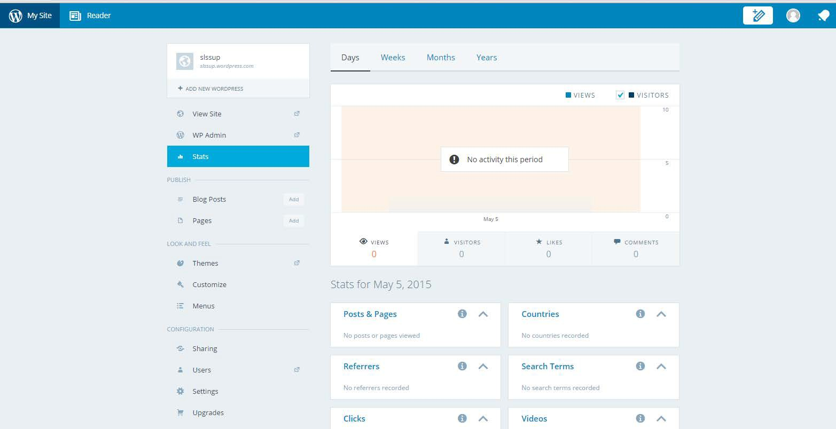

Digital Literacy Skills Induction

Once you have set up your account you are ready to start blogging

Click on the pencil icon to start blogging

70

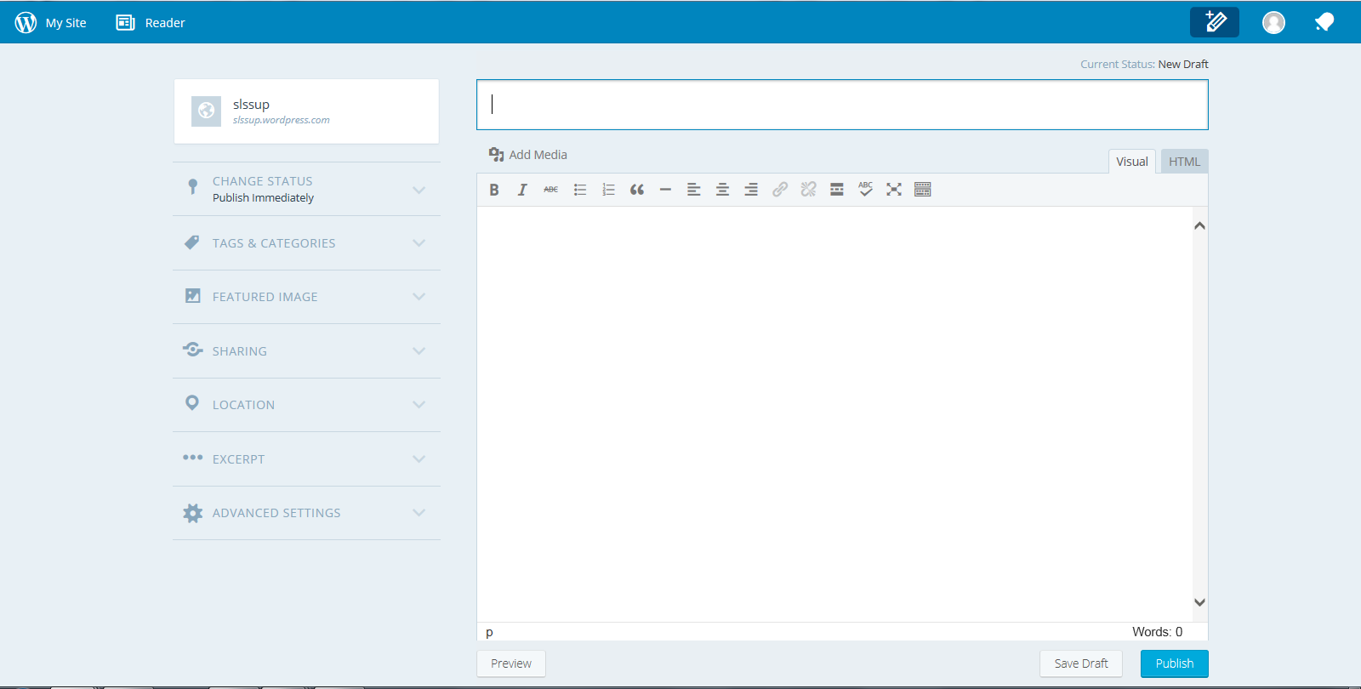

Digital Literacy Skills

Induction

You can post your title and blog entry

71

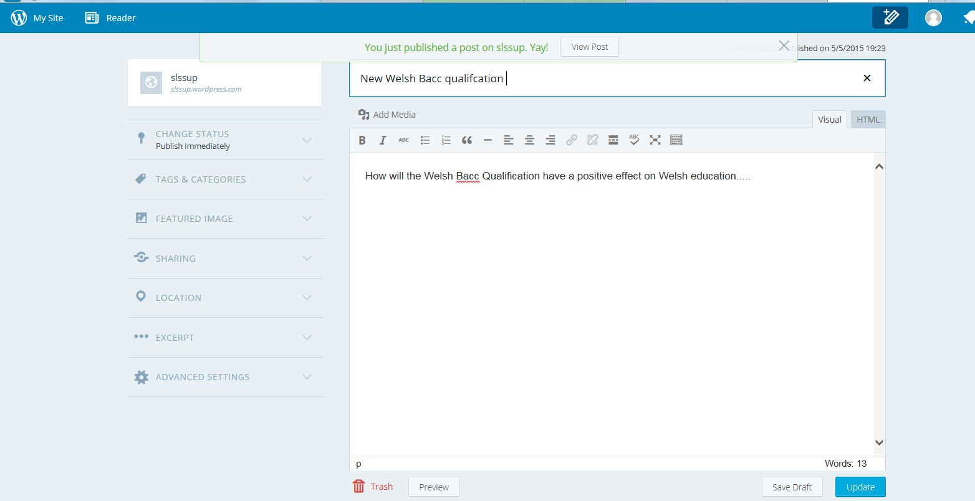

Digital Literacy Skills Induction

You can publish your post and then view it to see what it looks like

72

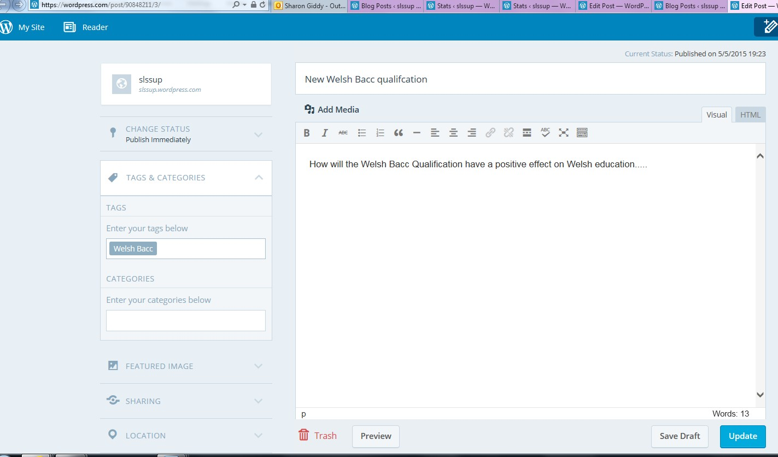

Digital Literacy Skills Induction

Enter a tag as people can search for your post under this tag

73

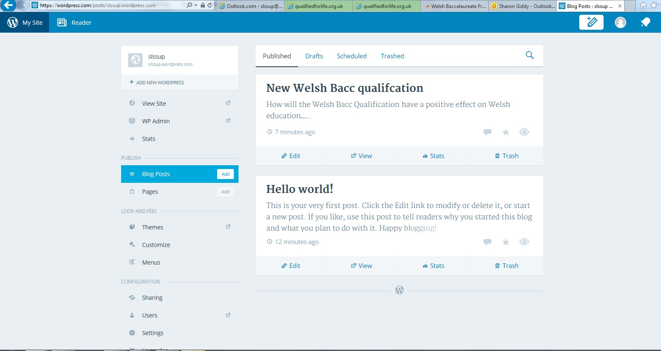

Digital Literacy Skills Induction

Click on my site and blog posts and you can view your blog

74

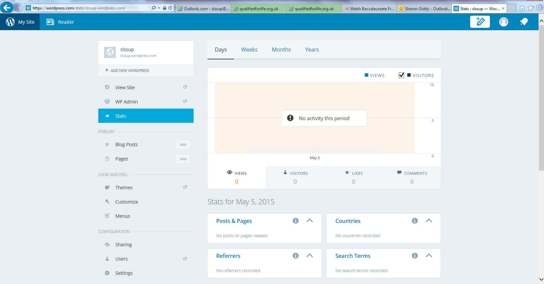

Digital Literacy Skills Induction

You can check how well the blog is doing by analysing statistics

75



Digital Literacy Skills Induction

Digital Literacy Level 3: (Activity 5.1b)

Lesson objective: Create a group blog using collaborative working to share opinions.

Introduction (3mins)

During this task you will use digital literacy skills and develop personal

effectiveness and creativity and innovation before you begin complete this table…

1. Very confident

76

Skills

Rate how confidence you are at applying these skills…

2. OK

3. Needs developing

4. Not confident

Use social media safely and effectively

Use, manipulate or create data and information and present it digitally for different audiences

Be able to find, organise, store, manage, share and protect digital information

Use digital techniques and methods for a range of activities including: collaboration, team working, creativity, problem solving and learning.

Be able to combine or develop ideas - choosing the blog topic through discussion and collaboration

Respect and respond to the values and opinions of others

Work effectively within a team

Evaluate own personal effectiveness

Reflect on the process and identify how it could be improved

How to create a blog

What is a blog?

• A blog is a regularly updated online personal journal or diary. It is where you are able to share your thoughts with any audience. We will say that a blog is your own website that you can update on an on-going basis. A blogger is known as

a person who posts content for a blog on a daily basis about their lives and opinions. Popular blogs include politics, business and society.



Digital Literacy

Skills

Induction

Skills session - 1 hour

1. Divide yourselves into groups of 4

2. Participate in a group discussion to decide on a topic that you will

create a blog about. (5mins max) Some ideas could include:

-

-

-

Charity event at your school that you can blog about

Form/Tutor/House blog

Current Issue in the news e.g. Politics – Election, NHS, Civil rights, Education, Natural disasters, War etc.

Cyber bullying

-

The blog can be in a variety of formats from a diary, work showcase

with pictures or even a video blog the choice is yours and your groups - Be creative! Discuss as a group which person will create the lead blog post comment/entry about your topic. For example if your topic is cyber bullying the lead blogger will post about the topic for all of the team to then comment and enter discussions on. (5mins

max)

77



Digital Literacy Skills Induction

3. You can use any blogging media you know to create your blog!

If you have never created a blog before: Click on the link below and it

will take you to Word Press that will provide you with a step by step guide on how to create your group blog account.

<https://learn.wordpress.com/get-started/>

This step by step guide will help you with creating your first blog. HOW TO CREATE A BLOG - A STEP BY STEP GUIDE.

4. Each member of the team must contribute and post on the blog

(Task 4 and 5 – 20min max)

Personal Review (10mins)

5.

Perform a personal review of your own performance during this

activity: Some things to review could be:

1.

2.

3.

Team working

Contribution to the task

Skills used

6.

Gain feedback from your peers on how they viewed your

contribution to the group task. Things you could ask them to feedback on:

1.

2.

3.

Team working

Contribution to the task

Skills used

What Skills have you developed during this task

78

Strengths

1.

2.

Weaknesses

1.

2.

Suggestions for improvement

1.



Digital Literacy Skills Induction

7.

After completing this task rate how confident you are at applying these

skills.

1. Very confident

79

Skills

Rate how confidence you are at applying these skills…

2. OK

3. Needs developing

4. Not confident

Use social media safely and effectively

Use, manipulate or create data and information and present it digitally for different audiences

Be able to find, organise, store, manage, share and protect digital information

Use digital techniques and methods for a range of activities including: collaboration, team working, creativity, problem solving and learning.

Be able to combine or develop ideas - choosing the blog topic through discussion and collaboration

Respect and respond to the values and opinions of others

Work effectively within a team

Evaluate own personal effectiveness

Reflect on the process and identify how it could be improved



Digital

Literacy

Skills

Induction

80

Unit 5:

Digital Literacy

Activity 5.2 Promotional publications

Length of Activity:

1 Hour

Activity Objectives:

• To develop an electronic noticeboard to share information with peers.

Introduction to Session:

Learners are introduced to Padlet

Resources: Computer Access to Padlet

5.2a Learner Work

Sheet

Activity:

1. Distribute Learner Work Sheet

2. Learners to look at how to set up Padlet: (Steps 1-6.) This part of the session can be teacher or learner led.

3. Learners to work individually to create a Padlet for their chosen subject in school or college. The success criteria are provided on the Work Sheet.

4. Learners should then exchange Padlet with another learner for peer feedback. The success criteria are given to assess against.

5. Learners to act on the feedback given and review Padlet as a tool for future use.

Learning Outcomes:

Use, manipulate or create data and information and present it digitally for different audiences

Use digital techniques and methods for a range of activities

including: collaboration, team working,

creativity, problem solving and learning.

Use, manipulate or create data and information and present it digitally for different audiences

Be able to find,

organise, store, manage, share and protect

digital information



Digital

Literacy

Skills

Induction

81

Plenary:

Learners to present noticeboard to group and get feedback.

Skills:

Use of ICT applications



Digital Literacy Skills Induction

What is a Padlet (Activity 5.2a)

Padlet is an online electronic notice board that allows you to share links, ideas,

images and text with other people. Padlet is a way to share ideas or information across a range of media that can be updated easily and accessed by everyone or

a closed group.

•Set up a Padlet account

•Go to [www.padlet.com](http://www.padlet.com/) and select `sign up.`

•Enter the details to set up your Padlet account. (You dont need to upgrade)

Step 1

•Welcome to the Dashboard. This is where you can see all of your projects and manage your Padlet account.

•Click on `New Padlet` at the top right hand side.

Step 2

•Tour of the Toolbar.

•Down the right hand side you will now see your toolbox.

•Hover over each icon and it will tell you what it does.

•Go to the last option `Modify this Padlet`

Step 3

•You will now have a list of options in a yellow band on the right hand side.

•You can now build your Padlet in anyway you like.

Step 4

•Tour of the toolbar.

•Basic Info- this allows you to add a title and short description for your Padlet.

•Wallpaper- You can select from a range or upload your own image.

•Layout- This will help you to have structure to your Padlet,if you want it!

•Privacy- You can set passwords here or opt to moderate posts.

•Notifications- This will email you daily to update you on the Padlet.

•Address- You can adapt the address to make it easier to find if you wish.

•Copy- This allows you to copy the Padlet as it is.

•Delete- You can remove the Padlet

Step 5

•Get posting. To add newposts, double click on the wall and then select an option, you can add text, embed a link or image.

•Have a go and enjoy!

Step 6

82



Digital Literacy Skills Induction

Task 1.

Options evening is coming up for the next Year 12 (frst year of college) and your

favourite subject has asked you to develop a Padlet that they can use to show the new students what is involved in the course.

On your Padlet you must include:

A title and short description.

A wallpaper

A password (Dont forget it!)

Add a URL

Add an image (take a photo)

And a minimum of 5 posts.

You can design your Padlet in anyway you like, consider using layouts if you wish

but remember who is going to read the Padlet and what information they will want to find out from the Padlet. Think about the purpose of the Padlet and the

Audience.

Task 2.

FInd someone who follows a course you also follow and review each others

Padlets. You will need to rate the Padlet in terms of:

▪

▪

▪

▪

Features used

Information given

Style used- (Text,colours, background) Language used

You must give one point that you think is very good and one item that you think

could be developed.

Task 3.

Read and react to the feedback given.

83



Digital

Literacy

Skills

induction

84

Unit 5:

Digital Literacy

Activity 5.3 Silent debate

Length of Activity:

1 Hour

Activity Objectives:

• To develop skills in working collaboratively using Googledocs (or similar) to share information and ideas.

Introduction to Session:

Learner will take part in a silent debate using ICT

such as Googledocs (or similar.)

Resources: Computer

Googledocs access (or similar)

5.3a PowerPoint

Activity:

1. Learners should be split into groups

(maximum of 6 learners per group).

2. Outline the rules of a silent debate and expectations.

3. Groups set up in Googledocs.

4. Learners are given an individual stand point and have 15 minutes to research their views using any means available.

5. Silence in classroom learners to debate their view point only by using Googledocs. All members of the group must contribute to the debate.

6. Groups must have a final vote and present their debating point using mindmaps, presentation and or graphs.

Learning Outcomes:

Use digital techniques and methods for a range of activities

including: collaboration, team working,

creativity, problem solving and learning

Use, manipulate or create data and information and present it digitally for different audiences

Be able to find,

organise, store, manage, share and protect

digital information

Plenary:

Learners to review the silent debate process and consider other applications of collaborative software.

Skills:

Use of ICT applications



Critical Thinking

&

Problem

Solving

Skills

Induction

85

Unit 6:

Critical Thinking and Problem Solving Skills

Induction

Activity 6.1: The Case of Evan Evans

Length of Session:

2 hours

Session Objectives:

• To understand what is meant by critical thinking

• To understand what is meant by problem solving

• To understand why being able to critically think and problem solve is so important

• To evaluate current levels of competency in critical thinking and problem solving

• To work collaboratively in responding to critical thinking and problem solving activities

Introduction to Session:

This session is intended to be experiential. Learners will take part in a number of group and individual based activities.

By the end of the session, learners should have an understanding of what is meant by critical thinking and problem solving as a result of being actively involved in the experience; asked to conceptualize the experience and in reflecting on the experience.

Resources:

6.1a PowerPoint

6.1b Learner worksheet



Critical Thinking

&

Problem

Solving

Skills

Induction

critical thinking and problem

86

Activity:

1. Divide class into teams of 3-6. Work through slides 1-8.

2. Slide 9 involves watching short you tube clip.

3. Work through slides 10-16

4. Slide 17 directs learners to the PISA website where they can take the PISA problem solving test. It is available at 3 levels – level

1, 2 & 3.

Learning Outcomes: Engaging in critical thinking

Engaging in problem solving

Reflecting on effectiveness in solving

Plenary:

Learners to reflect on the 2 questions in their work sheet (Task 7). Discuss their answers in pairs.

Skills:

Team working Critical Thinking Time management

Personal and team effectiveness

Problem Solving



Critical Thinking

&

Problem Solving Skills Induction

Learner Worksheet (Activity 6.1b)

Task 1: Time schedule for Evan Evans

87

Time

What Evan was doing

Further comments

6.00pm



Critical Thinking

&

Problem Solving Skills

Induction

Task 2: Eye Witness Testimony

*No longer than 200 words.*

88



Critical Thinking

&

Problem Solving Skills

Induction

Task 3: Cross examination questions

Questions to ask each team:

89

Team 1

Team 2

Team 3

Team 4

Team 5

Question 1

Question 2



Critical Thinking

&

Problem Solving Skills Induction

Task 4: Team ratings

Rate each team out of 10. *(10 being the best score and 1 being the lowest score for each category)*

90

Team 1

Team 2

Team 3

Team 4

Team 5

How plausible is each team’s account?

How reliable is each team’s

eye witness?

How plausible is each team’s

eye witness account?

TOTAL SCORE

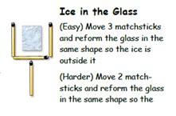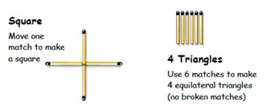

Critical Thinking

&

Problem Solving Skills Induction

Task 5:

*Circle your preferred answer:*

1. Do you prefer being given the correct answers rather than

figuring them out yourself?

Yes, always

Yes,

No, not

No, not at

sometimes really all

2. Do you like to think a lot about your decisions or do you

rely only on gut feelings?

Yes, always

Yes,

No, not

No, not at

sometimes really all

3. Do you review the mistakes you have made or do you just

forget about them?

Yes, always

Yes,

No, not

No, not at

sometimes really all

4. Do you like to be criticized?

Yes, always

Yes,

No, not

No, not at

sometimes really all

Task 6: Problem Solving

Starting from any point, draw four straight lines (without lifting

the pen from the page) so that each of the nine dots has at least one line running through it.

91

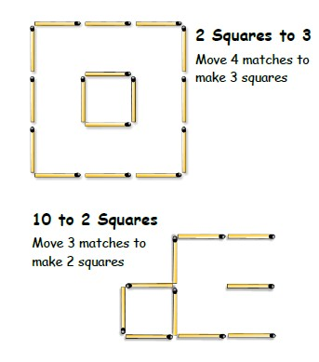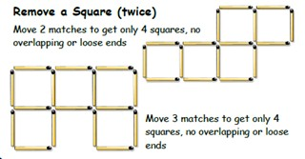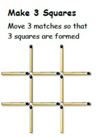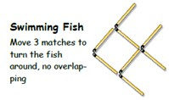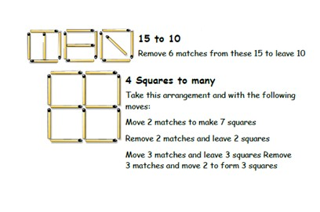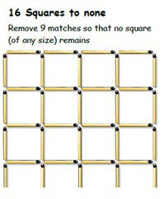

Critical Thinking

&

Problem

Solving

Skills

Induction

92



Critical Thinking

&

Problem Solving Skills

Induction

Task 7: Plenary

**What 3 things have you learnt from this**

**session?**

**How effective are your critical thinking**

**and problem solving skills?**

93



Creativity

&

Innovation

Skills

Induction

94

Unit 7:

Creativity and Innovation

Activity 7.1: The 20 shot Challenge

Length of Activity:

2 hrs

(Timings and challenge flexible to suit size and needs of group)

Session Objectives:

• To enable learners to utilise creativity and innovation to visually express understanding.

Introduction to Session:

Using mobile phones, mobile devices or camera equipment learners are given a ‘20 minute 20 shot photo challenge’.

Either working individually or in pairs learners are tasked with creating a montage of 20 photos to represent what creativity and innovation means to them.

Resources:

ICT

Mobile device or camera

Pens/paper

7.1a PowerPoint

Activity:

Prior – ask group to bring in mobile devices/inexpensive camera’s or arrange to utilise school/college resource. On the day

Part 1:

1. Announce the ‘20 minute 20 shot photo challenge’ to create a montage of twenty photographs representing their understanding of creativity and innovation. (Can be 10 shots in 10 minutes).

2. Establish whether the learner group would like to work individually or in pairs.

3. Give the group 10 to 15 minutes to plan what images they intend to photograph.

4. Ready, steady, go – learners have 20 minutes to complete the challenge and return to the starting point.

5. On their return learners will need to collate their images into a montage. There are various ways this can be done but the simplest is to put all the photos into a new album on the phone or device/download onto a computer, take a screenshot photo of the album, crop and you have a montage photo!

6. If learners have not taken twenty photos, don’t worry this is part of the learning process which can be discussed during reflection.

Learning Outcomes:

Learners are able to visually and vocally express understanding of creativity and innovation, through a time limited activity using

‘innovative’ tools and techniques.



Creativity

&

Innovation

Skills

Induction

95

Part 2 Reflective activity:

1. Learners prepare a presentation to discuss the images in the montage – the presentation can be delivered

via PowerPoint, Prezi, a blog (WordPress) or another tool can be used.

2. Learners present montages to the rest of the group, explaining their reasoning for selection, what they learnt and whether they would do anything differently.

3. Group discuss similarities and differences in understanding.

Post:

Ask the group to repeat the activity at home or the end of the year to demonstrate whether their understanding has changed, why and how e.g. the photographs could show how they have implemented the skills.

Plenary:

Ask the learners to write down one positive they took from the experience and one aspect they need to improve on. Ask the question: Why is being creative and innovative so important?

Skills:

Demonstrate original thinking and an ability to identify and challenge assumptions

Be able to combine or develop ideas

Assess and evaluate ideas, choosing and implementing options

Demonstrate imagination and initiative

Reflect on the process and identify how it could be improved



Planning

and

Organisation

Skills

Induction

available from

around £6 –

planning and

96

Unit 8:

Planning and organisation

Activity 8.1:Paper chains and plates

Length of Activity:

1 hour

Activity Objectives:

• To understand the factors to consider when planning

• To appreciate the features of successful planning system

Introduction to Session:

This is a fun teamwork exercise. There are three activities to choose from: paper chains, plates and cube building (depending on context/ resources/ space available). You may choose to undertake them all. It ends with a personal reflection.

Resources:

8.1a PowerPoint

SOMA cubes (these are numerous outlets for alternatively build an

exact replica of an intricate Lego model)

8.1b Learner Work

Sheet

Activity:

1. Work through the PowerPoint slides: start point depends on the activity chosen

2. Learners to review why it didn’t work

3. Learners to discuss the ingredients and process for successful team work

4. Learners to appreciate PLAN – DO – REVIEW

– REDO – 3 critical factors (time, people, resources)

5. Learners undertake the final planning task which involves modelling a successful planning process –using SOMA CUBES -

(these are available from numerous outlets for around £6 – alternatively build an exact

Learning Outcomes:

Importance of Planning and Organisation

Factors affecting organisation



Planning

and

Organisation

Skills

Induction

97

replica of an intricate Lego model)

6. Distribute Learner Works Sheet and learners work through the tasks. They should then reflect on their current planning and organisational skills and how they should use their preferred learning styles more effectively.

Plenary:

• Reflection – learners to identify and critically review the factors which impact on successful planning and organisation

Skills:

Planning and Organisation – Factors affecting planning



Planning and Organisation Skills Induction

Planning and organisation personal review (8.1b)

Organisation Quiz

RATE YOUR LEVEL OF SELF-ORGANISATION (where 4 = strength and 1 = needs to

improve)

1. I routinely bring the required equipment to lessons e.g. a pen

4

3

2

1

2. I routinely bring previous lesson notes to the next lesson

4

3

2

1

3. I always try to catch up with missed work

4

3

2

1

4. When required I always bring practical equipment to lesson e.g. calculator

4

3

2

1

5. I always organise my class hand-outs and notes

4

3

2

1

6. I would say that I plan my independent study time well

4

3

2

1

7. I routinely record deadlines e.g. in my diary / planner/ organisational app on my phone

4

3

2

1

8. When required, I always bring the required text books to lesson

4

3

2

1

98

REVIEW DISCUSSION



Planning

and

Organisation

Skills

Induction

99

Learning Styles Questionnaire (1)

Think about some of the things you have found both easy and challenging to learn. Think about why you found some things less difficult and others more so.

I made a success of learning:

I made a success of learning because:

[ ] I had enough time [ ] Other: [ ] I wanted to learn

[ ] I was interested in the subject / task

[ ] I had good support from other people

[ ] I was well prepared and organised

[ ] I was in a suitable place

I found it difficult to learn:

It was a challenge because:

[ ] Other people were telling me to learn

[ ] I found the subject boring and pointless

[ ] It was too difficult

[ ] I lost interest right at the beginning

[ ] I tried, but couldn’t keep up with the deadlines

[ ] I had little or no support

[ ] I was unprepared and disorganised

[ ] I was short of time

[ ] Other:



Planning

and

Organisation

Skills

Induction

100

Learning Styles Questionnaire (2)

Tick the boxes that best describe how you like to learn

FOCUS – What do you work best with? [ ] People

[ ] Technical things

[ ] Information

[ ] Ideas

[ ] Other:

CONDITIONS – What environment do you like?

[ ] Inside

[ ] Outside

[ ] With music

[ ] Hot

[ ] Cold

[ ] Quiet

[ ] Noisy

[ ] Unsupervised

[ ] Supervised

TIME – When do you work best? [ ] Morning

[ ] Afternoon

[ ] Evening

[ ] Night

[ ] Anytime

ROLE – When working with others, which role do you play best?

[ ] Organiser

[ ] Leader

[ ] Technical Adviser

[ ] Team member

[ ] Planner

SUPPORT – What sort of help do you find most useful?

[ ] Friends

[ ] Talks

[ ] Courses

[ ] Relatives

[ ] Demonstrations

[ ] Training events

[ ] Tutors/teachers

[ ] Books

[ ] Instructions

[ ] Tapes

[ ] Workbooks and study guides

[ ] Videos and CD ROMs

[ ] Pictures, charts and diagrams

[ ] Other:

PLACE – where do you work best? [ ] At home

[ ] Classroom, laboratory, lecture room

[ ] Training centre, workplace

[ ] Anywhere

[ ] Other:

TOOLS – what do you like using? [ ] Machines

[ ] Specialist equipment

[ ] Computers

[ ] Pen and paper

[ ] Brain

[ ] Other:



Planning

and

Organisation

Skills

Induction

101

Learning Styles Questionnaire (3) Tick the statements you agree with

Are you a Practical person

Do you enjoy learning by

[ ] Making presentation

[ ] Using research

Do you dislike

[ ] Open ended discussion

[ ] Listening to a lecture/lesson

[ ] Group discussion

Do you learn best from

[ ] Practical group work

[ ] Team projects and activities

[ ] Planning a project

Do you dislike

[ ] Working at a slow pace

[ ] Working outside a friendship group

Do you learn best from

[ ] Coaching

[ ] Feedback from staff

[ ] Demonstrations

[ ] Other people who act as role models

[ ] Practical action planning

Are you an Active person

Do you enjoy learning by

[ ] Sharing ideas

[ ] Taking a lead in discussions

Do you dislike

[ ] Sitting listening

[ ] Thinking on your own

[ ] Writing up notes, essays or projects

[ ] Repetition

[ ] Lack of varied activities

Do you learn best from

[ ] Competitive teamwork

[ ] Any sort of group work

Do you dislike

[ ] Following instructions

[ ] Having little scope for your own ideas

Do you learn best from

[ ] Project work

[ ] Problem solving

[ ] Having to work to a deadline

Are you a Reflective person

Do you enjoy learning by

[ ] Watching, thinking and listening

[ ] Having time to do research

[ ] Producing reports and analysing problems.

Do you dislike

[ ] Team work

[ ] Role play

[ ] Working to deadlines

[ ] Time pressures

[ ] Presenting to groups

[ ] Having to take the lead

Do you learn best from

[ ] Watching what other people do

[ ] Observation work

Are you a Theoretical person

Do you enjoy learning by

[ ] Question and answer technique

[ ] Analysis

[ ] Reading

[ ] Listening

Do you dislike

[ ] Group discussion

[ ] Presenting to groups

[ ] Open-ended problems

[ ] Working with people who prefer a more active style.

Do you learn best from

[ ] Questioning

[ ] Working out the logical answer to problems

[ ] Having a structure and purpose to

your work.



Planning and Organisation Skills Induction

Throughout the Welsh Baccalaureate, you will be developing your PLANNING &

ORGANISATION SKILLS to reach Level 3 and above. You need to ensure you understand what works best for you in terms of learning styles as well as being as organised as you can so that you fulfil your potential.

102

Now that you have completed the questionnaire and thought about what you like and dislike about learning, consider the different learning techniques available to you and which ones you would like to use to achieve your aim.

[ ] Reading

[ ] Written exercises

[ ] Demonstration

[ ] Teaching

[ ] Making/Practical

[ ] Listening

[ ] Research

[ ] Video

[ ] Online Tutorials



Mini

Challenge

A

103

Unit 9:

Mini Challenge

Activity 9.1 Planning an event/attraction

Length of Activity:

1 hour

(This could be extended)

Activity Objectives:

To enable learners to use creativity and innovation to generate an idea for a new event or attraction with a social purpose.

Introduction to Session:

According to Forbes (2011) over $450 billion was spent in the US during December mainly on holiday season related shopping. The World bank and UNDP estimate that it is likely to cost $20 billion to solve the global water crisis – less than 5% of what Americans alone spend during the holiday season:

[http://www.mapsofworld.com/infographics/poll/has- christmas-become-too-commercial-facts-](http://www.mapsofworld.com/infographics/poll/has-christmas-become-too-commercial-facts-infographic-text.html)

[infographic-text.html](http://www.mapsofworld.com/infographics/poll/has-christmas-become-too-commercial-facts-infographic-text.html)

This mini challenge asks learners to generate an idea for an event or attraction at Christmas with a social purpose.

Resources:

➢ ICT

➢ Digital devices, cameras or recording devices

Activity:

1. Learners should be divided into teams and be tasked with creating an idea for an event or attraction for Christmas.

2. Learners to decide on the social purpose for the event or attraction.

3. By the end of the session, teams must give a 90 second presentation explaining the decisions made.

4. The presentation should include a jingle or promotional video clip that could be used in the media. Learners could also design a poster, Facebook/twitter page or magazine advert to promote the event or attraction.

Learning

Outcomes:

Learners are able to generate ideas for a new event or attraction with a social purpose.



Mini

Challenge

A

104

Plenary:

Using drama strategies ask the learners in small groups to create a ‘still frame’ to show a key idea from the challenge. A ‘still frame’ is a single static image.

Skills:

• Identify potential solutions or responses and reasons for different views

• Critically assess the strength of options and arguments, take into account opposing views or alternative ideas, validity and reliability

• Use digital techniques and methods for a range of activities including:

collaboration, team working, creativity, problem solving and learning.

• Demonstrate imagination and initiative

• Reflect on approaches and techniques for critical thinking, decision making and problem solving and own proficiency in them



Mini

Challenge

B

105

Unit 10:

Mini Challenge

Activity 10.1 Creating a product

Length of Activity:

2 hrs

Activity Objectives:

To enable learners to spot opportunities and further develop market research skills.

Introduction to Session:

Before there were CDs, MP3s, playlists and music libraries there were cassette tapes. These tapes held entire albums on a magnetized tape.

The cassette tape was introduced by the Philips Company in 1963 and by 1968, cassette tapes had turned into a $150 million industry.

The popularity of cassette tapes increased with the introduction of portable cassette players, such as the Sony Walkman in 1979. In 1989 83 million music cassettes were sold. However,

cassette tape popularity declined rapidly with the introduction of compact discs in the late 1980s and as with all technology, they have become old fashioned and out of date. Because of the different kinds of plastic inside the tapes, they are not usually recycled, and usually end up in landfill sometimes at a charge. There are an estimated

500 million tapes gathering dust in UK households, however, tapes are now considered retro and a trend for alternative uses has emerged.

Resources:

➢ ICT

➢ Old cassettes

➢ Arts and craft materials

Activity:

1. Learners are challenged in teams of 4- 6 with creating a new product from the old cassette tape. Remember a cassette tape has many parts, including the plastic casing, the inlay card, the recording tape, steel screws and springs.

2. Teams should be given 30 minutes to produce a business proposal to include the 5 Ps and to design a promotional item or prototype to promote the product.

3. Teams are given 60 seconds each to pitch their product to the class.

Learning Outcomes:

Learners are able to generate product ideas and demonstrate knowledge of sales and marketing.



Mini

Challenge

B

106

Plenary:

Ask the learners to work together to create an infographic determining the skills they have used in the challenge. An infographic is a visual representation of information or data.

Skills:

• Identify potential solutions or responses and reasons for different views

• Demonstrate original thinking and an ability to identify and challenge assumptions

• Demonstrate imagination and initiative

• Be able to combine or develop ideas

• Assess and evaluate ideas, choosing and implementing options

• Critically assess the strength of options and arguments, take into account opposing views or alternative ideas, validity and reliability

• Reflect on approaches and techniques for critical thinking, decision making and problem solving and own proficiency in them



Mini

Challenge

C

107

Unit 11:

Mini Challenge

Activity 11.1 Wedding planning

Length of Activity:

3 hrs

Activity Objectives:

To enable learners to undertake a time bound mini challenge allocating roles and responsibilities to undertake all required activities through research and budgeting.

Introduction to Session:

Learners individually or as a team, act as an event management company who have been asked last minute to pitch for a high profile event. The learners have to plan and organise a wedding as outlined below and then prepare a short sales pitch to the prospective couple who will decide

on the best proposal. The proposal must include

a budget for 50 to 100 daytime guests and 100 to

150 additional evening guests.

Resources:

➢ ICT

➢ Internet access

➢ Arts and craft materials

Activity:

1. Learners individually or as a team set themselves up as an event management company which includes an arm that plans and organises weddings. Learners must give the business a name, slogan and logo and produce advertising for the business to include online information.

2. Learners to allocate roles and responsibilities and divide areas to research and cost.

3. Learners to decide on the clients, the theme, venue for the wedding and reception, colour scheme, outfits, wedding breakfast, flowers, transport, entertainment etc. The setting for the wedding can be anywhere. Learners should, for example;

a. research and select the outfits for the bride and groom, best man and bridesmaid including jewellery and rings in conjunction with the theme and

colour scheme.

Learning Outcomes:

Learners are able to research, plan, budget and pitch a service to a selected target market.



Mini

Challenge

C

108

b. decide on the salon for the hair and makeup for the bride and bridesmaids

4. Learners to produce a budget for all aspects

to include the wedding breakfast for 50 to 100 guests and evening food for an additional 100 to 150 guests.

In order to win the wedding contract the businesses will have to present storyboards to include venue, theme, outfits, layout, budget and plans to the judges.

Plenary:

Ask the learners to select the three hardest parts of the challenge and reflect on how these were managed – possibly planning, working as a team, time management and/or budgeting. Issues could be around; whether there was there enough time to complete the challenge, how were decisions

made - did conflicts need to be resolved in the team, who took

responsibility for leading and managing the task – was this effective, did the budget include fixed and variable costs and was it realistic.

Skills:

• Understand and apply decision-making and problem-solving approaches and techniques

• Be able to produce a plan, identify and manage resources, timescales, activities and allocate responsibilities

• Identify potential solutions or responses and reasons for different views

• Be able to combine or develop ideas

• Assess and evaluate ideas, choosing and implementing options

• Demonstrate imagination and initiative

• Use digital techniques and methods for a range of activities

• Reflect on approaches and techniques



Mini

Challenge

D

109

Unit 12:

Mini Challenge

Activity 12.1: Find The Gap

Length of Session:

3 hours

Activity Objectives:

To learn how to use evaluations, market research, and profiling to identify gaps in the market.

To learn how to work effectively, efficiently, and collaboratively in a group.

To learn how to apply the SWOT evaluation tool to designs and how to use the results of the evaluation to develop and improve an idea.

To learn how to present their ideas effectively to a professional audience.

Introduction to Session:

The aim of this Activity is to practise some of the skills required for the Enterprise and Employability challenge, and also the Individual Project. Learners are to design a new social media app, having evaluated current provisions, carried out some market research, and identified a gap in the market. They will be working collaboratively and they will present their

findings and their ideas collectively at the end of the Activity.

Resources:

12.1a PowerPoint

12.1b Worksheet 1

12.1c Worksheet 2

12.1d Worksheet 3

Activity:

1. Go through the initial PPT slides (1-3) introducing the Finding the Gap activity. Individually, learners should then use their own mobile phones to carry out a quick evaluation of the social media apps they have/use. Learners should get into (or be placed into) groups of 2-4 and they will remain in these groups for the rest of the Finding the Gap Activity. Using the results

Learning Outcomes:

1a. Learners will reflect on their own use of social media.

1b. Learners will create a table to evaluate the current use of social media apps.

1c. Learners will consider what effective



Mini

Challenge

D

110

of their own evaluations, learners should compile their results and complete the table. Looking at the information on slide 4, learners should create a survey about

social media which should be completed before the next session.

2. Looking at slide 5 and using the What is Missing? worksheet, learners should collate and discuss the results of their survey. Using these results, learners should then create the profile of their target audience, considering their key needs. Learners should spend the remainder of the session designing the social media application, using slide 6 to ensure that their designs are thorough. This work should be completed before the next session. [This is one point where a 4th session could be

used effectively.]

3. Using the SWOT Evaluation worksheet and slide 7 of the PPT, learners should evaluate their design, testing the market, if possible. They should use the results of this evaluation to make any adjustments to

their design and their presentation. Learners should then present their design to their class/teacher/Head of Business/ICT, etc.

questions for a survey are and will create a range of questions to be answered.

2a. Learners will collate and interpret information.

2b. Learners will learn to use information to create a needs profile.

2c. Learners will work creatively, collaboratively, and effectively.

3a. Learners will evaluate their own creative work.

3b. Learners will learn how to use evaluations to improve their work.

3c. Learners will present their work creatively.

Plenary:

Using slide 9, learners should reflect on the activity – what went well, what they struggled with, what they have learnt as a result, and what they will do to improve next time. This could be hand-written, typed, sketched, recorded, etc.

Skills:

Critical Thinking and Problem Solving: Identify and analyse problems or issues



Mini

Challenge

D

111

Identify potential solutions or responses

Creativity and Innovation:

Be able to combine or develop ideas

Reflect on the process and identify how it could be improved

Digital Literacy:

Use social media safely and effectively

Use digital techniques and methods for a range of activities, including:

collaboration, team-working, creativity, problem solving, and learning



Mini

Challenge D

FIND

THE

GAP! – Current Social

Media

Apps

(Activity

12.1b)

Even more?! Add them below or make another table…

112

Social Media App

Target

Audience

Main

purpose

Links with

other apps?

Used often?

Positives

Negatives



Mini Challenge D

What’s missing? (Activity 12.1c)

Using the research you have collected from your

survey, write down the key people, functions, or combinations that are being left out of social media.

Profiling

Now create a profile in the space below of your target audience for your social media app. You need to know who you are tailoring the app to before you really get cracking with it!

Age Range:

Profession/Education:

Why they are being missed out currently:

Social Media needs and wants:

How they would access the app:

Anything else:

113



Mini Challenge D

FIND

THE

GAP!

The

SWOT Evaluation and

Testing

the

Market

(Activity

12.1d)

The SWOT Evaluation

Testing the Market:

What they liked:

What they didn’t like:

Changes you would make:

114

Strengths

Weaknesses

Opportunities

Threats



Mini

Challenge

E

115

Unit 13:

Mini Challenge

Activity: You Shall Go To The Ball

Length of Session:

3½ hours

Activity Objectives:

To learn how to work effectively, efficiently, and collaboratively in a group. To learn how to budget effectively for an event.

To learn how to present their ideas effectively to a professional audience.

Introduction to Session:

The aim of this Activity is to practise some of the skills required for the Community challenge, as well as other transferrable skills. Learners are to work in groups to plan their Leavers' Ball. There will be some focus on the creative aspect, however they will need to budget carefully, and then respond to a change in their financial status. They present their final ideas at the end of the Activity, and the class will decide on the winning Ball.

Resources:

13.1a PowerPoint

13.1b Worksheet 1

13.1c Worksheet 2

13.1d Worksheet 3

Activity:

1. Go through the initial PPT slides (1-3) introducing the You Shall Go to the Ball activity. Learners should get into (or be placed into) groups of 2-5 and they will remain in these groups for the rest of the Ball Activity. Looking at the information on slide 3, learners are to collaborate on creatively planning their ideal Leavers' Ball. They should consider using the Bubble Map (image on PPT) or a mind map to aid creativity.

Learning Outcomes:

1a. Learners will work collaboratively.

1b. Learners will use creative thinking to plan a ball.

1c. Learners will create a visual presentation of their plan.



Mini

Challenge

E

116

2. Looking at slide 4 and using the Take One shopping list and the Take One Meeting sheet, learners should discuss the range of options they have for keeping to a tight budget. They should use their problem solving and numeracy skills to ensure that they get as much from their £1000 budget as possible. Learners will need to complete the Meeting Sheet to record the decisions made.

3. Slides 5 and 6 introduce an update to the problem: an increased budget and new guidelines. Learners should quickly reflect on the success of the previous two sessions, and they should make any necessary alterations to given roles and responsibilities. Learners will then use the

Take Two shopping list to re-plan their final ball. (There is a difference in the two lists,

so this is an important change.) Learners should record their decisions, but how they do this should be left up to them. The ball should be fully planned by the end of this session.

4. Using slide 7, learners should create a presentation to give to their classmates. Bearing in mind that the best ball idea/presentation “wins”, learners should ensure that their pitches are presented in an engaging manner. Each group should present their pitch, and a class vote should be held.

2a. Learners will work creatively, collaboratively, and effectively.

2b. Learners will use their numeracy skills to ensure they stick to their budget.

2c. Learners will record their whole group decisions.

3a. Learners will reflect on the success of the previous sessions.

3b. Learners will adapt to changes in circumstance when re- planning their ball.

3c. Learners will present their final decisions creatively.

4a. Learners will create a pitch to give to their classmates.

4b. Learners will present their plans.

4c. Learners will evaluate which pitch is best, and will vote.

Plenary:

Using slide 8, learners should reflect on the activity – what went well, what they struggled with, what they have learnt as a result, and what they will do to improve next time. This could be hand-written, typed, sketched, recorded, etc.



Mini

Challenge

E

117

Skills:

Numeracy:

Addition, subtraction, multiplication and division

Digital Literacy:

Use digital techniques and methods for a range of activities include:

collaboration, team working, creativity, problem solving, and learning

Critical Thinking and Problem Solving: Analyse problems or issues

Identify potential solutions or responses and reasons for different views

Creativity and Innovation:

Understand how to and be able to generate ideas

Demonstrate imagination and initiative

Be able to combine or develop ideas

Planning and Organisation:

Monitor and evaluate a plan, modifying it as needed and adapting to change



Mini Challenge E

You Shall Go To The Ball! (Activity 13.1b)

End of Year Ball Team – Meeting priorities:

•

•

Discuss your final idea for the organisation of the ball.

Assign roles and responsibilities: finance, entertainment, organisation, food, publicity and design, etc.

Draw up a clear plan (including an itemised budget) of the event and what is required.

•

at £3)

at £4.50)

118

PRICE LISTS AND ESTIMATES

Awards (mini statues, cups, or shields)

£2.50 each or £50 for 25

Barbecue hire and food

£450

Bouncer staff

£25 per hour

Bouncy castle

£550

Camera crew – three hours

£450

Celebrity Personal Appearance

£500 (limited to UK TV stars only)

Chocolate fountain machine

(could charge 50p a go or more)

£50 hire for evening

chocolate / marshmallows £4.50 bag

Cocktail bar (non-alcoholic)

£450 for the evening (prices for drinks start

Cocktail bar (alcoholic)

£600 for the evening (prices for drinks start

Decorations (balloons, props, confetti, etc.)

£200

DJ and disco – three hours

£350

Drinks

25p fizzy drink / 50p for brand name drinks

DVD year book and film of the event

£5 per DVD for 100 copies

£10 per DVD for less than 100 copies

Firework show

£250 to £750 based on what you select

Fully catered hotel event

£2500

Hire of gazebo for outdoor event

£190

Hotel - event room only

£750

Ice cream van

£75

Ice Sculpture

£200

Karaoke hire

£250

Local limousine company

£100 per 6-seater limo

Outside catering - three course dinner

£7.50 a head



Mini Challenge E

Remember – you can charge for tickets, but make sure they are affordable enough

that people can attend!

119

Photographer

£500 for the evening

School catered event

£3.50 a head

School cleaner and caretaking staff

£200 total cost

Two local bands

£100 per band



Mini Challenge E

You Shall Go To The Ball! (Activity 13.1c)

End of Year Ball Team – Meeting priorities:

•

•

Discuss a range of ideas for the organisation of the ball.

Draw up a clear plan (including an itemised budget) of the event and what is required.

Your headteacher/principal has only been able to give you £1000 this year for the ball.

You MUST stick to this budget!

Make smart choices to make this ball as enjoyable as possible for your friends.

120

SUMMER BALL PRICE LIST

Awards (mini statues, cups, or shields)

£2.50 each or £50 for 25

Barbecue hire and food

£450

Bouncer staff

£25 per hour

Bouncy castle

£550

Camera crew – three hours

£450

Celebrity Personal Appearance

£250 (limited to Welsh TV stars only)

Decorations (balloons, props, confetti, etc.)

£200

DJ and disco – three hours

£350

Drinks

25p fizzy drink / 50p for brand name drinks

DVD year book and film of the event

£5 per DVD for 100 copies

£10 per DVD for less than 100 copies

Hire of gazebo for outdoor event

£150

Hotel - event room only

£550

Ice cream van

£75

Ice Sculpture

£200

Karaoke hire

£250

Local limousine company

£100 per 6-seater limo

Outside catering - three course dinner

£7.50 a head

Photographer

£300 for the evening

School catered event

£3.50 a head

School cleaner and caretaking staff

£200 total cost

Two local bands

£100 per band



Mini Challenge E

Leavers' Ball Planning

Meeting

(Activity

13.1d)

Present:

Detailed plans and costings:

121

Details

Cost Breakdown

Theme and Decoration

Location

Food and Drink

Music/Entertainment

Photographer

Gifts/Prizes/Awards

Extras

TOTAL:



Mini

Challenge

F

their plan.

122

Unit 15:

Mini Challenge

Activity: You're the star!

Length of Session:

4 hours

Activity Objectives:

To learn how to create an effective digital pitch.

To learn how to transfer all of the skills developed to promote yourself.

To learn how to present their ideas effectively to a professional audience.

Introduction to Session:

Learning instructions: Create a digital pitch to sell yourself and get a place on the next big reality

TV show. You have been told about a new reality show that is looking for people to go on, this is something you have always wanted to do but the application process isn’t filling in a form, the brief is to be creative and sell yourself…. It's over to you!

Resources:

ICT

Cameras and video equipment.

Activity:

Learning instructions: Task 1.

Explore the different options open to you including:

• Video or written Blogging

• Developing your own virtual wall

• Social networking (Twitter, Facebook, LinkedIn)

• Use a Social curation site

• Use a presentation site

• Develop an App of yourself

• Create a Podcast

Learning Outcomes:

1a. Learners will record research effectively.

1b. Learners will be able to using digital productivity, digital creativity and digital learning.

1c. Learners will create a visual presentation of



Mini

Challenge

F

123

…….. the possibilities are endless! The more creative the better, you need to catch their attention to get the place!

Record this research in any way you feel is appropriate and meets your learning style: create a comparison table, produce an electronic mind map etc.

Task 2.

Using the BARB ([www.BARB.co.uk](http://www.barb.co.uk/)) website you need to find out what are the most popular TV shows, find out who is watching Reality TV and when.

Present this data in a useful format; you can use it to make sure you are pitching yourself at the right level.

Task 3.

Plan your pitch, what are you going to tell them? What is appropriate? What isn’t? Remember it is in the public domain so think carefully!

Task 4.

Produce your pitch, you may need to work in pairs for the final task recording each other’s pitches.

Task 5.

Edit your pitch and make it a final package.

Task 6. Pitch day!

You need to show your pitch to an audience and get feedback. Use this to consider what you would change next time.

2a. Learners will work creatively and effectively.

2b. Learners will analyse data, and reflect on success criteria

3a. Learners will present their final decisions creatively.

4a. Learners will create a pitch to present to their classmates.

5a. Learners will use creative digital methods to present.

6a. Learners will evaluate which pitch is best, and will vote.

6b. Learners will reflect on their progress

Plenary:

Learners should reflect on the activity – what went well, what they struggled with, what they have learnt as a result, and what they will do to improve next time. This could be hand-written, typed, sketched, recorded, etc.



Mini

Challenge

F

124

Skills:

Digital Productivity Digital Learning Digital Creativity Digital Responsibility

Digital Information Literacy Creativity and Innovation Literacy