Life expectancy shows a growing north-south divide

Men in London can live up to 14 years longer than their Glaswegian counterparts, according to ONS
figures, putting the latter on a par with life expectancy in Albania and Palestine.
Life expectancy for both males and females in Kensington and Chelsea is the highest in the UK. Men in Kensington and Chelsea can expect to live 14 years longer than those in Glasgow, according
to figures from the Office for National Statistics (ONS), which reveal a widening gulf in life expectancy between the north and south of the UK. “The best life expectancy in London is better than the average in Japan, which has the highest in the world, and the worst compares to Guatemala.”

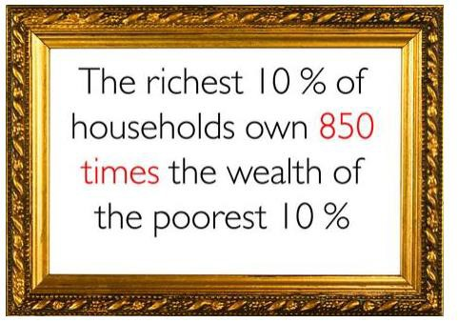In Westminster, life expectancy for women in the five wards with the highest level was 93.76 years on average; they are Harrow Road, Knightsbridge and Bayswater, Little Venice, Warwick and Vincent Square, according to the latest ward-level figures.

Harrow Road was the highest at 97.1 years.

In Kensington & Chelsea, it was 92.5 for the wards of Hans
Town, Colville, Courtfield, Cremorne and Earls Court.

In Glasgow’s Calton area, the average life expectancy of a male is just 53.9 years. In Iraq, after 10 years of sanctions, a war and a continuing conflict, suicide bombs and insurgency, the average man has a good chance of making it into his 60s;
the life expectancy of a male there is 67.49. In Iran it is 69.96, in North Korea, 71.37 and in the Gaza
Strip it is 70.5.

Glasgow as a whole remains the local authority with the worst record on both male and female life expectancy, although it did see a rise from 71.1 to 71.6 for males between 2007-09 and 2008-10.

Average pay for men in Glasgow in 2010 was £23,356, compared with £87,516 in Kensington and
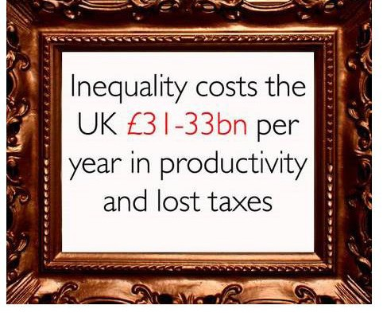Chelsea.

The TUC’s general secretary, Brendan Barber, said the figures were a “stark warning” to a government intent on forcing people to retire later.

“People living in areas like Glasgow and Blackpool can expect their retirement to be a decade shorter than those from more affluent parts of the UK.

“Ministers need to realise that rapidly accelerating the state pension age may sound sensible for the wealthy elite in
Kensington and Chelsea, but it is a frightening prospect to the millions of people living further north.”

Source: http://www.theguardian.com/money/2011/oct/19/life-expectancy-growing-north-south-divide

