Britain’s unequal society
Inequalities handout 2

UK only G7 country with wider inequality than at turn of century

Richest 10% control 54.1% of Britain’s wealth, up from 51.5% in 2000 and 52%
before financial crisis, says Credit Suisse

Britain is the only country in the G7 group of leading economies where inequality has increased this century, according to a report published on Tuesday.

The amount of the country’s wealth controlled by the richest 10% increased to 54.1% this year, up from 51.5% in 2000, according to the annual Credit Suisse global wealth report.

The increase in inequality has coincided with a boom in the number of rich and super-rich people in Britain. There are now 44 dollar billionaires in Britain, compared with eight at the start of the century, while the number of people whose net worth is at least $50m (£31m) almost quadrupled to 4,660.

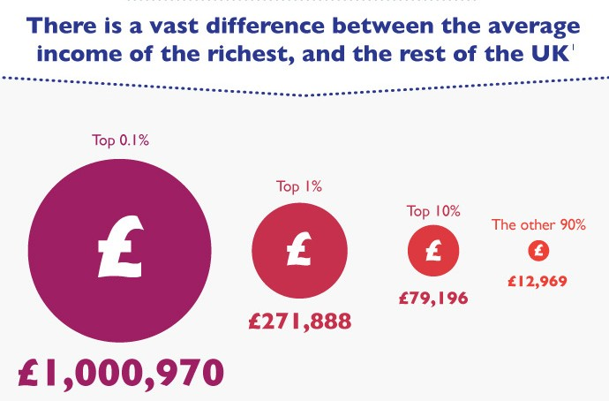As the rich have got richer, low and middle-income households have been squeezed by falling real incomes caused by years of rising household bills and lack of wage increases.

Text: http://www.theguardian.com/society/2014/oct/14/uk-inequality-wealth-credit-suisse
Images: http://www.equalitytrust.org.uk/resources/multimedia/infographic-income-inequality-uk

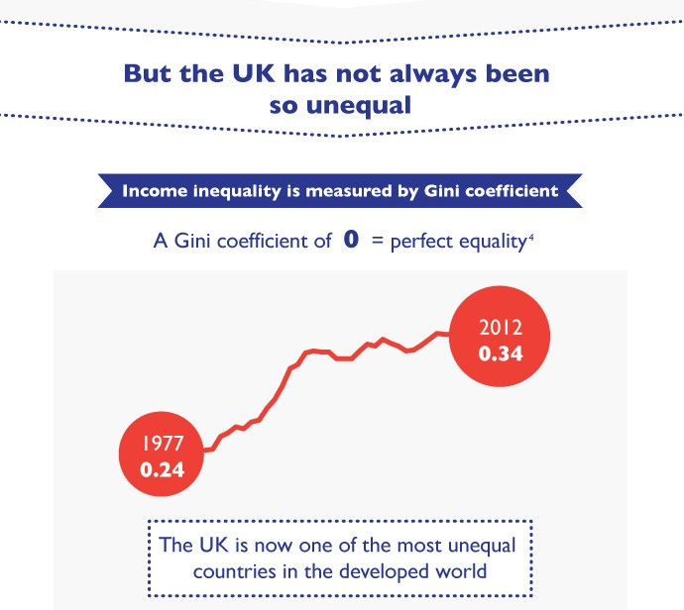Oxfam’s head of inequality, Emma Seery, said: “In the UK, successive governments have failed to get to grips with rising inequality. This report shows that those least able to afford it have paid the price of the financial crisis whilst more wealth has flooded into the coffers of the very richest.”

The richest 10% of the UK population have continued to get wealthier since the financial crisis – their share of the wealth was 52% in 2007. The report says the rich have become wealthier because financial assets such as shares have risen in value. Those assets rose strongly as investors looked for higher returns with interest rates at all-time lows.

Anthony Shorrocks, who helped to write the report, said the recovery of London, its soaring property prices and its position as the UK’s financial powerhouse was a factor in Britain’s rising inequality. In other European countries such as Germany and Italy, he said, “they don’t have a city that dominates in quite the same way”.
