Britain’s unequal society
Inequalities handout 1

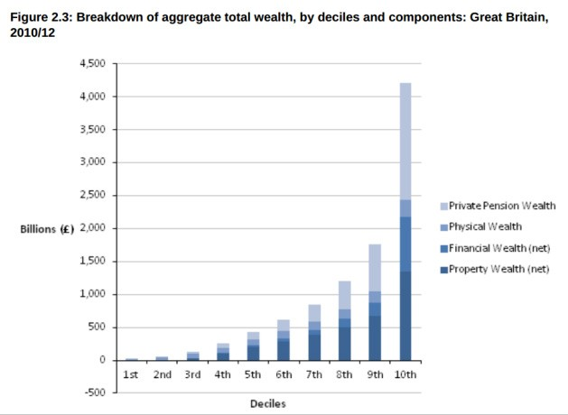

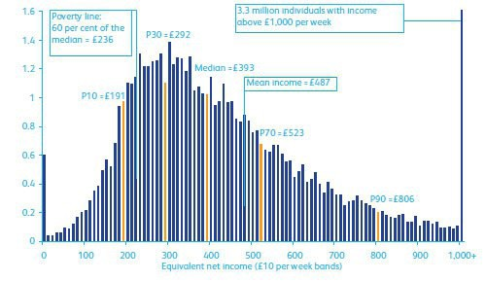

Graph 1: http://www.ons.gov.uk/ons/dcp171776_362809.pdf
Graph 2: http://makewealthhistory.org/2010/01/27/britains-unequal-society/

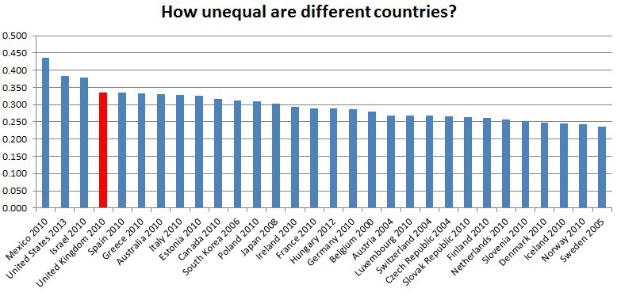

Graph 3: http://www.equalitytrust.org.uk/about-inequality/scale-and-trends/scale-economic-inequality-uk

Britain’s unequal society
Inequalities handout 1

The richest 10% of British people are 100 times wealthier than the poorest 10%, new government research shows. The household wealth of the top decile of UK society is £853,000, while the poorest hold just £8,800…

An Anatomy of Economic Inequality in the UK is a groundbreaking report, and it reflects a growing recognition that equality is vital to the health of society. It highlights some striking inequalities. Black African, Bangladeshi and Pakistani men earn 13–21% less than white men with the same qualifications. The median income for women is 21% lower than for men. Social mobility is also a problem: “economic advantage reinforces itself across the life cycle, and on to the next generation” says the report. “It matters more in Britain who your parents are than in many other countries.”

... Using the Gini coefficient as an index (where 0 is absolute equality, and 100 is absolute inequality), gross incomes have moved from 30 in 1977, to 38 in 2008. By way of comparison, Japan and Denmark score around 24, and the US, Turkmenistan and Cambodia score around 40. You’d have to be a corrupt petro-state to head north of 60, which is why those countries don’t keep figures.

Source: http://makewealthhistory.org/2010/01/27/britains-unequal-society/

