Guaranteed minimum prices

This exercise is designed to study price support schemes, using sugar in the EU as a case
(although the sugar sector is currently under reform).

Essentially the exercise is a pair/small group activity suitable for a maximum of three students
per group. It is a diagram-based and discussion activity which should develop into a whole group discussion. If you have already talked about price instability, you might have looked at buffer stock schemes in passing. If not, ask them to show, using a diagram, the effect of a floor price above equilibrium (this is easier if you have already done maximum prices).

Once they have the vague idea, give them Sheet 1. They should be able to work through the diagram (probably with some prompting as you go around and check on them) and then at the end there is an open-ended discussion exercise where they might start to think about what might go wrong.

At this point, you can draw/show the answer to the diagram on the board and talk through it (or
get one of them to do it) and then see what they think the problems might be, getting pairs to feed back.

Then show this clip about a similar scheme in Thailand:

http://www.bbc.co.uk/news/business-23875084

The students should think about the extent to which developments in Thailand match their expectations.

You can also show them the graphic below which highlights the CAP in its heyday:

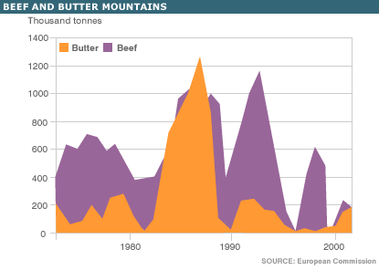

Source: http://newsimg.bbc.co.uk/media/images/40992000/gif/_40992736_beef_butter2_4gra16.gif

Then give them Sheet 2. This shows how the problems identified can be illustrated using the diagram. Once they have had a go in pairs and you have been around to check, again illustrate/ show/get them to show how it works on the IWB.

Once the students have had a chance to work out the areas and do the calculations, give them Sheet 3, which identifies some of the problems and asks them for solutions. You could talk about quotas and set-aside, before giving them the final sheet (Sheet 4) which explains how the CAP generally works today.

Ask them to read it and then in small groups to decide what they think about the CAP as it stands today. You might want to use the graphic below which highlights the fact that intervention prices have steadily fallen over the years. The free market price is usually above the guarantee, meaning that the purchase element doesn’t generally come into play:

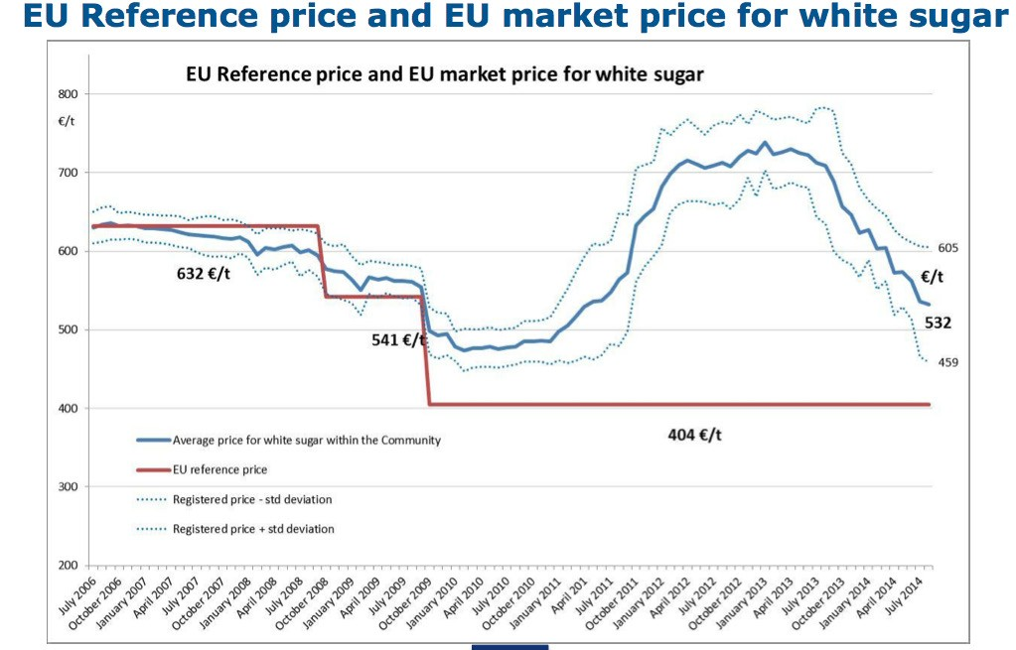

Source: http://ec.europa.eu/agriculture/sugar/presentations/price-reporting_en.pdf

At this stage, they should be able to go off and make the key notes, or you could provide a summary.

The diagram below represents the market for sugar beet in the EU.

P
S

500e Gp

Pe 300e

D

10m Q(tonnes)

1) In the diagram, shade in the equilibrium revenue for the producer before any intervention (i.e. at the original equilibrium Peq, Qeq).

2) What is the consumer surplus at the original price (Peq) – shade this on the diagram.

3) Suppose a guaranteed minimum price of Gp is offered – what will happen to supply and demand? Mark this on the graph (put in new quantities).

4) Because there is now excess supply, the government will have to buy any unsold production/ supply. Show the impact of a guaranteed minimum price of Gp on producer revenue (shade in the new total area).

The impact has been that producers now have much more revenue:

• rural living standards will be higher;
• farmers will be able to invest;
• prices have been stabilised giving greater certainty over the future;
• food supply should be guaranteed.

In groups of three, suggest a list of possible problems with operating a guaranteed price scheme like this.

700 euros
P
S

500 euros Gp

Pe 300e

D

6m 10m 11m Q

In the diagram show the areas representing:

• the cost to the government of buying the surplus production;
• the impact of the higher price on consumer surplus. Calculate these using the numbers provided.

P
S

Gp Gp

Peq

D

Qd Qeq Qs Q

Farmers have used more intensive methods of production – battery farming of chickens, organophosphate based fertilisers. Show the impact of this on the diagram in terms of:

• supply
• the cost to the government. What should the EU do?

Sheet 4
Source: http://www.bbc.co.uk/news/uk-england-29748285

Farm subsidies: does the CAP still fit for farmers?

…the biggest single CAP payments in the Midlands haven’t been for farming at all in the last few years.

Instead, they’ve been massive grants, about £3m (4 million euros) in 2012, for education and training… That’s a sign of just how much farm subsidies have evolved.

In a post-war Europe the idea was to make sure people never went hungry again and farmers were paid for production.

We certainly never starved but we also had to deal with butter mountains and wine lakes – friends still remember massive blocks of EU butter being distributed to Asian families in Wolverhampton for turning into ghee.

These days farmers are no longer paid cash based on the amount they produce, that link has been broken. Instead, the CAP has been slowly moving towards a more market orientated approach with a thick layer of environmental concerns and training slapped on top…

So… does the CAP work?

Well, food is plentiful and affordable. The English landscape here in the Midlands is still that patchwork of fields free of bracken and scrub that we find so pretty to look at and, at a time of plunging commodity prices it’s CAP cash that will keep many of our dairy and even arable farmers going this year.

The CAP still allows farmers to innovate and respond to the market and consumer demands.

Family farms or mega-dairies?

…At Gloucester Farmers Club I asked for a show of hands of how many farms wouldn’t survive without subsidy and almost all the hands went up. But, one farmer then made it very clear that while subsidy may be vital “it doesn’t mean we like it.”

So, if we leave the EU and the CAP with it how would our farmers cope? It would be a huge change so how would that be managed? Would a UK government introduce its own subsidy scheme?

Would such a scheme aim to preserve a particular way of farming and the look of the countryside or instead equip our farmers to compete with the really big agricultural boys like Brazil and America? Would th[is] support small Midlands family dairy farms or push for more “mega-dairies”?

For those that want us to leave the EU and CAP behind, these are big questions that need detailed answers.

