Learning Objectives:

At the end of this topic you will be able to;

- Explain how capacitors can be used to form the basis of timing circuits;
- Calculate the value of the time constant for an RC circuit using ;
- Sketch the charge and discharge curves for voltage and current;
- Select and use the following formulae relating to the voltage across a capacitor as a function of time:
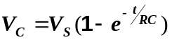 for a charging capacitor
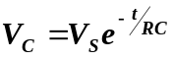 for a discharging capacitor
- Realise that:
V_{C} = 0.5V_{S} after 0.69RC
V_{C}  V_{S} after 5RC for charging capacitors
V_{C}  0V after 5RC for discharging capacitors.

RC Networks.

In this section we are going to investigate the basic circuit elements relating to timing circuits. In order to do this we have to introduce a new component called the capacitor.

The capacitor is essentially a device for storing small quantities of electric charge. It is made from two metal plates separated by an insulator. We can represent this as shown in the following diagram.

Metal Plates
Insulator

When connected into a circuit as shown below we observe some unusual and often unexpected results.

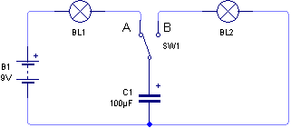

When pupils see this circuit for the first time, having looked at the construction of the capacitor, they often predict that in the configuration shown above with the switch at position A, that the lamp BL1 will not light, because there is an insulator between the plates of the capacitor, and with an effective break in the circuit current cannot possibly flow!

However when connected together lamp BL1 actually does come on briefly but then goes off again. So what exactly is happening.

Well, when the battery is first connected, some electrons move from the negative of the battery to the bottom plate of the capacitor. The presence of these electrons on the bottom plate of the capacitor repels a similar number of electrons from the top plate which return to the battery through the lamp which causes it to glow. It looks like a current is flowing, even though electrons are not crossing the insulating layer in the capacitor.

The electrons keep building up on the bottom plate until there are just as many on this plate as are being generated at the negative terminal of the battery. With two equal negative charges repelling each other, no other electrons can flow from the negative terminal onto the plate of the capacitor, so current stops flowing and the lamp goes out.

When the switch is moved to position B, the battery is disconnected from the circuit, but when contact is made with B, the lamp BL2, comes on for a short while before going out. We can explain this by thinking about the state of the capacitor when the switch is moved from contact A. The bottom plate has a large negative charge, whilst the top plate has a positive charge, since electrons have been repelled by the lower plate.

When contact is made with terminal B, a circuit is made between the two plates, through the bulb. The negative charges rush around the circuit to the positive charges on the top plate, causing the bulb to light as it passes through it. The bulb goes out after a very short time because there is only a small amount of electrons on the bottom plate, once these have moved to the top plate the capacitor cannot produce any extra electrons, as it is not a battery and so current stops and the light goes out.

Moving the contact back to A charges the capacitor again, and a short flash from the bulb is observed, before it goes out, and the process starts again.

It is always worth remembering that a capacitor can only store the charge it is given, it cannot under any circumstances generate its own charge, and therefore must not be compared to a battery or power supply.
In this example, the charging, and discharging of the capacitor occurred almost instantly, as the only resistance in the circuit is provided by the lamps, which is only about 100Ω. In electronics terms this is a really small resistance. As it stands the capacitor does not look like a very useful device in timing circuits, unless the time delays required are very small.

We can however improve the usability of the capacitor by slowing down the rate at which charge arrives at the capacitor by using a resistor. The basic timing circuit is shown below:

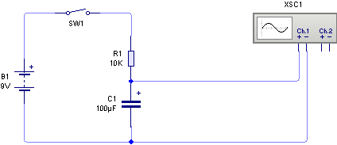

The following graph shows what happens to the voltage across the capacitor when the switch is closed.

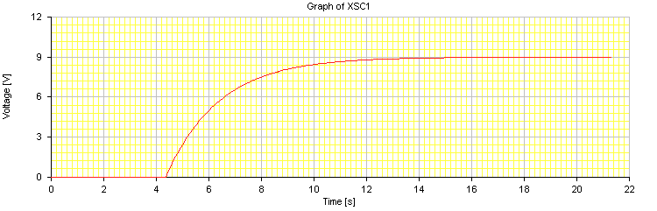
Switch closed here
From the graph you should observe that voltage across the capacitor does not rise in a linear manner. The increase is rapid at the start, when there is no charge on the capacitor, but slows towards the end as the charge arrives more slowly at the capacitor plate. The graph shows that the voltage across the capacitor eventually reaches the supply voltage some time after the switch has been closed.
Now consider the same circuit with the resistance decreased to 1kΩ.

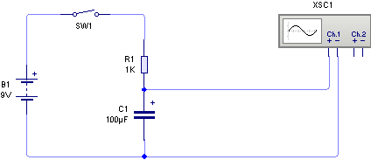

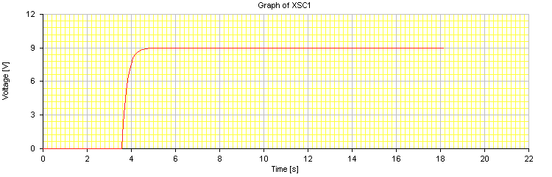
The voltage across the capacitor increases more rapidly, since the resistance is lower, so charge builds up faster.

And when the resistance is increased to 100kΩ we obtain the following graph of the voltage across the capacitor.

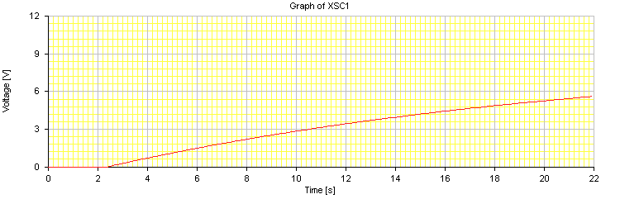
The voltage across the capacitor increases very slowly, in this example not even reaching the supply voltage in the time shown. The larger resistor slows down the rate of charging.

So far we have looked at examples of a capacitor charging, we will now look at what happens when a capacitor is discharged through a resistor.

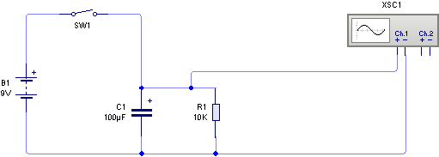

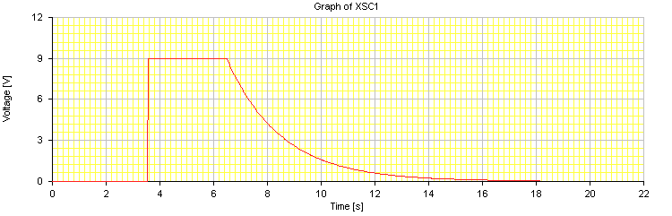
Switch closed here
Switch opened here
Here we can see that when the switch is closed the capacitor charges instantly, as there is no resistance to slow down the build up of charge on the plates. However when the switch is opened the charge on the capacitor slowly drops as current flows through the resistor. Once again changing the size of the resistor can change the rate at which the charge leaves the capacitor. The following graph for example shows the response when the resistance is increased to 68kΩ.
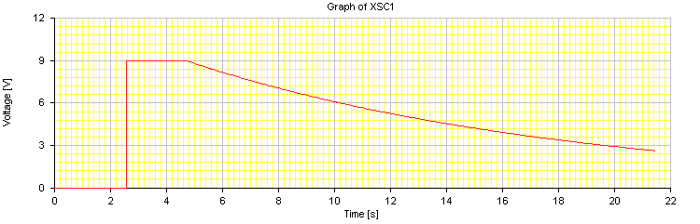
Now that we understand the basic operation of the capacitor, it is time to introduce some more mathematical information that will allow us to calculate specific time delays.

The first thing to consider are the units of Capacitance, these are called Farads, ‘F’. The Farad is a very large unit and it is much more common in electronics circuits to see much smaller units such as

- The microfarad (μF) = 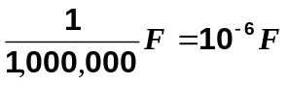
- The nanofarad (nF) = 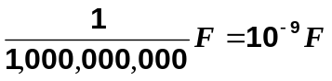
- The picofarad (pF) = 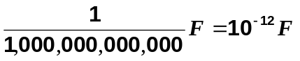

For example:

1000pF = 1 nF = 0.001μF

You will have to become familiar with converting from one unit to another, recognising either the written units of μF, nF and pF or their standard form multipliers i.e. x10⁻⁶, x10⁻⁹, or x10⁻¹². Indeed in order to perform the calculations involving capacitors you should be comfortable handling numbers in standard form, and have access to a scientific calculator.

One of the most common calculations you will perform as part of the design process for timing circuits is something called the Time Constant of the circuit.

This is very easily defined as

Time Constant = R x C

where R is in Ohms and C is in Farads, the Time Constant will be in seconds.

Examples:

1. Calculate the time constant of a circuit containing a 10kΩ resistor and a 470μF capacitor.

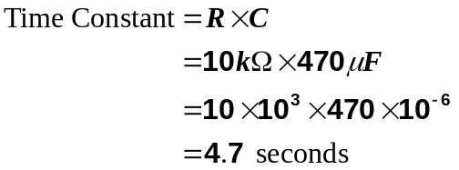

2. Calculate the time constant of a circuit containing a 22kΩ resistor and a 330nF capacitor.

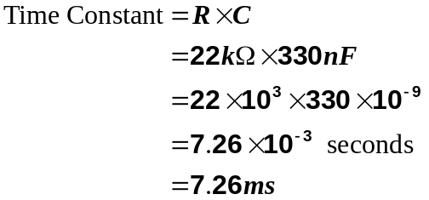

Student Exercise 1:

Calculate the time constant for the following combinations of resistor and capacitor.

i) R = 4.7kΩ, C = 1000μF.

........................................................................................................................................

........................................................................................................................................

ii) R = 82kΩ, C = 15μF.

........................................................................................................................................

........................................................................................................................................

iii) R = 56kΩ, C = 33nF.

........................................................................................................................................

........................................................................................................................................

iv) R = 470kΩ, C = 8.2nF.

........................................................................................................................................

........................................................................................................................................

v) R = 2.2MΩ, C = 33μF.

........................................................................................................................................

........................................................................................................................................

vi) R = 91kΩ, C = 0.22μF.

........................................................................................................................................

........................................................................................................................................

vii) R = 1.8MΩ, C = 470pF.

........................................................................................................................................

........................................................................................................................................

viii) R = 240kΩ, C = 33nF.

........................................................................................................................................

........................................................................................................................................
When we looked at the earlier examples of how capacitors behave in a circuit we saw that the voltage across the capacitor rises non-uniformly as time goes on.

The curve followed by the rising (or falling) voltage can be described mathematically as an exponential curve, and it can be shown that the following two mathematical expressions can be used to determine the voltage across a capacitor at any particular time.

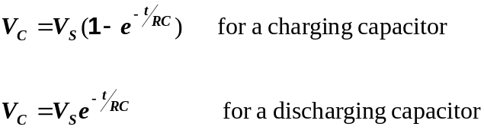

Where V_{C} is the voltage across the capacitor, V_{S} is the supply voltage, t is the time in seconds, and RC is the time constant of the circuit.

‘e’ is the exponential function, usually found on a scientific calculator above the natural logarithm ln function key as e^{x}. Unfortunately calculators deal with calculations in different ways and the way in which you enter the numbers into the calculator affects how the calculation is done. You must ensure that you know how to use your calculator correctly. Practice with the worked examples to be sure you get the same answers.

(Note: there is no requirement to be able to prove how these formulae are derived, nor do you need to remember them as they will be printed on the formula sheet at the front of each examination paper.)

Note : More information about the different types of capacitors available, and their properties will be found in the Supplementary Pack of Notes which are non-examinable called “Practical Circuit Assistance.”
Examples:

1. Find the voltage across the capacitor, after 0.05s and then after 0.25s, assume that before the switch is closed there is no charge on the capacitor.
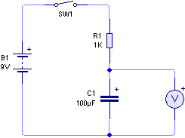
Solution:

The circuit is a charging circuit, and therefore the formula required will be
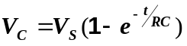

It is often good practice to calculate the Time Constant before using this equation as this simplifies the numbers to be put into the equation, and hence into the calculator.

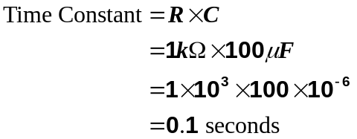

Now to calculate the voltage across the capacitor.

i) at 0.05s ii) at 0.25s
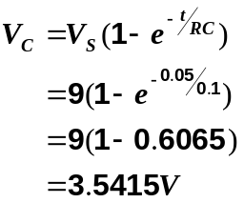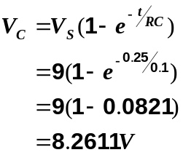
2. Calculate the voltage across the capacitor in the following circuit, 3s and 6s after the switch is opened.

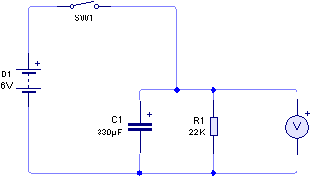

Solution:

The circuit is a discharging circuit, and therefore the formula required will be

Once again we will calculate the Time Constant before using this equation as this simplifies the numbers to be put into the equation, and hence into the calculator.

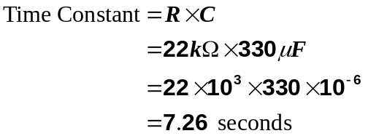

Now to calculate the voltage across the capacitor.

i) at 3s ii) at 6s
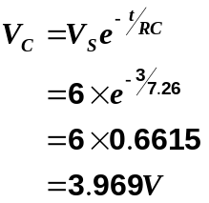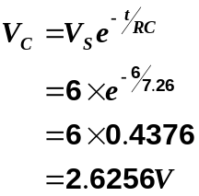

Student Exercise 2:

1. Find the voltage across the capacitor, after 0.5s and then after 8s, assume that before the switch is closed there is no charge on the capacitor.
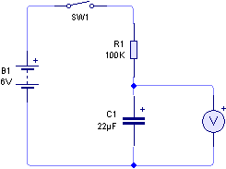

........................................................................................................................................
........................................................................................................................................
........................................................................................................................................
........................................................................................................................................
........................................................................................................................................
........................................................................................................................................
........................................................................................................................................
........................................................................................................................................
........................................................................................................................................
........................................................................................................................................
........................................................................................................................................
........................................................................................................................................
........................................................................................................................................
........................................................................................................................................

2. Calculate the voltage across the capacitor in the following circuit, 15s and 40s after the switch is opened.

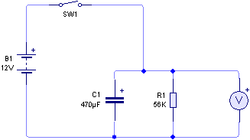

........................................................................................................................................
........................................................................................................................................
........................................................................................................................................
........................................................................................................................................
........................................................................................................................................
........................................................................................................................................
........................................................................................................................................
........................................................................................................................................
........................................................................................................................................
........................................................................................................................................
........................................................................................................................................
........................................................................................................................................
........................................................................................................................................
........................................................................................................................................
........................................................................................................................................
........................................................................................................................................
So far we have looked at how to calculate the voltage across the capacitor after a specific time has passed. Sometimes we may need to calculate the time taken for a specific change in voltage to occur. Consider the following examples.

1. In the circuit below the switch is closed at time t = 0, calculate the time taken for the voltage across the capacitor to reach 6V. The capacitor is initially uncharged.

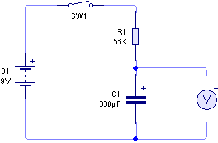

First we calculate the time constant, as before

Now we need to find the time from the charging equation
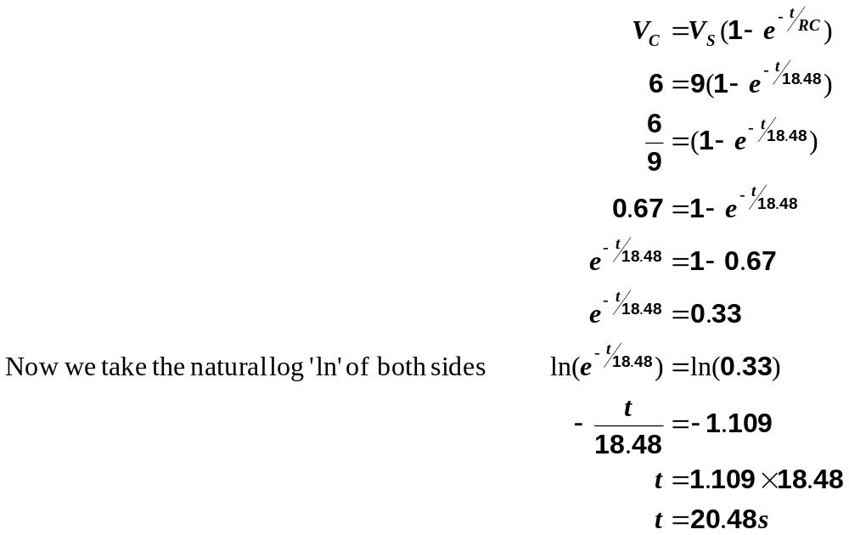
So the voltage will reach 6V, 20.48 seconds after the switch is closed.
For those of you that are not taking A-Level Mathematics, this last example may have proved to be a bit too difficult given all the re-arrangements needed to the equation. In electronics it is more important that you are able to determine the answer than it is to understand the mathematical process going on in the background.

Therefore on the examination paper you will find an additional formula, which will allow you to calculate this time directly. For a charging capacitor as in this case the formula is:
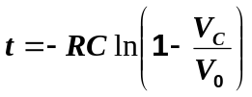

So a possible solution to the previous problem would be:

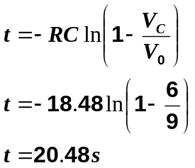

If the capacitor is discharging the there is a different formula to use which is as follows:

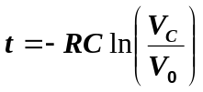

We will now look at a discharging example, and solve this using the simplified
method.
2. In the circuit below, the switch SW1 is closed which charges up the capacitor. Determine the time taken for the voltage across the capacitor to fall from 9V to 2V, when the switch is opened.

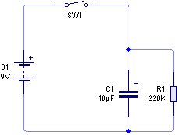

First we calculate the time constant, as before

Now we need to find the time from the discharging equation

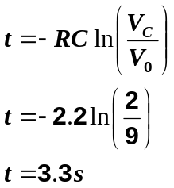

So the voltage will reach 2V, 3.33 seconds after the switch is opened.

Using this method, the solution is obtained very quickly, without the need for extensive mathematics. Remember you can use either method in the examination, the most important thing is to obtain the correct answer.

Quite often we want to know how long it takes the capacitor to reach the half-way point in the charging or discharge cycle but this calculation can be very time consuming.

So let us consider the charging circuit to start with, at what time does the voltage across the capacitor reach half of the supply voltage. We will not put any values in for R and C at the moment. The equation becomes:

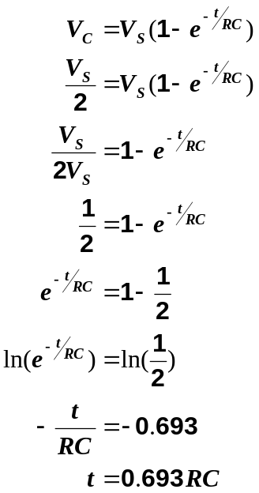

This means that for any charging circuit, the time taken to reach half of the supply voltage is 0.69RC, and is completely independent of the supply voltage, depending only on the value of the capacitor and resistor.

This provides a very simple way of determining this point on the graph and is summarised as follows.
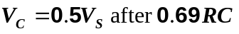
What about a discharging capacitor ?

We can perform a similar calculation using the discharging formula, as shown below:

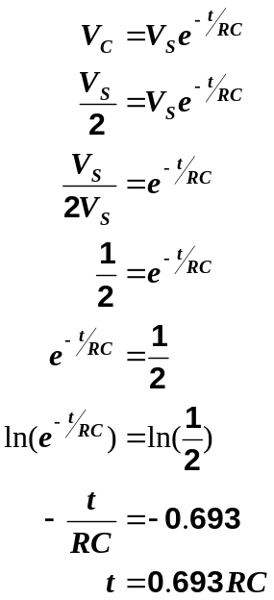

This result is exactly the same as for a charging capacitor, which is really good news as we do not have to remember another formula.

We now have a very simple way of determining the time taken to reach half of the supply voltage. It would be nice if there was a similar result we could use to determine the time taken to reach maximum charge when V_{C} = V_{S} and full discharge when V_{C} = 0V.

The problem with the exponential function is that the maximum charge is never actually reached in theory, because the curvature of the line gets smaller and smaller, never quite reaching the maximum value.

For our purposes, it would be a reasonable approximation to determine how long it would take for the voltage to rise to 99% of V_{S} in the case of a charging circuit and fall to 1% of V_{S} in the case of discharging circuit.

We can use a similar argument to the one we have just used, as follows.
For a charging capacitor For a discharging capacitor
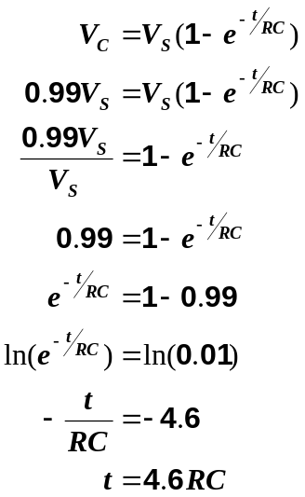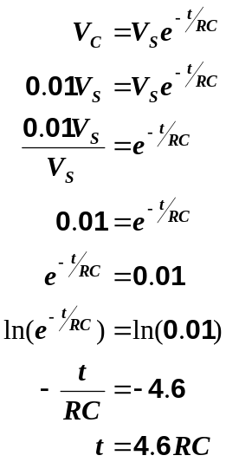

Once again we see that the results are identical, and as a general rule of thumb electronics engineers will consider a capacitor to be full charged, or fully discharged after a time period = 5RC. We can summarise these results as follows:

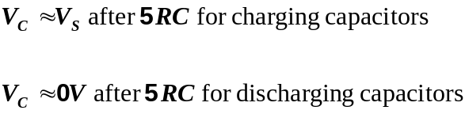

We are now in a position to be able to quickly sketch a charging or discharging curve for a circuit, by only making a few simple calculations.

Example :

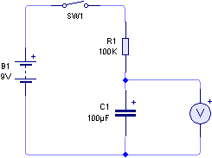
For the circuit shown opposite, sketch the charging characteristic to show how the voltage across the capacitor changes with time.

Step 1 : Calculate the time constant of the circuit.

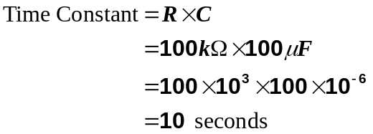

Step 2 : Calculate the time taken to reach half of the supply voltage.

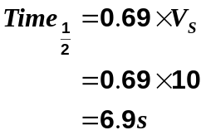

Step 3 : Calculate the time taken to reach V_{S}.

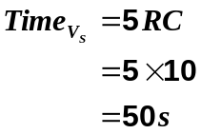

Step 4 : Plot these points on graph and join up with a smooth curve.
Step 2
Step 3
10

8

6

4

2

0

0 10 20 30 40 50 60 time (s)
Student Exercise 3:
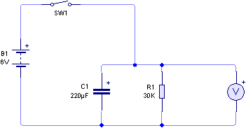
Now try this discharging example.

Step 1 : Calculate the time constant.

.................................................................................................................................................
.................................................................................................................................................

Step 2 : Calculate the time to reach half the supply voltage.
.................................................................................................................................................
.................................................................................................................................................

Step 3 : Calculate the time to reach 0V.
.................................................................................................................................................
.................................................................................................................................................

Step 4 : Plot the points on the graph paper and join with a smooth curve.

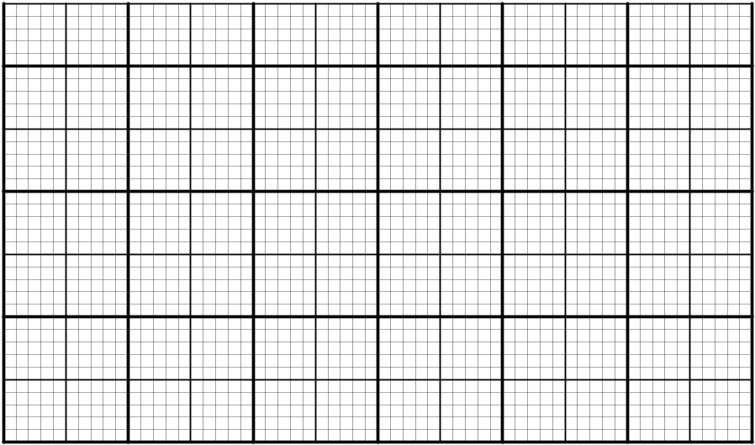

2. In the following circuit, the capacitor is initially uncharged and the switch is closed at time t = 0. How long will it take for the voltage across the capacitor to rise to 9V.

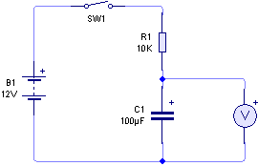

........................................................................................................................................

........................................................................................................................................

........................................................................................................................................

........................................................................................................................................

........................................................................................................................................

........................................................................................................................................

........................................................................................................................................

........................................................................................................................................

........................................................................................................................................

........................................................................................................................................

........................................................................................................................................

3. In the following circuit, the switch is closed to charge the capacitor instantly. Calculate how long after the switch is released for the output voltage to fall from 6V to 2V.

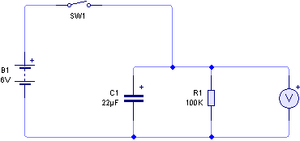

........................................................................................................................................

........................................................................................................................................

........................................................................................................................................

........................................................................................................................................

........................................................................................................................................

........................................................................................................................................

........................................................................................................................................

........................................................................................................................................

........................................................................................................................................

........................................................................................................................................

........................................................................................................................................

........................................................................................................................................
Solutions to Student Exercises.

Student Exercise 1:

i) R = 4.7kΩ, C = 1000μF.

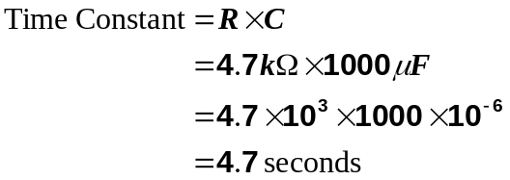

ii) R = 82kΩ, C = 15μF.

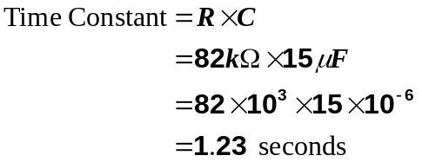

iii) R = 56kΩ, C = 33nF.

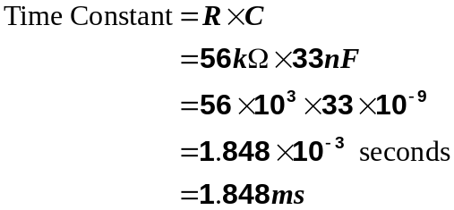

iv) R = 470kΩ, C = 8.2nF.

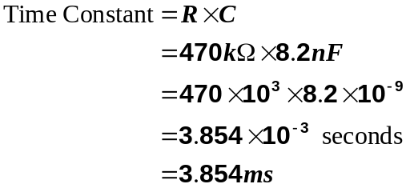

v) R = 2.2MΩ, C = 33μF.

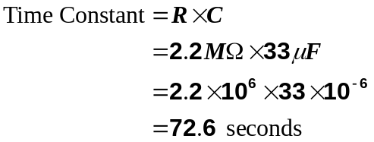

vi) R = 91kΩ, C = 0.22μF.

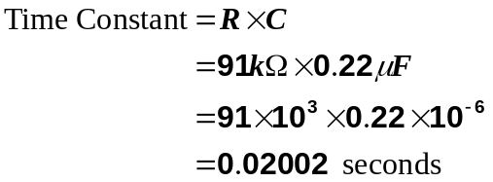

vii) R = 1.8MΩ, C = 470pF.

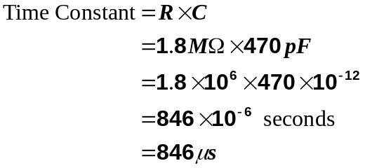

viii) R = 240kΩ, C = 33nF.

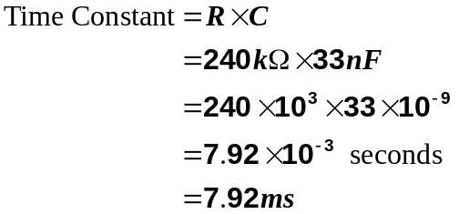

Student Exercise 2:

1.
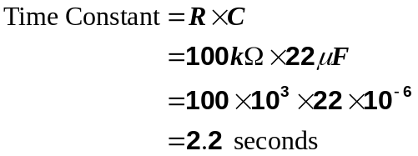

i) at 0.5s ii) at 8s
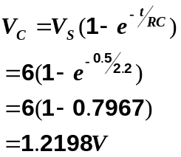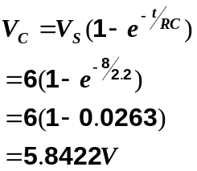

2.
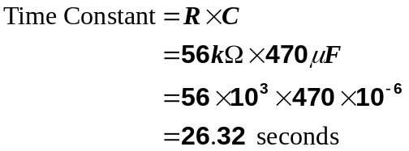

i) at 15s ii) at 40s
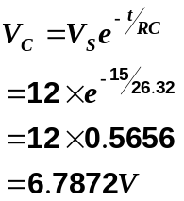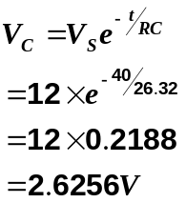

Student Exercise 3.
Step 1 : Calculate the time constant.

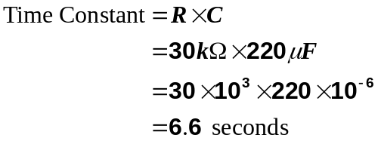

Step 2 : Calculate the time to reach half the supply voltage.

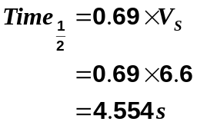

Step 3 : Calculate the time taken to reach 0V.

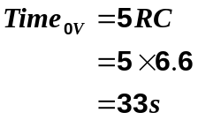

Step 4 : Plot the points on the graph paper and join with a smooth curve.

6

4

2

0

0 10 20 30 40 50 time (s)
2.
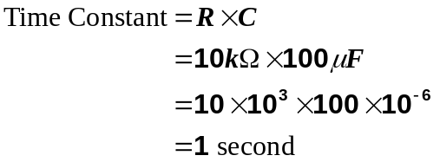

For the mathematician: For the non mathematician
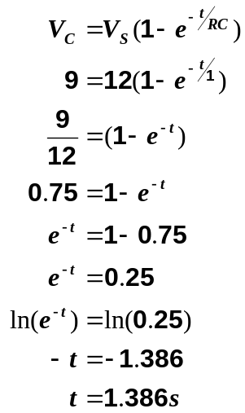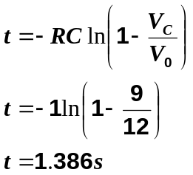

So the voltage will reach 9V, 1.386 seconds after the switch is closed.

3.
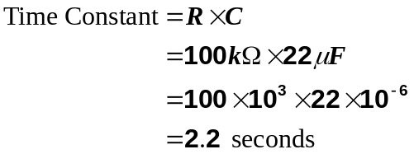

For the mathematician For the non-mathematician

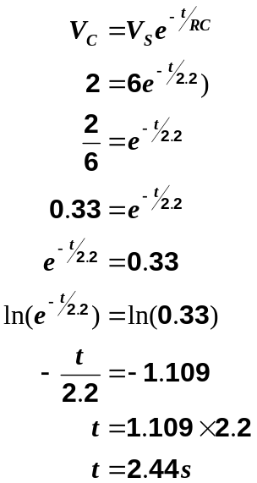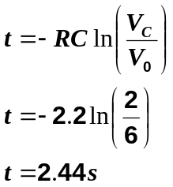

So the voltage will reach 2V, 2.44 seconds after the switch is opened.
The following section contains some past examination questions on RC Timing Circuits.

1. The following circuit is used to provide a time delay.

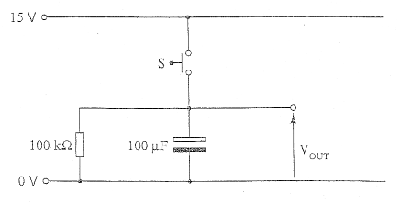

(a) Calculate the time constant of the circuit.

............................................................................................................................

............................................................................................................................
[1]
(b) When the switch S is momentarily closed the capacitor charges up to 15V. Calculate the output voltage 5 seconds after the switch is released.

............................................................................................................................

............................................................................................................................

............................................................................................................................
[2]
(c) Calculate the time taken after the switch is released for the output voltage to fall from 15V to 3V.

............................................................................................................................

............................................................................................................................

............................................................................................................................

............................................................................................................................
[2]
2. (a) The capacitor shown in the circuit below is initially discharged. Switch S₁ is closed at time t = 0.

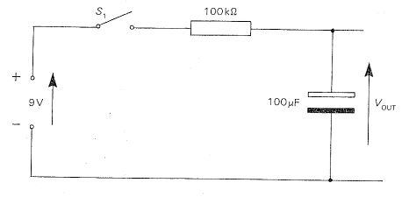

(i) Calculate the time constant of the circuit.

............................................................................................................................

............................................................................................................................
[1]

(ii) Calculate the output voltage after 2s.

............................................................................................................................

............................................................................................................................

............................................................................................................................
[2]
(iii) Calculate the time taken for V_{OUT} to reach 5V.

............................................................................................................................

............................................................................................................................

............................................................................................................................

............................................................................................................................
[2]

(b) The capacitor shown in the circuit below charges up to 12V when switch S₂ is closed.

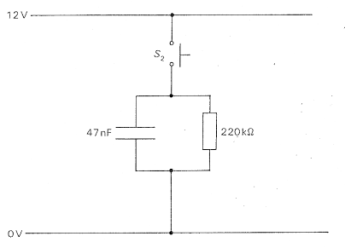

Calculate the time taken, after the switch is released, for the voltage across the capacitor to fall from 12V to 3V

............................................................................................................................

............................................................................................................................

............................................................................................................................

............................................................................................................................

............................................................................................................................

............................................................................................................................
[3]
3. The capacitor shown in the following circuit is initially discharged. The switch S is opened at time t = 0.

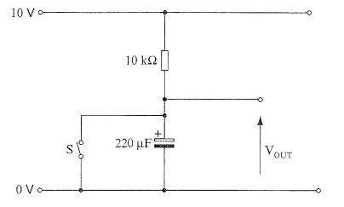

(a) Calculate the time constant of the circuit.

............................................................................................................................

............................................................................................................................
[1]
(b) Determine the time taken for V_{OUT} to reach 5V.

............................................................................................................................

............................................................................................................................

............................................................................................................................
[2]
(c) Calculate the output voltage 20 seconds after the switch is opened.

............................................................................................................................

............................................................................................................................

............................................................................................................................

............................................................................................................................

............................................................................................................................
[2]

4. The capacitor shown in the following circuit is initially discharged. Switch S is closed at time t = 0.

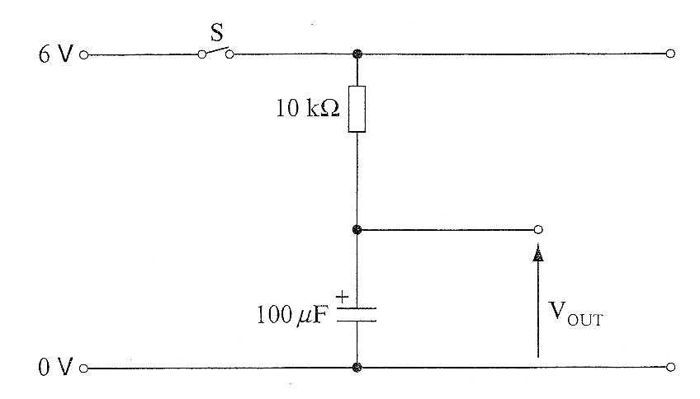

(a) Calculate the time constant of the circuit.

............................................................................................................................

............................................................................................................................
[1]
(b) Determine the time taken for V_{OUT} to reach 3V.

............................................................................................................................

............................................................................................................................

............................................................................................................................
[2]
(c) Calculate the output voltage after 5s.

............................................................................................................................

............................................................................................................................

............................................................................................................................

............................................................................................................................
[2]

5. (a) The capacitor shown in the circuit below is initially uncharged. S₁ is closed at time t = 0.

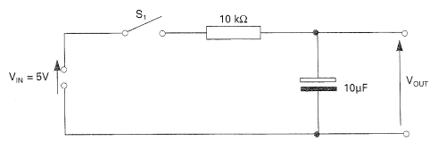

Calculate:

(i) the time constant of the circuit.

............................................................................................................................

............................................................................................................................
[1]
(ii) the time taken for V_{OUT} to reach 2V.

............................................................................................................................

............................................................................................................................

............................................................................................................................
[2]
(iii) the output voltage after 0.5s.

............................................................................................................................

............................................................................................................................

............................................................................................................................

(b) Complete the following graph by showing the output from the circuit when square pulses are applied at its input.

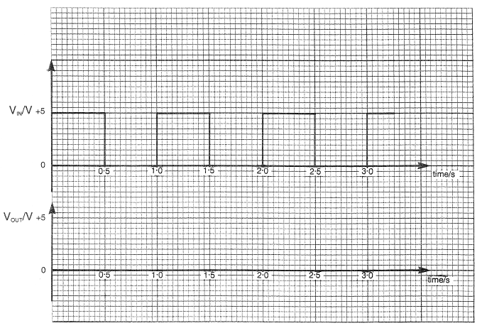
[2]

6. The following circuit is used to provide a time delay. The capacitor charges up to 12V when switch S is momentarily closed.

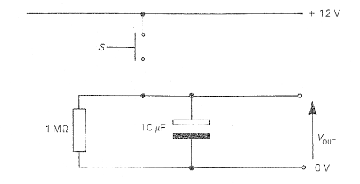

(i) Calculate the time constant of the circuit.

............................................................................................................................

............................................................................................................................
[1]
(ii) Calculate the output voltage 3 seconds after the switch is released.

............................................................................................................................

............................................................................................................................

............................................................................................................................
[2]
(iii) Calculate the time taken after the switch is released for the output voltage to fall from 12V to 4V.

............................................................................................................................

............................................................................................................................

............................................................................................................................

............................................................................................................................
[2]
7. The capacitor shown in the following circuit is initially discharged.

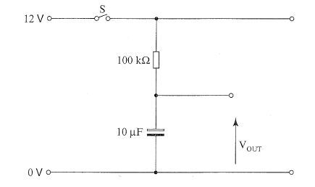

(a) Calculate the time constant of the circuit.

............................................................................................................................

............................................................................................................................
[1]
(b) Switch S is closed at time t = 0.

(i) Determine the time taken for V_{OUT} to reach half the supply voltage.

............................................................................................................................

............................................................................................................................

............................................................................................................................
[2]
(ii) Calculate the output voltage 2s after the switch is closed.

............................................................................................................................

............................................................................................................................

............................................................................................................................
[2]

Self Evaluation Review

Learning Objectives | My personal review of these objectives:
Learning Objectives | ☺ | 😐 | ☹
Explain how capacitors can be used to form the basis of timing circuits;
Calculate the value of the time constant for an RC circuit using ;
Sketch the charge and discharge curves for voltage and current;
Select and use the following formulae relating to the voltage across a capacitor as a function of time:
for a charging capacitor
for a discharging capacitor
Realise that:
V_{C} = 0.5V_{S} after 0.69RC
V_{C}  V_{S} after 5RC for charging capacitors
V_{C}  0V after 5RC for discharging capacitors.

Targets: 1. ………………………………………………………………………………………………………………
………………………………………………………………………………………………………………
- ………………………………………………………………………………………………………………
………………………………………………………………………………………………………………

