Learning Objectives:

At the end of this topic you will be able to;

- draw and interpret graphs of the response of inverting and non inverting amplifiers to AC and DC input signals;
- design single stage amplifiers based on inverting or non-inverting voltage amplifiers, to achieve a specified voltage gain or bandwidth.

Practical Voltage Amplifiers

In this section we are going to be putting together all of the work done in the previous topics to look at the design of both d.c. and a.c. amplifiers, inverting and non-inverting with or without specific bandwidth requirements. We will examine a few examples first and then you will be able to tackle the sort of questions that come up on examination papers.

The most important thing to remember with all of these questions is that you will be expected to be able to draw and recognise the circuit diagrams for both inverting and non-inverting amplifiers from memory. There are a couple of rules that may help you to remember how to draw the amplifier circuits as follows:

- the feedback resistor R_{F} always goes between the output, and the inverting or ‘-‘ input.
- for an inverting amplifier V_{IN} is connected to the inverting or ‘-‘ input through an input resistor R_{IN}. The non-inverting or ‘+’ input is connected directly to the 0V line.
- for a non-inverting amplifier V_{IN} is connected directly to the non-inverting or ‘+‘ input. The inverting or ‘-’ input is connected through a resistor R₁ to the 0V line.

So now let’s have a look at some examples and their solutions.
Example 1 : Look at the circuit diagram below:
180kΩ
30kΩ
+
-
V_{out}
V_{in}
0V

- What type of amplifier is this, inverting or non inverting ?

Answer = inverting since V_{IN} connected to ‘-‘ input.

(b) What is the input impedance of this amplifier?

Answer = 30kΩ (the value of R_{IN})

- What is the gain of this amplifier ?

Answer: 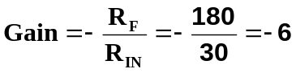

- The table gives some data about the Op-amp used in the circuit.

Parameter | Value
Open-loop gain | 120,000
Input Impedance | 15 M
Gain bandwidth product | 3 MHz
Slew-rate | 5 V/µs

- Calculate the bandwidth of the amplifier shown in the diagram.

Answer : From part (b) gain = 6, From table GBP = 3MHz.

So 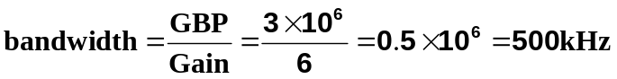

(ii) The inverting amplifier is re-configured to be a non-inverting amplifier, with the same gain, using the same op-amp.
What is the value of input impedance for this new circuit ?

Answer : 15MΩ (the value of the input impedance of the amplifier)

Example 2: The following circuit shows an amplifier constructed from an op-amp.
R_{f} = 22kΩ
R₁= 2.2kΩ
+
-
V_{out}
V_{in}
0V
+V
-V

- What type of amplifier is this, inverting or non inverting ?

Answer = non-inverting since V_{IN} connected to ‘+’ input.

(b) What is the gain of this amplifier ?

Answer: 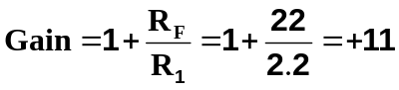

(c) A d.c. voltage of 0.2V is applied to V_{IN}, what is the value of the output Voltage V_{OUT}.

Answer: 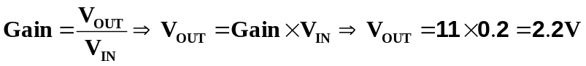

(d) The following graph shows a variable signal applied to the input V_{IN}. Complete the graph for V_{OUT}.

1.2

0.8

0.4

0

-0.4

-0.8

-1.2
14

12

10

8

6

4

2

0

-2

-4

-6

-8

-10

-12

-14
First put in all the minimum and maximum points, using the gain formula.
Second – Join points with straight lines in this case as inputs are straight lines.
V_{IN} / V
V_{OUT} / V

Now its your turn – Here are some previous exam questions to try.
Examination Style Questions:

- Here is the circuit diagram of an inverting voltage amplifier.

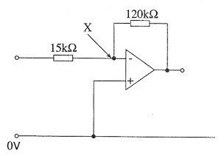

  - What is the gain of this amplifier ?

…………………………………………………………………………………………………

…………………………………………………………………………………………………
[2]
(b) The table gives some data about the op-amp used in this circuit.

Parameter | Value
Open-loop gain | 100,000
Input Impedance | 20 M
Gain bandwidth product | 1 MHz
Slew-rate | 35 V/µs

- Calculate the bandwidth of the amplifier shown in the diagram.

…………………………………………………………………………………………………

…………………………………………………………………………………………………
[1]
(ii) The inverting amplifier is replaced by a non-inverting amplifier, with the same gain, using the same op-amp.

What is the value of input impedance for this new circuit?

…………………………………………………………………………………………………
[1]
2. A DC voltage amplifier is required to change the output voltage from 0V to -2V when the input voltage increases from 0V to 0.1V.

The circuit diagram for the amplifier is given below.

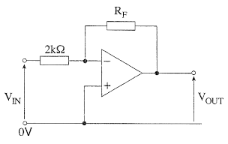

- What voltage gain is needed for the amplifier ?

Voltage gain = ………………………………………….
[1]
- With this gain, what would be the output voltage, V_{OUT} , when the input voltage V_{IN} = 0.01V.

V_{OUT} = …………………………………………………..
[1]
- State a suitable value for resistor RF to produce the required gain.

RF = …………………………………………………….
[1]
- What is the input impedance of the amplifier?

Input Impedance = ……..…………………………….....
[1]

3. The diagram shows part of the circuit of a non-inverting voltage amplifier.

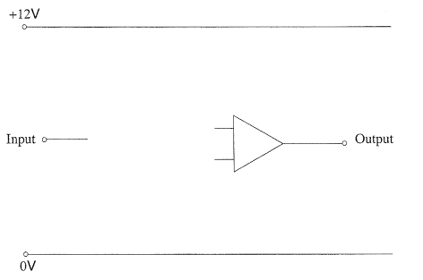

- Complete the circuit diagram by

  - adding any necessary connections,
  - labelling the inverting and non-inverting inputs of the op-amp.
[3]

- Label the circuit diagram with suitable resistor values to give the amplifier a gain of +48.

…………………………………………………………………………………………………

…………………………………………………………………………………………………
[2]
4. Here is some data about two Op-Amps, P & Q.

Property | P | Q
Input Impedance / Ω | 5 x 10⁹ | 4 x 10⁶
Open loop gain | 7 x 10⁵ | 2 x 10⁵
Max. output current /mA | 10 | 20
Gain bandwidth product / MHz | 4 | 1
Slew rate / Vs⁻¹ | 2.0 | 1.0
Max. output voltage / V | 16 | 5

(a) For each of the following questions state which op-amp would be most suitable.
Give a reason for your choice.
[2]

(i) Which amplifier is capable of reaching its maximum output voltage in the shortest time ?

Suitable Op-amp ...............................................................

Reason: .....................................................................................................................

....................................................................................................................................

(ii) Which amplifier would have a bandwidth of 125kHz when configured to have a gain of +32 ?

Suitable Op-amp ...............................................................

Reason: .....................................................................................................................

....................................................................................................................................

(b) A third op-amp R is configured as a non-inverting amplifier. Its frequency response is shown in the following graph. Use the graph to estimate the bandwidth of this amplifier. Show on the graph how you would obtain your result.
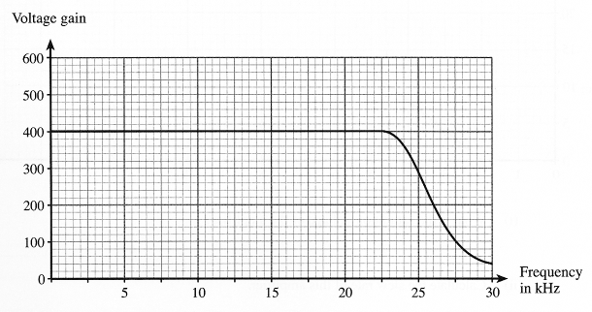

Bandwidth = .................................................................... kHz

5. (a) Draw the circuit diagram for an inverting voltage amplifier using an op-amp. Label V_{OUT} and V_{IN}.
[3]
+
-
0V

(b) Calculate suitable resistor values to give a voltage gain of -40.
[2]
…………………………………………………………………………………………………

…………………………………………………………………………………………………

…………………………………………………………………………………………………

…………………………………………………………………………………………………

(c) The following input signal is applied to V_{IN}. Sketch the output voltage on the axes below. Label the voltage axis with appropriate values.

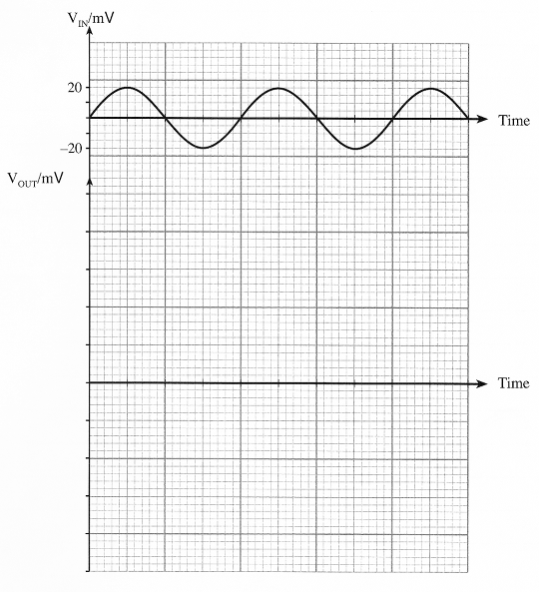

6. (a) Draw the circuit for a non-inverting amplifier based on an op-amp.
[3]
+
-
0V

(b) Select suitable resistors to give a voltage gain of 30.
[2]
...........................................................................................................................................................

...........................................................................................................................................................

...........................................................................................................................................................

(c) The upper graph shows a signal applied to the input of the voltage amplifier. Draw the output voltage on the lower set of axes provided. The op-amp is powered from a ±12V supply.
[3]

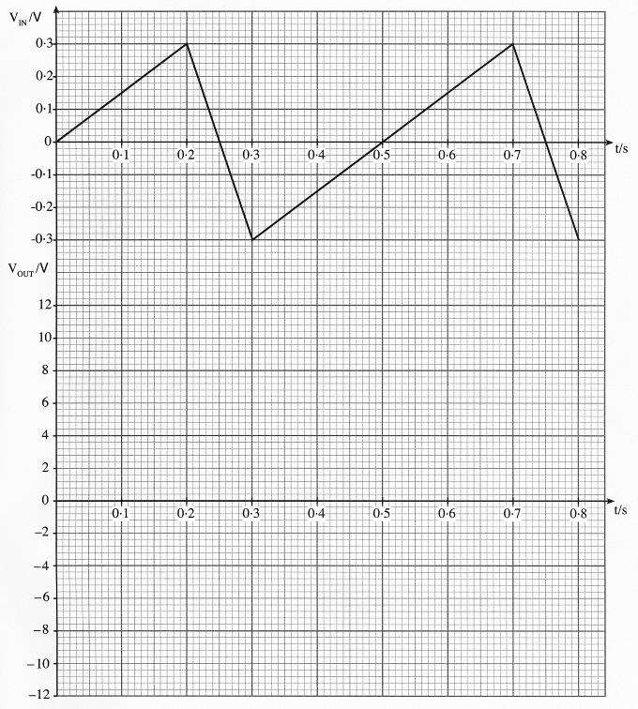

7. (a) Draw the circuit diagram for a non-inverting voltage amplifier, based on an op-amp.
[3]
+
-
0V

(b) Select suitable resistor values to give a voltage gain of 20.
[2]
…………………………………………………………………………………………………

…………………………………………………………………………………………………

…………………………………………………………………………………………………

…………………………………………………………………………………………………

Self Evaluation Review

Learning Objectives | My personal review of these objectives:
Learning Objectives | ☺ | 😐 | ☹
draw and interpret graphs of the response of inverting and non inverting amplifiers to AC and DC input signals;
design single stage amplifiers based on inverting or non-inverting voltage amplifiers, to achieve a specified voltage gain or bandwidth.

Targets: 1. ………………………………………………………………………………………………………………

………………………………………………………………………………………………………………

- ………………………………………………………………………………………………………………

………………………………………………………………………………………………………………

