Quality Assurance
The purpose of quality assurance
Organisations must be accountable for the level of service they offer. Quality assurance procedures are used to help services measure performance against a range of standards. This gives a good idea as to how well the service is running and identifies areas of improvement and areas of strength. It is a way of trying to ensure all service users receive good quality care and to increase the confidence of service users whilst receiving care.
How quality assurance is influenced
The standards that services have to work to are increasingly being developed and will be dependent on a range of factors. These can include pieces of legislation, such as The Disability Discrimination Act (1995) and The Care Standards Act (2000). Other influences can be codes of conduct or regulations, such as safeguarding, fire safety or health and safety within the workplace and lastly, national targets set by the government, such as targets to reduce waiting times.
Find more information about care standards at:
http://wales.gov.uk/topics/health/socialcare/carestandardsact/?lang=en

Methods of quality assurance

Quality assurance is carried out in a range of ways and is assessed internally or externally by regulatory bodies. It is an ongoing process. Methods can include:

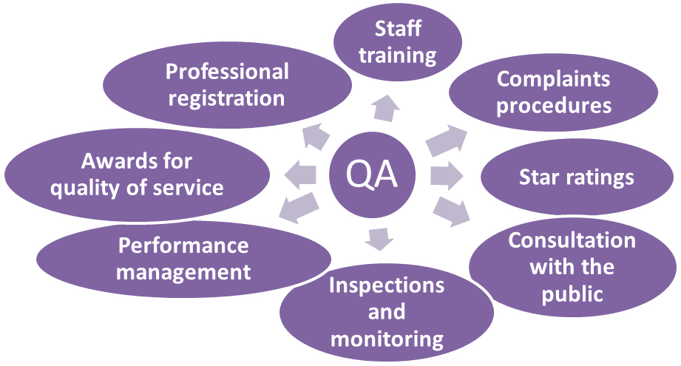

Monitoring and inspection of services
Monitoring and inspecting services can be an effective form of quality assurance. It can provide a wealth of information about the quality of care. Monitoring is carried out internally or externally by an external regulatory body.
Each sector has its own regulatory body. Examples of this include: The Health Inspectorate Wales (HIW), which undertakes inspections and investigations into the provision of healthcare in Wales; Ofsted which inspects education provision in England; and Estyn which inspects education provision in Wales.
When external inspections are carried out there will be a set of minimum standards set by the government that the service will have to meet.
When assessing the service, factors such as the quality of care, the facilities and use of resources will be inspected. Services are then graded on how well they meet the standards and this information is usually visible to the public to allow them to make informed decisions about their care.
Consultation with the public
Service users play a crucial role in the development and improvement of services. This can be done in many ways. These include:
- Patients’ forums where a select group of individuals represent others and talk about the service and try resolve issues.
- Leaflets about services.
- PALS which provides advice and resolves problems for NHS patients.
- Anonymous service user suggestion boxes which allow individuals to offer suggestions about ways they think the service could improve.
- Questionnaires sent to households or given out to service users to gather opinions on how well they think the service is run.

Complaints procedure
Another method of quality assurance is a complaints procedure. Each service must have a complaints procedure in place, with clear guidance on what an individual would need to do if they were not happy with the service they’d received. It can be an effective form of quality assurance and can allow a service to respond to individuals who are unhappy about the level of care they have received.
There are also independent bodies that help resolve complaints. These include:
- Citizens Advice Bureau
- Independent Complaints Advocacy Services
- The Patients Association

Quality awards and star ratings
Quality awards are a way of rewarding good practice. All public sector organisations can apply for formal assessment to receive what is known as a Charter Mark. The Charter Mark standard focuses on the level of their customer service. Organisations that meet the standard must be able to show they put their customers first and aim to constantly improve and give a good value service.
All holders of Charter Mark are assessed once a year to make sure they still meet the standards. Assessors judge organisations based on documentary evidence, observations and discussions.
To receive a Charter Mark and organisation must:
- show evidence of accessibility for everyone
- show effective use of resources
- meet performance indicators.
Star ratings
Star ratings are a form of performance indicators that are used within the NHS. They can indicate how well a particular NHS trust is run. The NHS trust will be assessed against targets set by the government. Information needed to complete the assessment will be collated from surveys given to staff, patients, and patient’s carers and then used to assess performance. The trust will then be graded from zero stars through to three stars. Individuals can then search the NHS trust and they can see how well they are performing, which can then help them to make decisions about their treatment options.
Staff training
Staff within any health, social care or children’s service need to be trained in order to provide effective care. Training is an ongoing process, as practices can change.
When first starting work at a service, there should be range of procedures in place to induct the individual about the settings’ practices. This can include:
- health and safety
- fire safety
- first aid
- manual handling.

Correct training can not only prevent accidents, it can also make service users feel secure within the setting and provide quality service.

Professional registration
Professional registration shows the level of competency an individual has and allows them to be recognised for it.
Each profession has its own professional body that sets standards and codes of conduct that will have to be followed. For example, teachers are registered with the General Teaching Council. The council sets codes of conducts and standards that teachers have to abide by.
Other bodies include the Nursing and Midwifery Council, who set standards and codes of conduct for all nurses and midwives. They also deal with allegations made about a nurse or midwife and will work to try to resolve the issue.
Performance management
Services and staff working in the services will have their performance monitored. This ensures that targets are being met in an effective and efficient way. The main focus of performance management is continuous improvement.
The process is cyclical and will start with identifying targets and ways to address the targets. This will then be monitored and measured as to how well the targets have been met.
Find more information about the NHS performance management in Wales at:
http://wales.gov.uk/topics/health/nhswales/performance/?lang=en

Continuous professional development

After initial training, each service has a responsibility to ensure their employees continue to develop. Employees should continuously keep up to date with current practices and identify areas of weakness and seek ways to address these, in order to progress and therefore promote good quality care. This is known as continuous professional development (CPD). This can include:
- Mentoring other individuals or being mentored by a more experienced individual.
- Gaining further qualifications.
- Attending external courses to update knowledge.
- Staff inductions to teach the policies and procedures within a service.
- Internal training.
- Reading about changes in practice.

Disclaimer:
All the web links used here were current and live at the point these resources were created. We do not hold responsibility for any of the links cited becoming broken or no longer in existence.

