Types of Joints

Look at every one of the types of joints shown below.

- Name every joint type
- Give one example within your body
- Describe the movement it allows.

The first has been completed already:

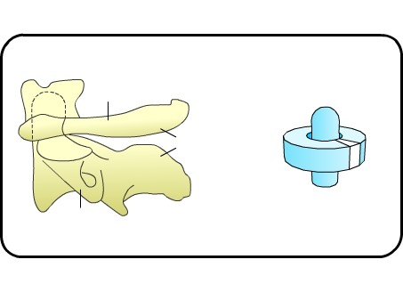 | Name: Pivotal  Example: Atlas and axis  Movement it allows:  It allows for rotating only.  We can move the head to the right or left.
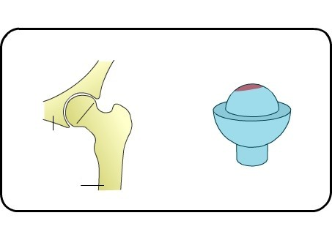 | Name:  Example:  Movement it allows:
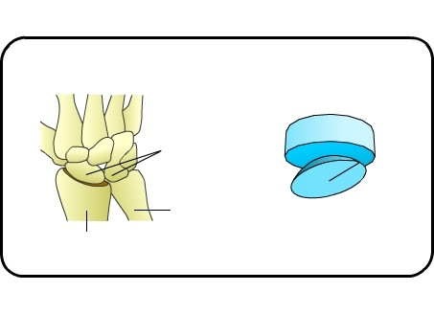 | Name:  Example:  Movement it allows:
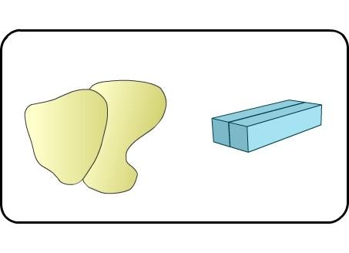 | Name:  Example:  Movement it allows:
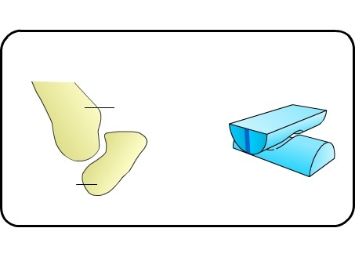 | Name:  Example:  Movement it allows:
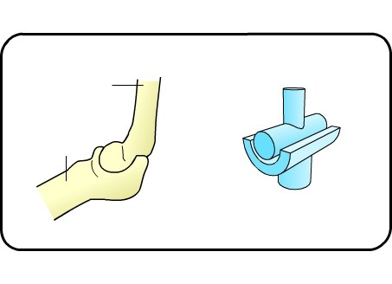 | Name:  Example:  Movement it allows:

