WJEC C2 June 2008
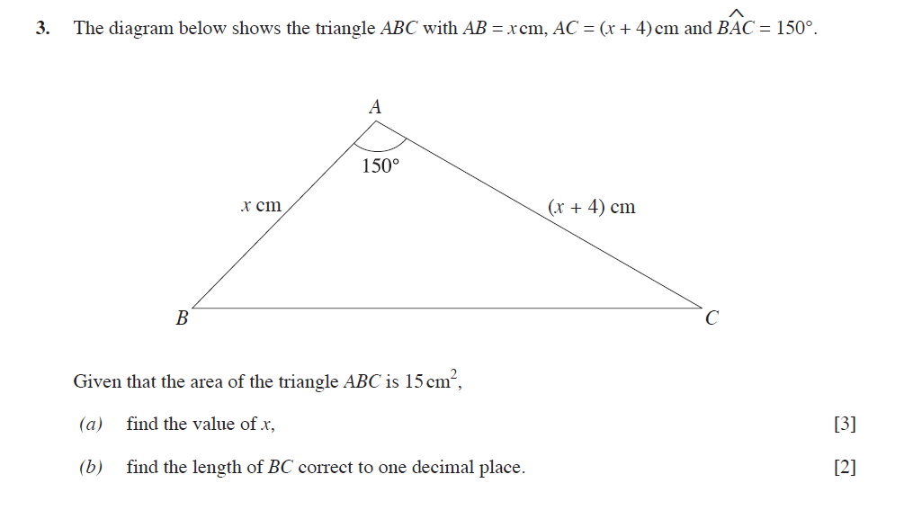
WJEC C2 January 2009

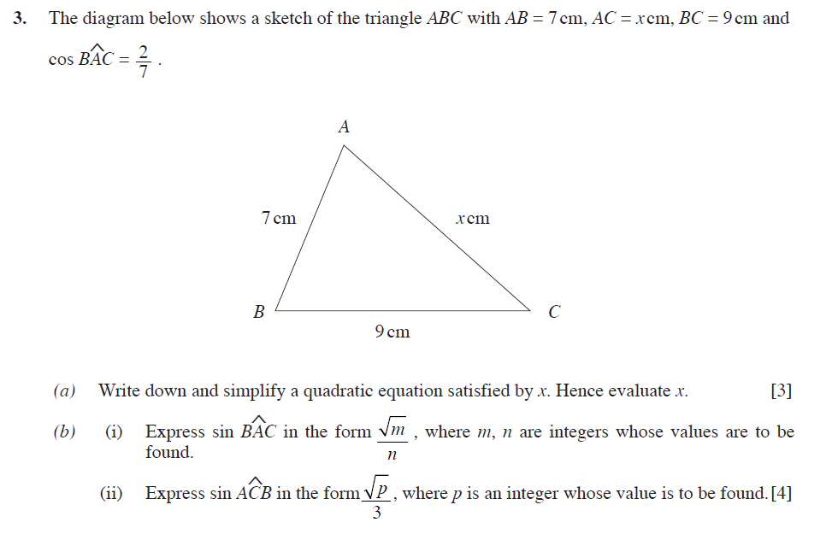

WJEC C2 June 2009
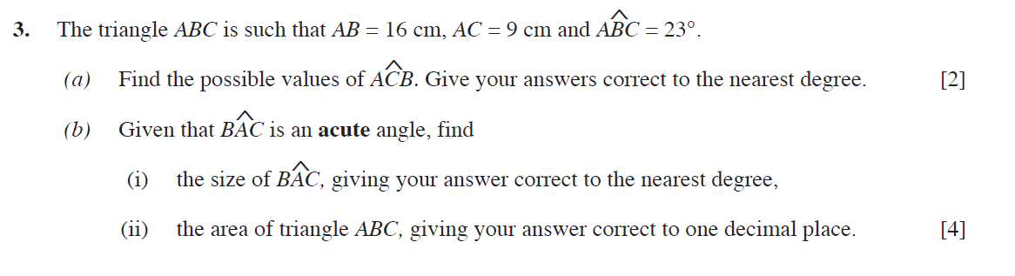

WJEC C2 January 2010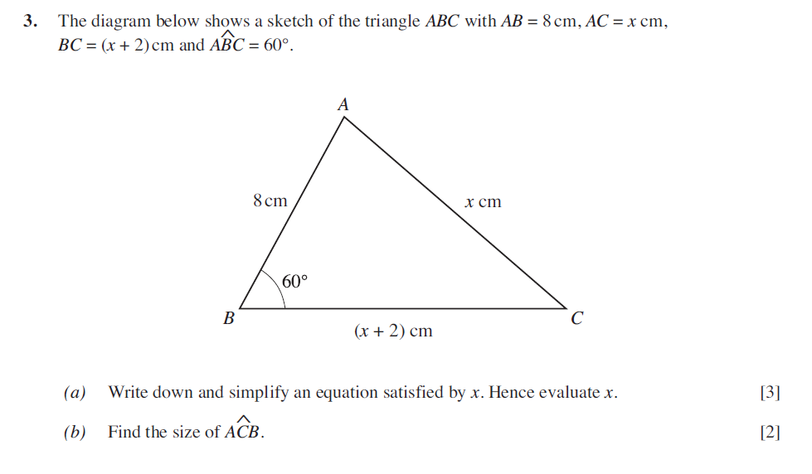
WJEC C2 June 2010
