WJEC C1 June 2008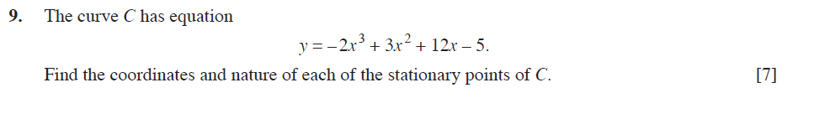
WJEC C1 January 2009
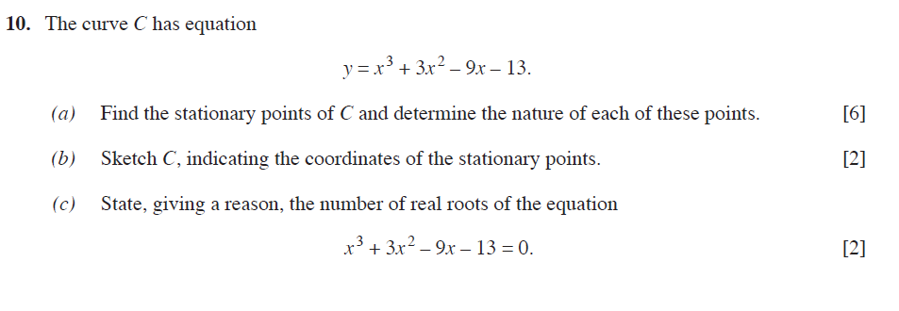
WJEC C1 June 2009
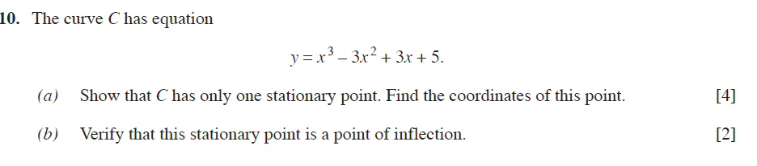
WJEC C1 January 2010
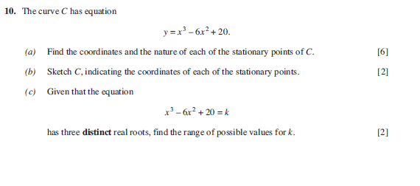

WJEC C1 June 2010
