WJEC C1 June 2008
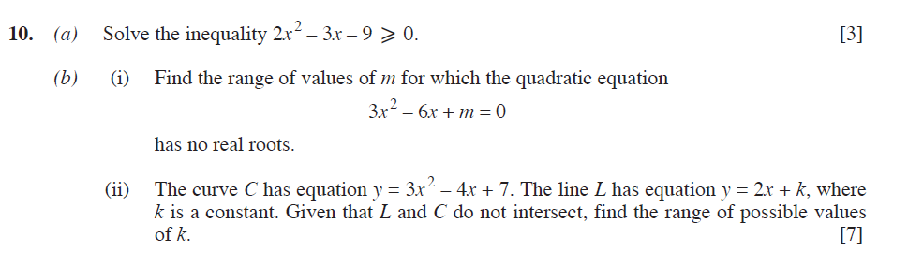

WJEC C1 January 2009
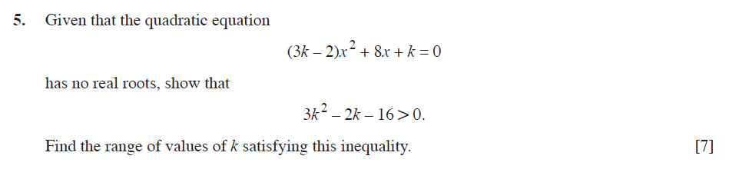

WJEC C1 June 2009

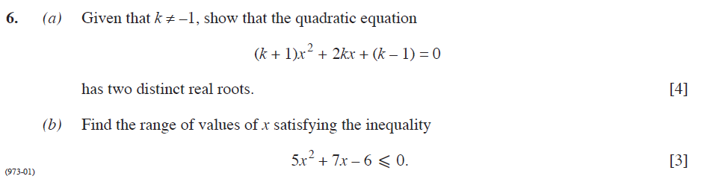

WJEC C1 January 2010
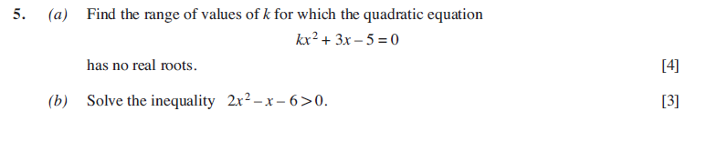

WJEC C1 June 2010
