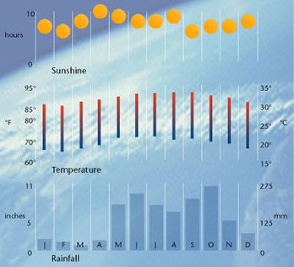

Activity 8 a
Study the climate graph for Grand Cayman above and complete the table below. (reveal)

Month with the most sunshine | April
Month with the least sunshine | February
Month with the highest temperature | August
Month with the lowest temperature | February
Month with the most rainfall | October
Month with the least rainfall | March

Activity 8 b
Find climate information for Cardiff and New York and then complete the tables below.
Month - January
Destination/Climate | Grand Cayman | Cardiff | New York
Temperature range (maximum & minimum)
Amount of rainfall

Hours of sunshine

Month - March
Destination/Climate | Grand Cayman | Cardiff | New York
Temperature range (maximum & minimum)
Amount of rainfall

Hours of sunshine

Suggest why the months of January, February and March are popular months to visit Grand Cayman.
______________________________________________________
______________________________________________________
______________________________________________________
______________________________________________________
______________________________________________________
______________________________________________________

