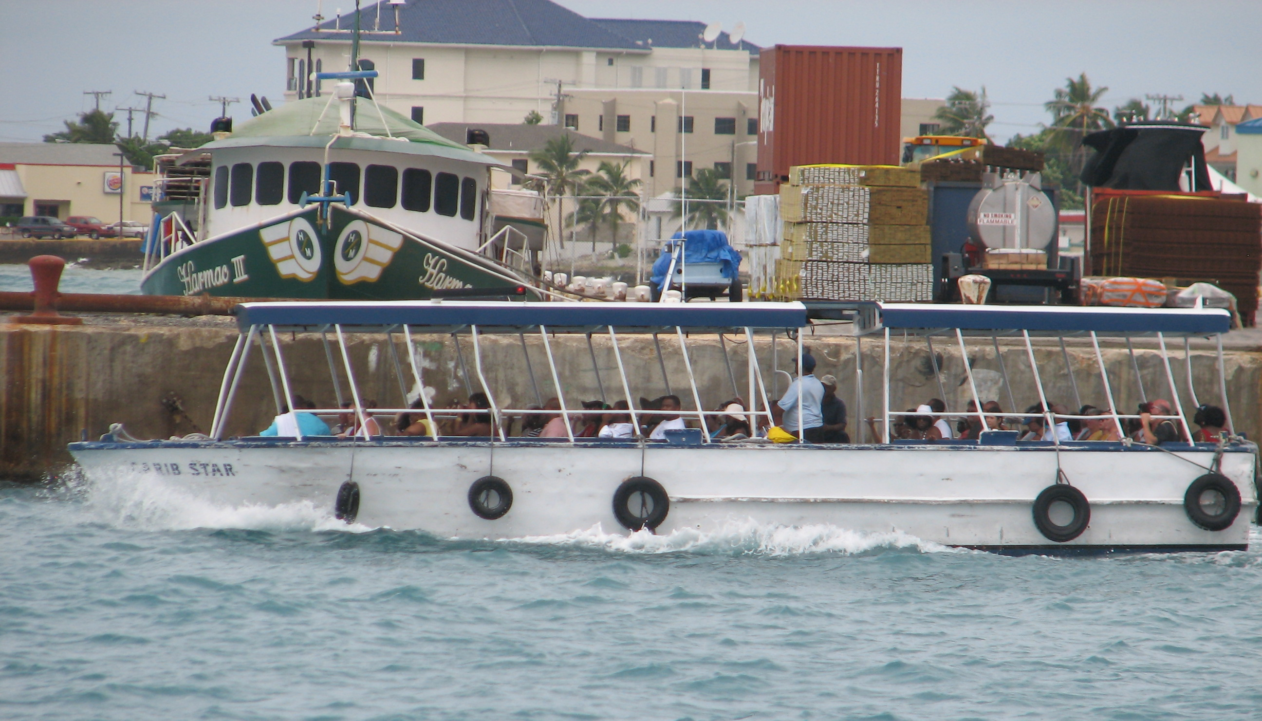
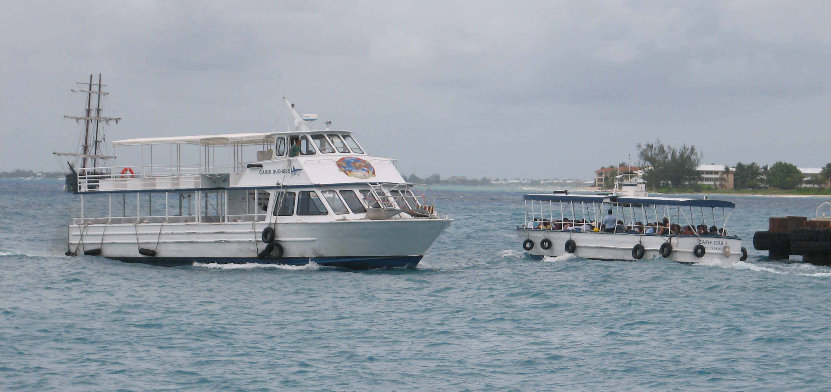
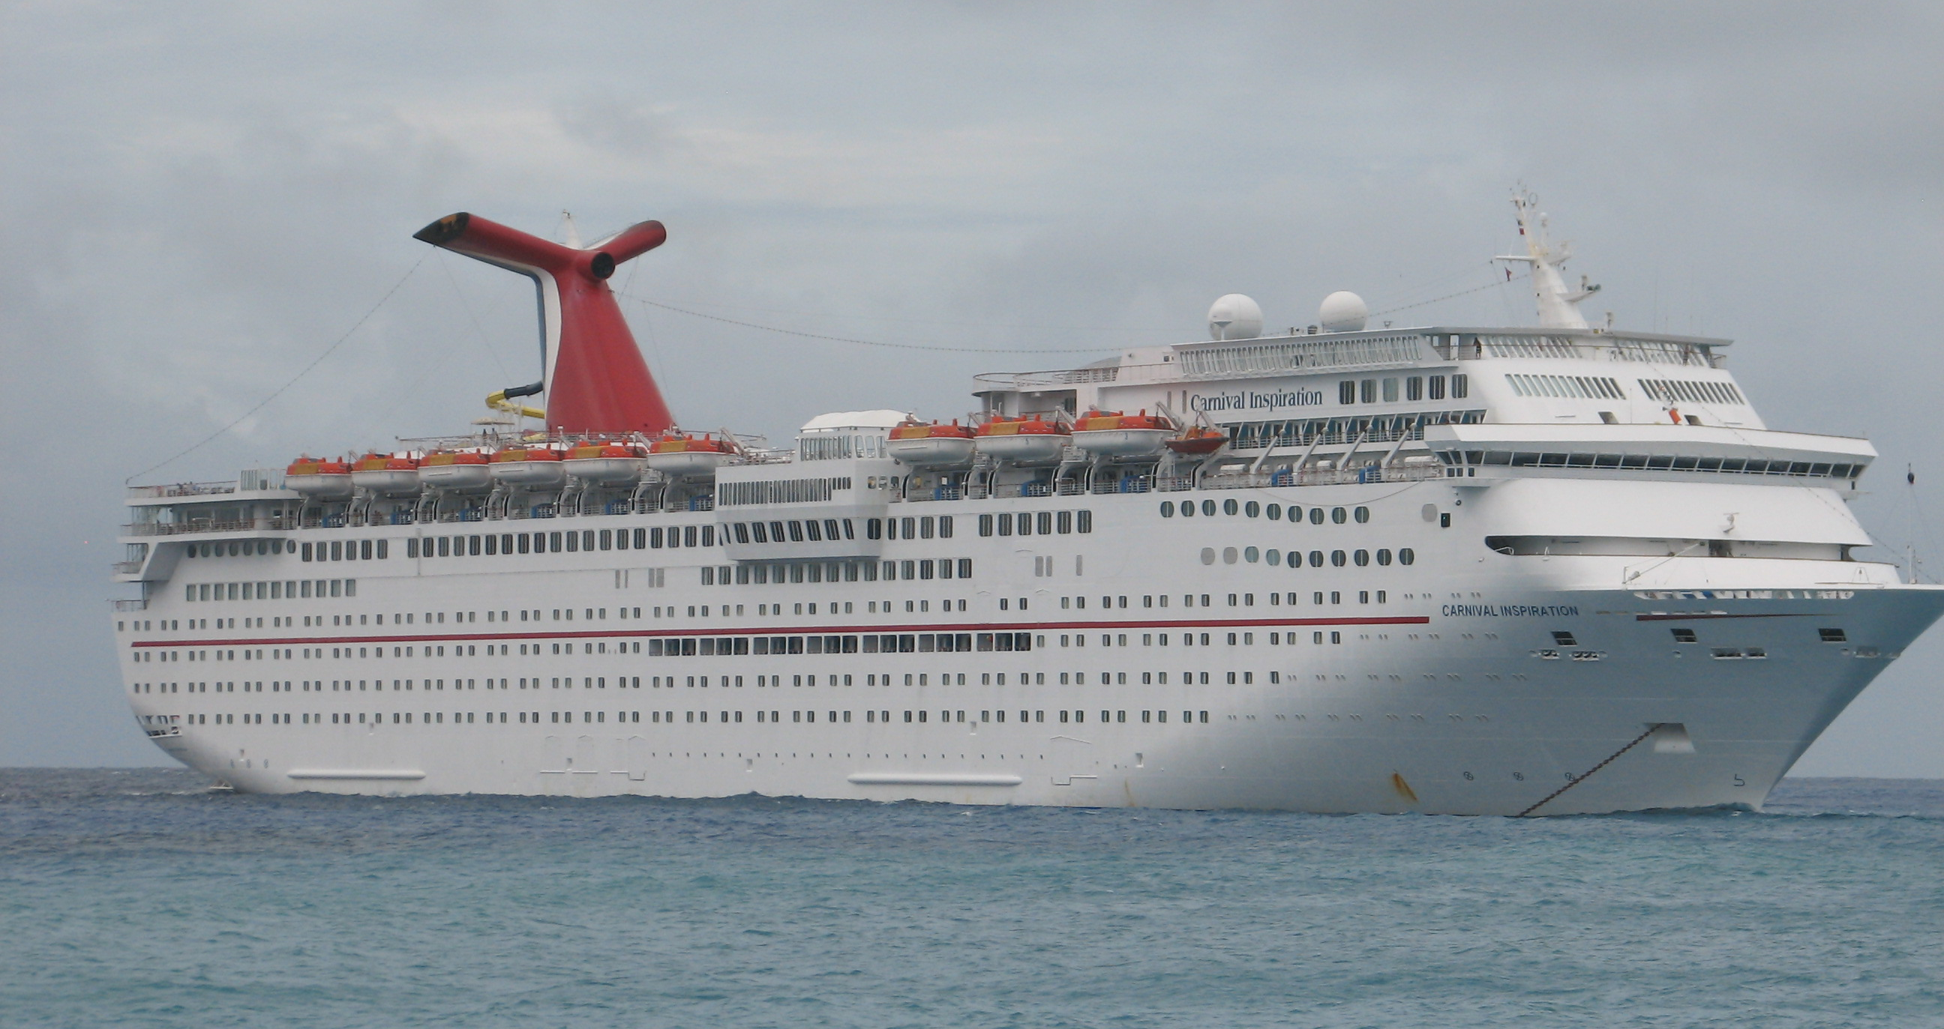
Activity 7
Think of three disadvantages for the economy of Grand Cayman if cruise ship passengers stay on board rather than going ashore.
- _________________________________________________
_________________________________________________
- _________________________________________________
_________________________________________________
- _________________________________________________

