Some of the other sites managed by the Cayman Islands National Trust include.
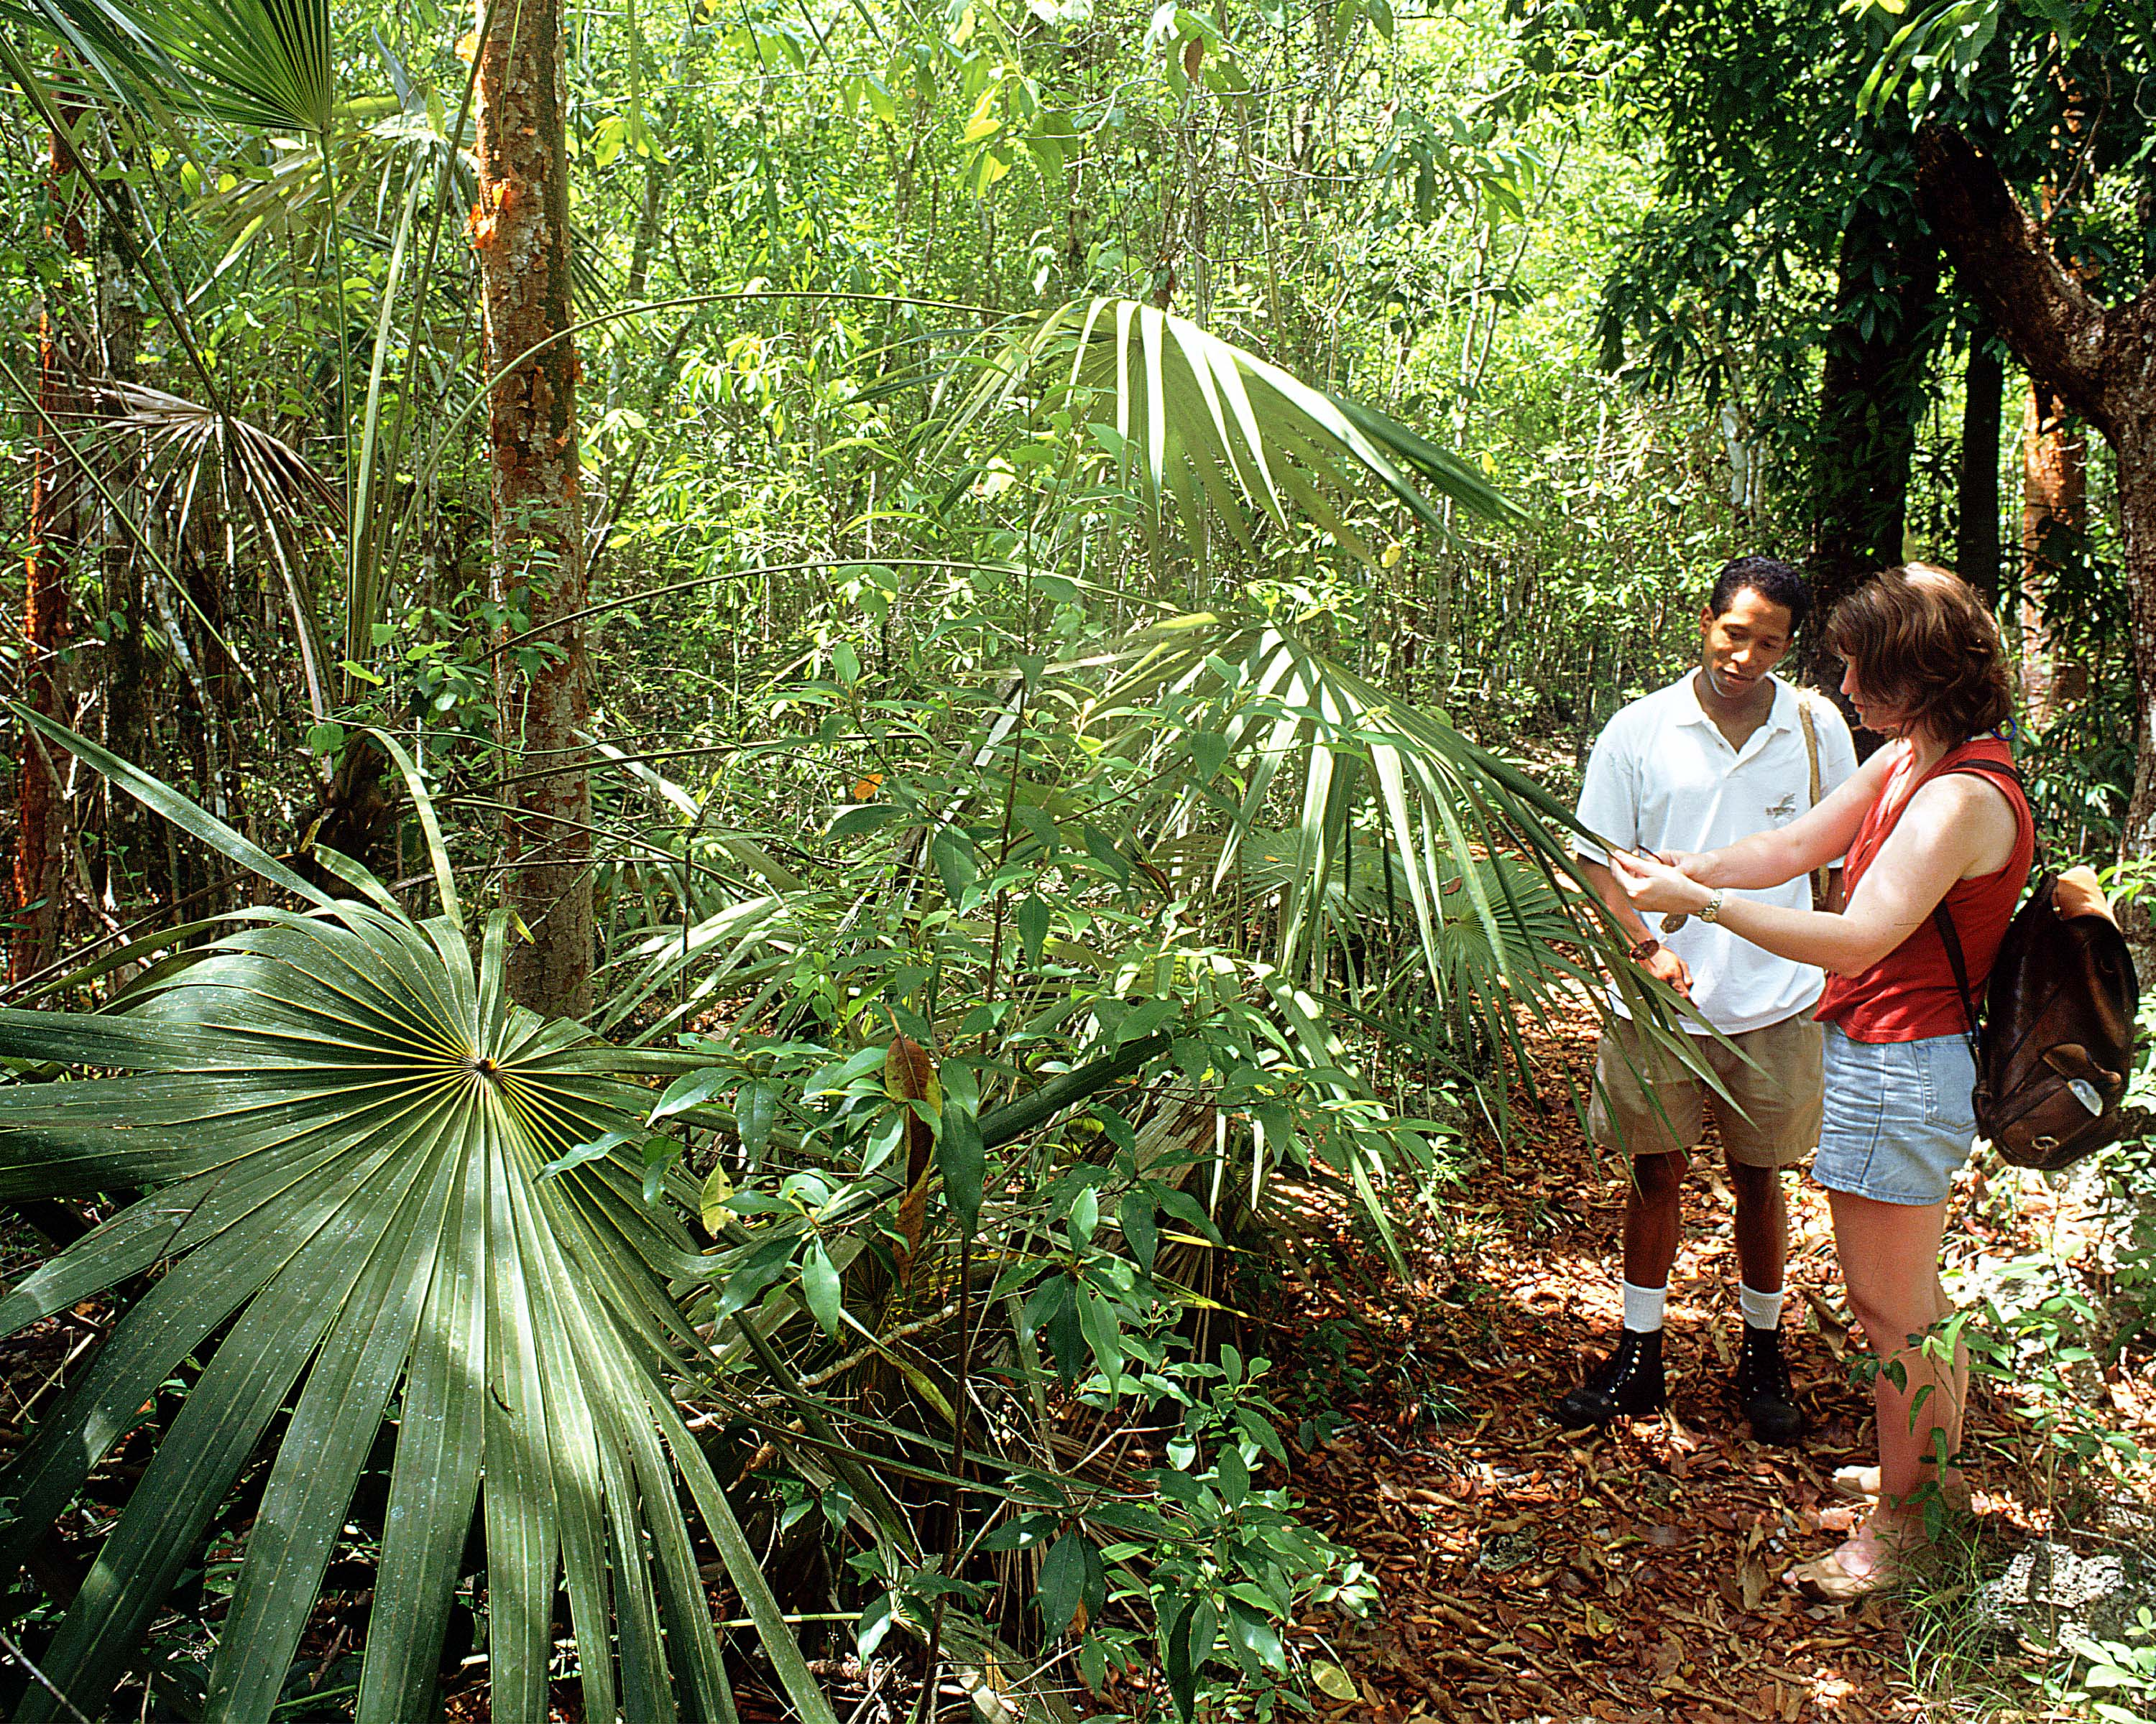
Savannah School House
Lighthouse Park
Miss Izzy’s School House
Fort George Historic Site
Savannah School House Historic Site
Bodden Town Guardhouse Park
Governor Gore Historic Site
Heritage Beach
Salina Reserve
Mastic Trail
www.nationaltrust.org.ky

Activity 4

Using the National Trust for the Cayman Islands website, provide a brief description of five of the attractions mentioned above.

