Swansea Marina - Information

Introduction

Swansea Marina lies in the very heart of the city's redevelopment programme and award winning Maritime Quarter. Formerly, the area was the docklands where ships docked to load and unload their cargo.
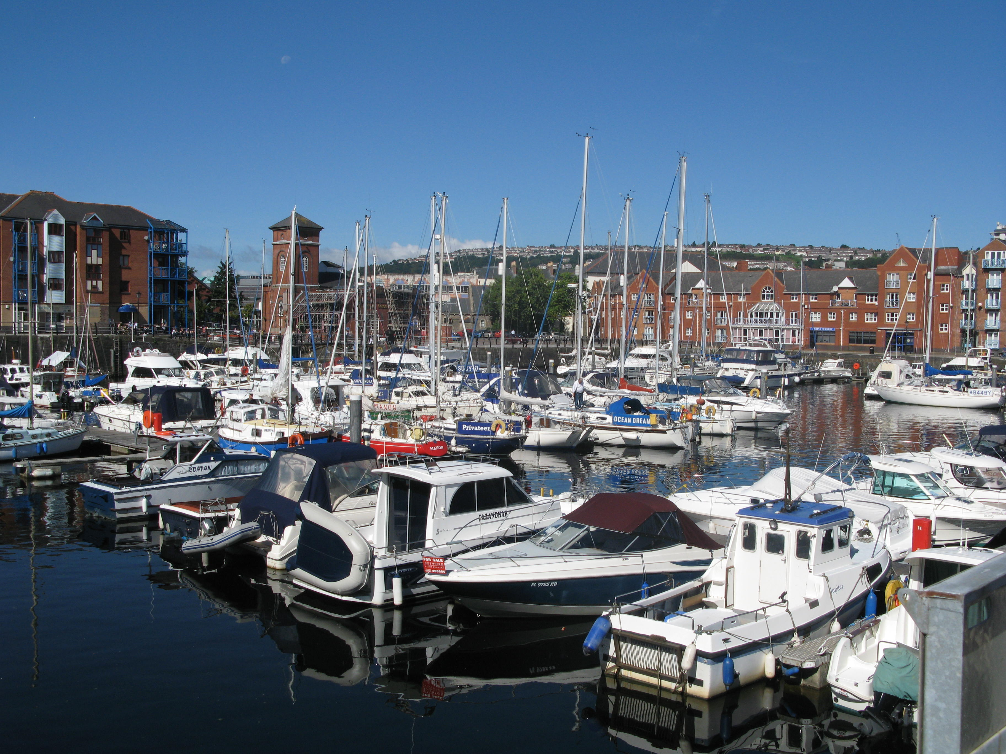
Swansea Marina was the first coastal marina to open in the Bristol Channel and is one of the few marinas in the UK to hold the coveted ‘Yacht Harbour Association 5 Gold Anchor’ award. The marina is bordered by the city centre on one side and a sandy beach on the other.

The marina works hard to provide customers with a first class service at value for money, and is committed to providing customers with a facility that offers both an excellent location and atmosphere.

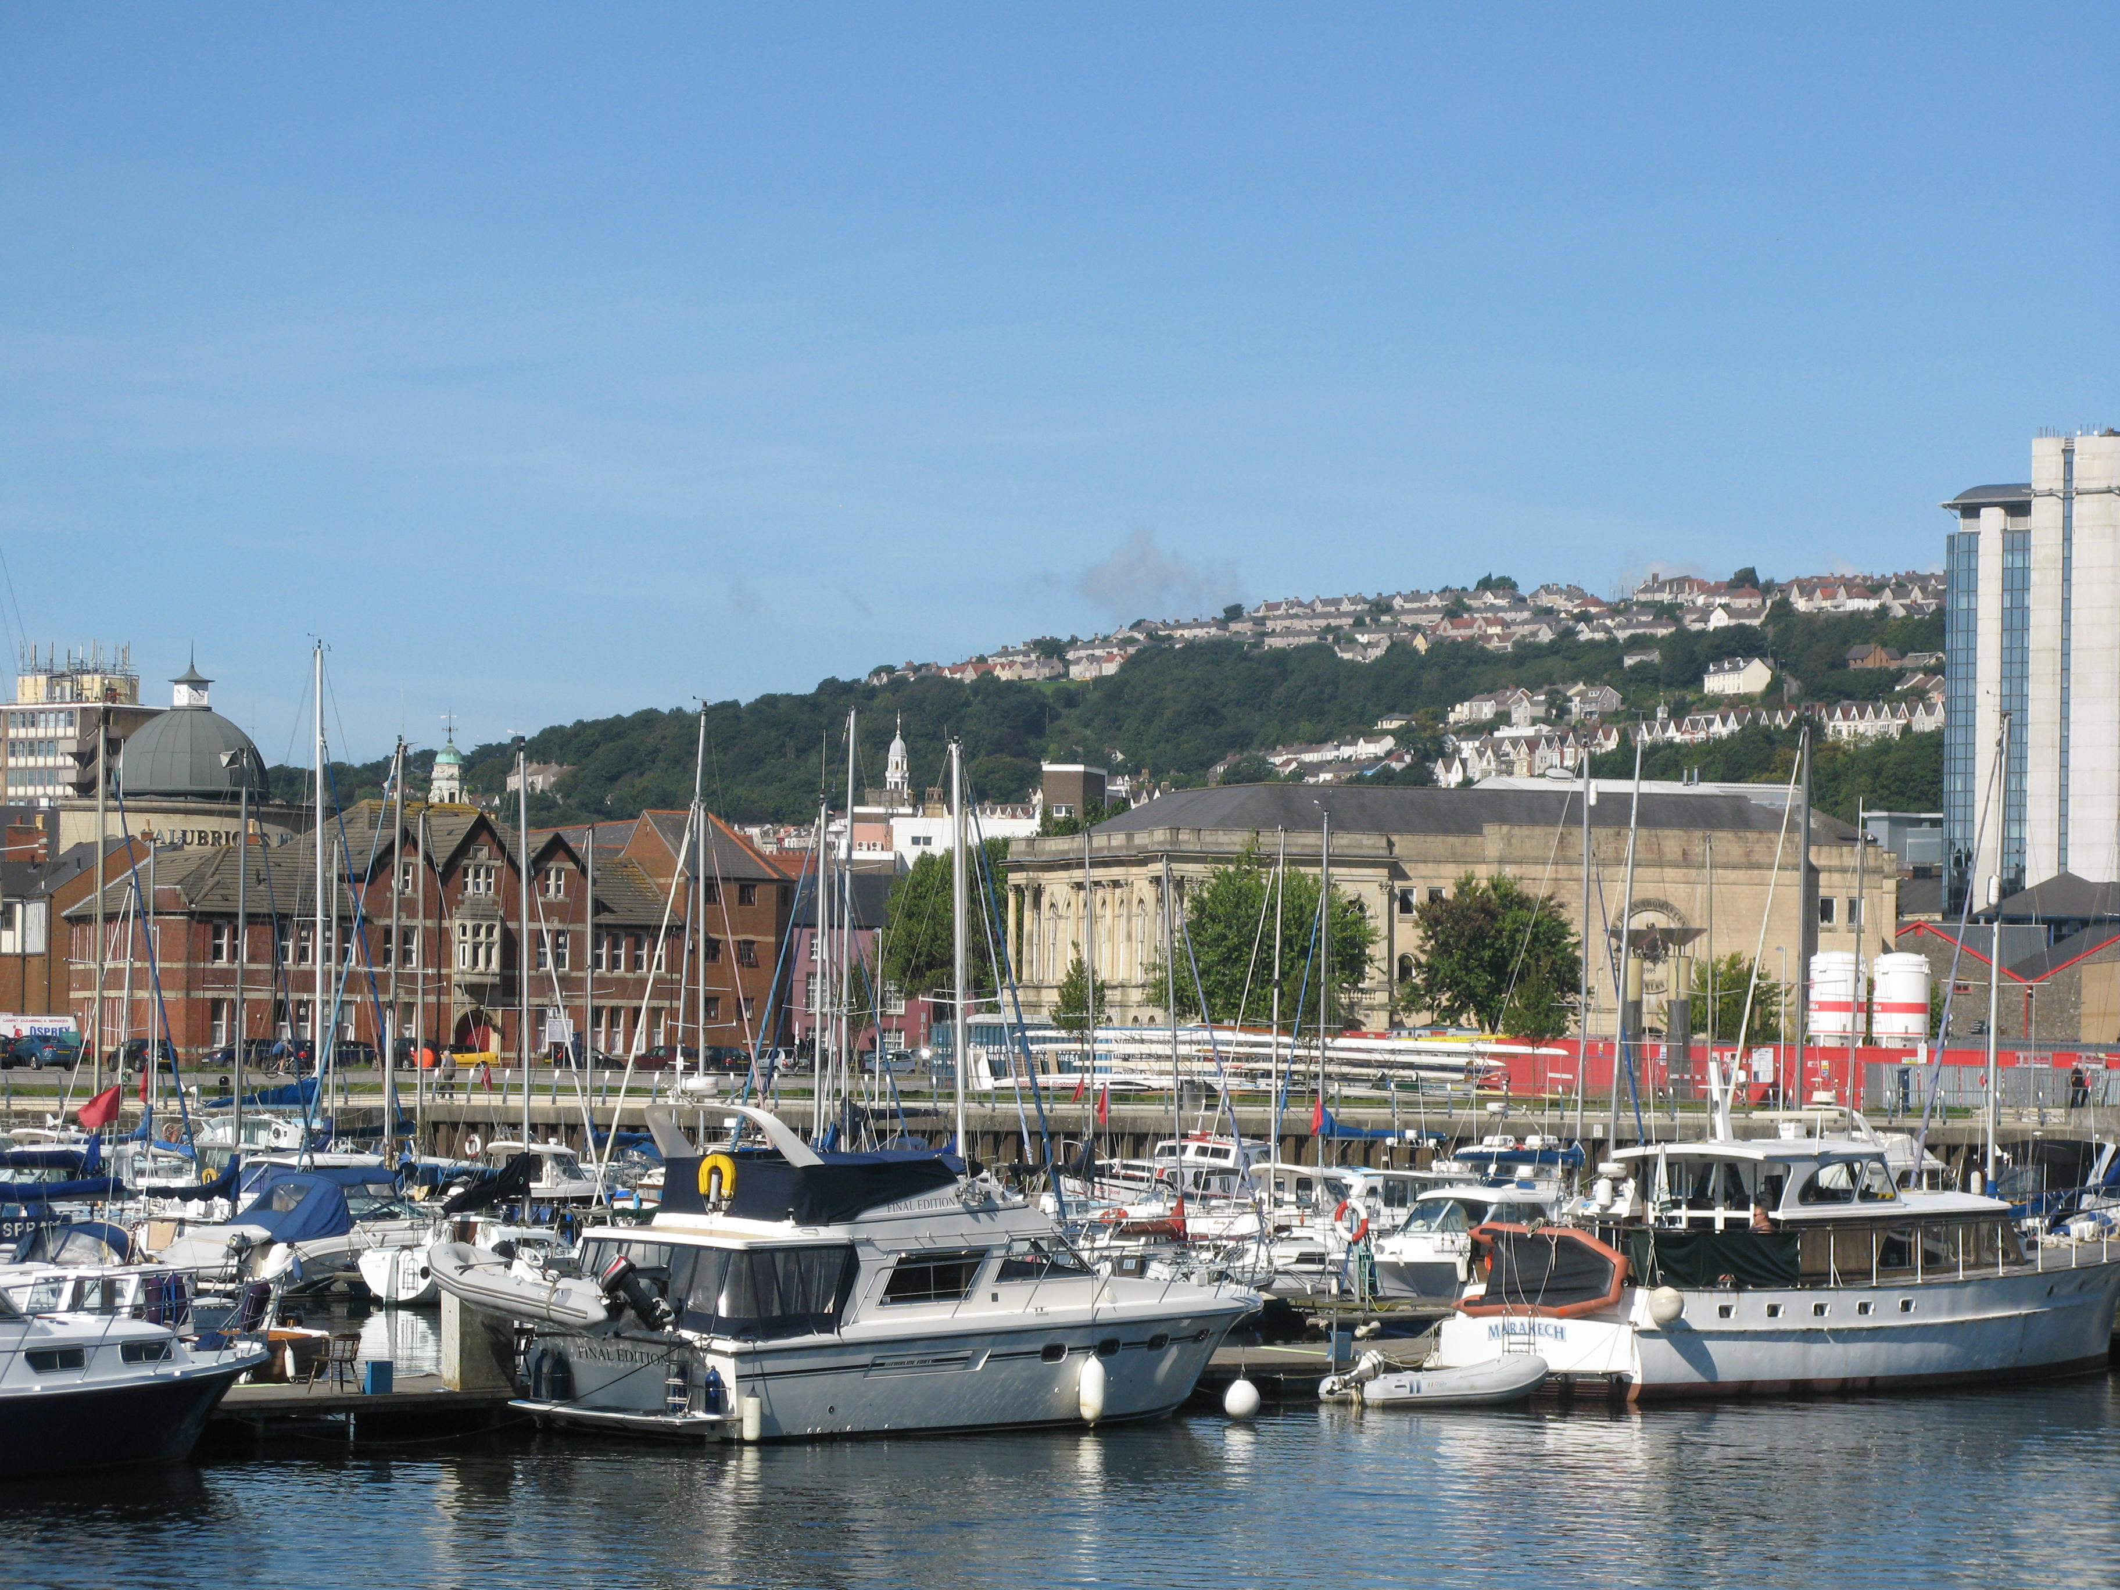

The marina offers visitors the best of both worlds: the attractions of a vibrant city right on your doorstep combined with the tranquillity of a waterfront location together with the fun of a beach resort.

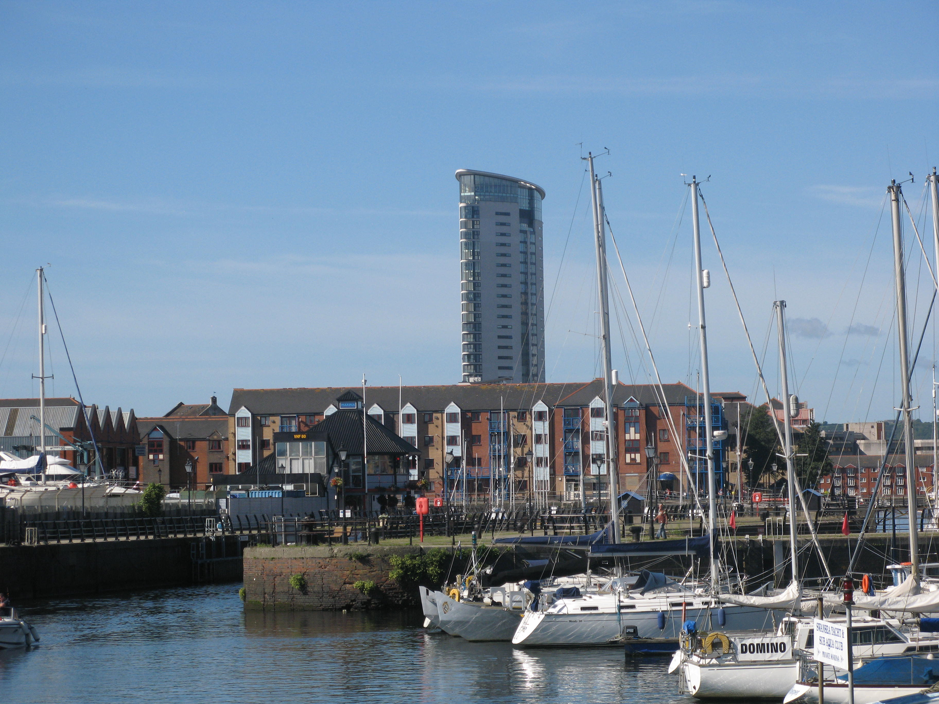

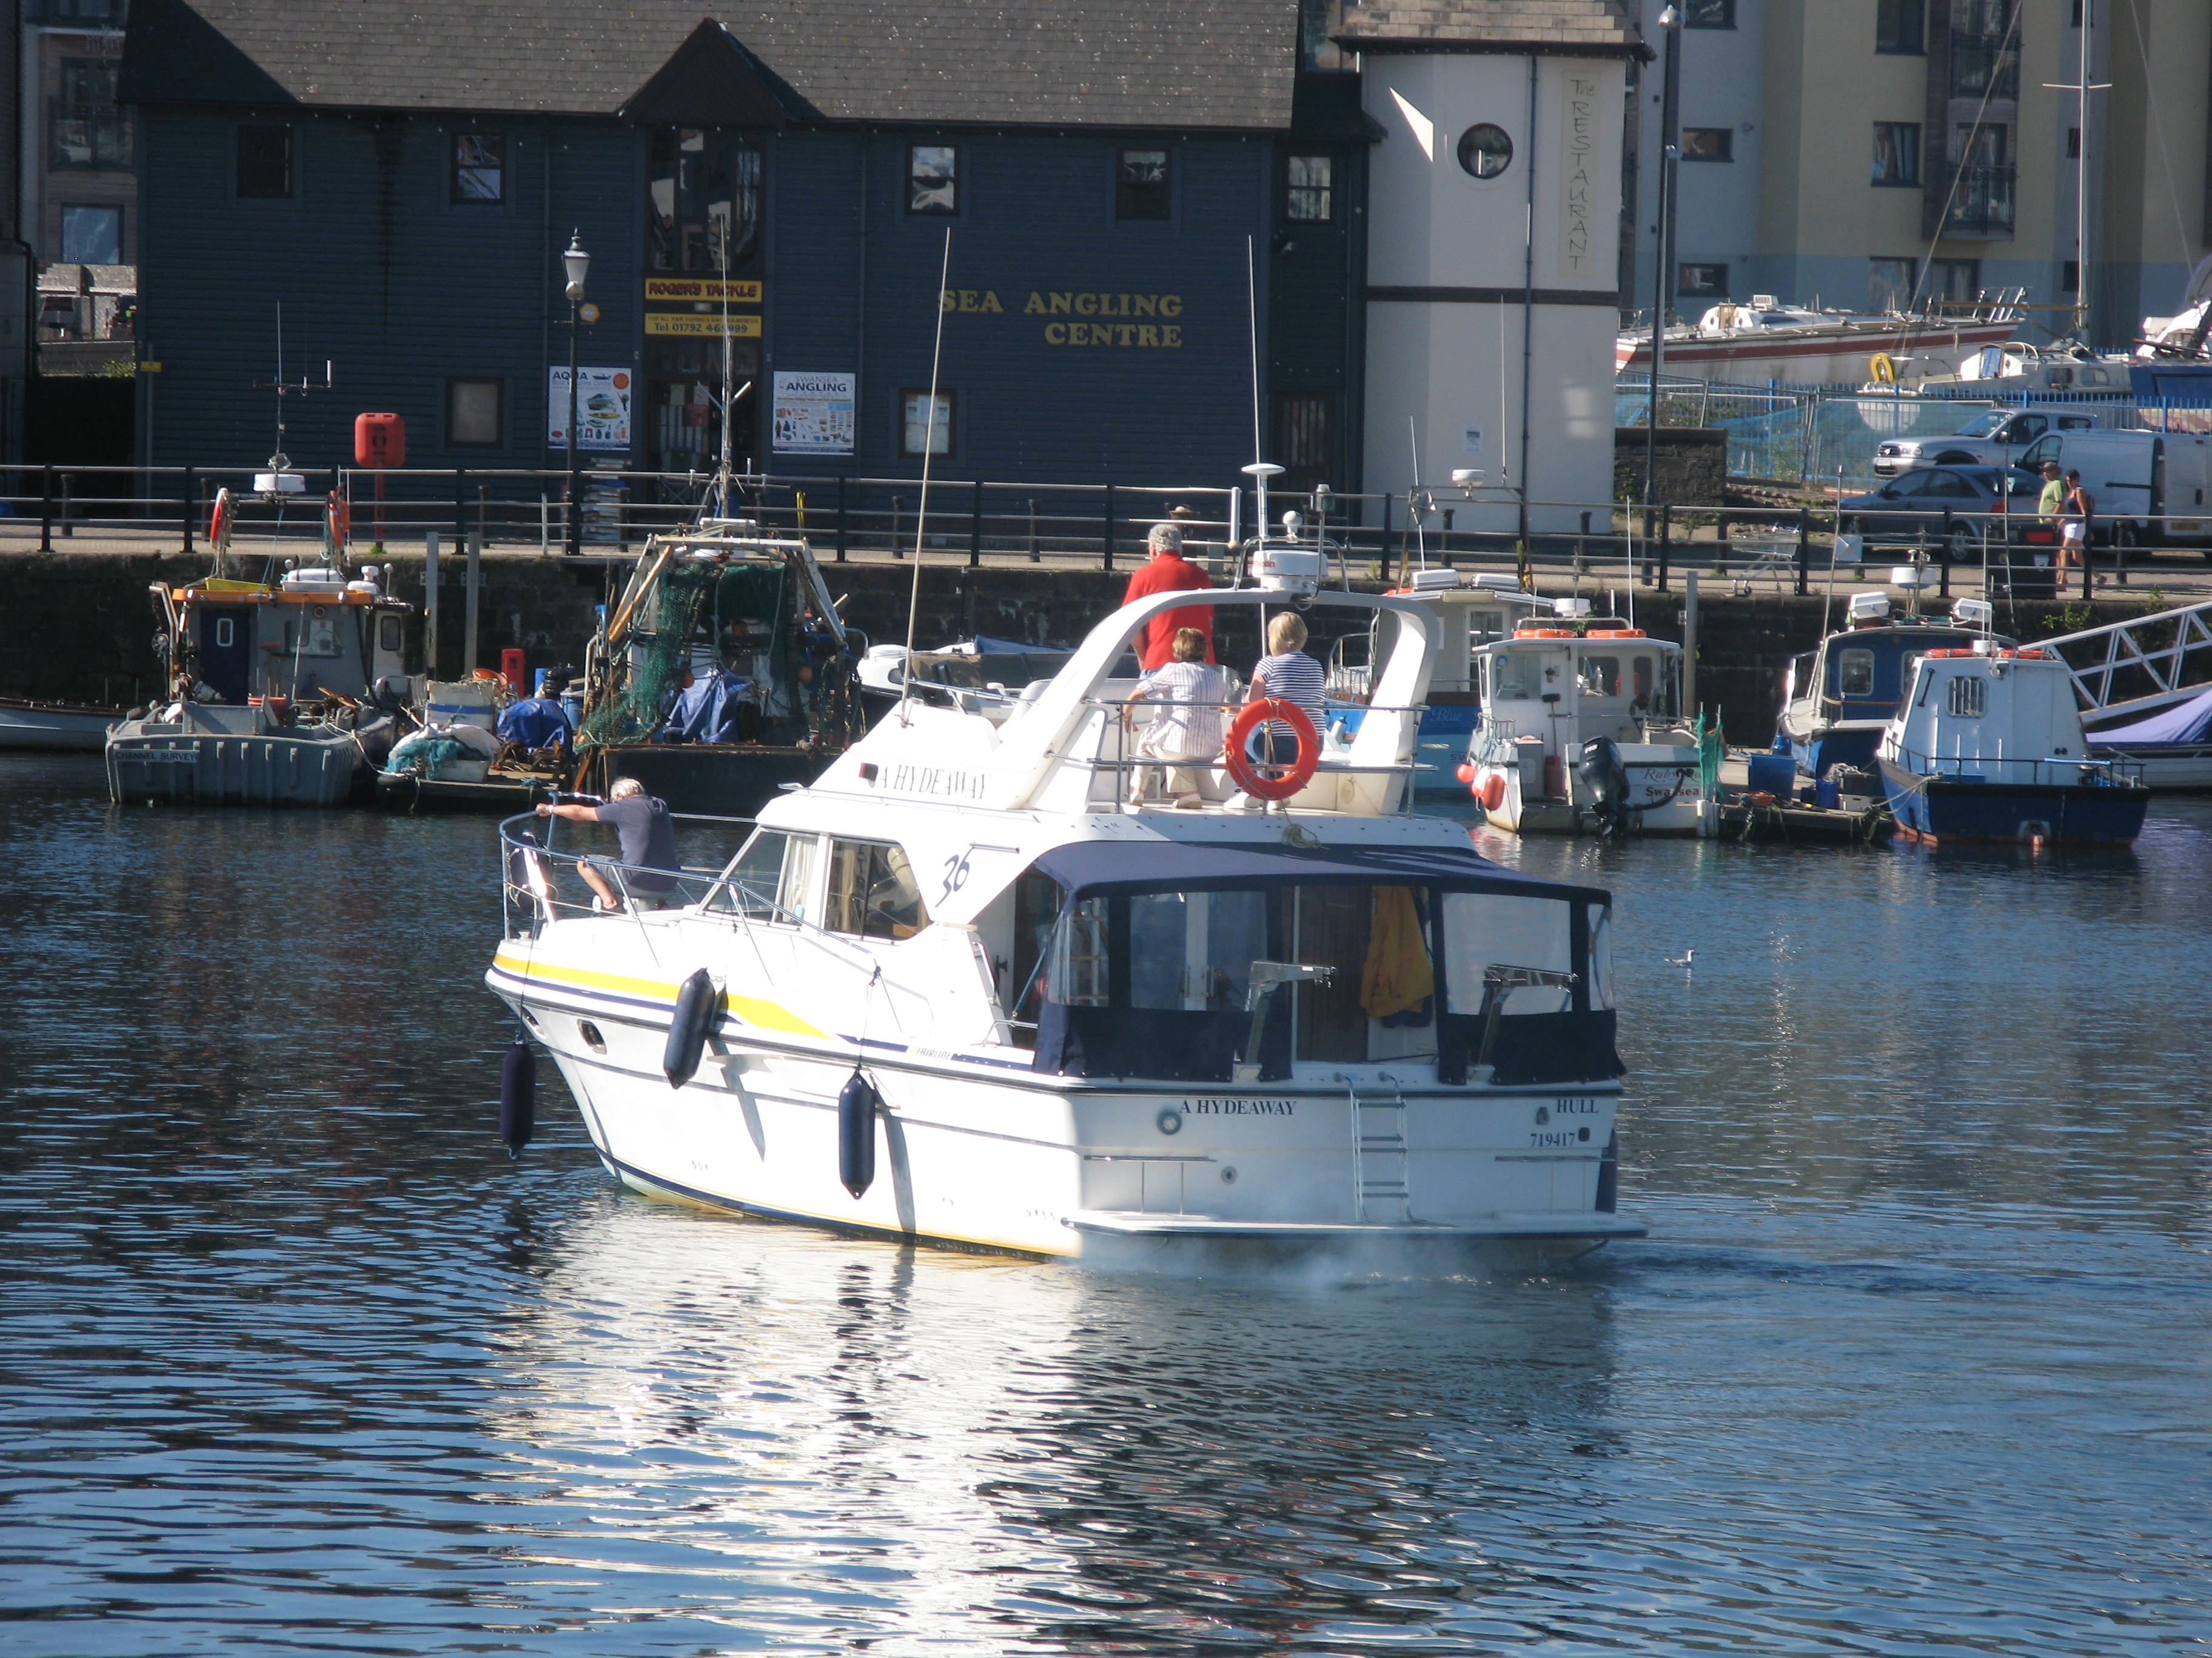
The Swansea sea front stretches for five miles as far as Mumbles Head - a good hour’s walk, or a twenty minute bike ride away.

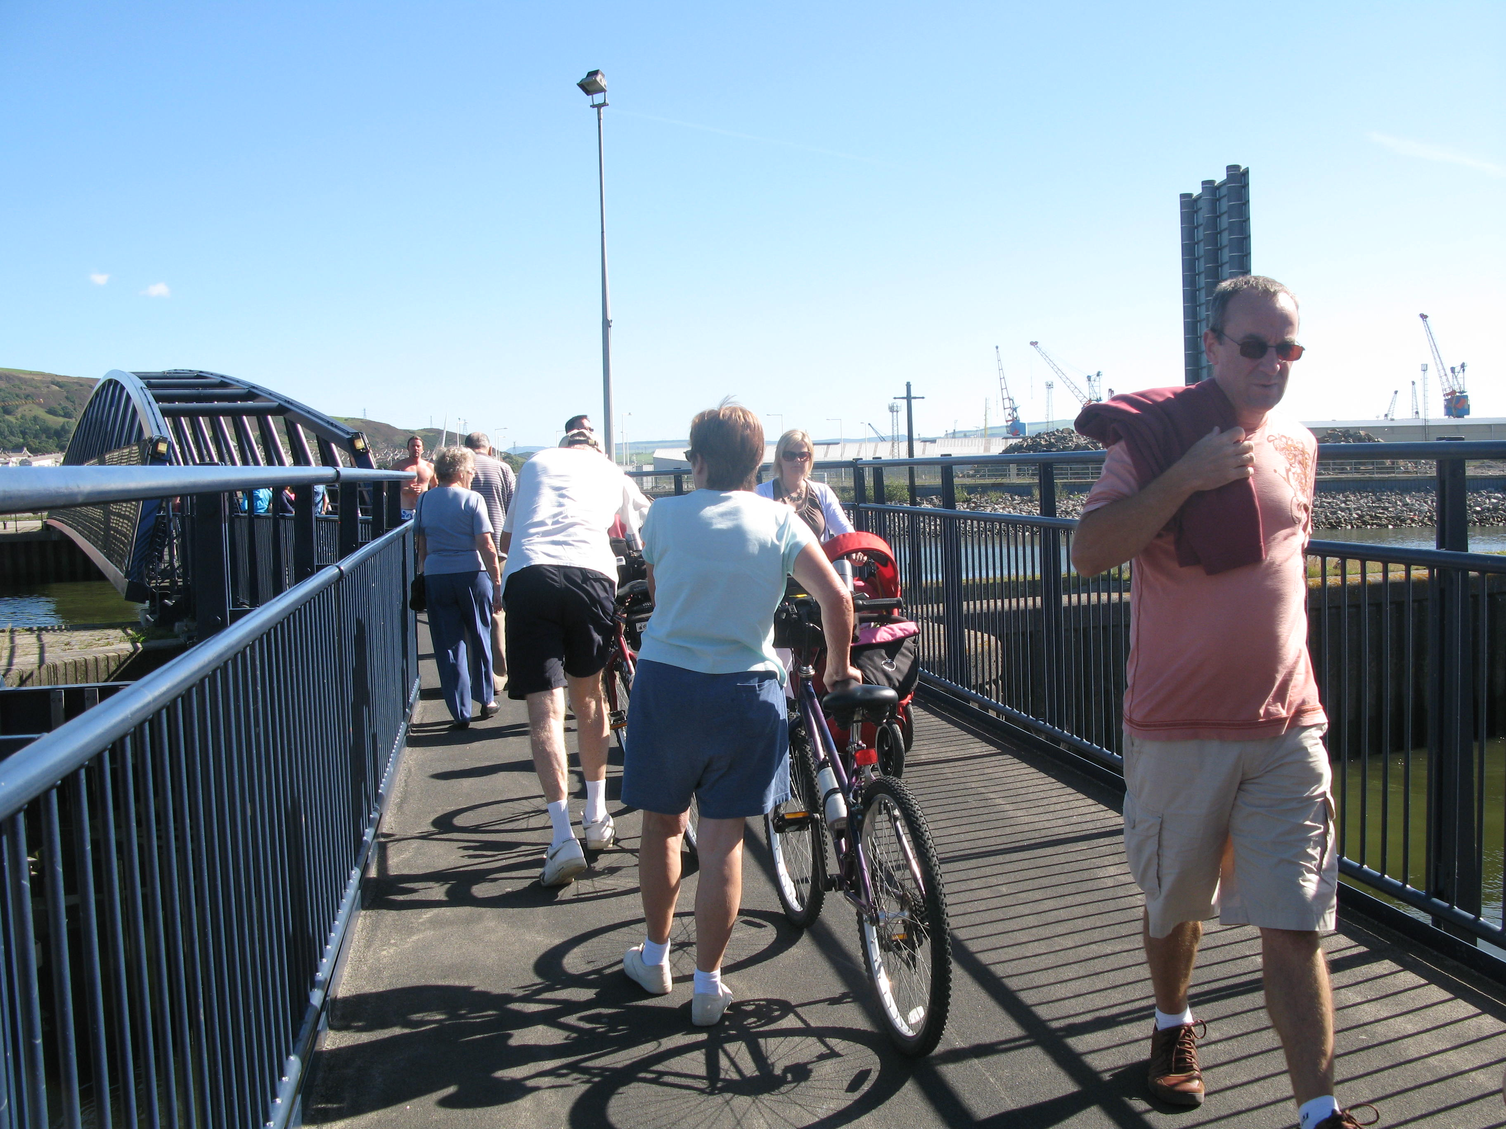
En-route visitors can join in the water sports activities – an opportunity to try wind surfing. Visitors can also take a stroll or even a bike ride around the marina basin, spend some time watching yachts, motor cruisers and fishing boats stack into the lock gate or simply relax and sample a designer coffee at one of the many cafe's.

Things to do.

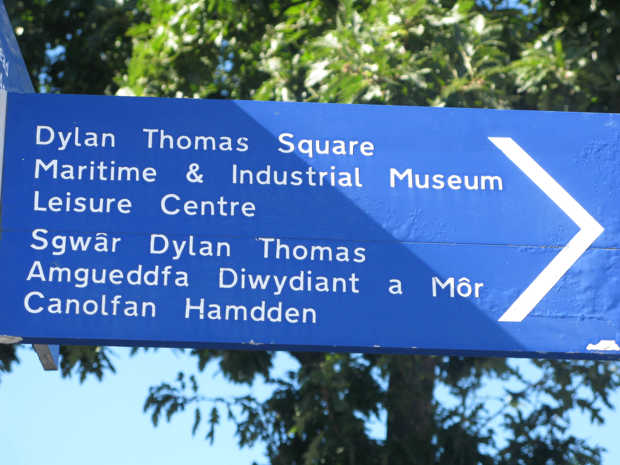
Visitors can go to the National Waterfront Museum, Swansea’s latest landmark, and learn about the maritime history of Swansea – once one of the most successful ports in Europe. Wander around fine examples of railway carriages from the world’s first passenger railway, or test drive some of the innovative ‘hands on’ learning zone exhibits.

Swansea Leisure Centre has reopened its doors after a £30 million pound refit. It now boasts state of the art facilities and has something for every member of the family.

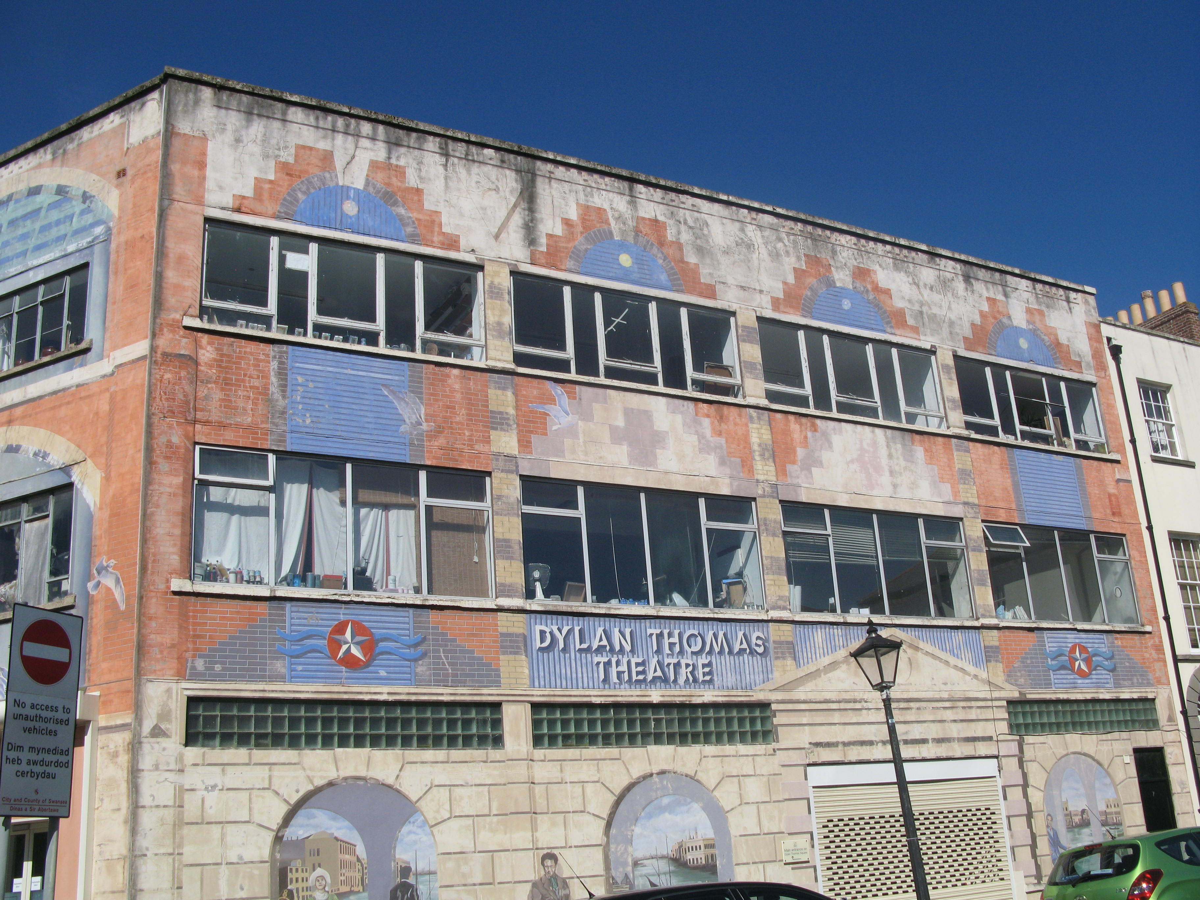
Swansea is proud of its connection with the famous poet Dylan Thomas and the Man and Myth exhibition, at the Dylan Thomas Centre, makes a great starting point for those wanting to know more about his fascinating life. Whether your preference is theatre, cinema or live music - the city is brimming with events and festivals all year round - many of which are outdoor during the summer months.

