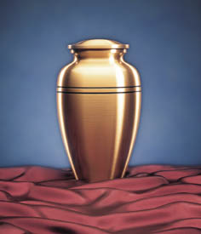









The minister and close friend or relative will usually say a few words about the dead persons life.

‘I am the resurrection and the life.......’ John 11, the service is started with these words.

White is worn by ministers or priests as it is the traditional symbol of life after death & resurrection.

There is a celebration of the Eucharist [ Communion, or Mass] at Roman Catholic funerals.

Readings and Hymns.

Burial in the ground is a choice.

Flowers and wreaths are left by family and friends.

A cross or a memorial stone may be placed at the place of burial [cemetery].

Sometimes the coffin is sprinkled with Holy water.

‘Earth to earth, ashes to ashes, dust to dust..

Some Christians choose not to be buried and prefer their body to be burnt.

A service of cremation may have slightly different words but the meaning will be the same.

Ashes are scattered in the garden of rest at the crematorium or where the dead person may have chosen.

Usually a gathering of family and friends afterwards.

Offering of comfort to close family and friends.

It is a celebration and thanksgiving of the person who died.

