

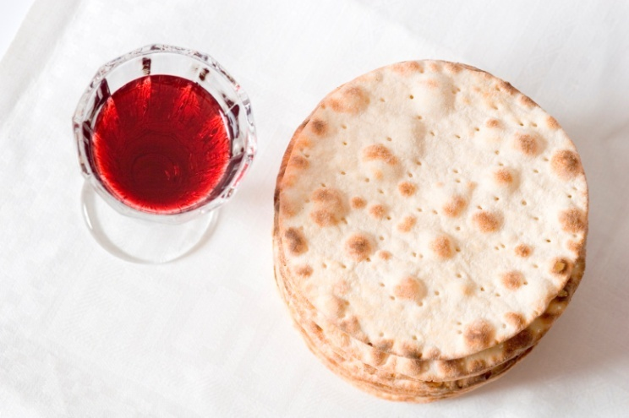
Odd Out
Study the four images and then work out which is the odd one out. Remember to provide a reason to support your answer.

Explain your reason;………………………………………………………………………………………………………………………………….
………………………………………………………………………………………………………………………………………………………………………..
………………………………………………………………………………………………………………………………………………………………………..
………………………………………………………………………………………………………………………………………………………………………..
……………………………………………………………………………………………………………………………………………………………………….
………………………………………………………………………………………………………………………………………………………………………..
………………………………………………………………………………………………………………………………………………………………………..

